WGSE PT45 meeting |  | Doc. SE45(18)059R2
Copenhagen, Denmark, 13-14 August 2018
Date issued: | 27 July 2018
Source: | BNetzA
Subject: | Selection of propagation models for FS analysis
Group membership required to read? (Y/N)
N
Summary:
It will be shown why following propagation models should be chosen for the studies between RLAN and FS.

Another input (a MCL study) using these models can be awaited for the week before next SE45 meeting.

Proposal:
To insert following Annex into the draft report
To use the proposed propagation models for the studies between RLAN and FS

Background:
SE45 studies the compatibility of new RLAN APs in the band 5925 MHz – 6425 MHz with incumbent services. This band is allocated for the FS. This contribution is aimed to support the study between RLAN and the FS.

Annex XXX: Selection of propagation models for FS MCL analysis
In this analysis the most appropriate propagation model will be chosen for MCL compatibility studies between RLANs and FS. The following propagation models are considered to be analysed:
- Winner II models as described in “WINNER II Part I Channel Models" deliverable (Winner II)
- Winner II models as described in Report ITU-R M.2135-1 (Winner II M.2135)
- Propagation model as described in Recommendation ITU-R P.452-16 (P.452)
- Propagation model as described in Recommendation ITU-R P.525-3 (P.525)
- Propagation model as described in Recommendation ITU-R P.1411-9 section 4.2.1 (P.1411)

In Addition following models are considered to be added to propagation models (e.g. when there is no description for Non-Line-Of-Sight (NLOS) conditions):
- Clutter loss as described in Recommendation ITU-R P.2108-0 (P.2108)
- Building entry loss as described in Recommendation ITU-R P.2109-0 (P.2109)
  - Defining Line-Of-Sight (LOS) and NLOS areas
The "WINNER II Part I Channel Models" deliverable Table 4-7 describes the probability for Line-of-sight (LOS) situations. These formulas are given in Figure 1 and the probabilities have been plotted below in Figure 2 in order to calculate applicability ranges for LOS conditions. The scenarios of interest are C2 (urban outdoor) and D1 (rural outdoor). According to the equations non-Line-of-sight (NLOS) conditions begin at 1000 m for the urban scenario and at 4017 m for the rural scenario. For this analysis it was assumed that LOS probability has to be less than 1.8 % to start with NLOS conditions. This should for urban environments reflect the description of break point distances in the Winner II deliverables.
Figure 1: Formulas for LOS probabilities
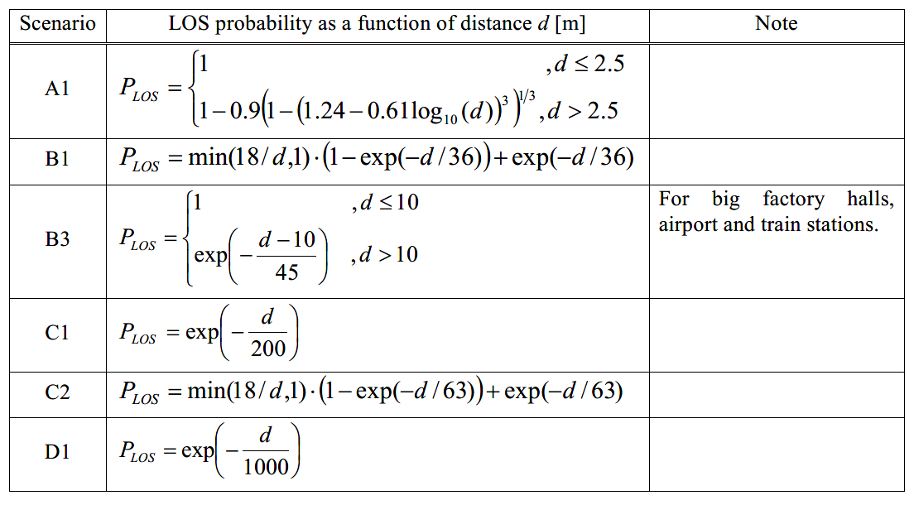
Figure 2: LOS probabilities for Urban and Rural scenarios
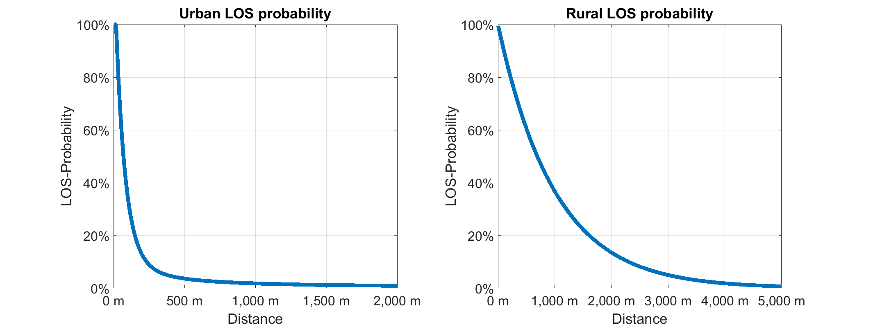
It can be concluded that the area around a FS receiver is characterised by LOS conditions followed by Non-Line-of-sight (NLOS) conditions. An illustration of that behaviour is shown in Figure 3.

Figure 3: Illustration of LOS and NLOS areas
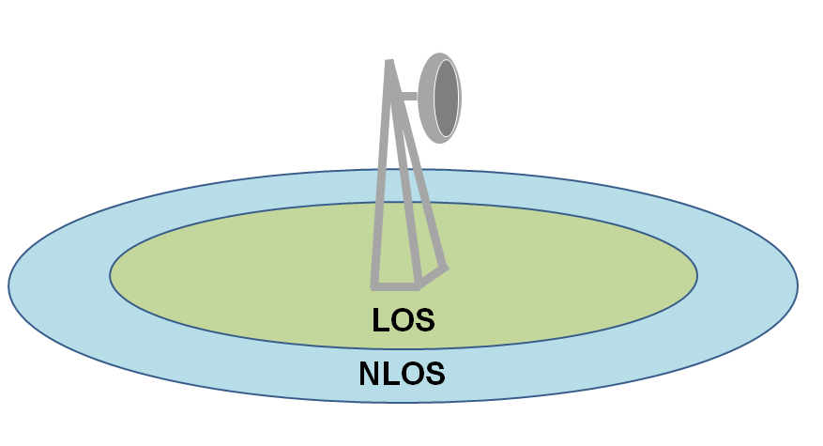
For indoor scenarios building entry loss is added to all models following P.2109. This does not change the comparison of propagation models. Additionally measurements (Figure 4) used to validate the proposed models had been made outdoors. Therefore building entry loss has not been regarded for the choice of propagation models.
  - Propagation model: Urban LOS (0m - 1000m)
For urban LOS scenarios a propagation model has to be chosen which does not deviate strongly compared to the Free Space Loss Model P.525. The frequency of 4.95 GHz will be used to get comparable results to measurements which were made at a frequency of 4.95 GHz. These measurements which had been shown in "WINNER II Part II Radio Channel Measurement and Analysis Results" deliverable Figure 3-129 are depicted in Figure 4.
Figure 4: Measurements from Winner II deliverable @4.95 GHz
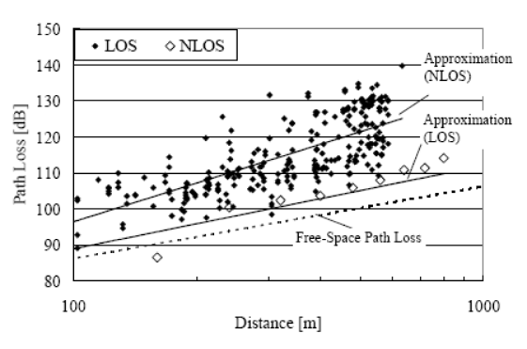
It should be noted that in the legend of Figure 4 the markers for LOS and NLOS are mixed up. In the plot itself the description is correct.
Figure 5: Comparison of propagation models
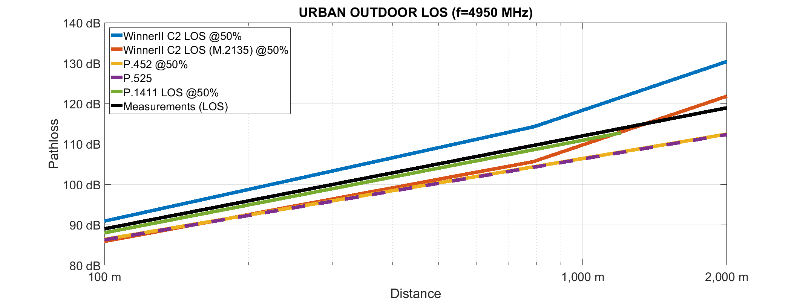
It should be noted that the Winner II models (blue and red lines) are defined up to 6 GHz.
Model Winner II C2 (blue line) seems to overestimate losses against Free-space-loss up to 12 dB. On the other hand model Winner II C2 M.2135-1 (red line) seems to be more appropriate. Also P.1411 (green line) seems to be a good estimation.
Additionally the model should align with measurements (black line). It can be seen again that model Winner II C2 M.2135-1 (red line) and model P.1411 (green line) estimate the measured values very good.
The same comparison for shorter distances is shown in Figure 6.
Figure 6: Comparison of propagation models
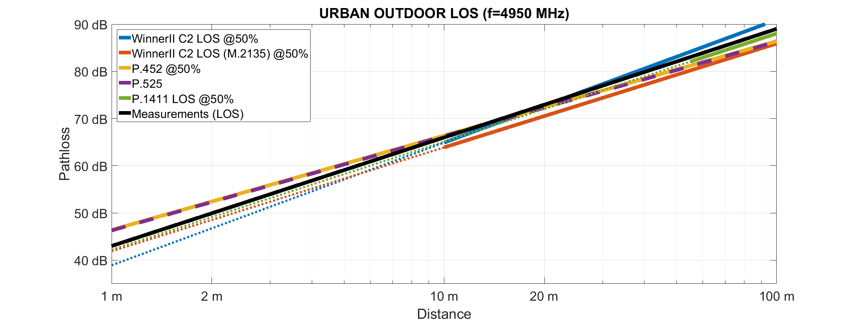
It should be noted that only for the free space loss model P.525 the distance is described as a 3 dimensional distance (consideration of antenna height difference). This implies that for short distances and great differences of height an error will appear in the illustration, because the other models define a 2 dimensional distance. However, this error is negligible for the considered scenarios. The free space model should generate slightly higher losses than P.452.
It can be seen that for short distances model P.1411 is closer to free space loss model and the regression line from the measurements. The Winner II models generate even lower values.
Therefore model P.1411 will be used for urban LOS scenarios for distances from 0 m to 1000 m. It should be noted that this model is defined for distances greater than 55 m but as it has been shown it will generate appropriate values in this range.

  - Propagation model: Urban NLOS (>1000m)
The measurements shown in Figure 4 should be confirmed when evaluating propagation models for NLOS conditions. For greater distances (measurements have been done for up to 1 km in distance) the chosen propagation model should not have a strong deviation compared to the model P.452 combined with P.2108 for clutter losses. If there is no description for NLOS conditions in a propagation model (e.g. P.525) P.2108 will also be used to generate additional clutter losses.
Figure 7: Comparison of propagation models @1% Clutter Loss percentage
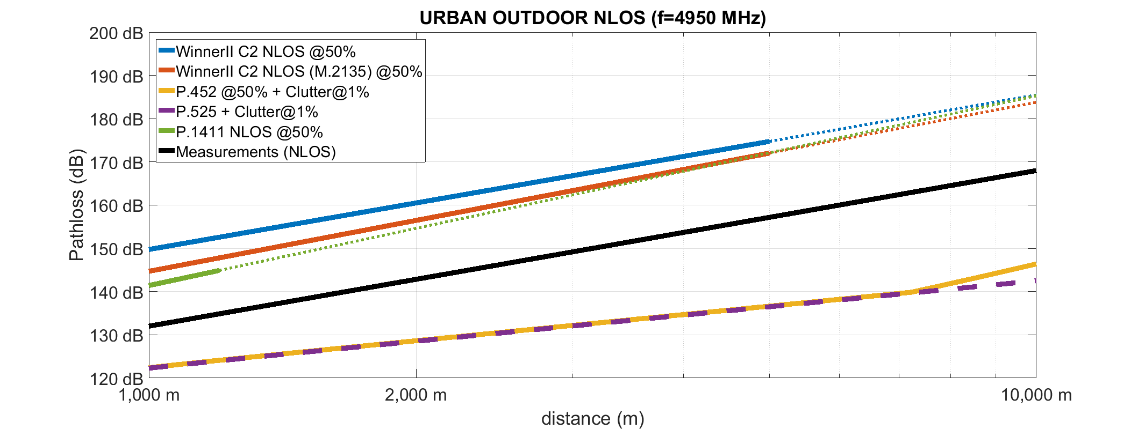

Figure 8: Comparison of propagation models @50% Clutter Loss percentage
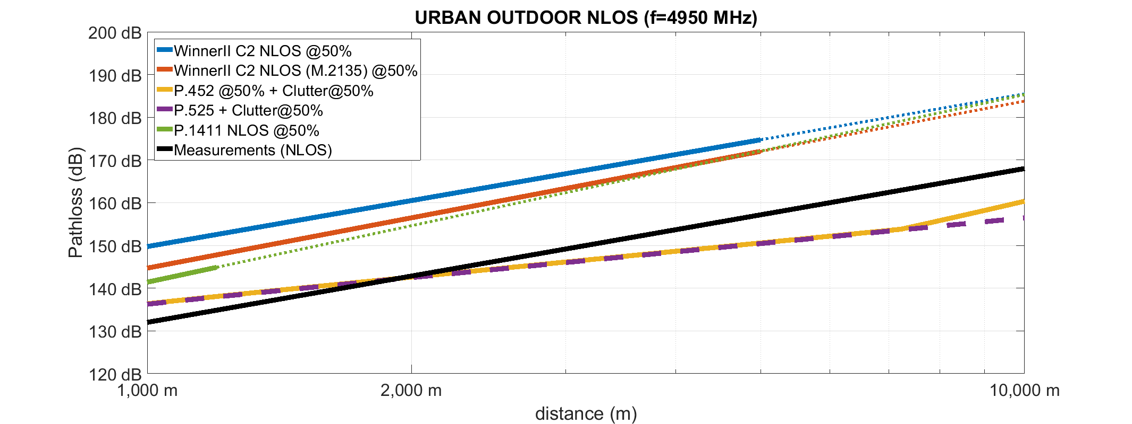

It should be noted that model P.1411 is just defined up to 1200 m and the Winner II models up to 5000m. The dotted lines represent the models if they were used outside of their bounds.
It can be seen that only model P.452 in combination with clutter loss model P.2108 at a percentage of 50% describes values comparable to the measurements shown in Figure 4. The Winner II models will overestimate the losses up to 20 dB. Model P.1411 for urban scenarios has also been plotted to generate a maximum limit of losses. Losses generated by another propagation model should be lower than from model P.1411. The Winner II models do not show this behaviour.
Therefore model P.452 combined with P.2108 at a percentage of 50% for clutter loss will be used for urban NLOS scenarios.

L=A*logd+B

L=169.8*logd+101.2
  - Propagation model: Rural LOS (0m - 4017m)
For rural scenarios P.1411 ist not valid anymore. Again it can be assumed that models generating higher losses would not be appropriate because there will be not more clutter than in urban scenarios.
Figure 9: Comparison of propagation models
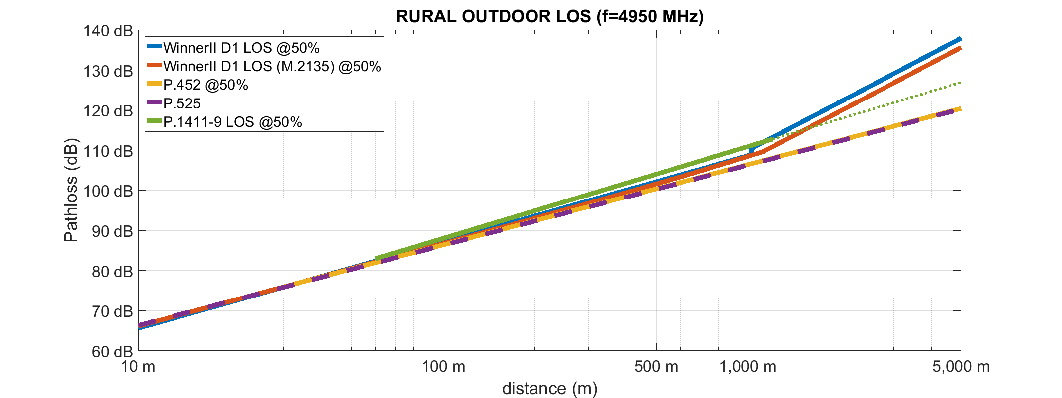
According to Figure 9 the Winner II models generate higher losses at about 1200 m than P.1411.
The results will very much depend on the antenna hights. Winner II models are just valid for antenna hights of 32 m.
Therefore model P.452 will be used for rural LOS scenarios.

  - Propagation model: Rural NLOS (>4017m)
Figure 10: Comparison of propagation models
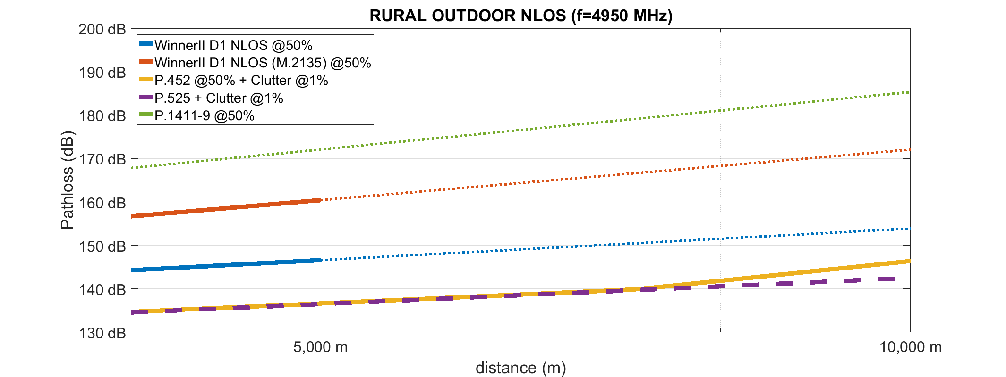
For distances greater than 5 km neither P.1411 nor the Winner II models are valid. Again the dotted lines represent the models if they were used outside of their bounds.
Therefore model P.452 combined with P.2108 at a percentage of 50% for clutter loss will be used for urban NLOS scenarios, although the Winner II models are generating lesser losses than model P.1411.
  - Conclusion on propagation models

Table 1: Urban propagation model
Distance | Propagation Model | Clutter | Building entry (applied in main study)
0 m <= d <= 1000 m (LOS) | [ITU-R P.1411-9]  (p=50%) |  | ITU-R P.2109-0
d >= 1000 m  (NLOS) | ITU-R P.452-16  (p=50%) | ITU-R P.2108-0  (p=50%) | ITU-R P.2109-0

Figure 11: Proposed urban propagation model (outdoor)
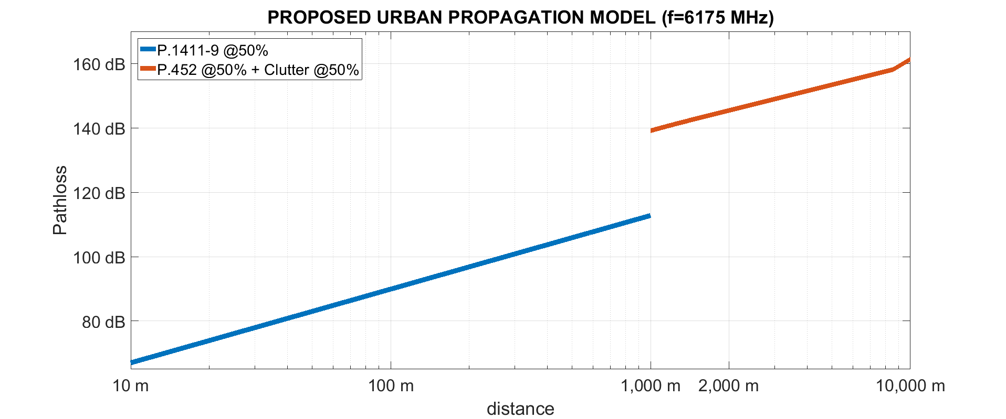
For the proposed model under urban conditions as depicted in Figure 11 the assumed heights used by P.452 are 1.5 m and 25 m. For other heights the model will look slightly different in the red part of the curve. At the distance of 1 km the loss will jump about 27 dB

Table 2: Rural propagation model
Parameter | Propagation model | Clutter | Building entry (applied in main study)
0 m < d < 4017 m (LOS) | ITU-R P.452-16  (p=50%) |  | ITU-R P.2109-0
d >= 4017 m  (NLOS) | ITU-R P.452-16  (p=50%) | ITU-R P.2108-0  (p=1%) | ITU-R P.2109-0

Figure 12: Proposed rural propagation model (outdoor)
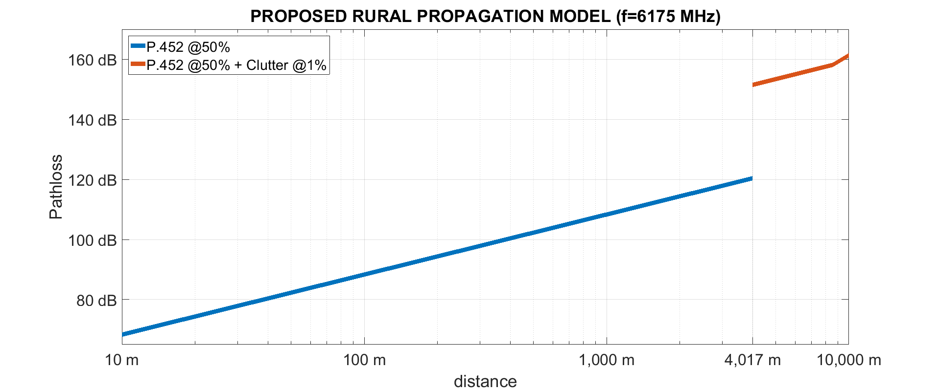
It is obvious that the behaviour of the proposed rural propagation model as depicted in Figure 12 is not continuous. This sudden increase occurs because of the discrete change from LOS to NLOS conditions as described in section a). For the single interferer analysis this behaviour is not relevant since the targeted separation distances are less than 4017 m.

