WGSE PT45 meeting |  | Doc. SE45(18)120R1
SE45 xxxxxxxxx, xxxxxxx
Date issued: | 10 December 2018
Source: | Siemens Mobility, Denmark
Subject: | Impact of RLAN on the Danish CBTC system in the 5925-5975 MHz band
Group membership required to read? (Y/N)
N
Summary:
This compatibility study evaluates the impact of RLAN co-existing with the Copenhagen CBTC system in the frequency band 5925-5975 MHz currently licensed to the Copenhagen CBTC system.
Proposal:
This study is submitted to SE45 for inclusion in the draft ECC Report on RLAN in 5925-6425 MHz.
Background:
ECC (Electronic Communications Committee) under CEPT (The European Conference of Postal and Telecommunications Administrations) is evaluating the technical and regulatory feasibility of allocating the 5925-6425 MHz frequency band for RLANs (Radio Local Area Networks). The studies evaluating the compatibility of RLANs with the existing radio systems in this band are being performed within the Project Team SE45 of ECC.

RLANs are also known as Wireless Local Area Network (WLANs). Currently, RLANs mainly operate in the frequency bands 2.4 GHz and 5 GHz and mostly use the radio technology based on the IEEE 802.11 standard, also known as WiFi.

The allocation of the 5925-6425 MHz frequency band for RLANs will essentially mean that public WiFi devices will be able to operate in this band freely, i.e. without a need for license.

Introduction
In Denmark, the Copenhagen S-bane CBTC (Communications-Based Train Control) system is operating in the licensed band 5925-5975 MHz, which constitutes the first 50 MHz of the proposed RLAN band 5925-6425 MHz, as shown in Figure 1. The time-critical and safety-related nature of a CBTC railway signalling system imposes stringent reliability and availability requirements, particularly on radio communication. The co-existence with public RLAN networks might thus severely impact the performance of the CBTC system.
Figure 1 - Overview of frequency bands
In this context, this study evaluates the impact of the interference produced by an RLAN device on the operation of the Copenhagen S-bane CBTC system.
Note that the scenarios and the methodology in this study are partially based on the studies [7] and [9] submitted to SE45.
Overview of the Copenhagen S-bane rail system
S-bane is the mass-transit rail system of the Copenhagen urban area that serves more than 350,000 passengers a day. Table 1 lists the key figures of the Copenhagen S-bane system.

Parameter | Value
Length of double track | 170 km
Length of double track in tunnel | 2 km
Length of double track in trench | 1.5 km
Number of train stations | 92
Number of rail lines | 7
Number of trains (with passengers) | 135 vehicles
Number of yellow fleets | 18 vehicles
Number of depots | 3
Number of traffic control centres (TCC) | 1
Table 1 – Key figures of Copenhagen S-bane rail system
Overview of the Copenhagen S-bane CBTC system
The Copenhagen S-bane system is currently being equipped with CBTC (Communications-Based Train Control). CBTC is a modern signalling system that uses radio communication to enable the exchange of high resolution and real-time train control information between the train and the wayside infrastructure. The Copenhagen S-bane system use a radio technology based on IEEE 802.11 Wi-Fi.
The train and the wayside communicate with each other by sending special CBTC messages. The train continuously sends its location to the wayside. Based on this information, the traffic control centre (TCC) at the wayside calculates the maximum speed and distance the train is permitted to travel and sends it to the train. This information is called "Movement Authority". Based on this information, the train onboard equipment continuously adjusts the train speed and maintains the safety distance to the preceding train. In the S-bane CBTC system, these CBTC messages are exchanged every 400 milliseconds. This real-time communication increases the line capacity by safely reducing the distance (headway) between the trains travelling on the same line [6].
To ensure a continuous radio connectivity, a large number of WiFi Access Points (APs) are installed at the wayside. Train is likewise equipped with at least two WiFi client devices, called a Train Unit (TU). As the train moves, it establishes a radio connection with the nearest AP.
The system availability in CBTC depends highly on the radio communication. Since railway operations involve safety of passengers, there exist particularly high requirements about the system availability. For this reason, CBTC systems generally support exceptionally high availability. For S-bane, the supported system availability is 99.999% (6.05 seconds of downtime per week).
In the S-bane CBTC system, the number of APs installed is approximately 650. The average distance between two consecutive APs is 600 meters. This number is based on the link budget calculations and ensures that there is adequate radio coverage at any given location on the track.
As CBTC is highly dependent on radio communication, stringent requirements are imposed to maintain a certain quality of communication. These requirements can be found in [10] and [11].
- Packet errors
A packet must be received with a minimum signal-to-noise ratio before it could be demodulated correctly. The number of errors introduced is directly proportional to the amount of interference received above this threshold. In the given scenario, the amount of interference will additionally depend on the number of RLAN interferers present in the proximity. Furthermore, it will depend highly on the type of application used and its data traffic characteristics. In other words, someone browsing websites on their RLAN device is less harmful compared to someone streaming videos or downloading large files on their RLAN device. The requirements listed in [10] specify maximum 1 erroneous packet out of 100 packets received, i.e. a Packet Error Rate (PER) of 1%.

- Bandwidth
The 802.11 radio technology is based on shared medium access. It uses the CSMA/CA (Carrier Sense Multiple Access/Collision Avoidance) mechanism to prevent a user from transmitting when another user is already transmitting (using the so-called back-off mechanism). This implies that the greater the number of users trying to transmit simultaneously at a given time, the lower the per user available bandwidth. As the S-bane CBTC system is also based on 802.11, it will recognize RLAN transmissions and will back-off (and vice-versa). In the S-bane CBTC system, the supported bandwidth is 18 Mbit/s. The required minimum bandwidth per train is 160 kbit/s which is analogous to voice over WiFi traffic flows from a bitrate and priority perspective. As an example, note that streaming HD (High Definition) video requires a bandwidth of approximately 5 Mbit/s. This implies, for example, that with large numbers of RLAN users streaming HD videos, the probability of simultaneous transmissions that could prevent a train from transmitting its location (i.e. due to the back-off mechanism) is increased.

Note that the above example assumes that these RLAN users are also using a channel of 20 MHz width and the same modulation and coding rate as S-bane. For RLAN users using a wider channel (i.e. 40, 80 or 160 MHz) and/or a higher modulation and coding rate, the number of RLAN users it will take to prevent the train from transmitting will be greater, particularly given the short duty cycle of 1.97% [2] (Section 4.3) achievable due to the resulting high data rates.

Note that the above-mentioned bandwidth of 160 kbit/s per train is for CBTC-related traffic only. In addition, 2 Mbit/s is allocated for non-CBTC-related traffic e.g. for software updates.

- Latency
Both low bandwidth and high interference can result in high latency. CBTC systems impose stringent requirements on latency as the location received from a train with an unacceptable delay does not accurately represent the train’s current location. The requirements listed in [10] specify a maximum allowed delay of 100 milliseconds.
A radio communication failure in CBTC can be defined as an event when the above requirements on packet errors, bandwidth, and latency are not met. In such an event, a train may not be able to receive the “Movement Authority” from the wayside in time. As the headways in CBTC are very short, it means in this situation, the train immediately stops automatically (i.e. it applies emergency brakes). Likewise, the train may not be able to send its location to the wayside, in which case the wayside might not able to calculate the “Movement Authority” for other nearby trains, and thus those trains must also stop. For this reason, in CBTC systems, a radio communication loss of more than 1 second is not acceptable, as listed in [10]. Once the train is stopped, it is considered “de-localized” and drops out of the CBTC control. TCC must subsequently issue a written order to the train driver, allowing him to drive the train manually at a low speed until the train has passed over two “balises” to acquire its location again—a balise is a transponder device placed on the rails transmitting the train its exact location. Table 2 lists the key figures of the S-bane CBTC system.

Parameter | Value
Number of Access Points (AP) | 650
Number of Train Units (TU) | 270
Inter-AP distance (average) | 600 m
CBTC message interval | 400 ms
Headway interval (minimum) | 70 s
Table 2 – Key figures of Copenhagen S-bane CBTC system
Currently, the S-bane CBTC system is operating as a Semi-Automated Train Operation (STO) system. It will subsequently be upgraded to a Driverless Train Operation (DTO) system that enables minimum or no driver involvement. Upgrading to a fully automated operation without any onboard staff—called Unattended Train Operation (UTO)—is under consideration after 2020.
The S-bane CBTC system is operating in the licensed band 5925-5975 MHz. It uses 2 channels of 20 MHz bandwidth each, centred at 5935 and 5965 MHz. Table 3 lists the key radio-related figures of the S-bane CBTC system.
In the S-bane system, both AP and TU operate at 30 dBm transmission power which translates to an Effective Isotropic Radiated Power (EIRP) of 38 dBm and 35 dBm, respectively, after the losses and gains are included.
Parameter | Value
Radio frequency band | 5925-5975 MHz
Radio technology | Based on IEEE 802.11
Frequency channels | 5935 MHz, 5965 MHz
Channel width | 20 MHz
Transmission power | 30 dBm
EIRP AP | 38 dBm
EIRP TU | 35 dBm
Maximum allowed EIRP | 46 dBm (33 dBm/MHz)
Table 3 - Radio related parameters for Copenhagen S-bane CBTC system

Experimental setup and methodology
It is noted that this study shall be regarded more as an analytical study than as an empirical study. Furthermore, it is in part based on the Minimum Coupling Loss (MCL) methodology [4] recommended by WG-SE (Working Group Spectrum Engineering) under ECC. The analytical/MCL methodology serves as a simplified approach as it relies mainly on calculations. For example, it supposes a single interferer transmitting at a fixed—usually the maximum—transmission power and using a fixed channel.
The following types of devices/units are involved in this study.
- CBTC receiver: There are two type of CBTC receivers involved:
  - A wayside CBTC receiver, i.e. a wayside Access Point (AP) radio device, referred to as a CBTC AP in this study.
  - A train onboard CBTC receiver, i.e. a Train Unit (TU) radio device, referred to as a CBTC TU in this study.
- RLAN interferer: An RLAN interferer could either be an AP or a mobile device. While an RLAN AP could generally only be located at the wayside, an RLAN mobile device, typically carried by a passenger, could be located both at the wayside or inside the train.
Propagation model
The following propagation model originally presented in [8] and used in the study [9] submitted to SE45 has been used for this study.
$$Path loss =\left\{\begin{matrix}20\log_{10}\left(\frac{4π}{c}\right)+20\log_{10}\left(d\right)+20\log_{10}\left(f\right) & d≤d_{0} \\ 20\log_{10}\left(\frac{4π}{c}\right)+20\log_{10}\left(d_{0}\right)+20\log_{10}\left(f\right)-10n_{0}log\left(\frac{d}{d_{0}}\right) & d_{0}≤d≤d_{1} \\ 20\log_{10}\left(\frac{4π}{c}\right)+20\log_{10}\left(d_{0}\right)+20\log_{10}\left(f\right)-10n_{0}log\left(\frac{d_{1}}{d_{0}}\right)-10n_{1}log\left(\frac{d}{d_{1}}\right) & d>d_{1}\end{matrix}\right.$$
Here c is the speed of light, d is the distance between the transmitter and receiver, and f is the frequency. The values of the breakpoint distance (d₀ and d₁) and path loss exponent (n₀ and n₁) in the formula depend on the environment and are listed in Table 4. Note that since the S-bane CBTC system operates primarily in an urban (or semi-urban) environment, this study uses the values for the urban case.

Parameter | Urban | Suburban | Rural
Breakpoint distance d₀ (m) | 64 | 128 | 256
Path loss exponent n₀ beyond d₀ | 3.8 | 3.3 | 2.8
Breakpoint distance d₁ (m) | 128 | 256 | 1024
Path loss exponent n₁ beyond d₁ | 4.3 | 3.8 | 3.3
Table 4 - Parameter values used for propagation model
Breakpoint distance is defined as the distance after which the signal power starts to degrade more sharply. The values of the breakpoint distance are normally based on real-life data. With the use of the path loss exponent, the loss that incurs due to the existence of obstructions along the path is incorporated in the path loss calculation. Note that while the resulting path loss may not accurately represent a real-life scenario, it serves as a reliable indicator. In addition to the path loss, this study includes antenna gains in the calculation as well, as described subsequently.
For this study, the following coordinate system is used to describe the location of the RLAN interferer relatively to the location of the CBTC receiver.
- The x-axis represents the axis parallel to the train track, therefore also parallel to the boresight of the CBTC AP antennas
- The y-axis represents the axis perpendicular to the train track
- The z-axis represents the axis vertical to the train track
For a given scenario, the CBTC receiver, either an AP or a TU, is located at the origin of the coordinate system. For each scenario, the coordinates “h” (height) and “s” (separation) of the RLAN interferer are defined, and the impact of the RLAN interferer at a given distance “d” from the CBTC receiver is studied. The coordinate system is shown in Figure 2.
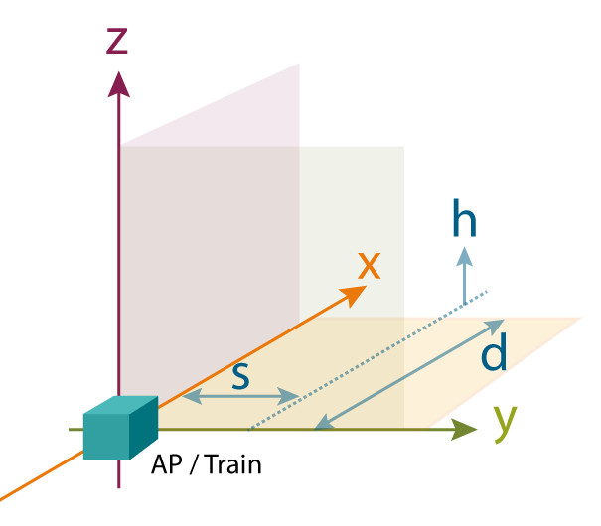
Figure 2 - Coordinate system
The S-bane CBTC system uses uni-directional antennas on both the AP and the TU. On the contrary, for simplicity, this study assumes that the RLAN device uses an omni-directional antenna. For a given location of the interferer (d,s,h), the antenna gain value is calculated according the azimuth and elevation angles using the radiation pattern of the antenna. Depending on the values of “h” and “s”, the “main lobe/main lobe” situation is achieved for a certain distance “d”. For shorter distances, the gain value is taken from the radiation pattern table for the antenna.
Note that the situation where the antennas of the CBTC unit (i.e. AP or TU) and the RLAN device are not aligned (i.e. the “main lobe/main lobe” situation is not met) might lead to the famous "hidden node problem" where the RLAN device is not able to hear the transmissions from the CBTC unit, i.e. CBTC unit is hidden from the RLAN device. The hidden node problem renders the "carrier sensing" protocol of 802.11 (i.e. CSMA/CA) ineffective as the two nodes are not able to hear each other. As a result, the RLAN device might not refrain from transmitting and thus produce interference for a CBTC unit that is already transmitting.
Experiment parameters
Table 5 lists the S-bane specific parameter values used in this study, including the values from the S-bane link budget calculations.
The antenna used in the S-bane CBTC system for both APs and TUs is HUBER+SUHNER Sencity SPOT-S antenna which has a gain of 14 dBi.
The value of the train windscreen loss is based on measurements carried out in the S-bane system. The value ranges between 3 and 6 dB. For this study, the maximum value (6 dB) has been used. For simplicity, the same loss value has been assumed for the train body as well.
Parameter | Value
Antenna gain | 14 dBi
Cable loss | 3 dB
AP splitter loss | 0.5 dB
Train windscreen loss | 6 dB
Modulation type | OFDM with QPSK
Coding rate | 3/4
Supported bandwidth | 18 Mbit/s
Table 5 - S-bane specific parameter values used in the study
Table 6 lists the generic parameter values used in this study, i.e. parameter values that are applicable for both CBTC and RLAN.
The EIRP values of 29.9 dBm and 18.5 dBm for RLAN AP and RLAN mobile device, respectively, have been used. These values have been adopted from [2] (Section 4.2.1.1).
For this study, it is assumed that S-bane is using the frequency channel cantered at 5965 MHz. For simplicity, it is assumed that the RLAN interferer is also using the same channel as S-bane, which is also of 20 MHz width.
Parameter | Value
EIRP RLAN AP | 29.9 dBm
EIRP RLAN mobile device | 18.5 dBm
Frequency | 5965 MHz
Channel width | 20 MHz
Protection ratio (PR) | 9 dB
Table 6 - Generic parameter values used in the study

Scenarios
The following six, worst-case scenarios are considered in this study. It is worth nothing that there will be a large number of additional scenarios affecting CBTC transmissions. For example, interference from RLAN mobile devices inside the buildings alongside the tracks is a common scenario. Nonetheless, it is not the worst-case scenario and therefore is not considered in this study.
For these scenarios, it is assumed that the distance between the track and the CBTC APs installed alongside the track is 2 meters. Likewise, it is assumed that the distance between the track and the station platform is 4 meters.
For each scenario, the distance between the CBTC receiver and the RLAN interferer (i.e., “d” in Figure 2) is increased incrementally by moving the RLAN interferer.
Scenario A – CBTC AP vs. RLAN AP close to track
This scenario studies the impact on a CBTC AP from the transmissions of an RLAN AP located close to the track, such that:
- Height of the RLAN AP antenna is equal to the height of the CBTC AP antenna: h=0
- Separation is at least s=5 m, i.e. the RLAN AP is outside of the CBTC protected area.
The scenario is applicable only in the elevated/outside systems. The scenario is illustrated in Figure 3.
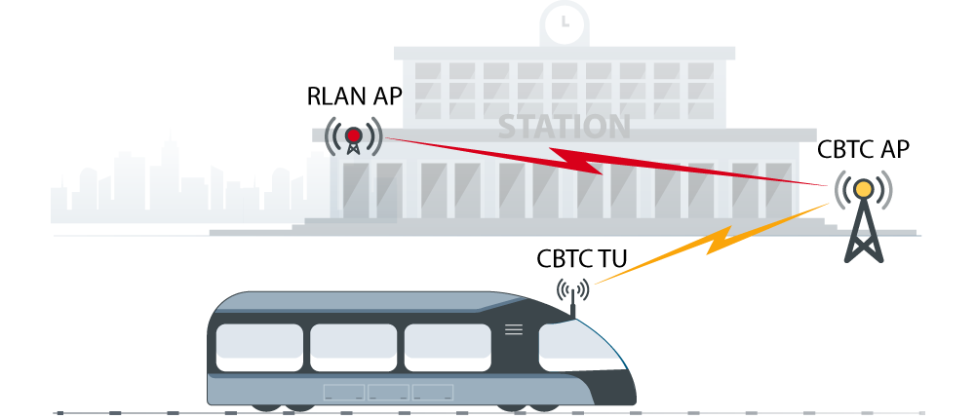
Figure 3 - Scenario A
Scenario B – CBTC TU vs. RLAN AP close to track
This scenario studies the impact on a CBTC TU from the transmissions of an RLAN AP located close to the track, such that:
- Height of the RLAN AP antenna is equal to the height of the CBTC TU antenna: h=0
- Separation is at least s=7 m, i.e. the RLAN AP is outside of the CBTC protected area.
The scenario is applicable only in the elevated/outside systems. The scenario is illustrated in Figure 4.
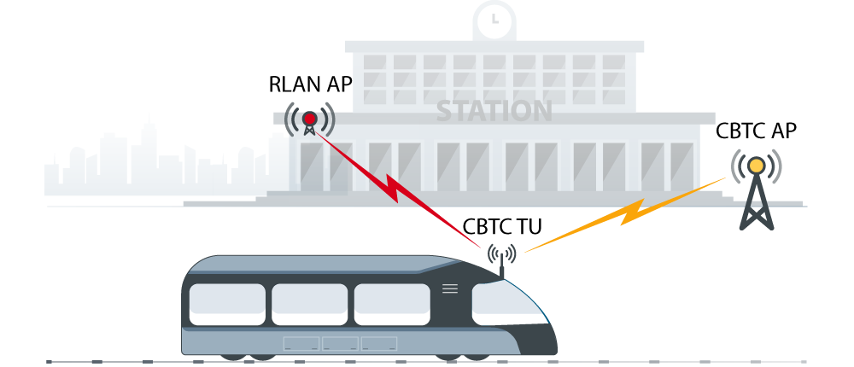
Figure 4 - Scenario B
Scenario C – CBTC AP vs. RLAN mobile inside train
This scenario studies the impact on a CBTC AP from the transmissions of an RLAN mobile device inside a train, just behind the windscreen of the train, due to the following scenario: a passenger is using his mobile phone as a WiFi hotspot to provide Internet connectivity to his computer.
- The height of the RLAN mobile device antenna is 3 meters less than the height of the CBTC AP antenna: h=3
- Separation is s=2 m
The scenario is applicable for elevated/outside stations as well as underground stations such as the Nørreport Station in Copenhagen. The scenario is illustrated in Figure 5.
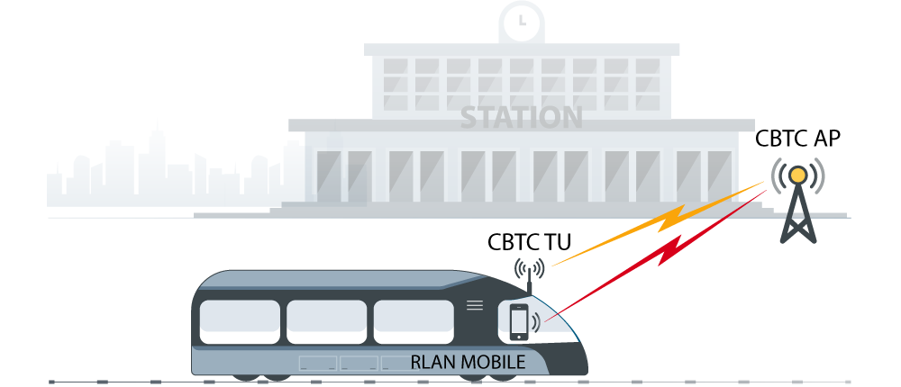
Figure 5 - Scenario C
Scenario D – CBTC TU vs. RLAN mobile inside train
This scenario studies the impact on a CBTC TU from the transmissions of an RLAN mobile device inside another train on the same track, just behind the windscreen of that train, due to the following scenario: a passenger is using his mobile phone as a WiFi hotspot to provide Internet connectivity to his computer.
- The height of the RLAN mobile device antenna is 1 meter less than the height of the CBTC TU antenna: h=1
- Separation is s=0 m
The scenario is applicable for elevated/outside stations as well as underground stations such as the Nørreport Station in Copenhagen. The scenario is illustrated in Figure 6.
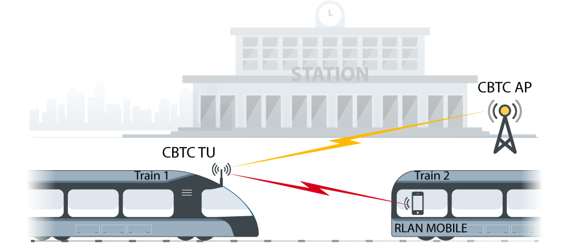
Figure 6 - Scenario D
Scenario E – CBTC AP vs. RLAN mobile on platform
This scenario studies the impact on a CBTC AP from the transmissions of an RLAN mobile device on the platform, due to the following scenario: a passenger or a staff member on the platform is either using his mobile phone to connect to a public WiFi AP at (or close to) the station or using it as a WiFi hotspot to provide Internet connectivity to his computer:
- The height of the RLAN mobile device antenna is 2 meters less than the height of the CBTC AP antenna: h=2
- Separation is s=2 m
The scenario is applicable for elevated/outside stations as well as underground stations such as the Nørreport Station in Copenhagen. The scenario is illustrated in Figure 7.
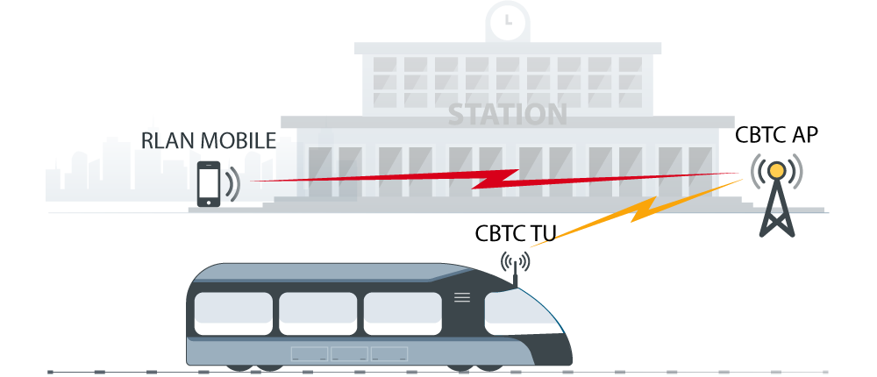
Figure 7 - Scenario E
Scenario F – CBTC TU vs. RLAN mobile on platform
This scenario studies the impact on a CBTC TU from the transmissions of an RLAN mobile device on the platform, due to the following scenario: a passenger or a staff member on the platform is either using his mobile phone to connect to a public WiFi AP at (or close to) the station or using it as a WiFi hotspot to provide Internet connectivity to his computer:
- The height of the RLAN mobile device antenna is 1 meter less than the height of the CBTC TU antenna: h=1
- Separation is s=4 m
The scenario is applicable for both elevated/outside and underground systems. The scenario is illustrated in Figure 8.
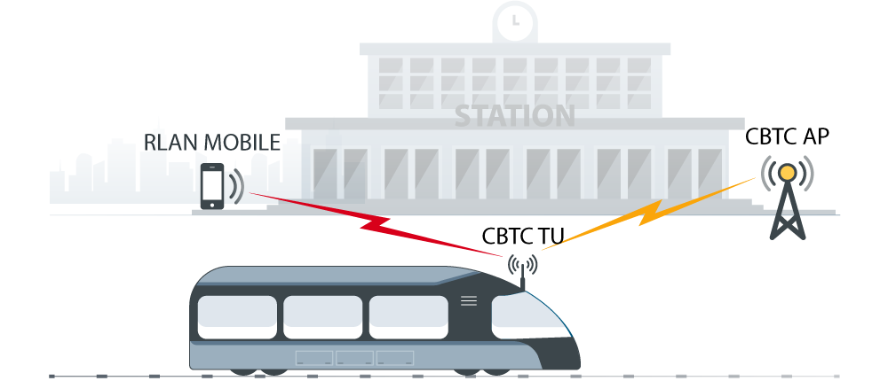
Figure 8 - Scenario F

Results and Discussion
Figure 9 presents the results for the above described six scenarios. The x-axis shows the distance of the RLAN interferer from the CBTC receiver, i.e. “d” in Figure 2. The y-axis shows the received interfering signal power form an RLAN device.
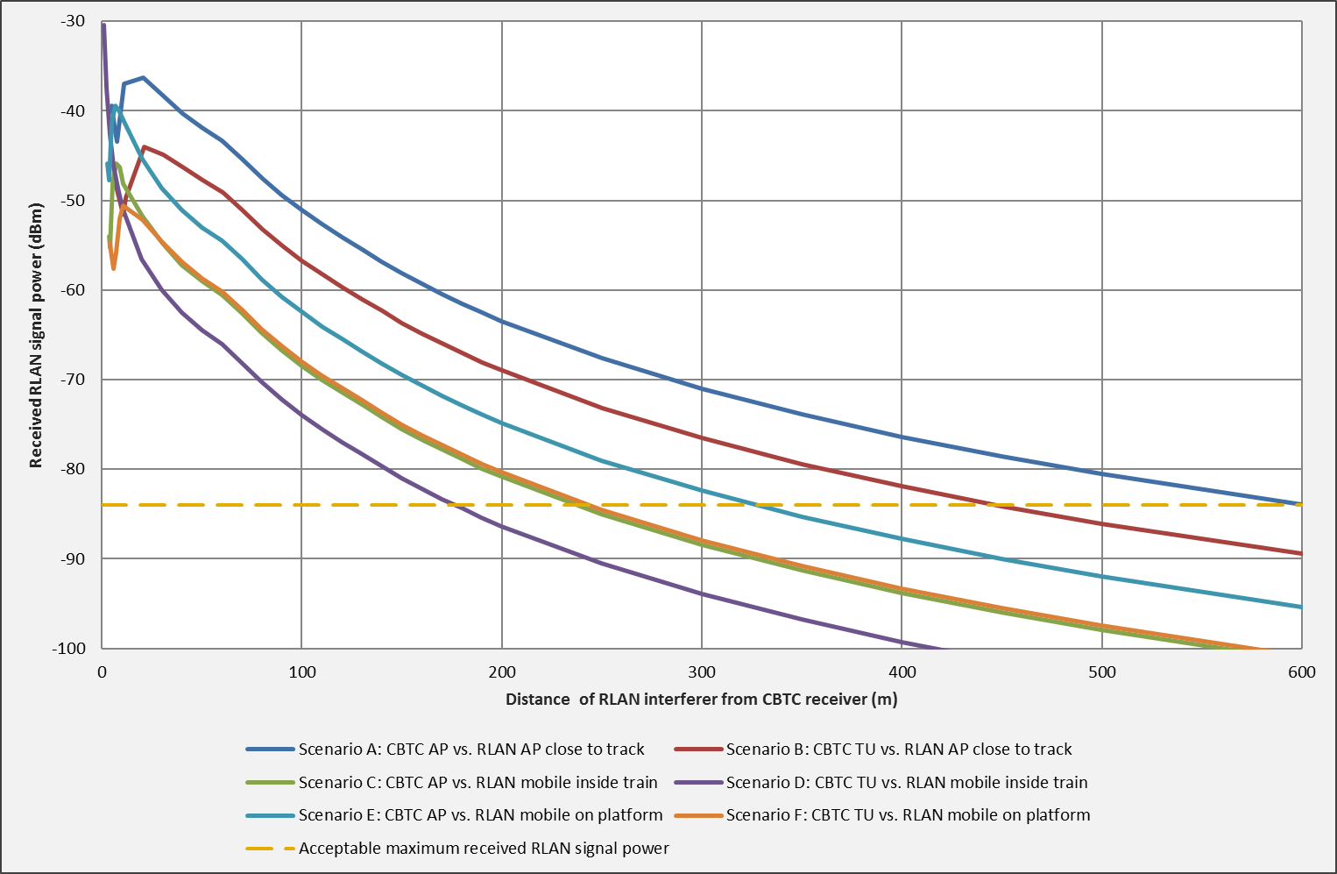
Figure 9 - Interference from RLAN
According to the radio coverage data collected from a train in the S-bane CBTC system, the average signal power received is -75 dBm. The train in this case ran on the EDP (Early Deployment Phase) line, from Jægersborg station to Hillerød Station, over a distance of 24 kilometers, and connected to 36 APs.
To receive a packet without errors, the desired signal (i.e. CBTC signal) must be received with a power significantly higher than the interfering signal (i.e. RLAN signal). In other words, a certain signal-to-noise ratio must be guaranteed (note that a more accurate term in this case is “carrier to interference plus noise ratio C/(N+I)”). CEPT refers to this ratio as Protection Ratio (PR) [3], and its value has been defined to be 9 dB for CBTC systems [2] (Section 11.1.4). This implies that the power of the CBTC signal must be 9 dB above the power of the RLAN signal. Since the power of the CBTC signal is known in this case (i.e. -75 dBm), it means the power of the RLAN signal must be at least 9 dB less than -75 dBm. In other words, the power of the RLAN signal must be equal or less than $-75 dBm-9 dB = -84 dBm$. The horizontal yellow line in Figure 9 represents this value. Specifically, the received power from an RLAN interferer must be below this line to enable the CBTC receiver to correctly demodulate the signal. In short, anything in Figure 9 shown above this line is bad.
Figure 9 shows that for Scenario B, the RLAN AP must be at least 450 meters away from the CBTC receiver in order not to interfere with it. Recall that in this scenario, the interferer is an RLAN AP close to the track and the receiver is a CBTC train (TU). In other words, the results show that if the RLAN AP is located within the 450 meters proximity of the CBTC TU, the CBTC TU will not be successfully able to receive the signal from a CBTC AP, i.e. the signal will not meet the signal-to-noise ratio requirement.
The results show further that the highest interference is received in the case of Scenario A. Recall that in Scenario A, the interferer is an RLAN AP close to the track and the receiver is a CBTC AP. The results show that the RLAN AP in this case must be 600 meters away from the CBTC AP for the CBTC AP to successfully receive the signal from the CBTC TU.
For Scenario C and Scenario F, the RLAN interferer must be 250 meters away from the CBTC receiver to achieve the required signal-to-noise ratio. Recall that in Scenario C, the interferer is an RLAN mobile device inside the train and the receiver is a CBTC AP. In Scenario F, the interferer is an RLAN mobile device on the platform and the receiver is a CBTC TU.
The results show that Scenario D is the most favourable scenario as it causes the least interference. Recall that in this scenario, the receiver is a CBTC TU and the interferer is an RLAN mobile device inside another train. The main reason why the RLAN mobile device could not have a critical impact on the CBTC TU is that its signal must penetrate through the body of two trains, causing certain loss to the signal power. Nonetheless, the results show that the RLAN mobile device must still be approximately 180 meters away from the CBTC TU in the first train for the CBTC TU to successfully receive a signal from a CBTC AP.
The required distances seen in Figure 9 have been summarized in Table 7. In the event that CBTC and RLAN have to share the same frequency band, it will not be possible to guarantee that no RLAN device will be present inside these distances from the S-bane system. Thus, it can be concluded that RLAN will have a critically negative impact on the CBTC operation.

Scenario | Distance (m)
A | 600
B | 450
C | 250
D | 180
E | 190
F | 250
Table 7 - Required minimum distance between CBTC receiver and RLAN interferer
Note if the signal-to-noise ratio requirement is not met, the CBTC receiver will receive a packet with errors and thus will discard it. As discussed in Section 1, a lack of communication between the train and the wayside for more than 1 second is considered unacceptable, and consequently, the train stops automatically. In other words, it means that it will only take an RLAN device interfere—with a certain impact—with a given CBTC receiver continuously for 1 second for the train to stop automatically.
As discussed above, the amount of interference will depend on the number of RLAN devices in the proximity and the data traffic characteristics of the applications used by them. Nonetheless, the case of a malicious “jammer” RLAN device will be of a particular concern. Jamming is a deliberate attempt of sabotaging a radio communication system by e.g. producing excessive interference. Today, such activities are deemed illegal due to the use of the licensed band by S-bane. However, once this band becomes license-free, it will become increasingly hard to identify and control such activities. As an example, in Siemens’ CBTC systems deployed in China where the 2.4 GHz license-free band is used, a large number of incidents involving trains stopping due to radio interference has been recorded.

Conclusion
This report presents the results from a study investigating the impact of RLAN devices co-existing in the same frequency band as the Copenhagen S-bane CBTC system. Six worst-case scenarios are considered where the RLAN device is either functioning as a RLAN AP or an RLAN mobile device, located in the close proximity of the train, e.g. a train station, or inside the train. The study investigates whether a CBTC receiver, e.g. onboard a train, will be able to receive signals from a CBTC sender, e.g. a CBTC AP, with an acceptable signal-to-noise ratio in the presence of interference from an RLAN device. The distance of the RLAN device from the CBTC receiver is then increased incrementally. The objective is to identify the minimum distance between the two devices required for the CBTC system to function normally.
The results show that the interference produced by the RLAN device is above the maximum acceptable threshold, which results in a significantly low signal-to-noise ratio at the CBTC receiver. In real life, this will lead to a large number of errors in the data (i.e. packets) received by the CBTC receiver, and as a result, the packets will have to be discarded.
The results present the required minimum distance between the RLAN device and CBTC receiver to avoid the interference from the RLAN device. This distance ranges from the 180 meters for Scenario D (minimum) to 600 meters for Scenario A (maximum). If S-bane and RLAN share the same frequency band eventually, it will not be feasible to reasonably assume that no RLAN devices will be present within these distances.
In the S-bane CBTC system, the train and the wayside must communicate with each other continuously using radio communication to share train control information. An interruption of more than 1 second in this communication between the train and the wayside is not acceptable, and eventually the train stops automatically—by applying emergency brakes—for safety reasons. Specifically, this means if an RLAN device continuously interferes with a given CBTC receiver for 1 seconds, the train will stop.
It is therefore concluded that RLAN will have a critical impact on the operation of the S-bane CBTC system. As mitigation, the design of the radio communication system, both for wayside and onboard, will have to be updated. The activities will involve one or more of the following: performing the link budget calculation and radio coverage survey again, installing additional APs at the wayside, and, updating the radio equipment—including radio cards and antennas—as well as the radio communication software.

References
[1] IEEE 802.11-2012 Part 11: Wireless LAN Medium Access Control (MAC) and Physical Layer (PHY) Specifications
[2] ECC Draft Report [RLAN6], Sharing and compatibility studies related to Wireless Access Systems including Radio Local Area Networks (WAS/RLAN) in the frequency band 5 925 – 6 425 MHz, Draft updated on 9 October 2018
[3] ECC Report 252, SEAMCAT Handbook Edition 2
[4] ERC Report 101, A Comparison of the Minimum Coupling Loss method, Enhanced Minimum Coupling Loss method, and the Monte-Carlo Simulation
[5] ETSI TR 103 111: SRdoc: Spectrum requirements for Urban Rail Systems in the 5,9 GHz range
[6] J. Farooq. “Performance Analysis and Evaluation of Advanced Designs for Radio Communication Systems for Communications-Based Train Control (CBTC)”. PhD thesis. Department of Photonics Engineering, Technical University of Denmark, 2017.
[7] SE45(18)0XX, Impact of RLAN on CBTC in the band 5915-5935MHz, Siemens Mobility, France
[8] ECC Report 244, Compatibility studies related to RLANs in the 5725-5925 MHz band
[9] SE45(18)074R1, RLAN @ 6GHz vs CBTC, an MCL approach
[10] ETSI TR 103 442, Railways Telecommunications (RT); Shared use of spectrum between Communication Based Train Control (CBTC) and ITS applications
[11] IEEE 1474.1, Standard for Communications-Based Train Control (CBTC) Performance and Functional Requirements

