|  |  |  |
| --- | --- | --- |
| WGSE PT45 meeting | | Doc. SE45(19)010 |
|  | | |
| Rome, Italy, 23–24 September 2019 | | |
|  | | |
| Date issued: | 12/09/2019 | |
| Source: | France | |
| Subject: | Fixed service protection criterion based on performance degradation | |
| Group membership required to read? (Y/N)  N | | |
|  | | |
| Summary: | | |
| WGFM sent a LS to WGSE requesting complementary studies to assist WGFM and FM57 in the process of developing CEPT Report B regarding WAS/RLANs in the 6 GHz band. Specifically, WG FM kindly asks WG SE to complement the existing studies of ECC Report 302 as appropriate, related to the results so far for the FS short-term protection studies between point-to-point applications and WAS/RLAN indoor only deployments. | | |
| Proposal: | | |
| Invites Group to  Consider the following elements for discussion when addressing FS link budget margins.  Invite the RLAN industry to provide the required parameters in order to continue developing simulations;  Follow the work carried out by SE19 on short term interference criterion. | | |
| Background: | | |
| ECC Report 302, SE45(19)005 (LS from WGFM to WGSE), SE19 work on short term criterion. | | |

# Introduction

Through Doc. SE45(19)005, WG FM asks WG SE to complement the existing studies of ECC Report 302 as appropriate, related to the results so far for the FS short-term protection studies between point-to-point applications and WAS/RLAN indoor only deployments. This paper contains some elements to be discussed by the group with regards to an alternative approach to be adopted to assess the short term criterion.

# C/N degradation due to fading and interference without ATPC

In the following, all lower cases *(c,n, ...)* denote linear values wheras capital letters *(C,N, ...)* denote values in dB.

Let consider the following events :

1. In the absence of any fading or interference effect, the signal to noise ratio is $SNR_{0}=c/n$. Where *c* denotes the carrier level and *n* denotes the noise floor.
2. If the carrier suffers from fading effects, the SNR can be written as $SNR_{F}=\frac{c/f}{n}$. Where *f*  denotes the fading effect.
3. Finally, in the presence of an interferer and fading effect, the SNR will be $SNR_{F+I}=\frac{c/f}{n+i}.$ Where *i* denotes the interference in linear.

The degradation in terms of SNR between the case 1 (absence of any fading and interference) and case 2 (fading effet only) is thus computed as being :

$Δ\frac{c}{n}=\frac{SNR_{F}}{SNR_{0}}=\frac{c}{n}\frac{n}{c/f}=f;$ in linear and in dB it would be

$Δ\frac{C}{N}=F$ in dB.

The overall SNR degradation between the case 1 and the case 3 (presence of fading and interference) is:

$Δ\frac{c}{n}=\frac{SNR_{F+I}}{SNR_{0}}=\frac{c}{n}\frac{n+i}{c/f}=f\frac{n+i}{n}$ in linear. In dB, the degradation is

$Δ\frac{C}{N}=F+10*\log{(1+{10}^{0.1\frac{I}{N}})}$.

It should be noted that in the above equations *F* and *I* are random variables, and functions of time. Thus, the distribution function of $Δ\frac{C}{N}$, given fading and interference effect, will be a convolution of the distributions of these two variables. The second term $10*\log{(1+{10}^{0.1\frac{I}{N}})}$ represents the interference contribution to the link degradation.

At frequencies below 17 GHz, the fading is dominated by multipath effect. When designing the FS link, a fade margin is introduced to compensate these fading effects, and thus the link is ”*unavailable*” when the SNR degradation consumes the fade margin.

As a consequence, and given that fading depth on the FS link and interference vary with time, the probability that interference affects the FS link performance objectives at any given time *t*, is the probability of the cumulative effect of the link attenuations due to degradation caused by interference and fading being higher than the FS link available margin (FFM for Flat fade Margin), as expressed in the following equation:

$$P_{out}=P\left(F(t)+10*\log\left(1+{10}^{0.1\frac{I\left(t\right)}{N}}\right)>FFM\right)$$

# C/N degradation due to fading and interference with ATPC

As described in the literature, at any given time, transmit power control can be modelled as an additional gain applied to the desired signal with a dependence on the attenuation as follows[1] :



Where :

ATPC is the ATPC value applied to the desired signal, at any given time (dB)

*F* is the fading depth on the FS link in absence of interference (using Recommendation ITU-R P.530-17) at any given (dB)

*ATPCrange* is the ATPC range (dB)

*ATPCthreshold* is the ATPC threshold, corresponding to the fade level at which ATPC starts to be active (dB)

The effect of APTC, function of the FS link fading depth is represented below:

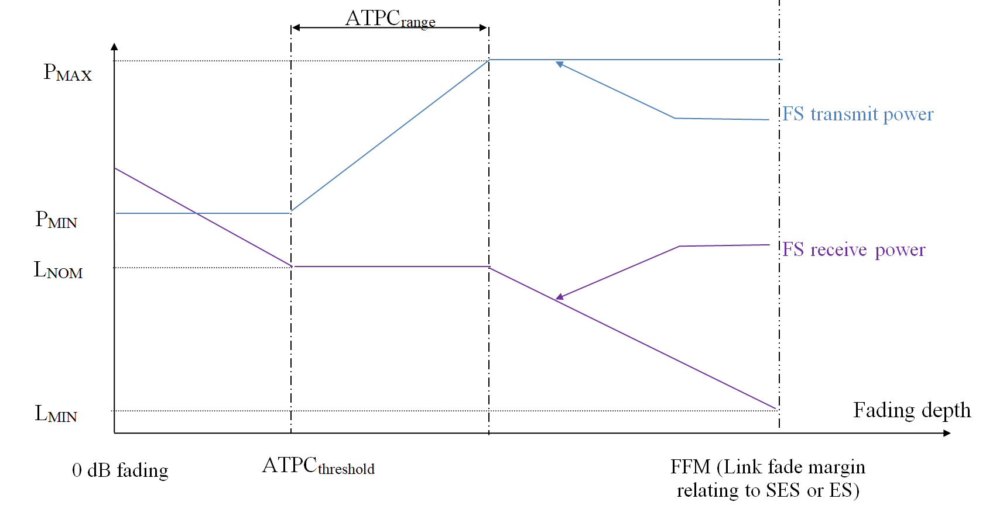

As a consequence, if ATPC is to be used on a FS link, then improvement of the FS link performance due to ATPC can be assessed from its performance in absence of ATPC using the following formula :

${∆\frac{C}{N}}_{ATPC}=10log\left(\frac{c}{n}.\frac{n}{c.atpc}\right)=-10.log\left(atpc\right)=-ATPC$

Note that this formula is a function of time as the ATPC value applied to the desired FS signal is function of the FS link fading depth which also varies with time.

Thus, taking into account the ATPC, the overall degradation on the FS link when taking into account fading and interference will be:

$$∆\frac{C}{N}=10log\left(1+{10}^{0.1(I/{N)}}\right)+F-ATPC$$

Combining equations above equations leads to:



Where $Δ\frac{C}{N_{I}}$ stands for the degradation due to interference effect only, meaning $Δ\frac{C}{N_{I}}=10log\left(1+{10}^{0.1(I/{N)}}\right).$ It is important to note that $\frac{N+I}{N}$ can be approximated by $\frac{I}{N}$ for high values of interference. The curve below shows the relation betwenn both values. It is clear that there is a linear part in the curve with a slope equals to one.

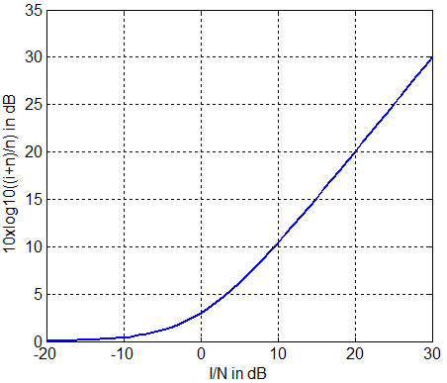

ATPC value and interference vary with time, therefore, the probability that interference affects the FS link performance objectives (i.e. increase of ES or SES compared to the ones without interference) at any given time t, is the probability of the cumulative effect of the link attenuations due to degradation caused by interference (${∆\frac{C}{N}}_{I})$, fadings due to propagation (F) and compensation by ATPC contribution being higher than the FS link available margin FFM, as expressed in the following equation:

$P_{out }=P\left(F\left(t\right)+{∆\frac{C}{N}}_{I}\left(t\right)-ATPC\left(t\right)>FFM\right)$

# Degradation of performance

The degradation of performance DP (%) of the total link objective (%) due to interference can then be derived as follows:

$DP =\frac{P_{2}-P_{1}}{P_{1}}×100$

Where the two probabilities P1 and P2 are defined as:

**In the absence of ATPC, we have:**

* P1 is the outage probability in presence of fading only:
* P2 is the outage probability in presence of both fading and interference as expressed above:

$P_{2}=P_{out}=P\left(F(t)+10*\log\left(1+{10}^{0.1\frac{I\left(t\right)}{N}}\right)>FFM\right)$.

**And in the presence of ATPC:**

$P_{1}=P\left(F\left(t\right)-ATPC(t)>FFM\right)$

$P_{2}=P\left(F\left(t\right)+{∆\frac{C}{N}}_{I}(t)-ATPC(t)>FFM\right)$

# Typical Degradation performance value used in ITU-R Recommandation

The typical degradation value used in ITU-R recommendations is $DP=10\%$. (Rec. ITU-R F.1494, Rec. ITU-R S.1323-2).

In other words, the contribution of the interference should not exceed 10% of the overall degradation. For example, if a link is designed for 99,99% time availability (meaning 0.01% unavailability) this would corresponds to a fraction 0,001% of the time due to interference. This only stands without ATPC being used.

**In the case without ATPC**

We have

$\operatorname{Pr}\left(Δ\frac{C}{N}≥FFM\right)=1.1 Pr\left(F≥FFM\right)$

This implies:

$\int_{FFM}^{∞}{(\int_{0}^{∞}{p_{F}\left(f\right).p_{\frac{ΔC}{N_{I}}}(x-f)}df)dx}={1.1 \int_{FFM}^{+∞}{p_{F}\left(f\right)df}}$

It is clear from the equation above, that the assessment of performance degradation requires knowledge of the interference distribution, and determining this distribution is not at all obvious.

However, in many ITU-R recommendations such as the F.1108, which develops the FDP, the knowledge of the interference distribution is fundamental even if this latter is the unknown to look for.

**Case with ATPC**

In this case, the total C/N degradation becomes $Δ\frac{C}{N}=Δ{\frac{C}{N}}_{I}+F-ATPC$. Given the dependency between fading and ATPC, the probability of reaching the FFM is:

$$\operatorname{Pr}\left(Δ\frac{C}{N}=FFM\right)=\operatorname{Pr}\left(Δ{\frac{C}{N}}_{I}+F-ATPC=FFM\right)=\int_{0}^{+∞}{p_{F-ATPC}\left(f\right)×p_{Δ{\frac{C}{N}}_{I}}(FFM-f)df}$$

Likewise the case without ATPC, the allowable performance degradation in term of C/N is defined such that "the probability of exceeding the threshold (FFM) in the presence of interference is 10% more than the probability of exceeding the threshold without interference" which is expressed in the case of by:

$$\operatorname{Pr}\left(Δ\frac{C}{N}≥FFM\right)=1.1 Pr\left(F-ATPC≥FFM\right)$$

# Relationaship between ATPC aparemeters and Short term criterion

For a given short term criteria, the link should have enough margin to compensate the effects of interference (short term) and the maximum fading value that can be rewarded by the ATPC:

$ATPC_{threshold}+ATPC_{margin}+\frac{I}{N_{short}}<FFM$ leading to

$$ATPC_{threshold}<FFM-ATPC_{margin}-\frac{I}{N_{short}}$$

Where we made the assumption that the interference degradation can be approximated to I/N.

This formula expresses that if you have ATPC which is designed in such a way that you do not have sufficient margin against your short term interference criteria with low level fading, then the time for which fading and interference are above FFM will obviously be above the time associated with your short term interference (ie 10% of the time unavailability without interference).

# Elements and methodlogy for simulations

## Methodlogy

The main objective is to be able to obtain CDF curves for the events ”fading” and ”interference plus fading”. This could be obtained as follows:

1. Using the fixed service link generate the fading pdf. The fading CDF is also required, as it will allow to obtain $P_{1}$;
2. Using the RLAN parameters (power, density, ...), perform a Monte-Carlo simulation that will allow to generate a set of Interference values being the aggregate interference computed at the FS receiver;
3. Convolute the fading pdf and the $10*\log{(1+{10}^{0.1\frac{I}{N}})}$ pdf to obtain $P_{2}=P_{out}.$
4. Deduce the DP and verify that the DP is less than 10%.

Generate interference pdf

Generate fading depth pdf

Convolution

Deduce the overall degradation pdf

Deduce the CDF and compute P1

Deduce the CDF and compute P2

Deduce the Performance Degradation in %

## fading depth

At 6 GHz the fading is mainly due to multipath. Recommendation ITU-R P.530-17 details in section 2.3 the fading due to multipath and related mechanism. As explained in this recommendation, the multipath fading is expressed as a function of the ”*multipath occurrence factor*” denoted $p_{0}$. With $p_{0}$ as a paramareter, the figure bellow gives a family of curves provideing a graphical representation of the method detailed in Recommendation ITU-R P.530-17 and depicted in Figure 1.

For example, for the link 2 studied in ECC Report 302, the multipath occurrence factor is computed using equation (10), section 2.3.2 of Rec. ITU-R P.530-7.

In this specific case the obtained value is $P_{0}= 2.2913$ (dashed red line in Figure 1).

|  |  |  |  |  |  |  |  |  |  |  |  |
| --- | --- | --- | --- | --- | --- | --- | --- | --- | --- | --- | --- |
|  | Station A | | | | | Station B | | | | | Length (km) |
| Parameter | **Lat°** | **Long°** | **h(m)** | **Ele°** | **Az°** | **Lat°** | **Long°** | **h(m)** | **Ele°** | **Az°** |  |
| Link 2 (Dijon) | 47,322 | 5,063 | 22 | 0,3 | 206,5 | 47,136 | 4,926 | 26,5 | -0,3 | 26,5 | 23,2 |



Figure 1 Percentage of time that the fade depth is exceeded in average worst month, p_0 as a parameter

In the example above (p0=2.2913), if the desired unavailability of the link is 4.5*10^-4% (99,9995 % of availability), than the security fade margin should be at least equal to 37.07 dB.

## Interference events

The aggregate interference events sould be computed and simulated using the methodoly described and agreed in ECC report 302. However, to do so, SE45 still need to define and agree on few parameters that are not clear for the case of outdoor portable devices. These paremeters are :

* RLAN power levels and their distribution (% of use);
* Typical duty cycle for this kind of use;
* Percentage of outdoor portable device among the 6 GHz capable device (so called market adoption factor in ECC report 302).

# Examples on the ATPC parameters and short term criterion

In the example above, for p0=2.2913, if we want a link with a 4.5*10^-4% unavailabality, the FFM should be FFM=37.07dB. The I/N for short term criterion known is 19dB. In the table below, we show an exmaple of values that the ATPC parameters should fulfill to allow the link to stay available for the percentage of time required. This leads to:

|  |  |
| --- | --- |
|  | Scenario |
| FFM (dB) | 37.07 |
| ATPC Threshold | **10.07** |
| ATPC Range | **8** |
| I/N Short for 4.5*10^-3% of the time | ***19*** |

# Conclusion

In this contribution, we presented a methodology to deduce if an interferer leads to an EPO degradation greater than 10% which is the total EPO degradation allowable to total interference. In order to materialize it, SE45 still needs some outdoor portable device parameters required for the simulations.

This methodology is to be conducted complementary to the short term approach on which SE19 is working on parallel on the definition of the short term protection criterion.

1. Other types of ATPC systems are activated when the level of received signal over noise plus interference degradation is higher than a threshold value. There are not considered here as these type of systems are less susceptible to inference than the one described here