|  |  |
| --- | --- |
|  | **Doc. SE7(18)018** |
| PT SE7 Meeting20-22 February 2018ECO, COPENHAGEN | |
| Date issued: 13th February 2018Source: 450connect, Germany, Georg Fischer; Friedrich-Alexander University Erlangen-Nuremberg (FAU) **Subject: Validation of the SEAMCAT-Plug-in for IM simulations** | |

N

Password protection required? (Y/N)

|  |
| --- |
| **Summary**  The validation of the current alorithm used in the SEAMCAT Plug-in for simulations of the interference by BS broadband signals due to IM distortion in NB MS receivers fails because of missing convergence. The algorithm implemented in the current Plug-in calculates IM power based on slicing of the broadband signal. This contribution shows that it provides divergent results for the same signals if they are split into slices of different size and proposes an alternative alorithm. |
| **Proposal**  Because of the divergence shown in this contribution we must conclude that the current SEAMCAT plug-in is based on an incorrect algorithm and cannot be used for the simulation of interference probability due to IMD. A modified SEAMCAT Plug-in can be developed based on piecewise linear approximation of the spectral regrowth as described in the contribution SE(17)097A1R2. That contribution proposed a piecewise linear approximation of IM power in the frequency domain which can be used in the SEAMCAT plug-in. The accuracy of this approach is proven by comparing the outcomes with rigorous results calculated in the time domain. It is proposed to send this piecewise linear approximation algorithm to STG in order to be implemented on the short term as a modified SEAMCAT IMD3 plugin. |
| **Background**  In order to be able to calculate the intermodulation interference probability due to LTE BS signals in non-linear narrowband MS receivers, a commonly accepted and validated tool is required. An interim solution based on the existing contribution can be developed and used for the current SE7 compatibility studies. This solution is limited to LTE broadband signals and cannot deal with signals that undergo a pre-selection filter of a general frequency response. Hence, we recommend that SE7 develops in a later stage a more refined algorithm for future SEAMCAT simulations of IMD. |

# Introduction

FAU and 450connect have been considering the theoretical foundations of the SEAMCAT IMD3 Plugin for deriving the Intermodulation distortion in receivers.

As SEAMCAT is a tool working in the frequency domain, it is highly desirable to have an algorithm that allows for the computation of IM products solely in the frequency domain. However, we have to recognise that nonlinearity is best described by a nonlinear transfer function in the time domain. Since the Fourier transformation is a linear transformation, it is not straightforward to transform the non-linear behaviour of the receiver from the time domain into the frequency domain.

For any IMD3 Plugin, outage calculations can be meaningful only if the results converge. That is to say, if we slice a broadband signal finer and finer, the computed IM power needs to converge to a stable value. However, the way the algorithm is currently defined does not lead to convergence.

# Justification

The observation that the current algorithm does not lead to convergent results, can be demonstrated by some straightforward sample calculations.

Consider two strong narrowband signals of equal strength. By applying IP3 formulas, one can estimate the IM power, say Poriginal

Now suppose that each of the two narrowband signals is divided into 10 equal slices, as a result of which the power of each slice is 10 dB lower than each of the original narrowband signals. Since IM distortion power decreases 3 dB per 1 dB, this 10 dB less power would deliver 30 dB less IM power produced by each slice combination. On the other hand, if we combine 10 times 10 slices, we get 100 combinations. Adding up their partial IM products would give us a 100 fold increase in power, which equates to 20 dB. Hence, it can be concluded that the IM prediction would overall be 10 dB less (-30+20=-10 dB) than Poriginal.

Note that as the two strong narrowband signals are narrow, even the spectral widening would ensure all IM products to fall within the receiver bandwidth of a victim receiver.

If we continue to split the original narrow band signals, this time into 100 slices each, we would have 20 dB less power in each slice, leading to an IM reduction of 60 dB. Now we have (100 x 100) = 10,000 combinations of slices leading to 40 dB increase when adding up all thecontributions as the current SEAMCAT Plug-in does. This leads to: -60+40=-20 dB compared to Poriginal. This is 20dB overall reduction of IMD power only because of the choice for a different slice bandwidth.

From these two steps it is clear that the algorithm does not converge: the narrower the slices, the lower the calculated IMD will be. Therefore the results of the current SEAMCAT plug-in are not valid.

Furthermore, it is crucial for any algorithm working in the frequency domain to provide approximately similar results of average IM power level as a rigourous calculation in the time domain. Computation results in both frequency and time domains need to be consistent. This crosscheck is essential to validate the plug-in before it can be released for wide usage.

# The Proposal

Given the shortcomings of the algorithm implemented in the current SEAMCAT IMD3 Plugin and considering that no other algorithm is currently available, we suggest the following:

450connect already provided to STG the contribution on spectral regrowth based on the calculations in the time domain to SE7 in Oct.2017, see SE(17)097A1R2). This contribution shows that the shape of spectral regrowth (IM3 shoulders around a broadband signal) does not vary with the LTE power. Their power level follows the 3-fold law as expected from the Two-Tone tests. A summary of the procedure to be implemented in SEAMCAT is attached to this document as Annex 1.

Furthermore, this contribution demonstrates that a linear piecewise approximation of the shoulder spectra scaled by the actual LTE signal power and IP3 provides accurate results with approximation errors less than 1 dB compared to rigorous time domain computations.

Given the studies provided, we thus have an algorithm that can work solely in the frequency domain. The formulas provided need only to be coded into a new IMD3 Plugin for SEAMCAT.

However, we also recognise that the piecewise approximation algorithm is limited to LTE broadband signals only and cannot deal with signals that undergo a pre-selection filter of a general frequency response. A pre-selection filter in a receiver would typically provide larger attenuation with larger offset leading to a slanted LTE spectrum which cannot be modelled with this algorithm.

Given these facts, a SEMACAT plug-in based on the IMD calculated by piecewise approximation algorithm can be an interim solution for the compatibility studies concerning IM due to LTE in a non-linear narrowband receiver line-up. It is therefore proposed to send this algorithm to STG in order to be implemented on the short term as a modified SEAMCAT IMD3 plugin.

In the longer term, a more generic algorithm is needed in order to deal with arbitrary shaped spectra beside wanted receive signals. Such a more generic algorithm would be able to include the benefits of pre-selection filters, i.e. increasing rejection with increasing frequency offsets.

1. Modelling of Intermodulation (Extract from SE(17)097A1R2).

# Modelling of IMD for SEAMCAT

The target of this section is to generate a simple frequency domain model of the IM3 components, which can be used in SEAMCAT simulations. Therefore, the IM3 generated by a brickwall filtered LTE signal at the input of the TETRA receiver are simulated in the MATLAB model described in the contribution SE(17)097A1R2).

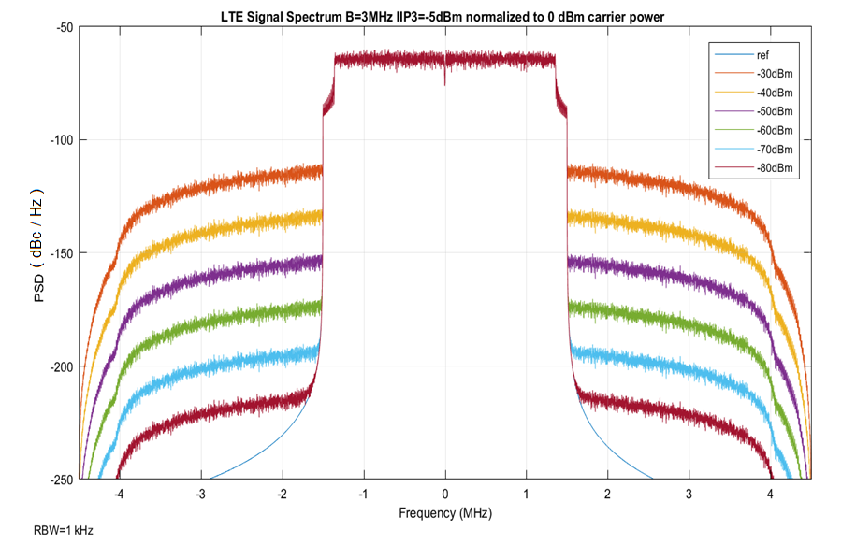

**Figure 1: Power spectral density for 3 MHz channel width at port R for different input powers at port B normalized to a carrier power of 0Bm; IP3=-5dBm. (scaled to dBc/Hz)**

The shape of the power spectral density is not affected by the variation of the power. The power within the shoulder changes by exactly 15dB for a 5dB input power change. Therefore, the nonlinearity operates in the small signal regime. It is assumed that this is valid right up to the 1dB compression point 10 dB below the IIP3. Moreover, the adjacent channel power caused by the 3rd order intermodulation scales ideally with the IIP3. The IM3 power decreases by 2 dB if the IIP3 is increased by 1 dB.

For an LTE signal of -30 dBm a relative power spectral density Sim3,-30=-115.9 dBc/Hz at a frequency offset of 500 kHz (at 2 MHz in the figure) from the channel edge is measured. This gives a total power of -72.9 dBc or -30 dBm – 72.9 dBc = -102.9 dBm in the 20 kHz wide TETRA channel. There are now two ways of reducing this power to an acceptable level:

a) Increasing the IIP3 by 5 dB, which would reduce the power by 10 dB, yielding a total power of -112.9 dBm. Practically speaking this would mean using IIP3 = 0 dBm instead of the IIP3 = -5 dBm assumed in Figure 1. Nowadays, practical designs are at IIP3=+3.5 dBm

b) Introducing selectivity by a tuneable preselector. If the preselector provides 3.3 dB of attenuation, then the intermodulation product goes down 3-fold, thus by 10 dB, delivering again -112.9 dBm.

An attenuation of 3.3 dB is realistic with preselectors, even if they suffer from limited Q. Furthermore it has to be stressed that the attenuation of the LTE signal is not constant. The wideband signal undergoes larger attenuation with larger frequency offset. This also means that the wider the LTE signal is configured the more benefits can be drawn from a preselector filter.



**Figure 2: Piecewise linear frequency domain model of the LTE spectrum**

The reference pointof the PSD in the piecewise linear model of Figure 2 of the PSD can be scaled with respect to the LTE signal power and IIP3:

 eq. (1)

The frequency dependence of the piecewise linear model is given by:

 eq. (2)

with the following parameter set for the 3 MHz LTE channel:

PLTE = -30 dBm

Sim3,-30 = -115.9 dBc/Hz at fref = 2.0 MHz

m1 = -7.6 dB/1.45 MHz = -5,241 dB/MHz m2 = -9.6 dB/0.7 MHz = -13.7 dB/MHz

Please note that the above formulas are describing operation in the ”dB”-domain or ”log”-domain.



**Figure 3: Comparison of the LTE spectrum to a piecewise linear frequency domain model**

In Figure 3 only the IM3 contribution to the ACPR based on above described piecewise linear model is shown. In order to calculate the total ACPR at 500 kHz the TETRA bandwidth of 20kHz and the LTE-OOBE PLTE,spectralmask has to be considered:

 eq. (3)

The above formula is used to generate the table of ACPR values in dBc for a frequency separation of 500 kHz given below:

**Table 1: ACPR at 500kHz offset within the 20 kHz bandwidth of the TETRA RX versus the LTE signal power generated using the piecewise linear model.**

|  |  |  |  |  |
| --- | --- | --- | --- | --- |
| **Modell** | ACPR at 500 kHz offset in 20 kHz bandwidth | | | |
| LTE Power | for LTE OOBE | | for LTE OOBE -25 dB | |
|  | IIP3=-9.5 dBm | IIP3=+3.5 dBm | IIP3=-9.5 dBm | IIP3=+3.5 dBm |
| -200.0 dBm | -51.7 dBc | -51.7 dBc | -76.7 dBc | -76.7 dBc |
| -40.0 dBm | -51.7 dBc | -51.7 dBc | -75.9 dBc | -76.7 dBc |
| -37.5 dBm | -51.6 dBc | -51.7 dBc | -74.6 dBc | -76.6 dBc |
| -35.0 dBm | -51.6 dBc | -51.7 dBc | -72.0 dBc | -76.6 dBc |
| -32.5 dBm | -51.6 dBc | -51.7 dBc | -68.2 dBc | -76.6 dBc |
| -30.0 dBm | -51.4 dBc | -51.7 dBc | -63.7 dBc | -76.5 dBc |
| -27.5 dBm | -50.9 dBc | -51.7 dBc | -58.8 dBc | -76.0 dBc |
| -25.0 dBm | -49.6 dBc | -51.6 dBc | -53.9 dBc | -75.0 dBc |
| -22.5 dBm | -47.0 dBc | -51.6 dBc | -48.9 dBc | -72.7 dBc |
| -20.0 dBm | -43.2 dBc | -51.6 dBc | -43.9 dBc | -69.1 dBc |

The above table provides the total ACPR by summing up the contributions of the direct OOBE Pspectralmask,LTE and the modelled IM3 components SIM3(f)·BTETRA. The values in the table match the MATLAB simulationin the time domain. . The maximum error is less than 1dB for the table above. Therefore, the accuracy should be good enough to support high level SEAMCAT system simulations.

For SEAMCAT simulations the actual unwanted power caused by the LTE signal at the location of the TETRA receiver has to be calculated:

, eq. (4)

or in the “dB”-domain

. eq. (5)

The simple piecewise frequency domain model of IM3 contribution provides a good approximation up to the 1dB compression point. For the implementation into SEAMCAT only the model parameters (SIMR,ref, m1, m2) have to be known and no FFT or IFFT is required.