|  |  |  |
| --- | --- | --- |
|  | | Doc. SE7(18)102 |
| SE7 meeting | | |
| ECO, Copenhagen 21-23 August 2018 | | |
|  | | |
| Date issued: | 28 June 2018 | |
| Source: | FAU (georg.fischer;bernhard.gaede@fau.de); | |
| Subject: | Reference values for RX intermodulation | |
| Group membership required to read? (Y/N)  N | | |
|  | | |
| Summary: | | |
| As part of validation activity of the IM plugin for SEAMCAT, FAU has setup a MATLAB simulation environment to predict spectral regrowth by non-linearity in TETRA RX. The MATLAB script considers an LTE signal at different signal bandwidths, swept at different receive power levels and computes the power falling into a TETRA RX channel at a certain frequency gap from the LTE signal.  The reference values i.e. power falling into TETRA RX channel are provided to facilitate a comparison with values computed by IM plugin.  The reference values provided in the following where verified by different methods and are consistent with earlier results provided by Motorola and by FAU&450connect. They can therefore be regarded as consensus.  The MATLAB script also allows for studying the IM distortion reduction by a preselector and therefore can help in validating the plugin in conjunction with preselector. | | |
| Proposal: | | |
| FAU invites group to  Discuss the validation approach presented in this contribution  Compare results by plugin with the reference figures provided here  Use IM plugin for outage calculations only after consistency with these reference values is confirmed | | |
| Background: | | |
| SE7 actually conducts the activity to validate the SEAMCAT IM plugin for the Monte Carlo studies of IM distortion in narrow band MS receivers, which then will allow for outage analysis.  So far the validity of the plugin code could not be checked. Based on request by FAU the plugin was expanded to facilitate writing of a protocol file that should reflect the spectrum present at the RX and the distortion power falling into TETRA RX channel bandwidth. However there are still problems with file format, which hindered validation of IM plugin. A trend check, in which the IIP3 was set very high, still revealed outage due to IM, which shouldn’t be the case. So inconsistencies are observed, which motivated FAU to provide reference values solely based on MATLAB without involvement of SEAMCAT.  Furthermore the provision of reference values was also requested by STG, so that STG could also conduct validation. | | |

# Overview

SE7 is currently validating IM plugin functionality as it is the basis for outage calculations due to RX intermod. The IM plugin is based on 3-frequency algorithm as depicted in [1]. This algorithm is an approximation working in frequency domain. However, the IM distortion is best described in time domain through a polynomial. Nevertheless, results obtained in frequency domain should be consistent to calculations in time domain. Time domain calculations are e.g. conducted by MATLAB or ADS.

# Method for obtaining reference values.

FAU has followed three different methods for obtaining results on spectral regrowth and especially the reference values indicating the IM power falling into TETRA RX channel.

1. “Brute force” time domain calculation at RF signal
2. Time domain calculation at equivalent baseband representation
3. Analytical approach

After verification of appropriate scaling factors between RF and Baseband all 3 methods delivered consistent results. These were also cross checked with data provided by Motorola [1] and FAU&450connect [2]. All 5 ways of calculation are in line stressing that consensus is reached here.

The analytical approach is very elegant and based on convolution of spectra. It is more versatile than the 3 frequency algorithm actually in use with the IM plugin. FAU will provide another SE7 input paper on the analytical approach as it could even serve for wider use within SEAMCAT and be the basis for a revised plugin. From an engineering perspective whenever possible an analytical approach should be given preference over an approximation if computation time permits. The analytical approach is based on iFFT and Goertzel algorithm which allows for fast computation avoiding the 3 nested loops in todays 3-frequency algorithm.

# Spectral regrowth with RX nonlinearity and no preselector

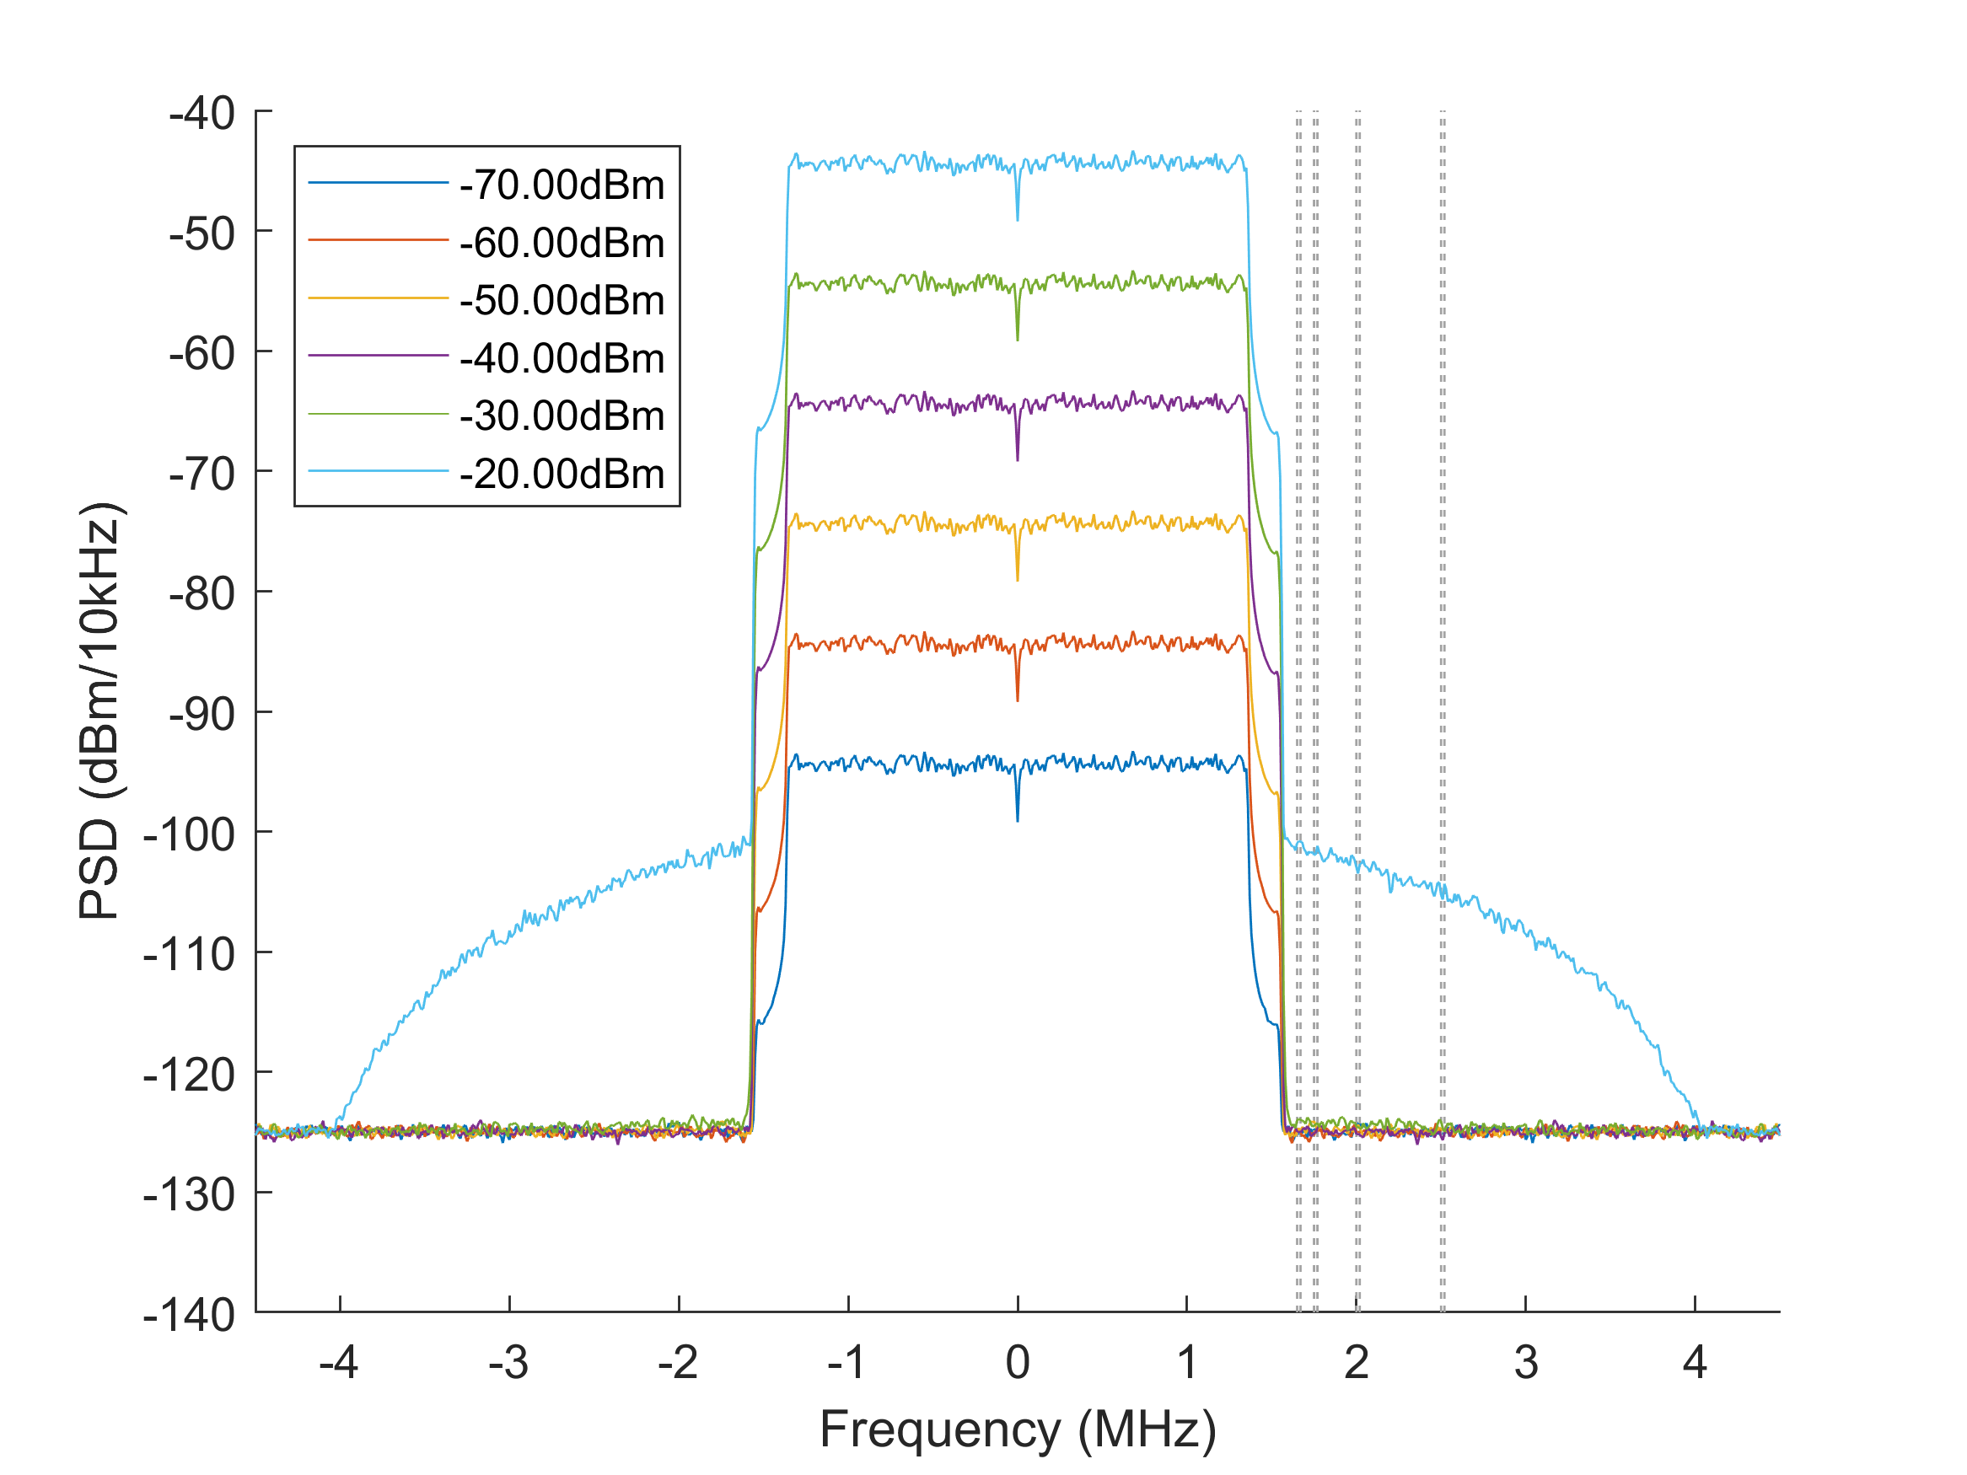

*Fig. 1: Power spectral density at the output port of the nonlinear LNA of the TETRA receiver (IIP3 +8.00dBm) caused by an adjacent LTE cell (BW: 3.0MHz). The thermal noise floor at -174dBm/Hz and a noise figure of 9dB is included. The preselector filter is disabled, the simulated spectral gaps are [150.0kHz 250.0kHz 500.0kHz 1000.0kHz].*

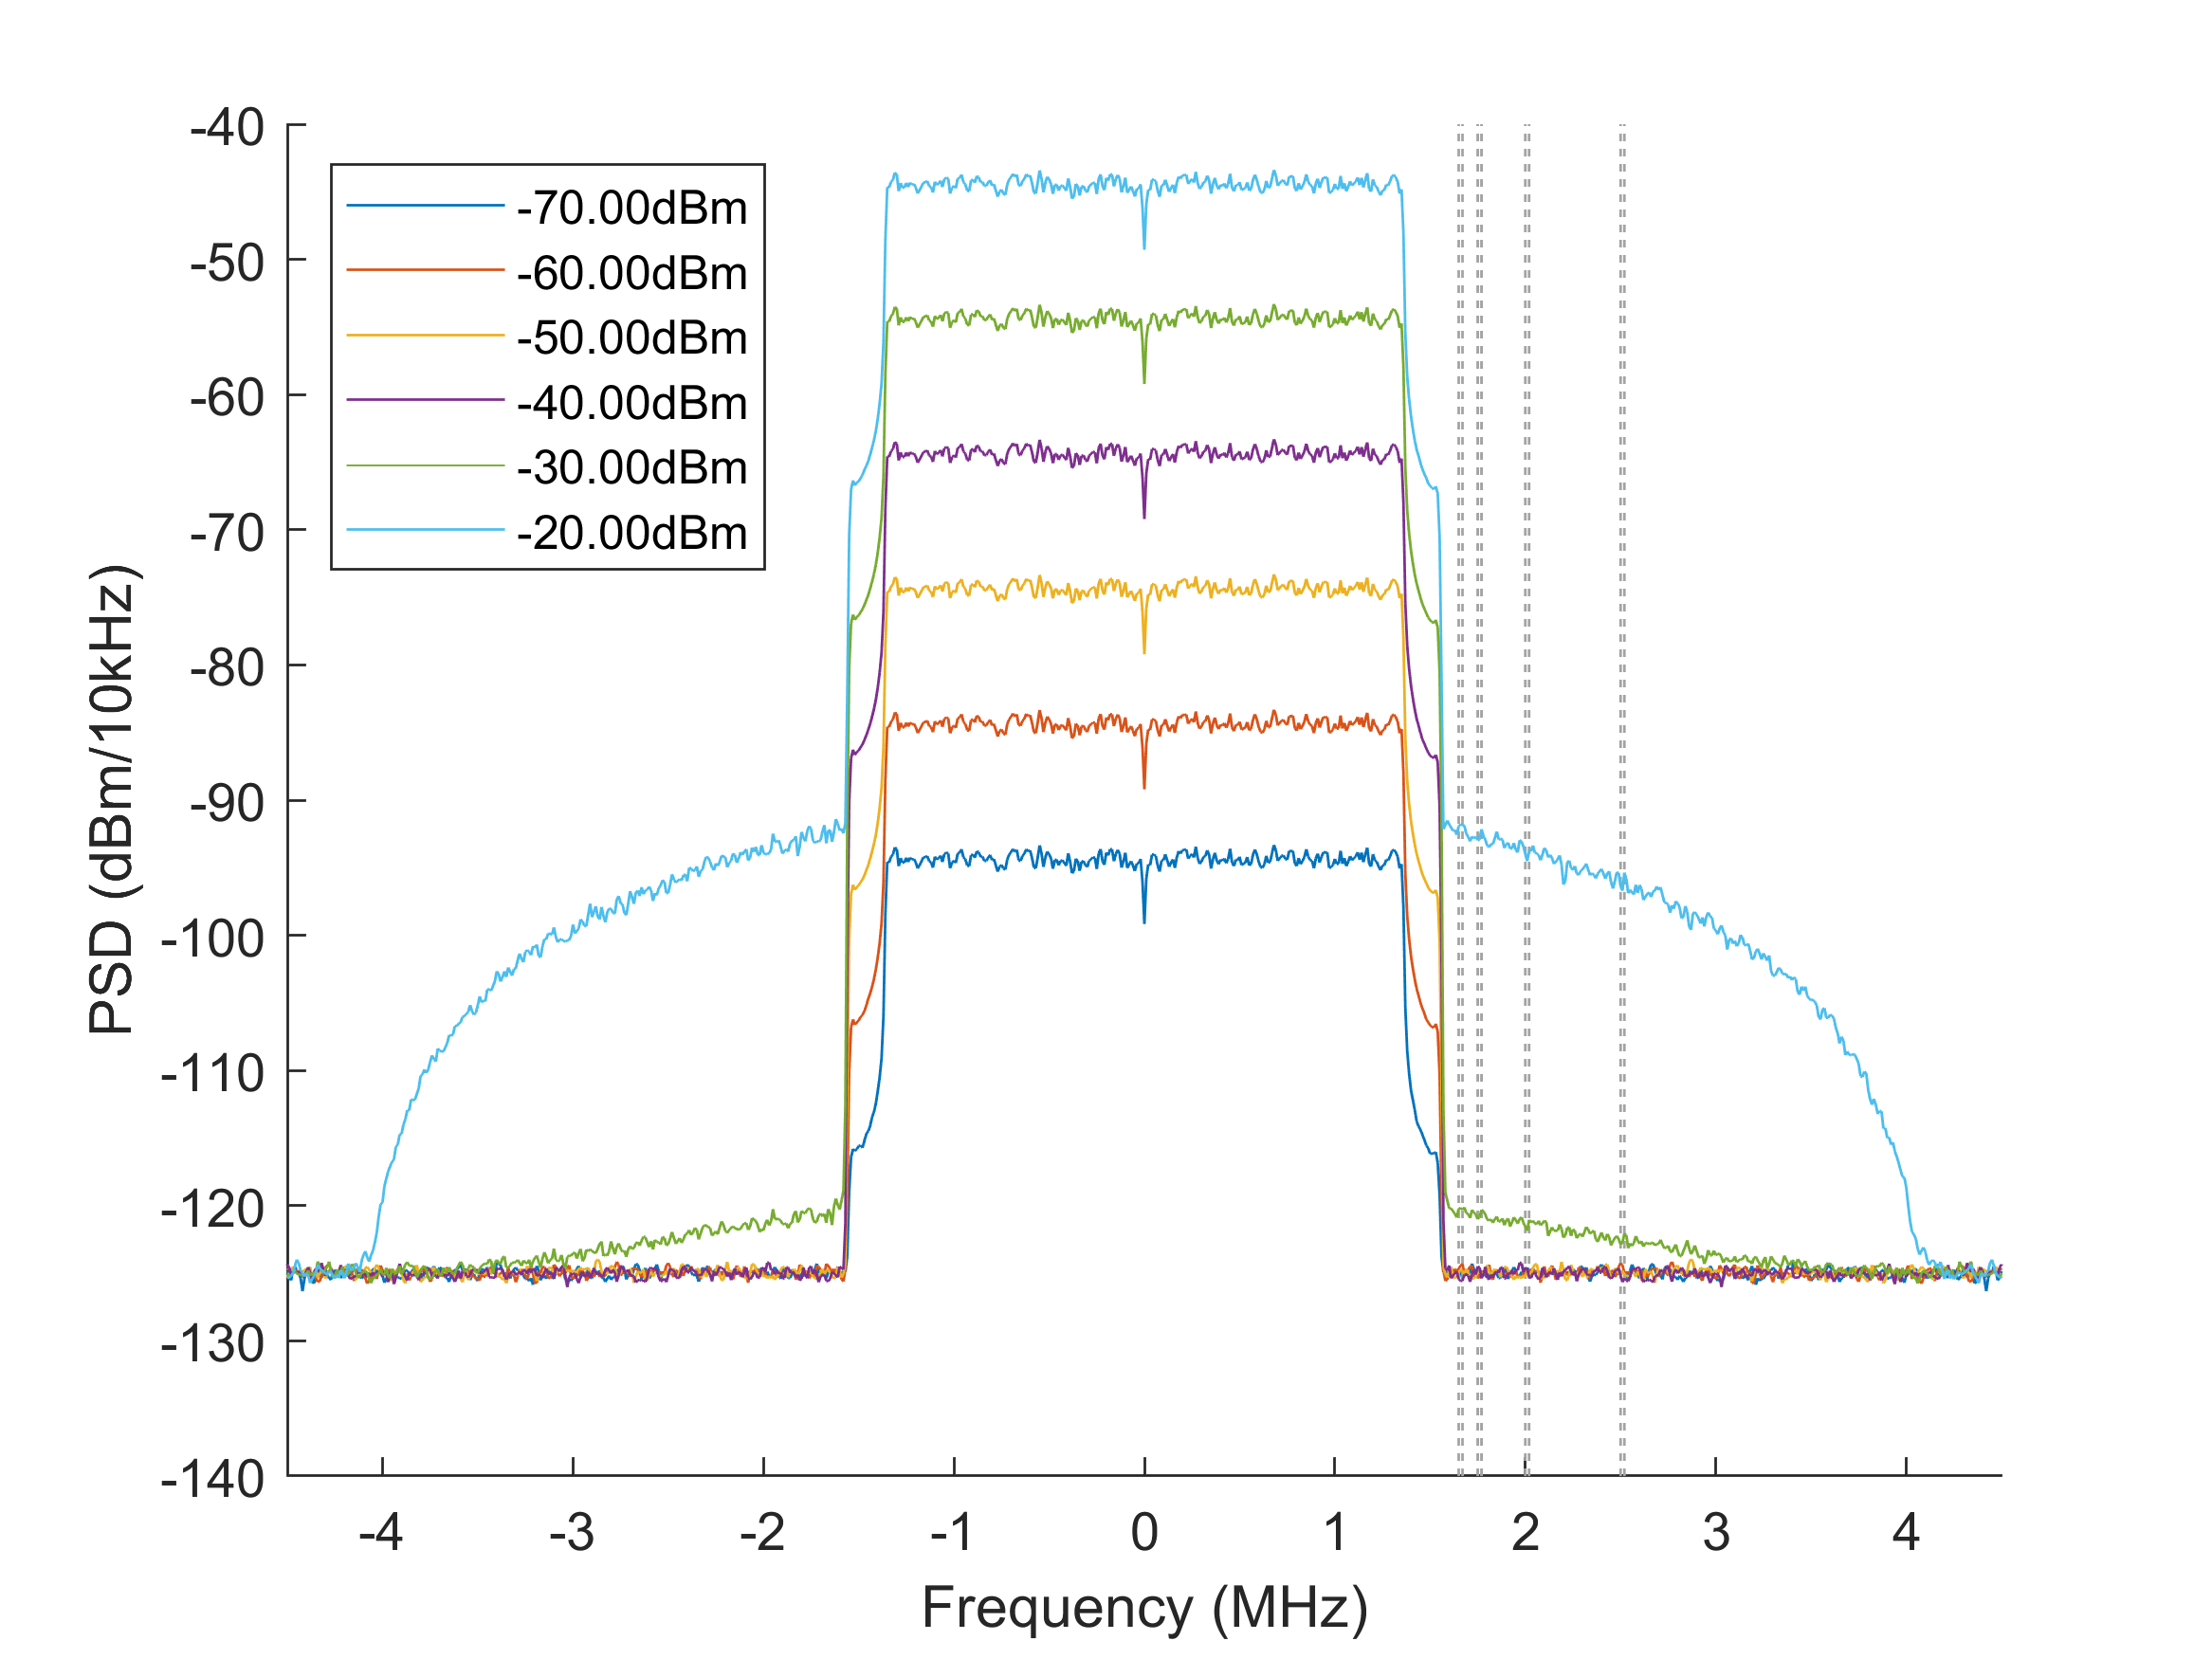

*Fig. 2: Power spectral density at the output port of the nonlinear LNA of the TETRA receiver (IIP3 +3.5dBm) caused by an adjacent LTE cell (BW: 3.0MHz). The thermal noise floor at -174dBm/Hz and a noise figure of 9dB is included. The preselector filter is disabled, the simulated spectral gaps are [150.0kHz 250.0kHz 500.0kHz 1000.0kHz].*

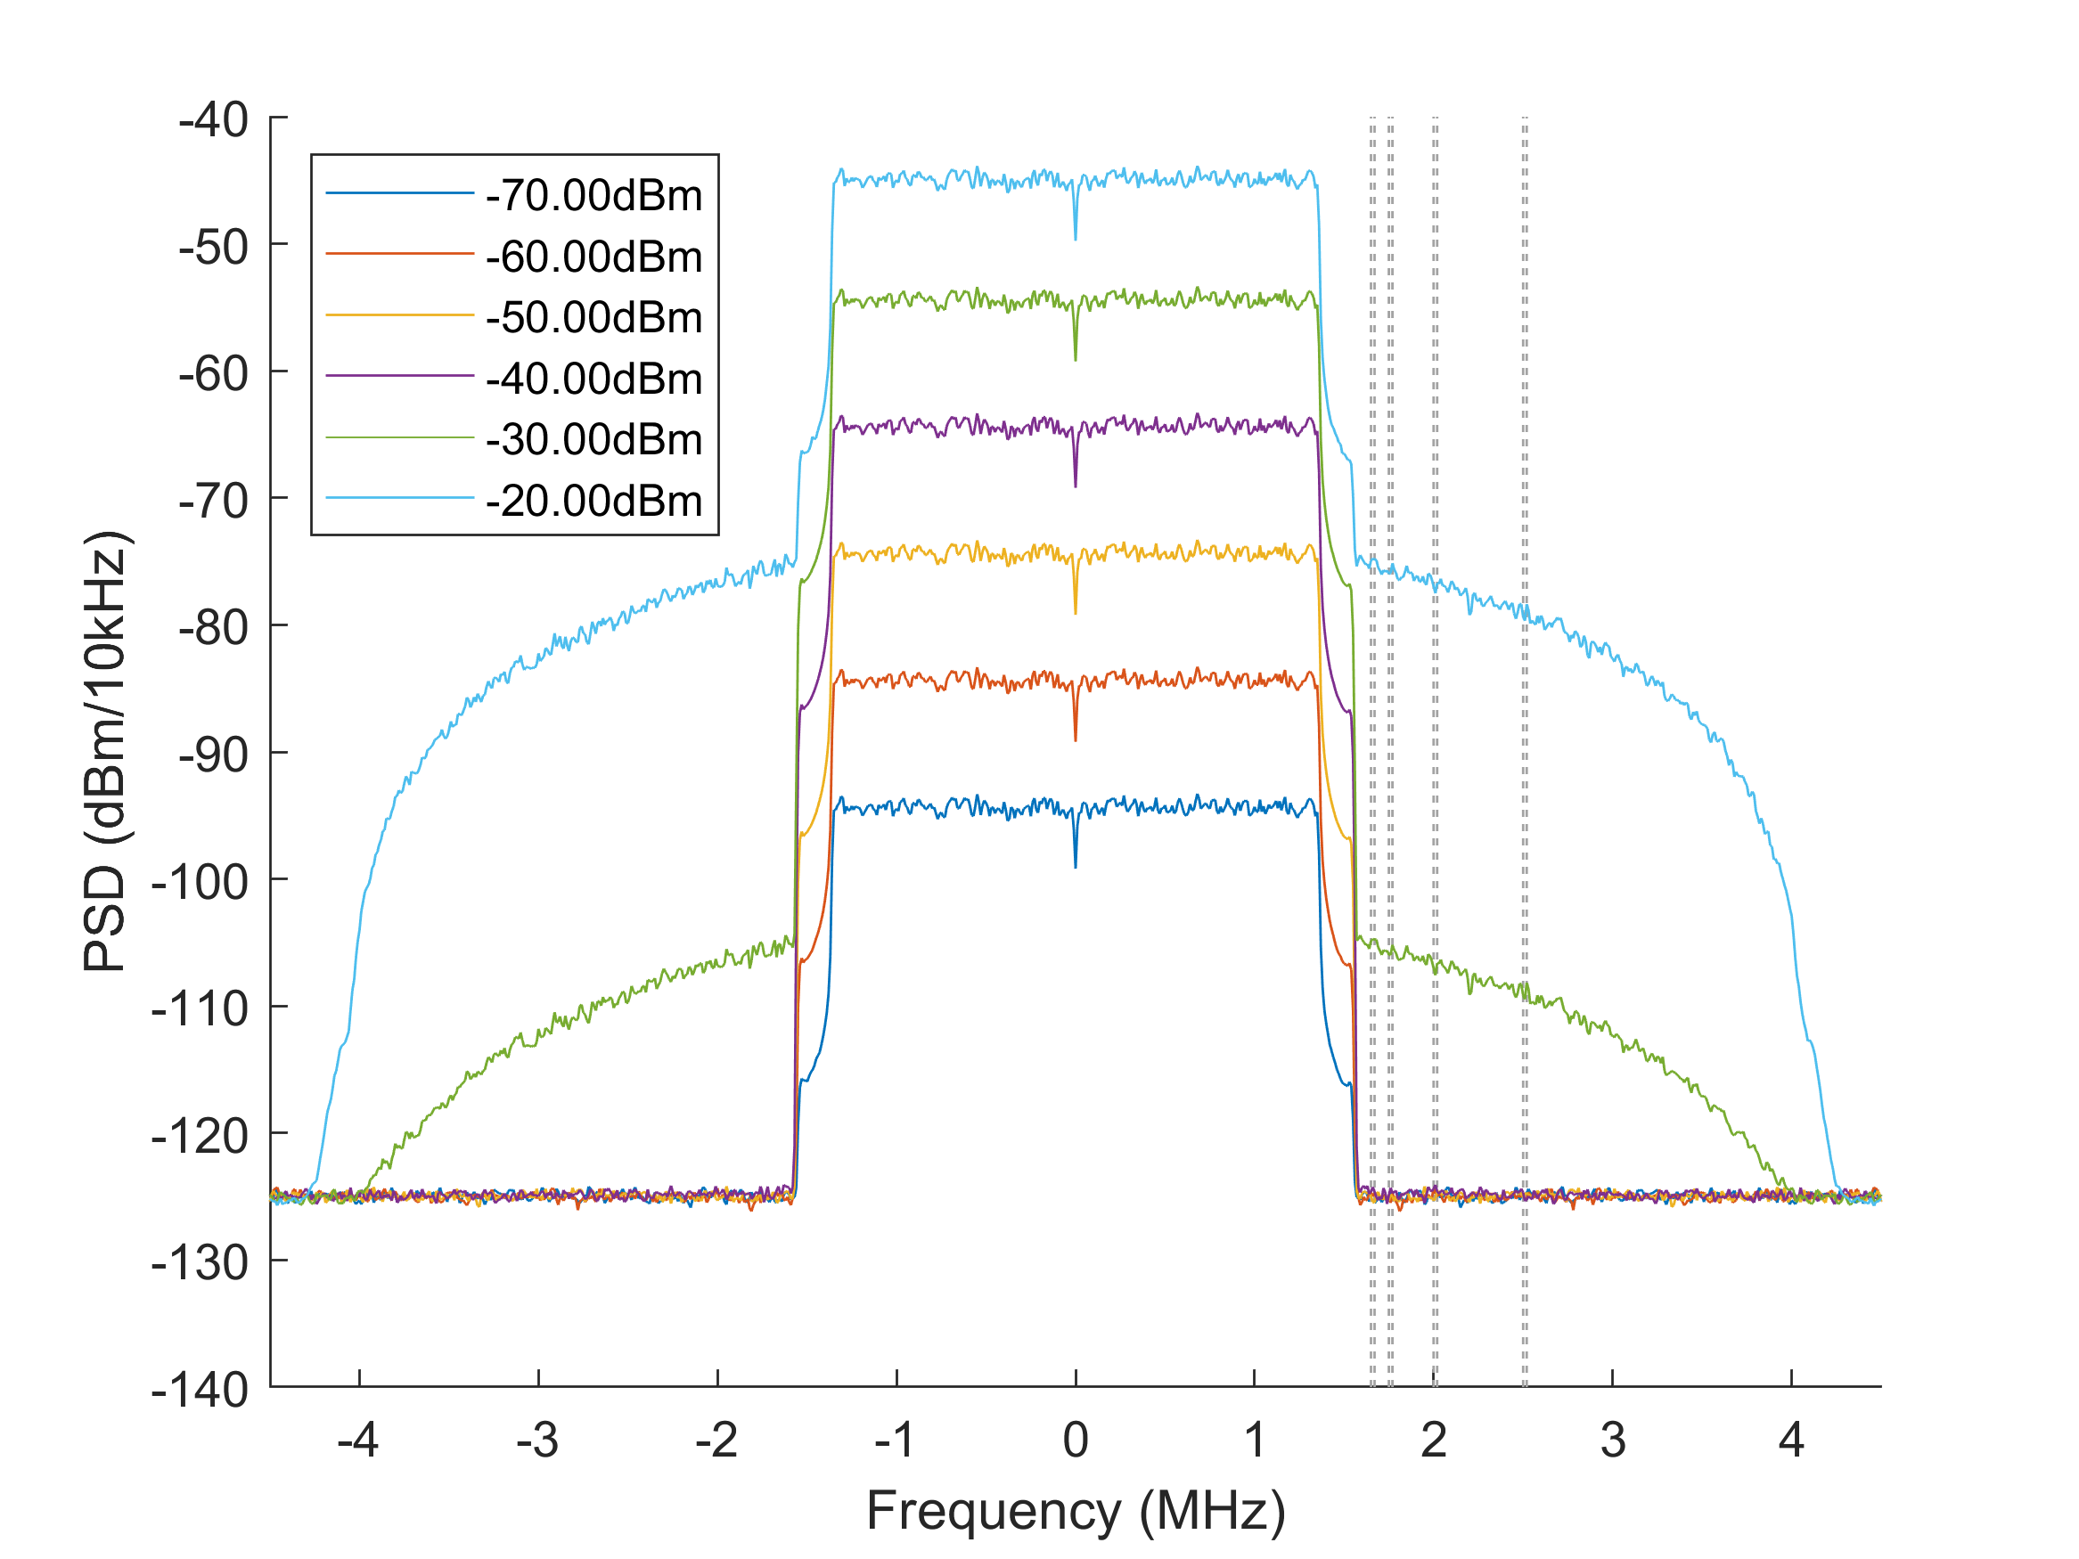

*Fig. 3: Power spectral density at the output port of the nonlinear LNA of the TETRA receiver (IIP3 -5dBm) caused by an adjacent LTE cell (BW: 3.0MHz). The thermal noise floor at -174dBm/Hz and a noise figure of 9dB is included. The preselector filter is disabled, the simulated spectral gaps are [150.0kHz 250.0kHz 500.0kHz 1000.0kHz].*

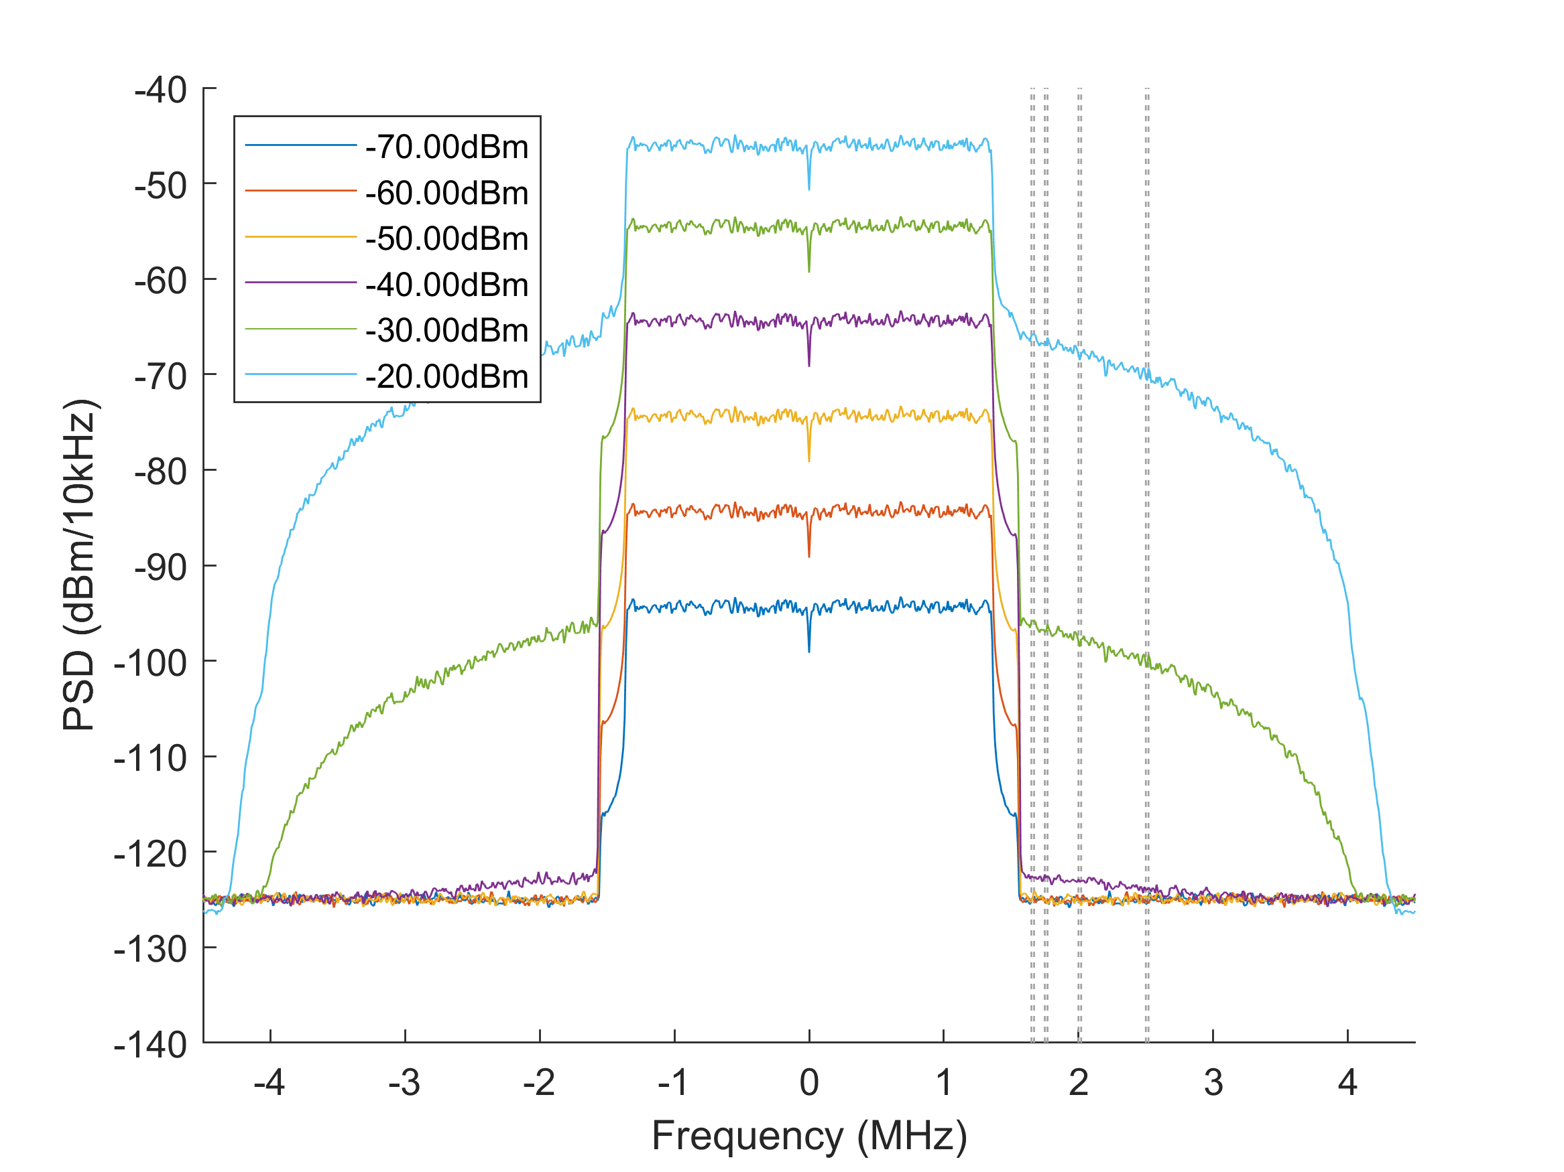

*Fig. 4: Power spectral density at the output port of the nonlinear LNA of the TETRA receiver (IIP3 -9.5dBm) caused by an adjacent LTE cell (BW: 3.0MHz). The thermal noise floor at -174dBm/Hz and a noise figure of 9dB is included. The preselector filter is disabled, the simulated spectral gaps are [150.0kHz 250.0kHz 500.0kHz 1000.0kHz].*

# Refererence values for case of no preselector

The power levels inside TETRA RX channel are given by the following MATLAB output:

SETTINGS

LTE bandwidth: 3MHz

TETRA bandwidth: 18kHz

Receiver linear gain factor: 1.0

Preselector enabled: false

Thermal noise floor enabled: true

Noise figure of receiver: 9dB

PSD averaging factor: 200

**IIP3 RPwr Gap IPwr**

**[dBm] [dBm] [kHz] [dBm]**

-9.50, -70.00, 150.00, -122.42

-9.50, -70.00, 250.00, -122.42

-9.50, -70.00, 500.00, -122.42

-9.50, -70.00, 1000.00, -122.42

-9.50, -60.00, 150.00, -122.42

-9.50, -60.00, 250.00, -122.42

-9.50, -60.00, 500.00, -122.42

-9.50, -60.00, 1000.00, -122.42

-9.50, -50.00, 150.00, -122.42

-9.50, -50.00, 250.00, -122.42

-9.50, -50.00, 500.00, -122.42

-9.50, -50.00, 1000.00, -122.42

-9.50, -40.00, 150.00, -120.09

-9.50, -40.00, 250.00, -120.24

-9.50, -40.00, 500.00, -120.61

-9.50, -40.00, 1000.00, -121.28

-9.50, -30.00, 150.00, -93.88

-9.50, -30.00, 250.00, -94.24

-9.50, -30.00, 500.00, -95.23

-9.50, -30.00, 1000.00, -97.59

-9.50, -20.00, 150.00, -63.88

-9.50, -20.00, 250.00, -64.25

-9.50, -20.00, 500.00, -65.24

-9.50, -20.00, 1000.00, -67.61

-5.00, -70.00, 150.00, -122.42

-5.00, -70.00, 250.00, -122.42

-5.00, -70.00, 500.00, -122.42

-5.00, -70.00, 1000.00, -122.42

-5.00, -60.00, 150.00, -122.42

-5.00, -60.00, 250.00, -122.42

-5.00, -60.00, 500.00, -122.42

-5.00, -60.00, 1000.00, -122.42

-5.00, -50.00, 150.00, -122.42

-5.00, -50.00, 250.00, -122.42

-5.00, -50.00, 500.00, -122.42

-5.00, -50.00, 1000.00, -122.42

-5.00, -40.00, 150.00, -122.05

-5.00, -40.00, 250.00, -122.08

-5.00, -40.00, 500.00, -122.15

-5.00, -40.00, 1000.00, -122.27

-5.00, -30.00, 150.00, -102.83

-5.00, -30.00, 250.00, -103.20

-5.00, -30.00, 500.00, -104.17

-5.00, -30.00, 1000.00, -106.49

-5.00, -20.00, 150.00, -72.88

-5.00, -20.00, 250.00, -73.25

-5.00, -20.00, 500.00, -74.24

-5.00, -20.00, 1000.00, -76.61

3.50, -70.00, 150.00, -122.42

3.50, -70.00, 250.00, -122.42

3.50, -70.00, 500.00, -122.42

3.50, -70.00, 1000.00, -122.42

3.50, -60.00, 150.00, -122.42

3.50, -60.00, 250.00, -122.42

3.50, -60.00, 500.00, -122.42

3.50, -60.00, 1000.00, -122.42

3.50, -50.00, 150.00, -122.42

3.50, -50.00, 250.00, -122.42

3.50, -50.00, 500.00, -122.42

3.50, -50.00, 1000.00, -122.42

3.50, -40.00, 150.00, -122.42

3.50, -40.00, 250.00, -122.42

3.50, -40.00, 500.00, -122.42

3.50, -40.00, 1000.00, -122.42

3.50, -30.00, 150.00, -117.96

3.50, -30.00, 250.00, -118.19

3.50, -30.00, 500.00, -118.78

3.50, -30.00, 1000.00, -119.97

3.50, -20.00, 150.00, -89.88

3.50, -20.00, 250.00, -90.25

3.50, -20.00, 500.00, -91.24

3.50, -20.00, 1000.00, -93.60

8.00, -70.00, 150.00, -122.42

8.00, -70.00, 250.00, -122.42

8.00, -70.00, 500.00, -122.42

8.00, -70.00, 1000.00, -122.42

8.00, -60.00, 150.00, -122.42

8.00, -60.00, 250.00, -122.42

8.00, -60.00, 500.00, -122.42

8.00, -60.00, 1000.00, -122.42

8.00, -50.00, 150.00, -122.42

8.00, -50.00, 250.00, -122.42

8.00, -50.00, 500.00, -122.42

8.00, -50.00, 1000.00, -122.42

8.00, -40.00, 150.00, -122.42

8.00, -40.00, 250.00, -122.42

8.00, -40.00, 500.00, -122.42

8.00, -40.00, 1000.00, -122.42

8.00, -30.00, 150.00, -121.54

8.00, -30.00, 250.00, -121.61

8.00, -30.00, 500.00, -121.76

8.00, -30.00, 1000.00, -122.03

8.00, -20.00, 150.00, -98.86

8.00, -20.00, 250.00, -99.23

8.00, -20.00, 500.00, -100.21

8.00, -20.00, 1000.00, -102.56

# Spectral regrowth with RX nonlinearity and with preselector

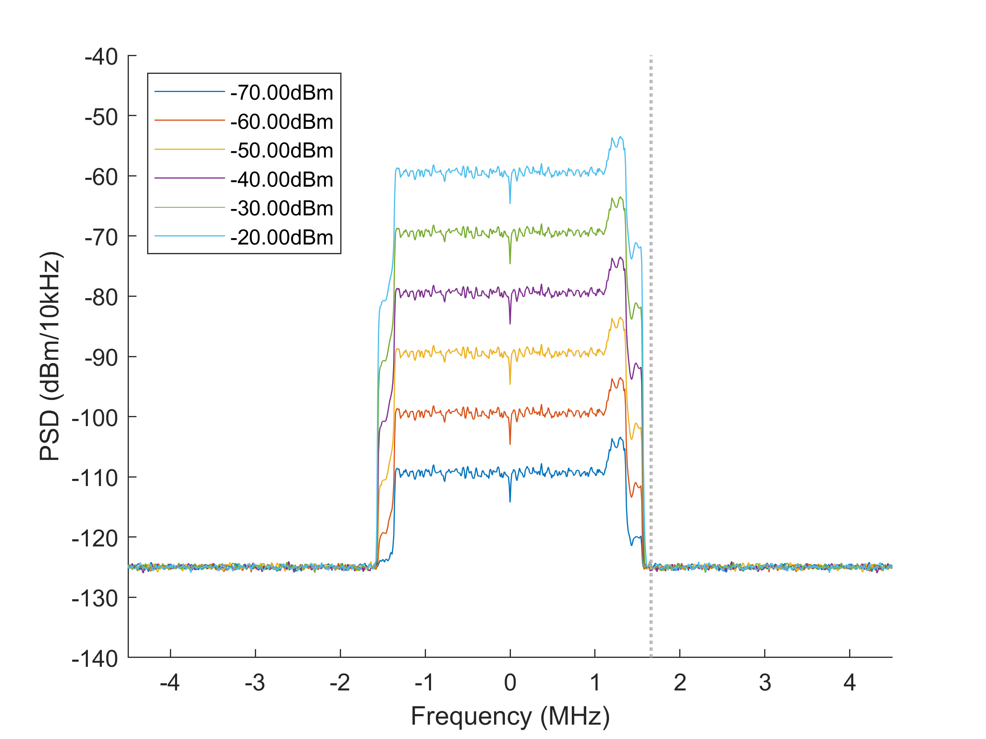

*Fig. 1: Power spectral density at the output port of the nonlinear LNA of the TETRA receiver (IIP3 +8.00dBm) caused by an adjacent LTE cell (BW: 3.0MHz). The thermal noise floor at -174dBm/Hz and a noise figure of 9dB is included. The preselector filter is enabled, the simulated spectral gaps are [150.0kHz 250.0kHz 500.0kHz 1000.0kHz].*

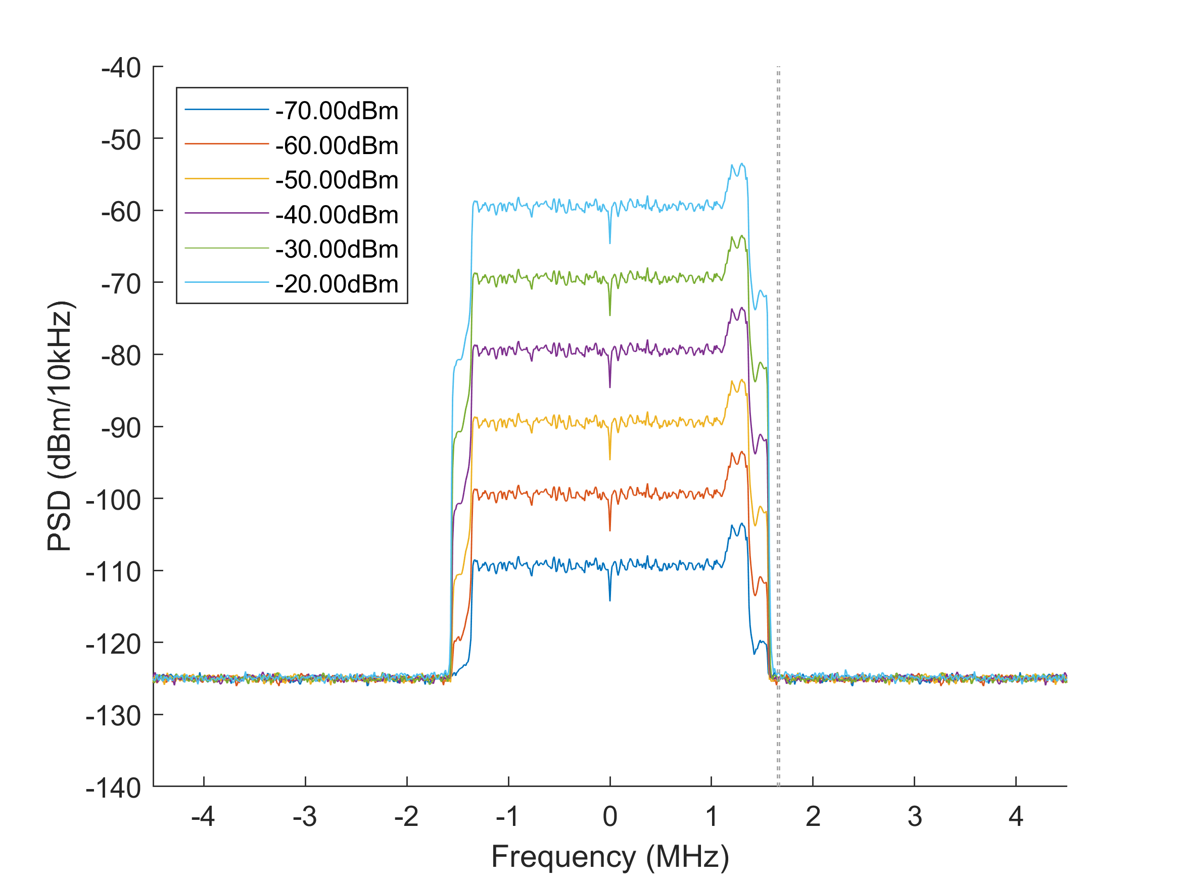

*Fig. 2: Power spectral density at the output port of the nonlinear LNA of the TETRA receiver (IIP3 +3.5dBm) caused by an adjacent LTE cell (BW: 3.0MHz). The thermal noise floor at -174dBm/Hz and a noise figure of 9dB is included. The preselector filter is enabled, the simulated spectral gaps are [150.0kHz 250.0kHz 500.0kHz 1000.0kHz].*

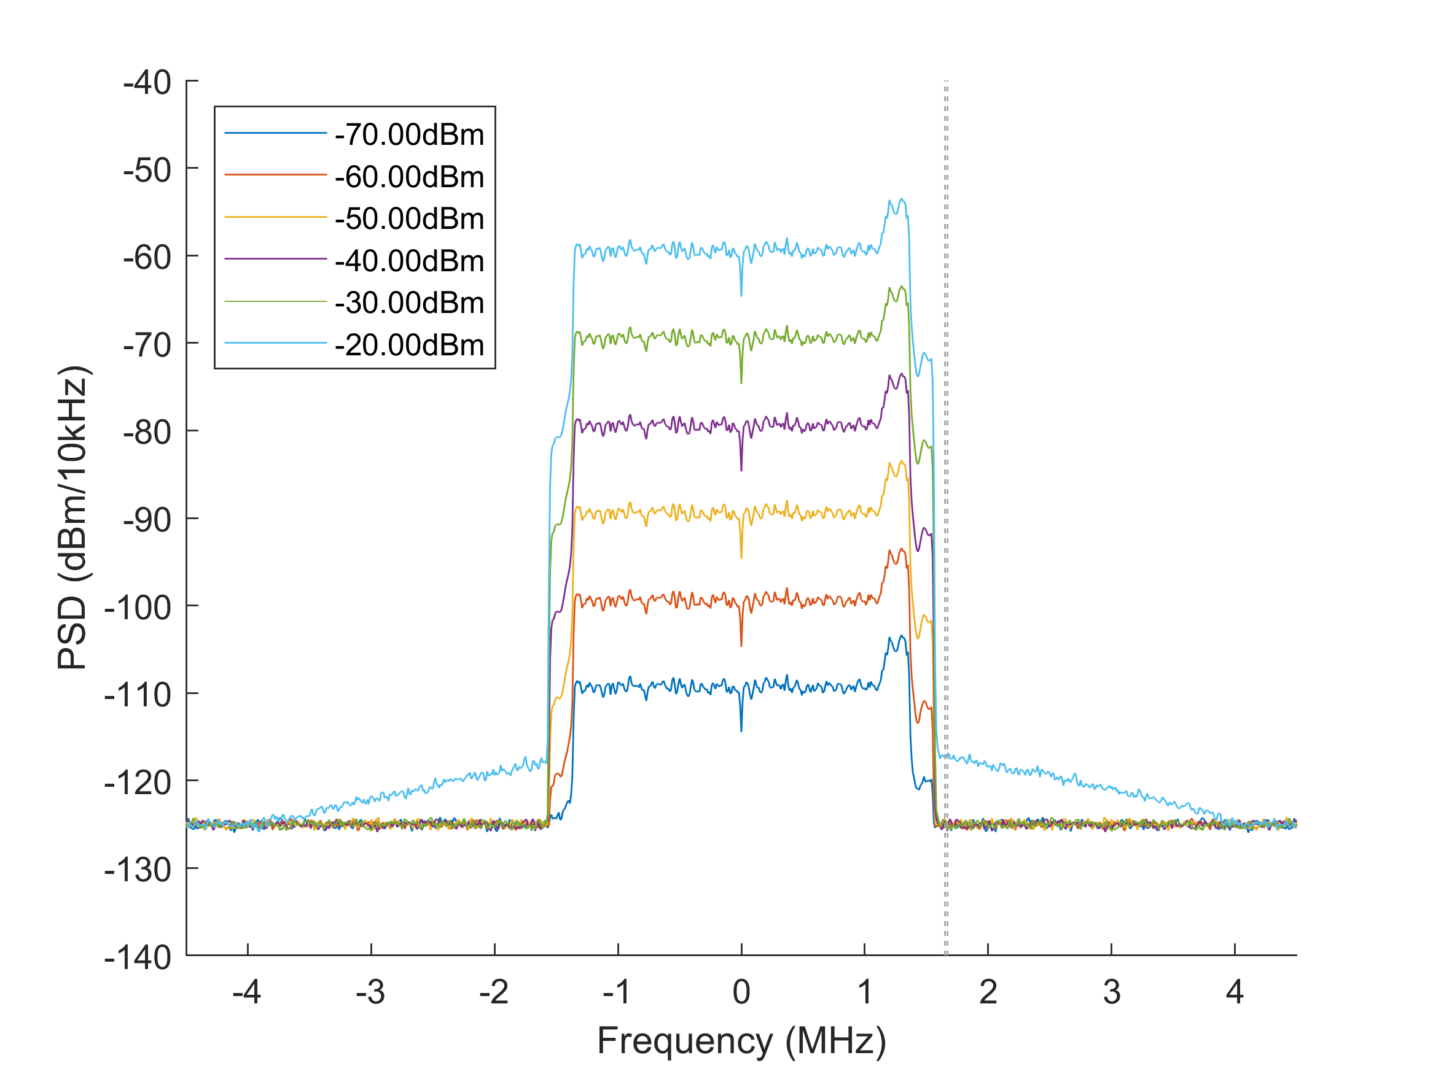

*Fig. 3: Power spectral density at the output port of the nonlinear LNA of the TETRA receiver (IIP3 -5dBm) caused by an adjacent LTE cell (BW: 3.0MHz). The thermal noise floor at -174dBm/Hz and a noise figure of 9dB is included. The preselector filter is enabled, the simulated spectral gaps are [150.0kHz 250.0kHz 500.0kHz 1000.0kHz].*

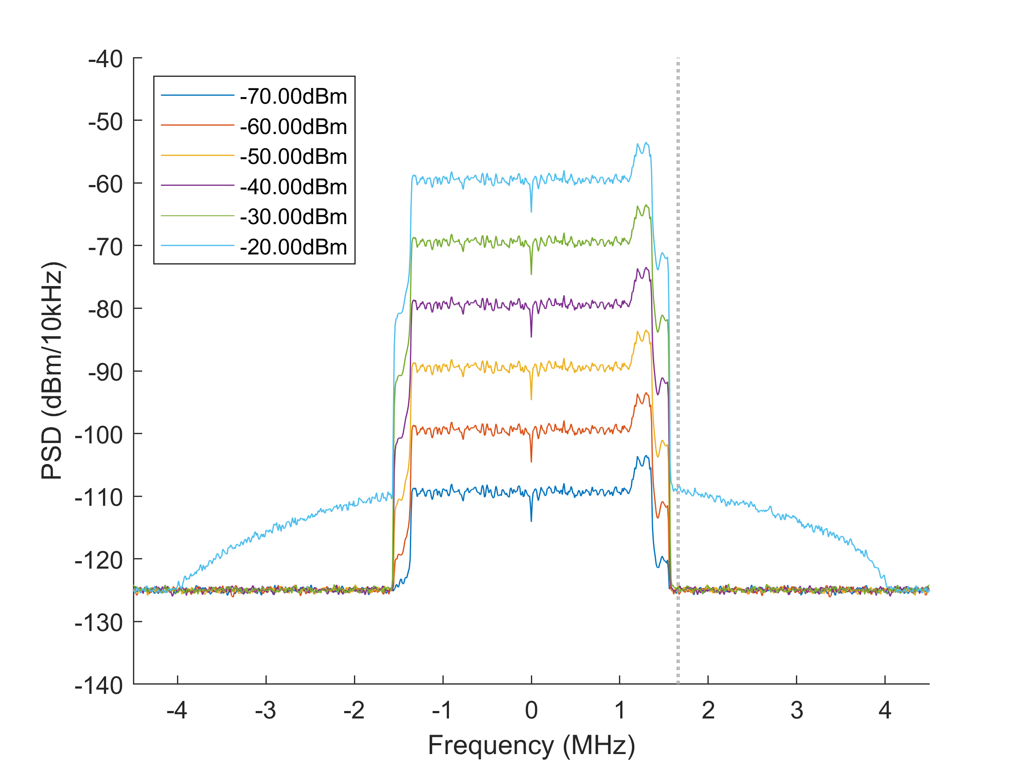

*Fig. 4: Power spectral density at the output port of the nonlinear LNA of the TETRA receiver (IIP3 -9.5dBm) caused by an adjacent LTE cell (BW: 3.0MHz). The thermal noise floor at -174dBm/Hz and a noise figure of 9dB is included. The preselector filter is enabled, the simulated spectral gaps are [150.0kHz 250.0kHz 500.0kHz 1000.0kHz].*

# Refererence values for case with preselector

The power levels inside TETRA RX channel are given by the following MATLAB output:

SETTINGS

LTE bandwidth: 3 MHz

TETRA bandwidth: 18 kHz

Receiver linear gain factor: 1.0

Preselector enabled: true

Thermal noise floor enabled: true

Noise figure of receiver: 9dB

PSD averaging factor: 200

**IIP3 RPwr Gap IPwr**

**[dBm] [dBm] [kHz] [dBm]**

-9.50, -70.00, 150.00, -122.42

-9.50, -60.00, 150.00, -122.42

-9.50, -50.00, 150.00, -122.42

-9.50, -40.00, 150.00, -122.42

-9.50, -30.00, 150.00, -122.26

-9.50, -20.00, 150.00, -106.48

-9.50, -70.00, 250.00, -122.42

-9.50, -60.00, 250.00, -122.42

-9.50, -50.00, 250.00, -122.42

-9.50, -40.00, 250.00, -122.42

-9.50, -30.00, 250.00, -122.31

-9.50, -20.00, 250.00, -107.83

-9.50, -70.00, 500.00, -122.42

-9.50, -60.00, 500.00, -122.42

-9.50, -50.00, 500.00, -122.42

-9.50, -40.00, 500.00, -122.42

-9.50, -30.00, 500.00, -122.36

-9.50, -20.00, 500.00, -110.13

-9.50, -70.00, 1000.00, -122.42

-9.50, -60.00, 1000.00, -122.42

-9.50, -50.00, 1000.00, -122.42

-9.50, -40.00, 1000.00, -122.42

-9.50, -30.00, 1000.00, -122.39

-9.50, -20.00, 1000.00, -112.31

-5.00, -70.00, 150.00, -122.42

-5.00, -60.00, 150.00, -122.42

-5.00, -50.00, 150.00, -122.42

-5.00, -40.00, 150.00, -122.42

-5.00, -30.00, 150.00, -122.40

-5.00, -20.00, 150.00, -114.78

-5.00, -70.00, 250.00, -122.42

-5.00, -60.00, 250.00, -122.42

-5.00, -50.00, 250.00, -122.42

-5.00, -40.00, 250.00, -122.42

-5.00, -30.00, 250.00, -122.41

-5.00, -20.00, 250.00, -115.90

-5.00, -70.00, 500.00, -122.42

-5.00, -60.00, 500.00, -122.42

-5.00, -50.00, 500.00, -122.42

-5.00, -40.00, 500.00, -122.42

-5.00, -30.00, 500.00, -122.42

-5.00, -20.00, 500.00, -117.64

-5.00, -70.00, 1000.00, -122.42

-5.00, -60.00, 1000.00, -122.42

-5.00, -50.00, 1000.00, -122.42

-5.00, -40.00, 1000.00, -122.42

-5.00, -30.00, 1000.00, -122.42

-5.00, -20.00, 1000.00, -119.07

3.50, -70.00, 150.00, -122.42

3.50, -60.00, 150.00, -122.42

3.50, -50.00, 150.00, -122.42

3.50, -40.00, 150.00, -122.42

3.50, -30.00, 150.00, -122.42

3.50, -20.00, 150.00, -122.03

3.50, -70.00, 250.00, -122.42

3.50, -60.00, 250.00, -122.42

3.50, -50.00, 250.00, -122.42

3.50, -40.00, 250.00, -122.42

3.50, -30.00, 250.00, -122.42

3.50, -20.00, 250.00, -122.13

3.50, -70.00, 500.00, -122.42

3.50, -60.00, 500.00, -122.42

3.50, -50.00, 500.00, -122.42

3.50, -40.00, 500.00, -122.42

3.50, -30.00, 500.00, -122.42

3.50, -20.00, 500.00, -122.25

3.50, -70.00, 1000.00, -122.42

3.50, -60.00, 1000.00, -122.42

3.50, -50.00, 1000.00, -122.42

3.50, -40.00, 1000.00, -122.42

3.50, -30.00, 1000.00, -122.42

3.50, -20.00, 1000.00, -122.32

8.00, -70.00, 150.00, -122.42

8.00, -60.00, 150.00, -122.42

8.00, -50.00, 150.00, -122.42

8.00, -40.00, 150.00, -122.42

8.00, -30.00, 150.00, -122.42

8.00, -20.00, 150.00, -122.37

8.00, -70.00, 250.00, -122.42

8.00, -60.00, 250.00, -122.42

8.00, -50.00, 250.00, -122.42

8.00, -40.00, 250.00, -122.42

8.00, -30.00, 250.00, -122.42

8.00, -20.00, 250.00, -122.39

8.00, -70.00, 500.00, -122.42

8.00, -60.00, 500.00, -122.42

8.00, -50.00, 500.00, -122.42

8.00, -40.00, 500.00, -122.42

8.00, -30.00, 500.00, -122.42

8.00, -20.00, 500.00, -122.40

8.00, -70.00, 1000.00, -122.42

8.00, -60.00, 1000.00, -122.42

8.00, -50.00, 1000.00, -122.42

8.00, -40.00, 1000.00, -122.42

8.00, -30.00, 1000.00, -122.42

8.00, -20.00, 1000.00, -122.41

# Interpretation of results

For the case of IIP3=-9.5 dBm and no preselector, which can be regarded as worst case, IM noise only gets significantly stronger than the thermal noise if the LTE signal is received around -30dBm. For the typical case of an IIP3=+3.5 dBm, IM noise starts dominating over thermal noise at levels around -20 dBm. However based on experience by LTE operator in 400 MHz band typical receive levels rarely exceed -30 dBm. Furthermore it can be observed that with increasing gap IM noise starts to vanish inside thermal noise.

For the case of IIP3=-9.5dBm and with preselector RX levels up to -30 dBm cause no harm. Just around   
-20 dBm IM noise dominates over thermal noise. For the case of a typical IIP3=+3.5 dBm with preselector, which is regarded a typical implementation there is no harm even at -20dBm RXlevel.

The reference values given above and this interpretation of results indicate that for the typical implementation of IIP=+3.5 dBm and with preselector there is no harm at all. This means no outage due to RX intermod should be predicted by SEAMCAT in this case.

For the case of no preselector and typical IIP3=+3.5dBm outage should happen rarely as up to -30 dBm RX level there is nearly no impact.

# Use with Validation of plugin

Results on power inside TETRA RX channel should be compared to prediction by SEAMCAT IM plugin to verify proper functionality of plugin.

# References

[1] SE7(18)028 Intermodulation issues by Motorola Solutions

[2] SE7(17)044 Intermodulation between LTE and NB systems in the 400 MHz band