CEPT investigations on possible usage of low power audio PMSE in the band 960-1164MHz
- WGSE/SE7 has prepared Annexes on technical analysis and short explanatory text to the Exec summary and to the Introduction. The main part of the Report will be prepared by FM/FM51.
approved DD Month YYYY (Arial 9)
APPENDIX FROM SE7 TO ECC Report <No>
[last updated: DD Month YYYY] (Arial 9)

Executive summary

Numerous technical studies have been considered. However, due to the complexity of the systems under consideration and the use cases, no consensus has been reached on the following aspects:
- Input parameters,
- Coexistence scenarios,
- Propagation models,
- Building attenuation and the impact of the human body,
- Safety margin for civil aviation equipment,
- Trials
Many studies have been performed with different assumptions that fully or partly reflect the specific requirements of individual countries and the relevant international aeronautical technical regulations. As an overall result of these studies it is shown that the possible sharing of low power audio PMSE in the 960-1164 MHz band with other services in this and adjacent bands heavily depends on the assumptions and the specific requirements of the various concerned parties. No consensus could be reached on the set of assumptions listed above. Consequently, the principle of sharing could not be agreed nor rejected.

TABLE OF CONTENTS

0 Executive summary 2
1 Introduction 6
2 Definitions 7
ANNEX 1: Background 8
ANNEX 2: Use of the band 960-1164 MHz for PMSE in the UK 14
ANNEX 3: [APWPT] Impact of PMSE on DME 55
ANNEX 4: [OFCOM UK] MCL study on the impact of the PMSE on DME 63
ANNEX 5: [BNetzA] MCL study on compatibility between PMSE and DME 103
ANNEX 6: [ANFR] Study on compatibility between ARNS and PMSE 113
ANNEX 7: [NARFA DEU] PMSE selectivity in presence of JTIDS/MIDS pulses 145
ANNEX 8: [Transfinite] Compatibility between PMSE in the band 960-1164 MHz and RNSS above 1164 MHz 163
ANNEX 9: [DFS Germany] Guidance for practical tests of DME and TACAN operations, the effects of multipath and signal strength variation 178
ANNEX 10: [BNETZA AND DFS GERMANY] PMSE interference measurements on DME/TACAN 182
ANNEX 11: [DFS GERMANY] DME and TACAN transponder identification interference 203
ANNEX 12: Guidance by ICAO relating to the protection of aeronautical systems 208
ANNEX 13: List of Reference 213

LIST OF ABBREVIATIONS

Abbreviation | Explanation
ACAS | Anti-Collision Avoidance system
ADS-B | Automatic Dependant Surveillance - Broadcasting
AGL | Above Ground Level
AMSL | Above Mean Sea Level
ARNS | Aeronautical Radio Navigation Service
BW | Bandwidth
C/I | Carrier to Interference
CEPT | European Conference of Postal and Telecommunications Administrations
CIS | Commonwealth of Independent States
CW | Carrier Wave
DME | Distance Measuring Equipment
ECC | Electronic Communications Committee
ESE | Extraneous Signal Environment
FL | Flight Level
FMS | Flight Management System
GNSS | Global Navigation Satellite System
GPS | Global Positioning System
I/N | Interference to Noise
ICAO | International Civil Aviation Organization
IFF | Identification Friend or Foe
JTIDS | Joint Tactical Information Distribution System
LDACS | L-band Digital Aeronautical Communications System
MCL | Minimum Coupling Loss
MIDS | Multifunctional Information Distribution System
MLAT | Multilateration
MM | Maritime Mobile
MSL | Mean Sea Level
OOB | Out-Of-Band
PAM | Pulse Amplitude Modulation
PMSE | Program Making and Special Events
PRMG | Posadotschnaja Radio Majatschnaja Grupa
RFI | Radio Frequency Interference
RSBN | Radionavigatsionnaya Sistema Blizhney Navigatsii
SSR | Secondary Surveillance Radar
TACAN | Tactical Air Navigation
TCAS | Traffic Collision Avoidance System
UAT | Universal Access Transceiver
WAM | Wide Area Multilateration

Introduction
In accordance with the minutes of 48th ECC meeting, WGSE, during its 80th meeting, tasked SE7 to provide the current status of the study relative to the possible use of low power audio PMSE (excluding airborne use) in the frequency band 960-1164 MHz.
Due to the complexity of the systems under consideration and the use cases, no consensus has been reached on the following aspects:
- Input parameters,
- Coexistence scenarios,
- Propagation models,
- Building attenuation and the impact of the human body,
- Safety margin for civil aviation equipment,
- Trials.
Numerous studies have been carried out using different approaches. This has resulted in diverging conclusions on the possible use of low power audio PMSE in the 960-1164 MHz band taking into account sharing with the aeronautical and governmental services in this band and the RNSS in the adjacent band.

Definitions
Below are the definitions (in ICAO Annex 10 Vol I) for ILS integrity and continuity of service. When used as a component of ILS, this applies to DME as well.
Term | Definition
Integrity | That quality which relates to the trust which can be placed in the correctness of the information supplied by the facility. The level of integrity of the localizer or the glide path is expressed in terms of the probability of not radiating false guidance signals.
Continuity of service | That quality which relates to the rarity of radiated signal interruptions. The level of continuity of service of the localizer or the glide path is expressed in terms of the probability of not losing the radiated guidance signals.

- Background
  - History of systems deployment in the band 960-1215 MHz
Initially, ITU allocated the band 960 to 1215 MHz exclusively to the Aeronautical Radio Navigation Systems (ARNS) and additionally later the band 1164 - 1215 to RNSS (WRC-2000) and the band 960 - 1164 MHz to AM(R)S (WRC-2007). Several states throughout the world have allocated the band also for shared use with governmental systems in accordance with the RR article 4.4., only after extensive theoretical and practical frequency compatibility studies identified the conditions and restrictions under which sharing is possible. Those studies are revised, whenever the new systems are defined by ICAO for operation or when the Extraneous Signal Environment (ESE) increases due to an increase in air traffic significantly beyond the previously defined scenario.
There is no Radio Frequency Interference (RFI) parameter for the protection of an ARNS system from other ARNS (or non-ARNS) systems. The international aeronautical standards and related provisions do not define any, and therefore the mandated performance for DME, SSR, and the next generation systems, is ensured by applying specialized discriminators and frequency offset only.
While at the beginning equipment designs and performance were similar in design, if not identical, development of new technology diversified the options for designer to achieve the required performance and achieve much higher sensitivity than mandated by ICAO and in MOPS [1].
Figure 1: Allocation of services and uses transmit centre frequencies in the band 960 to 1215 MHz [1]
  - Overview of the systems in the band 960-1215 MHz
Initially in 1949, an ICAO standardized Distance Measuring Equipment (DME) system was introduced in the frequency band. This system was then replaced by DME/N and TACAN. SSR Mode A and C, and IFF Modes 1 and 2 were introduced around 1960. As depicted in figure 2, a number of aeronautical communication, navigation and surveillance systems and equipment are currently operated in the band.
The frequency range and centre frequencies used by the systems are shown in the above figure, while Figure 2 below lists equipment, operation modes and use and if operation is limited to a state, area or worldwide. The technical characteristics of those systems are described in the next chapter.
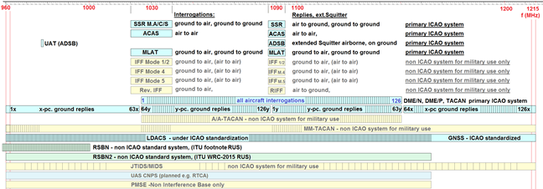
Figure 2: Transmit centre frequencies in the band 960 to 1215 MHz
    - Overview of DME system operation
DME is an essential aircraft navigation aid, used globally, and provides a part of the required navigation equipment on commercial aircraft. DME is used for en-route area navigation as well as departure, approach, landing and missed approach phases of flight. This use will continue and increase well beyond 2030 [Reference: "ICAO Global Air Navigation Plan" (5th edition, 2016 - https://www.icao.int/airnavigation/Pages/GANP-Resources.aspx)]. In most airspaces it is required to navigate by using multiple DME ground stations for position determination.
The Instrument Landing System (ILS) is used for precision approach and landing of aircraft. This system consists of a Localizer (108 - 117.975 MHz), Glideslope (328.6 - 335.4 MHz) and Marker Beacons (74.8 - 75.2 MHz) or DME for ranging to the Runway threshold. Marker Beacons are generally not used anymore unless there is no available DME frequency, only a few Marker Beacons remain in operation in Europe.
The three facility performance categories of the ILS precision approach (CAT I, CAT II and CAT III) are all certified as integral systems which include DME as a vital component. In real-time, with the accurate azimuth, elevation and the distance to the runway threshold combined, these systems permit coupled auto-pilot and stabilised approaches to runways around the globe.
Many airport ILS/DME installations have been certified at the highest level of precision approach procedures (CAT IIIc) and are authorised to be used for auto-landing operations. Any loss of DME operation in normal or low visibility conditions results in the need for alternative ranging information that require ATC intervention and associated impacts to the operation of that airport, for example flow control being applied with much lower throughput than during normal operations. Any loss of a component part of the ILS requires a demonstration period to be completed, providing fault rectification or resolution to the issue that caused the loss. Depending on the severity of the loss varying periods will be required to prove the stability and operational capability of the facility, for example this could be between 24 and 300 hours or as specified by the ANSP for that aid.
  - Principles on Aeronautical systems
Aeronautical systems differ from most other terrestrial systems, in so far that not only their ground components are situated obstacle free to reduce multipath, located as high as terrain and antenna masts permit.
Antenna heights of ground based systems vary typically between ~7 ft (2.1 m) and about 131 ft (40 m) Above Ground Level (AGL).
Locations are not limited to airports with terrain heights of the Airport Reference Point (ARP) of more than 2500 ft (762 m), but can be located on Hills or Mountains with terrain elevation of 10 987 ft (3349 m in Corvatsch, Switzerland).
Therefore, the RLOS for ground based equipment in Europe can exceed 172 NM (320 km).
While SSR allows for FL reports of aircraft of up to 126750 ft. Air Traffic Control presently foresees a max. of 66 000 ft (20116.8 m) Above Mean Sea Level (AMSL).
The RLOS between aircraft (airborne and on ground), ground equipment and impact of terrain height is depicted in Figure 3.
While not all signals within RLOS will be sufficiently strong to be processed, also signals well below the defined Minimal Detectable Signal (MDS) or Minimal Threshold Level (MTL) are processed depending on receiver design.
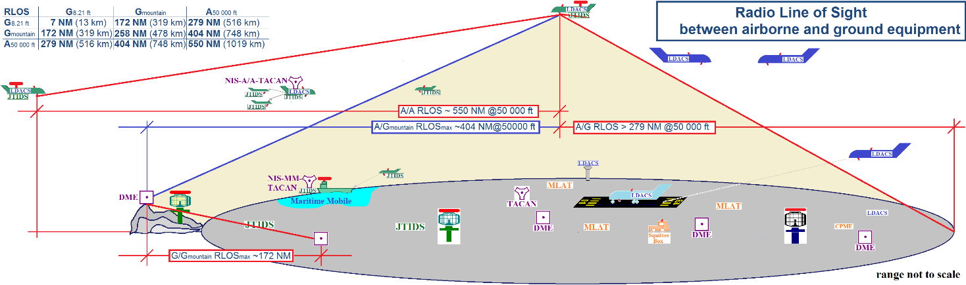
Figure 3: Airborne and Ground RLOS of aeronautical equipment in operation [1]
Note: Antenna height of ground equipment will vary in Europe between 1.8 m (6 ft) AGL and DME at mountain Corvatsch 3 349 m (10 987 ft) AMSL (Above mean sea Level). Some locations have also negative elevations e.g. Amsterdam Schiphol (ARP -11 ft).
The number of systems and density of equipment and signal strength received will differ depending on where in the band 960 to 1215 MHz the receiver is operating on.
For airborne equipment, it is necessary to divide studies in three cases which are depicted in Figure 4:
- aircraft equipment on ground
- aircraft during APP (approach), DEP (departure) below 10 000 ft to 20 000 ft and
- en-route flight up to 66 000 ft AMSL.
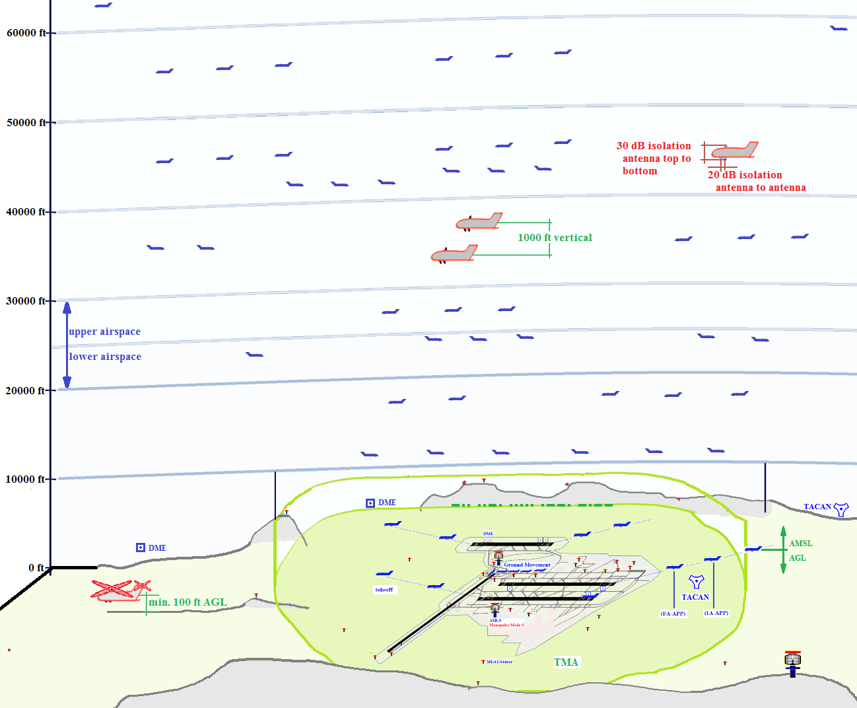
Figure 4: Upper- and Lower airspace ATC operation, Flight Level and altitude for aircraft to be considered in the various phases of a flight [1]

  - Integrity and continuity requirements - Fade margin issues
The very high integrity and continuity requirements (see section A1.5) for aeronautical navigation systems rely on the ratio between the desired and undesired signal level being strong enough to overcome temporal fades and enhancements due to, inter-alia, path obstructions, atmospheric or surface reflection multipath and precipitation. Hence, any compatibility studies involving the aeronautical radionavigation systems need to take into account the increased link budget required to reliably close the link between the radionavigation transmitter and receiver to ensure the required continuity of the service. An example continuity requirement for an ILS and ILS glideslope system providing a CAT I service is 1 – 4*10-6. For CAT II/III service, the continuity requirement is 1 – 2*10-6.
Although some data and propagation models applicable to aeronautical services already exist, e.g. Recommendation ITU-R P.528 “Propagation curves for aeronautical mobile and radionavigation services using the VHF, UHF and SHF bands and IF77” [Recommendation ITU-R P.528-3 (02/2012) 3], they typically do not provide useful temporal characteristics reflecting the very high signal availability/continuity requirements of aeronautical radionavigation systems providing a CAT I, II or III service.
Recommendation ITU-R P.2001 “A general purpose wide-range terrestrial propagation model in the frequency range 30 MHz to 50 GHz” [Recommendation ITU-R P.2001-2 (07/2015)] may provide some tools to predict the depth of temporal fades and temporal enhancements due to atmospheric and other effects, as it uses percentages of time in the range of 0.00001% to 99.99999%. However terrain data would also need to be accounted for as well as the aircraft elevation.
Some L-band (DME band) and C-band (5030-591 MHz band) flight test analyses have been performed by the United States National Aeronautics and Space Agency (NASA) to ascertain fade and required link budget characteristics for Control and Non-Payload Communications used for Unmanned Aircraft Systems. The results of these are available in the document RTCA-DO-362 “Command and Control (C2) Data Link Minimum Operational Performance Standards (MOPS) (Terrestrial)” [RTCA-DO-362, Command and Control (C2) Data Link Minimum Operational Performance Standards (MOPS) (Terrestrial), RTCA, 2016.September.22] published in September 2016 by RTCA Inc.
In summary, the information gathered by the NASA measurement campaign provides, amongst other data points, an evaluation of Excess Path Loss due to multipath and diffraction on the path between an aircraft and ground in a typical scenario which would also apply to DME operations. The figures below, depict the result of a hilly terrain test. The flight path flown was a semi-circle at a constant distance of 35 Nautical Miles (~65 km) and at different flight levels, including 14000 feet (~4300m), 7500feet (~2300m) and 3500 feet (~1100m) above ground.
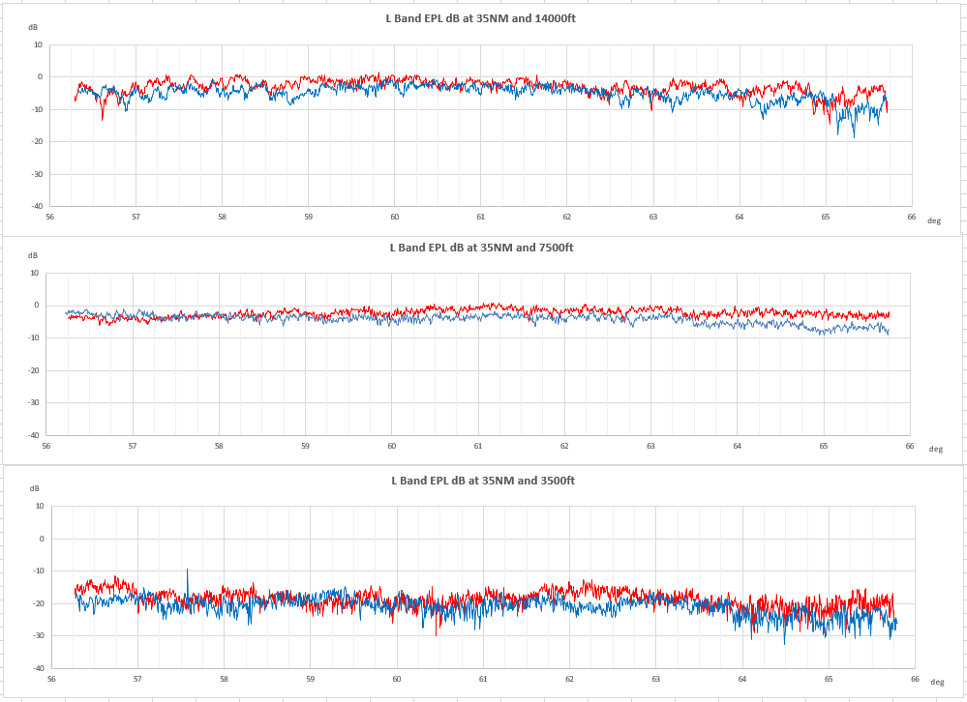
As evident from the graphs depicted, the Excess Path Loss observed during this test flight ranges from 0 up to over 30 dB.
The safe operation of aeronautical navigation systems, in particular ILS CAT I/II/III requires availability and integrity which is comparable to few if any other radio services. Such high availability and integrity can only be achieved by ensuring there is no interference to the various components of the ILS from other systems. In this context, extreme propagation anomalies (temporal fading and enhancement) need to be taken into account, as well as intentional or inadvertent co-sharing of a DME frequency by any other user, including the potential PMSE user. GNSS is not considered reliable enough for ILS precision approach.
  - Integrity and continuity of service
Annex 10 places an integrity/continuity requirement on DME/N at 1 – 1x10-5. For Category I instrument landing systems, integrity is quoted as 1 – 1x10-7, for Category II and III landing systems, integrity is quoted as 1 – 1x10-9. For those systems, continuity is quoted as 1 – 2x10-6. (ref Annex 10 Vol I, table C-2).
- States are obliged under the ICAO Convention to have a Safety Oversight program that serves to ensure the safe design and operation of all airspace procedures, ie; airport arrival/departure, and en-route. Ground based navigation facilities are integral components of airspace design.
- Safety case assessments of the airspace procedures take into account the RF operating environment of terrestrial navigation aids and identify potential risks that must be mitigated.
- Airport ILS precision approach procedures are depicted on specifically designed charts that form the legal basis for flight crews to accurately perform the approach using the navigation facilities.
- DME is an integral component of ILS precision approach; DME also provides the threshold distance reference, as an alternative means to Marker Beacons which are not commonly used anymore. DME is a critical component in runway missed approach overshoot procedures, and is used in RNAV procedures.
- GNSS/GPS is not a replacement for DME. The RF environment of GNSS is too vulnerable to place a comparable integrity/continuity requirement as ILS and DME.
- Potential introduction of PMSE in the frequency band used by DME and other aeronautical systems would change the RF operating environment of those systems, necessitating a reassessment of the safety cases of the systems supporting the airspace infrastructure.
- Considering the safety critical operation of DME as an integral component of precision ILS and its inclusion in the airspace infrastructure, any I/N compatibility study activity should take into account the integrity/continuity requirements of DME, including temporal fades and enhancements due to atmospheric effects and uneven terrain.
- Given the critical importance of DME as an integral component of precision ILS and the legal framework under which precision approach procedures are authorised, any impact on DME integrity/continuity as a result of a change in the RF operating environment due to introduction of PMSE or similar, should be at least one order of magnitude lower than that of the DME itself, as noted in Annex 10 Vol 1 Table G-15.
- The compatibility studies need to fully recognize the critical operational role of DME in precision ILS approach and landing procedures and hence ensure that any impact of PMSE is sufficiently low to not lower the integrity/continuity of the DME.
  - PMSE use
Please refer to ECC Report 204 [put link here] for information on the PMSE use.
- Use of the band 960-1164 MHz for PMSE in the UK

  - Summary
Ofcom has been licensing PMSE equipment in the 960 – 1164 MHz band since July 2016 using test and development licences, from January 2019 commercial use licence have been available. Trials have taken place by the BBC at Borehamwood, Glasgow, Birmingham, Broadcasting House (London) and by Sky at their studio complex at Osterley, West London plus the Cambridge theatre in central London. In addition long term monitoring and some PMSE use has taken place at Edgcott near Oxford and a commercial license was obtained for the site in January 2019. To date, no interference to or from PMSE has been noted, which generally endorses the Ofcom view that for the UK under current conditions this band is viable spectrum for secondary use by PMSE.
The Ofcom spectrum tool has been validated and has proven to identify clear spectrum for PMSE. Licensing continues under both the Test and Development regime and commercial use, licences have been issued or renewed as appropriate.
Trials have predominately been indoors within studios, with a limited number of outdoor deployments. This has been a consequence of practical issues rather than any interference concerns with the DME spectrum. Some additional outdoor trials have been made since the initial report was issued in January 2017. External use has using 10 channels has been carried out at Edgcott for days at a time with both T&D and commercial licences
During November 2017 an additional 16 channels of Shure and 2 channels of Wisycom equipment have been in use. All equipment has been inspected in the laboratory and found to meet the technical requirements of ETSI EN 300-422-1
Sufficient confidence was gained in the viability of the spectrum that from early in 2018 the equipment has be used in live productions at the Sky studios which is close to Heathrow Airport and must be considered one of the heaviest aircraft use arears in the UK with live programs lasting up to six hours without any interruptions or interference, this continues.
  - Scope
PMSE trials using the 960-1164MHz band for PMSE have been conducted at various sites around the UK in cooperation with the BBC, Sky and London Theatres. This work started in July 2016.
This report describes the five major locations in depth and shows the environment in which the trials took place, with photos illustrating the clutter which is typical of radio microphone operation. Two racks containing sixteen channels of digital equipment, both hand held and body worn units were deployed at the BBC studios. A single rack of 8 channels was deployed at the Sky studios and in November 2017 an additional 16 channels where deployed.
  - Introduction
This report covers the activities from March 2016 to March 2019.
Following the publication of a statement from Ofcom UK on the 10 March 2016 [], Shure engaged with Ofcom to initiate practical testing and the BBC and Sky were approached as potential future licensees.
The Ofcom statement was the culmination of some three years of work by Ofcom’s engineers and its consultants who were seeking to identify long term access to spectrum for PMSE within the UK which was unlikely to be considered for other services such as mobile broadband.
A consultation on “New Spectrum for Audio PMSE” [] was issued on the 23 October 2015 which provides background on the reasoning behind the technical investigations carried out by Ofcom.
This report describes the typical environment where the PMSE equipment has been trialled. High reliability is demanded by PMSE users to achieve the required high quality of service. Typical TV programmes require links operating for a duration of up to 10 hours and disruptions to the programme audio are in general not acceptable, and may result in job loss.
  - Glossary, symbols and abbreviations
    - Definitions
Distance measuring equipment (DME) is a transponder-based radio navigation technology that measures slant range distance by timing the propagation delay of VHF or UHF radio signals.
Distance measuring equipment (DME) is one of the most valuable pieces of avionics in the aircraft, especially for the Instrument Flight Rules (IFR) pilot. The main purpose of the DME is to display an aircraft’s distance to a ground station. DME reduces pilot workload by continuously showing the distance to the station, time-to-station, and groundspeed.
Link budget is the accounting of all of the gains and losses from the transmitter, through the medium (free space, cable, waveguide, fibre, etc.) to the receiver in a radio system. It accounts for the attenuation of the transmitted signal due to propagation, as well as the antenna gains and any cable or feedline losses and miscellaneous losses. Randomly varying channel gains such as fading are taken into account by adding some margin depending on the anticipated severity of its effects. The amount of margin required can be reduced by the use of mitigating techniques such as antenna diversity or frequency hopping.
A simple link budget equation is shown below:
Received Power (dBm) = Transmitted Power (dBm) + Gains (dB) − Losses (dB).
RF Audio Interference Level: The level in dB (V/m) of an unmodulated RF carrier that, when modulated by an 80% 1 kHz sine wave AM, produces the same level from a weighted square-law detector output as does the modulated RF signal under test when measured with the same weighted square-law detector.
VOR/DME refers to combined radio navigation station for aircraft, which consists of two radio beacons, placed together, a VHF omnidirectional range (VOR) and distance measuring equipment (DME). VOR produces an angle between the station and the receiver in the aircraft, while DME does the same for range.
    - Symbols and abbreviations
For the purposes of the present document, the following terms and definitions apply:

CEPT The European Conference of Postal and Telecommunications Administrations
dBc decibels below carrier
ECC Electronic Communications Committee
f frequency
GHz GigaHertz – 1 billion cycles per second
ITU International Telecommunications Union
kHz kilohertz
MHz megahertz – 1 million cycles per second
RF radio frequency
SRD short range device
T&D Test & Development License
Tx transmitter
W Watts
  - Background to the Testing
The PMSE manufacturers and users welcome the efforts made by Ofcom in identifying the 960-1164 MHz band for PMSE sharing, as this spectrum band has similar propagation characteristics to the 700MHz spectrum which will has been reallocated to the mobile service. There are however concerns on a range of issues appertaining to this secondary spectrum allocation. This report only considers “spectrum”; other issues will be dealt with by Ofcom directly or via CEPT studies in FM 51 and SE 7.
The objective of the tests described here was to investigate the suitability of the spectrum for uninterrupted PMSE use and test the Ofcom availability tool and coexistence approach that would provide access to the spectrum.
    - Period 2016-19 testing in the band 960-1000 MHz
For these tests, Shure used modified ULXD Series digital wireless systems. Four prototype ULXD4 quad receivers, 8 handheld transmitters, and 8 bodypack transmitters were used, for a total of 16 wireless audio channels. In addition, a Tektronix scanning receiver was made available for initial trials to check spectrum quality. The ULXD systems were modified to operate between 960-1000 MHz, tuneable in 25 kHz steps covering the Distance Measuring Equipment (DME) part of the 960-1164 MHz band, which currently has the greatest amount of available spectrum. Antennas consisted of half wave omnidirectional and paddle-type directional antennas for the receivers.
Following discussions between BBC, Sky and Ofcom, eight Test and Development Licences were issued by Ofcom (a copy of the first licence is shown in Annex B).
A brief report on each of the initial locations is included within this report.
    - Period 2017 onward Wisycom 960-1164 MHz
Wisycom supplied a dual-channel MRK960 receiver and a pair of MTP40S belt packs. These devices were tuneable across the entire 960 – 1164MHz band. Wisycom have indicated that they will market this equipment operating in the 960-1164MHz with any modifications required by the licencing conditions.
  - Equipment
    - Shure
      - Antenna
Receiver antennas consisted of paddle-type directional antennas for the receivers. The paddle-type antenna has a gain of 6 dBi and a 3dB-beamwidth of 100 deg.
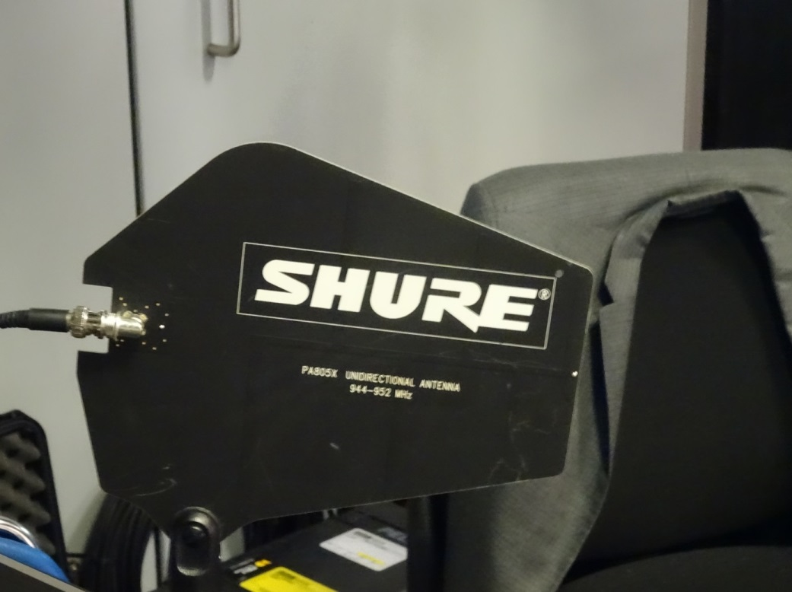
      - Rack containing Receivers
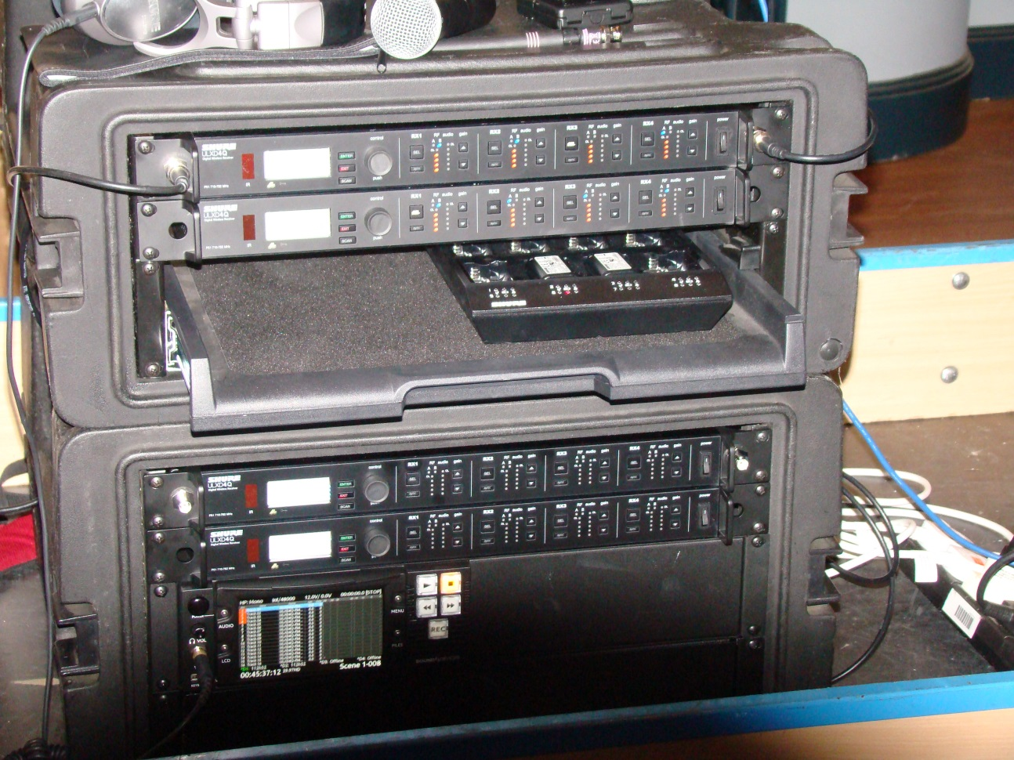

      - Transmitters
Antennas consisted of half wave omnidirectional
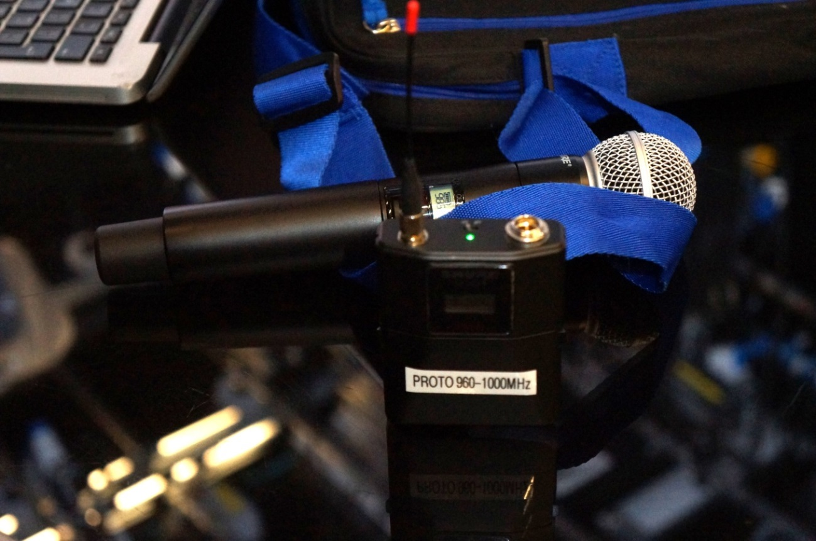

    - Wisycom
The Wisycom equipment uses a traditional FM carrier occupying a nominal bandwidth of 200 kHz. As such, it matches the technical characteristics assumed in the initial Ofcom technical work.
The equipment comprises a pocket belt pack (MTP40S) and a dual channel receiver (MKR 960). 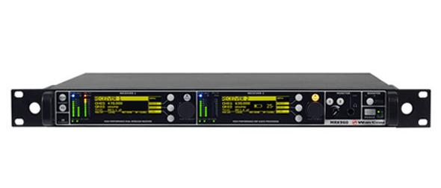 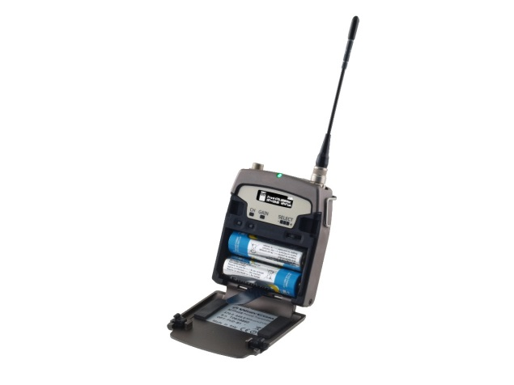
  - Spectrum Identification
DME can be considered (for spectrum availability) very similar to the situation within the broadcasting band 470-694 MHz in that both DME and a TV transmitter are:
- at a fixed geographical location
- have a defined coverage area
- operate on defined frequencies
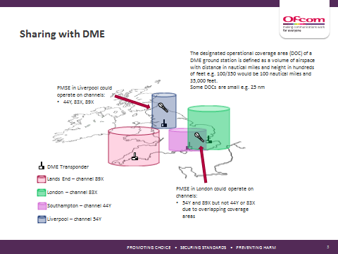
Therefore, the approach by Ofcom was to generate a “map” of available spectrum at a given location by considering both interference to aeronautical services and to PMSE use over the 960-1164MHz band. The calculation needs to consider all aeronautical services which may be affected in the UK and elsewhere in the Europe. Channels were then labelled:
- OK
- Taboo
- Or showed the potential interference to PMSE
In addition to an Excel table, the tool produces graphs that are coloured to indicate spectrum quality and availability:

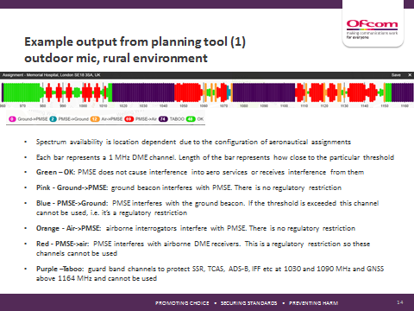

The map below shows the geographical reach of the tool, indicating the various DME stations across Europe that have been considered and protected using the parameters agreed within the UK when calculating the availability of interleaved secondary use spectrum for audio PMSE.
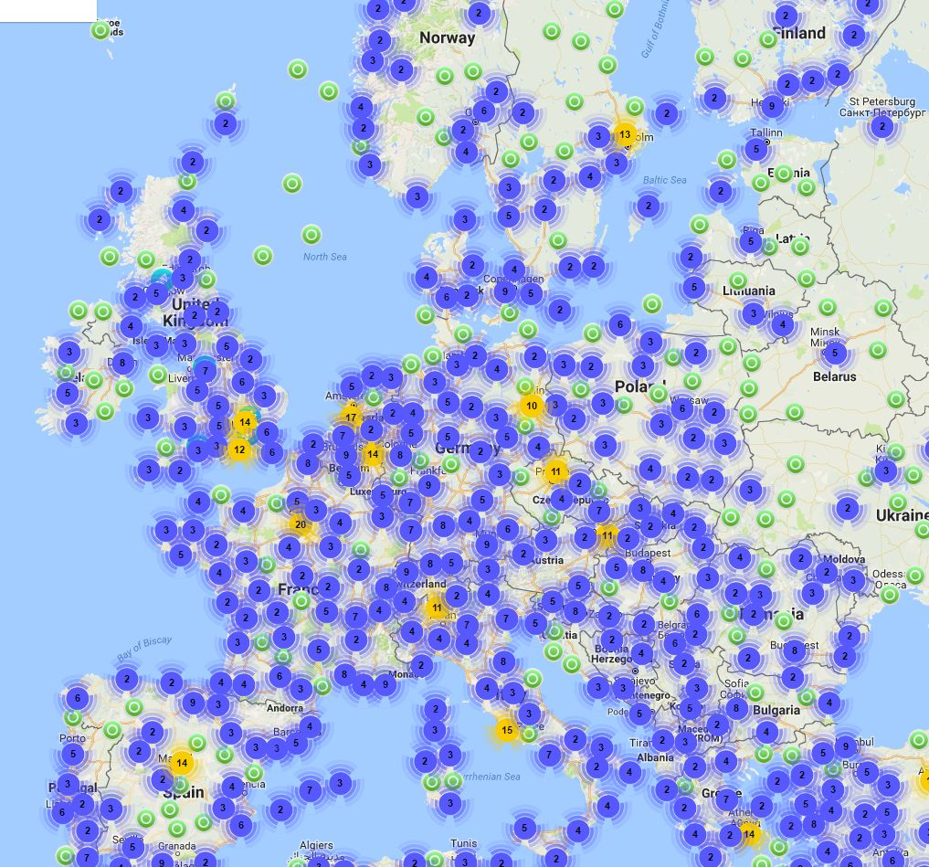

Spectrum plots – 17 dBm
Mailbox – 78 MHz available of which 15 MHz at risk of interference into PMSE from airborne
The graph above is for the BBC studios at the Mailbox in central Birmingham.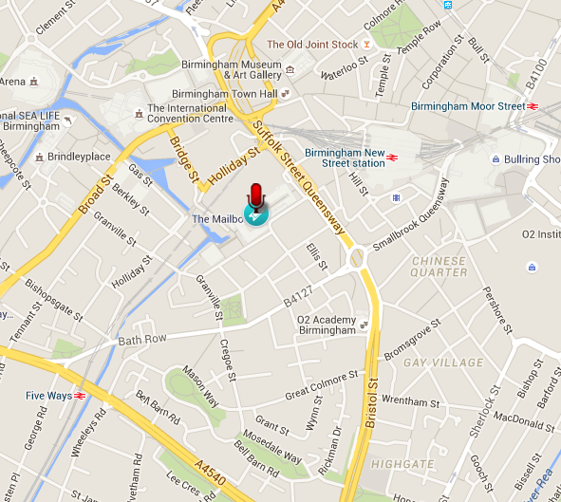
    - Spectrum availability
For these trials Shure prototype equipment was used, which could be tuned over the range 960 to 1000MHz. Despite these restrictions, the test and development licences calculated by Ofcom still had between 24-31MHz of available spectrum between 960-1000MHz. The total availability at each site is shown in the graphs attached to each site
Availability Sky studio
Sky, Osterley – 60 MHz available of which 8 MHz was indicated with a risk of interference to PMSE from airborne.

Indoor
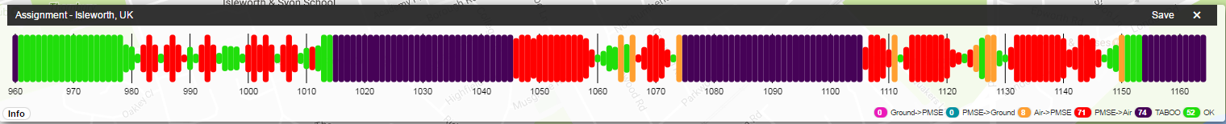
Outdoor
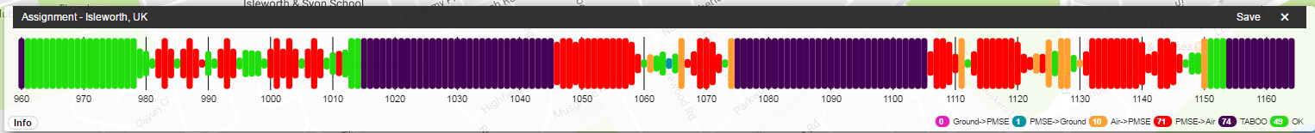

  - Mailbox Studios
This was the first location of the trials and the majority of activity was within the studio.
Annex C shows the Excel table generated by the tool for the Mailbox in Birmingham
Conclusions:
DME band noise floors appear comparable to UHF band
– Lower 40-50MHz of the 960-1164MHz band, generally clear of aeronautical transmissions and
Indoor use possible at most locations
– Upper part of band has intermittent transmissions from over flying
Aircraft which are attenuated indoors
• Prototype PMSE equipment performance similar to usual UHF-band Equipment
No interference to the PMSE use
    - BBC Studio, “The Mailbox”
The BBC’s Birmingham studios are located in a shopping mall in the central part of Birmingham

There are some interesting and familiar Inhabitants of the studio!
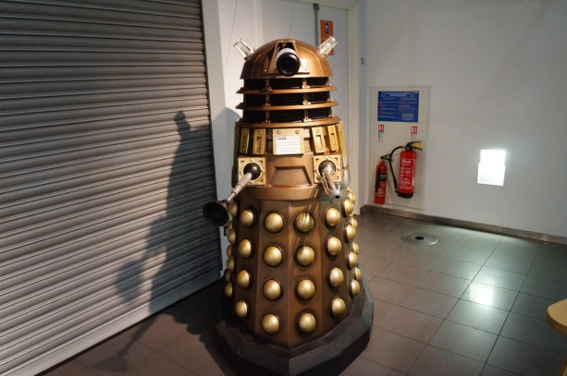

Birmingham is typical of many TV Studios and is a potentially challenging environment for radio microphone use with significant metal clutter required for lighting, air conditioning and camera pedestals.
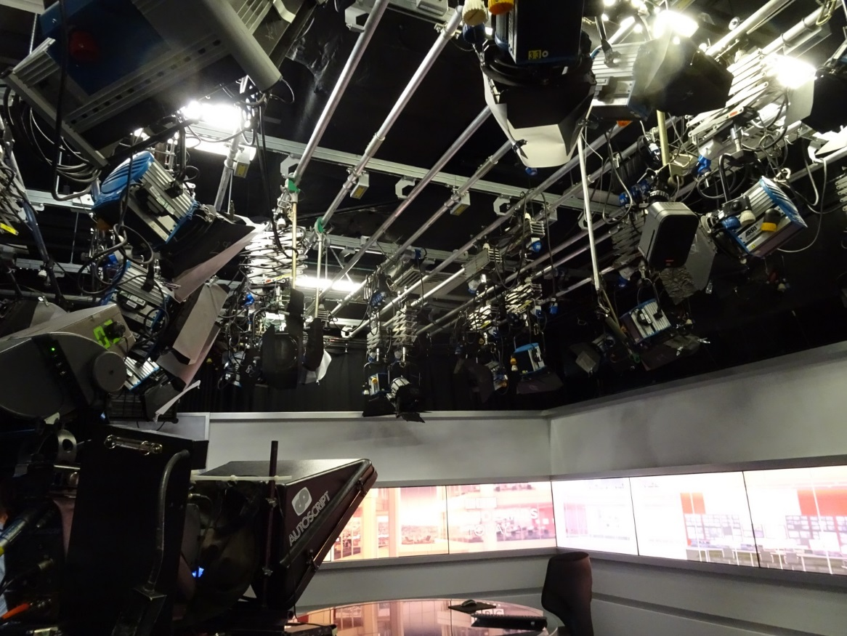
    - Mailbox Monitoring Scans
Indoor
This scan shows the 3 radio microphones deployed in the Mailbox regional news TV studio. The measured noise floor is around –93 dBm / 300 kHz (-148 dBm/Hz) which is dominated by the noise figure of the spectrum analyser (pre-amp off). Other discrete spurs are related to EMI within the studio space.

Outdoor
A scan of the band outdoors reveals a noise floor in the quiet parts of the band of -102 dBm / MHz (-162 dBm /Hz).

    - A Scan from Surrey
Max hold scan (outdoors)
The outdoor scan below was taken in Surrey and reveals little activity in the band 960 – 1020 MHz.

    - Birmingham Airport
Birmingham Airport is situated some 6.3 miles from the studios. It has a passenger count of 10,187,122 per year and is at an elevation of some 100 m. It is the seventh busiest airport in the UK.
The table below identifies the spectrum use for the airport.
Frequency [MHz] | Type | Relative Interference [dB] | Beacon | Channel
995 | PMSE->Air | -19.3 | BIRMINGHAM/BIRMINGHAM | 38X
995 | PMSE->Air | -19.3 | BIRMINGHAM/BIRMINGHAM | 38X
996 | OK
996 | PMSE->Air | -10.3 | BIRMINGHAM/BIRMINGHAM | 38X
996 | PMSE->Air | -10.3 | BIRMINGHAM/BIRMINGHAM | 38X
997 | OK
997 | PMSE->Air | -1.3 | BIRMINGHAM/BIRMINGHAM | 38X
997 | PMSE->Air | -1.3 | BIRMINGHAM/BIRMINGHAM | 38X
998 | NO
998 | PMSE->Air | 12.7 | BIRMINGHAM/BIRMINGHAM | 38X
998 | PMSE->Air | 12.7 | BIRMINGHAM/BIRMINGHAM | 38X
999 | NO
999 | PMSE->Air | 51.7 | BIRMINGHAM/BIRMINGHAM | 38X
999 | PMSE->Air | 51.7 | BIRMINGHAM/BIRMINGHAM | 38X
1000 | NO
1000 | PMSE->Air | 12.7 | BIRMINGHAM/BIRMINGHAM | 38X
1000 | PMSE->Air | 12.7 | BIRMINGHAM/BIRMINGHAM | 38X
1001 | OK
1001 | PMSE->Air | -15.8 | JERSEY/JERSEY | 40X
1001 | PMSE->Air | -2.3 | BIRMINGHAM/BIRMINGHAM | 38X
1001 | PMSE->Air | -2.3 | BIRMINGHAM/BIRMINGHAM | 38X
1002 | PMSE->Air | -11.3 | BIRMINGHAM/BIRMINGHAM | 38X
1002 | PMSE->Air | -11.3 | BIRMINGHAM/BIRMINGHAM | 38X
1002 | PMSE->Air | -12.7 | ROTTERDAM | 41X
1003 | OK
1003 | PMSE->Air | -19.3 | BIRMINGHAM/BIRMINGHAM | 38X
1003 | PMSE->Air | -19.3 | BIRMINGHAM/BIRMINGHAM | 38X
1062 | PMSE->Ground | -16.36 | BIRMINGHAM/BIRMINGHAM | 38X
1062 | PMSE->Ground | -16.36 | BIRMINGHAM/BIRMINGHAM | 38X

    - Airport Monitoring
In addition to the spectrum monitoring at The Mailbox, measurements were taken adjacent to the runway at Birmingham airport to investigate the characteristics of the DME signals.
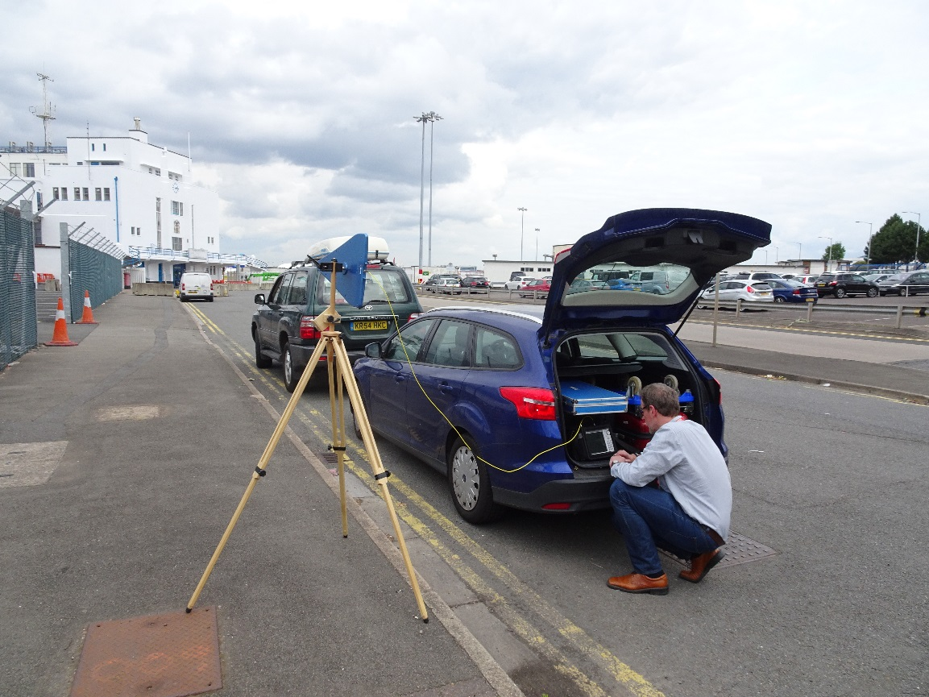

    - Airport Monitoring Antenna
Measurements were made with a broadband log periodic antenna having an antenna gain of approximately 4.5 dBi over the DME band 960 – 1164MHz.
    - Airport Monitoring Scans
The trace below was recorded using a zero span sweep with a resolution bandwidth of 1MHz. It shows the 40 ms pulses from the ground- based DME equipment at the airport.

A longer time base shows the DME pulses from the ground-based equipment responding to airborne interrogators with a typical spacing of 1ms.

  - BBC Elstree Studio
The studios are located some ten miles north of central London and initially operated as film studios in 1924. They are currently primarily used by the BBC for TV productions including soap operas and light entertainment shows. As can be seen from the studio photo, the construction is concrete walls, typically 0.5 m thick with large steel girders supporting the roof structure.
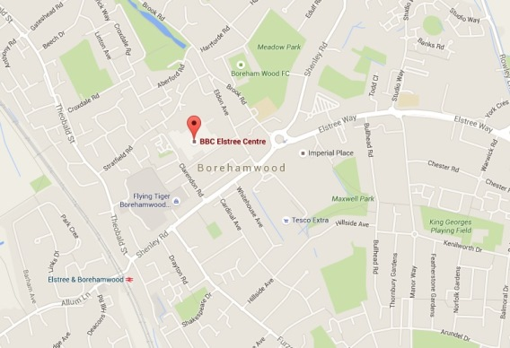

Conclusion
The results from the PMSE trials have been favorable. No interference to the PMSE use was noted either in the heavily shielded indoor tests or in outdoor use.
    - Spectrum Availability
The Elstree plot shows 60 MHz of available spectrum of which 9 MHz is at risk of interference from airborne DME use.
    - Studio construction
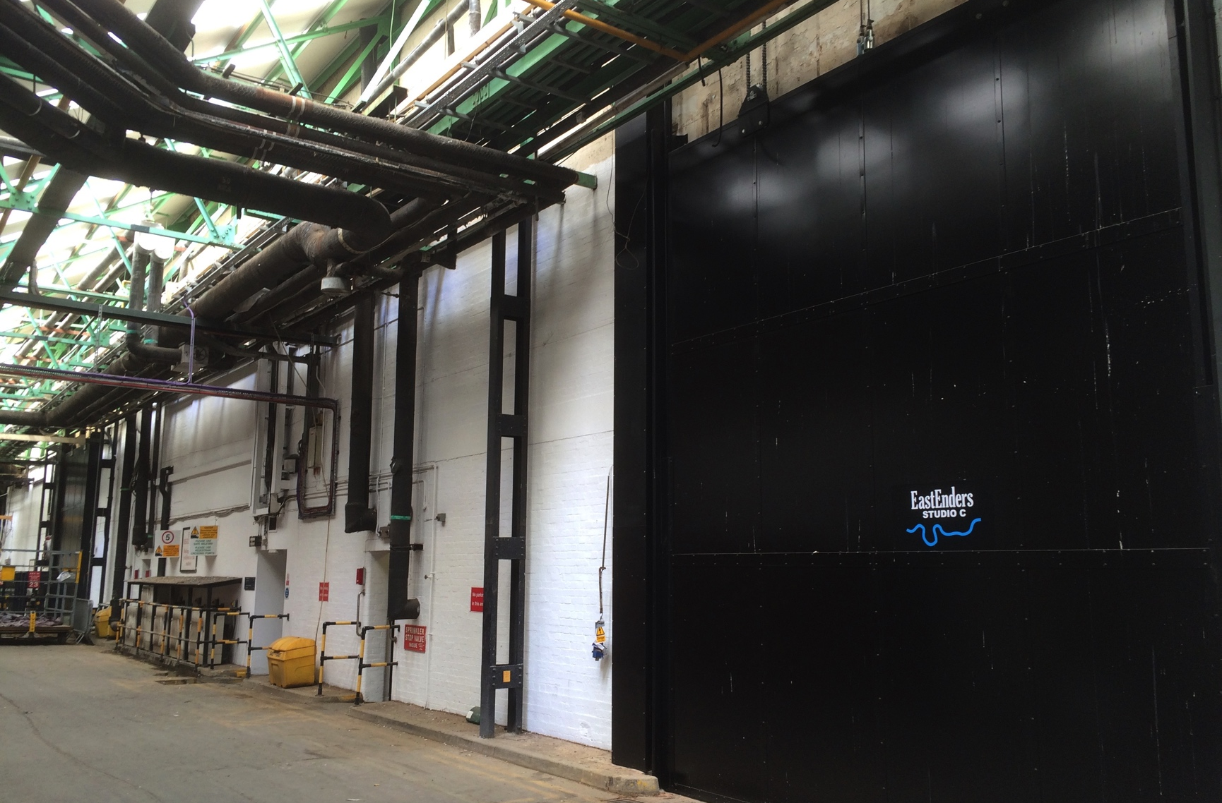

    - Studio used for PMSE Testing
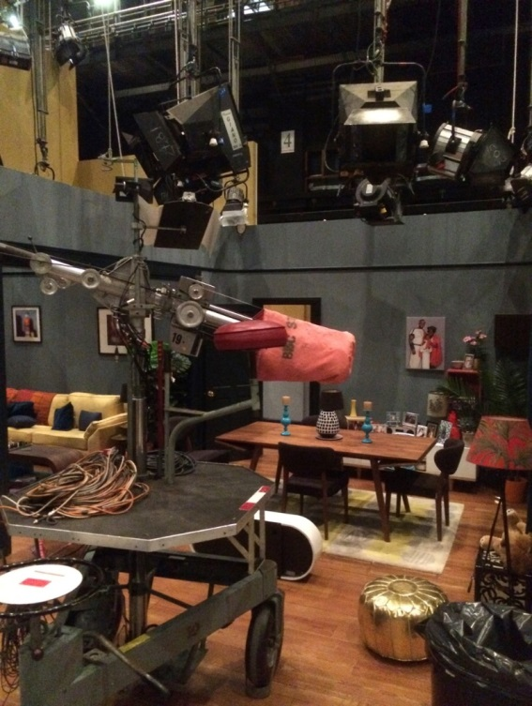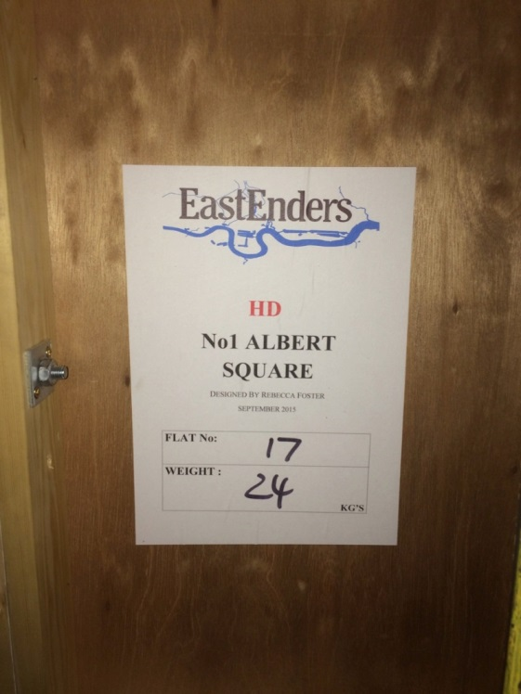

The environment for radio propagation in these studios is limited by the lighting and other overhead metal units but helped by the wooden construction of the sets. A studio at Elstree typically contains either a single large set for light entertainment programmers or in this case some 10-20 smaller sets representing various rooms in a house and other locations for a TV soap opera.

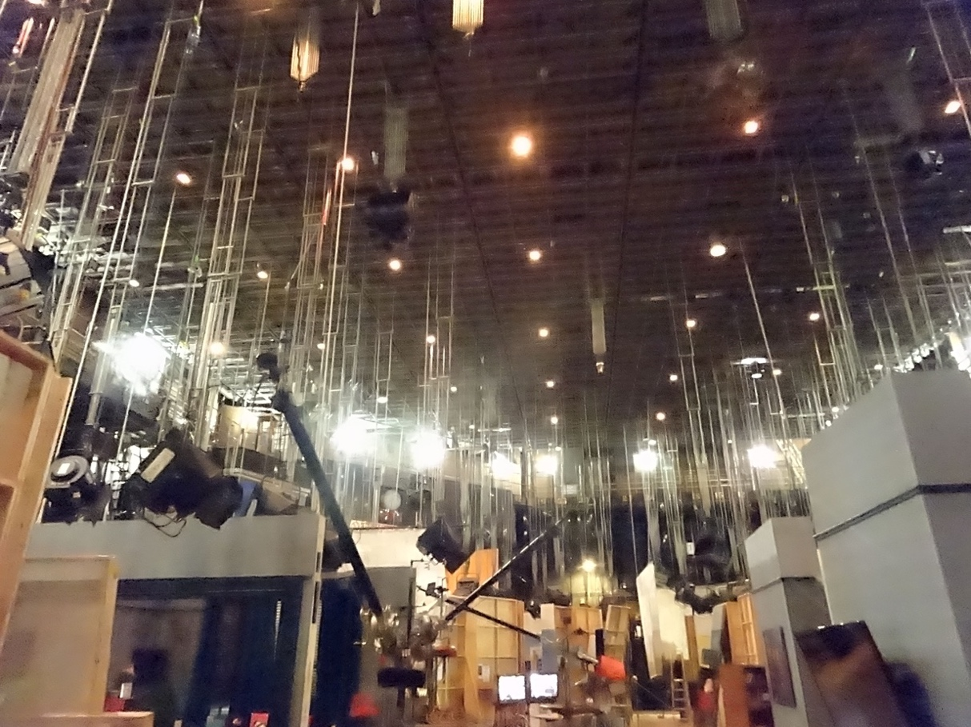

    - Equipment Location
The receive equipment was located outside the sets of the soap opera programme.
Note a pair of vertically polarized log periodic antennas were used in a diversity arrangement, which is typical in professional audio PMSE deployments.
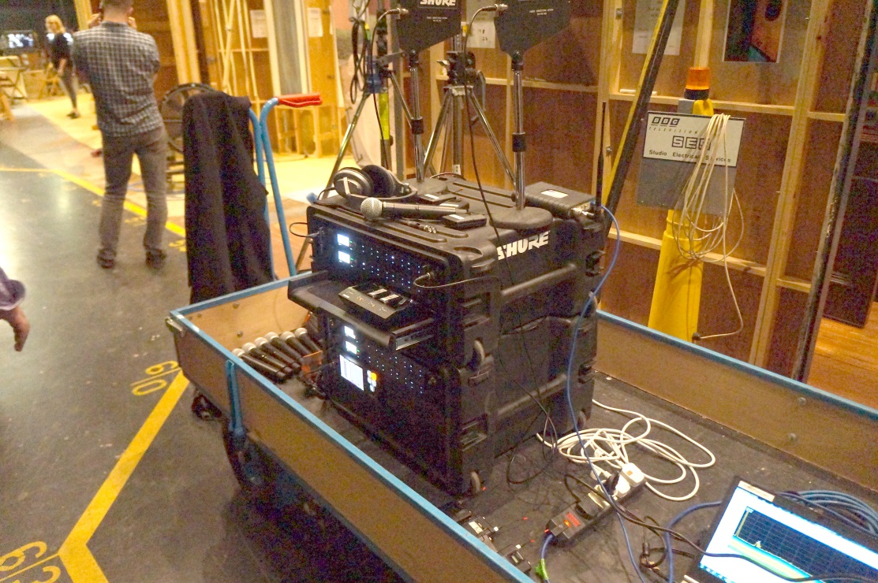

    - Band Scans
The spectrum scan indicated similar noise floors within the DME band to those experienced in the TV band (470 – 790 MHz). DTT usage from the Crystal Palace transmitter (CP) can be seen at the lower end of the TV band. LTE-800 and GSM-900 mobile signals are also clearly visible.

  - Cambridge Theatre Seven Dials
Located in the heart of London’s theatre land, this was also the site of Ofcom testing.

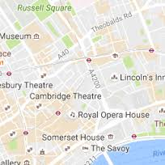
It is under the Heathrow flight path and the spectrum allocation needs to consider all the surrounding seven airports. For practical space reasons the equipment was located at row C of the stalls and in addition to using radio microphones on the stage members of the team walked around the three levels of the theatre to ensure both adequate coverage and a higher link budget which would increase the risk of interference.
Conclusion
No interference was noted during testing
    - Spectrum availability
Cambridge Theatre – 61 MHz available of which 10 MHz at risk of interference into PMSE from airborne
    - Seating plan of the Theatre
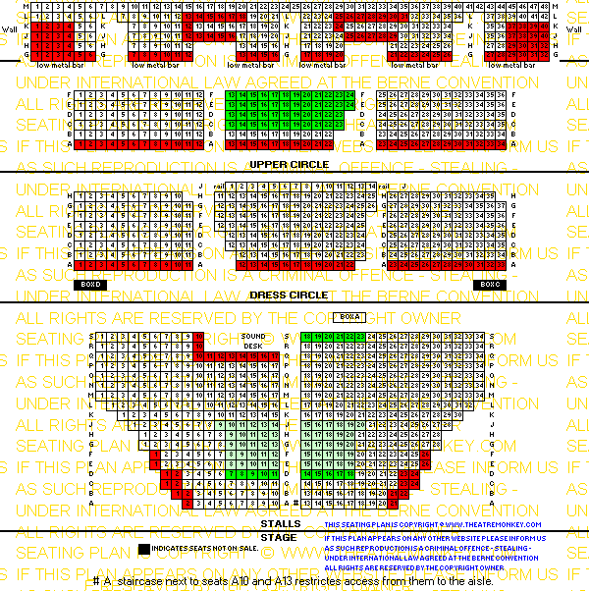
    - Equipment location
Located at row C of the stalls
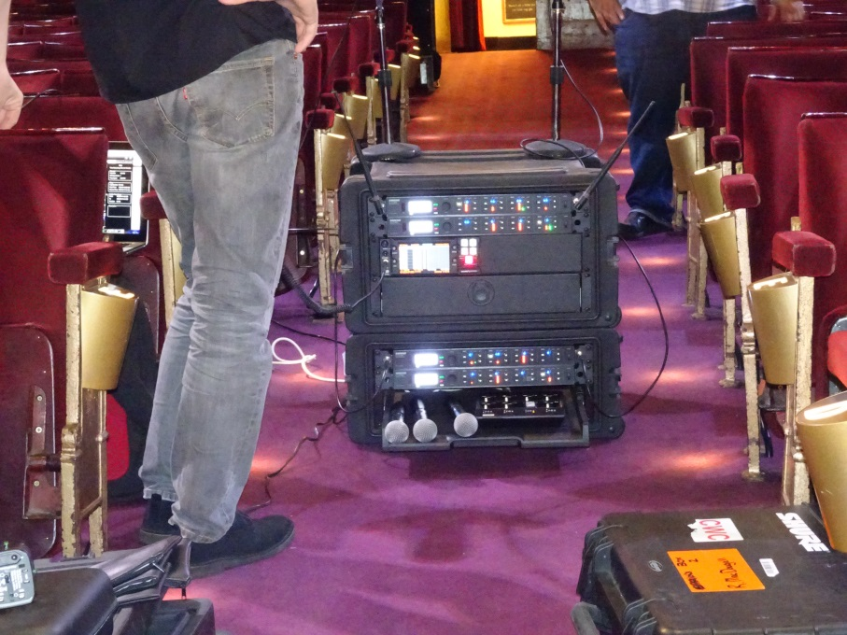



In addition to using radio microphones on the stage members of the team walked around the three levels of the theatre to ensure both adequate coverage and a higher link budget which would increase the risk of interference.

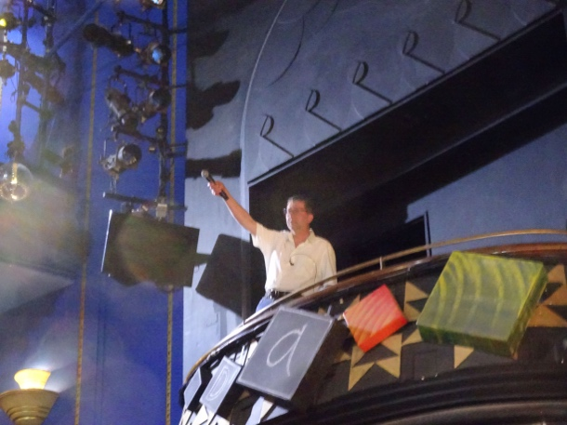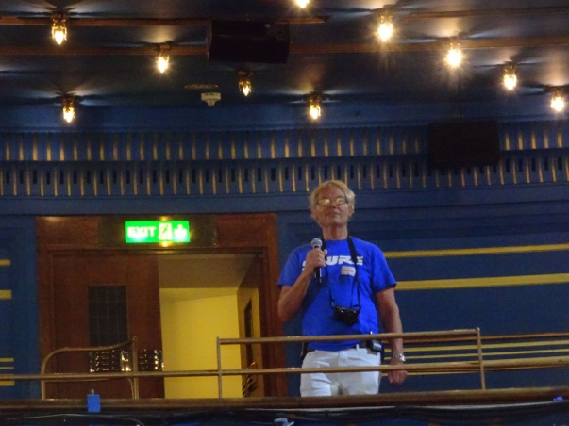

  - Sky Studios
Sky Studios are located some 9 km from Heathrow Airport and dependent on the direction of the wind have aircraft passing at low altitude every 1-3 minutes and is the worst case site in these trials for aircraft movement

Conclusions
No interference experienced
DME band noise floor (960 -980MHz) typically < -108dBm in 300 kHz BW
Measurement limited by MS2830A analyzer DANL
DTT band noise floor typically higher (-105 -> -90dBm in 300 kHz)
Set by intermodulation or IEM / Talkback OOB
DME airborne signals attenuated by studio
964 -990MHz very clean, even outdoors
The lower part of the DME band, especially 961-990 MHz, looks considerably cleaner than UHF PMSE spectrum - although this may be due in part to lower levels of local PMSE activity in the new band.
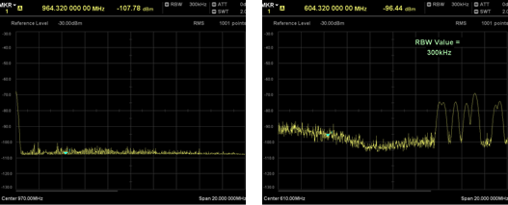
The prototype Shure equipment performed well in the tests.
Parts of the new band from 960-1164 MHz are therefore likely to be useful in some circumstances for PMSE use.
Further long term testing would be beneficial in building confidence in the new band so that a more complete picture of possible interference / use by incumbents can be assimilated.

    - Spectrum availability
Sky, Osterley – 60 MHz available of which 8 MHz at risk of interference into PMSE from airborne
Indoor

Outdoor: limited by possible interference to PMSE
    - Noise floors
      - Antennas
A broadband bi-cone was used for the logging. The chosen device was a Schwarzbeck BBUK 9139 Biconical + UBAA 9134 Balun. This has a nominal gain of -6 dBi gain over DME band
      - DME Band
Using the max-hold function of the analyser, revealed quiet spectrum in the band 960 – 1020 MHz. The DME interrogator signals are clearly seen on the right-hand trace with a separation of 1MHz.
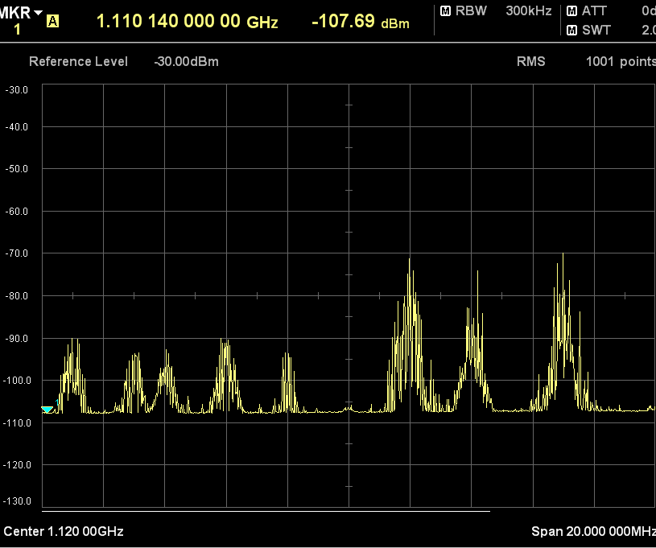
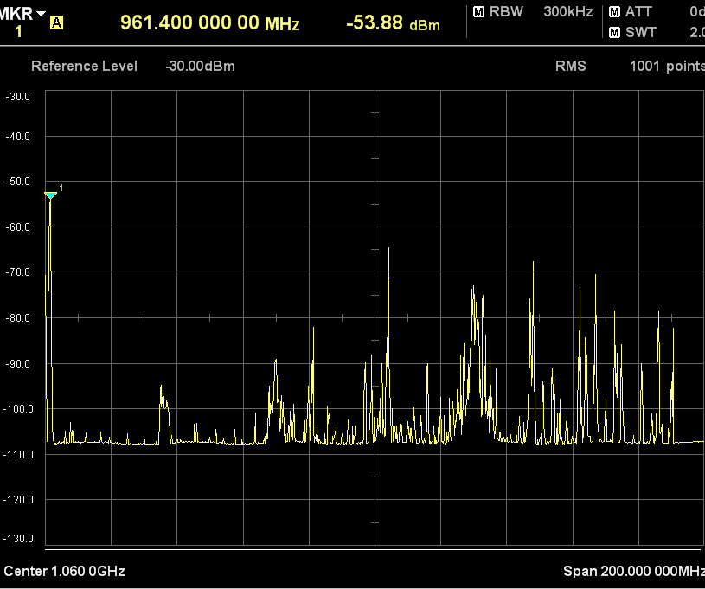

      - Measurement Noise Floors
Two analysers were used for the measurements and the analyser noise floor parameters are given below. With the pre-amp enabled, the DANL indicated a pre amp noise figure < 12dB.
Anritsu MS2830A
- DANL -108 dBm , 300 kHz RBW, Preamp on, 0 dB Att
- NF = -108 – (-174 + 10* log10(300e3)) = 11.2 dB
Anritsu MSS2034B
- DANL = -112 dBm, 100 kHz RBW, Pre-amp on, 0 dB Att
- NF = -112 – (-174+10*log10(100e3)) = 12 dB
    - Test Location
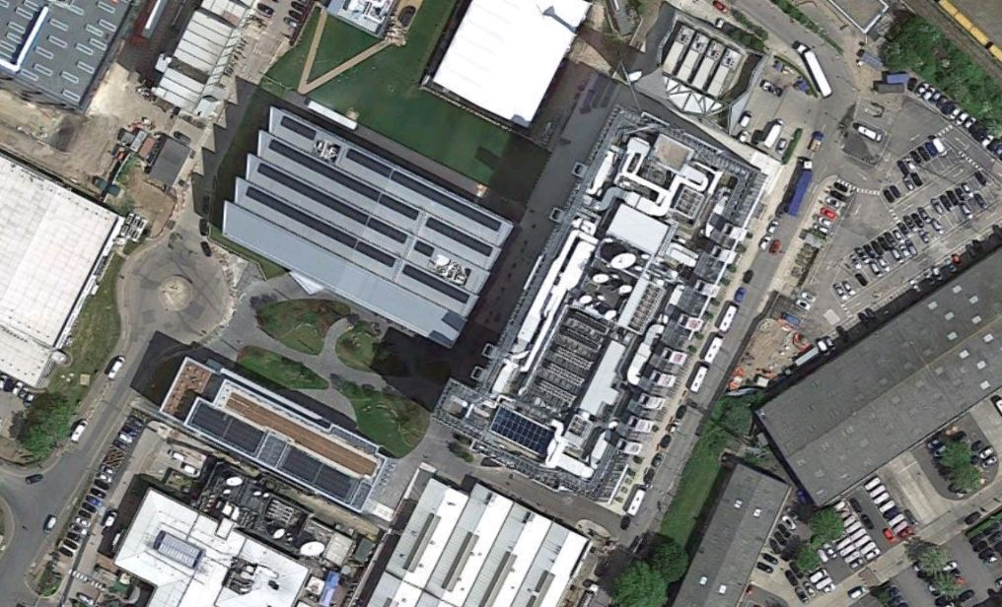
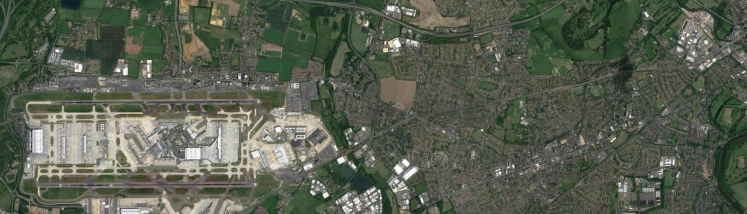
Studio 7
Sky Studios
Sky UK, Osterley
TQ 163 779

The studios are located 9km from London Heathrow Airport

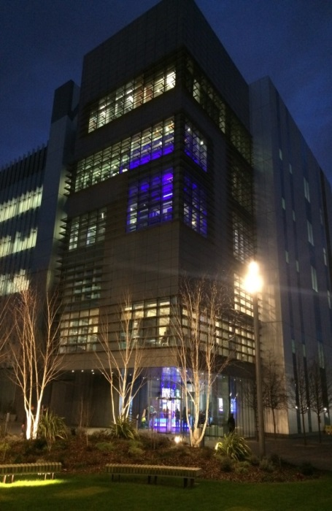
Sky Studios Building
Testing took place in Studio 7
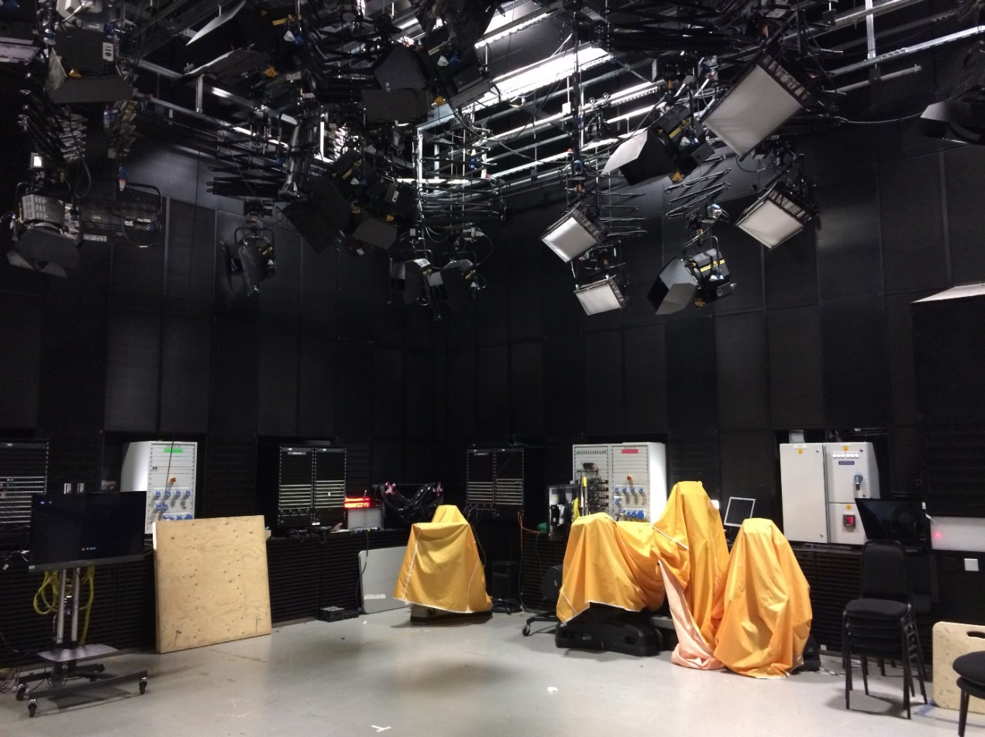
    - TEST 1 19th December 2016
Investigation into the RF environment at Sky were conducted by Mark Waddell , a lead engineer at the BBC
Conclusions:
DME band noise floor (960 -980 MHz) typically < -108 dBm in 300 kHz BW
– Measurement limited by MS2830A analyser DANL
DTT band noise floor typically higher (-105 -> -90 dBm in 300 kHz)
– Set by intermodulation or IEM / Talkback OOB
DME airborne signals attenuated by studio
– 964 -990 MHz very clean, even outdoors
    - TEST 2 5th January 2017
Investigation into operational aspects of Shure equipment
Conclusions:
The Shure equipment operating in 961-981 MHz behaves broadly similarly to Sky’s existing Sennheiser equipment operating in 682-687 MHz in operational terms.
The Shure equipment can operate at significantly higher channel densities.
    - Live Broadcast use 2018
Sufficient confidence has now been gained in the viability of the spectrum for live use of the equipment the following programs have been completely produced using the licenced spectrum whilst many others have part used this spectrum in conjunction with other UHF spectrum. Trails continue
Premier League Predictions Friday 2nd February 1hr
The Offload Wednesday 7th February 1hr
The Debate Wednesday 7th February 1hr
EFL Matters Thursday 8th February 1hr
The Debate Thursday 8th February 1h
The Offload Wednesday 14th February 1hr
The Debate Wednesday 14th February 1hr
EFL Matters Thursday 15th February 1hr
E Champions 10th May 6hr
    - Overall conclusions:
The lower part of the DME band, especially 961-990 MHz, looks considerably cleaner than UHF PMSE spectrum - although this may be due in part to lower levels of local PMSE activity in the new band.
The prototype Shure equipment performed well in the tests.
Parts of the new band from 960-1164 MHz are therefore likely to be useful in some circumstances for PMSE use.
Further long term testing would be beneficial in building confidence in the new band so that a more complete picture of possible interference / use by incumbents can be assimilated.
Sufficient confidence has now been gained in the viability of the spectrum that from early in 2018 the equipment has be used in live productions with programs lasting up to six hours without any interruptions or interference, this continues
Caveats
- Operational testing was limited to frequencies not in use for DME.
- Reliable spectrum analysis tools were not available during Test 2.
- The utility of the new band to PMSE equipment users will be determined by a number of factors including availability of suitable, affordable equipment on the market.
  - BBC Pacific Quay Studio
BBC Pacific Quay is BBC Scotland's television and radio studio complex at Pacific Quay, Glasgow, Scotland. Opened by then Prime Minister Gordon Brown in August 2007, the studios are home to BBC Scotland's television, radio and online services and the headquarters of the BBC in Scotland.
The studios are located adjacent to the Glasgow Science Centre, across the river from the Scottish Exhibition and Conference Centre and adjacent to the studios of commercial broadcaster STV. The new building is one of the most modern digital broadcasting facilities in the world, complete with the BBC's first HD-capable newsroom.
There are three main television studios based at BBC Pacific Quay.
Studio A is the largest television studio at the complex with 8,417 sq ft of studio floor space. It can easily accommodate studio audiences of up to 320.
Studio B is the small to medium-sized studio with 2,594 sq ft of studio floor space. Small studio audiences of up to 100 can be accommodated in Studio B.
Studio C is the smallest studio and is the home to BBC Scotland's flagship news programme "Reporting Scotland". The studio has 1,938 sq ft of studio floor space. This studio is used for local news, politics and current affairs programming for BBC Scotland and is therefore not usually available for use by other productions.

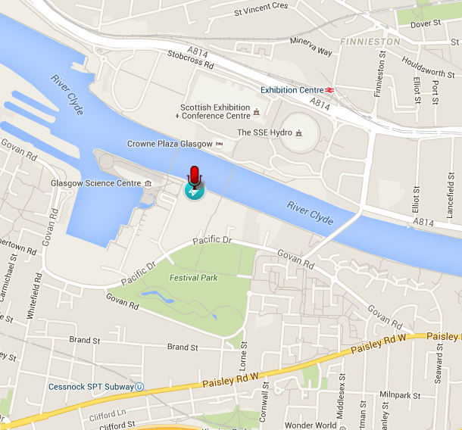
Conclusions
No interference noted, same comments as previously
    - Spectrum Availability

    - Spectrum Scan Roof September
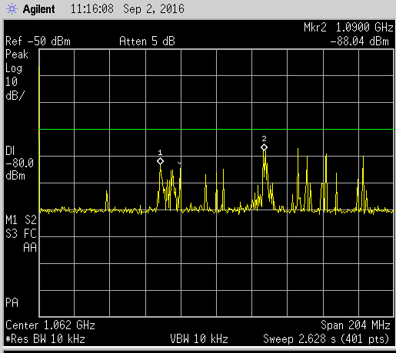

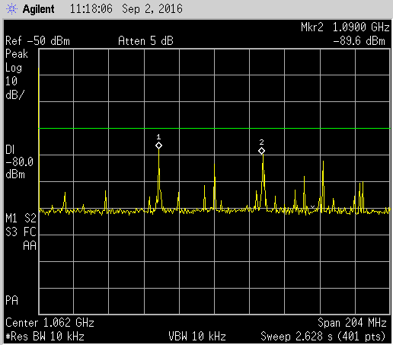

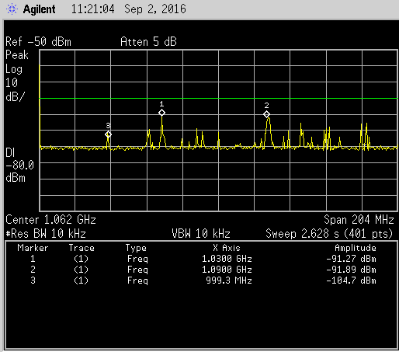
    - PQ Studio C September 1st: 4 Shure mics.GIF
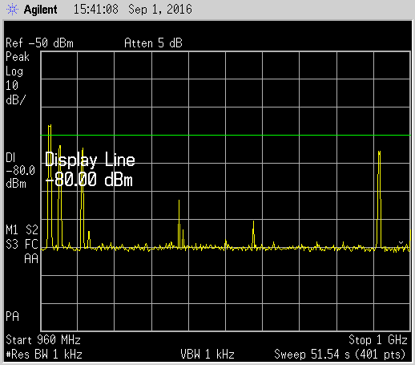

    - PQ inside Window

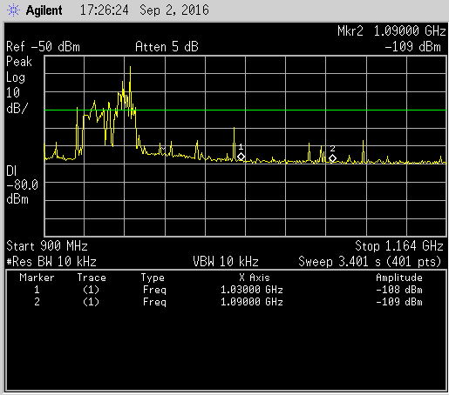
  - Monitoring and Transmissions at Edgcott
Edgcott is located to the west of London and some 20 miles north of Oxford, approximately 50 miles from both Heathrow and Birmingham Airports; it is also on route from a number of military airfields and has acrobatics taking place overhead on a regular basis.
    - Spectrum Availability
    - Monitoring
From June 2016 monitoring has taken place initially using a Marconi 2390 and a USB spectrum analyser, from mid-2017 adding a Shure UXLD4Q receiver, antennas have been located externally to the building. Time spans have been between a few hours to continuous monthly cycles
From March 2017 an Ofcom T&D license has enabled occasional transmissions using the Shure equipment; performance has been similar to equivalent models using the 470-694MHz band
Using the Ofcom spectrum plot above, the green spectrum has been interference free and no noticeable interference on the orange spectrum.
Since May 2018 additional Shure transmitters have been in use, no interference or interruptions have been seen for either indoor or outdoor use in spite of often heavy military presence from local airfield.
In January 2019 a commercial license was issued by Ofcom and the 10 channels identified in the license have been in use both indoor and outdoor. Increased military flights have been noted since February but no interference has been received

Conclusion
Use of PMSE at this location is practical using the Ofcom plot and license
  - Wisycom 960-1164 MHz Testing
The transmitter equipment was tested for compliance against the EN 300 422-1 block edge mask that defines the permitted level of out of block emissions. The equipment has a clean spectrum which is compliant with the mask.
  - Shure ULXD equipment

AXIENTTM 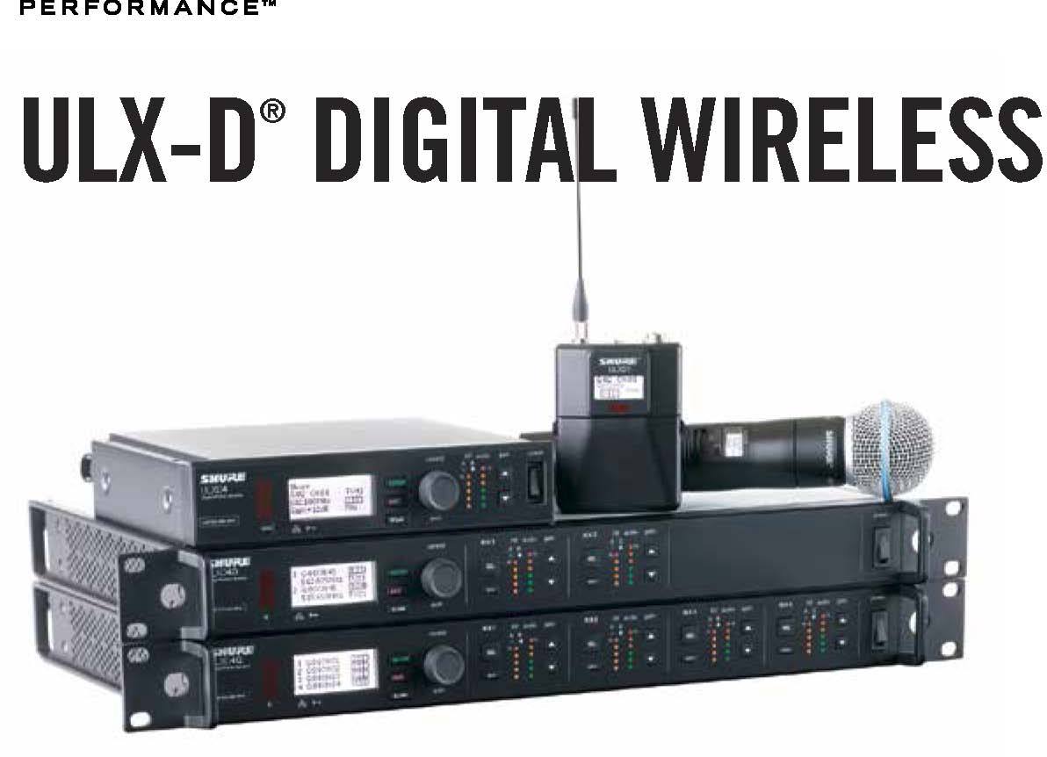
Shure ULX-D® Digital Wireless offers uncompromising 24-bit audio clarity and extremely efficient RF performance with single, dual, and quad channel receivers for any size professional sound reinforcement application. Generations ahead of any other available system in its class, ULX-D brings a new level of performance to professional sound reinforcement.
Uncompromising Professional Digital Wireless
- 24-bit/48 kHz digital audio that delivers incredibly clear and accurate sound reproduction
- 20 Hz – 20 kHz frequency range with flat response
- Greater than 120 dB dynamic range
- Wide selection of trusted Shure Microphones
Extremely Efficient and Reliable RF Performance
- Up to 64 MHz overall tuning range (region dependent)
- Up to 17 active transmitters in one 6 MHz TV channel (23 on an 8 MHz TV channel)
- High Density mode enables up to 47 active transmitters in one 6 MHz TV channel
- Rock-solid signal stability with no audio artefacts over the entire 100 meter range
- Optimized scanning automatically finds, prioritizes, and selects the cleanest frequencies available
Scalable, Intelligent Hardware
- Single (half-rack), Dual and Quad (full-rack) receiver form factors
- AES 256-bit encryption equipped for secure wireless transmission
- Dante™ digital networked audio over Ethernet
- Wireless Workbench® 6.11.2 compatible for advanced coordination, monitoring and control; features Site Survey tool for scanning frequencies in the 902-928 MHz ISM band
- Compatible with the Shure SB900 Rechargeable Battery and SBC chargers

ULX-D® System Specifications
RF Carrier Range 470–932 MHz, varies by region (See Frequency Range and Output Power table)
Working Range 100 m (328 ft.) Note: Actual range depends on RF signal absorption, reflection and interference.
RF Tuning Step Size 25 kHz, varies by region
Image Rejection >70 dB, typical
RF Sensitivity -98 dBm at 10-5 BER
Latency <2.9 ms
Audio Frequency Response ULXD1: 20 Hz – 20 kHz (±1 dB) ULXD2: 30 Hz – 20 kHz (±1 dB) Note: Dependent on microphone type
Audio Dynamic Range XLR Analog Output: >120 dB, A-weighted System Gain @ +10 Dante Digital Output (Dual and Quad receivers): 130 dB (typical), A-weighted
Total Harmonic Distortion <0.1% −12 dBFS input, System Gain @ +10
System Audio Polarity Positive pressure on microphone diaphragm produces positive voltage on pin 2 (with respect to pin 3 of XLR output) and the tip of the 6.35 mm (1/4-inch) output.
Operating Temperature Range -18°C (0°F) to 50°C (122°F) Note: Battery characteristics may limit this range.
Storage Temperature Range -29°C (-20°F) to 74°C (165°F) Note: Battery characteristics may limit this range.
.ULXD2 Wireless Handheld Transmitter
Overview
The Shure ULXD2 is a handheld wireless transmitter compatible with ULX-D® Digital Wireless Systems. Offering premium 20 Hz – 20 kHz audio quality, advanced rechargeability options, and a wide selection of interchangeable Shure microphone heads, the ULXD2 delivers uncompromising wireless performance for professional sound reinforcement applications. The ULXD2 is offered with SM58®, SM86, SM87A, Beta 58A®, Beta 87A, and Beta 87C.
- 30 Hz to 20 kHz range with flat frequency response (actual response is microphone dependent)
- >120 dB dynamic range
- 1, 10, and 20 mW selectable RF output power
- 5 segment battery fuel gauge
- Shure lithium-ion rechargeable battery pack provides up to 10 hours of battery life, precision metering, and zero memory effect
- Up to 11 hours continuous use with 2 x AA batteries
- Backlit LCD with easy to navigate menu and controls
- 100 meter (300 ft) operating range
- Rugged metal construction
- Frequency and power lockout

- [APWPT] Impact of PMSE on DME
  - summary
This study investigates audio PMSE sharing radio spectrum with aeronautical systems; Distance Measuring Equipment (DME) and Tactical Air Navigation System (TACAN) in the spectrum band 960 – 1164 MHz. Since TACAN provides the same service and has very similar system characteristics to DME, the interference susceptibility will be comparable. Therefore, it can be reasonably assumed that the same protection criteria will apply to both systems, so for convenience and simplicity, only DME is referred to in this document.
To investigate audio PMSE sharing radio spectrum with aeronautical systems, this study considers several minimum coupling loss calculations.
The types of audio PMSE use investigated are:
- handheld audio PMSE
- body worn audio PMSE

Each of these devices are considered in different environments (urban, sub-urban and rural), in outdoor and indoor cases. Minimum and median values are considered for the body loss. Only the co-frequency case is considered. It should be note that PMSE operated co-frequency with DME/TACAN in close vicinity are expected to be interfered. Therefore, PMSE are not expected to be operated co-frequency in the vicinity of DME/TACAN.

Table 1: Summary
PMSE interference into aeronautical systems | Required co-frequency separation distance (Gnd Receiver) | Required co-frequency separation distance (Air Receiver) | Comment
PMSE interference to DME | from* 0.2 to 27.8 km | from* 47.3 to 305.2 km | For Handheld (outdoor)
PMSE interference to DME | from* 0.1 to 15.7 km | from* 11.5 to 96.5 km | For Handheld (indoor)
PMSE interference to DME | from* 0.1 to 22.6 km | from* 28.8 to 192.6 km | For Body Worn equipment (outdoor)
PMSE interference to DME | from* 0.1 to 12 km | from* 0 to 60.9 km | For Body Worn equipment (indoor)
*Note: the wide ranges reflect the variability in the use cases.

  - PMSE parameters
Table 2: Parameters for handheld audio PMSE
Parameter | Unit | Value | Reference
Bandwidth (BW) | MHz | 0.2 | ECC Report 253
Antenna transmit height | m | 1.5 | ECC Report 253
Antenna receive height | m | 2
Body effect | dBd  dBi | 0 dB (minimum)  6 dB (median) | ECC Report 286
Modelled e.i.r.p | dBm | 13 | ERC/REC 70-03, Annex 10 and ECC Report 253
Antenna polarisation | NA | Vertical | ECC Report 253

Table 3: Parameters for body worn audio PMSE
Parameter | Unit | Value | Reference
Bandwidth (BW) | MHz | 0.2 | ECC Report 253
Antenna transmit height | m | 1.5 | ECC Report 253
Antenna receive height | m | 2
Body effect | dBd  dBi | 8 dB (minimum)  14 dB (median) | ECC Report 286
Modelled e.i.r.p | dBm | 17 | ECC Report 253 and ERC/REC 70-03, Annex 10
Antenna polarisation | NA | Vertical | ECC Report 253

Note: calculations are provided co-frequency and not for IEM, therefore, those parameters are proposed for removal from this annex.
    - PMSE receiver Parameters

Table 4: Parameters for audio PMSE receivers
Parameter | Unit | Value | Reference
Interference level to protect PMSE | dBm | -81 dBm | See discussion above.
Selectivity | dB | See curve below | ERC Report 63

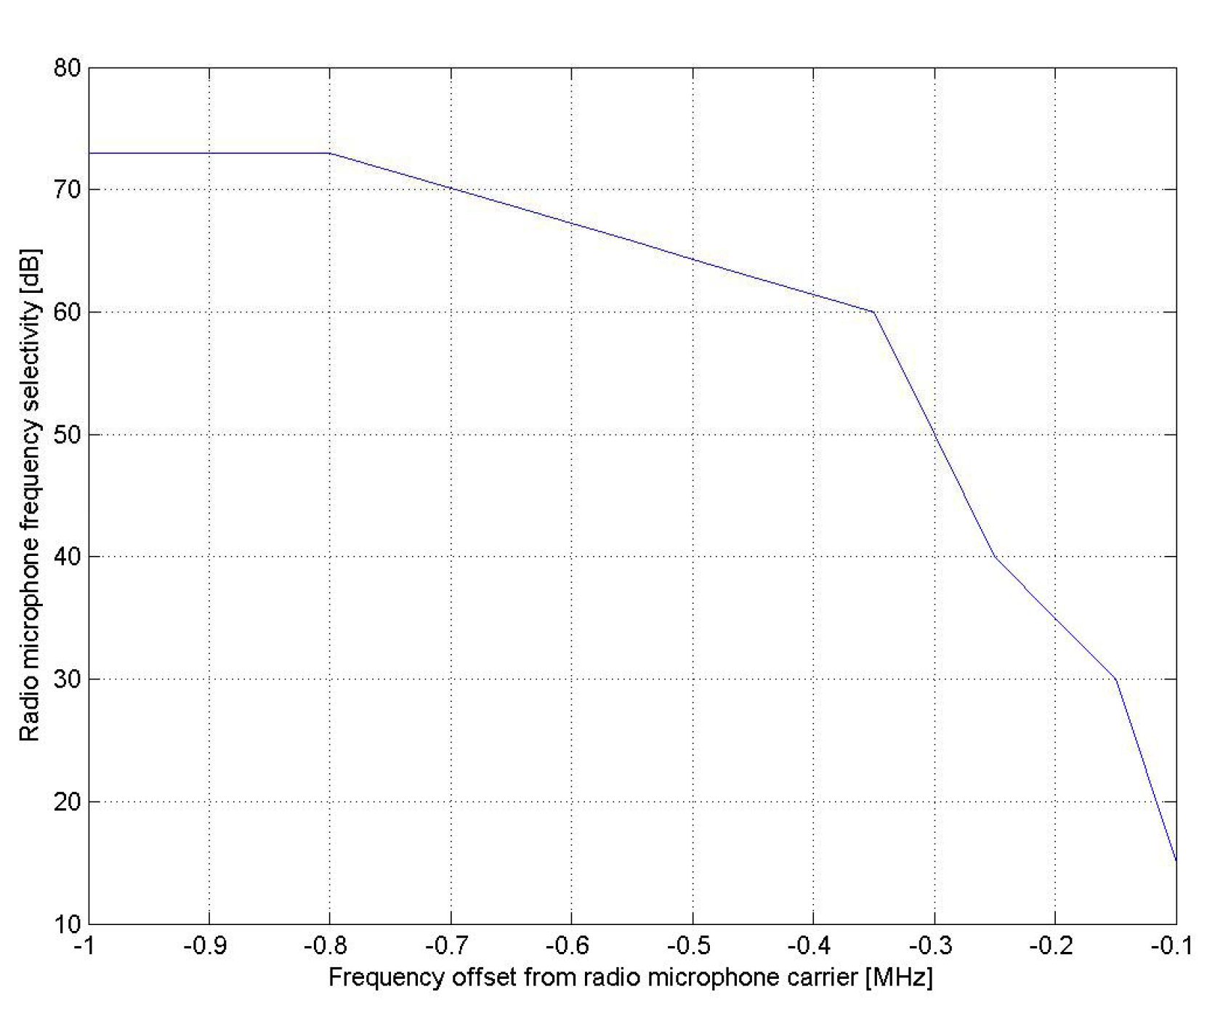
Figure 5: PMSE RF selectivity curves
We expect the receive characteristics, such as antenna receive height, antenna gain and body effect of the body worn and handheld audio PMSE, to be similar to the transmit characteristics, antenna receive height, antenna gain and body effect of the audio IEM and vice versa.
    - Parameters of body loss
For handheld equipment 0 dB (minimum) and 6 dB (median).
For body worn equipment 8 dB (minimum) and 14 dB (median).
    - Parameter for building loss
The PMSE equipment is assumed to be deployed outdoor or indoor with 10 dB attenuation as the equipment is inevitably within a congested stage or similar structure.
  - Propagation model
The propagation model which is considered in the calculations for ground to ground case is the Extended Hata model (see ECC Report 252 – SEAMCAT Handbook). For ground to air, free space is currently considered.
  - DME
    - DME parameters
Table 1: DME/N, DME/P and TACAN parameters used in study
Parameters | Unit | DME/N ground | DME/N airborne | DME/P ground | DME/P airborne | TACAN ground (civil use) | TACAN airborne (civil use)
Transmitter
Frequency range | MHz | 962-1213 | 1025-1150 | 962-1213 | 1025-1150 | 962-1213 | 1025-1150
Bandwidth | MHz | 3.5 | 3.5 | 3.5 | 3.5 | 3.5 | 3.5
Max e.i.r.p. | dBm | 74 | 68 | 75 | 68 | 75 | 69
Mask | N.A. | (see ICAO Annex 10) | (see ICAO Annex 10) | (see ICAO Annex 10) | (see ICAO Annex 10) | (see ICAO Annex 10) | (see ICAO Annex 10)
Receiver
Frequency range | MHz | 1025-1150 | 962-1213 | 1025-1150 | 962-1213 | 1025-1150 | 962-1213
Bandwidth | MHz | 3.5 | 3.5 | 3.5 | 3.5 | 3.5 | 3.5
Noise figure | dB | 4 | 4 | 4 | 4 | 4 | 4
Protection criteria (I/N)  (Note 1) | dB | -10/-20 | -10/-20 | -10/-20 | -10/-20 | -10/-20 | -10/-20
Antenna gain | dBi | max 16 (directional), 12 (omni-directional) | 5.4 | 16 | 5.4 | 12 | 5.4
Antenna pattern |  | [SE7(18)015]
Selectivity
(Note 2)
Note 1: These values are intended for initial studies only, they need further discussion, especially taking into account secondary service (PMSE) vs safety service (ARNS).
Note 2: ACS: ICAO Annex 10, Volume 1: Attachment C, Table C.7 and Table C.8.
    - Modelling assumptions
Two protection criteria are considered in the studies. I/N of -10 dB and I/N of -20 dB.
Three antenna heights are considered for the DME on the ground: 40 m, 25 m, 2.1 m. For the Airborne case, three altitudes are considered: 100 m, 1000 m, 10000 m.
    - Conclusion

Table 3: Results for Hand Held audio PMSE (outdoor) – DME ground station
Body loss | I/N | Environment | DME antenna height
 |  |  | 40 | 25 | 2.1
0 dB | -10 dB | Distances (Rural) km | 15.7 | 11.8 | 2.9
0 dB | -10 dB | Distances (Suburban) km | 4.4 | 3.4 | 0.8
0 dB | -10 dB | Distance (Urban) km | 2.2 | 1.7 | 0.4
0 dB | -20 dB | Distances (Rural) km | 27.8 | 22.1 | 5.5
0 dB | -20 dB | Distances (Suburban) km | 8.7 | 6.6 | 1.6
0 dB | -20 dB | Distance (Urban) km | 4.3 | 3.4 | 0.8
6 dB | -10 dB | Distances (Rural) km | 10.5 | 8.0 | 1.9
6 dB | -10 dB | Distances (Suburban) km | 2.9 | 2.3 | 0.5
6 dB | -10 dB | Distance (Urban) km | 1.5 | 1.1 | 0.2
6 dB | -20 dB | Distances (Rural) km | 20.3 | 15.4 | 3.7
6 dB | -20 dB | Distances (Suburban) km | 5.8 | 4.5 | 1.1
6 dB | -20 dB | Distance (Urban) km | 2.9 | 2.3 | 0.5

Table 3: Results for Hand Held audio PMSE (indoor) – DME ground station
Body loss | I/N | Environment | DME antenna height
 |  |  | 40 | 25 | 2.1
0 dB | -10 dB | Distances (Rural) km | 8.0 | 6.1 | 1.5
0 dB | -10 dB | Distances (Suburban) km | 2.2 | 1.8 | 0.4
0 dB | -10 dB | Distance (Urban) km | 1.1 | 0.9 | 0.2
0 dB | -20 dB | Distances (Rural) km | 15.7 | 11.8 | 2.9
0 dB | -20 dB | Distances (Suburban) km | 4.4 | 3.4 | 0.8
0 dB | -20 dB | Distance (Urban) km | 2.2 | 1.7 | 0.4
6 dB | -10 dB | Distances (Rural) km | 5.3 | 4.1 | 1.0
6 dB | -10 dB | Distances (Suburban) km | 1.5 | 1.2 | 0.2
6 dB | -10 dB | Distance (Urban) km | 0.7 | 0.6 | 0.1
6 dB | -20 dB | Distances (Rural) km | 10.5 | 8.0 | 1.9
6 dB | -20 dB | Distances (Suburban) km | 2.9 | 2.3 | 0.5
6 dB | -20 dB | Distance (Urban) km | 1.5 | 1.1 | 0.2

Table 3: Results for Body Worn audio PMSE (outdoor) – DME ground station
Body loss | I/N | Environment | DME antenna height
 |  |  | 40 | 25 | 2.1
8 dB | -10 dB | Distances (Rural) km | 12.0 | 9.1 | 2.2
8 dB | -10 dB | Distances (Suburban) km | 3.4 | 2.6 | 0.6
8 dB | -10 dB | Distance (Urban) km | 1.7 | 1.3 | 0.3
8 dB | -20 dB | Distances (Rural) km | 22.6 | 17.5 | 4.3
8 dB | -20 dB | Distances (Suburban) km | 6.6 | 5.1 | 1.2
8 dB | -20 dB | Distance (Urban) km | 3.3 | 2.6 | 0.6
14 dB | -10 dB | Distances (Rural) km | 8.0 | 6.1 | 1.5
14 dB | -10 dB | Distances (Suburban) km | 2.2 | 1.8 | 0.4
14 dB | -10 dB | Distance (Urban) km | 1.1 | 0.9 | 0.2
14 dB | -20 dB | Distances (Rural) km | 15.7 | 11.8 | 2.9
14 dB | -20 dB | Distances (Suburban) km | 4.4 | 3.4 | 0.8
14 dB | -20 dB | Distance (Urban) km | 2.2 | 1.7 | 0.4

Table 3: Results for Body Worn audio PMSE (indoor) – DME ground station
Body loss | I/N | Environment | DME antenna height
 |  |  | 40 | 25 | 2.1
8 dB | -10 dB | Distances (Rural) km | 6.1 | 4.7 | 1.1
8 dB | -10 dB | Distances (Suburban) km | 1.7 | 1.3 | 0.3
8 dB | -10 dB | Distance (Urban) km | 0.8 | 0.7 | 0.1
8 dB | -20 dB | Distances (Rural) km | 12.0 | 9.1 | 2.2
8 dB | -20 dB | Distances (Suburban) km | 3.4 | 2.6 | 0.6
8 dB | -20 dB | Distance (Urban) km | 1.7 | 1.3 | 0.3
14 dB | -10 dB | Distances (Rural) km | 4.1 | 3.2 | 0.7
14 dB | -10 dB | Distances (Suburban) km | 1.1 | 0.9 | 0.2
14 dB | -10 dB | Distance (Urban) km | 0.5 | 0.4 | 0.1
14 dB | -20 dB | Distances (Rural) km | 8.0 | 6.1 | 1.5
14 dB | -20 dB | Distances (Suburban) km | 2.2 | 1.8 | 0.4
14 dB | -20 dB | Distance (Urban) km | 1.1 | 0.9 | 0.2

Table 3: Hand Held audio PMSE (outdoor) – Airborne DME - Distances on the ground in km
I/N | DME antenna height (m) | 100 | 1000 | 10000
-10 dB | Body loss 0 dB | 96.5 | 96.5 | 96.0
-10 dB | Body loss 6 dB | 48.3 | 48.3 | 47.3
-20 dB | Body loss 0 dB | 305.2 | 305.2 | 305.1
-20 dB | Body loss 6 dB | 153.0 | 152.9 | 152.6

Table 3: Hand Held audio PMSE (indoor) – Airborne DME - Distances on the ground in km
I/N | DME antenna height (m) | 100 | 1000 | 10000
-10 dB | Body loss 0 dB | 30.5 | 30.5 | 28.8
-10 dB | Body loss 6 dB | 15.2 | 15.2 | 11.5
-20 dB | Body loss 0 dB | 96.5 | 96.5 | 96.0
-20 dB | Body loss 6 dB | 48.3 | 48.3 | 47.3

Table 3: Body Worn audio PMSE (outdoor) – Airborne PMSE - Distances on the ground in km
I/N | DME antenna height (m) | 100 | 1000 | 10000
-10 dB | Body loss 8 dB | 60.9 | 60.9 | 60.0
-10 dB | Body loss 14 dB | 30.5 | 30.5 | 28.8
-20 dB | Body loss 8 dB | 192.6 | 192.6 | 192.3
-20 dB | Body loss 14 dB | 96.5 | 96.5 | 96.0
Table 3: Body Worn audio PMSE (indoor) – Airborne PMSE - Distances on the ground in km
I/N | DME antenna height (m) | 100 | 1000 | 10000
-10 dB | Body loss 8 dB | 19.2 | 19.2 | 16.4
-10 dB | Body loss 14 dB | 9.6 | 9.6 | 0
-20 dB | Body loss 8 dB | 60.9 | 60.9 | 60.0
-20 dB | Body loss 14 dB | 30.5 | 30.5 | 28.8

  - SSR – 1030/1090 systems
Not studied.
  - UAT
Not studied.
  - CNPC
Not studied.
  - LDACS
Not studied.
  - JTIDS/MIDS
Not studied.
  - GNSS
Not studied.
  - Other systems
Not studied.

- [OFCOM UK] MCL study on the impact of the PMSE on DME
  - Summary
This study investigates the audio PMSE sharing radio spectrum with aeronautical systems Distance Measuring Equipment (DME), Tactical air navigation system (TACAN) and Secondary surveillance radar systems (SSR) in the spectrum band 960 – 1164 MHz. Since TACAN provides the same service and has similar system characteristics compared to DME, also the interference susceptibility will be comparable. Therefore, one can assume that the same protection criteria will apply to both systems, so for convenience we will only refer to DME.
The types of audio PMSE use investigated are:
- handheld audio PMSE,
- body worn audio PMSE,
- audio in-ear monitor (IEM).

In addition, this study also considers compatibility between PMSE and GNSS above 1164 MHz assuming a 10 MHz guard band from 1154 MHz. Within this study, three GNSS receiver masks are used (which can be referenced) to demonstrate that the separation distances required primarily depend on the assumption of the GNSS receiver mask. It is highlighted that receiver masks performance (across all the range of GNSS equipment) will vary and may not align with those assumed in this study, however, ETSI Standard EN 303 413 specifies a requirement to meet the adjacent frequency signal power level of -75 dBm at 1154 MHz.
To investigate audio PMSE sharing radio spectrum with the aeronautical systems, this study considers several minimum coupling loss calculations. For the interference scenarios of PMSE interference into DME and SSR, neither a safety margin nor apportionment have been assumed as explained in section A4.3. For PMSE interference into aeronautical RNSS, 6 dB safety margin has been included in accordance with ITU-R Recommendation M.1903.
Table 1: Summary
PMSE interference into aeronautical systems | Required co-frequency separation distance (Gnd Receiver) | Required co-frequency separation distance (Air Receiver) | Guard band
PMSE interference to DME | ~6 km | ~23 km | @ 1 MHz separation:  for transponder separation distances are 0.6 - 3.5 km;  for interrogator separation distances are 3.6 – 8.1 km.  @ 2 MHz separation:  for transponder distances are 0.2 – 2.7 km;  for interrogator distances are insignificant at 2 MHz separation.
PMSE interference to SSR (1030/1090) systems | ~4 km | ~11 km | @ 10 MHz guard band distances are between 200 m to 300 m for both interrogator and transponder.  @ 15 MHz guard band separation distances are negligible.  As it is not possible to coordinate with airborne receivers, a guard band of 15 MHz is appropriate.
Aeronautical systems interference into PMSE | Minimum co-frequency separation distance (Gnd Transmitter) | Minimum co-frequency separation distance (Air Transmitter) | Guard band
DME interference to PMSE | ~17 km | ~150 km | 2 to 3 MHz
SSR (1030/1090 MHz systems) interference to PMSE | ~6 km | ~35 km | ~20 MHz
PMSE interference into GNSS systems | Minimum separation distance (General Purpose receiver) | Minimum separation distance (Airborne Receiver) | Guard band
PMSE interference into GNSS systems | 698 m – 4 m depending on Rx mask assumed | 930 m – 13 m depending on Rx mask assumed | 10 MHz

  - PMSE parameters
The tables below show parameters for the handheld and body worn audio PMSE transmitter. These have been taken from the last published PMSE study from work carried out in SE7, ECC Report 253. We have applied the same parameters for our study apart from body loss.
For body loss/effect we have used the values from the ECC Report 286 “Body effect of handheld and body worn audio PMSE equipment” which is the latest work done within CEPT. The Report gives frequency dependent formulae for use in sharing and compatibility studies.
Table 2: Parameters for handheld audio PMSE
Parameter | Unit | Value | Reference
Bandwidth (BW) | MHz | 0.2 | ECC Report 253
Antenna transmit height | m | 1.5 | ECC Report 253
Antenna receive height | m | 2
Body effect | dBi | -4.85 | ECC Report 286
Modelled e.i.r.p | dBm | 8.15 | ERC/REC 70-03, Annex 10 and ECC Report 253
Antenna polarisation | NA | Vertical | ECC Report 253

Table 3: Parameters for body worn audio PMSE
Parameter | Unit | Value | Reference
Bandwidth (BW) | MHz | 0.2 | ECC Report 253
Antenna transmit height | m | 1.5 | ECC Report 253
Antenna receive height | m | 2
Body effect | dBi | -6.85 | ECC Report 286
Modelled e.i.r.p | dBm | 10.15 | ECC Report 253 and ERC/REC 70-03, Annex 10
Antenna polarisation | NA | Vertical | ECC Report 253

Table 4: Parameters for audio IEM
Parameter | Unit | Value | Reference
Bandwidth (BW) | MHz | 0.2 | ECC Report 253
Antenna transmit height | m | 2 | ECC Report 253
Maximum antenna gain | dBi | 8 | ECC Report 253
Maximum e.i.r.p. | dBm | 17 | ECC Report 253
Modelled antenna gain | dBi | 0 | ECC Report 253
Modelled e.i.r.p | dBm | 9 | ECC Report 253
Antenna polarisation | NA | Vertical | ECC Report 253
The usual configuration for IEM transmitter antennas is to mount them above the stage at a height of at least 2 metres. IEM transmitting antennas on the stage are then angled down towards the stage at approximately 45º. This reduces interference to nearby systems as propagation in a horizontal direction is via a combination of the side lobes of the antenna and scatter from the stage. As stated in ECC Report 253, “Considering the pointing downward of the IEM antenna, for the MCL calculations, an EIRP of 9 dBm is considered (9 dBm output power and 0 dB antenna gain).”
The spectrum masks for analogue and digital audio PMSE systems are given in Figure 1 and Figure 2 below. (ETSI EN 300 422 (V1.5.0 /2015-01).

Figure 1: Spectrum mask for analogue systems in all bands
(measurement bandwidth is 1 kHz)
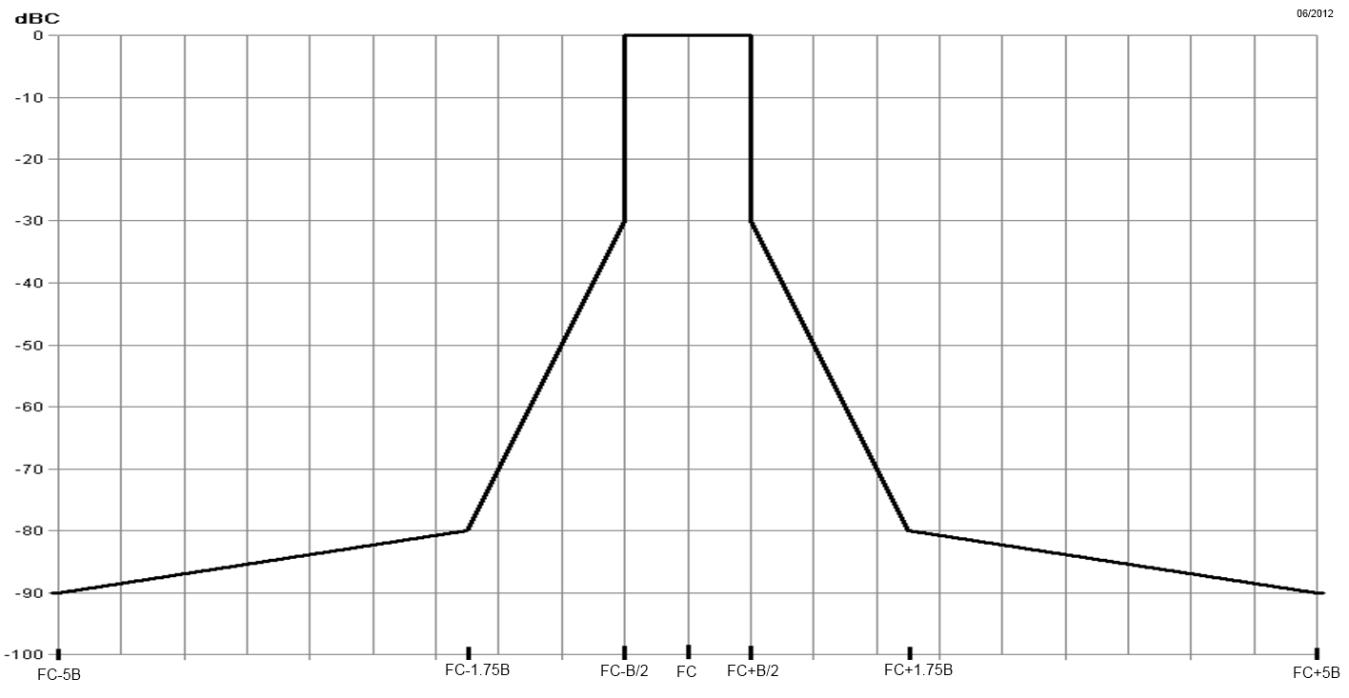
Figure 2: Spectrum mask for digital systems below 2 GHz
(measurement bandwidth is 1 kHz)
The spectrum mask for digital system has been used in this study. Note, that it can be seen in adjacent channel interference calculations the selectivity of the aeronautical receivers is the significant factor to the calculation and not whether the digital or analogue mask was assumed.
    - PMSE receiver Parameters
ERC Report 42 Handbook on Radio Equipment and Systems radio microphones and simple wide band audio links gives various radio microphone system calculations to be used in planning.
This report discusses excess fade margins of 30 dB to overcome multipath. The use of diversity reception, as is frequently the case in professional equipment, means that this fade margin can be further reduced.
Whilst PMSE is often planned to quite high wanted signal levels, a method of analysis that protects the noise floor of PMSE is a very cautious approach which is unnecessary in practice. Accordingly, ERC Report 42 suggests a wanted signal level of -69 dBm to protect radio microphones for the scenario of outside drama and documentary.
The Chester and RRC 06 frequency plans consider protecting radio microphones at a level of 68 dBµV/m at 1.5m with a protection ratio of 12 dB, which is equivalent to -69 dBm at 960 MHz, and the same level in ERC report 42.
Various process in the PMSE receiver mean that the impact of the EIRP of an interfering pulsed signal may be averaged over time, which could reduce the impact of the maximum EIRP of the pulsed system to the audio PMSE (e.g. de-emphasis filtering). A signal with a higher pulse rate may have a higher average power over time, than a pulse signal with a lower pulse rate. This effect can be observed with the JCSys measurement results, where a higher protection is needed with higher pulse rate of the DME signal, see Figure 3.

JCSys tested radio microphones in the presence of a DME signal. At a minimum interrogation rate of 700 pulse pairs per second (ppps), the PMSE performance, with wanted signal of -64 dBm, fails when DME power is greater than -63.6 dBm for X channel or greater than -62.6 dBm for Y channel.
As a cautious approach to protect audio PMSE, we use the maximum interference level of -81 dBm (-69 dBm - 12 dB protection ratio from RRC06) from the aeronautical pulsed systems. This level of protection gives additional margin than was found needed in practice by the practical tests by JCSys.
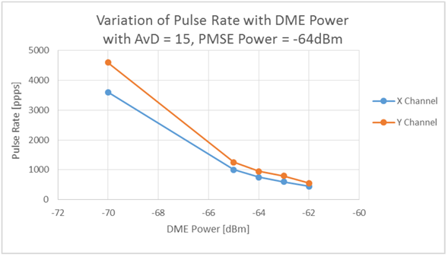
Figure 3: Trade-off of DME Power and Pulse Rate into PMSE
For the purpose of this study the receive characteristics of the body worn and handheld audio PMSE are assumed to be similar to the transmit characteristics of the corresponding applications, i.e. the IEM receiver is on the performer so therefore antenna height and body effect of the IEM receive path are assumed to be the same as the body worn transmitter. This means the IEM receive antenna is at 1.5m and there is a body effect assumed of -6.85 dBi. Similarly, the microphone receive antenna parameters are assumed to be the same as the IEM transmit antenna, ie. a height of 2m and 0 dBi body effect.
Table 5: Parameters for audio PMSE receivers
Parameter | Unit | Value | Reference
Interference level to protect PMSE | dBm | -81 dBm | See discussion above.
Selectivity | dB | See curve below | ERC Report 63
Antenna receive height | m | 2 (for body worn and hand-held microphones)  1.5 (for IEM | ECC Report 253
Body effect | dBi | -6.85 (IEM) | ECC Report 286  (body effect of the IEM receiver close to the human body)

Figure 4: PMSE RF selectivity curves
    - Parameters of body loss
Body effect has been assumed based on ECC Report 286. Values of body effect and the resulting EIRP are presented in the tables of PMSE transmitter parameters provided in section 2.
    - Parameter for building loss
ECC Report 121 [2] measured values of wall loss for the materials tested range from 6 dB to about 34 dB and most wall materials have an attenuation value above 10 dB.
Recommendation ITU-R P.2109-0, Prediction of building entry loss, also gives a potential wide range of values for building entry loss. Figure 5 gives a CDF of building entry loss for both traditional buildings and thermally efficient building.

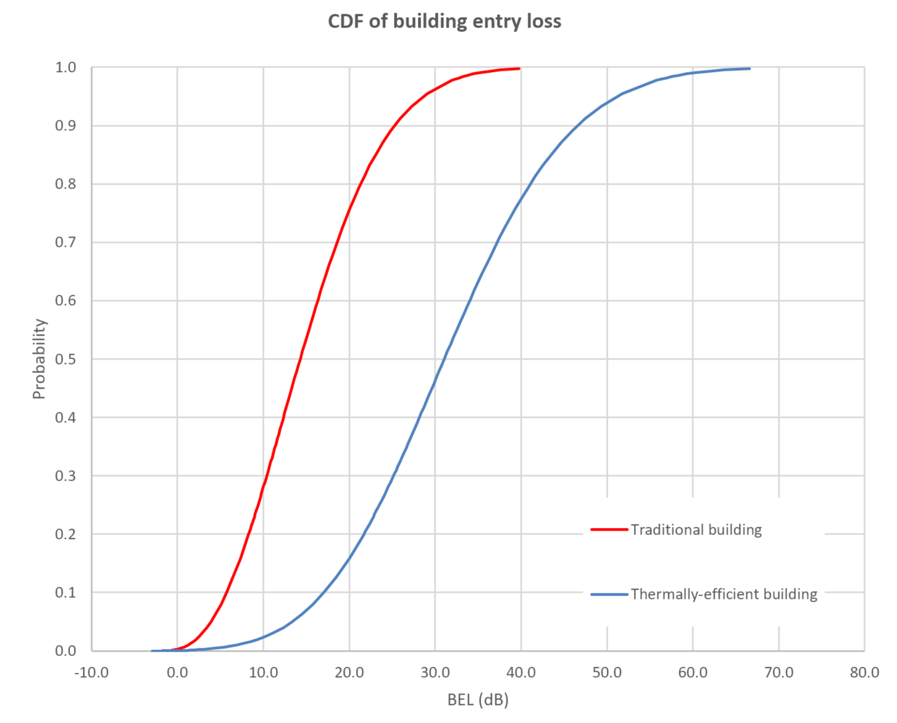
Figure 5: Cumulative distribution function of building entry loss at 960 MHz
This study only considers building entry attenuation in the terrestrial case between audio PMSE and the aeronautical ground stations in the modelled urban environment (building entry attenuation was not considered in our modelled rural environment). The value of 10 dB for building entry attenuation has been assumed in our study and is considered a cautious assumption. It is expected that in practice the actual building entry loss will be greater and in practice also potentially applicable to all scenarios modelled.
  - Propagation model
For the path loss calculation from PMSE to the airborne receivers (at heights 1km and 10km), the propagation model ITU-R P.528-3 has been chosen with a time probability of 1%. For the airborne receive height 100m, the IF-77 algorithm has been used with a time probability of 1%, as the model ITU-R P.528-3 only recommends interpolating the curves, not extrapolating the curves to get results at a height of 100m. The ICAO planning guidelines proposes a 50%-time probability for propagation modelling for frequency planning (see EUR Doc 011). For this study the 1%-time probability was chosen as it incorporates infrequent anomalous propagation effects and an in-built safety margin, which leads to larger protection distances. For cases where the separation distance is less than 1 km, free space path loss was used.
For the path loss calculation from the airborne transmitters (heights 1 km and 10 km) to PMSE, the propagation model with ITU-R P.528-3 with a time probability of 50% is chosen, this is very similar to free space path loss within the radio horizon. For the airborne receive height 100m, the IF-77 algorithm has been used.
For the path loss calculation from PMSE to the aeronautical ground receiver, the propagation model ITU-R P.452-16 has been chosen with a 1%-time probability and a height gain terminal correction for the Audio PMSE device only and assuming a smooth earth. The height gain terminal correction is based on Recommendation ITU-R P.2108-0 ref. $3.1. In an urban environment, an additional clutter loss of 22.6 or 22.9 dB is added depending on the height of the PMSE device (1.5m or 2m respectively). In rural and open environments, an additional 15.2 or 17.9 dB clutter loss is added depending on the height of the PMSE device (1.5m or 2m respectively).
For the path loss calculation from the aeronautical ground-based transmitter to the PMSE, the propagation model with ITU-R P.452-16 with a time probability of 50% is chosen, this is the same time probability chosen as with the other modelling which uses the Okumura Hata propagation model.
As noted in CEPT Report 42 (compatibility between UMTS base stations and DME and LDACS):
- “the apportionment is proposed to model that several sources of interferences may occur simultaneously on the DME devices. However, the pre-requisite is that the interferences are contributing in the same order. Otherwise, if one source of interference is predominant and the others are negligible, then the apportionment factor has no longer to be taken into account.”
Aeronautical systems within the band are pulsed systems and PMSE is a continuous signal, therefore the type of interference is different and do not contribute in the same order. In addition, DME assignments are planned and therefore intra-service interference is addressed within the planning criteria, e.g. co-channel desired-to-undesired protection ratio of 8 dB. A further consideration is that PMSE is not an ‘always on’ interferer, with microphones only transmitting for a few hours at a time. Given these conditions, any apportionment factor (if it exists) will be small and therefore has not been considered in this study.
    - Calculating interference at different frequency separations
The interference at different frequency separations was calculated considering the Adjacent Channel Interference Ratio, ACIR.
The Adjacent Channel Interference Ratio (ACIR) is defined as the ratio of the power of an adjacent-channel interferer, to the power measured after a receive filter in the adjacent channel and is a result of both transmitter and receiver imperfections.
Adjacent Channel Leakage Ratio (ACLR) of a signal is defined as the ratio of the signal’s power to the power of the signal when measured centred on an adjacent frequency.
Adjacent Channel Selectivity (ACS) is a measurement of a receiver's ability to process a desired signal while rejecting a strong signal in an adjacent frequency channel.
The combination of these two parameters below gives the ACIR:
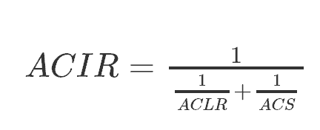
  - DME
    - DME parameters
      - DME transmitter parameters
Table 6: Parameters for DME airborne interrogator
Parameters | Unit | DME airborne | Reference
Transmit Frequency | MHz | 1025
Bandwidth | MHz | 0.4 | ITU-R. M .2205
Antenna (aircraft) height | m | 100, 1000, 10000
Power | dBm | 47 – 54 | REPORT ITU-R M.2205 and RTCA DO-189, Minimum Operational Performance Standards for Airborne Distance Measuring Equipment (DME) Operating within the Frequency Range of 960-1 215 MHz.
Minimum cable loss | dB | 1
Antenna gain | dBi | 5.4
Max e.i.r.p. | dBm | 58.4 | Calculated
Antenna polarisation | NA | Vertical | SE7(18)101A1
Mask | N/A | (see ICAO Annex 10) | See below

Table 7: Parameters for DME ground transponder
Parameters | Unit | DME ground | Reference
Transmit Frequency | MHz | 960
Bandwidth | MHz | 0.4
Antenna height | m | 40, 25, 2.1
Max e.i.r.p. | dBm | 70 | 99% of DME ground stations have an EIRP of 70dBm or less from COM3 database
Antenna polarisation | N/A | Vertical
Mask | N/A | (see ICAO Annex 10) | See below
The spectrum emission mask for the transponder and interrogator has been taken from ICAO Annex 10, and can be seen in Table 8 below.
Table 8: DME emission characteristics

Frequency Offset, MHz | DME emission characteristics, dBc | Reference
0 | 0 | see ICAO Annex 10
0.8 | 23 | see ICAO Annex 10
1 | 25.5 | Interpolated
2 | 38 | see ICAO Annex 10
3 | 80 | Spurious level, see ICAO Annex 10, 3.5.4.1.6.1 and 3.5.4.1.6.2

      - DME receiver paramaters
The interference threshold of -99 dBm is taken from EUROCAE ED-54, the minimum operational performance requirements for DME interrogators. From ITU-R Report M.1639 it is shown that for broadband interference the interference threshold of -99 dBm/MHz can be assumed. Therefore, we consider -99 dBm an appropriate interference protection threshold for narrowband audio PMSE.
Table 9: Parameters for DME airborne interrogator
Parameter | Unit | Value | Reference
Receive Frequency | MHz | 960
Antenna gain | dBi | 5.4 (maximum)
Minimum Cable loss | dB | 1
Interference threshold Note 1 | dBm | Sensitivity requirement shall be met for:  In-band continuous CW up to -99 dBm  Out-of-band CW up to -40 dBm | EUROCAE ED-54
DME selectivity | dB | See below | Report ITU-R M.2205

Note 1: For broadband interference the interference threshold of -99 dBm/MHz can be assumed (ITU-R M.1639)
The airborne DME selectivity values have been considered for frequency separations 1 MHz and 2 MHz. Some values have been linearly interpolated from the tabled values given in Report ITU-R M.2205.
Table 10: Values for airborne interrogator DME receiver selectivity

Frequency Offset, MHz | DME interrogator receiver characteristics, dB | Reference
0.9 | 6 | Report ITU-R M.2205
1 | 15.3 | Interpolated
1.05 | 20 | Report ITU-R M.2205
1.3 | 40 | Report ITU-R M.2205
1.5 | 60 | Report ITU-R M.2205
2 | 63.3 | Interpolated
3 | 70 | Report ITU-R M.2205

The tables 11 and 12 below show parameters for DME ground based transponders. The interference threshold of -106 dBm is derived from ICAO Annex 10 and EUROCAE ED-57, minimum performance specification for DME ground equipment.
ICAO Annex 10 specifies -103 dBW/m2 as the power density at the transponder antenna required to trigger the transponder. This corresponds to -96 dBm at the terminals of the ground antenna. ED-57 states that the required sensitivity level should be calculated (starting from the Annex 10 figure), taking the real antenna gain and cable losses into account.
ED-57 states that the ground DME receiver should provide a reply efficiency greater than 70% in the presence of in-band CW with a minimum C/I = 10 dB. As the ground DME RX handles similar signals as an airborne receiver, it should behave the same way in the presence of an interfering CW or broadband noise signal. Therefore, we consider -106 dBm an appropriate interference protection threshold for narrowband audio PMSE.
Table 11: Parameters for ground transponder DME
Parameter | Unit | Value | Reference
Receive Frequency | MHz | 1025
Antenna gain | dBi | 12 (omni-directional) | http://www.dbsant.com/5100AD7.php
Minimum cable loss | dB | 1
Interference threshold | dBm | -106 | ICAO Annex 10 and  EUROCAE ED-57
DME selectivity | dB | See below | ITU-R Report M 2235.

Figure 6: Ground station (beacon) receiver RF selectivity curves
The ground DME selectivity values have been considered for frequency separations 1 MHz and 2 MHz. Some values have been linearly interpolated from the graphed points from Figure 6. Measurements taken in the UK suggest that there are significantly better performing DME beacon receivers in practice.
Table 12: Values assumed for beacon receiver DME selectivity
Frequency Offset, MHz | Ground station beacon receiver selectivity, dB | Reference
0 | 0 | Recommendation ITU-R M.2013
1 | -4.5 | Interpolated
2 | -9.1 | Interpolated
2.2 | -10 | Recommendation ITU-R M.2013
3 | -13.6 | Interpolated
9.6 | -60 | Recommendation ITU-R M.2013
    - Modelling assumptions
For full details of modelling approach, see section 3. ACIR values for DME are given below.
Table 13: Values assumed for adjacent channel interference into airborne interrogator DME
Frequency separation from DME centre frequency | 0 MHz | 1 MHz | 2 MHz | 3 MHz | Reference
ACLR, dB | 0 | 90 | 90 | 90 | ECC Report 253 and ETSI EN 300 422 (V1.5.0 /2015-01
ACS, dB | 0 | 15.3 | 63.3 | 70 | Report ITU-R M.2205
ACIR, dB | 0 | 15.3 | 63.3 | 70 | Calculated

Table 14: Values assumed for adjacent channel interference into ground transponder DME
Frequency separation from DME centre frequency | 0 MHz | 1 MHz | 2 MHz | 3 MHz | Reference
ACLR, dB | 0 | 90 | 90 | 90 | ECC Report 253 and ETSI EN 300 422 (V1.5.0 /2015-01
ACS, dB | 0 | 4.5 | 9.1 | 13.6 | Recommendation ITU-R M.2013
ACIR, dB | 0 | 4.5 | 9.1 | 13.6 | Calculated

Table 15: Values assumed for adjacent channel interference into PMSE from DME
Frequency separation from DME centre frequency | 0 MHz | 1 MHz | 2 MHz | 3 MHz | Reference
ACLR, dB | 0 | 25.5 | 38 | 80 | Annex 10 ICAO
ACS, dB | 0 | 74 | 74 | 74 | ERC Report 63
ACIR, dB | 0 | 25.5 | 38 | 74 | Calculated
    - Conclusion
      - Separation distances to protect DME airborne interrogators
Table 16: Co-frequency separation distances to protect airborne interrogator
Parameter | Body worn | Handheld | IEM
Tx power | 17 dBm | 13 dBm | Not considered
Body effect | -6.85 dBi | -4.85 dBi | Not considered
Modelled e.i.r.p | 10.15 dBm | 8.15 dBm | 9 dBm
Building entry loss | 0 dB | 0 dB | 0 dB
PMSE height | 1.5 m | 1.5 m | 2 m
Interference level | -99 dBm
Antenna gain | Gmax= 5.4 dBi
Cable loss | 1 dB
Polarisation discrimination | 0 dB
Clutter loss | 0 dB
Path loss to meet the protection criterion | 113.55 dB | 111.55 dB | 112.4 dB
Separation distances in the main lobe of aircraft antenna at altitude of 100 m | 8.8 km | 7.9 km | 9.5 km
Separation distances in the main lobe of aircraft antenna at altitude of 1 km | 22.6 km | 18.9 km | 20.6 km
Separation distances in the main lobe of aircraft antenna at altitude of 10 km | 22.7 km | 16.3 km | 18.8 km
Table 17: Separation distances to protect airborne interrogator at 1 MHz frequency separation
Parameter | Body worn | Handheld | IEM
ACIR | 15.3
Path loss to meet the protection criterion | 98.25 dB | 96.25 dB | 97.1 dB
Separation distances in the main lobe of aircraft antenna at altitude of 100 m | 3.3 km | 2.9 km | 3.5 km
Separation distances in the main lobe of aircraft antenna at altitude of 1 km | 4.3 km | 3.3 km | 3.7 km
Separation distances in the main lobe of aircraft antenna at altitude of 10 km | N/A | N/A | N/A

Table 18: Separation distances to protect airborne interrogator at 2 MHz frequency separation
Parameter | Body worn | Handheld | IEM
ACIR | 63.3
Path loss to meet the protection criterion | 50.25 dB | 48.25 dB | 49.1 dB
Separation distances in the main lobe of aircraft antenna at altitude of 100 m | N/A
Separation distances in the main lobe of aircraft antenna at altitude of 1 km
Separation distances in the main lobe of aircraft antenna at altitude of 10 km
      - Separation distances to protect DME ground transponders
Table 19: Co-frequency separation distances to DME ground transponder
Parameter | Body worn | Handheld | IEM
Tx power | 17 dBm | 13 dBm | Not considered
Body effect | -6.85 dBi | -4.85 dBi | Not considered
Modelled e.i.r.p | 10.15 dBm | 8.15 dBm | 9 dBm
Building entry loss [Outdoor Open environment / Indoor Urban environment] | 0 dB; 10 dB
PMSE height | 1.5m | 1.5m | 2m
Interference level | -106 dBm
Antenna | Gmax= 12 dBi
Cable loss | 1 dB
Polarisation discrimination | 0 dB
Clutter loss (rural/urban) | 17.9 dB; 22.9dB | 17.9 dB; 22.9dB | 15.2 dB; 22.6 dB
Path loss to meet the protection criterion | 109.25 dB; 94.25 dB | 107.25 dB; 92.25 dB | 110.8 dB; 93.4 dB
Separation distances in the main lobe of DME at 40 m | 4.6 km; 1.3 km | 4.1 km; 1.0 km | 5.9 km; 1.1 km
Separation distances in the main lobe of DME at 25 m | 3.6 km; 1.3 km | 3.2 km; 1.0 km | 4.6 km; 1.1 km
Separation distances in the main lobe of DME at 2.1 m | 1.1 km; 0.4 km | 0.9 km; 0.4 km | 1.4 km; 0.5 km

Table 20: Separation distances to protect DME ground transponder at 1 MHz frequency separation
Parameter | Body worn | Handheld | IEM
ACIR | 4.5 dB
Path loss to meet the protection criterion | 104.75 dB; 89.75 dB | 102.75 dB; 87.75 dB | 106.3 dB; 88.9 dB
Separation distances in the main lobe of DME at 40 m | 3.5 km; 0.7 km | 3.1 km; 0.6 km | 4.5 km; 0.7 km
Separation distances in the main lobe of DME at 25 m | 2.7 km; 0.7 km | 2.4 km; 0.6 km | 3.5 km; 0.7 km
Separation distances in the main lobe of DME at 2.1 m | 0.8 km; 0.3 km | 0.7 km; 0.3 km | 1.0 km; 0.4 km

Table 21: Separation distances to protect DME ground transponder at 2 MHz frequency separation
Parameter | Body worn | Handheld | IEM
ACIR | 9.1 dB
Path loss to meet the protection criterion | 100.15 dB; 85.15 dB | 98.15 dB; 83.15 dB | 101.7 dB; 84.3 dB
Separation distances in the main lobe of DME at 40 m | 2.7 km; 0.4 km | 2.1 km; 0.3 km | 3.2 km; 0.4 km
Separation distances in the main lobe of DME at 25 m | 2.1 km; 0.4 km | 1.8 km; 0.3 km | 2.7 km; 0.4 km
Separation distances in the main lobe of DME at 2.1 m | 0.6 km; 0.2 km | 0.5 km; 0.2 km | 0.8 km; 0.3 km
      - Separation distances to protect PMSE from airborne interrogators
Table 22: Co-frequency separation distances to protect PMSE
Parameter | Body worn / Handheld | IEM
e.i.r.p | 58.4
Reduction in eirp due to bandwidth mismatch | 3 dB
Body effect | Not modelled | -6.85 dBi
Building entry loss | 0 dB | 0 dB
PMSE receive height | 2 m | 1.5 m
Interference level | -81 dBm
Antenna gain | 0 dB | Not modelled
Polarisation discrimination | 0 dB
Clutter loss | 0 dB
Path loss to meet the protection criterion | 136.4 dB | 129.55 dB
Separation distances in the main lobe of aircraft antenna at altitude of 100 m | 28.4 km | 19.4 km
Separation distances in the main lobe of aircraft antenna at altitude of 1 km | 81.0 km | 58.0 km
Separation distances in the main lobe of aircraft antenna at altitude of 10 km | 149.5 km | 68.2 km

Table 23: Separation distances to PMSE at 1 MHz frequency separation
Parameter | Body worn / Handheld | IEM
ACIR | 25.5 dB
Path loss to meet the protection criterion | 110.9 dB | 104.05 dB
Separation distances in the main lobe of aircraft antenna at altitude of 100 m | 8.0 km | 3.9 km
Separation distances in the main lobe of aircraft antenna at altitude of 1 km | 8.1 km | 3.6 km
Separation distances in the main lobe of aircraft antenna at altitude of 10 km | N/A

Table 24: Separation distances to PMSE at 2 MHz frequency separation
Parameter | Body worn / Handheld | IEM
ACIR | 38 dB
Path loss to meet the protection criterion | 98.4 dB | 91.55 dB
Separation distances in the main lobe of aircraft antenna at altitude of 100 m | 2.0 km | < 1km
Separation distances in the main lobe of aircraft antenna at altitude of 1 km | N/A
Separation distances in the main lobe of aircraft antenna at altitude of 10 km

Table 25: Separation distances to PMSE at 3 MHz frequency separation
Parameter | Body worn / Handheld | IEM
ACIR | 74 dB
Path loss to meet the protection criterion | 62.4 dB | 55.55 dB
Separation distances in the main lobe of aircraft antenna at altitude of 100 m | N/A
Separation distances in the main lobe of aircraft antenna at altitude of 1 km
Separation distances in the main lobe of aircraft antenna at altitude of 10 km
      - Separation distances to protect PMSE from DME ground transponders
Table 26: Co-frequency separation distances to protect PMSE
Parameter | Body worn / Handheld | IEM
e.i.r.p | 70 dBm
Reduction in eirp due to bandwidth mismatch | 3 dB
Body effect | Not modelled | -6.85 dBi
Building entry loss | 0 dB; 10 dB
PMSE receive height | 2 m | 1.5 m
Interference level | -81 dBm
Antenna gain | 0 dB | Not modelled
Polarisation discrimination | 0 dB
Clutter loss | 15.2 dB; 22.6 dB | 17.9 dB; 22.9 dB
Path loss to meet the protection criterion | 132.8 dB; 115.4 dB | 123.25 dB; 108.25 dB
Separation distances in the main lobe of aircraft antenna at altitude of 100 m | 17.2 km; 6.8 km | 9.1 km; 3.9 km
Separation distances in the main lobe aircraft antenna at altitude of at 1 km | 13.8 km; 5.5 km | 7.3 km; 3.2 km
Separation distances in the main lobe aircraft antenna at altitude of at 10 km | 4.7 km; 1.4 km | 2.4 km; 1.0 km

Table 27: Separation distances to protect PMSE at 1 MHz frequency separation
Parameter | Body worn / Handheld | IEM
ACIR | 25.5 dB
Path loss to meet the protection criterion | 107.3 dB; 89.9 dB | 97.75 dB; 82.75 dB
Separation distances in the main lobe of DME at 40 m | 4.4 km; 0.8 km | 1.9 km; 0.3 km
Separation distances in the main lobe of DME at 25 m | 3.5 km; 0.8 km | 1.7 km; 0.3 km
Separation distances in the main lobe of DME at 2.1 m | 1.1 km; 0.4 km | 0.7 km; 0.2 km

Table 28: Separation distances to protect PMSE at 2 MHz frequency separation
Parameter | Body worn / Handheld | IEM
ACIR | 38 dB
Path loss to meet the protection criterion | 94.8 dB; 77.4 dB | 85.25 dB; 70.25 dB
Separation distances in the main lobe of DME at 40 m | 1.4 km; 0.2 km | 0.5 km; N/A
Separation distances in the main lobe of DME at 25 m | 1.0 km; 0.2 km | 0.5 km; N/A
Separation distances in the main lobe of DME at 2.1 m | 0.5 km; 0.2 km | 0.3 km; N/A

Table 29: Separation distances to protect PMSE at 3 MHz frequency separation
Parameter | Body worn / Handheld | IEM
ACIR | 74 dB
Separation distances in the main lobe of DME at 40 m | N/A
Separation distances in the main lobe of DME at 25 m
Separation distances in the main lobe of DME at 2.1 m
  - SSR – 1030/1090 systems
    - SSR 1030/1090 MHz parameters
      - SSR 1030/1090 MHz transmitter parameters
Table 30: Transmitter characteristics of SSR airborne transponder
Parameters | Unit | SSR airborne Transponder | Reference
Transmit Frequency | MHz | 1090 | (RTCA DO-181 §2.2.3.1)
Bandwidth | MHz | 4.5 MHz (Mode A and C)  2.3 MHz (Mode S) | ITU.R.M2205
Tx Power | dBm | 57 dBm (peak) | (RTCA DO-181 §2.2.3.2) and ITU.R.M2205
Cable loss | dB | 3 | Manual on the  Secondary Surveillance  Radar (SSR) Systems, ICAO
Antenna gain | dBi | 2.8 | http://antennaassociates.com/datasheets.php
OOB | N/A | See below | ICAO Annex 10 Vol IV, fig. 3.5

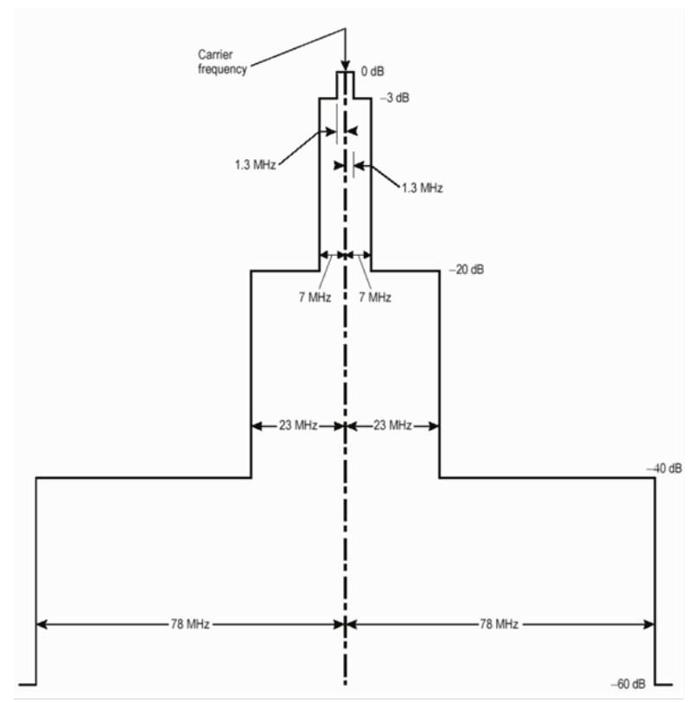

Figure 7: Out-of-band emissions of SSR airborne transponder

Table 31: Transmitter characteristics of SSR ground interrogator
Parameters | Unit | SSR ground radar | Reference
Frequency range | MHz | 1030 | ICAO Annexe 10 Vol4 §3.1.1.1.1
Tx Power (peak) | dBm | 62 | L-band interference scenarios characterisation, Eurocontrol
Cable loss | dB | 3 | Compatibility criteria and interference scenarios for SSR systems, Eurocontrol  ED-43 §3.2.4.2
Antenna gain | dBi | 27 (max) | https://www.nec.com/en/global/solutions/cns-atm/surveillance/ssr.html
Side lobe gain | dBi | 2 | https://www.nec.com/en/global/solutions/cns-atm/surveillance/ssr.html and footnote .
OOB | N/A | See below | ICAO Annex 10 Vol IV, Fig 3.2

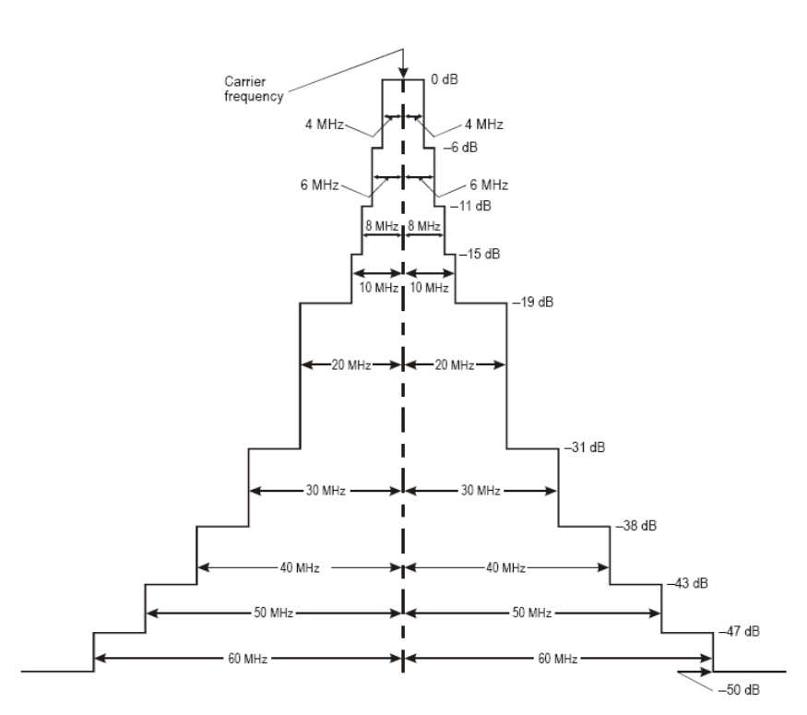
Figure 8: Out-of-band emissions of SSR interrogator ground station
      - SSR 1030/1090 MHz receiver parameters
The value of C/I of 20 dB has been used in our calculations to protect both the transponder and the interrogator from potential PMSE interference. RTCA DO-181C states that the transponder shall reply correctly to at least 90 percent of the interrogations in the presence of non-coherent Continuous Wave (CW) interference at signal levels of 20 dB or more below the desired Mode A/C or Mode S interrogation signal level.
The receiver sensitivity of airborne SSR transponders is given as -74 dBm ± 3dB and -73 dBm ± 3dB in ITU.R M.2205. The maximum interference into the transponder receiver is calculated by taking the most conservative value suggested -77dBm and -20dB.
The receiver sensitivity of the ground interrogator is given as -90dBm. The maximum interference into the interrogator receiver is calculated by taking -90dBm considering the C/I of 20 dB.
Table 32: Parameters for SSR airborne transponder receiver
Parameter | Unit | Value | Reference
Recieve Frequency | MHz | 1030
Antenna (aircraft) height | m | 100, 1000, 10000
Antenna gain | dBi | 2.8 | http://antennaassociates.com/datasheets.php
Antenna polarisation | N/A | Vertical
Sensitivity | dBm | -77 | Worst case example in ITU.R M.2205
Protection criteria, C/I | dB | 20 | RTCA DO-181C Minimum Operational Performance Standards for Air Traffic Control  Radar Beacon System/Mode Select (ATCRB/Mode S) Airborne Equipment  Compatibility criteria and interference scenarios for SSR systems, Eurocontrol
Cable loss | dB | 3 | Compatibility criteria and interference scenarios for SSR systems, Eurocontrol  ED-43 §3.2.4.2
Interference threshold | dBm | -97 | Calculated
SSR selectivity | dB | See below | Report ITU-R M.2205 and RTCA DO-181C
The airborne SSR selectivity values have been considered for frequency separations 10 MHz and 15 MHz. Some values have been linearly interpolated from the tabled values given in Report ITU-R M.2205.
Table 33: Values for airborne SSR transponder receiver selectivity
Frequency Offset, MHz | SSR transponder receiver characteristics, dB | Reference
3 | 3 | Report ITU-R M.2205 and RTCA DO-181C
10 | 24.6 | Interpolated
15 | 40 | Report ITU-R M.2205 and RTCA DO-181C

The receiver performance figures for SSR are detailed below.
Table 34: Parameters for ground interrogator SSR receiver
Parameter | Unit | Value | Reference
Receive frequency | MHz | 1090
Antenna height | M | 2.1, 25, 40
Antenna gain | dBi | 27 (max) | https://www.nec.com/en/global/solutions/cns-atm/surveillance/ssr.html
Antenna side lobe gain | dBi | 2 | -25dB to -30dB off peak power,,
Cable loss | dB | 3 | Compatibility criteria and interference scenarios for SSR systems, Eurocontrol  ED-43 §3.2.4.2  Manual on the  Secondary Surveillance  Radar (SSR) Systems, ICAO
Antenna polarisation | N/A | Vertical
Sensitivity | dBm | -90 | Compatibility criteria and interference scenarios for SSR systems, Eurocontrol
Protection criteria, C/I | dB | 20 | Assumed same C/I for CW like interference as transponder.
Interference threshold | dBm | -110 | Calculated
SSR selectivity | dB | See below

The antenna side lobe gain has been used for the calculations of the SSR interrogator as it is assumed the geometry of an SSR interrogator will be pointing towards an aircraft in the air. The side lobe antenna gain is typically 25 to 30 dB off the main gain, we have chosen the lower value 25 dB for our modelling.

The ground SSR interrogator selectivity values have been taken from the values given in Report ITU-R M.2205 for the transponder. In the UK we previously have measured the SSR characteristics and the values given within Report ITU-R M.2205 for the transponder are also a good fit for the interrogator.
Table 35: Values for airborne SSR interrogator receiver selectivity
Frequency Offset, MHz | SSR interrogator receiver characteristics, dB | Reference
3 | 3 | Report ITU-R M.2205 and RTCA DO-181C
10 | 24.6 | Interpolated
15 | 40 | Report ITU-R M.2205 and RTCA DO-181C
    - Modelling assumptions
For full details of modelling approach, see section 3. ACIR values for SSR (1030/1090 MHz systems) are given below.
Table 36: Values assumed for adjacent channel interference into SSR
Frequency separation from SSR centre frequency | 0 MHz | 3 MHz | 10 MHz | 15 MHz | Reference
ACLR, dB | 0 | 90 | 90 | 90 | ECC Report 253 and ETSI EN 300 422 (V1.5.0 /2015-01
ACS, dB | 0 | 3 | 24.6 | 40 | Report ITU-R M.2205
ACIR, dB | 0 | 3 | 24.6 | 40 | Calculated

Table 37: Values assumed for adjacent channel interference into PMSE from SSR airborne transponder
Frequency separation from SSR centre frequency | 0 MHz | 7 to 10 MHz | 23 MHz | Reference
ACLR, dB | 0 | 20 | 40 | ICAO Annex 10 Vol IV, fig. 3.5
ACS, dB | 0 | 74 | 74 | ERC Report 63
ACIR, dB | 0 | 20 | 40 | Calculated

Table 38: Values assumed for adjacent channel interference into PMSE from SSR ground interrogator
Frequency separation from SSR centre frequency | 0 MHz | 10 MHz | 20 MHz | Reference
ACLR, dB | 0 | 15 | 19 | ICAO Annex 10 Vol IV, Fig 3.2
ACS, dB | 0 | 74 | 74
ACIR, dB | 0 | 15 | 19 | Calculated

    - conclusion
      - Separation distances to protect SSR airborne transponders
Table 39: Co-frequency separation distances to protect airborne transponder
Parameter | Body worn | Handheld | IEM
Tx power | 17 dBm | 13 dBm | Not considered
Body effect | -6.85 dBi | -4.85 dBi | Not considered
Modelled e.i.r.p | 10.15 dBm | 8.15 dBm | 9 dBm
Building entry loss | 0 dB; | 0 dB; | 0 dB;
PMSE height | 1.5 m | 1.5 m | 2 m
Interference level | -97 dBm
Antenna gain | 2.8 dB
Cable loss | 3 dB
Polarisation discrimination | 0 dB | 0 dB | 0 dB
Clutter loss | 0 dB | 0 dB | 0 dB
Path loss to meet the protection criterion | 106.95 dB | 104.95 dB | 105.8 dB
Separation distances in the main lobe of aircraft antenna at altitude of 100 m | 6.0 km | 5.0 km | 5.9 km
Separation distances in the main lobe of aircraft antenna at altitude of 1 km | 11.3 km | 8.8 km | 9.9 km
Separation distances in the main lobe of aircraft antenna at altitude of 10 km | N/A | N/A | N/A
Table 40: Separation distances to protect airborne transponder at 10 MHz frequency separation
Parameter | Body worn | Handheld | IEM
ACIR | 24.6 dB
Path loss to meet the protection criterion | 82.35 dB | 80.35 dB | 81.2 dB
Separation distances in the main lobe of aircraft antenna at altitude of 100 m | 0.3 km | 0.2 km | 0.3 km
Separation distances in the main lobe of aircraft antenna at altitude of 1 km | N/A
Separation distances in the main lobe of aircraft antenna at altitude of 10 km

Table 41: Separation distances to protect airborne transponder at 15 MHz frequency separation
Parameter | Body worn | Handheld | IEM
ACIR | 40
Path loss to meet the protection criterion | 66.95 dB | 64.95 dB | 65.8 dB
Separation distances in the main lobe of aircraft antenna at altitude of 100 m | N/A
Separation distances in the main lobe of aircraft antenna at altitude of 1 km
Separation distances in the main lobe of aircraft antenna at altitude of 10 km

      - Separation distances to protect SSR ground interrogators
Table 42: Co-frequency separation distances to SSR ground interrogators
Parameter | Body worn | Handheld | IEM
Tx power | 17 dBm | 13 dBm | Not considered
Body effect | -6.85 dBi | -4.85 dBi | Not considered
Modelled e.i.r.p | 10.15 dBm | 8.15 dBm | 9 dBm
Building entry loss [Outdoor Open environment / Indoor Urban environment] | 0 dB; 10 dB
PMSE height | 1.5 m | 1.5 m | 2 m
Interference level | -110 dBm
Antenna gain towards horizon | 2 dBi
Cable loss | 3 dB
Polarisation discrimination | 0 dB
Clutter loss (rural/urban) | 17.9 dB; 22.9 dB | 17.9 dB; 22.9 dB | 15.2 dB; 22.6 dB
Path loss to meet the protection criterion | 103.25 dB; 88.25 dB | 101.25 dB; 86.25 dB | 104.8 dB; 87.4 dB
Separation distances to SSR at 40 m | 3.2 km; 0.6 km | 2.8 km; 0.5 km | 4.1 km; 0.5 km
Separation distances to SSR at 25 m | 2.5 km; 0.6 km | 2.2 km; 0.5 km | 3.2 km; 0.5 km
Separation distances to SSR at 2.1 m | 0.7 km; 0.3 km | 0.7 km; 0.3 km | 0.9 km; 0.3 km

Table 43: Separation distances to protect SSR ground interrogator at 10 MHz frequency separation
Parameter | Body worn | Handheld | IEM
ACIR | 24.6
Path loss to meet the protection criterion | 78.65 dB; 63.65 dB | 76.65 dB; 61.65 dB | 80.2 dB; 62.8 dB
Separation distances to SSR at 40 m | 0.2 km; N/A | 0.2 km; N/A | 0.2 km; N/A
Separation distances to SSR at 25 m | 0.2 km; N/A | 0.2 km; N/A | 0.2 km; N/A
Separation distances to SSR at 2.1 m | 0.2 km; N/A | 0.2 km; N/A | 0.2 km; N/A

Table 44: Separation distances to protect SSR ground interrogator at 15 MHz frequency separation
Parameter | Body worn | Handheld | IEM
ACIR | 40
Path loss to meet the protection criterion | 63.25 dB; 48.25 dB | 61.25 dB; 46.25 dB | 64.8 dB; 47.4 dB
Separation distances to SSR at 40 m | N/A
Separation distances to SSR at 25 m
Separation distances to SSR at 2.1 m

      - Separation distances to protect PMSE from SSR airborne transponders
Table 45: Co-frequency separation distances to protect PMSE
Parameter | Body worn / Handheld | IEM
e.i.r.p | 56.8 dBm
Reduction in eirp due to bandwidth mismatch | 13.5 dB
Body effect | Not modelled | -6.85 dBi
Building entry loss | 0 dB
PMSE receive height | 2 m | 1.5 m
Interference level | -81 dBm
Antenna gain | 0 dB | Not modelled
Polarisation discrimination | 0 dB
Clutter loss | 0 dB
Path loss to meet the protection criterion | 124.3 dB | 117.45 dB
Separation distances in the main lobe of aircraft antenna at altitude of 100 m | 16.5 km | 10.2 km
Separation distances in the main lobe of aircraft antenna at altitude of 1 km | 35.3 km | 13.4 km
Separation distances in the main lobe of aircraft antenna at altitude of 10 km | 34.5 km | 12.7 km

Table 46: Separation distances to PMSE at 7 to 10 MHz frequency separation
Parameter | Body worn / Handheld | IEM
ACIR | 20 dB
Path loss to meet the protection criterion | 104.3 dB | 97.45 dB
Separation distances in the main lobe of aircraft antenna at altitude of 100 m | 3.6 km | 1.7 km
Separation distances in the main lobe of aircraft antenna at altitude of 1 km | 3.4 km | 1.3 km
Separation distances in the main lobe of aircraft antenna at altitude of 10 km | N/A

Table 47: Separation distances to PMSE at 23 MHz frequency separation
Parameter | Body worn / Handheld | IEM
ACIR | 40 dB
Path loss to meet the protection criterion | 84.3 dB | 77.45 dB
Separation distances in the main lobe of aircraft antenna at altitude of 100 m | 0.4 km | 0.2 km
Separation distances in the main lobe of aircraft antenna at altitude of 1 km | N/A
Separation distances in the main lobe of aircraft antenna at altitude of 10 km

      - Separation distances to protect PMSE from SSR ground interrogators
Table 48: Co-frequency separation distances to protect PMSE
Parameter | Body worn / Handheld | IEM
e.i.r.p | 61 dBm
Reduction in eirp due to bandwidth mismatch | 13.5 dB
Body loss | Not modelled | -6.85 dBi
Building entry loss [Outdoor Open environment / Indoor Urban environment] | 0 dB; 10 dB
PMSE receive height | 2 m | 1.5 m
Interference level | -81 dBm
Antenna gain | 0 dB | Not modelled
Polarisation discrimination | 0 dB
Clutter loss (rural/urban) | 15.2 dB; 22.6 dB | 17.9 dB; 22.9dB
Path loss to meet the protection criterion | 113.3 dB; 95.9 dB | 103.75 dB; 88.75 dB
Separation distances in the main lobe of SSR at 40 m | 6.1 km; 1.4 km | 3.0 km; 0.7 km
Separation distances in the main lobe of SSR at 25 m | 4.9 km; 1.4 km | 2.2 km; 0.6 km
Separation distances in the main lobe of SSR at 2.1 m | 1.5 km; 0.5 km | 0.8 km; 0.3 km

Table 49: Separation distances to protect PMSE at 10 MHz frequency separation
Parameter | Body worn / Handheld | IEM
ACIR | 15 dB
Path loss to meet the protection criterion | 98.3 dB; 80.9 dB | 88.75 dB; 73.75 dB
Separation distances in the main lobe of SSR at 40 m | 1.9 km; 0.3 km | 0.7 km; 0.1 km
Separation distances in the main lobe of SSR at 25 m | 1.9 km; 0.3 km | 0.6 km; 0.1 km
Separation distances in the main lobe of SSR at 2.1 m | 0.6 km; 0.2 km | 0.3 km; 0.1 km

Table 50: Separation distances to protect PMSE at 20 MHz frequency separation
Parameter | Body worn / Handheld | IEM
ACIR | 19 dB
Path loss to meet the protection criterion | 94.3 dB; 76.9 dB | 84.75 dB; 69.75 dB
Separation distances in the main lobe of SSR at 40 m | 1.2 km; 0.2 km | 0.4 km; N/A
Separation distances in the main lobe of SSR at 25 m | 1.2 km; 0.2 km | 0.4 km; N/A
Separation distances in the main lobe of SSR at 2.1 m | 0.5 km; 0.2 km | 0.2 km; N/A
  - UAT
Not studied
  - CNPC
Not studied
  - LDACS
Not studied
  - JTIDS/MIDS
  - GNSS
    - Parameters
      - PMSE parameters
This study only considers body worn PMSE as the worst case scenario. The PMSE parameters in this study are provided in Table 51.
Table 51: Parameters for body worn audio PMSE
Parameter | Unit | Value | Reference
Bandwidth (BW) | MHz | 0.2 | ECC Report 253
Antenna transmit height | m | 1.5 | ECC Report 253
Antenna receive height | m | 2
EIRP | dMm | 17 | ECC Report 253
Body effect | dBi | -7.25 (@ 1154 MHz) | ECC Report 286
Modelled e.i.r.p | dBm | 9.75 | ECC Report 253 and ERC/REC 70-03, Annex 10
Antenna polarisation | NA | Vertical | ECC Report 253

      - GNSS parameters
The parameters for the protection criteria have been taken from Table 2-1 of ITU-R Recommendation M.1905, Characteristics and protection criteria for receiving earth stations in the radionavigation-satellite service (space-to-Earth) operating in the band 1 164-1 215 MHz.
The interference thresholds assumed are those given for acquisition mode threshold power level of aggregate narrowband interference at the passive antenna output for air navigation receiver 1 and the general purpose receiver as defined in Table 2-1. Note 6 to the table states:
The continuous RFI threshold value applies to airborne receiver operations above 6 096 m (20 000 feet) altitude above MSL. The acquisition mode values for airborne operations below 610 m (2 000 feet) altitude above ground are -143.1 dBW (narrow-band) and -133.1 dB(W/MHz) (wideband
Three GNSS receiver masks were considered. Two are from ITU-Report M.2235 Aeronautical mobile (route) service sharing studies in the frequency band 960-1 164 MHz:
- non pulsed interference levels at the aeronautical radionavigation satellite receiver antenna port (Figure 8 of ITU-R Rep M.2235).
- relative non pulsed interference attenuation referenced to the non-aeronautical high-precision(Figure 9 of ITU-R Rep M.2235).
In addition to the two receiver masks from ITU-R M.2235, a further mask from Figure 3 of the ”Characterization of L5 Receiver Performance Using Digital Pulse Blanking” has been used in the study. See Figure 12.
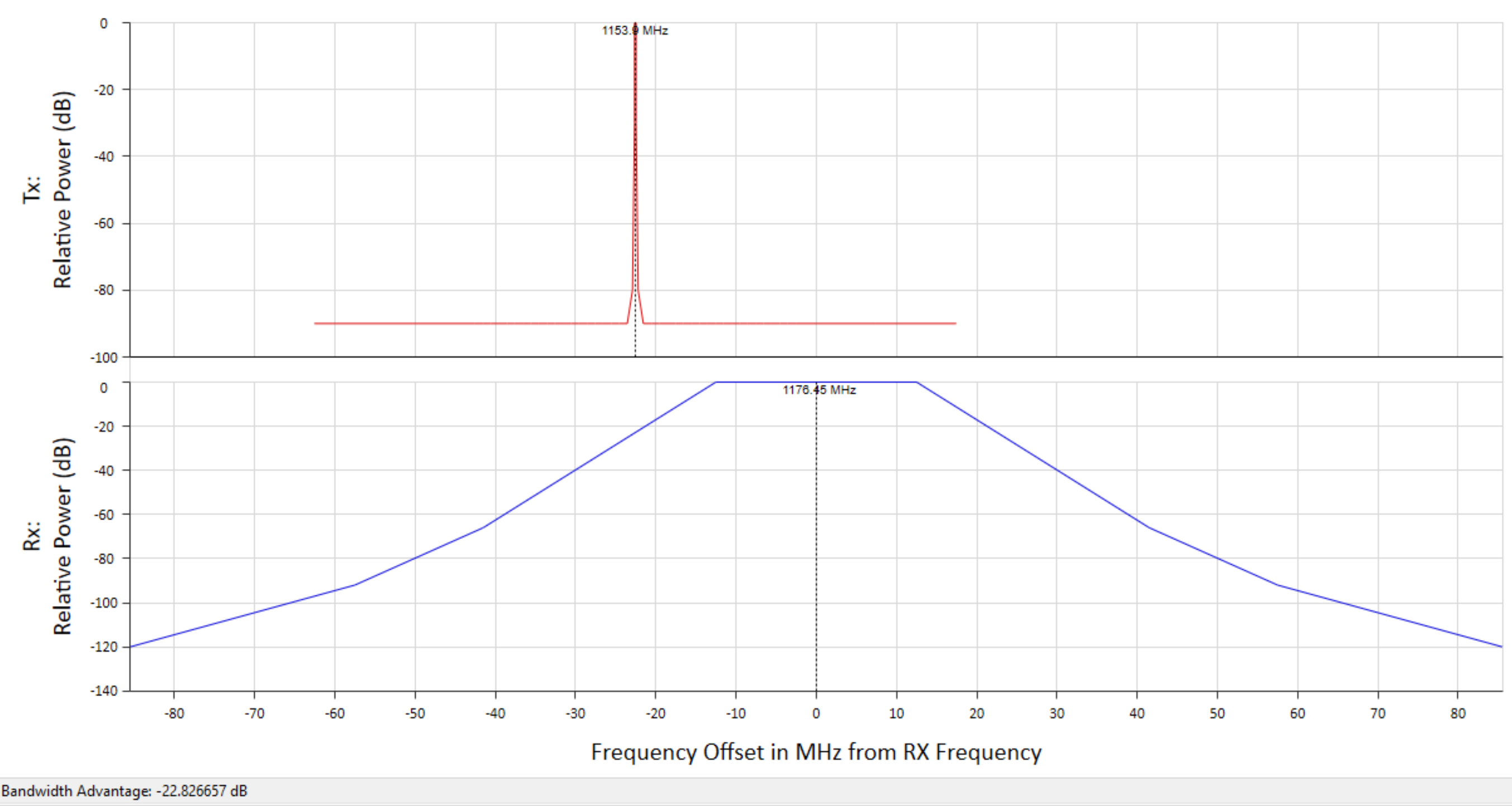
Figure 9: GNSS receiver mask (Fig 9 of ITU-R Rep M.2235)
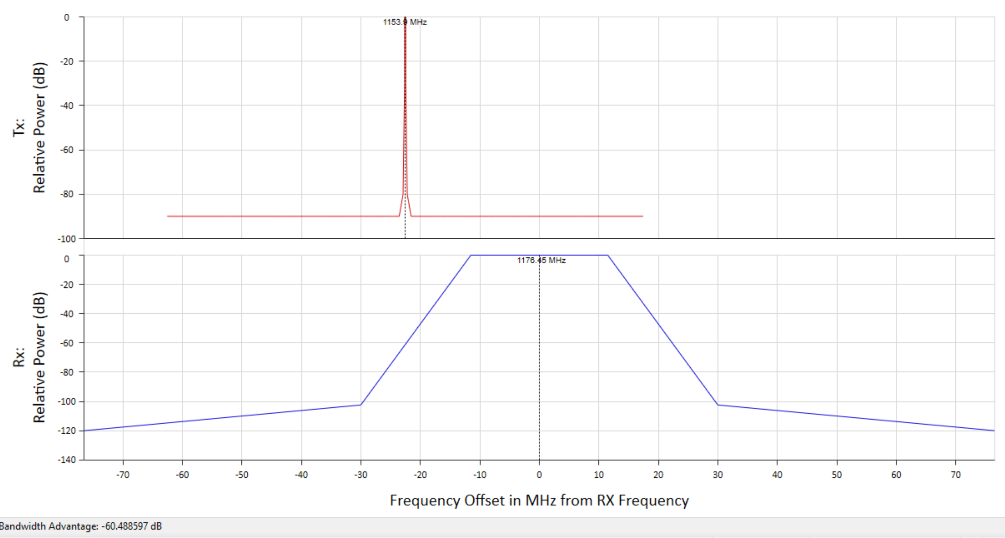
Figure 10: GNSS receiver mask (Fig 8 of ITU-R Rep M.2235)
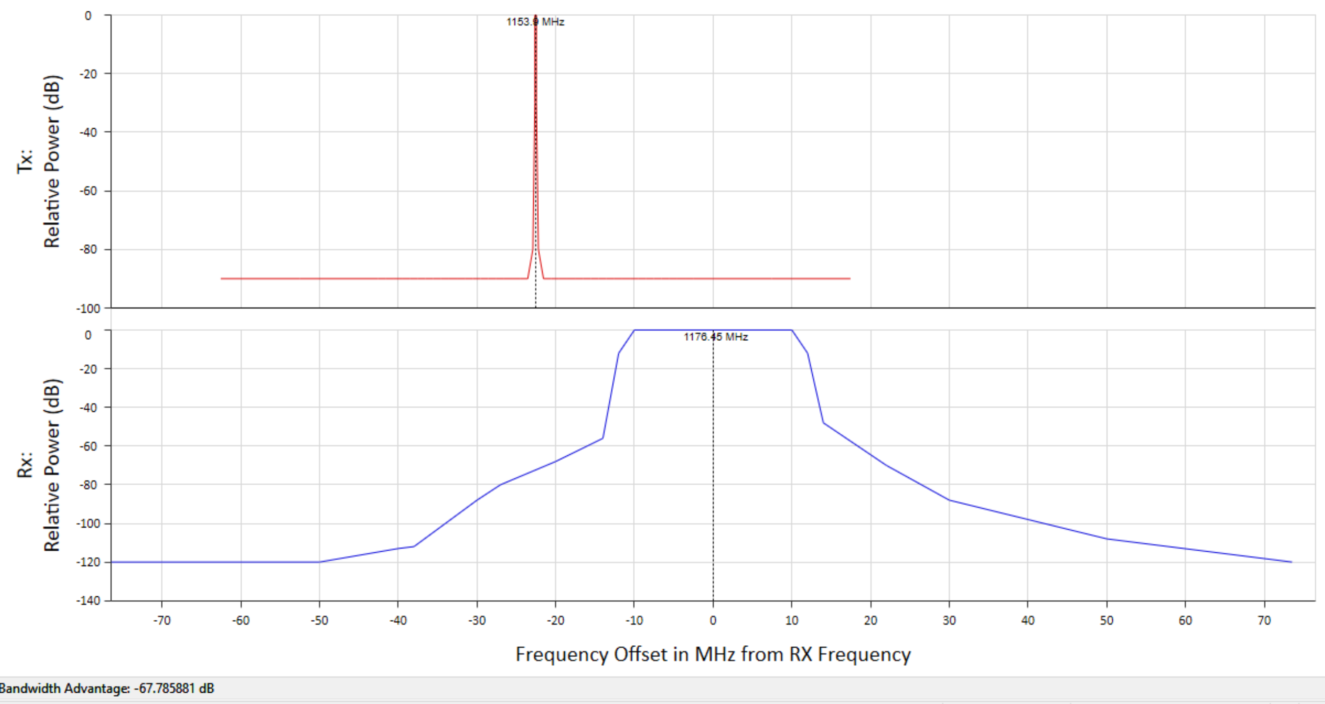
Figure 11: GNSS receiver mask (Fig 3 of Characterization of L5 Receiver Performance Using Digital Pulse Blanking)
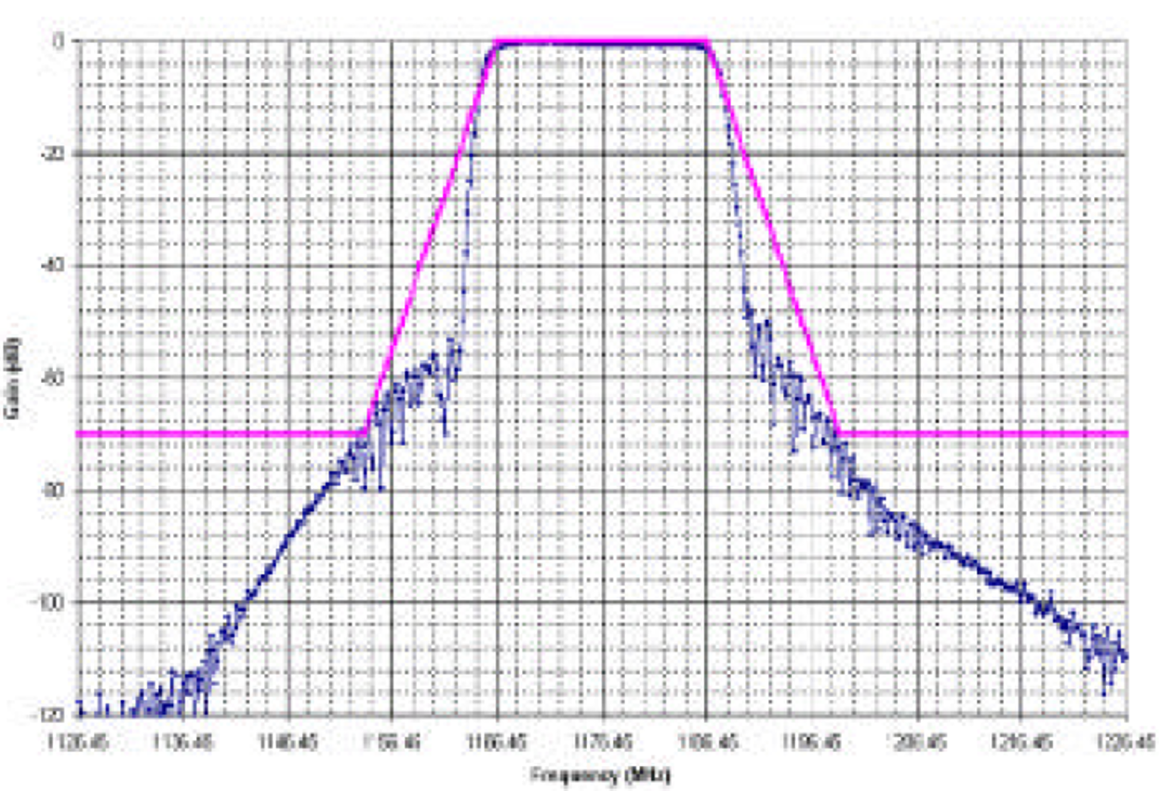
Figure 12: Characterization of L5 Receiver Performance Using Digital Pulse Blanking (Fig 3)
    - Modelling assumptions

Table 52: Modelling assumptions
Parameter | Unit | Value | Reference
Frequency | MHz | 1154 MHz | Assuming 10 MHz guard band to protect GNSS above 1164 MHz
Number of PMSE interferers |  | 5
Safety margin | dB | 6 | Only in the aeronautical case
Interference threshold (aero) | dBW | -149.1 (incl safety margin) | ITU-R Rec M.1905
Interference threshold (general purpose) | dBW | -156 | ITU-R Rec M.1905
Antenna gain (aero) | dBi | -10 | ITU-R Rec M.1905 for angles below -30°
Antenna gain (general) | dBi | -10 | ITU-R Rec M.1905
Polarisation discrimination | dB | 3 (for aero only) | GNSS signals are circularly polarised whereas PMSE is linearly polarised. Only applied in aero case as receive antenna is free from clutter
Building loss | dB | 0 | Only outdoor PMSE studied
Clutter loss (rural) | dB | 17.9 | Only rural considered as worst-case scenario
    - conclusion
Table 53: Separation distances for outdoor PMSE to airborne GNSS
Separation distances for outdoor PMSE to airborne GNSS
ITU-R Rep M.2235 Fig 9 receiver mask | 930 m
ITU-R Rep M.2235 Fig 8 receiver mask | 22 m
Mask GPS L5 real receiver mask | 13 m

Table 54: Separation distances for outdoor PMSE to general purpose GNSS
Separation distances for outdoor PMSE to general purpose GNSS
ITU-R Rep M.2235 Fig 9 receiver mask | 698 m
ITU-R Rep M.2235 Fig 8 receiver mask | 8 m
Mask GPS L5 real receiver mask | 4 m

  - Other systems
Not studied.
- [BNetzA] MCL study on compatibility between PMSE and DME
  - Summary
A MCL sharing study has been performed on audio PMSE interfere the co-frequency DME equipment.
If LoS is given, the free space model can be used. For NLoS other models are more appropriate. The time probability is relevant for long radio paths (e.g. >100 km) but could be neglected for short radio paths and low antenna height of the wireless microphone.
If the audio PMSE is used in densely built-up areas (cities) and/or indoor, no interference is likely to occur.
Audio PMSE should not be used in an open area of about 3 km around the ground DME station.
The required protection distance between audio PMSE used in a large open area and the airborne DME receiver depends on flight altitude and could reach up to 63 km.
This is a worst case analysis. There are margins because some of the assumptions, e.g. on the penetration loss or clutter loss, are very conservative. In reality these losses will be higher. The elevation antenna patterns are not taken into account, the maximum gain was used. The probability that the antennas are pointing to each other with the maximum in azimuth and elevation is not considered. An effective mitigation technique is the selection of adjacent frequencies and not the co-frequency band.
The Radionavigation Service in the frequency band 960-1164 MHz is a safety-of-life service. The full protection of these radio systems has to be ensured. Before accepting other radio applications in that band, e.g. low power audio PMSE, very careful compatibility and sharing studies with conservative assumptions and protection criteria have to be performed to determine the technical condition for new radio application while ensuring the full protection of the incumbent systems. The results of these compatibility studies are the basic for potential regulatory activities by the ECC.
  - PMSE parameters
    - PMSE parameters
Table 1 Handheld audio PMSE
Parameter | Unit | Value | Reference
Bandwidth (BIF,PMSE) | MHz | 0.2 | ECC Report 253
Antenna height (hPMSE) | m | 1.5 | ECC Report 253
Body loss (Lbody) | dB | 7 dB (minimum) | Draft ECC Report 286
Transmit Power (PPMSE) e.i.r.p | dBm | 17 | ERC/REC 70-03 Annex 10,  ECC Report 253
Antenna polarisation |  | Vertical | ECC Report 253
    - Body loss
ECC Report 286 contains the body effect of hand-held and body-worn audio PMSE equipment and is based on previous studies including measurements and simulations.
The body loss at 1 GHz can be estimated for hand-held microphones between 7 and 11 dB. The chosen value is 7 dB
    - Building loss
This Recommendation provides a method for estimating building entry loss at frequencies between about 80 MHz and 100 GHz. The method is not site-specific, and it is primarily intended for use in sharing and compatibility studies. This is a rather new Recommendation, adopted in 2017.
The penetration loss at 1000 MHz is about 13 dB for traditional houses and 28 dB for thermally efficient houses. The chosen value is 13 dB.
  - Propagation models
In the following various, commonly used propagation models are briefly analysed with regard to the application for this study (shortcomings and parameter ranges).
    - Free space attenuation
The free-space propagation is a fundamental reference for radio-engineering. The basic calculation of the free-space attenuation is provided in Recommendation ITU-R P.525. The basic transmission loss is referred to free-space attenuation between isotropic antennas and is a function of the frequency and the distance between the isotropic antennas.
Noting that the free space attenuation is independent of the antenna heights and is depending only on the frequency and direct radio path considered, i.e. no multi-path propagation is addressed.
It is obvious that the application is limited to LoS propagation, i.e. limited by the radio horizons d1, d2 , which are a function of the antenna height h1 , h2 above ground (sea level, respectively) and the effective Earth radius k R with k=4/3 considering the refractivity of the lower atmosphere:
$d_{1}=4.12 \sqrt{h_{1 }}$ with d1 in km and h1 in m.
The radio horizons for the antenna heights used in this contribution are listed below:
h1 / m | 1.5 | 2.1 | 25 | 40 | 100 | 1000 | 10000
d1 / km | 5 | 6 | 20.6 | 26 | 41.2 | 130 | 412
For the LoS condition both antenna heights have to be considered: $d≪d_{1}+ d_{2}$ . Noting, if $d≈d_{1}+ d_{2}$, then the 1st Fresnel zone touches the spherical Earth surface and additional attenuation has to be taken into account.
    - Recommendation ITU-R P.528
This Recommendation contains propagation curves for aeronautical mobile and radionavigation services using the VHF, UHF and SHF bands. It contains a method for predicting basic transmission loss in the frequency range 125-15 500 MHz, antenna heights of h1 between 1.5 m and 20 km and of h2 between 1 and 20 km and time probability between 1 and 95 %. The method uses an interpolation method on basic transmission loss data from sets of curves. These sets of curves are valid for ground-air, ground-satellite, air-air, air-satellite, and satellite-satellite links. The Recommendation does not take into account the terrain (only flat) and land-usage around the transmitter (e.g. buildings).
For frequencies around 1000 MHz, very low time percentage of 1 % and antenna height of
h1 = 1.5 m, the predicted basic transmission loss is slightly less than the related free space loss. This may be caused by multi-path propagation and/or atmospheric effects, like ducting. Significant contribution due to multi-path propagation could be an issue over very smooth surfaces, e.g. sea or lake, but is not an issue in rough terrain or urban area. For anomalous atmospheric conditions, stable atmospheric layers are required and a small angle of wave incident is required. These pre-conditions will not be found over cities where the atmosphere is mixed and can be described well by the standard atmosphere corresponding to k=4/3 and very low antenna height surrounded by obstacles.
Therefore, for Europe and over land, the assumption of the time probability of 50 % is a very reasonable assumption for the estimation. By the way, comparing 1 % with 50 or 95 % for short distances, let say less than 50 km, the extension of the distance is negligible.
    - Recommendation ITU-R P.452
This Recommendation contains a prediction method for the evaluation of interference between stations on the surface of the Earth at frequencies from about 0.1 GHz to 50 GHz, accounting for both clear-air and hydrometeor scattering interference mechanisms.
The propagation model was developed originally for point-to-point prediction for fixed service with antennas above roof tops. Later on it was amended for other frequency ranges and lower antenna heights. The models contained within Recommendation ITU-R P.452 work from the assumption that the interfering transmitter and the interfered-with receiver both operate within the surface layer of atmosphere. Use of exceptionally large antenna heights to model operations such as aeronautical systems is not appropriate for these models.
There is one shortcoming: The model predicts the basic transmission loss to less (compared with free space) for short distances (on Earth) and large antenna height differences because the two-dimensional distance between the antennas is not taken into account.
For large distances and LoS, the predicted transmission loss is approaching the free space value. For beyond the radio horizon and NLoS the path loss is increased by diffraction loss due to the spherical Earth surface. The consideration regarding the time probability of the atmosphere is similar to above (see above). All terrain heights used in this model are set to 0 m, i.e. smooth Earth surface.
    - Recommendation ITU-R P.1546
This Recommendation describes a method for point-to-area radio propagation predictions for terrestrial services in the frequency range 30 MHz to 3 000 MHz. It is intended for use on tropospheric radio circuits over land paths, sea paths and/or mixed land-sea paths up to 1 000 km length for effective transmitting antenna heights less than 3 000 m. The method is based on interpolation/extrapolation from empirically derived field-strength curves as functions of distance, antenna height, frequency and percentage time. The calculation procedure also includes corrections to the results obtained from this interpolation/extrapolation to account for terrain clearance and terminal clutter obstructions.
The model was developed originally for VHF/UHF broadcasting. It was later extended for receiving antenna heights lower than 10 m and transmitting antenna heights lower than 30 m and, of course, the frequency range was extended significantly. It is a very commonly used model for point-to-area prediction taking into account the different environments such as rural, suburban or urban and seems therefore appropriate to be used for the estimation of the radio path loss for the radio path PMSE to the ground DME station. In the model, the clutter height used for rural and suburban is 10 m and for urban is 20 m.
It is distinguished between time and location probability. For the time probability, the same consideration is valid as above. The location probability is typically set to 50 % and the loss limited by free space.
    - Recommendation ITU-R P.2108 on clutter loss
This Recommendation provides methods for estimating loss through clutter at frequencies between 30 MHz and 100 GHz. This is a rather new Recommendation, adopted in 2017, and driven by the studies for IMT.
The clutter loss depends on the frequency, type of environment and extension of the area. For about 1000 MHz with homogeneous built-up area of about 100 m around the PMSE transmitter, the additional loss is in the range of 17 dB. Extending the range of the built-up area up to 1 km, then the loss increases to about 25 dB.
The clutter loss will be used together with the Recommendations (P.525, P.452, and P.528) to consider the impact of build-up area. The model P.1546 contains already different environments.
The chosen value for clutter loss: 17 dB.
    - Propagation models considered
For impact of PMSE on the airborne DME receiver the basic transmission loss is determined by free space, P.528 and P.452.
For impact of PMSE on the ground DME receiver the basic transmission loss is determined by free space and P.1546.
Body loss, clutter and penetration losses are added as appropriate.
  - DME
    - DME parameters
Table 2 DME/P Airborne interrogator
Parameter | Unit | Value | Reference
Frequency range | MHz | 962-1213 | SE7(18)101A1
Bandwidth (BIF,DME) | MHz | 3.5 | SE7(18)101A1
Antenna height (h2) | m | 100, 1000, 10000 | SE7(18)101A1
Antenna gain (GDME) Note 1 | dBi | 5.4 (maximum) | SE7(18)101A1
Antenna polarisation |  | Vertical | SE7(18)101A1
Interference threshold (IDME) Note 2, 3 | dBm/MHz | Sensitivity requirement shall meet in-band continuous CW  up to -99 dBm | EUROCAE ED-54
Note 1: The antenna pattern is not taken into account in the study.
Note 2: SE7(18)097: For broadband interference the interference threshold of -99 dBm/MHz can be assumed (Recommendation ITU-R M.1639).
Note 3: The threshold referred to one PMSE channel of 200 kHz results in -106 dBm.
Table 3 DME Ground transponder
Parameter | Unit | Value | Reference
Frequency range | MHz | 1025-1150 | SE7(18)101A1
Bandwidth (BIF,DME) | MHz | 3.5 | SE7(18)101A1
Antenna height (h2) | m | 40, 25, 2.1 | SE7(18)101A1
Antenna gain (GDME) | dBi | 12  (omnidirectional) | SE7(18)101A1
Antenna polarisation |  | Vertical | SE7(18)101A1
Interference threshold (IDME) | dBm | -106 | ICAO Annex 10,  EUROCAE ED-57

    - Modelling assumptions
The sharing studies related to handheld microphones interfere with the co-frequency airborne and ground DME receivers are picked up to discuss the impact of different propagation models. The required protection distance is determined for various environments around the PMSE. Additionally, the indoor use of PMSE is studied.
Figure 20: Audio PMSE sharing radio spectrum with DME systems (Source: SE(18)097)

In this study, the following interference scenarios are considered:
- Audio PMSE transmitter to DME airborne interrogator receiver
- Audio PMSE transmitter to DME ground transponder receiver
The direction of DME interfere with audio PMSE is not addressed because it could be assumed the PMSE systems in the band 960-1164 MHz are operated by professional operators and the selected radio spectrum and geographic location were identified by the regulator before to ensure that PMSE does not interfere any aviation system.
The audio PMSE system is designed in such a way that each wireless microphone use an exclusive channel, i.e. two microphones will use two different frequency bands.
To simplify the consideration, the following (worst case) assumptions are taken in this study:
- audio PMSE device with the highest transmitted power: handheld audio PMSE,
- co-frequency use with the frequency of 1000 MHz,
- PMSE device is in the main antenna lobe of the DME equipment.

    - MCL Analysis
The interference on DME is estimated with MCL methodology. The basic transmission loss can be determined by
$$L_{b}= P_{PMSE}+G_{DME}-I_{DME}$$
Where Lb basic transmission path loss in dB
PPMSE transmitted power (e.i.r.p.) in dBm
GDME maximum of antenna gain in dBi of the DME equipment
IDME Interference threshold referred to the PMSE channel bandwidth in dBm
The required distance to protect DME is determined for various propagation models.
Then transmission loss is increased step-by-step
by body loss of the microphone, Lbody
by clutter in the vicinity of PMSE to take into account buildings (urban area), Lclutter
by penetration loss, Lbuilding for PMSE use indoor only
The detailed MCL analysis for airborne DME receiver is contained in Annex 1. The results are summarized in the following table.
Table 4 Required protection distance for Airborne DME receiver
Flight height | Required protection distance d / km  100 m 1000 m 10000 m
Open area | 18 | 63 | 62
+ body loss | 28 | 28 | 26
+ clutter loss | 4 | 4 | 0
+ building entry loss | 0 | 0 | 0

The worst case is when the PMSE device is used in open area with LoS to the airplane and the antennas are pointing to each other, then the separation distance results in about 18 to 63 km depending on the flight height.
Taking into account the additional body loss, the required range is reduced to 13 to 28 km.
Assuming that PMSE is applied usually in cities, the required distance is less than 4 km for low flight heights. Noting that if the elevation angle between airplane is between 50° and 90° (i.e. airplane is exact above PMSE), the antenna gain of the airborne DME is reduced by 5 to 17 dB (Recommendation ITU-R M.1642). That means no interference.
If PMSE is used in cities indoor only, no interference is likely to occur. An additional margin of about at least 13 dB is given.
The detailed MCL analysis for Ground DME receiver is contained in Annex 2. All considered cases (rural, suburban or urban) are below 3 km due to the low antenna heights. The worst case is rural. Ground DME stations are somewhere in the area of an airport. The required protection distance should be ensured easily in all cases by the responsible authorities.
    - PMSE (handheld) interfere with airborne DME receiver
      - Required transmission loss
Table 5 Required protection distance for Airborne DME receiver
 |  | Propagation model, d/km  P.525 P.528 P.452 |  |  | Transmission Loss  L/dB
DME_Airborne (VLR): h2 = 100m
Lb / dB | 0 | 62.8 | NA | 18 | 128.4
+ Lbody / dB | 7 | 28 | NA | 12.6 | 121.4
+ Lclutter / dB | 24 | 4 | NA | 4 | 104.4
+ Lbuilding / dB | 37 | 0.9 | NA | 0.9 | 91.4
DME_Airborne (VLR): h2 = 1000m
Lb / dB | 0 | 62.8 | 53.5 | 56.4 | 128.4
+ Lbody / dB | 7 | 28 | 27.7 | 27.4 | 121.4
+ Lclutter / dB | 24 | 3.6 | 3.8 | 4 | 104.4
+ Lbuilding / dB | 37 | 0 | 0 | 0 | 91.4
DME_Airborne (VLR): h2 = 10000m
Lb / dB | 0 | 62,0 | 61 | 60 | 128.4
+ Lbody / dB | 7 | 26,2 | 26 | 27.4 | 121.4
+ Lclutter / dB | 24 | 0 | 0 | 0 | 104.4
+ Lbuilding / dB | 37 | 0 | 0 | 0 | 91.4

      - Discussion
The required distance for protection of the airborne DME receiver against interference can be estimated well by the free space model. There are three exceptions:
For NLoS, e.g. low flight altitude (e.g. 100 m), the radio path is touching the Earth surface or is even diffracted at the spherical Earth. In that case the model P.452 is more appropriate.
If the calculated path length is considerably larger than the height difference of the antennas, then the horizontal distance is about the calculated path length, otherwise the antenna height difference has to be taken into account for the determination of the horizontal path length.
The calculated distance is less than the flight height, i.e. there is no interference but a margin. The values are set to 0 in the table.
The worst case is when the PMSE device is used in open area with LoS to the airplane and the antennas are pointing to each other, then the separation distance results in about 18 to 63 km depending on the flight height.
Taking into account the additional body loss, the required range is reduced to 13 to 28 km.
Assuming that PMSE is applied usually in cities, the required distance is less than 4 km for low flight heights. Noting that if the elevation angle between airplane is between 50° and 90° (i.e. airplane exact above PMSE), the antenna gain of the airborne DME is reduced by 5 to 17 dB (Recommendation ITU-R M.1642). That means no interference.
If PMSE is used in cities indoor only, no interference is likely to occur. An additional margin of about at least 13 dB is given.
    - PMSE (handheld) interfere with ground DME receiver
      - Required transmission loss
Table 6 Required protection distance for ground DME receiver
 |  | Propagation model, d/km  P.525 P.1546 P1546 P.1546  rural suburban urban |  |  |  | Transmission Loss  L/dB
DME_Ground (VLR): h2 = 2.1 m,
Lb / dB | 0 | 134 | 1.70 | 1.6 | 0.6 | 135
+ Lbody / dB | 7 | 60 | 1.1 | 1.1 | 0.5 | 128
+ Lbody  + Lbuilding / dB | 20 | 13.4 | 0.74 | 0.71 | 0.35 | 115
DME_Ground (VLR): h2 = 25 m
Lb / dB | 0 | 134 | 2.5 | 2.35 | 1.55 | 135
+ Lbody / dB | 7 | 60 | 1.6 | 1.5 | 1 | 128
+ Lbody  + Lbuilding / dB | 20 | 13.4 | 0.84 | 0.8 | 0.67 | 115
DME_Ground (VLR): h2 = 40 m
Lb / dB | 0 | 134 | 3 | 2.74 | 1.8 | 135
+ Lbody / dB | 7 | 60 | 1.8 | 1.70 | 1.1 | 128
+ Lbody  + Lbuilding / dB | 20 | 13.4 | 0.88 | 0.84 | 0.71 | 115

      - Discussion
The required distance for protection of the ground DME receiver against interference can be estimated well by the point to area model P.1546. The use of the free space model not appropriate because the LoS is not possible over this distance with these low antenna heights.
All considered cases (rural, suburban, urban) below 3 km. Ground DME stations are somewhere in the area of an airport. The required protection distance should be ensured easily in all cases by the responsible authorities.
    - Conclusion
A MCL sharing study has been performed on audio PMSE interfere the co-frequency DME equipment.
If LoS is given, the free space model can be used. For NLoS other models are more appropriate. The time probability is relevant for long radio paths (e.g. >100 km) but could be neglected for short radio paths and low antenna height of the wireless microphone.
If the audio PMSE is used in densely built-up areas (cities) and/or indoor, no interference is likely to occur.
Audio PMSE should not be used in an open area of about 3 km around the ground DME station.
The required protection distance between audio PMSE used in a large open area and the airborne DME receiver depends on flight altitude and could reach up to 63 km.
This is a worst case analysis. There are margins because some of the assumptions, e.g. on the penetration loss or clutter loss, are very conservative. In reality these losses will be higher. The elevation antenna patterns are not taken into account, the maximum gain was used. The probability that the antennas are pointing to each other with the maximum in azimuth and elevation is not considered. An effective mitigation technique is the selection of adjacent frequencies and not the co-frequency band.

- [ANFR] Study on compatibility between ARNS and PMSE
  - Summary
    - Executive Summary
This study investigates the possible use of audio PMSE in the frequency band 960-1164 MHz currently allocated to aeronautical mobile en route and radionavigation services.
The study took into account existing aviation systems (civil aviation DME, 1030/1090 MHz frequency, GNSS in the adjacent band and military JTIDS/MIDS) as well as on-going projects (short term UAT, mid-term LDACS and CNPC for drones, long term CNS). The band 960-1164 MHz being already saturated with these security systems, the adequate propagation model is Free Space Loss between aircrafts and PMSE devices, and an I/N = -6 dB criterion was used.
- Regarding PMSE transmitters, they are considered with omnidirectional EIRP. Due to lack of scenarios, the study considered aggregated interference in co-channel with up to 3 PMSE per one MHz, with a body loss of 0 dB.
- Regarding PMSE receivers, the interference level ensuring protection considered is -105 dBm.
- The resulting separation distances range from 225 km to 587 km for outdoor use of audio PMSE.
    - Overall criterion
The protection criteria I/N of -6 dB has been considered in this study.
I/N protection criteria are commonly used for various terrestrial systems at ITU-R level and in many studies at CEPT.
    - Status
An additional factor may have to be considered in order to recognize the status of the service under which aeronautical systems are operated compared to the one for PMSE. In this study, in order to protect this high availability and integrity requirement for the aeronautical radionavigation, the value of the protection criteria is defined at -10 dB in this study.
The band 960-1164 MHz is not allocated to the mobile service. Therefore, PMSE will have to operate under the article 4.4, whereas all the aeronautical systems operate on a primary basis in this band. Furthermore, the safe operation of aeronautical systems into the band 960-1164 MHz requires availability and integrity, which is comparable to few if any other radio services. Also, aeronautical Radionavigation needs to be even protected at a higher level than Aeronautical Radiocommunications.
In order to protect this high availability and integrity requirement for the aeronautical radionavigation, the value of the protection criteria must take into account this factor and is therefore defined at -10 dB in this study.
    - Safety margin consideration
ICAO handbook DOC 9718 defines the safety, as following:
Aeronautical safety applications are required to have continued operation through worst case interference, so all factors which contribute to harmful interference should be considered in analyses involving those applications. An aviation safety margin is included in order to address the risk that some such factors cannot be foreseen (for example impacts of differing modulation schemes). This margin is applied to the system protection criteria to increase the operational assurances to the required level. Traditionally for aviation systems/scenarios an aviation safety margin of 6–10 dB is applied. Until established on the basis of further study on a case-by-case basis, an aviation safety margin of not less than 6 dB should be applied.
Aeronautical systems of civil aviation operated in the frequency band 960-1164 MHz are for safety of life purpose, therefore a safety margin of 6 dB to comply with article 4.10 and ICAO handbook is considered appropriate for this study.
    - Aggregated effect and deployment scenario
So far, no much material was provided regarding a possible deployment scenario of audio PMSE in the band 960-1164 MHz.
Nevertheless, according to ETSI TR 102 546, during outdoor show, such as 14th of July in France, around 150 wireless microphones can be at the same place.
The aggregated effect has been taken into account although no much material was provided. Due to PMSE inter-system interferences, it appears relevant to consider a use of three wireless audio PMSE within one MHz bandwidth.
    - Summary
All the incumbent systems into the band 960-1164 MHz were considered. This includes the current applications (such as DME, UAT, and all the 1030-1090 frequencies systems) and also the future systems that are expected in Europe and in France in the short, middle and long term (CNPC for drones, LDACS and the long term CNS system).
For the compatibility studies, the main objective is to ensure security for the aeronautical systems, therefore they are considered as a victim and only the receivers parameters are shown below. The worst case considered is airborne systems and outdoor PMSE, with no building attenuation nor body attenuation.
Table 1: Summary
PMSE interference into aeronautical systems | Frequency Band (MHz) | Minimum co-frequency separation distance (Air Receiver) | Guard band
DME | 962-1164 | 571 km | 1.59 MHz
UAT | 978 | 419 km | 10.8 MHz
1030-1090 Frequencies | 1030  1090 | Not applicable | 23.1 MHz  21.4 MHz
CNPC | 960-1164 | 432 km | 486 kHz
LDACS | 1110-1156 | 287 km | >500 kHz
GNSS | 1176.45 | Not applicable | 30 MHz
Integrated CNS | 960-1164 | Unknown | Unknown
Aeronautical systems interference into PMSE | Frequency Band (MHz) | Minimum co-frequency separation distance (Air Receiver) | Guard band
DME | 962-1164 | 587 km | Not Studied
UAT | 978 | 587 km | Not Studied
CNPC | 960-1164 | 225 km | Not Studied
LDACS | 964-1010 | 298 km | Not Studied
Link 16 (JTIDS/MIDS emitters) | 969-1008,  1053-1065,  1113-1206. | 587 km | Not Studied
Integrated CNS | 960-1164 | Unknown | Not Studied

  - PMSE parameters
Table 1: Parameters PMSE
Parameters | Unit | Value | Comments
Handheld audio, body worn and In Ear Monitoring PMSE transmitter
Bandwidth (BW) | MHz | 0.2
Antenna height | m | 1.5
Maximum e.i.r.p. | dBm | 17 (RMS) / 21 (Peak) | The RMS value will be considered in this study.
OOBE |  | 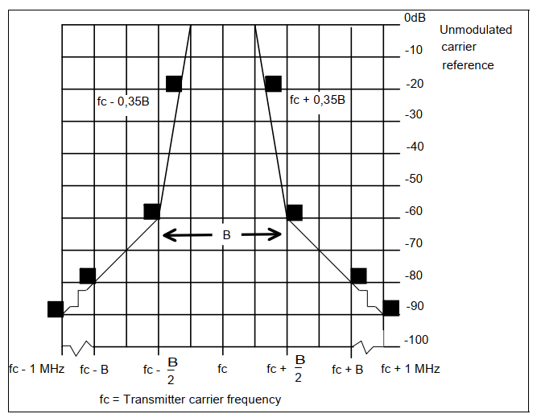
Receiver
Bandwidth (BW) | MHz | 0.2 | EN 300 422, Section 5.1.1. Table 1, Designator “R”
Reference Sensitivity | dBm | -90 | ETSI TR 102 546  Section B.4.1.3
Blocking Response | dB | 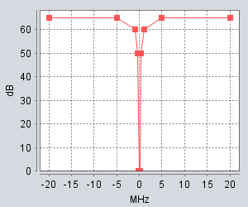 | SE7 Guidance, see EN 300 422 Attachment 2, Applicable Receiver Parameter for PWMS below 1 GHz.
Antenna height | m | 3
Antenna gain | dBi | 0 | Omni directional
    - PMSE receiver Parameters
Table 4: Parameters for audio PMSE receivers
Parameter | Unit | Value | Reference
Interference level to protect PMSE | dBm | -115 (RMS)  -105 (peak) | ETSI TR 102 546 for the level of -115 dBm.
Selectivity | dB | See curve below | ERC Report 63
    - Parameters of body loss
A body loss value of 0 dB has been considered in this study to reflect the Intra Ear Monitoring configuration and to be considered for the worst case configuration hand-held/body-worn system, the applicability of ECC Report 286 being not agreed for this study.
Therefore, the EIRP considered for PMSE devices is omnidirectional.
    - Parameter for building loss
The aeronautical systems involve aircrafts as mobiles in the air and PMSE devices on the ground. Outdoor use of PMSE is not excluded and it has to be noted that the level of attenuation due to building could be extremely variable. No building attenuation has been taken into account in the sharing scenarios.
  - Propagation model
The worst case scenario requires the Free Space Loss as the propagation model between the aircraft (mobile) and the PMSE (outdoor, without indoor or building entry considerations).
  - DME
    - DME parameters
      - Regular DME

Parameters | Unit | DME/N airborne
Transmitter
Frequency range | MHz | 1025-1150
Bandwidth | MHz | 0.9
Max e.i.r.p. | dBm | 68
Minimum cable loss | dB | 1
Receiver
Frequency range | MHz | 962-1213
Bandwidth | MHz | 1.8
Noise figure | dB | 4
Antenna gain | dBi | 5.4
Minimum cable loss | dB | 1

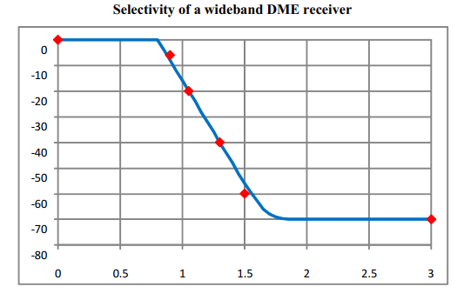
Figure XX: Airborne selectivity of a 442 DME receiver (Bandwidth of 1.8 MHz at 3dB)
      - Transportable DME
Per operational requirement, there are 2 DME channels reserved for French Civil Aviation Authority that can be unannounced deployed and used anywhere at any time in all the French territory.

Channel | Interrogation Frequency | Reply Frequency
97Y | 1121 MHz | 1058 MHz
119X | 1143 MHz | 1206 MHz
Each of these frequencies requires, for the reply towards DME airborne receivers, a reserved access and a guard band of at least 2 MHz in order to be protected from PMSE inferences (see dedicated sections above – this guard band is the figure that sets the separation distance to 1000 feet).
      - Other military frequencies in band 962-1164 MHz
Per operational requirement, there are 5 TACAN channels reserved for NATO and French Military for TACAN that can be unannounced used anywhere at any time in all the French territory.

Channel | Interrogation Frequency | Reply Frequency
26Y | 1050 MHz | 1113 MHz
34X | 1058 MHz | 995 MHz
54X | 1078 MHz | 1015 MHz
98X | 1122 MHz | 1185 MHz
112Y | 1136 MHz | 1073 MHz
There are also 16 pairs of Air-To-Air channels dedicated to NATO use over European and American skies in order to ensure protection missions regarding non-allied nations as well as training purposes. They can be activated without notice to the civil aviation authorities. Similarly, there are 4 channels dedicated for exclusive use by NATO naval units.
Table 6: Reserved frequencies for TACAN (European territory)
Air-To-Air channels | Navy channels
20&83X/Y | 1X
25&88X/Y | 16X
30&93X/Y | 1Y
35&98X/Y | 16Y
40&103X/Y
45&108X/Y
50&113X/Y
55&118X/Y
The military use for TACAN leads to similar considerations as Civil Aviation DME in the studies.
Each of these reply frequencies requires, for the reply towards TACAN airborne receivers, a reserved access and a guard band of at least 2 MHz in order to be protected from PMSE inferences (see dedicated sections below – this guard band is the figure that sets the separation distance to 1000 feet).
    - Modelling assumptions
The propagation model is Free Space Loss between an airborne platform and PMSE devices used in open-air conditions, therefore omnidirectional without building loss and body loss.
    - Conclusion and compatibility studies
      - DME Study for protection of the airborne receiver (between 962 and 1164 MHz)
This section presents the MCL DME study conducted in order to evaluate the necessary separation distance and the associated guard band to protect the DME airborne receiver between 962 and 1164 MHz.
      - Impact of audio PMSE transmitter on airborne receiver
The DME receivers are likely to receive interference from PMSE, which is computed with the hypothesis as follows:
Parameters
PMSE e.i.r.p (dBm) | 17 dBm
Agregated Effect (3 PMSE within 1 MHz Bandwidth) (dB) | 7.32 dB
DME receiver Noise (dBm) | -107.38 dBm
DME antenna gain (dBi) | 5.4 dB
Cable loss (dB) | 1 dB
Safety Margin (dB) | 6 dB
Interference Level allowed (dBm) | -123.78 dBm (I/N=-6dB) / -127.78 dBm (I/N=-10dB)
Requested Attenuation (dB) | 148.10 dB (I/N=-6dB) / 152.10 dB (I/N=-10dB)
FSL Distance Separation required at 1062 MHz | 571,44 km (I/N=-6dB) / 905,68 km (I/N=-10dB)
Radio Horizon (Flight level 600) | 587 km
According to the study, a separation distance of 571,44 km (I/N=-6 dB) or 905,68 km (I/N=-10dB) is needed in order to protect the DME/N receivers from audio PMSE.
As this distance is very important, the practical separation distance will be limited by the radio horizon. As a plane can flight up to 60 000 feet, the separation distance is then 587 km (I/N=-10 dB).
      - Guard Band to protect DME Channels (between 960 and 1164 MHz)
As it is shown by the precedent table, cohabitation between PMSE and DME on co-channel is not feasable because of the separation distances are too much important (571 km and 587 km, respectively for I/N = -6 dB and I/N = -10 dB).
In order to protect both systems, it is important to define a guard band. In this study we will consider that the closest distance between an airborne and an outdoor PMSE will be 1000 feet (around 330 m).

Parameters
PMSE e.i.r.p (dBm) | 17 dBm
Aggregated Effect (3 PMSE near the bandwidth edge victim) (dB) | 4.77 dB
DME receiver Noise (dBm) | -107.38 dBm
DME antenna gain (dBi) | 5.4
Cable loss (dB) | 1
Safety Margin | 6 dB
Interference Level allowed (dBm) | -123.78 dBm (I/N = -6 dB) / -127.78 dBm (I/N = -10 dB)
Requested Attenuation (dB) | 145.55 dB (I/N = -6 dB) / 149.55 dB (I/N = -10 dB)
FSL Attenuation for 330 m at 1062 MHz (dB) | 83.34 dB
Receiver Selectivity Required (dB) | 62.21 dB (I/N = -6 dB) / 66.21 dB (I/N = -10 dB)
Guard band to reach the receiver selectivity (MHz) | 1.59 MHz (I/N = -6 dB) / 1.75 MHz (I/N = -10 dB)
According to the receiver mask from an 442 DME receiver, a guard band of +/-1.59 MHz (I/N = -6 dB) or 1.75 MHz (I/N = -10 dB) is needed in order to protect the DME receivers from audio PMSE.
      - DME Study to protect PMSE receiver (between 960 and 1164 MHz)
The MCL DME study was conducted in order to assess the required separation distance to protect PMSE receivers between 960 and 1164 MHz. As the CNPC signal is a TDD pulsed signal, the protection criteria for PMSE is assumed to be -105 dBm for pulsed interferences. It has to be noted that no additional margin has been included here, therefore this value should be considered as a threshold and not disminished.
Parameters | Impact of DME airborne transmitter on PMSE receiver
DME Airborne EIRP (dBm) for 900 KHz | 68 dBm / 900 kHz
DME Airborne EIRP (dBm) | 64.47 dBm / 200 kHz
PMSE protection criteria (dBm) | -105 dBm
Requested Attenuation (dB) | 166.46 dB
FSL Distance Separation required (F=1062 MHz) | 4734 km (in co-channel)
Radio Horizon (Flight level 600) | 587 km
A separation distance of 4734 km is needed in order to protect the audio PMSE from the CNPC airborne transmitters.
As this distance is very important, the practical separation distance will be limited by the radio horizon. As a plane can flight up to 60 000 feet, the separation distance is then 587 km).
  - 1030/1090 MHz systems
    - 1030/1090 MHz parameters
In order to consider the worst case scenario, we only study airborne SSR receiver for the 1030 MHz frequency and the airborne ABSB receiver for the 1090 MHz frequency.

Parameters | Unit | SSR airborne Transponder Receiver
Frequency range | MHz | 1030 (RTCA DO-181 §2.2.2.2)
Antenna Gain | dBi | 5.4
Cable loss | dB | 3 (ED-43 §3.2.4.2)
Bandwidth | MHz | 6 (RTCA DO-181 §2.2.2.3)
Noise figure | dB | 5
Selectivity for the Airborne (Mode S replies) | dBc | 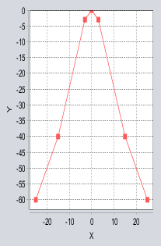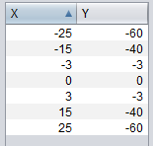  (RTCA DO-181 §2.2.2.3)  Spurious Rejection : 70 dBc

Parameters | Unit | ADS-B airborne receiver
Frequency range | MHz | 1090 (RTCA DO-260 §1.2.2)
Antenna Gain | dBi | 2 to 5 dBi (RTCA DO-260 M.4.1)
Cable loss | dB | 3 (RTCA DO-260 §P2.1.1)
Bandwidth | MHz | 11 MHz (RTCA DO-260 Table 2-82)
Noise figure | dB | 5
Selectivity  (RTCA DO-260 Table 2-82) | dBc | 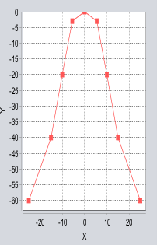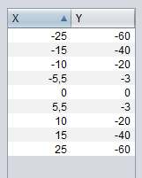
    - Modelling assumptions
The propagation model is Free Space Loss between an airborne platform and PMSE devices used in open-air conditions, therefore omnidirectional without building loss and body loss.
    - conclusion
The MCL 1030-1090 frequencies study aims to define the relevant guard band. Therefore it is considered that the closest distance between an airborne and an outdoor PMSE will be 1000 feet (around 330 meters).
      - Guard band to protect the 1030 MHz frequency
The system that has the widest receiver for the 1030 MHz frequency is the airborne SSR receiver (RTCA DO-181 §2.2.2.3).
In this section, we only study the impact of audio PMSE to airborne SSR receiver as it is wider than the PMSE receiver.
The airborne antenna gain is up to 5.4 dBi with a receiver bandwidth of 6 MHz.

Parameters | Impact of audio PMSE transmitter on SSR airborne receiver
PMSE e.i.r.p (dBm) | 17 dBm
Aggregated Effect (3 PMSE near the bandwidth edge victim) (dB) | 4.77 dB
SSR receiver Noise (dBm) | -101.15 dBm
SSR antenna gain (dBi) | 5.4
Cable loss (dB) | 1
Safety Margin (dB) | 6
Interference Level allowed (dBm) | -117.55 dBm (I/N = -6 dB) / -121.55 dBm (I/N = -10 dB)
Requested Attenuation (dB) | 139.32 dB (I/N = -6 dB) / 143.32 dB (I/N = -10 dB)
FSL Attenuation for 330 meters at 1030 MHz (dB) | 83.07 dB
Receiver Selectivity Required (dB) | 56.25 dB (I/N = -6 dB) / 60.25 dB (I/N = -10 dB)
Guard band to reach the receiver selectivity (MHz) | 23.1 MHz (I/N = - 6 dB) / >25 MHz (extrapolation) (I/N = -10 dB)
According to the SSR Selectivity from the study, a guard band of 23,1 MHz (I/N = -6 dB) or >25 MHz (I/N = -10 dB) is needed in order to protect the 1030 MHz frequency from audio PMSE.
      - Guard band to protect the 1090 MHz frequency
The system that has the widest receiver for the 1090 MHz frequency is the airborne ADS-B receiver (Table 2-82 DO-102A).
In this section, we only study the impact of audio PMSE to airborne ABSB receiver as it is wider than the PMSE receiver.
The airborne antenna gain is up to 5 dBi with a receiver bandwidth of 11 MHz.

Parameters | Impact of audio PMSE transmitter on ADS-B airborne receiver
PMSE e.i.r.p (dBm) | 17 dBm
Aggregated Effect (3 PMSE near the bandwidth edge victim) (dB) | 4.77 dB
ADSB receiver Noise (dBm) | -98.52 dBm
ADSB antenna gain (dBi) | 5 dBi
Cable loss (dB) | 1 dB
Safety Margin (dB) | 6 dB
Interference Level allowed (dBm) | -114.52 dBm (I/N = -6 dB) / -118.52 dBm (I/N = -10 dB)
Requested Attenuation (dB) | 136.29 dB (I/N = -6 dB) / 140.29 dB (I/N = -10 dB)
FSL Attenuation for 330 m at 1090 MHz (dB) | 83.57 dB
Receiver Selectivity Required (dB) | 52.72 dB (I/N = -6 dB) / 56.72 dB (I/N = -10 dB)
Guard band to reach the receiver selectivity (MHz) | 21.40 MHz (I/N = -6 dB) / 23.40 MHz (I/N = -10 dB)
According to the ADS-B Selectivity from the study, a guard band of +/-21.40 MHz (I/N = -6 dB) or 23.40 MHz (I/N = -10 dB) is needed in order to protect the ADS-B receivers from audio PMSE.
    - Overall results
Any interference into the frequencies 1030 or 1090 is unacceptable for safety reasons (e.g. no co-channel with SSR and above all TCAS and ADS-B). Therefore, the guard bands presented above are essential, hence mandatory.
  - UAT
    - UAT parameters
Parameters | Unit | UAT airborne
Transmitter
Frequency range  §12.1.2.1 | MHz | 978 (+/- 0.002 %)
Bandwidth  §12.1.2.3.3 | MHz | 1.3 MHz (-20 dB)
EIRP  §12.1.2.3.2 | dBm | 58 dBm
OOB  §12.1.2.3.3 | N.A. | 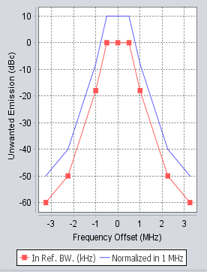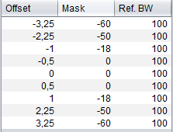
Receiver
Frequency range  §12.1.2.1 | MHz | 978 (+/- 0.002 %)
Antenna Gain | dBi | 0 to 4 dBi (RTCA DO-282B)  Assumed Omnidirectional
Cable loss | dB | 1-3 dB (DOC 9861)
Bandwidth  (RTCA DO-282B) | MHz | 1.3 MHz (-3 dB)
Noise figure | dB | 6 dB
Selectivity  For Airbornes | dB | 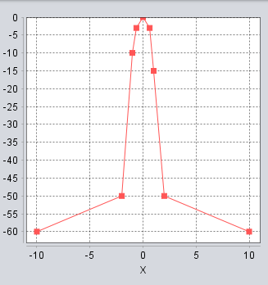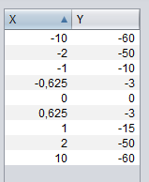
    - Modelling assumptions
The propagation model is Free Space Loss between an airborne platform and PMSE devices used in open-air conditions, therefore omnidirectional without building loss and body loss.
    - CONCLUSION
      - UAT Study to protect the airborne receiver (978 MHz)
The MCL UAT studies investigate the separation distance required and the associated guard band to protect the UAT airborne receiver at 978 MHz.
      - Impact of audio PMSE transmitter on UAT airborne receiver
The UAT receivers are likely to receive interference from PMSE, which is computed with the hypothesis as follows:
Parameters
PMSE e.i.r.p (dBm) | 17 dBm
Aggregated Effect (3 PMSE within 1 MHz Bandwidth) (dB) | 5.91 dB
UAT receiver Noise (dBm) | -106.79 dBm
UAT antenna gain (dBi) | 4 dB
Cable loss (dB) | 1 dB
Safety Margin (dB) | 6
Interference Level allowed (dBm) | -121.79 dBm (I/N = -6 dB) / -127.79 dBm (I/N = -10 dB)
Requested Attenuation (dB) | 144.70 dB (I/N = -6 dB) / 148.70 dB (I/N = -10 dB)
FSL Distance Separation required at 968 MHz | 419,53 km (I/N = -6 dB) / 664,91 km (I/N = -10 dB)
Radio Horizon (Flight level 600) | 587 km
According to the study, a separation distance of 419.53 km (I/N=-6 dB) or 664.91 km (I/N = -10 dB) is needed in order to protect the LDACS receivers from audio PMSE.
As this distance is very important, the practical separation distance will be limited by the radio horizon. As a plane can flight up to 60 000 feet, the separation distance is then 587 km (I/N = -10 dB).
      - Guard band to protect UAT (978 MHz)
As it is shown by the two precedent tables, cohabitation between PMSE and UAT on the same frequency (978 MHz) is not feasable because of the distance separation which are too much important (419 km and 587 km, respectively for I/N = -6 dB and I/N = -10 dB).
In order to protect both systems, it is important to define a guard band. In this study we will consider that the closest distance between an airborne and an outdoor PMSE will be 1000 feet (around 330 m).

Parameters
PMSE e.i.r.p (dBm) | 17 dBm
Aggregated Effect (3 PMSE near the bandwidth edge victim) (dB) | 4.77 dB
UAT receiver Noise (dBm) | -106.79 dBm
UAT antenna gain (dBi) | 4 dB
Cable loss (dB) | 1 dB
Safety Margin (dB) | 6
Interference Level allowed (dBm) | -121.79 dBm (I/N = -6 dB) / -127.79 dBm (I/N = -10 dB)
Requested Attenuation (dB) | 143.56 dB (I/N = -6dB) / 147.56 dB (I/N = -10 dB)
FSL Attenuation for 330 m at 978 MHz (dB) | 82.62 dB
Receiver Selectivity Required (dB) | 60.94 dB (I/N = -6 dB) / 64.94 dB (I/N = -10 dB)
Guard band to reach the receiver selectivity (MHz) ) | 10.8 MHz (extrapolation) (I/N = -6 dB) / 14 MHz (extrapolation) (I/N = -10 dB)
According to the receiver selectivity from the study, a guard band of +/-10,8 MHz (I/N = -6 dB) or 14 MHz (I/N = -10 dB) is needed in order to protect the UAT receivers from audio PMSE.
      - UAT Study to protect PMSE receivers (978 MHZ)
The MCL UAT Study was conducted in order to assess the required separation distance to protect the PMSE receiver at 978MHz.
As the UAT signal is a pulsed signal, the protection criteria for PMSE is assumed to be -105dBm for pulsed interferences. It has to be noted that no additional margin has been included here, therefore this value should be considered as a threshold and not disminished.
Parameters | Impact of UAT airborne transmitter on PMSE receiver
UAT Airborne EIRP (dBm) for 1.3 MHz | 58 dBm / 1.3 MHz
UAT Airborne EIRP (dBm) for 0.2 MHz | 49.87 dBm / 200 kHz
PMSE protection criteria (dBm) | -105 dBm
Requested Attenuation (dB) | 154.87 dB
FSL Distance Separation required (F=978 MHz) | 1352 km (in co-channel)
Radio Horizon (Flight level 600) | 587 km
According to the study, a separation distance of 1352 km is needed in order to protect the audio PMSE from the UAT transmitters.
As this distance is very important, the practical separation distance will be limited by the radio horizon. As a plane can flight up to 60 000 feet, the separation distance is then 587 km.

  - CNPC
    - CNPC parameters
All the parameters come from the RTCA document (DO-362).
Parameters | Unit | UAV CNPC airborne
Transmitter
Frequency range | MHz | 960-1164
Bandwidth | MHz | 0.500
e.i.r.p. | dBm | Range From 15 up to 30 with directional ground antennas  Range From 15 up to 37 dBm with omnidirectional ground antennas  +/-10% (average during 1 second) [see DO-362 §2.2.2.1.1.1]
OOB | N.A. | 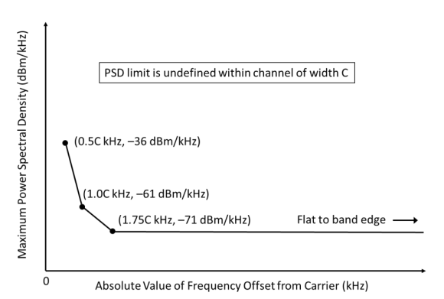  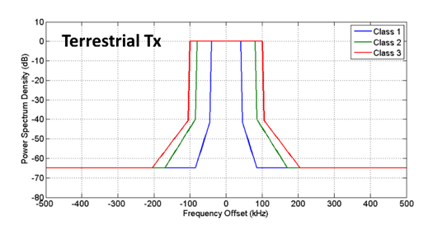§2.2.1.7.2
Receiver
Frequency range | MHz | 960-1164 (§1.5)
Antenna Gain | dBi | Omnidirectional 3 dBi (see DO-362 §2.2.1.6.2.1.1)
Cable loss | dB | 1 (see DO-362 Table G-8)
Bandwidth | MHz | 0.500
Noise figure | dB | 4 (see DO-362 §L.1 4)
Selectivity  §2.2.1.7.2 | dBc | 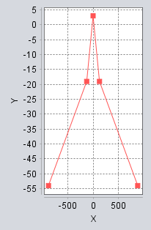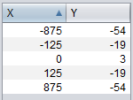  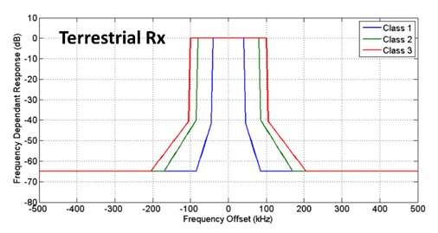
    - Modelling assumptions
The propagation model is Free Space Loss between an airborn platform and PMSE devices used in open-air conditions, therefore omnidirectional without building loss and body loss.
    - CONCLUSION
      - CNPC Study to protect the airborne receiver (between 960 and 1164 MHz)
The MCL CNPC study aims at establishing the required separation distance to protect the CNPC airborne receiver between 960-1164 MHz.
      - Impact of audio PMSE transmitter on CNPC airborne receiver
Parameters | Value
PMSE e.i.r.p (dBm) | 17 dBm
Aggregated Effect (3 PMSE within 1 MHz Bandwidth) (dB) | 1.76 dB
CNPC receiver Noise (dBm) | -112.94 dBm
CNPC antenna gain (dBi) | 3 dBi
Cable loss (dB) | 1 dB
Safety Margin (dB) | 6
Interference Level allowed (dBm) | -126.94 dBm (I/N = -6 dB) / -130.94 dBm (I/N = -10 dB)
Requested Attenuation (dB) | 145.70 dB (I/N = -6 dB) / 149.70 dB (I/N = -10 dB)
FSL Distance Separation required at 968 MHz | 432,67 km (I/N = -6 dB) / 685,74 km (I/N = -10 dB)
Radio Horizon (Flight level 600) | 587 km
According to the RTCA document (DO-362), a separation distance of 432.67 km (I/N = -6 dB) or 685.74 km (I/N = -10 dB) is needed in order to protect the CNPC receivers from audio PMSE.
As this distance is very important, the practical separation distance will be limited by the radio horizon. As a plane can flight up to 60 000 feet, the separation distance is then 587 km (I/N = -10 dB).
      - Guard band to protect CNPC (between 960 and 1164 MHz)
As it is shown by the two precedent table, cohabitation between PMSE and CNPC on co-channel is not feasable because of the distance separation which are too much important (280 km and 70 km).
In order to protect both systems, it is important to define a guard band. In this study we will consider that the closest distance between an airborne and an outdoor PMSE will be 1000 feet (around 330 m).

Parameters | Impact of audio PMSE transmitter on UAV airborne
PMSE e.i.r.p (dBm) | 17 dBm
Aggregated Effect (2 PMSE near the bandwidth edge victim) (dB) | 3 dB
CNPC receiver Noise (dBm) | -112.94 dBm
CNPC antenna gain (dBi) | 3 dBi
Cable loss (dB) | 1 dB
Safety Margin (dB) | 6
Interference Level allowed (dBm) | -126.94 dBm (I/N = -6 dB) / -130.94 dBm (I/N = -10 dB)
Requested Attenuation (dB) | 146.94 dB (I/N = -6 dB) / 150.94 dB (I/N = -10 dB)
FSL Attenuation for 330 m at 1062 MHz (dB) | 83.34 dB
Receiver Selectivity Required (dB) | 63.60 dB (I/N = -6 dB) / 67.60 dB (I/N = -10 dB)
Guard band to reach the receiver selectivity (MHz) | 486 kHz (I/N = -6 dB) / 526 kHz (extrapolation) (I/N = -10 dB)
According to the RTCA document (DO-362), a guard band of +/-486 kHz (I/N = -6 dB) or 526 kHz (I/N = -10 dB) is needed in order to protect the CNPC receivers from audio PMSE.
      - CNPC Study to protect PMSE receiver (between 960 and 1164 MHz).
The MCL CNPC Study was conducted in order to assess the required separation distance to protect the PMSE receiver between 960 and 1164 MHz.
As the CNPC signal is a TDD pulsed signal, the protection criteria for PMSE is assumed to be -105 dBm for pulsed interferences. It has to be noted that no additional margin has been included here, therefore this value should be considered as a threshold and not disminished.
Parameters | Impact of CNPC airborne transmitter on PMSE receiver
CNPC Airborne EIRP (dBm) for 500 KHz | 39 dBm
CNPC Airborne EIRP (dBm) for 200 KHz | 35.02 dBm
PMSE protection criteria (dBm) | -105 dBm
Requested Attenuation (dB) | 140.02 dB
FSL Distance Separation required (F=1062 MHz) | 225.39 km (in co-channel)
According to the RTCA document (DO-362), a separation distance of 225.39 km is needed in order to protect the audio PMSE from the CNPC airborne transmitters.
  - LDACS
    - LDACS UNDER ICAO CONSIDERATION parameters
Parameters | Unit | LDACS airborne receiver and Transmitter
Transmitter
Frequency range | MHz | 964-1010 MHz
Bandwidth | MHz | 0.500
e.i.r.p. | dBm | 42 dBm
OOB | N.A. | 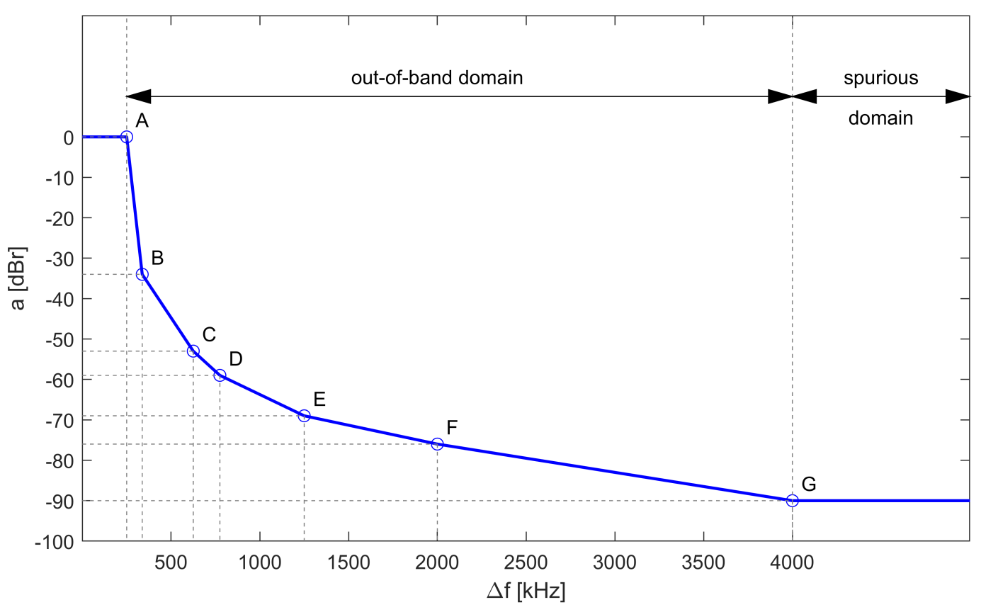
Receiver
Frequency range | MHz | 1110-1156 MHz
Antenna Gain | dBi | 3
Cable loss | dB | 3
Dupplexer Loss | dB | 1
Bandwidth | MHz | 0.5
Noise figure | dB | 6
Selectivity | dB | 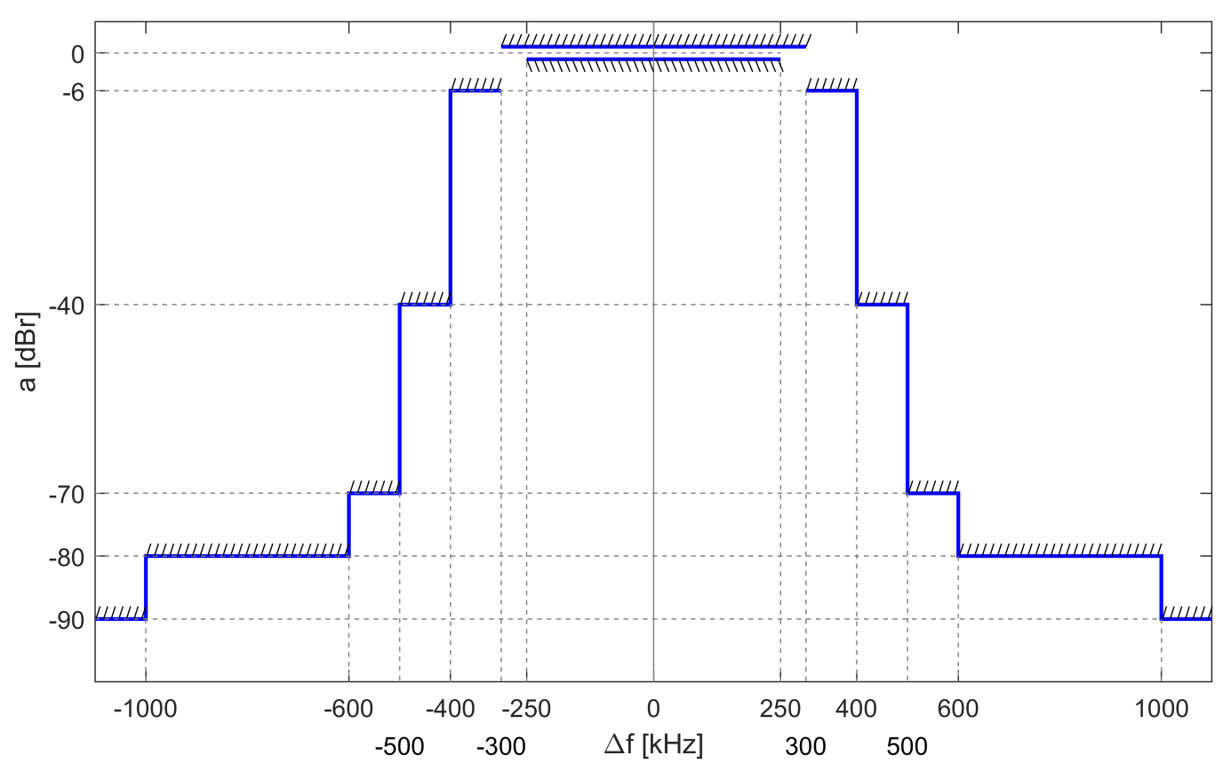
  Passband Ripple (±250 kHz) | within ± 1 dB
  Attenuation @ ±300 kHz | > 6 dB
  Attenuation @ ±400 kHz | > 40 dB
  Attenuation @ ±500 kHz | > 70 dB
  Attenuation @ ±600 kHz | > 80 dB
  Attenuation @ ±1000 kHz | > 90 dB
    - Modelling assumptions
The propagation model is Free Space Loss between an airborne platform and PMSE devices used in open-air conditions, therefore omnidirectional without building loss and body loss.
    - CONCLUSION
      - Impact of PMSE to protect airborne receivers of LDACS between 1110-1156 MHz
The PMSE equipments are assumed to be deployed outdoor, then the free space propagation model is considered.
The airborne antenna gain is up to 3 dBi, the receiver bandwidth is 0.5 MHz and the cable loss is 2 dB (including duplexer loss).
      - Separation distance to protect the LDACS airborne receiver

Parameters | Impact of audio PMSE transmitter on LDACS airborne receiver
PMSE e.i.r.p (dBm) | 17 dBm
Aggregated Effect (3 PMSE within 1 MHz Bandwidth) (dB) | 1.76 dB
LDACS receiver Noise (dBm) | -110.94 dBm
LDACS antenna gain (dBi) | 3
Cable loss (Duplexer included) (dB) | 2
Safety Margin | 6 dB
Interference Level allowed (dBm) | -123.94 dBm (I/N = -6 dB) / -127.94 dBm (I/N = -10 dB)
Requested Attenuation (dB) | 142.70 dB (I/N = -6 dB) / 146.70 dB (I/N = -10 dB)
FSL Distance Separation required (F=1133 MHz) | 287.65 Km (I/N = -6 dB) / 455.90 km (I/N = -10 dB)
Radio Horizon (Flight level 600) | 587 km
According to the study, a separation distance of 287.65 km (I/N = -6 dB) or 455.90 km (I/N = -10 dB) is needed in order to protect the LDACS airborne receivers from audio PMSE.
      - Guard band to protect LDACS airborne receiver

As shown above, cohabitation between PMSE and LDACS on co-channel is not feasable because of the distance separation which are too much important (287 km and 455 km, respectively for I/N = -6 dB and I/N = -10 dB).
In order to protect both systems, it is important to define a guard band. In this study we will consider that the closest distance between an airborne and an outdoor PMSE will be 1000 feet (around 330 m).
It has to be noted that in absence of the PMSE emission mask, this guard band will have to be reviewed.
Parameters | Impact of audio PMSE transmitter on LDACS airborne receiver
PMSE e.i.r.p (dBm) | 17 dBm
Aggregated Effect (2 PMSE near the bandwidth edge victim) (dB) | 3 dB
LDACS receiver Noise (dBm) | -110.94 dBm
LDACS antenna gain (dBi) | 3
Cable loss (Duplexer included) (dB) | 2
Safety Margin | 6 dB
Interference Level allowed (dBm) | -123.94 dBm (I/N = -6 dB) / -127.94 dBm (I/N = -10 dB)
Requested Attenuation (dB) | 142.70 dB (I/N = -6 dB) / 146.70 dB (I/N = -10 dB)
FSL Attenuation for 330 m (F=1133 MHz) (dB) | 83.90 dB
Receiver Selectivity Required (dB) | 58.80 dB (I/N = -6 dB) / 62.80 dB (I/N = -10 dB)
Guard band to reach the receiver selectivity (MHz). | >500 kHz (I/N = -6 dB & -10 dB)
According to the ICAO SARPS document, a guard band of >500 kHz (I/N = -6 dB & -10 dB) is needed in order to protect the LDACS receivers from audio PMSE.
      - LDACS Study to protect PMSE receiver (between 964 and 1010 MHz).
The MCL LDACS Study was conducted in order to assess the required separation distance to protect the PMSE receiver between 964 and 1010 MHz.
As the LDACS signal is a TDD pulsed signal, the protection criteria for PMSE is assumed to be -105 dBm for pulsed interferences. It has to be noted that no additional margin has been included here, therefore this value should be considered as a threshold and not disminished.
Parameters | Impact of LDACS airborne transmitter on PMSE receiver
LDACS Airborne EIRP (dBm) for 500 kHz | 42 dBm
LDACS Airborne EIRP (dBm) for 200 kHz | 38.02 dBm
PMSE protection criteria (dBm) | -105 dBm
Requested Attenuation (dB) | 143.02 dB
FSL Distance Separation required (F=1062 MHz) | 298.42 km (in co-channel)
According to the RTCA document (DO-362), a separation distance of 298.42 km is needed in order to protect the audio PMSE from the LDACS airborne transmitters.
  - JTIDS/MIDS
    - LINK 16 parameters
Parameters | Unit | JTIDS/MIDS ground | JTIDS/MIDS airborne
Transmitter
Frequency range | MHz | 969-1008,  1053-1065,  1113-1206 | 969-1008,  1053-1065,  1113-1206
Bandwidth | MHz | 3 | 3
Max TX peak power | dBm | 53-60 | 53-60
Antenna gain | dBi | 12 omni  16 directional | 5.4
Minimum cable loss | dB | 1 | 1
OOB | N.A. | See below
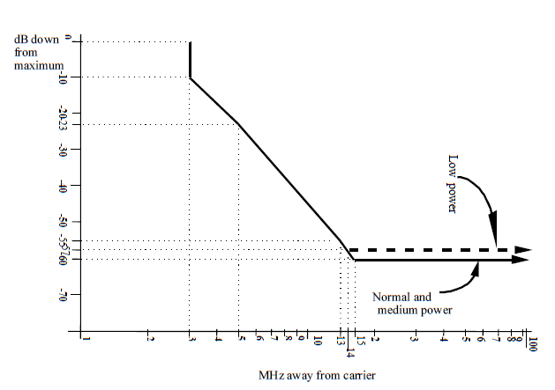
    - Modelling assumptions
The propagation model is Free Space Loss between an airborne platform and PMSE devices used in open-air conditions, therefore omnidirectional without building loss and body loss.
    - CONCLUSION
      - Link16 Study to protect PMSE receiver (969-1008, 1053-1065, 1113-1206)
The MCL Link16 Study was conducted in order to assess the required separation distance to protect the PMSE receiver between in the three sub-bands operated by military.
In this scenario the only source of interference considered is the JTIDS/MIDS terminal for the military datalink “Link 16” between aircrafts and between aircrafts and ground stations. This conveys tactical orders and short messages for orders, reports and tracking of other mobiles.
As the Link16 signal is a TDD pulsed signal, the protection criteria for PMSE is assumed to be -105 dBm for pulsed interferences. It has to be noted that no additional margin has been included here, therefore this value should be considered as a threshold and not disminished.
      - For airborne transmitter of 200 W power for ordinary configuration:
Parameters | Impact of Link16 airborne transmitter on PMSE receiver
Link16 Airborne peak power (dBm) for 3 MHz | 53 dBm / 3 MHz
Link16 Airborne antenna gain (dBi) | 5.4 dBi
Cable loss (dB) | 1 dB
Link16 Airborne EIRP (dBm) for 3 MHz | 57.40 dBm
Link16 Airborne EIRP (dBm) for 200 KHz | 45.63 dBm
PMSE protection criteria (dBm) | -105 dBm
Requested Attenuation (dB) | 150.64 dB
FSL Distance Separation required (F=1000 MHz) | >800 km (in co-channel)
Radio Horizon (Flight level 600) | 587 km
According to the RTCA document (DO-362), a separation distance greater than 800 km is needed in order to protect the audio PMSE from the Link16 ordinary airborne transmitters. As this distance is very important, the practical separation distance will be limited by the radio horizon. As a plane can flight up to 60 000 feet, the separation distance is then 587 km.
      - For airborne transmitter of 1000 W power for specific configuration:
Parameters | Impact of Link16 airborne transmitter on PMSE receiver
Link16 Airborne peak power (dBm) for 3 MHz | 60 dBm / 3 MHz
Link16 Airborne antenna gain (dBi) | 5.4 dBi
Cable loss (dB) | 1 dB
Link16 Airborne EIRP (dBm) for 3 MHz | 64.40 dBm
Link16 Airborne EIRP (dBm) for 200 KHz | 52.63 dBm
PMSE protection criteria (dBm) | -105 dBm
Requested Attenuation (dB) | 157.64 dB
FSL Distance Separation required (F=1000 MHz) | >1500 km (in co-channel)
Radio Horizon (Flight level 600) | 587 km
According to the RTCA document (DO-362), a separation distance greater than 1500 km is needed in order to protect the audio PMSE from the Link16 specific airborne transmitters. As this distance is very important, the practical separation distance will be limited by the radio horizon. As a plane can flight up to 60 000 feet, the separation distance is then 587 km.
      - Impact of JTIDS/MIDS on Audio PMSE
Even assuming an indoor use with the maximum wall attenuation of 20 dB, the separation distance would remain more than 150 km for 1 kW and more than 80 km for 200 W.
Based on the results in the previous table covering a large range of parameters, and considering that JTIDS/MIDS operates in fast frequency hopping mode all over the frequency band 960-1164 MHz (except 1030/1090 guards), the protection of audio PMSE cannot be ensured from JTIDS/MIDS on aircraft.
  - GNSS
    - Parameters
Table 29: RNSS Parameters
RNSS Receive type | Air-navigation | General-purpose
RNSS Receive mask | M.2235 Figure 8 (Aeronautical receiver) | Gaussian Filter Bandwidth 20.5 MHz
RNSS Centre frequency (MHz) | 1176.45 | 1176.45
RNSS Bandwidth (MHz) | 24 | 24
RNSS Gain (dBi) | -5 | 3
RNSS Receiver temperature (K) | 727 | 330

    - Modelling assumptions
Table 30: Integration of PMSE Digital Mask with RNSS Receiver Masks

    - Conclusion
Table 31: Results - Required Guard Band (MHz)
RNSS Receiver Type | Guard Band
General-purpose | 31 MHz
Air-navigation | 12 MHz

The conclusion is that a guard band of 30 MHz would be required to protect RNSS receivers (for both General purpose and air navigation).

  - Other systems (LONG TERM CNS)
CNS system are planned to be developed under ICAO standards to cover the following functions: Communication, Navigation and Surveillance.
There are currently no technical details about this future system but it is planned to be used in all the width of the frequency band 960-1164 MHz.

- [NARFA DEU] PMSE selectivity in presence of JTIDS/MIDS pulses
  - Summary
This contribution investigates the possible use of low power audio PMSE (excluding airborne use) in the aeronautical frequency band 960-1164 MHz, considering the influence on PMSE receivers of incumbent systems' emissions, in this case: JTIDS/MIDS.

Because of being focused on the impact on PMSE, only PMSE receiver's parameters become relevant, no user equipment's parameters have to be taken into account.
PMSE's standard signal power level was determined by measuring each PMSE receiver's sensitivity and increase it by +3 dB, yielding -90 dBm for two devices and -91 dBm for the third.
Although the scenario is based on outdoor use, a theoretical interpretation of the results has also been done for indoor use assuming a building entry loss (BEL) of 20 dB.
Additionally, a theoretical interpretation of the results has also been done for PMSE operating with a +20 dB higher signal power level than the above PMSE's standard1 signal power level.
Owing to poor availability of professional PMSE equipment operating at the focused band, professional PMSE equipment operating in frequency bands near that band had to be used. In doing so it was kept in mind that the equipment had to operate with comparable parameters.

The results as shown in Table 1 indicate – regarding the impact of JTIDS/MIDS only – that it would be possible to use PMSE equipment sharing JTIDS/MIDS systems in co-channel or adjacent channel scenarios as long as a minimum separation distance to those JTIDS/MIDS systems is assured.
With respect to a single JTIDS/MIDS channel a minimum frequency separation can be calculated for sharing the band.
In the case of PMSE complying with the minimum frequency separation and in conjunction with the distributed use of channels by JTIDS/MIDS it would require PMSE to operate near 1030 MHz or 1090 MHz.
But in an overall view on the band's utilization, including the defined guard bands and other application's frequency usage, no appropriate frequency is left for selection.

Table 1: Summary
PMSE, interferred by JTIDS/MIDS |  | Option 1 | Option 2
Scenario | Parameter | Minimum separation distance (LoS) | Minimum frequency separation
PMSE outdoor | Standard1 signal power level  (-90 dBm / -91 dBm) | 300 km (analog)  400 km (digital) | 7 MHz,  but no appropriate frequency in an overall view, due to band's heavy utilization
 | +20 dB signal power level  (-70 dBm / -71 dBm) | 30 km (analog)  40 km (digital)
PMSE indoor | Standard1 signal power level  (-90 dBm / -91 dBm) | 30 km (analog)  40 km (digital) 2
BEL=20 dB | +20 dB signal power level  (-70 dBm / -71 dBm) | 3 km (analog)2  4 km (digital) 2
  - PMSE parameters
The interference of the PMSE links depend on the PMSE receiver's selectivity, i.e. to recognize the wanted signal and to be able to process it without misinterpretation, but not on the parameters of the wanted signal's transmitter.
Therefore, the PMSE user equipment (with respect to its parameters, e.g. body loss) has not been taken into account. Furthermore no IEM - even though containing a receiver - has been taken into account, too.
PMSE links are recognized as undisturbed if a SINAD of at least 40 dB is assured (see 2.4).
There is a poor availability of PMSE equipment operating at 960-1160 MHz.
Thus, professional PMSE systems operating in other frequency bands near to 960-1164 MHz were chosen to be studied instead (see Table 2).
Table 2: PMSE equipment used for measurement
PMSE device under test (DUT) | Modulation | Frequency
Sennheiser G4 | FM | 823-865 MHz tested at 864.5 MHz
Sennheiser D6000/9000 | PI/4-QPSK; 64-DAPSK | 630-718 MHz tested at 630.0 MHz
Shure QLX-D | 8-PSK | 823-865 MHz tested at 864.5 MHz
  - PMSE receiver Parameters
The devices under test (DUT) have been measured for their reception threshold (see 9.3.5.1).
It was decided to use a SINAD threshold of 40 dB (see 2.4) and an integration duration of 2 ms for determining the SINAD. For comparison, also the SINAD for an integration duration of 1 ms is calculated.
For the measurement (see 9.3) a wanted signal level has been used corresponding to a level 3 dB above the threshold of the DUT's receiver. These low signal levels in the range of -90 dBm will occur for short time spans in real situations, e.g. due to shadowing from moving persons or fading effects of the radio channel.
  - Parameters of body loss
No body loss has been taken into account.
  - Parameter for building loss
Building loss has been assumed neither for the PMSE link itself nor for the interference measurement which is based on an outdoor scenario!
Nevertheless, for interpretation purpose the separation distances may be recalculated for indoor use.
Considering ITU-R publications [4] and [5] for the indoor use scenario a median building entry loss (BEL) at frequencies around 1000 MHz of 13 dB (traditional buildings) or 28 dB (thermally-efficient buildings) could be taken into account.
For the recalculation a value for the BEL of 20 dB has been assumed.
  - Criteria for audio transmission error
There are different threshold criteria used at which a PMSE link is said to be disturbed.
- Refering to ETSI, a SINAD value of 30 dB is demanded generally to satisfy the needs of professional audio applications (see [6], Table 12.2: Continuous phenomena, minimum performance criteria).
- The APWPT demands a value of at least 40 dB for professional audio.
This value has been used in SINAD calculation on the measured data (see 9.3.5.1 and 9.3.5.4).
- From the activities of CEPT SE7 regarding PMSE a proposal of a SINAD value of more than 50% of the undisturbed link was derived (see Table 3, where this was used to determine the undisturbed SINAD).
Table 3: Devices under test (DUT) and their undisturbed SINAD value
PMSE radio link | RF-level at RX | SINAD without interferer
DUT-A (digital) | -91 dBm | 68 dB
DUT-B (digital) | -90 dBm | 78 dB
DUT-C (analog) | -91 dBm | 60 dB
Note: The PMSE radio links have different SINAD values in the undisturbed state. As even under ideal transmission conditions, the SINAD value of the tested analog DUT is 8 dB / 18 dB below that of the examined digital DUTs, setting the threshold to 50% of the undisturbed case favors the analog system.
As the deciding factor for disturbance is the ratio between the levels of the wanted and the interfering signal, the results can easily be scaled to situations where the wanted signal is stronger. To cause the same disturbances, the level of the interfering signal has to be increased by the same factor as the wanted signal.
  - Propagation model
Both, JTIDS/MIDS (interferer) and PMSE (victim) are assumed to be used outdoor.
Airborne JTIDS/MIDS transmitters are considered as focal point, because of their unpredictable occurrence and emission's impact on PMSE.
In doing so, the propagation model for aeronautical mobile and radionavigation services using the i.a. UHF band (ITU-R P.528, [3]) would be suitable.
For the line-of-sight scenario a more simplified approach is free space propagation (ITU-R P.525, [2]) which has been used.
  - DME
Not studied.
  - SSR – 1030/1090 systems
Not studied.
  - UAT
Not studied.
  - CNPC
Not studied.
  - LDACS
Not studied.
  - JTIDS/MIDS
Data transfer with JTIDS/MIDS yields a pulsed emission using frequency hopping.
    - Parameters
      - Pulse and emission characteristics.
Each JTIDS/MIDS pulse contains a continuous phase shift modulated (CPSM) carrier during 6.4 µs followed by a dead time during 6.6 µs as shown in Figure 1 (see [11], page 2-48).

t
13 µs
6.4 µs
6.6 µs
"modulated carrier"
"dead time"
l
l
l
l
l

l
l
Figure 1: JTIDS/MIDS pulse, basic characteristics
As a requirement (see [10], AP1.3.5.1.) every JTIDS/MIDS pulse must comply with the spectral mask (in-band) featuring a -10 dB signal level at ± 3 MHz to its carrier frequency, a -23 dB level at ± 5 MHz , a -55 dB level at ± 13 MHz and a -60 dB level at ± 15 MHz (see Figure 2). These requirements shall apply between 920 MHz and 1266 MHz.

MHz away from Carrier
Down from selected output power level maximum
-60 dB
0 dB
-10 dB
-23 dB
-55 dB
3
5
15
13
0
Figure 2: JTIDS/MIDS pulse, power spectral mask requirement (in-band)
In [10], AP1.3.6., out-of-band-emission characteristics are defined: "Except for the second and the third harmonics, the OOB harmonics and all other spurious emission below 920 MHz and above 1266 MHz shall be at least 80 dB down from the level at the fundamental. The second and third harmonics shall be suppressed 50 + 10 log p (where p = peak power output in watts at the fundamental) or 80 dB, whichever requires less suppression. These out-of-band emission requirements shall apply for each selected power level."
      - Frequency usage
As summarized in [11] on page 2-51 "Link 16 operates in the 960-1215 MHz band, with JTIDS/MIDS frequencies occurring every 3 MHz between 969 and 1206 MHz."
To protect IFF at 1030 MHz and TCAS at 1090 MHz these frequencies are excluded for the use by JTIDS/MIDS (see [10], AP1.4.2.1.2. and also [11], page 2-51) leaving 51 frequencies in the band segments 969 MHz to 1008 MHz, 1053 MHz to 1065 MHz and 1113 MHz to 1206 MHz to be assigned to JTIDS/MIDS.
Frequency hopping, which is an essential part of every operational JTIDS/MIDS link, is done after each pulse (see [11], page 2-48.).
JTIDS/MIDS systems have to ensure a uniform distribution of all transmitted pulses over the 51 assigned frequencies within a so called 'JTIDS/MIDS frame' with a duration of 12 s (see [10], AP1.4.2.1.4.).
      - Transmitters
With regard to the output power several possible modes and relating restrictions are mentioned in [10] (AP1.3.2. and 1.3.3.). Power levels of more than 200 W are allowed as long as all EMC requirements are met. There are products available with output power up to 1 kW.
For calculation of separation distances in a co-channel and adjacent channel scenario, an output power of 400 W (as stated in the German FCA [12], chapter 2.2.2) has been taken into account.
For peak output power of up to 1 kW the appropriate increase in power has to be applied to upscale the separation distances provided in this document.
Additionally, the ground station's transmit power differs slightly only and so does not change the situation significantly.
    - Modelling assumptions
      - Propagation model for JTIDS/MIDS transmission
Since this study shall provide information about the possibilities of using audio PMSE in erratic vicinity of JTIDS/MIDS transmitters, the ground stations of JTIDS/MIDS have not been taken into account. This is because of the ground stations not being mobile and thus their interference direction being predictable.
"You certainly know where it is… only you don't know exactly at what time and frequency it emits."
Airborne JTIDS/MIDS transmitters are truly erratic interferers, because they may emit from any point in space (APIS) and with nearly every orientation with respect to the PMSE victim.
Further more due to mission requirements the interferer's course mustn't be assumed to be straight, hence interferer's signal strength has to be expected very variable and thus unpredictable.
"You certainly don't know where it is nor do you know at what time or frequency it emits."
And so, free space propagation is used.
      - Pseudo JTIDS/MIDS – interferer signal
Two different interferer signals were generated for the sensitivity tests.
- Interfering signal 1 "all slots" represents a theoretical worst case scenario.
All available "pulse slots" (13 µs duration, see Figure 1) are occupied by pseudo JTIDS/MIDS pulses without any guard intervals (theoretical TSDF of 233%).
There is no frequency hopping.
The pulse sequence contains 65536 (216) random JTIDS/MIDS pulses and is about 0.82 s long.
- The interference signal 2 "1in30 slots" emulates a more realistic JTIDS/MIDS signal.
Although no real frequency hopping takes place here either, the hopping is taken into account by reducing the pulse density.
The number of JTIDS/MIDS channels (bandwidth: approx. 5 MHz, channel spacing: 3 MHz) that can have an impact on a 200 kHz wide PMSE channel is determined. It can be assumed that only four of the 51 JTIDS/MIDS channels are relevant (see e.g. Figure 15). Therefore, the number of pulses from the interfering signal 1 can be reduced by a factor of 4/51.
Furthermore, the interfering signal 1 also has an unrealistic Time Slot Duty Factor (TSDF) of 233%. This circumstance is taken into account by reducing the number of pulses to a TSDF of 100%.
Remark: The TSDF is formally calculated over one frame of length 12 s. Transmitting airborne terminals will usually send one packet within one time-slot of length 7,8125 ms and then switch to receive mode for the following time-slots, resulting in an average TSDF of less than 100%. As the frames of digital PMSE systems are typically in the range of 1 ms to 2 ms, however, the relevant interference energy is occurring within one JTIDS/MIDS time-slot, and here the temporary TSDF is 100% for standard packets.
The total number of pulses can therefore be reduced by a factor of 30 (4/51 * 100/233 → 1/30).
In order to generate such a signal, blocks with 30 pulse slots each were used. For each block, exactly one random pulse was placed in a random pulse slot. If the pulse by chance falls into the first pulse slot, it is dropped, because in a real hopping pattern the direct neighbor channel is never used. The finally generated signal contains about 2100 random JTIDS/MIDS pulses and is also about 0.82 s long.
      - Further modelling aspects
By using TDMA only one transmitter is allowed to emit at a time within a JTIDS/MIDS net. Hence overlay of a single net's signals need not to be taken into account.
Overlay of different JTIDS/MIDS nets may occur. Ground stations of those additional JTIDS/MIDS nets are ordinarily not placed in vicinity. Thus impact of the net nearer to the PMSE victim will dominate and the influence of the one more far away may be neglected.
A possible overlay of airborne JTIDS/MIDS systems using different JTIDS/MIDS nets would enlarge the impact on PMSE, but has also not been taken into account.
JTIDS/MIDS systems use frequency hopping, which in reality leads to an occupancy of each JTIDS/MIDS channel every now and then, but by definition having a uniform distribution over all used JTIDS/MIDS channels within each 'JTIDS/MIDS frame' (duration of 12 s).
    - Test Method
      - SINAD Measurement
The SINAD (Signal to Noise and Distortion) measurement is a common method for evaluating transmission quality.
$SINAD= \frac{P_{signal}+P_{noise}+P_{distortion}}{P_{noise}+P_{distortion}}$
However, standard implementations are not directly suitable for pulsed interferers like the JTIDS/MIDS signal with pulse durations in the microsecond range. For example, measuring equipment like the Rohde&Schwarz Audioanalyzer UPV cannot measure the SINAD precisely for audio durations significantly below one second.
Thus, Dr. Müller from DFS has developed a modified version of the SINAD measuring method. The integration duration for the SINAD calculations is in the range of the frame length of PMSE (1 ms / 2 ms). It is suitable for digital and analog systems. This method was accepted by SE7 in December 2018 ([8]).
A single SINAD value is calculated here by fitting an ideal sine signal to a segment of the recorded audio signal, where the segment length corresponds to the integration time. Only the amplitude is taken into account, but not a possible frequency drift.
The algorithm is based on QR decomposition and requires an audio recording of any length and the expected frequency of the sine tone (typically: 1 kHz) as input.
Figure 3 shows exemplary a recorded test signal in black and the fitted reference signal in grey color. The difference between the two signals is shown in red.
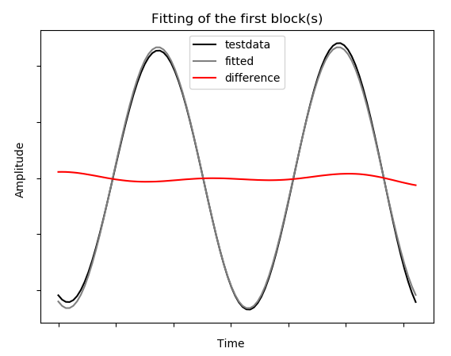
Figure 3: Fitting of recorded sine tone
      - Criteria for audio transmission error
For details about the assumptions defining a disturbed PMSE link, see 2.4.
      - Interferer signal
For details about the creation of the JTIDS/MIDS signal, see 9.2.2.
      - Test Setup
The measurements were made in a shielded chamber to avoid external influences.
The R&S UPV Audio Analyzer generates a test tone of 1 kHz and feeds it into the audio input of the DUT’s transmitter (TX). The transmitter generates a PMSE radio signal that is transmitted via coaxial cable.
A variable attenuator allows fine tuning of the signal level. This allows, among other things, to determine the reception threshold of the receiver.
In the following combiner, the interfering signal from the pseudo JTIDS/MIDS generator is added to the wanted PMSE signal. The combined signal is split up in order to forward it to the PMSE receiver (RX) and to a Spectrum- and Signal Analyzer for monitoring purposes. Because of the PMSE RX being directly connected to the combiner, no diversity mechanism within the RX is able to reduce the interference.
The receiver generates an audio signal from the radio signal, which is recorded in the UPV. Subsequently, an evaluation takes place on a remote control computer.
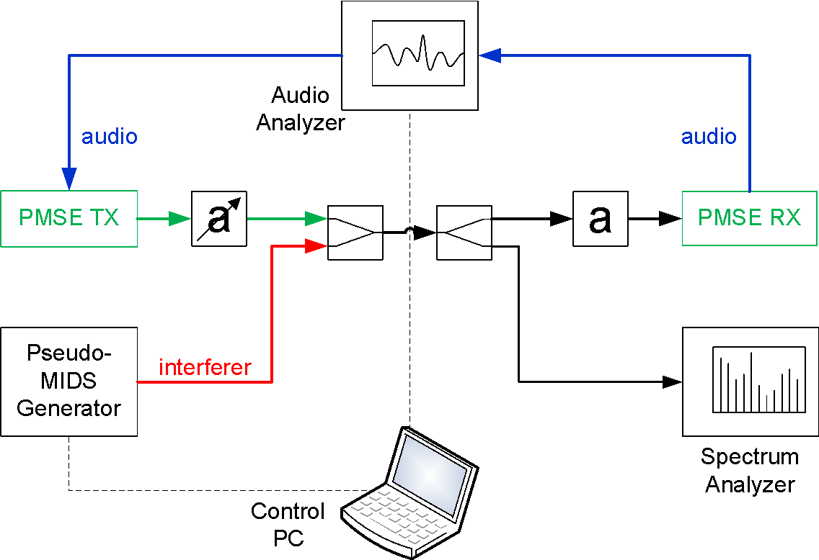
Figure 4: Test setup block diagram
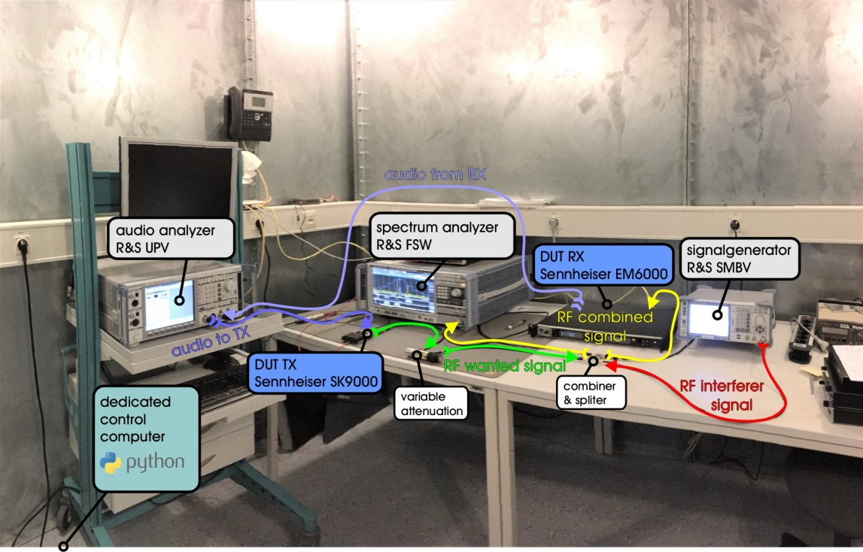
Figure 5: Test chamber
      - Test procedure
      - Step 1 - determining reception threshold
For the tests, the reception threshold of the respective DUT is determined. To determine the reception threshold, the variable attenuation in the test setup is continuously reduced, starting from a very high value, until the SINAD value is above the threshold of 40 dB for 60 minutes. During this procedure no explicit interferer is present. The reception is limited only due to thermal noise at room temperature.
      - Step 2 - setting level for wanted signal
When the reception threshold for the DUT is found, the wanted signal level for the measurements is set to 3 dB above this threshold for digital systems and 10 dB for analog systems according to [8]. For this, the variable attenuation is reduced by 3 dB or 10 dB, respectively.
      - Step 3 - testing
The selectivity test begins with an orientation test, for which one second long measurements are done for the entire parameter space.
The frequency of the interferer is varied in the range of ± 11 MHz around the PMSE signal's center frequency of in steps of 1 MHz. The interferer level is then increased from practically zero in steps of 3 dB.
Note: The interferer level of the pseudo JTIDS/MIDS generator is subsequently related to a 200 kHz wide PMSE channel. The conversion factor between a 5 MHz wide JTIDS/MIDS signal and a 200 kHz wide PMSE signal used here is -14 dB ( = 10*log10(200/5000) ). The components used between the pseudo JTIDS/MIDS generator using an Rohde&Schwarz SMBV and the DUT receiver were calibrated in advance so the offset between the generator level reading and the interferer level directly at the receiver is determined.
The audio signal from the DUT receiver is then recorded and stored as a file for following calculations.
      - Step 4 - calculating based on measured data
For each generated audio file, the SINAD values are calculated for an integration time of 1 ms (SBerr = Single Block Error) and 2 ms (MBerr = Multi Block Error). An example is shown in Figure 6.
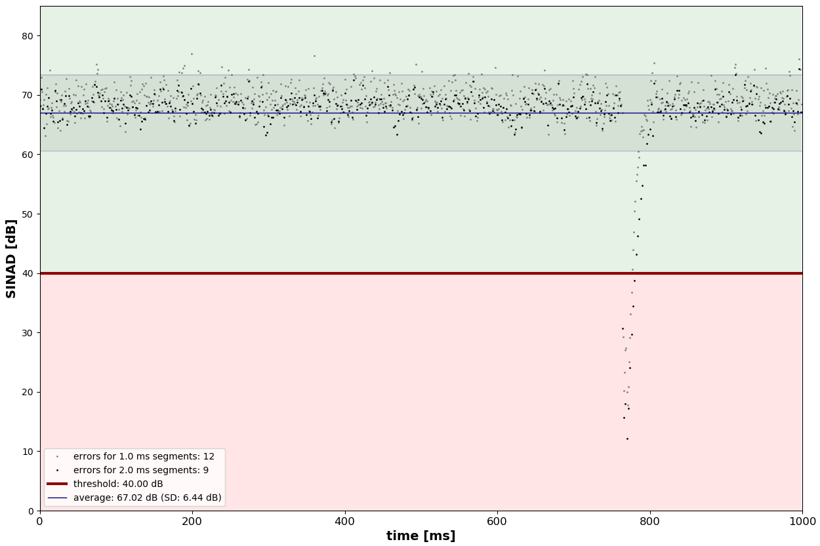
Figure 6: Exemplary SINAD plot
      - Step 5 - aggregating the results
In a further processing step, the results of the individual measurements are combined to form a selectivity plot as shown in the Figure 7.
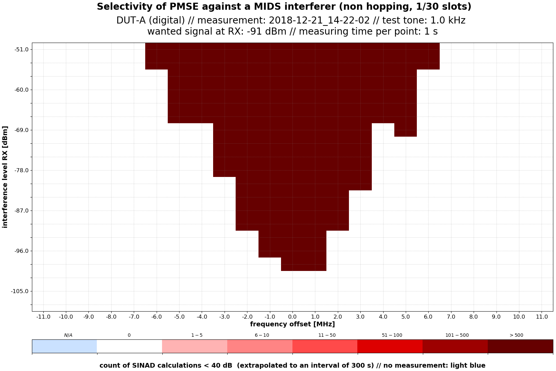
Figure 7: Exemplary result within the orientation test
      - Step 6 - repeat the testing steps making the precision test
In order to obtain reliable results, the measurement duration must be increased significantly from the one second for the orientation test. Measurements with different measurement durations have shown that measurement durations of 10 minutes represent a good compromise between precision and time expenditure.
For the precision test, the step size for increasing the interferer level was reduced to 1 dB. The generated file from the orientation test with the rough position of the interference threshold makes it possible to significantly reduce the test time during precision testing, as a large number of measurements in the parameter space can be omitted because the expected result corridor can be estimated before the test. The procedure for the precision test is the same as for the orientation test. The generated result files have the same format, so a precision test can be used as the basis for an even more precise test.
Figure 8 shows an example of the results of the precision tests.
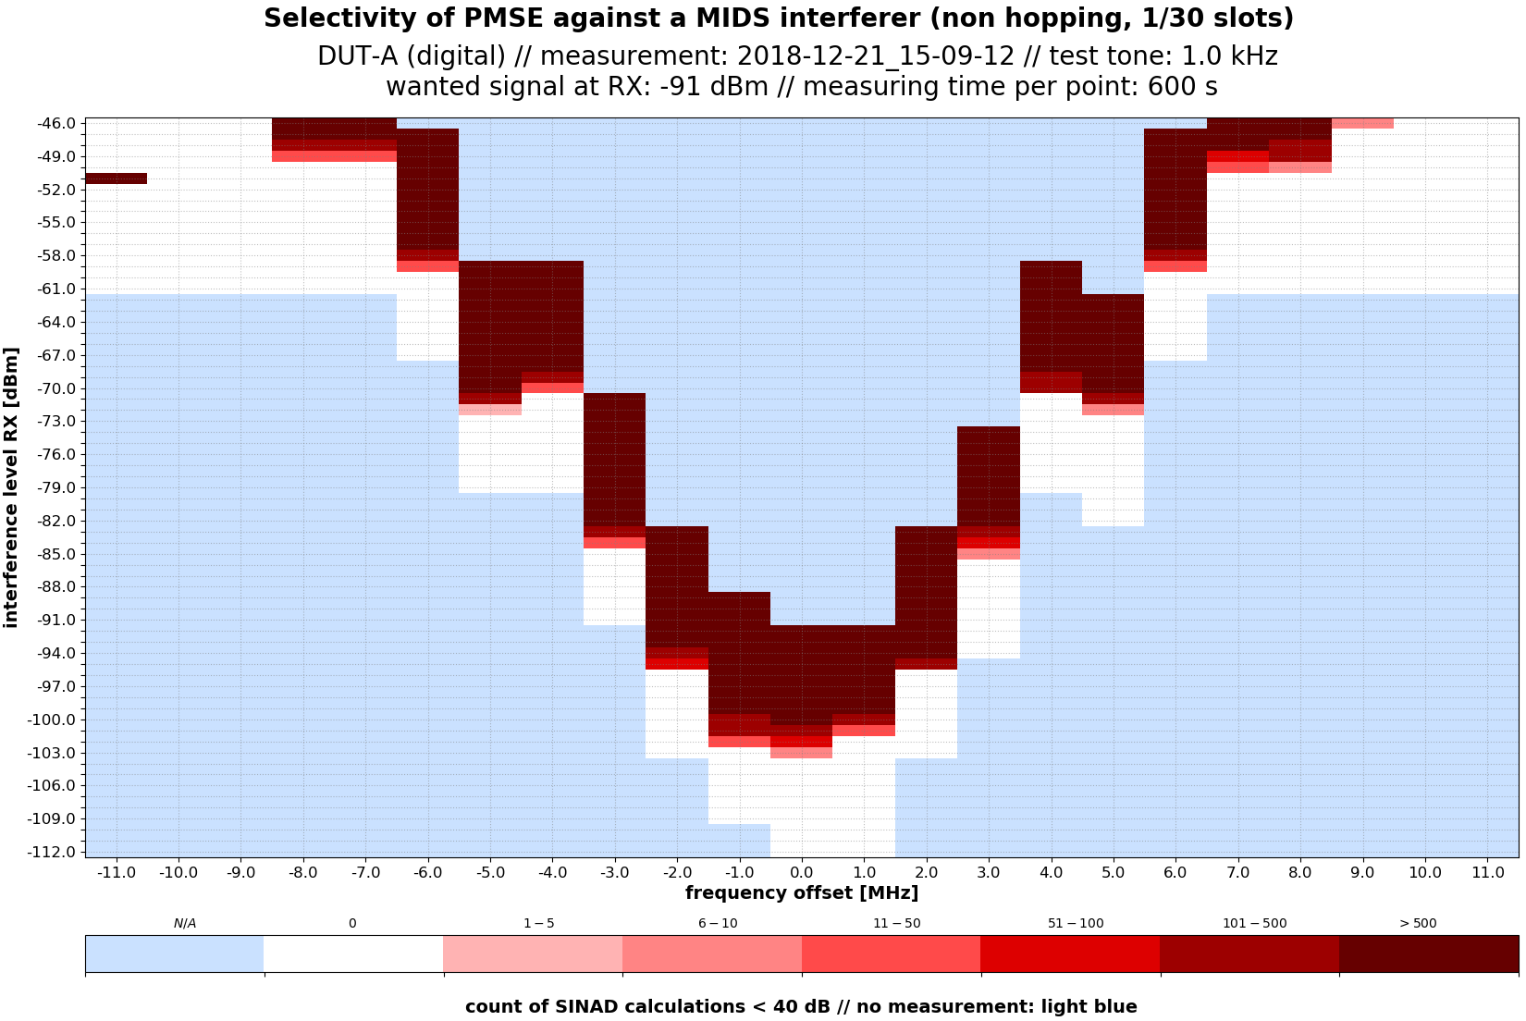
Figure 8: Exemplary result within the precision test

    - Test Results
      - DUT audio behavior
It has been found that errors (SINAD values below the threshold of 40 dB) often occur time-correlated as disturbance events. It is assumed that this is because the digital systems detect transmission errors and mute their audio output accordingly, to slowly increase the audio level again afterward. This usually leads to several low SINAD values in series, becoming continuously better. Figure 9 shows the audio recording and Figure 10 the corresponding SINAD plot for such a disturbance event.
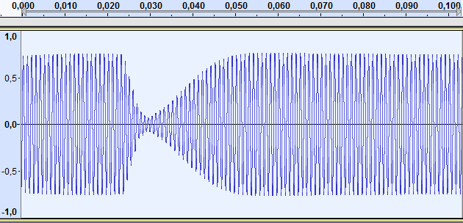
Figure 9: Audio recording during a disturbance event
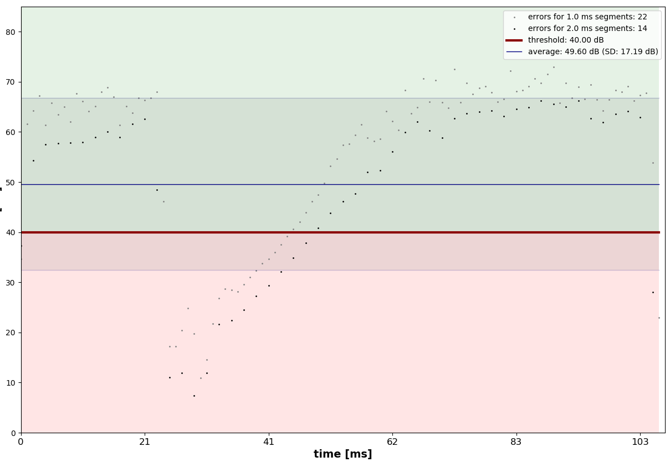
Figure 10: SINAD values during the disturbance event from Figure 9
      - Dependency on measurement duration
The graphs in Figure 11 show a selectivity plot for the DUT-A (digital) for different measurement durations. The signal 1 "all slots" is used as interference signal.
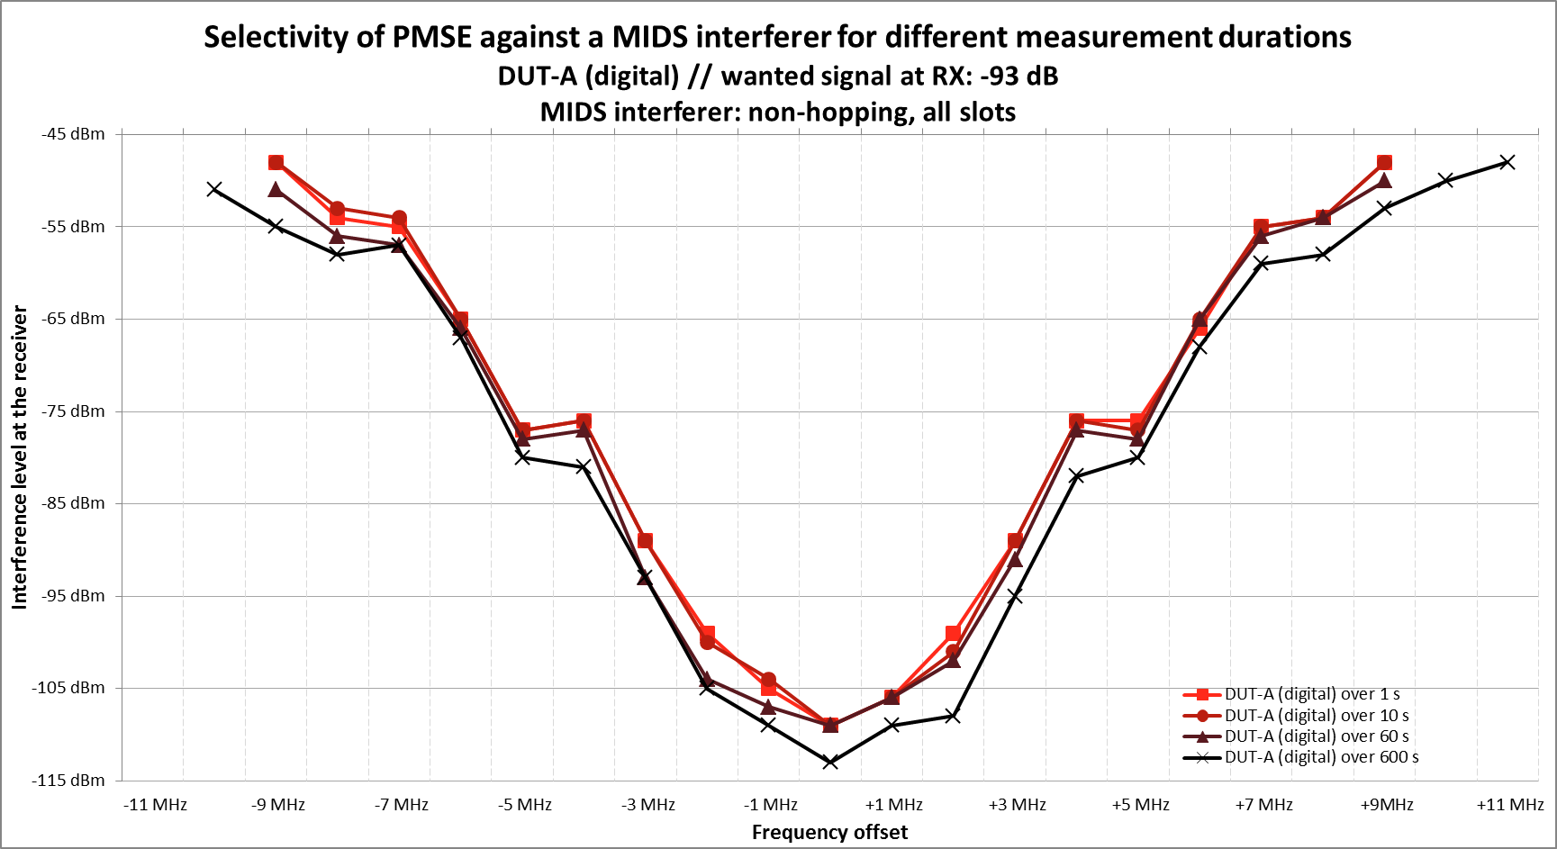
Figure 11: Selectivity of PMSE depending on measurement duration
The difference between a measurement duration of 1 s and 10 s is negligible. Between 1 s and 1 min the difference is about 2 dB. A longer measurement duration leads to a higher sensitivity against interference. The comparison between a measurement duration of 1 s and 10 min results in a difference of 4 dB.
      - Dependency on pulse density
In the following, the DUTs are examined with regard to their sensitivity for different pulse densities.
As shown in the following figure, the DUT-A (digital) is more sensitive to the all-slots signal than the 1in30 signal by 7 dB with the same measurement duration of 10 min. If the measurement duration for the all-slots signal is shortened to 20 s, the number of pulses is identical for the signal 1in30 with 10 min measurement duration. However, it turns out that the sensitivity of the DUT-A (digital) to the short all-slots interferer signal is also 5 dB higher than that of the 1in30 signal.
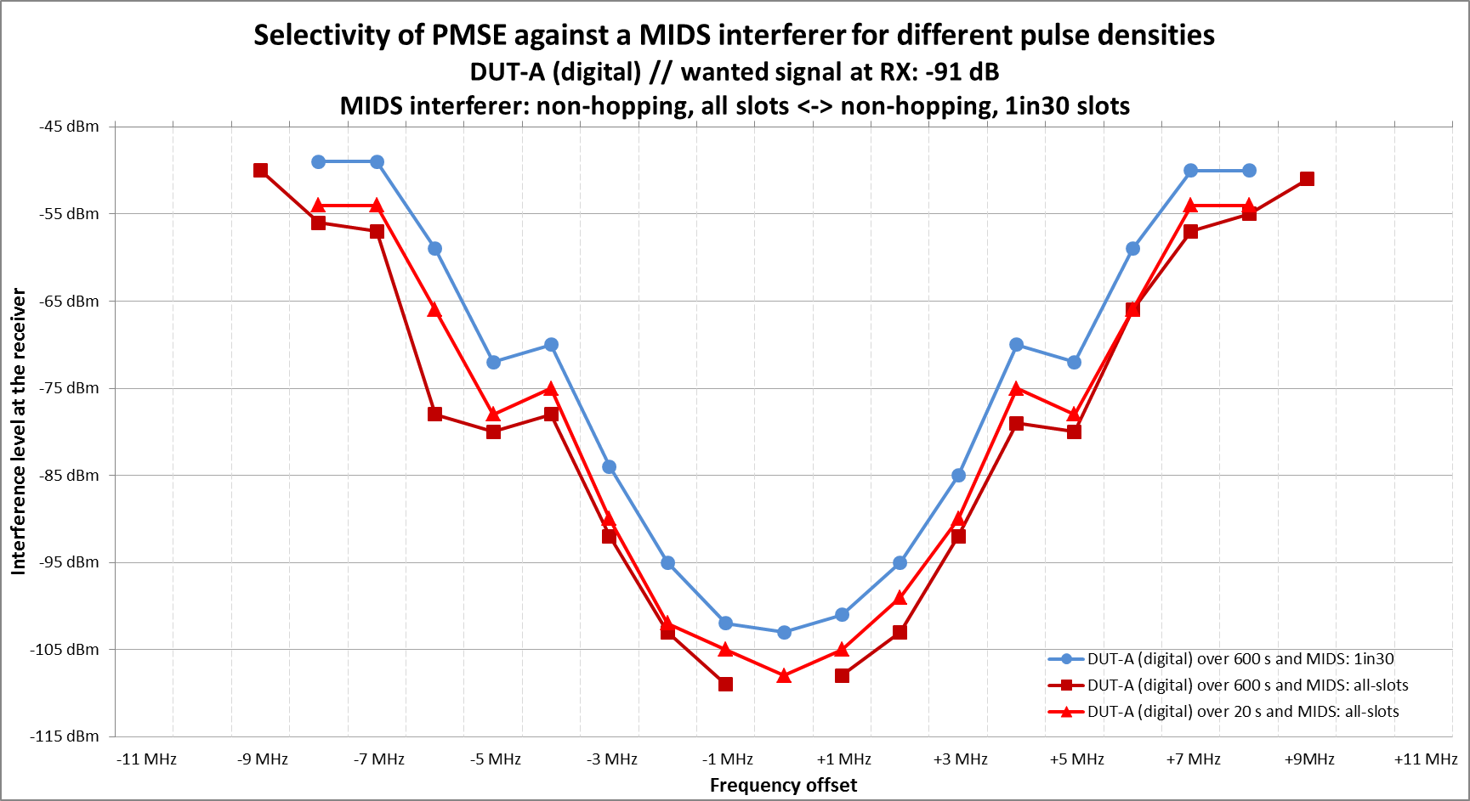
Figure 12: Selectivity of the DUT-A (digital) depending on pulse density
The interferer sensitivity of the DUT-B (digital), on the other hand, is largely independent of pulse density. The sensitivity of the DUT-B (digital) to the all-slots signal is only 1 dB higher than that to the 1in30 signal with the same measurement duration of 10 min.
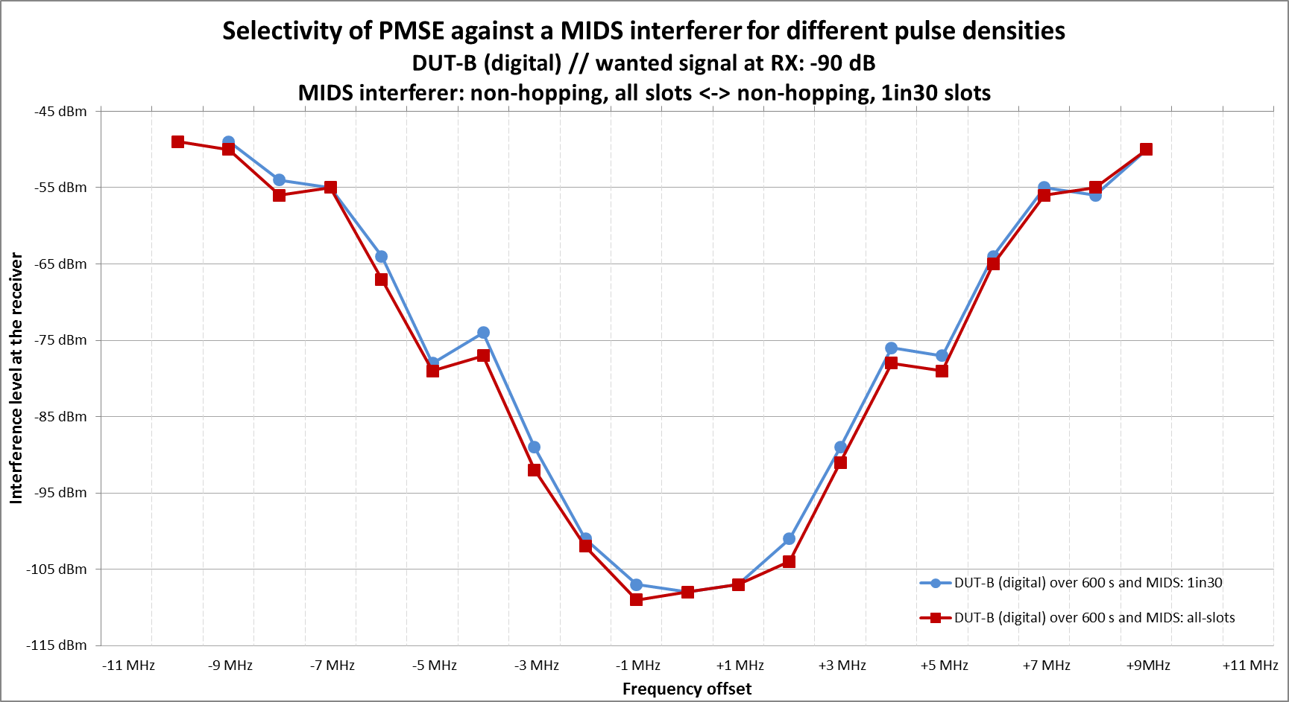
Figure 13: Selectivity of the DUT-B (digital) depending on pulse density
For the DUT-C (analog), the pulse density has no effect on the selectivity. In total, the difference between the two tested pulse sequences is 0 dB.
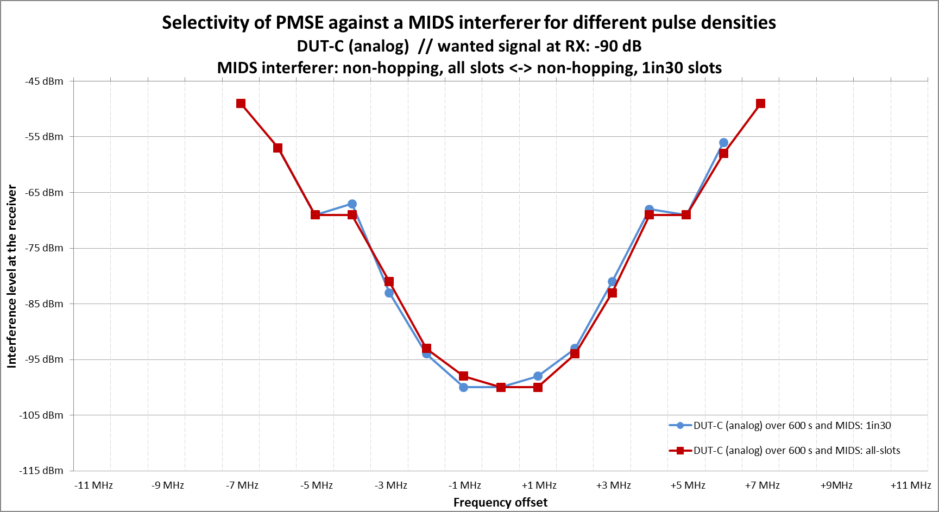
Figure 14: Selectivity of the DUT-C (analog) depending on pulse density
      - Comparison of DUTs
Figure 15 shows, for different DUTs, the level of a JTIDS/MIDS interferer, referenced to a bandwidth of 200 kHz, at which the first disturbances of the PMSE link occur, versus the frequency offset between the PMSE link and the interferer (signal 1in30 slots). It can be seen that
the DUT-B (digital) is the most sensitive; the difference to DUT-A (digital) is 3 dB,
the DUT-C (analog) proves to be the most robust; the difference to the DUT-B (digital) is 8 dB.
Note that the wanted signal level for the different DUTs varies by 1 dB.
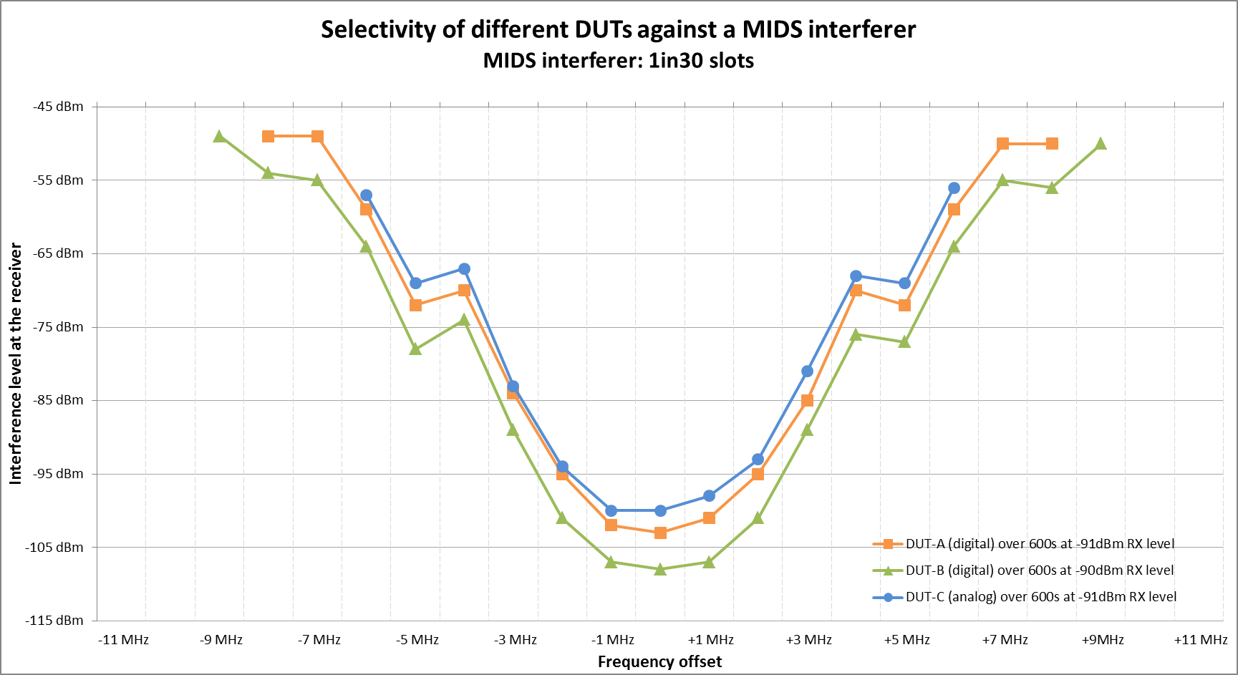
Figure 15: Selectivity of DUTs against a JTIDS/MIDS interferer
      - Interferer level and distance
The next diagram shows the interference levels from Figure 15 converted into distances. For calculation of the corresponding distance the following parameters are assumed:
Interferer TX power: 400 W EIRP, free space propagation loss at 1 GHz, PMSE RX antenna gain: 0 dBi
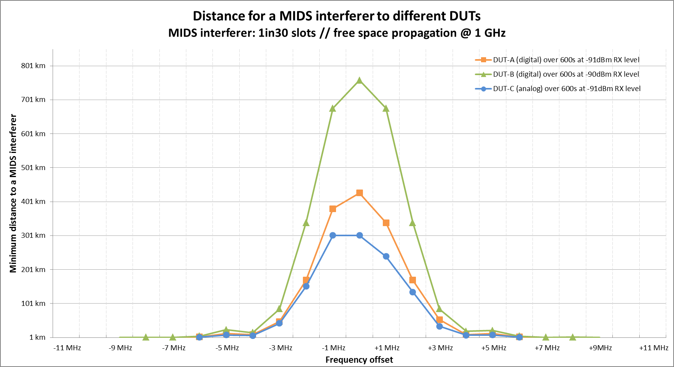
Figure 16: Distance between a JTIDS/MIDS interferer and DUTs
corresponding to the interferer levels from Figure 15
      - Summary of observations
The results are dependent of the measuring duration. A duration of 10 minutes represents a good compromise between accuracy and effort. It is slightly optimistic though as there is some probability that an error would occur after the 10 minute measurement duration.
The different DUTs behave differently towards a JTIDS/MIDS interferer.
The interference sensitivity of the DUT-B (digital) is higher than that of the DUT-A (digital). Most robust is the DUT-C (analog).
The DUT-A (digital) responds more sensitively to a higher pulse density than the DUT-B (digital).
In contrast, the DUT-C (analog) behaves almost independent of the pulse density.
No analysis was done if, or to what extent, the manufacturer's techniques of error concealment have an influence on the tests carried out.
    - Interpretation
The following interpretations are based on the plots from Figure 15 and Figure 16.
- The digital PMSE links are rather sensitive to interference. First disturbances in the PMSE link occur at a signal-to-interference ratio (in 200 kHz bandwidth) of 12 dB for the DUT-A (digital) and 18 dB for the DUT-B (digital), corresponding to JTIDS/MIDS levels 12 dB and 18 dB below the wanted PMSE signal level at the receiver.
- This means that, assuming free space propagation with a clear line-of-sight to an aircraft with an active JTIDS/MIDS and 400 W EIRP, the PMSE link gets disturbed already from a distance of about 300 km for the anlog DUT and of about 400 km and 750 km respectively for the digital ones (see Figure 16).
For most cases, in this distance range there will be no direct line-of-sight to aircraft at usual flight levels. However, if there is an aircraft with an active JTIDS/MIDS within line-of-sight to a PMSE link, the PMSE will get disturbed with a very high probability.

- The curves of Figure 15 are measured using a wanted signal level of -91 dBm (DUT-A, digital) and -90 dBm (DUT-B, digital), corresponding to a level 3 dB above the threshold of the PMSE receiver. In practice, the PMSE links are operated at higher signal levels.
According to the APWPT, though, these low signal levels in the range of -90 dBm will occur for short time spans also in real situations, e.g. due to shadowing from moving persons or fading effects of the radio channel.
If one assumes nevertheless that the wanted signal level always is maintained at 20 dB above the value assumed for Figure 15, thus at -71 dBm and -70 dBm respectively, the interference level also has to be correspondingly higher to cause disturbance.
With free space propagation, that change of +20 dB for the signal level means reducing the distance by factor 10. Instead of 300 km, 400 km and 750 km, the first disturbances would occur at distances of 30 km, 40 km and 75 km respectively.
In practice this also means that generally every aircraft in line-of-sight with an active JTIDS/MIDS will cause disturbance of the PMSE link.

- Disregarding a potential frequency remapping, there are no frequency ranges within the Air Band which are not used by the hopping JTIDS/MIDS waveform except the protection zones around the SSR frequencies 1030 MHz (transponder interrogation) and 1090 MHz (transponder reply). Omitting those, the optimum frequencies for a PMSE link are the ones exactly between the JTIDS/MIDS channels with their 3 MHz spacing, thus at 1.5 MHz offset to the JTIDS/MIDS center frequencies.
In the curves of Figure 15 and Figure 16 this offset corresponds to points between 1 MHz and 2 MHz frequency offset. The interference level for disturbance at this offset is about -98 dBm and -104 dBm, respectively for the digital DUTs, the distance about 272 km and 500 km.
Again, with a reduction by factor 10 for a PMSE link operating at 20 dB more wanted signal level, the distances are around 27 km and 50 km.
Thus, due to the broadband nature of the JTIDS/MIDS signals, using frequencies exactly between the JTIDS/MIDS channels for PMSE links improves only marginally on the interference liability.
Also in this case, any aircraft with active JTIDS/MIDS in line-of-sight means disturbance of the PMSE.

- When trying to ensure that an aircraft within line-of-sight and a flight altitude above e.g. 1500 m does not cause disturbances, according to Figure 15 a frequency separation of at least 7 MHz is required. This would require PMSE to operate in the defined guard bands between 960 MHz to 962 MHz, 1015 MHz to 1045 MHz or 1075 MHz to 1105 MHz.
As documented in the measurements by DFS [9] the segments between 1045 MHz and 1075 MHz and 1105 MHz to 1150 MHz have to be considered entirely in use by DME- and (A/A-) TACAN-interrogators (and -transponders), because aircraft operate and transmit at any time, at any place down to 100 ft AGL as mission requires. Signal strength up to and exceeding -40 dBm outdoor and -50 dBm indoor have been measured, which also requires that the wide spectrum of SSR and IFF transmissions centered on 1030 MHz and 1090 MHz ± 3 MHz are taken into account.
Hence, this frequency separation can hardly be achieved.

- The situation is different when the PMSE link is operated indoors. The additional attenuation however is strongly dependent of the building properties and can range from nearly 0 dB (uncoated glass windows) to more than 40 dB (steel reinforced concrete over several floors).
Assuming a median BEL of 20 dB would reduce the found separation distances by factor 10.
In practice, it can probably not be ensured that the BEL is always sufficient to prevent disturbances.
    - conclusion
It has to be assumed that PMSE links using equipment investigated here, or similar, get disturbed as soon as an aircraft with active JTIDS/MIDS is within line-of-sight.
This is also the case for JTIDS/MIDS ground stations, whose slightly different transmit power and antenna pattern does not change the situation significantly.
With respect to JTIDS/MIDS interferer only, a separation by a frequency offset by ± 7 MHz or more to JTIDS/MIDS center frequencies would require PMSE to operate near the SSR channels 1030 MHz and 1090 MHz.
In an overall view a separation by a frequency offset by ± 7 MHz or more to JTIDS/MIDS center frequencies in the Air Band is not possible because such frequencies for PMSE would be in the defined guard bands. Transmission from aircraft DME-, (A/A-) TACAN-interrogator (and -transponder) and the wide spectrum of SSR and IFF transmissions centered on 1030 MHz and 1090 MHz ± 3 MHz are additional signals that need to be taken into account, since aircraft signal strength up to and exceeding -40 dBm outdoor and -50 dBm indoor have been measured [9].
  - GNSS
Not studied.
  - Other systems
Not studied.
  - List of References
- "Untersuchungen zur Kompatibilität von JTIDS/MIDS-LVT BU2 mit anderen Diensten - Kompatibilitätsuntersuchungen zu JTIDS/MIDS mit PMSE und GNSS", Stefan Engerer and Christopher Laske, Fraunhofer Institut für Integrierte Schaltungen (FhG IIS), 2019
'Studies about compatibility of JTIDS/MIDS-LVT BU2 and other services – Compatibility study on JTIDS/MIDS to PMSE and GNSS,; Stefan Engerer and Christopher Laske, Fraunhofer Institute for Integrated Circuits, 2019
- Recommendation ITU-R P.525-3 (09/2016) Calculation of free-space attenuation
https://www.itu.int/rec/R-REC-P.525-3-201611-I/en
- Recommendation ITU-R P.528-3 (02/2012) Propagation curves for aeronautical mobile and radionavigation services using the VHF, UHF and SHF bands
https://www.itu.int/rec/R-REC-P.528-3-201202-I/en
- Recommendation ITU-R 2109-0 (06/2017) Prediction of building entry loss
https://www.itu.int/rec/R-REC-P.2109-0-201706-I/en
- Report ITU-R P.2346-2 (03/2017) Compilation of measurement data relating to building entry loss
https://www.itu.int/pub/R-REP-P.2346-2-2017
- ETSI TS 102 192-1 V1.1.1, 2004
https://www.etsi.org/deliver/etsi_ts/102100_102199/10219201/01.01.01_60/ts_10219201v010101p.pdf
- SE7(18)121, Methodology To Measure Audio Drop Out In Presence Of Pulsed Signals, DFS, Timisoara 19 to 21 September 2018
( https://www.cept.org/Documents/se-7/46145/se7-18-121_methodology-to-measure-audio-drop-out-in-presence-of-pulsed-signals )
- SE7(18)122R1, Interference measurement methodology for digital Audio PMSE, APWPT, DFS, Timisoara 19 to 21 September 2018, revised in Berlin 03 to 04 December 2018
( https://www.cept.org/Documents/se-7/48123/se7-18-122r1_interference-measurement-methodology-for-digital-audio-pmse-modified-by-se7 )
- SE7(19)176, Pulsed ARNS systems – Measured vs. calculated peak aircraft signal strength between 960-1164 MHz at Langen (Germany)
( https://www.cept.org/ecc/groups/ecc/wg-se/se-7/client/meeting-documents/?flid=9425 )
- Link 16 electromagnetic compatibility (EMC) features certification process and requirements, US Department of Defense, 2005
https://www.esd.whs.mil/Portals/54/Documents/DD/issuances/dodm/465001r1p.pdf
- Understanding Voice Data Link Networking, Northrop Grumman, 2014
http://www.northropgrumman.com/Capabilities/DataLinkProcessingAndManagement/Documents/Understanding_Voice+Data_Link_Networking.pdf
- MIDS/LINK 16 Frequency Clearance Agreement (FCA), Federal Republic of Germany, 30 June 2018

- [Transfinite] Compatibility between PMSE in the band 960-1164 MHz and RNSS above 1164 MHz
  - Summary
This study investigates the adjacent band sharing scenario of PMSE operating within the band 960 – 1164 MHz with Radio Navigation Satellite Service (RNSS) receivers above 1164 MHz. This document describes the Galileo RNSS system, the parameters assumed for each system, the methodology used and the results.
The analysis suggests that a guard band of 30 MHz below 1164 MHz would be required to protect the RNSS from out-of-band emissions from PMSE operating in the band 960 – 1164 MHz.
This Annex investigates the adjacent band sharing scenario of PMSE operating within the band 960 – 1164 MHz with Radio Navigation Satellite Service (RNSS) receivers above 1164 MHz. This scenario is shown graphically in the figure below:
Figure 1: PMSE in 960 – 1164 MHz Adjacent Band Sharing Scenario with RNSS operating above 1164 MHz
RNSS satellites operate at altitudes of over 20,000 km and hence the received signal is extremely weak with a threshold value of -155.25 dBW. Therefore, even though PMSE transmitters are relatively low power, there is the potential for harmful interference unless spectrum management techniques such as a guard band are employed.
RNSS has become essential for a very wide range of services, user groups and communities with many business and operations relying on its ubiquitous and continuous availability. This has been achieved by spectrum managers ensuring that this band is relatively clear of interference, so it can be used for the designated purpose.
This study analysed what spectrum measures would be required to continue to ensure that RNSS can provide a continuous and ubiquitous service to a range of user communities.

The analysis suggests that a guard band of 30 MHz below 1164 MHz would be required to protect the RNSS from out-of-band emissions from PMSE operating in the band 960 – 1164 MHz.

Table 1: Summary
PMSE interference into RNSS systems | Minimum co-frequency separation distance (Gnd Receiver) | Minimum co-frequency separation distance (Air Receiver) | Guard band
PMSE interference to RNSS | n/a | n/a | 30 MHz
This study did not consider the potential for interference due to intermodulation or the impact of PMSE on GNSS repeaters.
  - PMSE parameters
The tables below show parameters for the PMSE assumed for this study. Four types were considered, namely:
Body worn
Handheld
IEM with downtilt
IEM without downtilt.
It was noted that a key assumption of this study was that the bandwidth of the PMSE would be 200 kHz rather than other bandwidths (e.g. wideband). Use of wideband systems would result in a significant increase in adjacent band interference and hence require larger guard bands.
Table 2: Parameters for handheld audio PMSE
Parameter | Unit | Value | Reference
Bandwidth (BW) | MHz | 0.2 | ECC Report 253
Antenna transmit height | m | 1.5 | ECC Report 253
Antenna receive height | m | n/a
Body effect | dB | 6.8 | ECC Report 286
Modelled e.i.r.p | dBm | 17 | ERC/REC 70-03, Annex 10 and ECC Report 253
Antenna polarisation | NA | n/a | ECC Report 253
Table 3: Parameters for body worn audio PMSE
Parameter | Unit | Value | Reference
Bandwidth (BW) | MHz | 0.2 | ECC Report 253
Antenna transmit height | m | 1.5 | ECC Report 253
Antenna receive height | m | n/a
Body effect | dB | 9.4 | ECC Report 286
Modelled e.i.r.p | dBm | 17 | ECC Report 253 and ERC/REC 70-03, Annex 10
Antenna polarisation | NA | n/a | ECC Report 253

Table 4: Parameters for audio IEM with downtilt
Parameter | Unit | Value | Reference
Bandwidth (BW) | MHz | 0.2 | ECC Report 253
Antenna transmit height | m | 2 | ECC Report 253
Maximum antenna gain | dBi | 8 | ECC Report 253
Maximum e.i.r.p. | dBm | 17 | ECC Report 253
Modelled antenna gain | dBi | 0 | ECC Report 253
Modelled e.i.r.p | dBm | 9 | ECC Report 253
Antenna polarisation | NA | n/a | ECC Report 253

Table 5: Parameters for audio IEM with no downtilt
Parameter | Unit | Value | Reference
Bandwidth (BW) | MHz | 0.2 | ECC Report 253
Antenna transmit height | m | 2 | ECC Report 253
Maximum antenna gain | dBi | 8 | ECC Report 253
Maximum e.i.r.p. | dBm | 17 | ECC Report 253
Modelled antenna gain | dBi | 8 | ECC Report 253
Modelled e.i.r.p | dBm | 17 | ECC Report 253
Antenna polarisation | NA | n/a | ECC Report 253

The source of parameters was in most cases ECC Report 253.
Note that the transmit power and gain were not used: all the calculations were based upon EIRP.
It was noted that ECC Report 253 stated that:
“The usual configuration for IEM transmitter antennas is to mount them above the stage at a height of at least 2 metres. IEM transmitting antennas on the stage are then angled down towards the stage at approximately 45º.”
The phrase “usual configuration” implies that in other configurations there could be other geometries. Hence to ensure that all configurations have been studied a separate IEM option without this downtilt was also considered.
The body loss was calculated from Report 286 using a central frequency of 1154 MHz and the following equations as the proposed methodology (discussed later) was to be minimum coupling loss (MCL):
Hand-held Audio PMSE: Min Body Effect [dB] = 0.0015 dB/MHz * F [MHz] - 8.5239 dB
Body-worn Audio PMSE: Min Body Effect [dB] = -0.0049 dB/MHz * F [MHz] - 3.7769 dB
The body loss was used for horizontal paths but not high elevation paths as the data in Report 286 was based upon measurements in the horizontal plane not vertical plane.
Note that the body loss in Report 286 was defined as being the difference between a dipole and PMSE equipment in the presence of a human body. To use this directly would require information about the transmit power and gain pattern of the PMSE device. However, during type approval (and this study) the typical constraint is the maximum permitted e.i.r.p. Hence a range of transmit powers and gains could be feasible while remaining consistent with this e.i.r.p. constraint. In order to use the Report 286 data, it was assumed that the handheld and body worn PMSE devices had antennas that could be modelled as dipole and hence the body loss gain could be added to the e.i.r.p.
The spectrum masks for analogue and digital audio PMSE systems are given in the figure below taken from ETSI EN 300 422.
Figure 2: PMSE Transmit Spectrum Masks
The digital mask was used in this study.
It was noted that the spurious emission level in ETSI EN 300 422 appeared to be higher than the edge of the mask values (e.g. -54 dB vs. -90 dB) but it was assumed for the mask integration (described below) that the mask continued into the spurious domain with value as at the edge of the mask (e.g. -90 dB). It was felt that this was a valid assumption given the bandwidth of the RNSS signal was over 20 MHz and typically spurious emissions are narrow-band spikes.
    - PMSE receiver Parameters
Not applicable for this study.
    - Parameters of body loss
The body loss information is given in the tables above on PMSE parameters.
    - Parameter for building loss
The building loss is given in the propagation section below.
  - Propagation model
The scenarios considered (as described in the Modelling Assumptions section) all involved short distances, which is typical for adjacent band sharing scenarios. For these paths the appropriate propagation model is free space path loss with the potential for additional losses such as:
- Building entry loss (where applicable): 10 dB
- Rural clutter loss (where applicable): 11.6 dB
- Urban clutter loss (where applicable): 23.3 dB
The clutter loss was calculated using Recommendation ITU-R P.2108 using the height-gain model with rural obstruction height = 5 m and urban = 15 m.
  - DME
Not studied.
  - SSR – 1030/1090 systems
Not studied
  - UAT
Not studied
  - CNPC
Not studied
  - LDACS
Not studied
  - JTIDS/MIDS
Not studied
  - GNSS
Galileo is the European global satellite-based navigation system. Until now, radionavigation satellite service (RNSS) users around the world have had to depend on American GPS or Russian Glonass signals. Galileo gives users a new and reliable alternative, run by civil, not military authorities.
Satellite positioning is now an essential tool for all forms of transportation; if RNSS signals were switched off tomorrow, truck and taxi drivers, ship and aircraft crews, and millions of average citizens around the world would be lost – literally.
As the use of satellite-based navigation systems continues to expand, the implications of potential signal failure become even greater. Such an event, whether accidental or intentional, would jeopardise financial and communications activities, public utilities, security and humanitarian operations and emergency services.
As far back as the early 1990s, the European Union saw the need for a European-controlled global satellite navigation system. The decision to build one was taken in the spirit of other well-known European endeavours, such as the Ariane launcher and Airbus. A defining characteristic of Galileo is that, unlike GPS and Glonass, it was conceived and developed and will always remain under civilian control.
While European independence has been a key goal behind the creation of the new system, Galileo is nevertheless 100% interoperable with GPS and Glonass, making it a fully integrated new element in the worldwide global navigation satellite system, a powerful cornerstone that will allow more accurate and more reliable positioning, even in high-rise cities where buildings can obscure signals.
GPS, and to some extent Glonass, have opened up the markets for accurate positioning and timing, Galileo will take that further by working interoperably with GPS (and other RNSS systems) to offer even more reliable positioning, navigation and timing (PNT). This increased reliability and availability in areas such as city centres with tall buildings is likely to open up a range of new business opportunities for equipment manufacturers, application developers and providers of ‘reliability-critical' services.
The ubiquitous continuous operation of RNSS such as Galileo has led to a large number of services and users being dependent upon its availability. In additional to traditional pedestrians, bikes, aircraft, boat, road vehicle etc. navigation, new services and user communities continue to be developed that use RNSS navigation services, such as proposed driver-less cars and bike & scooter hire companies which allow the vehicles to be returned at any time and at any locations using RNSS positioning information. Many PMR devices can determine their location using RNSS and report back to a central office using polling. These PMR units could be used for security applications.
The value of RNSS to general society is extremely large and any degradation in its availability as a ubiquitous continuously available service would have extremely large costs, and in some cases, involve safety of life implications.
The Galileo system consists of a constellation of 30 satellites operating at an altitude of 23 600km. Each satellite transmits navigation signals on three carrier frequencies, in particular in the frequency band 1164 – 1215 MHz.
Galileo provides an open, free of cost, positioning, navigation and timing (PNT) service, enabling a wide range of applications particularly those aimed at the general public and civil aviation. The frequency band 1164 - 1215 MHz provides signals for safety related applications (particularly aviation) and will enable reliable, accurate and precise navigation fixes.
    - Parameters
The RNSS is used to provide navigation and timing services with continuous ubiquitous global coverage, typically provided by satellites in medium Earth orbit (MEO). An overview of the frequency arrangements for the Galileo, Glonass and GPS systems are shown in the figure below:
Figure 3: RNSS Use of Frequency Bands above 1164 MHz
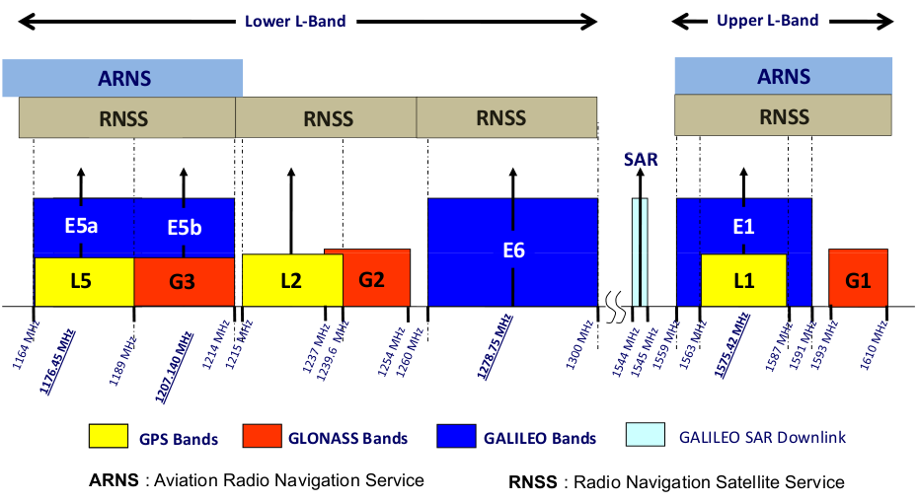
It can be seen that just above the 1164 MHz boundary are the E5a Galileo and L5 GPS bands.
The following Recommendations were used as the source of information for parameters:
Recommendation ITU-R M.1318-1 – Evaluation model for continuous interference from radio sources other than in the radionavigation-satellite service to the radionavigation-satellite service systems and networks operating in the 1 164-1 215 MHz, 1 215-1 300 MHz, 1 559-1 610 MHz and 5 010-5 030 MHz bands
Recommendation ITU-R M.1787 - Description of systems and networks in the radionavigation-satellite service (space-to-Earth and space-to-space) and technical characteristics of transmitting space stations operating in the bands 1 164-1 215 MHz,1 215-1 300 MHz and 1 559-1 610 MHz
Recommendation ITU-R M.1905-0 – Characteristics and protection criteria for receiving earth stations in the radionavigation-satellite service (space-to-Earth) operating in the band 1 164-1 215 MHz
Report ITU-R M.2235 - Aeronautical mobile (route) service sharing studies in the frequency band 960-1 164 MHz
These Recommendations included a number of options which were summarised into two configurations, one for air-navigation and another general purpose:
Table 2: RNSS Parameters
RNSS Receive type | Air-navigation | General-purpose
RNSS Receive mask | M.2235 Figure 8 (Aeronautical receiver) | Gaussian Filter Bandwidth 20.5 MHz
RNSS Centre frequency (MHz) | 1176.45 | 1176.45
RNSS Bandwidth (MHz) | 24 | 24
RNSS Gain (dBi) | -5 | 3
RNSS Receiver temperature (K) | 727 | 330

Recommendation ITU-R M.1905 gives two gain values, a minimum and maximum. For the air-navigation case the minimum was used assuming the maximum was pointing at the sky and minimum towards the ground. For the general-purpose case the maximum gain was used.
The threshold metric used was T(I/N) calculated using the parameters from Recommendation ITU-R M.1905 and the methodology in Recommendation ITU-R M.1318 and is shown in the following table:
Table 3: RNSS Interference Threshold
RNSS Receive type | Air-navigation | General purpose
Acquisition mode threshold power density level of aggregate wideband interference at passive antenna output (dBW/MHz) | -148.7 | -146
Receiver noise temperature (K) | 727 | 330
Noise (dBW/MHz) | -140.0 | -143.4
Safety of life margin (dB) | 6 | 0
Service apportionment factor | 4 | 4
Aggregate T(I/N) before safety of life margin (dB) | -8.7 | -2.6
Aggregate T(I/N) after safety of life margin (dB) | -14.7 | -2.6
Single service T(I/N) | -20.7 | -8.6

Note that the thresholds quoted are the ones for wideband interference rather than those for narrowband which are about 10 dB more stringent. Recommendation ITU-R M.1905 definitions are:
“Narrow-band continuous interference is considered to have a bandwidth less than 700 Hz. Wideband continuous interference is considered to have a bandwidth greater than 1 MHz. Thresholds for interference bandwidths between 700 Hz and 1 MHz are under study.”
This could require further consideration at a later stage.
It was noted that the interference thresholds in Recommendation ITU-R M.1905 were aggregate over all systems and services. Hence to determine a threshold to use for a specific scenario, namely one system (service) of PMSE (mobile) into RNSS an apportionment factor was used. In this case an apportionment factor of 4 was used. An example of the other services could be {other RNSS, Aeronautical, PMSE/mobile, other non-co-frequency}.
The receive filter masks for the two configurations considered are shown in the figure below:
Figure 4: RNSS Receive Filter Masks
The receive noise of a receive mask with Gaussian bandwidth was calculated using N = kT.bandwidth as that gives a value very close to that calculated using integration.
It should be emphasised that the RNSS received signal is extremely weak. For example, Recommendation ITU-R M.1787 gives a minimum receive power level of -155.25 dBW. This is significantly below the noise floor and gives an indication of why PMSE, while sometimes considered a low power service, could cause harmful interference if located within the vicinity of an RNSS receiver. An implication of this is that RNSS operation will be mostly outdoors.
It also should be noted that generic RNSS devices such as smartphones have limited space available (e.g. chips millimetres in size) and hence will operate with less attenuation than the filter characteristics of equipment that meets the Report M.2235 Figure 8 curve. There is significant benefit to citizens and consumers that generic RNSS devices are highly portable and hence there is little scope to provide greater attenuation.
Analysis of a typical RNSS network suggests that an operating signal would be close to this level with little margin available. Unlike PMSE receivers, the transmitter is many thousands of kilometres away and the link budget does not have a large fade margin within it. An example of an RNSS operation can be seen in the following screenshot of a simulation where the resulting wanted signal is only just above the threshold of -155.25 dBW:
Figure 5: Example RNSS Constellation Simulation
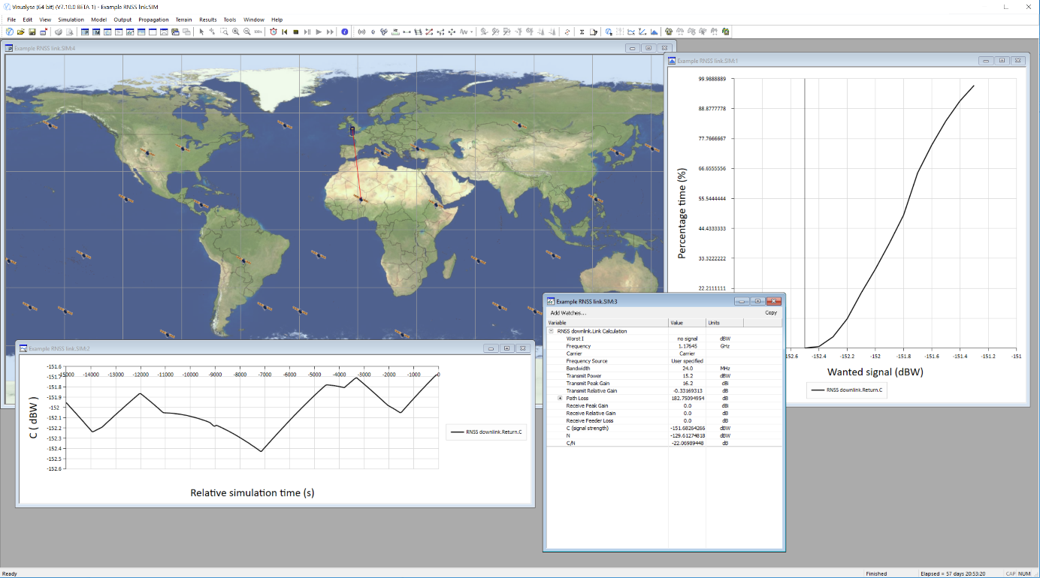

    - Modelling Assumptions
This section describes the modelling methodology used, including how the transmit and receiver masks were integrated, the propagation models, the equation used to calculate I/N and the various scenarios used to derive the required guard band.
      - Transmit and Receive Mask Integration
The interference at the RNSS receiver was calculated by integrating the transmit PMSE spectrum mask with the RNSS receiver filter mask using:
$$A_{MI}=\frac{p_{rx}}{p_{tx}}=\frac{\int_{f=0}^{f=∞}{m_{tx}\left(f\right)m_{rx}\left(f\right)}df}{\int_{f=0}^{f=∞}{m_{tx}\left(f\right)}df}$$
The integration range for the top integral was over the receive filter bandwidth with the assumption that the last value of the transmit spectrum mask continued outside the defined range. The integration range of the lower integral was over the transmit mask bandwidth.
The resulting plot of AMI vs frequency offset is shown in the figure below:
Figure 6: Integration of PMSE Digital Mask with RNSS Receiver Masks
      - Modelling Methodology
The I/N was calculated using the following equation:
$$\frac{I}{N}=EIRP+G_{tx,rel}-{L_{body}-L_{fs}\left(f,d\right)-L}_{clutter}-L_{BEL}+G_{rx}+A_{MI}\left(δf\right)-10\log_{10}\left(kTB\right)$$
Where:
EIRP = PMSE transmit EIRP (dBW)
Gtx,rel = PMSE transmit relative gain (dB)
Lbody = PMSE body loss (dB)
Lfs = free space path loss (dB) dependent upon frequency f and distance d
Lclutter = clutter loss on radio path (dB)
LBEL = building entry loss (dB) (if applicable)
Grx = RNSS receive gain (dBi)
AMI = Mask integration adjustment for given difference in frequency f (dB)
T = RNSS receive temperature (K)
B = RNSS receive bandwidth (Hz)
It can be seen that the I/N calculated depends upon separation distance d and frequency offset f. The distance was defined by the scenarios (as described below) and then the frequency offset varied until the calculated I/N met the required T(I/N). From the frequency offset the necessary guard band could be determined.
Polarisation loss is not considered as there is unlikely to be main-beam to main-beam alignment and hence significant de-polarisation affects.
      - Scenarios
A number of scenarios were defined, namely:
Theatre General: a generic RNSS receiver is operating outside a theatre where PMSE devices are being used inside. An example of this would be the West End of London.
Urban General: a generic RNSS receiver is operating on a location where PMSE devices are being used outdoors. An example of this would be the Boat Race in London or bike / scooter hire company in the Olympic Park.
Rural General: a generic RNSS receiver is being operated in a rural area with many PMSE devices are being used outdoors. Examples would include music festivals such as Glastonbury and sporting events such as Silverstone.
Theatre Air: an aircraft RNSS receiver is operating over an area where many theatres are using PMSE devices indoors. An example would be an aircraft over London which has a large number of theatres.
Urban Air: an aircraft RNSS receiver is operating over an area where PMSE devices are being used outdoors. An example of this would be the Boat Race in London or an event at the Olympic Park.
Rural Air: an aircraft RNSS receiver is operating at lower altitude over a rural area where PMSE devices are being used outdoors. Examples would include music festivals such as Glastonbury and sporting events such as Silverstone, both of which have high use of PMSE and have high helicopter traffic.
The parameters for these scenarios are defined in the table below:
Table 4: Scenario Parameters
Scenarios | Building entry loss (dB) | Clutter loss (dB) | Distance (m) | Site aggregation factor (dB)
Theatre General | 10 | 0 | 50 | 0
Urban General | 0 | 23.3 | 20 | 0
Rural General | 0 | 11.6 | 50 | 0
Theatre Air | 10 | 0 | 1000 | 20
Urban Air | 0 | 0 | 100 | 10
Rural Air | 0 | 0 | 50 | 10

The aggregation factor takes account of the number of PMSE interfering sites that have an impact on the aggregate interference. For short range paths this is 1 (i.e. 0 dB) but for aircraft over an area where there could be large numbers of sites using PMSE that contribute to the aggregate interference a factor of 10 dB or 20 dB was included (i.e. 10 or 100 sites).
At each site it was assumed there were 3 PMSE devices transmitting in the three channels nearest the RNSS receiver taking into account the guard band assumed, as shown in the figure below:
Figure 7: PMSE Channels, Guard Band and RNSS Receive Frequency
      - Sensitivity Analysis
A number of variations to the input parameters were considered, including:
Using a tighter threshold for the general case of T(I/N) = -6 dB as per ETSI EN 303 413
Considering more PMSE adjacent band channels (e.g. 5 rather than 3)
Consideration of air-navigation receiver No. 2 in Table 2.1 of Recommendation ITU-R M.1905 or the low height parameters
Consideration of actual masks of general-purpose receivers taken from receiver specifications.
In general, it was found that these changes make only a minor impact on the resulting guard bands required, and it was concluded that scenarios and parameters proposed in the main study were a representative set.
    - Conclusion
For each of the scenarios, for each of the PMSE types, the necessary guard band was calculated as in the table below:
Table 5: Required Guard Band Required to Meet T(I/N) (MHz)
RNSS Receiver Type | Scenario | Body worn | Handheld | IEM with downtilt | IEM no downtilt
General | Theatre | 28 | 29 | 28 | 32
General | Urban | 25 | 27 | 26 | 30
General | Rural | 27 | 28 | 28 | 31
Air | Theatre | 5 | 5 | 3 | 5
Air | Urban | 10 | 10 | 9 | 10
Air | Rural | 12 | 12 | 10 | 12

In each case the guard band was increased in 1 MHz steps until the I/N was below the T(I/N). For example, a plot of the first case (Theatre General / Body Worn) would be as in the figure below.
Figure 8: Plot of I/N at RNSS Receiver against Guard Band Size
Scenario = Theatre General / PMSE type = Body Worn

It was noted that the largest guard band was 32 MHz for the IEM with no downtilt case. As it is possible there could be some discrimination at the IEM transmitter, it was concluded that a 30 MHz guard band could be sufficient. This would also protect all other scenarios.
This study investigates the impact of PMSE operating in the band 960 – 1164 MHz on RNSS receivers in the adjacent bands above 1164 MHz. The study considered a number of PMSE types, RNSS receiver types and scenarios.
The conclusion was that a guard band of 30 MHz would be required to protect RNSS receivers.
  - Other systems
Not studied.
- [DFS Germany] Guidance for practical tests of DME and TACAN operations, the effects of multipath and signal strength variation
  - Summary
This Annex discusses the loading of the DME channel as perceived by DME/TACAN receivers, the effects of multipath and indicates the need for compatibility with PMSE to be determined with the Echo Suppression capabilities of transponders receiver enabled.
Note: This aspect has not been addressed in the PMSE compatibility studies/measurements contained in this report.
  - Introduction
While DME and TACAN pulses are normally depicted in literature to have only a width of 3.5 µs ±0.5 µs, this is only true at the 50 % amplitude points of the pulses. Below the 50% amplitude points width can be up 8 µs.
Echos and multipath can occur at most locations, especially since aeronautical pulses may be received at a signal level higher than -40 dBm. Multipath will increase the pulse width, or increase the number of pulses received above receiver thresholds, thus increasing apparent duty cycle.
In extreme cases, DME pulse trains that originate from a single interrogation pulse pair due to multiple echoes with decreasing signal strength will occur. Such pulse trains have been measured to last for 150 µs or longer. DME and TACAN transponder receivers are therefore equipped with Short- and Long-Distance Echo-Suppression circuits (SEDS and LDES) which can provide protection for up to 350 µs after the initial interrogation pulse pair was received.
  - Increase of DME and TACAN pulse width with amplitude and pulse form
DME/TACAN aeronautical pulses are often depicted as Gaussian shaped pulses in literature.
The definitions for DME pulses in ICAO Annex 10 Volume I are:
- pulse-width of 3.5 µs ±0.5 µs at 50% amplitude points.
- max. pulse rise time between 10% and 90%
- max. pulse decay time between 90% and 10% amplitude points
- pulse drop not to fall below >95 % amplitude
Note: TACAN pulse characteristics are similar to DME with the addition of pulse amplitude modulation.
This has direct impact on the spectrum emission mask which is 200 mW measured in 500 kHz centred ±0.8 MHz above and below centre frequency and 2 mW measured in 500 kHz centred ±2.0 MHz above and below centre frequency.
Below the -10 dB points a Gaussian pulse becomes wider as shown in measurements below. Manufactures are free to implement any waveform that meets the above criteria. The equipment measured are fully ICAO compliant, and are the result of different interrogator designs and technology.

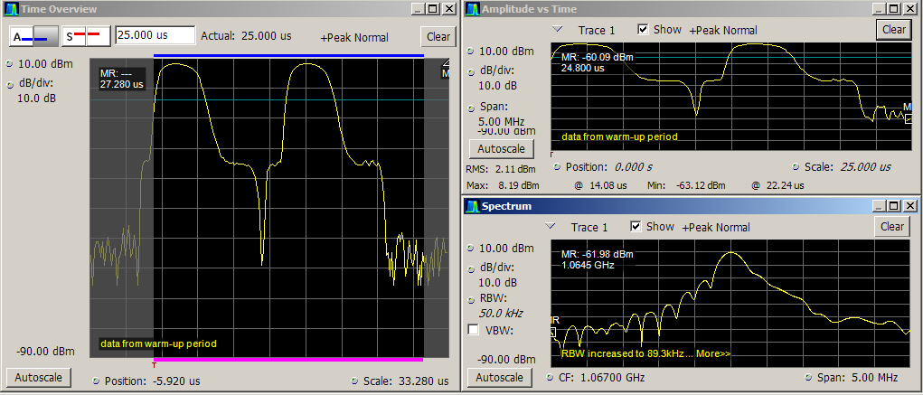 | Fig. 1 measured pulse form DME-40 (Collins)
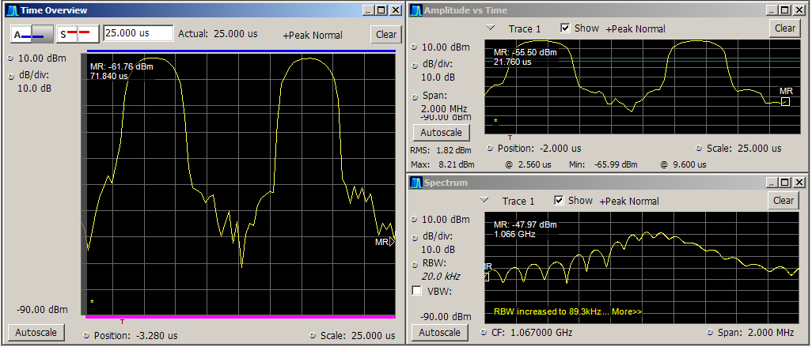 | Fig. 2 measured pulse form KTU-709 (Bendix)
  - Increase of DME and TACAN pulse count and aggregate duty cycle in presence of multipath
Multipath is generated by strong aircraft DME and TACAN interrogations (see figure 3). A more detailed description of DME and TACAN multipath can be found in FAA-6820.10.
Fig. 3 longitudal- and or lateral-echos/-multipath [FSS-6820.10]
    - Short Distance Multipath
An echo that falls between two interrogation pulses is considered as short distance multipath (see figure 4).
Fig. 4 short distance-echos/-multipath
    - Long Distance Multipath
An echo arriving after the initial interrogation pulses is called a Long Distance Multipath echo.
Multiple replies from the Frankfurt/Main TACAN were observed in 1969 during a flight inspection by BFS (Bundesanstalt für Flugsicherung). In addition to the transponder reply to the interrogation received via the direct path. a second and a third replies were generated by the transponder. The interrogation pulse pair were received via multiple reflections in the airport vicinity. Observation of the output signal of the logarithmic amplifier of the transponder identified a dense pulse train generated which was received as long as 150 µs after the initial interrogation pulse, before the amplitude of the multipath signals dropped below the set Minimum Triggering Level (MTL) of the TACAN receiver. US-FAA had identified similar occurrences. In consequence modifications to existing transponder, called echo traps, were made. Furthermore input material to ICAO lead to an amendment of ICAO Annex 10 with provisions countering multipath effects. Today DME and TACAN transponder have LDES and SDES circuits to counter multipath interference for up to 350 µs duration.
Fig. 5 long distance-echos/-multipath [BFS-RD-1969]

  - Conclusion
The measurements introduced in this Annex demonstrated that aeronautical pulses, e.g. from DME and TACAN, produce multipath echoes at most transponder locations, thus negatively affecting the reception of weaker DME/TACAN signals. Due to this, when assessing compatibility with PMSE, testing of DME/TACAN performance should be conducted with the Echo Suppression enabled to be representative of normal use of DME/TACAN. Echo suppression was not used in the DME-PMSE compatibility studies/measurements reported.
- [BNETZA AND DFS GERMANY] PMSE interference measurements on DME/TACAN
  - Summary
This Annex describes the laboratory measurements of DME and TACAN on-board equipment and DME ground stations interfered by digitally modulated PMSE signals. Special consideration was paid to the performance and interference behaviour of different DME and TACAN equipment of various design and from different manufacturers. It should be noted that due to time constraints, the measurement campaign is not considered to be conclusive in terms of identifying accurate compatibility criteria.
  - Introduction
The impact of only one of the possible digital waveforms for PMSE signal on the performance of DME/TACAN systems was measured at the laboratories of the DFS Germany, together with the Federal Network Agency Germany (BNetzA). DME and TACAN interrogator and DME transponder were conducted in separate measurements.
In a first step, the behaviour of the on-board and ground station equipment under test (EUT) in a non-interfered situation at low wanted signal levels was investigated. The main purpose of this measurement was to establish a failure (or performance) criterion for the DME/TACAN system, and to determine the system sensitivity.
In a second step, a digitally modulated PMSE signal was injected in the signal path with increasing level at different frequency offsets and the performance of the DME/TACAN equipment was recorded.
Each measurement was repeated multiple times to consider also statistical behaviour of the EUTs.
  - System description
The distance measuring equipment (DME) system consists of an on-board interrogator and a ground station transponder. The on-board interrogator sends out a series of unmodulated double pulses in a random time sequence. These pulses are received by the ground station receiver, delayed by a fixed time and re-transmitted to the aircraft on a different frequency. The aircraft equipment can then calculate the distance to the ground station by measuring the time between sent and received double-pulses.
The on-board interrogator transmits between 1025 and 1150 MHz (1 MHz channel steps) and the ground transponder transmits between 962 and 1213 MHz (63 MHz above or below the interrogator channel).

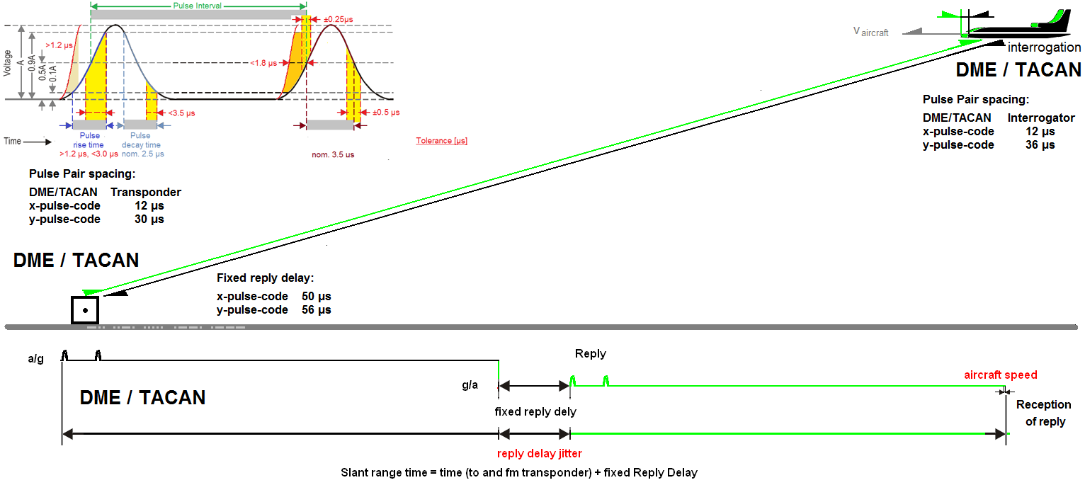
Figure A.1: DME/TACAN interroagtion and reply timing
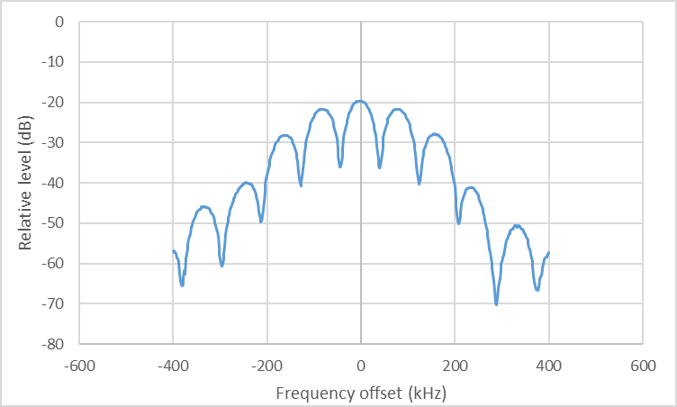
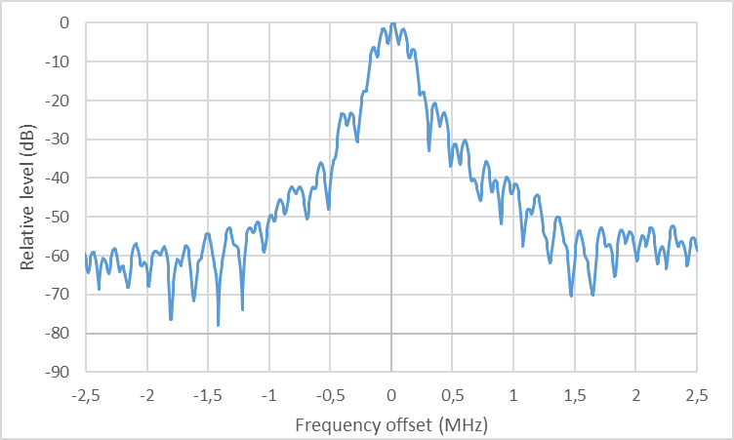
Figure A.2: DME spectrum
In addition to determining the slant range distance to the ground station and the identification in Morse-Code (1350 Hz tone), TACAN systems also allow determination of the bearing referenced to/from magnetic north, under which the ground station is seen from the aircraft. To facilitate this function, the TACAN ground station sends out 900 additional pulses pairs, forming Reference Pulse Groups (RPG). All pulses are transmitted via a mechanically or electronically rotating antenna. This antenna produces a Pulse Amplitude Modulation (PAM) in space across all transmitted pulses see SE7(18)182 and SE7(19)183. The level of the pulses, when received by the on-board receiver, are amplitude modulated with 15 and 135 Hz having 12 % to 55 % Depth of Modulation (DOM). The bearing angle to the ground station can then be calculated by evaluating the phase of the two AM-tones relative to the TACAN-RPG
The spectra of DME and TACAN are principally equal, but transponder and interrogator differ in width and requirement as specified in ICAO Annex 10-I. However, the maximum amplitude of the pulses from the TACAN ground transponder is changing due to the PAM. The following figure shows the pulse amplitudes of DME and TACAN over 85 ms time. The depth of modulation is 50%. As specified in ICAO Annex 10, the DME/TACAN levels are always referenced to the maximum peak amplitude of the pulses.
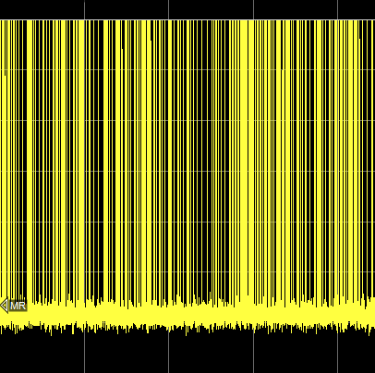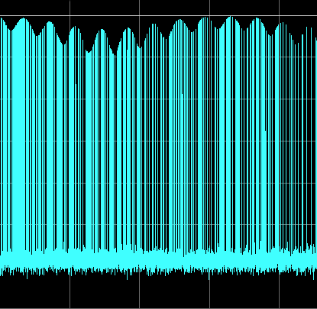
Rel. level/dB
0
-10
-20
-30
-40
-50
-60
-70
Figure A.3: DME (left) and TACAN with PAM (right) amplitude vs. time
Compared to DME, decoding of TACAN pulse pairs generally requires higher signal levels at the on-board receiver, because only very few pulses actually reach the peak power level due to the PAM.
To receive all pulses, the peak level of a TACAN transponder signal needs to be approximately 9 dB higher than a DME signal. Hence, also the required C/I may need to be higher.
In "search mode", the on-board interrogator sends out up to 150 pulse pairs per second (pp/s) and tries to synchronize/lock-on with the ground transponder. If acquisition/lock-on is successful, the interrogator changes to "track mode" where it transmits below 30 pp/s. The time needed for synchronisation is called acquisition, Lock-on or Time to acquire" (TTA).
Ground DME and TACAN transmit up to 5400 pp/s and additional 900 pp/s during identification in Morse code. To enable identification of the specific ground station, an ID consisting of two to four characters is sent every 30 to 40 seconds as Morse Code, The Morse Code dots and dashes are generated by a series of pulses to sustain a 1350 Hz audio tone. The aircraft equipment decodes the ID into an audible tone or provides it as digital data word via the ARINC-429 aircraft bus.
  - Interfering signal
For these measurements, the signal interfering from one available a digital wireless microphone using QPSK was analysed. The following figure shows the spectrum of the PSME signal, recorded with RMS detector in 1 kHz resolution bandwidth. The power was set to maximum to create the highest possible unwanted emissions.
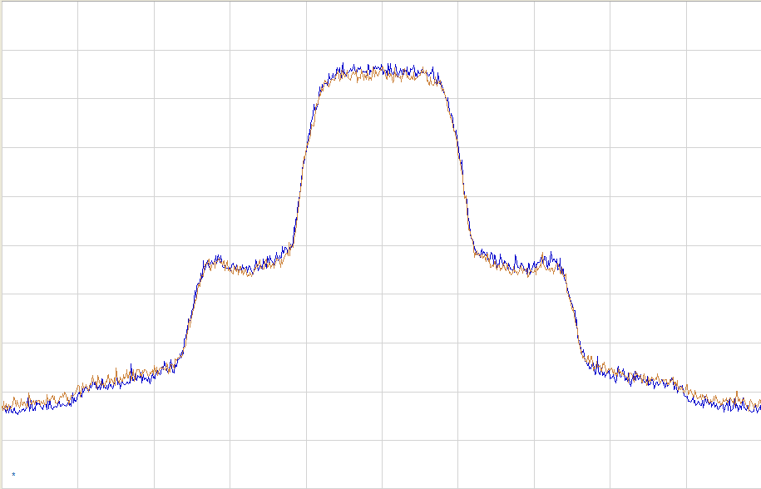
0
100
200
300
400
500
-100
-200
-300
-400
-500
Offset/kHz
Rel. level/dB
0
-10
-20
-30
-40
-50
-60
-70
-80
Figure A.5: PSME signal from a typical wireless microphone
In order to be able to freely adjust frequency and level of the PMSE signal, it was decided to use a vector signal generator to produce the interfering signal for these measurements. The relevant RF parameters are:
- Bandwidth: 180 kHz
- Modulation: QPSK
- PAPR (peak to average power ratio): 3.5 dB
The following figure shows the resulting spectrum of the interfering PMSE signal used.
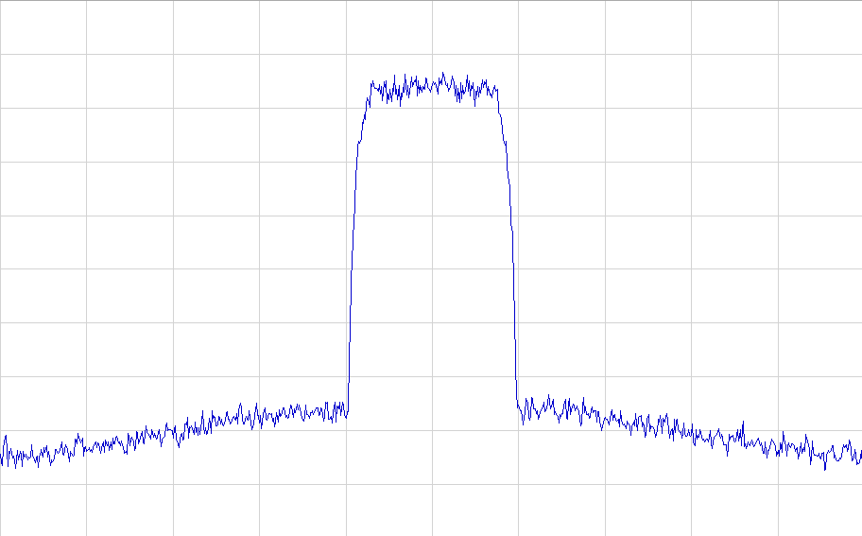
0
100
200
300
400
500
-100
-200
-300
-400
-500
Offset/kHz
Rel. level/dB
0
-10
-20
-30
-40
-50
-60
-70
-80

Figure A.6: Interfering PSME signal generated with SMU200A
The interference potential of modulated continuous signals to DME/TACAN may be dependent on the PAPR which can range from 0 dB (for MSK/FSK modulation) up to about 13 dB if OFDM modulation is used. These other possible PMSE modulations were not tested due to time constraints.
All indicated PMSE levels are RMS values over the whole PMSE signal bandwidth.
  - Performance requirements
Operationally used DME- and TACAN. interrogator equipment are specified by one of the below listed FAA TSO C66(a to c) and may additionally be certified by MOPS listed below. The requirements vary as shown in the following table.
 | TSO | MOPS
Criteria | TSO-C66(a) | DO141 | DO-150(A) | DO-189
EUT | DME-40, KDM-706  KTU-709 |  | KTU-709 (TACAN)
Search speed | <35 s | Not defined | ≥6 NM/s
TTA | Not defined | Not defined | Not defined | Not defined
Ranging error | <100 NM: ±0.5 NM or 3% of distance, whichever is greater  >100 NM: <3 NM |  | ±0.4 NM or 1% of distance or <3 NM, whichever is greater | +/- 0.17 nautical miles (NM) or 0.25% of distance
Sens. DME source | Not defined | Not defined | Not defined | -83 dBm
Sens. TACAN source | -79 dBm | -78 dBm | -90dBm ≤-79 dBm search  ≤-82 dBm track | Not defined
Table A.1: TSO and MOPS requirement for the DME- and TACAN-interroagtor under test(MOPS)
The criteria that were applied interrogator testing are mostly not identical to the mandatory requirements, for example, tests are to be conducted with TACAN-PAM or there are no requirements for the TTA at all.
  - On-board interrogator as equipment under test
    - Failure criteria
Interference to the on-board interrogator equipment can have the following effects:
- the time to acquire (TTA) increases
- the ranging error increases
- for TACAN: the bearing distortion increases
- the ID is not unambiguous or undetectable
- the flag sign is raised, meaning no track occurs and memory flag is raised
- loss of track occurs (lockout)
In this measurement campaign, not all interference criteria listed above have been investigated.
If the ID is distorted, interruptions of the audio signal occur. For example, depending on the position of these interruptions, they can cause a Morse code dash to be misinterpreted as a series of dots.
Except for the ID, which has to be evaluated separately, the most critical failure criterion measured in this series is a combination of multiple parameters that is called "acquire stable operation" (ASOP). For these measurements, the ASOP is "successful", if the following conditions are met:
- TTA is below a certain value
- Ranging error is below a certain value
- Absence of flag
Assumptions made during TACAN- and therefore also today's DME/N System design (see EC-1956-xxx), result in the fact that not 100% of all interrogation pulse pairs will be decoded. These are especially:
- Interrogator pulses being transmitted at an arbitrary point in time from multiple aircraft may overlap at the ground transponder making it impossible to separate them in all cases
- For transponder sites where due to multipath additional interrogations are received from the same interrogation signal
- During the delay time for a pulse pair, and during the time of re-transmission, the ground station receiver is switched off and is therefore not able to receive pulses from other aircraft
- During the time another on-board system such as secondary radar is transmitting, the DME receiver is switched off to avoid destruction
The ASOP as defined for the evaluated failure criterion have been defined to be true for only 80% of the measurements. In this measurement campaign, the 80 % requirement is also used (here: 8 out of 10 and 16 out of 20).
For TACAN systems, the required bearing accuracy of +/-3° has to be reached only in 95% of the cases.
    - Measured receivers
The following on-board equipment was available for the measurements:
No. | Type | Application | MOPS
Rx1 | Rockwell Collins DME40 | General aviation | TSO C66a
Rx2 | Bendix King KDM706 | General aviation and business jets | TSO C66a
Rx3 | Bendix King KTU709 / TACAN | General aviation and military | TSO C66a, TSO-151A
Table A.2: Measured on-board interrogator equipment
    - Measurement setup
For all measurements of the on-board interrogator, the following principle measurement setup was used:
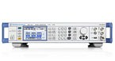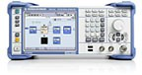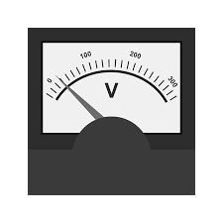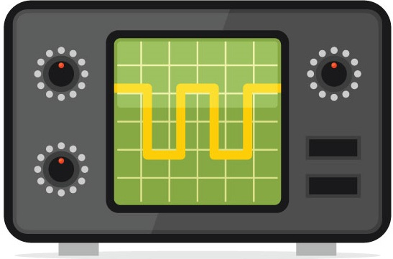
Power sensor
20dB
50Ω
50Ω
3dB
20dB
PMSE generator
R&S SMU200A
Step atten.
RF switch
9-10dB
RX1
DME40
DME simulator
R&S SMA100A
Range
Flag
RX2
KDM706
RX3
KTU709
Converter
MV-meter
Oscillos-cope
ARINC429 Data
Databus RC586
USB
LAN
LAN
LAN
LAN
LAN
LAN
LAN
DME
PSME
Figure A.7: Measurement setup for on-board interrogators as EUT

    - Measurement procedure
All measurements were performed automatically, controlled by a laptop computer with specially developed Python software. The results were stored in an SQL database. The principal measurement procedure was as follows:
- Set PMSE frequency (for interference measurements only, with PMSE generator)
- Adjust wanted and/or unwanted signal level(s) (DME generator and step attenuator after the PSME generator)
- De-select the desired EUT (RF switch off for EUT)
- Wait until EUT is locked out (typically 10 seconds)
- Select the desired EUT (RF switch)
- Select the desired EUT (RF switch on for EUT)
- Wait for the EUT to acquire signal (read out MV-meters/ARINC converter/oscilloscope
- Measure the time to acquire signal (TTA) in case tracking was successful in less than predefined timeout
- Wait for one second (if tracking was successful)
- Record indicated range in case tracking was successful
- Switch to next EUT (RF switch)
- Repeat measurement from step 4
- After predefined number of repetitions: continue with next signal combination at step 1
To achieve results with some statistical relevance and to evaluate deviations in the performance of the same EUT when tested multiple times, each signal level/combination was measured between 10 and 20 times.
Measurements with additional background load simulating DME,TACAN, SSR and/or IFF signals were not done due to time constraints. Also the identification of the Morse code ID and bearing information were not evaluated in these measurements.
The onboard interrogator EUT measurements were done on the DME channel 17X (receive frequency: 978 MHz), whereas the ground station transponder EUT measurements were performed at 107Y (receive frequency: 1131 MHz).

    - Measurements of sensitivity and non-interfered behaviour
In order to assess the general performance and behaviour of the EUT at low wanted signal levels, the different performance parameters were measured in a non-interfered situation.
The following graphs show the results of these measurements.
      - Rx 1 (DME40)
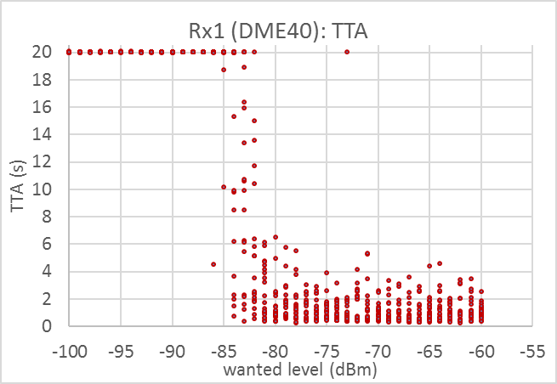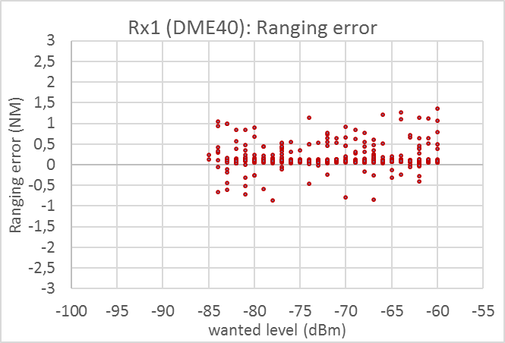
Figure A.8: TTA and ranging error for the non-distorted Rx1 (measurement timeout was 20 s)
Evaluation:
The equipment under test meets the requirements specified during time of certification

Following the above results, the threshold for an undistorted TTA was set to 5 seconds and the threshold for the ranging error was set to 1 NM which is 2 times the standard deviation of all measurements where the equipment was able to track the signal within 5 seconds. The resulting sensitivity of Rx 1 is -81 dBm

      - Rx 2 (KDM706)
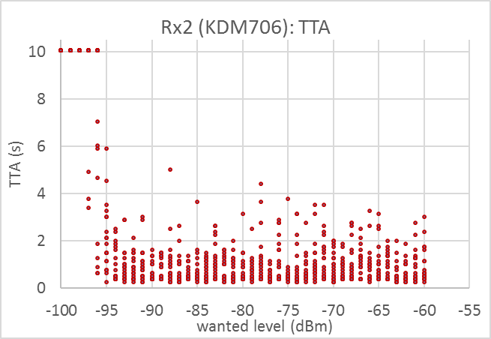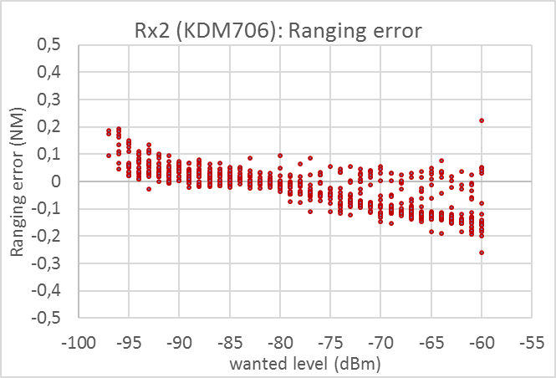
Figure A.9: TTA and ranging error for the non-distorted Rx2 (measurement timeout was 10 s)
Evaluation:
- The equipment under test meets the requirements specified during time of certification
- Following the above results, the threshold for an undistorted TTA was set to 4 seconds. The resulting sensitivity of Rx 2 is -95 dBm

      - Rx 3 (KTU709)
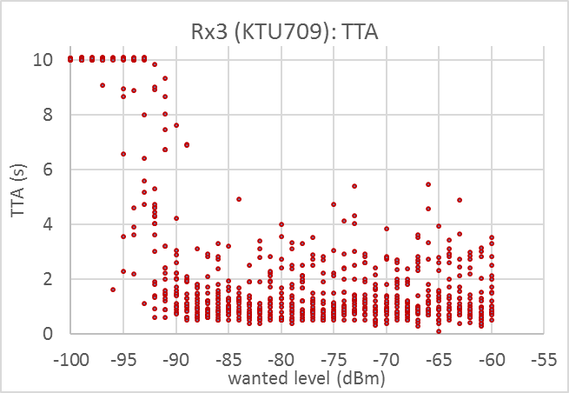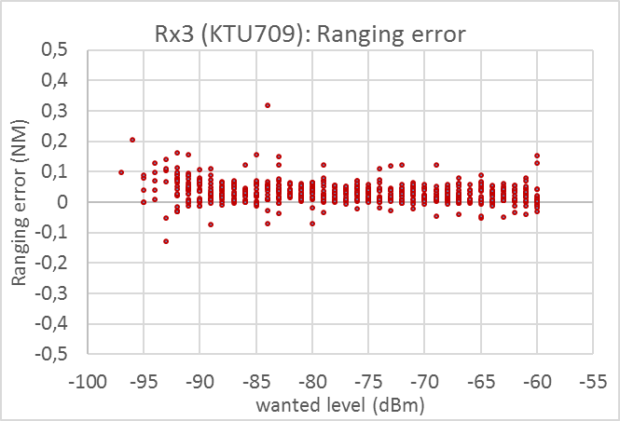
Figure A.10 TTA and ranging error for the non-distorted Rx3 (measurement timeout was 10 s)

Evaluation:
- The equipment under test meets the requirements specified during time of certification
- Following the above results, the threshold for an undistorted TTA was set to 5 seconds. The resulting sensitivity of Rx 3 is -90 dBm

      - ASOP evaluation
Due to the observations above, the applicable threshold values for TTA and ranging error had to be adjusted individually for every tested receiver. The respective values that mark the point of failure were chosen as follows:
Parameter | Rx1 (DME40) | Rx2 (KDM706) | Rx3 (KTU709)
TTA | 5 s | 4 s | 5 s
Ranging error | 1 NM | 0.17 NM | 0.17 NM
Table A.4: Selected threshold values for the failure criterion of the tested on-board interrogators
The following figure shows the percentage of successful ASOP under the above criteria.
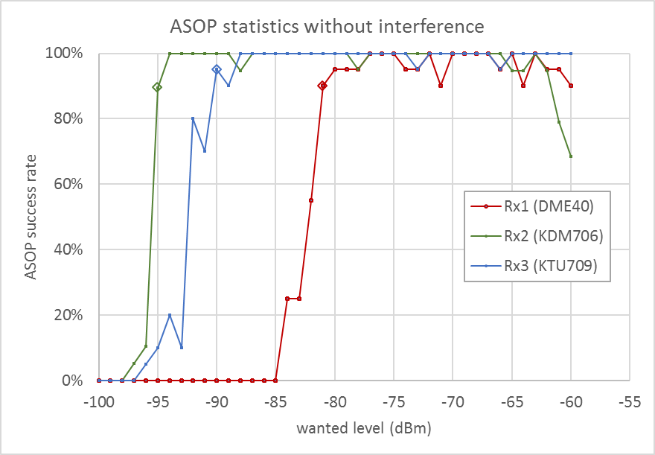
Figure A.11: Non-interfered ASOP statistics for selected failure criterion
Evaluation:
- The sensitivity of the on-board interrogators ranges from - 95 dBm to -81 dBm
- Whenever the system is operated at wanted levels above the sensitivity, the ASOP is always successful in more than the required 80%. An exception is Rx2 whose performance degrades with increasing wanted signal level owing to the raising ranging error. However, this behaviour was not considered in the following C/I measurements as it is not due to any interfering RF signal.
    - Measurements with PMSE interferer
Using the failure criteria selected in the previous section, measurements with the interfering PMSE signal at different frequency offsets were conducted. The wanted signal levels for these measurements were set to 3 dB and 10 dB above the determined receiver sensitivity.
Only positive frequency offsets were measured, i. e. the interferer frequency was above the DME frequency.
The general behaviour at the interference threshold was equal to the behaviour near the sensitivity in the non-distorted case. As an example, the following graphs show the ASOP results for the co-channel case (offset wanted/unwanted signal = 0) at a wanted signal level that is 3 and 10 dB above the measured sensitivity.
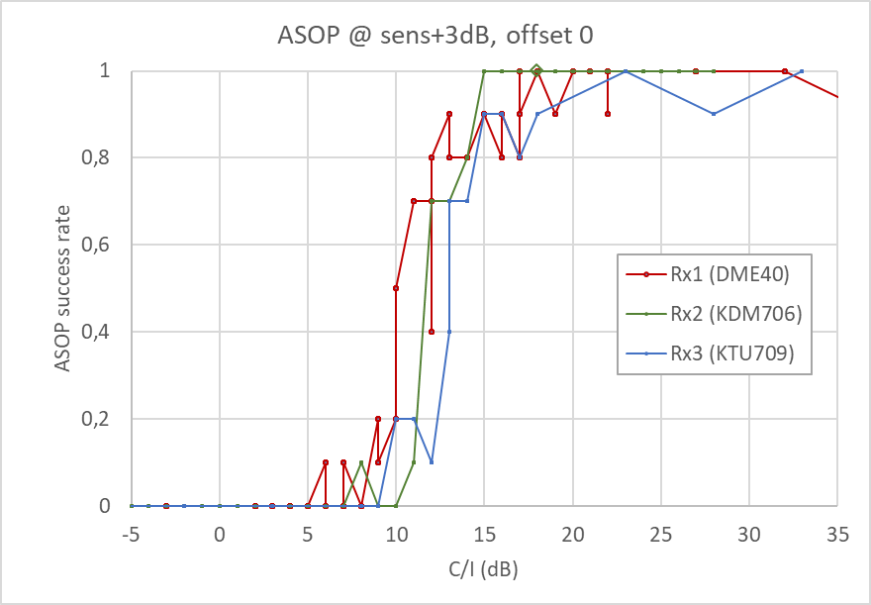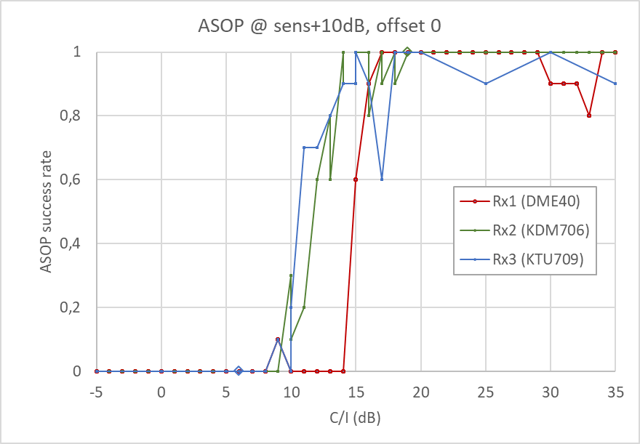
Figure A.12: ASOP success rate at different wanted signal levels when interfered by a co-channel PMSE signal
The measurements showed a good reproducibility. This can be seen in the following graph that compares the same parameter combination (wanted signal level -79 dBm, offset = 0) in three different measurement series having been performed on different days.
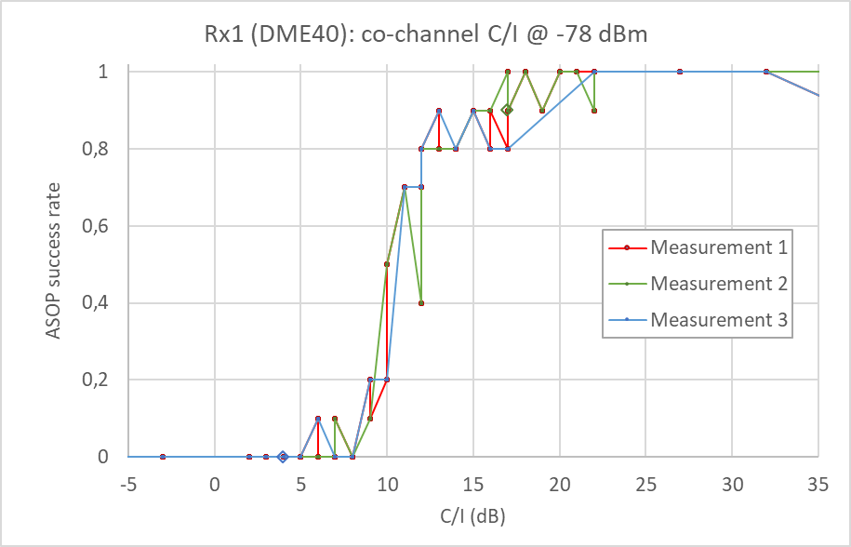
Figure A.13: Co-channel C/I for the DME40 interrogator at three different measurement days
The following table and graphs show the required C/I depending on the frequency offset and using the ASOP criterion described above.
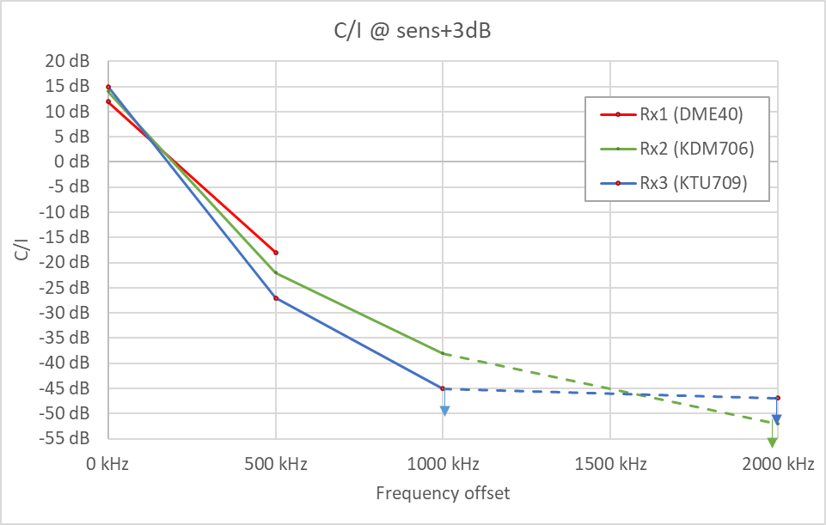
Figure A.14: ASOP C/I for different offsets at wanted levels 3 dB above sensitivity
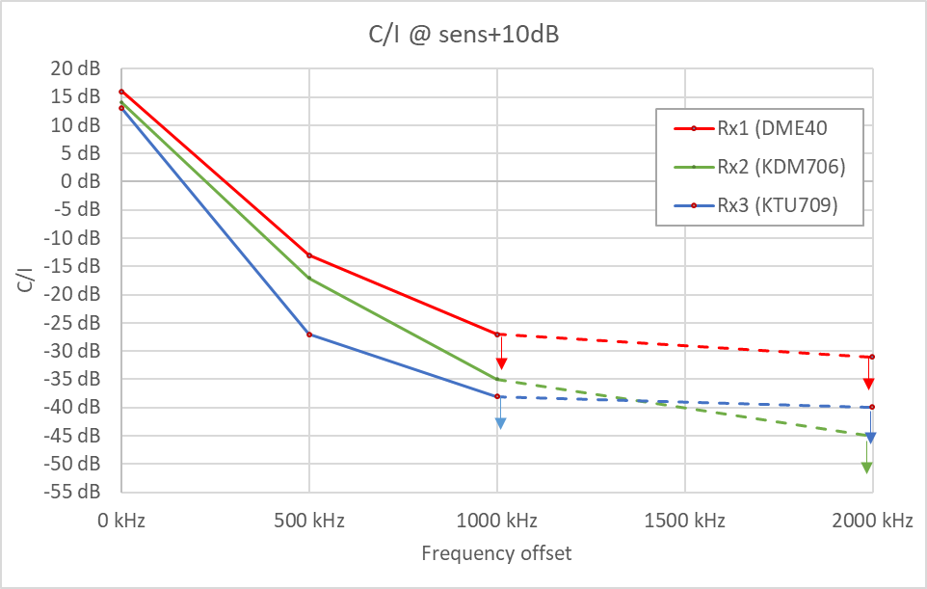
Figure A.15: ASOP C/I for different offsets at wanted levels 10 dB above sensitivity

 | Rx 1 (DME40) |  | Rx 2 (KDM706) |  | Rx3 (KTU709)
Offset | @sens+3dB | @sens+10dB | @sens+3dB | @sens+10dB | @sens+3dB | @sens+10dB
0 kHz | 12 dB | 16 dB | 14 dB | 14 dB | 15 dB | 13 dB
500 kHz | -18 dB | -13 dB | -22 dB | -17 dB | -27 dB | -27 dB
1000 kHz |  | < -27 dB | -38 dB | -35 dB | < -45 dB | < -38 dB
2000 kHz |  | < -31 dB | < -52 dB | < -45 dB | < -47 dB | < -40 dB
Table A.5: ASOP C/I for different offsets
Evaluation:
- The co-channel C/I of the tested on-board receivers is around 15 dB with little variation
- For offsets higher from 0.5 MHz on, the required C/I varies considerably. The receiver requiring the highest C/I is Rx 1 (DME40).
- When the frequency offset is 2 MHz or higher, none of the tested on-board receivers could be interfered with PMSE levels up to -40 dBm.
- The C/I measurement results were reproducible

  - Ground transponder as equipment under test
    - Failure criteria
The following interference effects to the ground transponder were investigated:
- The beacon reply efficiency drops
- The ranging error increases
- The monitor warning/alert is triggered
The ground transponder receiver is internally tested by transmitting a series of test pulses from a short antenna located directly at the receiver antenna. The level of these pulses is near the expected receiver sensitivity. If these test pulses are not evaluated correctly by the system, the monitor alert is raised indicating that the system is malfunctioning. In such cases the system is switched off assuming that a stand-by system takes over. This is the most serious interference effect possible because if the effect is caused by external interference the standby system will also switch off and maintenance staff has to visit the site to switch the DME on again.
As mentioned before, several properties in the system design result in the fact that not 100% of all interrogator pulses will be evaluated correctly. These are for example:
- Interrogator pulses being transmitted at an arbitrary point in time from multiple aircraft may overlap at the ground transponder making it impossible to separate them in all cases
- During the delay time for a pulse pair, and during the time of re-transmission, the ground station receiver is switched off and is therefore not able to receive pulses from other aircraft
- During the time another on-board system such as secondary radar is transmitting, the DME receiver is switched off to avoid destruction
- For transponder sites where due to multipath additional interrogations are received from the same interrogation signal
For the above reasons, the beacon reply efficiency, which is the percentage of evaluated and re-transmitted interrogator pulses versus the total interrogator pulses being transmitted, is expected to be only 70%.
  - Measured receivers
The following ground station equipment was available for the measurements:

No. | Type | Tx power | Nominal sensitivity
Rx1 | Selex SE 1119A | 1 kW | -94 dBm
Rx2 | Thales DME415 | 100 W | -81 dBm
Rx3 | Alcatel/Thales FSD-45 | 1 KW | -91 dBm
Rx4 | Alcatel/Thales DME40 | 100 W | -81 dBm
Table A.6: Measured ground transponder equipment
It should be noted that the receiver sensitivity is adjustable. The nominal sensitivity is adjustable between -81 and -97 dBm and depends on the transmitter EIRP, typically -81 dBm or -91 dBm. It should be noted that the C/I measurements were done with wanted signal level that is 3 dB above the measured sensitivity, not the nominal sensitivity.
    - Measurement setup
For all measurements of the ground transponder, the following principle measurement setup was used:

Power sensor
20dB
50Ω
50Ω
3dB
20dB
PMSE generator
R&S SMU200A
Step atten.
DME simulator
R&S SMA100A
To EUT
DME
PMSE
50Ω
50Ω
Figure A.16: Measurement setup for ground transponders as EUT

In the laboratory environment, the DME transmitter is sent into a dummy load instead of the antenna. To simulate the nearfield monitor antenna directional couplers and attenuators were installed as shown in the following figure.
To measurement setup
EUT
Rx 2, 3, 4
20dB
20dB
Monitor 1
2
Ant.
To measurement setup
EUT
Rx 1
20dB
20dB
Monitor 1
2
Ant.

Figure A.17: Setup for the monitor function of the EUTs

    - Measurement procedure
All measurements were done manually. The DME level was adjusted directly at the DME generator, the PMSE level vas adjusted with the step attenuator. The DME generator was set to send 800 pp/s. Beacon reply efficiency (BRE) was evaluated and read from the DME generator SMA100. It should be noted that the DME stations also had an internal indication of the BRE. However, it was found that the values of this indicator were mostly higher than the actual BRE as evaluated by the SMA.
Note: Due to time constraints, the measurements were not conducted with activated SDES and/or LDES, which has been found during JTIDS/MIDS interference compatibility measurements to be more susceptible to pulsed interference.

    - Measurements of sensitivity and non-interfered behaviour
In order to assess the general performance and behaviour of the EUT at low wanted signal levels, different performance parameters were measured in a non-interfered situation.

The following graphs show the results of these measurements.
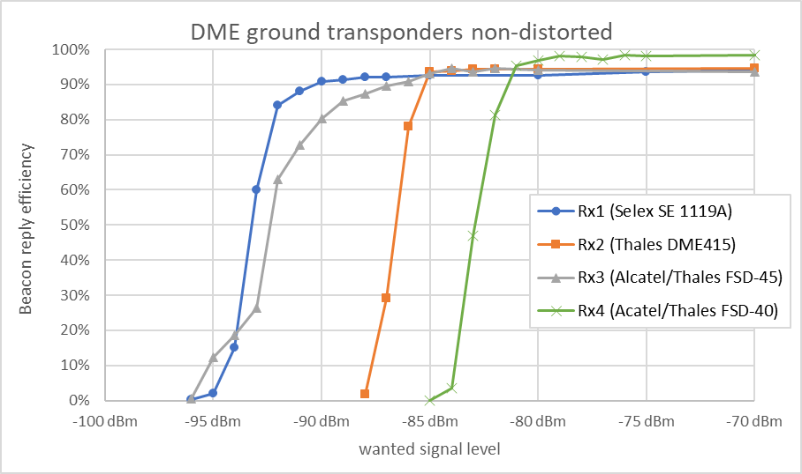
Figure A.18: Beacon reply efficiency at low signal levels
Evaluation:
- The sensitivity varies considerably among the tested equipment.
- The following table lists the sensitivity for a BRE of at least 70 %.

Rx | Sensitivity for BRE > 70 %
1 | -92 dBm
2 | -86 dBm
3 | -91 dBm
4 | -82 dBm
Table A.7: Sensitivity of the DME ground transponders
To determine the variation of the Reply efficiency versus number of interrogations, Rx 1 was tested at a wanted signal level of -87 dBm with different interrogation pulse pair rate.
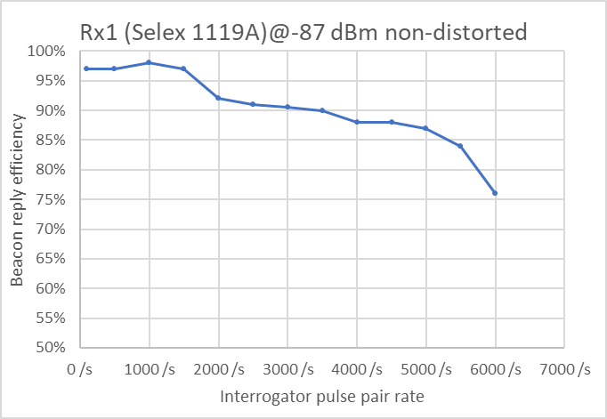

Figure A.19: Ground transponder performance depending on the number of interrogator pulse pairs per second
The BRE decreases with an increase of interrogations. For the C/I measurements, the interrogator pulse pair rate (meaning interrogation pulse pairs) was set to 2000 Hz equalling to a of 2000 pp/s.
    - Measurements with PMSE interferer
Using the BRE of 70 % and the triggering of an alarm or warning as failure criteria, measurements with the interfering PMSE signal were conducted. To assess the behaviour around the failure points, a series of co-channel interference (offset = 0) at a wanted signal level that is 3 dB above the measured sensitivity for a BRE of 70 % (see Table A.7). The following figure shows the result of these measurements:
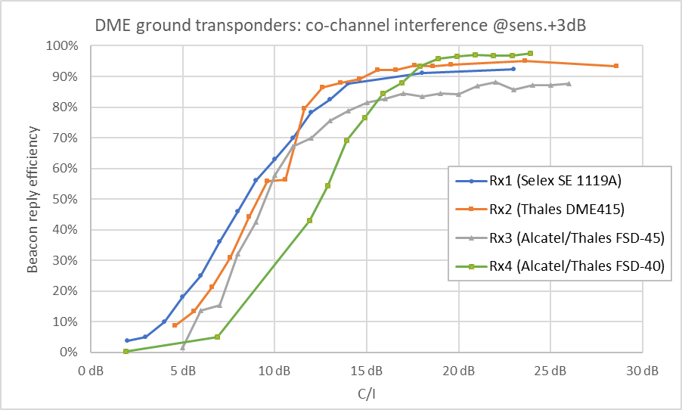
Figure A.20: BRE at different co-channel C/I
Evaluation:
- When exposed to a co-channel PMSE interferer the BRE drops continuously. For C/I between 11 dB (Rx.1) to 14 dB (Rx.2) the BRE is below the required 70% BRE, until at a C/I of 2 dB the BRE is reduced close to at 0 %
- The following table denotes the resulting co-channel C/I for a BRE of 70 %.

Rx | C/I for BRE > 70 %
1 | 11 dB
2 | 12 dB
3 | 12 dB
4 | 14 dB
Table A.8: Co-channel C/I for a BRE of 70 %
The required C/I for both BRE ≥ 70 % and triggering of alarm or warnings was measured for different frequency offsets. The wanted signal levels for these measurements were set to 3 dB above the determined receiver sensitivity.
Only positive frequency offsets were measured, i.e. the interferer frequency was above the DME frequency.
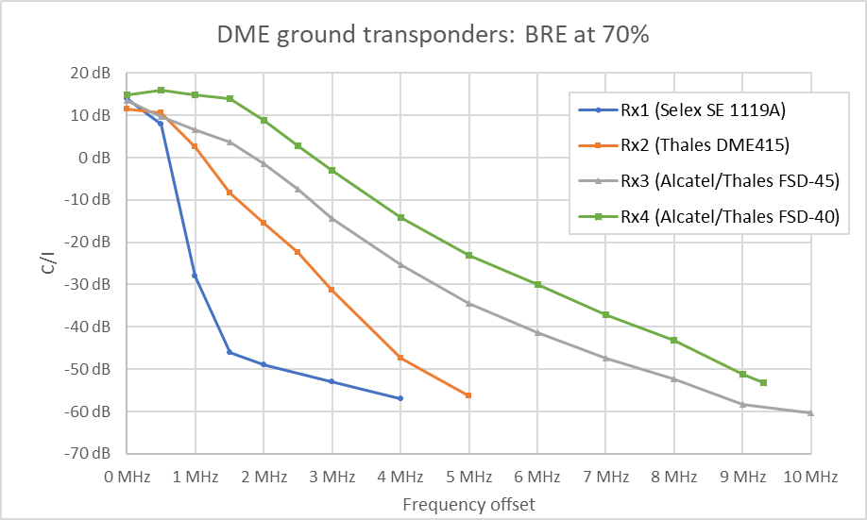
Figure A.21: C/I for a minimum beacon reply efficiency of 70 %
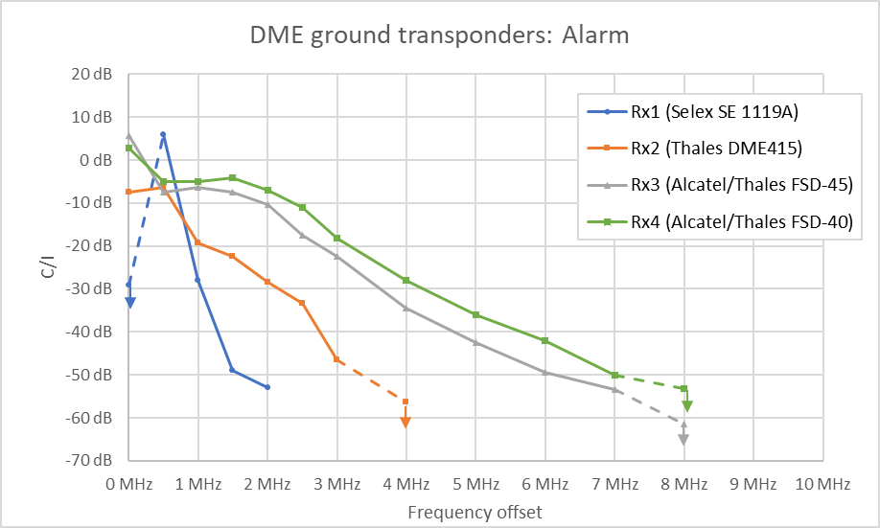
Figure A.22: Required C/I to ensure no alarm or warning is triggered
In some cases the alarm/warning did not occur even at the highest possible interfering level. In these cases the arrows shown in Figure A.21 indicate that the C/I is higher (i.e. more negative) than shown in the graph.
Evaluation:
- The alarm criterion generally occurs at higher interference levels than the criterion to reach at least 70% BRE, even if the alarm interference level is sometimes very close to the interference level required to fulfil the BRE-requirement.
- The selectivity of the tested DME receivers varies considerably. For example Rx1 requires only -50 dB C/I at frequency offsets of 2 MHz. To accept the same interfering level, the PMSE frequency must be at least 9 MHz away from the receiving frequency of Rx4.

  - Conclusion
The present test results indicate for the measured equipment that:
- The measured, non-distorted sensitivity of both on-board and ground DME receivers varies considerably by as much as 14 dB. More sensitive receiver than those tested exist, their behaviour during interference may be different.
- The C/I required by on-board interrogators for co-channel PMSE operation varies between 12 and 16 dB. If the frequency offset is at least 1 MHz, the C/I varies distinctly at values better than about -35 dB.
- The C/I required by ground transponders for co-channel PMSE operation varies between 11 and 14 dB and is typically 12 dB. Further increase of PMSE interference level reduces the beacon reply efficiency continuously down to approx. 0 %. For frequency offsets of 1 MHz or more, the required C/I varies at maximum by 60 dB.
- The selectivity of on-board receivers varies less than that of ground receivers. At 1 MHz offset, for example, the spread among tested on-board receivers is about 10 dB while it is up to 45 dB for ground transponder receivers.
- The ground transponder alarm criterion generally occurs at higher interference levels than the criterion to reach at least 70 % BRE, even if the alarm interference level is sometimes very close to the interference level required to fulfil the BRE-requirement. However, the alarm criterion is most critical and it must be ensured that the required C/I is not exceeded at any time.
- The selectivity for the alarm functions varied considerably for the tested DME receivers. One receiver tested required only -50 dB C/I at frequency offsets of 2 MHz, while another receiver tested required at least 9 MHz off set for the same rejection performance.
- It should be noted that due to time constraints the measurement campaign is incomplete up to now, and does not allow a conclusion in terms of compatibility. Particularly not all possible signal and interference combinations could be measured and therefore, the maximum C/I required in worst case scenarios may be higher than these measurement results indicate.

- [DFS GERMANY] DME and TACAN transponder identification interference
  - Summary
This Annex describes laboratory measurements of the susceptibility of the airborne DME and TACAN interrogator receiver to interference. In the case of TACAN as signal source, attention is given to the Pulse Amplitude Modulation of the signal. It is concluded that a TACAN signal as desired signal source needs an additional protection margin compared to DME as a desired signal source.
The results further demonstrate that a C/I protection of at least 20 dB is needed in order to avoid unacceptable interference to the TACAN transponder identification code.
  - Variations of the needed C/I for taCan compared to DME
    - Introduction
Today many European countries, e.g. Germany, operate TACAN at many locations instead of DME for civil and military users. TACAN transponders do not differ significantly from DME transponder, except TACAN provides bearing information, through 900 additional Reference Pulse Groups (RPG) and a negative 15 Hz and 135 Hz Pulse Amplitude Modulation (PAM) across all transmitted pulses. Consequently the peak pulse power can vary by over 10 dB.
    - Difference in EIRP in reply pulses due to the PAM
The initial TACAN designs generated the PAM across all transmitted pulses in mechanically scanning antenna that consisted of two nonconductive cylinders, with embedded wires to provide the PAM a 15 Hz and 135 Hz modulation. In electronic scanning TACAN antenna, 16 or more vertical antenna arrays, aligned around the center of the antenna base, are amplitude and phase shifted as necessary to generate the required PAM .
The depth of modulation for each of the two signals is defined as 21 ±9%, however some manufacturer define them as 20 ±10%, while the depth of modulation for the sum of the 15 Hz and 135 Hz is max. 55%. The depth of modulation varies with the elevation angle up to a max. of 55% between ±45° of the horizontal plane.
The peak pulse power can vary by over 10 dB and due to the PAM of the pulse pairs transmitted by TACAN transponder, only a few of the reply pulses will provide the same signal strength as a DME transponder having an identical, but continuous peak EIRP.
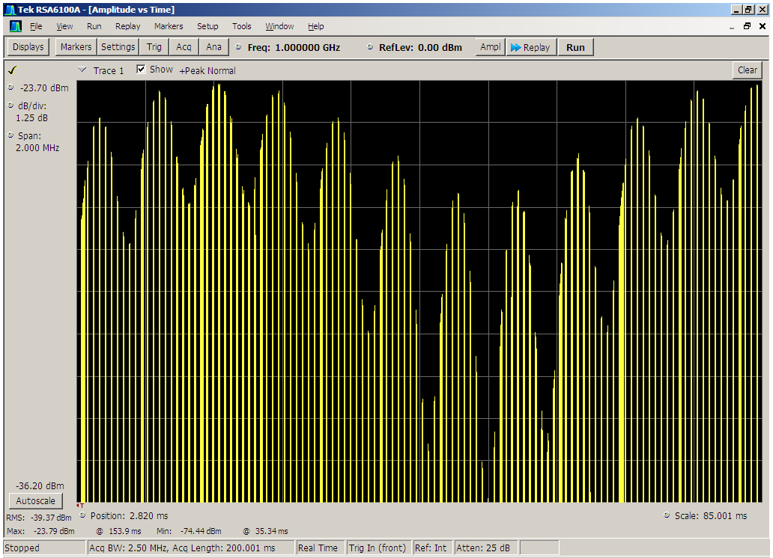
Fig. 1: Example of PAM during a morse code identification (SDX-2000).
    - Conclusion
The peak pulse power can vary by over 10 dB. Therefore TACAN are more sensitive to PMSE interferences than DME. Hence when considering TACAN/PMSE compatibility, an additional protection ratio is required.
  - Measured effect of PMSE interference on TACAN identification
    - Introduction
As described in the section A11.2, TACAN and DME transponders are interchangeable in providing slant ranging distance and identification to the DME and TACAN interrogators. Therefore any transponder used as source for distance ranging and the corresponding Identification of the transponder could be a TACAN. Ground DME and TACAN transmit up to 5400 pp/s and additional 900 pp/s during identification in Morse code. To enable identification of the specific ground station, an ID consisting of two to four characters is sent every 30 to 40 seconds as Morse Code, The Morse Code dots and dashes are generated by a series of pulses to sustain a 1350 Hz audio tone. The aircraft equipment decodes the ID into an audible tone or provides it as digital data word via the ARINC-429 aircraft bus.
    - Test setup
The test setup is described in the figure below with SDX-2000 as TACAN transponder simulator source. The TACAN transponder signal was set to channel 17x (978MHz). Varying signal levels, each having a PAM with Depth of Modulation (DOM) of 50%, were used.
The PMSE Test signal was generated using a SMU-200A PMSE signal, with the following parameter, using QPSK modulation with a Bandwidth set to 180 kHz, having a PAPR (peak to average power ratio) of 3.5 dB.
Fig. 1: Test setup for PMSE on TACAN-Identification tests
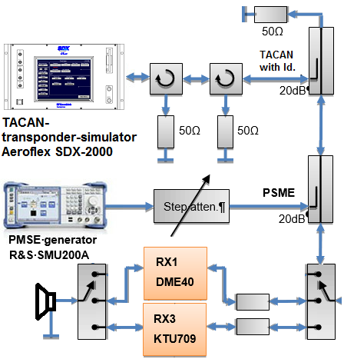
The test Identification sent the Morse Code message "CQCQ". The TACAN transponder simulator signal level was varied between -85 dBm to -90 dBm, and recorded in an audio file.

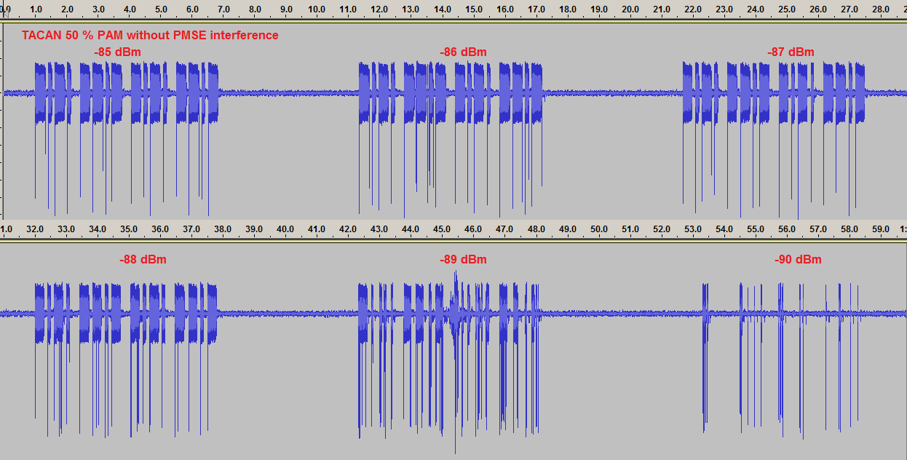 | Fig. 2: KTU-709 TACAN identification without PMSE interference
An Identification was considered to be clear and unambiguous, when dots, dashes and pauses of an Identification could be distinguished.
A signal level of -87 dBm was selected for tests when PMSE interference was added. To allow easier comparison between the Identification without interference and the interfered identification, the first CQ was without PMSE interference, while before beginning of the second CQ the PMSE interference was switched on. With increasing interference more of the audio sustaining the Morse code gets muted. At S/I of 20 dB detections of the identification became ambiguous, and with further increase of the PMSE signal level, more audio that sustains the identification in Morse code becomes muted.
Measurements on a DME-40 (Collins DO-138) interrogator identified that – 82 dBm signal level and a S/I of 20 dB was required to detect Identification clear and unambiguous.
The receiver selectivity with offset to the DME/TACAN channel center frequency for both receiver is asymmetrical, and therefore requires more detailed measurements, which were impossible due to time constraints.

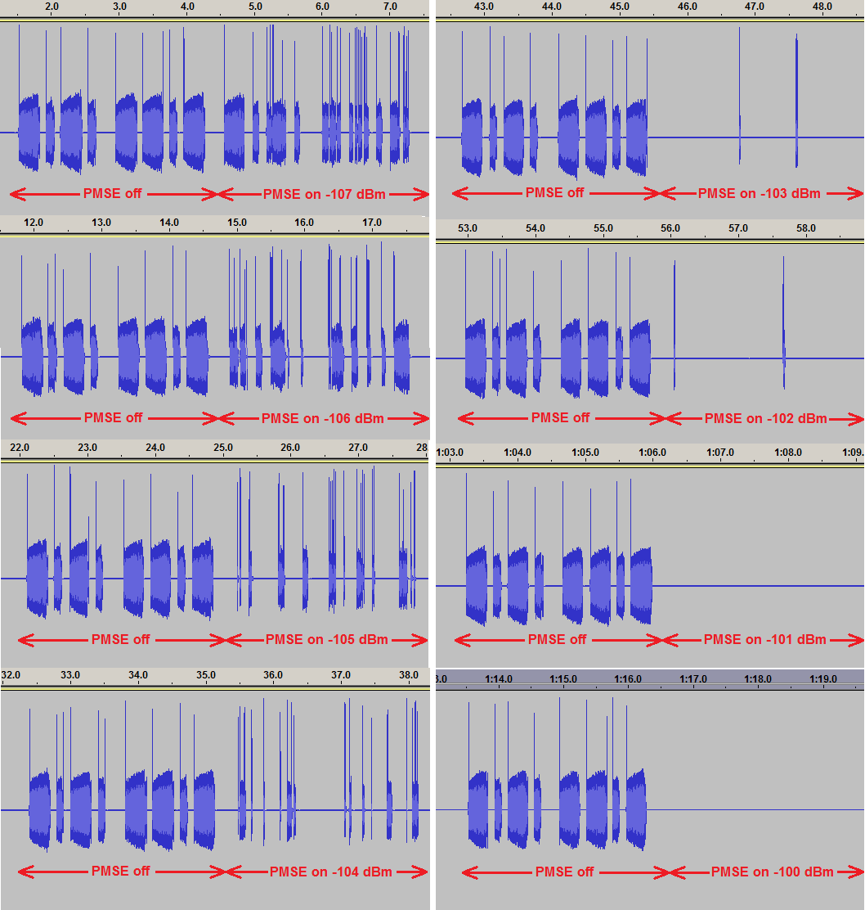 | Fig. 3: KTU-709 PMSE on DME interference requiring a S/I of 20 dB
    - Conclusion
The measured, non-distorted sensitivity for identification varies by 7 dB. More sensitive receiver than those tested exist, their behaviour during interference may be different.
Due to the depth of the pulse amplitude modulation of TACAN signal during Morse Code identification, when there are co-channel PMSE signals, the S/I required by on-board interrogators is 20 dB for clear and unambiguous Identification from a TACAN source.
The receiver selectivity with offset to the DME/TACAN channel centre frequency for both receiver is asymmetrical, and therefore more detailed measurements may be required.

- Guidance by ICAO relating to the protection of aeronautical systems
  - Summary
This Annex provides suggested guidelines, as developed by the International Civil Aviation Organization, for parameters to be used for the technical studies relevant to the safe operation of the aeronautical systems in the band 960-1164 MHz, referencing relevant ITU-R Recommendations; relevant ICAO Standards and Recommended Practices and guidance material; and other relevant industry standards.
  - Parameters to be used in Sharing studies
Section A11.3 below discusses the appropriate I/N criteria to be used in a sharing studies based on the I/N methodology; section A11.4 discusses the application of aeronautical safety margins; and the remaining sections indicate the appropriate DME receiver parameters to be used in MCL studies based on the C/I methodology.
  - Traditional Protection of the Radio Broadcast Services
Recommendations ITU-R BT.1895 and ITU-R BS.1895, “Protection criteria for terrestrial broadcasting systems”, for Television and Sound respectively, recommend:
“1 that the values in recommends 2 and 3 be used as guidelines, above which compatibility studies on the effect of radiations and emissions from other applications and services into the broadcasting service should be undertaken;
2 that the total interference at the receiver from all radiations and emissions without a corresponding frequency allocation in the Radio Regulations should not exceed 1 % of the total receiving system noise power;
3 that the total interference at the receiver arising from all sources of radio-frequency emissions from radiocommunication services with a corresponding co-primary frequency allocation should not exceed 10% of the total receiving system noise power.”
The second recommends, which is equal to an I/N of -20 dB applies to interference sources such as PMSE when operating in the television broadcast bands, while the third recommends, which is equal to an I/N of -10 dB applies to interference between two equal co-primary services.
The 960-1164 MHz band is allocated to ARNS and AM(R)S and is heavily used by systems providing safety critical aeronautical radionavigation and radiocommunication. Any operation of PMSE in the band would be in accordance with Article 4.4 of the Radio Regulations. In order to achieve sufficient protection of the incumbent aeronautical safety services, any sharing conditions provided to those incumbent services need to be, as a minimum, similar to those required by the Radio Broadcast services in the bands those services operate in. Hence, an I/N of no more than -20 dB is recommended.
  - Consideration of aeronautical safety margins in sharing studies
The frequency band 960-1215 MHz is used by systems operating in the aeronautical radionavigation service (ARNS), the aeronautical mobile (R) service (AM(R)S) and the aeronautical mobile satellite (R) service (AMS(R)S), providing critical navigation, surveillance and collision avoidance functions on a global basis. Those systems operate in accordance with ICAO standards and recommended practices (SARPs). Article 4.10 of the Radio Regulations applies to the protection of aeronautical safety of life services.
Aeronautical radionavigation systems are characterized in ICAO SARPs and associated provisions as requiring exceptionally high Integrity and Continuity, typically measured as probabilities of 1 - 1*10-9 and 1 - 2*10-6 respectively.
While Recommendation ITU-R M.1903 provides characteristics and protection criteria for receiving earth stations in the radionavigation-satellite service (s-E) and receivers in the aeronautical service operating in the band 1559-1610 MHz, its Annex 1 contains a generic and informative description of the term aeronautical safety margin and its purpose.

Following are a few quotes from Annex 1 of Recommendation ITU-R M.1903:
“1 Introduction
There is a long history within ITU and ICAO of reserving a portion of the interference link budget for a margin in order to ensure that the safety aspects of the radionavigation service are protected. These margin values typically lie in the range of 6 to 10 dB, or more. Furthermore, there is ample precedent for a safety margin for radionavigation safety applications in ITU-R
…
2 Purpose of a safety margin
A safety margin (which may also be called a public safety factor), is critical for safety-of-life applications in order to account for risk of loss of life due to radio-frequency interference that is real but not quantifiable. To support safety-of-life applications, all interference sources must be accounted for.
3 Aeronautical radionavigation applications of safety margin
3.1 Aeronautical radionavigation safety margin background
The utilization of safety margins in navigation systems is well established. ICAO specifies a safety margin for the microwave landing system (MLS) of 6 dB (Annex 10 to ICAO Convention: International Standards and Recommended practices Aeronautical Telecommunications, Vol. 1 – Radio Navigation Aids (Attachment G, Table G-2)). The instrument landing system (ILS) applies a safety margin of 8 dB (see Recommendation ITU-R SM.1009-1, Appendix 3 to Annex 2). In each case the margin is defined with respect to the navigation system carrier power.
That is, to test system performance for these systems, the desired signal power is reduced from the nominal level by the safety margin, and then tested to determine whether the system provides the required performance in the presence of interference. In other words, the manufacturer must design the equipment to handle the highest anticipated interference level while receiving a desired signal level lower (by the safety margin) than would be otherwise received.
…”

ICAO Doc 9718, “Handbook on Radio Frequency Spectrum Requirements for Civil Aviation”, Volume I, has the following description of an aviation safety margin:
“9.2.23 Aeronautical safety applications are required to have continued operation through worst case interference, so all factors which contribute to harmful interference should be considered in analyses involving those applications. An aviation safety margin is included in order to address the risk that some such factors cannot be foreseen (for example impacts of differing modulation schemes). This margin is applied to the system protection criteria to increase the operational assurances to the required level. Traditionally for aviation systems/scenarios an aviation safety margin of 6–10 dB is applied. Until established on the basis of further study on a case-by-case basis, an aviation safety margin of not less than 6 dB should be applied.”
Consideration of an aviation safety margin is included in a number of ITU-R Recommendations, including Recommendation ITU-R M.1639 “Protection criteria for the aeronautical radionavigation service with respect to aggregate emissions from space stations in the radionavigation-satellite service in the band 1164-1215 MHz”, which applies a 6 dB aviation safety margin.

  - DME Receiver Sensitivity and susceptibility to interference from Continuous Wave sources
DME is an interrogator (airborne) / transponder (ground based) system which provides an aircraft with its slant range (distance) from the ground transponder. Transmitting a pair of 3.5 µs wide pulses on a frequency (up to a maximum of 40 times per second) the aircraft interrogates the ground transponder and the transponder replies on a separate frequency separated by 63 MHz. The turnaround time of this transaction is used for distance measurement.
Interrogations by the various aircraft are not synchronized in time, hence DME can be described as a self-interfering system. A ground transponder can serve multiple aircraft interrogators at a time, a DME transponder may handle traffic from more than 100 aircraft at the same time. During maximum loading conditions and with the minimum power flux densities prescribed in ICAO SARPs, the reply rate of the transponder shall never be less than 70 % of the interrogation rate from the aircraft.
    - Minimum received signal level by the ground based DME/N transponder
ICAO Annex 10 Volume I, para 3.5.4.2.3.1 defines the minimum sensitivity of the ground based DME transponder receiver as -103 dBW/m2 when the DME/N transponder is intended for a coverage range greater than 56 km (30 NM). This describes a typical Enroute DME/DME navigation scenario, such as when used for Performance Based Navigation (PBN) RNAV 1 routes.
Since the issue is to compare the reception of both desired and undesired signals, a 0 dB gain antenna is assumed, with no dips or nulls. In the maximum lobe of a higher gain antenna, both the desired and undesired signals will be amplified equally. However in the worst case, as aircraft will be seen at an angle often substantially greater than 0 degrees, the antenna pattern of a higher gain antenna may often be more favourable towards the unwanted ground based signal which comes in at a lower angle.
While this does not accurately depict a worst-case scenario, the below conversion assumes 0 dB antenna gain and no cable loss.
-103 dBW/m2 equates to -96 dBm
    - Minimum received signal level by the airborne DME/N interrogator
ICAO Annex 10 Volume I, para 3.5.4.1.5.2 specifies a means to determine the minimum specified transmitter power for a DME/N ground transponder used in association with an ILS or a VOR. In this case the minimum peak isotropically radiated power output of the DME transmitter needs to be sufficient to ensure a minimum received field strength of -89 dBW/m2 within the intended coverage area of the DME/VOR or DME/ILS pair.
The below conversion assumes 0 dB antenna gain and no cable loss.
-89 dBW/m2 equates to -82 dBm
In this context, note should also be taken of the DME/N monitoring function, for which ICAO Annex 10 Volume I, para 3.5.4.7.2.4 recommends that an alert should be asserted in the case of a fall of 3 dB or more in the transponder transmitted output power.
Hence, in order to ensure safe operation, a minimum level for the airborne interrogator receiver should be assumed to be -85 dBm. When applying SARPs, though not mandatory, the general rule is to apply Recommendations. However, since this is in the form of a Recommendation, these additional 3 dBs are not applied below.
In the above context, it needs also to be noted that DME/DME navigation (DME not used in association with ILS or VOR) as used for RNAV 1 may use DMEs at ranges outside of their designated DME/ILS or DME/VOR coverage areas. In this case the received signal levels will be even less.
The ICAO SARPs describe signal levels in an actual operational scenario, including interference from other DME as well as other pulse modulated aeronautical and governmental systems operating in the 960-1164 MHz band.
  - Protection against Continuous Wave (CW) signals
    - Definition of maximum CW signals
EUROCAE ED-54 “Minimum Operational Performance Requirements for Distance Measuring Equipment Interrogator (DME/N and DME/P) operating within the Radio Frequency Range 960 to 1215 MHz” provides parameters and test conditions to verify proper function of the airborne interrogator in a test bench scenario.
ED-54 states that the sensitivity requirement shall be met when a CW signal having a level of -99 dBm is applied on the assigned channel frequency. Assuming a zero gain antenna, this equates to -106 dBW/m2.
EUROCAE ED-57 “Minimum Performance Specification for Distance Measuring Equipment (DME/N and DME/P) (Ground Equipment)” provides parameters and test conditions to verify proper function of the ground based transponder.
ED-57 states that whenever an interrogation signal is within the dynamic range of the receiver, and is 10dB or more above the level of an interfering CW signal, the reply efficiency shall remain greater than 70%. Note that this applies to a test bench scenario with no other interfering signals present.
This equates to -106 dBm, or -113 dBW/m2 when assuming a zero gain antenna.
    - Apportionment of interference levels
Recommendation ITU-R M.1639-1 “Protection criterion for the aeronautical radionavigation service with respect to aggregate emissions from space stations in the radionavigation-satellite service in the band 1164-1215 MHz” describes a scenario where DME share frequencies with a “weak” CW like signal from the RNSS. From a signal-in-space sharing point of view, this scenario is in fact similar to the one of DME sharing with PMSE.
As a point of verification, with the exception of the ground transponder receiver sensitivity level, Table 1 of Recommendation ITU-R M.1639-1 provides similar values to those displayed above. Since DME ground transponders do not receive in the band 1164-1215 MHz, only values for the aircraft interrogator receiver are provided in the material contained in that Recommendation.
Recognizing that DME is a pulse modulated (self-interfering) system, the Recommendation states the following:
“2.3 Apportionment of the DME maximum allowable aggregate interference level to RNSS
The chosen factor of 6 dB for the apportionment of the maximum allowable aggregate interference level, from all other interference sources to the RNSS maximum allowable aggregate interference level, recognizes that there exists the possibility of interference from other DME in the same frequency band, from the spurious and out-of-band emissions of other airborne ARNS and aeronautical mobile-satellite service (AMSS) systems and also from the bands adjacent to the ARNS. The on-board ARNS systems include multiple secondary surveillance radar transponders, multiple airborne collision avoidance systems and other DME interrogators; on-board satellite terminals in the AMSS also operate. Adjacent band sources of interference are high-powered radiolocation service radar operating just above 1 215 MHz and broadcast service transmitters operating below 960 MHz.”
25 % apportionment or 6 dB is the factor Recommendation ITU-R M1639-1 recommends in order to accommodate RNSS interference to DME in the 1164-1215 MHz, this band is not as heavily used for DME as the band 960-1164 MHz. Taking into account the much heavier loading of the band 960-1164 MHz, 10 % or 10 dB is proposed as a more realistic apportionment factor for any CW type of interference in that band.

  - required C/I based MCL study levels to protect DME against CW interference
    - Summary Tables
      - DME Interrogator (airborne) receiver
 | Parameter | Unit | Value | Reference
1 | Required minimum PFD of received signal | dBW/m2 | -89 | ICAO Annex 10 Volume I, para 3.5.4.1.5.2
2 | Equivalent receiver input level | dBm | -82 | See discussion above
3 | CW interference threshold at antenna | dBm | -99 | EUROCAE ED-54, para 3.16.4
4 | Equivalent PFD of interference threshold | dBW/m2 | -106 | See discussion above
5 | Aeronautical Safety Margin | dB | 6 | Recommendation ITU-R M.1639-1  Recommendation ITU-R M.1903, Annex 1  ICAO Doc 9718
6 | Apportionment of CW interference from PMSE to all the interference sources | dB | 10 | Apportion 10 % of total permissible interference to PMSE
7 | Maximum aggregate PFD of PMSE signal at receiver antenna | dBW/m2 | -122 | Combine 4, 5 and 6  (4 minus 5 minus 6)

      - DME Transponder (ground) receiver
 | Parameter | Unit | Value | Reference
1 | Required minimum PFD of received signal | dBW/m2 | -103 | ICAO Annex 10 Volume I, para 3.5.4.2.3.1.
2 | Equivalent receiver input level | dBm | -96 | See discussion above
3 | CW interference threshold at antenna | dBm | -106 | See discussion above and  EUROCAE ED-57, para 3.3.8
4 | Equivalent PFD of interference threshold | dBW/m2 | -113 | See discussion above
5 | Aeronautical Safety Margin | dB | 6 | Recommendation ITU-R M.1639-1  Recommendation ITU-R M.1903, Annex 1  ICAO Doc 9718
6 | Apportionment of CW interference from PMSE to all the interference sources | dB | 10 | Apportion 10 % of total permissible interference to PMSE
7 | Maximum aggregate PFD of PMSE signal at receiver antenna | dBW/m2 | -129 | Combine 4, 5 and 6  (4 minus 5 minus 6)

- List of Reference
- 960 MHz to 1215 MHz Extraneous Signal Environment Hand Book (ESE-HB), Compendium of systems and equipment and their technical and operational parameter for sharing studies and Radio Frequency Interference (RFI) compatibility work, Joachim Wollweber, DFS, Germany
- DOD. MIL-STD291, (SHIPS), Military Standard TACAN Signal 1957325, Reprint in [ARINC-521B] & [ARINC-521C] Attachment 13
- DOD Mil-Std-291a Test signals for electronic 1958305
- DOD Mil-Std-291b STANDARD TACTICAL, Tactical Air Navigation signals (TACAN) 1967c13
- DOD Mil-Std-291c STANDARD TACTICAL AIR NAVIGATION (TACAN) SIGNAL, 1998210
- [STANAG 4175]
- STANAG-4193, IFF
- STANAG-4193, Ed.2, IFF
- STANAG 4193 C3 {EDITION 3) - TECHNICAL CHARACTERISTICS OF THE IFF Mk XIIA
- STANAG-4565 Ed.1, Airborne Multi-Mode Receiver for Precision Approach and Landing, 2003926
- STANAG-5034, TACAN
- STANAG-5034 Ed.2, TACAN
- STANAG-5034 Ed.3, TACAN
- STANAG-5516, JTIDS/MIDS
- ESD-TR-91-224, JTIDS/MIDS EMC in the band 960 – 1215 MHz, R. S. Lokuta, Jan. 1992
- ICAO, International Standards and Recommended Practices, Aeronautical Telecommunications, Annex10 to the convention on international civil aviation, Volume I (Radio Navigation Aids),
- ICAO, International Standards and Recommended Practices, Aeronautical Telecommunications, Annex10 to the convention on international civil aviation, Volume I (Radio Navigation Aids), ed.2 April1968
- ICAO, International Standards and Recommended Practices, Aeronautical Telecommunications, Annex10 to the convention on international civil aviation, Volume I (Radio Navigation Aids), ed.3 1972
- ICAO, International Standards and Recommended Practices, Aeronautical Telecommunications, Annex10 to the convention on international civil aviation, Volume I (Radio Navigation Aids), ed.4 1985April
- ICAO, International Standards and Recommended Practices, Aeronautical Telecommunications, Annex10 to the convention on international civil aviation, Volume I (Radio Navigation Aids), ed.5 1986 July
- ICAO, International Standards and Recommended Practices, Aeronautical Telecommunications, Annex10 to the convention on international civil aviation, Volume I (Radio Navigation Aids), ed.6 2006
- ICAO, International Standards and Recommended Practices, Aeronautical Telecommunications, Annex10 to the convention on international civil aviation, Volume IV, Surveillance Radar and Collision Avoidance Systems, 1st ed. 1995Mar;
- ICAO, International Standards and Recommended Practices, Aeronautical Telecommunications, Annex10 to the convention on international civil aviation, Volume IV, Surveillance Radar and Collision Avoidance Systems,2nd ed. 1998 Jul;
- ICAO, International Standards and Recommended Practices, Aeronautical Telecommunications, Annex10 to the convention on international civil aviation, Volume IV, Surveillance Radar and Collision Avoidance Systems,3rd ed. 2002Jul,
- ICAO, International Standards and Recommended Practices, Aeronautical Telecommunications, Annex10 to the convention on international civil aviation, Volume IV, Surveillance Radar and Collision Avoidance Systems,4th ed
- ICAO, International Standards and Recommended Practices, Aeronautical Telecommunications, Annex10 to the convention on international civil aviation, Volume IV, Surveillance Radar and Collision Avoidance Systems,5th ed
- ICAO, Doc-4444, PANS-ATM, Procedures for Air Navigation Services – Rules of the Air and Air Traffic Services,
- ICAO, Doc-9863, Airborne Collision Avoidance System II (ACAS II) Manual,
- ICAO, Doc-8071, Flight Inspection manual
- ICAO, Doc-8071, Flight Inspection manual
- ICAO, Doc-8071, Flight Inspection manual
- ICAO, Doc-8071, Flight Inspection manual
- ICAO, Doc-8168, PANS-OPS, Procedures for Air Navigation Services – Aircraft
- ICAO, Doc-9863, Airborne Collision Avoidance System (ACAS) Manual, 1.ed, 2006
- ICAO, Doc-9684, Manual on the Secondary Surveillance Radar (SSR) Systems, 1. ed., 1997
- ICAO, Doc-9688, Manual on Mode S Specific Services, 1ed. 1997
- ICAO, Doc-9871, Technical Provisions for Mode S Services and Extended Squitter, 1.ed 2008
- ICAO, Doc 9849, ICAO GNSS Manual
- ICAO, Doc-9924, Aeronautical Surveillance Manual, 1ed, ICAO
- ICAO, EUR-Doc-011, Frequency management Manual, updated yearly or when needed
- ED-31, Minimum Performance Specification for Ground Distance-Measuring Equipment (DME), EUROCAE, 1980. Jul
- ED-43, MOPR for SSR Transponder and Alticoder, EUROCAE, 1983.Oct.
- ED-54, Minimum Operational Performance Specification Distance Measuring Equipment Interrogator (DME/N and DME/P) Operating within the Radio Frequency 960 to 1215 MHz (Airborne Equipment), EUROCAE, 1987 Jan.
- ED-54, Minimum Operational Performance Specification Distance Measuring Equipment Interrogator (DME/N and DME/P) Operating within the Radio Frequency 960 to 1215 MHz (Airborne Equipment), EUROCAE, 1987Jan.
- ED-57, Minimum Performance Specification for Ground Distance-Measuring Equipment (DME), EUROCAE
- ED-73-B, Minimum Performance Specification for Secondary Surveillance Radar Mode S Transponders, EUROCAE, May 1, 2011;
- ED-73-C, Minimum Performance Specification for Secondary Surveillance Radar Mode S Transponders, EUROCAE,
- ED-73-D, Minimum Performance Specification for Secondary Surveillance Radar Mode S Transponders, EUROCAE,
- ED-73E, Minimum Performance Specification for Secondary Surveillance Radar Mode S Transponders, EUROCAE, May 2011
- ED-102 MOPS for 1090 MHz Extended Squitter Automatic Dependent Surveillance – Broadcast (ADS-B) & Traffic Information Services – Broadcast (TIS-B), EUROCAE
- ED-102A Corrigendum 1 MOPS for 1090 MHz Extended Squitter Automatic Dependent Surveillance - Broadcast (ADS-B) & Traffic Information Services – Broadcast (TIS-B), 2012.Jan.
- ED-102A - MOPS for 1090 MHz Extended Squitter Automatic Dependent Surveillance – Broadcast (ADS-B) & Traffic Information Services – Broadcast (TIS-B), EUROCAE, 2009.Dec.
- ED-117, MOPS for Mode S Multilateration Systems for Use in A-SMGCS, EUROCAE, 2003.Nov.
- ED-129, Technical Specification for a 1090 MHz Extended Squitter ADS-B Ground System, EUROCAE, 2010.Jun.6
- ED-143 CHANGE 2 – MOPS for Traffic Alert and Collision Avoidance System II (Tcas II) version 7.1, EUROCAE,
- ED-143 – Vol I: MOPS for Traffic Alert and Collision Avoidance System II TCAS II)-Vol II: TCAS II, EUROCAE,
- ED-221A – Minimum Operational Performance Standards (MOPS) for Traffic Alert and Collision Avoidance System II, EUROCAE
- ARINC Characteristic NO. 521B, Airborne Distance Measuring Equipment TACAN (DMET), 1957 Mar. 25
- ARINC Characteristic NO. 521B, Airborne Distance Measuring Equipment (DME), 1962 Jun. 28
- ARINC- Characteristic 532, Air Traffic Control Transponder, 1955 ; 532B 1957; 532-C 1965-1-01
- ARINC- Characteristic 532-D incl. suppl. 1 -5, Air Traffic Control Transponder, 1965101
- ARINC Characteristic-709-1 Mark 5 Airborne Distance Measuring Equipment, 1979-Mar-23
- ARINC Characteristic 709A, Precision Airborne Distance Measuring Equipment (DME/P), 1987Oct01 & Revision; 1994Aug17
- ARINC Characteristic 718B, Mark 2 Air Traffic Control Transponder (ATCRBS/ Mode S), ARINC Characteristic 718-4, Mark 3 Air traffic Control Transponder (ATCRBS/Mode S), ARINC Characteristic 718-4, 1989c15
- ARINC Characteristic 735, Traffic Alert and Collision Avoidance System (TCAS), 1989309, ARINC Characteristic 735A, Traffic Alert and Collision Avoidance System (TCAS II)
- RTCA, DO-144, Minimum Operational Characteristics For Airborne ATC Transponder Systems, RTCA, 1970.March.12
- RTCA, DO-150, Minimum Performance Standards – Airborne ATC Transponder Equipment, RTCA, 1972.March.17
- RTCA, DO-151, Minimum Performance Standards Airborne Distance Measuring Equipment (DME) Operating Within the Radio-Frequency Range of 960-1215 Megahertz, RTCA, 1972818, DO-151A 1978b, DO-181B 199729
- RTCA, DO-185B, Minimum Operational Performance Standards for Traffic Alert Collision Avoidance System (TCAS II) Airborne Equipme
- RTCA, RTCA DO-189, Minimum Operational Performance Standards (MOPS) for Airborne Interrogator Distance Measuring Equipment (DME) Operation within the Radio Frequency of 960-1215 Megahertz, 1985 Sep.
- DO-197A, Minimum Operational Performance Standards for an Active Alert and Collision Avoidance System (Active TCAS I)
- RTCA/DO-300, Minimum Operational Performance Standards for Traffic Alert and Collision Avoidance System (TCAS II) For TCAS II Hybrid Surveillance.
- RTCA, DO-300A, Minimum Operational Performance Standards (MOPS) for Traffic Alert and Collision Avoidance System II (TCASII) Hybrid Surveillance, RTCA
- EN 300 422-1 V2.1.2, ETSI, RED publication on 10.2.2017
- EN 300 422-2 V2.1.1, ETSI, RED publication on 10.3.2017
- EN 300 422-3 V2.1.1, ETSI, RED publication on 10.3.2017
- EN 300 422-4 (not applicable – refers to hearing aids)
- ETSI TR 103 450 V1.1.1, System Reference document (SRdoc); Technical characteristics and parameters for Wireless Multichannel Audio Systems (WMAS) 2017. Jul.
- IF-77 Electromagnetic Wave Propagation Model (Gierhart-Johnson), Institute for Telecommunication Sciences, https://www.its.bldrdoc.gov/resources/radio-propagation-software/if77/if-77-electromagnetic-wave-propagation-model-gierhart-johnson.aspx
- Aerospace Propagation Prediction Capabilities Associated with the IF-77 Model, M. E. Johnson; G. D. Gierhart, Conference Proceedings: Operational Modelling of the Aerospace Propagation Environment, North Atlantic Treaty Organization (NATO), Advisory Group for Aerospace Research and Development (AGARD), Neuilly-sur-Seine (France), November 1978, Vol. 2, No. 238
- RD-73-103, Computer Programs for Air/Ground Propagation and Interference Analysis (0.1 to 20GHz), Johnson, M. E. and Gierhart, G. D., 1983, FAA, U.S. Department of Commerce, lnstitute for Telecommunication Sciences. Boulder, Colorado
- RD-77-60, Application Guide: Propagation and Interference Analysis Computer Programs (0.1 to 20 GHz), Johnson, M. E. and Gierhart, G. D., 1978b, FAA, U.S. Department of Commerce, lnstitute for Telecommunication Sciences. Boulder, Colorado
- RD-79-9, Comparison of measured data with IF-77 propagation Model predictions, M.E. Johnson and G.D. Gierhart, 1979.Aug., FAA, U.S. Department of Commerce, lnstitute for Telecommunication Sciences. Boulder, Colorado
- RD-80-1, An Atlas of Basic Transmission Loss for 0.125 to 15.5 GHz, Johnson, M. E.• and Gierhart, G. D., 1983, FAA, U.S. Department of Commerce, lnstitute for Telecommunication Sciences. Boulder, Colorado
- ES-83-3, The IF-77 Electromagnetic Wave Propagation Model, Johnson, M. E. and Gierhart, G. D., 1979.Sep., FAA, U.S. Department of Commerce, lnstitute for Telecommunication Sciences. Boulder, Colorado
- ITU-R P.528-2, ITU-R P.528-3, Propagation curves for aeronautical mobile and radionavigation services using the VHF, UHF and SHF bands, 2.ed. 1986.Jul, 3.ed. . 2012.2,
- Distance Measuring Equipment and its Evolving role in aviation, Kelly Robert J., Cusick Danny R., Adavances in Electronics and Electron Physics, Vol.68: page 1-243, 1986
- ITU-R P.1411-5 Propagation data and prediction methods for the planning of short-range outdoor radiocommunication systems and radio local area networks in the frequency range 300 MHz to 100 GHz
- ITU-R F.1336-2 Reference radiation patterns of omnidirectional, sectoral and other antennas in point-to-multipoint systems for use in sharing studies in the frequency range from 1 GHz to about 70 GHz
- ITU-R Report BT.2338, Services ancillary to broadcasting/services ancillary to programme making spectrum use in Region 1 and the implication of a co-primary allocation for the mobile service in the frequency band 694-790 MHz, November 2014
- Sekundär Radar, Peter Honold, Siemens-Aktiengesellschaft
- Secondary radar: Fundamentals and instrumentation, Peter Honold, 1971, Update 1976, ISBN-13: 978-3800912261
- Secondary Surveillance Radar, Michael Stevens, 1988
- RD-75-93, DABS Modulation and Coding Design – A Summary, T. J. Goblick, 1976. Mar., Lincoln Laboratory
- RD-77-143, Proposed Technical Characteristics for the Discrete Address Beacon System (DABS), J. D. Welch, P. H. Robeck, 1977. Sep., Lincoln Laboratory
- PM-86/19, ATC-42 Rev D, Mode S Beacon System: Functional Description, V. A. Orlando, P. R. Drouilhet, 1986.Aug., Lincoln Laboratory
- RD-65-123, Modification of general aviation transponder to incorporate a crystal video receiver, American Electronic Laboratories, 1965.Dec
- RD-72-30, ATC-9, Transponder-Test-Program, Colby_1972
- RD-73-160, ATC-25, DABS/ATCRBS Transponder Bench Testing Program, J.R. Samson, J.D. Welch, E.R. Becotte, E.A. Crocker, H.D. Schofield, 1973.Nov., Lincoln Laboratory p25 Table 3.1. ATCRBS Receiver Passband Data. (3 dB Bandwidth Based on Measured Peak Sensitivity)
- Selection Order: U.S. National Aviation Standard for the IFF Mark X (SIF/Air Traffic Control Radar Beacon System Characteristics, “#1010. 51A, Dept. of Trans. FM, (8 March 1
- RD-74-144, ATC-37, An Analysis of Aircraft L-Band Beacon Antenna Patterns, G.J. Schlieckert, 1975. Jan., Lincoln Laboratory
- RD-75-23, ATC-47, Scale Model Pattern Measurements, of Aircraft L-Band Beacon Antennas, K. J. Keeping, J. C. Sureau, 1975.Apr.
- RD-75-75, ATC-44, Model Aircraft L-Band Beacon Antenna Pattern Gain Maps, D. W. Mayweather, 1975. Apr., Lincoln Laboratory
- RD-76-2, ATC-62, Beacon CAS (BCAS) An Integrated Air/Ground Collision Avoidance System, V. A. Orlando, J. D. Welch, 1976.Mar., Lincoln Laboratory
- Introduction to TCAS II, Version 7.1, 2011. Feb., U.S. Department of Transportation Federal Aviation Administration
- PM-85-10, Traffic Alert and Collision Avoidance System - Final Report, G. P. Soucek, Jr. T. A. Pfaff R. W. White W. D. Smith, 1985.Mar., U.S. Department of Transportation Federal Aviation Administration[1],Technical Note 1435, COMPATIBILITY STUDY: POTENTIAL INTERFERENCE BETWEEN TWO CANDIDATE AMIS SYSTEMS AND DME/TACAN, L. Bastos, NATO C3, 2010 Aug., NATO Unclassified, Releasable to EAPC
- L-DACS1 System Definition Proposal: Deliverable D2. Eurocontrol, 2009213
- ITU-R M.2235, Aeronautical mobile (route) service sharing studies in the frequency band 960-1 164 MHz, 2011b
- ECC/CPG11/PTC(2009)31 Bucharest, WRC-11 Agenda Item 1.4 - Technical characteristics of the ARNS systems operating in the frequency band 960-1164 MHz, 17 – 20 March 2009
- ECC Report 204, Spectrum use and future requirements for PMSE, Approved February 2014
- ECC Report 253, Compatibility studies for audio PMSE at 1492-1518 MHz and 1518-1525 MHz, Approved 30 September 2016
- ETSI TR 102 546: Technical characteristics for Professional Wireless Microphone Systems (PWMS), 2007.
- ICAO, EANPG, FMG-11, WP-02 Documentation of RSBN4 system parameter, Joachim Wollweber, 11 Sep 2007.
- EANPG, FMG Study Group 16 (Paris, June 2-5, 2009), DME Compendium Distance-Measuring-Equipment, -Antennas and -Systems in the Band 960 to 1215 MHz, Joachim Wollweber
- RECOMMENDATION ITU-R P.1406, Propagation Effects Relating To Terrestrial Land Mobile Service In The VHF And UHF Bands, 1999
- John Wiley, Military Avionics Systems, 2006, ISBN: 0-470-01632-9
- Doc 9861, Manual on the Universal Access Transceiver (UAT), 1.ed
- DO-358, Minimum Operational Performance Standards (MOPS) for Flight Information Services Broadcast (FIS-B)
- ITU-R Report M.2205, Results of studies of the AM(R)S allocation in the band 960-1 164 MHz and of the AMS(R)S allocation in the band 5 030-5 091 MHz to support control and non-payload communications links for unmanned aircraft systems.
- ITU-R Report M.2013, Wind Profilers Radars
- ECC Report 204, Spectrum use and future requirements for PMSE
- ITU-R Report BT.2338, Services ancillary to broadcasting/services ancillary to programme making spectrum use in Region 1 and the implication of a co-primary allocation for the mobile service in the frequency band 694-790 MHz
- ECC Report 121, Compatibility studies between Professional Wireless Microphone Systems (PWMS) and other services/systems in the bands 1452-1492 MHz, 1492-1530 MHz, 1533-1559 MHz also considering the services/systems in the adjacent bands (below 1452 MHz and above 1559 MHz).
- Recommendation ITU-R P.2109, Prediction of building entry loss
- ECC Report 252, SEAMCAT Handbook
- ITU-R Report M.2205, Results of studies of the AM(R)S allocation in the band 960-1 164 MHz and of the AMS(R)S allocation in the band 5 030-5 091 MHz to support control and non-payload communications links for unmanned aircraft systems
- Recommendation ITU R M.1642, Methodology for assessing the maximum aggregate equivalent power flux-density at an aeronautical radionavigation service station from all radionavigation-satellite service systems operating in the 1 164-1 215 MHz band

https://www.ofcom.org.uk/__data/assets/pdf_file/0021/62481/New-Spectrum-for-Audio-PMSE-statement.pdf
https://www.ofcom.org.uk/__data/assets/pdf_file/0023/76352/new-spectrum-audio-pmse-consultation.pdf
https://leagueofextraordinarytechnicians.wikispaces.com/DIstance+Measuring+Equipment++-+Operation
Please see Annex A for further information.
Final Acts of the Regional Radiocommunication Conference for planning of the digital terrestrial broadcasting service in parts of Regions 1 and 3, in the frequency bands 174-230 MHz and 470-862 MHz
Test Report for the Coexistence of PMSE with Aeronautical Services in the Band 960-1164 MHz, JCSys/C053/004/3, https://www.ofcom.org.uk/__data/assets/pdf_file/0024/57840/annex6.pdf
From ITU-R P.528-3 the difference in path loss between the 1200 MHz/50% and 1200 MHz/1% time curves is between 2.4 dB and 23.1 dB depending on separation distance (92% of distances between 0 km and 1,800 km have a difference of path loss >6 dB).
https://www.ofcom.org.uk/__data/assets/pdf_file/0024/57840/annex6.pdf
http://dgca.gov.in/intradgca/intra/icaodocs/Doc%209684%20-%20Manual%20on%20the%20Secondary%20Surveillance%20Radar%20(SSR)%20Systems%20Ed%203%20Amd%201%20(En).pdf
https://www.eurocontrol.int/sites/default/files/article/content/documents/communications/25082009-lcis-s1tos5-compatibility-scenarios-v10.pdf
https://www.eurocontrol.int/sites/default/files/article//content/documents/communications/24082009-lcis-c3-criteria-and-tests-v10.pdf
https://gdmissionsystems.com/-/media/General-Dynamics/Satcom/PDF/Antennas/Legacy-Products/655-0031A_1325-32SSR.ashx?la=en&hash=9F9BC69A86183C2FBC4118BB504D0314C2082FC6
https://www.eurocontrol.int/sites/default/files/article//content/documents/communications/24082009-lcis-c3-criteria-and-tests-v10.pdf
http://dspace.upce.cz/bitstream/handle/10195/54565/Radar%20AntennaA.pdf?sequence=1
https://gdmissionsystems.com/-/media/General-Dynamics/Satcom/PDF/Antennas/Legacy-Products/655-0028A_214SM.ashx?la=en&hash=6E64C5F413DC388C20AB8FFA33374C12EBCB6479
https://www.eurocontrol.int/sites/default/files/article//content/documents/communications/24082009-lcis-c3-criteria-and-tests-v10.pdf
http://dgca.gov.in/intradgca/intra/icaodocs/Doc%209684%20-%20Manual%20on%20the%20Secondary%20Surveillance%20Radar%20(SSR)%20Systems%20Ed%203%20Amd%201%20(En).pdf
Test Report for the Coexistence of PMSE with Aeronautical Services in the Band 960-1164 MHz, JCSys/C053/004/3, https://www.ofcom.org.uk/__data/assets/pdf_file/0024/57840/annex6.pdf
Assuming that the power is over 4.5 MHz bandwidth.
Assuming the same reduction as the transponder.
BNetzA is preparing a contribution to ITU-R SG3 and STG is already aware of this issue.
This separation frequency should be respect considering a minimum separation distance between aeronautical systems and PMSE.
Even assuming an indoor use with the maximum wall attenuation of 20 dB, the separation distance would remain more than more than 80 km for 200 W and 150 km for 1 kW).
"Standard" in the meaning of "used as reference within this study"
Theoretical distance only, some buildings comply to assumed BEL, others not. 'LoS' between interferer and building rather than the victim.
Note that during the tests it happened that an audio error occurred only after a measurement duration more than 3 hours, meaning that to ascertain an absolute error-free PMSE link, 10 minutes measurement duration is not sufficient.
Note: The signal-to-interference level can be read from the curves in Figure 15 by subtracting the interference level at a certain frequency offset from the signal level of the wanted signal as stated in the plot legend.
JTIDS/MIDS frequency remapping is simplified a manually defined set of JTIDS/MIDS channels, that have to be ommitted by a certain JTIDS/MIDS net.
Where the notation T(X) implies the threshold of metric X

