Draft ETSI TR 102 791 V1.2.2 (2013-01)
Electromagnetic compatibility
and Radio spectrum Matters (ERM);
System Reference Document;
Short Range Devices (SRD);
Technical characteristics of wireless aids for
hearing impaired people operating in the VHF and
UHF frequency range

Technical Report
Reference
DTR/ERM-TG17WG3-262
Keywords
audio, hearing aid, SRD
ETSI
650 Route des Lucioles
F-06921 Sophia Antipolis Cedex - FRANCE

Tel.: +33 4 92 94 42 00 Fax: +33 4 93 65 47 16

Siret N° 348 623 562 00017 - NAF 742 C
Association à but non lucratif enregistrée à la
Sous-Préfecture de Grasse (06) N° 7803/88

Important notice
Individual copies of the present document can be downloaded from:
http://www.etsi.org
The present document may be made available in more than one electronic version or in print. In any case of existing or perceived difference in contents between such versions, the reference version is the Portable Document Format (PDF). In case of dispute, the reference shall be the printing on ETSI printers of the PDF version kept on a specific network drive within ETSI Secretariat.
Users of the present document should be aware that the document may be subject to revision or change of status. Information on the current status of this and other ETSI documents is available at http://portal.etsi.org/tb/status/status.asp
If you find errors in the present document, please send your comment to one of the following services:
http://portal.etsi.org/chaircor/ETSI_support.asp
Copyright Notification
No part may be reproduced except as authorized by written permission.
The copyright and the foregoing restriction extend to reproduction in all media.

© European Telecommunications Standards Institute 2012.
All rights reserved.
DECTTM, PLUGTESTSTM, UMTSTM and the ETSI logo are Trade Marks of ETSI registered for the benefit of its Members.
3GPPTM and LTE™ are Trade Marks of ETSI registered for the benefit of its Members and
of the 3GPP Organizational Partners.
GSM® and the GSM logo are Trade Marks registered and owned by the GSM Association.
Contents
Intellectual Property Rights 5
Foreword 5
Executive summary 5
Introduction 5
1 Scope 6
2 References 6
2.1 Normative references 6
2.2 Informative references 6
3 Definitions, symbols and abbreviations 8
3.1 Definitions 8
3.2 Symbols 9
3.3 Abbreviations 9
4 Comments and status of the System Reference Document 9
4.1 Comments on the System Reference Document 9
5 Background to Current Systems 9
6 Market information 10
7 Technical information 12
7.1 Detailed technical description 12
7.1.1 Requirements 12
7.2 Technical parameters and implications on spectrum 13
7.2.1 Current ITU and European Common Allocations 13
7.2.2 Sharing and compatibility studies (if any) already available 13
7.2.3 Sharing and compatibility issues still to be considered 13
7.2.4 Transmitter parameters for Telecoil Replacement Service operating at VHF and UHF frequencies 13
7.2.5 Unwanted emissions 13
7.3 Information on relevant standard(s) 13
8 Radio spectrum requirement and justification 14
8.1 Justification 14
8.2 Requirement 15
9 Regulations 15
9.1 Current regulations 15
9.1.1 Current regulations in Europe for aids for hearing impaired 15
9.2 Proposed regulation and justification 17
9.2.1 Proposed Regulation 17
9.2.2 Justification 17
Annex A: Detailed presentation of the system 18
A.1 Hearing loss 18
A.2 Types of hearing aids 19
A.2.1 Air conductive hearing aids 19
A.2.2 Implanted hearing aids 19
A.2.3 Advanced Digital Signal Processing Hearing Aids 20
A.2.4 Digital wireless accessories for additional applications 21
A.2.5 Assistive Listening Devices 22
A.2.5.1 Induction Loop (IL) Systems 22
A.2.5.2 Infrared (IR) Systems 23
A.2.5.3 Frequency Modulated (FM) Radio Systems 23
Annex B: Expected market size and value 28
B.1 Air conductive hearing aids 29
B.1.1 Behind-the-ear 29
B.1.2 In the ear, in the canal and completely in the canal 29
B.2 Assistive listening systems (often described as FM systems) 29
B.3 Traffic and equipment density forecast 30
Annex C: Bibliography 31
History 32

Intellectual Property Rights
IPRs essential or potentially essential to the present document may have been declared to ETSI. The information pertaining to these essential IPRs, if any, is publicly available for ETSI members and non-members, and can be found in ETSI SR 000 314: "Intellectual Property Rights (IPRs); Essential, or potentially Essential, IPRs notified to ETSI in respect of ETSI standards", which is available from the ETSI Secretariat. Latest updates are available on the ETSI Web server (http://ipr.etsi.org).
Pursuant to the ETSI IPR Policy, no investigation, including IPR searches, has been carried out by ETSI. No guarantee can be given as to the existence of other IPRs not referenced in ETSI SR 000 314 (or the updates on the ETSI Web server) which are, or may be, or may become, essential to the present document.

Foreword
This Technical Report (TR) has been produced by ETSI Technical Committee Electromagnetic compatibility and Radio spectrum Matters (ERM).

Executive summary
Developments in hearing health care have seen the dawn of the need to interconnect hearing aid devices wirelessly. This is referred to as a body network configuration, namely from the left ear to the right ear and vice versa, but also from hearing aids to nearby peripherals (such as mobile phones), control devices (such as remote controls for the hearing aid), relay stations and remote microphones. Some existing techniques for connecting to nearby peripherals such as inductive "Telecoil" systems do not meet today's information rich world and the present document seeks to provide this social service in an enhanced format.
The proponents of the present document believe that use of these radio systems may require minor amendments to the present regulatory framework for some target bands.
CEPT/ERC Recommendation 70-03 [i.1], annex 10 identifies frequencies for Radio microphones and Assistive Listening Systems including aids for hearing impaired. In parallel, ETSI has also published the Harmonized European Standard EN 300 422-2 [i.3].
The present document aims to describe the existing and near future technology employed in aids for hearing impaired people and requests access to additional spectrum in the VHF or UHF frequency range for operation of this equipment.
The purpose of producing the present document is to inform CEPT of the current state-of-the-art of the aids for hearing impaired and provide the ability of industry to quickly bring innovative and useful products that cater to hearing health to the market while avoiding any harmful interference with other services and equipment operating in the same band. A continuing license exempt regulation status for these types of applications is requested.

Introduction
The present document has been developed to support the co-operation between ETSI and the Electronic Communications Committee (ECC) of the European Conference of Post and Telecommunications Administrations (CEPT).
Status of the System Reference Document
The present document has been developed by ETSI TC ERM TG17 WP 3. It has undergone coordination by ERM and two resolution meetings, following these the references to the 400 MHz band has been removed. The current version requests spectrum for a Telecoil Replacement Service (TRS).
EHIMA supports the objectives of the present document.
Version 1.2 inculdes the results of a study to provide a more spectrum efficient digital system capable of frequency hopping, remote control from a database and a lower duty cycle then the current FM systems

1 Scope
The present document describes the current state of the art of ALDs for hearing impaired people using the VHF and UHF frequency range and requests spectrum for a Telecoil replacement Service.
It includes in particular:
market information;
technical information;
regulatory issues.

2 References
References are either specific (identified by date of publication and/or edition number or version number) or non-specific. For specific references, only the cited version applies. For non-specific references, the latest version of the reference document (including any amendments) applies.
Referenced documents which are not found to be publicly available in the expected location might be found at http://docbox.etsi.org/Reference.
NOTE: While any hyperlinks included in this clause were valid at the time of publication, ETSI cannot guarantee their long term validity.

2.1 Normative references
The following referenced documents are necessary for the application of the present document.
Not applicable.

2.2 Informative references
The following referenced documents are not necessary for the application of the present document but they assist the user with regard to a particular subject area.
[i.1] CEPT/ERC Recommendation 70-03: "Relating to the use of Short Range Devices (SRD)".
[i.2] CEPT/ERC Report 14: "Develop a strategy to improve the effectiveness and flexibility of spectrum availability for Short Range Devices (SRDs)".
[i.3] ETSI EN 300 422-2: "Electromagnetic compatibility and Radio spectrum Matters (ERM); Wireless microphones in the 25 MHz to 3 GHz frequency range; Part 2: Harmonized EN covering the essential requirements of article 3.2 of the R&TTE Directive".
[i.4] Council Directive 93/42/EEC of 14 June 1993 concerning medical devices.
[i.5] Commission Decision 2005/928/EC of 20 December 2005 on the harmonisation of the 169,4-169,8125 MHz frequency band in the Community (OJ L 344, 27.12.2005, p. 47-51).
[i.6] ECC/DEC/(05)02: "ECC Decision of 18 March 2005 on the use of the Frequency Band 169.4-169.8125 MHz".
[i.7] Launer, S. 2003 Wireless Solutions - The State of the Art and Future of FM Technology for the Hearing Impaired Consumer, In Proceedings from the 1st International FM Conference: "Achieving Clear Communication Employing Sound Solutions - 2003": 31-38.
[i.8] Ricketts, T. A., and Dittberner, A. 2002. Directional Amplification for Improved Signal to Noise Ratio: Strategies, Measurements and Limitations. Hearing Aids: Standards, Options and Limitations. M. Valente. Stuttgart, Thieme. Second edition.
[i.9] Crandell, C. 1991. Individual differences in speech recognitions ability: Implications for hearing aid selection. Ear and Hear 5: 100-107.
[i.10] Helfer, K., and Huntley, R. 1991. Aging and consonant errors in reverberation and noise. Journal of the Acoustical Society of America 90(4): 1786-1796.
[i.11] Needleman, A., and Crandell, C. 1995. Speech recognition in noise by hearing-impaired and noise-masked normal-hearing listeners. Journal of the American Academy of Audiology 6: 414-424.
[i.12] Killion, M. 1997. SNR loss: "I can hear what people say but I can"t understand them." The Hearing Review 4(12): 8-14.
[i.13] Moore, B. 1997. An introduction to the psychology of hearing (4th Edition). San Diego: Academic Press.
[i.14] Dubno, J., Dirks, D., and Morgan, D. 1984. Effects of age and mild hearing loss on speech recognition in noise. Journal of the Acoustical Society of America 76(1): 87-96.
[i.15] Hawkins, D., and Yacullo, W. 1984. Signal-to-noise advantage of binaural hearing aids and directional microphones under different levels of reverberation. Journal of Speech and Hearing Disorders 49: 278-285.
[i.16] Duquesnoy, A., and Plomp, R. 1983. The effect of a hearing aid on the speech-reception threshold of hearing impaired listeners in quiet and in noise. Journal of the Acoustical Society of America 73(6): 2166-2173.
[i.17] Plomp, R. 1986. A signal-to-noise ratio model for the speech-reception threshold for the hearing impaired. Journal of Speech and Hearing Research 29: 146-154.
[i.18] Kochkin, S. 1994. MarkTrak III: Why 20 million in US don't use hearing aids for their hearing loss. The Hearing Journal 46(1): 20-27, 46(2): 26-31, 46(4): 36-37.
[i.19] Valente, M., Crandell, C. C., Lewis, M.S., and Enrietto J. 2003 Improving Speech Recognition in Noise: Directional Microphone and FM Systems, In Proceedings from the 1st International FM Conference: "Achieving Clear Communication Employing Sound Solutions - 2003": 39-52.
[i.20] Ross, M. 1994 FM Large-Area listening Systems. In Communication Access for Persons with Hearing Loss, Ross, M. (Ed), 51-70. Timonium, MD: York Press, Inc.
[i.21] Crandell, C., and Smaldino, J. 2000. Room acoustics for listeners with normal hearing and hearing impaired. In M.Valente., H. Hosford-Dunn and R. Roeser. (eds.), Audiology: treatment strategies (pp. 601-638), New York: Thieme Medical Publishers.
[i.22] Crandell, C., and Smaldino, J. 2001. Improving classroom acoustics: Utilizing hearing-assistive technology and communication strategies in the educational setting. Volta Review 101(5): 47-62.
[i.23] Bakke, M. H., Levitt, H., Ross, M., & Erickson, F. 1999. Large area assistive listening systems (ALS): Review and recommendations: Final report to United States Architectural and Transportation Barriers Compliance Board (U.S. Access Board), Lexington School for the Deaf/Center for the Deaf, Rehabilitation Engineering Research Center on Hearing Enhancement, New York. Retrieved January 24, 2006.
[i.24] Ledermann, N., and Hendricks, P. 2003. "Induction Loop Assistive Listening Systems: A Venerable Technology meets the New Millenium" Seminars in Hearing 24(1): 81-92.
[i.25] Yanz, J. L., and Preves, D. 2003. "Telecoils: Principles, Pitfalls, Fixes, and the Future." Seminars in Hearing 24(1): 43-62.
[i.26] Ross, M. 2003 FM Systems: A Little History and Some Personal Reflections. In Proceedings from the 1st International FM Conference: "Achieving Clear Communication Employing Sound Solutions - 2003": 17-28.
[i.27] Helfer, K., and Wilber, L. 1990. Hearing loss, aging, and speech recognition in reverberation and noise. Journal of Speech and Hearing Research 33: 149-155.
[i.28] Nikoloski N., 2008 FM Technology - Regulatory Challenges and Global Harmonization Efforts, In Proceedings from the 2nd International FM Conference: "Achieving Clear Communication Employing Sound Solutions - 2008", in press.
[i.29] Shield, B., 2006 Evaluation of the social and economic costs of hearing impairment. Report for Hear-it.
NOTE: Available at www.hear-it.org.
[i.30] Kochkin, S. 2005 MarkeTrak VII Survey, Hearing Review.
NOTE: Available at www.hear-it.org.
[i.31] ECC Report 55: "Compatibility between existing and proposed SRDs and other Radiocommunication applications in the 169.4-169.8 MHz frequency band".
[i.32] Boymans, M.; Theo Goverts, S; Kramer, Sophia E.; Festen, Joost M.; Dreschler, Wouter A., "A Prospective Multi-Centre Study of the Benefits of Bilateral Hearing Aids", Ear and Hearing., vol. 29(6), pp. 930-941, Dec. 2008.
NOTE: Available at http://www.hear-it.org.
[i.33] Recommendation T/R 20-08: "Frequency planning and frequency for the GSM system".

3 Definitions, symbols and abbreviations

3.1 Definitions
For the purposes of the present document, the following terms and definitions apply:
aids for hearing impaired: all types of hearing aids and their accessories as well as all types of assistive listening systems for hearing impaired people
Assistive Listening System (ALS): systems utilizing electromagnetic, radio or light waves, or a combination of these, to transmit the acoustic signal from the sound source (a loudspeaker or a person talking) directly to the hearing impaired person
emission bandwidth: width of the signal spectrum between the points on either side of carrier centre frequency that is 20 dB down relative to the maximum level of the modulated carrier
NOTE: Compliance is determined using instrumentation employing a peak detector function and a resolution bandwidth approximately equal to 1 % of the emission bandwidth of the device under test.
hearing aids: medical devices in the context of Directive 93/42/EEC (MDD) [i.4] comprising electro acoustic amplifiers including a microphone and a loudspeaker and having a frequency response and dynamic characteristics specific to each person's individual hearing loss
personal hearing aid system: radio communication system comprising one narrow band transmitter, which can be handheld, on a table or around the neck of a hearing impaired person and one or more receivers, where each receiver can have wired or inductive connection to a hearing aid
public hearing aid system: broadcast radio communication system comprising one transmitter (up to 500 mW), which is installed at a fixed location in a large auditorium, e.g. in a church or theatre and one or more receivers, where each receiver can have wired or inductive connection to a hearing aid
Telecoil: Audio Induction Loop systems, also called audio-frequency induction loops (AFILs) or hearing loops are an aid for the hard of hearing
NOTE: They are a loop of cable around a designated area, usually a room or a building, which generates a magnetic field picked up by a hearing aid. The benefit is that it allows the sound source of interest - whether a musical performance or a ticket taker's side of the conversation - to be transmitted to the hearing-impaired listener clearly and free of other distracting noise in the environment. Typical installation sites would include concert halls, ticket kiosks, high-traffic public buildings (for PA announcements), auditoriums, places of worship, and homes. In the United Kingdom, as an aid for disability, their provision where reasonably possible is required by the Disability Discrimination Act 1995, and they are available in "the back seats of all London taxis, which have a little microphone embedded in the dashboard in front of the driver; at 18,000 post offices in the U.K.; at most churches and cathedrals".

3.2 Symbols
For the purposes of the present document, the following symbols apply:
f Frequency
P Power
R Distance
t Time

3.3 Abbreviations
For the purposes of the present document, the following abbreviations apply:
ALD Assistive Listening Devices
dB decibel
dBi decibel relative to an isotropic radiator
ECA European Common Allocation
EMC Electro Magnetic Compatibility
e.r.p. effective radiated power
eirp effective isotropic radiated power
HIBAN Hearing Instruments Body Area Networks
IL Induction Loop
IR Infrared
R&TTE Radio and Telecommunications Terminal Equipment
SNHL SensoriNeural Hearing Loss
SRD Short Range Device
TRS Telecoil Replacement Service

4 Comments and status of the System Reference Document

4.1 Comments on the System Reference Document

5 Background to Current Systems
Historically, hearing aids consisted of little more than basic "miniature audio amplifiers" placed in or behind their ear(s) solely boosting the incoming sounds. As semiconductor technology has evolved and become miniaturised, hearing impaired people enjoy extremely sophisticated digital systems incorporating a range of communication capabilities.
State-of-the-art technology uses specialized Digital Signal Processing (DSP) technology that is advanced enough to fulfil the stringent mechanical (ultra miniature) and power consumption (only one small single cell battery) requirements that are specified for modern hearing aid devices. DSPs manipulate the incoming sound spectrum mathematically, converting it into a digital representation; programmable software then manipulates this digital representation to achieve:
background noise reduction;
correction of patient specific deficiencies;
enhancement of sound cues and other listening parameters used by the brain to reconstruct normal hearing.
Hearing aids contribute to patient safety, comfort and enjoyable listening experience. However, real life offers an incredible richness in different listening environments in some of which even the most sophisticated hearing instruments show only a limited benefit. Examples of acoustic environments or listening situations where the performance of conventional hearing instruments can substantially be improved by applying additional communication devices are the following:
reverberant environments such as big churches or lecture halls;
communication over larger distances, e.g. in a lecture or in a classroom;
communication on the telephone, especially cell phones.
In these environments the application of assistive listening systems (ALS) based on wireless communication technologies offer substantial additional benefits and significantly improve speech intelligibility [i.7]. The advent of digital broadcasting is now displacing some of the frequencies where these wireless ALS's have traditionally operated.
In North America and Europe, approximately 1 person in 10 has some form of hearing loss, from mild to severe. Today only 20 % of these people are assisted by hearing aid technology. The binaural rate (wearing two hearing aids: one left and one right) is ~75 % to 80 % in North America, ~60 % in Europe and 10 % to 12 % in the rest of the world. Reasons for such low adoption rates in general vary from negative stigma associated with wearing cosmetically non-appealing devices to high cost and certain types of hearing losses that could not be corrected.
Recent progress made in binaural hearing health revealed that having for example the right hearing aid being able to communicate with the left hearing aid and vice versa helps achieve another level of breakthrough in restoring someone's hearing. This also directly contributes to the safety of that person's listening environment, for example directionality of sounds can be better perceived, in cases such as an approaching ambulance or fire truck which cannot be seen but only heard, is physically located. In some instances where one ear is totally impaired, sounds captured from that side of the head can be relayed to the other ear and processed such as that person experiences full 360° hearing again.
A major role of allowing the hearing impaired to communicate and also enjoy similar experiences to those with normal hearing has been played by the Telecoil system (clause A 2.5.1) which is in worldwide use. Unfortunately these are difficult or impossible to install in large public places such as airports and train stations and are both expensive to install and maintain. Also building owners are often reluctant to allow them to be installed. In addition they only supply a single low quality voice channel. To implement a Telecoil replacement service effectively wireless technology and its associated spectrum are required, which will greatly benefit the hearing impaired.
For further detailed information, see annex A.

6 Market information
Hearing loss in general
In Europe, about 71 million adults aged 18 years to 80 years have a hearing loss greater than 25 dB, which is the definition of hearing impairment recognized by the World Health Organization (WHO). In the EU alone, the number of people with hearing loss is more than 55 million. The data on hearing loss in Europe is reported in the scientific survey, "Evaluation of the Social and Economic Costs of Hearing Impairment" [i.29]. According to the report, just one in six of those who could benefit from using hearing aids are being treated with hearing aids.
Numerous scientific surveys show that the satisfaction among hearing aid users is high, and several studies have concluded that the use of hearing aids causes significant improvement in the quality of life. Furthermore, two recent studies (one conducted by researchers at the Academic Medical Centre of the University of Amsterdam and a second one conducted by Karolinska Instituttet in Stockholm) have reported that hearing aid users prefer using two hearing aids than using a single device. The Dutch study has found that having tried both for limited time periods, 93 % preferred using two hearing aids rather than one because of improved speech recognition and sound discrimination. The findings were supported by the Swedish study, indicating an 18 percent improvement in speech recognition with two hearing aids, as compared to 13 % improvement with a single hearing aid [i.32].
Hearing loss in different countries
The report findings make it possible to calculate the numbers of people with hearing impairment in any given region or area in Europe and other industrialized nations.
Some examples:
Germany: 10,2 million.
France: 7,6 million.
United Kingdom: 7,5 million.
Italy: 7,2 million.
Spain: 5,5 million.
Poland: 4,7 million.
The Netherlands: 2 million.
The data and calculations presented in [i.29] show that the cost to Europe of hearing impairment of all grades is 284 billion Euros for the year 2004, and 224 billion Euros for the European Union. These costs has been arrived at by taking a 'quality of life' approach, which will account for overall effects, including the psychosocial impacts of hearing loss.
Hearing loss is the third most widespread chronic affliction in the United States, surpassed only by arthritis and hypertension. The frequency is assumed to be similar in Canada. According to [i.30]:
More than 31 million Americans were hearing impaired, corresponding to more than 10,5 % of the population in the United States.
More than 24 million of them did not have a hearing aid.
Only about 23,5 % of hearing impaired Americans actually use hearing aids.
Since 2000, when the last survey was conducted, the number of hearing impaired people in the US has increased from 28,6 million to almost 31,5 million. According to the same study, projections on the North American population with hearing loss through 2050 indicate that the hearing loss population will increase to almost 53 million and that the number will surpass 40 million by 2025.
Among children, hearing loss is common in both the US and Canada, according to several studies. In Canada, six babies in 1,000 are born with some degree of hearing loss making the total number of hearing impaired newborn Canadians approximately 1,000 per year. Approximately one American school aged child in ten suffers from some form of hearing loss.
In 1995 the UN World Health Organization, WHO, estimated that more than 25 million people in Southeast Asia suffer from "disabling" hearing loss. In Thailand, data indicates that approximately 13,5 % of the population suffers from hearing loss.
In China, six in every 1,000 infants screened are hearing impaired.
In rural Pakistan, one child in 12 is suffering from hearing loss.
In Thailand, on average 13,6 % suffer from different degrees of hearing loss.
In many less developed areas of countries such as Malaysia, India, Pakistan and Saudi Arabia, the knowledge and awareness of hearing loss is low [i.30].
Further detailed market information can be found in annex B.

7 Technical information

7.1 Detailed technical description
Devices operating at VHF and UHF frequencies at present.
At present, a typical system of ALSs comprises.
A multi-frequency FM transmitter (body worn or handheld) with direct channel synchronization, entirely new multi-talker network possibility for team teaching environments or a Bluetooth connection to a mobile phone.
A miniaturized multi-frequency receiver with flexible channel management. The receiver can be directly connected to the hearing aid or worn around the neck.
In the school environment a third component can be added to an FM System - an automatic channel synchronizer mounted on the wall of a room for all students entering that room.
In cases of big events attended by many hearing impaired people, i.e. typically for large auditoriums, theatres, churches or other public places, public hearing aids systems can be employed. The transmitter and receiver parameters for public hearing aids systems are defined in ECC Report 55 [i.31], ECC Decision ECC/DEC/(05)02 [i.6] and EC Decision 2005/928/EC [i.5]).
During the last several years, digitally operating hearing aid devices as well as digital ALSs operating at UHF frequencies have been placed on the European market. Due to the lack of worldwide harmonized spectrum for these devices, hearing instruments' manufacturers have been forced to find appropriate solutions in the available 900 MHz and 2,4 GHz ISM bands.
NOTE: In Europe the 900 MHz ISM band is not available. Instead the band 863 MHz to 865 MHz is used for wireless audio applications.
The hearing aid devices, which are operating in these bands are body worn medical devices (in and around the ear) in the context of Directive 93/42/EEC (MDD) [i.4]. They can be described as body worn therapeutic medical devices used to provide improved medical treatment of a patient. The ALSs and the accessories for hearing aids can be also classified as medical devices or non-medical devices depending on their connection to the hearing instruments and their intended use in the sense of Directive 93/42/EEC (MDD) [i.4].

7.1.1 Requirements
Hearing aids can be described as body worn therapeutic medical devices used to provide improved medical treatment of a patient. Therefore, they are subject to the very same constraints as all other body worn medical devices:
They perform therapeutic tasks aimed a treating, curing, hence bettering patient's lives.
They are installed / worn in and around the body.
They are subject to sever power consumption constraints, due to their discreet mechanical size, that commands very small source of energy (single cell battery).
They need a worldwide deployable band to accommodate for travelling patients.
They need the radio spectrum to be optimized in terms of energy spent for range and link robustness achieved, hence a low noise floor and minimal interference band, where body tissue absorption and spectrum usage density are taken into account.
They should not be subject to undue interference as this is both frightening and in some cases dangerous to the user.
After detailed consideration of spectrum up to 2 GHz and taking in the points outlined above (especially the world wide requirement) the existing ISM and SRD band have been excluded, the only spectrum which is worldwide and likely to be reasonably interference free are: 156,4875 to 156,5625 and 156,7625 to 156,8375 (T/R 20-08 [i.33], annex 1) Maritime , these could be used in conjunction with the existing 169 MHz band in Europe and Japan and the 216 MHz band in USA or 960 MHz to 1 164 MHz Band Aeronautical.
During the ETSI consultation stage information on the new proposed SRD bands 870 MHz to 876 MHz and 915 MHz to 921 MHz has become available and it is requested that these are included in studies for European use.

7.2 Technical parameters and implications on spectrum

7.2.1 Current ITU and European Common Allocations
Operation of these devices is assumed according to a provision of the Radio Regulations (RR4.4) that does not require any new allocation (i.e. on a non-protected basis and causing no harmful interference).

7.2.2 Sharing and compatibility studies (if any) already available
None have presently been carried out.

7.2.3 Sharing and compatibility issues still to be considered
In order to minimize interference to existing services the digital system has power levels of 10 mW, low duty cycle and frequency hopping along with an ability to be controlled by a remote database for frequency selection. However, a detailed interference analysis with DME/TACAN equipment in the frequency range 960 MHz to 1164 MHz needs to be performed due to the following reasons: (1) As stated in the ICAO EUR DOC 011, DME EIRP power for En-route service is typically 37dBW PEP, whereas TACAN EIRP is typically set to 40dBW PEP. In aircraft, on-board equipment EIRP ranges up to 30dBW PEP; (2) The coordination requirements (ICAO EUR DOC 011, clause 5.2.1.5) between DME/TACAN intra-service are based on the assumption of an out-of-band emission of 200mW PEP in the first channel and 2mW PEP in the second channel of the DME interferer. As long as a coordination for DME ground equipment of 2mW EIRP interferer channel power is required, an interference of 10mW EIRP cannot be accepted in mobile equipment. Therefore, the proponents of this document believe that forwarding the present document to CEPT will allow any interference and compatibility issues to be fully examined.

7.2.4 Transmitter parameters for Telecoil Replacement Service operating at VHF and UHF frequencies

Further to the publication of ETSI TR 102-791 which focused on analogue technology, the European Hearing Instrument Manufacturer’s Association (EHIMA) commissioned TTP to investigate the technology options for a radio based digital telecoil replacement system. Following the conclusion of the initial phase in June 2012 this outline technical information has been produced which builds on the work within the TR. The study focused on the body worn receiver as this is the critical component but the devices investigated are transceivers* therefore the spectrum masks (Annex C) would be the same for the main transmitter (<10mW) and occasional use of a return link from the body worn device (< 10mW). There are a number of devices available which would be similar in performance. A critical issue in the study was the end to end audio delay which where any “face to face” use requires a maximum of <10ms delay, this in turn limits the type of audio codec to be used.
A major problem with these systems is the small physical size and low battery consumption (single button cell) required for the receivers (and return link), For most applications a minimum eight hour battery life is required whilst initially a necklace style unit would be used, conversion to incorporating the electronics into an ear worn and then to “in ear canal” device would be the second stage.
In addition the fixed “base” transmitters can have the transmit spectrum remotely controlled from a database

:

- Up to 600kHz channel bandwidth (20dB -bandwidth) (narrower bandwidth possible by using low data rate)
- 500kbit/s modulated data rate, using, e.g., 4GFSK modulation
- 10mW transmitter ERP for typical cases
- 25% transmitter duty cycle or frequency hopping, no LBT
- Systen can use fixed frequencies or frequency hopping

7.2.5 Unwanted emissions
Unwanted emissions are the same as currently specified for these bands.

7.3 Information on relevant standard(s)
After discussions within CEPT, a new work item will be raised to revise EN 300 422 [i.3] to include the Telecoil Replacement Systems, indicate acceptable parameters, as well as the necessary measurement methods and power limits.

8 Radio spectrum requirement and justification

8.1 Justification
After detailed consideration of spectrum up to 2,6 GHz and taking in the points outlined in clause 7 (especially the world wide requirement), the existing ISM and SRD band have been excluded. Investigation of extending the existing Telecoil system using advanced modulation techniques have failed to provide a satisfactory or practical answer, the only spectrum which is worldwide and likely to be compatible with TRS is:
156,4875 to 156,5625 and 156,7625 to 156,8375 (T/R 20-08 [i.33], annex 1) Maritime , these could be used in conjunction with the existing 169 MHz band in Europe and Japan and the 216 MHz band in USA; or
960 MHz to 1 164 MHz Band Aeronautical.
During the ETSI consultation stage information on the new proposed SRD bands 870 MHz to 876 MHz and 915 MHz to 921 MHz has become available and it is requested that these are included in studies for European use.
Bluetooth technology had been extensively investigated for constant audio streaming between the left to right ear, and vice versa; unfortunately due to the physical size and power consumption this is not a practical option in the present stage of technology and has therefore been excluded for TRS.
Infrared systems have also been investigated but are unable to provide coverage in large areas.
Hearing aids contribute to patient safety, comfort and enjoyable listening experience. However, real life offers an incredible richness in different listening environments in some of which even the most sophisticated hearing instruments show only a limited benefit. Examples of acoustic environments or listening situations where the performance of conventional hearing instruments can substantially be improved by applying TRS devices are the following:
Reverberant environments such as big churches or lecture halls.
Communication over larger distances e.g. In a lecture or in a classroom.
Communication on the telephone, especially cell phones.
Announcement systems in public places such as Airports and train stations.
Theatre and Concert hall.
At home with TV, audio systems and door bells.
In these environments the application of assistive listening systems (ALS) with TRS based on wireless communication technologies offer substantial additional benefits and significantly improves speech intelligibility.
To implement these functions effectively wireless technology and its associated spectrum are required, which will greatly benefit the hearing impaired. However, compared to wireless hearing aids using inductively coupled transmission, hearing aids using transmission systems in the VHF and UHF frequency bands have an advantage in terms of range - allowing them to receive from a source in the same large area or room directly to the hearing aids.
Devices operating in ISM bands in the UHF frequency range additionally profit from globally available unlicensed spectrum. Therefore, Bluetooth low energy specification or Zigbee, both with their sheer sophisticated protocols have been considered but found inappropriate, due to the relatively high power consumption leading to unacceptable battery consumption, life and size. Additionally it was investigated whether any of the designated spectrum under annex 10 of the CEPT/ERC Recommendation 70-03 [i.1] could allow deployment of wirelessly enabled hearing instruments on a worldwide basis . Infrared systems have also been investigated but are unable to provide coverage in large arrears.

8.2 Requirement
Up to 6 or more channels operating up to 10 mW in the frequency range:
156,4875 to 156,5625 and 156,7625 to 156,8375 (T/R 20-08 [i.33], annex 1) Maritime , these could be used in conjunction with the existing 169 MHz band in Europe and Japan and the 216 MHz band in USA; or
960 MHz to 1 164 MHz Band Aeronautical.
During the ETSI consultation stage information on the new proposed SRD bands 870 MHz to 876 MHz and 915 MHz to 921 MHz has become available and it is requested that these are included in studies for European use.
In relation to the 870 MHz to 876 MHz and 915 MHz to 921 MHz bands these channels have two services to consider:
- Indoor: short range, which can share with devices such as RFID which are unlikely to be in the same physical space at the same time.
- Outdoor or Station, and Airport systems: long range 25 meters plus, dedicated channels would be required or sharing with devices not likely to share the same physical space.

9 Regulations

9.1 Current regulations

9.1.1 Current regulations in Europe for aids for hearing impaired
The existing technologies employed in aids for hearing impaired are operating in various bands as defined in annexes 1, 9 and 10 of the CEPT/ERC Recommendation 70-03 [i.1] as well as in ECC/DEC(05)02 [i.6] and EC Decision 2005/928/EC [i.5] depending on the specific application. Detailed information about the use of these bands is described in annex A.
Table 1: Current Annex 10 of CEPT/ERC Recommendation 70-03 [i.1]
Annex 10 - Radio microphones and Assistive Listening Devices
 | Frequency Band | Power | Spectrum access and  mitigation requirement | Channel spacing | ECC/ERC Decision | Notes
c | 863 MHz to 865 MHz | 10 mW e.r.p. | No requirement | No spacing
h1 | 169,4000 MHz to 169,4750 MHz | 10 mW e.r.p. | No requirement | Max 50 kHz | ECC/DEC/(05)02 [i.6] | Aids for the hearing impaired (Personal Hearing Aid System)
 |  | 500 mW e.r.p. | No requirement | Max 50 kHz | ECC/DEC/(05)02 [i.6] | Aids for the hearing impaired (Public Hearing Aid System) Individual Licence may be required.
h2 | 169,4875 MHz to 169,5875 MHz | 10 mW e.r.p. | No requirement | Max 50 kHz | ECC/DEC/(05)02 [i.6] | Aids for the hearing impaired (Personal Hearing Aid System)
 |  | 500 mW e.r.p. | No requirement | Max 50 kHz | ECC/DEC/(05)02 [i.6] | Aids for the hearing impaired (Public Hearing Aid System) Individual Licence may be required.
b | 173,965 MHz to 174,015 MHz | 2 mW e.r.p. | No requirement | 50 kHz |  | Aids for the hearing impaired
i | 169,4 MHz to 174,0 MHz | 10 mW e.r.p. | No requirement | Max 50 kHz |  | Aids for the hearing impaired  On a tuning range basis  Administrations should consider channel plan for band 169,4 MHz to 169,8125 MHz detailed in ECC/DEC/(05)02 [i.6] and the risk of interference towards systems operated in the band 169,6 to 169,8125 band when developing their national frequency table

9.2 Proposed regulation and justification

9.2.1 Proposed Regulation
That up to 6 or more channels are made available within the identified spectrum on a licence exempt basis.

9.2.2 Justification
CEPT Report 14 [i.2], which was developed in response to the second EC Mandate given to CEPT to develop a strategy to improve the effectiveness and flexibility of spectrum availability for Short Range Devices (SRDs) pursuant to article 4 of the Radio Spectrum Decision, had to focus on the development of a forward-looking strategy for SRDs. In recommendation v it is stated:
"That additional spectrum should only be made available to SRDs on the basis of a clear and demonstrable need. Any analysis of the case for new spectrum should include a valid reason why existing SRD spectrum is unsuitable and must fully take into account the impact on radio services."
According to the "Plan for the implementation of SRD strategy given in the CEPT Report 014" particularly in the analysis of Recommendation v of CEPT Report 014, it is further stated:
"CEPT Report 14 recommends that additional spectrum should only be made available to SRDs on the basis of a clear and demonstrable need.
CEPT Report 14 furthermore concludes, based on the market predictions detailed in the report, that there is a probable need for additional spectrum for SRDs in the future, especially in the UHF band (see Conclusion xiii of CEPT Report 14)".
Given the above statements and the social benefits to be obtained from the new allocation we believe that we have demonstrated that existing spectrum in Rec 70-03 is not available worldwide (other than 2.4 GHz) and therefore does not meet the requirements for TRS.

Annex A:
Detailed presentation of the system

A.1 Hearing loss
Hearing loss, depending on its type and severity can be treated in three distinct areas of the human auditory system, namely in the:
outer ear;
middle ear; and
inner ear (see figure A.1).
Auditory system in short:  Hearing functions on capturing acoustic pressure waves representative of sound, that are then translated by the auditory system for the brain to interpret as such.  The outer ear funnels the waves via the ear canal (1) to the eardrum (2) that captures its vibrations.  The middle ear relays these vibrations mechanically through three small ossicles (bones) (3, 4, 5) onto the cochlea.  The inner ear at last translates these vibrations into tiny electric impulses (inside the cochlea, 10), that are still representative of the sound captured initially. These impulses are then relayed to the brain for sound interpretation, via the cochlear nerve (11). | 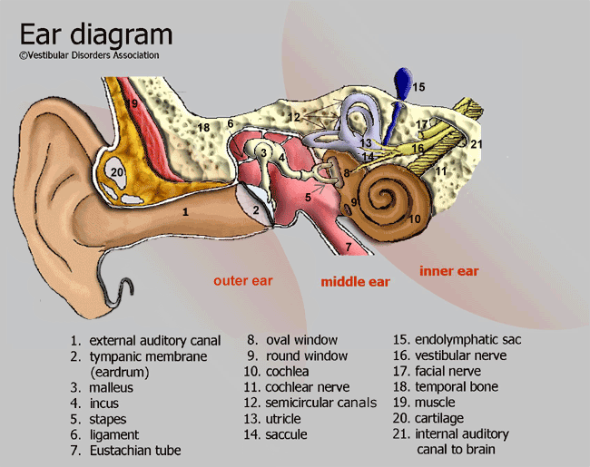
Figure A.1

A.2 Types of hearing aids

A.2.1 Air conductive hearing aids
The vast majority of hearing aids are "air conductive"  Air conductive hearing aids are not fully implanted in the body; rather a portion thereof is inserted in the ear canal. Air conductive hearing aids reproduce the acoustic pressure waves that are representative of the incoming sounds. These are amplified and corrected to each patient’s unique hearing loss.  Air conductive hearing aids exist in different form factors. While all are very small, they range from worn around the ear, in the ear and completely inserted in the ear canal (see figure A.2).  Behind the ear hearing aids typically allow for additional sound processing features and at times more precise corrections as more than one microphone can be placed on the outer device. | 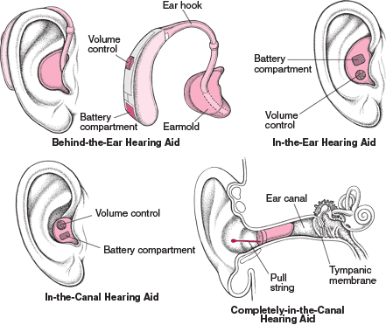
Figure A.2

A.2.2 Implanted hearing aids
But there are also implanted hearing aids:  Hearing health care does not just rely on air conducting hearing aids; there are implants as well. The cochlear implant is by far the most significant, whereby an electrode is inserted into the cochlea to reproduce the missing electrical impulses, representative of sound, that the brain will then interpret. Cochlear implants have an external sound processor that shapes the captured sound and transmits it to the implanted portion that will in turn then drive the electrode.  Bone anchored solutions exist (figure A.3), where the sound vibrations are amplified and applied to the skull (near the cochlea) for it to pick them up, if the outer ear and inner ear are dysfunctional; or middle ear implants (picture) where a mechanical vibrator/actuator replaces the three ossicles and activates the cochlea instead. | 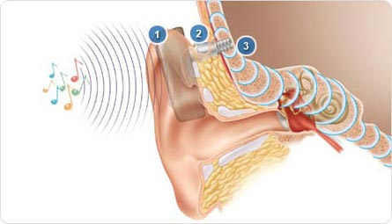 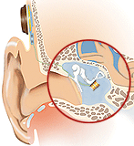  Bone Anchored Hearing Aid Middle Ear Implant  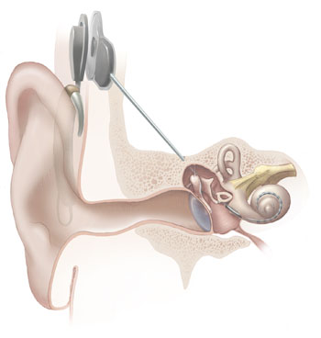 Cochlear Implant
Figure A.3

A.2.3 Advanced Digital Signal Processing Hearing Aids
Today's digital hearing instruments have become rather complex micro-systems incorporating a lot of sophisticated signal processing technologies. Most of today's high end digital hearing instrument offer a lot of sophisticated technology for improving the quality of life of hearing impaired people in numerous conditions. The signal processing schemes applied today can be divided into several broad classes of processing schemes:
multi-channel frequency dependent signal processing and amplification schemes for precisely compensating the frequency dependent hearing loss;
intelligent environment control for automatically adapting the hearing instrument settings to varying acoustic environments;
noise reduction systems applying two technologies for reducing interfering sound sources and background noises;
directional microphone arrays/multimicrophone technology;
single microphone noise canceller;
signal processing schemes for reducing feedback.
The signal processing employed today applies high resolution spectral filtering in order to split the acoustic signal into a number (at least 10 to 20) of different frequency bands or channels. This allows a lot of sophisticated signal processing to be performed. First of all, it allows correcting the frequency dependent hearing loss and thus reduced dynamic range (recruitment) precisely to the individual listening needs. Some hearing instruments even apply psychoacoustic models of hearing impaired perception for controlling the gain instead of purely sound pressure level based amplification schemes [i.7].
Typically hearing instruments use different signal processing schemes and parameter settings in different acoustic environments. For example, for processing in noisy environments, noise reduction algorithms such as directional microphones are being switched on. In order to facilitate the operation of the hearing instrument for the hearing instrument wearer, signal processing algorithms have been developed that allow to automatically identify the acoustic environment based on several different acoustic features such as modulation, level fluctuations, pitch, etc. This allows to reliably identify a number of different broad classes of acoustic environments such as speech in quiet, speech in different types of background noises, noise alone or music. It has been shown in several studies that these systems are very well perceived by the hearing instrument wearer. Nevertheless it is important to offer a "brain control" (i.e. either via a switch or a remote control) for this automatic functionality that allows the hearing instrument wearer to make the final decision about which listening program to chose in which environment. Future versions of these intelligent environment control systems will allow identifying a larger set of different acoustic environments and also automatically selecting different input sources such as personal FM systems or T-Coil inputs.
Finally, algorithms have been developed for lessening one of the most severe problems of hearing impaired subjects: speech communication in adverse, difficult listening conditions, e.g. due to a lot interfering sound source and background noise. Digital technology allowed to further improve a very successful approach for reducing background noises by making directional microphones applying multi-microphone beam forming optimally adapt to the respective environment. Today's multi-microphone systems are capable of adapting their directionality by changing their directivity pattern in order to always provide optimal signal to noise ratio and thus optimal speech intelligibility. It has been shown in numerous studies that directional microphones significantly improve speech intelligibility under a variety of very realistic real life conditions including diffuse environments, interfering sources from the side or even moving noise sources [i.8]. A second strategy for reducing the detrimental effect of background noises is by applying single microphone noise cancelling techniques which rely on identifying spectral bands containing only background noise and attenuating those bands. These signal processing schemes have also proven to be beneficial however not in terms of improving speech intelligibility but by improving ease of listening and listening comfort [i.7].
Wireless enabled hearing aids see additional applications possible that improve patient's safety and comfort.
Wireless ear-to-ear synchronization for improved localisation
The brain localizes sound by analyzing incoming delay and intensity differences between the L and R ear.
Two un-synchronized aids will individually amplify/correct the sound, resulting in lost directional information.
Wirelessly synchronized aids can exchange data to restore an accurate hearing.
Figure A.4: Wireless ear-to-ear
Wireless ear-to-ear data exchange for improved directionality
Exchange of information between the user's hearing aids allows for optimized directionality resulting in better comfort, improved speech to noise level as well as improved spatial hearing.
Wireless "sound relay" for more safety
When sound emanates from one direction only, in the case where that side’s ear is fully impaired, capturing the sound with the remaining ear can be challenging.
Capturing and relaying the sound from one side to the other adds listening comfort and safety by restoring a 360° aural field!
Figure A.5: Wireless "sound relay" for more safety

A.2.4 Digital wireless accessories for additional applications
Wireless "audio zoom" for increased listening precision
Hearing impaired people are challenged the most in noisy situations.
Hand-held or body worn “zooming microphones” can help select sounds of interest.
Wirelessly relaying it to the aids ads freedom of movement.
Figure A.6: Wireless "audio zoom" for increased listening precision
Additional wireless applications in hearing health care include but are not limited to:
communication between the sound processor (body worn) to the implanted device;
communication between one or both hearing aids (L+R) to a doctor/audiologist programming device;
communication between one or both hearing aids (L+R) to a user control device for parameter adjustment, data retrieval, etc.;
communication between one or both (L+R) hearing aids to a relay device to gain access to secondary audio sources, such as a cell phone, a TV set, a music player, a computer, etc.;
streamers which wirelessly connects the hearing instruments to audio sources for communication, entertainment and information purposes. Acting as a wireless Bluetooth interface to a mobile phone, such a product gives the client a hands-free solution with optimum speech intelligibility by streaming sound to both ears.

A.2.5 Assistive Listening Devices
A major consequence of sensorineural hearing loss (SNHL) is communicative difficulty, especially with the addition of noise and/or reverberation [i.9], [i.10], [i.11], [i.12], [i.13], [i.14], [i.15], [i.27]. Unfortunately, conventional amplification with omnidirectional microphone technology may provide little or no improvement to the signal-to-noise ratio (SNR) in adverse listening environments [i.16], [i.17], [i.21], [i.22]. In fact, a lack of perceptual improvement in noisy listening environments is one of the major reasons why individuals with SNHL report dissatisfaction with and reject amplification [i.18], [i.19]. Real life offers an incredible richness in different listening environments in some of which even the most sophisticated hearing instruments show only a limited benefit. In a number of conditions applying other than the above described technologies still can improve performance of hearing instruments significantly. Examples of acoustic environments or listening situations where the performance of conventional hearing instruments can substantially be improved by applying additional communication devices are the following:
reverberant environments such as big churches or lecture halls;
communication over larger distances e.g. in a lecture or in a classroom;
communication on the telephone, especially cell phones.
In these environments the application of assistive listening devices (ALD) based on wireless communication technologies offer substantial additional benefits and significantly improve speech intelligibility [i.7]. At present, there are various technologies that have been shown to improve speech recognition in poor listening environments. These technologies include a wide range of assistive listening systems such as Induction Loop (IL) systems, Frequency Modulated (FM) personal or public radio systems, and Infrared (IR) systems. Each offers the advantages of bridging the acoustical space between the source and the listener. Thus each can potentially offer advantages not possible when listening to a live voice or in the acoustic far field of a loudspeaker. Each, however, presents its own unique set of installation and user related concerns [i.20].

A.2.5.1 Induction Loop (IL) Systems
Inductive systems rely on coupling an audio amplifier, e.g. for the microphone of a speaker in a lecture hall or a teacher in a classroom, directly to an induction loop system which basically directly transmits the rather low frequency audio signal as a radiated time varying magnetic field. Induction loop systems use a large coil antenna integrated in the floor of a large room for radiating the magnetic field [i.7]. Once properly installed, and given that the listener's hearing aids include "T" coils, an IL system is undoubtedly the most convenient and possibly the most cost effective ALS. To hear the audio, all a person has to do is enter the looped area and switch his/her personal hearing aids to the telecoil position. As long as the person's hearing aids include "T" coils, he or she always has an assistive device "receiver" available (see [i.23]).
However this technology also has some technical drawbacks which limit the range of application of this technology. The physics of inductive coupling requires the receiving coil (T-Coil) to be perpendicularly oriented to the field of the sending coil or induction loop. This is sometimes difficult to achieve because the orientation of the induction loop is fixed and the orientation of the T-Coil depends on how it is built into the hearing instrument and the person's orientation. Furthermore, the inductive transmission strongly depends on the distance between sender and receiver which sometime results in a weak signal. The receiver also always has to remain within the loop in order to receive a signal. External interferences (from power lines or fluorescent lights, computer monitors copiers, fax machines, cell phones, etc.) creating background noises or distortions in the hearing instrument, are difficult to remove. Next, in school environments, several different systems are required for different classrooms. When applying two different systems in neighbouring classrooms it often is difficult to avoid spillover from one induction loop system to the next although recently technological progress has been made for reducing this problem. Furthermore, induction loop systems are not portable and can only be applied where they have been pre-installed [i.7], [i.24], [i.25].

A.2.5.2 Infrared (IR) Systems
An IR system transmits audio signals via invisible infrared light waves. The frequency of infrared light falls somewhere between 700 nm and 1000+ nm; visible light waves fall between 400 nm and 700 nm. The specific bandwidth of the IR carrier varies among manufacturers; it may be as narrow as 50 nm wide, or considerably broader and perhaps be visible as a faint reddish glow (Laszlo l998). The audio signal, from any source, is used to frequency modulate an RF sub-carrier which in turn is impressed upon, and essentially amplitude modulates, the IR carrier. An FM/AM double modulation of the IR light wave is the result. All IR systems are composed of three basic components: the transmitter (also called the modulator), the emitter and the IR receiver. The modulator processes the audio signal so that it can be transmitted via infrared light [i.23]. For optimal transmission, the receiver has to be in a direct line of sight with the emitter which limits the distance or range of application of such systems. In large theatres or lecture halls, arrays of transmitters have to be installed in order to guarantee good sound quality on each seat. Furthermore, people should not be moving around a lot. Thus in a home environment, for watching TV this might be a suitable solution while for a child in a classroom setting, other solutions probably allow more flexibility and thus should be preferred [i.7].

A.2.5.3 Frequency Modulated (FM) Radio Systems
Personal FM systems were first introduced for use by hearing-impaired children in the middle and late 1960's. The initial systems were using the commercial FM band 88 MHz to 108 MHz. As can be imagined, the children picked up lots of extraneous radio signals on this band. To bypass the limitations imposed by the 88 MHz to 108 MHz band, and since the technology had already proven its importance to children in class rooms, a different portion of the radio spectrum had to be designated for wireless FM systems. In 1971, the FCC allocated the 72 MHz to 76 MHz band for use with audio enhancement devices for hearing-impaired people. Much later the 216 MHz to 217 MHz band was added which, because of the smaller wavelength, offered many additional technical advantages [i.26]. In 2005, both the European Commission and CEPT have issued Decisions for harmonized use in Europe of parts of the band 169,4 MHz to 169,8 MHz for aids for hearing impaired people [i.5], [i.6].
The experience in the past has shown that FM systems, which were operating in the range 72 MHz to 76 MHz were particularly vulnerable to electromagnetic interference from pagers, emergency vehicles, etc. Recent technology advances enabled successful interference mitigation by channel tuning changes, but raised another issue for consideration - the number of available channels especially in school environments. Some examples of frequency bands presently available for FM systems are given in table A.1.
Table A.1: Frequency bands of operation of FM transmitters
Region/Country | Class | Frequencies
Europe | Radio Microphones and ALS | 169,4 MHz to 169,8 MHz +173,965 MHz to 174,015 MHz + parts of 174 MHz to 216 MHz
USA  Canada | Low Power Radio Services transmitters | 216 MHz to 217 MHz
China | Wireless Microphones | 189,9 MHz to 223 MHz
Australia  New Zealand | Low Interference Potential Devices | 173 MHz to 174 MHz
Japan | Specified Low Power Radio Equipment | 169,4 MHz to 169,8 MHz

This large variety of frequencies has put the industry under pressure to further develop the FM technology to be able to cover as wide as possible frequency range with only one equipment and thus eliminating the need to change the transmitter when travelling for business or vacation. Additionally, different worldwide restrictions of the transmitter power levels, channel bandwidth and spacing are further increasing the complexity of the regulatory situation. Therefore, one of the main regulatory challenges in the area of the FM systems is still achievement of worldwide harmonization of the technical parameters (frequencies and power levels) or in other words, the establishment of a global radio standard for ALS. Only this way will it be possible to maintain international technology uniformity leading to better accessibility of the FM systems at established high audio quality due to the minimization of still existing compatibility issues.
In the past, the only available FM systems were large and heavy with unreliable cords. In addition to that, the inconvenience of electromagnetic interference with analogue TV channels and remote controls, alarms and paging systems as well as equipment compatibility and cord problems were making the FM systems less attractive to their users. During the last ten years most of these problems were successfully addressed and solved. At present, a new generation FM system comprises (figure A.7):
a multi-frequency FM transmitter (body worn or handheld) with direct channel synchronization, entirely new multi-talker network possibility for team teaching environments as well as a Bluetooth connection to a mobile phone. Typical frequencies of operation are 40 kHz or 3,7 MHz (for channel synchronization), 169 MHz to 220 MHz, 2,4 GHz ISM band or Bluetooth (figure A.7a);
a miniaturized multi-frequency receiver with optimized FM advantage and flexible channel management. The receiver can be directly connected to the hearing aid or worn around the neck. Typical frequencies of operation are 40 kHz or 3,7 MHz (for channel synchronization), and 169 MHz to 220 MHz (figure A.7b-c);
in a school environment a third component can be added to an FM System - an automatic channel synchronizer mounted on the wall of a room for all students entering that room (typically operating at 40 kHz or 3,7 MHz) (figure A.8).
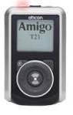 | 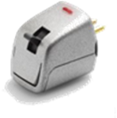
a. FM Multi-frequency transmitter | b. FM Receiver transmitter
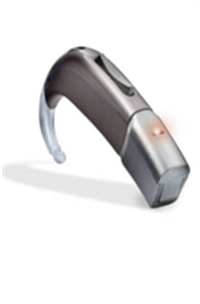
c. Has coupled with FM receiver and hearing
aid with design integrated FM receiver
Figure A.7: Typical components of a Personal FM system
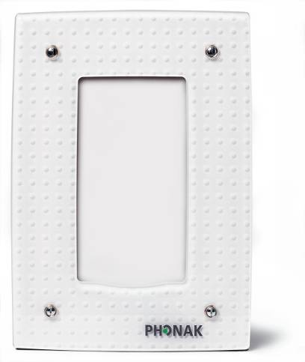
Figure A.8: Wall mounted channel synchronizer
Taking the above example of an FM system, one can argue that the inductive frequencies of the newest recently available Hearing Instruments Body Area Networks (HIBAN) (figure A.9) were not mentioned. The reason is the fact that, despite their ability to transfer the audio signal directly in the hearing aid wirelessly and without additional need for receiver attachment, these new HIBANs do not offer the traditional FM advantage of at least +10 dB in typical listening environments, which the existing FM delivers to the hearing aid. [i.28]. Past investigations have demonstrated that the use of directional microphone technology can improve speech recognition in noise by as much as 3 dB to 8 dB over omnidirectional microphone technology in the same hearing instrument depending on microphone location, type of noise, test materials, reverberation, etc., whereas personal FM systems can improve speech recognition in noise by as much as 10 dB to 20 dB over the unaided listening condition. Additionally, speech recognition performance is further enhanced by almost 3 dB using of two FM receivers rather than one FM receiver. These data suggest that FM technology will offer significantly better communicative performance in adverse listening situations than any type of hearing aid microphone configuration [i.19].
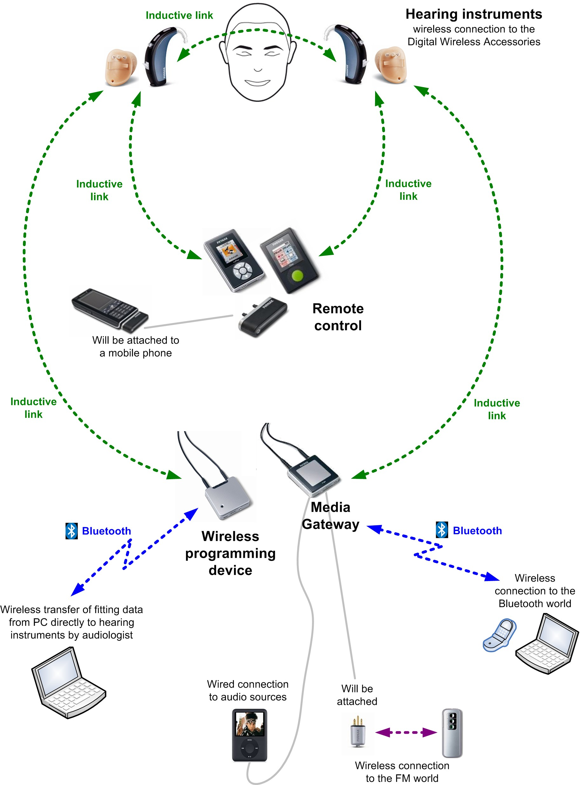
Figure A.9: Hearing instrument system with inductive link for
wireless connection to digital accessories
However, personal FM systems are low power systems (typically operating with power up to 10 mW) and are intended for use over short ranges up to a few tens of meters. This could be enough for classrooms, but for large auditoriums, theatres, churches or other public places, high power transmitters (up to 500 mW as defined within ECC Decision ECC/DEC/(05)02 [i.6] and EC Decision 2005/928/EC [i.5]) should be used to improve significantly the Signal-to-Noise Ratio in these kinds of noisy and highly reverberant environments. Typically high power FM transmitters in combination with universal FM receivers are also known as Public FM systems (figure A.10). Public FM systems are usually used in cases of big events attended by many hearing impaired people, who otherwise would experience strong interferences caused by personal hearing aid systems if used simultaneously and in a very close proximity one from another. For successful coverage of large auditoriums, e.g. stadiums during big sport events, more than one high power transmitter might be necessary. In such cases appropriate stadium segmentation with corresponding assignment should be considered to avoid co-channel interferences between two or more transmitters. In these cases, automatic synchronization of the receiver worn by each hearing impaired person is provided to assure that when a person enters a different sector his receiver will be automatically synchronized to the transmitter covering the current sector.
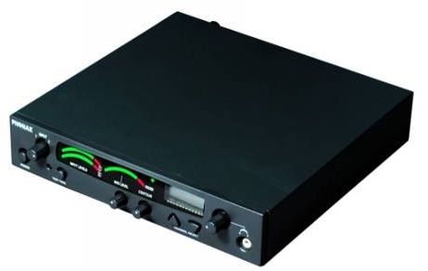
Figure A.10: FM transmitter for fixed installation of public FM systems

Annex B:
Expected market size and value
In 2007 some 9 million hearing aids were sold worldwide. With the relentless breakthrough in DSP technology, hearing aids are becoming much more effective in treatment of patient specific disabilities. Wireless technology suited for hearing aids is also expected to further help improve these devices. The combined technology, housed in hearing aids that are more discreet, cosmetically more appealing (ever smaller devices) and more comfortable to wear will contribute to significantly growth in this market.
Figure B.1 shows the market predictions for hearing aids. The light blue portion of the bar graph (bottom portions) assumes the typical growth this market has seen year over year. The dark blue bars in the graph (top portions form 2007 onwards) assume the additional volumes due to improved technology, appealing cosmetic and comfort.
Figure B.1: Market predictions for hearing aids
The study was commissioned by the European Hearing Instrument Manufacturer's Association (EHIMA, http://www.ehima.com). The EHIMA regroups the top five European hearing instrument manufactures that collectively develop, manufacture and sell 80 % of all hearing aid devices sold world wide and over 90 % of all hearing aid devices sold in Europe: The EHIMA comprises of:
Siemens Audiologische Technik AG, headquartered in Erlangen, Germany.
Sonova Holdings (fmr. Phonak Group), headquartered in Stäfa, Switzerland.
William Demant Holdings, headquartered in Smørum, Denmark.
GN Resound, headquartered in Bellerup, Denmark.
Widex A/S, headquartered in Værløse, Denmark.
There is a sixth, American based, company that is also a member of the EHIMA, which is Starkey Laboratories, headquartered in Eden Prairies, Minnesota, USA.
Collectively these six hearing instrument companies develop, manufacture and sell over 90 % of all devices deployed world wide.
EHIMA supports the objectives of the present document.

B.1 Air conductive hearing aids
Air conductive hearing aids described below are by far the most deployed in hearing health care. Luckily they can solve a great part of the hearing disabilities; having said that, the need for various types of implants is very much present. The value of having these hearing aids be able to operate wirelessly is essential.

B.1.1 Behind-the-ear
Behind The Ear (BTE) hearing aids are growing to become the most deployed of all styles of hearing aids. In Europe they already represent between 70 % and 85 % of air conductive hearing aids installed, in North America they now represent ~45 % of such devices deployed, up from 29 % in 2004; the rest of the devices are ITE (In The Ear), ITC (In The Canal) or CIC (Completely In the Canal). BTE have moved from basic "banana shaped" beige colored devices, that were cosmetically totally unappealing, to rather stylish and substantially smaller devices. This has directly contributed in their increased popularity, but it is also contributing to the overall growth of hearing aid adoption. Having reduced the stigma that represented wearing hearing aids, modern BTEs have helped reduce the average adoption aged of first time hearing aid users by approximately 9 years! More people ever get helped! This translates into substantial growth.
BTEs are also cost effective; they no longer need custom made moulds to be able to fit users' individually shaped ears. Thanks to DSP technology, acoustic effects such as feedback (amplified sound signal feeds from the speaker back into the microphone again), resulting in painful whistling, can now be reduced dramatically if not suppressed altogether. This means the ear canal, where the hearing aid's miniature loud speaker gets lodged, no longer needs to be sealed off to prevent feedback. As such small loud speakers can be inserted very much like a universal foamy ear plug, which is to say that BTEs can be manufactured on a "one size fits all" basis, otherwise put, in a cost effective manner.
BTEs are also the best types to accommodate wireless technology. Their slightly large size allows for better antenna positioning, possibly a slightly larger battery to compensate for the additional current draw.

B.1.2 In the ear, in the canal and completely in the canal
In The Ear (ITE), In The Canal (ITC) and Completely In the Canal (CIC) air conductive hearing aids were mainly developed to combat the negative stigma which the hearing health industry suffered from. In mild hearing disability cases, these devices actually may produce better results as their BTE counterparts because they can "re-use" the outer ear as the natural amplifier and wind noise reducing effect that it provides; and as such, some of the sound "pre-shaping" is performed naturally. However, given the higher cost of having to singly craft them to adapt to the patient's ear(s), these devices tend to lose out in favour of BTEs, as noted in the paragraph above.

B.2 Assistive listening systems (often described as FM systems)
A good hearing is essential for children for following classes as well as for adults in their daily life and business activities. Hearing impaired children experience problems when attending mainstream schools unless they receive proper help and support. They may not become properly integrated, and they tend to keep in the background as they try to avoid standing out from their classmates. Even a minor hearing loss may result in lower performance and difficulty in concentration given the fact that classrooms are far too noisy. For those hearing impaired children for whom hearing aids are only a partial solution, a user-friendly assistive listening system (FM system in a VHF or UHF band) is indispensable. It is estimated that the current need of ALDs world wide is about 1 million devices per year. In reality less than 10 % of those who can benefit from ALDs are using FM systems mainly due to poor awareness, cost factors or old stigma about hearing loss.

B.3 Traffic and equipment density forecast
The hearing aid devices and their related equipment covered in the present document are expected to emit electromagnetic radiation with different power levels depending on the particular application (see annex A). Transmission times will vary from brief intervals for some devices, e.g. remote controls to continuous transmission by some hearing aids and their associated peripheral equipment. In ALS applications as personal or public hearing aid systems, the traffic and equipment density was discussed in ECC Report 55 [i.31].
For TRS the traffic density will be dependent on its location for example a theatre would have constant transmission for the duration of a performance say three hours but nothing until the next day, a train station would be intermittent use for eighteen hours a day and home use would be dependent on the TV programs preferred by the viewer.

Annex C:
Overview of the system
Wireless audio systems considered here transmit speech or audio from a microphone, over a digital radio link, to a receiver. One example would be an assistive listening system for use by the hearing impaired in public spaces such as churches and theatres, where the transmitter is connected to the audio programme and the receiver is worn by users, or integrated into users’ hearing aids.
The use of digital technology, with 4GFSK modulation and low bit-rate audio coding, provides a balance between the need for good audio quality (a requirement to maintain intelligibility and minimise user fatigue), spectrum efficiency and range. These systems can work well between 150MHz and about 1GHz.
Depending on available spectrum and coexistence requirements, systems to operate in approximately 200kHz, 400kHz and 600kHz occupied bandwidth are outlined. The transmitter and receiver duty cycle is inversely proportional to the bandwidth, which means that the amount of spectrum resource used is roughly independent of the bandwidth, but the receiver power consumption is proportional to the duty cycle.
This means that a 600kHz system would allow receivers to consume approximately 1/3 the power of a 200kHz system, which is highly beneficial in power-limited applications such as hearing aids. Wider bandwidth also decreases end-to-end delay, which is of benefit to many audio applications where the audio must maintain lip-sync with the talker in order to maximise intelligibility.

200kHz system
Channel bandwidth | 200kHz
Frequency tolerance | +/- 0.005% (transmitter)  +/- 0.005% (receiver)
Transmitter radiated power (ERP) | 10mW
Transmitter field strength @30m | 88 dBμV/m
Transmitter out of band emission @30m | 70 dBμV/m, 100kHz from carrier, narrowband  40 dBμV/m, 1MHz from carrier, wideband
Transmitter modulation (indicative) | 4GFSK @120kbit/s, +/-40kHz maximum deviation (outer symbols), BT=0.5
Transmitter duty cycle (indicative) | 30-50% for one audio channel
Receiver sensitivity, direct inject | –80dBm or better
Receiver selectivity | 30dB minimum, adjacent channel  40dB minimum, alternate channel, image channel and above
Receiver blocking rejection | 50dB minimum, +/-2MHz separation
Example transmitter mask (max hold)  (note measurement noise floor at –55dBm)  Nominal 200kHz bandwidth | 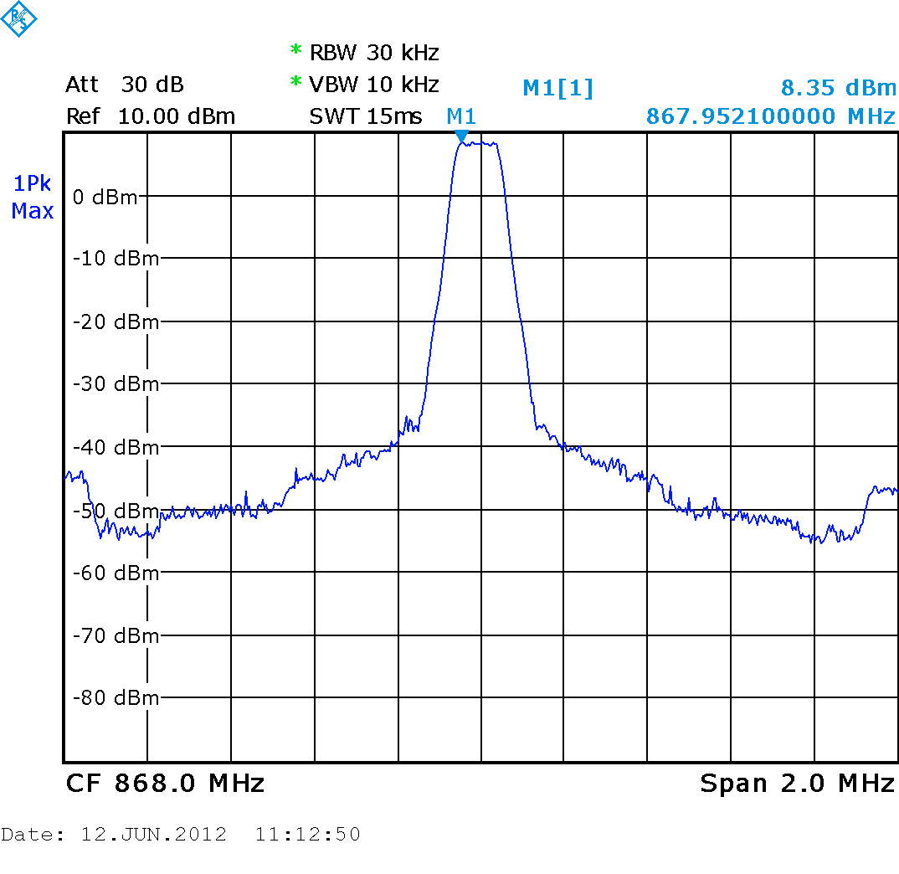  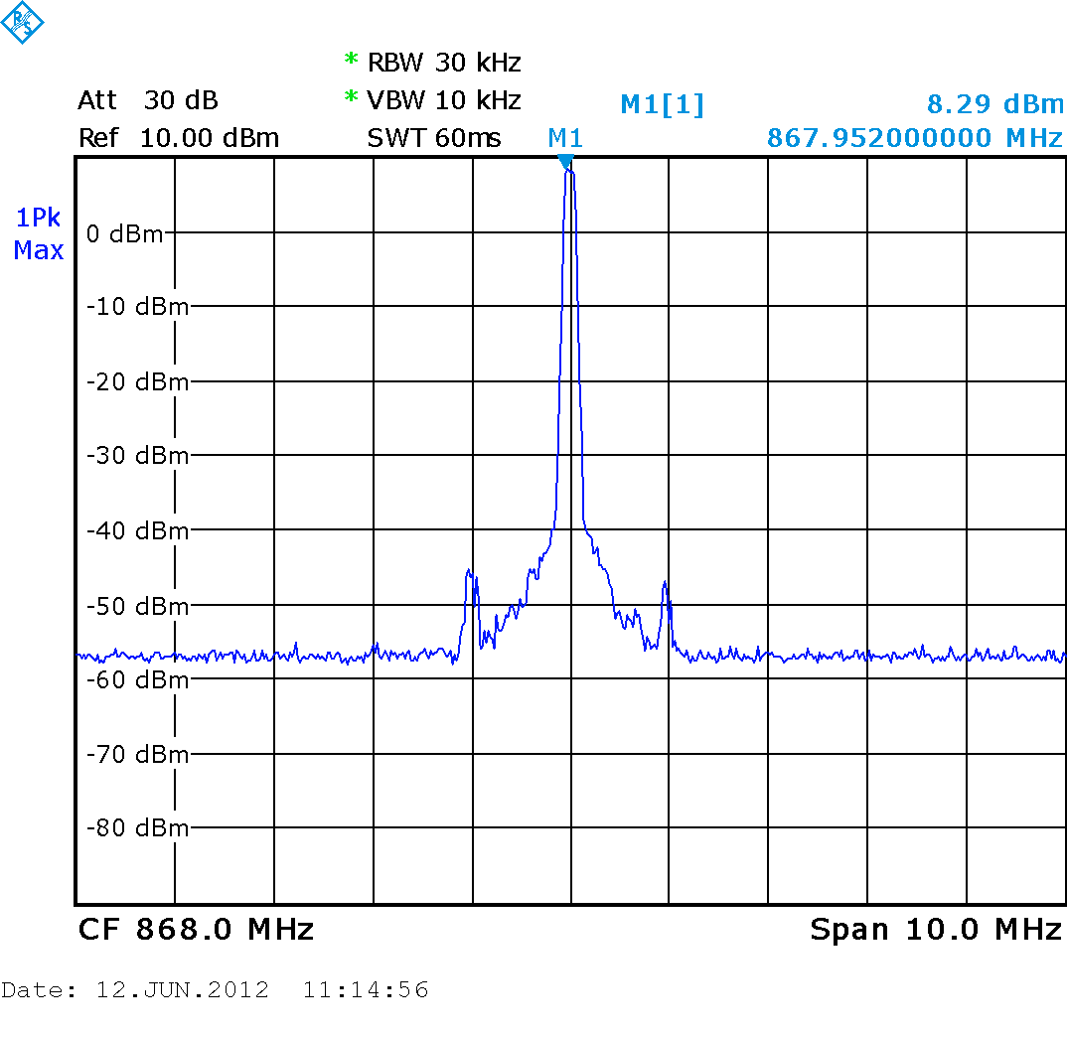
Example transmitter mask (average and max hold)  (note measurement noise floor at –55dBm)  Nominal 200kHz bandwidth | 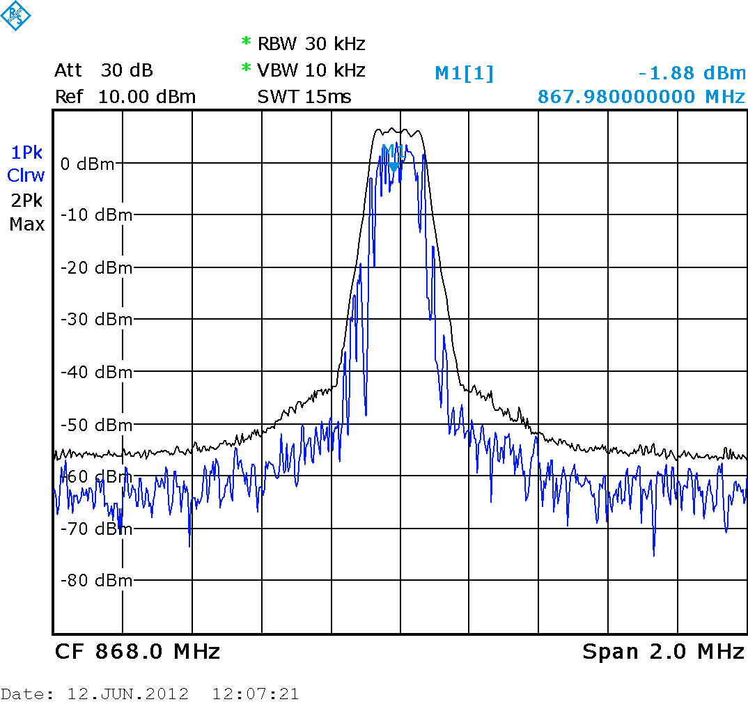  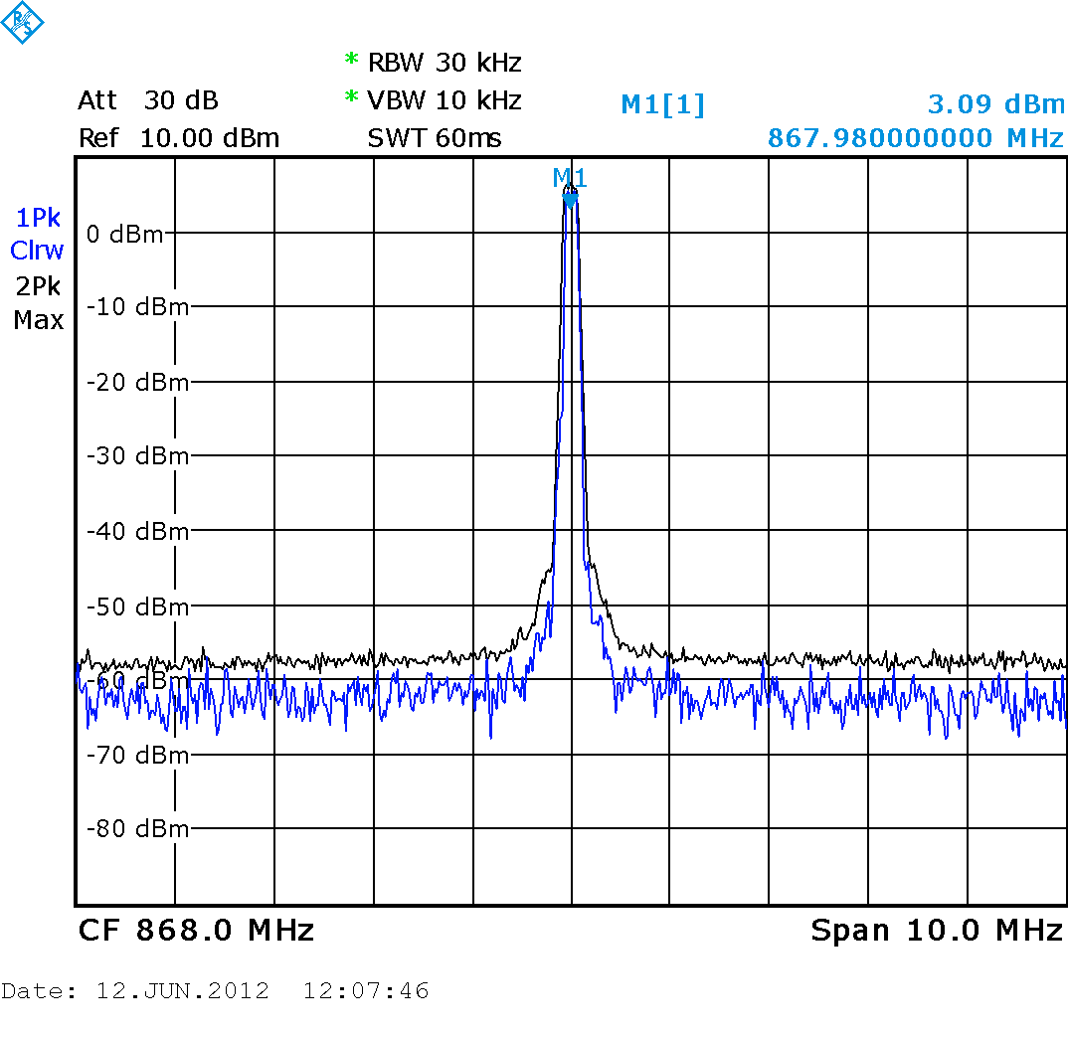

400kHz system
Channel bandwidth | 400kHz
Frequency tolerance | +/- 0.005% (transmitter)  +/- 0.005% (receiver)
Transmitter radiated power (ERP) | 10mW
Transmitter field strength @30m | 88 dBμV/m
Transmitter out of band emission @30m | 70 dBμV/m, 200kHz from carrier, narrowband  40 dBμV/m, 1MHz from carrier, wideband
Transmitter modulation (indicative) | 4GFSK @250kbit/s, +/-80kHz maximum deviation (outer symbols), BT=0.5
Transmitter duty cycle (indicative) | 15-25% for one audio channel
Receiver sensitivity, direct inject | –80dBm or better
Receiver selectivity | 30dB minimum, adjacent channel  40dB minimum, alternate channel, image channel and above
Receiver blocking rejection | 50dB minimum, +/-2MHz separation
Example transmitter mask (average and max hold)  (note measurement noise floor at -55dBm)  Nominal 400kHz bandwidth | 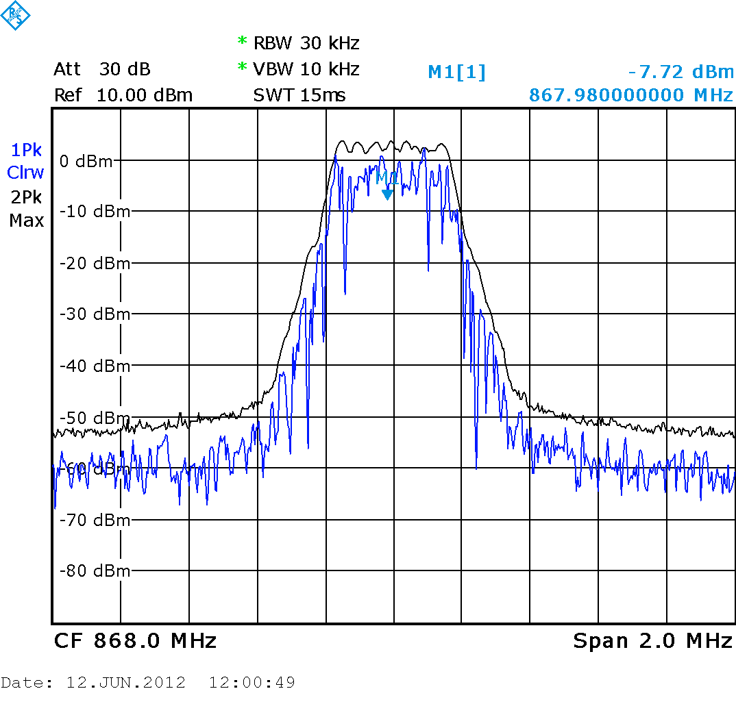  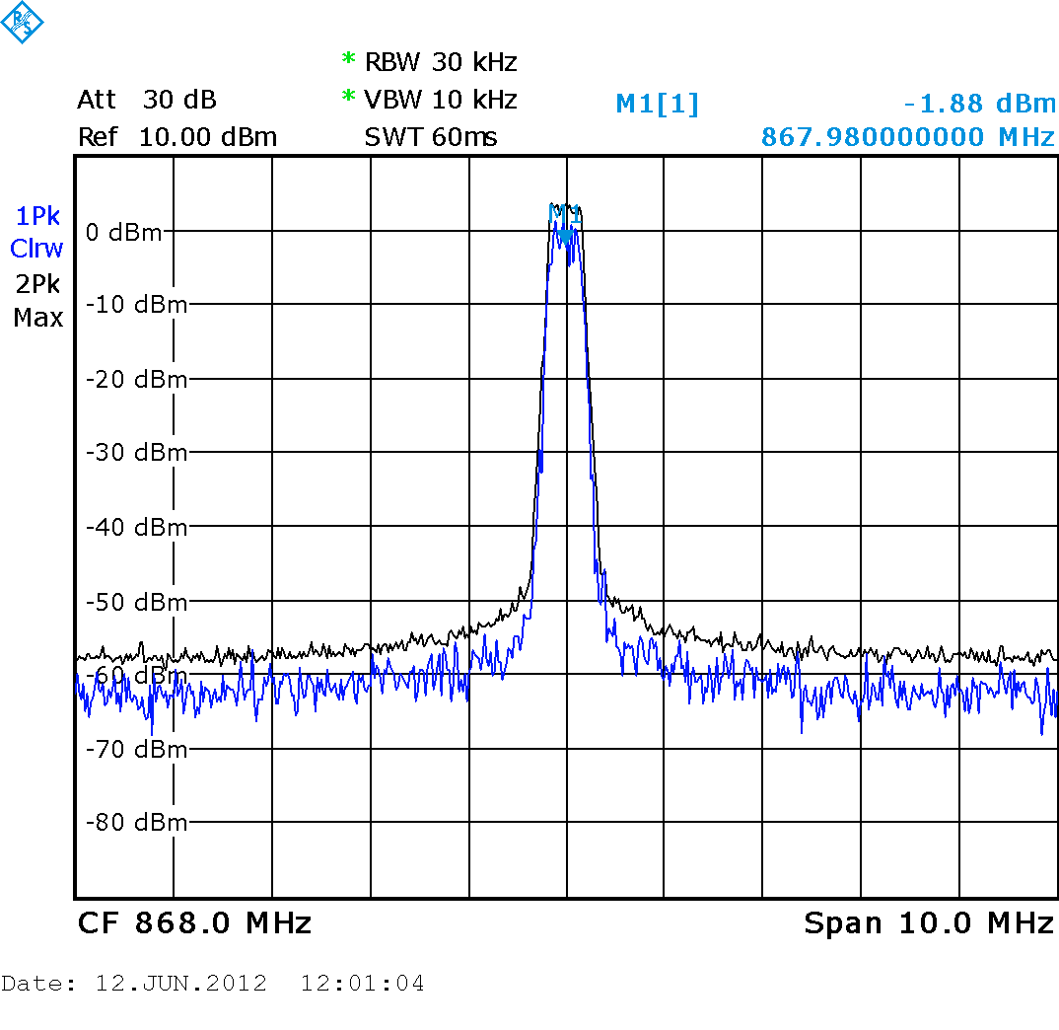

600kHz system
Channel bandwidth | 600kHz
Frequency tolerance | +/- 0.005% (transmitter)  +/- 0.005% (receiver)
Transmitter radiated power (ERP) | 10mW
Transmitter field strength @30m | 88 dBμV/m
Transmitter out of band emission @30m | 70 dBμV/m, 300kHz from carrier, narrowband  40 dBμV/m, 1MHz from carrier, wideband
Transmitter modulation (indicative) | 4GFSK @500kbit/s, +/-120kHz maximum deviation (outer symbols), BT=0.5
Transmitter duty cycle (indicative) | 10-20% for one audio channel
Receiver sensitivity, direct inject | –80dBm or better
Receiver selectivity | 30dB minimum, adjacent channel  40dB minimum, alternate channel, image channel and above
Receiver blocking rejection | 50dB minimum, +/-2MHz separation
Example transmitter mask (average and max hold)  (note measurement noise floor at -55dBm)  Nominal 600kHz bandwidth | 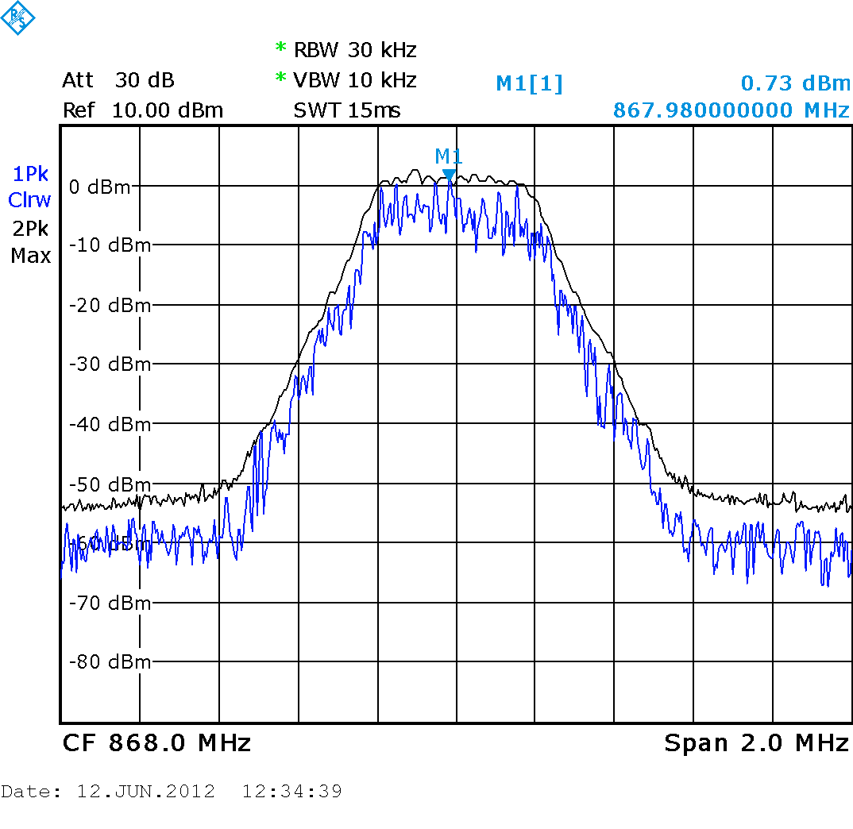  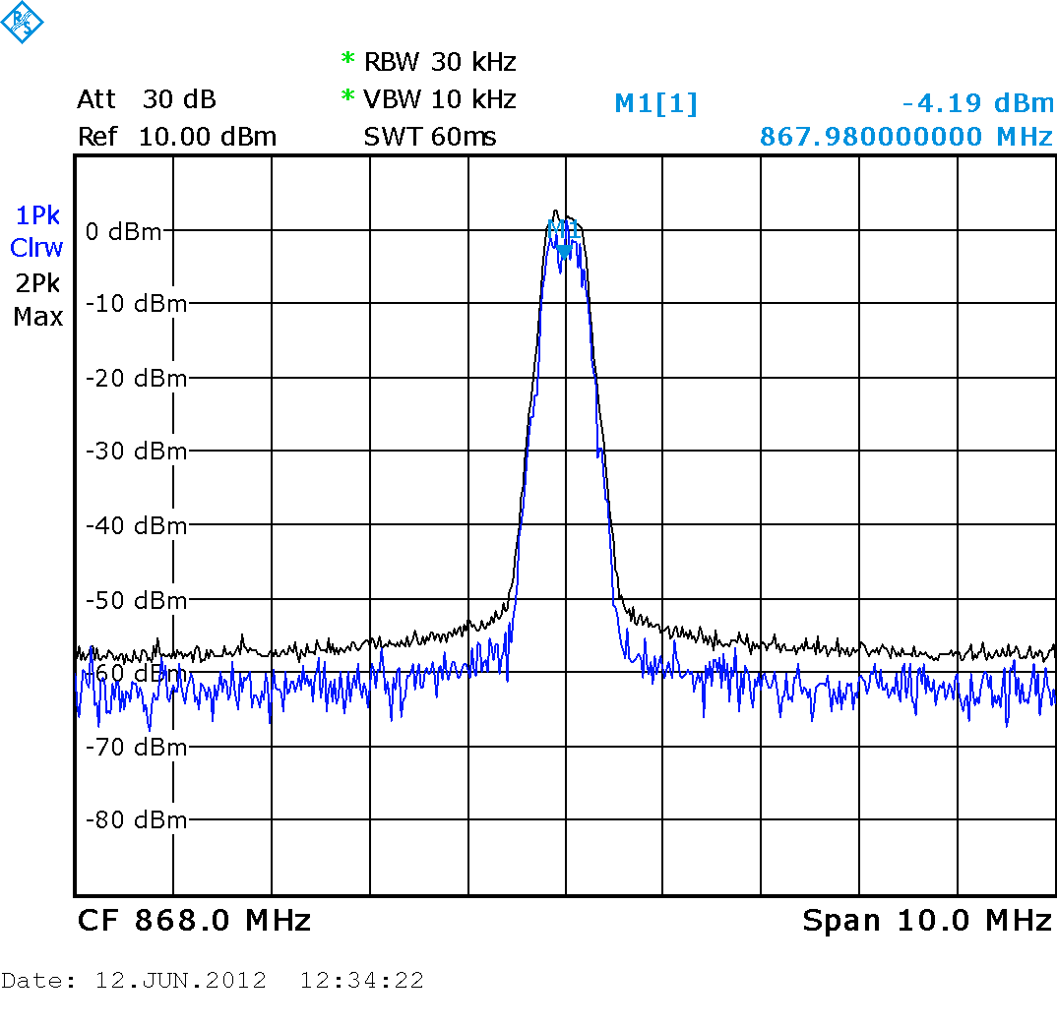

Annex D:
Bibliography
Directive 1999/5/EC of the European Parliament and of the Council of 9 March 1999 on radio equipment and telecommunications terminal equipment and the mutual recognition of their conformity.
ITU-R Recommendation SA 1346: "Sharing between the Meteorological Aids Service and the Medical Implant Communications Systems (MICS) operating in the Mobile Service in the Frequency Band 401-406 MHz".
CEPT/ERC Report 25: "The European Table of Frequency Allocations and Utilisations Covering the Frequency Range 9 kHz to 275 GHz: Lisboan January 2002 - Dublin 2003 - Turkey 2004".
CEPT Report 005: "Report from CEPT to the European Commission in response to the Mandate to Short Range Devices, Radio Spectrum Harmonisation".
"Electromagnetic Simulation of Mobile Phone Antenna Performance", Microwave Journal, Vol. 51, No. 1 January 2008, Page 78 by Omid Sotoudeh, Sony Ericsson Mobile Communications; Tilmann Wittig, CST GmbH.
Wen-Tzu Chen and Huey-Ru Chuang, "Numerical Computation of Human Interaction with Arbitrarily Oriented Superquadric Loop Antennas in Personal Communications", IEEE Trans. Antennas Propagat.,vol. 46, pp. 821-828, June 1998.
H.-R. Chuang, "Human operator coupling effects on radiation characteristics of a portable communication dipole antenna," IEEE Trans. Antennas Propagat., vol. 20, pp. 556-560, Apr. 1994.
K. Ito, I. Ida, and M.-shien Wu, "Body effect on characteristics of small loop antenna in pager systems," in IEEE Antennas Propagat. Soc. Int. Symp. Dig., Chicago, IL, July 1992, vol. 2, pp. 1081-1084.
M. A. Jensen and Y. Rahmat-Samii, "EM interaction of handset antennas and a human in personal communications," Proc. IEEE, vol. 83, pp. 1-17, Jan. 1995.
IFAC.
NOTE: Available at http://niremf.ifac.cnr.it/tissprop.
ETSI EN 302 537: "Electromagnetic compatibility and Radio spectrum Matters (ERM); Short Range Devices (SRD); Ultra Low Power Medical Data Service Systems operating in the frequency range 401 MHz to 402 MHz and 405 MHz to 406 MHz; Part 1: Technical characteristics and test methods".
ETSI EN 300 220: "Electromagnetic compatibility and Radio spectrum Matters (ERM); Short Range Devices (SRD); Radio equipment to be used in the 25 MHz to 1 000 MHz frequency range with power levels ranging up to 500 mW".
ECC Report 37: "Compatibility of planned SRD applications with currently existing radiocommunication applications in the frequency band 863 - 870 MHz".

History
Document history
V1.1.1 | May 2012 | Publication
V1.2.0 | October 2012 | ERMsupport inserted new work item ref erence
V1.2.1 | October 2012 | Revised with Digital TRS system
V1.2.2 | January 2013 | Revision after Remote Consensus comments

