5.2 Recommended Band plan
In total there are 2 x 35 MHz in 900 MHz band and 2 x 75 MHz in 1800 MHz frequency band:
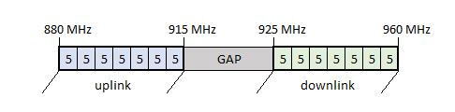
Figure 1: 900 MHz band plan

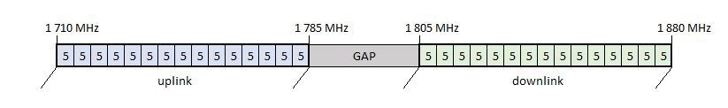
Figure 2: 1 800 MHz band plan

