Coexistence between the radionavigation-satellite and the amateur services in the frequency range 1 260 - 1 300 MHz
[approved DD Month YYYY]
ECC Report <GALE6_AS>
[last updated: 29 August 2019]

Executive summary
The frequency range 1 260-1 300 MHz, used by the Europe-an GALILEO system for the provisioning of global radionavigation-satellite service (GNSS), occupies a portion of the frequency band 1 240- 1 300 MHz which is also allocated to the amateur and amateur-satellite services on a secondary basis in the ITU Radio Regulations. Further, this band is shared with primary allocations to the radiolocation (RLS), radionavigation (RNS) on a co-primary basis and with the Earth exploration-satellite service (EESS (active)) a co-secondary basis.
With the implementation of the GALILEO system, it has become necessary to clarify more specific the operating conditions for certain applications (operating modes) in the amateur and amateur satellite services to ensure the continued use of this band and to ensure an appropriate long-term development of both services.
For radio amateurs worldwide the allocation to the amateur service in the frequency band 1 240-1 300 MHz, also known as the “23cm-band”, is an important frequency band between the allocations in 430-440 MHz and 2 300-2 450 MHz as the physical propagation conditions are very specific for propagation monitoring and communication experiments.

TABLE OF CONTENTS

0 Executive summary 2
1 Introduction 5
2 Definition of the Galileo E6 and signals emitted in the Amateur Services 6
2.1 GALILEO E6 signal description 6
2.2 Amateur services in 1 240 – 1 300 MHz 7
2.2.1 Introduction 7
2.2.2 Characteristics of amateur signal emissions 7
2.2.3 IARU band plan 8
3 Methodology and results of test cases performed 11
3.1 Methodology and measurement set-up 11
3.2 Test cases and measurement results 12
3.3 GALILEO E6B probability of bit error conditions under varying C/No 12
4 Quantification of interference and options for RFI mitigation 13
4.1 Analysis of protection criteria 13
4.2 RFI mitigation on GALILEO E6B receiver 13
4.3 Mitigation in amateur emissions 13
4.4 Statistics of use of band by amateur services (time and location) 13
5 Conclusions 14
ANNEX 1: List of ReferenceS 15

Note on the Table of Contents (to be deleted after completion of doc.)
This is automatically styled and compiled from the headings, subheadings and page numbers from the document that follows. To update the Table of Contents move cursor within the table and press F9.

LIST OF ABBREVIATIONS

Abbreviation | Explanation (style: ECC Table Header red font)
ARNS | Aeronautical Radionavigation Service (ITU RR)
ATV | Amateur television (usually analogue FM emissions)
BOC | Binary Offset Carrier
BPSK | Binary phase shift keying
CAS | Commercial Authentication Service (GALILEO E6)
CBOC | Composite Binary Offset Carrier modulation
CDMA | Code Division Multiple Access
C/NAV | Commercial Navigation message (provided in E6-B signal)
cps | Chips per second
CRC | Cyclic Redundancy Check
CW | Continuous wave (in amateur service also used for Morse telegraphy communication
DATV | Digital Amateur TV (applying DVB-S and DVB-S2 Standards)
ECC | Electronic Communications Committee
FEC | Forward Error correction
FSK | Frequency Shift Keying
HAS | High-Accuracy Service (GALILEO E6)
IARU-R1 | International Amateur Radio Union (Region 1); Regions 2 and 3 comprise the same areas as Regions defined by the ITU; IARU coordinates the band plan for the frequency band 1 240- 1 300 MHz
ICD | European Union, “Galileo Open Services Signal in Space Interface Control Document (OS SIS ICD)”; http://ec.europa.eu/growth/sectors/space/galileo/
ITU-R | ITU Radiocommunications Sector
GNSS | Global Navigation Satellite Service
OS | Open Service (GALILEO)
PSA | Precision Step Attenuator
PSD | Power Spectral Density
RFI | Radio Frequency interference
RNSS | Radionavigation-Satellite Service (ITU RR)
SIS | Signal-In-Space
sps | Symbols per second

Introduction
The frequency range 1 260-1 300 MHz, used by the Europe-an GALILEO system for the provisioning of global radionavigation-satellite service (GNSS), occupies a portion of the frequency band 1 240- 1 300 MHz which is also allocated to the amateur and amateur-satellite services on a secondary basis in the ITU Radio Regulations. This band is further shared with primary allocations to the radiolocation (RLS), radionavigation (RNS) on a co-primary basis and with the Earth exploration-satellite service (EESS (active)) a co-secondary basis.
With the implementation of the GALILEO system, it has be-come necessary to clarify more specific the operating conditions for certain applications (operating modes) in the amateur and amateur satellite services to ensure the continued use of this band and to ensure an appropriate long-term development of both services.
For radio amateurs worldwide the allocation to the amateur service in the frequency band 1 240-1 300 MHz, also known as the “23cm-band”, is an important frequency band between the allocations in 430-440 MHz and 2 300-2 450 MHz as the physical propagation conditions are very specific for propagation monitoring and communication experiments.
This report analyses conditions for the coexistence of the GALILEO GNSS receiver processing the E6 signals with emissions from stations operating in the amateur and amateur-satellite services allocated in the frequency range 1 260-1 300 MHz. It is based on two measurement campaigns (2, 3).

AMATEUR SERVICES

Amateur services in 1 240 – 1 300 MHz

Introduction
The ITU Radio Regulations allocate the frequency band 1 215 – 1 300 MHz also to the amateur service and the amateur-satellite service with a secondary status. ITU RR no. 1.56 define the amateur service as: “A radiocommunication service for the purpose of self-training, intercommunication and technical investigations carried out by amateurs, that is, by duly authorized persons interested in radio technique solely with a personal aim and without pecuniary interest.”

Characteristics of amateur signal emissions
The characteristics of typical applications are shown in Table 2.
Table 2: Amateur service applications and usage scenarios in the frequency range 1 260-1 300 MHz
Application | Typical Bandwidth | Details | Remarks
Digital Voice | 12,5 kHz (Tetra: 25 kHz) | DMR, D-Star DV, NXDN, Tetra, APCO 25, C4FM | simplex and repeaters (interconnected by the Internet), mobile/ handheld/ stationary usage  DMR: TDMA Access (two timeslots – 50% duty cycle)
Digital Data | 12,5 – 150 kHz | Packet Radio (AFSK 1k2, FSK 9k6), D-Star, Digital Data 128 kbit/s | signal bursts, automatic stations, mobile/ stationary usage
Morse Code | 500 Hz | CW (100 WPM) | Moon bounce (high power), Beacons (24/7 automatic stations), Contests (Activity weekends), stationary usage
Analogue Wide | 12,5 kHz | FM | simplex and repeaters (some interconnected by the Internet – Echolink), mobile/handheld/stationary usage
Analogue Narrow | 2 700 Hz | SSB | simplex and linear transponders, Contests (Activity weekends), stationary usage
MGM (machine generated mode) | 6 – 2 700 Hz | RTTY, SSTV, PSK31, WSPR | simplex, operator controlled (no automatic stations), Contests (Activity weekends), satellites (only CO-65 in space), stationary usage
Analogue ATV | 16 – 18 MHz | FM-ATV | simplex and repeaters, stationary usage
Digital ATV | 2 – 8 MHz | DATV (DVB-T, DVB-S) | simplex and repeaters, stationary usage

IARU band plan
As an affair of self-administration of the worldwide amateur service, the International Amateur Radio Union (IARU) coordinates the interests of its Member Organisations. The three IARU Regions are organized to broadly mirror the structure of the ITU and its related regional tele-communications organizations. In any case, national regulatory provisions prevail and may lead to different regulations.
The currently recommended IARU band plan for the amateur allocation in the frequency range 1 240 – 1 300 MHz in Region 1 is shown in Table 3. Out of the many applications operated in this allocation, a pre-selection process categorised emissions into four Groups
- G1: Signal bandwidth <1 kHz,
- G2: Signal bandwidth 15 kHz
- G3: Signal bandwidth up to 200 kHz
- G4: Signal bandwidth 1...16 MHz
that represent the diversity of all potential RF emissions.
Table 3: IARU Region 1 band plan for 1 240 - 1 300 MHz
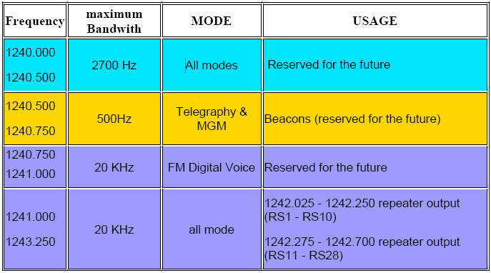
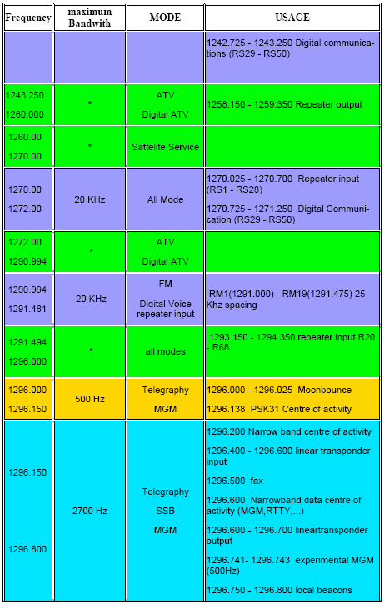
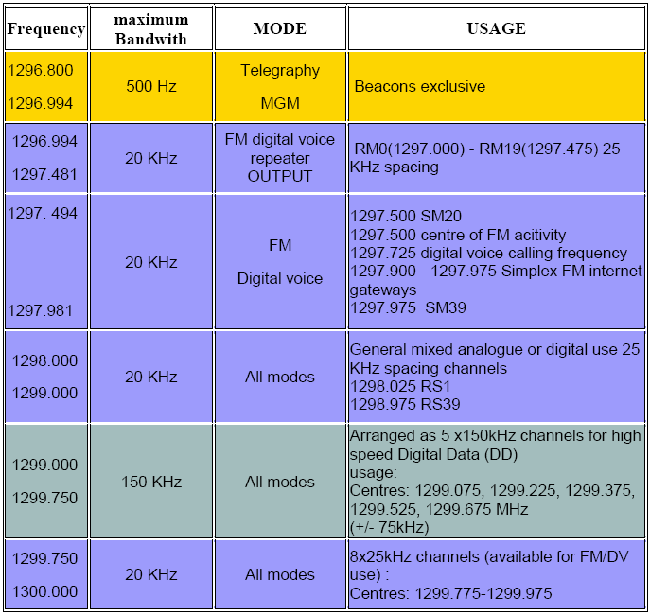

Use of frequency band by GALILEO E6 and amateur services i.a.w. bandplan
Figure 3 shows the spread GALILEO E6-signal and the corresponding portions with applications of the amateur service. Except the very wide-band modes of FM-ATV and various options for D-ATV (DVB-T/DVB-S) the remainder of applications falls into three categories which may show different grades of impact, if at all, on the reception and decoding of the GALILEO signals.

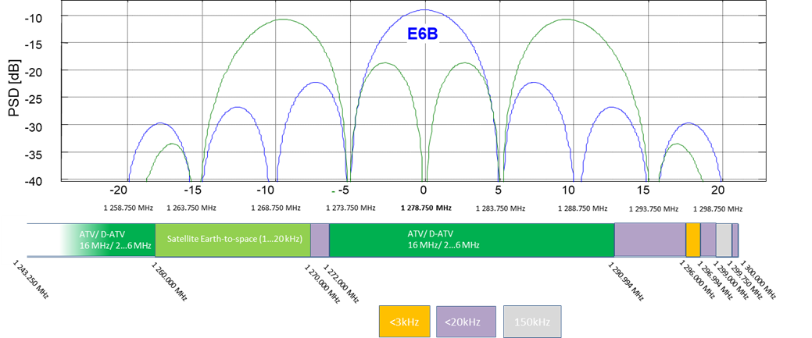

Figure 3: Amateur service applications and the GALILEO E6 signal PSD

Amateur Station Categorisation and Typical Usage Patterns
There are many applications in the amateur service but the stations and their usage patterns can be broadly categorised into three types:
  - Home Station.
  - Temporary “Portable” Station.
  - Permanent installations (away from an individual’s home address).

The operational details are considered specific to the band 1240-1300 MHz as they are dependent upon the nature of the equipment needed and operator skills to operate in this band as well as the propagation characteristics.
It should also be borne in mind that often nationally specific conditions can lead to variations in the operating pattern in particular the frequencies used by permanent installations.

2.2.4.1 Home Station
This would be installed at the usual station licence holder home location. The majority of home station usage is for narrow band terrestrial ad-hoc communications with other similarly equipped amateur stations. However since the propagation characteristics are more challenging than those in lower UHF and VHF bands the band would not be the first choice for casual contacts or group/club on-air gatherings. Most stations are better equipped in the lower frequency bands for this type of operation. Casual random calls under flat propagation conditions are rare as high antenna gain and narrow beam widths preclude useful ”broadcast” calls. The highest level of home station activity occurs during (usually competitive) scheduled activity periods that take place on a publicised regular basis during weekday evenings and a number of weekends throughout the year. Generally analogue narrow band Morse, SSB and MGM applications are used in the range 1296 – 1298 MHz
Enhanced propagation conditions tend to be variable and can occur randomly throughout the year. They may last from minutes to days depending on the mechanism at work. These can encourage operation although activity levels will be less compared with the more popular lower UHF and VHF bands. Generally analogue narrow band Morse, SSB and MGM applications are used in the range 1296 – 1298 MHz.
In order to extend the communication distance that can be achieved, this band is popular amongst a few stations suitably equipped to overcome the losses inherent in an earth-moon-earth (EME) reflected path. Of course these are only possible when the moon is visible and require high performance low noise stations with larger antenna systems that may not be compatible with all locations. These weak signal contacts most commonly use analogue narrow band Morse and MGM applications in the range 1296 – 1298 MHz. MGM applications are most commonly used for random contacts.
This band is a popular choice for Amateur TV (ATV) applications due to the bandwidth available. Nowadays digital ATV (DATV) is encouraged and becoming the most popular application. As discussed above, random activity is quite rare but again activity (and contest) periods are scheduled as a focus for operation and experimentation. Simplex TV operation tends to occur around 1255 MHz.
For all applications, narrow band or wideband, the highest activity levels and band usage are concentrated into the scheduled activity periods summarised in the table below:
Typical Peak Activity based on some in-country data in CEPT:
Usage Type | Annual Activity Periods | Active Home Stations
Narrow Band Activity Period and Contests | Total, on average 108 hrs over a year | Between 100 (NL) and 260 (F)
EME | 5 x 24hrs contest periods | 10 (UK); 7 (F).  (Maximum 100 across Europe)
Wide band Activity Period and Contests (ATV) | Total, on average 120 hrs over a year | 10 maximum
Operation through amateur satellites takes place within the uplink only band at 1260-1270 MHz and these can include tele-command activities as well as direct narrow band voice and low rate data communications. There are four currently active in this band at present but this is a lively area of interest.

2.2.4.2 Temporary ”Portable” Station
Often the propagation constraints experienced for a home station (usually due to local clutter) can be overcome in part by temporarily siting a station in an advantageous position (usually high ground) away from the home location and usually in a rural setting. Again the majority of usage is for terrestrial ad-hoc communications with other amateur stations for short duration narrow band contacts usually associated with scheduled (competitive) activity periods.
ATV activity is also possible, although random activity is rarely seen outside scheduled activity (and contest) periods which act as a focus for operation and experimentation.
EME activity is unlikely as there is no advantage to be gained.

Typical Peak Activity based on some in-country data in CEPT:
Usage Type | Annual Activity | Active Portable Stations
Narrow Band Activity Period and Contests | Total, on average 108 hrs over a year | 15 to 20
Wide band Activity Period and Contests (ATV) | Total, on average 120 hrs over a year | 10 maximum

Permanent Installation
Permanent installations include specific voice repeaters, ATV (and occasionally data) repeaters and propagation beacons. As permanent stations, these are licensed in their own right for their specific location, operating frequency and output power (as ERP). The licence is usually associated with a licensed ”keeper” of the installation. Propagation beacons usually operate 24/7 and will typically emit a narrowband FSK signal with call sign ID and location information in the range 1296.8 – 1296.994 MHz.
Voice repeaters usually re-transmit narrow band analogue and digital voice traffic when activated with a signal on the input frequency and are mostly associated with extending mobile user coverage. Propagation at these frequencies does not lend itself to reliable wide area repeater coverage so activity is far less than in lower UHF and VHF bands (and fewer commercial radios are suitable for mobile installations). The most common installations transmit around 1297 - 1298 MHz although a few experimental systems may operate in other parts of the band.
Data and TV repeater stations transmit the widest bandwidth amateur signals and often transmit test signals when not being accessed by a user station on the input channel. This band is the most popular for amateur TV repeaters which tend to operate with input and output frequencies in the range 1242 – 1260 MHz. Actual assignments can be nationally dependant. There are cases where alternative output frequencies are used to facilitate national inter-service coordination (e.g. UK TV repeater output frequencies are in the range 1300 – 1325 MHz).
Typical Activity Examples from some countries in CEPT:
Usage Type | Annual Activity | Active Installations
Narrow Band Propagation Beacons | Transmitting 24/7 usually | 10 (UK); 14 (F); 16 (D); 5 (NL).  IARU R1 = 88 in total.
Narrow Band Voice Repeaters | Random and sporadic on the input frequency.  In Beacon mode – Transmitting 24/7 usually | 5 (UK); 7 (F); 14 (NL).
ATV Repeaters | Transmitting 24/7 usually on the output frequency. | 18 (UK); 10 (F); 12 (NL)
ATV Repeater user | Random and sporadic | 5 to 10 per repeater

Typical Amateur Station Type Characterisitcs
There is no standard amateur station. The following antenna types and power levels are typical based on published information about the activity periods and operating contests. In general home and temporary stations would use highly directional antennas.

Home Station
Most Home Stations will use a single directional beam antenna, however in a few cases multiple beam antennas can be combined to increase the array gain. This is more usual for EME operators for whom high antenna gain is essential for overcoming the high path and reflection loss. A higher performance EME station might use a medium size dish antenna.

Antenna Type | Gain Typical | 3dB Beam width
Single Yagi beam (23 to 55 element) | 18 to 21 dB | 18 to 10 deg
Multiple Yagi (for EME)  Dish antenna (for EME) | 21 dB  (4m) 32 dB | 10 deg  4 deg
Analysis of a typical activity period results (non EME) shows that around 15% of active stations used a multi-antenna array.
Analysis of the same activity period showed the following spread of transmitter power levels (NB: 100% = 34 stations only):
Power Range (Watts) | % Stations
Up to 10 | 47%
11-25 | 9%
26 - 100 | 26%
101 - 300 | 12%
Over 300 | 6%
For EME operation experiences have shown that a minimum performance station could expect to make MGM based contacts using around 50W of power into a multiple antenna beam array. Higher performance stations are likely to require at least around 10dB more EIRP through a combination of power level and increased antenna gain.

Temporary ”Portable” Station
As with Home Stations there is a spread of the same antenna types that might be used. Similarly analysis of the same activity period as above show that only 15% of stations used multi-antenna arrays. (The actual number was 3).
Analysis of the same activity period shows the following spread of transmitter power levels (NB: 100% = 13 stations only):
Power Range (Watts) | % Stations
Up to 10 | 61.5%
11-25 | 7.5%
26 - 100 | 7.5%
101 - 300 | 15%
Over 300 | 7.5%

Permanent Installation
Most permanent installations (beacons and repeaters) are less directional and are generally intended to provide coverage over an area. They are usually licensed to operate at a specific ERP.
Antenna Type | Gain Typical | 3dB Beamwidth
Various (e.g. Alford slot, Colinear array, horn, flat panel, big wheel...) | Up to around 13 dB | Omni to 60 deg

ERP Range (Watts) | % NB Beacons | % Repeaters (ERP)
Up to 10 | 69% | 16%
11-25 | 8% | 76%
26 - 100 | 20% | 8%
101 - 300 | 1% | 0%
Over 300 | 1% | 0%

[Early Draft ideas to identify the Key] Amateur Scenarios for coexistence evaluation
[From contribution SE40(20)003 - to be developed further]
[TBD] scenarios are proposed to cover the majority of expected amateur and amateur satellite applications in the 1240-1300MHz band.
Scenario 1 covers the home and temporary “portable” station situations with an amateur operator using narrow band telegraphy and telephony applications including MGM modes. Satellite uplink operation and EME operation can be taken into account by considering antenna off axis gain. Wideband modes such as DATV need to be considered too as a “sub-scenario”. Although nominal values are highlighted and a range of reasonable values can be proposed for sensitivity analysis.
Scenario 2 covers permanent installations such as beacon and repeater station outputs using antennas intended for area coverage (omni/low gain).

Scenario 1:
Directional antenna radiating away from a home or temporary station site, the following parameters are considered:
Tx Power: Majority usage nominally [B] but consider [A to C]
Antenna Gain: Majority usage nominally [B] but consider [A to C]
Antenna 3 dB beam width: Majority usage nominally [B] but consider [A to C] (horizontal)
Height above ground: Majority usage nominally [y] m but consider [x to z] m
Antenna off axis gain: Typically -y dB but consider [0dB to -z dB]
Pointing angle: Typically [ 0 deg] but consider [0 to x deg]
Clutter environment: Typically “sub-urban” but consider rural extreme.
Propagation model: [TBD]
Frequency offset from Galileo centre: Typically [x-y MHz] but consider [D to E]

Parameter | Scenario 1a (narrow) |  | Scenario 1b (wideband)
 | Nominal | Sensitivity Range | Nominal | Sensitivity Range
Tx Power (dBW)
Antenna Gain (dBi)
Antenna 3dB beam width (deg)
Height over ground (m)
Antenna off axis gain (dB)
Pointing Angle (deg)
Clutter Environment
Propagation Model
Freq Offset (MHz)

Scenario 2:
Omni-Directional antenna radiating away from a permanent station site:
Tx Power: Majority usage [B] but consider [A to C]
Antenna Gain: Majority usage [B] but consider [A to C]
Antenna 3 dB beam width: N/A (horizontal)
Height above ground: Majority usage [y] m but consider [x to z] m
Antenna off axis gain: Typically -y dB but consider [0dB to -z dB]
Pointing angle: Typically -y dB but consider [0dB to -z dB]
Clutter environment: Typically “sub-urban” but consider rural extreme.
Propagation model: ??
Frequency offset from Galileo centre: [TBD - 1278.75 MHz +/- x MHz]
If there are significant differences revealed by the measurement campaigns between transmission types (e.g. time varying versus constant carrier) then this should be considered.
Here Scenario 2a could be a narrowband signal (e.g. beacon or voice repeater) and Scenario 2b could be a wideband signal (e.g DATV repeater)
[End of contribution SE40(20)003]

GLONASS

Protection requirements

GALILEO E6

Protection requirements
The Galileo Signal-In-Space ICD (1) defines the E6-signal as: “The Galileo E6-signal consists of the signal components E6-B and E6-C and is transmitted in the frequency band 1 260-1 300 MHz allocated on a worldwide co-primary basis (ITU Radio Regulations), sharing with radar systems of the radio navigation and radiolocation service. The signal components E6-B and E6-C comprise a data- and a pilot -component, respectively. The E6-signal provides the C-NAV message and supports the Commercial Service (CS) High-accury service (HAS) and the Commercial Authentication Service (CAS).
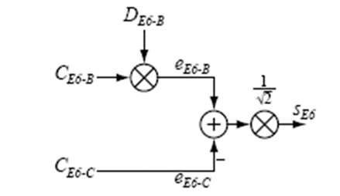
Figure 1: Multiplexing of the GALILEO E6B+C signal
The Galileo E6-signal is defined in the EU Interface Control Document (1) and reflected in Recommendation ITU-R M.1787-2 (4) as a complex (vectorised) signal comprising components which are shown in Table 1. A detailed mathematical description of the emitted spread-spectrum CDMA signal (Binary offset coded) can be found in [1 and RD7]. The envelope of the emitted signal is shown in Figure 1 which is taken from (1).
Table 1: Galileo E6 transmissions in the 1 164-1 300 MHz frequency band
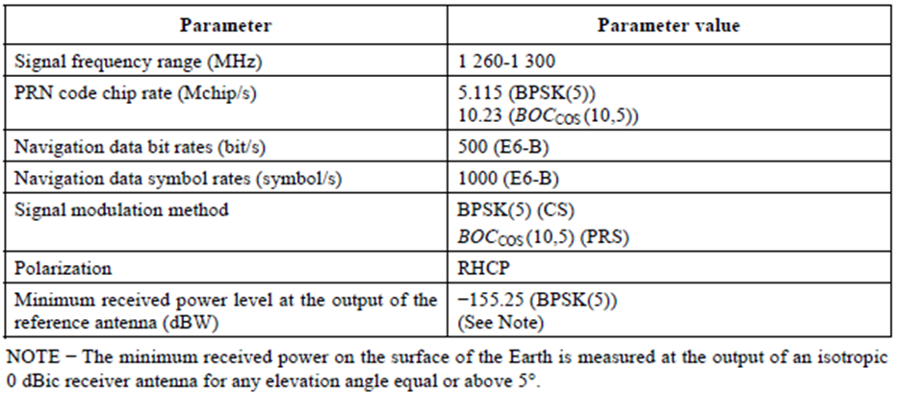

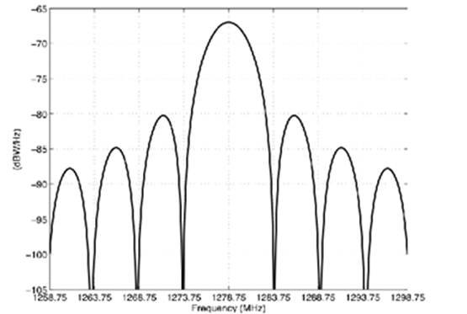

Figure 2: Power Spectral Density (PSD) of the Galileo E6-signal

Methodology

SIMULATIONS

Measurements

Methodology and measurement set-up
GALILEO E6 was represented by super positioning ten E6 signals. One signal served as the victim while the other nine were considered adding white noise to the overall noise floor. The GALILEO ICD defines each CDMA signal at a minimum RF level of -120 dBm at a 0 dBi antenna 1m above the surface of the Earth.
Instead of performing go-no tests to a given threshold, the measurements were performed parametrically, i.e. by applying a wider range of RFI power level while measuring the decrease of the post-correlation C/No of the used GNSS receiver.
The measurement setup, shown in Figure 4, shows two separate signal paths, one for the GALILEO E6B/C signal and one for the variety of pre-defined amateur radio signals (Groups 1-4) which were applied one after the other. Victim and interfering signals from both sides are added at controlled power level and fed into the GNSS receiver.
All receiver input signals are also available to a set of monitoring and measurement equipment (devices 11, 12 and 13). The receiver, like all other active elements in the test set-up, except the RSA, are interconnected and controlled via LAN. Some test cases include a special Interference Suppression Unit (ISU), which is then inserted in front of the GNSS receivers input. Precision step attenuators in both paths enable controlled setting of signal levels. This concept was preferred as it assures reproducible test conditions with direct RF power level.
The signal generating amateur radio equipment was located in a separate room about 10 m apart from the laboratory hosting the GNSS test set-up. All signals were delivered via high performance coaxial cable to enable unambiguous RF power level conditions at the GNSS receiver input. This separation proofed successfully the rejection of radiation that was measurable in the close vicinity of some transmitters.
Details on each source of amateur signals are provided in (4). A commercial GNSS simulator generates GALILEO E6B/C-signals and 10 GPS-L1-C/A signals. The additionally generated GPS L1-signal is used as a time marker. The simulator also adds controlled noise to simulate a defined C/No-condition in the GNSS receiver.
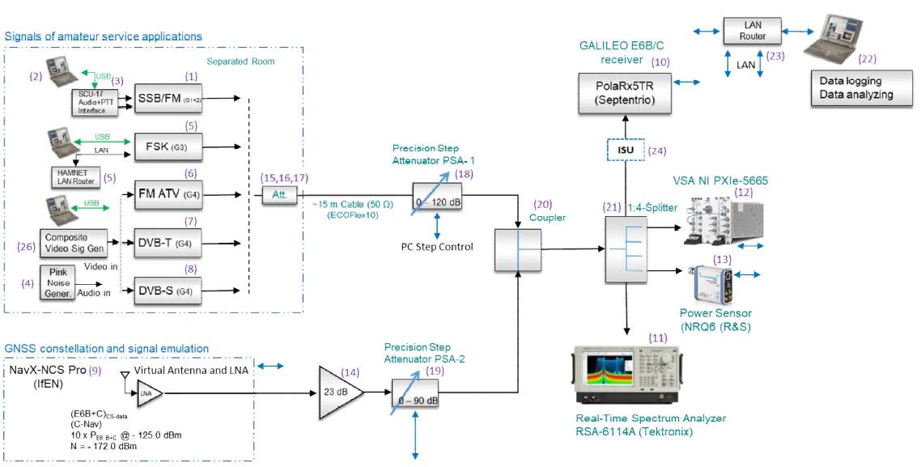
Figure 4: Measurement set-up

Test cases and measurement results

GALILEO E6B probability of bit error conditions under varying C/No

Quantification of interference and options for RFI mitigation

Analysis of protection criteria

[RFI mitigation on GALILEO E6B receiver]

Mitigation in amateur emissions

Statistics of use of band by amateur services (time and location)

Conclusions

- List of ReferenceS
- European Union, “Galileo Open Services Signal in Space Interface Control Document (OS SIS ICD)”; http://ec.europa.eu/growth/sectors/space/galileo/; 2016
- "Compatibility between Amateur Radio Services and Galileo in the 1260-1300 MHz Radio Frequency Band", Issue 1.1, European Commission, Joint Research Centre 2015 (FM44(19)017)
- "Compatibility between Amateur Radio Services and GALILEO in the 1260- 1300 MHz Radio Frequency band". JRC Scientific and Policy Reports, Issue 1.1 2015
- "Coexistence measurements: amateur radio service and Galileo E6 in the frequency range 1260 – 1300 MHz", Measurement report G 001/00261/18 and G 531/00282/18 BNetzA, Germany (FM44(19)017)
- Recommendation ITU-R M.1787-3: Description of systems and networks in the Radio Navigation-Satellite Service (space-to-Earth and space-to-space) and technical characteristics of transmitting space stations operating in the bands 1 164-1 215 MHz, 1 215-1 300 MHz and 1 559-1 610 MHz”, International Telecommunication Union, Geneva, 2018
- The International Amateur Radio Union, IARU Region 1 band plan for 1240 - 1300 MHz (Landshut, 2017); https://iaru-r1.org/index.php/spectrum-andband-plans/uhf/23-centimeter; last accessed: 2019-01-21
- “Binary Offset Carrier Modulations for Radionavigation” John Betz, Journal of the Institute of Navigation (IoN), Vol. 48, No 4, Winter 2001/2002, USA,
- “Effect of Narrowband Interference on GPS Code Tracking Accuracy”, John Betz, ION NTM 2000, 26-28 January 2000, Anaheim, CA
- ”Effect of Partial-Band Interference on Receiver Estimation of C/No: Theory”, J. Betz, MITRE Report, 2006
- “GNSS Disruptions,” in GNSS technology and applications series, Understanding GPS/GNSS: Principles and applications, E. D. Kaplan and C. J. Hegarty, Eds., Boston, London: Artech House, 2017, pp. 549–617
- „A Dual-Frequency Interference Suppression Unit for E1/E5a Designed with National Instruments Software Defined Radios", Kraus T., Sailer S., Eissfeller B., Presentation at ION GNSS+2015, 17.09.2015, Tampa, Florida, USA
- “Modul zur Unterdrückung von Störsignalen für globale Navigationssysteme mit NI SDR”, Kraus T., Sailer S., Eissfeller B., In: R. Jamal, R. Heinze (Hrsg.): Virtuelle Instrumente in der Praxis 2015. Begleitband zum 20. VIP-Kongress, VDE Verlag 2015, pp. 43-46
- "Auswerten von CPU-gestützten Algorithmen zur Störsignalunterdrückung im GNSS-Bereich und FPGA-Implementierung eines SDRs", Sailer S. Diplomarbeit, Hochschule Mittweida, 2015
- COMMISSION IMPLEMENTING DECISION (EU) 2017/224 of 8 February 2017 setting out the technical and operational specifications allowing the commercial service offered by the system established under the Galileo programme to fulfil the function referred to in Article 2(4)(c) of Regulation (EU) No 1285/2013 of the European Parliament and of the Council
- "Galileo E6-B/C Codes" Technical Note; January 2019

