ECC PT1 |  |  | ECC PT1(24)024
ECC PT1 #77
Groningen, Netherlands and online, 23-25 January 2024

Date issued: | 19/01/2024
Source: | EUROCONTROL
Subject: | Study of the impact of IMT on radio altimeters
Group membership required to read? (Y/N) |  | N
Summary:
This study proposes a set of assumptions and a methodology that are relevant to analysis of the potential for interference from MFCN operating in the 3.4–3.8 GHz band on Radio Altimeters (RAs) operating in the 4.2–4.4 GHz band. The results of the study demonstrate that for the parameters and scenarios defined in the draft ECC report on RAs (“Compatibility between MFCN operating in 3400-3800 MHz and Radio Altimeters (RA) operating in 4200-4400 MHz"), it is not possible to conclude that interference will not occur for all MFCN and aircraft operational conditions.
Proposal:
Invites the group to review the assumptions, methodology, and results of this study and to update the contents of Annex 4 of the draft ECC report on RAs with the material herein.
Background:
EUROCONTROL provides an analysis of the potential for interference from MFCN operating in the 3.4–3.8 GHz band on Radio Altimeters operating in the 4.2–4.4 GHz band by considering multiple permutations of assumptions about 5G antenna radiation patterns, RA altitude dependence, and RA antenna angular dependence. The analysis uses the parameter sets and scenario described in the draft ECC report on RAs as inputs and employs a three-dimensional grid to compare MFCN emissions to RA interference thresholds. The analysis results in a set of compatibility maps, which are summarized in “assumption tree” tables covering multiple permutations of the analysis assumptions described above.

Attachment :

Methodology
This section details the methodology considered in this study. This approach consists of a three-dimensional grid-based analysis over which MFCN emissions and RA interference tolerance are compared a discrete points in the grid. The following assumptions are made:
- A three-dimensional rectangular coordinate system grid is established with the origin as the centre point of a runway consistent with the scenario described in §4.
  - The grid is bounded by a deviation distance from the edge of the runway in the x direction (parallel to runway).
  - The grid is bounded by a deviation distance from the runway centreline in the y direction (perpendicular to runway).
  - The grid is bounded by 1000 feet in the z direction.
- Two surfaces are defined within the bounds of the grid described in part a).
  - An aircraft minimum surface (“AMS”) is defined. For this surface it is assumed the aircraft can be positioned at any point at or above a surface defined by the shallowest aircraft glideslope approach to the closest touch-down-point to the runway edge.
    - The aircraft analysis points are defined using independent x, y, and z step sizes.
    - The aircraft x and y coordinates fall on multiples of the respective x and y step sizes.
    - The aircraft z coordinate at any arbitrary x,y coordinate is defined based on the agreed scenario in §4.1.
    - At each aircraft x and y coordinate, the aircraft z coordinate is increased by the z step-size until the upper z-bound is reached.
  - The obstacle limiting surface (“OLS”) or obstacle clearance surface (“OCS”) is defined. For this surface it is assumed that a base station is located at any point on this surface.
    - The base station analysis points are defined using independent x, y, and z step sizes.
    - The base station x and y coordinates fall on multiples of the respective x and y step sizes.
    - The base station z coordinate at any arbitrary x,y coordinate is defined based on the agreed scenario in §4.2.
- A single base station is located at each possible base station (x,y,z) coordinate set and is assessed against an aircraft located at all possible (x,y,z) aircraft coordinates.
  - Given the coordinate-based system, a slant range and angle allow for path loss and antenna gain values to be calculated.
  - The maximum calculated ITT power exceedance from the base station based on the assessment of all possible positions of the aircraft is reported at each base station (x,y,z) location.
- The results are plotted to show a “compatibility” map based on all the assumptions made in the analysis.

Inputs and ASSUMPTIONS

Base Station
This section describes the three different base station antenna scenarios and related assumptions used in this study.
- The first scenario assumes the extended AAS model swept over the operationally typical electrical and mechanical tilt and scan angles then takes the maximum gain at each tilt angle and rotates that about the z-axis. Figure X-1 shows an AAS antenna radiation pattern swept over a range of electrical and mechanical tilt and scan angles, and the figure on the right shows the max gain at each tilt angle rotated about the z-axis.
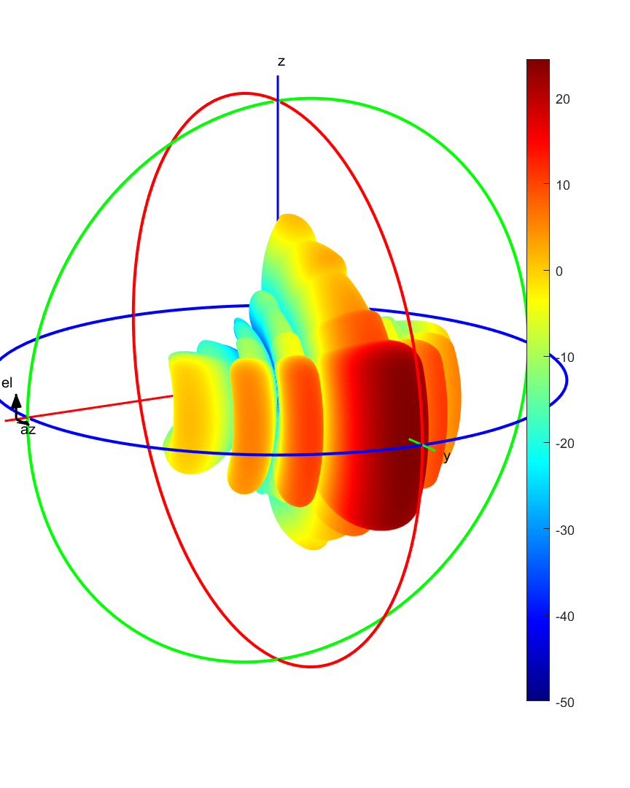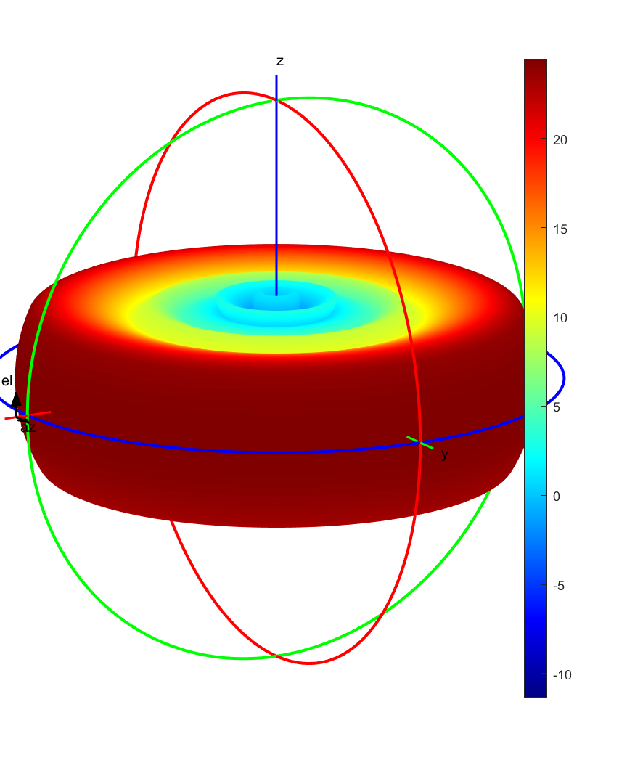
Figure X-1: Example of the “swept AAS model” assumption
- A second scenario assumes that a regulatory EIRP elevation mask is adopted such as that which currently exists in the United States. When this assumption is made, the MFCN antenna pattern is swept over all azimuth and elevation angles subject to the EIRP limits that are defined by the elevation mask parameters above the horizon. Figure X-2 shows an AAS antenna radiation pattern on the left with a representative EIRP elevation mask applied resulting in the plot on the right side of the figure.
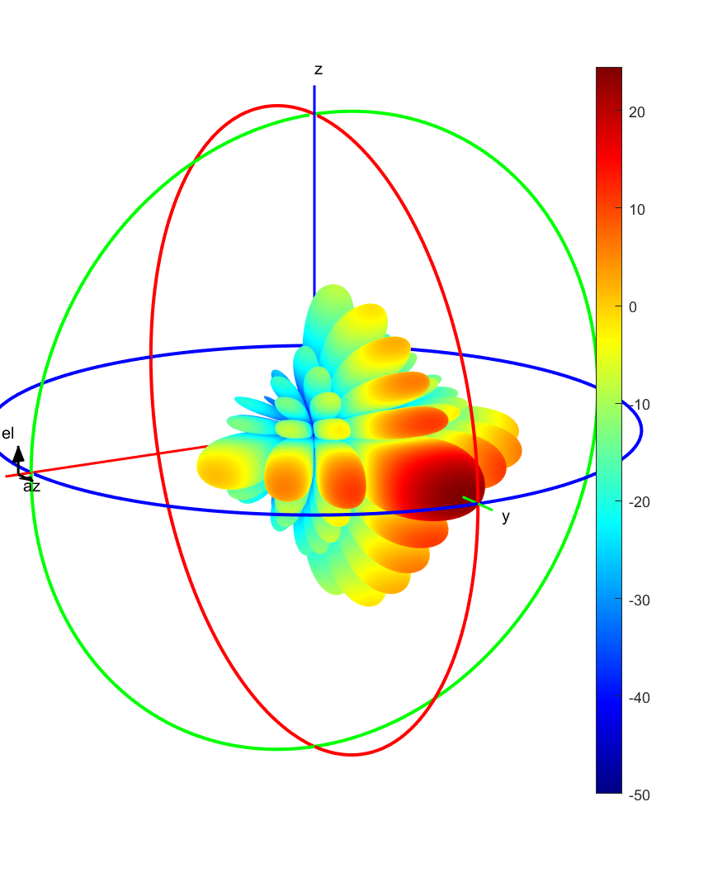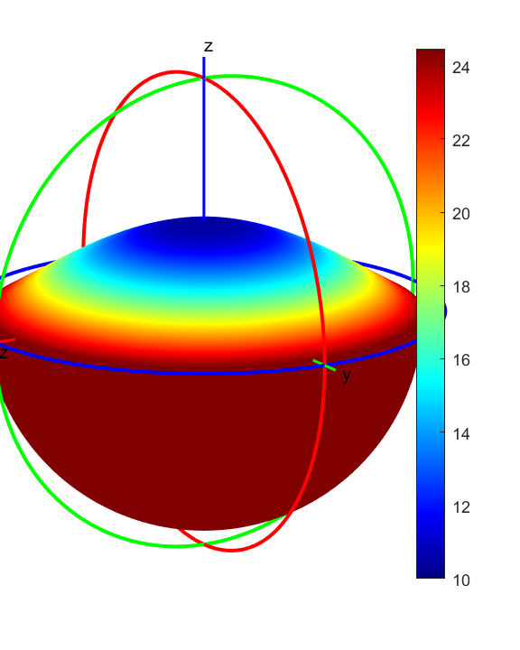
Figure X-2: Example of the “EIRP elevation mask” assumption
- The third scenario reflects the fact that spectrum regulators may not place any regulatory requirement on base station pointing. Without a regulatory requirement, it may be assumed the base station antenna can point at any combination of azimuth and elevation angles. This assumption is reflected by an omni-directional equivalent antenna pattern with the maximum gain determined by the AAS antenna maximum gain. Figure X-3 shows an AAS antenna radiation pattern on the left and the result of applying this assumption shown in the plot on the right side of the figure.
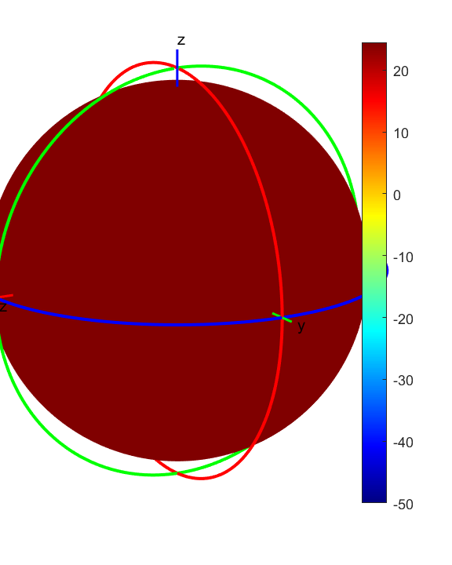
Figure X-3: Example of the “omni-directional equivalent” assumption

Radar Altimeter ITT Assumptions in the 3.4 – 3.8 and 4.2 – 4.4 GHz Band
This study uses both the out-of-band (OOB) and in-band (IB) ITT in the frequency band 3.4 – 3.8 GHz and 4.2 – 4.4 GHz respectively for each RA model considered.
This methodology considers the RA performance at all altitudes in the three-dimension grid and makes assumptions regarding the altitudes where tolerance is not specified in the ITT parameters sets. This study analyses both a log-linear and stair-step for interpolation and stair-step for extrapolation. Figures X-4 and X-5 depict the altitude dependency assumptions.
The stair-step approach provides a conservative approach for considering realistic flight conditions for which data is not available by assuming RA tolerance no worse than that at the data point at the next highest altitude. Figure X-4 illustrates the case for data points specified at 200 ft and 1,000 ft. The breakpoint value specified at 200 ft applies for all altitudes less than or equal to 200 ft, while the value specified at 1,000 ft applies for altitudes greater than 200 ft. No extrapolation above 1,000 ft is considered.

Figure X-4: Example of stair-step interpolation and extrapolation
Figure X-5 shows an example of log-linear interpolation and stair-step extrapolation. This approach provides a less conservative estimate for tolerances at non-specified altitudes based on the assumption that the combination of interference source path loss, RA receiver signal-to-noise, and RA receiver sensitivity can be modelled as a log-linear change in tolerance versus altitude between specified data points for all RA models. Extrapolation below the lowest and above the highest data points use the more conservative stair-step method since the tolerance is not bounded on one end of the range.

Figure X-5: Example of log-linear interpolation and stair-step extrapolation

Radar Altimeter Antenna Assumptions in the 3.4 – 3.8 and 4.2 – 4.4 GHz Band
This study uses the RA antenna patterns discussed in §3.4 in the frequency bands 3.4 – 3.8 and 4.2 – 4.4 GHz. The methodology described herein applies both angular dependence and non-angular dependence assumptions regardless of whether or not the RA antenna performance is specified as a function of angle. Figure X-6 depicts the example plot assuming a RA antenna pattern with peak gain of 0 dBi with no angular dependence. Figure X-7 depicts the example plot assuming a RA antenna pattern with peak gain of 0 dBi and a 60° 3 dB beamwidth.

Figure X-6: Example assumed RA antenna pattern with no specified angular dependence

Figure X-7: Example assumed RA antenna pattern with a 60° 3dB beamwidth

Scenario Parameters
This methodology employs the obstacle limiting surface (OLS) starting at the end of the runway safety area, as illustrated in Figure X-8, to define the location of the MFCN base station antennas. The obstacle limiting surface establishes the z coordinates of the base station based on the assumption that MFCN towers will be no higher than the local OLS height.
Since aircraft must maintain safety in off-normal operations, an aircraft minimum surface (AMS) is also defined that is based on the aircraft’s possible horizontal deviation on the approach path and by the shallowest aircraft glideslope. This methodology assumes the aircraft can be at or above this aircraft minimum surface because the aircraft can deviate horizontally from the approach path, perform a go-around at any point, or approach the runway at various angles to unique touch-down-points.
Figures X-8 and X-9 show the OLS and AMS surfaces overlayed on the same plot at different view angles. These plots provide a visual representation of where a base station is assumed to be located and the minimum surface at which an aircraft is assumed to be located. The left heatmap scale is for the obstacle clearance surface; the right-most heatmap scale is for the aircraft minimum surface. The white area in the centre of each plot represents the obstacle free zone contained within the obstacle clearance surface.

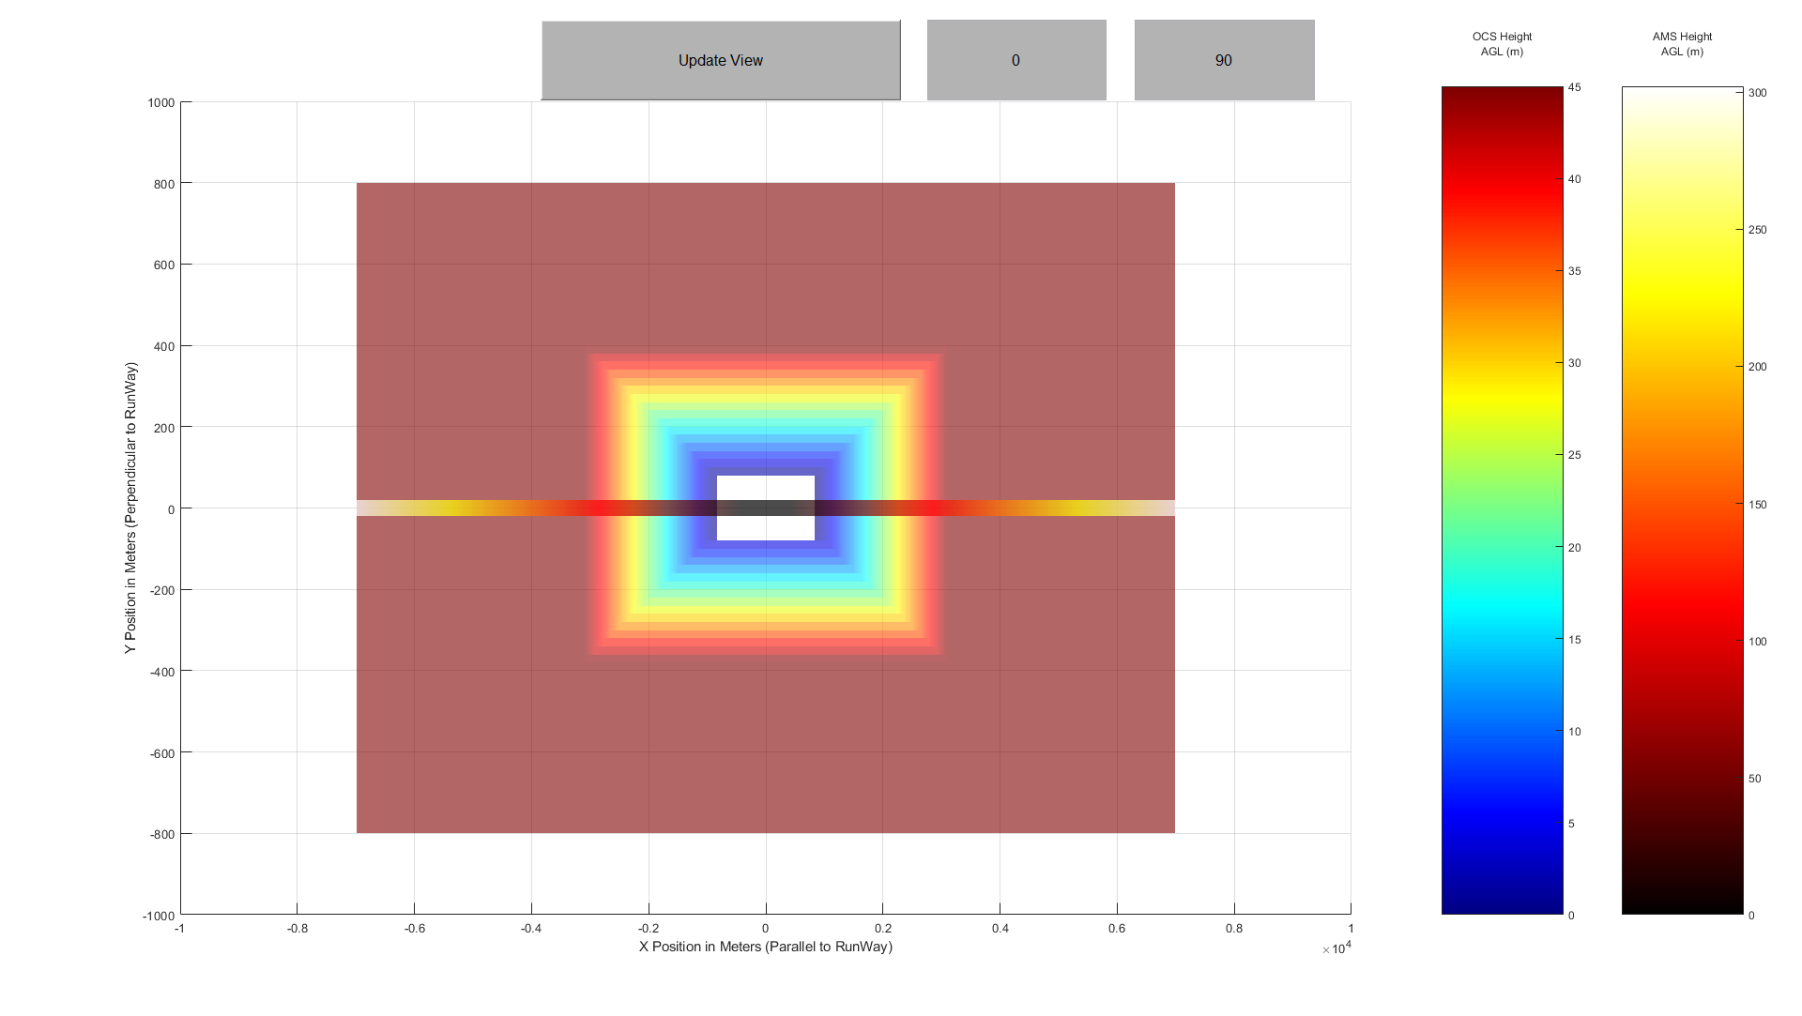
Figure X-8: Example top-down view of the study scenario

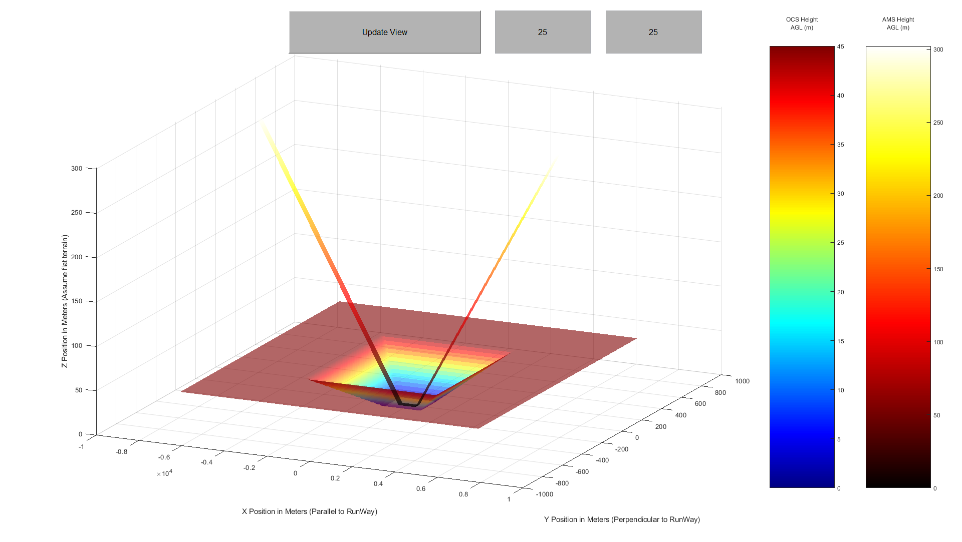
Figure X-9: Example oblique view of the study scenario

Outputs

Compatibility Maps
The code developed for this study outputs a compatibility map necessary determine where and if there is interference. The compatibility map provides a visual representation of the ITT exceedance by a single base station located at any point and is analysed in order to summarize the results of this study. An example compatibility map is provided below to illustrate the methodology, but over 200 maps considering combinations of the assumptions described above were analysed. The results of this analysis are incorporated in the results summary tables in X-4 through X-6, but individual maps have been omitted for brevity.
In the compatibility maps, the origin is the centre of the runway, the x-axis represents the displacement from the runway centre-point in metres parallel to the runway length, the y-axis represents the displacement from the runway centre-point in metres perpendicular to the runway length, the white area in the centre represents the obstacle free zone, and the heat map labelled ‘Margin’ indicates the power level by which the ITT is exceeded if a base station were to be located at that particular x y ordered pair (with the antenna at the OLS height at that point).
Figure X-10 is an example of a possible output, with several random data marks. The data mark at (-2570, 80, -2.90552) indicates that if a base station were to be located 2570 metres offset from the centre-point of the runway in the negative x direction and 80 metres offset from the centre-point in the positive y direction, that the maximum ITT exceedance by the base station will be -2.9 dB based on all the assumptions made in the analysis and considering all the aircraft’s possible positions. In this case, a negative exceedance means that the MFCN signal is less than the tolerance threshold level at the input to the RA transceiver. More succinctly, a base station at this location will not exceed the ITT if operated in accordance with all the assumptions made in the analysis. In contrast, the data mark at (1760, 0, 4.94404) indicates that if a base station were to be located 1760 metres offset from the centre-point of the runway in the positive x direction and 0 metres offset from the centre-point in the positive y direction, that the maximum ITT exceedance by the base station will be +4.9 dB based on all the assumptions made in the analysis and considering all the aircraft’s possible positions. More succinctly, a base station at this location will exceed the ITT if operated in accordance with all the assumptions made in the analysis.
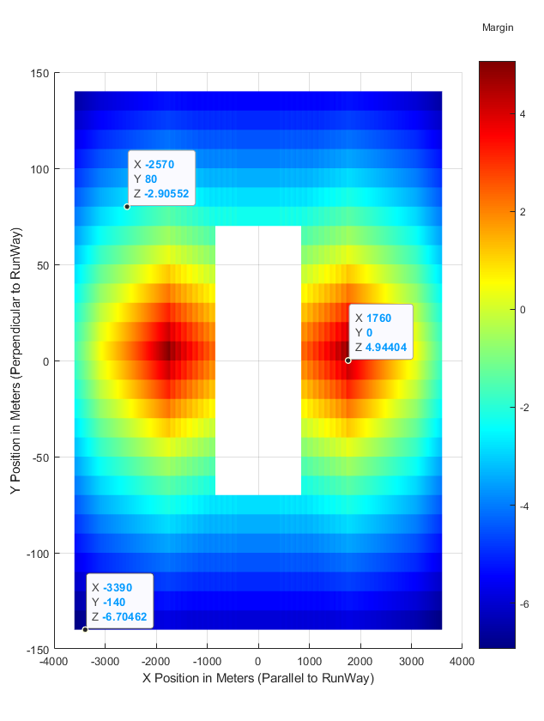
Figure X-10: Example compatibility map output

Results Summary Table
The analysis in the frequency band 3.4–3.8 GHz was performed for parameters defined in two sub-bands (3.4–3.7 GHz and 3.7–3.8 GHz) as identified in Table 9 in Section §3.4.2.1. A summary table is provided for each frequency sub-band studied. Table X-1 illustrates an unpopulated example summary table. The tables provide a concise summary of the results of multiple analyses spanning different permutations of input assumptions. For example, this study is being performed assuming three possible 5G antenna radiation patterns, two RA altitude dependence interpolation/extrapolation methods, and two RA antenna angular dependence methods; consequently, there are a total of 12 unique results. The value in this summary table approach is to show which conditions benefit compatibility and could potentially lead to regulations that help ensure compatibility between the systems.
Table X-1: Example unpopulated summary table
Summary of Results for 3.4 – 3.7 GHz Studies
 | Assumption Tree |  |  | Radio Altimeter Model-Specific ITT Set 1 Parameters |  |  |  |  |  | Radio Altimeter ITT Set 2 Parameters
Assumption Tree | 5G Antenna Radiation Pattern | RA Altitude Dependence | RA Antenna Angular Dependence | F | L | T | X | U | Y | Radio Altimeter ITT Set 2 Parameters
Assumption Tree | Omni-directional equivalent  (58 dBm/MHz) | Stair-step | No
Assumption Tree | Omni-directional equivalent  (58 dBm/MHz) | Stair-step | Yes
Assumption Tree | Omni-directional equivalent  (58 dBm/MHz) | Log-Lin | No
Assumption Tree | Omni-directional equivalent  (58 dBm/MHz) | Log-Lin | Yes
Assumption Tree | Elevation Mask (US Proposal) | Stair-step | No
Assumption Tree | Elevation Mask (US Proposal) | Stair-step | Yes
Assumption Tree | Elevation Mask (US Proposal) | Log-Lin | No
Assumption Tree | Elevation Mask (US Proposal) | Log-Lin | Yes
Assumption Tree | AAS Model: Scan Range of +15 to -20 degrees about local horizon | Stair-step | No
Assumption Tree |  | Stair-step | Yes
Assumption Tree |  | Log-Lin | No
Assumption Tree |  | Log-Lin | Yes
The results in the table are presented in one of the following formats: “(Number1) x (Number2)”, “NI”, “NDA”, or “Inconclusive”.
- The “(Number1) x (Number2)” format indicates that the RA ITT was calculated to be exceeded by any amount of margin at points “(Number1)” metres beyond the edge of the runway in the length or x direction and “(Number2)” metres beyond the runway centreline in the width or y direction. The reported “(Number1)” value is the x value calculated in the compatibility map minus half of the total runway length assumed for that analysis. “(Number1)” is reported in this manner because this normalizes the result for all possible runway length assumptions. Figures X-11 and X-12 depict the compatibility maps using two arbitrary sets of inputs that are identical except for the runway length parameter. Figure X-11 assumes a runway length of 1200 metres and Figure X-12 assumes a runway length of 2400 metres. Because the “(Number1)” result is the distance in metres beyond the edge of the runway in the length direction, the result reported for both figures would be identical indicating the result as “7050 x 640”. It is acknowledged that airports serving commercial air transport airplanes typically have much longer runways than 1200 metres. However, since the results are normalized, the runway length assumption in this study will not alter the result. The “(Number2)” result is similarly normalized for the runway width. These results will be indicated in a red colour.
- The “NI” result indicates there was no interference calculated using the assumptions. In other words, every point in the three-dimensional grid analysed resulted in an RA ITT margin exceedance of 0 or less. These results will be indicated in a green colour.
- The “NDA” result indicates no data was available to perform a study and therefore there is no result. These results will be indicated in a grey colour.
- The “Inconclusive” result indicates that this study was performed using the agreed RA parameters, but there was insufficient data available to draw any valid conclusion. For example, if an RA model did not observe a breakpoint in testing and the highest power tested was -30 dBm/MHz, then this study is performed using the -30 dBm/MHz value. If the study output indicates there will be interference, this is an “Inconclusive” result because no actual breakpoint was observed. However, if the study indicates there is no interference, the result is conclusive and reported as “NI”. These results will be indicated in a yellow colour.
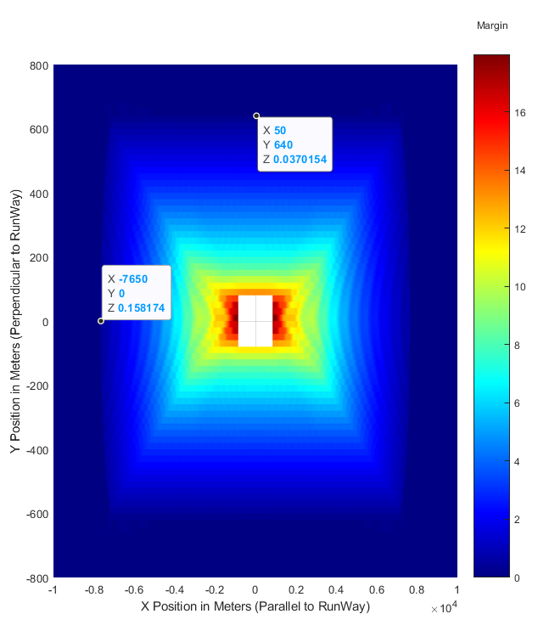
Figure X-11: Example compatibility map with runway length of 1200 metres
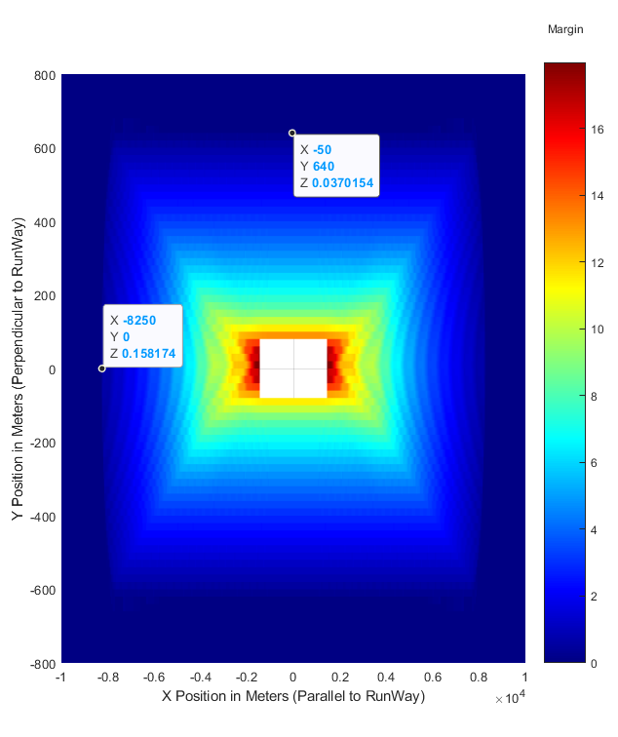
Figure X-12: Example compatibility map with runway length of 2400 metres

Study RESULTS USING SET 1 and SET 2 PARAMETERS

5G MFCN antenna Assumptions for 3.3 to 3.8 GHz
Table X-2 provides all the variables considered to generate the base 5G antenna radiation pattern. Figure X-13 is one of the 5G antenna radiation patterns assumed in this study.
Table X-2: MFCN antenna radiation parameters used in this study
Parameter | Value | Units
Radiated Power | 58 | dBm/MHz
Vertical Element Count | 8
Horizontal Element Count | 8
Vertical 3 dB bandwidth | 65 | Degrees
Horizontal 3 dB bandwidth | 90 | Degrees
Vertical Element Spacing | 70 | percent of Wavelength
Horizontal Element Spacing | 50 | percent of Wavelength
Front-to-back Ratio | 30 | dB
Sidelobe Ratio | 30 | dB
Max Single Element Gain | 6.4 | dBi
Step Size Between Angles | 0.5 | degrees
Azimuth Angle Range | ±90 | degrees
Elevation Angle Range | 0 to 180 | degrees
Electrical Tilt Angle Range | 15 above; 20 Below | degrees About Local Horizon
Electrical Scan Angle Range | 0 | degrees About Local Horizon
Mechanical Tilt Angle Range | 0 ; 10 Below | degrees About Local Horizon
Mechanical Scan Angle Range | 0 | degrees About Local Horizon
Figure X-13: Swept MFCN antenna gain profile used in this study
Equation X-1 models the 5G antenna radiation pattern of Figure X-14 closely but not identically as a function of the elevation angle (in degrees) above the horizontal plane at phase centre of the base station antenna. Equation X-1 is later used when drawing conclusions regarding this study. Equation X-1 would benefit from refinement to model the 5G antenna gain attenuation behaviour above the horizontal plane more closely.
$G_{5G}\left(θ\right)=$ $24.5$ for $θ≤0$
$\frac{θ^{6}}{5*{10}^{9}}-\frac{θ^{5}}{4*{10}^{6}}+\frac{θ^{4}}{1.4*{10}^{3}}-\frac{θ^{3}}{2.3*10}+22.2*θ^{2}-1107.3*θ+22636$ for $θ>0$
Equation X-1
Where: $G_{5G}$ is the 5G antenna radiation pattern (in dBi) as a function of elevation angle (in degrees)
$θ$ is the elevation angle (in degrees) above the horizontal plane at phase centre of the base station antenna.
Another 5G antenna radiation pattern assumed in this study considers the maximum gain of the radiation pattern depicted in Figure X-13 and applies an already adopted elevation attenuation mask utilized in the United States. The maximum gain was calculated to be 24.5 dBi, and Equation X-2 is considered as the elevation attenuation mask.
$G_{5G}\left(θ\right)=$ $24.5$ for $θ≤0$
$24.5+20* \log_{10}\left(1/{\sin\left(θ+11.5\right)}\right)-14$ for $θ>0$
Equation X-2
Equation X-2 results in the radiation pattern depicted in Figure X-14.
Figure X-14: Masked MFCN antenna gain profile used in this study
The final 5G antenna radiation pattern assumed in this study considers the maximum gain of Figure X-13 at any azimuth elevation pointing angle combination. The result is a 24.5 dBi omni-directional equivalent antenna depicted in Figure X-15.
Figure X-15: Omni-directional equivalent MFCN antenna gain profile used in this study

5G MFCN antenna Assumptions for 4.2 to 4.4 GHz
This study assumes an omni-direction equivalent radiation pattern of -13 dBm/MHz for the 5G MFCN antenna for the frequency range of 4.2 to 4.4 GHz.

Radar Altimeter Assumptions for 3.4 to 3.8 GHz
The RA parameters discussed in §3.4 of the main report are considered in this study and the methodology described in §1.1.2 and 1.1.3 of this annex is applied to those parameters. This study also always applies an ICAO safety margin of 6 dB.

Scenario Parameters
The runway safety area and obstacle limiting surface detailed in §4 of the main report are considered in this study and the methodology described in §1.1.4 of this annex is applied to those parameters. Table X-3 lists the parameters and associated values specifically used as inputs when completing this study.
Table X-3: Scenario parameters used in this study
Parameter | Value | Units
Runway Length¹ | 1200 | m
Runway Width¹ | 140 | m
Touch-down-point Distance from Runway End | 200 | m
Analysis Distance Beyond Runway Length | Variable | m
Analysis Distance Beyond Runway Centreline | Variable | m
Base Station Step Size in Length (x) Direction | Variable | m
Base Station Step Size in Width (y) Direction | Variable | m
Aircraft Position Step Size in Length (x) Direction | Variable | m
Aircraft Position Step Size in Width (y) Direction | Variable | m
Aircraft Position Step Size in Altitude (z) Direction | Variable | m
Runway Safety Area Length Parameter² | 240 | m
Runway Safety Area Width Parameter³ | 140 | m
Obstacle Limiting Surface Angle in the Length Direction⁴ | 1.146 | degrees
Obstacle Limiting Surface Angle in the Width Direction⁴ | 8.138 | degrees
Aircraft Approach Angle | 2.625 | degrees
Aircraft Horizontal Deviation⁵ | 30 | m
Aircraft Pitch and Roll Range | 0 | degrees
Note ¹: The runway length and width do not impact the result of this study. See §1.3 of this annex for further clarification.
Note ²: The runway safety area length parameter is the distance beyond the edge of the runway bounding the runway safety area. See §4.2 of the main report for further clarification.
Note ³: The runway safety area width parameter is the distance beyond centreline of the runway bounding the runway safety area. See §4.2 of the main report for further clarification.
Note ⁴: See §4.2 of the main report for further clarification.
Note ⁵: This study assumes the aircraft upon approach can deviate horizontally from the approach path by an amount no larger than the “Aircraft Horizontal Deviation” parameter.

Results Summary
The results of this study are summarized in Tables X-4 through X-6.
Table X-4: 3.4 – 3.7 GHz Summary Table
Summary of Results for 3.4 - 3.7 GHz Study (Distance Beyond Edge of Runway and Centreline in Metres ITT will be exceeded)
 | Assumption Tree |  |  | Radio Altimeter ITT Model Specific Set 1 Parameters |  |  |  |  |  | Radio Altimeter ITT Set 2 Parameters
Assumption Tree | 5G Antenna Radiation Pattern | RA Altitude Dependence | RA Antenna Angular Dependence | F | L | T | X | U | Y | Radio Altimeter ITT Set 2 Parameters
Assumption Tree | Omni-directional equivalent  (58 dBm/MHz) | Stair-step | No | 5800 x 260 | NI | Inconclusive | Inconclusive | Inconclusive | NDA | 7900 x 1500
Assumption Tree | Omni-directional equivalent  (58 dBm/MHz) | Stair-step | Yes | 5800 x 120 | NI | Inconclusive | Inconclusive | Inconclusive | NDA | 6800 x 375
Assumption Tree | Omni-directional equivalent  (58 dBm/MHz) | Log-Lin | No | 5700 x 200 | NI | Inconclusive | Inconclusive | Inconclusive | NDA | 7900 x 1450
Assumption Tree | Omni-directional equivalent  (58 dBm/MHz) | Log-Lin | Yes | 5700 x 100 | NI | Inconclusive | Inconclusive | Inconclusive | NDA | 6800 x 375
Assumption Tree | Elevation Mask (US Proposal) | Stair-step | No | 2900 x 240 | NI | Inconclusive | Inconclusive | Inconclusive | NDA | 7900 x 1500
Assumption Tree | Elevation Mask (US Proposal) | Stair-step | Yes | 1300 x 40 | NI | Inconclusive | Inconclusive | Inconclusive | NDA | 6600 x 250
Assumption Tree | Elevation Mask (US Proposal) | Log-Lin | No | 2400 x 200 | NI | Inconclusive | Inconclusive | Inconclusive | NDA | 7900 x 1450
Assumption Tree | Elevation Mask (US Proposal) | Log-Lin | Yes | 775 x 40 | NI | Inconclusive | Inconclusive | Inconclusive | NDA | 6600 x 125
Assumption Tree | AAS Model: Scan Range of +15 to -20 degrees about local horizon | Stair-step | No | 2050 x 240 | NI | Inconclusive | Inconclusive | Inconclusive | NDA | 7900 x 1475
Assumption Tree |  | Stair-step | Yes | NI | NI | NI | NI | NI | NDA | 2100 x 150
Assumption Tree |  | Log-Lin | No | 1150 x 200 | NI | Inconclusive | Inconclusive | Inconclusive | NDA | 7900 x 1375
Assumption Tree |  | Log-Lin | Yes | NI | NI | NI | NI | NI | NDA | 900 x 90
Table X-5: 3.7 – 3.8 GHz Summary Table
Summary of Results for 3.7 - 3.8 GHz Study (Distance Beyond Edge of Runway and Centreline in Metres ITT will be exceeded)
 | Assumption Tree |  |  | Radio Altimeter ITT Model Specific Set 1 Parameters |  |  |  |  |  | Radio Altimeter ITT Set 2 Parameters
Assumption Tree | 5G Antenna Radiation Pattern | RA Altitude Dependence | RA Antenna Angular Dependence | F | L | T | X | U | Y | Radio Altimeter ITT Set 2 Parameters
Assumption Tree | Omni-directional equivalent  (58 dBm/MHz) | Stair-step | No | 7100 x 700 | NI | Inconclusive | Inconclusive | Inconclusive | 7200 x 800 | 7900 x 1500
Assumption Tree | Omni-directional equivalent  (58 dBm/MHz) | Stair-step | Yes | 6600 x 225 | NI | Inconclusive | Inconclusive | Inconclusive | 6700 x 275 | 6800 x 375
Assumption Tree | Omni-directional equivalent  (58 dBm/MHz) | Log-Lin | No | 7100 x 650 | NI | Inconclusive | Inconclusive | Inconclusive | 7200 x 750 | 7900 x 1450
Assumption Tree | Omni-directional equivalent  (58 dBm/MHz) | Log-Lin | Yes | 6600 x 225 | NI | Inconclusive | Inconclusive | Inconclusive | 6700 x 275 | 6800 x 375
Assumption Tree | Elevation Mask (US Proposal) | Stair-step | No | 7100 x 700 | NI | Inconclusive | Inconclusive | Inconclusive | 7200 x 800 | 7900 x 1500
Assumption Tree | Elevation Mask (US Proposal) | Stair-step | Yes | 3900 x 150 | NI | Inconclusive | Inconclusive | Inconclusive | 5400 x 175 | 6600 x 250
Assumption Tree | Elevation Mask (US Proposal) | Log-Lin | No | 7100 x 625 | NI | Inconclusive | Inconclusive | Inconclusive | 7200 x 750 | 7900 x 1450
Assumption Tree | Elevation Mask (US Proposal) | Log-Lin | Yes | 3400 x 100 | NI | Inconclusive | Inconclusive | Inconclusive | 3600 x 100 | 6600 x 125
Assumption Tree | AAS Model: Scan Range of +15 to -20 degrees about local horizon | Stair-step | No | 5300 x 700 | NI | Inconclusive | Inconclusive | Inconclusive | 5800 x 800 | 7900 x 1475
Assumption Tree |  | Stair-step | Yes | NI | NI | NI | NI | NI | NI | 2100 x 150
Assumption Tree |  | Log-Lin | No | 4800 x 580 | NI | Inconclusive | Inconclusive | Inconclusive | 5000 x 600 | 7900 x 1375
Assumption Tree |  | Log-Lin | Yes | NI | NI | NI | NI | NI | NI | 900 x 90

Table X-6: 4.2 – 4.4 GHz Summary Table
Summary of Results for 4.2 - 4.4 GHz Study (Distance Beyond Edge of Runway and Centreline in Metres ITT will be exceeded)
 | Assumption Tree |  |  | Radio Altimeter ITT Model Specific Set 1 Parameters |  |  |  |  |  | Radio Altimeter ITT Set 2 Parameters
Assumption Tree | 5G Antenna Radiation Pattern | RA Altitude Dependence | RA Antenna Angular Dependence | F | L | T | X | U | Y | Radio Altimeter ITT Set 2 Parameters
Assumption Tree | Omni-directional equivalent  (-13 dBm/MHz) | Stair-step | No | 2700 x 100 | 1800 x 80 | NI | 5900 x 240 | NI | 2500 x 90 | 2700 x 100
Assumption Tree | Omni-directional equivalent  (-13 dBm/MHz) | Stair-step | Yes | 2700 x 50 | 1800 x 40 | NI | 5900 x 100 | NI | 2500 x 50 | 2700 x 50
Assumption Tree | Omni-directional equivalent  (-13 dBm/MHz) | Log-Lin | No | 300 x 20 | 800 x 50 | NI | NI | NI | NI | 1600 x 80
Assumption Tree | Omni-directional equivalent  (-13 dBm/MHz) | Log-Lin | Yes | 300 x 20 | 800 x 40 | NI | NI | NI | NI | 1600 x 40

Conclusions
The results of this study indicate that when considering the twelve combinations of assumptions for the 3.4 – 3.7 GHz and 3.7 – 3.8 GHz bands, the four combinations of assumptions for the 4.2 – 4.4 GHz band, and the reference scenario, that no combination of any assumption yields a conclusive interference-free environment simultaneously for all the studied radio altimeters. For both radio altimeter parameter Set 1 and Set 2 and the reference scenario, the study results do not support a conclusion that existing radio altimeters and existing/proposed MFCN implementations are compatible.
The results of this study vary depending on the considered radio altimeter model and assumptions, but this variability cannot be considered independently when defining a harmonised regulatory framework related to spectrum usage. Consequently, a credible aviation safety analysis requires the use of radio altimeter parameter Set 2 because it more accurately reflects the full set of radio altimeters currently in operation.
The radio altimeter parameter Set 2 results demonstrate that when using radio altimeter parameters more operationally relevant to aviation safety, for every combination of assumptions used in this study, the radio altimeter ITT is exceeded by some amount. Using the most demanding set of assumptions (i.e., an omni-directional equivalent MFCN radiation pattern of 58 dBm/MHz, a MFCN -13 dBm/MHz spurious emission limit in the 4.2 – 4.4 frequency range, a stair-step RA ITT altitude dependence, and an omni-directional equivalent RA antenna dependence), the minimum distance needed to ensure protection is 7900 metres beyond the edge of the runway in the length, or x direction, and 1500 metres beyond the runway centreline in the width, or y direction (see Table X-5 Radio Altimeter ITT Set 2 Parameters).
Aviation safety dictates that Set 2 must be the sole reference for any future studies. Furthermore, it must be noted that the radio altimeter antenna systems are not standardized nor designed to exhibit the angular dependence assumption. It must also be noted that the radio altimeters are not standardized nor designed to exhibit a log-linear ITT altitude dependence. For these reasons alone, the results under this set of assumptions should not be considered as conclusive of compatibility between the systems.

