ECC Report <No>

Review of the characterisation of the unwanted emissions to achieve a more efficient use of the spectrum
Approved DD Month YYYY (Arial 9pt bold)
[last updated: DD Month YYYY) (Arial 9pt) [date of the latest update]]

Executive summary
Body text (style: ECC Paragraph)

TABLE OF CONTENTS

0 Executive summary 2
1 Introduction 5
2 Definitions from radio regulatons 6
3 Definitions 7
4 boundary questions 8
5 unwanted emissions in the out-of-band domain 9
6 unwanted emissions in Sporious domain 10
7 Examples of unwanted emissions 11
7.1 Communications Services 11
7.1.1 Mobile devices in the 406-430 MHz band 11
7.1.2 Mobile devices in the 800 MHZ band 11
7.1.3 Mobile devices in the 2.6 GHZ band 11
7.1.4 Mobile/Fixed devices in the 3.4 GHz band 13
7.1.5 RLAN devices in the 2.4 GHz band 13
7.1.6 Radiodetermination in 2.7 GHz band 15
7.1.7 SRD in 122-123 GHz frequency band 15
7.1.8 BDA2GC 16
8 Discussion 17
9 Proposal 18
ANNEX 1: the results from german measurement campain 19
ANNEX 2: Categories of spurious domain emission limits defined in Recommendation ITU-R SM.329 20
ANNEX 3: List of reference 22

LIST OF ABBREVIATIONS

Abbreviation | Explanation (style: Arial 10pt bold red (colour values RGB: 210, 35, 42)
CEPT | European Conference of Postal and Telecommunications Administrations
ECC | Electronic Communications Committee
<abbr> | <explanation – edit the table as necessary>

Introduction
The limits of the unwanted emissions are important parameters in the standardisation of radio systems and for the estimation of the compatibility between different radio systems operating in adjacent or the same frequency ranges. The unwanted emissions are classified into two domains the Out-of-Band (ITU-R SM.1541) and spurious domains (ERC REC 74-01, ITU-R SM.329). This report is addressing both domains the OOB domain and spurious domain with particular focus on the wideband systems.
The definitions for unwanted emissions and their limits are provided in Section 2. The regulatory limits are defined to address a maximum allowed unwanted emission and these maximum allowed limits should be considered to be the norm when carrying out compatibility analysis. But often the assumed values will be derived more from the real emissions or measurements especially if digital systems are involved.
The definitions and descriptions for unwanted emissions in the spurious domain (see Annexes 1 and 2) are mainly based on analogue technologies which are and were very sensitive to spikes especially in the frequency domain. New digital, broadband technologies could deal with this type of interference (narrow frequency domain spikes) more easily. For example, only a very small number of sub-carriers may be impaired in an OFDM system.
Therefore, consideration should be given to the current characterisation of unwanted emission and its continuing adequacy, or is there a need for a more detailed characterisation to enable more efficient spectrum usage in the future? For example, the unwanted emission could be characterised by two different limits, one for narrow frequency domain spikes like harmonics and one for the generic noise floor or reference baseline level which would be significantly lower when measured over a much wider bandwidth.
Further careful studies are needed before implementing any changes to the current regime as implementing a new regime will impact significantly the methods used in sharing and compatibility analysis. There will also be impacts on both the methodologies used and the framework used for setting the requirements and measurement techniques used in standards.
It is not intended to relax the existing unwanted limits but to use the spectrum in a more efficient way in the spurious domain.

In recent studies the limits for Spurious Emissions have been interpreted in different ways when used in various sharing and compatibility studies. This may be because the contributors have assumed that the spurious emissions are noise like interference which result in a straight line signal at or just below the spurious emission limit quoted in the regulations. This seems to be the case particularly for studies looking at the effect that mobile broadband services and consumer devices may have on adjacent services. However, the measured values of real radio equipment are considerably below these regulatory limits as illustrated in Section 3.
Although these limits are under constant review we believe that it is a suitable time to re-consider how these limits are presented. Advances in broadband technology have resulted in significantly different signal characteristics and mass produced chip sets for a global market. This may result in identical or similar digital filtering being used in a number of applications in other areas and this should be taken into account.
Therefore taking into account the rapid development of technology and the growing demand for additional spectrum for the various services, it is necessary to consider a better characterisation of the unwanted emissions as an appropriate and adequate description to achieve the most efficient spectrum usage in the long-term.

Definitions from radio regulatons
Term | Definition
out-of-band emission (1.144) | Emission on a frequency or frequencies immediately outside the necessary bandwidth which results from the modulation process, but excluding spurious emissions.
spurious emission (1.145) | Emission on a frequency or frequencies which are outside the necessary bandwidth and the level of which may be reduced without affecting the corresponding transmission of information. Spurious emissions include harmonic emissions, parasitic emissions, intermodulation products and frequency conversion products, but exclude out-of-band emissions.
unwanted emissions (1.146) | Consist of spurious emissions and out-of-band emissions.
out-of-band domain (of an emission) (1.146A) | The frequency range, immediately outside the necessary bandwidth but excluding the spurious domain, in which out-of-band emissions generally predominate. Out-of-band emissions, defined based on their source, occur in the out-of-band domain and, to a lesser extent, in the spurious domain. Spurious emissions likewise may occur in the out-of-band domain as well as in the spurious domain. (WRC-03)
spurious domain (of an emission) (1.146B) | The frequency range beyond the out-of-band domain in which spurious emissions generally predominate. (WRC-03)
necessary bandwidth (1.152) | For a given class of emission, the width of the frequency band which is just sufficient to ensure the transmission of information at the rate and with the quality required under specified conditions.

Definitions
The relevant definitions for unwanted emission and the spurious domain are contained in the Articles Nos. 1.144 to 1.146 of the Radio Regulations (RR) (see also Annex 1).
The related limits, bandwidths and measurement ranges are provided in Recommendation ITU-R SM.329. The relevant parts are extracted in Annex 2.

boundary questions

unwanted emissions in the out-of-band domain

unwanted emissions in Sporious domain

Examples of unwanted emissions
[Some of the examples of measured unwanted emission shown in this section illustrate the spurious emissions in the band 2 700-3 100 MHz used for the radiodetermination service generated by mobile services in the bands below 2 690 MHz and in the 3.4 GHz band, and vice versa spurious emissions caused by a radar system operating in the 2 700-2 900 MHz band. Noting between the mobile service below 2690 MHz and radar above 2 700 MHz, there is 10 MHz allocated to Radio Astronomy, so that for compatibility studies between both services the unwanted emissions in the spurious domain are the relevant parameters.]

Communications Services

Mobile devices in the 406-430 MHz band

Mobile devices in the 800 MHZ band
Editor’s note: Proposal to look into spurious emissions in 790-862 MHz bands from SRDs and LTE into SRD band

Mobile devices in the 2.6 GHZ band

Editors note: Measurements are to be put in the annex, only the representative cases will stay in the main text

The following Figures 1 and 2 show a snapshot of conducted measurements of unwanted emissions for a production line 2.6 GHz LTE mobile service terminals with following characteristics:
Table 1: Characteristics of the system measured
Description | 2.6 GHz LTE User Station
Declared Output Power: | 23 dBm Conducted
Tx Frequency Range: | 2 500 to 2 570 MHz
System Bandwidths Tested: | 20 MHz and 5 MHz

- Figure 1: – UE 2.6 GHz LTE production device – conducted emissions 20 MHz

[Looking at in radar band spurious emissions (to the right of 1st red marker line), spurious emission limit for UE/BS in land mobile service in accordance with Table 2.1 of ERC Rec. 74-01 [3] is -30 dBm, figure shows worst case measurement in spurious domain approx. -85 dBm/MHz.
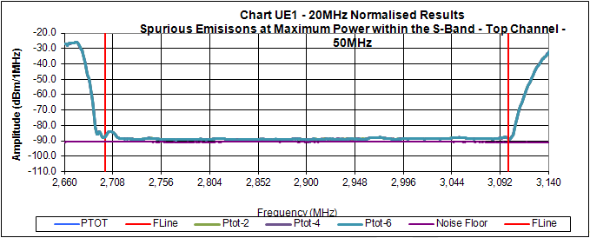
Figure 1: Emissions in radar frequency band (between red markers) – for 20 MHz

- Figure 2: – UE 2.6 GHz LTE production device – conducted emissions 5 MHz

Looking at in radar band spurious emissions (to the right of 1st red marker line), spurious emission limit for UE/BS in land mobile service in accordance with Table 2.1 of ERC Rec. 74-01 [3] is -30 dBm, figure shows worst case measurement in spurious domain approx. -85 dBm/MHz.

Figure 2: UE - Emissions in radar frequency band (between red markers) - 5 MHz]

Mobile/Fixed devices in the 3.4 GHz band
The following Figure shows conducted measurements of unwanted emissions for a production line 3.4 GHz WiMAX terminal with following characteristics:

Table 2: Characteristics of the system measured
Description | 3.4 GHz WiMAX User Station
Declared Output Power: | 27 dBm/10 MHz
Tx Frequency Range: | 3 600 MHz to 3 800 MHz
System Bandwidths Tested: | 10 MHz

- Figure 3 – production device – conducted emissions 10 MHz

Looking at in radar band spurious emissions (to the right of red marker line), spurious emission limit for UE/BS in land mobile service in accordance with Table 2.1 of ERC Rec. 74-01 [3] is -30 dBm, figure shows worst case measurement in spurious domain approx. -70 dBm/MHz

Figure 3: UE 3.4 GHz WiMAX - Emissions in radar frequency band (between red markers) - 10 MHz

RLAN devices in the 2.4 GHz band
The following Figure shows conducted measurements of unwanted emissions for a production line 2.4 GHz RLAN terminal with following characteristics:

Figure 4: Characteristics of the system measured
Description | 2.4 GHz RLAN Access Point
Declared Output Power: | 20 dBm
Tx Frequency Range: | 2 400–2 483 MHz
System Bandwidths Tested: | 20 MHz

- Figure 4 – Production device – conducted emissions

Looking across the 2 700-3 100 MHz radar band spurious domain, spurious emission limit is for RLAN in accordance with Table 2.1 of ERC Rec. 74-01 [3] -30 dBm, figure shows worst case measurement in spurious domain approx. - 65 dBm/MHz.

Figure 5: 2.4 GHz AP Emissions in radar frequency band (between red markers) - 20 MHz

The limit for unwanted emission in the spurious domain for the mobile service is -30 dBm/MHz. This limit is met over the whole frequency range for radar systems (2 700-3 100 MHz).
It can be noted from Figures 1 to 4 that the real spurious emissions for different production model broadband technologies operating around the radar frequency ranges 2 700–3 100 MHz are far below the -30 dBm/MHz limit. The noise floor measured for these devices in the radar services band 2 700–3 100 MHz varies between approx. -65 to -85 dBm/MHz, which is 35 to 55 dB below the spurious limit for the band.

Radiodetermination in 2.7 GHz band
This example shows the unwanted emission of an air traffic control radar system with two centre frequencies of 2 765 and 2 885 MHz. The maximum signals are normalized to 0 dBm/MHz. Typical power levels of such radars are in the order of 56 to 60 dBW and the antenna gain is in the range of 30 to 45 dBi.
The unwanted emission limit for this type of radar in accordance with Table 5.1 of ERC Rec. 74-01 [3] is -60 dBc (marked red). A few spikes reach this limit. The noise floor is about 40 dB below.

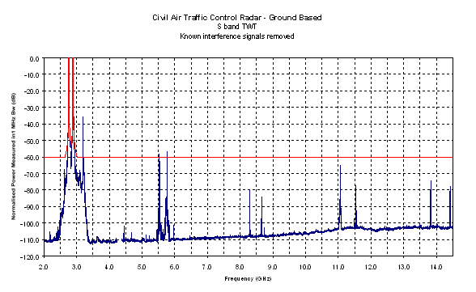

Figure 6: Unwanted emission of an air traffic control radar system

SRD in 122-123 GHz frequency band

Editors note: text is from SE24 document xx, it has to be checked and revised
[According to ERC Recommendation 74-01 and EN 305 550, unwanted emissions in the spurious domain of SRD operating in the 122-123 GHz are set to -30 dBm/MHz.
Within the EESS (passive) reference bandwidth of 200 MHz, this is hence corresponding to a -17 dBm/200 MHz power density, on top of which possible SRD antenna gain will have to be considered.
Therefore, a relevant assessment of SRD antenna gain together with SRD density will have to be performed before considering that such spurious level could be sufficient to ensure protection of EESS (passive).
In addition, EN 305 550 specifies the unwanted emissions in the spurious domain as “those at frequencies beyond the limit of 250 % of the necessary bandwidth above and below the centre frequency of the emission”.
However, EN 305 550 seems currently silent on the “out-of-band” domain, i.e from 50% up to 250% of the necessary bandwidth in which one can expect higher emission levels.
Unlike relatively small bandwidth, this unknown situation related to OOB emissions could become an issue for SRD making use of large bandwidth for which the 250% bandwidth can hence extend far within the EESS (passive) band, even below 122 GHz.
Here also, a relevant characterisation of SRD bandwidth and OOB emissions will have to be performed.
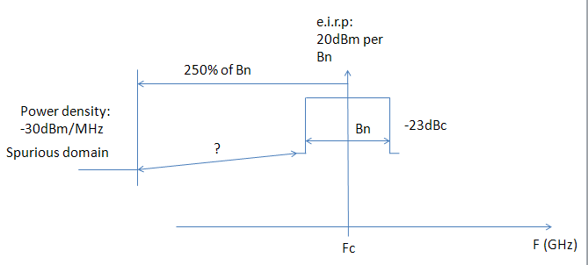
Figure 7: SRD emissions in the OOB and spurious domains

RAS community to check on the unwanted emissions falling below 116 GHz.]

BDA2GC

Discussion
The measured examples in Section 3 have illustrated that the signal in the spurious domains can be generally characterised by
- Narrowband sporadic spikes normally characterised as spurious emissions and
- A generic noise floor or reference level that the majority of the unwanted emissions from equipment would not normally exceed.

For the mobile service, the noise floor in the selected examples between 2 700-3 100 MHz is up to 55 dB below the regulatory limit of -30 dBm/MHz. [A similar large difference is found for radar. Editors note: to be put in the annex for the time being. From ECC report 174
The limits provided in the Recommendation ITU-R SM.329 differ between the various radio services significantly. Taking this example of a radar system with a calculated absolute limit of about 70 dBm/MHz (transmit power + antenna gain – relative limit of 60 dBc) and the example of the mobile service with the absolute limit of -30 dBm/MHz, the difference would be about 100 dB.
Referring only to the signal floor, the mutual impact to the adjacent systems would be up to 40 dB better than when applying the spurious limits. Another observation is that the spikes that characterise normal spurious emissions are very narrow compared to the transmit bandwidth of the equipment being measured.
Whereas the noise floor of the measured services in the spurious domain is nearly independent of the frequency offset. It is also obvious that the larger the frequency offset is, the smaller the impact of the spikes (from harmonics) will be and the magnitude of the spikes is dependent on the service and technology used, in particular on the filter in the output circuit and the method of generation of the intended signal.
This indicates that if a certain chip set and filtering design dominates mass produced consumer devices that all use the same frequency range then there may be a situation where interference from any spikes in the spurious domain may be accentuated at a certain frequency. This may result in localised interference at that frequency if there is a high concentration of these consumer devices operating in close proximity to an affected service.

conclusions

- the results from measurement campaigns

  - measurements for …2.6
    - Results from Germany
  - measurements for …3.4
    - Results from Germany

  - measurements for RLAN devices in the 2.4 GHz band
    - Results from Germany

  - measurements for …2.7
    - Results from Germany

- Categories of spurious domain emission limits defined in Recommendation ITU-R SM.329
- Categories of spurious domain emission limits defined in Recommendation ITU-R SM.329

Category A | Category A limits are the attenuation values used to calculate maximum permitted spurious domain emission power levels. RR Appendix 3 is derived from Category A limits. These limits are given in § 4.2.
Category B | Category B limits are an example of more stringent spurious domain emission limits than Category A limits. They are based on limits defined and adopted in Europe and used by some other countries. These limits are given in § 4.3.
Category C | Category C limits are an example of more stringent spurious domain emission limits than Category A limits. They are based on limits defined and adopted in the United States of America and Canada and used by some other countries. These limits are given in § 4.4.
Category D | Category D limits are an example of more stringent spurious domain emission limits than Category A limits. They are based on limits defined and adopted in Japan and used by some other countries. These limits are given in § 4.5.
Category Z | Radiation limits for ITE specified by the International Special Committee on Radio Interference (CISPR). These limits are given in § 4.6.

- Application of the limits (see ITU-R SM 1539, ITU-R SM 1540, ITU-R SM 1539)

- Frequency range for measurement of unwanted emissions

Fundamental  frequency range | Frequency range for measurements
 | Lower limit | Upper limit  (The test should include the entire harmonic  band and not be truncated at the precise  upper frequency limit stated)
9 kHz-100 MHz | 9 kHz | 1 GHz
100 MHz-300 MHz | 9 kHz | 10th harmonic
300 MHz-600 MHz | 30 MHz | 3 GHz
600 MHz-5.2 GHz | 30 MHz | 5th harmonic
5.2 GHz-13 GHz | 30 MHz | 26 GHz
13 GHz-150 GHz | 30 MHz | 2nd harmonic
150 GHz-300 GHz | 30 MHz | 300 GHz

A reference bandwidth is a bandwidth in which spurious domain emission levels are specified. The following reference bandwidths are recommended:
- 1 kHz between 9 and 150 kHz;
- 10 kHz between 150 kHz and 30 MHz;
- 100 kHz between 30 MHz and 1 GHz;
- 1 MHz above 1 GHz.

As a special case, the reference bandwidth of all space service spurious domain emissions should be 4 kHz.

- List of reference
- Reference one (style: reference)
- ECC Report 174 ‘Compatibility between the mobile service in the band 2 500 2 690 MHz and the radiodetermination service in the band 2 700-2 900 MHz’
- ERC/RECOMMENDATION 74-01E ‘Unwanted emissions in the spurious domain’

See also ECC Report 174 on the ‘Compatibility between the mobile service in the band 2 500-2 690 MHz and the radiodetermination service in the band 2 700-2 900 MHz’ published in 2012 by CEPT/ECC.

