Task Group 6 |  |  | TG6(14)071
ECC TG6 – M5
Lyon, 13 - 15 May 2014
Date issued: | 8 May 2014
Source: | MEDIA BROADCAST GmbH
Subject: | Broadcasting Systems over Cellular Infrastructure
N
Password protection required? (Y/N)

Summary:
The document reports on studies which were carried out in order to get a better knowledge on the relationship between inter-site distances in a LPLT network and the maximum SINR which can be reached, resulting in certain spectrum efficiency.
LTE eMBMS – as it is standardised to day – would not be an efficient solution to (almost) universal nationwide coverage; due to the required base station density the resulting network would be extremely expensive. Studies using a CP of 100 µs confirmed some results in TG6(14)048 also for portable reception, e.g. that limit SINR (spectrum efficiency) increases a lot.
In several scenarios of the current Working Document, it is assumed that frequency re-use factor of 1 can be achieved for some LTLP scenarios. This assumption cannot be confirmed, at least not for portable reception and using the same QoS criterion as used for broadcast coverage.
For several areas along the German border, there is a request for social and cultural exchange across borders. However, any re-use which “avoids” a certain overlap would hinder this benefit for the society on both sides of the border and require other means to provide this coverage.
Proposal:
TG6 to consider this document in the assessment of relevant scenarios
Background:
ECC-TG6 should provide technical studies on the evolution of broadcasting and mobile networks and services as well as other services and applications.
In this context, broadcasting should encompass foreseen developments in video resolution, coding, modulation/systems, receiving modes and coverage requirements. This includes aspects as network topologies and new technologies such as eMBMS and Tower-Overlay. In addition, the concept of convergence/cooperation of both types of services/networks should be addressed.

Broadcasting Systems over Cellular Infrastructures

1. Introduction
A key parameter in any consideration on overall system efficiency is the amount of data which could be transmitted by an eMBMS network in a given bandwidth and time. In single-frequency OFDM networks, this parameter depends on the Guard Interval (in DVB) or Cyclic Prefix (CP, in LTE), network topology in general (inter-site distance, ISD) as well as transmitter parameters.

2. Spectrum Efficiency
This section summarizes studies on spectrum efficiency for LTE eMBMS, as a function the inter-site distance (ISD) and transmitter parameters. All studies were carried out for an interference-limited regime and focused on portable outdoor reception of the broadcasting service.
Some studies already tried to provide answers to the topic under consideration (see e.g. [1]-[4], TG6(13)044 and TG6(14)048). A detailed analysis – with respect to different frequency bands, eMBMS base station antenna height and building entry loss – is provided in [4]. The results show e.g. that spectrum efficiency in urban area (BS antenna height of 15 m) would be about 0.7 bit/s/Hz for ISD of 3 km and about 0.8 bit/s/Hz for an ISD of 5 km in a rural area (assumed BS antenna height of 50 m; both for 700 MHz band, 20 dB penetration loss). One of the main conclusions in [4] is that eMBMS is not an efficient solution to offer contiguous nationwide broadcast services, due to the larger ISD’s outside congested and surrounding areas resulting in much lower data rates which can be transported.
However, almost all these studies coverage evaluation followed a methodology which is used for coverage evaluation of a Mobile Service. This method differs substantially from what is recommended by ITU-R for evaluation of broadcast coverage and used by the studies reported in this section.

2.1 Methodology, Network Structures and Parameters
In general, many base stations have been placed on a regular grid over the area under consideration, with different values for the ISD.
The field strength of each individual base station has been calculated and appropriate statistical treatment of overall field strength (LNM) was used in order to get the coverage probability.
Two different sets of studies were performed with respect to overall network layout and its “location”:
- Hexagon structures – network layout based on simple hexagons
  - propagation model ITU-R P.1546, with effective antenna height simply given by antenna height (no terrain)
- Regular network structures covering a certain area
  - Real coverage area, e.g. an allotment of 56*46km in Bavaria, GE06)
  - information on population density has been used for statistical evaluation
  - propagation model ITU-R P.1546 with effective antenna height according to topography, or specific propagation model using topography and clutter data
For each individual pixel (about 100m*100m) within the area, the location probability has been calculated for a certain SINR. All those pixels for which a location probability of 95% was reached or even exceeded where taken into account in the overall evaluation, i.e. the aggregated area of all these pixels was calculated and/or the population (information on population is available for each individual pixel). The SINR has been varied until at least 95% of population or 100% of area were covered with a location probability of 95% or more.
Table 1 provides an overview on general parameters which have been used throughout most of the studies. An antenna height of 32 m can be considered as a “general basis”, but values of 20 m or 50 m have been used for some of the studies. Beside the guard interval 0f 33 µs,
Table 1: Basic planning assumptions used for most studies
Two different types of base station antenna diagrams were used, omni-directional (ND) and tri-sector. The latter is a diagram which aggregates radiations from three individual sector antennas separated by 120 degrees (phase-matched).

2.2 Conversion into Spectrum Efficiency
All studies provide at the end the maximum SINR which can be used to cover at least 95% of population or 100% of the area, with a location probability of at least 95%.
[4] provides a relation for two different values BLER which could be used in order to convert these limit SINR values into spectrum efficiency (MCS). Results for a BLER of 10⁻³ are considered to be representative for a Rayleigh channel, and the following values of SINR spectrum efficiency (SE) correspond to each other:
SE of 2 bits/s/Hz SINR of at least 16.2 dB
SE of 1.5 bits/s/Hz SINR of at least 12.6 dB
SE of 1 bits/s/Hz SINR of at least 9 dB
For the purpose of this document, the limit SINR to reach a spectrum efficiency of 2 bps/Hz is considered to be 16 dB. In the following, only limit SINR values are used.

2.3 Results
The following parameters were studied:
- Different propagation models
- Different antenna configurations (ND and tri-sector later with different tilts)
- Different antenna heights for BS (20m, 50m, 32m)
- Different values for ISD 2, 3, 4, 5, 10 and 20km (for some scenarios)
- Different number of tiers (i.e. impact of BS being further away)
- Mainly for a CP of 33 µs, but some also for 100 µs
Detailed results are provided in the Annex.

Summary of results for portable indoor, hexagon structures and CP of 33 µs
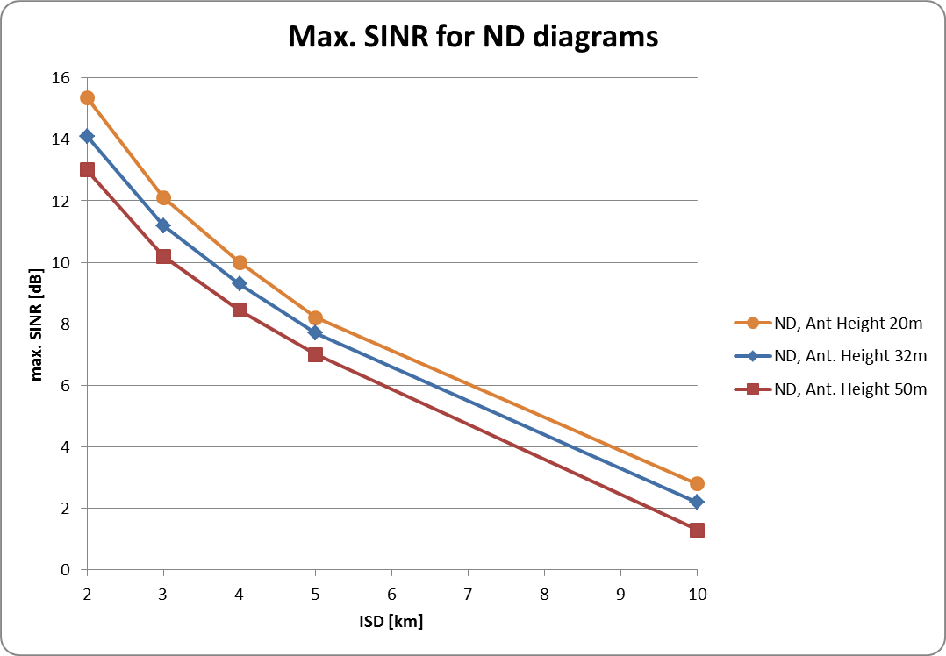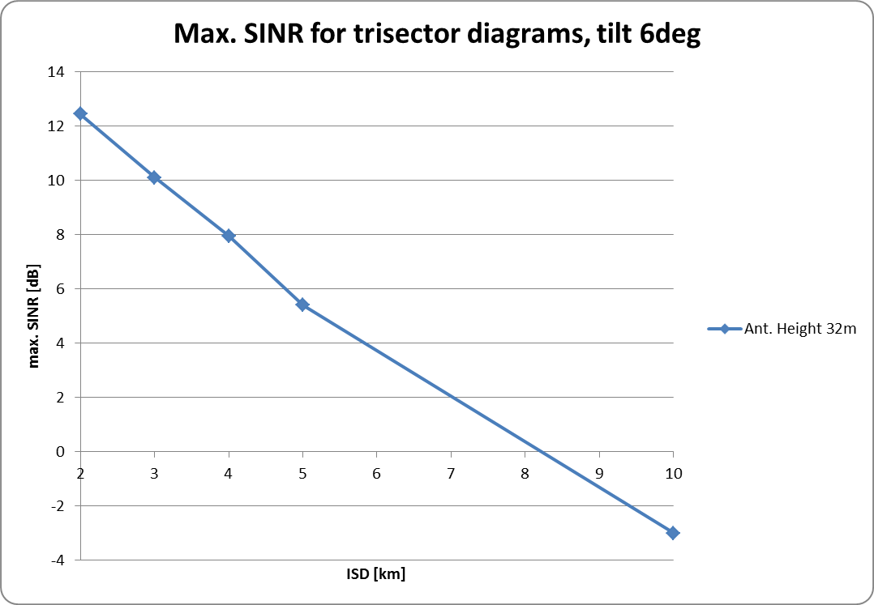
Figure 1: Max. SINR for different values of ISD and different BS antenna heights; for omni-directional BS antenna diagram (left) and tri-sector diagrams (right)
For a CP of 100 µs and an ISD of 10km, the limit SINR is by about 15 dB larger than for a CP of 33 µs. Note that results in Fig.1 above were achieved for different network configurations (hexagons vs. allotment) and propagation models. However, the value in Fig.1 (right) of -3 dB for an ISD of 10 km is similar to what is provided in Table A1 in the Annex (-3.6 dB), for an antenna height of 32m.

3. Frequency Re-Use
In a few tests were carried out with respect to frequency re-use. For this purpose, the biggest hexagon structure for an ISD of 2 km has been used and a different SFN ID was given to 34 BS within a certain area (upper right corner of the big hexagon). A few results are displayed in Figure 2 below, for different “guard stripes” – no guard, a guard of about 6km and a guard of about 8.5 km. Area covered at least with 95% location probability is indicated in green, white areas have lower coverage. Areas with lower coverage are clearly reduced from left to right.
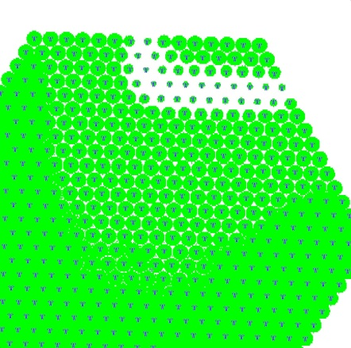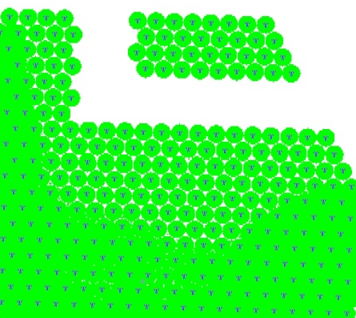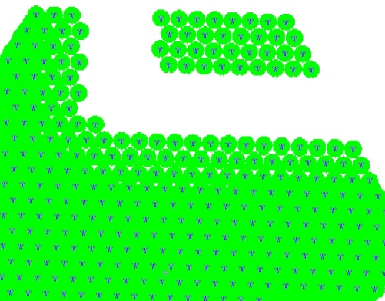
Figure 2: Networks and coverage, all BS are co-channel but 34 BS in a different SFN; without a “guard” (left), with a “guard” of about 6km (middle) and with a “guard” of about 8.5 km (right)
It is noted that without a guard stripe, interferences “propagate” far into the SFN area.
The results of all these tests indicate that a re-use of zero or close to it cannot be achieved without changing QoS at the same time, at least not for portable reception.

4. Conclusions
Our studies show that LTE eMBMS – as it is standardised to day – would not be an efficient solution to (almost) universal nationwide coverage; due to the required base station density the resulting network would be extremely expensive.
Results in section 2.3 indicate that a limit SINR of 16 dB is reached for a CP of 33 µs only for an ISD of 2 km (ND BS antenna diagrams). Studies using a CP of 100 µs confirmed some results in TG6(14)048 also for portable reception, e.g. that limit SINR (spectrum efficiency) increases a lot and that a value of about 2 bps/Hz might be possible for some configurations.
In several scenarios of the current Working Document towards the TG6 Report, it is assumed that frequency re-use factor of 1 can be achieved for some LTLP scenarios. This assumption cannot be confirmed, at least not for portable reception and using the same QoS criterion as used for broadcast coverage.
Furthermore, another issue is to be noted: For several areas along the German border, we know that there is a big interest from customers and a political demand to have access to AV content also from the other side of the border, i.e. there is a requirement/request for social and cultural exchange across borders. However, any re-use which avoids a certain overlap would hinder this benefit for the society on both sides of the border and require other means to provide this coverage (e.g. by additional frequencies/coverage, same content in both networks etc.).

5. References
[1] Lohmar, Th., et al. “Delivering content with LTE Broadcast”, in Ericsson Review 2013 – 1, Feb 11 2013
[2] Dudda, T., et al.: „eMBMS: Broadcast-Dienste über LTE”, in FKT 1-2/2013, page 10ff
[3] QUALCOMM , “LTE eMBMS Technology Overview”, San Diego, Nov. 2012; http://s3.amazonaws.com/sdieee/222-eMBMS_tech_overview_IEEE_112712.pdf
[4] Uri, A., et al.: „Evolved Multimedia Broadcast Multicast Service in LTE: An Assessment of System Performance Under Realistic Radiuo Network Engeneering Conditions”, Bell Labs Technical Journal 18(2), 57-76 (2013)
[5] Eibert, T.F.; Kuhlmann, P.: “Notes on Semiempirical Terrestrial Wave Propagation Modelling for Macrocellular Environments – Comparisons with Measurements”; IEEE Trans on Ant. and Prop., Vol.51, No.9, Sept. 2003

Annex Results of Studies on Spectrum Efficiency
In general, two different network structures were considered, based on simple hexagons as well as a certain allotment structure.
A1.1 Hexagonal Network Structure
The general network layout used for these studies is shown in Fig. A1 for two different values of ISD. Studies were performed for different values of ISD (2, 3, 4, 5 and 10 km) and number of tiers/rings (see also Fig. A2). These studies were limited to a CP of 33 µs.
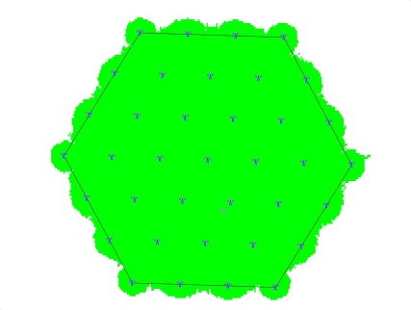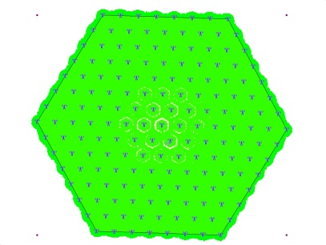
Figure A1: Hexagonal network structures
Number of Tiers
In this study, the number of tiers has been varied. Some results are shown in Figure A2, for different overall network diameters (“distance”/x-axis; each data point stands for an additional ring of base stations). It can be easily seen that a certain number of tiers is needed before results converge, and BS which are e.g. 20 km away from the center still contribute to self-interferences.
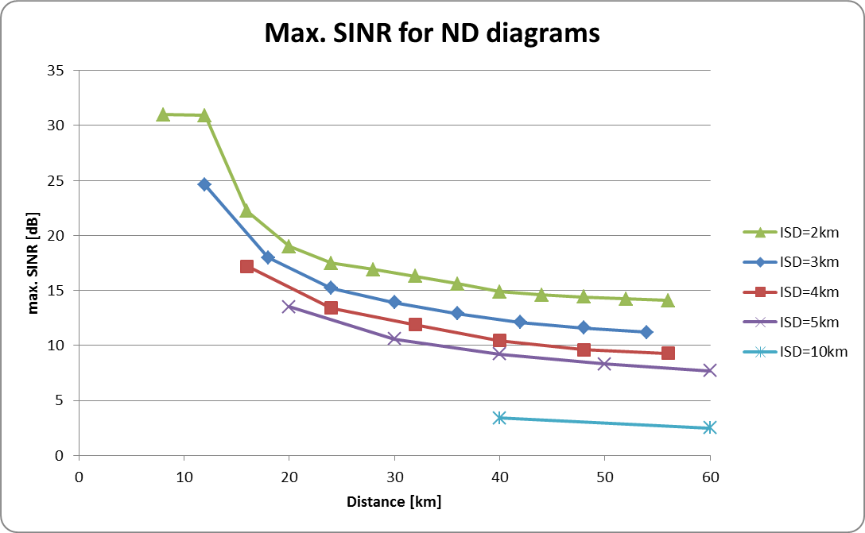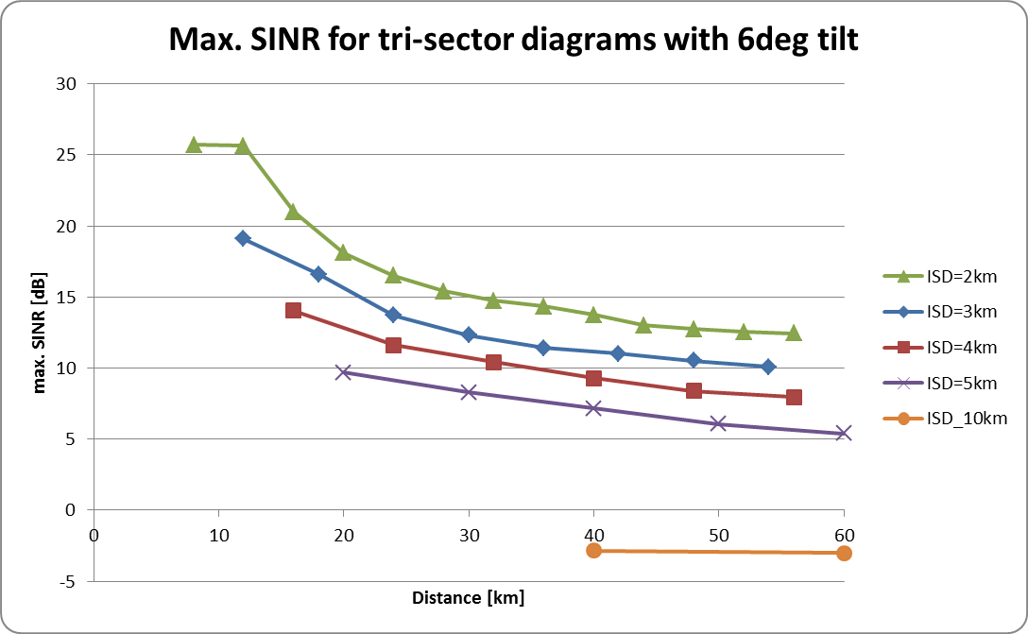
Figure A2: Maximum SINR for different values of ISD and number of tiers (horizontal axis), for omni-directional BS antenna diagram (left) and tri-sector diagrams with 6 deg tilt (right)
Observations:
- Convergence starts at about 30km in network diameter, but there is still some variation even for diameters of 60 km
- Difference between ND and tri-sector diagrams is in the order of a few dB, only

BS Antenna Height
In this study, the BS antenna height has been varied. Some results are shown in Figure A3, for an ISD of 2km and different BS antenna diagrams. Again, the number of tiers has been varied in order to see where results start to converge.
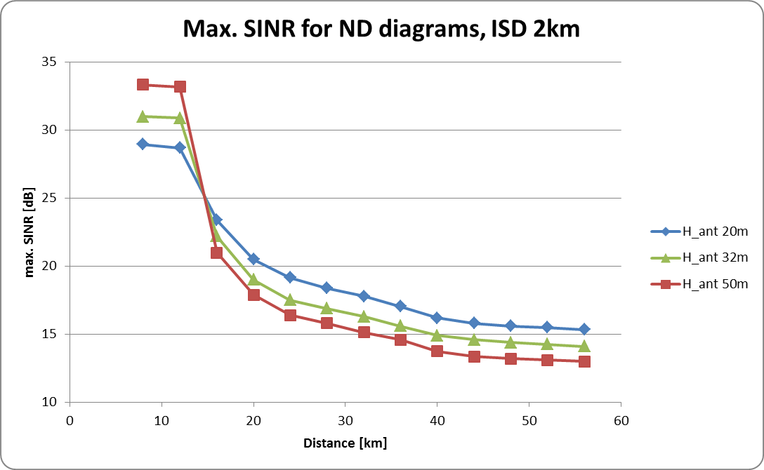
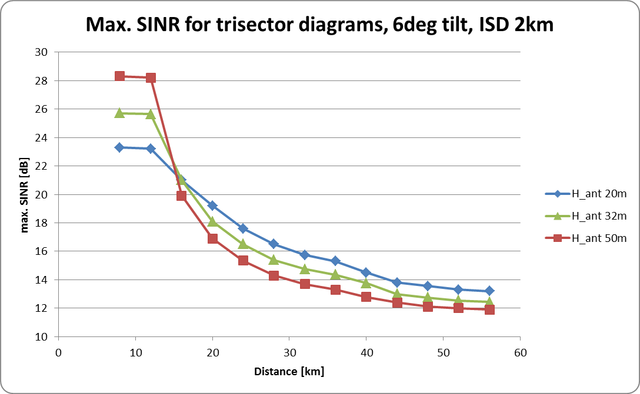
Figure A3: Max. SINR for an ISD of 2 km, different overall network size and different BS antenna heights; for omni-directional BS antenna diagram (left) and tri-sector diagrams (right)

A1.2 Allotment area
The areas which have been considered by these studies are shown in Fig. A5. The smaller area (red rectangle) has been chosen to get results within a reasonable time frame also for smaller ISD. A fundamental difference compared to studies reported in A1.1 is that in this case high resolution terrain information and ground cover (clutter) has been used.
Studies were performed for different values of ISD, up to 10km.
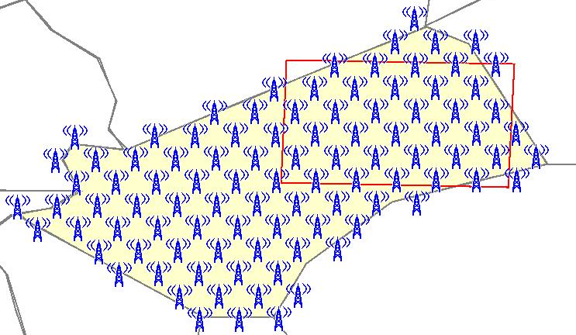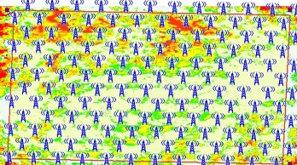
Figure A5: Allotment area and smaller area (indicated by the red rectangle; coverage prediction for this area is shown in the smaller figure to the right, for smaller ISD)
The methodology is illustrated in Figures A6 and A7, for an ISD of 10 km and portable reception. For each individual step, coverage is calculated, population on pixels with location probability of 95% and above is counted and the overall ratio is visualized (see Fig. A7). The area is treated as being covered when 95% of the entire population is covered.
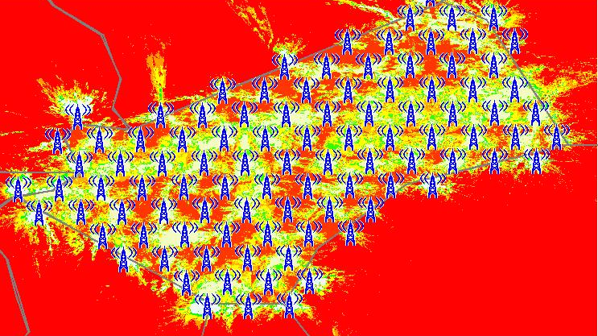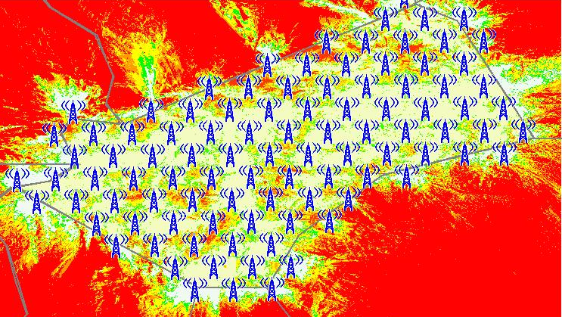
Figure A6: Coverage probability for a certain SINR, 9dB (left) and 3 dB (right)
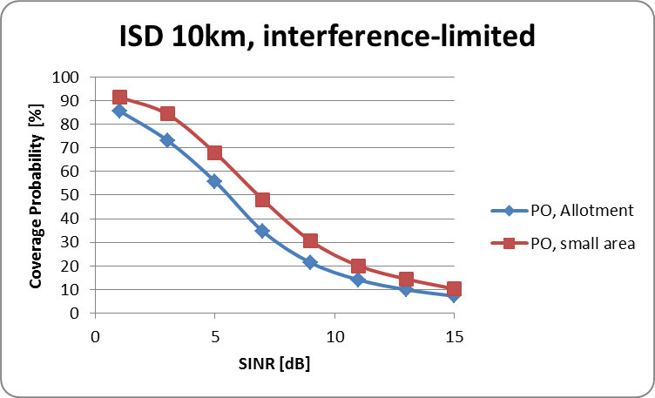
Figure A7: Example of a complete “scan” of SINR-values, for the two areas indicated in Fig. A5 above (allotment area and smaller area/red rectangle) and an ISD of 10 km

Different Propagation models
Two different propagation models have been used in this study, ITU-R P.1546 and a specific model which has been developed within Deutsche Telekom.
Some results are shown in Figure A8. The resulting pop coverage (vertical axis) is higher for ITU-R P.1546 for higher percentages of coverage, resulting in a higher overall SE.
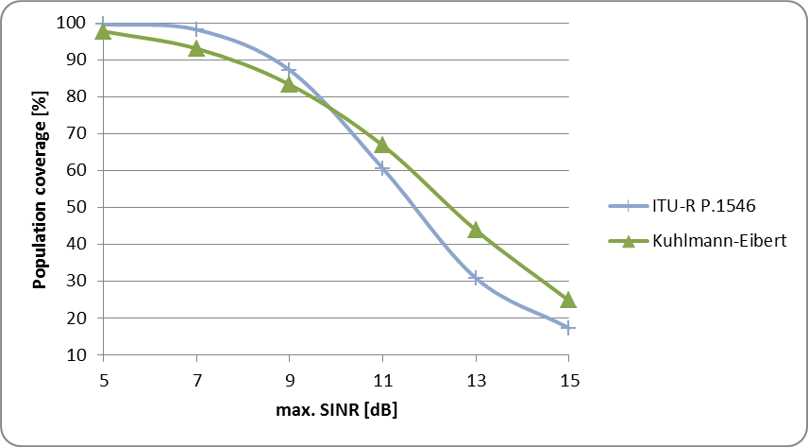
Figure A8: Example of a complete “scan” of SINR-values, for the allotment area in Fig. A5 and two different propagation models

Larger values of CP (100 µs)
In this study, a larger CP value of 100 µs has been used. All studies were carried out for tri-sector antennas with a tilt of 6 degrees and ISD of 10 km, but for different BS antenna heights (20 m, 30 m and 50 m). The results are given in Table A1 below.

Table A1: Results for portable outdoor, an ISD of 10 km and different values of CP
For an ISD of 10 km and a BS antenna height of 50 m, the resulting limit SINR is 15.7 dB. It is noted that the ISD corresponds to 1/3 of the CP.

Kuhlmann-Eibert, developed by Deutsche Telekom, well-proven for broadcast coverage predictions e.g. for DVB-T internet predictions in Germany, see also [5]
note that propagation model ITU P.1546 has been used for this study
Kuhlmann-Eibert, well-proven for broadcast coverage predictions e.g. for DVB-T internet predictions in Germany, see also [5]

