Working document – work in progress – no conclusions
The following frequency option are developed by the CG and further amended by WGFM#88. Based on this working document, WGFM#88 tasked the CG to discuss in detail frequency options for professional UAS as under the scope of draft ECC Report 268 and report back to WGFM#89. The considerations in the CG should also evaluate as far as possible the spectrum demand for UAS telecommand and control.
Clarification of the status a UAS, requirement to use aeronautical bands?
Use of aeronautical mobile service allocations is not a pre-requisite for the UAS applications which fly in circumstances where they do not need communications with air traffic control (ATC), i.e. open and specific category UAS (but not certified), as defined in the new proposed EASA regulation. For this kind of UAS, the UAS application does not need to be linked to specific radio service allocations.
The composition of allocations and related frequency band and allocation footnotes in a frequency band will be decisive, e.g. in the 5 GHz range the mobile service except aeronautical mobile service allocation is seen as linked to the co-primary radiolocation service in effect making the DFS mechanism mandatory for WAS/RLAN for the protection of radars. The UAS usage scenario was never considered when the DFS mechanism was designed. 790-862 MHz: the restriction of Mobile except aeronautical mobile is likely to be reinvestigated due to the fact that terrestrial broadcasting is not anymore a major utilisation in this band in Europe.
Frequency options:
- Frequency bands which are considered as suitable
The following frequency bands and options are considered as suitable by the CG. Further guidance and sharing studies may be required.

- Using existing and future MFCN networks for UAS
Question to ECC PT1 about the impact on services and applications in the adjacent frequencies (other MFCN operators or other services and applications). MFCN bands below 1 GHz provide much better coverage for UAS, esp.in non-urban areas.
Already studies and tests ongoing, first results are available, e.g. case by Qualcomm (https://www.qualcomm.com/news/onq/2017/05/03/qualcomm-technologies-releases-lte-drone-trial-results) in the 700 MHz range in the USA or by Deutsche Telekom (1.8 GHz) at: https://www.telekom.com/en/media/media-information/archive/high-level-cooperation-443952. Trials and test are ongoing in Germany. First results will be available in the near future.
While the 700 MHz, 800 MHz, 900 MHz, 1.5 GHz, 2.6 GHz and 3.4-3.8 GHz bands are allocated to mobile service except aeronautical mobile service, Article 43.1 of the RR states that frequencies in any band allocated to the aeronautical mobile (R) service and the aeronautical mobile-satellite (R) service are reserved for communications relating to safety and regularity of flight between any aircraft and those aeronautical stations and aeronautical earth stations primarily concerned with flight along national or international civil air routes.
It can be argued that the C&C and payload needs of drones do not fall within the definition of aeronautical service and therefore mobile service except aeronautical mobile service - MFCN bands may be used for the operation of UAS. However, this approach may be challenged insofar as the future implementation of U-space communication requirements is concerned (U-space is still under development).
A clarification in the ECA Table could be helpful. Two aspects need to be addressed: a) decision on a national basis, b) protection of networks in adjacent countries.
Considerations in ECC PT1 may include:
- 3.4 GHz: impact of UAS on radars below 3400 MHz would need to be assessed.

- 2.6 GHz: ECC Report 187 concluded that the deployment of MCA is not possible in the 2.6 GHz band due to the impact on meteorological and civil aviation radars above 2.7 GHz. The situation has to be clarified for UAS.
- From ECC Decision (18)06: MFCN in the 24.25-27.5 GHz band shall not be used for connectivity from base stations to terminals onboard UA and that only communications for connectivity from terminals on-board UA to base stations is authorised. There are further investigations in ECC PT1.

- Frequency bands for which further considerations are needed
  - 1880 – 1900 MHz (proposal F)
For governmental use, better parameters, CNPC + data acquisition

- 1900 – 1920 MHz
For 1900-1920 MHz, there is likely to be competing spectrum demand and existing licenses Indoor restricted, duty cycled indoor-restricted DECT/SRD may work on a secondary basis. UAS command & control may need the whole 20 MHz.
Existing licence situation may result in a situation that 1900-1920 MHz does not become available on some countries in the near future (most licences expire in 2019-2027 timeframe);

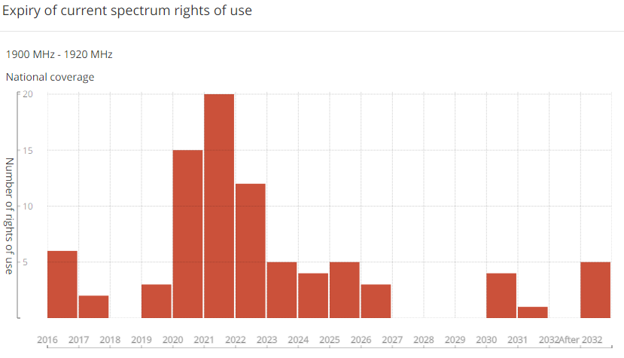
Adjacent to 1800 MHz and 2100 MHz MFCN bands as well as PMSE tuning range (see below), which could be used for the payload;
ECC Report 220: mobile video links can be used in 1900-1920 MHz, only restricted in 1915-1920 MHz to 23 dBm e.i.r.p. in urban environment, otherwise no restriction.
United Kingdom use for special PPDR in 1899.9-1909.9 MHz
New alternative usages for DECT-based microphones and industrial applications in process of being described in a new revised ETSI SRdoc TR 103 149)
Proposals from FM56 on RMR investigations

- Video PMSE bands, 2010 - 2110 MHz and 2200 - 2500 MHz
Focusing on the band C1 – C5 of ERC REC 25-10 Annex 3 (tuning range for cordless camera, portable and mobile video links bands); evaluate implementation possibilities to use these bands or parts of it. In addition, reconsider the regulation of cordless cameras and their sharing condition in the light of using it on UAS (higher altitudes, etc.) may liaise with or give that task to FM51
On a tuning range basis;

- 5150 – 5250 MHz
Used for WAS/RLAN; restricted to WAS/RLAN indoor use in almost all European countries;
also used by BBDR according to ECC/REC/(08)04 based on studies with very low BBDR usage density (ECC Report 110). Proposed by NED. It is noted that DEN does not have an indoor restriction.
Original indoor Restriction for RLANs in 5150-5250 MHz in the USA (taken as a ‘representative similar case’):
Problem. Aggregated Interference into MSS satellite front end, see Globalstar
https://ecfsapi.fcc.gov/file/7520959857.pdf

However, the FCC changed the rules in 2014 and withdrew the indoor restriction.

U-NII Low (U-NII-1): 5.150-5.250 GHz. Originally limited to indoor use only. Regulations required use of an integrated antenna, with power limited to 50 mW. Rules changed in 2014 to permit outdoor operation, maximum fixed power 1 watt, maximum fixed EIRP 4 watts (+36 dBm) point-to-multipoint, 200 watts (+53 dBm) point-to-point. However, strict out-of-band emission rules limit practical point-to-point power to lower levels.

See FCC:
https://transition.fcc.gov/bureaus/oet/ea/presentations/files/oct14/51-New-Rules-for-UNII-Bands,-Oct-2014-TN.pdf

Possibility for the UA payload to the ground? May need strict elevation angle related limits to avoid aggregated interference into the satellite receiver frontend.

Possibility for the UA payload to the ground may be feasible subject to investigations?

Some aeronautical telemetry in 5150-5250 MHz

- 5030 – 5091 MHz and 5091 – 5150 MHz
Depending on the outcome of the ICAO/EASA developments. There are proposals to use combined terrestrial/satellite links for UAS for command and control links, e.g. utility or train network monitoring 5.443C : The use of the frequency band 5030-5091 MHz by the aeronautical mobile (R) service is limited to internationally standardized aeronautical systems. Unwanted emissions from the aeronautical mobile (R) service in the frequency band 5030-5091 MHz shall be limited to protect RNSS system downlinks in the adjacent 5010-5030 MHz band. Until such time that an appropriate value is established in a relevant ITU-R Recommendation, the e.i.r.p. density limit of −75 dBW/MHz in the frequency band 5010-5030 MHz for any AM(R)S station unwanted emission should be used. (WRC-12)

Footnote 5.444B
The use of the band 5091-5150 MHz by the aeronautical mobile service is limited to: - systems operating in the aeronautical mobile (R) service and in accordance with international aeronautical standards, limited to surface applications at airports. Such use shall be in accordance with Resolution 748 (Rev. WRC-15); - aeronautical telemetry transmissions from aircraft stations (see No. 1.83) in accordance with Resolution 418 (Rev. WRC-15). (WRC-15)

- 5875 – 5925 MHz (ITS band)
Communication solutions for UAS-to-UAS, UAS-to-infrastructure
    - IEEE 802.11p and LTE-V2X aim for using the 5855-5925 MHz
    - Cooperative awareness messages, or any other communication transmitters distributing positioning information in order to avoid colissions

- Frequency bands considered as NOT suitable
The following frequency bands and options are considered not suitable. The reasons are enclosed.
- 2300-2400 MHz
MFCN Decision but no EC Decision yet (i.e. long term availability for UAS could be considered as doubtful)
PMSE use in many countries for video PMSE incl. wireless cameras, civil and governmental use, temporary use.
NED: 8 channels in 2325 to 2445 MHz. No option for France (FS and defense)
May not be an option for harmonisation.

- 5000 – 5010 MHz
Aeronautical radionavigation;
There is also RAS in 4990-5000 MHz under 5.149 (urges administrations to undertake all practical steps to avoid interference to RAS)
- AERONAUTICAL MOBILE-SATELLITE (R) (5.443AA)
- AERONAUTICAL RADIONAVIGATION
- RADIONAVIGATION-SATELLITE (EARTH-TO-SPACE)
- Radio Astronomy
- Space Research (passive)
5.443AA: In the frequency bands 5000-5030 MHz and 5091-5150 MHz, the aeronautical mobile-satellite (R) service is subject to agreement obtained under No. 9.21. The use of these bands by the aeronautical mobile-satellite (R) service is limited to internationally standardized aeronautical systems. (WRC-12)
Do not study further.

Possible additional spectrum requirements
So far, there is no European harmonisation for the following features i.e. it is impossible to derive the precise spectrum demand for it.
- E-identification
Identification of UAS, which have to be broadcasted
Further requirements and information to be provided by EASA/EUROCONTROL/etc. In particular whether e-identification will also be used for tracking the flightpath and the related repetition rate of the e-identification information.

- Spectrum for Geo awareness (geofencing)
Distribution of permanent and temporally no fly zones and/or restrictions

- UAS traffic management
Further information can be found within the U-space regulation

- Radar - Spectrum for DAA (meaning for collision avoidance)
  - Collision avoidance under all circumstances may include radar use
  - Study the radiolocation service possibilities to find solutions outside of the existing aeronautical radars for airborne use for UAS. Only if there is a requirement to do so. It could be superseded by the communications solutions above.

- Real-time Transport of information from UAS to a network
e.g. PPDR, which must be reliable, but is limited in time and space (temporary capacity issues). Some possibilities under general authorisation (but this will limit the operating distances)

