SE(19)022_Annex4
ECC Recommendation (YY)XX

Unwanted Emissions – Guidance and methodologies when using typical equipment performance in sharing/compatibility studies
Approved DD Month YYYY

introduction
The demand for spectrum is continuing to grow from both existing and new services and applications. CEPT / ECC is constantly looking at how to enable greater spectrum and conducts sharing and compatibility studies to determine the risk of interference. To optimise use of the spectrum it is important for these studies to be as accurate as possible. It is also important that the risk of interference is not underestimated where harmful interference occurs. It is also important that the risk of interference is not overestimated where new spectrum uses are unduly restricted or not enabled.
Sharing and compatibility studies consist of many different parameters and assumptions and it is important that these are as close to reality as possible to enable accurate studies. All these assumptions and parameters need to be considered together in studies and any one of these parameters can have an impact on the results. Unwanted emissions are one of the assumptions where in some cases there could be some improvements in future studies.
ECC Report 249 “Unwanted emissions of common radio systems measurements and use in sharing/compatibility studies” contains a number of measurements on samples of some real equipment types. It was observed that the measured emissions are, lower than the limits in recommendations and ETSI standards. In many cases the emissions measured in Report were significantly lower with a margin of several tens of dBs in the spurious domain, except for the harmonic frequencies. Typically, manufacturers will design and manufacture products with some margin so that the unwanted emissions from its products easily meet the limits. This finding has an important implication for sharing and compatibility studies which have previously based limits set out in standards / regulation and treated as a constant level, which may not lead to the most accurate outcomes.
This ECC Recommendation gives guidance on the consideration of unwanted emissions in sharing and compatibility studies to CEPT/ECC groups.

ECC recommendation of YY(XX) on Unwanted Emissions – Guidance and methodologies when using typical equipment performance in sharing/compatibility studies
“The European Conference of Postal and Telecommunications Administrations,
considering
- that spectrum is becoming an increasingly congested environment utilised resource to accommodate developing radio applications;
- using worst case assumptions for unwanted emissions in co-existence / sharing studies from limits can lead to less efficient use of spectrum;
- the term ‘typical unwanted emissions’ means the actual unwanted emission level(s) that are representative of equipment deployed in the field;
- the outcomes of ECC Report 249 [1] show that some typical unwanted emissions are lower / better than the limits set in ECC recommendations and ETSI harmonised standards;
- in the long term, it may be possible to improve the unwanted emission limits in standards and recommendations to align more closely with typical equipment performance.
recommends

- To primarily be used by CEPT/ECC groups when conducting sharing/compatibility studies;
- that assumptions of unwanted emissions levels sharing/compatibility studies should in the first case be based on information derived from relevant ETSI harmonised standards and/or EC/ECC delivrables, if available;
- that if ETSI harmonised standards or EC/ECC delivrables are not yet available, then information on assumed equipment performance should be requested from relevant ECC working groups and project teams as well as ETSI;
- that studies should be further supplemented by other available information from ITU-R Recommendations/Reports, previous measurement campaigns and/or manufacturer data, where available, according to the methodologies and information in Annexes 2, 3, 4 and 5;
- that if studies based on information from the above sources show a potential co-existence issue due to unwanted emissions, and in the absence of existing data on measured equipment performance, a measurement campaign should be, if possible, undertaken in order to further quantify the risk of interference, according to the methodology outlined in Annex 3;
- that measurements should take account of a range of typical devices and testing conditions as far as possible in order to capture all relevant usage scenarios;
- that further sharing/compatibility studies should be performed based on the results of measurements;
- that sharing/compatibility studies should consider any relevant mitigation techniques with respect to unwanted emissions.
- that sharing/compatibility studies could include a sensitivity analysis to determine the impact of variation of unwanted emissions, as well as the impact of mitigation techniques, according to the methodology outlined in Annex 4;
- that points 1 to 9 above should be implemented according to the method outlined in Annex 1.”
Note: Please check the Office documentation database https://www.ecodocdb.dk for the up to date position on the implementation of this and other ECC Recommendations.
- Flow chart
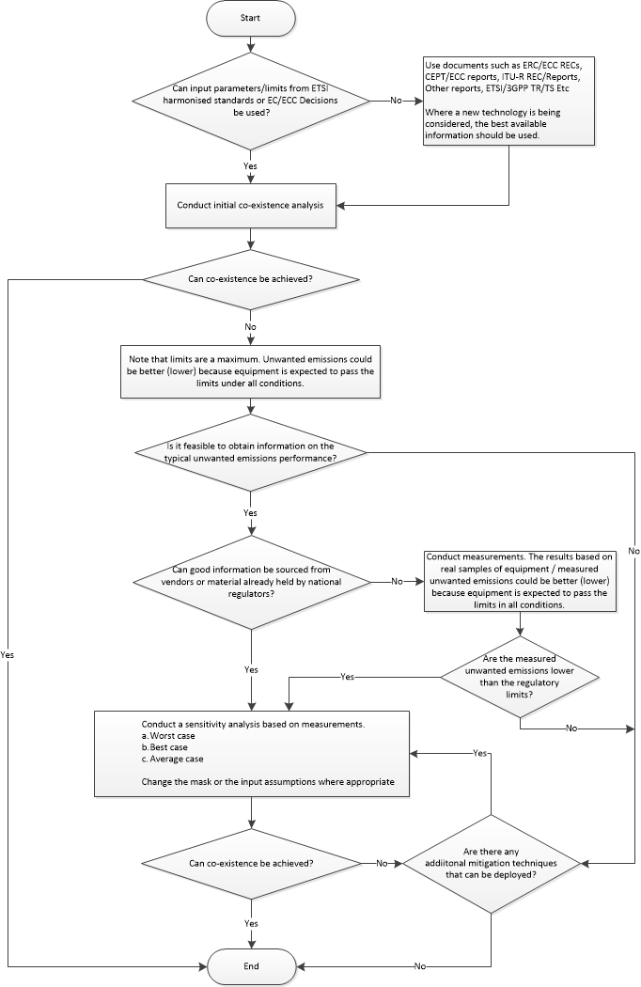
- TYPICAL Uwanted emission perfoRmance of EQUIPMENT in SHARING and compatibility STUDIES
The normal starting point for most sharing and compatibility studies is to source input parameters from existing documentation that specifies the characteristics of the radio equipment. Regarding unwanted emissions, for the initial analysis parameters should be based on the limits derived from:
- Relevant ETSI Harmonised Standards, published by ETSI and listed in the Official Journal of the European Union and/or;
- EC Harmonisation Decisions or Regulation and/or;
- ECC Decisions and/or;
- ECC Recommendations.
In certain cases, where new technologies are being studied, documentation, such as standards on unwanted emission limits may not yet be available as equipment could still be under development or in a prototype phase. In this case, information on the assumed equipment performance should be requested from the relevant ECC working parties and project teams.
The limits derived from the documents in the list above should be used to conduct an initial analysis. Where this initial analysis indicates that co-existence may not be achieved with respect to unwanted emissions, a more in-depth investigation should be undertaken. Typically the level of unwanted emissions from real equipment will be below the limits in ETSI Harmonised Standards, EC/ECC Decisions, ERC/ECC Recommendations, CEPT/ECC Reports, ITU-R Recommendations/Reports and other ETSI/3GPP Technical reports and specifications. Using the limits from these documents are worst-case assumptions.
A more in depth analysis, to better characterise typical unwanted emissions of equipment, would enable more accurate sharing and compatibility studies. This could lead to benefits accruing from a more efficient use of the spectrum. The first stage to achieving a better characterisation of unwanted emissions could be gleaned from information already held by vendors / regulators or from actual measurements of real equipment. This information can be used, then the analysis can be re-run to take into account of more realistic ‘typical’ unwanted emissions. Where suitable information is not available a measurement campaign should be used to characterise typical unwanted emissions and form part of the study to quantify the risk of harmful interference to radiocommunication services.
Typical levels of unwanted emissions of equipment are below unwanted emissions limits of EC/ECC and ETSI deliverables

ECC Report 249 “Unwanted emissions of common radio systems measurements and use in sharing/compatibility studies” [1] identified that the measured typical unwanted emissions of a sample of some real equipment types is lower than the limits prescribed in Harmonised Standards and/or ECC Recommendations/ITU-R Recommendation. This was particularly true for unwanted emissions in the spurious domain.
In Europe, Directive 2014/53/EU (Radio Equipment Directive - RED) [2] requires that radio equipment makes effective and efficient use of radio spectrum. One method to conform with the RED for those placing products (typically manufacturers) on the market within the European Economic Area is to apply a relevant ETSI Harmonised Standard. These are ‘EN’ standards, a reference to which has been published in the Official Journal of the European Union, and giving a presumption of conformity to the essential requirements of the RED.
The limits laid down in ETSI Harmonised Standards, therefore, set a benchmark for equipment performance. Where a manufacturer has applied a Harmonised Standard all equipment will need to meet or be lower than the limits set out in the standard. The level of unwanted emissions from the radio equipment must be below the limits defined in the relevant ETSI Harmonised Standard.
Typically, manufacturers will design and manufacture products with some margin so that the unwanted emissions from its products easily meet the limits. There have also been improvements in unwanted emission due to improvements in components and more integration onto silicon. Unwanted emissions limits in ETSI standards are normally defined as a straight line whereas, in reality, unwanted emissions are less linear / constant than this. Manufacturers will also need to ensure that any, spectral regrowth from filter artefacts, spurious (spikes) and harmonics are under the regulated limit.
The measurements carried out on real equipment for ECC Report 249 showed that, in most cases, typical equipment performance is (better) superior to that defined in the existing Harmonised Standards and recommendations (see Annex 2).
For co-existence and sharing studies the typical, or actual, performance of equipment is more relevant to determine if compatibility can be achieved and if harmful interference will occur. The purpose of limits set in Harmonised Standards is to ensure products are well enough constructed to be placed on the market. This is not necessarily the same purpose as sharing and compatibility studies carried by CEPT, though obviously there is a link with respect to avoidance of harmful interference and efficient use of spectrum. Consequently, using typical equipment performance in CEPT sharing and compatibility studies instead of deriving limits from Harmonised Standards will likely result in improved, more accurate, studies and consequently, a more efficient use of the spectrum.
Unwanted emissions in the Out of Band and spurious domains considerations

ECC Report 249 “Unwanted emissions of common radio systems measurements and use in sharing/compatibility studies” [1] observed that the measured emissions are lower than the limits in recommendations and ETSI standards. In many cases the emissions measured in the Report were significantly lower with a margin of several tens of dBs in the spurious domain, except for the harmonic frequencies. This finding has an important implication for sharing and compatibility studies which are typically based on the assumption that equipment would only just meet the limits set out in standards.
Regarding unwanted emissions in the Out of Band domain, there are benefits for considering typical levels as the integrated power or power spectral density will be lower than the limits. For unwanted emissions in the spurious domain, using typical levels for will likely bring the greatest benefit to sharing and compatibility studies based on the evidence in ECC Report 249.
Typically, most sharing and compatibility studies consider bands directly adjacent in frequency to the band where the victim service may lie. ECC Report 249 observed in this case that unwanted emissions were more predictable without spikes or harmonics. However, spurious emissions with a greater separation from the centre frequency of the emission can be less predictable in frequency and amplitude. ECC groups may wish to consider this in studies that are looking beyond the directly adjacent band.
- Defining the typical unwanted emission performance of equipment
Where ECC working parties and project teams have carried out the initial analysis and have determined that a more in-depth analysis is required, typical unwanted emissions will need to be defined. There are two suggested methods to better characterise and define the unwanted emission performance of the equipment. The first method is to use pre-existing information sourced from vendors or regulators. Where this is not available, a measurement campaign should be carried out.

Sourcing information from vendors or material already held by regulators

Information on the typical unwanted emission performance could already held / available from vendors or already held by regulators. Where this is available, it can provide a quick and simple way to define the typical unwanted emissions performance of equipment and improve the assumptions in the sharing and compatibility study regarding unwanted emissions. When using this information ECC working parties and project team should use their expert judgment on the quality of the information. What qualifies as good information’s needs to be judged on a case by case basis. Some considerations could include:
- Is this from a single vendor or multiple vendors?
- Is the information representative of the typical performance of unwanted emissions of products?
- Are the levels based on measurement data, estimations, a mask or a theoretical model?
- Is there adequate transparency as to how the information has been obtained?
- Is this information representative of the typical equipment expected in the band?
- How does the information compare with the limits defined in ETSI Harmonised Standards or EC/ECC decisions, if it is showing similar levels then this might not be representative of typical emissions?

Where adequate information is not available from vendors or regulators or where the information is shows a similar level to ETSI Harmonised Standards or EC/ECC decisions, a series of measurements would be beneficial to the study.

Conducting a series of measurements based on real samples of equipment

A series of measurements on real equipment will help characterise and define the typical unwanted emission performance for the sharing and compatibility study. Measurements are likely to give the best characterisation of unwanted emissions to define typical unwanted emissions leading to the most accurate sharing studies. Each series of measurements will need to be done on a case by case basis relevant to the study. ECC working parties and project teams will need use their own expert judgement on the best way to do this. Some suggested factors to take into account are:
- The number of equipment samples to measure, it could be preferable to look at products from different vendors and the different products that could use the band. However, there is no definitive guidance on this, nor is there any minimum number, this is for the judgement of the ECC working parties and project teams;
- The conditions or usage scenarios that the equipment is tested under;
- Environmental conditions and production variation are unlikely to need to be considered unless the ECC working parties and project teams considers that this is a significant issue.

In cases, when investigating new technologies, it may not be possible to obtain production products for measurement. However, in this case, it could still be possible to do a set of measurements to better characterise the unwanted emissions. Some things that could be done are:
- Measure prototypes and make a judgment call on how representative this could be of a production product;
- Measure products or individual components of products that may provide a good representation of the likely production product.
- As there will be more uncertainty in this type of approach, a careful sensitivity analysis could be needed.

Measurement process and setup

This gives typical setups for the measurement unwanted emissions in the Out of Band and spurious domains. The setup to be used depends on the required dynamic range of the result and on whether the emission is pulsed or continuous. This setup can be used in defining the typical unwanted emission performance of equipment for sharing studies. Measurements will be on a case by case basis specific to the study so ECC groups could chose to use alternative setups. This setup is based on Annex 1 of ECC Report 249 which was used for obtaining the results.
For conducted measurements of transmitters not requiring a return path, the signal can be derived directly from the transmitter output, after suitable attenuation (dummy load) or from a measurement output (if provided). In case external output filtering is applied, the measurement point can be after the filter.
For conducted measurements of transmitters requiring a return path to operate and not having a measurement output, the signal can be taken from the output of a directional coupler that is inserted into the transmit path. A major disadvantage of this method is that the signal to be measured is attenuated by the directional coupler (typically 20 dB) which limits the detection level of unwanted emissions especially for devices with very low power. Some systems allow access to the transmit line before the Rx/Tx splitter which is then the preferred measurement point.
Those transmitters that do not have an antenna port have to be measured radiated, preferably in a G-TEM cell with known RF properties.
For radiated measurements of bigger transmitters where a passive antenna is used, the signal is taken from a measurement antenna. The most critical issue in this measurement is to gather as much RF energy as possible, and the frequency range of interest should be free of emissions from other transmitters. Both issues can be addressed by using an antenna with high directivity (and therefore high gain) pointing directly into the transmit antenna at the shortest distance possible.
Setup Type 1

Where the required dynamic range is not higher than the difference between the maximum level that the measurement receiver can handle without being overloaded and its own noise level, the simplest setup can be used for continuous signals:

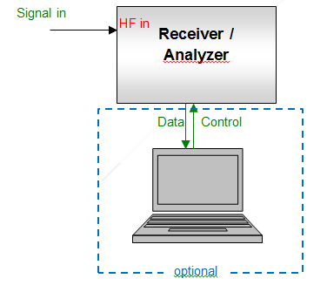
Figure 1: Principle measurement setup Type 1

Setup Type 2

This setup can be used for continuous signals when the required dynamic range of the result exceeds the capabilities of the measurement receiver/analyser.
To enhance the dynamic range of the measurement receiver/analyser, the wanted signal has to be suppressed by a (tuneable) filter. First, the filtered spectrum on the wanted channel/frequency as well as in the OoB or spurious domain is measured and recorded. In a second measurement, using the same receiver/analyser settings, the attenuation (frequency response) of the filter is measured and recorded. Then, using a software tool (e. g. Microsoft Excel), both curves are added to retain the original spectrum of the signal. The measurement is most efficient if controlled by a computer.
Depending on the application, frequency and bandwidth of the signal under test, a band pass filter or a band stop filter may be used. For spurious emissions, a band stop filter tuned to the wanted frequency is preferred as it allows measuring the whole spurious range at once. For OoB measurements, band pass filters tuned to the frequency range of the Out-of-band domain to be measured, could also be used.
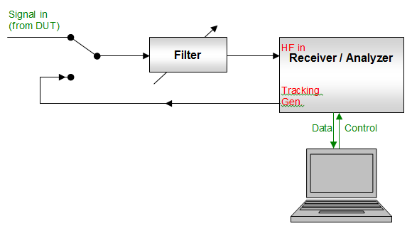
Figure 2: Principle measurement setup Type 2
Setup Type 3
For TDMA systems that transmit in bursts, the limits usually apply to the times where the transmitter is on. Unless the peak level is specifically mentioned in the relevant recommendation or standard, the average burst level has to be measured which is the RMS level during the burst only. This is done by externally triggering the measurement receiver to the burst start and adjusting the measurement time to match the burst length. The trigger is derived from a second spectrum analyser, operated in zero span mode and tuned to the wanted frequency.

The measurement process is identical to the setup Type 2.
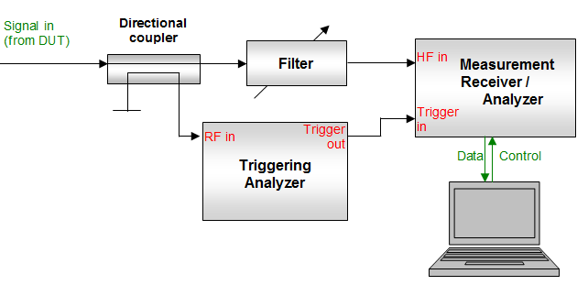
Figure 3: Setup Type 3 for measurements of TDMA systems
Data processing

The measurement bandwidth is always chosen to be equal to, or smaller than, the reference bandwidth stated in the relevant recommendation or standard. Especially in the vicinity of peak spurious emissions and in the OoB domain close to the wanted frequency, it is necessary to use a narrow measurement bandwidth because otherwise the measured spectrum would be unduly widened, leading to an overestimation of the unwanted level.

The signal levels (or spectral densities) taken in the selected measurement bandwidth are linearly converted to the corresponding levels or power densities in the reference bandwidths using the formula:
With:
- PrefBW = signal level in reference bandwidth;
- PmeasBW = signal level in measurement bandwidth;
- refBW = reference bandwidth;
- measBW = measurement bandwidth.

- Sensitivity analysis - applying the typical performance to sharing and compatiblity studies
ECC Report 249 “Unwanted emissions of common radio systems measurements and use in sharing/compatibility studies” [1] identified that unwanted emissions based measurements could be used as a sensitivity analysis to results based on limits. The report noted that measurements of the unwanted emissions equipment could be used as an alternative set of assumptions for in the study as a sensitivity analysis.

ECC working parties and projects teams should first conduct an initial analysis using the unwanted emission limits found in ETSI Harmonised Standards or EC/ECC decisions. It is noted that as part of the first step there should also be an investigation of all relevant assumptions in (e.g. deployment, frequency separation, propagation model, receiver parameter) which will be part of the overall study. If the initial analysis shows that there could be interference issues due to unwanted emissions then typical unwanted emission performance should be investigated. Once a typical unwanted emission performance is determined from measurements, this should be applied to the study as an alternative set of assumptions and the analysis re-run. The new results can be compared with the initial results as a sensitivity analysis in the study.

Assumptions made for input parameters into sharing studies - both interfering transmitters and victim receivers - need to be chosen carefully so that realistic results are achieved that both protect victims but, also, do not over estimate probabilities of interference. In particular, ECC Report 249 highlighted how actual systems’ spurious emissions can be several tens of dBs better than current standards and so studies should consider sets of parameters based on typical performance of the equipment in a statistical manner. For example, assumptions made for Emissions in the spurious domain can particularly sensitively affect the results of studies, especially if the victim is broadband (>1MHz). The assumptions chosen can often alter the apparent interfering power factors of one thousand, and in studies where aggregate emissions from the spurious domain dominate this can skew the study results.

Each sensitivity analysis regarding unwanted emissions will be on a bespoke, case by case, basis and will depend on how typical ‘unwanted emissions’ of equipment was defined and applied in the study. It will need to be up to the judgement of the ECC working parties and project teams as to how the sensitivity analysis is carried out. Some factors to consider could be:

- Where worst case unwanted emissions levels are used: This could be for example where the level used in the analysis based on the worst performing device either from measurements or other documentation. This is likely to lead to the most conservative results and most pessimistic outcome. In this case it is unlikely that additional sensitivity analysis would show much (if any) variation in the results. However, this could depend on the certainty of the worst-case values and if there is some chance / probability that some devices could have higher levels than the worst case analysed.
- Where the best case unwanted emission levels are used: For example, was the level used in the analysis based on the lowest levels (best performing) of unwanted emissions from devices. This is likely to lead to the more optimistic results. In this case additional sensitivity analysis could look at a couple / of different levels different levels of unwanted emissions and see what the variation on results are.
- Where average case or a statistical distribution of unwanted emission levels are used: This for example could be where there is a distribution in the level of unwanted emissions from devices, and either an average or a statistical distribution was used in the analysis. In this case, additional sensitivity could look at could vary the average level of the distribution then re-run the analysis to see what the impact on results are.

It is noted that it may be desirable to vary different input assumptions in relations to unwanted emissions to check the sensitivity of the results. It is also noted that this may part of a broader sensitivity analysis on looking at other parameters in the study not directly related to unwanted emissions.

There could be some additional factors that ECC groups may wish to consider in its sensitivity analysis regarding spurious emissions. These could be:

- The interfering system operating different bandwidths where other (wider or narrower) bandwidths are available currently or in the future.
- Likelihood and impact of a ‘spike’ spurious emission, considerations could include:
- Is it likely to fall within the bandwidth of the victim receiver? Is there any time / device to device variation that needs to be considered?
- What is the ’spike’ spurious emission bandwidth compared with the receiver bandwidth, what sort of bandwidth adjustment should be applied?
- How does the receiver behave to a ’spike’ spurious emission, for example with in systems such as OFDM victim does it only impact a single carrier and therefore have minimal impact?
- If the levels of unwanted emissions in the spurious domain are based on conducted levels, is the antenna performance / selectivity likely to provide attenuation to this?

- Likelihood and impact of harmonics:
- Are harmonics likely to fall within the bandwidth of the victim receiver?
- If the levels of unwanted emissions in the spurious domain (harmonics) are based on conducted levels, is the antenna performance / selectivity likely to provide attenuation to this?

- Dependence on assumptions for spurious emissions:
- Are spurious emissions from the equipment actually dominant in the interference scenario? For example, the results of the studies could be compared with the transmitter being active and inactive where the spurious emissions switched ‘on’ then ‘off’ (i.e. the interferers’ transmission masks be set to an arbitrarily low value, e.g. to -200dB, beyond the OOB domain). Markedly differing results should be treated with caution.
Caution has to be taken when conducting a sensitivity analysis of unwanted emissions where others parameters are not well defined (e.g. deployment, propagation models). Spurious emissions are just one of many parameters in sharing and compatibility studies (i.e. receiver blocking). While it may seem that there is a margin in regards to spurious emissions alone, variation of the other parameters may mean that there is no margin in the overall sharing and compatibility scenario and interference could occur.
Although at the time of publication of this recommendation there were no examples of ECC work that has done a sensitivity analysis relating to the levels of unwanted emissions. However, there are some more general examples of ECC Reports that performed a sensitivity analysis, these are:
- ECC Report 174 - Compatibility between the mobile service in the band 2500-2690 MHz and the radiodetermination service in the band 2700-2900 MHz [7];
- ECC Report 239 - Compatibility and sharing studies for BB PPDR systems operating in the 700 MHz range [8];
- ECC Report 271 - Compatibility and sharing studies related to NGSO satellite systems operating in the FSS bands 10.7-12.75 GHz (space-to-Earth) and 14-14.5 GHz (Earth-to-space) [9].
- oTHER cONsiDERATIONS
The boundary between Out of Band and spurious domains

The boundary / transition between unwanted emissions in the Out of Band domain and the spurious domains is where spurious becomes dominant over Out of Band effects. ECC Report 249 [1] identified that generally defined as 250% of the necessary bandwidth (2 channels from the edge of the wanted emission / channel) according to Annex 1 to Appendix 3 of the ITU Radio Regulations [5]. However, more specific definitions may be applicable, for example in some IMT systems based on a variable channel bandwidth where the boundary is presently specified in section 2.6 of Rec. ITU-R M. 2070 [10] for base stations as 10 MHz beyond the operating band edge. This is a particular case which is due to a filter being used on the entire operating band.
For sharing and compatibility studies, it may be beneficial to look at this at the boundary between unwanted emissions in the Out of Band and spurious domains. It is expected that the boundary will typically be less than 250%. The reason to consider this is that in sharing and compatibility studies is the following:
- ECC Report 249 observed that typical unwanted emissions in the spurious domain are significantly lower than the limits.
- Unwanted emissions in the spurious domain could be treated statistically and the effect of spurious ‘spikes’ may not be significant to the receiver, depending on the bandwidth(s) of the ‘spike’ and receiver.
- Considering a boundary less than 250% in studies will have a greater benefit to the study because this could allow lesser frequency separations from the band edge of the victim service under study to be considered as spurious
ECC Report 249 contains a number of measurements and some observations can be made from this as to the boundary between unwanted emissions in the Out of Band and spurious domain. These observations have defined the boundary as the point where the unwanted emission falls and becomes more of a constant level (flattens out). The observations from ECC Report 249 are in table 1. However, while this is a useful reference, it is based on a limited number of equipment samples for particular technologies and may not be generally applicable to studies. This simple approach could be used by other ECC groups to define a suitable boundary between unwanted emissions in the Out of Band and spurious domain relevant to the study
Table 1: Examples of transition between Out of Band and spurious domains from ECC Report 249 [1]. The values are based on a limited number of equipment samples and are not representative of all technology, therefore may not be generally applicable to studies
Technology / Case | Related section in ECC Report 249 | Observed transition between Out of Band and spurious emissions | Current regulatory boundary between spurious and out of band
DAB+ | 4.2 | 200% | 250%
DVB-T | 4.3 | 150% | 250%
LTE 800 BS | 4.4 | 10 MHz  (from edge of operating band) | 10 MHz  (from edge of operating band)
LTE 800 UE | 4.5 | 150% | 250%
LTE 2300 UE | 4.8 | 150% | 250%
DECT | 4.8 | 200% | 250%
UMTS 2100 BS | 4.9 | 150% | 250%
2.4 GHz RLAN | 4.10 | 200% | 250%
25 GHz P-to-P | 4.12 | 150% | 250%

Baseline assumptions in the absence of measurements and or other documents for particular technologies

When ECC groups are looking to use typical unwanted emissions of equipment in studies and the technology being considered is already measured in ECC Report 249, the information from the report could be applied in a sensitivity analysis. It should be noted that this information is based on a limited number of equipment samples and ECC groups should use judgement when applying these. There are three suggested approaches for applying these values:
- Use the figures from table 2 in the sensitivity analysis regarding spurious plus a margin where appropriate, noting that there are a limited number of equipment samples;
- For a conservative analysis apply a statistical distribution between the limits in table 2 and the limit set out in the ETSI standard;
- Use the revised information in table 3, noting this is based on a limited number of equipment samples.
When ECC groups are applying the information from ECC Report 249 without conducting their own measurements, care should be taken in regards to the second harmonic. ECC report 249 did not investigate the second harmonic in detail therefore it is proposed that the ETSI / regulatory limits are applied in this case. Caution has to be taken when applying the measured levels of unwanted emissions where others parameters are not well defined (e.g. deployment, propagation models). Spurious emissions are just one of many parameters in sharing and compatibility studies (i.e. receiver blocking). While it may seem that there is a margin in regards to spurious emissions alone, variation of the other parameters may mean that there is no margin in the overall sharing and compatibility scenario and interference could occur.
It is observed all results generated in ECC Report 249, compared with limits from ERC 74-01 [3]/SM.329 [4] were minimum of 20 dB better than the limit. Many of the measurements were limited by the noise floor of the measuring equipment so the actual unwanted emissions could be lower. Since the publication of ECC Report 249 there has been updates to some ETSI Harmonised Standards so, other ECC groups should investigate this before applying the numbers in Table 2 or 3.
Table 2: Findings in ECC Report 249 for unwanted emissions in the spurious domain for a limited sample of equipment for particular technologies
Technology / Case | Related section in  ECC Report 249 | dB below limit | Compared with limit from
DAB+ | 4.2 | ≥57 dB | ERC 74-01 [3]
DVB-T | 4.3 | ≥30 dB | ERC 74-01[3]
LTE 800 BS | 4.4 | ≥ 40 dB | ETSI EN 301 908-14 [11]
LTE 800 UE | 4.5 | ≥ 20 dB | ETSI / ERC 74-01[3]
LTE 2300 UE | 4.8 | ≥ 30 dB | ETSI EN 301 908-13 [12]/ERC 74-01 [3]
GSM 900 BS | 4.7 | ≥ 25 dB | ETSI TS 145 005 [13]
DECT | 4.8 | 10 dB | ETSI EN 300 175-2 [14]
UMTS 2100 BS | 4.9 | ≥ 30 dB | SM 329 [4]/ERC 74-01 [3]
2.4 GHz RLAN | 4.10 | 20 to 30 dB | SM 329 [4]/ERC 74-01 [3]
WIMAX 3.6 | 4.11 | ≥ 40 dB | SM 329 [4]/ERC 74-01 [3]
25 GHz P-to-P | 4.12 | 20 dB | ITU-R SM.1541 [15]

Table 3: Revised emission masks based on ECC Report 249 for use in sharing and compatibility studies for a limited sample of equipment for particular technologies
Technology | Filtered  Y/N | Proposed border  OoB value at 250%  Y/N | OoB mask | Spurious mask vs. Regulatory mask
DAB+ | Y | Y | Same as regulatory mask RRC06 | From 250% to 350%, ETSI ref., from 1000% on ETSI mask - 10 dB and in-between the linear approximation
DVB-T | Y | Y | Same as regulatory mask RRC06 | ETSI mask
LTE UE band edge | Y | Y | Measurement values or ETSI mask - 10 dB | ETSI standard -10 dB
LTE 800 BS | N | Y | Until 150%: ETSI  from 150% - 250%:  measurement values or ETSI mask - 10 dB | ETSI standard - 26 dB
LTE 2300 UE | N | Y | ETSI mask | ETSI standard mask - 8 dB
GSM 900 BS | N | Y | Until 150%: ETSI  from 150%-250%:  measurement values or ETSI mask - 5 dB | From 250% to 500% ETSI mask, - 15dB, at 1000% ETSI mask - 7.5 dB and above 5000%, ETSI mask
UMTS 2100 BS | N | Y | Until 50%: ETSI  from 50%-250%:  measurement values or ETSI mask - 10 dB | From 250 - 300 % ETSI mask, from 500% on ETSI mask - 17%, and linear approximation between 300% and 500%.
25 GHz P-P | N | Y | Until 50%: ETSI  from 50%-250%:  measurement values or ETSI mask | From 250% on ETSI mask,-20 dB.
RLAN 2.4 GHz | N | Y | Until 100%: ETSI  from 100%-250%:  measurement values or at 100% and 200% ETSI mask and at 150%, 250% or ETSI mask - 10 dB | From 250% to 400% ETSI mask - 10 dB, from 500% on ETSI mask - 15 dB.
DECT | N | Y | Until 100%: ETSI  from 100%-150%:  ETSI-10 dB  from 150%-250%:  measurement values or ETSI mask - 20 dB | From 250% to 300% ETSI mask, from 350 - 500% ETSI mask .- 20 dB, form 5000% on ETSI mask - 10dB, from 500%-500% linear approximation.

Transmitters applying external filtering

One reason that some systems measured have performed so much better than ETSI standards is that the transmitters have external filters that are applied after the final amplifier stage. While the ETSI standard usually specifies the performance directly at the transmitter output, the final system may have no measurable unwanted emissions, especially in the start of the spurious domain. Reasons for fitting external filtering include the following:
- The device has a receiver on a different frequency that has to function at the same time as the transmitter (e. g. full-duplex systems, devices covering multiple radio systems such as smartphones);
- National regulations require specific attenuation of unwanted emissions in adjacent bands (e. g. block edge masks) that cannot be met by the transmitter alone;
- Multiple transmitters sharing the same antenna have to be sufficiently decoupled from each other (e. g. broadcasting transmitters at shared sites).

One effect of external filtering is that the suppression of unwanted emissions is increasing with frequency offset even well inside the spurious domain, where current limits generally apply a frequency-independent baseline limit. For the purpose of sharing studies, unwanted emissions in the spurious domain can generally be set to zero for such systems.
- List of references
This annex contains the list of relevant reference documents.
- ECC Report 249: “Unwanted emissions of common radio systems: measurements and use in sharing/compatibility studies”
- Directive 2014/53/EU of the European Parliament and of the Council of 16 April 2014 on the harmonisation of the laws of the Member States relating to the making available on the market of radio equipment and repealing Directive 1999/5/EC (Radio Equipment Directive
- ERC Recommendation 74-01 (Siófok 98, Nice 99, Sesimbra 02, Hradec Kralove 05, Cardiff 11): “Unwanted emissions in the spurious domain”
- Recommendation ITU-R SM.329: “Unwanted emissions in the spurious domain”
- ITU Radio Regulations, Edition of 2016
- Recommendation ITU-R SM.1539: “Variation of the boundary between the out-of-band and spurious domains required for the application of Recommendations ITU-R SM.1541 and ITU-R SM.329”
- ECC Report 174 : “Compatibility between the mobile service in the band 2500-2690 MHz and the radiodetermination service in the band 2700-2900 MHz”, April 2012
- ECC Report 239: “ Compatibility and sharing studies for BB PPDR systems operating in the 700 MHz range”, September 2015
- ECC Report 271: “Compatibility and sharing studies related to NGSO satellite systems operating in the FSS bands 10.7-12.75 GHz (space-to-Earth) and 14-14.5 GHz (Earth-to-space)”, January 2018
- Recommendation ITU-R M. 2070-1: “Generic unwanted emission characteristics of base stations using the terrestrial radio interfaces of IMT-Advanced ”
- ETSI EN 301 908-14 V11.1.2: “IMT cellular networks; Harmonised Standard covering the essential requirements of article 3.2 of Directive 2014/53/EU; Part 14: Evolved Universal Terrestrial Radio Access (E-UTRA) Base Stations (BS)”
- ETSI EN 301 908-13 V11.1.2: “IMT cellular networks; Harmonised Standard covering the essential requirements of article 3.2 of Directive 2014/53/EU; Part 13: Evolved Universal Terrestrial Radio Access (E-UTRA) User Equipment (UE)”
- ETSI TS 145 005 v10.8.0: “Digital cellular telecommunications system (Phase 2+); Radio transmission and reception (3GPP TS 45.005 version 10.8.0 Release 10)”
- ETSI EN 300 175-2 V2.7.1: “Digital Enhanced Cordless Telecommunications (DECT); Common Interface (CI); Part 2: Physical Layer (PHL)”
- Recommendation ITU-R SM.1541-6: “Unwanted emissions in the out-of-band domain”

http://www.etsi.org/standards
https://ec.europa.eu/growth/single-market/european-standards/harmonised-standards/red_en
The RED provides other methods of demonstrating conformity such as using a notified body
https://ec.europa.eu/growth/single-market/european-standards/harmonised-standards/red_en

