CPG PTC(13) INFO 16
3rd Meeting CPG PTC
Bucharest, 08-11 October 2013
Date issued: 30 September 2013
Source: France
Subject: VDES Agenda item 1.16

Summary:
VHF Data Exchange System (VDES) is a technological concept developed by the IALA e-NAV Committee and now widely discussed at ITU, IMO and other organizations. VDES was originally developed to address emerging indications of overload of VHF Data Link (VDL) of AIS and simultaneously enabling a wider seamless data exchange for the maritime community. VDES is capable of facilitating numerous applications for safety and security of navigation, protection of marine environment, efficiency of shipping and others. VDES will prospectively have a significant beneficial impact on the maritime information services including Aids to Navigation and VTS in the future. The VDES concept is developed under the framework of AI 1.16 for WRC-15 and is decoupled of the work for e-navigation for the WRC-18

Proposal: This Info document together with the PowerPoint presentation is there to help to better understand the VDES concept.
Background:

Information Paper on
VHF Data Exchange System (VDES)

PURPOSE
The purpose of this information paper is to inform PT C of VDES, its purpose, plans and progress.

RATIONALE OF VDES
AIS is now well recognized and accepted as an important tool for safety of navigation and is a carriage requirement for SOLAS vessels (Class-A). However, because of its effective and useful technology, the use of AIS is expanded to vessels not complied with the carriage requirement (Class-B) and other applications such as Aids to Navigation (AtoN), Application Specific Messages (ASM), Search and Rescue Transmitter (SART), Man Over-Board unit (MOB) and EPIRB-AIS. This expanding use of AIS technology has caused significant increase in VHF Data Link (VDL) loading which has become an active concern in IMO and ITU.

Simultaneously, because of increasing demand of radio spectrum for digital communication such as mobile phone and data, ITU now requests more efficient and effective use of radio spectrum. In 2009, ITU issued Recommendation ITU-R M.1842-1 “Characteristics of VHF radio systems and equipment for the exchange of data and electronic mail in the maritime mobile service RR Appendix 18 channels.” This technique will provide higher data rates (up to 32X) than the present AIS and will become core element of VDES. Furthermore VDES network protocol should be optimized for data communication so that each VDES message is transmitted with a very high confidence of reception. Consequently VDES will allow more efficient and effective use of marine VHF spectrum.

Considering this, the WRC-12 adopted Resolution 360 (WRC-12) “Consideration of regulatory provisions and spectrum allocation for enhanced Automatic Identification System technology applications and for enhanced maritime radiocommunication” and decided to discuss the matter at WRC-15 under agenda item 1.16.

According to IALA Recommendation A-124 Appendix 18 “VDL Loading Management”, if the VDL loading exceeds 50%, it may have an impact on smooth transmission of AIS station. The recent ITU-R WP5B meeting (May 2013) reported that the VDL loading was already exceeded 64% in the Northern Gulf of Mexico, USA, and was also reached almost 40% in Korea and Japan. It is therefore urgently necessary to allocate new frequencies for new and emerging applications of AIS technology in order to mitigate overloading of AIS VDL.

E-navigation is defined by IMO as “the harmonized collection, integration, exchange, presentation and analysis of marine information onboard and ashore by electronic means to enhance berth to berth navigation and related services for safety and security at sea and protection of the marine environment.” IMO is now developing an e-navigation strategy implementation plan with a target completion year for the plan of 2014. Simultaneously, IMO is now conducting a review and modernization of GMDSS with a target completion year of 2017. In the discussion of both matters, one of the common key elements is exchange of information and this will be achieved possibly by digital data exchange.

Digital data exchange can be achieved using a whole multitude of commercially available data links, however global availability and interoperability is an issue. Since VDES is an opportunity for a globally interoperable capability of significantly higher speed and larger volume data exchange than AIS or DSC, and potentially with worldwide coverage, VDES can become one of core facilitating elements for both implementation of e-navigation and modernization of GMDSS.

IMPACTS ON MARITIME COMMUNITY

One of the impacts could be a migration of AIS ASM and all other related messages from AIS 1 and 2 channels to ASM 1 and 2 channels. The main rationale for the development of VDES is to avoid overloading of AIS VDL and hence to protect AIS main function of safety of navigation. Thereby the AIS 1 and 2 channels will be solely allocated for navigational safety purposes. Other supplemental messages, i.e. ASM such as weather info, could be moved to ASM 1 and 2 channels. AtoN authorities now broadcasting ASM using AIS 1 and 2 channels will consider to use the new frequencies, ASM 1& 2 and IALA will coordinate and provide technical assistance for the change.

Since VDES has higher speed and robust data exchange capability with potential for worldwide coverage, there may be numerous benefits to AtoN services and VTS. Virtual AtoN could be deployed beyond a limit of VHF range such as the high seas, or remote/polar areas. VTS could exchange more comprehensive data with ships than the present AIS can provide. Machine readable digital data will enable a navigational display to portray navigational safety information graphically, assisting to overcome language barriers between VTS operator and mariners. AtoN authorities will be able to develop various applications for their use and make advanced services available to ship using VDES. IALA will coordinate and harmonize development and implementation of such applications which are under his competence.

ROAD MAP
It is anticipated that VDES may be implemented in two parts, terrestrial VDES and satellite VDES. Some radio manufactures have already started to develop the prototype VDE transceiver that has capability of VHF digital data exchange (VDE) function which is defined by Recommendation ITU-R M.1842-1. Those prototypes will be available to support testing in 2014. Although this VDE transceiver will have only limited capability of VDES, the core technology of the VDE transceiver will be incorporated into the first implementation of VDES. If WRC-15 approves to allocate new frequencies for VDES, because of the present technical development and urgency of protection of AIS VDL, terrestrial VDES could be implemented first, even before satellite assets are available. Sharing studies between mobile satellite service (space-to-Earth) and land mobile/fixed service in the VHF frequency band are underway in ITU-R. It is expected that such studies will be completed during the development of the ITU Recommendations for VDES so that final decisions by WRC-15 can facilitate a fully featured VDES including the satellite aspects. Figure 2 provides a possible roadmap for VDES.
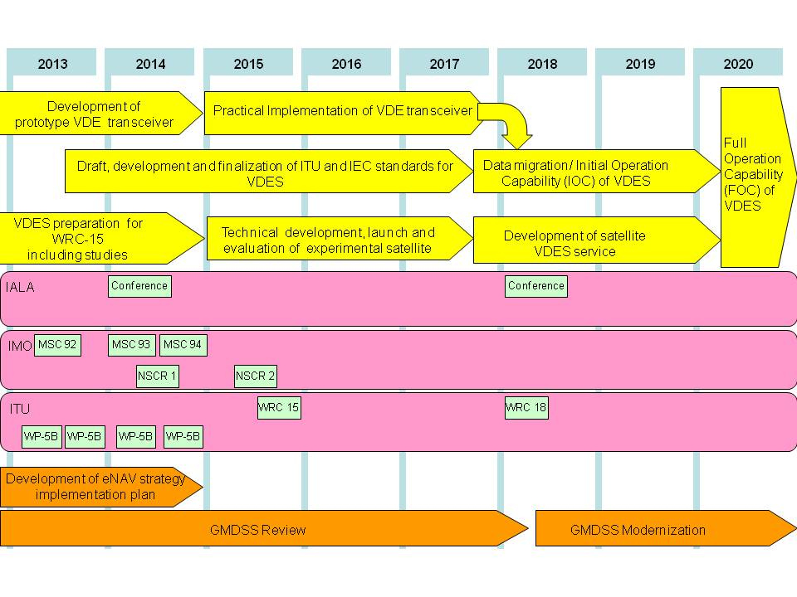
Figure 2: Possible Roadmap for VDES

TECHNICAL FEATURE
The VDES integrates the function of AIS, ASM and VDE and includes the channels for these functions with satellite transmission and reception. A proposed arrangement of the globally available channels and usage is shown in Table 1. Further studies and testing will be required for a final arrangement of the channels.
Table 1
Example channel designations
Appendix 18 channels and frequencies for the VHF data exchange system (AIS, ASM and VDE)

Channel number in RR Appendix 18 | Transmitting frequencies (MHz) for ship and coast stations
Channel number in RR Appendix 18 | Ship stations (ship-to-shore)  (long range AIS)  Ship stations (ship-to-satellite) | Coast stations  Ship stations (ship-to-ship)  Satellite-to-ship
AIS 1 | 161.975 | 161.975
AIS 2 | 162.025 | 162.025
75 (long range AIS) | 156.775 (ships are Tx only) | N/A
76 (long range AIS) | 156.825 (ships are Tx only) | N/A
2027 (ASM 1) | 161.950 (2027) (SAT Up1) | 161.950 (2027) (SAT Up1)
2028 (ASM 2) | 162.000 (2028) (SAT Up2) | 162.000 (2028) (SAT Up2)
24/84/25/85 (VDE 1)  24  84  25  85 | 100 kHz channel  (24/84/25/85, lower legs, merged)  Ship to shore  Ship to satellite (SAT Up 3) | 100 kHz channel  (24/84/25/85, upper legs, merged)  Ship to ship, Shore to ship  Satellite to ship under certain conditions (SAT2 possible extension)
24/84/25/85 (VDE 1)  24  84  25  85 | 157.200 (1024) | 161.800 (2024)
24/84/25/85 (VDE 1)  24  84  25  85 | 157.225 (1084) | 161.825 (2084)
24/84/25/85 (VDE 1)  24  84  25  85 | 157.250 (1025) | 161.850 (2025)
24/84/25/85 (VDE 1)  24  84  25  85 | 157.275 (1085) | 161.875 (2085)
26/86  26  86 | 50 kHz channel  (26/86, lower legs, merged) VDE 2  Ship to satellite (SAT Up3) | 50 kHz channel  (26/86, upper legs, merged)  Satellite to ship (SAT 1)
26/86  26  86 | 157.300 (1026) VDE 2, SAT Up3 | 161.900 (2026) (SAT 1)
26/86  26  86 | 157.325 (1086) VDE 2, SAT Up3 | 161.925 (2086) (SAT 1)

FUNCTIONALITIES
Since VDES is designed for higher data exchange capability than AIS with worldwide coverage, various functionalities can be considered. The radio links enabled by robust VDES and their use by ships, shore stations and satellites are illustrated pictorially in Figure 1.
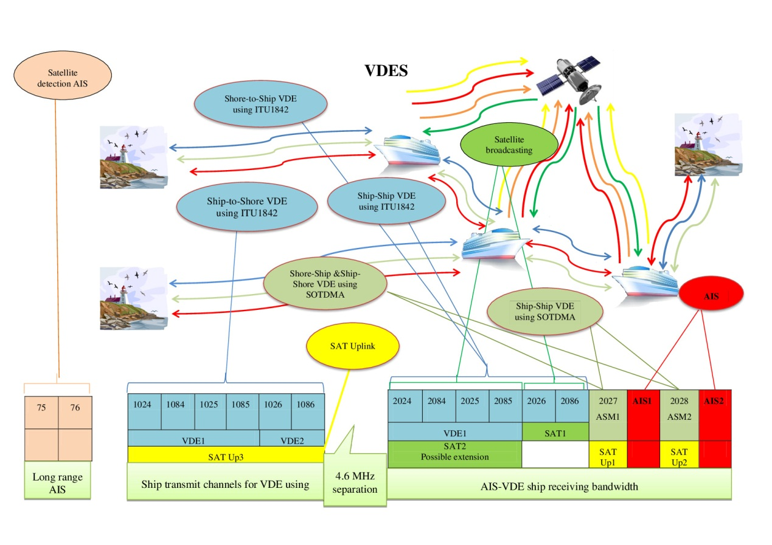

Figure 1: VDES radio links

Table 2 provides a summary of the proposed technical assignment of various VHF channels for communication including protocol and types of messages to meet the functionality required by user needs.

Table 2
VDES Communications including AIS, ASM and VDE
 | VHF Data Communications (including ASM and VDE) |  | AIS
Sub-group | Data communications for ASM | Data communications for VDE | AIS for safety of navigation | AIS long range
Radio channels | - Channels 27 and 28  - World-wide dedicated channels | - Channels 24, 84, 25, 85, 26, 86 for VDE terrestrial and satellite | - AIS-1 & AIS-2 (simplex) | - Channels 75 and 76 (simplex)
Functionality | - Marine safety information  - Marine security information  - Short safety related messages  - General purpose information communication | - General purpose data exchange  - Robust high speed data exchange  - VDE satellite communications | - Safety of navigation  - Maritime locating devices | - Satellite detection of AIS  - Locating during SAR
Message types for AIS protocol | - IMO SN.1/ Circ.289 international application specific messages  - Regional application specific messages  - Base Station |  | - Vessel identification  - Vessel dynamic data  - Vessel static data  - Voyage related data  - Aids to Navigation  - Base Station | - Satellite detection of AIS  - Message 27
Applications | - Area warnings and advice  - Meteorological and hydrographic data  - Traffic management  - Ship-shore data exchange  - Channel management | - High message payload  - Satellite communications | - Ship to ship collision avoidance  - VTS  - Tracking of ships  - Locating in SAR  - VDL control (by Base Station) | - Detection of vessels by coastal states beyond range of coastal AIS base stations

CONCLUSIONS
VDES may be the globally interoperable key to the future introduction of e-navigation. Its capability of higher speed digital data exchange with potential for a worldwide coverage may pave the way for implementation of e-navigation and modernization of GMDSS.
Due to the high complexity of the integration of both terrestrial and satellite aspect of the VDES, together with the need to have a 100% certainty that VDES will not interfere with AIS, a tremendous number of studies are in progress. Numerous web meeting are organized to confirm, infirm, validate the various option of a channel plan. What is presented today in this info document is a snapshot of one of the two channel plan under discussion. The first one was the one already presented in ITU and which is contained in the Draft CPM text. The difference between the two is the swap between SAT 1 and SAT2 and the guard band establish by SAT 1 between VDE1 and ASM1. However technical issues are still under development.
For this reason an important web meeting comprising of more than 35 representatives of the major worldwide maritime industry and regulator from various administrations (involved in the development of the VDES) will took place Thursday 3rd October 2013, an information paper will be deliver to PT C prior to the start of the meeting in order to resume the discussion which have occurs during this web meeting.

_____________________________

However, even in this high slot usage situation, a mobile AIS station is designed to avoid losing a target that may pose a danger by using time slots of the most distant stations and therefore the most important function of AIS, i.e. ship to ship anti-collision functionality, is more robust.

