CPG |  | Doc. CPG(18)INFO55
CPG19-6
Turku, Finland, 26th - 29th June 2018
Date issued: | 19th June 2018
Source: | ECO
Subject: | ECO tools on documentation
Group membership required to read? (Y/N)
N
Summary:
This document provides information on the ECO tools on documentation.
In particular the new Documentation Database and the EFIS are presented, giving a few examples on how these tools can be employed to retrieve useful information on documentation in support of the CEPT preparation to WRC-19.
Proposal:
CPG is invited to:
note the availability of ECO tools and databases on documentation;
encourage the use of these tools in support of the CEPT preparation to WRC-19 (e.g. for the continuous update of Section 4 of the draft CEPT Briefs on “List of relevant documents”).
Background:
ECO maintains the ECO Documentation Database, a library of Decisions, Recommendations and Reports in the field of spectrum and numbering regulation approved by the ECC. A new, more detailed and easier to navigate version of the ECO Documentation Database has gone live in April 2018 with the intent to add value to users and administrations.
ECO also maintains and continuously upgrade the ECO Frequency Information System (EFIS). EFIS is the tool to fulfil EC Decision 2007/344/EC on the harmonised availability of information regarding spectrum use in Europe and the ECC Decision ECC/DEC/(01)03.

ECO TOOLS on Documentation

Documentation Database
The ECO Documentation Database is a library of Decisions, Recommendations and Reports in the field of spectrum and numbering regulation approved by the ECC. Relevant EC Decisions are also provided for information. All radio spectrum related EC deliverables approved by the EC and relevant equipment technical standards produced by ETSI can be downloaded from their respective websites.
Since last April, the new Documentation Database is live and replaces the former ECO DocDB. It offers improved and new features, including:
- Improvement of the quick search and update history tools;
- Implementation of a user notification feature to inform via email once per month about new documents and other updates;
- Creation and maintenance of the list of review of ECC/ERC Decisions within the database;
- Other small improvements such as sorting of documentation and handling of SEAMCAT workspaces in related documents.
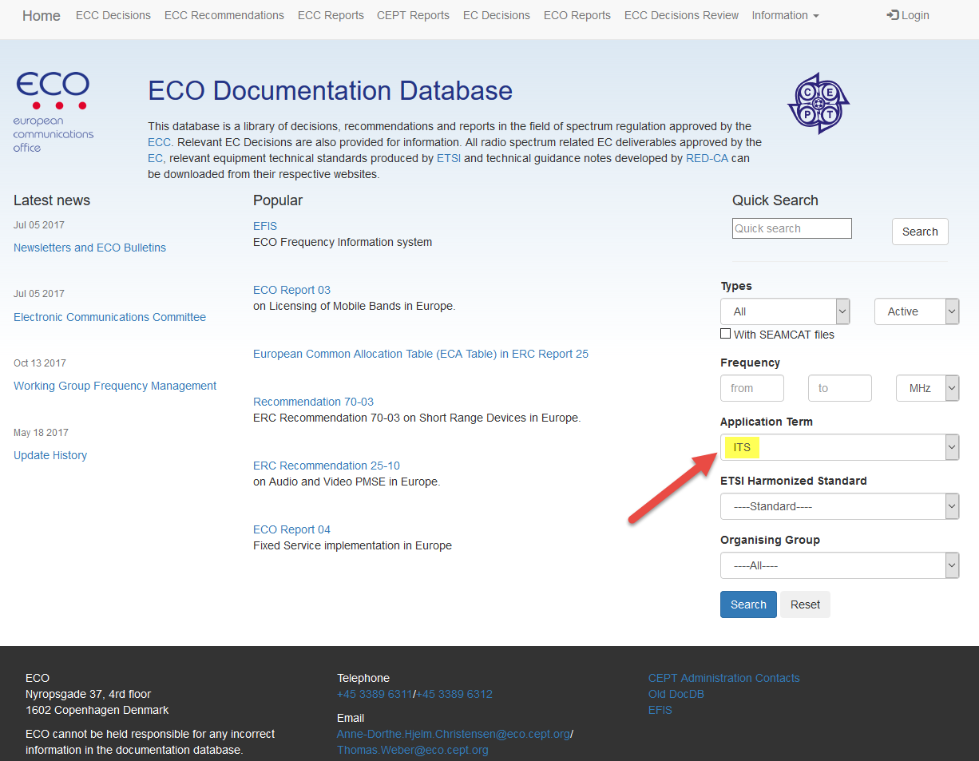
Figure 1: Example of quick search in the new ECO Documentation Database with a single key
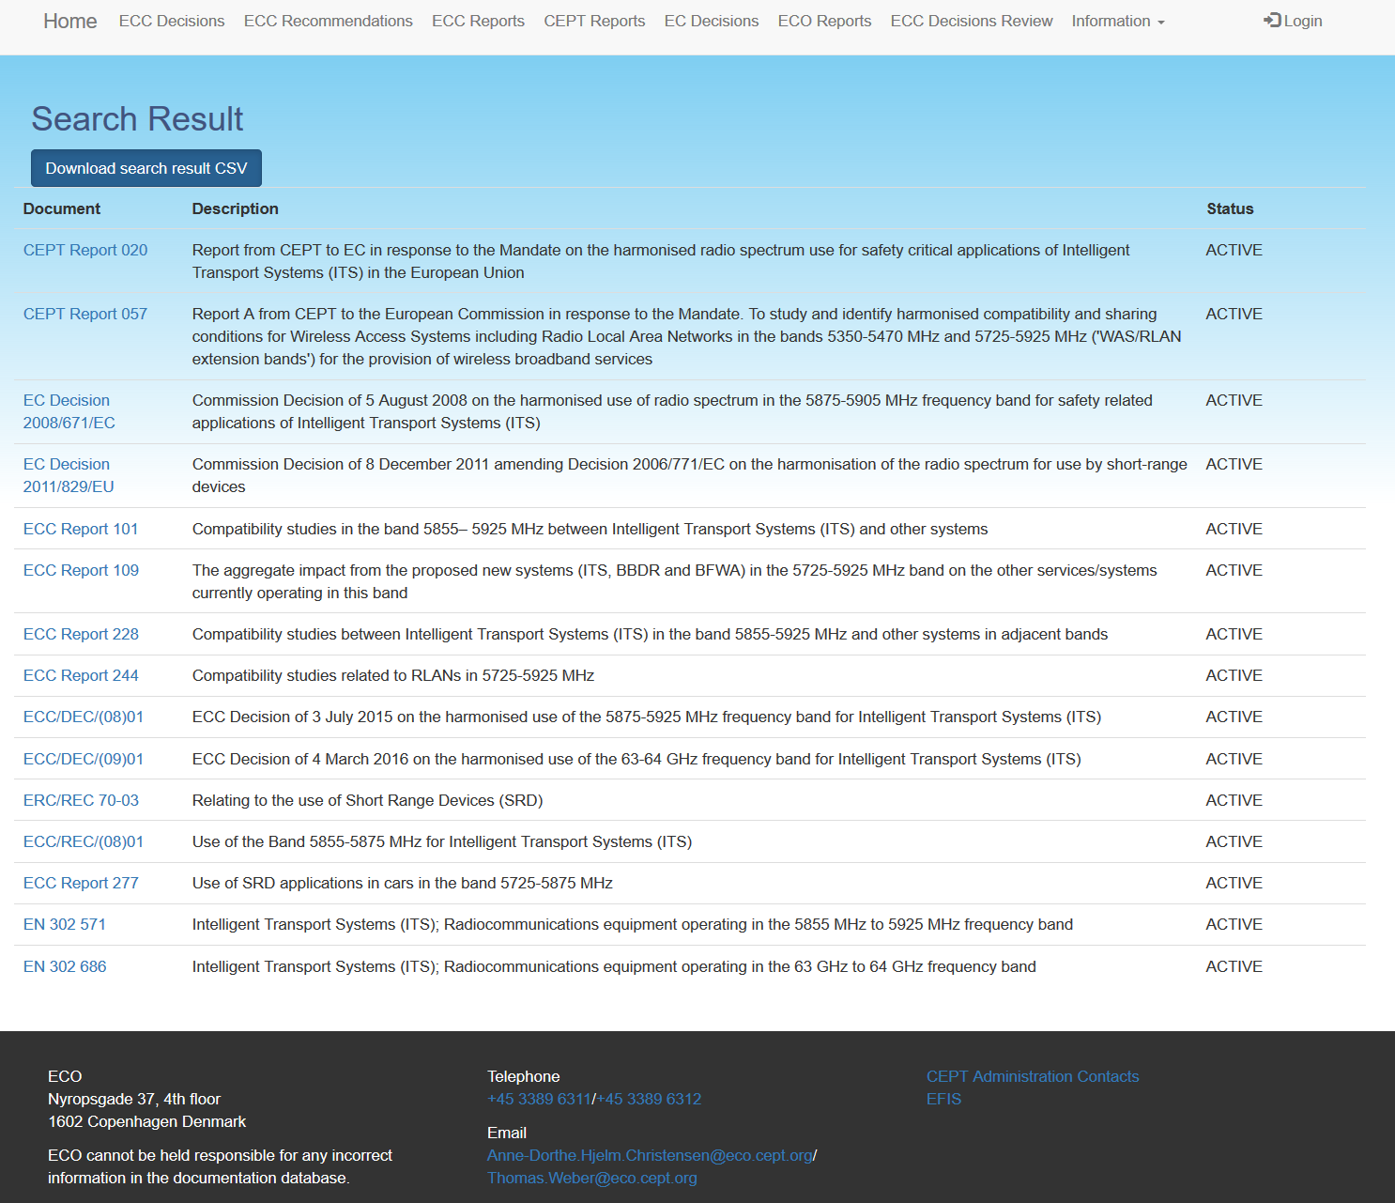
Figure 2: Outcome of the search on ITS in the new ECO Documentation Database

EFIS
EFIS (www.efis.dk) is the tool to fulfil EC Decision 2007/344/EC on the harmonised availability of information regarding spectrum use in Europe and the ECC Decision ECC/DEC/(01)03 on EFIS.
With EFIS, users can search for and compare spectrum use across Europe as well as related information such as CEPT activities, radio interface specifications and other national or international regulations.
In particular, EFIS allows searching for all documents for a table or for a specific type of documents. If no selection criteria apart from the table name are entered, all documents related to that table will be shown in the search result. The search can be narrowed by entering a frequency band, selecting an application or a type of document in EFIS. Search results can also be exported to a CSV file.
Additional information on EFIS is available on the ECC webpage:
https://cept.org/eco/eco-tools-and-services/efis-eco-frequency-information-system
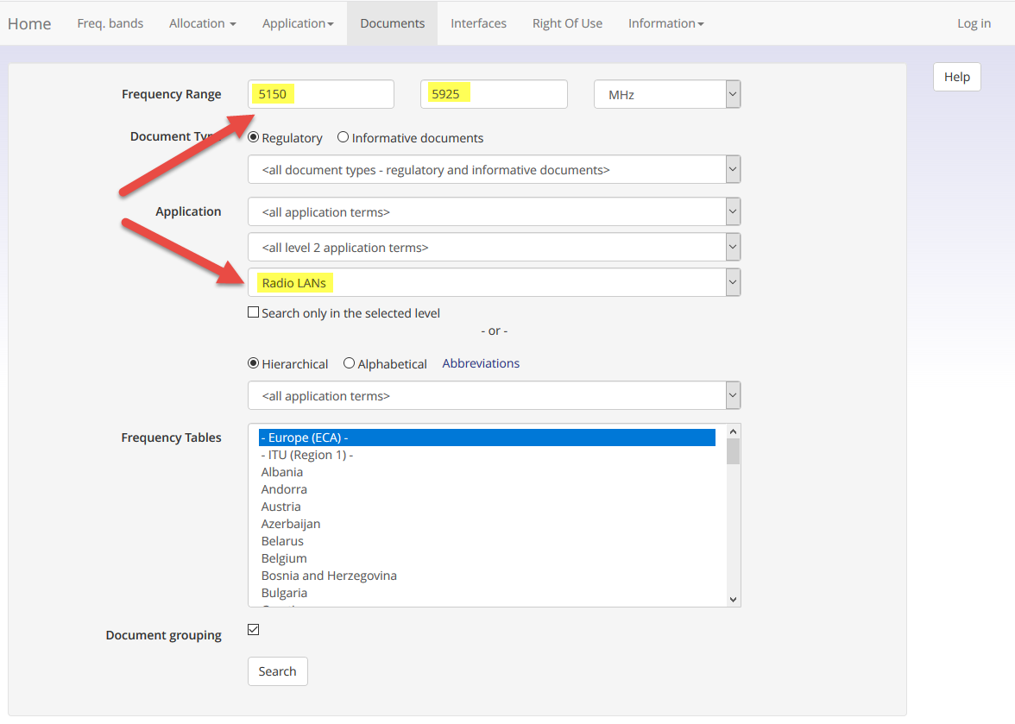
Figure 2: Example #1 of document search in EFIS with multiple keys
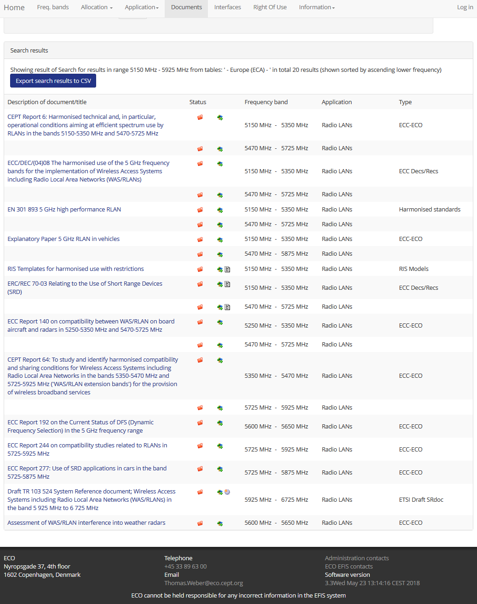
Figure 4: Outcome on the search on Radio LANs in the 5150-5925 MHz range in EFIS

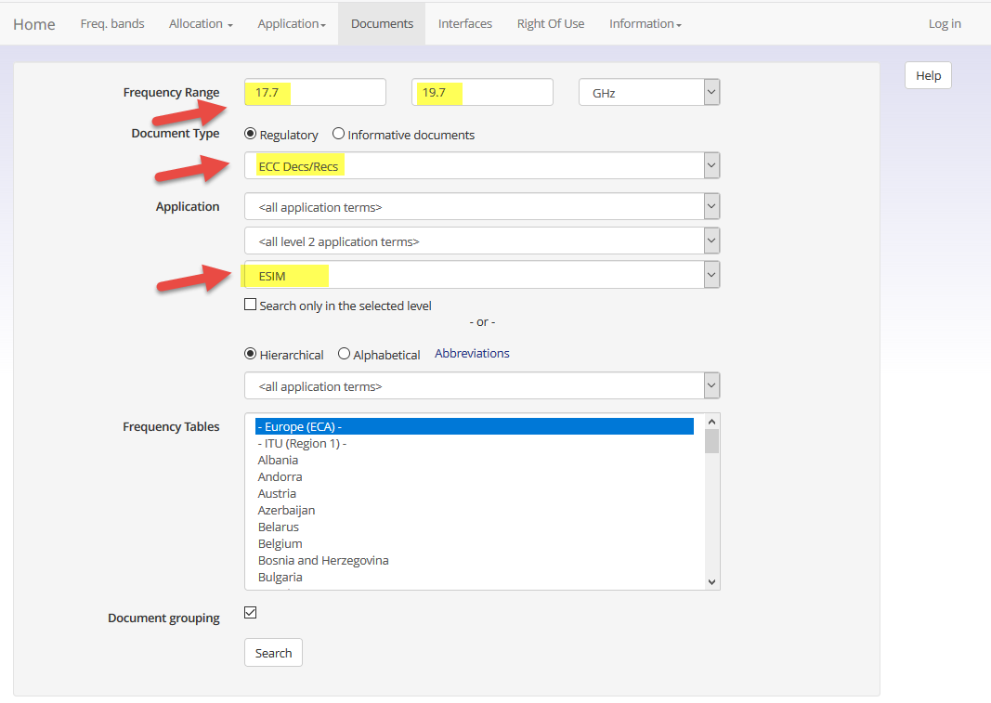
Figure 5: Example #2 of document search in EFIS with multiple keys
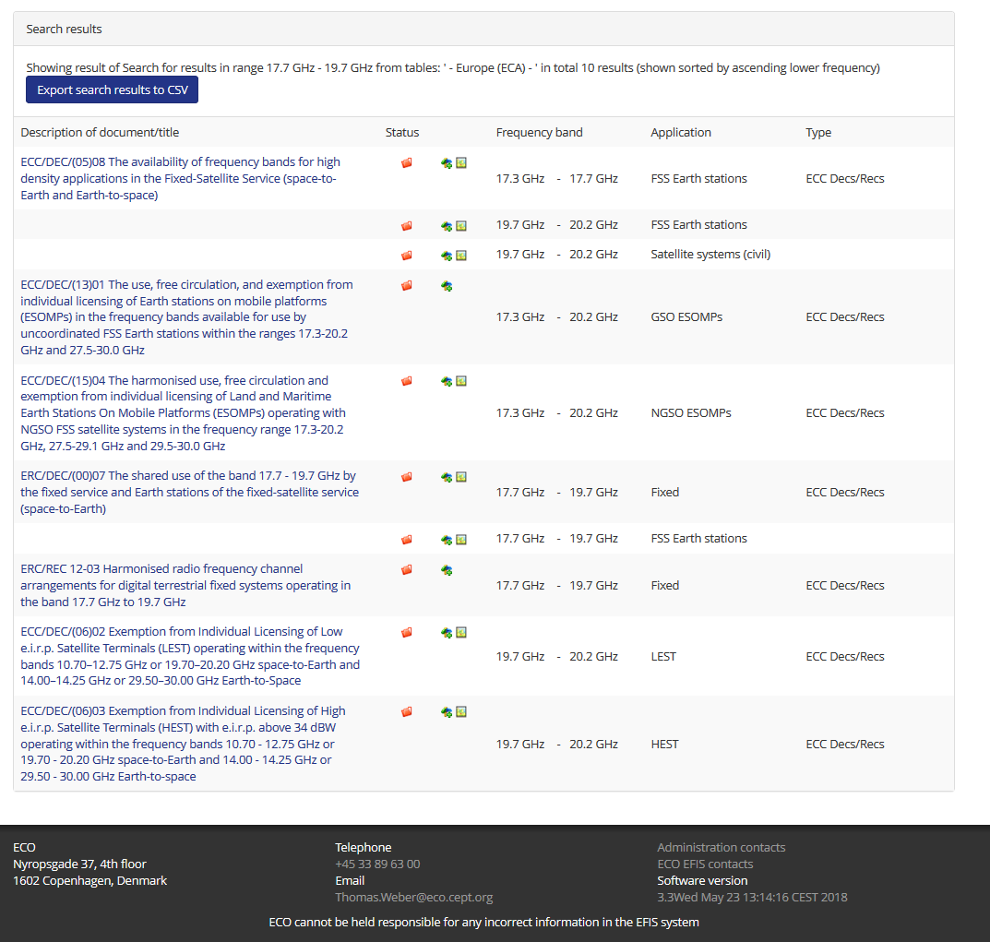
Figure 6: Research of ECC Decs/Recs on ESIM in the 17.7-19.7 GHz MHz range in EFIS

FUTURE updates
The development of a new application programming interface (API) has recently started.
This new project is intended to facilitate the future use and developments of our current databases (in particular EFIS and Doc DB) by putting in a common tool and in a structured way the required information with appropriate import/export features. This API is also going to be used to import information from CEPT administrations (EFIS information, national implementation information) and from ETSI about published harmonised standards and system reference documents.

