World Radiocommunication Conference (WRC-15)  Geneva, 2-27 November 2015 | 
INTERNATIONAL TELECOMMUNICATION UNION
PLENARY MEETING | Addendum 1 to  Document CMR15/4-E
PLENARY MEETING | 2 July 2015
PLENARY MEETING | Original: English
Director, Radiocommunication Bureau
REPORT OF THE DIRECTOR ON THE ACTIVITIES OF THE RADIOCOMMUNICATION SECTOR
part 1: activities of the radiocommunication sector in the period between WRC-12 and WRC-15

Table of Contents
Introduction 5
1 WRC-15 preparations 5
1.1 BR preparations for WRC-15 5
1.2 Regional preparations in response to Resolution 72 (Rev.WRC-07) 5
1.3 ITU-R Study Groups work for WRC-15 5
2 Application of the Radio Regulations for Spaces services 6
2.1 Introduction 6
2.2 Processing of notices: non-planned services 6
2.2.1 Advance publication information (API) 6
2.2.2 Coordination requests (CR) 8
2.2.3 Notification for recording in the Master Register 10
2.3 Processing of notices: planned services 16
2.3.1 Appendices 30 and 30A 16
2.3.2 Appendix 30B 18
2.4 Special assistance on coordination, notification and Plans 20
2.4.1 Assistance cases for non-planned services 20
2.4.2 Assistance cases for Appendices 30, 30A and 30B 20
2.4.3 Request for assistance under § 6.13 of Article 6 of Appendix 30B 21
2.5 Resolution 49 (Rev.WRC-12) – Due diligence 21
2.5.1 Introduction 21
2.5.2 Changes made by WRC-12 21
2.5.3 Implementation 21
2.5.4 Results of the process 22
2.5.5 Suggestions for improvement of the Resolution 49 procedure 22
2.6 Resolution 55 (Rev.WRC-12) 23
2.7 Resolution 609 (Rev.WRC-07) 23
2.8 Resolution 80 (Rev.WRC-07) 24
2.9 Resolution 907 (WRC-12) 24
2.10 Cost recovery for processing satellite network filings 25
2.11 Resolution 703 (Rev.WRC-07) 26
2.12 Resolution 647 (WRC-07) 26
3 Application of the Radio Regulations for terrestrial services 27
3.1 General observations 27
3.2 Coordination requests pertaining to terrestrial services 27
3.3 Plan modification procedures for terrestrial services 28
3.4 Notification, examination, recording and other regulatory procedures 29
3.4.1 Notification procedure (Article 11 of the Radio Regulations) 29
3.4.2 Processing of submissions for HF broadcasting schedules 30
3.5 Activities related to the end of the Transition period from analogue to
digital broadcasting set forth by the GE06 Regional Agreement 30
3.6 Other regulatory procedures pertaining to terrestrial services 31
3.6.1 Resolution 12 (WRC-12) 31
3.6.2 Implementation of Resolution 150 (WRC-12) 31
3.6.3 Resolutions 205 (Rev.WRC-12) 31
3.6.4 Implementation of Resolution 417 (Rev.WRC-12) 32
3.6.5 Implementation of Resolution 612 (Rev.WRC-12) 32
3.6.6 Implementation of Resolution 647 (WRC-07) 33
3.6.7 Implementation of Resolution 749 (Rev. WRC-12) 33
3.6.8 Implementation of Resolution 755 (WRC-12) 33
3.7 Software development related to the terrestrial services 34
4 Study Groups 34
4.1 BR support for Study Group activities 34
4.2 Response to the results of RA-12 34
4.3 Preparatory work for WRC-15 35
4.4 Recommendations, Handbooks and Reports 37
4.5 Liaison with ITU-D and ITU-T 38
4.6 Liaison and collaboration with other organizations 38
4.7 Support to membership 38
4.8 Statistics regarding meetings, documentation and finalized texts
(in electronic or paper form) 38
5 Radiocommunication Advisory Group 38
6 Publications, seminars/workshops, communication and outreach 40
6.1 Publications 40
6.1.1 Regulatory publications 40
6.1.2 Service publications 41
6.1.3 Study Groups and other publications 42
6.1.4 ITU-R Publications Downloads 43
6.1.5 Navigation and analysis tools for ITU-R electronic publications 47
6.2 Seminars and workshops 48
6.2.1 World Radiocommunication Seminars (WRS) 48
6.2.2 Regional Radiocommunication Seminars (RRS): 48
6.2.3 Other Events 51
6.3 Communication and Outreach 53
6.3.1 Membership 53
6.3.2 Communication and Promotion 53
6.3.3 Web management 53
6.3.4 Frequently Asked Questions (FAQ) 54
7 Assistance to Member States 54
7.1 Assistance to administrations of developing countries 54
7.2 Assistance to Regional Groups 55
7.2.1 Assistance to ATU 55
7.2.2 Assistance to ASMG 55
7.2.3 Assistance to CITEL 55
7.3 Assistance to other groups of countries 56
7.4 Treatment of cases of harmful interference 56
7.4.1 General overview 56
7.4.2 Developments regarding specific cases of harmful interference 57
8 Cooperation 58
8.1 Cooperation with ITU-D 58
8.1.1 GSR 58
8.1.2 ICT Survey and ICT Eye 59
8.1.3 Spectrum Management Training Programme (SMTP) 59
8.2 Cooperation with ITU-T 59
8.3 Cooperation with international and regional organizations 60
Annex 1 61
Annex 2 63

Introduction

1 WRC-15 preparations

(…)

2 Application of the Radio Regulations for Spaces services

2.1 Introduction

2.2 Processing of notices: non-planned services

2.2.1 Advance publication information (API)
(…)

2.2.1.3 Resolution 908 (WRC-12)

2.2.2 Coordination requests (CR)
(…)

2.2.2.3 Resolution 553 (WRC-12)

2.2.2.4 Coordination requests for non-GSO FSS systems subject to Nos. 22.5C, 22.5D, 22.5E

2.2.3 Notification for recording in the Master Register
(…)

2.2.3.4 Resolution 4 (Rev.WRC-03)
In accordance with Resolution 4, the period of validity of a frequency assignment can be extended and the revised period of validity is published in a Special Section RES4 of the Bureau’s International Frequency Information Circular (BR IFIC).
After the expiry of the period of validity of the frequency assignments, in accordance with resolves 1.1 of Resolution 4, the Bureau shall invite the notifying administration to cancel the corresponding frequency assignments, if the Bureau has not been informed of the wish of the administrations to extend the original period of operation under resolves 1.2 of the same resolution. If no reply is received within three months, the Bureau shall insert a symbol in the Remarks Column of the Master Register to indicate that the assignments are not in conformity with this Resolution.
Table 2.2.3.4-1
Statistics on Resolution 4
Number of RES 4 publications by year
2010 | 33
2011 | 51
2012 | 66
2013 | 67
2014 | 57
06.2015 | 26
Total number of networks recorded as not in conformity with RES 4
2010 – 2014 | 33
Period of validity recorded in the Master Register
Minimum | 1 year
Maximum | 99 years
Average | 34 years
Extension requested by the administrations
Minimum | 1 year
Maximum | 79 years

In line with Circular Letter CR/301 dated 1 May 2009 on the removal of unused satellite network frequency assignments from the MIFR, the Bureau has been sending since the 23 June 2011 a telefax to all administrations that did not reply after the expiry of the period of validity, asking them to provide, in accordance with the provisions of No. 13.6, evidence of continuous operation of the frequency assignments of the satellite network, or to remove these assignments from the MIFR in case some of them were discontinued. In the absence of information by the notifying administration on the evidence of the continuing use of frequency assignments beyond the recorded period of validity, the Bureau initiate the cancellation of the relevant MIFR entries in accordance with the provisions of No. 13.6 and the associated Rule of procedure.

2.2.3.5 Resolution 85 (WRC-03)

2.2.3.6 Resolution 552 (WRC-12)

2.2.3.7 Resolution 555 (WRC-12) dealing with additional regulatory provisions for broadcasting-satellite service networks in the band 21.4–22 GHz in Region 1 and 3 for the enhancement of equitable access to this band

2.2.3.8 Resolution 755 (WRC-12) dealing with power flux-density limits for transmitting stations in the 21.4–22 GHz band (space stations).

2.2.3.9 Removal of obsolete information from the SRS database
In accordance with the provisions of No. 11.48, the Bureau cancels frequency assignments not brought into use or for which the first notice for recording the assignments under No. 11.15 has not been submitted to the Bureau within the regulatory period specified under Nos. 11.44 and 11.44.1, and cancels the corresponding information published under Nos. 9.2B and 9.38, as appropriate.
Information related to requests for coordination for which the corresponding frequency assignments have been submitted for notification and recorded in the MIFR, however, continued to be maintained in the Space Radiocommunication Stations (SRS) database even beyond the end of the above regulatory period, and to be taken into account in the technical examination of subsequent satellite network coordination requests by the Bureau.

On 1 January 2015, the SRS database included 1 018 recorded satellite networks including associated requests for coordination with dates of receipt earlier than 1 January 2008.
This situation resulted in the identification of coordination requirements based on obsolete requests for coordination information, a likely overprotection of recorded frequency assignments with characteristics (e.g. smaller bandwidth, restricted service area, lower EIRP of earth stations, etc.) different from the coordination request characteristics still taken into account, and thus also created an unnecessary coordination burden on administrations.
As already suggested in paragraph 3.4 of Addendum 7 to WRC-12 Document 4 (Report of the Director to WRC-12), as a possible solution to facilitate the completion of coordination and to alleviate the above coordination burden, the Bureau in its Circular Letter CR/377 dated 23.01.2015 informed all administrations of the removal of obsolete API and request for coordination information from the SRS database for which the regulatory period specified under Nos. 11.44 and 11.44.1 has expired and for which the frequency assignments have partly or wholly been recorded in the Master International Frequency Register (MIFR).
The first SRS database without obsolete API and request for coordination information was published in BR IFIC 2787 (17.02.2015). Starting from this IFIC, on a regular basis every two weeks, the Bureau identifies the satellite networks or systems for which the regulatory deadline (seven-year period) has been reached and for which a PART II-S special section has been published. The corresponding API and request for coordination information for these networks are then removed from the SRS database or SpaceWisc, as appropriate, and the administrations informed accordingly on both the Bureau website and in the BR IFIC (Space services).
2.2.3.10 Resolution 222 (Rev. WRC-12)

2.2.3.11 Resolution 756 (WRC-12)
Resolution 756 (WRC-12) “Studies on possible reduction of the coordination arc and technical criteria used in application of No. 9.41 in respect of coordination under No. 9.7” dealing with Agenda Item 9.1.2 of WRC-15 requests the Director inter alia to include in his Report statistics on the use of No. 9.41 in respect of coordination under No. 9.7.
In order to support the studies under Agenda Item 9.1.2 the Bureau submitted an input contribution to Working Party 4A meeting in June 2014 (doc. WP4A/579). This contribution included statistics on No. 9.41 requests processed by the Bureau. The main conclusion, since the introduction of CR/E Special Section publication together with Spacecom software in 2011 containing the status of comments received under No. 9.41, is the Bureau’s observation of a steady increase in the number of requests submitted under No. 9.41 per coordination request (CR/C).
Subsequently, the abovementioned contribution was included into the CPM Report (see Section 5/9.1.2/3.1.4) and Preliminary Draft New Report ITU-R S.[RES756].
In this study presented to WP4A the Bureau also requested that consideration be given to the appropriate means which would either directly or indirectly lead to the limitation of wide distribution of the Appendix 4 characteristics of the filings. Indeed, the Bureau has noticed that some frequency assignments are notified with parameters which may not be justified from technical point of view and which would lead to unrealistic calculations (e.g., unrealistic earth station antenna parameters, very low earth station noise temperature…). Without these measures properly investigated and studied, the Bureau considers that simple transition to another coordination trigger may not fully address the problem of “effectiveness and appropriateness” of the existing and proposed criteria, in particular with respect to the satellite networks and associated characteristics already submitted for coordination or recorded in the MIFR. The foreseen increased in the workload of the Bureau for implementing the changes and then processing the satellite network filings would also require to be carefully considered.
2.2.3.12 Resolution 903 (WRC-07)

2.3 Processing of notices: planned services

2.3.1 Appendices 30 and 30A
(…)

2.3.1.3 Resolution 547 (Rev.WRC-07)

2.3.1.4 Change of beam identification and notifying administrations for assignments in Appendices 30 and 30A Plans

2.3.1.5 Equivalent protection margin (EPM) and overall equivalent protection margin (OEPM) values for the assignments in the Appendices 30 and 30A Plan

2.3.2 Appendix 30B
(…)

2.3.2.3 Resolution 148 (WRC-07)

2.3.2.4 Resolution 149 (Rev.WRC-12)

2.3.2.5 Change of beam identification and notifying administrations for allotments in Appendix 30B

2.3.2.6 Reference situation for the allotment of Appendix 30B

2.4 Special assistance on coordination, notification and Plans

2.4.1 Assistance cases for non-planned services

2.4.2 Assistance cases for Appendices 30, 30A and 30B

2.4.3 Request for assistance under § 6.13 of Article 6 of Appendix 30B

2.5 Resolution 49 (Rev.WRC-12) – Due diligence

2.5.1 Introduction

2.5.2 Changes made by WRC-12

2.5.3 Implementation

2.5.4 Results of the process

2.5.5 Suggestions for improvement of the Resolution 49 procedure
2.5.5.1 Resolution 49 information (administrative due diligence) is supposed to be provided before the launch and beginning of operation of a satellite network. Indeed, the information to be submitted refers to a contractual delivery window for the spacecraft manufacturer and a launch or in-orbit delivery window for the launch service provider. There is no provision today in Resolution 49 to compel administrations to update their due diligence information – e.g. post-launch confirmation of information already provided, change of spacecraft for frequency assignments already recorded, or resumption of use following a suspension.
2.5.5.2 In order to remedy the above issues, possible improvements to Resolution 49 might include:
– The submission of due diligence information within [30] days following the bringing into use/resumption of operation of frequency assignments to a satellite network (this would allow for easier association of a real satellite/date of launch (when applicable) with the orbital location at which these assignments are brought into use).
– A formal requirement to renew the information whenever changes occur (requirement to be linked also with the suspension under No. 11.49).
2.5.5.3 Another difficulty encountered by the Bureau when examining Resolution 49 information is the tracking of a satellite already filed under Resolution 49, in order to avoid the same satellite being recorded as operational at several orbital locations simultaneously. One possibility to increase transparency in this context could be to extend the existing ITU ID number for the identity of the spacecraft, item 2a of Annex 2 to Resolution 552 (WRC-12). The Bureau published the numbering scheme for this item in its Circular Letter CR/343 of 31 January 2013.
2.5.5.4 The Conference may wish to consider the above proposed changes with a view to including them in a new/enhanced Resolution 49. In order to increase confidence and obtain experience on the proposed changes, WRC-15 might consider first applying such modifications on a field trial basis to specific services and bands

2.6 Resolution 55 (Rev.WRC-12)

2.7 Resolution 609 (Rev.WRC-07)
2.7.1 Resolution 609 (Rev.WRC-07) instructs the Radiocommunication Bureau to determine whether the pfd level in recommends 1 of Recommendation 608 (Rev.WRC-07) is exceeded by any space station that is subject to this resolution, and to report the findings of this determination to the participants of the consultation meeting referred to under resolves 6 of the same resolution. Instructs the Radiocommunication Bureau 1 further charged the Bureau to participate to the consultation meetings and to observe carefully results of the epfd calculation mentioned in resolves 1.
2.7.2 In order to help administrations and to comply with the above tasks, the Bureau is maintaining an up-to-date list of Articles 9 and 11 satellite network filings including RNSS frequency assignments in the 1 164-1 215 MHz band (as of 08.04.2015, this List contains 303 satellite network filings (API/A, CR/C or Part-I/II-S) representing 196 satellite networks from 21 administrations: 172 GSO /24 non-GSO). The Bureau also maintained a RES-609 (Rev.WRC-07) webpage and forum at: http://www.itu.int/ITU-R/space/res609/ for submission and exchange of information between the participants of the consultation meetings as well as for any administration interested in these meetings.
2.7.3 Eleven Resolution 609 (Rev.WRC-07) Consultation Meetings has been held so far (Geneva-2003, Ottawa-2004, Munich-2005, Bangalore-2006, Xi’an-2007, Correspondence Meeting-2009, Toulouse-2010, Geneva-2011, Tokyo-2012, Los Angeles-2013 and Shenzhen-2014) for which the Bureau has completed the required actions and published the results in its BR IFIC. Based on conclusion of the 11th Resolution 609 (Rev.WRC-07) Consultation Meeting the maximum aggregate epfd of satellites associated with the referenced RNSS networks and systems is determined to be no greater than -122.01 dB(W/(m²·MHz)), i.e. 0.51 dB below the Resolution 609 limit of -121.5 dB(W/(m²·MHz)). This result is based on the use of worst-case assumptions in terms of interference from RNSS into ARNS.
2.7.4 The 11th Resolution 609 (Rev.WRC-07) Consultation Meetings encouraged the Bureau to continue contacting those administrations with RNSS filings in the 1 164-1 215 MHz band that have not until now participated fully or on a continuing basis to the Resolution 609 consultation process in an effort for these administrations to attend when appropriate to the consultation meeting, highlighting the mandatory nature of the Resolution 609 (Rev. WRC-07) Consultation Meeting for those systems/administrations with concrete plans to operate RNSS systems in the 1 164-1 215 MHz band.
The Conference may wish to consider this issue.

2.8 Resolution 80 (Rev.WRC-07)

2.9 Resolution 907 (WRC-12)
In response to the instructs the Radiocommunication Bureau of Resolution 907 (WRC-12), the Bureau identified the basic requirements to offer modern and secure electronic correspondence between administrations and the Bureau with high trust and of high degree of acceptance by all users. In cooperation with the ITU IS Department, the Bureau studied existing and possible measures on user management authentication, computer server and network security.
Currently the ITU user identity management system is using the TIES user system. At the end of 2015 it is expected that ITU will move from the TIES user management to a more consolidated and secure CRM users management system. In order to improve the TIES user account identification system a more secure and robust login system using a two-phase Multifactor Authentication (MFA) system was successfully tested in 2014. The implementation of the MFA was kept in abeyance pending the conclusion on the implementation of the CRM user management system.
The Bureau is also considering extending the notion of “digital box” for the exchanges between administrations and also between administrations and the Bureau.
WRC-15 is invited to provide advice on whether the current TIES or the new CRM user management system or any of these approaches using a MFA system would be responding to Resolution 907 requirement as well as the development of “digital box” approach.
Resolution 907 mentions that a modern and secure electronic correspondence system would be used for the administrative correspondence between the administrations and the Bureau. The Bureau understands that the administrative correspondence could also include filing submissions for satellite networks, earth stations and radio astronomy stations and comments to the Bureau or between the administrations under relevant provisions of the RR.

2.10 Cost recovery for processing satellite network filings

2.11 Resolution 703 (Rev.WRC-07)

2.12 Resolution 647 (WRC-07)

3 Application of the Radio Regulations for terrestrial services

4 Study Groups

5 Radiocommunication Advisory Group

6 Publications, seminars/workshops, communication and outreach

(…)

6.1.5 Navigation and analysis tools for ITU-R electronic publications

6.1.5.1 Radio Regulations tools
The Bureau is developing software tools to facilitate the use and review of the Radio Regulations:
– An electronic browser tool for navigation within the Radio Regulations following the references from one provision of the RR to another, including Appendices, Resolutions and Recommendations, or to Rules of Procedure, ITU-R Recommendations (incorporated by reference or not) or basic texts of the Union.
– A software tool to conduct detailed search and analysis of the Table of Frequency Allocations of Article 5 of the Radio Regulations, enabling filtering and reformatting by frequency range, service, category of service, footnote, country, etc.
The development of these tools is nearing completion. A ready-to-use version is expected to be available during WRC-15.

6.1.5.2 ITU-R Recommendations database search tool
At its 19th meeting, the RAG invited the BR Director to develop a database, within existing budgetary limitations, that would enable ITU-R Recommendations to be searched and filtered by categories such as the radiocommunication service(s) and applicable frequency band.
In April 2014, considering the importance of its early introduction, and the usefulness of expansion of this search function to the ITU-R documents such as Questions, Reports, Handbooks, Resolutions, the Ministry of Internal Affairs and Communications (MIC), Japan kindly provided a voluntary contribution of USD 290’000 to encourage and expedite this search database development, which BR is responsible for, and to make it accessible for ITU Members, including developing countries.
Since then, with the support of experts from the Japanese Administration and ITU’s IS Department, the development of the ITU-R documents database search facility has been progressed, in parallel with ITU’s on-going migration to the new Sharepoint platform.
The work has covered the following areas:
– Review all ITU-R documents and extract search elements.
– Use the ITU’s new SharePoint platform.
– Provide a synchronization function for maintaining the ITU-R documents and their search elements.
– Document the working procedures specifying roles and responsibilities of ITU/BR and ITU-R SGs/WPs to maintain the database.
– Develop a search application accessible by mobile terminals.
At this stage, the search database for ITU-R Recommendations and ITU-R Questions is ready for review and comment.
In parallel to the development of the search database of ITU-R Recommendations and ITU-R Questions, the review of the ITU-R Reports has started. The search criteria for ITU-R Reports will be similar to the ones for the ITU-R Recommendations.
The implementation of ITU-R Questions and Reports on the search database is expected to be finalized by the end of 2015, followed by the implementation of the ITU-R Resolutions and Handbooks in 2015-2016. Consideration of the procedure to maintain the database and the possible development of a mobile application will be carried out in 2016.
The whole project is estimated to be completed by the end of 2016.
(…)

7 Assistance to Member States

7.4 Treatment of cases of harmful interference
(…)

7.4.2.3 Harmful interference between the mobile–satellite service and Radioastronomy in the band 1 610.6-1 613.8 MHz
The Bureau has been informed of harmful interference to Radioastronomy stations operating in the band 1 610.6-1 613.8 MHz with a primary status generated by unwanted emissions from a non-GSO satellite network in the mobile satellite service operating in the band 1 618.25-1 626.5 MHz (space to Earth) on a secondary status. The Bureau has however so far not received any request for assistance in accordance with the provisions of section I of Article 13.
No. 5.149 and No. 5.372, respectively indicate that “In making assignments to stations of other services to which the bands: …, 1 610.6-1 613.8 MHz, … are allocated, administrations are urged to take all practicable steps to protect the radio astronomy service from harmful interference. “ and that “Harmful interference shall not be caused to stations of the radio astronomy service using the band 1 610.6-1 613.8 MHz by stations of the radiodetermination-satellite and mobile-satellite services (No. 29.13 applies)”.
In addition No. 29.11 specifies that “When assigning frequencies to stations in other bands, administrations are urged, as far as practicable, to take into consideration the need to avoid spurious emissions which could cause harmful interference to the radio astronomy service operating in accordance with these Regulations” with the regulation governing the resolution of harmful interference in this case mentioned in the provisions of No. 4.6 of the Radio Regulations: “For the purpose of resolving cases of harmful interference, the radio astronomy service shall be treated as a radiocommunication service. However, protection from services in other bands shall be afforded the radio astronomy service only to the extent that such services are afforded protection from each other”.
In order to settle this issue, the Bureau encouraged the involved administrations to cooperate and exercise the utmost goodwill and mutual assistance, noting also the relevant ITU‑R Recommendations with the aim of limiting interference to the radio astronomy service from other services (No. 29.13)

8 Cooperation

Annex 1
Matters raised in Document CPM15-2/85 regarding the use of the bands 1 980-2 010 MHz and 2 170-2 200 MHz by the satellite and terrestrial components of IMT
Document CPM15-2/85 was not discussed by CPM15-2 on the understanding that the difficulties raised in that document would be reported to WRC-15 as part of the BR Director's report. This is the purpose of this Annex.
Document CPM15-2/85 draws attention to existing studies and on-going discussions between ITU-R Study Group 5 (Terrestrial services) and ITU-R Study Group 4 (Satellite services) regarding the use of the bands 1 980 2 010 MHz and 2 170-2 200 MHz by the satellite and terrestrial components of IMT. The document claims that there are differing interpretations of the provisions of the Radio Regulations regarding operation of terrestrial and satellite IMT systems in these bands and that there are no suitable regulatory provisions for coordination between these systems in the Radio Regulations.
Since CPM15-2, the liaison activity between the above-mentioned Study Groups and the relevant Working Parties has been continuing in an attempt to harmonize the differing views.
Document CPM15-2/85 noted that the coordination procedure under No.9.11A should not be applied between the satellite and terrestrial components of IMT in the 2 170-2 200 MHz frequency bands because of the non-applicability of the coordination threshold values provided in Table 5-2 of Appendix 5 for coordination under No.9.11A due to Note 3 to the Table which states:
“Note 3 The coordination thresholds in the band 2 160-2 170 MHz (Region 2) and 2 170-2 200 MHz (all Regions) to protect other terrestrial services do not apply to International Mobile Telecommunications (IMT) systems, as the satellite and the terrestrial components are not intended to operate in the same area or on common frequencies within these bands.”
When applying No. 5.389A for the coordination under No. 9.11A between stations in the mobile-satellite service (MSS) and stations in the fixed service (FS) and mobile-service (MS) in the band 2 170-2 200 MHz, the Bureau determines administrations whose terrestrial services might be affected by the planned satellite network by:
i) identifying the administrations on the territory of which the PFD threshold values in Table 5-2 of Annex 1 to Appendix 5 are exceeded; and,
ii) indicating among the identified administrations those that have either MS or FS stations, or both with overlapping frequency bands that are recorded in the Master International Frequency Register (MIFR).
When establishing the coordination requirements under No. 9.11A for an MSS satellite network, the Bureau takes into account only the services of the space and terrestrial stations, but does not consider the use of the bands, i.e. whether or not it is intended to implement IMT, due to the lack of such information in Appendix 4 of the Radio Regulations.
In that context, an administration operating MS stations implementing IMT but on the territory of which the PFD threshold values are not exceeded, would therefore not be identified by the Bureau in the coordination under No. 9.11A of the planned MSS satellite network. However, that administration may, if it so wishes, be included in the coordination under No. 9.11A of the planned MSS satellite network, by informing the requesting administration of its disagreement and providing information concerning its assignments upon which the disagreement is based, with copy to the Bureau, in accordance with No. 9.52.

Annex 2
Considerations relating cases of Harmful interference to Space Services

1 Current Situation

2 ITU actions and initiatives to combat harmful interference

2.1 Extension and use of the international monitoring system (IMS) related to space services (cooperation agreement)
The Radiocommunication Bureau, within its role of promoting a rational, equitable, efficient and economical use of the radio-frequency spectrum and orbit resources and in line with the strategic goal of the ITU Radiocommunication Sector to ensure interference-free operation of radiocommunication systems has contacted in November 2014 administrations having monitoring facilities on their territories which form or being in the process of forming part of the international monitoring system in accordance with Resolution ITU-R 23-1 and Recommendation ITU-R SM.1139. The aim of this approach was to conclude Cooperation Agreements that would establish a framework for the assistance that could be provided to ITU by these administrations by means of their space monitoring earth station facilities.
The above communications was a follow-up to prior action taken by the Secretary General of ITU on 6 August 2013.
The scope of these Cooperation Agreements is to cover the provision of data to assist ITU in the resolution of cases of harmful interference pursuant to Article 15 and No. 13.2 of the ITU Radio Regulations, as appropriate, the provision of monitoring data, at the request of ITU, in cases of reported interference arising from coordination issues (ITU Radio Regulations Article 11, No. 11.41), and the provision of monitoring data concerning the technical characteristics of GSO satellite systems to ensure the compliance of the actual use with the information recorded by ITU in the MIFR or plans, as appropriate.
In its Resolution 186 (Busan, 2014) on “strengthening the role of ITU with regard to transparency and confidence-building measures in outer space activities”, the 2014 Plenipotentiary Conference has resolved:
“to encourage the dissemination of information, capacity building and the sharing of best practices in the use and development of radiocommunication satellite networks/systems, with the objectives to, inter-alia, bridge the digital divide and enhance the reliability and availability of the above mentioned satellite networks/systems”,
and instructed the Director of the Radiocommunication Bureau:
“1 to promote access to information, upon request by concerned Administrations, related to satellite monitoring facilities, to address cases of harmful interference in accordance with Article 15 of the Radio Regulations, through Cooperation Agreements referred to under invites the Council above within the budgetary limitations of the Union in order to implement the objectives of this Resolution”.
In line with Resolution 186 (Busan, 2014), the Bureau has pursued discussions with administrations having an interest in concluding a cooperation agreement with ITU. As of July 2015, one such agreement has been signed with one administration, in April 2015.

2.2 Exchange of experiences, cooperation, and provision of assistance to ITU Members

2.3 ITU-R studies

2.3.1 Access Procedures for fixed-satellite service Occasional Use, transmissions to GSO Space Stations in the 4/6 GHz and 11-12/13/14 GHz FSS Bands (Rec. ITU-R S.2049, December 2013)

2.3.2 Carrier Identification system for digital-modulation transmissions of fixed-satellite service occasional use carrier earth station transmissions using geostationary-satellite networks in the 4/6 GHz and 11-12/13/14 GHz FSS bands (Rec. ITU-R S.2062, September 2014)

2.4 Development of an Interference Resolution and Reporting System
Resolution 186 (Busan, 2014) instructs the Director of the Radiocommunication Bureau:
“2 to continue taking action to maintain a database on cases of harmful interference, reported in accordance with relevant provisions of the Radio Regulations and in consultation with Member States concerned;”
In this regard the Bureau is developing a project to facilitate effective and fast communication among the administrations involved in a case of harmful interference to space services in response to any incident reported, either for information or requesting the assistance of the Bureau under No. 13.2 of the Radio Regulations, with the aim of contributing to a prompt resolution of the case.
The main characteristics under consideration for the project are listed below:
– Web-based Application (online submissions and consultations);
– Alert provided when a case of harmful interference is reported;
– Remote access from fixed or mobile devices;
– Possibility to export/download data for analysis, statistics, reports;
– Possibility of controlled read-only access;
– Submission of events facilitated and granted to administrations through a secure connection;
– List of parameters based on Appendix 10 to the radio Regulations with additional elements from Report ITU-R SM.2181;
– Flexibility for future expansion of parameters;
– Graphical information such as scan plots, geolocation plots, uplink-downlink footprints and other documents in any common used format can be uploaded;
– The information to be displayed can be configured at different levels depending on the sensitivity indicated by the administration, i.e. the administration reporting the case of harmful interference may choose and request the Bureau to treat the case publically or not.
In view of the “instructs 2” Resolution 186 (Busan, 2014) and the current software development, WRC-15 may wish to consider further improvements to the list of parameters required for the resolution of a case of harmful interference to satellite networks, including appropriate revisions to, for example, Appendix 10 of the Radio Regulations to include possibly appropriate elements from Report ITU-R SM.2181.
A draft screen for submission of reports of cases of harmful interference by using this application may look as follows:

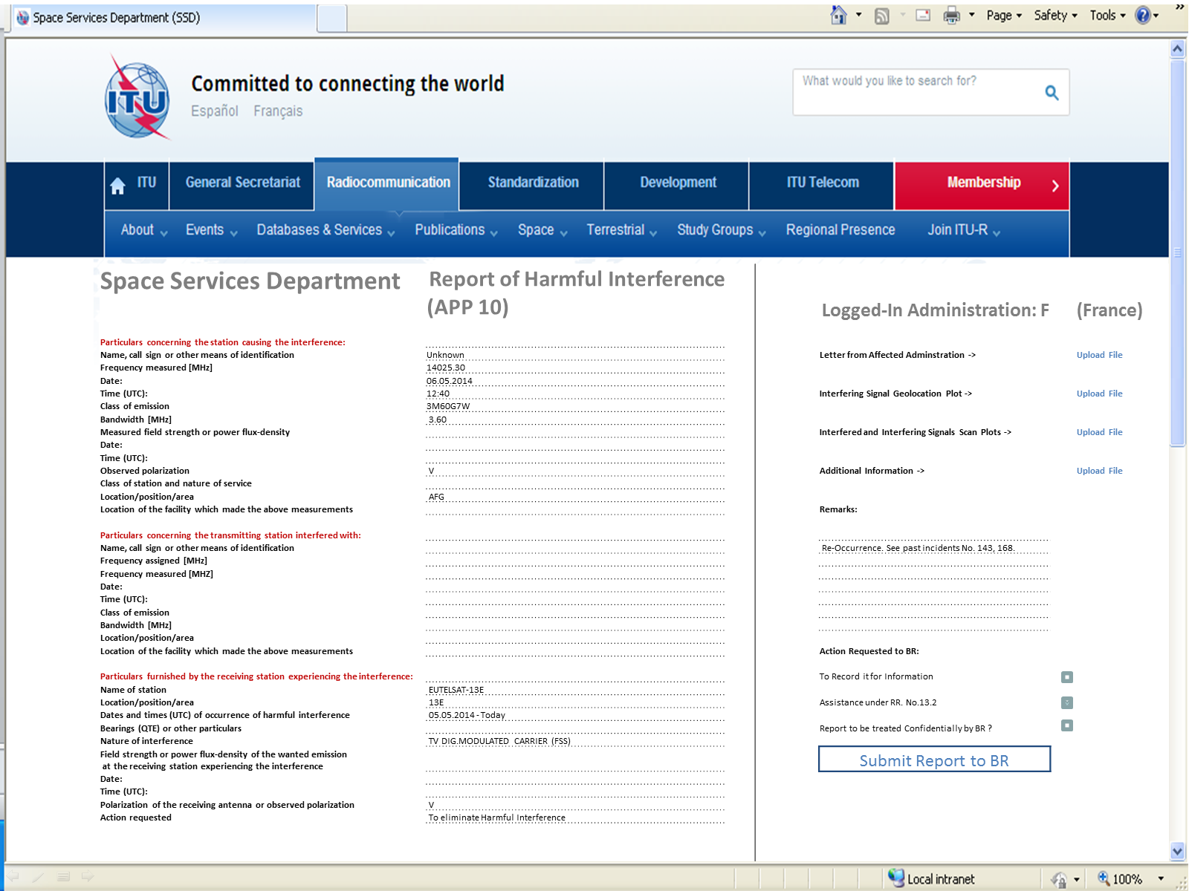
Draft architecture of the system is described below:
WRC-15 may wish to consider appropriate actions, as possible modification to Article 15 or Appendix 10 or the Radio Regulations or as a WRC Resolution, to provide a steady framework to the harmful interference database mentioned in “instructs 2” of Resolution 186 (Busan, 2014).
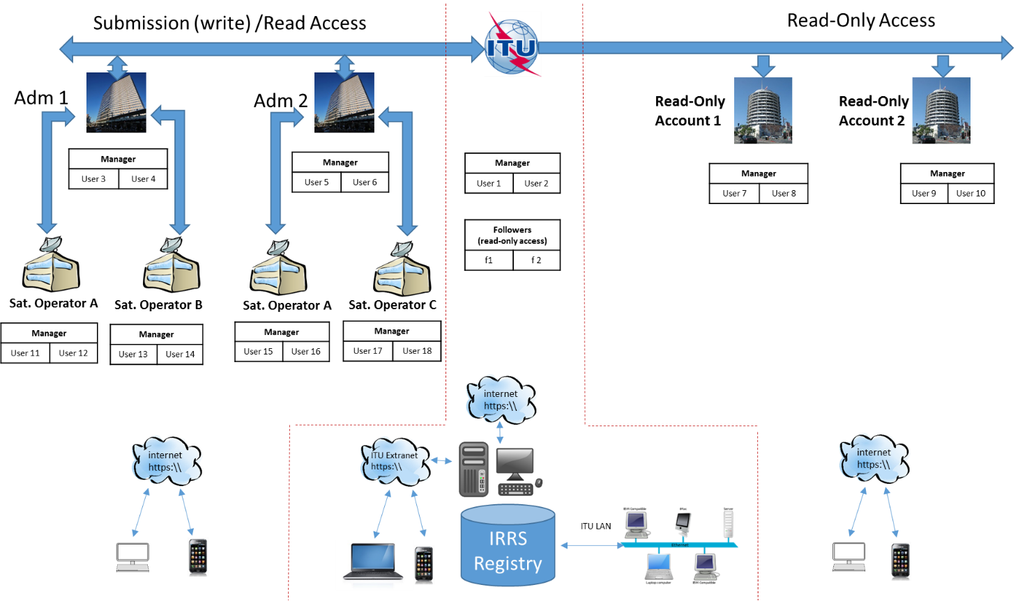

______________

https://www.itu.int/en/ITU-R/conferences/rag/Documents/Vlachos_ITU_RAG_CRM_Project_Briefing.pptx

