LTE band 28 UE emissions to DTT frequencies
Source: Nokia Corporation
Date: August 26, 2013

1 Introduction

This document discusses the unwanted emissions of an LTE band 28 (APT-700) UE towards DTT broadcast frequencies. A possible frequency arrangement for IMT/LTE is 703-733 MHz in uplink and 758-788 MHz in downlink. This arrangement would be aligned with the LTE band 28, which is 703-748 / 758-803 MHz. The band 28 UE implementation assumes dual duplexer architecture, with 2x30 MHz duplex filters with 15 MHz overlap. The lower duplexer would cover the band 694-790 MHz, having significant benefits due to economies of scale.

The band 28 and the proposed 700 MHz digital dividend arrangement is shown in Figure 1.

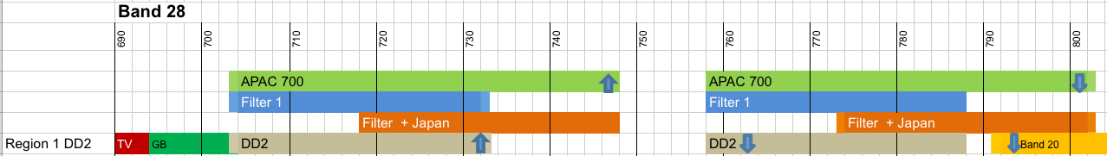
Figure 1: Frequency arrangement for E-UTRA band 28.
The highest channel for digital terrestrial television would be #48, at the frequency position 686-694 MHz. This would leave a guard band of 9 MHz to the LTE uplink.

In 3GPP TS 36.101 (V11.2.0, the LTE UE RF requirement specification), the protection of adjacent services is defined in section 6.6.3.2. From band 28 UEs, the DTT frequencies are protected with an emission limit of –26.2 dBm/6 MHz up to 694 MHz, measured at the antenna connector.

This emission limit is a worst-case target in UE design, and many factors affect the actual emissions of the UE. This document shows how the LTE channel bandwidth, resource allocation within the channel, and transmit power control, impact on the emissions toward the highest DTT channels. Other real life implementation factors such as temperature variation and device manufacturing process variation are not within the scope of this document.

2 LTE band 28 UE transmitter characteristics

This section describes the basic characteristics of an LTE UE transmitter, when operating in FDD mode. The transmitter chain includes signal generation, digital to analog conversion, up conversion to RF frequency, power amplification, and duplex (bandpass) filtering, before the RF signal reaches the antenna. There may be band selection switches, for example, to select between multiple duplex filters, if the device supports multiple operating bands.

The 3GPP UE radio frequency requirements are tested at the antenna connector.

The most significant unwanted emissions are generated at the PA. Typically the UE emissions are analyzed at the PA output, because the amplifiers are biased at similar operating points for all device vendors due to the high efficiency requirements.

3GPP TS 36.101 specifies ACLR, general spectral emission mask, and spurious emission mask, which are used to protect e.g. adjacent cellular operators. These emission requirements do not assume any particular duplexer response, and thus should not be used as is for out-of-band emission evaluation, except for the frequency range immediately adjacent to the transmit operating band (within about 1% of the frequency around the band edge, for example ~7 MHz for band 28).

Figure 2 shows a simulated emission spectrum of a fully populated 20 MHz LTE uplink, at the lowest carrier frequency available at band 28. The same simulator is used in 3GPP radio frequency specification work, and the simulation assumptions are aligned with other 3GPP participant companies. As is done in Figure 2, typically simulation results are evaluated at the PA output, before any band selection filtering.

LTE band 28 specifications assume 4 dB passband losses after the PA, to cover duplex filter attenuation, band selection switches, and other possible front-end losses. Therefore the transmit output power is 22 dBm in this case – 3GPP specifications allow 1 dB of relaxation to the output power due to the large resource allocation. Typical UE implementations take advantage of this relaxation in order to keep the transmitter linearity requirements more reasonable. The 23 dBm maximum output power is required when the resource allocation is narrow, e.g. less than 8-16 resource blocks depending on the channel bandwidth.

The ACLR requirement is 30 dB, which is met with a small margin in the simulation (the E-UTRA ACLR in the simulation is 30.5 dB) – hence the emissions represent a realistic worst-case UE implementation. ACLR does not depend on the used duplex filter, since it is a relative measure. On the other hand, the margins to spectral emission mask and spurious emission mask do benefit from the duplexer attenuation.
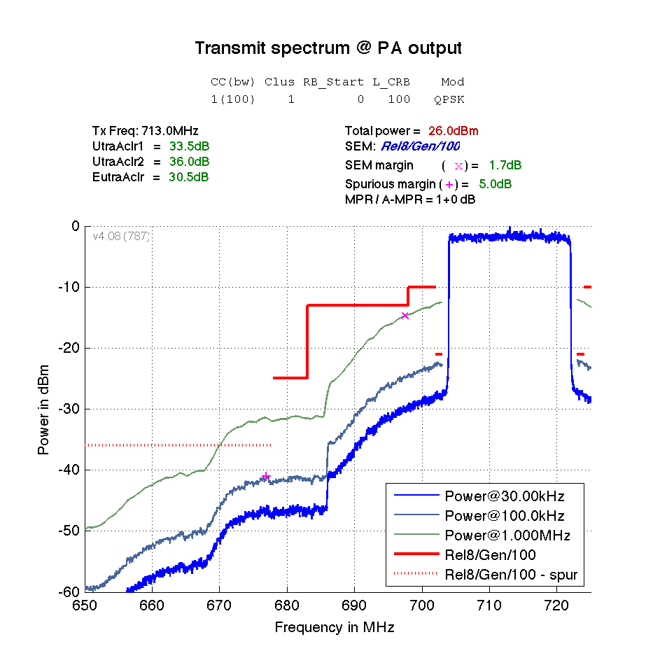
Figure 2: Emissions at PA output, with fully populated 20 MHz carrier.
During the LTE band 28 specification phase, simulation data from three different duplex filter vendors was presented, in order to evaluate if the –26.2 dBm/6 MHz emission limit was achievable below 694 MHz. Table 1 shows the duplex filter data.

Table 1: Simulation results for the lower duplexer (from 3GPP TR 36.820).
Vendor | pass-band | Tx IL (min) | Rx IL (min) | Rx Iso (min) | Tx Iso (min) | Tx Att (min) @694MHz
1 | 30 MHz | 3.8 dB | 3.7 dB | 42 dB | 55 dB | 35 dB
1 | 32.5 MHz | 5.0 dB | 4.5 dB | 42 dB | 55 dB | 35 dB
2 | 30 MHz | 5.0 dB | 5.0 dB | 40 dB | 51 dB | 15 dB
2 | 32.5 MHz | 7.5 dB | 5.0 dB | 40 dB | 53 dB | 15 dB
3 | 30 MHz | 3.5 dB | 3.5 dB | 47 dB | 55 dB | 23 dB
3 | 32.5 MHz | 4.0 dB | 3.5 dB | 47 dB | 50 dB | 23 dB

30 MHz passband was assumed, so that the complete 45 MHz spectrum could be covered by two duplex filters with 15 MHz overlap. For DTT protection, the evaluation was done with the worst duplexer attenuation of 15 dB (minimum) at frequencies below 694 MHz.

Figure 3 shows similar emissions evaluation that was done during the LTE band 28 work in 3GPP. The worst-case emissions result from 20 MHz uplink channel, either with full resource allocation or with 1 resource block at the channel edge.
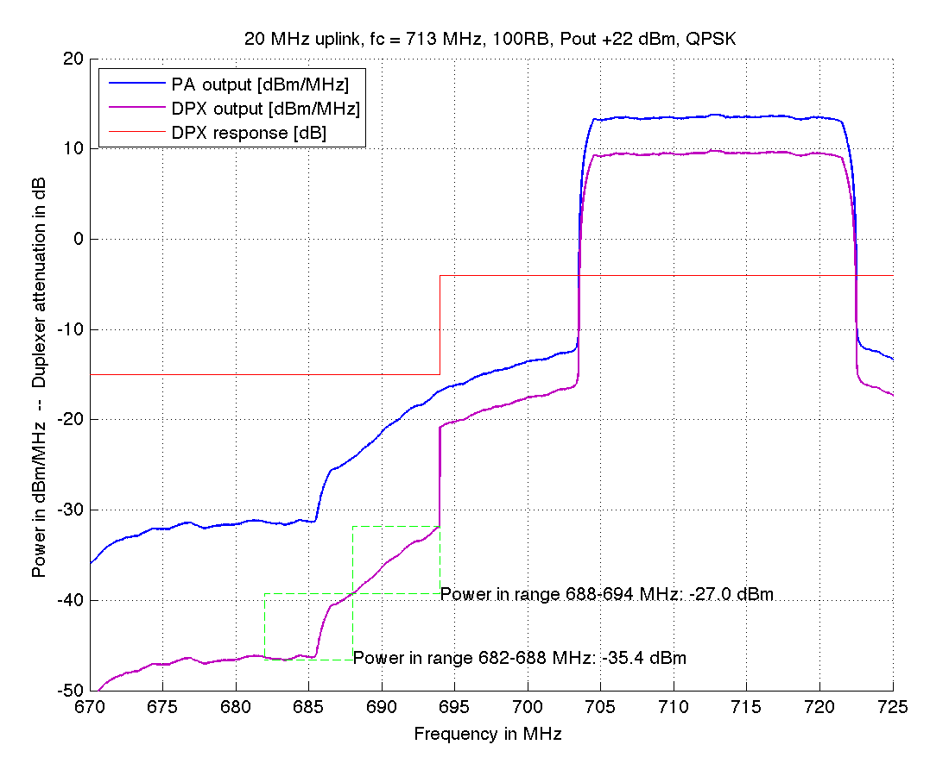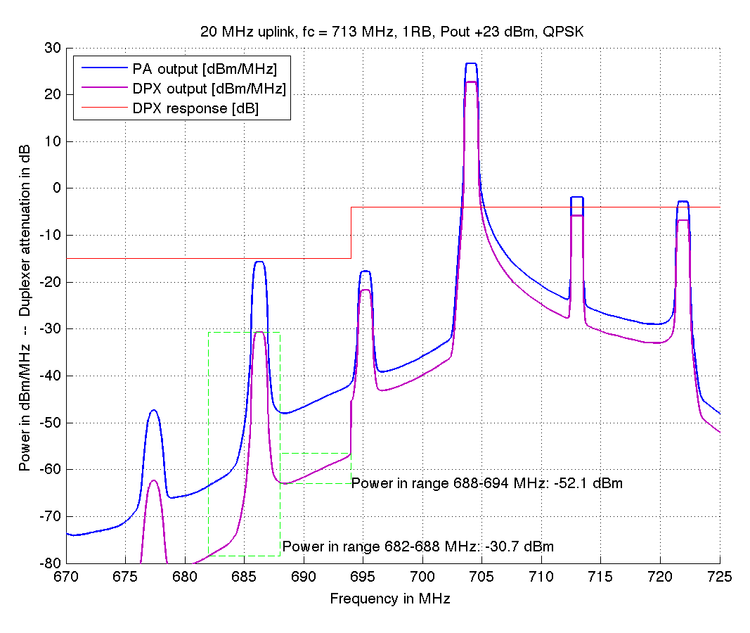
Figure 3: Emissions for 20 MHz LTE UL with band 28 duplexer. Left hand side: full (100 resource block) allocation. Right hand side: 1 resource block allocation at channel edge. Evaluation for 6 MHz DTT channels.

It can be seen from Figure 3, that with the 15 dB duplex filter attenuation that was seen feasible, the emissions reach at most –27.0 dBm/6 MHz for the fully populated 20 MHz LTE carrier. The 3GPP participant companies concluded that the –26.2 dBm/6 MHz limit was feasible with current implementation technology.

For the rest of this document, we assume 15 dB duplexer attenuation at frequencies below 694 MHz, since this filter response was used to base the LTE band 28 requirements in 3GPP.

3 Effect of LTE uplink channel bandwidth and DTT channel number

In section 2 we described how LTE band 28 user equipment are able to meet the DTT protection level of –26.2 dBm/6 MHz below 694 MHz. For the widest, 20 MHz LTE uplink carrier, located at the lowest position in the available band 28 spectrum (i.e. 703-723 MHz), the emissions were shown to be at most –27.0 dBm/6 MHz.

In this section, we describe the effect of other uplink channel bandwidths, with the same approach, and propose how to take this information into account in the coexistence simulations. Also the emissions are evaluated over the highest 4 DTT channels, i.e. channels 45-48 (662-694 MHz).

The figures on the next page show the emissions towards DTT frequencies, for 20, 15, 10, and 5 MHz LTE channel bandwidths. Both full resource allocation and 1 resource block have been simulated. The emissions are shown with 1 MHz measurement bandwidth, and the total unwanted power over the 4 highest DTT channels is also reported. Evaluation is done for 8 MHz DTT channels

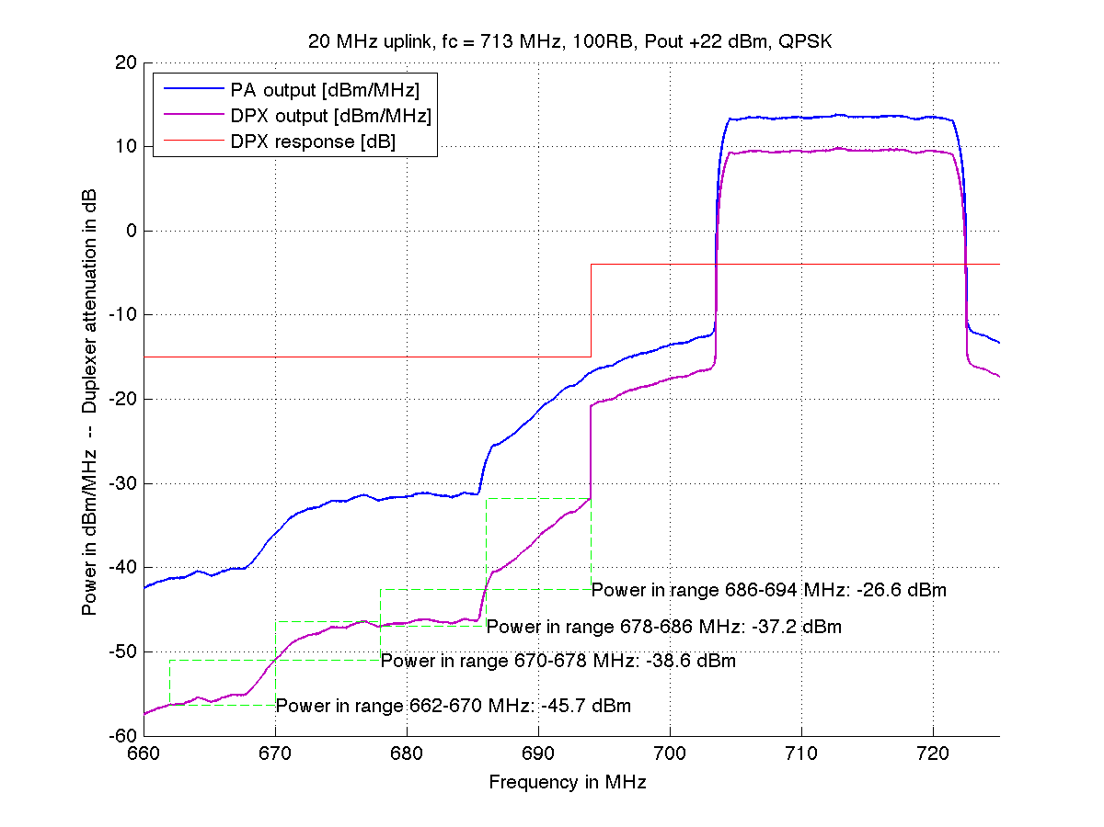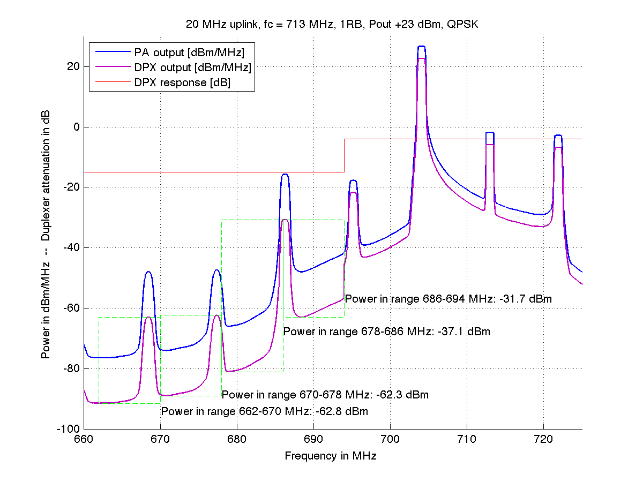
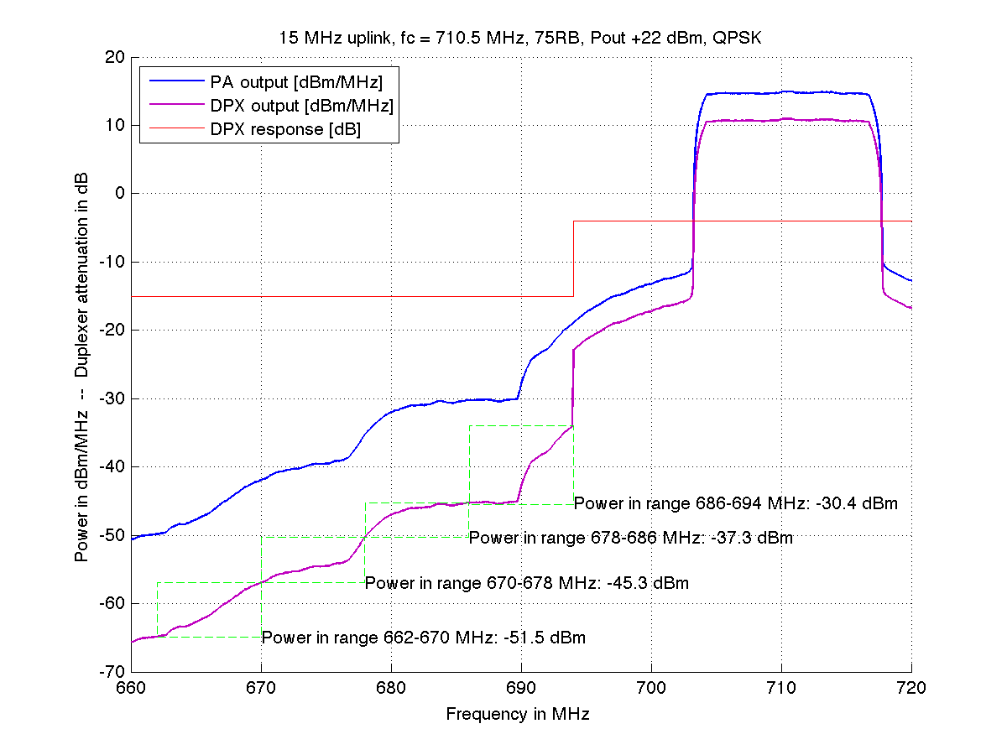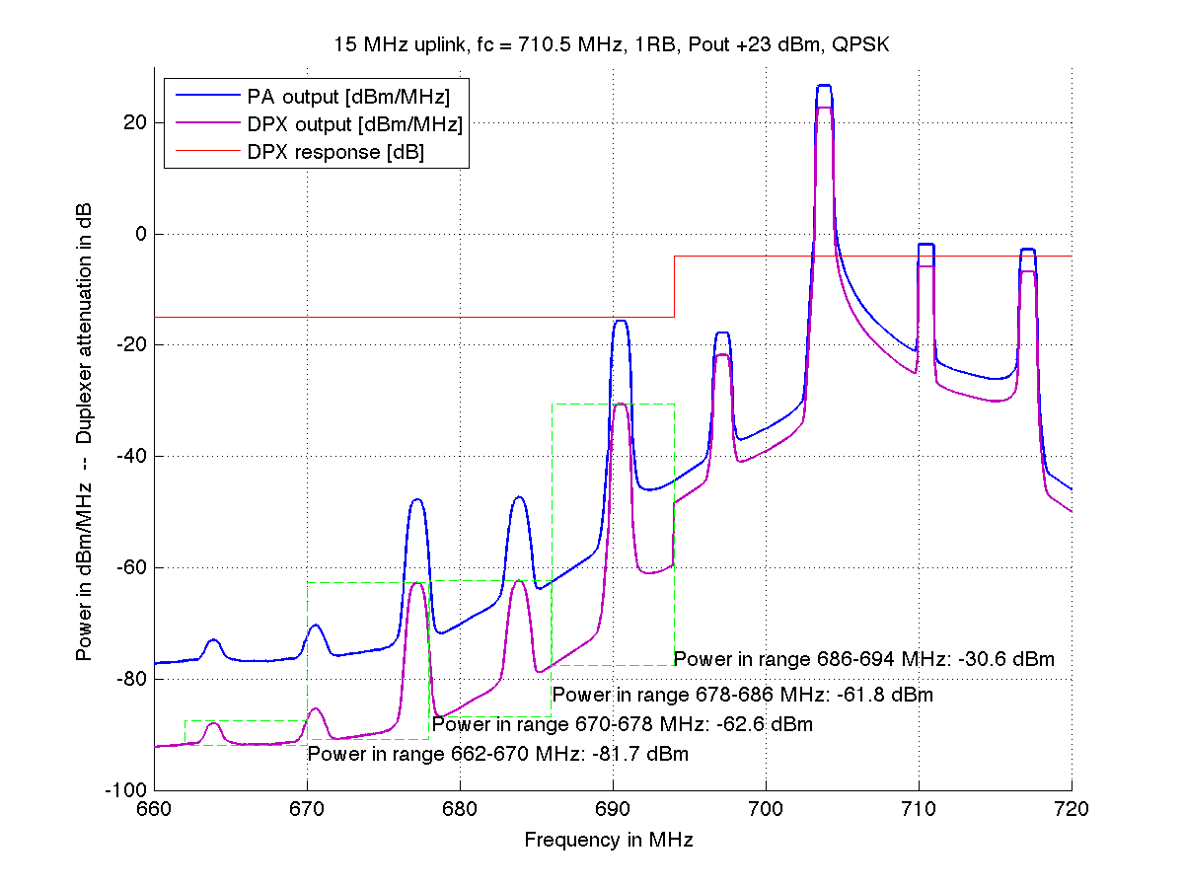
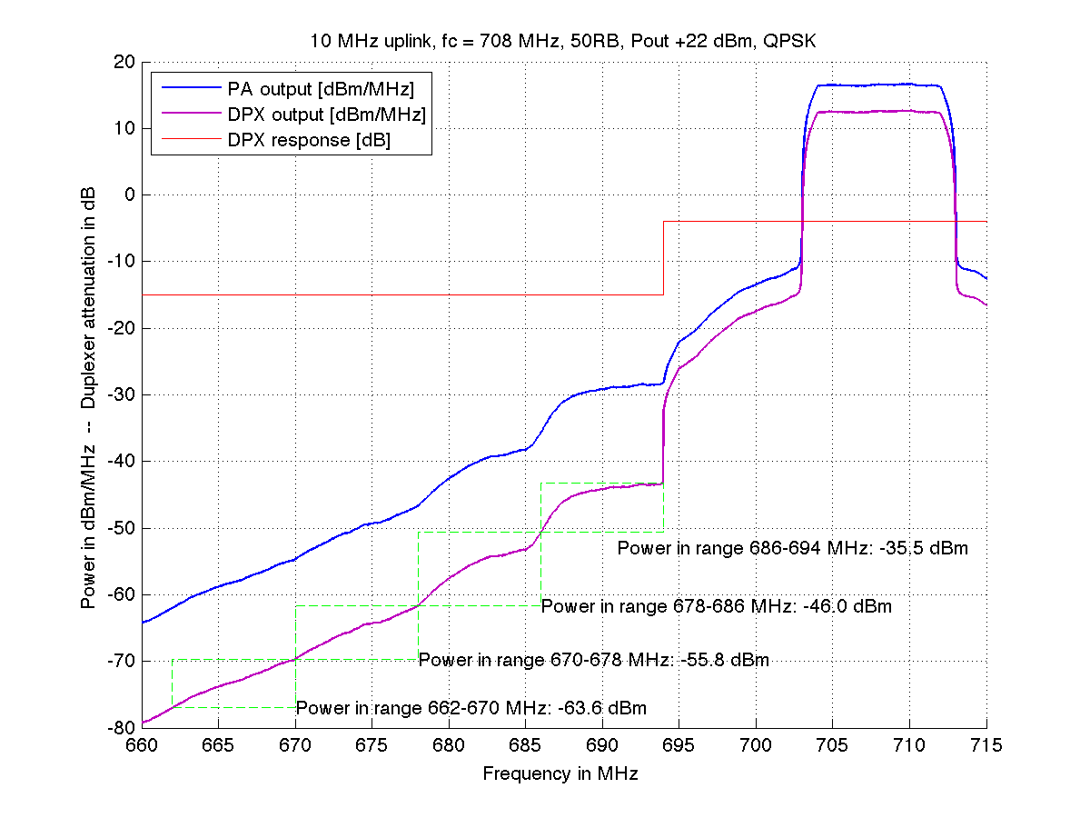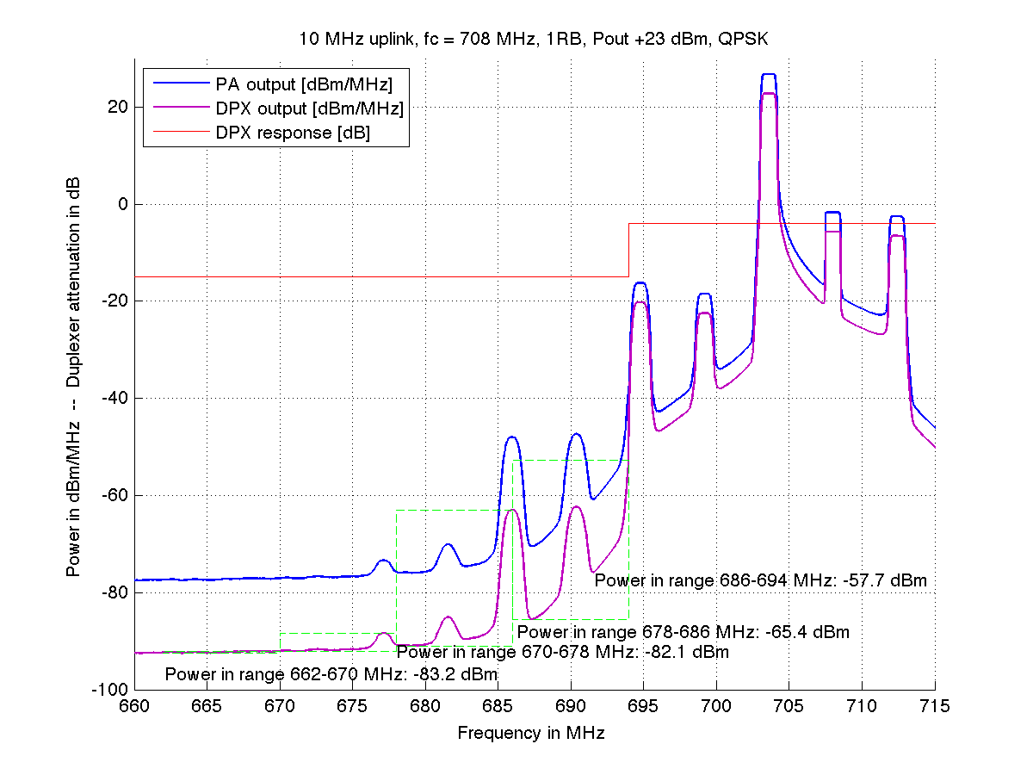
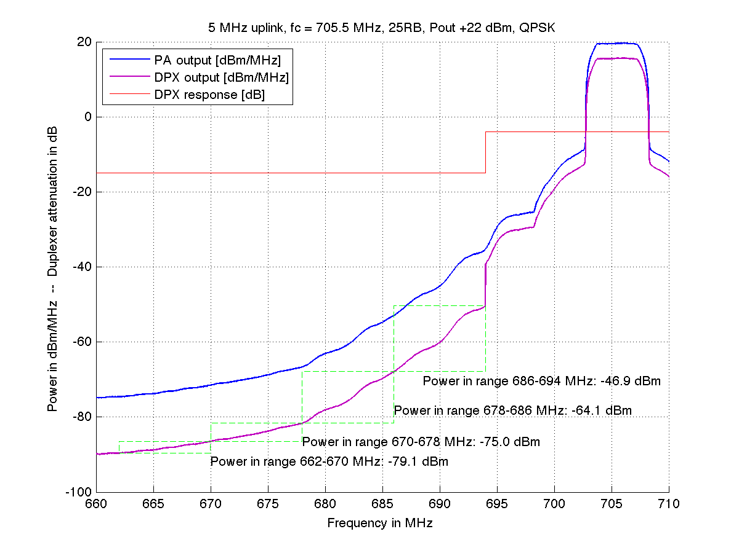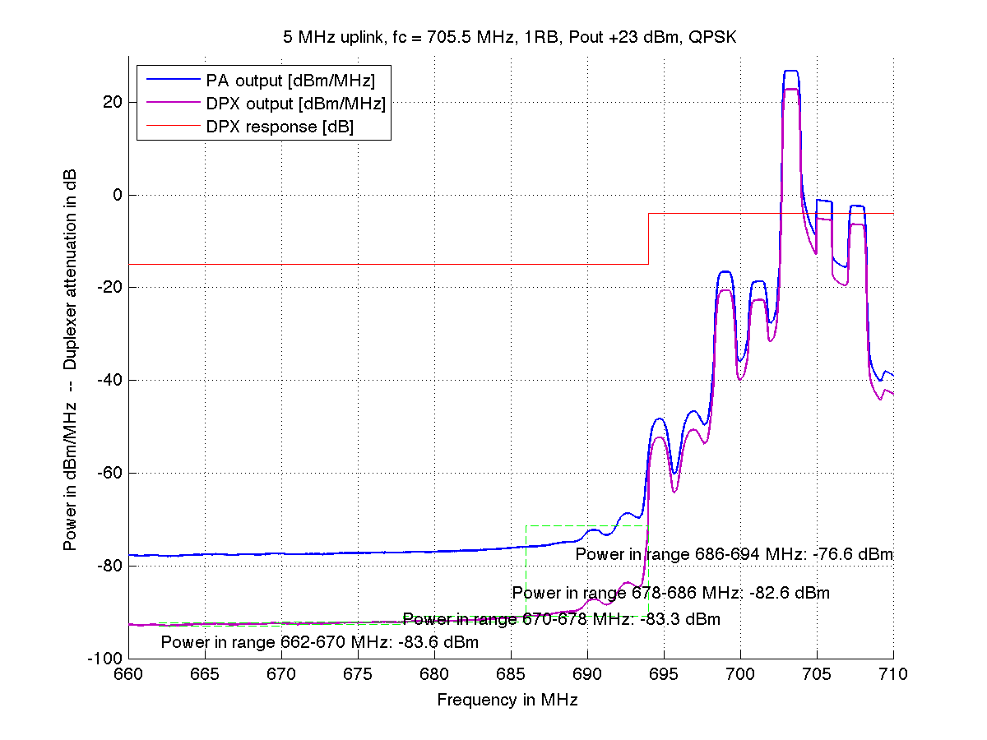

The simulation results are captured in Table 2. In all cases, full resource allocation results in the strongest unwanted emissions.

Table 2: Unwanted out-of-band emissions to DTT frequencies, per LTE channel bandwidth.
LTE channel BW | #RBs | Emissions to DTT channel (dBm/8 MHz)
LTE channel BW | #RBs | #48 | #47 | #46 | #45
20 MHz | 100RB  1RB | –26.6 dBm  –31.7 dBm | –37.2 dBm  –37.1 dBm | –38.6 dBm  –62.3 dBm | –45.7 dBm  –62.8 dBm
15 MHz | 75RB  1RB | –30.4 dBm  –30.6 dBm | –37.3 dBm  –61.8 dBm | –45.3 dBm  –62.6 dBm | –51.5 dBm  –81.7 dBm
10 MHz | 50RB  1RB | –35.5 dBm  –57.7 dBm | –46.0 dBm  –65.4 dBm | –55.8 dBm  –82.1 dBm | –63.6 dBm  –83.2 dBm
5 MHz | 25RB  1RB | –46.9 dBm  –76.6 dBm | –64.1 dBm  –82.6 dBm | –75.0 dBm  –83.3 dBm | –79.1 dBm  –83.6 dBm

If an LTE band 28 UE can meet the –25 dBm/8 MHz emission limit over the highest DTT channel #48 (686-694 MHz), at 20 MHz channel bandwidth, the same UE can be assumed to have lower emissions when using channel bandwidths narrower than 20 MHz. The emissions will also be weaker over the lower DTT channels. Therefore, we propose to take this information into account in the coexistence simulations.

Proposal 1:
Compared to the 20 MHz LTE UL emissions to DTT channel #48, when using other LTE channel bandwidths or DTT channels, further attenuation of out-of-band emissions according to Table 3 should be used in coexistence simulations:

Table 3: Emission reduction relative to 20 MHz LTE bandwidth.
LTE channel BW | DTT channel
LTE channel BW | #48 | #47 | #46 | #45
20 MHz | 0 dB | 10 dB | 12 dB | 19 dB
15 MHz | 3 dB | 10 dB | 18 dB | 24 dB
10 MHz | 8 dB | 19 dB | 29 dB | 37 dB
5 MHz | 20 dB | 37 dB | 48 dB | 52 dB

4 Effect of LTE uplink resource allocation within the channel

The JTG meeting in July 2013 decided to use two different scenarios in the coexistence simulations. The first scenario is a single cell scenario, where a single UE is transmitting in uplink at a time, using all available resources. The second scenario is a larger IMT network, where 3-6 UEs share the resources of a given cell, as suggested by the Working Party 5D document about sharing parameters in IMT coexistence studies.

The single cell scenario can be simulated using the assumptions in Proposal 1.

For the larger IMT network scenario, the 5D document suggests that since each transmitting UE only transmits using a fraction of the available resources (hence narrower transmission bandwidth than the channel bandwidth), the out-of-band emissions should be evaluated for these transmission bandwidths. This is also evident from the emissions figures shown in the previous section, where typically 1 resource block transmission generates less emission to DTT frequencies than full allocation for the same channel bandwidth.

In the next set of figures (Figure 4), we show the emissions of 10 MHz LTE uplink (50 resource blocks total) shared by 4 UEs, each transmitting 12 resource blocks, at the lowest available non-overlapping positions.

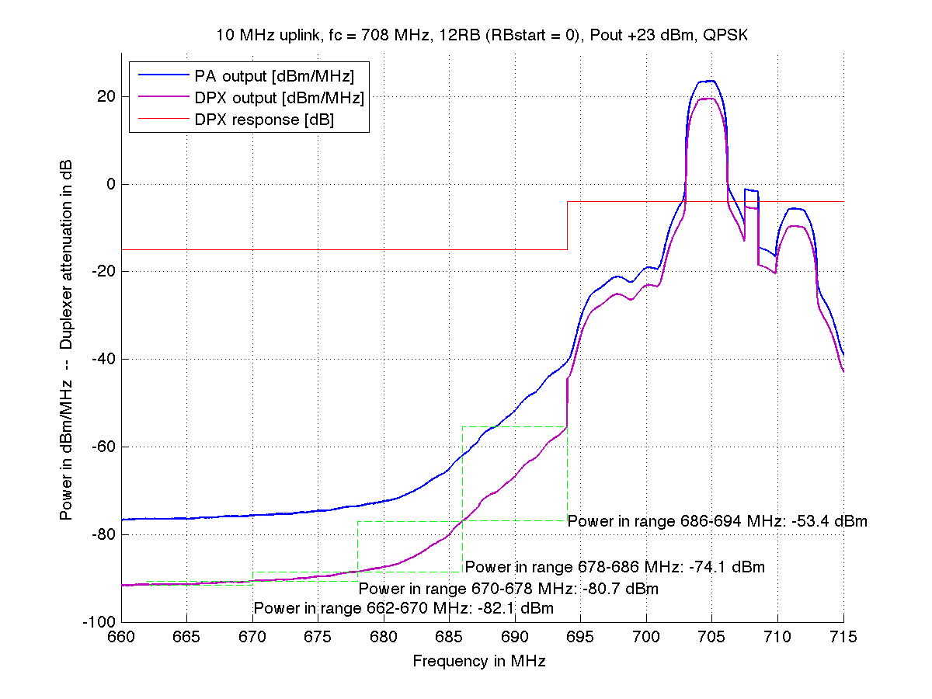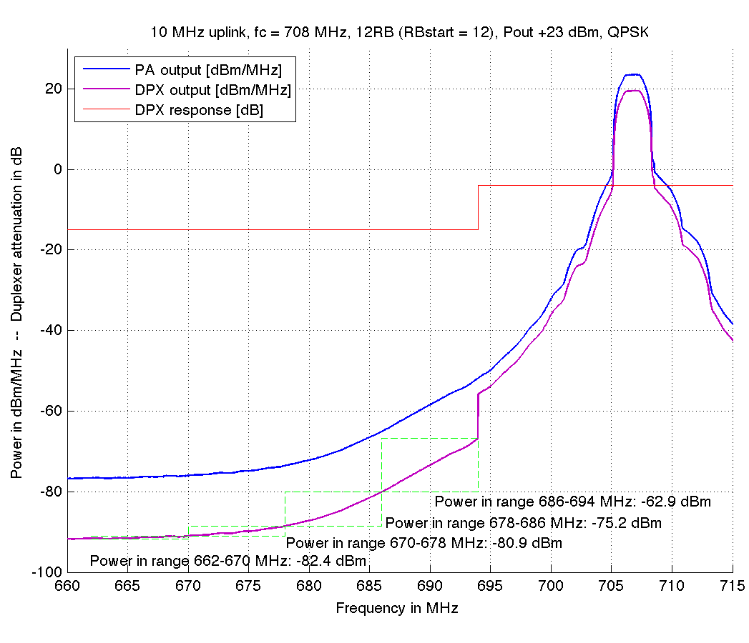
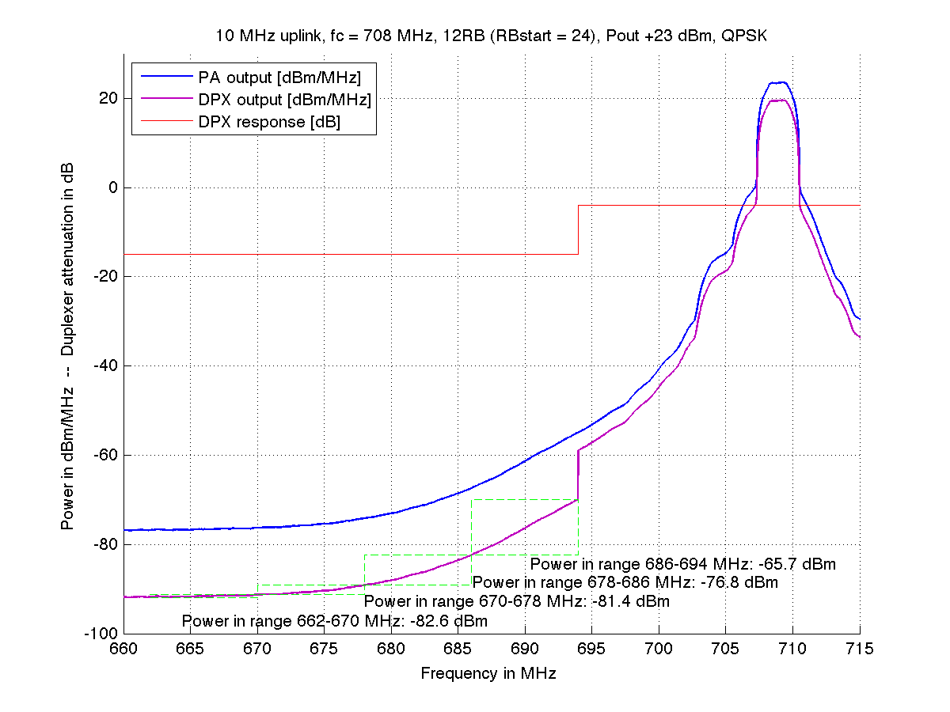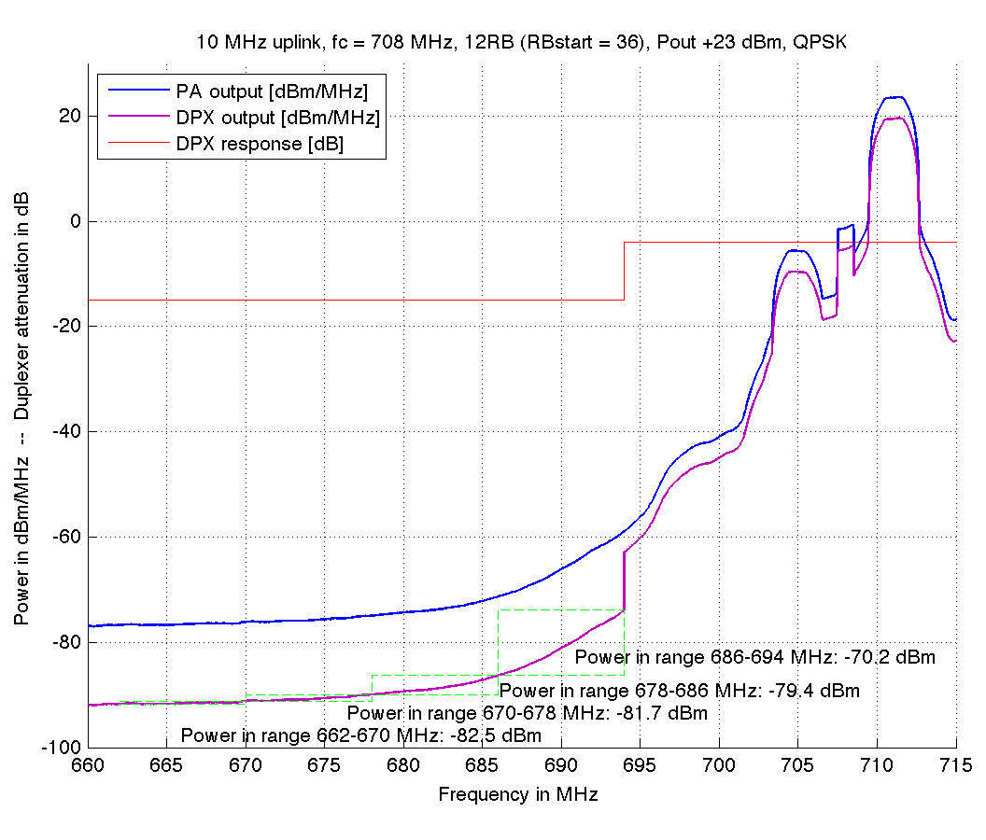
Figure 4: Out-of-band emissions of 10 MHZ LTE uplink with partial resource allocation at non-overlapping positions.
The results Figure 4 can be summarized as follows. Partial 12 RB resource allocation for 10 MHz LTE channel reduces the OOB emissions compared to full allocation. For the highest DTT channel #48, the resulting emissions are –53.4 to –70.2 dBm/8 MHz, depending on the allocation position within the LTE channel (for full allocation, the emissions reach to –35.5 dBm/8 MHz). For all DTT channels below #48, the emissions are below –74 dBm/8 MHz.

We have simulated all valid resource allocations for all LTE channel bandwidths using the same method. The following tables show the resulting emissions for the cases, where 3-6 UEs share the channel with non-overlapping resource allocation.

Table 4: Unwanted out-of-band emissions to DTT frequencies, for 20 MHz LTE channel bandwidth, with partial resource allocation.
LTE users (#RBs) | RB start index | Emissions to DTT channel (dBm/8 MHz)
LTE users (#RBs) | RB start index | #48 | #47 | #46 | #45
1 (100RB) * | 0 | –26.6 dBm | –37.2 dBm | –38.6 dBm | –45.7 dBm
3 (32RB) | 0  32  64 | –35.6 dBm  –53.2 dBm  –55.1 dBm | –52.0 dBm  –63.2 dBm  –68.5 dBm | –63.1 dBm  –72.2 dBm  –75.7 dBm | –73.2 dBm  –77.2 dBm  –79.2 dBm
4 (25RB) | 0  25  50  75 | –34.5 dBm  –55.3 dBm  –60.9 dBm  –52.7 dBm | –53.3 dBm  –66.1 dBm  –68.3 dBm  –72.6 dBm | –64.7 dBm  –73.3 dBm  –74.7 dBm  –79.1 dBm | –75.9 dBm  –78.1 dBm  –78.7 dBm  –81.2 dBm
5 (20RB) | 0  20  40  60  80 | –33.8 dBm  –56.2 dBm  –61.2 dBm  –65.1 dBm  –51.8 dBm | –53.8 dBm  –68.9 dBm  –67.0 dBm  –71.2 dBm  –74.4 dBm | –63.9 dBm  –75.8 dBm  –73.3 dBm  –77.5 dBm  –80.1 dBm | –76.9 dBm  –80.0 dBm  –78.1 dBm  –80.8 dBm  –82.0 dBm
6 (16RB) | 0  16  32  48  64  80 | –30.7 dBm  –51.9 dBm  –60.3 dBm  –62.9 dBm  –67.1 dBm  –52.0 dBm | –53.1 dBm  –65.7 dBm  –66.2 dBm  –69.0 dBm  –72.6 dBm  –74.7 dBm | –61.0 dBm  –72.5 dBm  –72.3 dBm  –74.8 dBm  –78.1 dBm  –79.7 dBm | –75.7 dBm  –77.7 dBm  –77.9 dBm  –79.3 dBm  –81.2 dBm  –81.9 dBm
* Same as in Table 2

Table 5: Unwanted out-of-band emissions to DTT frequencies, for 15 MHz LTE channel bandwidth, with partial resource allocation.
LTE users (#RBs) | RB start index | Emissions to DTT channel (dBm/8 MHz)
LTE users (#RBs) | RB start index | #48 | #47 | #46 | #45
1 (75RB) * | 0 | –30.4 dBm | –37.2 dBm | –45.3 dBm | –51.5 dBm
3 (25RB) | 0  25  50 | –40.2 dBm  –56.1 dBm  –57.3 dBm | –58.9 dBm  –68.2 dBm  –73.1 dBm | –72.2 dBm  –75.4 dBm  –78.6 dBm | –78.4 dBm  –79.6 dBm  –80.8 dBm
4 (18RB) | 0  18  36  54 | –38.7 dBm  –60.4 dBm  –63.8 dBm  –60.8 dBm | –61.6 dBm  –72.3 dBm  –73.0 dBm  –76.9 dBm | –76.5 dBm  –78.8 dBm  –78.8 dBm  –80.8 dBm | –80.9 dBm  –81.4 dBm  –81.3 dBm  –82.0 dBm
5 (15RB) | 0  15  30  45  60 | –34.5 dBm  –58.3 dBm  –64.7 dBm  –64.0 dBm  –54.4 dBm | –59.6 dBm  –69.0 dBm  –72.9 dBm  –71.7 dBm  –76.7 dBm | –75.7 dBm  –76.7 dBm  –78.7 dBm  –77.8 dBm  –81.3 dBm | –80.9 dBm  –80.7 dBm  –81.5 dBm  –80.9 dBm  –82.4 dBm
6 (12RB) | 0  12  24  36  48  60 | –32.6 dBm  –56.6 dBm  –60.2 dBm  –62.6 dBm  –65.2 dBm  –57.2 dBm | –59.7 dBm  –69.1 dBm  –68.3 dBm  –70.3 dBm  –74.0 dBm  –77.9 dBm | –76.0 dBm  –78.2 dBm  –76.3 dBm  –77.7 dBm  –80.3 dBm  –81.7 dBm | –81.5 dBm  –81.6 dBm  –80.2 dBm  –81.2 dBm  –82.3 dBm  –82.5 dBm
* Same as in Table 2

Table 6: Unwanted out-of-band emissions to DTT frequencies, for 10 MHz LTE channel bandwidth, with partial resource allocation.
LTE users (#RBs) | RB start index | Emissions to DTT channel (dBm/8 MHz)
LTE users (#RBs) | RB start index | #48 | #47 | #46 | #45
1 (50RB) * | 0 | –35.4 dBm | –46.0 dBm | –55.8 dBm | –63.6 dBm
3 (16RB) | 0  16  32 | –53.4 dBm  –63.7 dBm  –69.7 dBm | –73.4 dBm  –76.0 dBm  –78.6 dBm | –79.8 dBm  –80.5 dBm  –81.1 dBm | –81.6 dBm  –82.0 dBm  –82.1 dBm
4 (12RB) | 0  12  24  36 | –53.3 dBm  –63.0 dBm  –65.7 dBm  –70.3 dBm | –74.7 dBm  –75.2 dBm  –76.8 dBm  –79.4 dBm | –80.7 dBm  –80.9 dBm  –81.4 dBm  –81.7 dBm | –82.1 dBm  –82.4 dBm  –82.6 dBm  –82.5 dBm
5 (10RB) | 0  10  20  30  40 | –53.7 dBm  –67.2 dBm  –64.4 dBm  –66.4 dBm  –72.4 dBm | –72.6 dBm  –78.9 dBm  –76.3 dBm  –76.6 dBm  –81.1 dBm | –80.7 dBm  –81.8 dBm  –81.2 dBm  –81.1 dBm  –82.2 dBm | –82.3 dBm  –82.6 dBm  –82.7 dBm  –82.5 dBm  –82.8 dBm
6 (8RB) | 0  8  16  24  32  40 | –53.6 dBm  –63.5 dBm  –65.1 dBm  –66.4 dBm  –68.0 dBm  –74.8 dBm | –75.8 dBm  –76.0 dBm  –77.4 dBm  –77.5 dBm  –78.3 dBm  –81.6 dBm | –81.4 dBm  –81.2 dBm  –81.9 dBm  –81.8 dBm  –82.1 dBm  –82.5 dBm | –82.5 dBm  –82.7 dBm  –82.9 dBm  –82.9 dBm  –82.9 dBm  –82.9 dBm
* Same as in Table 2

Table 7: Unwanted out-of-band emissions to DTT frequencies, for 5 MHz LTE channel bandwidth, with partial resource allocation.
LTE users (#RBs) | RB start index | Emissions to DTT channel (dBm/8 MHz)
LTE users (#RBs) | RB start index | #48 | #47 | #46 | #45
1 (25RB) * | 0 | –46.9 dBm | –64.1 dBm | –75.0 dBm | –79.1 dBm
3 (8RB) | 0  8  16 | –71.7 dBm  –73.6 dBm  –75.8 dBm | –80.5 dBm  –81.0 dBm  –81.3 dBm | –82.1 dBm  –82.4 dBm  –82.4 dBm | –82.6 dBm  –82.8 dBm  –82.9 dBm
4 (6RB) | 0  6  12  18 | –74.8 dBm  –75.8 dBm  –77.8 dBm  –78.8 dBm | –81.3 dBm  –81.7 dBm  –81.9 dBm  –81.9 dBm | –82.3 dBm  –82.6 dBm  –82.6 dBm  –82.6 dBm | –82.8 dBm  –82.9 dBm  –83.0 dBm  –82.9 dBm
5 (5RB) | 0  5  10  15  20 | –75.5 dBm  –75.5 dBm  –74.6 dBm  –78.8 dBm  –80.2 dBm | –81.5 dBm  –81.8 dBm  –81.8 dBm  –82.1 dBm  –82.0 dBm | –82.4 dBm  –82.6 dBm  –82.6 dBm  –82.7 dBm  –82.7 dBm | –82.7 dBm  –83.0 dBm  –83.0 dBm  –83.1 dBm  –83.1 dBm
6 (4RB) | 0  4  8  12  16  20 | –76.7 dBm  –77.7 dBm  –74.1 dBm  –73.8 dBm  –78.8 dBm  –79.9 dBm | –81.7 dBm  –82.0 dBm  –82.0 dBm  –82.0 dBm  –82.2 dBm  –82.1 dBm | –82.6 dBm  –82.7 dBm  –82.8 dBm  –82.7 dBm  –82.8 dBm  –82.8 dBm | –83.1 dBm  –83.2 dBm  –83.3 dBm  –83.3 dBm  –83.4 dBm  –83.3 dBm
* Same as in Table 2

As a summary, partial resource allocation reduces the out-of-band emissions to DTT, when comparing to full allocation. Compared to full resource allocation for band 28 LTE UE, which meets the –25 dBm/8 MHz emission limit, the emissions are further reduced by 10-57 dB when partial resource allocation is used.

Because there are such many possible resource allocations, a simplified emissions model is proposed. For each cell in Tables 4-7 (i.e. “emissions to DTT channel x from y RB transmission in each non-overlapping position”), we take the minimum and maximum emissions, and use linear interpolation to get the emissions for individual RB positions.

For example, for 20 MHz channel bandwidth, 4 LTE users (25 RB transmission), DTT channel 48, the simulated emissions are –34.5, –55.3, –60.9, and –52.7 dBm. With the proposed linear interpolation method, the emissions become –34.5, –43.3, –52.1, and –60.9 dBm. This method gives more pessimistic out-of-band emissions than using the exact simulated values.

Further, to make the emissions model easier to implement in the coexistence simulation campaign, the actual emissions are converted to reduction compared to 20 MHz full allocation, like in Table 3.

Proposal 2:
Compared to the 20 MHz LTE UL emissions to DTT channel #48, when using partial LTE uplink allocation instead of full allocation, further attenuation of out-of-band emissions according to Tables 8-11 should be used in coexistence simulations:

Table 8: Emission reduction for partial allocation in 20 MHz bandwidth, relative to 20 MHz full allocation.
LTE users (#RBs) | DTT channel
LTE users (#RBs) | #48 | #47 | #46 | #45
1 (100RB) | 0 dB | 10 dB | 12 dB | 19 dB
3 (32RB) | 9 – 28 dB | 25 – 41 dB | 36 – 49 dB | 46 – 52 dB
4 (25RB) | 7 – 34 dB | 26 – 46 dB | 38 – 52 dB | 49 – 54 dB
5 (20RB) | 7 – 38 dB | 27 – 47 dB | 37 – 53 dB | 50 – 55 dB
6 (16RB) | 4 – 40 dB | 26 – 48 dB | 34 – 53 dB | 49 – 55 dB

Table 9: Emission reduction for partial allocation in 15 MHz bandwidth, relative to 20 MHz full allocation.
LTE users (#RBs) | DTT channel
LTE users (#RBs) | #48 | #47 | #46 | #45
1 (75RB) | 3 dB | 10 dB | 18 dB | 24 dB
3 (25RB) | 13 – 30 dB | 32 – 46 dB | 45 – 52 dB | 51 – 54 dB
4 (18RB) | 12 – 37 dB | 35 – 50 dB | 49 – 54 dB | 54 – 55 dB
5 (15RB) | 7 – 38 dB | 33 – 50 dB | 49 – 54 dB | 54 – 55 dB
6 (12RB) | 6 – 38 dB | 33 – 51 dB | 49 – 55 dB | 53 – 55 dB

Table 10: Emission reduction for partial allocation in 10 MHz bandwidth, relative to 20 MHz full allocation.
LTE users (#RBs) | DTT channel
LTE users (#RBs) | #48 | #47 | #46 | #45
1 (50RB) | 8 dB | 19 dB | 29 dB | 37 dB
3 (16RB) | 26 – 43 dB | 46 – 52 dB | 53 – 54 dB | 55 – 55 dB
4 (12RB) | 26 – 43 dB | 48 – 52 dB | 54 – 55 dB | 55 – 56 dB
5 (10RB) | 27 – 45 dB | 46 – 54 dB | 54 – 55 dB | 55 – 56 dB
6 (8RB) | 27 – 48 dB | 49 – 55 dB | 54 – 55 dB | 55 – 56 dB

Table 11: Emission reduction for partial allocation in 5 MHz bandwidth, relative to 20 MHz full allocation.
LTE users (#RBs) | DTT channel
LTE users (#RBs) | #48 | #47 | #46 | #45
1 (25RB) | 20 dB | 37 dB | 48 dB | 52 dB
3 (8RB) | 45 – 49 dB | 53 – 54 dB | 55 – 55 dB | 56 – 56 dB
4 (6RB) | 48 – 52 dB | 54 – 55 dB | 55 – 56 dB | 56 – 56 dB
5 (5RB) | 48 – 53 dB | 55 – 55 dB | 55 – 56 dB | 56 – 56 dB
6 (4RB) | 47 – 53 dB | 55 – 55 dB | 56 – 56 dB | 56 – 56 dB

5 Effect of LTE uplink power control

The ACLR, spectral emission mask, and spurious emission mask requirements are the most difficult when using maximum uplink transmit power. In many situations, the UE does not need to transmit at maximum power, as is noted in the sharing parameters documentation by 5D.

It is difficult to estimate the exact behavior of a UE, when it operates at a reduced output power, because the implementations can vary. Because the ACLR is relative, when the output power is lowered by 1 dB, also the adjacent channel leakage power must reduce by at least 1 dB, in order to meet the required ACLR. This would also have a similar effect into the emissions outside ACLR region, i.e. spectrum and spurious emission masks. Therefore, we propose:

Proposal 3:
When the LTE UL transmit power is reduced from the maximum, also the OOB emissions are reduced. The proposed ratio is linear, i.e. 1 dB reduction of OOB emissions for each 1 dB reduction of output power.

6 Conclusion

The regulatory emission limit provides only the starting point when considering the emissions of an LTE UE towards the DTT frequency band.

We have discussed the emissions from LTE band 28 UEs to the 4 highest DTT channels (45-48) in Europe (662-694 MHz). The emission limit in Asia is –26.2 dBm/6 MHz below 694 MHz, and it has been shown that with the 3GPP LTE minimum requirements there is little margin (<1 dB) to this limit, when 20 MHz LTE carrier is placed at the lowest available frequency position.

The same UE could meet about –25 dBm/8 MHz emission limit with a similar margin, with 20 MHz LTE UL. When other LTE channel bandwidths are used, we have shown that the emissions are further reduced, by about 3-20 dB depending on the bandwidth.

When evaluating the emissions to the DTT channels further away from the LTE UL, the emissions are also further reduced. The amount of reduction is about 10-52 dB compared to DTT channel #48, depending on the LTE channel bandwidth, and the DTT channel being evaluated.

We have also shown, that the resource allocation within the LTE channel has a large impact on the emissions towards DTT frequencies. The coexistence simulation scenarios may assume that 3-6 UEs share the frequency resources of an LTE cell. This also reduces the emissions compared to full allocation on 20 MHz channel, by about 4-56 dB, depending on the LTE channel bandwidth, and the DTT channel being evaluated.

The uplink transmit power control has also been discussed in this document. We can assume, that each 1 dB of reduction in output power also reduces the OOB emissions by 1 dB.

When evaluating the impact of LTE UL interference to DTT receivers, these aspects of the UE behavior should be taken into account, instead of assuming that all active UEs emit out-of-band emissions according to the fixed regulatory limit. The exact proposals are:

Proposal 1: Compared to the 20 MHz LTE UL emissions to DTT channel #48, when using other LTE channel bandwidths or DTT channels, further attenuation of out-of-band emissions according to Table 3 should be used in coexistence simulations.

Proposal 2: Compared to the 20 MHz LTE UL emissions to DTT channel #48, when using partial LTE uplink allocation instead of full allocation, further attenuation of out-of-band emissions according to Tables 8-11 should be used in coexistence simulations.

Proposal 3: When the LTE UL transmit power is reduced from the maximum, also the OOB emissions are reduced. The proposed ratio is linear, i.e. 1 dB reduction of OOB emissions for each 1 dB reduction of output power.

