CPG PTB |  | Doc. PTB(18)022
6th meeting CPG-19 PTB
Copenhagen, 10th – 13th April 2018
Date issued: | 2 April 2018
Source: | Russian Federation
Subject: | Compatibility analysis on WRC-19 Agenda Item 9.1.9
Summary: This contribution of the Russian Federation presents studies on interference impact into EESS passive sensor, based on parameters of the Russian multi-channel conical-scan radiometer, deployed onboard existing satellites of the Meteor-3M satellite system.
Proposal: CPG PTB is kindly requested to consider additional compatibility study, as attached, on interference impact into EESS passive sensor

ANNEX 1
Russian Federation
COMPATIBILITY STUDIES BETWEEN FSS IN THE 51.4-52.4 GHz band (earth-to-space) and eess (passive) in the 52.6-53 ghz band

1 Compatibility study for EESS passive sensor, located onboard Meteor-3M satellite system
Meteor-3M satellite system comprises of two satellites, Meteor-M №1 (launched in 2009) and Meteor-M №2 (launched in 2014), deployed in sun-synchronous circular orbit (LTAN 9-30) with orbit height of 835 km and inclination around 98.85°. Each satellite carries passive instrument, representing a multi-channel conical scan radiometer, using 0.65 m (-3 dB beamwidth 0.65°) reflector receiving antenna (H, V polarizations are used) with maximum gain of 48 dBi (including antenna feeder losses) and off-nadir pointing angle of 53.3°. Separate cold calibration channel is applied to increase accuracy.
Meteor-M satellite antenna could be modelled using analytical antenna gain pattern, provided in Recommendation ITU-R RS.1813. Main beam of Meteor-M satellites has a scanning sector 105 degrees wide (angle alpha changing from 165 to 270 degrees, off-nadir pointing angle beta is 53.3 degrees), scan period is 2.5 seconds.
Parameters of transmitting FSS Earth stations were based on information, provided in Section 2 (FSS Technical Characteristics) of the preliminary draft new report ITU-R S.[SPECTRUM SHARING] (WP 4A Chairman’s Report 4A/675 Annex 3), which are described in Table 1.
TABLE 1
Earth-to-space communication from an Earth station (feeder link) towards a GSO FSS space station
Carrier characteristics
Polarization | LHCP and RHCP
Frequency (MHz) | 52 000
Carrier occupied bandwidth (MHz) | 475
FSS ES transmit parameters
Antenna Diameter (m) | 13.5
Gain (dBi) | 74 (75 at 52.7 GHz)
Radiation pattern | ITU-R S.580
Minimum elevation angle (deg) | 15
e.i.r.p. (dBW) | 73.4
e.i.r.p. density (dBW/MHz) | 46.6
Max. power spectral density (dBW/MHz) | -27.4

Taking into account that wideband carriers are planned to be used for FSS feeder links (475 MHz) and separation between active and passive band is limited to 200 MHz, 52.6-53 GHz passive band would fall into the out of band domain of unwanted emissions, therefore out-of-band emission mask, described by Recommendation ITU-R SM.1541, Annex 5, could be applied to obtain unwanted emission level within reference band (100 MHz). Integration of maximal power spectral density of FSS ES emissions using that mask within 52.6-52.7 GHz would result in out-of-band emission power of -19.7 dBW/100 MHz.

1.1 Single-entry static studies
Several single-entry studies were performed to assess worst-case situation. Results of static study for main beam to main beam scenario are provided in Table 2, showing that threshold interference level is exceeded by 72.1 dB.
TABLE 2
Worst-case Static Analysis (main-to-main beam scenario)
FSS Unwanted emission limit | -19.7 | dBW/100 MHz (Integration of out-of-band emission mask for FSS set out in ITU-R SM.1541)
FSS Antenna Gain | 75 | dBi (FSS Antenna Gain at 52.7 GHz)
Off-nadir angle | 53.3 | Degrees
FSS ES elevation angle | 24.94 | Degrees
EESS Antenna Gain | 48 | dBi
Slant distance | 1621.2 | Km
Free Space Loss | 191.1 | dB (at 52.7 GHz)
Polarization discrimination | 1.5 | dB
Atmospheric losses | 10.6 | dB
Interference level at the input of passive sensor | -99.9 | dBW
Protection Level | -172 | dBW (apportionment of 3 dB is applied)
Exceedance | 72.1 | dB

Results of static study for passive sensor main beam to FSS ES back-lobe scenario are provided in Table 3, showing that threshold interference level is not exceeded.
TABLE 3
Passive sensor main beam to FSS ES back-lobe scenario
FSS Unwanted emission limit | -19.7 | dBW/100 MHz (Integration of out-of-band emission mask for FSS set out in ITU-R SM.1541)
FSS Antenna Gain | -10 | dBi
Off-nadir angle | 53.3 | Degrees
FSS ES elevation angle | 24.94 | Degrees
EESS Antenna Gain | 48 | dBi
Slant distance | 1621.2 | Km
Free Space Loss | 191.1 | dB (at 52.7 GHz)
Polarization discrimination | 1.5 | dB
Atmospheric losses | 10.6 | dB
Interference level at the input of passive sensor | -184.9 | dBW
Protection Level | -172 | dBW (apportionment of 3 dB is applied)
Exceedance | -12.9 | dB

Results of static study for passive sensor back-lobe to FSS ES main beam scenario are provided in Table 4, showing that threshold interference level is exceeded by 7.4 dB.
TABLE 4
Passive sensor back-lobe to FSS ES main beam scenario
FSS Unwanted emission limit | -19.7 | dBW/100 MHz (Integration of out-of-band emission mask for FSS set out in ITU-R SM.1541)
FSS Antenna Gain | 75 | dBi (FSS Antenna Gain at 52.7 GHz)
Off-nadir angle | 53.3 | Degrees
FSS ES elevation angle | 24.94 | Degrees
EESS Antenna Gain | -16.7 | dBi
Slant distance | 1621.2 | Km
Free Space Loss | 191.1 | dB (at 52.7 GHz)
Polarization discrimination | 1.5 | dB
Atmospheric losses | 10.6 | dB
Interference level at the input of passive sensor | -164.6 | dBW
Protection Level | -172 | dBW (apportionment of 3 dB is applied)
Exceedance | 7.4 | dB

Based on results of static studies it is shown that threshold interference level will be exceeded each time passive sensor’s main beam pointed towards main beam of transmitting FSS ES. There is also large deficit of 7.4 dB when Meteor-M satellite falls within main-lobe of transmitting FSS ES, therefore additional limitation on unwanted emissions will be required.

1.2 Single-entry dynamic studies
Single-entry dynamic studies were performed, based on the following characteristics:
- scan period is 2.5 seconds,
- simulation time step 10 sec (ES is not visible), 0.001 sec (within visibility of ES),
- total simulation time around 14 days,
- initial sub-satellite point is 0N, 0E,
- initial sensor orientation α=270°, β= 53.3°,
- scanning sector 105 degrees wide,
- collected Statistics – duration of time, when sensor is pointed towards FSS ES (ES is located within IFOV of sensor) with corresponding interference level
- FSS system earth station coordinates are 0N, 11.7588E,
- GSO slot is 45.4163W.
Results of dynamic study are provided in Picture 1, showing that threshold interference level (-172 dBW (apportionment of 3 dB is applied)) is exceeded by 47 dB for more than 0.1% of time and by 71 dB for more than 0.06% of time.
Specific limit could be clarified based on dynamic studies for other passive sensors.

PICTURE 1
Results of dynamic analysis
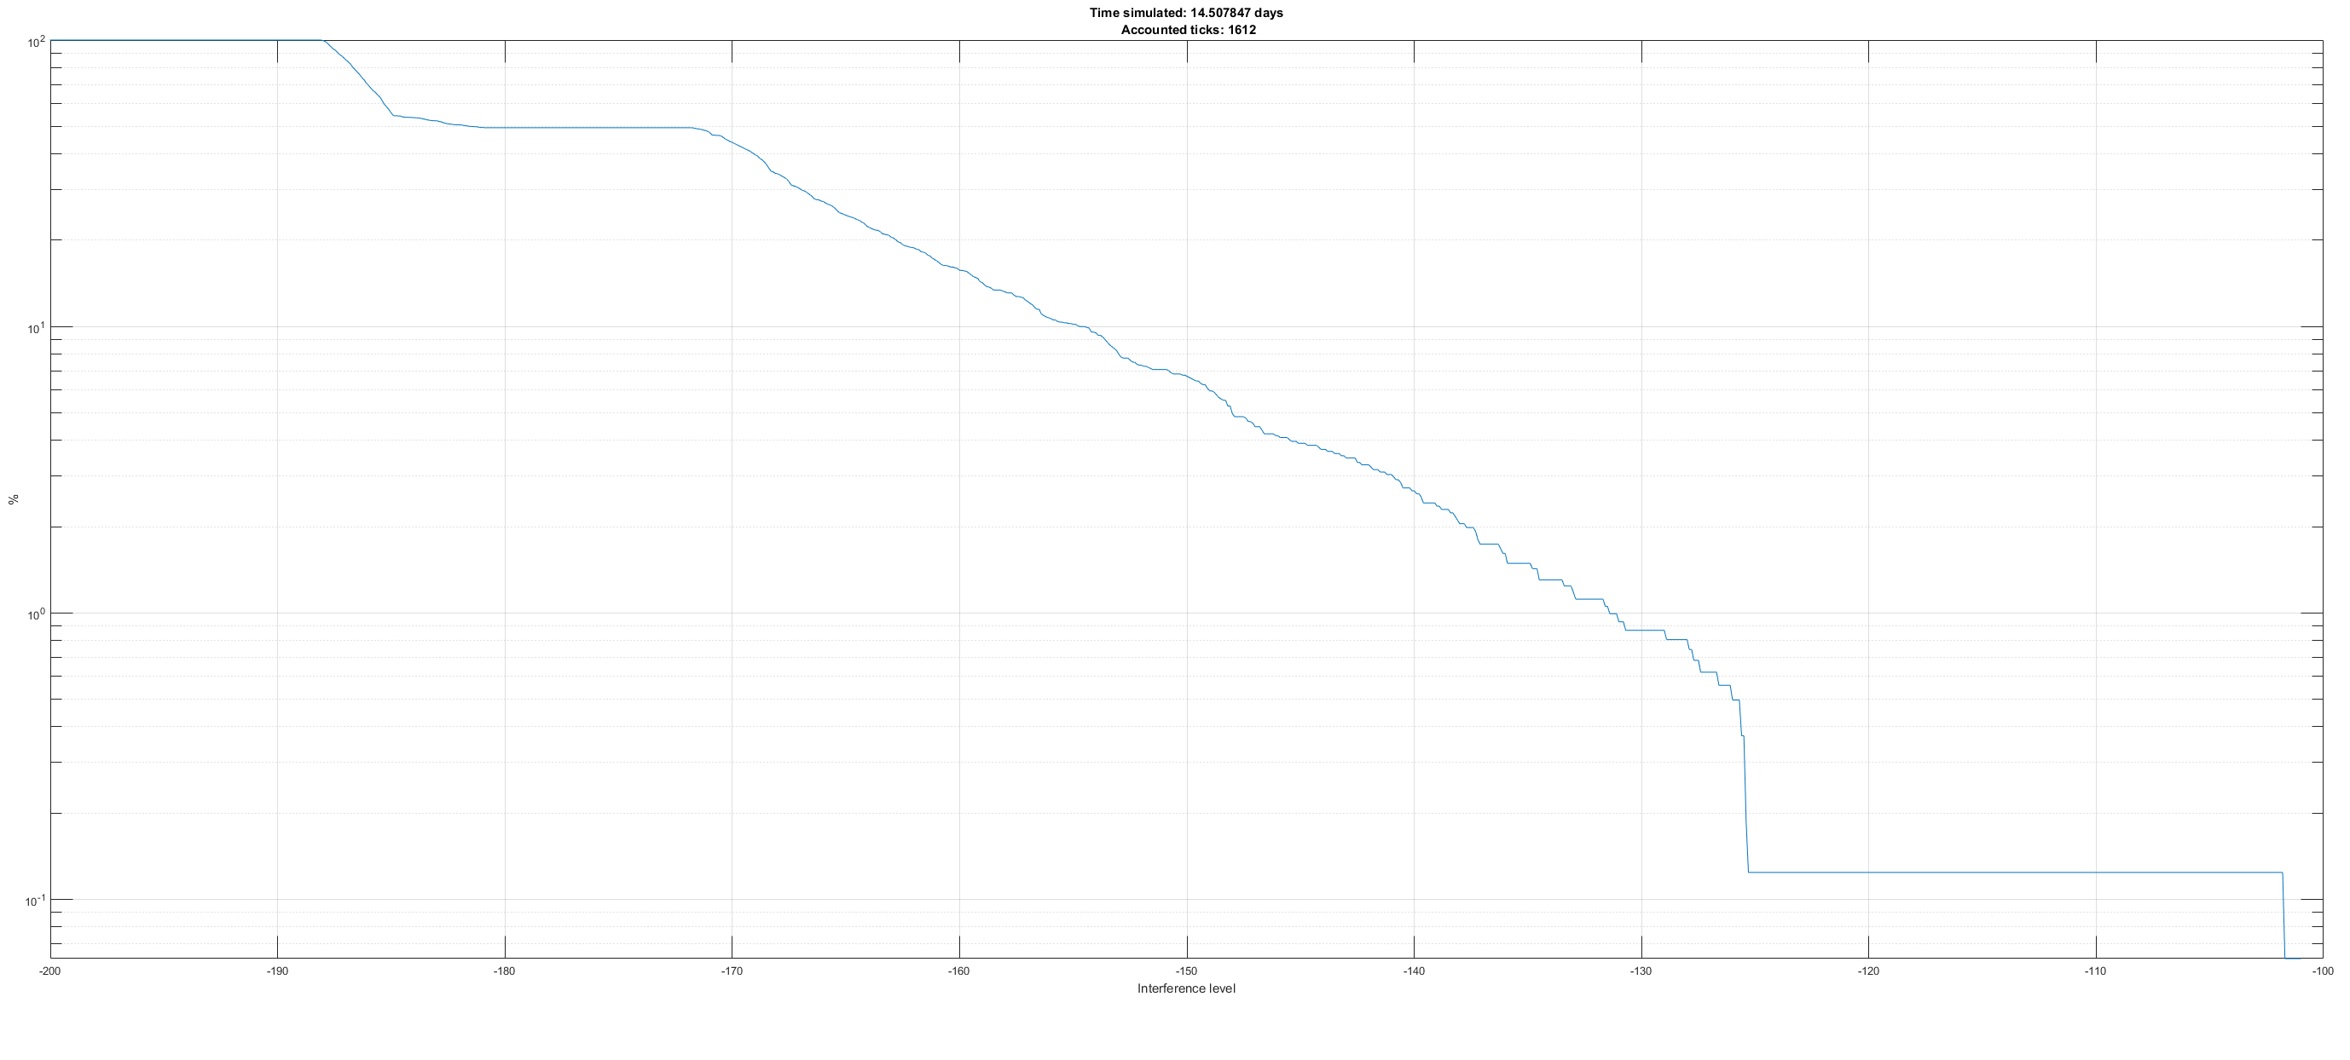

2 Conclusions
Based on results of static studies of interference into Meteor-3M satellite system conical scan radiometer it was shown that for the worst-case single-entry main-to-main beam scenario threshold interference level will be exceeded by 72.1 dB. Additional limitation on unwanted emissions will be required.
Results of dynamic studies shows that threshold interference level (-172 dBW (apportionment of 3 dB is applied)) is exceeded up to 71 dB.
______________

