ECC Report <No>

Practical guidance for TDD networks synchronization
Approved DD Month YYYY (Arial 9pt bold)
[last updated: DD Month YYYY) (Arial 9pt) [date of the latest update]]

Executive summary
The purpose of the report is to address the synchronization issue for TDD networks.

[Following the approval of ECC DEC(11)HH on … a few open issues were left for study: considering dd
There are several possible techniques for improving coexistence between TDD networks
- synchronization
- additional filtering
- site coordination
- restricted blocks/guard bands.
The aim of this report is to provide an evaluation of the techniques that facilitate the coexistence of TDD networks. The use of restricted blocks/guard bands is obviously a method which leads to less efficient use of spectrum and is to be avoided if possible.

.]

TABLE OF CONTENTS

0 Executive summary 2
1 Introduction : synchronization of TDD networks 5
1.1 Problem statement 5
1.2 Deployment scenarios 5
2 TDD network synchronization techniques 7
2.1 Definition for synchronized TDD networks 7
2.2 Synchronization of the start of frame 8
2.2.1 Accuracy constraints 8
2.2.2 Synchronization by GNSS 9
2.2.3 Synchronization over packet networks 10
2.2.4 Over-the-air synchronization for LTE HeNB by network listening 12
2.2.5 Terrestrial synchronization networks 13
2.2.6 [Other synchronization methods] 14
2.2.7 Holdover and resilience 14
2.3 Frame structure coordination 15
2.3.1 Cross-technology network synchronization 15
2.3.2 [Imperfect frame alignment] 17
2.3.3 [Dynamic UL/DL ratio] 17
2.3.4 Conclusion 18
3 Practical guidance for inter-operator deployment 19
3.1 Clock synchronization 19
3.2 Inter-operator synchronisation pre-requisites 19
3.3 possible procedures to follow 20
3.4 conclusions 20
4 Conclusion 21
ANNEX 1: WiMAX and LTE-TDD frame structures 22
4.1 3GPP LTE 22
4.2 WiMAX 802.16e 23
4.3 WiMAX/LTE-TDD compatibility matrix 24
ANNEX 2: ITU-T SG15/Q13 standards and workplan 26
ANNEX 3: Existing examples of cross-operator TDD synchronization 27
List of reference 28

LIST OF ABBREVIATIONS

Abbreviation | Explanation
BEM | Block Edge Mask
BS | Base station
BWA | Broadband Wireless Access
CEPT | European Conference of Postal and Telecommunications Administrations
ECC | Electronic Communications Committee
EC | European Commission
ECO | European Communications Office
eNB | eNodeB (LTE BS)
EU | European Union
E-UTRA | Evolved Universal Terrestrial Radio Access
FDD | Frequency Division Duplex
FFS | For Further Study
GNSS | Global Navigation Satellite System (GPS, Galileo, Glonass, BeiDou, etc…)
GPS | Global Positioning System
HeNB | Home eNodeB (LTE femtocell)
IMT | International Mobile Telecommunications
LORAN | LOng RAnge Navigation system
MFCN | Mobile/Fixed Communications Networks
MFW | Multipoint Fixed Wireless
MTIE | Maximum Time Interval Error
OTA | Over-the-air
PDV | Packet Delay Variation
PMP | Point to Multipoint
PTP | Precision Time Protocol (IEEE-1588)
PRTC | Primary Reference Time Clock
SDO | Standard developing organization
TDD | Time Division Duplex
TS, SS | Terminal Station, Subscriber Station
UE | User Equipment (LTE TS)
UL/DL | Uplink/Downlink

Introduction : synchronization of TDD networks

Context
Several unpaired frequency bands are allocated, these frequency bands may be used for TDD network deployments, [such as but not limited to: 1900-1920 MHz, 2010-2025 MHz, 2300-2400 MHz, 2570-2620 MHz, 3400-3600, 3600-3800 MHz].

TDD network must be synchronized using the same UL/DL return point in the whole network between difference radio base stations in order to avoid inter-cell (BS to BS, UE to UE, and UE to BS) interference.

This report is not limited to a specific TDD band and applies generically to any TDD deployment.

When more than one TDD network operates in the same geographic areas (towers, sites), severe interferences may happen if the networks are uncoordinated, i.e. if some equipment is transmitting while other equipment is receiving in the same time-slots and in the same band (on the same channel or on adjacent channels) while having a poor isolation (e.g. because of geographical proximity like in co-sited deployments in a multi-operator context, or because of line of sight situations). Indeed, in this situation, both out-of-band and spurious emission on the transmitter side and imperfect adjacent channel selectivity on the receiver side can desensitize or block the neighbour receiver, preventing it from properly listening to desired signals.

Figure 1: adjacent network interference scenarios for unsynchronized TDD and FDD (from [3])
In the case of TDD-TDD coexistence, one way to avoid all BS-BS and UE-UE interference without using guard band and specific filtering is to synchronize in phase networks so that no simultaneous downlink and uplink occur across neighbouring equipment. This report will focus on those techniques allowing achieving this goal.

Deployment scenarios
Most often (except in the case of isolated BS deployments), all TDD equipments from the same operator are synchronized in order to avoid self-interference. At the time of this writing, most TDD networks have been deployed with outdoor macrocells where BS antenna is installed above the roof-top or on a mast. In this context, synchronization is mostly not a technical issue thanks to GNSS. Besides, they have mostly been deployed in single-technology and single-operator per region context, avoiding issues for cross-operator or cross-technology common frame structure configuration.

In a near future, other deployment scenarios are expected. More precisely, this report will consider the following new orthogonal cases that may require different synchronisation techniques:
- Networks deployments using indoor and/or outdoor cells of any kind (macrocell, microcell, picocell, femtocell, HetNets…) and using various type of backhaul links (e.g. Ethernet, Microwave, xDSL, xPON, etc.)
- Networks using different technologies
- Networks from different operators on adjacent channels
- Or a combination of those cases

TDD network synchronization techniques

Definition for synchronized TDD networks
The word “synchronization” is used in many different contexts with different meanings. For example, BS-UE synchronization within the same network, frequency and phase synchronization at the carrier level for demodulation purposes and frequency synchronization for FDD networks, etc. This report will only focus on synchronization at the frame level between TDD networks for interference mitigation purposes.

Frequency synchronization, phase synchronization and time synchronization can be distinguished, as illustrated in the following figure:
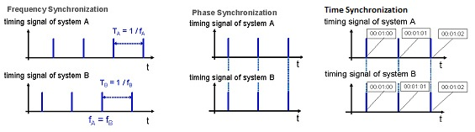
Figure 2: frequency, phase and time synchronization
Frequency synchronization (also called "syntonization") means equipment A and B get a common reference signal and evolve at the same rate within a given accuracy and stability but significant instants of the signal are not aligned in time.
Phase synchronization means equipment A and B get a common reference signal and significant instants are aligned in time within a given accuracy and stability but are not necessary traceable to UTC..
Time synchronization means equipment A and B are phase-synchronized with a known traceable reference clock (e.g. UTC, same reference for leap seconds, etc.).

Both FDD and TDD mobile networks usually require frequency synchronization in order to implement seamless handovers. In addition to that, TDD networks require to align DL/UL switching points between cells in overlapping coverage areas in order to avoid interference. 3GPP has defined "synchronized operation" [15] as "Operation of TDD in two different systems, where no simultaneous uplink and downlink occur", which implies:
- Having a common phase reference to align the DL/UL switching points
- Configuring compatible frame structures, i.e. setting the length of the frame, the TDD uplink/downlink ratio and guard period so that the period between the last transmitter stop and the first receiver start is longer than the signal propagation delay of the BS-BS links causing interference.

This definition is valid both within a single operator network (in order to avoid self-interference between equipment from the same operator), and between operators in the same band (e.g. on adjacent-channels). It has to be noted:
- In order to avoid interference, only cells in overlapping coverage areas need to be synchronized.
- Time synchronization is not required strictly speaking, but may help having a common traceable reference (e.g. UTC), especially in a multi-operator context

The following picture illustrates interference when the start of frame is not aligned (2nd scenario) or when TDD UL/DL ratio is not aligned (3rd scenario).

Examples of synchronized operations (no TX/RX overlap and no interference, despite slightly different frames)
Operator A |  |  |  |  |  |  |  |  |  |  |  |  |  |  |  |  |  |  |  |  |  |  |  |  |  |  |  |  |  |  |  |  |  |  | OK
Operator B |  |  |  |  |  |  |  |  |  |  |  |  |  |  |  |  |  |  |  |  |  |  |  |  |  |  |  |  |  |  |  |  |  |  | OK
Operator C |  |  |  |  |  |  |  |  |  |  |  |  |  |  |  |  |  |  |  |  |  |  |  |  |  |  |  |  |  |  |  |  |  |  | OK
Operator D |  |  |  |  |  |  |  |  |  |  |  |  |  |  |  |  |  |  |  |  |  |  |  |  |  |  |  |  |  |  |  |  |  |  | OK
Same frame structure, but not same start of frame
Operator A |  |  |  |  |  |  |  |  |  |  |  |  |  |  |  |  |  |  |  |  |  |  |  |  |  |  |  |  |  |  |  |  |  |  | NOK
Operator B |  |  |  |  |  |  |  |  |  |  |  |  |  |  |  |  |  |  |  |  |  |  |  |  |  |  |  |  |  |  |  |  |  |  | NOK
Interference periods |  |  |  |  |  |  |  |  |  |  |  |  |  |  |  |  |  |  |  |  |  |  |  |  |  |  |  |  |  |  |  |  |  |  | NOK
Same start of frame, but not same frame structure
Operator A |  |  |  |  |  |  |  |  |  |  |  |  |  |  |  |  |  |  |  |  |  |  |  |  |  |  |  |  |  |  |  |  |  |  | NOK
Operator B |  |  |  |  |  |  |  |  |  |  |  |  |  |  |  |  |  |  |  |  |  |  |  |  |  |  |  |  |  |  |  |  |  |  | NOK
Interference periods |  |  |  |  |  |  |  |  |  |  |  |  |  |  |  |  |  |  |  |  |  |  |  |  |  |  |  |  |  |  |  |  |  |  | NOK
 |  |  | Downlink |  |  |  |  |  |  |  |  |  |  |  |  |  | Uplink
Figure 2: Interference scenarios for TDD/TDD systems

Some advanced features in both FDD and TDD networks such as CoMP and MBSFN also require phase synchronization in order to be effective. The exact values are still under discussions and could be more stringent than the requirements for TDD. This report focuses on phase/time synchronization in TDD network for interference-mitigation purposes.

Phase Synchronization of the reference clock

Accuracy requirements
At the time of this writing, most IMT technologies have a typical requirement of 50ppb in frequency accuracy for wide area base stations. When phase synchronization is required, it is often on the order of 1µs, as illustrated in the following table:
Table 1: phase/time accuracy requirements for various technologies
Technology | Phase/time accuracy requirements
CDMA2000 (FDD) | 3µs
WCDMA TDD (TS 25.402) | 2.5 µs
TD-SCDMA (TS 25.836) | 3µs
LTE TDD (TS 36.133) | 3µs (normal cell radius), 10µs (large cells), 1.33µs+Tprop (HeNB above 500m radius)
WiMAX 802.16e TDD | 1µs

The calculations that lead to the 3µs value between LTE eNB can be found in 3GPP contribution R4-082105. From this calculation, the main constraint comes from the fixed TA_offset value.

Synchronization by GNSS
Description:
GNSS systems such as GPS, Galileo, GLONASS or BeiDou allow a receiver to get time synchronization with an accuracy of 100 ns. Standard G.8272 defines those PRTC aspects and constraints.

Maturity and current deployment:
Synchronization by GNSS is suitable for base stations that have an outdoor component and therefore can receive a GNSS signal. Macro-cell outdoor BS should then be able to be synchronized by this method, which is already widely used for most existing outdoor TDD systems like WiMAX and TD-SCDMA networks, as well as CDMA2000 networks. It has to be mentioned that at the time of writing some GNSS system are not yet fully available (e.g. Galileo) or are not worldwide available (e.g. BeiDou).

Implementability:
Currently this method requires sky visibility, which makes it difficult to implement in some situations (e.g. for indoor cells or in urban canyons), [although some advances from chipset sensitivity suggest this limitation could sometimes be overcome in the near future: [according to some chipset vendors, next generation GNSS receivers designed for indoor femtocells will have an initial acquisition sensitivity of -161 dBm and a reacquisition sensitivity of -163 dBm (while current ones have a sensitivity around -145 dBm)].
Using directly a GNSS solution implies some costs (antenna, lightning arrester, possible amplifier, cable to the base station that may not be located immediately near). This cost may be small for macro/microcell compared to the cost of the site and equipment, but may be non-negligible for small cells, depending on advances on chipsets designed specifically for these.

The threat from GPS jamming by commercially available jammers has been extensively research in the UK by two UK Government supported projects GAARDIAN and SENTINEL. This threat should not be ignored. Since the signal from space to earth is extremely low (equivalent to a 20W light bulb at a distance of 20,000 km), it is very easy to jam with a relatively low power jammer. Actual interference events have found their way into common knowledge such as the truck driver on the I95 highway near Newark Airport USA. He was eventually tracked down and fined but not before he had regularly disrupted GBAS trails at Newark airport over a 6 month period. Other interference effects such as space weather and multipath may also affect GPS reception. Early low power jammers slotted into the vehicle auxiliary power or cigarette lighter socket, however recent evidence points to the evolution and use of more powerful devices with a much greater impact radius. As a consequence, GPS should not be considered 100% reliable and may experience temporary outages. However GPS jamming or outages are currently expected to remain mostly localized in time and space (except in very serious and specific situations such as military conflicts, terrorist or organised crime activity).

Figure 4 below shows a histogram of jamming events over 5 seconds duration at a sensor from the SENTINEL project located in the city of London during the period Feb-Dec 2013. Most months show in excess of 100 events. The real challenge is not so much the event duration but whether the event is of sufficient power to totally deny GPS reception for a period which then causes the GPS receiver to have to reacquire signal. Then there is the holdover capability to consider. A good benchmark for holdover might be 50% of the maximum allowable time offset in 30 minutes.

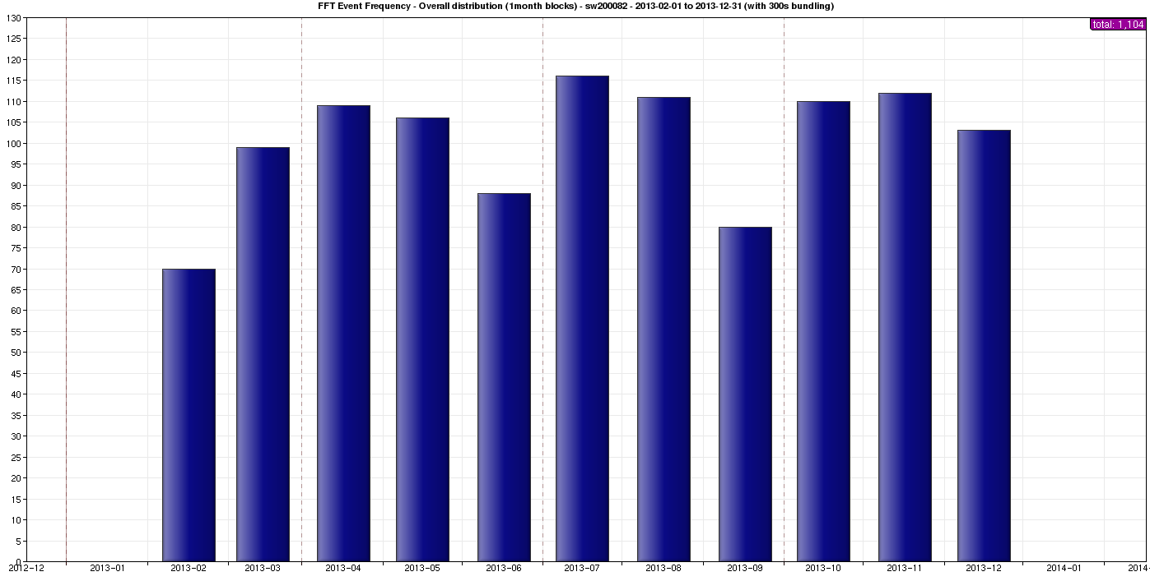
Figure 4: GPS Jamming Events per Month in the City of London, and pdf or jamming duration
As an example, the following statistics could be computed about jamming events on a site in London (UK), in the whole year 2013 (duration is in seconds):

Number of events | 1755
Mean duration | 44,68
Stdev of duration | 66,85
Max duration | 605
Total sum of durations | 1755

This shows that most jamming events have a duration of about a few seconds or minutes, however longer durations (10 minutes in this example) cannot be excluded even though those events are rare.

GPS receiver designs should consider the potential for being jammed and ensure that they don’t suffer catastrophic failures (e.g. manual reset) after such events.

More information on the GPS Jamming threat including examples of event frequency analysis is available within the SENTINEL Project Report (currently being finalised).

Synchronization over packet networks
Introduction:
Several techniques have been designed in the past in order to ensure clock transport over packet networks:
- NTP is one of the oldest protocols and is widely deployed for non-critical applications with an accuracy of around 1ms, but in general it is not designed with hardware support in mind and therefore is not suited for accuracies around 1µs even though some proprietary non-standard implementations with proper hardware support can achieve this kind of accuracy.
- Synchronous Ethernet (SyncE) has been specified by ITU-T SG15/Q13. It is only designed for frequency synchronization, reusing many concepts from SDH, and does not support phase/time synchronization. It may be used complimentary to a phase/time synchronization technique in order to improve frequency synchronization and/or holdover time.
- IEEE-1588v2 (Precision Time Protocol or PTP) is the main considered technique in order to transport synchronization by the network with the desired accuracy for IMT purposes. It may be used for frequency synchronization and/or for phase/time synchronization.

It has to be noted that all those methods are only clock transport mechanisms, not clock source. This means a proper clock source has to be defined and used as a reference. It may be a GNSS receiver (as described in G.8275) or any other system.

Considering the accuracy requirements previously defined for IMT deployments, this section will focus on IEEE-1588v2 (PTPv2) for phase/time synchronization, possibly assisted with SyncE.

IEEE-1588v2/PTPv2 : presentation
Precision Time Protocol (PTP) version 1, also known as IEEE1588, is a standardized protocol defined by the IEEE in 2002, coming initially from the automation world. The initial objective of this protocol is to deliver time synchronization with a very high accuracy (sub-microsecond) in a LAN environment. Therefore, IEEE 1588 is not a technology dedicated only to telecom.

A second version of the standard has been approved by IEEE in 2008. It provides new features that enables it to be used in telecom applications. However, it is a large standard with many options defined for different contexts (not restricted to telecoms), therefore there is a need to define a subset of the options in order to avoid unnecessary complexity and ensure interoperability in telecom environments. Additional specifications are also needed in order to define user requirements (e.g. performance, architecture, reference model, security, management, etc.). This is part of the so-called "telecom profiles" defined by the ITU-T SG15/Q13 standard group.

Several telecom profiles have been or are being specified by ITU-T:
- G.826x: in 2010, ITU-T Q13/SG15 has defined a PTP telecom profile for “end-to-end” frequency distribution in the Recommendations G.8265 and G.8265.1. “End-to-end” means that the nodes in the synchronization path (the path the PTP packets follow from the grandmaster to the slave) do not embed PTPv2 functions
- G.827x: ITU-T Q13/SG15 is currently working on new profiles to address the phase and time distribution by the network. These profiles rely on the fact that all the nodes (full on path support) or only some nodes (partial support) in the synchronization path embed PTPv2 functions

Annex 2 summarizes the relevant ITU-T standards.

IEEE-1588v2/PTPv2 : technical description
The following figure illustrates the basic PTP dialog between master and slave when PTP is used as a two-way protocol and Delay_request / Delay_response messages are used:
Figure 5: Principle for PTP algorithm [32]

Master and slave have their own internal reference clock, and the purpose is to align slave internal clock on master reference clock. Thanks to the dialog depicted in the figure above, the slave knows the four timestamps t1, t2, t3, and t4, and will use them to calculate the offset its internal clock experiences compared to master reference clock, using the following formula:
$$T_{Offset}=\frac{{(t}_{2}-t_{1})-{(t}_{4}-t_{3})}{2}$$

This calculation assumes that the delays in both directions (delay from Master to Slave and Delay from Slave to Master) are symmetric, or at worst that the asymmetry is fixed and known (otherwise, it is not possible to determine and compensate the slave internal clock offset).

As we can see, PTP is normally a two-way protocol since messages are exchanged between master and slave in both directions. It is possible to use PTP as a one-way protocol, using only the "Sync" messages, in order to deliver only frequency. In this case, the calculation differs from the previous formula and is based in general on “adaptive clock recovery” principles, which consists in recovering frequency synchronization via packets. For phase/time synchronization, two-way communication is always needed.

As described on figure 4, the basic PTP dialog consists for the master to send "Sync" messages containing timestamps to the slave. Note that "Follow-up" messages are optional; when used, they are combined to the "Sync" messages in order to deliver more accurate time stamps (this feature is especially used in case of software implementation in the master, or in case the implementation is not fast enough to insert the precise timestamp in the "Sync" message “on the fly”). These two approaches correspond to the notions of "one step clock" when the precise timestamp is directly inserted in the "Sync" messages, and "two-steps clock" when a "Follow-up" message is used to transmit the precise timestamp. When PTP is used with the two-way mode (for phase and time delivery), the slave initiates the path delay calculation, e.g. by issuing "Delay_Request" messages to the master, which answers by "Delay_Response" messages, in order to calculate and compensate the delay that the packets spend through the network.

Packet Delay Variation (PDV also called packet jitter) is the main factor impacting the PTP solutions when there is no hardware support from the intermediate nodes. In order to be able to reach the requirements for phase/time, two mechanisms are defined in the protocol, based on hardware and software PTPv2 functions embedded in nodes:
- Telecom Bounday Clock (T-BC): it acts like a slave on the ingress port (connected to a master) and as a master on the egress port (connected to slave(s)). This allows to compensate the internal latencies and jitter of the node.
- Telecom Transparent Clock (T-TC): it measures the time of residence of the PTP packet in the node by timestamping its arrival time on the ingress port and its departure time on the egress port. The difference is inserted on the fly in the PTP packet in the correction field. The end application slave will use this correction field to compensate PDV and calculate its offset.

Those mechanisms, as part of the PTP protocol, will not help to fight against links asymmetry. In case of asymmetry in the links, the protocol is not capable to determine and compensate it alone and there will be a time error in the calculation of the slave internal clock offset if there is no prior calibration. For instance over fibre links, it is generally agreed that a meter of length difference between the two ways will generate roughly 2.5 ns of time error. Potentially this error may accumulate over the links of the synchronization path.

Asymmetry can be made of:
- Constant time error: if the link asymmetry is static (e.g. when Tx and Rx fibers have different length), it can be calibrated during the deployment (e.g. using a GPS receiver as a reference clock) and set as a parameter in order to compensate the asymmetry in T-BCs/T-TCs and slave equipment.
- Dynamic time error: since clock packets are multiplexed with data packets of different length, and for many other reasons such as temperature effects on oscillators, some jitter is introduced in the equipment (even when the IEEE-1588v2 traffic is prioritized). This is precisely where hardware assistance in BC and TC helps improving the accuracy.

Maturity and current deployment:
As mentioned previously ITU-T Q13/SG15 is currently defining several telecom profiles for phase and time delivery:

- G.8275.1 is the phase/time profile assuming full on-path timing support (i.e. assuming that all equipment between the master clock and the slave clock support PTP functions). This recommendation is expected to be approved in March 2014 and can be considered as nearly finished. The currently defined mapping occurs at OSI layer 2 (e.g. Ethernet). Deployments are already happening in China using this draft profile. It should be noted that interworking with other technologies than Ethernet (e.g. xPON, xDSL, microwaves, etc.) has to be assessed on a case by case basis.
- G.8275.2 is the phase/time profile assuming Assisted Partial on-path Timing Support (APTS). This is the current Q13 work item that refers to the case where a GNSS receiver is deployed at the base station for frequency and time synchronization, and protected with PTP Partial on-path Timing Support (PTS) i.e. allowing legacy non PTP-aware equipment between the master and the slave clock. This is therefore rather a protection scenario than a real phase/time distribution solution that simplifies the problem of partial timing support, because the asymmetry of the network can be estimated when the GNSS is working properly. Based on the asymmetry compensation, the partial on-path support link shall overcome any GNSS failures for several hours within +/-1,5us maximum time error.
- G.8275.x stands for future profile that is not yet studied but is likely to describe the case of Partial on-path Timing Support. Achievable performance of such solution is therefore hard to predict or guarantee. Indeed, despite static/fixed asymmetry can be corrected by proper calibration, dynamic asymmetry and other effects such as packed delay variation are much more challenging to handle, even though clock noise filtering might be able to attenuate some of those effects. Therefore at the time of writing of this document, PTS solution should not be considered as an applicable solution to deliver phase and time with the proper quality.

Some equipments are already available at the time of this writing for phase/time sychronisation, but are not yet compliant with G8275.1 so interoperability is not fully guaranteed until those equipments are upgraded (it is expected that software upgrade will be sufficient).

What is feasible on various technologies (such as xDSL, xPON, microwaves) is a case-by-case analysis. Some of those have been assessed in [33].

Over-the-air synchronization for LTE HeNB by network listening
Description:
Network listening is presented in 3GPP document TR 36.922 §6.4.2, and the corresponding signaling messages are specified in TS 36.413 §9.2.3.34 and TS 32.592 §6.1.1.8.1. It is described as a possible solution for synchronization when other solutions are not available and when HeNB synchronization is still considered mandatory despite the low power and high wall penetration loss (and ACIR in case of adjacent channels). As described in 3GPP 36.922 §6.4.2: “The technique in which a HeNB derives its timing from a synchronized eNB or HeNB (which in turn may be GNSS-synchronized) is referred to here as "synchronization using network listening." A HeNB that uses network listening (say HeNB1) may utilize a synchronization or reference signal from another eNB (say sync eNB) to derive its timing. […] The HeNB may periodically track one or more signals from the donor cell (e.g. Primary and Secondary Synchronization Signals, Common Reference Signal, Positioning Reference Signal) to maintain its synchronization.”

This over-the-air synchronization approach can also be used between different operators with multiple layers sharing the same band, not only for Femto, but also for other layers like Pico. When this approach is used between different operators, it is necessary for the new entry BS to receive all the possible interfering channels including other operators within the same band. Since only PSS, SSS and CRS signals are needed for setting up the synchronization, no subscription to other operators’ network is required as other information like synchronization stratum level could be obtained through standardization of MBSFN pattern. Test cases for synchronization with other channels in the same band can help to verify the cross-operator synchronization mechanism.

The master is not required to be a macrocell connected to GNSS since the scheme allows for multi-hop femtocell-to-femtocell. However, the number of hops should not be too high in order to avoid accumulation of timing errors. 3GPP has defined 4 levels of precedence (0 is high and 3 is low), which allow up to 3 hops (in TS-36.413 §9.2.3.34 [13]). According to lab tests, the synchronization accuracy can be as low as 189ns, which shows the solution is technically feasible.
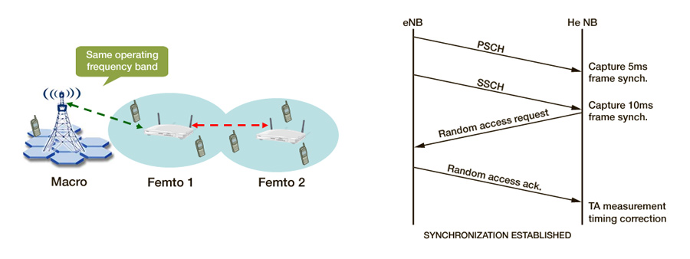
Figure 6: illustration of over-the-air "network listening" mechanism for LTE-TDD
Obviously, this mechanism makes sense mostly in the case where the master and slave BSs operate in the same band using the same technology (though not necessary the exact same channel). The case of network listening on a different band would obviously require a dedicated receiver for the target listening band, but may be simpler to implement since the HeNB would not have to rely on complex algorithms in order to periodically switch between UE and eNB modes.

[MBSFN approach
GP approach]

A new SI “small cell enhancements for E-UTRA and E-UTRAN Physical layer aspects” (RP-122032, RP-132073) was set up in 3GPP RAN#58 for Rel-12. In this SI, coordinated and time synchronized operation of the small cell layer and between small cells and the macro layer is assumed for specific operations, feasibility and benefits of radio-interface based synchronization mechanisms will be assessed.

Maturity and current deployment:

At the time of this writing, the network-listening approach has been successfully implemented and tested for single-operator LTE femtocell synchronization even though those are still lab experiments. Those reference implementations use the two approaches described in 36.922 §6.4.2.1.3.

Implementability:
This solution is restricted to the LTE HeNB in the same band (not necessary on the same channel). It currently requires less than 4 hops between the master and the slave cell. The new WID allows for more hops, and may enable the technology to other types of nodes than HeNB.

Terrestrial synchronization networks
Description:

The LOng RAnge Navigation system (Loran) is a narrowband terrestrial timing and positioning system, employing pulsed radio signals at 100 kHz, a frequency at which signal propagation is exceptionally time-stable. Its current version, called eLoran, is replacing the earlier Loran-C which was widely deployed for civil and military maritime and aviation navigation. From [21], "Enhanced Loran (or eLoran) is a Loran system that incorporates the latest receiver, antenna, and transmission system technology to enable Loran to serve as a backup and complement to global navigation satellite systems (GNSS) for navigation and timing. This new technology provides substantially enhanced performance beyond what was possible with Loran-C”. “For example, it is now possible to obtain absolute accuracies of 8-20 meters using eLoran for harbor entrance and approach. Similarly, eLoran can function as an independent, highly accurate source of universal coordinated time (UTC)”. For timing, eLoran transmissions are precisely synchronized to an accurate source of UTC. Also, a UTC time message is broadcast to the user over an eLoran Data Channel.

The Loran signal is currently unavailable in the United States, but recent US government-funded research by UrsaNav Inc. there has demonstrated wide-area time distribution using transmissions compatible with eLoran. In the UK, prototype eLoran has operated for over 3 years and Initial Operational Capability (IOC) has recently been implemented for maritime positioning, navigation and timing (PNT). The service provides precise timing for land users across the UK, Ireland and parts of the Continent. These UK eLoran transmissions are backward-compatible with Loran-C, which remains operational in northwest Europe with transmitters in France, Denmark (Faroe Islands), Germany and Norway. All Loran-C stations can be modernised to provide eLoran navigation and timing. Global evolution towards eLoran is anticipated, with integrated eLoran/GNSS receivers aimed at multiple applications.

According to [20, 25], eLoran has the following benefits (contrary to most other terrestrial systems [23]):

- UTC traceability, accuracy and stability on a par with GPS and other GNSS

- Not impacted by GPS jamming, (and therefore is a mitigation solution when GNSS fails.

- Better indoor penetration antenna than GNSS for when neither GNSS nor backhaul network synchronization is available.

According to Chronos Technology Ltd., eLoran is more accurate than DCF77, MSF and similar radio technologies [22], since even with perfect source time their propagation delays are uncertain. Their continuous-wave signals are reflected by the ionosphere, resulting in the reception of both ground-wave and sky-wave components, causing fading and phase delay variations. eLoran avoids ionospheric reflections by means of a pulsed signal and its stations employ multiple caesium Primary Reference Standards. Techniques for determining eLoran propagation delay over land paths are highly advanced, See Figure 7 resulting in accuracies which degrade to 500ns in the red zone at a 1500 km radius of the transmitter.

The use of differential corrections could improve accuracy to 50ns. Low-power stations could be deployed to enhance land coverage.

Drawbacks of eLoran currently are:

- eLoran is targeted at maritime PNT users, resulting in uneven coverage that favours sea areas; however.

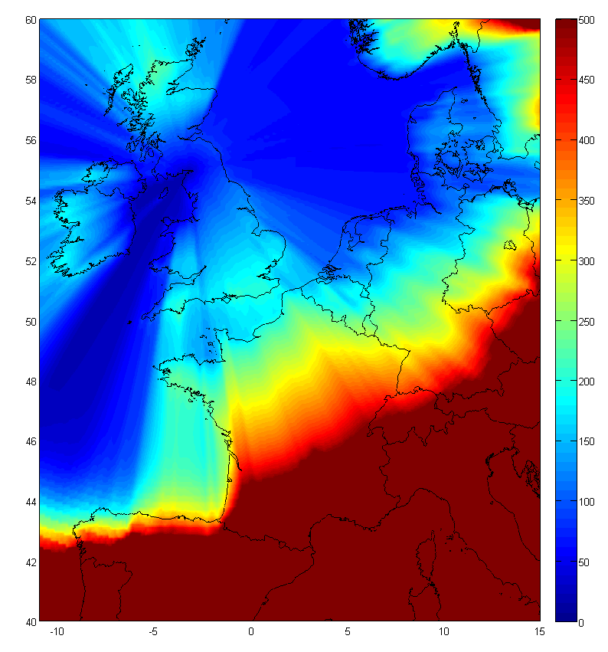 | 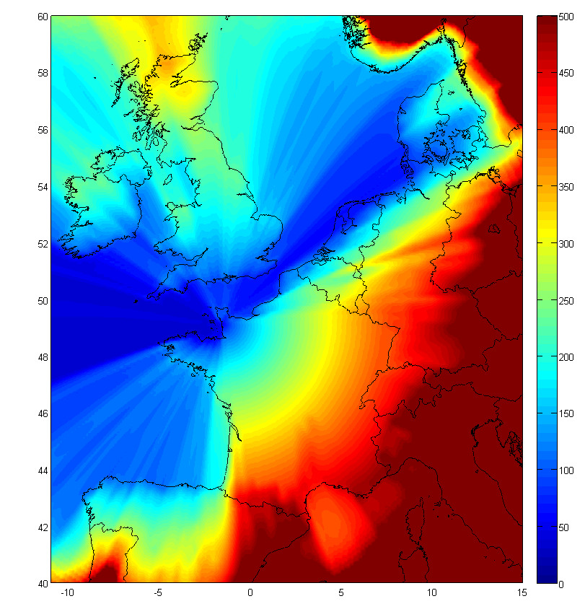 | 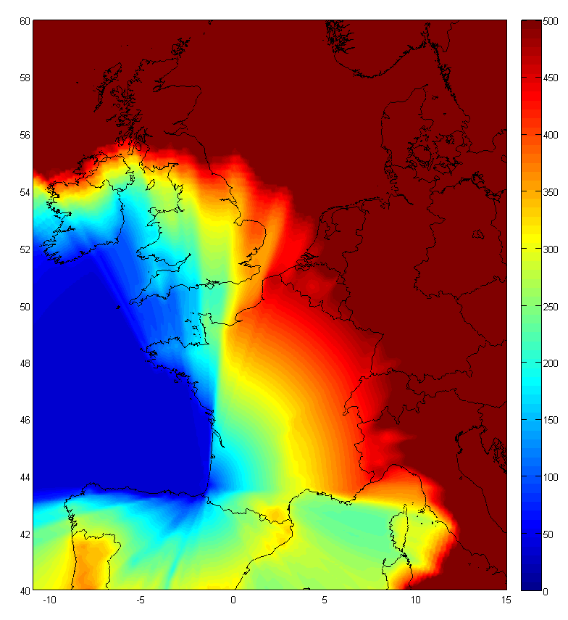
Figure 7: Best (Blue) to 500ns (Red) eLoran Coverage for Anthorn, Lessay and Soustons

- Some countries are planning to shut down Loran-C without upgrading to eLoran; however, this trend is being countered by growing concern worldwide over GPS jamming and an appreciation of the need for a complementary, independent and dissimilar backup to GNSS.

- The cost, volume and footprint of current receivers may be acceptable for macrocells but not yet for low-cost small cells; however, developing a dedicated low-cost receiver ASIC would not be difficult technically, or commercially given sufficient volume.

- Indoor reception of eLoran requires “H-field antenna” technology which needs further research to make them smaller as does the receiver footprint if it is to be suitable for small cell applications.

At the time of this writing, eLoran appears to be the only terrestrial synchronization technology able to provide the accuracy required for IMT deployments.

An indication of the relative accuracy of GPS and eLoran timing references is shown in Figure 8 and Figure 9 below. It can be seen that eLoran_{UTC} tracks GPS_{UTC} (USNO_{UTC}) extremely well.

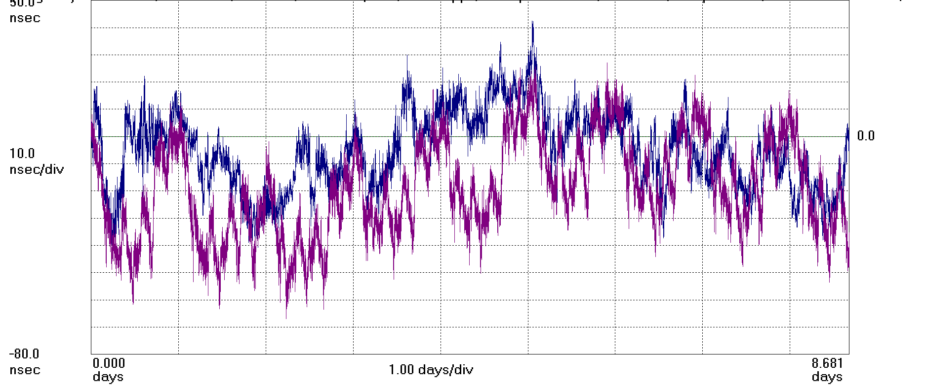
Figure 8: TIE graph of eLoran (Blue) and GPS (Magenta) 1pps timing signals over 9 days
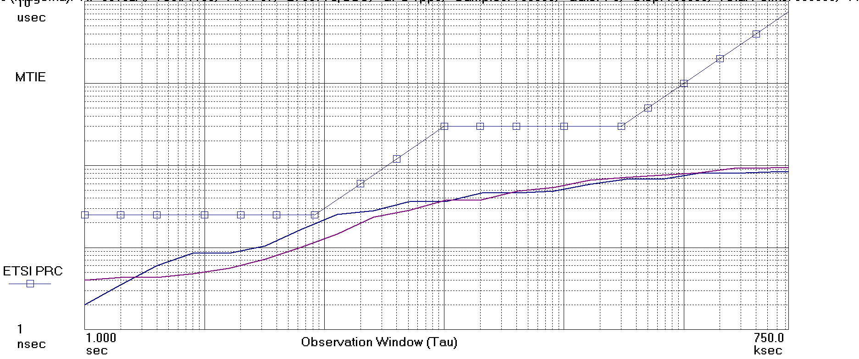
Figure 9: MTIE graph of eLoran (Blue) and GPS (Magenta) 1pps timing signals over 9 days

[Other synchronization methods]
[Since we only need phase synchronization between close BS rather than time synchronization, we need to explore the general case of a separate receiver dedicated to synchronization in the slave BS, extracting and using the clock of another reference RF signal in another band and another technology. For example, is it possible to get phase synchronization from SCH in a surrounding GSM network ?]

[Besides, any signals carrying synchronization information may be used for local phase synchronization between equipment in the vicinity of each other even though it does not carry time information and therefore does not ensure global synchronization between far away stations. Some research is also actively being done in the area of network sensors and synchronization networks [18], which may allow decentralized synchronization schemes in the case of femtocell-only deployments. All those approaches may be considered for further studies, but are not considered mature for industrial implementations at the time of this writing.]

Holdover and resilience

All oscillators drift over time when they are not disciplined by the reference clock. More expensive oscillators such as OCXOs drift more slowly than cheap ones like TCXOs (which are more frenquently used in UEs and small cells), even though new TCXO generations have an increasing quality that may allow them to be used in situations where an OCXO used to be required. T
he following tables gives indications on the typical holdover time for various clocks defined by ITU-T (it does not exclude better performances by available hardware from the industry):

Table 1: Time to Produce a Particular Error for Various Oscillator Types

Table 2: Error Produced in a Particular Time for Various Oscillator Types

When base stations lose the reference clock, they can still continue to operate with their local oscillator during a period of time called "holdover", i.e. until the drift exceeds the maximum acceptable accuracy error. Frequency holdover (often just called “holdover”) and time holdover are not the same, and time holdover is typically shorter (except when the local base station oscillator can still get a reference frequency clock in order to drift more slowly).

Some base station vendors allow to configure a default holdover parameter (e.g. 2 hours for some WiMAX macro base stations, supposedly better for newer LTE-TDD eNB with more recent oscillators), and take appropriate measure when they lose the time reference for a duration that exceeds this configured holdover (e.g. fallback on a backup reference clock if available, or shutdown the equipment as described in [33]). It should however be noted that the clock drift does not only depend on oscillator quality, but also on several parameters such as temperature, so the configured holdover time has to take into account the worst-case drift.

Synchronization methods described in this report are not exclusive and may be complementary and/or used as a backup. For example:
- [In case of a localized GNSS jamming, an IEEE-1588v2 may allow to transport a remote backup clock if properly engineered that way from the initial design]
- Despite being focused on frequency synchronization, SyncE may help to discipline the local oscillator so that it drifts more slowly in case the reference time clock is lost (this is taken into account in G.8271)
- G.8275.1 has extensive resiliency features (e.g. to reselect a new master clock in case the primary master clock fails)

Frame structure coordination

Definition
Synchronizing the start of the frame is not enough to avoid interference between networks. Since TDD allows flexibility in the frame length and uplink-downlink ratio, they may transmit and receive in the same time i.e. align DL/UL switching points. In TDD networks, the frame structure (i.e. frame length and uplink-downlink ratio) can be configured as software parameter. Therefore “synchronizing” the frame structure means agreeing on common parameters.

It should be noted that agreement on a common UL/DL ratio decreases the flexibility of TDD with respect to the choice of the ratio, maybe leading to some suboptimal ratio at the individual level for each operator. However synchronization also allows saving some spectrum that would be otherwise wasted or under used in restricted blocks or guard bands, and therefore helps improve the overall capacity. Therefore the benefits and drawbacks have to be compared and balanced with the waste of spectrum created by restricted blocks/guard bands in the case of unsynchronized networks. Also, the common TDD ratio is not restricted to 50:50 but may be a kind of average between the needs of the various involved operators, and some flexibility remains since this common TDD ratio can always be further modified if the overall DL:UL ratio changes from the macroscopic point of view.

Cross-technology network synchronization
For both LTE and WiMAX technologies it is possible to synchronize networks in adjacent bands that use the same technology. In the case of WiMAX there is an actual example of synchronization as described in document ECC PT1(11)103 (see paragraph below, assuming the networks were using WiMAX). In the case of LTE, 3GPP RAN4 gave the following indication in an liaison statement to ECC PT1 (see document ECC PT1(11)077): “for the LTE TDD BS, the 3GPP requirements are defined assuming synchronization between blocks assigned to operators”. We can infer from this statement that it is technically possible to synchronize network of different operators using TD-LTE.

LTE and WiMAX are the two main candidate technologies for MFCN networks within several TDD bands. There is therefore a possibility that those two technologies be deployed in adjacent bands by different operators. They have different frame structures and therefore the technical feasibility has been studied in this section.

Based on the current state of the specification exposed in annex [4], it can be shown that most WiMAX 802.16e configurations have at least one equivalent TD-LTE set of parameters, giving options for synchronizing two networks implementing different technologies

Some limitations exist however: current WiMAX Forum profiles only support 5ms frame length and TDD ratios above 50% for downlink. This study focuses on currently available technologies, thus only LTE up-down configurations #1 and #2 are applicable. Table 7 in annex 1 shows how many % of the frame are overlapping (i.e. with WiMAX transmitting while LTE is receiving, or LTE transmitting while WiMAX is receiving) for each WiMAX vs LTE TDD configuration. The most desirable scenario is the fully synchronized one, which correspond to a "0%" overlap. The following table shows which LTE frame type and "S" subframe configurations correspond to each WiMAX configurations:
Table 2: LTE-TDD equivalent parameters for existing WiMAX frame configurations
WiMAX configuration | LTE frame configuration | LTE "S" possible configurations
10MHz 35:12 | 2 | 0,1,5,6
10MHz 34:13 | 2 | 0,5
10MHz 33:14 | 2 | 0,5
10MHz 32:15 | 2 | 0,5
10MHz 31:16 | 2 | 0,5
10MHz 30:17 | - | Overlap 0,5%
10MHz 29:18 | - | Overlap 1,1%
10MHz 28:19 | 1 | 0-4
10MHz 27:20 | 1 | 0-8
10MHz 26:21 | 1 | 0-2,5-7
7MHz 24:9 | 2 | 0,1,5,6
7MHz 23:10 | 2 | 0,5
7MHz 22:11 | 2 | 0,5
7MHz 21:12 | - | Overlap 0,1%
7MHz 20:13 | 1 | 0-4
7MHz 19:14 | 1 | 0-8
7MHz 18:15 | 1 | 0-2,5-7
8.75MHz 30:12 | 2 | 0,5
8.75MHz 29:13 | 2 | 0,5
8.75MHz 28:14 | 2 | 0,5
8.75MHz 27:15 | - | Overlap 0,3%
8.75MHz 26:16 | - | Overlap 1,3%
8.75MHz 25:17 | 1 | 0-5
8.75MHz 24:18 | 1 | 0-3,5-8

Considering the frame structures of the two technologies as described in annex 1, it is necessary to specify an offset (e.g. if the WiMAX frame is aligned on multiple of 1s+k*5ms boundaries, then the neighbor TD-LTE network has to align its frame on 1s+1ms+k*5ms boundaries when using type 1 configuration or 1s+2ms+k*5ms boundaries when using configuration type 2).

In a few cases (e.g. WiMAX TDD ratio 29:18), no direct TD-LTE equivalent parameters exist. However, even in those cases, only minimal overlap happens, so that several technical solutions are applicable in order to solve this. Taking the example of 29:18 WiMAX ratio, the two following approaches are valid:
- Blank-out the two last OFDM symbols in the WiMAX frame (making it effectively 27:18), at the expense of a 8% capacity loss on the WiMAX side. This can be done in several ways.
- Blank-out a part of the UpPTS field in the LTE “S” subframe. As this carries no payload and the system can use other slots for RACH and SRS, there is nearly no loss of capacity and therefore less downside compared to the previous approach, except a relatively narrow “inter-technology TTG”. The picture below shows an example of such configuration:

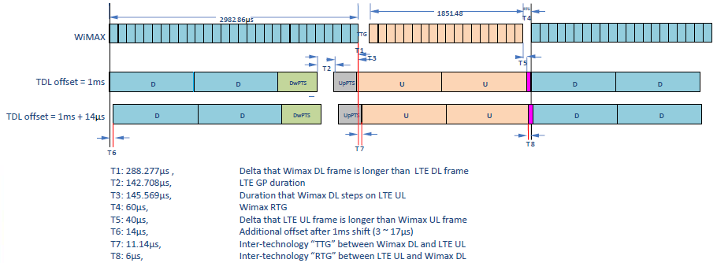
Figure 9: frame alignment mechanism between WiMAX with 29:18 TDD ratio and LTE-TDD
This solution has been successfully implemented by Clearwire US as part of their WiMAX to LTE-TDD transition, which shows it is technically effective.

Practical guidance for inter-operator deployment

Clock synchronization
The following table summarizes and compares the assessed techniques for phase/time synchronization:
Table 3: summary of assessed techniques for various scenarios
Scenario | GNSS | Packet networks | LTE OTA | eLoran
Status | Yes, mature. implemented in existing TDD networks. | G.8275.1 assumes full on-path support (i.e. new equipment with hardware time stamping support for IEEE-1588v2).  G.8275.2 will address partial on-path support cases but is not ready yet. | Yes but mostly designed for indoor small cells without GNSS and backhaul sync. | Yes though not yet deployed for IMT
Cross-technology (e.g. WiMAX-LTE) | Yes | Yes | No, LTE-only | Yes
Works indoors | Short term: no  Mid/long-term : pending improvements in sensitivity | Case by case: e.g. OK for VDSL and DOCSIS backhaul. Not yet working for ADSL backhaul. | Yes, up to 3 hops for time synchronization.  [FFS for more hops. FFS for femtocell-only scenarios] | FFS. Should theoretically work, though not yet tested.  FFS for the chipset and antennas (currently designed for macro sites).

Inter-operator synchronisation pre-requisites
In a multi-operator context, operators need to agree
- On a common phase clock reference (e.g. UTC) and accuracy/performance constraints (either using their own equipment to get the clock, or sharing the same phase/time clock infrastructure).
- On a compatible frame structure
- On a commitment not to interfere with each other (e.g. on the reliability of the reference clock and/or on a procedure when losing this reference clock)
- On the terms & conditions where cross-operator synchronization applies (e.g. synchronization may not be always required, for example in isolated/rural/non-colocated / femtocell deployments)

Possible procedures to achieve inter-operator agreement
Regulators may anticipate the lack of agreements when issuing the licences, for example:
- By mandating proper BEM and/or guard bands in those situations, synchronization being an optional way to ensure better use of the spectrum and lower costs in hardware filters
- By defining default parameters (for example: UTC as the reference clock, 5ms frame length, and 60% DL/UL ratio) if they consider synchronization as mandatory
- Coexistence between existing licensees and new ones should also be properly anticipated (e.g. when a new operator B deploys after operator A, should operator A be mandated to change his UL/DL settings in order to reach a tradeoff?)

Conclusion
[In section 1, it has been stated that future TDD IMT deployment will require phase/time synchronization accuracy with the order of magnitude of 1 to 10µs depending on the scenario in order to avoid TDD interference (3µs is taken as a reference for 3GPP LTE deployments without any specific customization). The required accuracy may be relaxed with proper configuration like cyclic-prefix extension, or may be constrained below 1µs by other IMT-Advanced features like eMBMS and CoMP). Outdoor macrocells are no longer the only considered scenario, but this report also assesses small indoor cells in a cross-operator context.

In section 2, several synchronization techniques have been assessed. The following deployment scenarios can be addressed by existing synchronization techniques:
- Outdoor cells: can be synchronized by GNSS, both for intra-network and cross-operator network synchronization. Packet networks may also be used in cases where full on-path PTP support is feasible.
- Indoor micro/picocells: IEEE-1588v2 may be considered over an ethernet LAN, and therefore may be used to bring time/phase reference to an indoor picocell from an outdoor GNSS receiver that would behave as a local reference clock. Over-the-air synchronization may also be used.
- Indoor femtocells: Over-the-air "network listening" has been validated for intra-network synchronization, in a scenario where femtocells synchronize to a master cell (typically outdoor macrocell). The specifications allow femto-femto synchronization up to 3 hops.

Those existing techniques can cover most deployment cases, except femtocell-only scenarios (i.e. without GNSS-connected macrocell operating in the same band). Several techniques may be used as a solution, like eLoran, decentralized synchronization networks [18], IEEE-1588v2/PTP (e.g. over VDSL or DOCSIS), improved GNSS receivers, etc. However those approaches still need further studies.

In section 3, it has been shown that common frame structure configuration is not restricted to a single-technology but may also be applied among different technologies provided they allow for common compatible parameters. It has been shown that all WiMAX frame structures have an equivalent LTE-TDD configuration (but the opposite is not true since LTE also allows for more uplink than downlink, contrary to WiMAX), and existing examples of WiMAX-LTE adjacent-channel network coexistence have been exhibited. This may help coexistence or transition between legacy BWA to newer IMT deployments. Existing examples of cross-operators (same technology) synchronization have also been exhibited.]

[Conclusion for frame structure coordination]
From the technical perspective, it has been shown that common frame structure configuration is not restricted to a single-technology but may also be applied among different technologies provided they allow for common compatible parameters. In the example of WiMAX and LTE-TDD, both technologies support 5ms frame length, and common uplink-downlink parameters. In the few cases where WiMAX parameters do not have an exact LTE equivalent (like in the 29:18 TDD ratio commonly used in WiMAX), there are technical solutions to ensure synchronization – which have been effectively used by operators transitioning from WiMAX to LTE-TDD.

It should be noted that although all WiMAX TDD ratios have an equivalent LTE-TDD ratio, the opposite is not true since the lowest WiMAX DL/UL ratio has 65% of downlink, while LTE-TDD allows down to 35% (i.e. more uplink than downlink). Such cross-technology synchronization may also come at the expense of some loss of capacity (e.g. if the LTE "guard period" or upPTS are large). Cell radius and some of the OTA "network listening" mechanism are also impacted by parameters like the guard period size and the dwPTS size, which are more constrained with cross-operator synchronization.

Successful examples of inter-operator TDD network synchronization, e.g. in Malaysia, Korea, and Japan, demonstrates the feasibility and the “real world” applicability of such approaches. Successful examples of cross-technology synchronization have been implemented in the US by Clearwire.

This report has been focusing on perfect synchronization without any TX/RX overlap, just as most interference studies consider 100% overlap. Further studies would be needed to assess behavior and resilience when imperfect synchronization is implemented (e.g. due to synchronization error, or slightly different start of frame or frame structure), leading to a limited interference zone in the frame. First results suggest that an LTE-TDD victim should be resilient since the data loss would only affect payload data in the interference zone of the frame, without blocking more important control messages, which may be acceptable if the probability of simultaneous transmission is not very high. More assessment is needed, especially targeting a WiMAX victim.

- WiMAX and LTE-TDD frame structures
This annex details the supported parameters in LTE and WiMAX specifications at the time of this writing.

3GPP LTE
TS 36.211 (§4.2) [1] defines the following frame structure for TDD-LTE (frame type 2)
Figure 10: LTE-TDD frame structure
Each subframe has a 1ms length, and can be used in the 3 following modes: "D" (downlink), "U" (uplink) and "S" (switching point). The LTE superframe supports the following configurations:
Table 4: LTE TDD uplink-downlink configurations
Uplink-downlink  configuration | Downlink-to-Uplink  Switch-point periodicity | Subframe number |  |  |  |  |  |  |  |  |  | %DL (min-max)
 |  | 0 | 1 | 2 | 3 | 4 | 5 | 6 | 7 | 8 | 9
#0 | 5 ms | D | S | U | U | U | D | S | U | U | U | 24% - 37%
#1 | 5 ms | D | S | U | U | D | D | S | U | U | D | 44% - 57%
#2 | 5 ms | D | S | U | D | D | D | S | U | D | D | 64% - 77%
#3 | 10 ms | D | S | U | U | U | D | D | D | D | D | 62% - 69%
#4 | 10 ms | D | S | U | U | D | D | D | D | D | D | 72% - 79%
#5 | 10 ms | D | S | U | D | D | D | D | D | D | D | 82% - 89%
#6 | 5 ms | D | S | U | U | U | D | S | U | U | D | 34% - 47%

The "S" subframe itself is made of 3 parts: DwPTS (downlink pilot and data timeslot), GP (guard period) and UpPTS (uplink pilot timeslot). The following configurations are defined for this "S" subframe (where Ts = 32.55 ns):
Table 5: LTE-TDD "S" subframe configurations (values are in number of Ts)
Special subframe configuration | Normal cyclic prefix in downlink |  |  | Extended cyclic prefix in downlink
Special subframe configuration | DwPTS | UpPTS |  | DwPTS | UpPTS
Special subframe configuration | DwPTS | Normal cyclic prefix in uplink | Extended cyclic prefix in uplink | DwPTS | Normal cyclic prefix in uplink | Extended cyclic prefix in uplink
#0 | 6592 | 2192 | 2560 | 7680 | 2192 | 2560
#1 | 19760 | 2192 | 2560 | 20480 | 2192 | 2560
#2 | 21952 | 2192 | 2560 | 23040 | 2192 | 2560
#3 | 24144 | 2192 | 2560 | 25600 | 2192 | 2560
#4 | 26336 | 2192 | 2560 | 7680 | 4384 | 5120
#5 | 6592 | 4384 | 5120 | 20480 | 4384 | 5120
#6 | 19760 | 4384 | 5120 | 23040 | 4384 | 5120
#7 | 21952 | 4384 | 5120 | - | - | -
#8 | 24144 | 4384 | 5120 | - | - | -

WiMAX 802.16e
In WiMAX 802.16e (as defined in the WiMAX Forum System Profiles [4, 5], based on [2]), the frame length is always 5ms. The TTG/RTG must be above 5µs, but the current WiMAX Forum profiles define a fixed value of 60µs for the RTG (or 74.4µs for the 8.75 MHz channel size). The TTG is taking the remaining part of the frame (which allows a cell radius of ~8km for the 5 MHz and 10 MHz channel size, and ~16km for the 3.5 MHz and 7 MHz channel size. If it is required, it is still possible to blank some OFDM symbols in order to increase the TTG to allow a greater cell radius).
Figure 11: IEEE-802.16e (WiMAX) frame structure
Table 6: WiMAX 802.16e parameters
BW | 10 MHz | 7 MHz | 5 MHz | 3.5 MHz | 8.75 MHz
Min TDD ratio (DL:UL) | 35:12 | 24:09 | 35:12 | 24:09 | 30:12
Max TDD ratio (DL:UL) | 26:21 | 18:15 | 26:21 | 18:15 | 24:18
Sampling factor | 1.12 | 1.142857143 | 1.12 | 1.142857143 | 1.142857143
FFT size | 1024 | 1024 | 512 | 512 | 1024
Fs (sampling frequency) | 11200000 | 8000000 | 5600000 | 4000000 | 10000000
Carrier spacing (Hz) | 10937.5 | 7812.5 | 10937.5 | 7812.5 | 9765.625
Useful OFDM symbol length (µs) | 91.4 | 128 | 91.4 | 128 | 102.4
Cyclic prefix length (µs) | 11.4 | 16 | 11.4 | 16 | 12.8
Total OFDM symbol length (µs) | 102.8 | 144 | 102.8 | 144 | 115.2
Useful OFDM symbols / frame | 47 | 33 | 47 | 33 | 42
RTG | 60µs | 60µs | 60µs | 60µs | 74.4µs
TTG | 105.7µs | 188µs | 105.7µs | 188µs | 87.2µs

WiMAX/LTE-TDD compatibility matrix
The next table shows the overlap (in % of the 5ms frame) between the WiMAX and the LTE-TDD frame. Hence all the results with "0%" value mean there is perfect coexistence between the two networks (i.e. no DL transmission from one network while the other is in UL mode). "Ratio" shows how much downlink there is in % of the total 5ms frame. "DL_length", "UL_length" and "UL_start" are in seconds. The percentages are computed with the following formula :
Overlap == max( (lte_dl_length-wimax_ul_start), (wimax_dl_length-lte_ul_start) ) / frame_length

When this computation is negative, it means there is no overlap, and there is extra time and tolerance for frame misalignment. However for clarity purposes, the following table shows "0%" instead of negative values to illustrate that there is no overlap and that frames are compatible. Scenarios where the minimum overlap is >0% means that the standards do not allow an exact compatible frame structure between the two technologies without using some technical tricks (like offsetting start of frame, or blanking out some OFDM symbols, as described in section 3.3).

Table 7: 802.16e/LTE-TDD coexistence
 |  |  |  |  |  | LTE U-D config | 1 |  |  |  |  |  |  |  |  | 2
 |  |  |  |  |  | "S" frame | 0 | 1 | 2 | 3 | 4 | 5 | 6 | 7 | 8 | 0 | 1 | 2 | 3 | 4 | 5 | 6 | 7 | 8
 | Ratio |  |  |  |  |  | 44.3% | 52.9% | 54.3% | 55.7% | 57.1% | 44.3% | 52.9% | 54.3% | 55.7% | 64.3% | 72.9% | 74.3% | 75.7% | 77.1% | 64.3% | 72.9% | 74.3% | 75.7%
 |  | DL length |  |  |  |  | 0.0022 | 0.0026 | 0.0027 | 0.0028 | 0.0029 | 0.0022 | 0.0026 | 0.0027 | 0.0028 | 0.0032 | 0.0036 | 0.0037 | 0.0038 | 0.0039 | 0.0032 | 0.0036 | 0.0037 | 0.0038
 |  |  | TTG / GP |  |  |  | 0.0007 | 0.0003 | 0.0002 | 0.0001 | 7E-05 | 0.0006 | 0.0002 | 0.0001 | 7E-05 | 0.0007 | 0.0003 | 0.0002 | 0.0001 | 7E-05 | 0.0006 | 0.0002 | 0.0001 | 7E-05
 |  |  |  | UL length |  |  | 0.0021 | 0.0021 | 0.0021 | 0.0021 | 0.0021 | 0.0021 | 0.0021 | 0.0021 | 0.0021 | 0.0011 | 0.0011 | 0.0011 | 0.0011 | 0.0011 | 0.0011 | 0.0011 | 0.0011 | 0.0011
 |  |  |  |  | UL start |  | 0.0029 | 0.0029 | 0.0029 | 0.0029 | 0.0029 | 0.0029 | 0.0029 | 0.0029 | 0.0029 | 0.0039 | 0.0039 | 0.0039 | 0.0039 | 0.0039 | 0.0039 | 0.0039 | 0.0039 | 0.0039
Conf WiMAX |  |  |  |  |  |  |  |  |  |  |  |  |  |  |  |  |  |  |  |  |  |  |  |  | Min
10MHz 35:12 | 74.5% | 0.0036 | 0.0001057 | 0.0012343 | 0.0037057 |  | 13.4% | 13.4% | 13.4% | 13.4% | 13.4% | 14.9% | 14.9% | 14.9% | 14.9% | 0.0% | 0.0% | 0.2% | 1.6% | 3.0% | 0.0% | 0.0% | 0.2% | 1.6% | 0.0%
10MHz 34:13 | 72.3% | 0.0034971 | 0.0001057 | 0.0013371 | 0.0036029 |  | 11.4% | 11.4% | 11.4% | 11.4% | 11.4% | 12.8% | 12.8% | 12.8% | 12.8% | 0.0% | 0.8% | 2.2% | 3.7% | 5.1% | 0.0% | 0.8% | 2.2% | 3.7% | 0.0%
10MHz 33:14 | 70.2% | 0.0033943 | 0.0001057 | 0.00144 | 0.0035 |  | 9.3% | 9.3% | 9.3% | 9.3% | 9.3% | 10.7% | 10.7% | 10.7% | 10.7% | 0.0% | 2.9% | 4.3% | 5.7% | 7.1% | 0.0% | 2.9% | 4.3% | 5.7% | 0.0%
10MHz 32:15 | 68.1% | 0.0032914 | 0.0001057 | 0.0015429 | 0.0033971 |  | 7.3% | 7.3% | 7.3% | 7.3% | 7.3% | 8.7% | 8.7% | 8.7% | 8.7% | 0.0% | 4.9% | 6.3% | 7.8% | 9.2% | 0.0% | 4.9% | 6.3% | 7.8% | 0.0%
10MHz 31:16 | 66.0% | 0.0031886 | 0.0001057 | 0.0016457 | 0.0032943 |  | 5.2% | 5.2% | 5.2% | 5.2% | 5.2% | 6.6% | 6.6% | 6.6% | 6.6% | 0.0% | 7.0% | 8.4% | 9.8% | 11.3% | 0.0% | 7.0% | 8.4% | 9.8% | 0.0%
10MHz 30:17 | 63.8% | 0.0030857 | 0.0001057 | 0.0017486 | 0.0031914 |  | 3.1% | 3.1% | 3.1% | 3.1% | 3.1% | 4.6% | 4.6% | 4.6% | 4.6% | 0.5% | 9.0% | 10.5% | 11.9% | 13.3% | 0.5% | 9.0% | 10.5% | 11.9% | 0.5%
10MHz 29:18 | 61.7% | 0.0029829 | 0.0001057 | 0.0018514 | 0.0030886 |  | 1.1% | 1.1% | 1.1% | 1.1% | 1.1% | 2.5% | 2.5% | 2.5% | 2.5% | 2.5% | 11.1% | 12.5% | 13.9% | 15.4% | 2.5% | 11.1% | 12.5% | 13.9% | 1.1%
10MHz 28:19 | 59.6% | 0.00288 | 0.0001057 | 0.0019543 | 0.0029857 |  | 0.0% | 0.0% | 0.0% | 0.0% | 0.0% | 0.5% | 0.5% | 0.5% | 0.5% | 4.6% | 13.2% | 14.6% | 16.0% | 17.4% | 4.6% | 13.2% | 14.6% | 16.0% | 0.0%
10MHz 27:20 | 57.4% | 0.0027771 | 0.0001057 | 0.0020571 | 0.0028829 |  | 0.0% | 0.0% | 0.0% | 0.0% | 0.0% | 0.0% | 0.0% | 0.0% | 0.0% | 6.6% | 15.2% | 16.6% | 18.1% | 19.5% | 6.6% | 15.2% | 16.6% | 18.1% | 0.0%
10MHz 26:21 | 55.3% | 0.0026743 | 0.0001057 | 0.00216 | 0.00278 |  | 0.0% | 0.0% | 0.0% | 0.1% | 1.5% | 0.0% | 0.0% | 0.0% | 0.1% | 8.7% | 17.3% | 18.7% | 20.1% | 21.5% | 8.7% | 17.3% | 18.7% | 20.1% | 0.0%
7MHz 24:9 | 72.7% | 0.003456 | 0.000188 | 0.001296 | 0.003644 |  | 10.5% | 10.5% | 10.5% | 10.5% | 10.5% | 12.0% | 12.0% | 12.0% | 12.0% | 0.0% | 0.0% | 1.4% | 2.8% | 4.3% | 0.0% | 0.0% | 1.4% | 2.8% | 0.0%
7MHz 23:10 | 69.7% | 0.003312 | 0.000188 | 0.00144 | 0.0035 |  | 7.7% | 7.7% | 7.7% | 7.7% | 7.7% | 9.1% | 9.1% | 9.1% | 9.1% | 0.0% | 2.9% | 4.3% | 5.7% | 7.1% | 0.0% | 2.9% | 4.3% | 5.7% | 0.0%
7MHz 22:11 | 66.7% | 0.003168 | 0.000188 | 0.001584 | 0.003356 |  | 4.8% | 4.8% | 4.8% | 4.8% | 4.8% | 6.2% | 6.2% | 6.2% | 6.2% | 0.0% | 5.7% | 7.2% | 8.6% | 10.0% | 0.0% | 5.7% | 7.2% | 8.6% | 0.0%
7MHz 21:12 | 63.6% | 0.003024 | 0.000188 | 0.001728 | 0.003212 |  | 1.9% | 1.9% | 1.9% | 1.9% | 1.9% | 3.3% | 3.3% | 3.3% | 3.3% | 0.1% | 8.6% | 10.1% | 11.5% | 12.9% | 0.1% | 8.6% | 10.1% | 11.5% | 0.1%
7MHz 20:13 | 60.6% | 0.00288 | 0.000188 | 0.001872 | 0.003068 |  | 0.0% | 0.0% | 0.0% | 0.0% | 0.0% | 0.5% | 0.5% | 0.5% | 0.5% | 2.9% | 11.5% | 12.9% | 14.4% | 15.8% | 2.9% | 11.5% | 12.9% | 14.4% | 0.0%
7MHz 19:14 | 57.6% | 0.002736 | 0.000188 | 0.002016 | 0.002924 |  | 0.0% | 0.0% | 0.0% | 0.0% | 0.0% | 0.0% | 0.0% | 0.0% | 0.0% | 5.8% | 14.4% | 15.8% | 17.2% | 18.7% | 5.8% | 14.4% | 15.8% | 17.2% | 0.0%
7MHz 18:15 | 54.5% | 0.002592 | 0.000188 | 0.00216 | 0.00278 |  | 0.0% | 0.0% | 0.0% | 0.1% | 1.5% | 0.0% | 0.0% | 0.0% | 0.1% | 8.7% | 17.3% | 18.7% | 20.1% | 21.5% | 8.7% | 17.3% | 18.7% | 20.1% | 0.0%
5MHz 35:12 | 74.5% | 0.0036 | 0.0001057 | 0.0012343 | 0.0037057 |  | 13.4% | 13.4% | 13.4% | 13.4% | 13.4% | 14.9% | 14.9% | 14.9% | 14.9% | 0.0% | 0.0% | 0.2% | 1.6% | 3.0% | 0.0% | 0.0% | 0.2% | 1.6% | 0.0%
5MHz 34:13 | 72.3% | 0.0034971 | 0.0001057 | 0.0013371 | 0.0036029 |  | 11.4% | 11.4% | 11.4% | 11.4% | 11.4% | 12.8% | 12.8% | 12.8% | 12.8% | 0.0% | 0.8% | 2.2% | 3.7% | 5.1% | 0.0% | 0.8% | 2.2% | 3.7% | 0.0%
5MHz 33:14 | 70.2% | 0.0033943 | 0.0001057 | 0.00144 | 0.0035 |  | 9.3% | 9.3% | 9.3% | 9.3% | 9.3% | 10.7% | 10.7% | 10.7% | 10.7% | 0.0% | 2.9% | 4.3% | 5.7% | 7.1% | 0.0% | 2.9% | 4.3% | 5.7% | 0.0%
5MHz 32:15 | 68.1% | 0.0032914 | 0.0001057 | 0.0015429 | 0.0033971 |  | 7.3% | 7.3% | 7.3% | 7.3% | 7.3% | 8.7% | 8.7% | 8.7% | 8.7% | 0.0% | 4.9% | 6.3% | 7.8% | 9.2% | 0.0% | 4.9% | 6.3% | 7.8% | 0.0%
5MHz 31:16 | 66.0% | 0.0031886 | 0.0001057 | 0.0016457 | 0.0032943 |  | 5.2% | 5.2% | 5.2% | 5.2% | 5.2% | 6.6% | 6.6% | 6.6% | 6.6% | 0.0% | 7.0% | 8.4% | 9.8% | 11.3% | 0.0% | 7.0% | 8.4% | 9.8% | 0.0%
5MHz 30:17 | 63.8% | 0.0030857 | 0.0001057 | 0.0017486 | 0.0031914 |  | 3.1% | 3.1% | 3.1% | 3.1% | 3.1% | 4.6% | 4.6% | 4.6% | 4.6% | 0.5% | 9.0% | 10.5% | 11.9% | 13.3% | 0.5% | 9.0% | 10.5% | 11.9% | 0.5%
5MHz 29:18 | 61.7% | 0.0029829 | 0.0001057 | 0.0018514 | 0.0030886 |  | 1.1% | 1.1% | 1.1% | 1.1% | 1.1% | 2.5% | 2.5% | 2.5% | 2.5% | 2.5% | 11.1% | 12.5% | 13.9% | 15.4% | 2.5% | 11.1% | 12.5% | 13.9% | 1.1%
5MHz 28:19 | 59.6% | 0.00288 | 0.0001057 | 0.0019543 | 0.0029857 |  | 0.0% | 0.0% | 0.0% | 0.0% | 0.0% | 0.5% | 0.5% | 0.5% | 0.5% | 4.6% | 13.2% | 14.6% | 16.0% | 17.4% | 4.6% | 13.2% | 14.6% | 16.0% | 0.0%
5MHz 27:20 | 57.4% | 0.0027771 | 0.0001057 | 0.0020571 | 0.0028829 |  | 0.0% | 0.0% | 0.0% | 0.0% | 0.0% | 0.0% | 0.0% | 0.0% | 0.0% | 6.6% | 15.2% | 16.6% | 18.1% | 19.5% | 6.6% | 15.2% | 16.6% | 18.1% | 0.0%
5MHz 26:21 | 55.3% | 0.0026743 | 0.0001057 | 0.00216 | 0.00278 |  | 0.0% | 0.0% | 0.0% | 0.1% | 1.5% | 0.0% | 0.0% | 0.0% | 0.1% | 8.7% | 17.3% | 18.7% | 20.1% | 21.5% | 8.7% | 17.3% | 18.7% | 20.1% | 0.0%
3.5MHz 24:9 | 72.7% | 0.003456 | 0.000188 | 0.001296 | 0.003644 |  | 10.5% | 10.5% | 10.5% | 10.5% | 10.5% | 12.0% | 12.0% | 12.0% | 12.0% | 0.0% | 0.0% | 1.4% | 2.8% | 4.3% | 0.0% | 0.0% | 1.4% | 2.8% | 0.0%
3.5MHz 23:10 | 69.7% | 0.003312 | 0.000188 | 0.00144 | 0.0035 |  | 7.7% | 7.7% | 7.7% | 7.7% | 7.7% | 9.1% | 9.1% | 9.1% | 9.1% | 0.0% | 2.9% | 4.3% | 5.7% | 7.1% | 0.0% | 2.9% | 4.3% | 5.7% | 0.0%
3.5MHz 22:11 | 66.7% | 0.003168 | 0.000188 | 0.001584 | 0.003356 |  | 4.8% | 4.8% | 4.8% | 4.8% | 4.8% | 6.2% | 6.2% | 6.2% | 6.2% | 0.0% | 5.7% | 7.2% | 8.6% | 10.0% | 0.0% | 5.7% | 7.2% | 8.6% | 0.0%
3.5MHz 21:12 | 63.6% | 0.003024 | 0.000188 | 0.001728 | 0.003212 |  | 1.9% | 1.9% | 1.9% | 1.9% | 1.9% | 3.3% | 3.3% | 3.3% | 3.3% | 0.1% | 8.6% | 10.1% | 11.5% | 12.9% | 0.1% | 8.6% | 10.1% | 11.5% | 0.1%
3.5MHz 20:13 | 60.6% | 0.00288 | 0.000188 | 0.001872 | 0.003068 |  | 0.0% | 0.0% | 0.0% | 0.0% | 0.0% | 0.5% | 0.5% | 0.5% | 0.5% | 2.9% | 11.5% | 12.9% | 14.4% | 15.8% | 2.9% | 11.5% | 12.9% | 14.4% | 0.0%
3.5MHz 19:14 | 57.6% | 0.002736 | 0.000188 | 0.002016 | 0.002924 |  | 0.0% | 0.0% | 0.0% | 0.0% | 0.0% | 0.0% | 0.0% | 0.0% | 0.0% | 5.8% | 14.4% | 15.8% | 17.2% | 18.7% | 5.8% | 14.4% | 15.8% | 17.2% | 0.0%
3.5MHz 18:15 | 54.5% | 0.002592 | 0.000188 | 0.00216 | 0.00278 |  | 0.0% | 0.0% | 0.0% | 0.1% | 1.5% | 0.0% | 0.0% | 0.0% | 0.1% | 8.7% | 17.3% | 18.7% | 20.1% | 21.5% | 8.7% | 17.3% | 18.7% | 20.1% | 0.0%
8.75MHz 30:12 | 71.4% | 0.003456 | 8.72E-05 | 0.0013824 | 0.0035432 |  | 10.5% | 10.5% | 10.5% | 10.5% | 10.5% | 12.0% | 12.0% | 12.0% | 12.0% | 0.0% | 2.0% | 3.4% | 4.9% | 6.3% | 0.0% | 2.0% | 3.4% | 4.9% | 0.0%
8.75MHz 29:13 | 69.0% | 0.0033408 | 8.72E-05 | 0.0014976 | 0.003428 |  | 8.2% | 8.2% | 8.2% | 8.2% | 8.2% | 9.7% | 9.7% | 9.7% | 9.7% | 0.0% | 4.3% | 5.7% | 7.2% | 8.6% | 0.0% | 4.3% | 5.7% | 7.2% | 0.0%
8.75MHz 28:14 | 66.7% | 0.0032256 | 8.72E-05 | 0.0016128 | 0.0033128 |  | 5.9% | 5.9% | 5.9% | 5.9% | 5.9% | 7.4% | 7.4% | 7.4% | 7.4% | 0.0% | 6.6% | 8.0% | 9.5% | 10.9% | 0.0% | 6.6% | 8.0% | 9.5% | 0.0%
8.75MHz 27:15 | 64.3% | 0.0031104 | 8.72E-05 | 0.001728 | 0.0031976 |  | 3.6% | 3.6% | 3.6% | 3.6% | 3.6% | 5.1% | 5.1% | 5.1% | 5.1% | 0.3% | 8.9% | 10.3% | 11.8% | 13.2% | 0.3% | 8.9% | 10.3% | 11.8% | 0.3%
8.75MHz 26:16 | 61.9% | 0.0029952 | 8.72E-05 | 0.0018432 | 0.0030824 |  | 1.3% | 1.3% | 1.3% | 1.3% | 1.3% | 2.8% | 2.8% | 2.8% | 2.8% | 2.6% | 11.2% | 12.6% | 14.1% | 15.5% | 2.6% | 11.2% | 12.6% | 14.1% | 1.3%
8.75MHz 25:17 | 59.5% | 0.00288 | 8.72E-05 | 0.0019584 | 0.0029672 |  | 0.0% | 0.0% | 0.0% | 0.0% | 0.0% | 0.5% | 0.5% | 0.5% | 0.5% | 4.9% | 13.5% | 14.9% | 16.4% | 17.8% | 4.9% | 13.5% | 14.9% | 16.4% | 0.0%
8.75MHz 24:18 | 57.1% | 0.0027648 | 0.0000872 | 0.0020736 | 0.002852 |  | 0.0% | 0.0% | 0.0% | 0.0% | 0.1% | 0.0% | 0.0% | 0.0% | 0.0% | 7.3% | 15.8% | 17.3% | 18.7% | 20.1% | 7.3% | 15.8% | 17.3% | 18.7% | 0.0%
 |  |  |  |  |  | Min | 0.0% | 0.0% | 0.0% | 0.0% | 0.0% | 0.0% | 0.0% | 0.0% | 0.0% | 0.0% | 0.0% | 0.2% | 1.6% | 3.0% | 0.0% | 0.0% | 0.2% | 1.6%

- ITU-T SG15/Q13 standards and workplan
Figure [XXX]: frequency, phase and time synchronization profiles from ITU-T SG15/Q13
- Existing examples of cross-operator TDD synchronization
Successful inter-operator synchronization have already been implemented. As an example:
- [Insert feedback from CMCC]
- [Insert feedback from Linkem/Aria]
- From ECC PT1(11)103: “In the Asia Pacific region Malaysian operators in the 2300MHz band operate synchronized TDD systems (frame timing and UL/DL transmission) in unpaired blocks through a voluntarily agreed cooperation agreement. The agreed DL/UL ratio is 29:18 but there is a possibility to agree alternative ratios. Internationally, the 29:18 DL/UL ratio is a very common and popular ratio for the uplink and downlink sub-frames in TDD mode.”
- In Japan, according to the operator Softbank: PHS is using 3GPP band #39 (1880-1920). Three operator (DDI-P, NTT-P, ASTEL) share the frequency. So, there are no guard band between operator. PHS require one dedicated Control Carrier for each operator, but share all the traffic CH. among operators and also unlicensed PHS devices. PHS has a fixed 1:1 uplink-downlink ratio, so there was no discussion regarding this area.
- The KT/SKT synchronization on their TDD WiBRO 802.16e network is another example of inter-operator agreement on all aspects discussed in this report – including DL/UL ratio. According to Korea Telecom : “For the decision of TDD ratio, Operators made a task force including KCC (Korea Communications Commission, government organization). Through the result of operators harmonization, government made a regulation for the TDD ratio”.
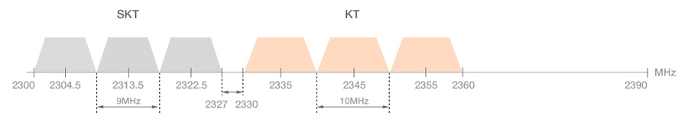
Figure 12: band plan for WiBRO in Korea

List of reference
- http://www.3gpp.org/ftp/specs/archive/36_series/36.211/36211-910.zip
- http://standards.ieee.org/getieee802/download/802.16-2009.pdf
- http://www.wimaxforum.org/technology/downloads/Service_Recs_Tech_Neutrality_-_FDD-TDD_Coexistence.pdf
- http://wimaxforum.org/sites/wimaxforum.org/files/technical_document/2009/07/WMF-T23-007-R010v02_MSP-IMT-2000.pdf
- http://wimaxforum.org/sites/wimaxforum.org/files/technical_document/2009/07/WMF-T23-002-R015v01_MSP-TDD.pdf
- http://www.erodocdb.dk/Docs/doc98/official/pdf/ECCREP131.PDF
- http://www.3gpp.org/ftp/Specs/archive/36_series/36.922/36922-910.zip (§6.4), and TS 36.133 (§7.4)
- ECC PT1(11)103 WiMAX Forum
- ECC PT1(11)113 BYT-FT-TI
- ECC PT1(11)117 Bolloré Telecom
- FORUM ECC PT1 SWGA
- http://www.3gpp.org/ftp/Specs/archive/36_series/36.828/36828-b00.zip
- http://www.3gpp.org/ftp/Specs/archive/36_series/36.413/36413-b00.zip (§9.2.3.34)
- http://www.itu.int/dms_pub/itu-t/oth/06/38/T06380000040006PPTE.ppt
- http://www.3gpp.org/ftp/Specs/archive/37_series/37.104/37104-b10.zip
- http://www.3gpp.org/ftp/Specs/archive/37_series/37.801/37801-a00.zip
- http://www.tellabs.com/info/lte/tlab_sync_wp.pdf
- http://en.wikipedia.org/wiki/Synchronization_networks
- http://en.wikipedia.org/wiki/Crystal_oven
- http://www.chronos.co.uk/files/pdfs/itsf/2011/Day2/1215_Chronos_Charles_Curry.pdf
- http://loran.org/
- http://en.wikipedia.org/wiki/DCF77
- http://en.wikipedia.org/wiki/Radio_clock
- http://www.smallcellforum.org/resources-white-papers
- http://www.loran.org/news/eLoran Definition Document 0 1 Released.pdf
- http://www.ntp.org/
- http://www.eecis.udel.edu/~mills/ntp.html
- "The UMTS Long Term Evolution: From Theory to Practice", M.Baker , S.Sesia, I.Toufik
- “Synchronization and timing in telecommunications”, Kishan Shenoi
- “Synchronization of Digital Telecommunications Networks”, Stefano Bregni
- http://www.nist.gov/el/isd/ieee/ieee1588.cfm
- http://www.ines.zhaw.ch/fileadmin/user_upload/engineering/_Institute_und_Zentren/INES/Downloads/Technology_Update_IEEE1588_v2.pdf
- http://scf.io/en/documents/075_-_Synchronisation_for_LTE_small_cells.php

N.B. those scenarios have also been assessed by white-papers from the Small Cells Forum [24]
Contrary to what this figure suggests, frequency synchronization should not be considered as a subset of phase/time synchronization, but rather complementary: indeed, even though phase/time references such as GNSS may be used even for frequency, some other sources may be a better alternative for frequency reference. Besides, a frequency reference can help increase the time holdover when losing the time reference..
This takes into account the propagation delay in LOS non co-sited cases. Notice that the frame structures do not need to be exactly identical provided this condition is met.
,synchronizationslowly).
Those value are peak-to-peak time error between base stations according to the relevant standards for the air interfaces. One practical way to implement those is to refer to a reference like UTC (e.g. in the case of LTE-TDD, consder +/- 1.5 µs from UTC)
Like for intra-network synchronization, the reference clock does not need to be the same within the whole network, but only needs to differ less than the required accuracy between two neighbor cells

