 |  |  | ECC PT1(17)111
ECC PT1 # 55
Berlin, Germany, 24-28 April 2017
Date issued: | 2017-04-19
Source: | Ericsson, Qualcomm, Huawei
Subject: | Analysis of the suitability of TRP compared to EIRP as a metric for setting AAS requirements
N
Group membership required to read? (Y/N)

Summary:
Considering that AAS will be a fundamental part of 5G/NR and 5G/LTE evolution products, it is crucial to assess the suitability of setting requirements in terms of total radiated power (TRP) rather than EIRP. This contribution provides an analysis of the suitability of TRP compared to EIRP as a metric for setting such requirements.
Proposal:
TRP is the appropriate metric for AAS systems and should be used instead of EIRP to avoid misleading results and reduced protection for co-existing systems.
Background:
Following the recently approved LS response from 3GPP to CEPT PT1 on “Suitability of technical conditions of ECC DEC (11) 06 for 5G” [1], this contribution provides the necessary technical background behind the content of the LS.

Introduction
3GPP recently approved an LS response to CEPT PT1 on “Suitability of technical conditions of ECC DEC (11) 06 for 5G” [1]. In 3GPP RAN4 #82bis held in Spokane, the content of the LS was extensively discussed with focus on the main RF characteristics which differentiate the Next Generation New Radio (NR) from existing LTE services.
RAN4 LS provides the main expected RF characteristics for both Base Station (BS) and User Equipement (UE) operating in C-band. For NR specification in below 6GHz deployments, 3GPP already agreed to reuse LTE RF requirements as much as possible.
In terms of impact to adjacent systems, no major differences are expected between NR and LTE UEs operating in similar frequency ranges. On the downlink (DL) side, for the same total maximum conducted power, adopting larger number of antennas at BS may lead to high values of peak equivalent isotropic radiated power (EIRP), although the total radiated power (TRP) will remain unchanged. In 3GPP, RAN4 technical group thoroughly analysed the impact of large antenna systems in the Active Antenna Systems (AAS) work item. In the Release 15 AAS specification, unwanted emissions will be specified as over-the-air (OTA) rather than as conducted requirement. In particular, the OTA emission limits will be expressed in terms of TRP, rather than EIRP. The motivation behind this choice is related to the fact that the most relevant metric determining the impact to adjacent mobile systems is the total amount of interference which is injected into the network.
In the following sections, we will provide key observations about the different impact of TRP and EIRP requirements, and we will also clarify the key differences between non-AAS and AAS. The goal of this contribution is to provide the necessary technical background behind the content of the LS agreed in 3GPP.

Active Antenna Systems
It is envisioned that 5G/NR and 5G/LTE evolution will support several multi-antenna transmission techniques and will strive for efficient antenna building solutions. One essential need in this context is the use of Active Antenna Systems (AAS) and the ability to access multiple antenna elements.
For instance, this can be realized by mapping a set of antenna ports into a physical antenna, where each antenna port consists of a certain number of antenna elements. Consequently, signals from the different antenna ports are added coherently at the receiver side to form a beam pointing in the direction of the receiver. The antenna diagram and beam characteristics will be dependent on the chosen antenna implementation, number of antenna ports, antenna elements, etc… The transmitter will in turn be able to direct the energy to different directions (i.e. following the positions of the served receivers).

Current requirements
Existing CEPT rules are derived from 3GPP specification 37.104, where unwanted emission requirements are applied per antenna connector. The antenna connector would most likely be connected to a passive antenna array, meaning that the resulting antenna gain is fairly invariant (between different implementations and between wanted and unwanted signals). Hence, using EIRP as a metric for setting requirements was considered to be suitable (as a substitute for TRP), given the passive nature of the antenna array.

Requirements for AAS
On the other hand, in the context of AAS, different antenna implementations may lead to different Total radiated powers (TRPs) and different beam patterns, even when meeting the same EIRP limit as shown in Figure 1 [3]. Note that even for the same antenna implementation, the wanted signal and the unwanted signal may have different beam shapes.

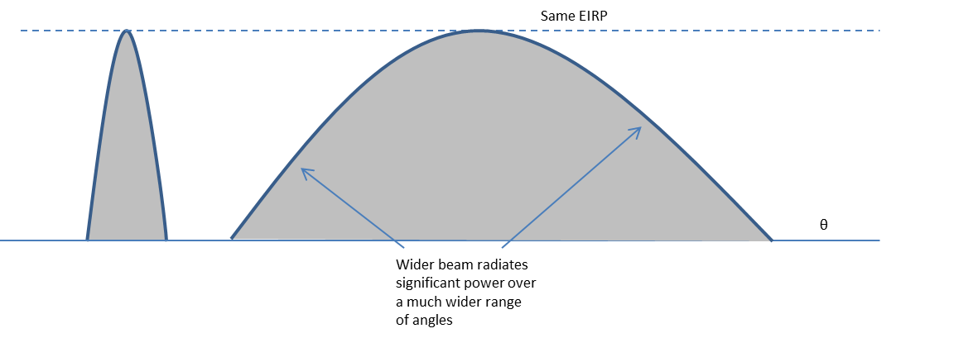
Figure 1: Exaggerated example showing dispersed and concentrated spatial radiation of unwanted emissions
The level of correlation of the unwanted emissions coming from the different AAS transmitters depends on the actual BS implementation. Previous 3GPP studies [2], have investigated the impact of correlation of adjacent channel unwanted emissions on the performance of a victim system by simulating the cases with 0%, 50% and 100% correlation.
With the simulation assumptions used for the studies, 100% correlation implies that the unwanted emissions are beam-formed in the same manner as the wanted signal. Such correlation is very unlikely, but was included in the study for completeness. 0% correlation implies that the unwanted emissions are not beam-formed but are radiated with the individual antenna element pattern.
The results of these studies showed that in all cases, the level of correlation (and hence the spatial pattern of the emissions) does not impact the co-existence performance. In other words, different BS implementations may lead to the same impact on a given victim system, meaning that limiting the BS implementation would not bring any benefit to the victim system and would only lead to less flexible and less efficient antenna solutions. Hence, the requirements should be independent of the correlation level of the unwanted emissions.
In addition, as highlighted in the LS [1], the Total Radiated unwanted emission Power is directly proportional to the victim network throughput degradation, meaning that setting the requirements in terms of Total Radiated Power (TRP) would directly translate into limiting the level of throughput degradation in the victim network to a desired level. On the other hand, setting the requirements for AAS in terms of EIRP would lead to misleading results and potentially reduced protection for co-existing systems [3]. It was therefore suggested in [3] to apply TRP as a metric for unwanted emissions for AAS systems instead of EIRP.

Total radiated power
In this section, we further focus on the rationale behind the agreement in 3GPP that the correct requirement metric is TRP The general principles described below are valid for both in-band and out-of-band/unwanted emissions.
The relationship between the TRP and EIRP is directly related to the number of radiating antennas and depends also on specific base station implementation. In other words, specifying an EIRP limit could results in different levels of total radiated power depending on implementations. Just as an example, considering two systems achieving same EIRP, but deploying different number of radiating elements, i.e. different total antenna gain. By defining an EIRP limit, the system with lower antenna gain could meet emission requirements by injecting higher level of interference into the network (the exaggerated example depicted on the right hand side of Figure 1).
The example above shows how specifying an EIRP requirement will not allow to guarantee a control of the total amount of interference in the network. On the other hand, a TRP requirement will limit the total amount of interference injected in the network regardless the specific BS implementation. For the same level of TRP, BS with higher antenna gains will have higher directivity, thus higher spatial control of the radiating interference, while the total amount of injected interference will be the same compared to a BS deploying lower number of antenna elements.
Finally, another relevant element behind 3GPP choice of defining unwanted emission with a TRP metric is the different behaviour between passive and active antenna systems. In case of passive systems, the antenna gain does not vary much between the wanted signal and unwanted emissions. Thus EIRP is directly proportional to TRP and can be used as a substitute. For active systems, the EIRP could vary wildly between wanted signal and emisisons and between implementations, so EIRP is not proportional to TRP and using EIRP to substitute TRP would be incorrect.
The observations above provide a justification of why 3GPP recommended to adopt TRP limits for unwanted emissions. As a minor note, it is worth noticing that a TRP requirement would also correspond to the conducted requirement in case of an ideal system with perfect matching and no antenna losses.

Conclusion
Considering that AAS will be a fundamental part of 5G/NR and 5G/LTE evolution products, it is crucial to assess the suitability of setting requirements in terms of total radiated power (TRP) rather than EIRP. This contribution provides an analysis of the suitability of TRP compared to EIRP as a metric for setting such requirements.
Based on the presented references, if the OTA unwanted emissions are based on total radiated emissions around the base station, the co-existence performance provided by the OTA unwanted emissions requirements will be the same as with the requirements of today. On the other hand, if the requirements are based on directional emissions power (EIRP), the level of co-existence protection would be variable depending on the spatial pattern of the unwanted emissions and the amount of correlation in unwanted emissions between transmitters, which would be variable and probably implementation dependent.
Hence, TRP is the appropriate metric for AAS systems and should be used instead of EIRP to avoid misleading results and reduced protection for co-existing systems.

References
- R4-1704402, “LS on Suitability of technical conditions of ECC DEC (11) 06 for 5G”.
- R4-165899, “On modelling the spatial shape of ACLR”, Ericsson, 3GPP TSG-RAN WG4 #80
- R4-165896, “Metric for unwanted emissions and ACLR”, Ericsson, 3GPP TSG-RAN WG4 #80

Active Antenna Systems refer to systems for which antenna and radio transmitters are designed together such that MIMO and beamforming is optimised.

