ECC PT1 |  | ECC PT1(18) C-Band SYNCH CG I-7
ECC PT1 Correspondence Group “Toolbox on 3400-3800 5G synchronization framework”

Copenhagen, Denmark, 25,26 June 2018
Date issued: | 22nd June 2018
Source: | Huawei Technologies
Subject: | 5G NR Frames assessment
Group membership required to read? (Y/N)
N
Summary:
This contribution provides an assessment in terms of latency and capacity performance for 3 possible frame structure for 5G NR.

.
Proposal:
Adopt the material for inclusion in section 4.2.1 of the draft ECC “C-band synch toolbox” Report.

Background:

ECC PT1 is developing an ECC Report on toolbox for the most appropriate synchronisation regulatory framework including coexistence of MFCN in 3400-3800 in unsynchronised and semi-synchronised mode.

Technology backgrounD

LTE frame structure and options

5G NR frame structure and options

Assessment of the 5G NR frame structure options
The following sections provide an assessment in terms of latency and capacity performance for the three frame structures provided in Figure 1.
Figure 1: NR frame structures for evaluation – slot level.
Differently from LTE, 5G NR allows for the assignment of DL and UL transmission directions at OFDM symbol level (in LTE TDD the UL/DL assignment is done at subframe level), the assessment therefore depends on the specific choices at OFDM symbol level which are illustrated in Figure 2.

Figure 2: NR frame structures for evaluation – OFDM symbol level.

Latency assessment
According to Report ITU-R M.2410 [2], user plane latency is the contribution of the radio network to the time from when the source sends a packet to when the destination receives it (in ms). It is defined as the one-way time it takes to successfully deliver an application layer packet/message from the radio protocol layer 2/3 SDU ingress point to the radio protocol layer 2/3 SDU egress point of the radio interface in either uplink or downlink in the network for a given service in unloaded conditions, assuming the mobile station is in the active state.
Based on the definition and the evaluation method provided in Report ITU-R M.2412 [3], the components of user plane latency are listed in Table 1.
Table 1: Components of UP latency
ID | Component | Notations
1 | UE processing delay | t_{UE}=t_{UE,rx} + t_{UE,tx}  For DL: t_{UE,rx} is the time interval between the PDSCH is received and the data is decoded; t_{UE,tx} is the time interval between the data is decoded, and ACK/NACK packet is generated.  For UL: t_{UE,tx} is the time interval between the data is arrived, and packet is generated; t_{UE,rx} is the time interval between the ACK is received and the ACK is decoded.
2 | Frame alignment (transmission alignment) | t_{FA,DL} or t_{FA,UL}  It includes the waiting time (e.g., in TDD, data transmission needs to wait for the next available DL/UL non-slot/slot)
3 | TTI for data packet transmission | t_{data_duration}
4 | HARQ retransmission | t_{HARQ}
5 | BS processing delay | t_{BS}=t_{BS,rx} + t_{BS,tx}  For UL: t_{BS,rx} is the time interval between the PUSCH is received and the data is decoded; t_{BS,tx} is the time interval between the data is decoded, and ACK/NACK packet is generated.  For DL: t_{BS,tx} is the time interval between the data is arrived, and packet is generated; t_{BS,rx} is the time interval between the ACK is received and the ACK is decoded.
- | Total one way user plane latency for DL | t_{UP}= (t_{BS,tx} + t_{FA,DL}) + t_{data_duration} + t_{UE,rx} + n×t_{HARQ}  where t_{HARQ} = (t_{UE,tx} + t_{FA,UL}) + t_{data_duration} + t_{BS,rx} + (t_{BS,tx} + t_{FA,DL}) + t_{data_duration} + t_{UE,rx}, and n is the number of re-transmissions (n≥0)
 | Total one way user plane latency for UL | t_{UP}= (t_{UE,tx} + t_{FA,UL}) + t_{data_duration} + t_{BS,rx} + n×t_{HARQ}  where t_{HARQ} = (t_{BS,tx} + t_{FA,DL}) + t_{data_duration} + t_{UE,rx} + (t_{UE,tx} + t_{FA,UL}) + t_{data_duration} + t_{BS,rx}, and n is the number of re-transmissions (n≥0)

The role of the described components in a BS-to-UE data transmission procedure is further illustrated in Figure 3.
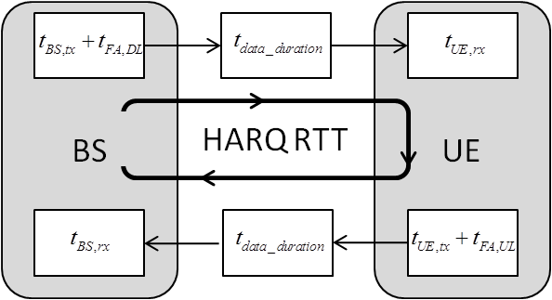
Figure 3: illustration of User Plane latency components.
It is noted that the values of the above components depend on the frame structure and numerology, UE capability on processing, as well as PDSCH/PUSCH mapping type. These impact factors are further subject to duplexing schemes like FDD, TDD and TDD+SUL (Supplemental Up Link).
The UE processing time, t_{UE}, has been agreed in 3GPP RAN1#90bis, known as “UE capability 1” (PDSCH processing capability 1). For different numerologies, the value of t_{UE} is expressed in terms of OFDM symbols (OS), say K OS, as listed in Table 2 (see section 5.3 in [4]).
Table 2: UE processing time (PDSCH processing capability 1).
µ_{DL} | Sub-carrier spacing | PDSCH decoding time N₁ [symbols]
µ_{DL} | Sub-carrier spacing | No additional PDSCH DM-RS configured | Additional PDSCH DM-RS configured
0 | 15 kHz | 8 | 13
1 | 30 kHz | 10 | 13
2 | 60 kHz | 17 | 20
3 | 120 kHz | 20 | 24

BS processing time (t_{BS}) is assumed to be the same as that of UE’s. For this evaluation, it is further assumed that the two parts of t_{UE} and t_{BS}, that is, t_{X,rx} and t_{X,tx}, are equal. Based on these assumptions, one has
t_{BS,rx} = t_{BS,tx} = t_{UE,rx} = t_{UE,tx} = K/2
If the number of OFDM symbols per TTI is M, then t_{data_duration}=M. Taking FDD as an example, the average user plane latency is calculated as below,
where p is the error probability of the first HARQ retransmission. Note that in the evaluation, grant free based UL transmission is considered in order to derive the lower bound of user plane latency performance.
For TDD, the extra frame alignment delay for both DL and UL, t_{FA,DL} and t_{FA,UL}, might be larger than 0 due to the DL/UL configuration (the time needed to wait for the next available DL/UL TTI).
The following assumptions were made as basis for this evaluation :
- The UE processing time is determined with the assumption of UE capability 1 and no additional DMRS configured.
- PDSCH/PUSCH mapping Type B is employed, which is more flexible to support non-slot based scheduling.
- Additionally, the packet is assumed to be arrived randomly in any symbol in any slot.
Based on the above assumption, the average latencies for DL and UL for different frame structures are illustrated in Table 3 and Table 4.
Due to the shorter DL/UL switching period, the user plane latency and round-trip time (RTT) of DSDU frame is lower in most cases.
The user plane latency and RTT associated with DDDSU and DDDDDDDSUU frames can be further reduced by using lower frequencies (e.g. 700MHz, 800MHz, 900MHz, 1800MHz) in combination with the 3400-3800 MHz band (e.g. through Carrier Aggregation or Supplemental Uplink schemes). The resulting RTT will meet the most stringent latency requirement for URLLC and eMBB simultaneously.
Table 3: DL latency evaluation results for NR frame structures (SCS = 30 kHz).
Slot / non-slot based scheduling | Latency |  | Frame structure ( GP: 2 OS)
Slot / non-slot based scheduling |  |  | DDDSU | DDDDD  DDSUU | DSDU | DDDSU  + SUL | DDDDD  DDSUU  + SUL
2OS non-slot based scheduling | User plane latency (ms) | p=0 | 0.53 | 0.57 | 0.52 | 0.53 | 0.57
2OS non-slot based scheduling | User plane latency (ms) | p=0.1 | 0.71 | 0.88 | 0.63 | 0.60 | 0.66
2OS non-slot based scheduling | RTT (ms) |  | 1.77 | 3.02 | 1.12 | 0.78 | 0.82
slot-based scheduling | User plane latency (ms) | p=0 | 0.87 | 0.93 | 0.90 | 0.87 | 0.92
slot-based scheduling | User plane latency (ms) | p=0.1 | 1.07 | 1.25 | 1.04 | 0.99 | 1.04
slot-based scheduling | RTT (ms) |  | 1.98 | 3.24 | 1.42 | 1.12 | 1.17

Table 4: UL latency evaluation results for NR frame structures (SCS = 30 kHz).
Slot / non-slot based scheduling | Latency |  | Frame structure ( GP: 2 OFDM symbols)
Slot / non-slot based scheduling |  |  | DDDSU | DDDDD  DDSUU | DSDU | DDDSU  + SUL | DDDDD  DDSUU  + SUL
Non-slot based scheduling | User plane latency (ms) | p=0 | 1.22 | 2.01 | 0.78 | 0.49 | 0.50
Non-slot based scheduling | User plane latency (ms) | p=0.1 | 1.39 | 2.30 | 0.88 | 0.58 | 0.58
Non-slot based scheduling | RTT (ms) |  | 1.71 | 2.95 | 1.05 | 0.82 | 0.86
Slot-based scheduling | User plane latency (ms) | p=0 | 1.61 | 2.40 | 1.46 | 0.92 | 0.92
Slot-based scheduling | User plane latency (ms) | p=0.1 | 1.80 | 2.72 | 1.62 | 1.06 | 1.08
Slot-based scheduling | RTT (ms) |  | 1.90 | 3.14 | 1.69 | 1.43 | 1.59

Capacity assessment
The following aspects have an impact on the 5G NR frame structure performance in terms of system capacity:
- Guard Period (GP) overhead:
GP is introduced at the downlink/uplink switching point. Frequent DL/UL switching will introduce larger GP overhead, which determines system capacity reduction;
- UL slot availability:
The UL slot availability affects the Channel State Information (CSI) feedback and ACK/NACK feedback delay. The more frequent availability of UL subframes will reduce the CSI and ACK/NACK feedback delays. The reduced CSI feedback delay is beneficial for system capacity for fast varying channels. The reduced ACK/NACK feedback delay is beneficial for reducing RTT delay, and increasing user perceived throughput in some cases;
- DL and UL ratio:
The DL and UL ratio associate with a certain frame structure should be consistent with the DL and UL traffic pattern. Otherwise, the DL or UL system capacity will be degraded.
Considering the above aspects, it is observed that the DSDU frame structure performance benefits from fast CSI measurement and feedback, however the frequent downlink and uplink switching that characterizes this frame structure brings about the extra overhead.
On the other hand, the DDDSU and DDDDDDDSUU frame structures may suffer from a relatively slower CSI feedback, yet benefiting from reduced GP transmission overhead.
Taking into account the channel varying nature that depends on the device moving speed distribution (in current evaluation assumption we have 80% indoor users with 3km/h and 20% outdoor users with larger moving speed), the tradeoff of the CSI feedback and the overhead introduced by DL/UL switching point need to be carefully evaluated for different candidate frame structures. In this context, the spectral efficiency and the user-perceived throughput (UPT) are evaluated for the frame structure DDDDDDDSUU, DDDSU, and DSDU. The detailed evaluation assumption is illustrated in section providing the assumptions for this analysis.
Based on the evaluation assumptions listed in Table 5, the total overhead for the different frame structures are provided in Table 6. In Table 6, DSDU has the highest overhead resulted due to the increased CSI-RS and GP overhead for the fast CSI measurement and DL/UL switching. As the length of GP increases from 2 to 4 OFDM symbols, the difference in the total overhead for the DSDU frame and for the DDDSU frame will be further increased. The DDDSU frame structure provides good balance for overhead and CSI acquisition.

Table 5: assumptions for overhead calculations for different frame structures.
Overhead assumption | DDDSU | DDDDD  DDSUU | DSDU
PDCCH | 2 complete symbols in the downlink dominant slot | 2 complete symbols in the downlink dominant slot | 2 complete symbols in the downlink dominant slot; 1 complete symbol in the uplink dominant slot
DMRS | Type II DMRS, dynamic calculation according to paired layer number | Type II DMRS, dynamic calculation according to paired layer number | Type II DMRS, dynamic calculation according to paired layer number
CSI-RS | 4 ports per UE with 5 slots period;  40 REs/PRB for 10 users | 4 ports per UE with 10 slots period;  40 REs/PRB for 10 UEs | 4 ports per UE with 4 slots period;  40 REs/PRB for 10 UEs
SSB | 8 SSBs per 20 ms | 8 SSBs per 20 ms | 8 SSBs per 20 ms
TRS | 2 burst consecutive slots per 20 ms, bandwidth with 51 PRBs | 2 burst consecutive slots per 20 ms, bandwidth with 51 PRBs | 2 burst consecutive slots per 20 ms, bandwidth with 51 PRBs
GP | 2/4 symbols | 2/4 symbols | 2/4 symbols

Table 6: overhead calculation for different frame structures.
Overhead | GP (2 symbols) |  |  | GP (4 symbols)
Overhead | DDDSU | DDDDD  DDSUU | DSDU | DDDSU | DDDDD  DDSUU | DSDU
PDCCH | 0.15 | 0.15 | 0.16 | 0.15 | 0.15 | 0.16
DMRS | 0.10 | 0.10 | 0.09 | 0.10 | 0.10 | 0.09
CSI-RS | 0.06 | 0.03 | 0.08 | 0.06 | 0.03 | 0.08
SSB | 0.03 | 0.03 | 0.03 | 0.03 | 0.03 | 0.03
TRS | 0.002 | 0.002 | 0.002 | 0.002 | 0.002 | 0.002
GP | 0.04 | 0.02 | 0.09 | 0.07 | 0.04 | 0.19
Total overhead | 0.38 | 0.33 | 0.46 | 0.41 | 0.35 | 0.55

For spectrum efficiency evaluation, the performance under downlink full buffer traffic with different moving speeds is illustrated in Figure 4 and Figure 5. It should be noted that the moving speeds indicated in Figure 4 and Figure 5 apply to 20% outdoor users, and the moving speed of 80% indoor users is kept to 3 km/h.
According to Figure 4 and Figure 5, the cell average spectrum efficiency for DDDSU and DDDDDDDSUU are comparable. The DDDDDDDSUU frame structure can attain higher cell average spectrum efficiency and cell-edge spectrum efficiency due to the lower overhead, for the low speed scenario in particular.
When the speed of outdoor users is 10 km/h, the cell average and cell-edge spectrum efficiency can achieve 15% and 23% gain for DDDDDDSUU vs. DSDU, respectively. This is resulted by the slow channel variation due to the low speed users and in this case, the fast CSI measurement and feedback cannot bring significant gain.

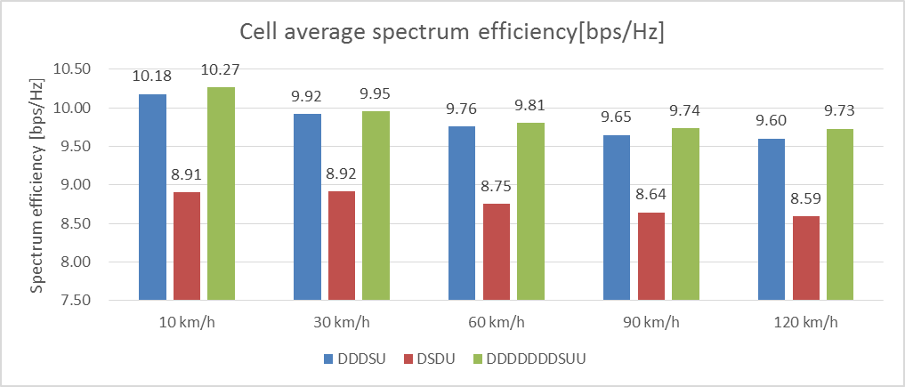
Figure 4: Spectrum efficiency with different speeds - cell average spectrum efficiency.
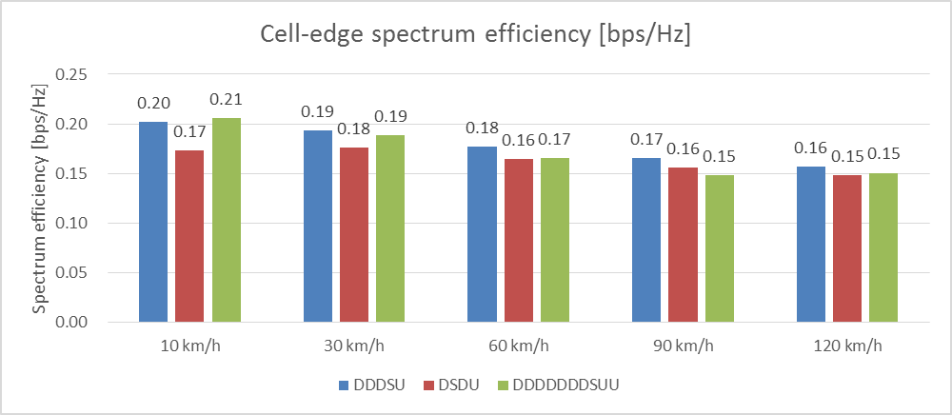
Figure 5: Spectrum efficiency with different speeds - cell-edge spectrum efficiency.

The assessment of the User Perceived Throughput (UPT) is provided for downlink burst traffic. It is noted that UPT in this evaluation is defined on the basis of a data packet, i.e., UPT = (packet size) / (time to complete the transmission of this packet). Therefore the UPT performance statistic is conducted per data packet basis, which offers the assessment on data packet throughput distribution.
In Figure 6, Figure 7, Figure 8 and Figure 9 the UPT performance with different arrival rates is illustrated to evaluate the performance under different traffic loads.
In the evaluation, the speed of the 20% outdoor users is assumed to be 30 km/h and the 80% indoor users again keep the moving speed of 3km/h.
With the good balance of overhead and feedback delay, DDDSU frame structure has the best performance in most cases and the gain compared to DSDU can be achieved by more than 10%. Due to the lower overhead, the frame structure DDDDDDDSUU also can obtain gain for average UPT and 95% UPT (up to 20% gain), where re-transmission is less needed.
For 5% UPT, it is observed that DSDU has around 5% gain over DDDDDDDSUU. This is due to the fact that these poor packets are usually transmitted via re-transmissions. In this case, the RTT delay is a major factor that impacts UPT, and DSDU can outperform by reduced RTT delay. However, the gain is not significant after the trade-off with the GP overhead is taken into account.
Besides, if the lower frequency bands are used in combination (e.g. Carrier Aggregation and Supplemental UplLink scehmes) with the 3400-3800 MHz band with DDDDDDDSUU, the RTT delay will be significantly reduced based on the analysis in section 4.2.1.1, and the performance will be improved for 5% UPT in case of SUL.

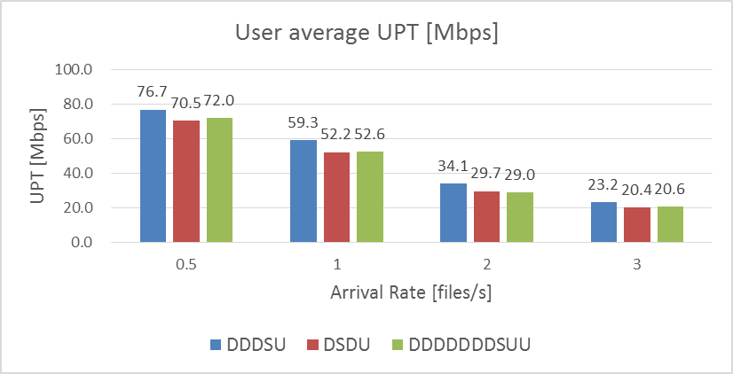
Figure 6: UPT with different arrival rates in burst traffic - user average UPT

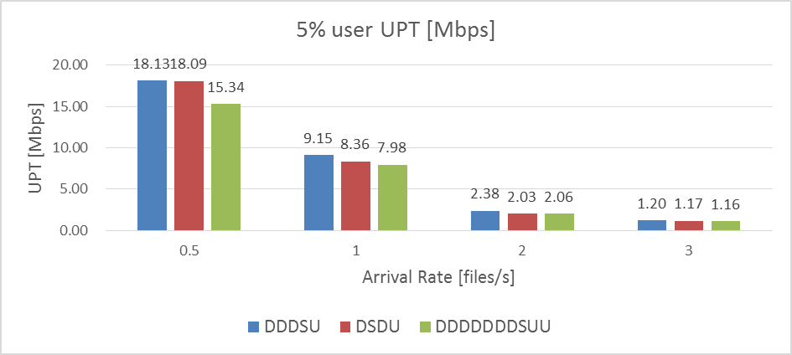
Figure 7: UPT with different arrival rates in burst traffic - 5% UPT

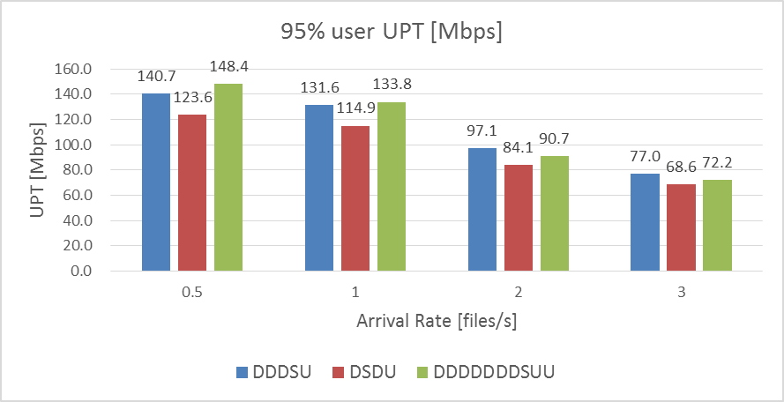
Figure 8: UPT with different arrival rates in burst traffic - 95% UPT
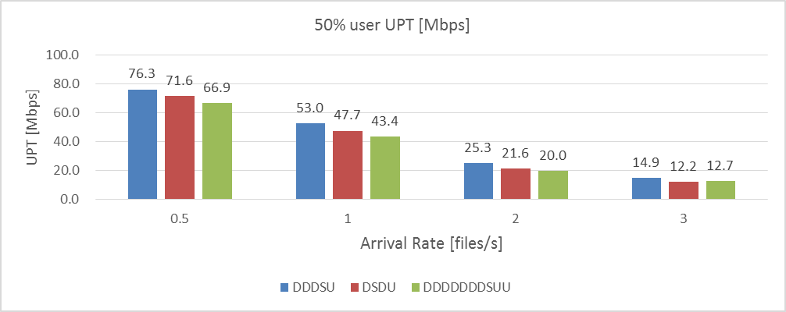
Figure 9: UPT with different arrival rates in burst traffic - 50% UPT

Based on the above evaluation for latency and capacity, it demonstrates that the frame structures of DDDSU and DDDDDDDSUU can introduce good system capacity and high user perceived throughput, and by the use of SUL together, DDDDDDDSUU could further reduce the latency and boost the lower part of user perceived throughput.

References
[1] ECC PT1 (18) 075, “Impact of 5G NR adopting an LTE TDD compatible frame structure”, Qualcomm, Prague, Czech Republic, April 2018.
[2] Report ITU-R M.2410, “Minimum requirements related to technical performance for IMT-2020 radio interface(s)”, Nov. 2017.
[3] Report ITU-R M.2412, “Guidelines for evaluation of radio interface technologies for IMT-2020”, Nov. 2017.
[4] 3GPP TS 38.214 V15.0.0, “NR; Physical layer procedures for data (Release 15)”, December, 2017.

Assumptions
The system configuration parameters for the Marco Urban test environment are illustrated in Table A-1 and the technical parameters are illustrated in Table A-2.
Table A-1: simulation parameters for Macro Urban test environment.
System configuration parameters | Values
Test environment | Macro Urban
Carrier frequency | 3.5GHz (1 macro layer)
BS antenna height | 20m
Total transmit power per TRxP | 46 dBm
UE power class | 23 dBm
Inter-site distance | 500 m
User distribution | Indoor: 80%  Outdoor: 20%
UE speeds of interest | Indoor users: 3 km/h  Outdoor users: 10/30/60/90/120 km/h
Inter-site interference modelling | Explicitly modelled
BS noise figure | 5 dB
UE noise figure | 9 dB
BS antenna element gain | 8 dBi
UE antenna element gain | 0 dBi
Thermal noise level | -174 dBm/Hz
Traffic model | Full buffer;  Burst buffer: file size 0.5 Mbytes, arrival rate 0.5/1/2/3
UE density | 10 UEs per TRxP
UE antenna height | Outdoor UEs: 1.5 m  Indoor UTs: 3(nfl – 1) + 1.5;  nfl ~ uniform(1,Nfl) where  Nfl ~ uniform(4,8)
Channel model variant | Channel model A (follow TR36.873)
TRP number per site | 3
Mechanic tilt | 90 degree in GCS (pointing to horizontal direction)
Electronic tilt | 100 degree
Handover margin (dB) | 1
UT attachment | Based on RSRP from port 0
Wrapping around method | Geographical distance based wrapping
Minimum distance of TRxP and UE | Follow corresponding channel model variant
Polarized antenna model | Model-2 in TR 36.873
frequency reuse | 1
Antenna pattern | Follow TR 36.873
Below rooftop base station antenna deployment | 0%
Indoor user terminal penetration loss | Follow channel model A in TR 36.873

Table A-2: technical configuration parameters.
Technical configuration Parameters |  | Values
Waveform |  | OFDM-based
Multiple access |  | OFDMA
Duplexing |  | TDD
Network synchronization |  | Synchronized
Modulation |  | Up to 256 QAM
Numerology |  | 30kHz SCS
Guard band ratio on simulation bandwidth |  | 8.2% (for 20 MHz)
Simulation bandwidth |  | 20 MHz (51 PRBs)
Frame structure |  | DDDSU, DDDDDDDSUU, DSDU
Transmission scheme |  | Closed SU/MU-MIMO adaptation
DL CSI measurement |  | Precoded CSI-RS based, non-PMI
DL codebook |  | N/A
MU dimension |  | Up to 12 layers
SU dimension |  | Up to 4 layers
SRS transmission |  | Non-precoded SRS, 4 Tx ports,  8 PRBs per symbol,  2 symbols per 10 slots for DDDDDDDSUU,  2 symbols per 5 slots for DDDSU,  2 symbols per 4 slots for DSDU
CSI feedback |  | CQI/RI feedback every 10 slots for DDDDDDDSUU,  CQI/RI feedback every 5 slots for DDDSU,  CQI/RI feedback every 4 slots for DSDU,  Non-PMI feedback, Sub-band based
Interference measurement |  | SU-CQI
Max CBG number |  | 1
ACK/NACK delay |  | N+1
Re-transmission delay |  | the next available DL slot after receiving NACK
Antenna configuration at TRxP |  | 32 TxRU, (8,8,2,1,1;2,8),  (dH, dV)=(0.5, 0.8)λ,  Vertical 1 to 4.
Antenna configuration at UE |  | 4 TXRU, (1,2,2,1,1; 1,2)  (dH, dV)=(0.5, N/A)λ
Scheduling |  | PF
Receiver |  | MMSE-IRC
Channel estimation |  | Non-ideal
Overhead | PDCCH | 2 symbols
Overhead | SSB | 8 SSB / 20ms
Overhead | CSI-RS | DDDDDDDSUU: 4 ports per UE with 10 slots period (UE-specific beamformed CSI-RS);  DDDSU: 4 ports per UE with 5 slots period (UE-specific beamformed CSI-RS);  DSDU: 4 ports per UE with 4 slots period (UE-specific beamformed CSI-RS);  40 REs/PRB for 10 users per cell
Overhead | DMRS | Type II, up to 12 ports
Overhead | TRS | 2 burst consecutive slots per 20 ms, bandwidth 51 PRBs
Overhead | GP | 2 symbols

Compatibility with LTE Frame structure
With reference with the synchronized operation of 5G NR based stations and LTE base stations, the 5G NR DDDDDDDSUU frame structure with 30 kHz subcarrier spacing (SCS) can be aligned to LTE DSUDD frame structure with 15 kHz SCS.
Figure 10: synchronized operation of 5G NR (DDDDDDDSUU) and LTE (DSUDDDSUDD frame).

5G NR characteristics when using a frame structure compatible with LTE frame structure
The performance of the DDDDDDDSUU 5G NR relatively to other 5G NR frame structures is assessed in section 4.2.1.

