Performance impacts from frame structure selection
One of the main scenarios for the rollout of 5G will be based on the 5G-NR air interface and on Macro BSs implementing AAS technology in a multi-operator environment. The unsynchronised operation in such scenario would pose additional challenges compared to the existing TDD uses in the 3500 MHz or 2600 MHz which:
- Were mostly based on Macro non-AAS BSs (see Section 2.2.2), where unsynchronised operation with guard band and custom filters was feasible cost-effectively;
- Were often involving one operator per geographic region with limited inter-operator synchronisation issues;
- Were mostly based either on WiMAX or LTE-TDD.
Inter-technology synchronised operation between WiMAX and LTE-TDD has been achieved in a number of cases by adopting the “WiMAX compatible” LTE-TDD frame structure without significant performance loss for LTE-TDD (see ECC Report 216 Section 2.3.2). However, synchronised operation between WiMAX / LTE-TDD and 5G-NR may imply a cost in terms of performance with regards to 5G latency targets especially.
This Section focusses on the implications associated with the selection of a compatible frame structure in a 5G-NR multi-operator context. There may also be a need to ensure coexistence with LTE-TDD base stations for some Administrations. This Section summarises the results from two performance assessments (see the full studies in ANNEX 3:) between three possible examples of 5G-NR frames (“DDDSU”, “DSDU” and “DDDDDDDSUU”). Other 5G-NR frame structures can be considered for selection, although the performance has not been assessed in this Report, such as: "DDSU", "DDSUU", "DDDSUUDDDD" or combinations like "DDDSUDDSUU".

General information about 5G-NR frame structure
Compared to LTE-TDD, 5G-NR allows significantly more flexibility in the frame structure with the ability to configure uplink / downlink / mixed transmission at the symbol level. This is necessary for some solutions to fulfil IMT-2020 compliance on URLLC latency.
This Section provides a brief description for the 5G-NR frame structures while Sections A3.1 and section A3.2 include more details on LTE-TDD and 5G-NR frame structures respectively.
5G-NR downlink and uplink transmissions are organised into frames with 10ms duration, each consisting of ten sub-frames of 1ms duration. The number of consecutive OFDM symbols per sub-frame is given by:
Each frame is divided into two equally-sized half-frames of five sub-frames each with half-frame 0 consisting of sub-frames 0 – 4 and half-frame 1 consisting of sub-frames 5 – 9. The UL or DL transmissions are configured within each slot. With reference to the transmission directions, OFDM symbols in a slot can be classified as 'downlink' (denoted 'D'), 'flexible' (denoted 'X'), or 'uplink' (denoted 'U') see ANNEX 3:.

Performance impacts of 5G-NR frame structures
The frame structure selection has an impact on several aspects of network performance, including:
- DL / UL traffic ratio;
- Spectrum utilisation efficiency;
- Round-trip time (RTT) latency;
- Coverage (DL synch. coverage and UL coverage).
As described below, there are links between the aspects that are listed above. The selection of a certain frame structure will improve performance in some aspects whilst reducing it in others. The selection of a certain frame structure therefore aims at reaching the most appropriate performance trade-off for the specific operator's needs and targets in terms of services to the end users.

The frame structure determines a specific DL / UL ratio: the frame structure selection shall therefore carefully account for the expected traffic patterns. The DL / UL ratio typically relates to the traffic generated by the services proposed by the operator and therefore can be linked to the business model of the operator.
The more frequent the DL / UL and UL / DL switching, the lower the RTT is. A short latency improves the channel estimation quality (CQI feedback) using TDD channel reciprocity properties and also enables fast HARQ retransmissions. More frequent switching therefore has a positive impact on spectrum efficiency in high mobility conditions. On the other hand, considering that guard periods (GP) are required at each DL / UL switch, more frequent switching increases the GP overhead which can have a negative impact on spectrum efficiency.
The frame structure impacts coverage performance. The guard period (GP) between downlink and uplink must be large enough to compensate the propagation delay for large cells (and for coexistence with other cells in line of sight). Larger guard periods can reduce spectrum efficiency. If a TDD cell can interfere with another cell up to 60km away in co-channel, then this means that the GP may need to be larger than 200µs.
As illustrated in Figure 7, different frame structures correspond to different trade-offs relatively to key performance aspects. Operators in different markets will assess the behaviour of the key network characteristics associated with the different frame structure options in order to decide the most appropriate frame structure for their own networks and when discussing the options for a compatible frame structure with other operators. Operators owning other MFCN frequency bands (e.g. 700, 800, 900, 1800 MHz or mmWave) will have the possibility to use jointly such frequencies with the 3400-3800 MHz band through the Carrier Aggregation or Supplemental Uplink schemes. Such combined use will provide additional ways to meet the target network characteristics. The terminals supporting the CA/SUL schemes will require to support for another band in addition to the C-band.

Carrier Aggregation (CA) is a technique that aggregates various component bands into an overall wider bandwidth. Supplementary Up Link (SUL) makes it possible to use another frequency carrier for NR UL transmission instead of NR's dedicated UL carrier in a switchable manner. SUL is similar to CA, however, unlike CA concept, simultaneous data transmissions are not possible in SUL carrier and NR UL carrier it is linked to. Additionally, there is no possibility for precise estimation of the UL channel [path loss / response] used for the other carrier.

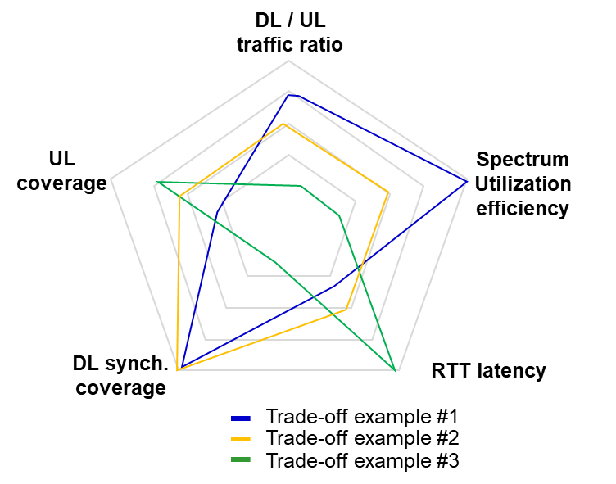
Figure 7: Factors for frame structure selection
All of those effects have been studied in order to quantify them, and the detailed studies are in ANNEX 3:.

Compatibility of 5G-NR frame with LTE-TDD frame structure

With reference to the synchronised operation of 5G-NR BSs and LTE-TDD BSs, noting that every LTE-TDD frame configuration has at least one compatible 5G-NR equivalent configuration, the 5G-NR TDD pattern should be based on the following sequence of DL, UL and special slots: "DDDSUUDDDD". Two example variants may be considered:
- Variant 1: LTE-TDD and 5G-NR have an aligned frame start, i.e. "DDDSUUDDDD".
- Variant 2: non-zero frame start offset between LTE-TDD and 5G-NR, e.g. “DDDDDDDSUU”.
These variants, with 30 kHz subcarrier spacing (SCS) can be aligned to LTE-TDD “DSUDD” frame structure with 15 kHz SCS (LTE-TDD frame configuration #2).
It is to be noted that there should also be a compatible structure for the symbols within the LTE-TDD "S" subframe.

For the studies considered in this Report, the “DDDDDDDSUU” frame configuration is used to represent the performance that 5G-NR would have in case of synchronised operation with a neighbour LTE-TDD network. in the same band and in the same area using LTE-TDD frame configuration #2. Note that similar results apply in case the non-shifted variant, i.e. "DDDSUUDDDD", is used.
----------------------------
SESSION 4 has reached this point ------------------

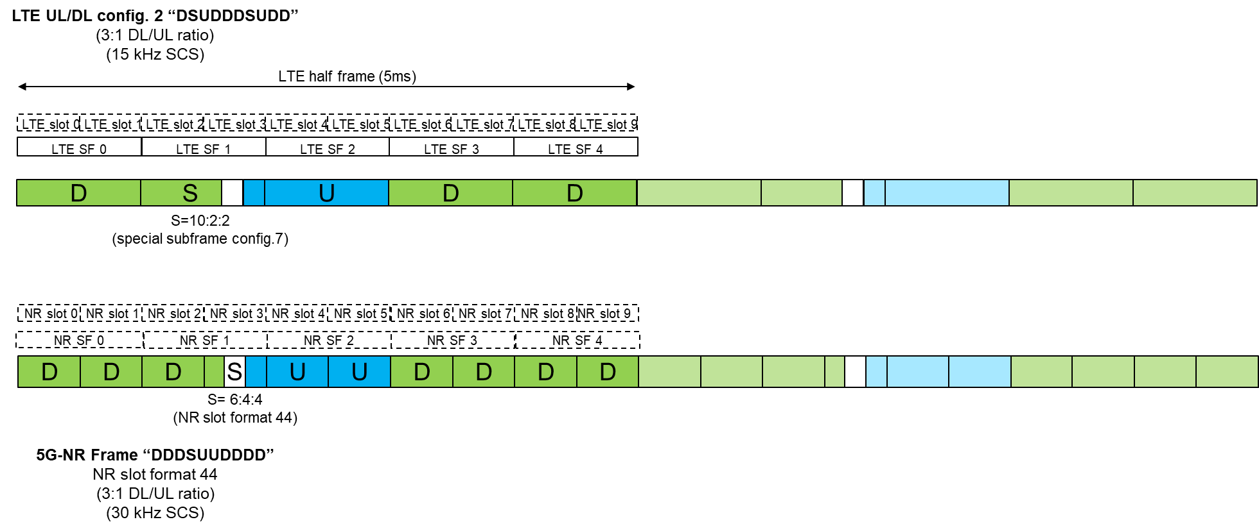 Figure 8: Variant 1: synchronised operation of 5G-NR ("DDDSUUDDDD" frame) and LTE-TDD (“DSUDD” frame)

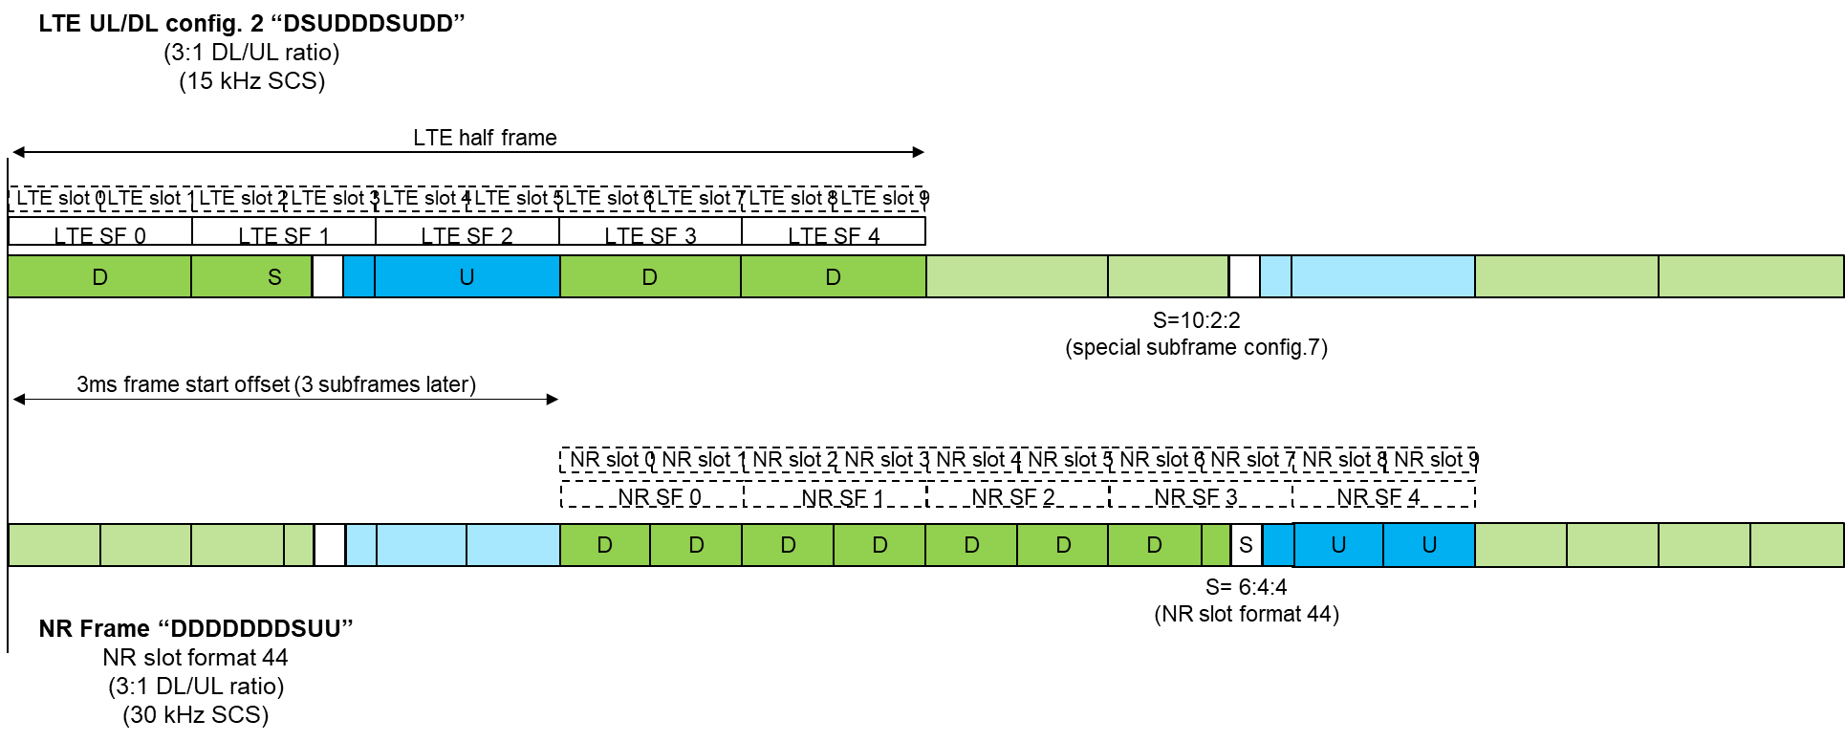
Figure 9: SynchronisedVariant 2: synchronised operation of 5G-NR (“DDDDDDDSUU” frame) and LTE-TDD (“DSUDD” frame)
The performance assessment of 5G-NR in case of adoption of the “LTE-TDD compatible” frame structure is provided in the following Sections where the results from studies # 1 and # 2 are provided.

Summary from Study #1 (grant-based UL transmissions)
Study #1 provides an assessment in terms of latency and capacity performance for two frame structures provided, namely DSDU and LTE-TDD compatible frame structure.
The analysis carried out in this study assumes grant-based UL transmissions.
Detailed assumptions and a full set of simulation results are presented in Appendix A.3.3.1; in the following a summary of latency and capacity comparison between the two analysed frame structure is reported.

Latency assessment
A summary of the latency analysis results is reported in Table 3.
Table 3: Simulation analysis – latency
 | DSDU | LTE-TDD compatible frame structure
# required HARQ processes | 4 | 8
DL HARQ RTT | 2-3 ms | 5 ms
UL HARQ RTT | 2 ms | 5 ms
UL scheduling delay | 1-2 ms | 4.5-9.5 ms
It can be observed that when 5G-NR has a frame structure aligned with LTE-TDD (configuration #2 as in this specific example), considering scheduling and MS / network processing latency, this frame structure will lead to L1 latency > 4 ms. As already mentioned, the IMT-2020 eMBB latency requirement is 4 ms and URLLC latency requirement is 1ms. Therefore, 5G-NR deployments in 3400-3800 MHz using the LTE-TDD frame structure would not be able to meet some of the IMT-2020 requirements, including the deployment of innovative services such as URLLC, unless spectrum in other bands can also be used.
With the assumptions provided in Appendix 3.3.1, the DSDU configuration shows significant benefits over the LTE-TDD compatible 5G-NR frame structure with respect to HARQ RTT and UL scheduling delay, as reported in Table 3. The simulations result in more than twice the time (5 ms) that is needed to complete one HARQ round trip as compared to DSDU (2-3 ms).
Table 3 also shows the improved scheduling delay (1-2 ms) over the time required in the case of LTE-TDD synchronisation (4.5-9.5 ms). This is achieved by more frequent transmit opportunities for UL Scheduling Requests (SR ) and UL data, and is suitable to multiplex low latency services with existing eMBB traffic.
Capacity assessment
The increased flexibility of the DSDU frame structure also has a direct impact on the overall capacity of the network. The more frequent UL opportunities can allow a higher spectral efficiency due to the fast channel feedback. The UL symbols every allow1 ms allows MS to send sounding reference signals (SRS) and channel quality information (CQI), allowing the BS to have an up-to-date estimate of the channel conditions. A more accurate channel estimation allows for a more efficient usage of beamforming and better rate control through more accurate modulation and coding scheme (MCS) selection.
The result is improved cell capacity, as shown for a heavily loaded scenario in Figure 10. The figure has been obtained considering an outdoor user with different moving speeds running a full buffer DL traffic pattern. More frequent opportunities to transmit sounding reference signals (SRS) leads to better spectral efficiency over the PDSCH symbols in a fast fading channel. Faster sounding allows better tracking of channel fluctuations, thus allowing improved demodulation performance. Figure 10 compares the simulated spectral efficiency at 5 ms and 1 ms SRS transmission opportunities. The median and 5%-tile spectral efficiency are shown in Figure 10. It can clearly be seen that the fast switching of DSDU achieves a better spectral efficiency across all speeds as compared to LTE-TDD compatible 5G-NR frame structure. While the median gain is 30 to 40%, the gain at the lower percentile (e.g. cell edge conditions) rises to 70%.

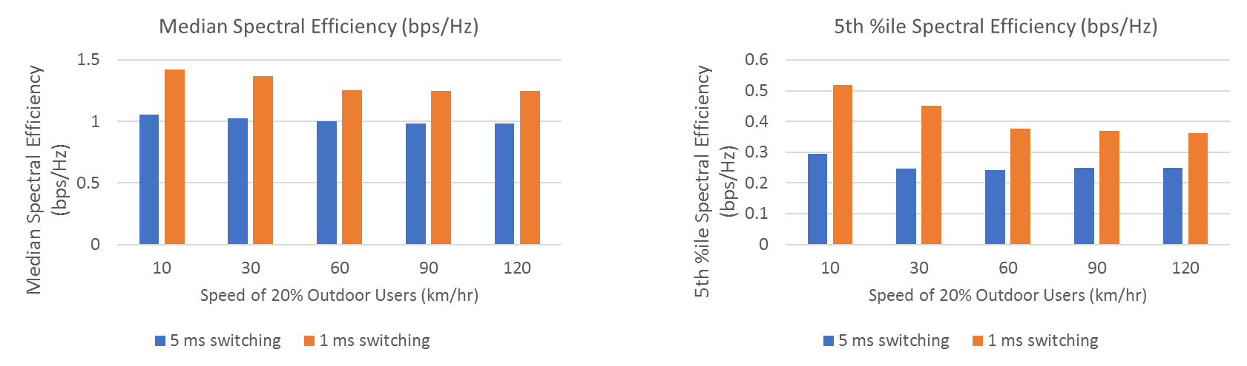
Figure 10: Spectral efficiency gains vs. speed
To simulate the effect of the slot structure on user perceived throughput in a realistic scenario, a bursty traffic pattern (bursty FTP model 3, 0.5 MB file size, variable file arrival time) was simulated. The results are shown in Figure 11. The shorter DL / UL switching periodicity of DSDU creates more transmission opportunities. The improved spectral efficiency enables the use of larger transport blocks. With these advantages, the gain of the median throughput can be as high as 50% (593 Mbps for DSDU vs. 394 Mbps for LTE-TDD compatible 5G-NR frame structure). Even in cell edge conditions, a 23% gain can still be achieved.
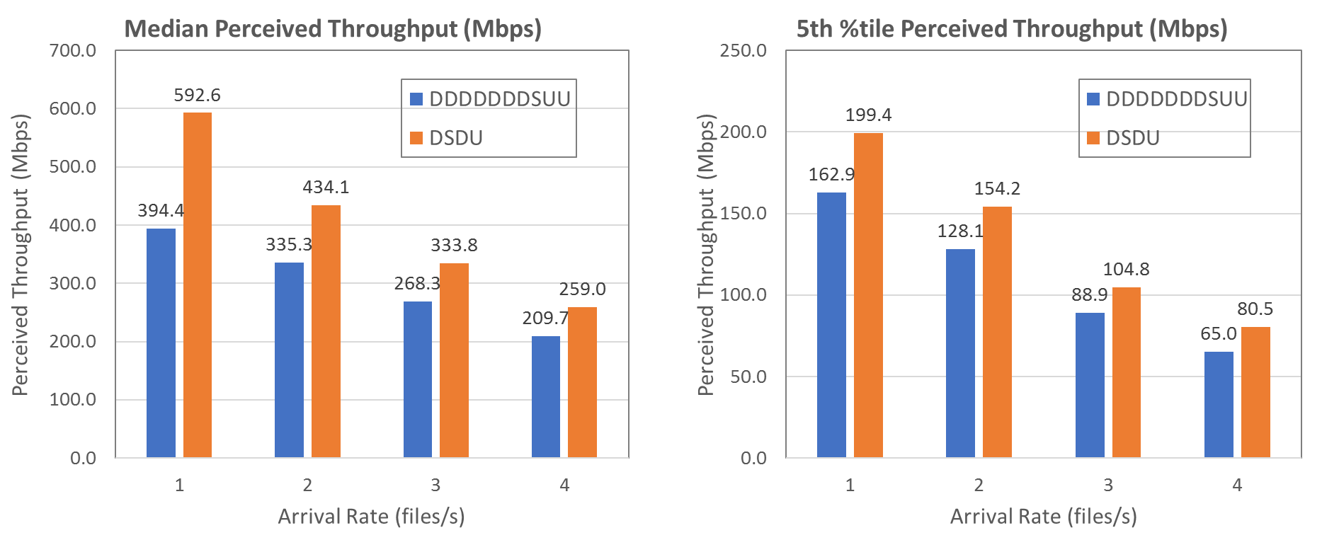
Figure 11: Bursty traffic – perceived throughput vs. file arrival rate

Summary from Study #2
Study #2 provides an assessment in terms of latency and capacity performance for the three frame structures shown in Figure 12.
Figure 12: 5G-NR frame structures for evaluation – slot level
The analysis carried out in this study assumes grant-free UL transmissions for the latency assessment and grant-based UL transmissions for the assessment of UL and DL capacity and spectral efficiency.
The more complete set of results and detailed assumptions for this study is available in Section A3.3.2.

Latency assessment (grant-free UL transmissions)
The round-trip time (RTT) for the frame structures is presented in Table 4. Due to the shorter DL / UL switching periodthe DSDU frame structure has a lower RTT than the other frame structures considered.
The RTT associated with DDDSU and LTE-TDD compatible 5G-NR frame structures can be reduced by using lower frequencies (e.g. 700MHz, 800MHz, 900MHz, 1800MHz) in combination with the 3400-3800 MHz band (e.g. through Carrier Aggregation (CA) or Supplemental Uplink (SUL) schemes). The resulting RTT will meet the most stringent latency requirement for URLLC and eMBB simultaneously. It is to be noted, that licensees for the 3400-3800 MHz frequencies do not necessarily have access to lower frequency bands and so may not be able to take adantage of CA or SUL to enable URLLC..
In this evaluation, it was assumed that one MS always uses either the SUL for all its UL transmissions, or always uses the 3400-3800 MHz UL for all its UL transmissions, based on measured RSRP. NR specifications allow configuring the MS to use both uplinks in a TDM manner, which provides more flexibility in the operation than simulated here. Taking this into account, the simulation results presented here should be interpreted as a "best case" scenario., as the impact of the signalling required to assign the lower band UL to SUL/CA operation has not been taken into account.. Accounting for partial resource availability for NR users in the SUL band (or in the uplink portion of the band in case of CA) would reduce the improvement in latency to some extent.
The latency assessment results in Table 4 account for the “grant-free” UL transmissions feature (also known as “configured grant”) which is an optional feature for 5G-NR in 3GPP. The “grant-free” UL is beneficial for low latency since it avoids the need to first transmit a scheduling request on UL followed by a scheduling grant on downlink before UL data transmission can take place.
It is to be noted that decisions to mandate features for Rel-15 5G-NR MSs were made in consideration of eMBB services, which are first services that are likely to be delivered using early 5G. Most of the featuresfeatures relatingrelated to low latency and/or reliability are optional. This includes not only the “grant-free” feature, but also other features such as the mini-slots (frequency control monitoring and short transmission durations), MS processing capability #2 (necessary for the "self-contained" slot operation), dynamic signalling of slot format (see Table 16), etc.
Simulations results with grant-free based UL transmission are valuable in deriving the lowest possible user plane latency performance.
It is also worth noticing that a comparison between Carrier Aggregation and SUL has not been analysed in this report. In terms of latency performance, at least the same latency gain presented for the SUL case can be achieved in case of Carrier Aggregation. Both CA and SUL have their own merits and drawbacks, which are not addressed in this Report. One of the main differences between CA and SUL is the possibility to use the DL carrier in the Carrier Aggregation case. Also with SUL simultaneous data transmissions are not possible in SUL carrier and NR UL carrier it is linked to. Therefore with CA there is an increase in both DL and UL throughput compared to SUL scenario In addition, the DL carrier can be used e.g. for DL measurements, power control calculation, mobility management, etc It should also be noted that at the time of publication of this Report 3 GPP is still working on etc.)some aspects of SULspecifications.

Table 4: DL and UL latency evaluation results for 5G-NR frame structures (SCS = 30 kHz)
DL / UL | Non-slot based scheduling | RTT (ms) for 5G-NR frame structure (GP: 2 OFDM symbols)
DL / UL | Non-slot based scheduling | DDDSU | DDDDDDDSUU | DSDU | DDDSU+SUL | DDDDDDDSUU+SUL
DL | 2 OFDM symbols | 1.77 | 3.02 | 1.12 | 0.78 | 0.82
UL | 2 OFDM symbols | 1.71 | 2.95 | 1.05 | 0.82 | 0.86

DL capacity assessment (grant-based UL transmissions)
Grant-based UL transmissions are assumed for this assessment, therefore the latency results presented in Table 4 (which assume grant-free UL transmissions) do not apply here.
Spectral efficiency with different MS moving speeds and the user-perceived throughput (UPT) with different arrival rates are evaluated.
It is observed that the DSDU frame structure performance benefits from fast CSI measurement and feedback, however the frequent DL / UL switching brings about the extra GP overhead.
Figure 13 provides the cell average and cell-edge spectrum efficiency under 10 km/h moving speed can achieve 15% and 23% gain for DDDDDDSUU vs. DSDU, due to the lower overhead.

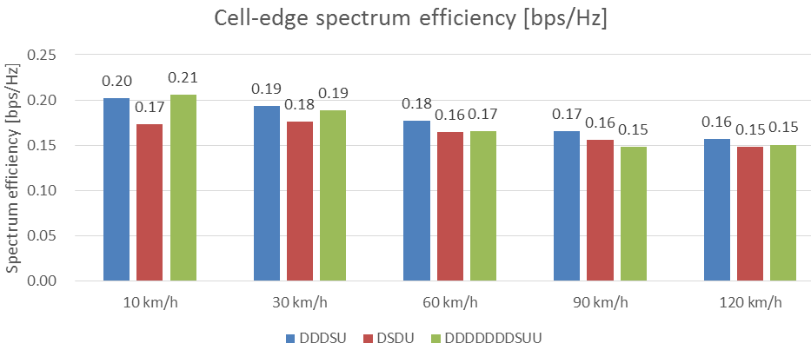
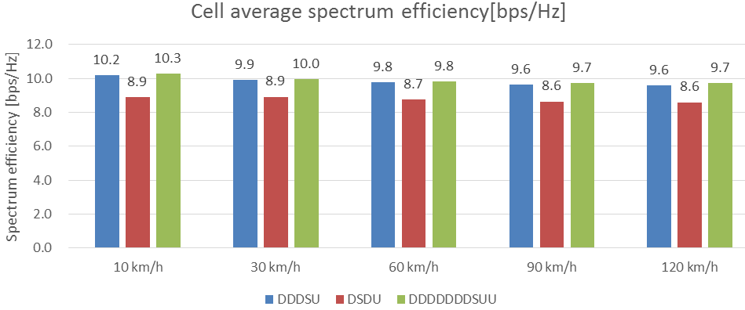
Figure 13: DL spectrum efficiency with different speeds
Figure 14 shows the balance between overhead and feedback delay, DDDSU frame structure has the best performance in most cases and the gain compared to DSDU can be achieved by more than 10%.

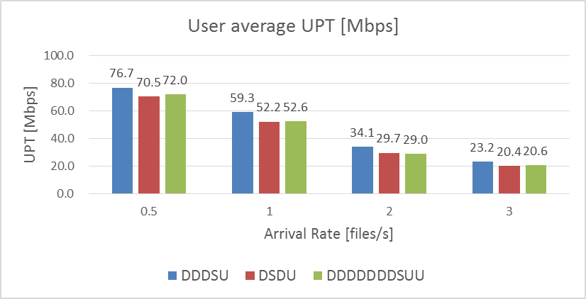

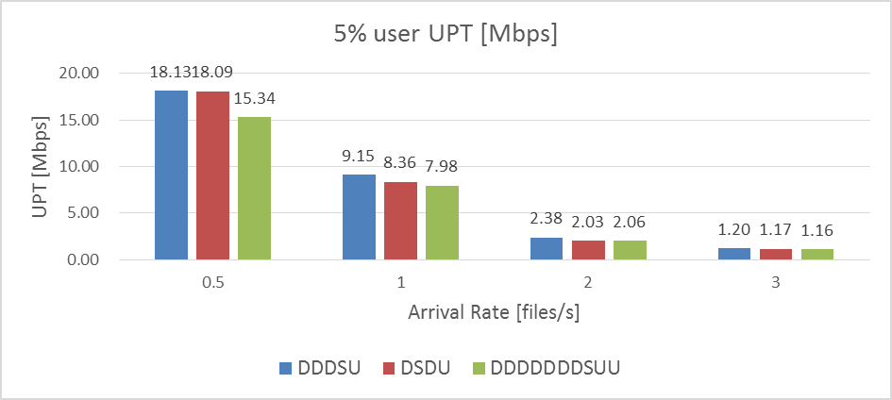

Figure 14: DL user-perceived throughput (UPT) with different file arrival rates

UL capacity assessment (grant-based UL transmissions)
According to the study performed:
- DDDSU frame structure with the good balance of overhead and delay has better performance in most cases under different traffic loads. Compared to DSDU, the gain of user average UPT can achieve to 17%.
- If using SUL band, up to 5-times gain can be reached for 5% user throughput since such users benefit from the lower path loss and the sufficient bandwidth in the SUL band.
and/or harmonic interference.Intermodulation , but harmonic interference cannot be solved this way.can beThese bands can also be used for CA.

TO PC
While the 1800 MHz SUL band and the 3400-3800 MHz frequencies may be related by second-order inter-modulation products, such interference can be always avoided by ensuring the MS always uses one of the two uplinks only. When configured with the two uplinks, the MS is configured with timing patterns that ensure uplink transmissions only in time-division multiplexing manner, as specified in 3GPP. Other choices of SUL frequencies are also available in bands specified by 3GPP (e.g. 700, 800 or 900 MHz), where second-order inter-modulation products would not appear in the 3400-3800 MHz band. TDM patterns to avoid the same inter-modulation products are also specified in 3GPP for LTE-NR dual connectivity with or without the use of a SUL.

Interference mitigation for unsynchronised operation with ECC baseline out of block power limit
As it was mentioned in Section 2.2, the ECC has defined the restricted baseline out of block power limit for unsynchronised and semi-synchronised operation of MFCN BSs (see ECC Decision (11)06 (October 2018) Table 4 [3]. However, the ECC Decision allows CEPT Administrations to define a "relaxed alternative “restricted baseline limit” applying to specific implementation cases to ensure a more efficient usage of spectrum […] depending on national circumstances." ).
The practical interference criteria adopted to derive the ECC restricted baseline limit is 5% degradation in the mean UL throughput of the victim MFCN due to ACLR of interfering BS, with the understanding that interference is not dominated by the adjacent channel selectivity (ACS) of the victim BS. The limits were derived from a study (see ANNEX 3: in ECC Report 281) which considered the interfering and victim MFCNs consisting of Macro BSs in a hexagonal grid (19 sites with three cells each) with an inter-site distance (ISD) of 500 metres. The study considered a shift of the victim MFCN with respect to the interfering MFCN by 70 metres (representing a conservative, not worst case, scenario) and by 288 metres (the best-case scenario). The restricted baseline limit was then derived considering the 70 metres shift. Coexistence in case of uncoordinated collocated sites (e.g. two base stations installed in different corners on the same rooftop and possibly pointing at each other) would correspond to the worst-case scenario.
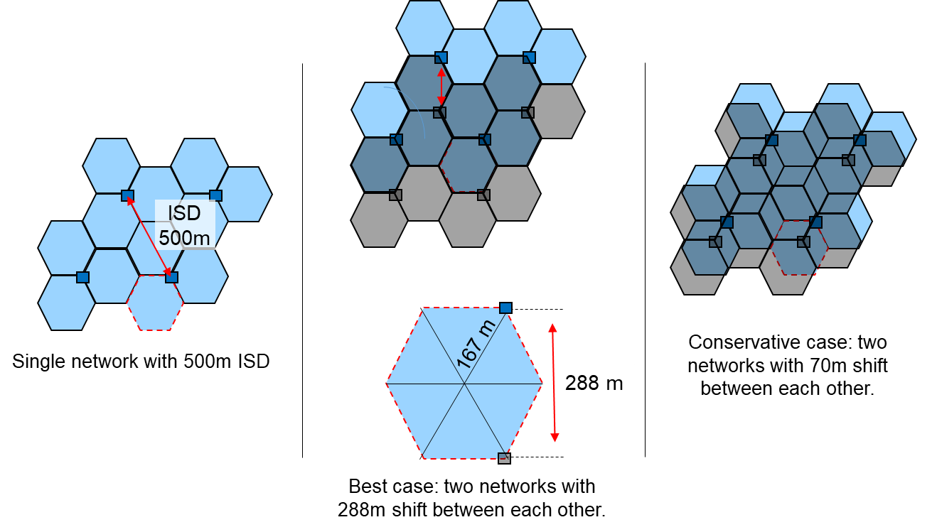
Figure 15: Best case and conservative (not worst case) network shifts
The study has assumed the required ACLR to be nominally equal to the required ACIR, with the understanding that interference is not dominated by the adjacent channel selectivity (ACS) of the victim base station. Therefore the study does not account for the blocking effect due to BS-BS interference.
The study does not assess the MS-MS interference while it is expected that some 5G use cases will imply the deployment of MSs that are in fixed positions and close to each other (e.g. crowded stadiums, trains, busses, (home) CPEs in fixed wireless access (FWA) systems, and fixed machinery/robots in factories). In such scenarios, the MS-MS interference might not be negligible anymore.
It is worth noting that ECC restricted baseline out of block power limit defined in ECC Report 281 was derived assuming the specific case of adjacent operators with misaligned duplex directions for the whole frame duration ("anti-synchronised" assumption, sometimes referred to as "fully unsynchronisedanti-synchronised"). The probability for this specific case to happen is low and, therefore, the "anti-synchronised" assumption is a worst case assumption.
While the "anti-synchronised" assumption is worst-case from the overall network throughput perspective, if the studies looked at the performance of a given MS which is scheduled in just one or a few slots, it is possible that all the slots allocated to that UE are subject to the worst case interference even if not all slots are subject to the worst-case interference.
It is also to be noted that the adopted assumption is consistent with the definition provided in ECC Report 281: “the unsynchronised operation in the context of this Report means operation of TDD in several different networks, where at any given moment in time at least one network transmits in DL while at least one network transmits in UL. This might happen if the TDD networks either do not align all UL and DL transmissions or do not synchronise at the beginning of the frame”.
The implementation challenges, based on currently available technology, associated with the ECC restricted baseline out of block limit have been described in Section 2.2.2.
Interference due to unsynchronised operation can be partly mitigated by adopting the following solutions individually or in combination:
- Adoption of a guard band and operator-specific filtering between the adjacent spectrum assignments associated with the interfering network and the victim network;
- Geographic separation between the interfering network and the victim network;
- Alternative network topologies to Macro-cellular networks:
  - Micro BS networks;
  - Indoor BS networks;
- Semi-synchronised operation.

The following Sections assess to what extent each of these interference mitigations can improve coexistence between operators. The main results from coexistence studies are introduced while leaving the full set of studies to the Annexes of this Report.
It is worth noting that the performance criteria in the co-existence studies is maximum 5% throughput loss. For URRLC use cases 5% loss is not acceptable. For these use cases the relevant throughput loss level to should be closer to 0%.

Guardband requirement for unsynchronised operation
For non-AAS BSs, according to ECC Report 203 a 5 MHz guard band and operator-specific filtering are necessary for coexistence between TDD and FDD networks in the 3400-3800 MHz band and it is expected that a similar guard band and external filtering would be required for unsynchronised non-AAS TDD networks. According to ECC Report 281 using current filtering technology, about 20 MHz guard band and internal operator-specific filters would be required for AAS to meet the baseline to protect radars below 3400 MHz. There was no technical analysis on the size of guard band and internal operator-specific filters required for AAS to meet the ECC restrictive baseline out of block power limit.
With AAS operation, operator-specific RF filters implementation would be very challenging, and the implementation of a guard band, which would also reduce the spectral efficiency in the band, would not provide any benefit in practice.
For AAS BSs, ECC Report 281 says that, using current filtering technology, about 20 MHz guard band and internal filters would be required for AAS to meet the baseline to protect radars below 3400MHz. A similar size of guard band and similar internal operator-specific internal filters may be required for AAS to meet the ECC restrictive baseline out of block power limit.

geographic separation of Networks
This Section investigates the coexistence between unsynchronised Macro-cellular networks operating in 3400-3800 MHz band.
The objective is to derive the minimum isolation, expressed in terms of separation distance, required between two unsynchronised networks when all deployed BSs meet the baseline out of block power limits as defined in ECC Decision (11)06 (October 2018) Table 3 [3].

Proposed methodologies
This Section discusses and proposes the methodology when coordinating two unsynchronised TDD Macro-cellular networks at national level.
There are two possible approaches to deal with coexistence among two unsynchronised TDD networks within a country:
- Method #1: define the minimum required separation distance between the two unsynchronised networks;
- Method #2: define the electric field strength trigger value at the nearest victim BS.
Either of these two approaches can be applied.
With reference to the BS technology options, three possible cases can be considered:
- Non-AAS Network A to non-AAS Network B, which could represent two LTE-TDD FWA networks;
- AAS Network A to non-AAS Network B, which could represent one 5G-NR network and another LTE-TDD FWA network;
- AAS Network A to AAS Network B, which could represent two 5G-NR networks.
The separation distance can be derived based on different protection thresholds:
- 5% network cluster average UL throughput loss ;

- I/N=-6 dB at the nearest victim BS.

Method #1: Separation distance calculation
As illustrated in Figure 16 and Figure 17, the separation distance is defined between the two nearest BSs in network A and network B.

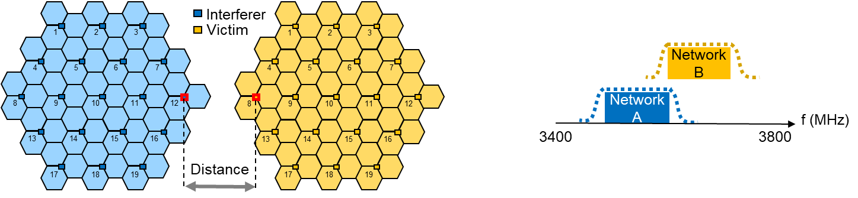

Figure 16: separation distance between Networks A and B – adjacent channel

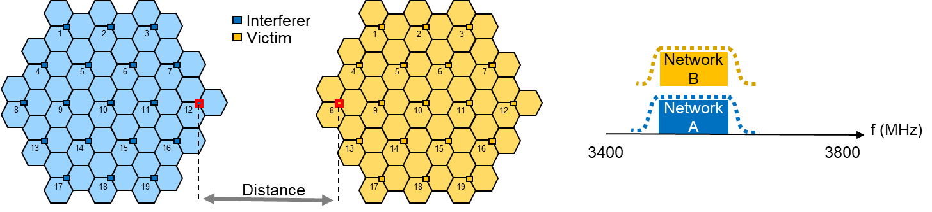

Figure 17: separation distance between Networks A and B – co-channel
If networks A and B are both non-AAS, then the separation distance can be calculated using the protection ratio of I/N=-6 dB or determined by simulation based on the agreed average UL throughput loss (e.g. 5% network cluster average UL throughput loss) between the two concerned mobile operators.
If either network A or B or both adopt AAS BSs, then the separation distance has to be determined by simulations based on the agreed average UL throughput loss (e.g. 5% network cluster average UL throughput loss) between the two concerned mobile operators.

Method #2: Trigger Values calculation
An alternative approach is to define a trigger value (dBµV/m/5MHz) at the nearest BS receiving antenna or at 3m height above the ground, as shown in Figure 18.
When the trigger value is defined at 3m height above ground, a BS antenna height conversion factor should be used, the determination of antenna height conversion factor is discussed in ANNEX 5: Section A5.2.7.

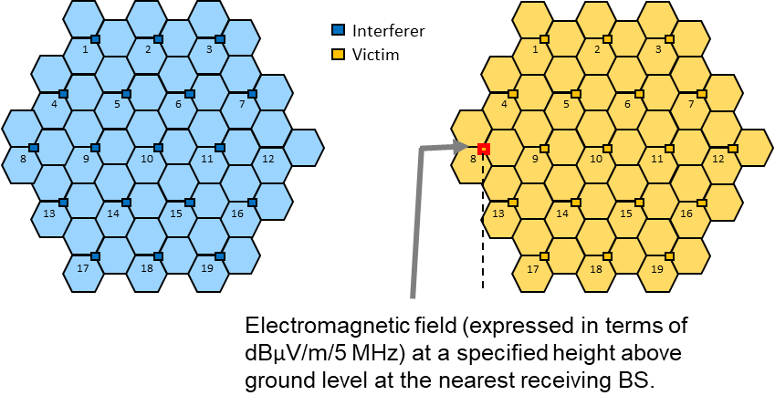
Figure 18: Electromagnetic field trigger value between Networks A and B
Calculation of trigger values
The relation between field strength E (dBµV/m) and power level PR (dBm) can be expressed as:
E = P_{R} + 20 * LOG₁₀(F) + 77.2 (1)
P_{R} = P_{TX} + G₁ – PL (2)
Where:
- F (MHz): frequency;
- P_{R} (dBm): received power level at the receiving BS antenna (before antenna);
- P_{TX} (dB): transmit power before antenna;
- G₁ (dB): interfering BS antenna gain including feeder loss in the direction of the receiving antenna;
- PL (dB): path loss at the distance D.
It should be pointed out that the trigger value determination for the case AAS BSs is much more complicated due to the dynamic behaviour of the AAS antenna pattern.
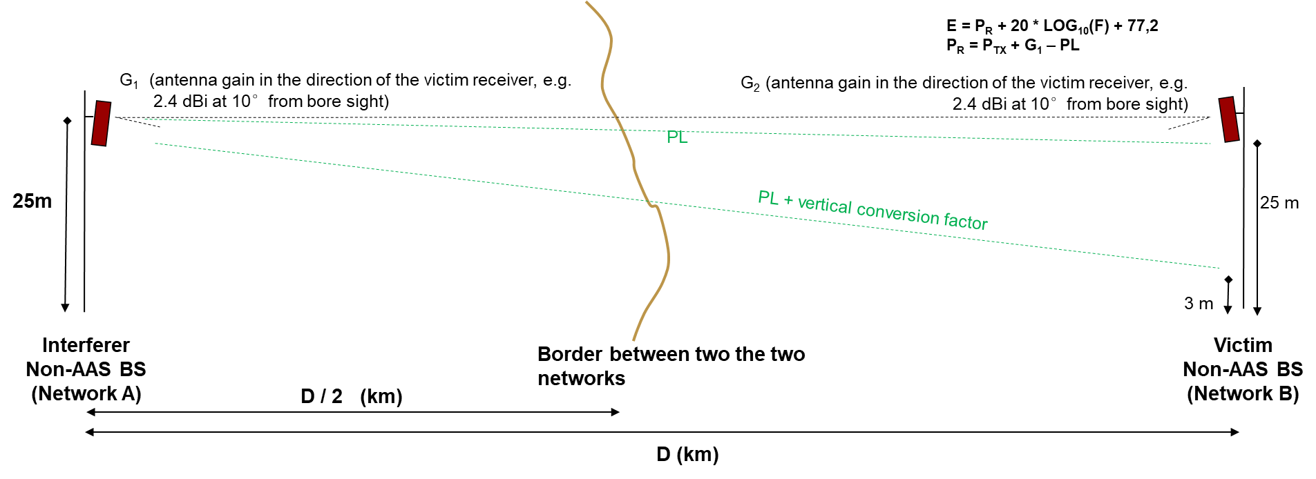
Figure 19: relationship between the interferer transmitter power and the electric field strength at the victim receiver

Summary of the studies
Two studies described in ANNEX 5: have presented the simulation results in terms of separation distance between two unsynchronised Macro-cellular networks. The simulation results are summarised in Table 5.
Table 5: Summary of the simulation results of separation distance between two Macro-cellular networks
 |  | Study 1  (5% avg. throughput loss, P.452 20% time) | Study 2  (5% avg. throughput loss,  P.452 50% time)
Co-Channel | AAS-AAS | 60 km | 50 km
Co-Channel | Non-AAS – Non-AAS |  | 50 km
Adjacent  Channel | AAS-AAS | 10.5 km | 14 km
Adjacent  Channel | Non-AAS – Non-AAS |  | 15 km
The results from the two studies based on 5% network average UL throughput loss show that:
- For the co-channel case, the required separation distance is in the order of 50 to 60 km;
- For the adjacent channel case, the required separation distance is in the order of 10 to 15 km.
For the non-AAS to non-AAS co-channel case, the calculated separation distance based on I/N=-6 dB for non-AAS to non-AAS case is 44 km.

Conclusions from studies
The analysis and the simulations that were carried out in this Section lead to the following conclusions:
- .
- The two methodologies are described in this Section, either based on the separation distance or on the electric field trigger value) can be applied;
- Specific separation distance values can be defined at national level based on the specific circumstances. This is because the required separation distance and electric field trigger values calculation depend on many factors:
  - Cellular network technology and topology (LTE-TDD or 5G-NR, non-AAS or AAS, BS antenna height, environment, cell range);
  - Propagation environment and propagation mode used in relation with this environmentl;
  - Frequencies and overlap of the blocks, e.g. full overlap for co-channel case, or partial overlap (e.g. in some cases of co-existence between operators in adjacent areas) , or adjacent channel);
  - Protection ratio, e.g. I/N, or nearest cell throughput loss at x%, or network average throughput loss at y%, etc.

Coexistence between unsynchronised Micro BS and Macro BS deployments

Coexistence between unsynchronised Micro BSs and Macro BSs –Study #1
In Annex A6.1 the interference between Micro and Macro BSs is studied. For the Macro-cellular network the BSs have an output power (TRP) of 51 dBm and 500 m ISD while the BS in the Micro BS network has an output power (TRP) of 40 dBm and an ISD of 166 m. The impact on both types of BS is studied. The distance between aggressor and victim BS varies, but for the closest pair the distance is 30 m.
The propagation between BSs is modelled using the Urban Macro (UMa) model and this model has a random component. Performance of one specific realisation of the BS-BS propagation is studied. This is the best way to model the situation in practical deployments since the BS-BS propagation will not vary over time. According to the study, in order to limit the throughput loss to maximum 5% the required ACIR (adjacent channel interference ratio) between the networks has to be around 60 dB to protect the Micro BS network and 45 dB to protect the Macro-cellular network for typical deployments. For the most sensitive pair of BS, the ones with 30m separation, the ACIR has to be between 50 dB and 70 dB to protect the Micro BS network and between 45 dB and 60 dB to protect the Macro-cellular network.
Considering that the ECC baseline gives defined standard requires an ACIR of slightly less than 45 dB, it can be concluded that there are a few cases, i.e. deployment scenarios, where standard equipment will result in less than 5% throughput loss, but in the majority of cases the losses are larger. In these scenarios synchronisation will be an effective interference mitigation technique.

Coexistence between unsynchronised Micro BSs and Macro BSs – Study #2
This Section provides the main conclusions from the study in 0, which considers the impact of BS-BS interference between MFCNs with simultaneous UL / DL transmission in terms of the resulting degradation in the mean UL throughput of the victim MFCN. The MFCNs consist of Macro BSs and Micro BSs.
The study addresses two scenarios according to the specific class of base stations, namely:
- Macro-cellular network (hexagonal grid of outdoor stations) is operating as the interferer and the Micro BS network (hexagonal grid of outdoor stations) is interfered;
- Micro BS network (hexagonal grid of outdoor stations) is operating as the interferer and the Macro BS (placed outdoors) is interfered;
- Interference from one Micro BS to another Micro BS (both base stations are placed outdoors).

Network topologies and main assumptions
The two interfering deployments operate in the same geographic area on adjacent frequency channels.
All Micro and Macro BSs are assumed to be AAS base stations forming a beam towards a MS (MSs are assumed to be uniformly distributed within a cell).
The Macro BSs have 25 m high antennas and comprise three sectors per site; the Micro BSs are placed 6m above ground, comprising one sector per site with random boresight.
Base stations are "anti-synchronised", i.e. they transmit and receive at the opposite times to one another
See Section A6.2.3 for the full list of assumptions and parameters.
a) Macro BSs network as interferer; Micro BSs network as victim
Figure 20 provides the topology used for the coexistence studies in case of a Macro BSnetwork (hexagonal grid placed outdoors) operating as the interferer towards a Micro BS network (hexagonal grid placed outdoors).
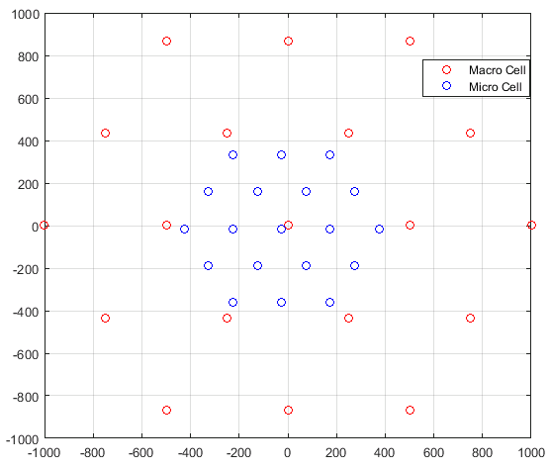
Figure 20: Topology for the Macro BS to Micro BS interference scenario
b) Micro BSs network as interferer; Macro BSs network as victim
Figure 21 provides the topology used to support coexistence studies in case of Micro BS network (hexagonal grid placed outdoors) operating as the interferer towards the Macro-cellular network (hexagonal grid placed outdoors). In line with ECC Report 203, the simulations address one Macro BS, which is completely surrounded by the Micro BS network grid.
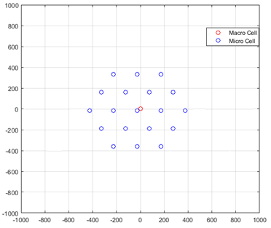
Figure 21: Topology for the Micro BS to Macro BS interference scenario
c) Micro BSs to Micro BSs
The two approaches which have been used to assess the interference from AAS Micro BSs to AAS Micro BSs are described below:
Approach 1: in this analysis the separation distance between the Micro BSs is an input parameter, the Urban Microcell (UMi) path loss model determines the associated Line-of-sight probability.

The following two settings have been considered:

- Case 1a: 30m separation distance between the two Micro BSs leading to 80% LoS probability based on the UMi path loss model (the smaller the distance, the greater the probability the two Micro BSs will be along the same street).
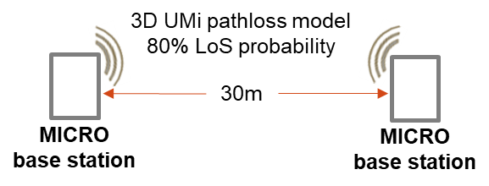
Figure 22: Micro BS to Micro BS interference scenario topology - Case 1a:
30m separation distance leading to 80% LoS probability based on UMi pathloss model

- Case 1b: 100m separation distance between the two Micro BSs leading to 25% LoS probability based on the UMi path loss model (the larger the distance, the greater the probability the two Micro BSs will be located in different streets).

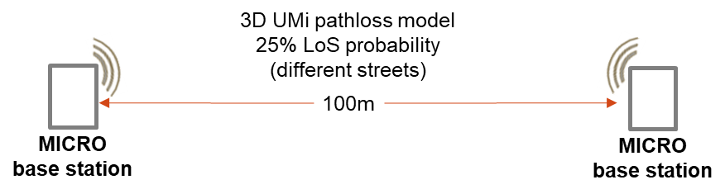
Figure 23: Micro BS to Micro BS interference scenario topology - Case 1b:
100m separation distance leading to 25% LoS probability based on UMi pathloss model

Approach 2: in this analysis the separation distance between the Micro BSs is an input parameter as well as the line-of-sight probability.

This approach accounts for the fact that it is difficult to carry out meaningful simulations to assess the interference between two Micro BS networks in the same urban area since the interference scenario will be strongly impacted by the LoS / NLoS conditions, which radically change depending on where the Micro BS are installed with respect to each other in built-up areas.

The study therefore considers two specific set of cases for the deployments of the interfering and victim base stations.

- Cases 2a, 2b and 2c: two Micro BSs located in different streets at 30m, 50m and 75m separation distance with 0% LoS probability

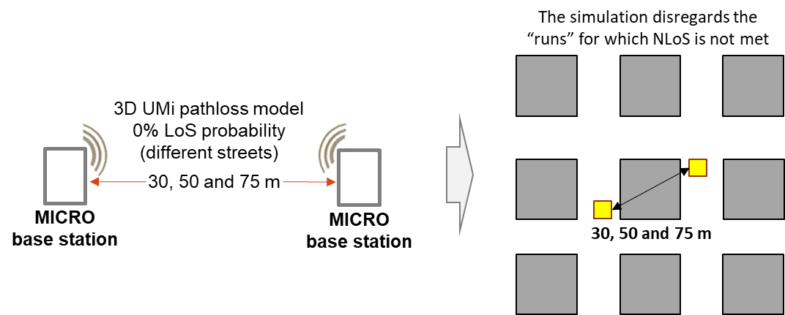
Figure 24: Micro BS to Micro BS interference scenario topology. Case 2a, 2b and 2c:
30, 50, 70 m separation distance and 0% LoS probability (different streets)

- Case 2d: two Micro BSs located along the same street (100% LoS probability) at 100 m separation distance.
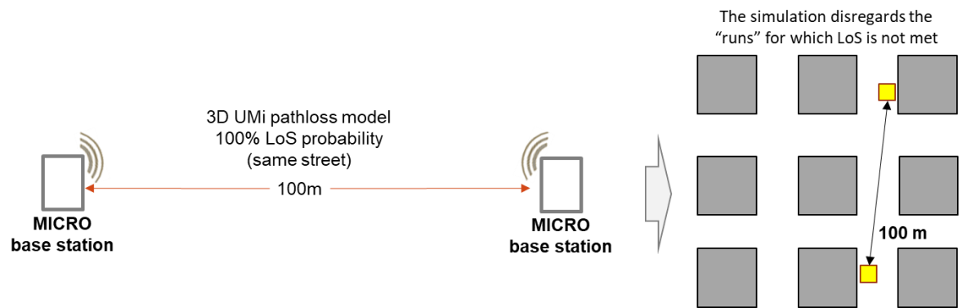
Figure 25: Micro BS to Micro BS interference scenario topology. Case 2d:
100m separation distance and 100% LoS probability (same street)

Simulations results and conclusions

This Section presents the simulations results expressed in terms of degradation of the mean uplink throughput of the victim MFCN due to base station to base station interference from the interfering MFCN, presented as a function of ACIR. In general terms, as expected, the impact of interference on network performance diminishes with increasing values of ACIR.
Note that the required ACLR is assumed to be nominally equal to the required ACIR, with the understanding that interference is not dominated by the adjacent channel selectivity (ACS) of the victim base station. Therefore the study did not take into account the BS blocking effects on the victim BS receiver.
Note that both victim BS and interferer base stations are assumed to operate with 60 MHz channel bandwidth.
It is important to highlight that the study:: did not account for MS-MS interference.

Interference from AAS Macro-cellular network tointo AAS Micro BS network:
With reference to the topology proposed in Figure 20, an ACIR greater than 68dB is required to ensure a mean uplink throughput degradation smaller than 5%.

Interference from AAS Micro BS network tointo AAS Macro BS network:
With reference to the topology proposed in Figure 21, an ACIR greater than 55dB is required to ensure a mean uplink throughput degradation smaller than 5%.
Interference between two AAS Micro BSs:
With reference to the topology proposed in Figure 22 (Case 1a: 30m separation distance leading to 80% LoS probability based on UMi path loss model), an ACIR greater than 63dB is required to ensure a mean uplink throughput degradation smaller than 5%.
With reference to the topology proposed in Figure 23 (Case 1b: 100m separation distance leading to 25% LoS probability based on UMi path loss model), an ACIR greater than 54dB is required to ensure a mean uplink throughput degradation smaller than 5%.
With reference to the topology proposed in Figure 24 (Case 2a, 2b and 2c: 30, 50, 70 m separation distance and 0% LoS probability (different streets), shows how an ACIR greater than 49dB is required to ensure a mean uplink throughput degradation smaller than 5% for 30m separation distance. If the separation distance is 50m, 45dB ACIR co-existence is required5% uplink throughput degradation .
With reference to the topology proposed in Figure 25 (Case 2d: 100m separation distance and 100% LoS probability (same street). An ACIR greater than 70dB is required to ensure a mean uplink throughput degradation smaller than 5%.

Coexistence between unsynchronised Indoor BSs and Macro BS
In Annex A7.1 the impact on an indoor system from a Macro-cellular network is studied. The indoor BS network is located in a 50x120m large building, which is located 70m from the Macro BS. For the Macro-cellular network the BS have an output power (TRP) of 51 dBm and 500m ISD while the indoor BS is ceiling mounted with an output power (TRP) of 24 dBm.
The propagation between BS is modelled using the UMa model and this model has a random component. We study performance of one specific realisation of the BS-BS propagation. This is the best way to model the situation in practical deployments since the BS-BS propagation will not vary over time.
Based on the study, in order to limit the UL mean UL/average? throughput degradation for the indoor network to maximum 5% the ACIR (adjacent channel interference ratio) between the networks has to be in the range 25 dB to 65 dB, depending on the actual channel realisation between the Macro BS and indoor BS.
In the ECC baseline giveshas definedIMT-2020 BS hasrequires an ACIR of slightly less than 45 dB. From this it can be concluded that in some cases standard equipment will result in less than 5% throughput loss and in other cases the losses are larger. This indicates that, for this type of scenario, unsynchronised operation may be possible for carefully installed indoor BS, but synchronisation may be required for BS installed in shallow indoor locations...
It is worth noting that the criterio5% UL mean UL/average throughput URLLCURLLC degradation performance criterionfor URRLC use cases. needs to becomply with is closer to 0%. According to the resultsabove it can be seen, the URLLC use cases will require an additional isolation somewhere in the order of 20-25 dB compared to the 5% loss results. Such additional isolation could be obtained with accurate indoor BS planning and, for example, with adoption of proper shielding around the building.

Study on semi-synchronisation for Microcell and Macrocell cases CASES
The benefits and challenges associated with semi-synchronised operation have been discussed in Section 2.3. In the following sub-sections, adjacent channel simulation results are presented. These results are based on the study available in ANNEX 8:.

Table 6: Study on semi-synchronisation for Microcell and Macrocell cases – summary of results
Scenario | Macro-cellular network to  Macro-cellular network |  |  |  | Micro BS network to  Micro BS network
Minimum distance  among networks | 288m |  |  |  | 96m
BS-BS  propagation model | Free space path loss |  |  |  | 3GPP TR 38.901 - UMi
Semi-synchronisation percentage | 10%  unsynch | 20% unsynch. | 50%  unsynch. | anti-synch | 10%  unsynch | 20%  unsynch | 50%  unsynch | anti-synch.
ACIR needed for  5% UL mean/averaged throughput degradation | 54dB | 62dB | 70dB | 75dB | N/A | 40dB | 47dB | 54dB
As shown in Figure 15, the 288m network shift assumption between Macro-cellular networks represents the best case. Similarly, the 96m network shift assumption between Micro-cellular networks represents the best case between the two analysed assumptions.
Differently from the approach followed in this study, the recommended approach is to use the separation distance and the line-of-sight probability as input parameter during the coexistence studies for the Macro-cellular network and the Micro BSs network cases. This approach accounts for the fact that it is difficult to carry out meaningful simulations to assess the interference between two Micro BS networks in the same urban area since the interference scenario will be strongly impacted by the LoS / NLoS conditions which radically change depending on where the Micro BS are installed with respect to each other in built-up areas.
Coexistence between the Macro-cellular network and the Micro BS network was not assessed by this study.
It is worth noting that the study assumes that operators do not always decide to modify UL symbolsslots into DL symbolsslots in the flexible part of the frame. This reflects a real deployment scenario where:
- The two operators adopt the same default frame structure; and
- When the default frame structure is not modified (in its flexible portion), the network is actually operating in synchronised mode;
- An operator might decide to modify the agreed default frame structure in some specific locations (hot spots) and at specific point in time (specific event or busy hour, for instance). In this particular case, only the base stations in these areas and at these times will be subject to cross-link interference.
Taking this into account, the results presented in this section represent a worst case scenario in terms of throughput degradation resulting from the semi-synchronised case.
"DL to UL modifications": the default DL transmission direction in the flexible part is modified into UL
In this case, from BS-BS interference perspective, the network that modifies the default DL transmission direction into UL will not interfere with the other network while it will receive additional interference from the other network during the period of the modified transmission direction.
In most circumstances, MS-MS interference will be negligible because terminals typically transmit intermittently and many will be mobile so any interference would be transient. When the MS-MS interference can be neglected, the ECC baseline out of block power limit can be adopted without requiring regulatory intervention.

It is expected that some 5G use cases will imply the deployment of MSs that are in fixed positions and close to each other (e.g. crowded stadiums, trains, busses, (home) CPEs in fixed wireless access (FWA) systems, and fixed machinery/robots in factories). In some of those specific scenarios, the MS-MS interference might not be negligible anymore: no specific studies were performed with this respect. Therefore, in case of MSs that are in fixed positions and close to each other, no conclusion can be derived on the applicability of the ECC baseline out of block power limit. [Whenstandardisation bodies
"UL to DL modifications": the default UL transmission direction in the flexible part is modified into DL
In this case, from BS-BS interference perspective, the network that modifies the default UL transmission direction into DL will interfere with the other network while it will not receive additional interference from the other network.
Under the specific assumptions and methodology used in this study, it can be concluded:
- For Macro-cellular network to Macro-cellular network results show that the throughput degradation is ~9% when operators are unsynchronised (UL to DL modification) for 10% of time. The modelling considered that the interfering operator always changes the transmission direction during the flexible part of the frame so is a worst case analysis. This means that the throughput degradation will likely be lower in a realistic scenario where the interfering operator does not always modify the transmission direction of the flexible portion of the frame.of the UL mean UL/averaged? throughput degradation in case of loss operation operation may; for a BS - BS separation distance at 288 m
From Micro BS to Micro BS interference perspective, it is possible to use the ECC baseline out of block power limit for synchronised operation as specified if the operators have simultaneous UL / DL transmissions for at most 20% of the frame(based on acceptable Loss 5% and ACIR 45dB); for a BS - BS separation distance at 96 m;
- Noconclusion can be derived for the Macro-cellular network to Micro BS network case since this scenario was not studied. In the case of Micro BS network to Macro-cellular network, due to the lower power of the interfering BS it is expected that interference from the Macro base station will dominate the coexistence analysis.-.
Based on the above, since UL to DL flexibility creates additional BS-BS interference to the neighbour operator, the specific cases in which the semi-synchronised operation (for UL to DL flexibility) could be allowed require agreement at national level.
e.g.

Summary of all studies performed
The following tables collect the results from the studies performed.
Table 7: Coexistence between unsynchronised / semi synchronised Macro-cellular network and
Macro-cellular network – summary of results
(*) Best case. Agreed assumption for the network shift (Macro BS ↔ Macro BS case): baseline: 70m, additional for reference: 288 m (see Table 33).
Table 8: Coexistence between unsynchronised / semi synchronised Macro-cellular network and
Micro BS network – summary of results
(**) Best case. Agreed assumption for the min. separation distance between Macro BS and Micro BS: 30m (see Table 33).
(***) Differently for this study, it was agreed to use the separation distance and the line-of-sight probability as input parameter during the coexistence studies between the Macro-cellular network and the Micro BSs network. This approach accounts for the fact that it is difficult to carry out meaningful simulations to assess the interference between two Micro BS networks in the same urban area since the interference scenario will be strongly impacted by the LoS/NLoS conditions which radically change as the Micro BSs change their locations with respect to buildings.
Table 9: Coexistence between unsynchronised Macro-cellular network and indoor BS network – summary of results
(****) Qualitative assessment was performed for this scenario.

Toolbox: options for administrations to support the design of synchronisation frameworks at national level

Key aspects to be considered when setting up the synchronisation framework at national level
Synchronisation and semi-synchronisation are effective for mitigating cross-link interference between operators. Additional interference mitigation techniques may be required if operators intend to use unsynchronised AAS BS (including separation distances, alternative network topologies, etc.). Synchronised operation is accompanied with some challenges related to the selection of common clock and frame structure. Such challenges are explained in more detail in Section 5.2.1.
At the time of this writing, new 5G AAS systems cannot cost-effectively implement the operator-specific filtering which would be required to meet the ECC restricted baseline out of block power limits and protect the receiver from blocking from adjacent and non-adjacent channels in the same band.
Based on currently available AAS BS technology, it is assumed that equipment will only implement filters designed to comply with the ECC out of band power limits.

If interference mitigation due to unsynchronised operation relies on separation distances, the minimum distances required will depend on network topology, terrain and clutter and will need to be discussed at the national level. The results from the coexistence studies summarised in section 4 of this Report show that the separation distances required between unsynchronised Macro cells could be up to 60 km when co-channel and up to 14 km when operating in the adjacent-channel.
s
Semi-synchronised operation is similar to synchronised operation, with the exception that simultaneous UL / DL transmissions between networks can be allowed in some defined parts of the frame. This leads to a degree of flexibility at the expense of some additional interference that can be controlled to some extent. Compared to unsynchronised operation, semi-synchronised operation reduces the impact from BS-BS and MS-MS interference. Results from studies in Sectionsection 4.5 show that the ECC baseline out of block power limit can be applied to the semi-synchronised operation in specific circumstances. The interference impact on network performance associated with semi-synchronised operation is reduced when interference on the control channels is avoided (e.g. where possible, the flexible portions of the frame do not include control plane channels). As in the case of synchronised operation, semi-synchronised networks will need a common accurate phase / time synchronisation and an agreement on a compatible frame structure which identifies the portions of the frame where transmission direction is flexible.

Enabling synchronised, unsynchronised and semi-synchronised operation at national level based on multilateral agreements among MFCN licensees

Synchronised operation
Synchronised operation is the recommended mode for Macro cells in general since it avoids any BS-BS and MS-MS interference therefore allowing coexistence between adjacent networks without the need for guard bands or additional filters. This operating mode therefore simplifies network deployment because no additional interference mitigation is required. Synchronised operation leads to the selection of a compatible frame structure, which determines a specific DL / UL transmission ratio , which contribute to the network performance (latency, spectral efficiency, throughput).
The out of block power limit associated with the synchronised operation mode was defined in ECC Decision (11)06 (October 2018) Table 3.
For synchronised operation the following issues should be agreed at national level with a general framework involving all MFCN licensees in the band and in the same geographic area. In some cases, Administrations may get involved in order to reach multilateral agreements in a fair and timely manner:
- A common phase clock reference (e.g. UTC) and accuracy/performance constraints that depend on the underlining technology (e.g. +/- 1.5 μs for LTE-TDD and 5G-NR), either using their own equipment to provide the clock, or sharing the same phase / time clock infrastructure. Permanent monitoring of the agreed clock source is needed. When losing the primary reference time clock (PRTC) equipment may continue operation for some time ("holdover period") that has to be agreed and which depends on the quality of the local oscillator in the BS and on the wireless network accuracy requirement. If the PRTC is lost for a period that is longer than the holdover period, the system shall no longer be considered in synchronised operation and may cause interference to other operators. Proper action shall therefore be taken (e.g. the BS shall be shut down until the PRTC is recovered);
- A frame structure to avoid simultaneous UL / DL transmissionsFigure 3;Figure 3);
- The conditions when synchronisation must apply and/or may not be required (including the geographic area and macrocells, microcells and indoor cells);
- Periodic review of the agreed conditions may be needed to account for possible market and technology developments (e.g. introducing new technologies, adjusting to new needs in the DL / UL ratio or latency, etc.)
Report
Synchronised operation between 5G-NR and LTE-TDD/WiMAX systems could imply a cost in term of user plane latency and throughput performance. Operators may have the option to reduce the user plane latency and RTT, under some circumstances, by using lower frequencies (e.g. 700, 800, 900, 1800 MHz) in combination with the 3400-3800 MHz band (e.g. through Carrier Aggregation or Supplemental Uplink schemes). It Some licensees may not have access to additional spectrum in lower frequency FDD bands with available capacity (e.g. verticals and some MNOs) and the user terminals supporting these functionalities may not be available in short term. s. and semi-synchronised operations.

Unsynchronised operation based on the ECC baseline out of block power limit
Unsynchronised operation does not require the adoption of a compatible frame structure among licensees. Licensees can select the most appropriate frame structure independently and can adapt the frame structure to service and end user requirements, which may change depending on the location and on time.
However, in a multi-operator scenario, the flexibility in operators’ frame structure selection leads to a number of interference scenarios that need to be assessed and managed.
The out of block power limit for unsynchronised and semi-synchronised operation is defined in Table 4 of ECC Decision (11)06 (October Table 4, the "Restricted baseline". However, the ECC Decision allows CEPT Administrations to define a "relaxed alternative “restricted baseline limit” applying to specific implementation cases to ensure a more efficient usage of spectrum […] depending on national circumstances.") .
assessedThe simulations defined in this report assess the feasibility of unsynchronised operation when using the ECC baseline limit and not the restricted baseline limit because of the practical difficulties in achieving the restricted baseline limit as discussed earlier.ECC Decision (11)06 (October -2018) Table 3. . The assumptions in the studies are consistent with the definition and assumptions in ECC Report 281, including the simultaneous UL / DL transmissions across the whole frame (. (aka "fully asynchronised" or "anti-synchronised transmission)." scenario).
System level simulations do not account for the additional potential data loss that would result from interfered control channels (e.g. inability to decode the whole frame resulting in larger throughput degradation). Link-level simulations would be required for a more accurate analysis.
Unsynchronised operation could be allowed at national level in a limited number of specific cases where sufficient isolation between interferer and victim base stations exists. The associated parameters should be agreed at national level with multilateral agreements among all MFCN licensees in the same geographic area in the band in a fair and timely manner. Such agreements could account for the following options:

Options for enabling the unsynchronised operation involving Macro-cellular networks:
A specific recommendation for the separation distance or a single set of trigger values between unsynchronised Macro-cellular networks cannot be provided (due to the dependency on various factors). Section 4.2.1 provides the methodology to support Administrations and MFCN licensees in deriving specific values for separation distances and/or trigger values at national level. MFCN licensees need those values to establish an agreement when their networks are notfully or semi-partiallysynchronised.
The results from the coexistence studies summarised in section 4 of this Report show that those distances could be up to 60 km when co-channel and up to 14 km when operating in the adjacent-channel. Those separation distances are based on the analysis detailed in ANNEX 6: for a flat terrain environment. Smaller distances may be achieved in a different environment and/or with proper mitigation techniques e.g. with some coordination on the azimuth/down tilt, etc.
In case of coordination within national borders, different coordination parameters may be defined (leading to different separation distances) compared to the case of international cross border coordination. While the specific coordination parameters will need to be agreed at national level, the international coordination approaches defined in Rec. ECC Recommendation (15)01 [4] may be used as a reference to deal with the case of two unsynchronised Macro-cellular networks within a given country when the physical borderline is defined between two networks.

Options for the unsynchronised operation involving Micro BS networks in the same area:
The studies are summarised in section 4.3 and reported in ANNEX 6:. Simulation results have shown that, in general, unsynchronised operation of Micro BSs in case of ECC baseline out of block power limit in the same geographic area might not be feasible.
There could be very specific circumstances where two Micro BSs could coexist when using the ECC baseline out of block power limit. For example, when the adjacent-channel Micro BSs are not in line of sight (i.e. 100% NLoS). These Micro BSs might still face coexistence issues with the Macro-cellular network coverage layer above them because they are likely to be in LoS of Macrocells and Macrocells are higher power.

Options for the unsynchronised operation involving indoor BS:
Studies summarised in section 4.4 and reported in ANNEX 7: investigated unsynchronised operation of indoor BS and Macro-cellular network in the same area. Simulation results have shown that (under specific assumptions, in the adjacent channel case) in order to limit the mean UL throughput degradation for the indoor BS network to maximum 5%, the ACIR (adjacent channel interference ratio) between the networks has to be in the range 25 to 65 dB, depending on the actual channel realisation between the Macro BS and indoor BS.
Based on the above: the unsynchronised operation of low power indoor BSs standard equipment, in some cases, it will lead to less than 5% mean UL throughput degradation and in other cases it will lead to larger losses. This indicates that unsynchronised operation should be possible with careful installation of the indoor BS. Synchronised operation of indoor BS may be difficult in practice because of the challenges involved in distributing the common clock signal to indoor BSimplementation9challenges.
The meanSome services, including URLLC, may require performance criterion is not acceptableURRLC use cases. For these use cases the throughput loss and could not tolerate 5%.Simulations level needs to be closer to 0%. According to the results show that a close to 0% throughput lossthe URLLC use cases will require an additional isolation of around 20-25 dB .appropriate
.
Such additional isolation could be obtained with accurate indoor BS planning and, for example, with adoption of proper shielding around the building.
The case where the Macro-cellular network is the victim has not been simulated because the indoor cells will be lower power and so are expected to pose a lower risk of interference. However, if there are several buildings with indoor systems deployed, there could be a need to consider the effect of the aggregate interference.
In the case of co-channel operation of Macro BS and Indoor BS, the conclusions on coexistence between the two systems should account for lack of out of block filtering on the Macro BS and on the indoor BS transmitters' side.
Accounting for the above, agreements among MFCN licensees that operate Macro-cellular networks and the Indoor BS in the same area and in the same band could include the conditions that identify the specific circumstances under which indoor BS networks could operate in unsynchronised mode.

Semi-synchronised operation based on the ECC baseline out of block power limit
Semi-synchronised operation is similar to synchronised operation, with the exception that simultaneous UL / DL transmissions between networks can be allowed in some defined parts of the frame. This leads to a degree of flexibility at the expense of some additional interference that can be controlled to some extent. Compared to unsynchronised operation, semi-synchronised operation reduces the impact on BS-BS and MS-MS interference. The results from studies in Section 4.5 show that in specific circumstances the ECC baseline (as defined in ECC Decision (11)06 (October 2018) Table 3), out of block power limit can be applied to the semi-synchronised operation.
In order to deploy semi-synchronised operation of TDD mobile networks in a multi-network context (without guard bands or operator-specific custom filters), MFCN licensees need to reach agreement on:
- Time synchronisation, as for synchronised operation;
- Partial frame alignment: the agreement shall define a default frame structure for synchronised operation (for which UL/DL directions are defined across the whole frame) and the part of the frame where each operator is allowed to reverse the default transmission direction (flexible part);
- The conditions under which the ECC baseline out of block power limit can be applied to the semi-synchronised operation.
Options for the semi-synchronised operation of Macro BSs and Micro BSs:
The studies summarised in section 4.5 and reported in ANNEX 8: have led to the following results (under specific assumptions):

- In case an operator selects the UL direction in the flexible part while the default frame structure adopts the DL direction (DL to UL modifications), the operator which follows the default (DL) frame transmission direction does not receive additional BS-BS interference compared the synchronous case;
- In case an operator selects the DL direction in the flexible part while the default frame structure adopts UL direction (UL to DL modifications), the operator which follows the default (UL) frame transmission direction receives additional BS-BS interference compared to the synchronous case.
"DL to UL modifications": the default DL transmission direction in the flexible part is modified into UL
In this case, from BS-BS interference perspective, the network that modifies the default DL transmission direction into UL will not interfere the other network while it will receive additional interference from the other network.
In most circumstances, MS-MS interference will be negligible because terminals typically transmit intermittently and many will be mobile so any interference would be transient. (October 2018)
It is expected that some 5G use cases will imply the deployment of MSs that are in fixed positions and close to each other. In some of those specific scenarios, the MS-MS interference might not be negligible anymore: no specific studies were performed with this respect. Therefore, in case of MSs that are in fixed positions and close to each other, no conclusion can be derived on the applicability of the ECC baseline out of block power limit.
A general framework could be defined at the national level specifying the scope of semi-synchronised operation in terms of geographical areas: defining whether and in which types of scenario downlink slots may be unilaterally converted to uplink slots should take into account situations when MS-MS interferences can be considered acceptable and when they cannot, assuming MS RF requirements are handled by SDOs and associated harmonised standards.
"UL to DL modifications": the default UL transmission direction in the flexible part is modified into DL
In this case, from BS-BS interference perspective, the network that modifies the default UL transmission direction into DL will interfere the other network while it will not receive additional interference from the other network.
A general framework could be defined at the national level specifying the scope of semi-synchronised operation in terms of geographical areas and type of cells: defining whether and in which types of scenario uplink slots may be unilaterally converted to downlink or flexible slots should take into account situations when BS-BS interferences can be considered acceptable and when they cannot.
It is worth noting that operators will not always decide to modify the default transmission direction from UL into DL (and from DL into UL) in the whole flexible part of the frame. In a typical scenario, an operator might decide to modify the agreed default frame structure in specific locations (e.g. hot spots) and at specific times (e.g. specific event or busy hour). In this particular case, only cells in areas where the transmission direction has been changed will be subject to cross-link interference.
Multi-stakeholder agreements will need to target the optimal balance between transmission direction flexibility and the additional interference (with associated throughput degradation). Such multi-stakeholder agreements should account for the following options which are based on the results from section 4.5:

- In case of UL to DL flexibility:
- Coexistence is facilitated if semi-synchronised operation is applied to Micro and indoor BS but it could be technically challenging for indoor BS to be semi-synchronised with outdoor networks.;
- Coexistence could be more challenging if semi-synchronised operation is applied to Macro BS before efficient interference cancellation algorithms have been developed and implemented.

Options for agreements

A general framework could be defined at the national level specifying:
- The technical parameters for synchronised and, for semi-synchronised operation if appropriate as described in previous Sections;
- The scope of synchronised, semi-synchronised and unsynchronised operation in terms of geographical areas and type of cells (e.g. whether indoor cells may operate in unsynchronised operation, and when semi-synchronised operation may be used);
The definition of such framework before the spectrum awards would lead to greater market certainty.

Administrations may facilitate be involvedthe process to ensure fair and timely agreements in cases where agreements could be more challenging, for example:
- Different operators may prefer different frame structures based on the services they seek to provide. As a consequence, the negotiation to achieve common parameters (especially on the DL / UL ratio and performance targets) may become challenging;
- Multilateral agreements (involving all licensees in the band that may interfere with each other are needed);
- Agreements on more complex synchronisation frameworks are more difficult to be achieved (e.g. regional/local licensing);
- Agreements may become more difficult in case of asymmetric or non-mutual interference scenarios (e.g. Macro-cellular networks vs. Indoor BS networks, downlink-only configurations) - see also ECC Report 216 Section 3.3;
- Licensees operating networks in the band which do not implement AAS technology in their BSs might have less incentive in synchronised operation (due the possibility, in case of non-AAS BSs, to add external filters to meet the ECC restricted baseline out of block power limit).
Licensees may seek to periodically update (e.g. every five years) the characterisingsynchronisation framework. Such updates may be necessary to adapt to evolving technology and market requirements (e.g. latency and DL / UL ratio requirements and advances in semi-synchronised operation).
Administrations might consider consolidating similar systems together in specific portions of the 3400-3800 MHz band. Such measures will facilitate unsynchronised operation between nationwide 5G networks and other types of networks by reducing the number of geographic and spectrum “boundaries” (see ECC Report 287).
In case of regional / local assignments, Administrations might consider defining stable borders and coexistence conditions at those borders. Such measures will facilitate unsynchronised operation between networks not in the same area e.g. based on approaches defined in ECC Recommendation (15)01 [4].

Conclusions
Starting from the definitions provided in ECC Report 281 for the synchronised, unsynchronised and semi-synchronised operation, this Report supports Administrations, wishing to do so, in setting up a synchronisation framework at national level for the introduction of 5G-NR in the 3400-3800 MHz band in a multi-operator environment.
Benefits and challenges of the above mentioned three operating modes are briefly summarised as follows:
Synchronised operation is the recommended mode for Macro cells in general since it since it avoids any BS-BS and MS-MS interferences therefore allowing coexistence between adjacent networks without the need of guard bands or additional filters. This operating mode simplifies network deployment because no additional interference mitigation is required. Synchronised operation leads to the selection of a compatible frame structure, which determines a specific DL / UL transmission ratio and frame length which contribute to the network performance (latency, spectral efficiency, throughput). A common phase clock reference (e.g. UTC) and accuracy/performance constraints that depend on the underlining technology (e.g. +/- 1.5 μs for LTE-TDD and 5G-NR) is required and those aspects and challenges are detailed in ECC Report 216.
Unsynchronised operation does not require the adoption of a compatible frame structure among licensees. Licensees can select the most appropriate frame structure independently and can adapt the frame structure to service and end user requirements, which may change depending on the location and on time. However, in a multi-operator scenario, the flexibility in operators’ frame structure selection leads to a number of interference scenarios that need to be assessed and managed.
Semi-synchronised operation is a mixed mode of synchronised and unsynchronised operation. This mode allows simultaneous UL / DL transmissions between networks in some defined parts of the frame. This leads to a degree of frame structure flexibility at the expense of some additional interference that can be controlled to some extent. A common phase clock reference (e.g. UTC) and accuracy/performance constraints that depend on the underlining technology (e.g. +/- 1.5 μs for LTE-TDD and 5G-NR) is required.
This Report has identified the following items that should be agreed at the national level to enable the three operating modes.
For synchronised operation, a common framework or a multilateral agreement has to be defined at the national level so that all MFCN licensees in the same band use:
- A common phase clock reference (e.g. UTC), with proper accuracy/performance constraints and permanent monitoring and agreed remedies in case of accuracy loss;
- A frame structure to avoid simultaneous UL / DL transmissions;

The feasibility and performance impacts of synchronised operation between different radio technologies has to be assessed on a case-by-case basis depending on the specific technologies. The synchronised operation of 5G-NR and LTE-TDD may imply a cost in terms of user plane latency and performance, especially with regards to 5G URLLC latency targets. Operators may have the option to reduce the user plane latency and RTT, under some circumstances, by using lower frequencies (e.g. 700, 800, 900, 1800 MHz) in combination with the 3400-3800 MHz band (e.g. through Carrier Aggregation or Supplemental Uplink schemes).
In case of semi-synchronised operation, a common framework or a multilateral agreement has to be defined at the national level so that all MFCN licensees in the same band use:
- A common phase clock reference, as for synchronised operation;
- Partial frame alignment: the agreement shall define a default frame structure as for synchronised operation (for which UL/DL directions are defined across the whole frame) and at the same time the part of the frame where each operator is allowed to reverse the default transmission direction (flexible part).;
- The terms and conditions under which the ECC baseline out of block power limit can be applied to the semi-synchronised operation.
Unsynchronised operation does not require the adoption of a compatible frame structure among licensees. Licensees can select the most appropriate frame structure. Licensees will need to agree on the terms and conditions under which the ECC baseline out of block power limit can be applied to the unsynchronised operation. Meaning that unsynchronised operation could be allowed at national level in a limited number of specific cases where sufficient isolation between interferer and victim base stations exists and where the ECC baseline out of block power limit can be applied to the unsynchronised operation.
According to ECC Decision (11)06 (October 2018), in case of unsynchronised and semi-synchronised operation the EC ,jC restricted baseline limit applies by default. In this case:
- The interfering BS transmitter requires custom filters and guard band;

Operator-specific filters would likely be necessary to meet the ECC Restricted baseline emissions limit. Based on currently available technology, it is assumed that it will be challenging to implement operator-specific filters cost effectively in AAS BSs. Therefore, this Report provides an analysis on whether and under which conditions the unsynchronised and semi-synchronised operating modes can be used when base stations implement the ECC baseline out of block power limits. Here follows a concise summary for the main options that have been identified noting that more details are provided in the "Toolbox Section" (Section 5).
With respect to unsynchronised operation with the ECC baseline out of block power limit, the following options are identified:
Unsynchronised Macro-cellular networks in the same area
- Without operator-specific filters, it may not be possible to rely on guard bands alone to enable unsynchronised operation between operators;
- Separation distances are therefore needed but a specific recommendation or single set of trigger values cannot be provided due to the dependency from various factors. The studies show minimum distances required between unsynchronised Macro-cellular networks could be up to 60 km when co-channel operation and up to 14 km when operating in the adjacent-channel.
Unsynchronised Micro BS networks and Macro-cellular networks in the same area
- The studies show that, in general, adjacent-channel unsynchronised operation of Macro-cellular networks and Micro BS networks might not be feasible in the same area. Separation distances have not been assessed in this Report.
- If there is no Macro-cellular network, adjacent-channel unsynchronised operation between two Micro BS networks might be feasible with careful planning avoiding line of sight between Micro BS.
Unsynchronised Indoor BS networks and Macro-cellular networks in the same area
- Under specific assumptions in the adjacent channel case, unsynchronised operation should be possible with careful installation of the indoor BSs.
- Synchronised operation of indoor BS may be difficult in practice because of the challenges involved in distributing the common clock signal to indoor BS;
- In case of co-channel operation of Macro BSs and indoor BSs, the lack of out of block filtering on the Macro BS and on the indoor BS transmitters' sides will need to be considered.
With respect to semi-synchronised operation with the ECC baseline out of block power limit, it is useful to distinguish DL-to-UL and UL-to-DL modifications compared to the reference frame:
"DL to UL modifications": the default DL transmission direction in the flexible part is modified into UL
- From BS-BS interference perspective, the network that modifies the default DL into UL will not interfere the other network while it will receive additional interference from the other network;
- In most circumstances, MS-MS interference will be negligible because terminals typically transmit intermittently and many will be mobile so any interference would be transient.When the MS-MS . It is expected that some 5G use cases will imply the deployment of MSs that are in fixed positions and close to each other. No specific studies were performed on MS-MS interference. Therefore, in case of MSs that are in fixed positions and close to each other, no conclusion can be derived on the applicability of the ECC baseline out of block power limit.
"UL to DL modifications": the default UL transmission direction in the flexible part is modified into DL
- From BS-BS interference perspective, the network that modifies the default UL transmission direction into DL will interfere the other network while it will not receive additional interference from the other network;
- Coexistence is facilitated if semi-synchronised operation is applied to Micro and indoor BS but it could be technically challenging for indoor BS to be semi-synchronised with outdoor networks.;
- Coexistence could be more challenging if semi-synchronised operation is applied to Macro BS before efficient interference cancellation algorithms have been developed and implemented;

The actual coexistence feasibility for the different scenarios will depend on the specific circumstances and assumptions that can only be clarified at national level.
A general framework could be defined at the national level by Administrations wishing to do so specifying:
- The technical parameters for synchronised operation, and for semi-synchronised operation if appropriate (including reference clock and reference frame structure);
- The scope of synchronised, semi-synchronised and unsynchronised operation in terms of geographical areas and type of cells (e.g. whether indoor cells may operate in unsynchronised operation, and in which scenarios downlink slots may be unilaterally converted to uplink slots).

Administrations may befacilitate the process to ensure fair and reasonable agreements.
Administrations could establish mechanisms through which the parameters characterising the synchronisation framework are periodically updated. This process could be triggered by the Administrations or by the licensees.
Administrations might want to consider consolidating similar systems together in specific portions of the 3400-3800 MHz band. Such measures will facilitate unsynchronised operation between nationwide 5G networks and other types of networks by reducing the number of geographic and spectrum “boundaries” (see ECC Report 287).
In the case of regional/local assignments, Administrations might consider defining stable borders and coexistence conditions at those borders. Such measures will facilitate unsynchronised operation between networks not in the same area.

LTE frame structure #2 with Special Subframe structure #5 3:9:2.
5G-NR frame structure compatible with LTE frame structure.
As defined in A.3.2
The examples in this figure do not refer to the frame structures that are addressed in the studies from this Report.
Applicable in case of LTE-TDD configuration 2 frame.
The DDDDDDDSUU frame structure was used in the simulations..
In case of grant-based transmission, the latency is expected to be higher.
The studies have adopted the performance criteria of 5% maximum average UL throughput loss. It is worth noting that, for URLLC use cases, 5% loss may not be acceptable while the target throughput loss level could be closer to 0%.
For example, in case of a completely random situation, in which the two adjacent operators are fully uncoordinated and select a random direction, the probability of Tx/Rx overlapping in adjacent channels is a function of the average DL / UL ratio. For instance, an average 1:1 DL / UL ratio (i.e. equal DL and UL probability), at a given point in time the probability for the UL slots to be interfered will be 25%, and the probability for the DL slots to be interfered will be 25%. Nevertheless as slots would not be aligned in case of unsynchronised use, a given slot of Operator A may overlap in time with two slots of Operator B, so that the number of interfered slots might be higher.
ECC REPORT 203 page 26: “One important thing to note here is that the results contained in Table 17 are for one reference cell in the Macro-cellular network, which is overlapped completely by the Micro BS network (Manhattan) grid (see Figure 19).”
According the studies' assumptions reported in Table 33: -Network shift (Macro BS ↔ Macro BS case): Baseline: 70m Additional for reference: 288 m - Min. separation distance between Macro BS and Micro BS: 30m
For example: assuming a configuration in which the flexible "X" slots represent 20% of the entire frame and are used for DL, the actual percentage of time with cross DL to UL interference will be lower. Even assuming that the operator will use his flexible part in DL for 50% of the time and for all gNBs, the actual percentage of slots affected by cross interference will be 10% if and only if the other operator always switches the UL in the same 50% of time. It follows that the actual cross-link interference will be even lower than 10%. On top of this, not all the gNBs in the network will need to change the baseline configuration and as a consequence the cumulative interference will be strongly reduced
ECC baseline out of block power limit is defined in ECC Decision (11)06 (October 2018) Table 3 with reference to the synchronised operation.
As explained in section 2.2, operators’ agreements must be multilateral, involving all operators sharing a band, because the blocking effect can happen within the whole band regardless of any frequency separation within that band and is not restricted to the adjacent channel.
“Same geographic area” refers to an area within which two networks can be impacted by mutual interference in case of simultaneous UL / DL transmissions.
Simulations have mapped SINR to throughput, which allows accounting for interfered Physical Uplink Shared Channel (PUSCH). When determining the average UL throughput loss, simulations have not accounted for interference on control channels such as the Physical Uplink Control Channel (PUCCH), which would have impacts on ACK/NACK transmissions (such mechanism cannot be covered by the SINR – throughput curve. Simulations, in fact, accounted for cell-to-cell interference).
As explained in section 2.2, operators’ agreements must be multilateral, involving all operators sharing a band, because the blocking effect can happen within the whole band regardless of any frequency separation within that band and is not restricted to the adjacent channel.
“Same geographic area” refers to an area within which two networks can be impacted by mutual interference in case of simultaneous UL / DL transmissions.
Network technologies and topologies (LTE / 5G-NR, non-AAS / AAS BS, BS antenna height), propagation environment and propagation model, frequency assignments, protection criteria (I/N or network throughput loss at x%, etc.….).
It should be noted that ITU-R M.2374 has performed a study between adjacent-channel unsynchronised LTE systems in the 2.3 GHz band, with the conclusion that « without any additional RF improvement, one BS could influence unsynchronised BSs operating in adjacent spectrum block in an area with a radius of. 2.4 to 5.3 km depending on the propagation environment », which illustrates that input hypothesis such as the propagation model are of significant importance.
24 dBm TRP was assumed in the study included in ANNEX 7:to this Report. 3GPP 38.104 defines 24 dBm as the maximum TRP for the Local Area BS power class.
For example ”careful installation” would include measures like ceiling-mounted installation, placement of indoor BS away from windows, additional shielding around buildings in the worst case. Such measures may be more appropriate for professional installations which seem less suitable for consumer-type of scenario (without further mitigation schemes implemented in the indoor BS). Such measure seems to be feasible in case of industrial – type of use case (e.g. smart factory indoor coverage).
A) As shown in Figure 15, the 288m network shift assumption between Macro-cellular networks represents a best case assumption. Similarly, the 96m network shift assumption between Micro-cellular networks represents a best case assumption. B) Differently from the approach followed in this study, the recommended approach is to use the separation distance and the line-of-sight probability as input parameter during the coexistence studies between the Macro-cellular network and the Micro BSs network. This approach accounts for the fact that it is difficult to carry out meaningful simulations to assess the interference between two Micro BS networks in the same urban area since the interference scenario will be strongly impacted by the LoS / NLoS conditions which radically change as the Micro BSs change their locations with respect to buildings. C) Coexistence between the Macro-cellular network and the Micro BS network was not assessed by this study.
E.g. crowded stadiums, trains, busses, (home) CPEs in fixed wireless access (FWA) systems, and fixed machinery/robots in factories.
Such case have also been assessed in section §3.3 of ECC Report 216.
Not limited to the licensees with adjacent blocks.
ECC report 216 has assessed LTE-TDD/WiMAX cross-technology synchronisation feasibility. This report has assessed 5G-NR/LTE-TDD cross technology synchronisation. The case for 5G-NR/WiMAX cross-technology synchronisation has not been assessed but it is understood that every LTE-TDD configuration has at least one 5G-NR equivalent configuration, making it therefore theoretically feasible to align a 5G-NR carrier with an adjacent-channel WiMAX carrier as assessed in ECC report 216.
Not limited to the licensees with adjacent blocks.
See ECC Decision (11)06 (October 2018) Table 4.
ECC baseline out of block power limit is defined in Table 3 of ECC Decision (11)06 (October 2018) with reference to the synchronised operation.
Network technologies and topologies (LTE/5G-NR, non-AAS/AAS BS, BS antenna height), propagation environment and propagation model, frequency assignments, protection criteria (I/N or network throughput loss at x%, etc.….).
For example ”careful installation” would include measures like ceiling-mounted installation, placement of indoor BS away from windows, additional shielding around buildings in the worst case. Such measures may be more appropriate for professional installations which seem less suitable for consumer-type of scenario (without further mitigation schemes implemented in the indoor BS). Such measure seemseemseemseemseemseemseems to be feasible in case of industrial – type of use case (e.g. smart factory indoor coverage).
E.g. crowded stadiums, trains, buses, (home) CPEs in fixed wireless access (FWA) systems.

