Toolbox for the most appropriate synchronisation regulatory framework including coexistence of MFCN in 24.25-27.5 GHz in unsynchronised and semi-synchronised mode
approved DD Month YYYY (Arial 9)
ECC Report <No>
[last updated: DD Month YYYY] (Arial 9)

Executive summary (style: ECC Heading 1)
Body text (style: ECC Paragraph)
(advice: the Executive Summary should provide a short and concise explanation on the purpose of the respective ECC Report and should clearly indicate the covered subjects to which it applies. In addition, it should clearly explain the application of the document.)

TABLE OF CONTENTS

0 Executive summary (style: ECC Heading 1) 2
1 Introduction 5
2 Definitions (optional section) 6
3 Background and ECC regulatory framework 7
3.1 LTRC for 5G in 24.25-27.5 GHz 7
3.2 Previous ECC studies on TDD synchronisation 7
3.3 Other studies on TDD synchronisation 7
4 Technolgy background 8
4.1 TDD interference scenarios 8
4.2 Frame structures 8
4.3 Synchronised, SemiSynchronised and Unsynchronised operation 8
4.4 Benefits and drawbacks 8
5 Evaluations 9
5.1 Parameters used in Evaluations 9
5.2 Evaluated Deployments 9
5.3 Evaluation 1 9
5.4 Evaluation 2 9
6 Analysis and Synthesis 10
7 Recommendations for Regulatory framework 11
7.1 Recommendations for deployment A 11
7.2 Recommendations for deployment B 11
7.3 Recommendations for deployment C 11
7.4 Recommendations for deployment D 11
8 Conclusions 12
ANNEX 1: Heading (style: ECC Annex - Heading1) 13
ANNEX 2: List of Reference 14

LIST OF ABBREVIATIONS

Abbreviation | Explanation (style: ECC Table Header red font)
CEPT | European Conference of Postal and Telecommunications Administrations
ECC | Electronic Communications Committee
<abbrev> | <explanation – edit the table as necessary>

Introduction

- This section will be developed once the content of the report stabilizes.

The 24.25-27.5 GHz band ("26 GHz band") has been harmonised for MFCN in CEPT by ECC Decision (18)06 and is recognised to be the 5G pioneer mmWave band in Europe. The 26 GHz band can provide much wider contiguous spectrum blocks than the frequency bands below 6 GHz and this makes the 26 GHz band crucial for 5G deployments in Europe and beyond.
At the time of publication of this Report, several European administrations are working on the national regulatory frameworks for the 26 GHz band and synchronisation related aspects are part of these future frameworks. The harmonised technical conditions for MFCN networks in the 26 GHz band provided in ECC Decision (18)06 and CEPT Report 068 have been developed based on the assumption of individual licensing and the synchronised operation of MFCN networks in the same or neighbouring geographical areas. It is currently assumed that unsynchronised/semi-synchronised operation is possible with geographical separation (consistent with the considerations in Section 3.4 of CEPT Report 068). However unsynchronised /semi-synchronised operation of geographically overlapping or neighbouring MFCN networks is currently not addressed within the scope of the ECC deliverables referred to above. This ECC Report is therefore aimed at providing the technical material for the possible future review of these harmonised technical conditions, subject to market demand.
It is further noted that ECC Report 296 is a similar ECC report aimed at supporting administrations in setting up the synchronisation frameworks at national level for the introduction of MFCN in the 3400-3800 MHz band in a multi-operator environment leveraging on the synchronised, unsynchronised and semi-synchronised modes. ECC Report 296 further extends the contents of previous ECC Report 216 and in ECC Report 281 to account for 5G-NR new frame structures, the adoption of Active Antenna System (AAS) technology to MFCN base stations and also for the semi-synchronised operation which is a new mode of operation. ECC Report 296 is a supplementary instrument to assist administrations in implementing the harmonised regulatory framework for the 3400-3800 MHz band defined in the revised ECC Decision (11)06 while this ECC Report is aimed at addressing the technical aspects of unsynchronised /semi-synchronised operation of MFCN networks in 26 GHz which are currently not part of the relevant harmonised technical conditions.
In this report the following scenarios of unsynchronised and semi-synchronised (not for all scenarios) operation in 26 GHz are analysed based on the simulations:
- Evaluation 1: …
- Evaluation 2…
- Evaluation 3 : outdoor BS vs. outdoor BS (uncoordinated locations, non-synchronised operation, up to 5% degradation in the mean uplink throughput of victim MFCN base station)
- Evaluation 4: …
Based on the above simulations, the least restrictive technical conditions have been derived in individual simulations in terms of the minimum ACIR (Adjacent Channel Interference Ratio) and the corresponding Out-Of-Block (OOB) emission limit. Differences in the resulting OOB limits derived in individual simulations for the similar scenarios can be explained by different specific deployment assumptions (e.g. the offset angle between the aggressor and victim base stations) adopted in the different simulations.
[Therefore this ECC Report does not always provide a unified recommendation for setting a scenario-specific OOB limit for the unsynchronised/semi-synchronised operation of MFCN networks in the 26 GHz band but rather suggests a range of the OOB limit values which could be seen as corresponding to the different levels of acceptable interference between unsynchronised/semi-synchronised networks. ]
Thus, this Report provides technical material for the future discussion on the acceptable levels of MFCN base stations' OOB emissions for unsynchronised/semi-synchronised operation which could inform the possible future revision of the existing harmonised regulatory framework for MFCN in the 26 GHz band.

Definitions (optional section)

Term | Definition
ECC Table text | ECC Table text
ECC Table text | ECC Table text
ECC Table text | ECC Table text

Background and ECC regulatory framework

LTRC for 5G in 24.25-27.5 GHz
The regulatory provisions for operation of MFCN is given in ECC Dec 18(06) ” Harmonised technical conditions for Mobile/Fixed Communications Networks (MFCN) in the band 24.25-27.5 GHz”. The decision states the requirements for coexistence of MFCN in the band. The requirements are assuming synchronised operation.
However the decision also notes that ” Administrations may define appropriate mitigation measures to be applied in case of unsynchronised or semi-synchronised operations, taking into account, if available, an ECC Report on a toolbox for coexistence of MFCN in unsynchronised or semi-synchronised operations. Alternatively, administrations may further develop and use an appropriate block edge mask at national level.”
This report is the one mentioned in the decision. The aim of this report thus is to provide a basis for deciding on the most suitable synchronisation framework at a national level.
- This section should give an overview of the current decisions in place for the band and the regulatory conditions for the band.

Previous ECC studies on TDD synchronisation
The topic of synchronising TDD networks have been studied and discussed before in a number of ECC reports and decisions. This report takes the approach of referencing relevant material wherever possible and will only extend into areas not previously covered.
The main ECC reports on synchronisation approaches for TDD networks are:
ECC Report 216 ” Practical guidance for TDD networks synchronisation” (Aug. 2014) This report provides band-neutral practical guidance for synchronisation of TDD networks. The Report addresses specific BS-BS and MS-MS interference scenarios in case of unsynchronised operation and provides background about synchronised operation, definitions, technical aspects for clock and phase/time, cross-technology frame alignment between WiMAX / LTE-TDD, and options for Administrations for designing a general framework at the national level for synchronised operation in a multi-operator context;
ECC Report 281 ”Analysis of the suitability of the regulatory technical conditions for 5G MFCN operation in the 3400-3800 MHz band” (Jul 2018). and ECC Decision (11)06 ” Harmonised frequency arrangements and least restrictive technical conditions (LRTC) for mobile/fixed communications networks (MFCN) operating in the band 3400-3800 MHz” (Oct 2018). These define the Least Restrictive Technical Conditions (LRTCs) applicable to 5G MFCN using non-AAS and AAS based station systems in the 3400-3800 MHz band. Such LRTCs extend the LRTCs defined in ECC Report 203 [5] (which was based on IMT-Advanced / 4G). The LRTCs include the baseline out of block power limit and the transitional regions power limits to be used in case of synchronised operation as well as the restricted baseline out of block power limit to be used in case of unsynchronised and semi-synchronised operation.
ECC Report 296 “National synchronisation regulatory framework options in 3400-3800 MHz: a toolbox for coexistence of MFCNs in synchronised, unsynchronised and semi-synchronised operation in 3400-3800 MHz” (Jan 2019). This report provides guidance on the most appropriate synchronisation framework for MFCN operating in 3400-3800 MHz. It discusses synchronised, semi-synchronised and unsynchronised operation including definitions, benefits and challenges. In addition it provides quantitative analysis for AAS systems coexisting in this band. Finally the report provides recommendations for Administrations that intend to implement a regulatory framework.
ECC Recommendation (15)01 “Cross-border coordination for mobile / fixed communications networks (MFCN) in the frequency bands: 694-790 MHz, 1452-1492 MHz,3400-3600 MHz and 3600-3800 MHz”(Feb 2016). This recommendation addresses synchronisation and coordination of TDD MFCN networks across national borders.
- This section should give references to the previous syncronisation reports along with a short summary of the contents of these reports.

Other studies on TDD synchronisation
- This section should be similar to the one above except that the section should refer to studies done outside of ECC.

Technolgy background
In this chapter the generic technology topics related to TDD is discussed. The intention is to give a brief overview. These topics are similar for many TDD bands and thus references to other relevant reports are used whenever possible.

Synchronised, SemiSynchronised and Unsynchronised operation
- Explain what it is.
ECC Report 281 [XXX] contains the definition of synchronised, semi-synchronised and unsynchronised operation:
Synchronised operation:
The synchronised operation in the context of this Report means operation of TDD in several different networks, where no simultaneous UL and DL transmissions occur, i.e. at any given moment in time either all networks transmit in DL or all networks transmit in UL. This requires the alignment of all DL and UL transmissions for all TDD networks involved as well as synchronising the beginning of the frame across all networks.
Unsynchronised operation:
The unsynchronised operation in the context of this Report means operation of TDD in several different networks, where at any given moment in time at least one network transmits in DL while at least one network transmits in UL. This might happen if the TDD networks either do not align all DL and UL transmissions or do not synchronise at the beginning of the frame.
Semi-synchronised operation:
The semi-synchronised operation corresponds to the case where part of the frame is consistent with synchronised operation as described above, while the remaining portion of the frame is consistent with unsynchronised operation as described above. This requires the adoption of a frame structure for all TDD networks involved, including slots where the UL/DL direction is not specified, as well as synchronising the beginning of the frame across all networks.
In [ECC Rep 296] the differences and commonalities between these modes of operation are further elaborated. In addition, the report discusses the implications on clock and frame structure alignment as well as the out of block power limits.

TDD interference scenarios
- Explain that the main cases of interference and highlight that the BS-BS and UE-UE interference is unique for TDD.
Different interference scenarios may occur when two TDD networks are deployed in blocks within the same band (including the co-channel case and the adjacent channel case), depending on whether simultaneous UL / DL transmissions take place (i.e. one BS (or MS) belonging to one network transmits while another BS (or MS) belonging to the other network receives at the same time.
Figure XXX (from [ECC REP 296]) illustrates the interference scenarios in case of simultaneous UL / DL transmissions: the green arrows represent the desired links, while the potential interference is represented by the yellow arrows. BS-MS interference happens in all cases (FDD and TDD, whether synchronised or not) and are handled as part of the standards. MS-MS and BS-BS interferences happen in case of unsynchronised and semi-synchronised operation.
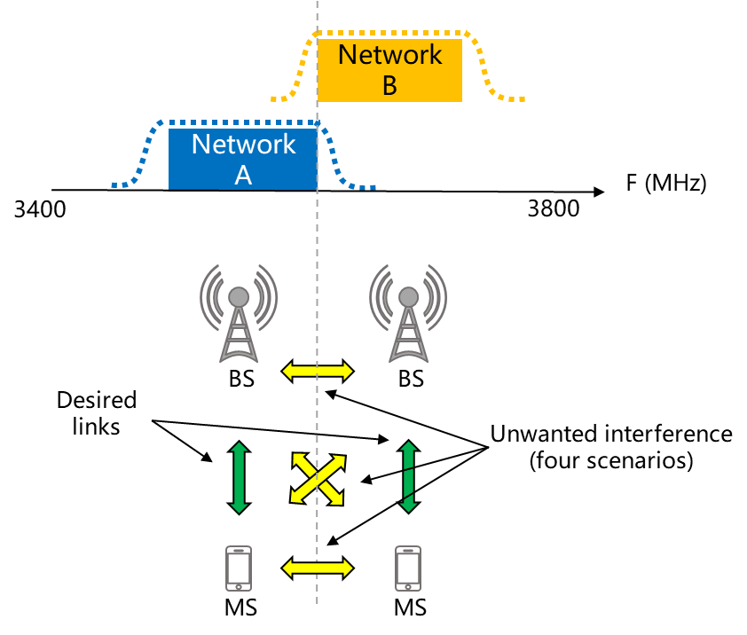
Figure 1: Interference scenarios in case of simultaneous UL / DL transmissions in MFCN TDD networks, from [ECC REP 296]

Frame structures
- This section should give an overview of the LTE and NR frame structures and the possibilities for configuration. This section should not be too extensive and when there is a large overlap with previous reports references can be made to other ECC reports or other relevant reports.
The frame structure selection has an impact on several aspects of network performance, including:
- DL / UL traffic ratio;
- Spectrum utilisation efficiency;
- RTT (Round Trip Time) latency;
- Coverage (DL sync. channel coverage and UL coverage.
These topics are extensively discussed in [ECC REP 296], Although this report discusses the 3.4-3.8 frequency range many conclusions also hold for 26 GHz, e.g. the frame structure lengths will have the same impact on latency. One of the key difference between the 3.4-3.8 GHz frequency range and the 26 GHz band is that there are no LTE deployments in the 26 GHz band. Thus, for the 26 GHz band the considerations relating to alignment of NR and LTE frame structures do not apply.

Benefits and drawbacks
- Either quickly refer back to other reports on the benefits and drawbacks and/or give a short recap.
The benefits and drawbacks of synchronised, semi-synchronised and unsynchronised operation is discussed in [ECC REP 296]. The areas discussed mainly revolve around the implications on clock and frame structure alignment as well as the out of block power limits.
The same benefits and drawbacks qualitatively applies in this band as well, but the exact tradeoff has to take into account the change in propagation conditions for this frequency range.

Evaluations
- This section should contain the evaluations done to be able to make recommendations on syncronisation frameworks.

Parameters used in Evaluations

IMT-2020 Outdoor Hotspot BS Parameters
Table 1: Outdoor BS parameters
Parameter | Value
General
Duplex method | TDD
Band of operation | 26 GHz
Channel Bandwidth | 200 MHz
Antenna height (radiation centre) | 6 m or 15 m (above ground level)
Sectorization | 3 sectors
Downtilt | 10 or 15 degrees
Antenna deployment | Below roof top/At the edge of the roof
Network loading factor | 100% (full buffer traffic)
Antenna Pointing | - [Directly toward served UE, Huawei to confirm]
Antenna Characteristics
Antenna pattern | Refer to Recommendation ITU-R M.2101
Element gain | 5 dBi
Horizontal/vertical 3 dB beamwidth of single element (degree) | 65º for both H/V
Horizontal/vertical front-to-back ratio (Am and SLAV) | 30 dB for both H/V
Antenna polarization | Linear ±45º
Antenna array configuration (Row × Column) | 8x8 elements
Horizontal/Vertical radiating element spacing | 0.5 of wavelength for both H/V
Array Ohmic loss (dB) | 3
Antenna Normalisation | Applied
Transmitter Characteristics
Power dynamic range (dB) | 0 dB conducted BS output power
Spurious emissions | –13 dBm/MHz Total Radiated Power
Conducted power (before Ohmic loss) per antenna element (dBm/200 MHz) | 10
Receiver Characteristics
Noise figure | 10 dB
Sensitivity | –
ACS | 23.5 dB
SINR operating range | The SINR mapping function is given in section xxx

IMT-2020 Indoor BS Parameters
Table 1: Indoor BS parameters
Parameter | Value
General
Duplex method | TDD
Band of operation | 26 GHz
Channel Bandwidth | 200 MHz
Antenna height (radiation centre) | 3 m above floor level
Sectorization | Single sector
Downtilt | 90 degrees (ceiling mount)
Antenna deployment | N/A
Network loading factor | 100% (full buffer traffic)
Antenna Pointing | [Directly toward served UE, Huawei to confirm]
Antenna Characteristics
Antenna pattern | Refer to Recommendation ITU-R M.2101
Element gain (dBi) | 5
Horizontal/vertical 3 dB beamwidth of single element (degree) | 90º for both H/V
Horizontal/vertical front-to-back ratio (dB) | 25 for both H/V
Antenna polarization | Linear ±45º
Antenna array configuration (Row × Column) | 8x8 elements
Horizontal/Vertical radiating element spacing | 0.5 of wavelength for both H/V
Array Ohmic loss (dB) | 3
Antenna Normalisation | Applied
Transmitter Characteristics
Power dynamic range (dB) | 0 dB conducted BS output power
Spurious emissions | –13 dBm/MHz Total Radiated Power
Conducted power (before Ohmic loss) per antenna element (dBm/200 MHz) | 5
Receiver Characteristics
Noise figure | 10 dB
Sensitivity | –
ACS | 23.5 dB
SINR operating range | The SINR mapping function is given in section xxx

IMT-2020 UE Parameters
Table 1: UE Parameters
Parameter | Value
Antenna Parameters
Body loss resulting from proximity effects | 4 dB
Antenna pattern | Refer to Recommendation ITU-R M.2101
Element gain | 5 dBi
Horizontal/vertical 3 dB beamwidth of single element (degree) | 90º for both H/V
Horizontal/vertical front-to-back ratio (dB) | 25 for both H/V
Antenna polarization | Linear ±45º
Antenna array configuration (Row × Column) | 4x4 elements
Horizontal/Vertical radiating element spacing | 0.5 of wavelength for both H/V
Array Ohmic loss (dB) | 3
Antenna normalisation | Applied
Transmitter Characteristics
Power dynamic range (dB) | 63 dB
ACLR | 17 dB
Spurious emissions | –13 dBm/MHz Total Radiated Power
Conducted power (before Ohmic loss) per antenna element (dBm / 200 MHz) | 10
Power control model | Refer to Recommendation ITU-R M.2101
Maximum user terminal output power, PCMAX | 22 dBm
Transmit power (dBm) target value per 180 kHz, P0_PUSCH | -95
Path loss compensation factor,  | 1
Receiver Characteristics
Noise figure | 10 dB
Sensitivity | –
ACS | 22.5 dB
SINR operating range | The SINR mapping function is given in section 3.3

- This section should contain the parameters and models relating to specific node types. Examples include antenna configurations, transmit powers, power control models, etc.

Evaluated Deployments

Outdoor vs. Outdoor [(uncoordinated locations)]
In this deploymet there are two networks consisting of three-sector sites in a hexagonal layout. The networks are shifted so that the minimum distance between two BS is what is defined in Table 1. The direction of the antennas can be the same which results in a 60 degree offset between the victim and agressor. This is illustrated in in Figure XXX. The BS in the victim network can also be rotated 60 degrees so that the offset between the victim and agressor is 0 degrees. This is illustrated in figure XXX.

Table 1: Outdoor vs Outdoor deployment
Parameter | Value
Inter-site distance | 200 m
Minimum distance between nodes (network shift) | One of: 30m, 70m, 114m
Offset angle between aggressor and victim | - [30 degrees as baseline, 0 degrees as sensitivity analysis, HW to propose update]  HW propses: To use both 30 and 0 degrees as alternatives in studies until reference for the baseline above can be shown.
BS heights | Two cases:  6m height in both networks and 15m height in both networks
UE distribution | Random uniform distribution over the cells
Figure XXX: Outdoor vs Outdoor deployment with 30m distance and 60 degrees offset
Figure XXX: Outdoor vs Outdoor deployment with 30m distance and 0 degrees offset

Table 1: Outdoor vs Outdoor propagation modelling

Table style: ECC Table – red header | Style: ECC Table Header white font
BS-UE | UMi
BS-BS | For 6m BS antenna height: UMi  For 15m BS antenna height: [UMi and free space]
UE-UE | N/A

Outdoor vs. Indoor
The indoor system consists of a single building with 3 access points.
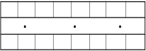
Table 1: Outdoor vs Indoor deployment
Parameter | Value
Indoor system deployment | Indoor office:  Floor dimensions:  120 m × 50 m × 3 m  No. of cells: 3  ISD = 40 m
Minimum distance between outdoor BS and building wall (network shift) | 30m
Building orientation | Outdoor BS in the middle of short wall or long wall (2 cases)
BS heights | Outdoor BS: 6m  Indoor BS: 3 m
UE distribution | Indoor office: Random uniform distribution in the building.  Outdoor: Random uniform distribution over the cells except the area occupied by the building.
Table 1: Outdoor vs Outdoor propagation modelling
Table style: ECC Table – red header | Style: ECC Table Header white font
BS-UE | UMi  For wall penetration M.2109
BS-BS | UMi  For wall penetration M.2109
UE-UE | N/A

- This section contains explanations for the deployments used in the evaluations. For example this section can contain explanations of how sites are located in relation to each other, where buildings are placed etc.

Evaluation 1 – OUTDOOR VS OUTDOOR
- This section contains results from one set of evaluations. Further sections contain more results for other evaluations.
The uplink throughput is evaluated in an area with two macro networks deployed. In the propagation model there is a random component. Since the propagation between base stations is not likely to change we have done several simulations with the BS to BS propagation constant. In Figure X, the result of 20 different simulations is shown. In Figure Y the values for all simulations are averaged.
The results show that an ACIR in the range between 24 and 33 dB is required to achieve less than 5% throughput loss in this scenario. In average an ACIR of 29 dB is required.
Figure X - Uplink throughput loss averaged over the outdoor hotspot BS serving different users for different realizations of the channel model for 6m BS height.
Figure Y - Uplink throughput loss averaged over the outdoor hotspot BS serving different users for different realizations of the channel model for 6m BS height.

EVALUATION 3 - OUTDOOR VS. OUTDOOR
The deployment used is the deployment in section outdoor vs outdoor deployment. The base station offset is 0 degrees.

Simulation parameters and propagation models
The parameters used are according to the ones shown in Section 5.1.1 with the following exceptions and the following selected options:
Table X1. IMT-2020 parameters used in the simulations
Parameter | For 6m antenna height (urban/ suburban hotspot) | For 15m antenna height (suburban open space)
BS-BS propagation model | UMi (not selectable) | ITU-R Recommendation P.525 (free space path loss)
Antenna downtilt | 10° | 15°
Interferer-victim sites offset | 30 m | 30m, 70 m
Antenna boresites offset | 0º | 0º
Array Ohmic loss (dB) | 0 dB | 0 dB
Beamforming, UEs distribution | Beamforming towards UEs (closest beam out of the beamset serves individual UEs)  UEs uniformly distributed in each hexagonal cell | Beamforming towards UEs (closest beam out of the beamset serves individual UEs)  UEs are uniformly distributed in each hexagonal cell
Beam set at TRxP  (Constraints for the range of individual analogue beams per TRxP) | For direction of TRxP analogue beam steering (in LCS):  Azimuth angle phai_i:  [-56.25º, -33.75º, -11.25º, 11.25º, 33.75 º, 56.25º]  Zenith angle theta:  6x3 beamset :  j = [84º,96º,129º]  6x4 beamset:  j = [84º, 96º,112º,129º]  NOTE: (azimuth, zenith)=(0, 90) is the direction perpendicular to the array plane.

Simulation results

6m antenna height - Urban/suburban hotspot scenario
Figure X3 shows the estimated degradation of the mean uplink throughput of the victim MFCN network due to base station to base station interference for the urban/suburban hotspot scenario, presented as a function of ACIR.
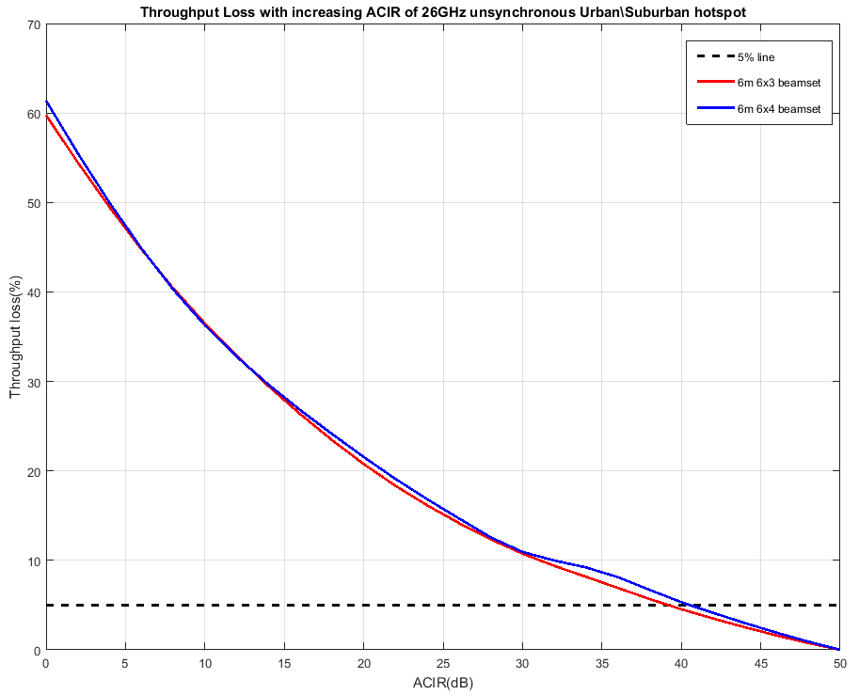
Figure X3: Impact of base station to base station interference on mean uplink throughput, urban/suburban hotspot (ACIR) - 30m offset between interferer and victim BS
Figure X4 shows the estimated degradation of the mean uplink throughput of the victim MFCN network due to base station to base station interference for the urban/suburban hotspot, presented as a function of the absolute OOB emission limit in dBm/MHz.
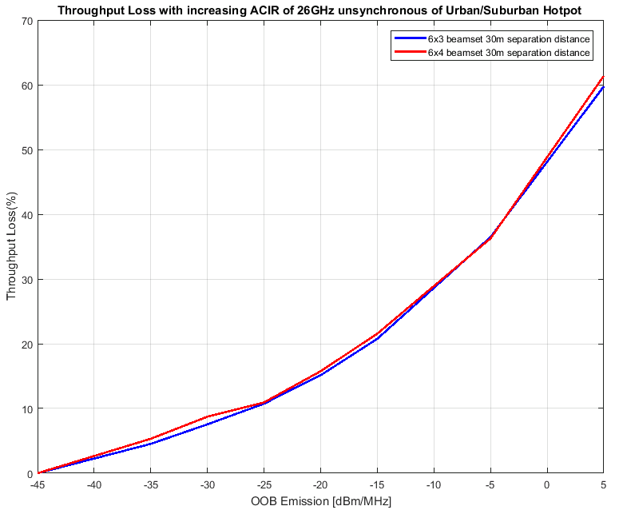
Figure X4: Impact of base station to base station interference on mean uplink throughput, urban/suburban hotspot (OOB emission limit) - 30m offset between interferer and victim BS

15 m antenna height - Suburban open space scenario
Figures X5 and Y5 (for 30m and 70m offsets between the interferer base station and the victim base station respectively) show the estimated degradation of the mean uplink throughput of the victim MFCN network due to base station to base station interference for the suburban open space scenario, presented as a function of ACIR.
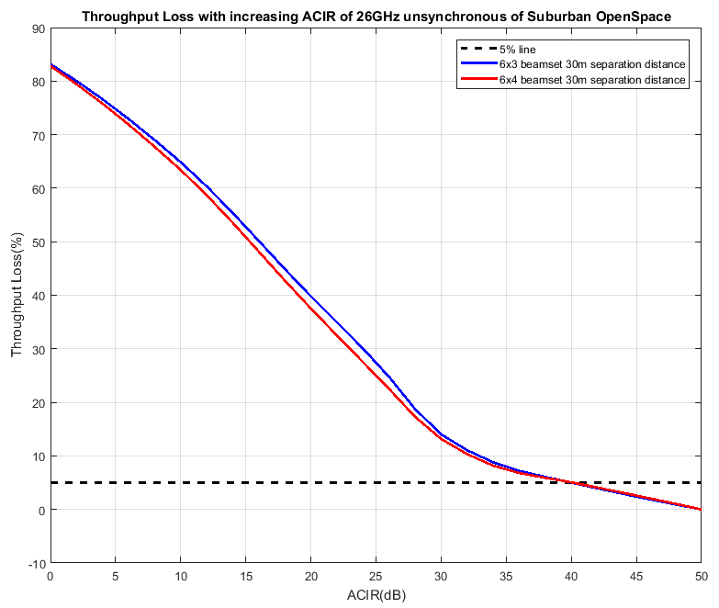
Figure X5: Impact of base station to base station interference on mean uplink throughput, suburban open space (ACIR) - 30m offset between interferer and victim BS
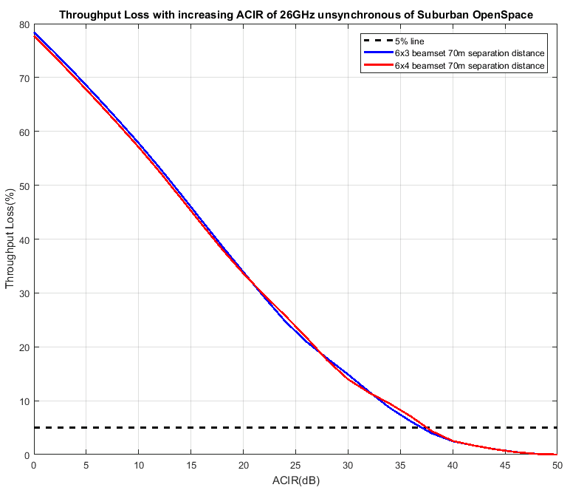
Figure Y5: Impact of base station to base station interference on mean uplink throughput, suburban open space (ACIR) - 70m offset between interferer and victim BS

Figure X6 and Y6 (for 30m and 70m offsets between the interferer base station and the victim base station respectively) show the estimated degradation of the mean uplink throughput of the victim MFCN network due to base station to base station interference for the suburban open space scenario, presented as a function of the absolute OOB emission limit in dBm/MHz.
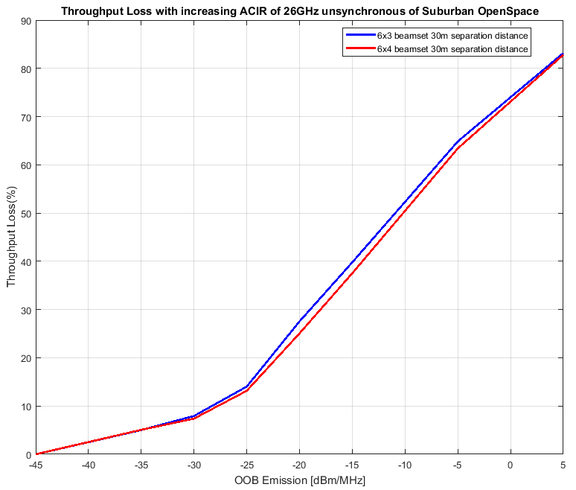
Figure X6: Impact of base station to base station interference on mean uplink throughput, suburban open space (OOB emission limit) - 30m offset between interferer and victim BS
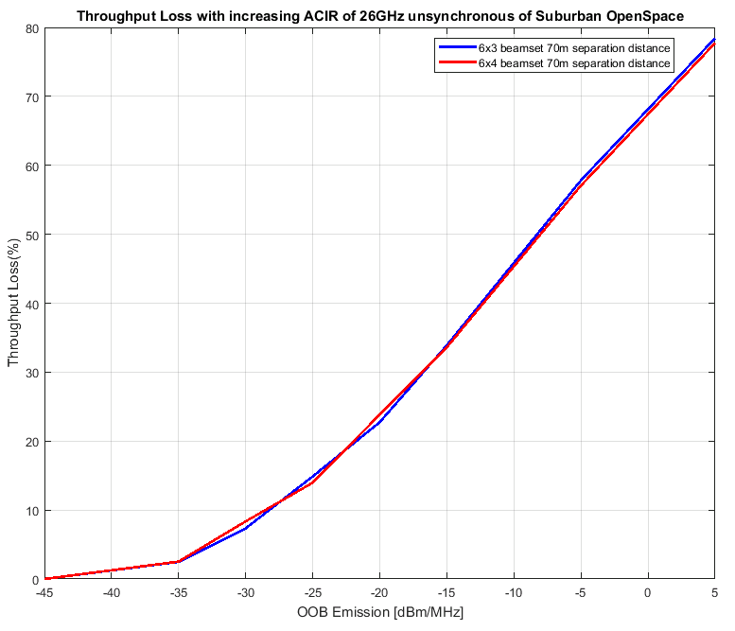
Figure Y6: Impact of base station to base station interference on mean uplink throughput, suburban open space (OOB emission limit) - 70m offset between interferer and victim BS

Summary of the simulation results
Tables X4 below presents the derived restrictions on the out-of-block emission levels of the interfering MFCN base station based on a target 5% degradation in the mean UL throughput of the victim MFCN base station, for the non-synchronised operation.
Note that the minimum required ACLR is assumed to be nominally equal to the required ACIR, with the understanding that the interference is not dominated by the adjacent channel selectivity (ACS) of the victim base station.
Table X4. Out-Of-Block (OOB) emission limits on interfering MFCN base station (outdoor vs outdoor, uncoordinated locations, non-synchronised operation, up to 5% degradation in the mean uplink throughput of victim MFCN base station)

Interferer BS channel bandwidth | Victim BS channel bandwidth | In-block radiated power, TRP | Scenario | ACIR, min (dB)  (~ACLR) | OOB emission limit (dBm/MHz)
200 MHz | 200 MHz | 28dBm/200MHz | Urban/suburban hotspot, 30m offset between interferer and victim BS | 39…40 | -35…-34
200 MHz | 200 MHz | 28dBm/200MHz | Suburban open space, 30m offset between interferer and victim BS | 40 | -35
200 MHz | 200 MHz | 28dBm/200MHz | Suburban open space, 70m offset between interferer and victim BS | 37…38 | -33…-32
In summary, the impact of the interference on the victim MFCN base stations performance diminishes with increasing values of ACIR or, equivalently, with the decreasing Out-Of-Block (OOB) emissions levels of the interfering MFCN base stations. It could be concluded from this evaluation that the Out-Of-Block emission limit of –35 dBm/MHz for MFCN base stations would ensure a co-existence of MFCN outdoor non-synchronised networks deployed in a non-coordinated manner and operating in the same or immediately adjacent geographical areas in all types of environments.

Evaluation 5 – OUTDOOR VS Outdoor
In this section, the UL throughput loss is evaluated in the Outdoor vs Outdoor deployment for the two cases of fully unsynchronized and semi-synchronized operation. The two operators network layout is illustrated in Figure 3 for a network shift of 30m.
Assumptions on UE parameters are in agreement with simulation assumptions defined by ITU-R with the exception of UE antenna array configuration and UE output power. In this report we considered a 2x2 UE antenna array and 11.4dBm UE output power to reflect the current development of the industry and 3GPP standard.
In the case of fully-unsynchronized operation, the impact of asynchronous BS to BS interference on the average UL throughput of the single operator network is shown in Figure 5 for different network shift values. From the results we see that performance degrades very fast for network shifts below 80m but, even in the worst case of 30m network shift, it is possible to keep the target degradation within 5% by adopting requirements in line with the ones defined for the synchronous case.
In the case of semi-synchronized operation, Figure 5 shows the average UL throughput loss in the worst case of 30m network shift when 20% and 50% of the frame is synchronized. It is worth noticing that these results can also be used as a reference in the case two operators have fully unsynchronized (in terms of frame structure and alignment) operation but with opposite duplex directions for only 80% or 50% of the frame. In conclusion, the ACIR required to satisfy the 5% throughput loss condition narrows down already to 28dB when two networks have opposite duplex directions for 80% of the time.
Figure 3. Two operators network layout - Outdoor vs Outdoor
Figure 5. Average UL throughput loss in case of fully-unsynchronized operation

Figure 5. Average UL throughput loss in case of semi-synchronized operation

Evaluation 2 – OUTDOOR VS INDOOR
The uplink throughput is evaluated in the Outdoor vs Indoor deployment. Two cases are evaluated with the short wall facing the BS (case 1) and the long wall facing the BS (Case 2). The system layout is illustrated in Figure X.
The impact of the Outdoor network on the Indoor network is shown in Figure X and Figure Y. The same reasoning regarding the realisation of the BS-BS propagation is applied as in Evaluation 1. We can see that an average throughput loss of less than 5% is always achieved for an ACIR of 20 dB.

Case 1 | Case 2
Figure Y – System layout for Case 1 (short wall facing the BS) and Case 2 (long wall facing the BS)
Case 1 | Case 2
Figure Y – Uplink throughput loss for the Indoor network. Throughput loss in each curve averaged over many realisations of the Macro BS serving different users.

Case 1 | Case 2
Figure Y - Average uplink throughput loss for the Indoor network. Throughput loss averaged over different O2I channel realizations and the interfering Macro BS serving different users.

Evaluation 3 – OUTDOOR VS INDOOR
The uplink throughput is evaluated in the Outdoor vs Indoor deployment. The two operators network layout is illustrated in Figure 1. The three dots represent the Indoor victim network inside the building while the outdoor hexagonal network is the aggressor system.
Assumptions on UE parameters are in agreement with simulation assumptions defined by ITU-R with the exception of UE antenna array configuration and UE output power. In this report we considered a 2x2 UE antenna array and 11.4dBm UE output power to reflect the current development of the industry and 3GPP standard.
The impact of asynchronous BS to BS interference on the average UL throughput of the single operator network is shown in Figure 1 and it is negligible for every value of ACIR. Based on these results, we conclude that in this scenario asynchronous operation is possible even in the case of co-channel operation.
Figure 1. Two operators network layout - Outdoor vs Indoor
Figure 2. Average UL throughput loss due to aysnchronous BS to BS interference

Analysis and Synthesis
- This section should contain a discussion and synthesis from the results in the previous section. This secion should also contain the motivation for the recommendations in the next section.

Baseline Performance Specifications
The total interference caused in one channel by transmitters in an adjacent channel depends on both the emissions in the adjacent channel caused by the interfering transmitter as well as the ability of the receiver to suppress (strong) signals in the adjacent channel. These two effects are combined into what is known as the adjacent channel interference ratio (ACIR) [3GPP TR 38.803 clause 5.2.6]. The ACIR can be calculated as follows for two systems of the same bandwidth:

The values for Adjacent Channel Selectivity (ACS) and Adjacent Channel Leakage Ratio (ACLR) can be found in the technical specifications of the systems. For NR the levels given are 28 dB for ACLR [3GPP TS 38.104 Table 9.7.3.3-1] and 23 dB for ACS [3GPP TS 38.104 Table 10.5.1.3-1]. This will then in total give a ACIR of around 22 dB.Service dependence, embb vs URLLC
Two of the main envisioned service categories for 5G are mobile broadband (eMBB) and ultra reliable and low latency (URLLC) services.
For eMBB the main performance measure is throughput, either measured as capacity in a cell or as the datarate that can be achieved by a specific user. Since this has been the predominant service for quite some time the measurements and requirement levels are well established. It is quite common to use 5% throughput loss as the limit when conducting sharing studies between MFCN networks. In practice this means that some of the transmissions are lost, but there are mechanisms for detecting packet losses and retransmitting that so that all data eventually reaches the receiver.
For URLLC the performance measures are not as well established. One observation is that for services that rely on extremely short latency there is no time to perform retransmissions. This means that more stringent requirements should be applied compared to the eMBB case.

Scenario comparison
When comparing the ACIR values obtained from the technical specifications with the results obtained in the studies we can see the following:
From the studies carrier out so far, in the Outdoor vs Outdoor evaluation we see that the baseline equipment performance does not meet the requirement of 5% throughput loss.
For the Outdoor vs. Indoor evaluation the performance requirements for eMBB type of services are met. For URLLC the performance requirements are met most of the time, but exactly how often depends on the exact requirement that is used.

Recommendations for Regulatory framework

Recommendations for indoor deployment with single licensee
For the case with a single licensee operating insida a specific building there is no need to synchronise the network to other networks that are outside of the buuilding if the indoor and outdoor networks are on adjacent channels.
When the licensee in the building and outside of the building are using the same (co-)channel ????

Recommendations for outdoor deployments
For the case of networks deployed outdoor, where the BS are using the baseline emission limits and when the network is deployed in in the same geographic area (closer than X m) as other networks on adjacent channels. [It is necessary to synchronise or semisynchronise the networks with a small fracton e.g. up to X% flexible frames.]
For the case where the BS are using the baseline limits, but there is a geographical separation of at least X m there is no need to synchronise if the networks are using adjacent channels. If there networks are using the same channel the separation distance should be at least Y m.
For the case where the networks are deployed outdoor in the same geographic area (closer than X m) and where the BS emissions meet a restricted baseline limit of Z dBm/50 MHz there is no need to synchronise the networks.

Recommendations for Indoor deployment with mulitple license holders
Studies are missing.
It should be noted that differences in the resulting OOB limits derived in individual evaluations for the similar scenarios can be explained by different specific deployment assumptions (e.g. the offset angle between the aggressor and victim base stations) adopted in the different simulations. Accordingly, it was not always possible to provide a unified recommendation with one scenario-specific OOB limit for the unsynchronised/semi-synchronised operation of MFCN networks in the 26 GHz band. Thus, recommendations for some scenarios suggest a range of the OOB limit values which could be seen as corresponding to the different levels of acceptable interference between unsynchronised/semi-synchronised networks.

Conclusions
- (advice: a conclusion may review the main points of the ECC Report. A conclusion might elaborate on the results of the ECC Report and suggest extensions.)

- Heading (style: ECC Annex - Heading1)
- Placeholder for annexes.
- List of Reference
- Reference one (style: reference)
- Reference two
- etc.

Example of Footnote

