ECC PT1 |  | ECC PT1(22)211
ECC PT1 #72
Hybrid: Copenhagen and web meeting, 26-30 September 2022
Date issued: | 20 September 2022
Source: | Ericsson, Huawei and Nokia
Subject: | Parameters assumption for sharing and compatibility analysis of FSS (Earth-to-space) operating in the frequency band 6 425 - 7 075 MHz and IMT operating in the frequency band 6 425-7 125 MHz for WRC-23 agenda item 1.2
Group membership required to read? (Y/N)
N
Summary:
This input contribution aims to provide some information on the parameters used for the sharing studies of FSS (Earth-to-space) in the 6 GHz frequency band under WRC-23 agenda item 1.2.

Proposal:
ECC PT1 is invited to
- consider IMT deployment Ra option 1 and Rb option 3
- consider the correction to Rb by removing unpopulated areas when considering large study areas which includes African countries
- consider not to include rural deployments.
- consider the sharing studies without apportionment
- consider FSS antenna normalisation/scaling and account for antenna efficiency
- consider the potential to use either the Recommendation ITU-R P.2108-1 or Annex 6 to document 3K/178 for the clutter loss model

Background:
There have been 18 studies (for the 6 GHz FSS uplink) submitted to ITU-R WP 5D where 14 of those studies indicated that coexistence is feasible between the IMT and FSS uplink. Out of these 14 studies, 10 of them are from administrations, and no studies from CEPT countries showing coexistence is not feasible, paving the way for an IMT identification in the 6 GHz frequency range under WRC-23 agenda item 1.2.
The sharing studies were done based on the parameters provided by ITU-R WP 5D along with some assumptions that are not defined. The result of the studies varies depending on the choice of parameters and the assumptions considered.

Introduction
There have been 18 studies (for the 6 GHz FSS uplink) submitted to ITU-R WP 5D where 14 of those studies indicating that coexistence is feasible between the IMT and FSS uplink. 10 out of these 14 studies were submitted by administrations.
The sharing studies were done based on the parameters provided by ITU-R WP 5D along with some assumptions that are not defined. The result of the studies varies depending on the choice of parameters and the assumptions considered.
Although there are no studies from CEPT administrations showing that coexistence is not feasible, it is still good to provide further information to inform other administrations who are not too familiar with the current discussions and disagreements in the choice of parameters and assumptions.

Parameters and assumptions
There have been some disagreements in some of the parameters and assumptions used in the studies and these are:
- Choice of Ra and Rb options
- Corrections to Rb to account for unpopulated areas
- Deployments in rural areas
- Apportionment of the interference criterion between multiple services
- Scaling of FSS antenna gain
- Modelling of clutter losses

Choice of Ra and Rb options
Ra and Rb are two of the parameters used in the sharing studies for IMT at WRC-23. They are used to estimate the density of IMT BSs for a large area, and hence choosing the appropriate value is important.
They form part of the methodology agreed by WP 5D in 2021 for the Characteristics of Terrestrial Component of IMT for Sharing and Compatibility Studies in Preparation for WRC-23. This methodology, and the options for Ra and Rb, are given in Annex 4.4 to the Chairman’s report of the 38th Meeting of WP 5D. The options for Ra and Rb are shown in the table below (in section 2.1.1). Proponents of studies must choose which value is appropriate to the land area under study. As such, choosing the appropriate value for Ra and Rb is critical to the validity of the study.

Ra and Rb explained
The formula from the WP 5D for estimating the density of macro-cellular IMT BS (Dl) is below. The resulting density must be multiplied by the area of the study (in km²) to arrive to the total number of BSs modelled in the area:
Dl = Ds * Ra * Rb
where:
Ds = density value for coverage area, i.e. density of simultaneously transmitting BS per km²;
Ra (%) = ratio of coverage areas to areas of cities/built areas/districts;
Rb (%) = ratio of built areas to total area of region in study.
For the formula above, WP 5D provides values for Ds, Ra and Rb for urban and suburban deployments as follows:

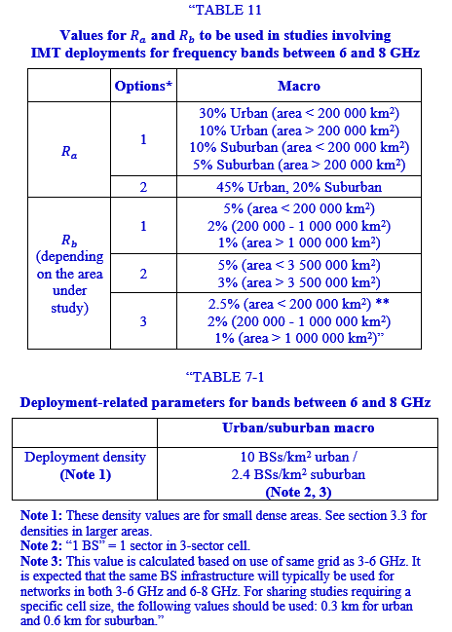

The application of this methodology when urban and suburban deployments are considered results in a total number of IMT BSs in the area under study of
$$N_{BS}=N_{BS,u}+N_{BS,s}=\left(D_{u}R_{a,u}R_{b}+ D_{s}R_{a,s}R_{b}\right)A$$
Where A is the area in km² and the “u” and “s” subscripts indicate values for urban and suburban scenarios respectively.

Choosing Ra and Rb
The choice of Ra and Rb values is important to the study outcome. Many of the studies in WP 5D consider very large areas, such as the entire African continent (approximately 30 million km²) or the visible area of a satellite covering all of Region 1 and Region 2 (90 million km²).
These areas will cover countries or regions that are highly developed, with high population density, but also deserts, forests and other unpopulated locations. It cannot be assumed that Ra & Rb options that are valid for small size, highly developed countries (for instance, Germany or the Netherlands), can be used across a simulation area of millions of km². When the simulation area is very large (such as the millions of km² in Region 1 or just the African continent), it is only realistic to choose the Ra and Rb options that more closely represent the reality of the entire large area on average. With this in mind, the values relevant to large study areas are:
Ra - Option 1
Rb - Options 1 & 3
It must be noted that:

- The formula above calculates the number of BSs operating co-channel, and not the number of BSs in the band. Consequently, if one seeks to estimate the total number of BSs deployed in the 6 GHz band, N_{BS} above would need to be adjusted taken into account of multi-channels. It is important to take this into account if the results of the formula are compared with deployments in existing bands
- WP 5D has not defined the Ra and Rb values in Table 11 as high/low values of a range. Instead, these options are alternatives, and the proponents of a study must evaluate which Ra and Rb options are most appropriate for the area under consideration in their study.
While it can be difficult to estimate the value of Ra for a large area, Rb can be easily tested. The Rb options proposed by WP 5D can be compared with publicly available datasets of built-up ratio per country, such as the data provided by the OECD and used in contribution 5D/996 from Cameroon. This data shows that the actual built-up ratio of the Region 1 plus Region 3 land area (91 million km2) is about 0.6%, and thus Rb=1% is the most appropriate value for such scenario.
2.1.2.1 Example of calculations of a number of co-channel macro-cellular 100 MHz carriers at 6 GHz for Region 1
- Total area of Region 1 is 56,315,536 km².
- Region 1 consists of Europe, Sub-Saharan Africa, ASMG and RCC members.
Table below shows the result of calculations of estimated numbers of co-channel macro-cellular carriers at 6 GHz in Region 1 based on parameter value options proposed by WP 5D.

WP5D: Estimated no. of co-channel  macro-cellular 100 MHz carriers at 6 GHz |  | $$R_{a}$$
 |  | Option 1 | Option 2
$$R_{b}$$ | Option 1 | 630,734 | 2,804,514
$$R_{b}$$ | Option 2 | 1,892,202 | 8,413,541
$$R_{b}$$ | Option 3 | 630,734 | 2,804,514
We have compared the above numbers with corresponding commercially available data from Ookla for Region 1. The analysis indicates that:
- (Ra1, Rb1) is readily justified in Region 1 for the 6 GHz band, when comparing with IMT deployments in the most mature and similar bands; namely 2.6 GHz band in Europe/Russia and the 1.8 GHz band in ASMG, Sub-Saharan Africa and the rest of RCC.
- (Ra2, Rb2) over-estimates the number of BSs by a factor greater than 13.

Corrections to Rb to account for unpopulated areas
There were comments in the discussions during PT1 #71 where some studies consider a correction to Rb where the study area includes the Africa continent.
The topography of Africa is also a unique challenge when making choices for assumptions. As noted in 5D/996, the real built up ratio for most African countries is below 1%. Only 3 countries of small size (Gambia, Mauritius and Comoros) have a built-up ratio higher than 1% in Africa, and the African average is 0.15%. However, the minimum allowed by the Rb parameters, which is 1%, exceeds these values significantly.
The smallest value of Rb tends to overestimate the built-up ratio when the area under study is very large (millions of km2), but importantly it also overestimates the built-up ratio for African countries. A study that models IMT in the Africa land area and uses Rb=1% to calculate the number of BSs would grossly overestimate the proportion of built-up areas in Africa and subsequently the number of BSs and the interference at the satellite. The same problem arises when area under study a satellite visible area, which can cover for instance Africa, Europe, Middle East and Asia.
Some WP 5D participants have addressed this inaccuracy with the removal of unpopulated areas from the simulation (for instance 5D/782 from Cameroon, Nigeria, South Africa and Zimbabwe, 5D/1042 from France). This makes sense: if an area is unpopulated (pop. density less than 1 person/km²), then it will not have any built-up and its Rb would be 0%.
It has been argued that the use of Rb=1% together with the removal of unpopulated areas is double counting. This is not correct. For instance, the area of study in 5D/782 consists of the African continent after the removal of unpopulated pixels in the Sahara desert. The built up ratio of this area of study (Africa excluding unpopulated pixels in the Sahara) is still below 1%. Therefore, using Rb=1% still overestimates built up even after unpopulated areas are removed.

Deployments in rural areas
6 GHz is an upper mid-band that will typically be used to provide city-wide coverage. Rural areas will rely on lower bands, especially those below 1 GHz, as these have better propagation characteristics for covering sparsely populated areas.
If studies assume a deployment of 6 GHz with extensive rural coverage, they will significantly overestimate the total number of base stations that will be deployed and thus produce more negative sharing results.
There are two aspects to consider with regards to the potential inclusion of rural deployments in the studies:
- The guidance from WP 5D in the IMT parameters document (Annex 4.4 to 5D/716)
- The reality and experience of mobile deployments in rural areas

WP 5D guidance
WP 5D work on IMT parameters in Annex 4.4 to 5D/716 assumes that rural areas will not be the target deployment scenario for 6-8 GHz. Annex 4.4 states that:
“contiguous coverage is not expected in this frequency range in rural areas, and any such base stations that may exist in small numbers will be isolated installations at specific locations”.
It also notes that If the rural deployment environment is modelled in a sharing study, it should assume the BS density (per sector) of 0.001 - 0.006 BS per km² . However, the document clarifies that:
“These BS density (per sector) values have been derived for an area of around 100 000-500 000 km² and some initial analysis subject to further verification showed it could be applicable up to 2 000 000 km².”
It further states that:
“For studies involving IMT deployments over smaller or larger areas (than 500 000 km2), including the case where mixed environments of urban, sub-urban and rural are considered in the satellite footprint, it may not be appropriate to assume that IMT base stations will be deployed at the same density as the above across the whole area, and thus, the deployment density values may need to be adjusted. This adjustment should be explained together with the results of studies.”
Finally it is worth emphasising that Annex 4.4 to 5D/716 states:
“It should be noted that the 'Ra, Rb methodology' described in Section 3.3 needs to be further developed in order to fully accommodate the rural deployment scenario”
The Ra/Rb methodology thus needs to be further developed to fully accommodate the rural scenario, and, as it stands, using Ra or Rb equal to 100% together with the rural densities above would overestimate the numbers of BSs in rural areas.

The reality of rural mobile deployments
In practice the 6 GHz band is unlikely to be chosen by mobile operators for deployment in rural areas. Population density is a key driver of traffic demand in any given area: the higher the density, the higher the demand. Operators will fulfil the demand with the most efficient technology solution. Low frequencies provide better coverage and are cheaper to deploy, so they will be used first. If traffic demand exceeds the capacity in the low frequencies, then operators would use lower mid-bands (2100 MHz, 2600 MHz) which will have a better coverage and cost than higher bands. Upper mid-bands like 6 GHz will, in reality, be used in denser urban and suburban usage areas.
This is because in practice demand from rural areas (which by definition have lower population density than urban/suburban areas) will not be so high as to require deployment of high frequencies such as C-band, 6 GHz or mmWave.
It is highly improbable, either from a demand perspective or an economic feasibility perspective, that the 6 GHz band will be used to provide contiguous rural coverage. Any deployment for a small rural town or isolated population centre would not stretch to coverage of uninhabited locations such as fields or wild areas. The WP 5D parameters document clearly states this, and only provides tentative BS densities that cannot be directly applied to large areas.

Apportionment of the interference criterion between multiple services
Apportionment is the process of defining how much of the total theoretical interference allowance to one service can come from any other specific service. In the case of 6 425-7 125 MHz, this means defining how much of the protection criteria assigned to existing primary allocations, e.g. FSS, may apportioned to the other services to which the band is allocated e.g. MS and FS.
The question of apportionment of theoretical interference is a delicate balance that merits careful study and must not be done arbitrarily (such as splitting the apportionment on a 50:50 basis between two services). The precise characteristics of the services involved must be taken into account.
WP 4A has provided protection criteria for satellite receivers. The criteria specify the interference power level that should not be exceeded for a percentage of time. The criteria used by most studies in WP 5D is “I/N=-10.5 dB not exceeded more than 20% of the time”.
This criteria accounts for all possible interference sources meaning that, if there are several services in the band, then the aggregated interference should not exceed the criteria. The 6 425-7 125 MHz is allocated to the Fixed Service on a primary basis, as well as Mobile. As the fixed service is widely deployed, aggregated interference into satellite receivers from FS transmitters and potential IMT deployments must not exceed the criteria.
There is a question of how much of the total interference that is allowed at the satellite receiver should be apportioned to each service. Some studies in WP 5D consider that FS and IMT are each allowed half of the interference power allowed by the criteria. This approach would mean that IMT interference must be lower than -10.5 dB – 3 dB below the Noise level.
However, this is a very coarse approach. If FS interference is very low, then IMT can be allowed to get close to the -10.5 dB criteria. For instance, if FS interference is 20 dB below the criteria, then IMT interference could be 99% of the criteria and the aggregated interference would still respect the -10.5 dB criteria. On the other hand, if the FS interference is half of the total allowed interference (-13.5 dB) , then IMT interference will need to be capped at half as well. This is shown graphically below.
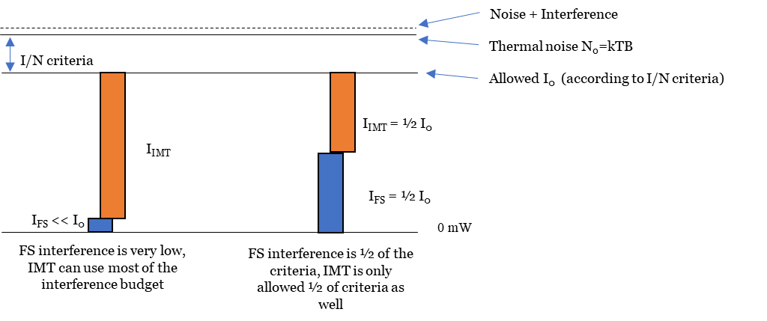

Understanding FS and IMT characteristics
The characteristics of FS interference towards the satellite are very different from potential IMT deployments. First, the number of FS transmitters in the band is not high, in particular when compared to the IMT deployments being considered in WP 5D. Also, the FS antennas are very directive (3 dB BW of less than 3 degrees) and face different azimuth directions and hence the probability of directly pointing towards a satellite is very low. Moreover, the fixed links are spread over the whole band, and only a fraction of FS transmitters would be operating in the same channel as the FSS receiver.
As a consequence, the level of interference from all FS transmitters in the band will be much lower than the potential interference from IMT.
It must be noted that a worst-case scenario where 1) several FS transmitters are directly pointing towards a satellite, 2) the satellite is also pointing to their location (with maximum antenna gain), and 3) there are no obstacles in the way, is extremely unlikely to occur.

Scaling of FSS antenna gain
Realistic assumptions on antenna gain will also positively impact studies. It is not possible to produce antennas that are 100% efficient. In the real world, antennas have losses and some of the energy incident on the antenna’s aperture is, in fact, reflected or otherwise not conducted to the antenna’s connector as electrical output power.
The Total Integrated Gain (TIG) of an antenna represents the integration of the antenna gain $G\left(θ,φ\right)$ over the entire radiated sphere. For a loss-less (perfect) antenna this value is equal to unity, however the TIG of a real antenna will always be less than 1.
$$TIG=\frac{1}{4π}\int_{-π}^{π}{\int_{0}^{π}{G\left(θ,φ\right)\sin\left(θ\right)dθdφ}}$$
Past practice – such as that carried out by TG 5/1 in the WRC-19 process – has been to scale the antenna patterns to ensure that the TIG figure is less than one, and thus correspond to real-life antennas.
However, the models in the studies of IMT – FSS UL coexistence in 6 GHz do not take this into account. The FSS antenna models used in the simulations in WP 5D are based on the parameters provided by ITU-R WP 4A and on the parameters in Appendix 30B. We have calculated the TIG of these antenna models and found that, in all cases, it is higher than one. The tables below show the results for the some of the satellite carriers specified by WP 4A (in 5D/734) and some Appendix 30B allotments for African countries.

WP 4A Carrier | 1 | 2 | 3 | 7 | 8 | 12
WP 4A  peak receive  antenna gain, $G_{m}$ (dBi) | 22 | 28 | 32 | 22 | 32 | 20/36.4
WP 4A  receive antenna  gain pattern, $a\left(θ,φ\right)$ | Recommendation ITU-R S.672-4
WP 4A  receive antenna  gain pattern, $a\left(θ,φ\right)$ | Global beam,  Single-feed, Circular,  BW = 15°. | Hemi beam, Elliptical^{(a)(b)},  BW: 6°×7°.  (a)(b) | Zone beam, Elliptical,  BW: 3°×7°.  (a)(c) | Annex 1 Section 1.1,  $L_{S}$ = -25,  BW: 14°. | Annex 1 Section 1.1,  $L_{S}$ = -25,  BW: 4.5°. | Annex 1  Section 1.1,  $L_{S}$ = -25,  BW: 17.7°/2.6°.
TIG (dBi) | +3.1 | +2.5 | +3.0 | +2.8 | +2.9 | +2.6/+2.9

AP30B allotment | Major axis beamwidth $φ_{01}$ (degrees) | Minor axis beamwidth $φ_{02}$ (degrees) | $G_{max}$ (dBi) | TIG  (dBi)
BFA00000 | 1.7 | 1.6 | 40.1 | +2.5
CTI00000 | 1.6 | 1.6 | 40.4 | +2.6
GHA00000 | 1.6 | 1.6 | 40.4 | +2.6
GUI00000 | 1.6 | 1.6 | 40.4 | +2.6
MLI00000 | 3.3 | 2.5 | 35.3 | +2
NGR00000 | 2.10 | 1.70 | 38.9 | +2.4
SEN00000 | 1.6 | 1.6 | 40.4 | +2.6
This means that the models from WP 4A and AP30B do not represent real antennas. The effect of this in the simulations is that interference will be overestimated because the gain of the FSS receiving antenna is modelled higher than it actually is.
A solution to this problem is to scale the FSS antenna pattern to ensure that TIG is below 1 (0dB), and that antenna efficiency is accounted for. As noted above this approach was applied during the previous study cycle in TG 5/1 to ensure that AAS IMT BSs have a TIG<1.
It is also considered in this cycle at least in two models: the current IMT parameters document (Annex 4.4 to 5D/716) for AAS antennas in 6 to 10 GHz take account of antenna efficiency with the inclusion of ohmic losses of 2 dB, and ITU-R WP 7C has applied an efficiency scaling to the EESS antenna models that are used for studies for the 10-10.5 GHz band.
A methodology to apply the scaling factor to the FSS antenna patterns used in the AI1.2 studies has been submitted to WP 5D (document 5D/1318). The methodology ensures that a) the antenna patterns are normalized so that TIG=1, and b) the efficiency of real antennas is taken into account. A scaling factor such those derived with this methodology should be applied when the antenna models in Rec. ITU-R S.672 and AP30B are used in the studies of sharing between IMT and FSS (Earth-to-space) in the band 6 425-7 125 MHz.
It must be noted that the application of “scaling factor” does not violate the guidance from WP 4A. No consensus was reached in WP 4A regarding this topic and as a result WP 4A produced no guidance, leaving TIG figures unrealistically high and thus the studies that used such figures more negative than reality.

Modelling of clutter losses
Clutter loss is the degree to which natural or man-made obstacles or ‘clutter’ impact the radio signal.
Theoretically the application of clutter loss model is driven by the Line of Sight/Non-Line of Sight (LOS / NLOS) conditions between the interferer and the victim. This is different from “above/below rooftop position”, which reflects an IMT station deployment status rather than typical propagation conditions.
There is no direct link between ‘above/below rooftop deployment’ and ‘LOS/NLOS’ concepts. For a BS deployed above roof, there can be buildings higher than such base station acting as a clutter or shielding. As an example, according to Rec. ITU-R P.452-17 (Table 4), the nominal clutter height for urban areas is 20-25 metres which is higher than IMT BS height of 18 metres. Therefore, an IMT BS deployed above rooftop can still be below the surrounding clutter height and NLOS conditions would apply. Furthermore, depending on building statistics of a specific area, the distribution of buildings can vary with buildings taller than the nominal clutter height. Therefore, the 3K/178 model addresses this and the following figure illustrates the CDF curves of the clutter loss for urban macro BS.
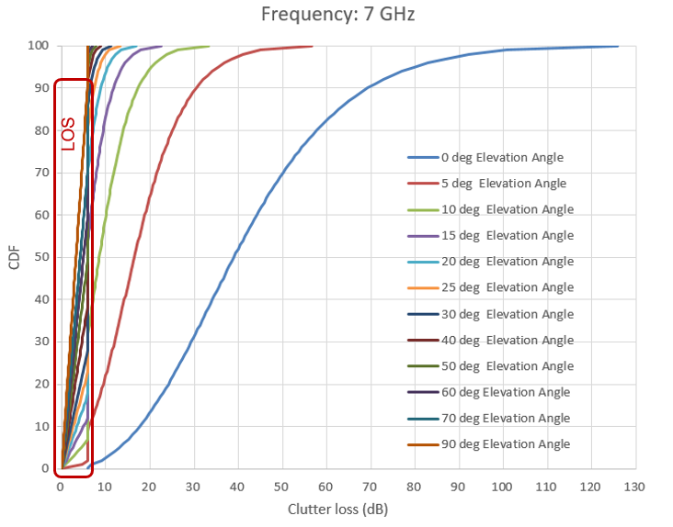
For the studies considering the 6 GHz band under AI 1.2, the current model in Rec. ITU-R P.2108-1 was originally meant for frequencies above 10 GHz considering low terminal heights, whereas the scenarios considered for the 6 GHz studies under AI 1.2 are different. This is also addressed in the updated model (Annex 6 to Document 3K/178).
Both the model in Rec. ITU-R P.2108-1 and the clutter loss model in Annex 6 to Document 3K/178 (3K/178 model) could be used to model the clutter loss in sharing studies with equal status.

Conclusion
The choice of parameters and assumptions in a study is key to achieve meaningful results. The assumptions must be realistic and based on evidence as much as possible. Studies should use the most advanced propagation and clutter models, which benefit from the progress in our understanding of the subject over the years. On the other hand, if worst case assumptions are used, then studies will not be representative of real scenarios and will invariably conclude on a negative assessment of coexistence.
With this in mind, it is proposed that studies should converge to a set of assumptions that allows to model IMT deployments and FSS characteristics realistically, and that uses the most recent clutter model. Such set of assumptions could be used to assess the suitability of existing studies, or to conduct additional studies in the future. The following assumptions are proposed:
Ra / Rb options
- Ra option 1
- Rb option 3
Corrections to Rb
- Unpopulated areas can be removed for large study areas
Rural deployments
- Not included / If rural deployments are included in the studies, the IMT BS densities in Annex 4.4 to 5D/716 should be corrected to account for the large areas under study (the BS densities in Annex 4.4 were derived for areas up to 500 000 km2 whereas AI1.2 studies typically consider a satellite visible area, with a landmass of several million km2)
Apportionment of the interference budget
- No apportionment
FSS antenna TIG:
- Scaling factor to normalize TIG and account for antenna efficiency
Clutter loss model:
Annex 6 to document 3K/178 or Rec. ITU-R P.2108-1. Application of clutter loss model is not directly related to ‘above/below rooftop deployment’.

https://www.itu.int/md/R19-WP5D-C-0716/en
https://stats.oecd.org/Index.aspx?DataSetCode=BUILT_UP#
https://www.itu.int/md/R19-WP5D-C-0996/en
https://www.itu.int/md/R19-WP5D-C-0782/en
https://www.itu.int/md/R19-WP5D-C-1042/en
https://www.itu.int/md/R19-WP5D-C-1318/en

