ECC PT1 |  |  | ECC PT1(24)107
ECC PT1 #78
Athens, Greece and online, 28-31 May 2024
Date issued: | 21 May 2024
Source: | United Kingdom
Subject: | Propagation model text for the Working Document on the ECC Report “Feasibility of a potential shared use of the 6425-7125 MHz frequency band by MFCN and WAS/RLAN”
Group membership required to read? (Y/N) |  | N
Summary:
We used data from a propagation measurement campaign in central London at 5.85 GHz, which included predominantly NLOS paths, to benchmark
- ITU-R P.1411-12 Section 4.2.1 within its applicability range of 1.2 km in an urban environment, and
- the combination of ITU-R P.452-17 with P.2108-1.
Results indicate good alignment between measured and predicted loss. Benchmarking against the NLOS branch of P.1411-12 and the combination of P.452-17 and P.2108 shows effective prediction of measured loss, with low median and standard deviation of prediction error and high Pearson correlation.
Based on these benchmarking results, the paper supports the use of either propagation model for sharing studies in urban environments and provides guidance on applying ITU-R P.452-17 and P.2108-1 for relatively short paths.
Proposal:
invites Group to
Consider including this input contribution in the annex of the working document
Consider replacing Table 8 in the main body of the working document with the following:

 | Parameter | Options (Note 1)
1.1 | Propagation model (Note 2) | Option 1 (Note 3, 4)  Recommendation ITU-R P.1411-12 [1]:  - Section 4.1.1. when both the transmitting and receiving stations are below rooftop.  - Section 4.2.1. when one of the stations is located above-rooftop.  Option 2 (Note 4)  WINNER model up to 1 km, where the first 40 m is upper bounded by free space model [2].  Option 3 (Note 4)  Recommendation ITU-R P.452-18 [3] for the transmission loss with a fixed time percentage (Tpc) of 20% and appropriate clutter heights. Alternatively, Recommendation ITU-R P.452-17 for the median loss with additional loss due to local clutter protection at 0 dB and Recommendation ITU-R P.2108-1 [4] for the clutter loss. Additionally:  - Log-linear extrapolation applied below 250 m for Rec. P.2108.  - Rec. P.2108 applied to all paths regardless of distance, with clutter loss limited to minimum 0 dB  - Clutter loss model from P.452 may be used for rural stations.  Option 4 (Note 4)  Pathloss and line-of-sight (LoS) probability modelling based on ETSI Technical Report (TR) 138 901, Section 7.4 [5].
1.2 | Shadowing model
1.3 | Clutter loss model
1.4 | Building entry loss (Note 5) | Option 1  Recommendation ITU-R P.2109-2 [6] with 70% ‘Traditional’ and 30% ‘Thermally-efficient’ buildings, with a uniformly distributed probability from 1% to 99%, as done in [2].  Option 2  Outdoor-to-Indoor (O2I) penetration loss modelling based on ETSI Technical Report (TR) 138 901, Section 7.4.3 [5].
1.5 | Polarisation mismatch | Option 1: 0 dB  Option 2: 3 dB on average for aggregate interference [7].
1.6 | Body loss | Body loss is assumed to be non-existent for MFCN BSs and WAS/RLAN APs.  Body loss of 4 dB is typically assumed for terminals (see Table 6).
Note 1: Models from different options may be combined if proper justification is provided. Additionally, it should be noted that the software currently available for certain ITU-R recommendations might be of an older version than the most recent one.
Note 2: The path loss between WAS/RLAN equipment and MFCN terminals (UE) can be modelled as free space path loss. Additional clutter and building entry losses may apply depending on the scenario.
Note 3: This Recommendation provides guidance on propagation ranges of less than 1.2 km.
Note 4: The selection of specific line-of-sight (LoS) probabilities or the percentage of locations should be justified, e.g., depending on the scenario.
Note 5: The use of other values of signal loss caused by building materials should be justified with reference to measurement results.

Background:
Several propagation model options have been proposed for use in upper 6 GHz sharing propagation calculations. Typically, CEPT studies prefer the use of ITU-R models wherever possible as these models have been thoroughly assessed.

Attachment: none

Introduction
A propagation measurement campaign conducted in the UK, detailed in Document 3K/249 with associated data processing outlined in Document 3K/236, included measurements in central London at 5.85 GHz. These measurements spanning 6 days (2-9 May 2017) underwent thorough review by the ITU Study Group 3 community, influencing revisions to ITU recommendations. Although the dataset covering extensive distances, calculations in this input contribution only include points within 1200 m from the transmitter, aligning with the recommendation's applicability range.
The London transmitter's location is urban, supported by MNO deployment density of around 10 BSs / km², aligning with the WRC-23 urban deployment value. Surrounding urbanisation varies, with patches to the West and Northeast featuring larger open spaces due to parks, railways, and canals. The southern area is predominantly high-rise urban, while the remainder is low-rise urban.
Figure 1 illustrates transmitter and measurement locations, building occupancy and heights, and non-line-of-sight (NLOS) paths which are expected to be mostly over rooftops. The measurements are available in the ITU Study Group 3 (Radiowave Propagation) databank and also accessible for download in Document 3K/249. Selected measurement parameters are provided in Table 1.
We determined the path type to be line-of-sight (LOS) in only 52 out of the 15,753 measurement locations. This assessment was conducted using a Digital Surface Model (DSM) and a Digital Terrain Model (DTM), both resampled to 10 m using averaging.

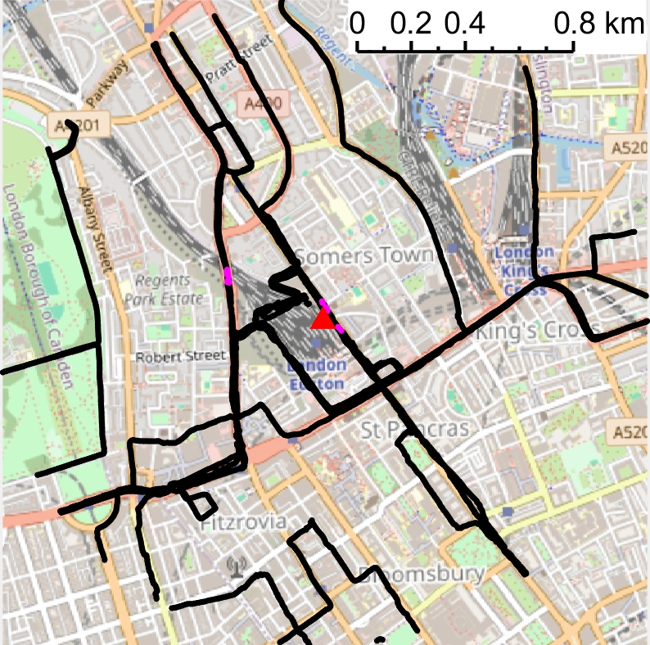 | 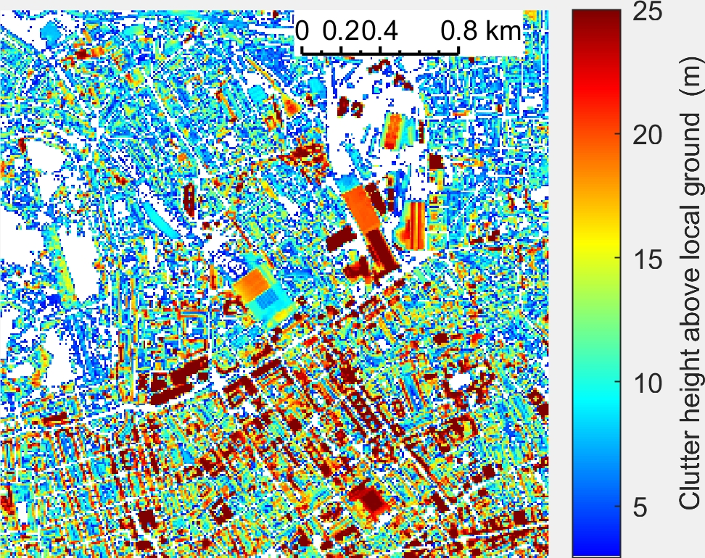
(a) Measurement locations in NLOS (black dots), in LOS (pink dots), and the tx location (red triangle) | (b) Clutter heights, plotted with resolution of 10 m
Figure 1 Maps of the measurement area

Table 1 Measurement parameters
Parameter | Value
Tx Easting | 529544
Tx Northing | 182832
Tx height above ground | 25 m
Tx frequency | 5.85 GHz
Rx height above ground | 1.5 m

ITU-R recommendations benchmarked for urban propagation at upper 6 GHz
This input contribution assesses Rec ITU-R P.1411-12 Section 4.2.1 “Site-general model” against the London 5.85 GHz dataset. This is a similar enough frequency to the upper 6 GHz band that similar propagation mechanisms would occur and is suitable to benchmark the recommendation for use for upper 6 GHz predictions in an urban setting. Due to the limited number of LOS samples, we chose to benchmark against the NLOS branch of the recommendation for all 15,753 measurements.
Additionally, we benchmarked the combination of ITU-R P.452-17 and P.2108-1. Whilst P.452-18 is the in-force version, software tools have not been updated yet so we benchmark the above combination as an alternative. We ensured the additional loss due to local clutter protection ($A_{h}$) was set to zero to avoid double counting clutter losses. P.2108-1 Section 3.2 is not valid for distances shorter than 250 m. However, some studies have extrapolated it for shorter distances, although this introduces some uncertainties. Extrapolating P.2108-1 Section 3.2 formulas for distances under 250 m, we have capped the loss at zero dB. Figure 2 (a) shows the CDF of clutter loss for varying 2D Tx-Rx distances, illustrating paths becoming incrementally clutter-free at shorter distances. Figure 2 (b) shows the P.2108-1 Section 3.2 formula ($p=50$) extrapolated to distances under 250 m. Both figures have been plotted at 6.775 GHz to be directly referenceable by other studies.
The P.2108-1 Section 3.2 formulas were derived from a mix of LOS and NLOS paths, recommending their use for all paths. Applying it only to NLOS paths would double count LOS probability, introducing more LOS paths than indicated by the original measurement campaigns. In our benchmarking, we applied P.2108-1 to all paths, including LOS, with $p=50$.

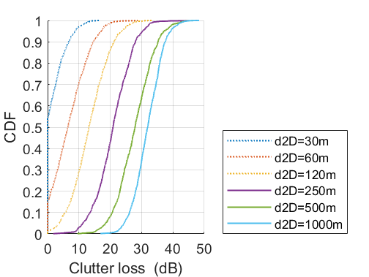 | 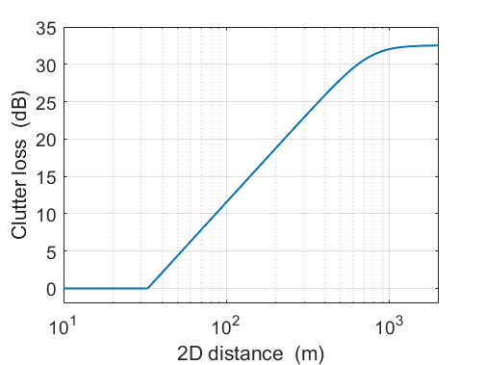
(a) CDF of clutter loss for variable 2D Tx-Rx separation distance, d2D | (b) Median clutter loss extrapolation by using the in-force formulas for distances shorter than 250 m
Figure 2 ITU-R P.2108-1 Section 3.2 at 6.775 GHz

Results
The benchmarking results in Table 2 show that Rec ITU-R P.1411-12 Section 4.2.1, and the combination of ITU-R P.452-17 and P.2108-1 effectively predict measured loss. The prediction errors (PE), calculated as predicted loss minus measured loss, demonstrate good overall alignment between measured and predicted loss. To achieve this fit with P.452-17, we set the additional loss due to local clutter protection to zero and used P.2108-1 for all paths, even those shorter than the recommendation’s applicability range.
Despite the recommendations’ lack of deterministic formulation, the standard deviation is low for the frequency. In addition, the Pearson correlation and coefficient of determination which assess how closely the predicted path loss values align with the recorded path loss values, with a value of 1 indicating a perfect model fit to the measurement data, are high.
Based on the recommendation’s benchmark and the fact that there is no need to use any model outside its applicability range, we support use of the Rec ITU-R P.1411-12 Section 4.2.1 for sharing studies in urban environment. As a fallback option, the combination of ITU-R P.452-17 ($A_{h}=0$) and P.2108-1 applied to all paths could be supported.
Table 2 Prediction error statistics
Parameter | Values
ITU-R recommendation used | P.1411-12 Section 4.2.1 | P.452-17 ($A_{h}=0$)  P.2108-1
Sample size | 15,753 measurement points
Mean PE | -2.4 dB | -3.7 dB
Median PE | -2.4 dB | -3.2 dB
Standard deviation | 7.5 dB | 7.7 dB
Pearson correlation | 0.87 | 0.87
Coefficient of determination | 0.73 | 0.66

GSMA, ECC PT1(21)189, Coexistence between IMT in 40.5-43.5 GHz and FSS in 39.5-40.5 GHz (Annex 1).

