Guidance on the use of aerial UE in border areas operating in the bands 703-733 MHz, 832-862 MHz, 880-915 MHz, 1710-1785 MHz, 1920-1980 MHz, 2500-2570 MHz and 2570-2620 MHz
approved DD Month YYYY
ECC Report <No>

Executive summary

TABLE OF CONTENTS

0 Executive summary 2
1 Introduction 5
2 Definitions 6
3 Aerial UE in border areas 7
3.1 Aerial UE usage and applications 7
4 Agreements in place at the border 8
4.1 Between administrations 8
4.2 Between mobile operators 8
4.3 Roaming agreements between mobile operators 8
5 Possible case of interference issues in border areas 9
6 Possible mitigation techniques applicable in border areas 10
6.1 Impact of non-transmission zones in border areas 10
7 Conclusions 11
ANNEX 1: Simulation scenario and assumption for UAS operation in border areas 12
A1.1 Reference case in border area 12
A1.2 Simulation scenario in border area 12
A1.3 Simulation assumption 13
A1.4 Method for determining the no transmission zone 16
A1.5 Simulation results 16
ANNEX 2: List of References 17

LIST OF ABBREVIATIONS

Abbreviation | Explanation
CEPT | European Conference of Postal and Telecommunications Administrations
ECC | Electronic Communications Committee

Introduction

Definitions

Term | Definition

Aerial UE in border areas

Aerial UE usage and applications

Agreements in place at the border

Between administrations

Between mobile operators

Roaming agreements between mobile operators

Possible case of interference issues in border areas

- Use case Bâle Mulhouse international airport
- Proposal from Latvia to perform practical measurements to assess possible impact of Aerial UE on RAS

Possible mitigation techniques applicable in border areas

- See ECC Report 309

Impact of non-transmission zones in border areas

Conclusions

- Assessment of a need for a toolbox for administrations

- Simulation scenario and assumption for UAS operation in border areas
  - Reference case in border area
In the border area, before the authorisation of UAS operation, the reference case is the cross-border coordination rule from ECC Recommendation(s). The reference case scenario is illustrated in Figure 1.
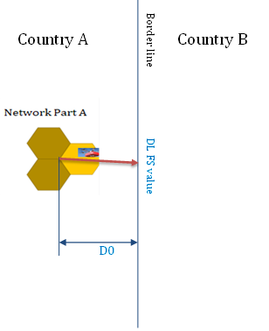
Figure 1: Reference case scenario
Calculate the distance D0 with the field strength value from the ECC cross-border coordination recommendation.
  - Simulation scenario in border area
The simulation scenario for UAS operation in the border area is illustrated in Figure 2.
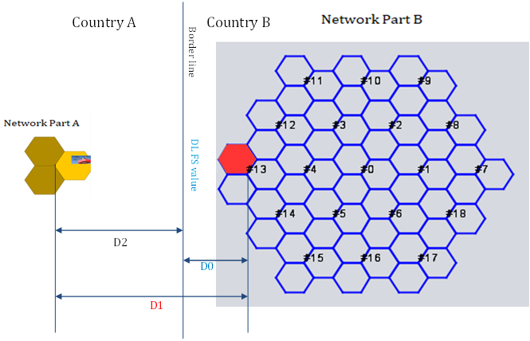
Figure 2: Simulation scenario for UAS operation in border area
ECC Report 309 has concluded that the adjacent channel interference from UAS to MFCN UL is not a problem. The simulation from UAS operation in the network A in Country A to the network B in Country B will be carried out only for co-channel case. As shown in Figure 2, the simulation is to be done following the steps below:
- 1 UAS UE and 2 ground UEs in the reference cell of the network A, UE traffic represents 33% of the cell capacity, 3GPP Report xxx said aerial UE traffic should be less than 30%;
- Aerial UE flying height is randomly between 30 and 200 meters;
- The separation distance D1 between the network A reference cell BS and the network B reference cell BS is determined with the criterion that the network B reference cell uplink throughput loss is less than 5%.
  - Simulation assumption
Simulation assumptions are taken from the Table 28 in the Annex 5 of the ECC Report 309 [1] and are provide in Table 1.
Table 1: Simulation assumptions for drones operation in 700, 800 and 2600 MHz bands in urban and rural areas
Parameter | Network Part A | Network Part B | Reference
System | LTE | LTE
Duplex mode | FDD | FDD | 3GPP TS36.104 [2]
Channel bandwidth (MHz) | 10 MHz  (UL: 703-713 MHz)  (UL: 842-852 MHz)  (UL: 2500-2510 MHz) | 10 MHz  (UL: 703-713 MHz)  (UL: 842-852 MHz)  (UL: 2500-2510 MHz) | LTE 10 MHz channel
Centre frequency (MHz) | UL: 708  UL: 2505 | UL: 708  UL: 2505
MIMO | 2x2 | 2x2
BS Tx Power | 43 dBm/10 MHz per MIMO branch  46 dBm/10 MHz per cell | 43 dBm/10 MHz per MIMO branch  46 dBm/10 MHz per cell | Report ITU-R M.2292 [3]
Antenna | Recommendation ITU-R F.1336 (recommends 3.1) [4]  ka = 0.7  kp = 0.7  kh = 0.7  kv = 0.3  Horizontal 3 dB beamwidth: 65 degrees  Vertical 3 dB beamwidth: determined from the horizontal beamwidth by equations in Recommendation ITU-R F.1336 [4]. | Recommendation ITU-R F.1336 (recommends 3.1) [4]  ka = 0.7  kp = 0.7  kh = 0.7  kv = 0.3  Horizontal 3 dB beamwidth: 65 degrees  Vertical 3 dB beamwidth: determined from the horizontal beamwidth by equations in Recommendation ITU-R F.1336 [4] | Report ITU-R M.2292 [3]
Antenna height (m) | 700-800 MHz:  30 (Urban)  40 (Rural)  2600 MHz:  20 (Urban)  30 (Rural) | 700-800 MHz:  30 (Urban)  40 (Rural)  2600 MHz:  20 (Urban)  30 (Rural) | Report ITU-R M.2292 [3] and Doc WP5D#416 [5]
BS Antenna gain (dBi) | 700-800 MHz  15 (Urban)  18 (Rural)  2600 MHz  16 (Urban)  18 (Rural) | 700-800 MHz  15 (Urban)  18 (Rural)  2600 MHz  16 (Urban)  18 (Rural) | ECC Report 82 [6] for 700 MHz with similarity to 800 MHz  ITU-R Report M.2292 [3] for 2600 MHz
Feeder loss (dB) | 3 | 3 | Report ITU-R M.2292 [3]
Downtilt | 700-800 MHz  6° (Urban)  3° (Rural)  2600 MHz  10° (Urban)  3° (Rural) | 700-800 MHz  6° (Urban)  3° (Rural)  2600 MHz  10° (Urban)  3° (Rural) | Report ITU-R M.2292 [3]  Based on national data for 700-800 MHz band urban
Maximum e.i.r.p. (dBm) | 58 dBm  61 dBm | 58 dBm  61 dBm | Report ITU-R M.2292 [3]
BS Noise figure | 5 | 5 | Report ITU-R M.2292 [3]
Site type | Tri-sector | Tri-sector
Cell Range (m) | 700-800 MHz  600 (Urban)  8000 (Rural)  2600 MHz  400 (Urban)  4000 (Rural) | 700-800 MHz  600 (Urban)  8000 (Rural)  2600 MHz  400 (Urban)  4000 (Rural) | ECC PT1(10)128 [7]  Report ITU-R M.2292 [3]
Handover Margin (dB) | 1 | 1 | ECC PT1(10)128 [7]
SINR Minimum (dB) | -10 | -10 | ECC PT1(10)128 [7] and 3GPP TR 36.942 [8]
UE Tx Power (dBm) | 23 | 23 | 3GPP TS36.101 [9]
UE Antenna height (m) | For normal UE in urban (Note 1): 1.5, 4.5, 7.5, 10.5, 13,5, 16.5, 19.5 (Note 2)  For normal UE in rural: 1.5 m  For drone: 30, 50, 100, 150, 200, 250, 300 | For normal UE in urban: 1.5, 4.5, 7.5, 10.5, 13.5, 16.5, 19.52  For normal UE in rural: 1.5 m | 6-7 floors are considered in urban area
UE Antenna gain (dBi) | -3 | -3
Indoor penetration loss (dB) | 20 dB (Urban)  10 dB (Rural) | 20 dB (Urban)  10 dB (Rural)
Body loss (dB) | 0 for drone  1 dB for normal UE | 1
Minimum Tx Power (dBm) | -40 | -40 | ECC PT1(10)128 [7]
UE noise figure (dB) | 9 | 9 | Report ITU-R M.2292 [3]
Number of UEs/Cell | 1 | 1
BS to UE propagation model | Free Space (UEs being drones) | Recommendation ITU-R P.1546-5 Urban/Rural for H<30 m | Recommendation ITU-R P.1546-5 [10]
Standard deviation (dB) | 6 (Urban)  8 (Rural) | 6 (Urban)  8 (Rural)
UEs distribution per floor | ground floor (h=1.5 m): 25%/30% (Note 3)  1st floor (h=4.5 m): 25%/30%  2nd floor (h=7.5 m): 10%  3rd floor (h=10.5 m): 10%  4th floor (h=13.5 m): 10%  5th floor (h=16.5 m): 10%  6th floor (h=19.5 m): 10% (Note 4) |  | ECC Report 309 [1] section A5.3.4
Propagation model for interference link from Drone to the victim network Part B BS | Free Space for H>= 30 m  With 5 dB standard deviation
Standard deviation for the interference link | 5 dB for Free Space
Separation distance between reference cell of Part A and Part B | Cell Range *(3/2) corresponding to the BS Inter-Site distance  700-800 MHz: 900 m in urban,12 km in rural  2600 MHz: 600 m in urban, 6 km in rural
Indoor/outdoor UEs | Urban: 70% indoor, 30% outdoor  Rural: 50% indoor, 50% outdoor
UE and drone transmission power scheme | Power control algorithm over -40.23 dBm output power range | Power control algorithm over -40.23 dBm output power range | 3GPP TR 36.942 [8] (Section 12.1.4) and Recommendation ITU-R M.2101-0 [11]
Note 1: Based on 3 m height of floor.
Note 2: 19.5 m is only valid for 700 MHz because the typical height of a building for 2600 MHz is 20 m.
Note 3: 25% for 700 MHz Band, 30% for 2600 MHz because the typical size of building (in urban environment) is lower when deploying antenna in higher frequency.
Note 4: Only for the 700 MHz band case.
  - Scenario 1 where the BS antenna is pointing to the borderline
    - Method for determining the no transmission zone
For each frequency band: 700 MHz, 800 MHz, 900 MHz, 1800 MHz, 2100 MHz and 2600 MHz, follow the steps below:
- Calculate the distance D0 as described in the section A1.1;
- Determine the distance D1 using the simulation scenario and method described in section A1.2 and the simulation assumptions in the section A1.3;
- The no transmission zone is the distance to the borderline: D2 = D1 – D0.
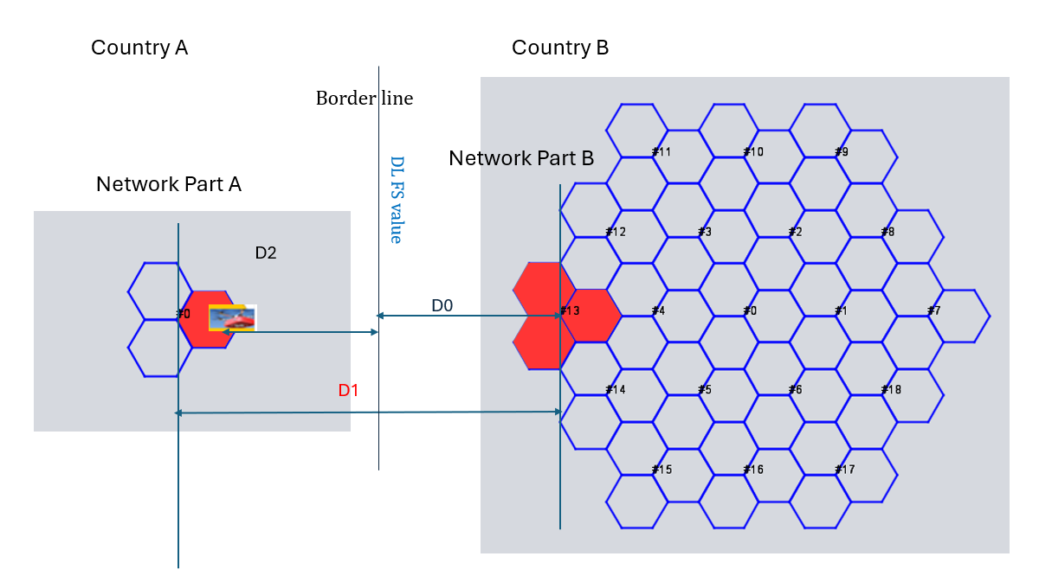
Figure 3 Simulation scenario for UAS operation in border area first method
    - Simulation results
    - Simulations results first method for 800 band in rural area
Table 4: Simulation results for 800 band in rural area for the first scenario
D1 inter system distance km | Bitrate loss ref cell % | Victim BS iRSS unwanted Median dBm | D2 no transmission zone km
21.5 | 0.9 | -120.1 | 0

Those results show that the drones can fly up to the border line without a need of no-transmission zone.
  - SCENARIO 2 WHERE THE BS ANTENNA IS NOT POINTING TO THE BORDERLINE
    - Method for determining the no transmission zone
In this method we keep the same parameters as the one given in ECC Report 309 see (2.2 and 2.3 section) except we use a single sector system for network B, and interfering sector from network A which is not pointing to the border.
The simulation scenario for UAS operation in the border area is illustrated in Figure 5.
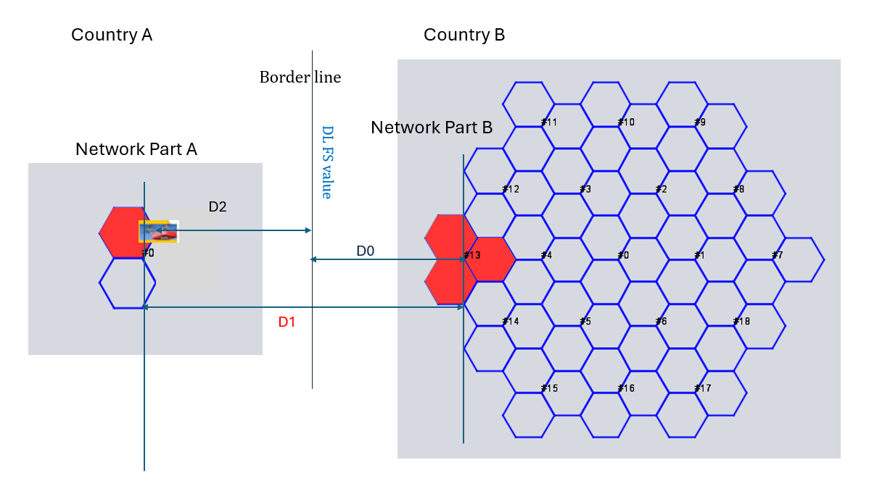
Figure 5. Simulation scenario for UAS operation in border area second method
We keep also the steps for determining D0 and D2 as in scenario 1.
Results of simulations are detailed below:
Table 5: Simulation results for reference case
D0 distance to border (km) | FS value at 3m at the border line (dBm)
3.15 | -79.1
For 800 MHz is rural environment in scenario 2, distance to border D0 calculated to meet the closest the field strength value 59 dB(µV/m)/5 MHz is equal to 3.15 km.

Simulations results second method for 800 band in rural area
As the D0 distance to the border of 3.15 km calculated above is lower than the cell radius used for rural environment, two cases were simulated:
One where inter-site distance D1 is 6.3 km with a cell radius of 3.15 km so that the drone in system A cannot fly above the border.
The second D1 is 8 km and cell radius is set to 4 km as defined in the previous parameters sets.
Table 6: Simulation results for 800 band in rural area second scenario
D1 inter system distance km | Cell Radius km | Bitrate loss ref cell % | Victim BS iRSS unwanted Median dBm | D2 no transmission zone km
6.3 | 3.15 | 2.33 | -118.38 | 0
8 | 4 | 2.2 | -118.59 | 0
The simulation results show that network B reference cell uplink throughput loss is around 2% when drone flies within a sector not pointing at the border area.

Conclusions
The simulation results show that there is no need to define a no-transmission zone for drones’ operation in 800 MHz band in border of rural area for both scenarios.

- List of References

- ECC Report 309: "Analysis of the usage of aerial UE for communication in current MFCN harmonised bands", approved 3 July 2020
- 3GPP TS 36.104: "Evolved Universal Terrestrial Radio Access (E-UTRA); Base Station (BS) radio transmission and reception"
- Report ITU-R M.2292: "Characteristics of terrestrial IMT-Advanced systems for frequency sharing/interference analyses”
- Recommendation ITU-R F.1336-4 (02/2014): "Reference radiation patterns of omnidirectional, sectoral and other antennas for the fixed and mobile service for use in sharing studies in the frequency range from 400 MHz to about 70 GHz"
- Document ITU-R WP5D 416: "Use of IMT for audio-visual distribution and production"
- ECC Report 82: "Compatibility study for UMTS operating within the GSM 900 and GSM 1800 frequency bands", approved June 2006
- ECC PT1(10)128: “LS to STG on LTE parameters for SEAMCAT”
- 3GPP TR 36.942: "Evolved Universal Terrestrial Radio Access (E-UTRA); Radio Frequency (RF) system scenarios"
- 3GPP TS 36.101 V15.4.0: “Evolved Universal Terrestrial Radio Access (E-UTRA); User Equipment (UE) radio transmission and reception”
- Recommendation ITU-R P.1546-5 (09/2013): "Method for point-to-area predictions for terrestrial services in the frequency range 30 MHz to 4 000 MHz"
- Recommendation ITU-R M.2101-0 (02/2017): "Modelling and simulation of IMT networks and systems for use in sharing and compatibility studies"

