Project Team FM22
46th Meeting of FM22  Copenhagen, 03 – 06 October 2016 | FM22(16)51

Date issued: 22 September 2016

Source: France

Subject: Monitoring of the adjacent frequency bands of the MSS Search and Rescue band at 406 MHz

N
Password protection required? (Y/N) *

Summary

Proposal

Background

Introduction
WRC Resolution 205 was modified at the last World Radiocommunication Conference (November 2015), and in particular, an additional “resolves” was added to request Administrations not to make new frequency assignments within the frequency bands 405.9 to 406.0 MHz and 406.1 to 406.2 MHz under the mobile and fixed services. Administrations are also urged to take all practical steps to limit the levels of unwanted emissions of stations operating within the 403 to 406 MHz and 406.1 to 410 MHz frequency ranges in order not to cause harmful interference to mobile-satellite systems operating in the 406 to 406.1 MHz frequency band.
Administrations are also encouraged to take measures such as authorizing new assignments to stations in the fixed and mobile services with priority given to selecting channels with greater frequency separation from the 406 to 406.1 MHz frequency band and ensuring that the e.i.r.p. of new fixed and mobile systems at all but low elevation angles is kept to the minimum required level,
In addition to the added ITU requirements to protect the Cospas-Sarsat system, the amendments to WRC, Resolution 205 also instructs the Director of the ITU Radiocommunication Bureau to organize monitoring programmes on the impact of unwanted emissions from systems operating in the frequency bands 405.9-406 MHz and 406.1-406.2 MHz on MSS reception in the frequency band 406-406.1 MHz in order to assess the effectiveness of this resolution, and to report to subsequent World Radiocommunication Conferences. It is planned that the next Report of the Director to be published for the next WRC in 2019 (agenda item 9 of the WRC) should contain elements regarding this important issue since the BR has a direct responsibility on this issue.

Currently, it is to be noted that according to the Radio Regulations, through Resolution 205, the BR is requested to organise a monitoring programme in the frequency band 406-406.1 MHz exclusively allocated to mobile-satellite service for search and rescue activities. The objective of this monitoring programme is to identify and locate unauthorized emissions in the band 406-406.1 MHz that cause harmful interference to the reception of satellite emergency position-indicating radio beacons (EPIRB) signals of the COSPAS-SARSAT system. The Administrations participating in this monitoring programme provide their reports to the Bureau in application of WRC Resolution 205. Upon receipt of the reports, the Radiocommunication Bureau immediately contacts the Administrations responsible for the area where the unauthorized transmitters are located, requesting them to take immediate action with a view to stopping the emissions. The publication of the monitoring reports for in band emissions can be found at http://www.itu.int/net4/ITU-R/terrestrial/res205/default.aspx.

The fact is that now, according to the revisions brought by WRC15, the BR is also requested to organise monitoring in the frequency adjacent bands 405.9-406 MHz and 406.1-406.2 MHz. The monitoring of these adjacent bands is probably much more complex than the in band monitoring. This is the reason why a specific CEPT action item has been agreed within WGFM.

The purpose of this document is to explain in detail the basic problem and to begin proposing concrete solutions.

Background

Description of the Cospas Sarsat system
The Cospas-Sarsat system encompasses three space segment components:
1) a LEO component with satellites embarking SARP (Search and Rescue Processor) and SARR (Search and Rescue Repeater) instruments on polar sun-synchronized orbit;
2) a GEO component with different satellites (MSG, GOES, Insat-3A, Electro and Luch) embarking a SAR repeater;
3) a MEO component with three main radionavigation systems (GPS, Galileo, Glonass) embarking on their satellites a SAR repeater.

Figure 1
Existing Cospas Sarsat LEOSAR, GEOSAR system

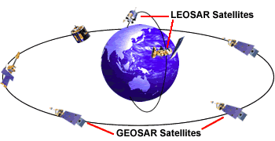

The MEOSAR system should begin the Initial Operational Capability phase, in which distress alerts provided by the MEOSAR system will be operationally used by the SAR authorities. When enough MEOSAR satellites and commissioned ground stations are available to provide worldwide, real time coverage, the MEOSAR system will be declared at its Full Operational Capability.
Some of the current and future payloads mounted on medium Earth altitude orbiting (MEO) satellite constellations (also called the MEOSAR space segment), in conjunction with suitable MEOLUTs (ground stations applicable to the MEOSAR) in geographically diverse locations, will be particularly well suited for this monitoring task. These particular MEOSAR payloads, which had been successfully used in recent years to visualyse signals transmitting in the adjacent frequency range, are the DASS payloads
(see http://searchandrescue.gsfc.nasa.gov/dass/, http://gpsworld.com/innovation-the-distress-alerting-satellite-system-10883/, http://gpssystems.net/gps-emergency-systems-dass/)
as shown in the following figure. These specific payloads are specific and since they have a “non-filtered” window of around 270 kHz (therefore much larger than the 100 kHz allocation), they could be used for testing and monitoring purposes. On the contrary, the GALILEO payloads which have sharper filtering patterns leaving only a 110 kHz bandwidth (10 dB attenuation) may be not adequate for this adjacent band monitoring task.

Figure 2
Cospas Sarsat future MEOSAR system
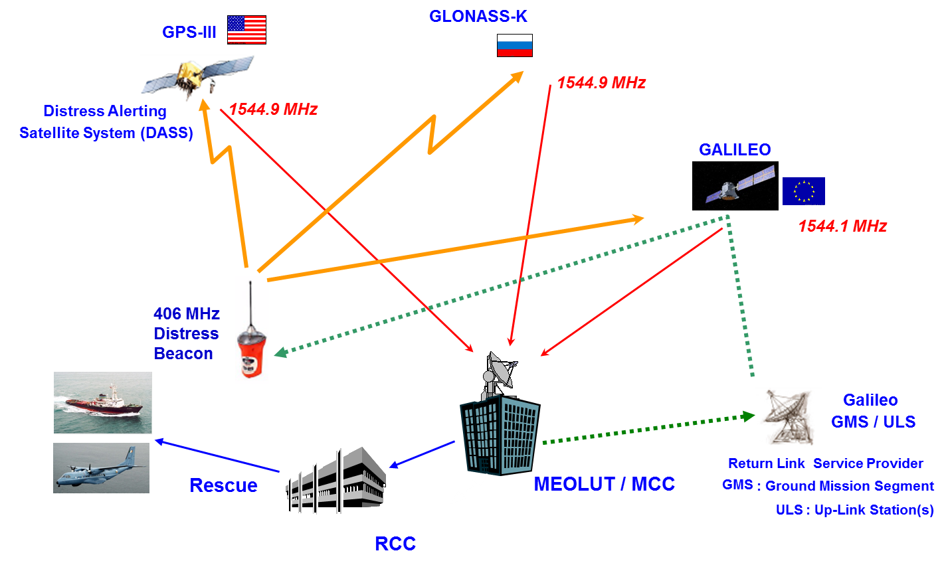

Plots of the out of band interference
According to the REPORT ITU-R M.2359-0 Protection of the 406-406.1 MHz band, plots showing the signals relayed by existing satellite carrying a 406 MHz payload, are provided.

Thanks to the MEO DASS, spectral activity can be relayed and explicitly shown in the following figures.

Figure 3 shows a general plot of the spectrum as repeated by DASS. Figure 4 and 5 are details of this general plot and big interferers can be seen in the upper adjacent band.
Figure 3
Spectrum Graphic frequency versus time, power denoted by colour) of the 406.0-406.1 MHz frequency band relayed by PRN17 (MEO).). The left edge of the image corresponds to August 20, 2012, at 17:00:05 UTC
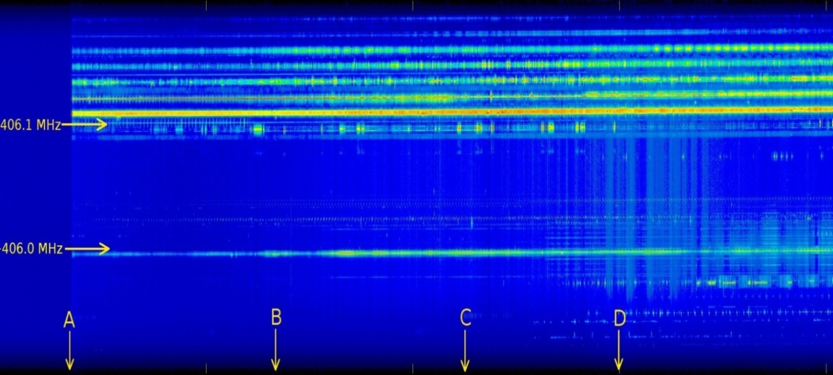

Figure 4
Power spectrum 406.0-406.1 MHz frequency band relayed by PRN17 (MEO) on August 20, 2012, at 18:00:05 UTC (i.e. 1 hour after the start of the image in Figure 3)

Figure 5
Power spectrum 406.0-406.1 MHz frequency band relayed by PRN17 (MEO) on August 20, 2012, at 20:00:05 UTC (i.e. at time D, 3 hours after the start of the image in Figure 3)
In addition, observations made through GLONASS, GPS and GALILEO have shown that strong interferers are very close to 406 MHz, the lower part of the MSS band. Figure 6 shows the received 406 MHz signal relayed through a DASS, as shown in the following figure.
Figure 6
Power spectrum 406.0-406.1 MHz frequency band relayed by DASS (MEO)

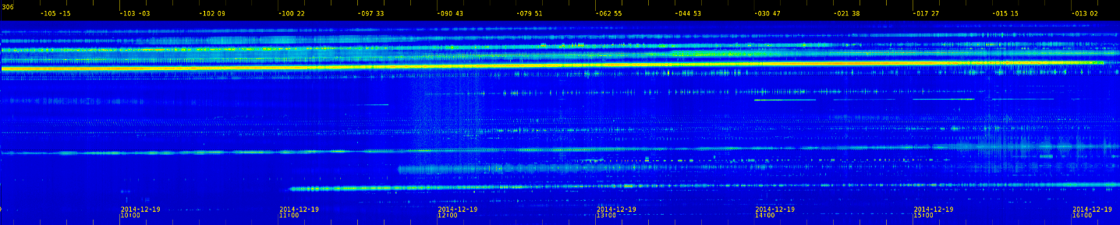

The figures -105, -103, -102 show the longitudes of the nadir positions as seen by the satellite at various times.
The lower part of the figure corresponds to 405.9 MHz and the higher part to 406.2 MHz. Between those two parts, the search and rescue band 406-406.1 MHz can be found with dashed lines.
The REPORT ITU-R M.2359-0 Protection of the 406-406.1 MHz band, contains many other plots showing similar situations.

Description of the of the usage within the adjacent bands of the Cospas Sarsat system

The other characteristics that need to be known before proposing a monitoring plan are the different types of devices deployed in these frequency bands. The following table 1 provides an overview of the deployment of mobile systems around 400 MHz. Especially above 406.1 MHz, according to table 2, the bandwidths currently used in CEPT countries are either 12.5 KHz or 25 kHz.

TABLE 1
Overview of CEPT documentation regarding the deployment
of mobile systems around 400 MHz
Frequency plan under Recommendation  TR 25-08 CEPT | 29.9 MHz duplex  – 380 to 389.9 MHz band (uplink) and 390 to 399.9 MHz (downlink);  – Bands 410-420 MHz (uplink) and 420-430 MHz (downlink);  – Bands 450-460 MHz (uplink) and 460-470 MHz (downlink).  14 MHz simplex: band 389.9 to 390 MHz, 406.1-410 MHz and 440-450 MHz.
Other provisions | The 400 MHz band is identified by Decision (08) 05 ECC dated June 27 2008 for the harmonized implementation of digital systems for PPDR applications. This decision provides that Member States must make available the necessary frequencies:  – For the implementation of digital narrow-band (less than 25 kHz channel) for PPDR applications in the band 380-385 MHz duplex / 390-395 MHz;  – The implementation of broadband digital systems (channel equal or greater than 25 kHz) for applications in the PPDR band 380-470 MHz.  The bands 406.1-430 MHz and 440-470 MHz are identified by Decision (06) 06 ECC dated 7 July 2006, in which CEPT Member States are encouraged to make available, according to market demand, the amount of spectrum required for digital PMR systems to narrow-band (channels equal or less than 25 kHz).

TABLE 2
TETRAPOL noise levels in the unwanted domain
Frequency offset | Maximum level
12.5 kHz | –60 dBc
25 kHz | –70 dBc

Outside CEPT, in Canada, tables 3 and 4 provide information on the range of technical characteristics of Canadian land mobile systems operating in the band 406.1-420 MHz. Typical values are shown in parenthesis. Systems in this band are predominately analogue, using channels that are 12.5 kHz or 25 kHz wide. In spectrum congested areas, newer systems being deployed tend to be trending towards digital technologies. For this country, the bandwidths are around 11 and 16 kHz.
TABLE 3
Base station characteristics of systems in Canada in the
band 406.1-420 MHz
Output power (W) | 1 to 30 (7)
Antenna gain (dBd) | 0 to 15 (10)
ERP (dBW) | 0 to 28 (16)
Necessary bandwidth (kHz) | 11/16
NOTE – Typical values are shown in parenthesis.

TABLE 4
Mobile station characteristics of systems in Canada in the
band 406.1-420 MHz
Output power (W) | 1 to 30 (H: 5, V: 30)
Antenna gain (dBd) | 0
ERP (dBW) | 0 to 15 (H: 7, V: 15)
Necessary bandwidth (kHz) | 11 / 16
NOTE – Typical values are shown in parenthesis. “H” represents the value for handheld mobile stations and “V” represents the value for vehicular mobile stations.

Lastly, in China, bandwidths of 12.5 kHz are also widely used.

Implementation of WRC15 instructions

Work to be conducted by Cospas-Sarsat Participants
The scope of this monitoring program, which is not yet implemented, is to track the RF activity in these adjacent bands. Some work is needed to modify existing MEOLUTs to make spectral measurement in the adjacent 100 kHz bands above and below the 406.0-406.1 MHz frequency band. These MEOLUTs, located in geographically diverse locations, will also need to commit in tracking DASS payloads on a periodic basis with spectrum analysis to compile data over the coverage area. The Cospas-Sarsat participants have to agree on the methodology for the measurements to be made, as well as the possible timeline for the deployment of a frequency monitoring program capable of monitoring signals within and in bands adjacent to the 406.0 to 406.1 MHz band. Beginning the monitoring of emissions is a matter of some urgency as any new terrestrial systems deployed in the adjacent bands 405.9 to 406.0 MHz and 406.1 to 406.2 MHz would subsequently be regarded as part of the noise “baseline” until systematic monitoring would have commenced.

Cospas-Sarsat participants as MEOSAR ground segment providers are aware that acquiring the capability to monitor the spectral activity of the band is essential to be in compliance to the new WRC Resolution.

Cospas-Sarsat Participants will intensively help develop, support and implement the new monitoring program proposed in WRC Resolution 205 (rev WRC15) to assess the effectiveness of the new regulations in protecting Cospas-Sarsat from emissions in the adjacent 405.9 to 406.0 MHz and 406.1 to 406.2 MHz adjacent bands.

The objective of the satellite monitoring is to create a data base and the following parameters will need to be mentioned.
The results should be provided for the following frequency bandwidths in kHz: 11, 12.5, 16 and 25. For each observed channel, a center frequency should be provided (if the center frequency can be known).
A specific algorithm should be optimized to track these signals and the duration of the integration of the signals will be probably one of the key parameters. The advantage of using MEO satellites is that their relative speed is moderate compared to the LEO satellites, and therefore the time spent over a specific area is long enough to get a good knowledge of the RF activity. Once the monitoring program is installed, one of the first task that will need to be performed is to carefully tune this integration time and answer the basic question: when is it possible to declare that a given observation can be put within the database of the RF activity?
At a certain stage, due to the relative movement of the satellite and taking advantage of the multiplicity of the MEO satellites looking at a given area in different orbits, the task of locating these sources should be initiated.
The level of each observed emission in dBW/Hz or any other adequate unit should be provided.

In order to have a good picture of the evolution of the situation, once the monitoring is in place, Cospas-Sarsat participants will be invited to reiterate this process several times a year.

Work to be conducted by administrations
It is probably expected that the usage of MEO satellites such as DASS will provide more or less detailed pictures of the situation, but probably not exact locations of transmitters. This is the reason why it would be useful for administrations to actively participate in the monitoring program capable of observing the use of the spectrum, identifying the emissions and location of interference sources, within the bands adjacent to the 406.0 to 406.1 MHz frequency band.

The characteristics are the same as described before, and it is expected that the administrations provide the same kinds of results as explained above.

It is also expected to maintain a certain periodicity of the observations, once the process has been agreed.

Conclusion
According to the terms of WRC Resolution 205, the BR is entitled to provide results as parts of the monitoring program within the 405.9 to 406.2 MHz frequency bands. It is expected that these results be contained in the Director’s Report for the next WRC19. Therefore, in addition to the Cospas-Sarsat participants who are involved in this frequency monitoring, administrations are kindly asked to provide support within their own country to exchange and compare results for the benefit of completing the tasks attributed to the BR. At the end, a detailed methodology should be drafted and adopted by CEPT and ITU-R.

______________

