 |  | FM22(23)07
Project Team FM22
59th Meeting of FM22
Copenhagen / Web Meeting, 28 – 31 March 2023
Date issued: | 15 March 2023
Source: | Germany
Subject: | EMF measurements on 5G base stations using AAS
Group membership required to read? (Y/N)
N
Summary:
Mobile base stations may never produce field strengths in excess of the exposure limits at locations accessible to the public. The necessary EMF measurements should preferable be possible during normal operation of the base station. For systems using passive antennas, a traffic-independent part of the base station signal is measured and then extrapolated to simulate a situation with full traffic load. Report ITU-R SM.2452 recommends this principle also for 5G NR base stations, and it is also applied by all vendors producing EMF measurement equipment. However, Germany is of the opinion that this method, although in principle valid, is not practicable because the necessary assumptions on a measurement location inside the main beam cannot be fulfilled in most cases. It is therefore suggested to directly measure a traffic beam attracted to the measurement location using a UE. This document describes possible ways to realize this measurement.
Proposal:
FM22 members are invited to consider the proposed measurement methods and possibly get in dialogue with vendors of EMF measurement equipment with the aim to implement it.
Background:
FM22 work programme

Background and aim of measurements
The exposure of the general public by RF radiation from mobile base stations becomes more and more an issue in almost all countries. Regulating authorities have the responsibility that the applicable EMF limits (e.g. from ICNIRP) are not exceeded at locations accessible to the public at any time. To guarantee this, EMF measurements of the maximum possible exposure at selected locations near the base stations are necessary. The measurement locations are close to the calculated safety zone where the predicted field strength limits could just be met or exceeded. Typically, this is in distances between 10 and 30 m from the respective base station.
The measurements should preferably be possible during normal operation of the base station. However, the total power from an LTE or 5G NR station depends on user traffic. During the measurement, it cannot be assumed that the station is fully loaded with traffic. However, the result of the measurement should assess a situation with maximum exposure, making it necessary to extrapolate from the actual measured value to a value that can be assumed if the station is fully loaded. Up to LTE, the solution to this problem is to measure only those parts of the signal that is traffic-independent, and extrapolate to full traffic by calculation. This part is usually the signal carrying broadcast information. In 5G NR systems, it is the synchronisation and signalling block (SSB) that is typically transmitted every 20 ms and has a bandwidth of 7.2 MHz (in frequency range FR1).
This method, however, is not regarded practical, for reasons discussed in the following sections.

Practical limitations of measuring the SSB
5G NR base stations typically use active antenna arrays (AAS) consisting of multiple dipoles. This setup enables the creation of different beams with different antenna patterns and gains, pointing in different directions. For EMF measurements, the following beams are relevant:
- SSB beams: The SSB information is transmitted in either one or up to 8 blocks per frame. If one SSB is transmitted, the beam has a horizontal opening angle of about 120 degrees. If 7 or 8 beams are configured, they are transmitted in sequence in up to 8 different horizontal directions, also covering a total angle range of about 120 degrees, but having a higher directivity than a configuration with one SSB. The vertical opening angle of the SSB beam(s) is usually quite low (only a few degrees).
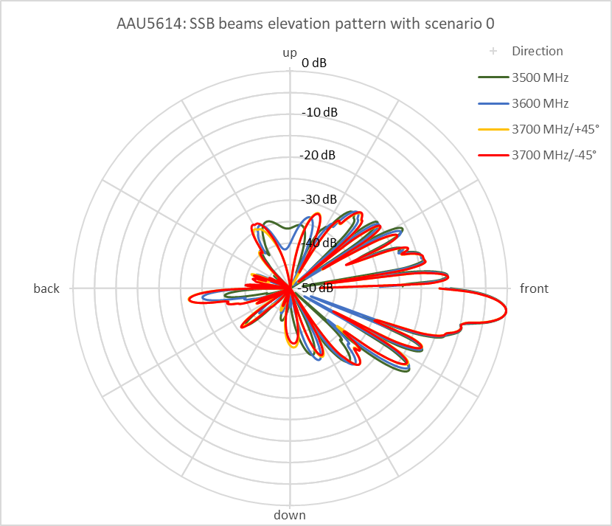
Figure 2-1: Example of a typical vertical SSB antenna diagram
- Traffic beams: User traffic is transmitted via beams with varying gain and in varying directions. This enables the station to follow a moving user. The vertical and horizontal angle range of the traffic beams is much wider than that of SSB beams.
When measuring the EMF close to a base station, the measurement location is usually outside the main lobe of the SSB, but may be inside the possible angle range of a traffic beam.
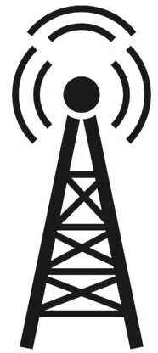
SSB
Traffic
Figure 2-2: Different angle ranges of SSB and traffic beams
The currently promoted method is to measure the SSB signal and extrapolate to a field strength caused by a traffic beam using the differences in antenna gains between both beams (see Report ITU-R SM.2452). While this is possible in theory, it has the following practical disadvantages:
- The method relies on knowledge of the antenna patterns of both SSB and traffic beams which is often not available.
- The method only works if the measurement position is inside the main lobe of the SSB beam. Trying to calculate gain differences outside the main lobes is not reliable because of the narrow width of side lobes. This would further require determination of the angle between transmitter and measurement position with an accuracy of at least 1 degree, which in practice is not possible.
- In real situations, the environment is not reflection-free. Signals arriving through reflection may even be stronger than a direct wave when measuring outside the main lobe. The angle under which a reflection arrives is not known, making a comparison between traffic and SSB gains impossible.

Measurement of traffic signals
For the above reasons, measurements with the aim to assess maximum possible exposure have to be performed on traffic signals. This would have the following advantages:
- No knowledge of antenna patterns, tilt ranges and gain differences of SSB and traffic beams is necessary.
- The measurement position can be located anywhere, also outside the main lobe ranges of both SSB and traffic beams.
- The measurement directly reveals maximum possible field strength even under strong reflective receiving conditions.
However, three issues have to be solved if the measurement is to be done with a standard realtime analyser:
- It has to be ensured that during the measurement a traffic beam is directed towards the measurement location.
- In case dynamic power control is applied at the base station it has to be ensured that the traffic blocks used for the measurement are transmitted with maximum power and antenna gain, even if the measurement location is very close to the base station.
- During the measurement, other users may be active and served by the base station.
The following sections introduce two possible measurement methods that can solve the issues above.

Manual measurement with passive instruments
A user equipment (UE) is placed behind, but near the measurement location, logs into the network and performs a download from a server with maximum possible speed. This will cause the base station to direct a traffic beam to the measurement location as good as possible.
In case dynamic power control is realized, the UE has to run a specialized test software that always reports poor reception conditions to the base station, even if in fact the signal is excellent. This would force the base station to use maximum power and antenna gain to serve our UE.
Even if our UE is the only one served by the base station at the time of measurement, it is not guaranteed that it will get all possible resource blocks (RBs), over the whole bandwidth. Time and bandwidth of resource blocks allocated to our UE depend on:
- the programming of the scheduler,
- the maximum data rate that the server from which we download is capable to deliver,
- the presence of other UEs in the cell served at the same time.
Although most schedulers will try to stagger traffic for multiple UEs in time rather than splitting the bandwidth, there will be instances where we don’t get the full bandwidth. It is therefore not sufficient to just measure the channel power vs. time in the slots where our UE is served. We have to have a possibility to determine which part of the channel bandwidth was allocated to our UE, and limit the measurement to only those resource blocks.
This means the instrument must have the following functionality:
- The instrument must have a capture bandwidth of at least 100 MHz.
- The instrument must be able to synchronize to the 5G signal.
- It must be possible to display a full frame of 20 ms over the whole signal bandwidth (up to 100 MHz), where the level of the resource blocks is shown in different colours, like a spectrogram. This can be done by recording a single shot.
- With the aim of this display, it must be possible to select a rectangle in frequency and time, either by directly drawing a rectangle or by horizontal and vertical start and stop lines.
- The instrument should then measure the average power of the recorded resource blocks inside the selected rectangle.
- The maximum possible power is calculated by simply multiplying the average power of a resource block (= measurement result) with the total number of RBs in the channel.
Figure 3-1 shows an example of such a display. The x-axis is the time, the y-axis is frequency. The resolution bandwidth is 30 kHz which corresponds to the bandwidth of one Resource Element. To the left side the seven SSBs can be seen. Scattered across the frame, our UE was served in four blocks, but block #2 was not using the full bandwidth, although no other users were active.

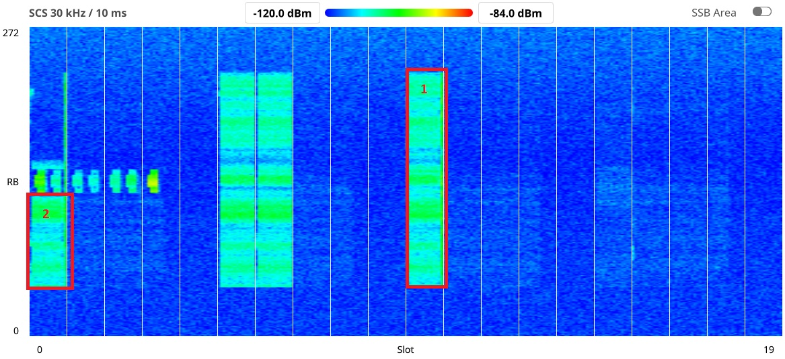
Figure 3-1: Example display of a 5G frame and selection of blocks for the measurement (red rectangles show two possible measurement blocks)
For the measurement, any of the four traffic blocks could be selected.
It can also be seen that not all RBs allocated to our UE were received with the same level, although they left the transmitter with equal power. This is typical in a reflective environment. It is therefore not correct to just determine the RB with the highest received level and use that to extrapolate to full bandwidth. This would overestimate the total field strength. It is rather necessary to average the received level over all RBs inside the selected signal block. The result will be more accurate if the allocated bandwidth in the measured block is high. In the example in Figure 3-1 it would therefore be more appropriate to select block #1 instead of block #2. However, the measurement would also achieve valid results if none of the blocks allocated to our UE have the full bandwidth.
It could be helpful if the instrument automatically selects a block with maximum power by default, but it must be possible to manually adjust or change it, if the automatic selection is not correct. For example, block #1 in Figure 3-1 has ranges where due to selective fading the power is much lower (yellow circle). While engineers looking at the graph will immediately see that the block continues over this “dip”, the automatic may see this situation as multiple separate blocks.
In order to perform a measurement with an isotropic antenna in all three polarisation planes, it would be necessary to repeat the above procedure three times and add the results. Because position and amount of RBs allocated to our UE may be different in every frame, three measurement shots have to be recorded and selection of the blocks to measure also has to be done three times.

Automatic measurement with active instruments
The most convenient method to apply the above measurement method would be to use an instrument that includes the functions of a (modified) UE and can actively connect to the base station.
After connection, the download could be started manually from a selectable server address and measurement is started as soon as data is transmitted.
This kind of instrument would allow a fully automatic measurement of the field strength. Having the functions of a UE included, the instrument can automatically determine the allocated RBs because they are announced by the base station. The software driving the UE could already be modified in a way that it always reports poor receiving conditions, thereby forcing the base station to use maximum power and antenna gain.

Conclusion
In the absence of a defined test signal from a base station, the maximum possible field strength of a 5G NR base station at any location can only be determined by measuring the traffic signal. Up to now, no handheld, battery-driven device on the market has this capability, although some companies already realize the hardware prerequisites (e.g. 100 MHz realtime bandwidth).
Implementing at least the manual method described in Section 3.1 would already provide a big step forward in 5G EMF measurement capabilities for many regulating authorities.

