FM44(23)005
Project Team FM22
73th Meeting of FM44
Zagreb / Web Meeting, 9 – 11 May 2023
Date issued: 27 April 2023
Source: ICAO GNSS RFI Correspondence Group
Subject: Presentation of ICAO GNSS RFI Correspondence Group activities
Group membership required to read? (Y/N)
N
Summary:
The GNSS RFI Correspondence Group (CG) has been created following ICAO FSMP/16 meeting. Its main objectives consist in:
- Highlighting the scale of the problematic of GNSS Radio Frequency Interference (RFI) for civil aviation.
- Elaborating elements to support contributions material for ITU-R WP-4C/1C, as well as for the relevant groups of regional telecommunications organizations.
- Proposing material, best practices, and guidance to mitigate the impact of GNSS RFI on civil aviation operations.
Proposal:
The meeting is invited to:
- Review the information introduced by this paper.
- Examine whether the CEPT regulatory framework handle the proposed ICAO actions to mitigate GNSS interference.
- Propose, taking into account elements given in Appendix 1 of this working paper, what regulatory harmonization measures could be handled by CEPT to support ICAO on GNSS RFI issues.
Background:
Actions to limit GNSS interference are on-going. In particular, FM-22 developed a benchmark on GNSS jammers and interferences in 2019. The responses notably raised the problem of the selling of jammers on Internet which is difficult to tackle. It also raised the fact that today not all EU countries forbid the possession of jammers even if all countries forbid their usage (with exception for defence and national security). Since this benchmark, Austria undertook a change of its legislation so that the possession of jammers is now forbidden. It would be useful that other countries where the possession of jammers is not prohibited follow the same path.
FM-44 opened a work item on the protection of Galileo and Glonass.
At a more global level, ITU and ICAO sent to their Member States recommendations in order to protect civil aviation from interferences.
To go further, ICAO FSMP created a GNSS RFI Correspondence Group. The objective of this Correspondence Group is to support appropriate ITU action to limit as much as possible the impact of GNSS RFI on civil aviation operations.

GNSS RFI CG: historical background and objectives
Because of the low GNSS power at Earth surface, GNSS is very sensitive to radio frequency interferences (RFI). In last decade, the number of GNSS RFI events reported by civil aviation has increased. In response to this growing threat, aeronautical and spectrum organizations reminded current good practices and regulations to prevent RFI on GNSS.
- EASA output Safety Information Bulletin SIB No 2022-02R1 on Global Navigation Satellite System Outage Leading to Navigation / Surveillance Degradation (EASA, 2022). In this bulletin, airspaces impacted by GNSS RFI are identified. SIB No 2022-02R1 also reminds potential consequences of GNSS RFI on civil aviation operations, and good practices for civil aviation authorities, air navigation service providers and air operators to mitigate the impact of GNSS RFI.
- By signing a Memorandum of Cooperation between ITU and ICAO (ITU, et al., 2012), the ITU acknowledges the necessity of an enhanced cooperation regarding the protection of the GNSS from harmful interference with a potential impact on aviation safety. ITU sent a circular letter CR/488 (ITU, 2022) which reminds ITU regulation protecting safety-of-life services such as GNSS from harmful interferences. CR/488 also points to some measures decided by the ICAO at its 40th Assembly (October 2019) and disseminated by ICAO State Letter AN 7/5-20/89 (ICAO, 2020).
The next step is now to ask for a regulatory action, in order to enforce these measures.
To this aim, ICAO FMSP/16 meeting created a Correspondence Group (CG). The objective of this CG consists in:
- Identifying any applicable normative reference material to supplement the material derived by the informal group at the FSMP in its 16th WG meeting.
- Proposing material, best practices, and guidance to mitigate the impact of GNSS RFI on civil aviation operations.
- Providing elements to support contributions material for ITU-R WP-4C/1C, as well as for the relevant groups of regional telecommunications organizations. CEPT FM-44 has been identified as a relevant group of regional telecommunications organization.

Impact of GNSS RFI on civil aviation
GNSS RFI is a growing threat for civil aviation. The impact of GNSS RFI on civil aviation is highlighted by several large-scale monitoring surveys conducted by aeronautical companies (Aireon, Airbus), organization (Eurocontrol) or administration (European commission). These surveys include:
- Aireon ADS-B monitoring. Aireon is able to provide real time indications about GNSS RFI, thanks to ADS-B satellite-based monitoring (Garcia, 2020).
- Through its EVAIR (Eurocontrol voluntary ATM incident reporting) program, Eurocontrol encourages air operators to report any GNSS outage.
- A continuous monitoring of GNSS outage reported by some Airbus aircrafts.
- Strike 3 project analyzed GNSS outages in various strategic points on ground (Towlson, et al., 2019). Some airports were included in the points of interest.
- GNSS Finland Service detects GNSS RFI thanks to GNSS C/N₀ monitoring on 47 ground locations spread in the country (Bhuiyan, 2021).
The objective of this section is to raise awareness on the GNSS RFI problematic for civil aviation. It first introduces some jamming classification. Second, it details the possible impact of GNSS RFI on civil aviation operations. Third, a summary of the reported GNSS RFI events from some of the above-mentioned studies is presented.

GNSS RFI classification

ICAO classification
GNSS RFI have initially been classified in ICAO GNSS Manual Appendix F (ICAO, 2017). Five RFI categories are listed:
- Unintentional RFI: Unintentional RFI is often the consequence of an equipment malfunction.
- Intentional RFI, not directed at aviation: This category addresses RFI targeting non-aeronautical receiver, but which may have collateral impact on civil aviation. Most of illegal civil jammers, such as Portable Privacy Devices (PPD), are part of this category.
- Intentional RFI, directed at aviation: This category addresses RFI voluntarily targeting civil airspace and airports.
- Military testing: This category includes GNSS state jamming operations, and operations happening for public safety reasons. Since jamming is part of the anti-drone struggle, it is expected that state jamming operations will increase in the coming years.
- Re-radiators/Repeaters additionally to the signal received from GNSS satellite: Re-radiators and repeaters, which signal are not contained indoor and not used according to the regulations, may be considered as spoofers. Re-radiators and repeaters are often used for indoor positioning. They may impact the civil aviation GNSS integrity if the civil aviation GNSS receiver processes signal transmitted by the repeater. As re-radiators and repeaters may cause integrity problems when not used in accordance with the regulations, their use is constrained. In particular, EN-302645 standard (ETSI, 2010) limits the maximum gain for such devices. In addition, ECC report 145 (ECC, 2010) limits the maximum EIRP transmitted by GNSS repeaters:
  - Maximum EIRP: -77 dBm
  - Maximum aggregate gain of antenna plus RF module: 45 dB (amplifier+antenna gain)
Also, ECC report 145 discusses the regulatory aspect of such devices in terms of licensing, authorizations, locations. These conditions of use are also described in ECC Recommendation (10)02 (ECC, 2010). ECC report 129 (ECC, 2009) proposes technical requirements on installed repeaters, in particular in terms of filtering at the bounds of GNSS frequency bands.

WG-C classification
This classification has been reviewed within EU-US Cooperation on Satellite Navigation WG-C to take into account new RFI sources (WG-C Service Resilience Sub-Group, 2019). This new classification is also adopted in Eurocae minimum operational performance standard ED-259 (Eurocae, 2023). In this new classification, spoofing is separated from jamming. Also, this classification does not depend anymore on the intention of the jammer. In this classification, jamming refers to emissions that do not mimic GNSS signals, but rather interfere with the receiver’s ability to acquire and track GNSS signals. It is opposed to spoofing for which the interference is a GNSS-like signal.
Jamming sources are divided in 4 categories:
- J1- Collateral jammers: Jammers emitting signals that do not contain GNSS-specific features, often with low power and specific range. This category corresponds to RFI not directed to aviation.
- J2- RFI from misused radio, electronic and electric equipment: Misused military or civil transmitters or miss-operated test equipment which results in jamming over broad area including regions with very high signal power.
- J3- Targeted jammers: Jammers, such as those described in J1 or similar, when specifically targeting a civil aviation GNSS receiver.
- J4- Targeted sophisticated jammers: Sophisticated jammers beyond the capabilities of J3, which include dedicated features to defeat existing jamming detectors or radio interference monitors. This category includes, for example, highly directive jammers such as jamming guns.

Similarly, spoofing is divided in 5 categories:
- S1: Repeaters
- S2: Errant signal
- S3: Collateral spoofers - Simulators
- S4: Collateral Re-radiating spoofers
- S5: Targeted spoofers – Simulators
- S6: Targeted Re-radiating spoofers
- S7: Targeted sophisticated spoofers
In this jamming and spoofing classification, the term collateral is used when the position, code phase, frequency, power of the RFI are unlikely to be aligned with the corresponding values of the authentic GNSS signal. This is usually the case when the RFI transmitter is not directed against the victim GNSS receiver. However, the intent of the RFI transmitter is unknown at the receiver level. Conversely, the term targeted when some of the RFI parameters (in terms of position, code phase, frequency, power of the RFI), are aligned with the authentic GNSS signal, so that the resulting GNSS outputs errors are not so obvious.

Possible impact of gnss RFI on civil aviation operations
The impact of GNSS RFI on civil aviation is well detailed in IATA Bulletin (IATA, 2019), or in Airbus website (Airbus, 2019). The main consequence of GNSS RFI is the degradation of Navigation and Surveillance performances.
Navigation performances:
Depending on the strength and characteristics of the RFI, possible consequences on navigation performances may be:
- Downgraded aircraft position computation: The accuracy of the position output by GNSS receiver is degraded but still respect minimum performance requirements.
- Impact on navigation operations: When the RFI impact on the civil aviation GNSS receiver is high enough, the performance of the receiver in presence of the RFI may not be sufficient to meet the required navigation performance for a given operation. In this case, the pilot would have to switch to procedure with lower navigation requirements, based on alternative navigation aids (ILS, DME, VOR).
Surveillance performances:
Since some surveillance systems are GNSS dependent, possible consequences of a GNSS RFI on surveillance performances may be:
- Loss of the predictive Terrain Awareness and Warning system (TAWS) functions, as this function is often linked to GNSS in modern aircrafts.
- Loss of ADS-B out reporting: the basis of ADS-B, which is used for many surveillance systems such as secondary surveillance radar and Traffic Collision Avoidance System (TCAS), is the broadcasting of the aircraft position as computed by the on-board GNSS receiver.
- Loss of ADS-B in Air Traffic Situational Awareness (ATSAW) function: ADS-B signals are used to know the position of surrounding aircrafts. A loss of GNSS would of course results in the loss of this function.
- Loss of (Runway Overrun Warning) ROW/(Runway Overrun Prevention System) ROPS functions: These functionalities help the pilot in knowing if the aircraft can safely stop with the remaining runway length. These functions are used during take-off and landing. As they rely on the aircraft position and speed computed by the GNSS receiver, these functions may be lost in case of GNSS RFI.
The list of consequences of a GNSS RFI on aircraft systems presented above is not exhaustive.
It should be noted that a loss of GNSS lead to immediate major safety issue, such as risk of collision between aircrafts. As a matter of fact, during the GNSS RFI occurrence, most civil aircrafts FMS (Flight Management System) would switch to alternative navigation and surveillance modes, using inertial system and/or terrestrial navigation aids for example. However, a loss of GNSS may lead to strong operational constrains by increasing the separation distance between aircrafts, this mitigation limits the flow of traffic.

Scale of gnss problematic for civil aviation

Airbus GNSS RFI reports
Based on in-flight monitoring of air transport category aircraft GNSS receivers by Airbus, 10,843 RFI events were detected globally in 2021. In 2022 this number rose to 49,605 events, thereby setting a concerning trend. The graphics below show the geographic distribution by area. The increase is mainly due to the increase in the Middle East and Eastern Europe. This data is confirmed by EUROCONTROL in European Member States and including other countries, for example data from Israel.
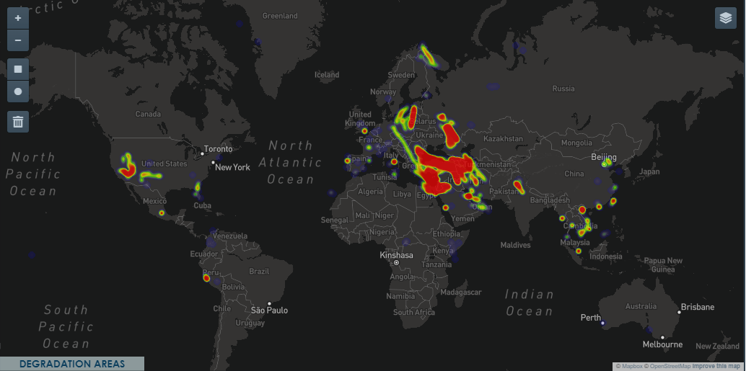
Figure 1 - Q1 2022 recorded events
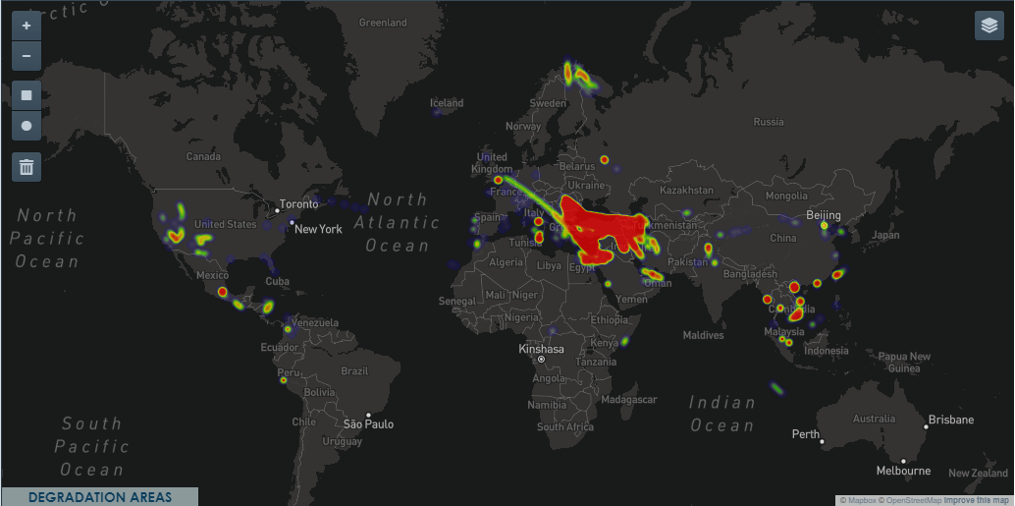
Figure 2 - Q2 2022 recorded events

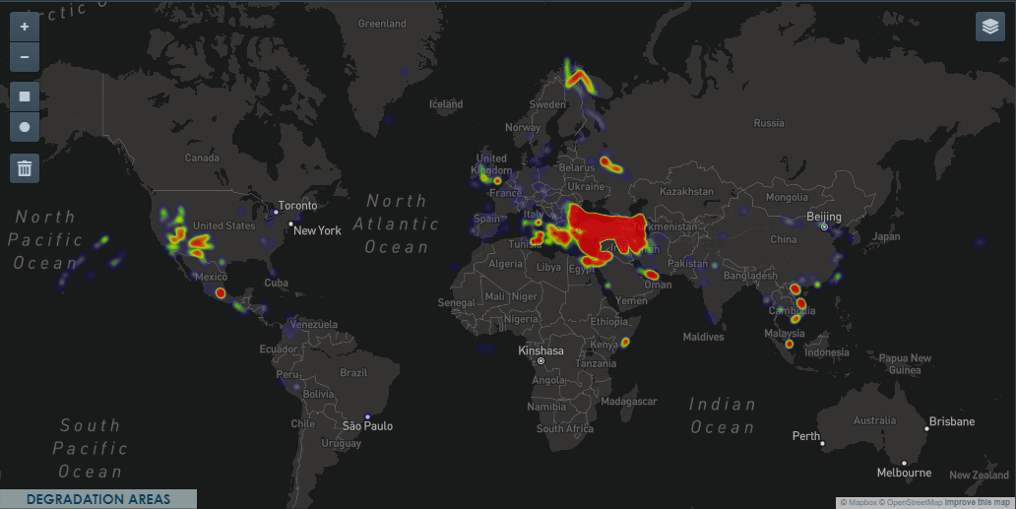
Figure 3 - Q3 2022 recorded events
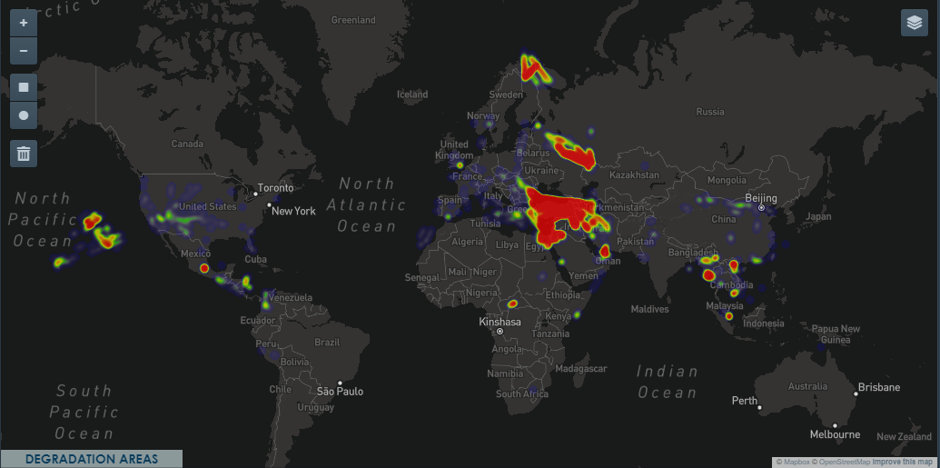
Figure 4 - Q4 2022 recorded events

AIREON GNSS RFI monitoring
The location and the number of GNSS RFI data is now available from Aireon (Aireon, 2023), a company operating space-based ADS-B and that carries out RFI detection. The space-based measurement has the advantage that it sees all ADS-B capable aircraft globally. The criteria used to count RFI events were explained by Aireon as follows:
“we set our event detection criteria for aircraft within ~60 NM radius hexagons within each region. If there were at least 10 aircraft within one of these hexagons in a 3 min period and at least 65% of those aircraft were reporting a PIC < 7, then this would increment the count for that region”.
The PIC (Position Integrity Category) is a figure of merit specifying the containment radius integrity associated with horizontal position data.
The different regions considered in this campaign are presented in Figure 5.
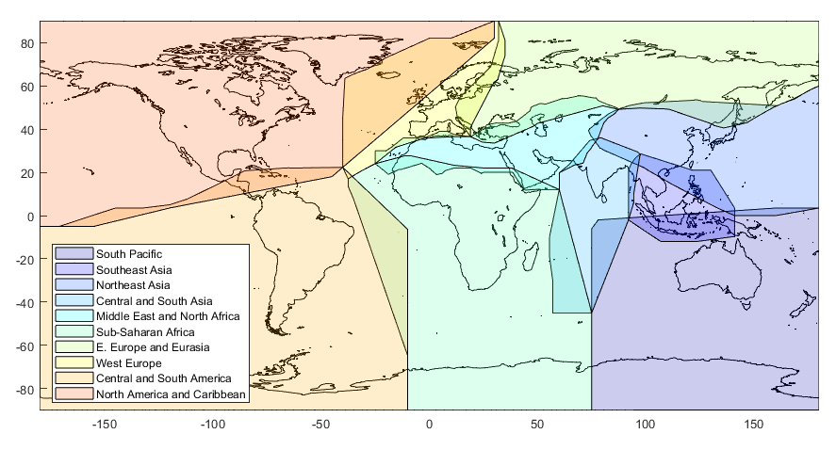
Figure 5 - Large regions for ITU analysis
The number of detected RFI events is deduced from data made available par Aireon and is represented in Figure 6.

Figure 6: Number of detected GNSS RFI event through satellite-based ADS-B monitoring
Even not visible in Figure 6, the number of detected GNSS RFI events in West Europe, North America and Caribbean, Central and South America and Central and South Asia is not null.
The following can be readily deduced from the Aireon derived data:
- GNSS RFI events occur everywhere in the world;
- The increase between 2021 (1,077 events) to 2022 (1,247 events) is not as significant compared to the aircraft level, meaning that either there must be many geographically large events which impact a lot of aircraft, or that the Airbus monitoring campaign detects a lot more individual aircraft events with their method. The reality is most likely to be a combination of the two cases;
- Surprisingly, the Northeast Asia GNSS RFI events are actually larger than the Eastern Europe / Middle East combination. This illustrates the limitation of monitoring by only a few operators – meaning the true number of impacted aircraft in 2022 is likely to be significantly larger than the 49,609 aircraft events detected by Airbus monitoring campaign.

Potential solutions to mitigate the impact of gnss rfi on civil aviation
The set of solutions to mitigate the impact of GNSS RFI on civil aviation can be divided into the existing measures, and potential new solutions that can be enforced either by ICAO or ITU.

Existing measures
In ITU Circular letter CR/488, the ITU Radio Regulations Board reminds the provisions of the ITU legal instruments applicable to safety-of-life services. These provisions include the following ITU RR and Constitution articles:
- RR No 4.10: ”Member States recognize that the safety aspects of radionavigation and other safety services require special measures to ensure their freedom from harmful interference; it is necessary therefore to take this factor into account in the assignment and use of frequencies”.

- Article 45 of the ITU Constitution: ”All stations, whatever their purpose, must be established and operated in such a manner as not to cause harmful interference to the radio services or communications of other Member States or of recognized operating agencies, or of other duly authorized operating agencies which carry on a radio service, and which operate in accordance with the provisions of the Radio Regulations”.

- Article 47 of the ITU Constitution: ”to take the steps required to prevent the transmission or circulation of false or deceptive distress, urgency, safety or identification signals, and to collaborate in locating and identifying stations under their jurisdiction transmitting such signals”.

- Article 48 of the ITU Constitution:
  - “Member States retain their entire freedom with regard to military radio installations.
  - Nevertheless, these installations must, so far as possible, observe statutory provisions relative to giving assistance in case of distress and to the measures to be taken to prevent harmful interference, and the provisions of the Administrative Regulations concerning the types of emission and the frequencies to be used, according to the nature of the service performed by such installations.
  - Moreover, when these installations take part in the service of public correspondence or other
services governed by the Administrative Regulations, they must, in general, comply with the regulatory provisions for the conduct of such services.”

- RR No 15.28: “Recognizing that transmissions on distress and safety frequencies and frequencies used for the safety and regularity of flight (see Article 31 and Appendix 27) require absolute international protection and that the elimination of harmful interference to such transmissions is imperative, administrations undertake to act immediately when their attention is drawn to any such harmful interference”.

- RR No 15.1: “All stations are forbidden to carry out unnecessary transmissions, or the transmission of
superfluous signals, or the transmission of false or misleading signals, or the transmission of signals
without identification (except as provided for in Article 19)”.

Potential solutions to mitigate the impact of gnss rfi on civil aviation
According to Article 48 of the ITU Constitution, military jamming is not covered by any ITU measures aiming to protect GNSS. Indeed, in most countries, GNSS jamming is allowed for public security purpose. However, some solutions can be considered in order to limit the impact of military jamming, as well as jamming of class J1 and J2 (see classification of section 2.1.2), on civil aviation. These solutions are identified by ICAO and presented to State Members in ICAO State Letter AN 7/5-20/89 (28 August 2020). These solutions have also been reminded in ITU Circular Letter CR/488. They consist in:
- reinforcing navigation systems resilience to interference;
- retaining essential conventional navigation infrastructure for contingency support in case of RNSS outages, and developing mitigation techniques for loss of services.
- increasing collaboration between radio regulatory and enforcement authorities;
- reinforcing civil-military coordination to address interference risks associated with RNSS testing and conflict zones;
- increasing coordination between aviation, military and radio-regulatory authorities;
Solution a) is currently developed within the aeronautical area and does not require any further action at ITU. For example, GNSS resilience to RFI will be improved by the development of dual frequency multi constellation (DFMC) GNSS receiver. Minimum operational performance standards (MOPS) for this new generation of aeronautical GNSS receiver is currently under elaboration. As an innovation compared to legacy aeronautical GNSS receiver MOPS, DFMC MOPS include certification tests in presence of chirp RFI, or re-radiated RFI.
A response to Solution b) should be brought by ICAO in its CNS plan for the future.
ITU and CEPT actions on Solutions c), d), e) would make their implementation easier. As a matter of fact, administrations different from civil aviation authorities would be involved in the coordination and collaboration processes described in solutions c), d) and e). As a consequence, these solutions cannot be dealt internally within ICAO.
Solution d) to deal with interference risk associated with RNSS testing and conflict zones addresses a national problematic under the responsibility of the State which allowed the operation. It is important to note that RNSS testing addressed in this solution includes GNSS jamming exercises as well as experiments that may be conducted by industries after having received authorization by the responsible administration. This solution also addresses the point of military GNSS jamming in conflict areas. Even though Article 48 of the ITU constitution states that Member States retain their entire freedom with regard to military radio installations, these military radio installations should also prevent harmful interference as far as possible (article 48 of ITU constitution, No 203).
Eventually, Solution e) should not be limited to the coordination between aviation and radio-regulatory authorities with military, but should also include any national entity authorized to operate RNSS jammer (including military).
This CG will mainly work on potential way to implement Solution c), d) and e) in a systematic manner. To do so, the RFI issue can be divided into three problems. The first is that coordination at national and international level is often not defined and/or not consistent, with the consequence that RFI cases do not always go reported. The second is obtaining data to support the identification and location of GNSS signal interference. The third problem is the spread and increasing use of illegal jammers.
Coordination at national and international level
A better coordination between civil and military authorities, and an improvement of multi-agency coordination would ensure that appropriate levels of mitigation are in place ahead of GNSS outages as a result of planned activities. Such coordination would also ensure that the mitigations themselves are fit for purpose, and that they preserve the level of safety required for the airspace concerned. Since this is a national prerogative, there is little consistency in how coordination is carried out and in how mitigations are applied. In Europe for instance, recognition of this limitations led to recent initiatives developing guidance and best practice for civil-military coordination, spearheaded by EUROCONTROL and with the contribution of its member states. The guidance is now published online as “EUROCONTROL Guidelines on a Process for Civil-Military GNSS Interference Testing” (Eurocontrol, 2023).
GNSS RFI source detection and localization
Collection and sharing of GNSS RFI occurrence data in order to detect events that often have cross-border implications is especially important because of the insidious nature of RFI alluded to above, and because it is not always straightforward to correlate GNSS anomalies with specific interference sources. Some regions have initiated formal monitoring and systematic collection of data on events on the GNSS frequencies. One objective of the GNSS RFI CG is to develop guidance in order to report detected RFI as often as possible.
As a matter of fact, the report of GNSS RFI to the spectrum authority is important as spectrum authority is in charge of investigating in order to solve the interference. The duration of a GNSS RFI is indeed part of its gravity. That’s why, to reduce the impact of GNSS interference, reporting them to the spectrum national authorities in a timely manner would allow them to apply their spectrum police capacities.
Reporting is also important for statistics. If GNSS interference are not reported, the problem may be minimized and prevent sufficient preparation and capacities to resolve these situations. The « culture » for reporting GNSS interference affecting civil aviation is not the same in all countries leading to underestimating the importance of the subject. This point is highlighted in section 2.3: the number of reported events is underestimated.
Prevention of the spread of illegal jammers
GNSS RFI reported events are dealt within the country by the national spectrum authority as part of its mission of spectrum monitoring and enforcement. If RFI cases originated from one country and affect others, the impacted countries may ask the report of harmful interference as for AP10 form and the intervention of national spectrum authority of the country where the RFI comes from. ITU may intervene in a second time if necessary.
FM-22 conducted a benchmark in 2019, analysing the different strategies, technical and legal capacities used by national spectrum authorities to resolve GNSS RFI events and fight the circulation of GNSS jammers. Since this benchmark, Austria undertook a change of its legislation so that the possession of jammers is now forbidden. This CG would consider the relevance of an update or extent of this benchmark, in order to identify if there is a need for an action to harmonize the different strategies to resolve or prevent GNSS RFI events.

Conclusion
The development of GNSS RFI monitoring actions in recent years has highlighted the scale of the GNSS RFI problem, and the vulnerability of civil aviation GNSS receiver facing GNSS RFI. As a consequence, ICAO and ITU reminded current regulation to protect civil aviation GNSS receiver from harmful interferences. Since it is acknowledged that the complete suppression of all GNSS RFI is impossible and even not desirable (military jamming contribute to the public security for example), some additional measures, taken at the ITU level, could contribute to the limitation of the RFI impact on civil aviation. Some identified measures that can limit the RFI impact on civil aviation are the coordination at national and international level during state jamming exercises, and the development of tools to detect and localize GNSS RFI sources. The ICAO GNSS RFI CG is in charge of developing material best practices, and guidance supporting the limitation of GNSS RFI impact on civil aviation.
The meeting is invited to:
- Review the information introduced by this paper.
- Examine whether the CEPT regulatory framework handle the proposed ICAO actions to mitigate GNSS interference
- Propose, taking into account elements given in Appendix 1 of this working paper, what regulatory harmonization measures could be handled by CEPT to support ICAO on GNSS RFI issues.

References
Airbus. 2019. GNSS Interference. [Online] 2019. https://safetyfirst.airbus.com/gnss-interference/.
Aireon. 2023. RFI Occurence Data Obtained through ADS-B. 2023.
Bhuiyan, Zahidul. 2021. GNSS Finland Service: GNSS Monitoring in Finland. 2021.
EASA. 2022. Safety Information Bulletin SIB No 2022-02R1: Global Navigation Satellite System Outage Leading to Navigation/Surveillance Degradation. 2022.
ECC. 2010. ECC Recommendation(10)02: A Framework for Authorization Regime of GNSS Repeaters. 2010.
—. 2009. ECC REPORT 129: Technical and Operational Provisions Required for the Use of GNSS Repeaters. 2009.
—. 2010. ECC Report 145: Regulatory Framework for Global Navigation Satellite System (GNSS) Repeaters. 2010.
ETSI. 2010. ETSI EN 302 645: Electromagnetic compatibility of Global Navigation Satellite Systems (GNSS) Repeaters. 2010.
Eurocae. 2023. ED-259: Minimum Operational Performance Standards for Dual-Frequency Multi-Constellations Satellite-Based Augmentation System. 2023.
Eurocontrol. 2023. EUROCONTROL Guidelines on a Process for Civil and Military GNSS Interference Testing. 2023.
Garcia, Michael. 2020. Global Surveillance and Tracking of Aircraft via Satellite. SCPNT Symposium : s.n., 2020.
IATA. 2019. Harmful Interference to Global Navigation Satellite System (GNSS) and its impacts on flight and air traffic management operations. 2019.
ICAO. 2017. Doc 9849: Global Navigation Satellite System (GNSS) Manual. 2017.
—. 2020. ICAO State Letter AN 7/5-20/89: Strengthening of communications, navigation, and surveillance (CNS) systems resilience and mitigation of interference to global navigation satellite system (GNSS). 2020.
ITU and ICAO. 2012. Protection of the Global Navigation Satellite System from harmful interference with a potential impact on aviation safety. 2012.
ITU. 2022. Circular Letter CR/488: Prevention of harmful interference to Radio Navigation Satellite Service Receivers. 2022.
Towlson, Oliver, et al. 2019. Strike 3: Threat Database Analysis Report . 2019.
WG-C Service Resilience Sub-Group. 2019. Threat and Countermeasures for Aviation Applications. 2019.

Appendix 1: Potential actions to be implemented against GNSS RFI
This appendix provides some elements of response to the GNSS RFI problem. As discussed in this paper, solutions to protect GNSS users, including civil aviation, can be divided in 3 categories.
- Coordination at national and international level during GNSS state jamming operations
Some guidances on the coordination during a GNSS state jamming exercises have been developed by Eurocontrol (Eurocontrol, 2023). This document includes guidelines on the coordination process to be followed before a GNSS state jamming operation. More precisely, the three following topics are addressed:
- Planning of interference testing:
The planning of the interference testing should include:
  - The determination of the area in which GNSS receiver may be affected;
  - The definition of an interruption procedure of the exercise, in case the safety of civil aviation is impacted in area larger than was initially predicted and communicated;
  - The identification of key stakeholders between which coordination should take place;
  - The approval process, in particular in case of cross borders an high sea testing.

- GNSS RFI testing notification:
GNSS RFI testing notification should be communicated to GNSS users by NOTAM for civil aviation, and through GNSS users support services and spectrum authorities for other sectors.

Spectrum authorities and civil aviation authority can also forward the information through their website (for example, see https://www.ofcom.org.uk/spectrum/information/gps-jamming-exercises).

- GNSS RFI testing execution:
GNSS RFI testing execution guidances are directed to:
  - Pilot: procedure to be followed if hitted by the state jamming operation;
  - ANSP: anticipation of the potential impact of wide scale GNSS RFI on ATC workload.

- GNSS RFI detection, report, source localization
Report:
Even though the report of GNSS interference is usually advised, the report of GNSS RFI events is not always done. However, the report of GNSS RFI is essential for spectrum regulator, in order to investigate and resolve these events. The report of GNSS RFI is also primordial for statistics, in order to have a clear view of the scale of the GNSS RFI problem and to prepare an efficient response. Potential solution to improve GNSS RFI reporting may include:
- To involve all sectors using GNSS, notably for detecting likely GNSS RFI, such as civil aviation, maritime, terrestrial transport, mobile operators, etc.
- To provide the professional GNSS users with a procedure (RFI information to be transmitted) and the organization in charge to report the event (see example from IATA, ICAO).
Detection:
The GNSS RFI detection is improved by large scale spectrum monitoring. For example, Finnish geospatial research institute conducts a continuous monitoring of its ground station network to detect GNSS RFI impacting the stations and report them to spectrum authorities. Such initiatives, which are necessary to have a clear view of the scale of the GNSS RFI problem and to struggle illegal jammer, would be encouraged. All this monitoring information are valuable when investigating on the localization of an RFI source.
To conduct these large scale monitoring activities, the use of ground stations may be helpful. Indeed, some ground station networks already exist. For example, EGNOS is monitored by a network of around 40 RIMS stations which can have RFI detection capabilities. This concept to use a receiver whose position is known in order to detect GNSS RFI may be easily implemented.

- Regulatory actions against the spread of illegal jamming and enforcement
Several actions may be considered to prevent the apparition of illegal jamming:
- Increase awareness of the impact and consequences of illegal jamming (for example, see https://www.anfr.fr/fileadmin/mediatheque/documents/Actualites/Fiche_brouilleur_v5-2.pdf).
- Strengthen regional and national regulation to forbid the manufacturing, sale, detention and use of GNSS jammer, except for certain state usages such as national defence and homeland security.
- Strenghten regional and national regulation against the online sale of illegal jammers.
- Consider having a sufficient level of sanction and inquiry capacity in case of illegal actions implying jammers.
- Encourage the UN agencies such as ITU and WTO to set out recommendations for limiting the spread of GNSS jammers.

This graphic is to be considered with reference to the data on regional RFI events recorded in Ref 3.

