FM44 |  | Doc. FM44(24)048
FM44#81
Bienne, 3-5th September 2024
Date issued: | 29/08/2024
Source: | Türkiye
Subject: | Plan-S (CONNECTA IoT) Declaration of compliance according to ERC Decision (99)06
Group membership required to read? (Y/N)
N
Summary:
- CONNECTA IoT satellite system is compliant with milestone 1 of Annex 3 of the ERC Decision (99)06 and Türkiye requests it is incorporated to the Annex 1 of the Decision.
- Türkiye also requests that the CONNECTA IoT satellite system is considered for the compatibility studies referred to in DECIDES 5b) of ERC Decision (99)06 for its inclusion in Annex 2 of the Decision.

Proposal:
invites FM44 to
- Approve the CONNECTA IoT satellite system to be added to Annex 1 of the amended ERC Decision (99)06
- Approve a LS from FM44 to SE40 with copy to WGSE

Background:
The CONNECTA IoT satellite system will operate within one of the frequency bands in the scope of ERC Decision (99)06. CONNECTA IoT satellite system will employ the frequency band 862-870 MHz band for uplink, and for downlink where permitted. In jurisdictions where the 862-870 MHz band is not available for downlink, the 400.15-401 MHz band will be used as a backup.

System name | ITU Name | Candidate bands | Year of expected commercial service introduction
Plan-S | CONNECTA IOT | Down-link: 400.15-401 MHz | 2024-2025

The information required for the declaration of a system to be added to Annex 1 of the ERC Decision (99)06, which involves the submission of a filing to ITU, is indicated in the table below.
Satellite network designation | Orbit | ITU Notice ID and BR Registry Date | Notifying Administration
CONNECTA IoT | N-GSO downlink | 124520081-04.04.2024 | Türkiye

ExPLANATORY NOTES FOR REQUESTS
Plan-S was established in 2021 and is headquartered in Türkiye. The company’s primary mission is to provide IoT connectivity and Earth Observation services across diverse sectors such as agriculture, oil & gas, maritime, transportation, energy, finance, and more as an international satellite operator. Additionally, Plan-S is dedicated to design and manufacture of satellite systems, encompassing satellites, ground stations, and ground devices, as well as the essential network software for seamless operation.
Plan-S will operate within 862-870 MHz in Europe, while fully adhering to regional and national regulations for the device-to-satellite link (Earth-to-space). IoT satellites will employ this range from space-to-Earth direction as well for sending wake-up beacons and broadcast messages only for a short period of time in case national regulation permits. As a backup, Plan-S will utilize the 400.15-401 MHz frequency band where the 862-870 MHz band is unavailable due to regulatory constraints.
In order to operate within CEPT countries, Plan-S has informed us about its intention to the inclusion of ERC Decision (99)06.
According to Decides 4) of ERC Decision (99)06, S-PCS < 1 GHz systems may be added to the list in Annex 1 upon the request of at least one CEPT administration, on the condition that this Administration declares compliance of that system with milestone 1 of Annex 3.
Türkiye hereby declare that the filing for CONNECTA IoT has been submitted, with the BR Registry Date recorded as April 4, 2024, and request the inclusion of CONNECTA IoT Satellite System to the list in Annex 1 of ERC Decision (99)06.
Additionally, for its inclusion in Annex 2 of ERC Decision (99)06, it is required that all necessary compatibility studies for an S-PCS < 1 GHz system be successfully completed, and that the satellite system has met milestones 1 to 6 outlined in Annex 3 of this Decision.
Plan-S is a designer, developer, and manufacturer of small satellites, satellite subsystems, payloads, ground stations, ground infrastructures, and the hardware/software required to operate its satellites and deliver IoT and Earth Observation services. To date, Plan-S has successfully demonstrated these capabilities by operating five test satellites.
Recently, on August 16, 2024, Plan-S successfully launched four commercial IoT satellites into orbit and has commenced the commissioning process. The company has declared that they will be ready to provide services through the Connecta IoT Satellite System as of October 2024. Furthermore, Plan-S has stated that they will increase the number of commercial satellites to 16 by August next year through already scheduled launches. By 2029, Plan-S aims to deploy over 100 active satellites in orbit to provide IoT services with low latency, high QoS, and high capacity.
With the launch of satellites operating in the frequency band 400.15-401 MHz, Türkiye confirms that CONNECTA IoT Satellite System has met milestones 1 to 6 outlined in Annex 3 of this Decision as follows:
- Submission of ITU Advance Publication and Co-ordination Documents
- Satellite manufacturing
- Completion of the Critical Design Review
- Satellite launch agreement
- Gateway earth stations
- Launch of satellites

Finally, for the inclusion of the CONNECTA IoT Satellite System in Annex 2 of ERC Decision (99)06, Türkiye requests FM44 to initiate studies in WGSE and SE40 to conduct the appropriate compatibility analysis according to DECIDES 5b) of ERC Decision (99)06. Türkiye and Plan-S will provide the necessary information and support to WGSE and SE40 for these studies. For this purpose, a proposed liaison statement from FM44 to SE40 (with a copy to WGSE) for the next meeting is attached for consideration by the meeting.

- The information regarding CONNECTA IoT Satellite System provided by Plan-S is found in Section 2.
- A proposed liaison statement from FM44 to SE40 is found in Section 3.

Annex: CONNECTA IoT Satellite System Description Overview
The Connecta IoT satellite system has 45 orbital planes, each containing 8 satellites. It has two different inclination angles: 97.6 degrees and 53 degrees. For both orbital inclinations, the apogee and perigee values are the same, at 550 km with a 95-minute orbital period.
The satellite deployment plan of the Connecta IoT Network for the first 16 satellites is provided below:
- 4 satellites --> SpaceX Transporter - 11 mission --> 16th of August
- 4 satellites --> SpaceX Transporter - 12 mission --> Oct/Nov 2024
- 4 satellites --> SpaceX Transporter - 13 mission --> Feb/March 2025
- 4 satellites --> SpaceX TSIS-2 mission --> Feb/Aug 2025
According to the deployment plan of the satellites into their orbits, Plan-S aims to commence commercial services as of October 1, 2024.
Additionally, Plan-S plans to deploy over 100 active satellites in orbit to provide IoT services with low-latency, high QoS, and high capacity. To achieve this, it has two major phases for the launch of satellites:
- The expansion phase, during which we will increase the number of satellites in the network,
- The sustainment phase, during which we will both add new satellites and replace old ones.
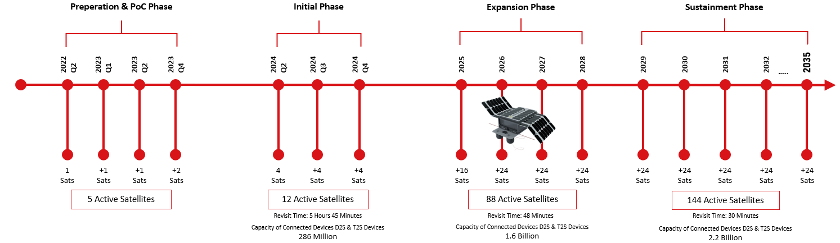
Connecta IoT Constellation Deployment Plan
According to the plan depicted in the Figure above, Plan-S will have 84 active satellites by 2028 with a 48-minute revisit time and 286 million connected device capacity. With the increase of the number of satellites to 144 by 2035, Plan-S will reduce the revisit time to 30 minutes and increase connected device capacity to 2.2 billion.
The transmission properties of CONNECTA IoT Satellite System within the frequency band 400.15-401 MHz are indicated in the table below.

Frequency Band | Direction | Operating Bandwidth | EIRP | Polarization | Duty Cycle | Multiple Access
400.15-401 MHz | Space-to-Earth | 62.5 or 125 kHz | <2.7 dBW | CR | ≤1% per location | Chirp Spread Spectrum
Satellite Transmission’s Properties
Satellites will broadcast Lora signals (Chirp Spread Spectrum, CSS) to IoT modules at different time intervals. Lora signals (Chirp Spread Spectrum) bandwidth can be equal to 62,5 kHz and 125 kHz. Our plan is to use 125 kHz wide-channel in this frequency band to wake up IoT terminals. The sample spectrogram of chirp spread spectrum signal when the bandwidth equals to 125 kHz is shown in the figure below.
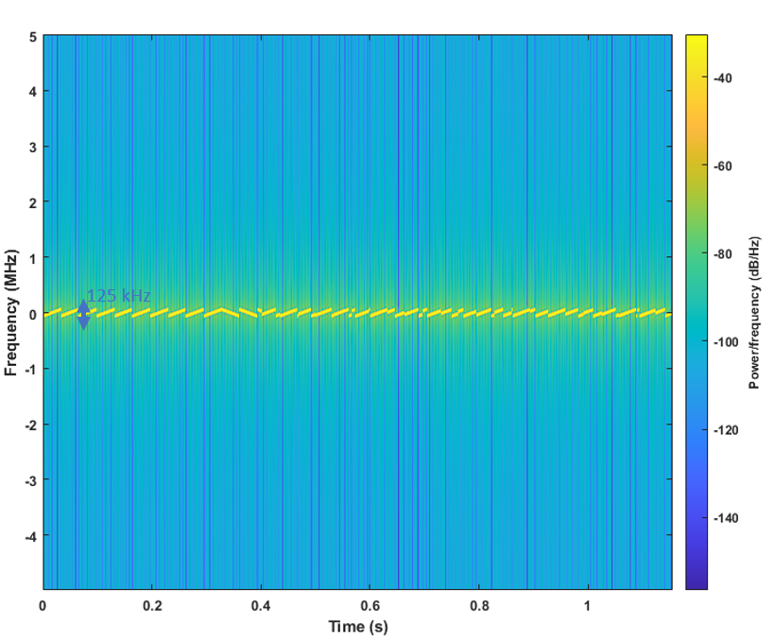
Sample spectrogram for 125 kHz wide channel

A proposed Lıason statement from fm44 to se40 with a copy to the WGSE
FM44#81
Bienne, 3-5th September 2024
Date issued: | XX/09/2024
Subject: | Plan-S (CONNECTA IoT) Declaration of compliance according to ERC Decision (99)06
To: | Mr. Jesús Arnau Yañez, SE40 Chairman  E-mail: jesus.arnauyanez@ofcom.org.uk
Cc: | Mr. Jérôme Andre, WGSE Chairman  E-mail: jerome.andre@anfr.fr
Dear Jesús
During its 81st meeting, the FM44 validated the compliance of the following new candidate to Annex 1 of the ERC Decision (99)06: CONNECTA IoT.
According to ERC Decision (99)06, there is a need that all necessary inter-service and intra-service compatibility studies for these S-PCS < 1 GHz systems have been successfully completed for inclusion in Annex 2 of ERC Decision (99)06.
Please note that the CONNECTA IoT satellite system’s operations are carried out in the frequency band 400.15 - 401 MHz (space-to-Earth).
We kindly request that your group conduct the relevant compatibility studies for the CONNECTA IoT satellite system. For this purpose, the detailed information will be provided to your group by the operator of this satellite system.
Best regards,

Amar SAÏDANI
FM44 Chairman
E-mail: amar.saidani@anfr.fr

