 | FM PT58 |  | Doc. FM58(19)45
3rd Meeting of FM58
Tallinn, 11 – 12 December 2019
 | Date issued: | 22 November 2019
 | Source: | Belgium
 | Subject: | New rules regarding 406 MHz beacon registrations
Group membership required to read? (Y/N)
N
 | Summary:
The ‘regular’ coding of EPIRBs is done by means of an MMSI number.

Information from Cospas-Sarsat confirms that the second generation of MEOSAR EPIRBs with RLS (return link service) capabilities has to be coded using a protocol with serial numbers only (a combination of the model and the S/N of the equipment). Our administration is therefore hesitant to abandon the actual coding with the MMSI and change it to the coding with a serial number.

On the Cospas-Sarsat website we can read that not a lot of countries have made a decision yet and that only a few countries have accepted the EPIRB coding with serial numbers. It seems that the advantages of the RLS do not have full play.
If the EPIRB was to be programmed with a serial number it would seem necessary to enter the hexadecimal codes in the national database and to register it into the ITU Mars database.

Each Administration can find out the actual status regarding the 406 MHz beacon regulation (C/S S.007) on the Cospas-Sarsat website: https://www.cospas-sarsat.int/en/documents-pro/beacon-regulations-handbook

 | Proposal:
 | The Group is invited to discuss and decide as appropriate. Belgium would like to know the opinion of the group on this issue and investigate if a common approach is possible.

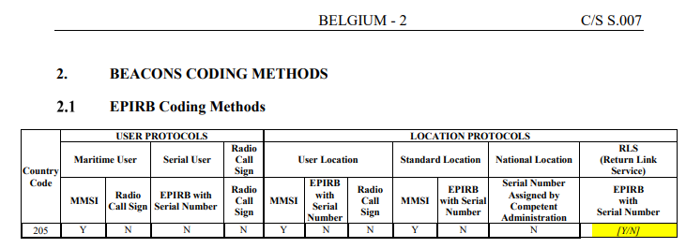

Background:
- The introduction of the Return Link Service which provides an acknowledgement message to the distress beacon equipped with a Galileo receiver through a Galileo signal. Galileo is currently the only GNSS system to provide this service.

- Although not immediately included in the current definition, in the future the Return Link Service could be extended to provide other very helpful features such as:
- Remote activation of beacons on boats and aircraft that have been reported missing;
- Turning off beacon transmission when the SAR mission has been completed (for example in case of practical problems to recover the beacon);
- Changing the repetition rate of the beacon transmissions in order to save the battery.

Reaction of Cospas-Sarsat:

Dear Mr. Vindevoghel.
Thank you for contacting us again.

Please note that since last year, the possibility to encode an RLS-capable EPIRB with an RLS protocol has been improved.
We currently have two choices:
- the regular RLS protocol based on manufacturer Serial Number and Type Approved Certificate (TAC) number,
- the National RLS Number (NRN) option derived from the first one by reserving a batch of high TAC numbers for countries which would like to allocate themselves a ‘National Serial Number’ instead of the ‘regular manufacturer Serial Number’, and thus, keep a close control of the registration of RLS-capable beacons in particular to ensure that vessel/aircraft identification is provided by the beacon owners when asking for getting a beacon and the associated NRN.

Please note that having a third option available should be decided at our next Council Session in November. It consists in reserving another batch of high ‘TAC’ numbers for letting the possibility to provide the MMSI instead of the manufacturer Serial Number or the NRN. This option would be available to only encode EPIRBs and PLBs for maritime environment, as necessary. If agreed at our CSC-62 Council, a one-year delay will be necessary to have this option open for registration as we must ensure that our Ground Segment is fully ready in order to manage the alerts coming from those devices.

If everything goes as planned, we should have soon:

Country Code | USER PROTOCOLS |  |  |  | LOCATION PROTOCOLS
Country Code | Maritime User |  | Serial User | Radio  Call Sign | User Location |  |  | Standard Location |  | National Location | RLS  (Return Link Service)
Country Code | MMSI | Radio  Call Sign | TAC & Serial Number | Radio  Call Sign | MMSI | TAC & Serial Number | Radio Call Sign | MMSI | TAC & Serial Number | SN Assigned by Competent Administration | National RLS Number | TAC &  Serial Number | MMSI
[Y/N] | [Y/N] | [Y/N] | [Y/N] | [Y/N] | [Y/N] | [Y/N] | [Y/N] | [Y/N] | [Y/N] | [Y/N] | [Y/N] | [Y/N] | [Y/N]

Figure 1: EPIRB coding methods, as will be proposed in document C/S S.007

Country Code | USER PROTOCOLS |  |  |  | LOCATION PROTOCOLS
Country Code | Maritime User |  | Serial User | Radio  Call Sign | User Location |  |  | Standard Location |  | National Location | RLS  (Return Link Service)
Country Code | MMSI | Radio  Call Sign | EPIRB with Serial Number | Radio  Call Sign | MMSI | EPIRB with Serial Number | Radio Call Sign | MMSI | EPIRB with Serial Number | Serial Number Assigned by Competent Administration | National RLS Number | EPIRB  Serial Number | MMSI
[Y/N] | [Y/N] | [Y/N] | [Y/N] | [Y/N] | [Y/N] | [Y/N] | [Y/N] | [Y/N] | [Y/N] | [Y/N] | [Y/N] | [Y/N] | [Y/N]

Figure 2: PLB coding methods, as will be proposed in document C/S S.007

- For your information, some countries said a conservative ‘No’ to the RLS-capable beacons, not because they do not believe in RLS in general, but because it is sometimes easier to first have the RLS close and later have it open for their beacons, than the opposite.

- For your information, the time when the Return Link Service would enter operation might be decided at this CSC-62 Council Session.

I hope my answer will help you to have a better view on the RLS and RLS-capable beacon coding options.
(copy to Mr. Eric Harpell, Technical Officer at the Cospas-Sarsat Secretariat especially in charge of beacon matters)

Best regards,

 | Arnaud Sindou  Operation Officer / Officier Opération  ______________________________  International Cospas-Sarsat Programme  1250 boulevard René-Lévesque Ouest  Suite 4215  Montréal, Québec H3B 4W8 Canada  Tel.: +1 514-693-5141  Fax: +1 514-500-7996  Email/courriel : asindou@cospas-sarsat.int  Website/Site Internet : www.cospas-sarsat.int

