 | Project Team SE19 |  | SE19(17)11
 | 76th Meeting, 28-30 March 2017
Berlin, Germany
 | Date issued: | 21 March 2017
Source: |  | Mario G. L. Frecassetti, NOKIA
Subject: |  | Frequency Bands and Carrier Aggregation (BCA) concept

Background

Aim of this document is to present the concept of frequency Bands and Carrier Aggregation (BCA) in the contest of Fixed Service.
BCA is a link arrangement where at least two frequency carriers are used to deliver capacity. The concept itself could appear not new, but, as explained in the following, is a way to efficiently use the spectrum.

In this contribution, we’ll provide a description of BCA, how BCA works, some BCA use cases and a link design for a particular implementation with millimeter-wave (mmW) case.

A list of benefit is provided as well

This contribution is provided in the contest of the Technical Report on W-Band and D-Band, but not only, since it is introducing a new concept is going to be broadly implemented and where E-Band is an immediate candidate for such application.

Among the scopes of this contribution, we expect to stimulate the discussion on specific deployments and license matters could be envisaged by the administrations.

To be noticed that a dedicated WI on BCA is ongoing in ETSI ISG mWT, and more details could be delivered in future, if needed.

Frequency Bands and Carrier Aggregation concept

The requirements which will challenge the wireless transport evolution depend on the services to be transported and can be very different (and even conflicting) in terms of throughput/capacity, latency, QoS, availability, etc etc.
The payload should be therefore considered as a mix of different services and the link design should take care of this to be more efficient and commercially effective. This 5G approach is known as Network slicing.

Considering that, the “nice to have” radio link solution should:
- Provide the capabilities to satisfy all services to be transported
  - Avoiding to design the link for the most demanding service
- Use in the most efficient way the frequency spectrum
  - Saving valuable spectrum
- Minimise the overall costs, CAPEX & OPEX
  - Reached using less expensive spectrum and less radio HW

To better understand what said above, let is now consider what is behind BCA.

A logical scheme of BCA includes a carrier aggregation engine and different physical radio channels.
Most of BCA benefits can be obtained thanks to the engine design, that in a few words could be resemble to a sort of Link Aggregation Group (LAG), Traffic service aware and channel radio aware.

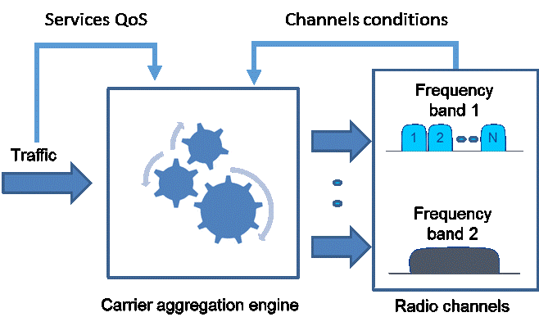

Fig.1 BCA logical scheme
Regarding the frequency spectrum, radio channels behaviours can be different because:
• Channels may be different in size or may belong to different frequency bands
• Channels may deliver different capacity and latency
• Channels may have different availabilities profile

Being spectrum a critical asset, it is fundamental to implement methods which could be able to efficiently use the spectrum, without wasting resources and adapting as much as possible radio portions to the actual payload needs.

It should be evident that, the link design will be a trad-off among multiple objectives.

Example of Applications and use cases for BCA
BCA is mainly applicable to mobile Backhaul/Fronthaul application and to wireless transport in general.

Main use cases applicable to BCA are listed here:

- General case: Channels in the same Frequency bands

The most common use case is the use of two or more channels inside the same frequency band. Anyway, even in this case, the adoption of different channels in size, or channels engineered for different objectives, capacity/availability/latency, may produce some benefits. i.e.: Energy efficiency could be improved, changing the link working conditions according to the actual traffic volume.

- Channels aggregation in low microwave frequency bands (Long Haul application)

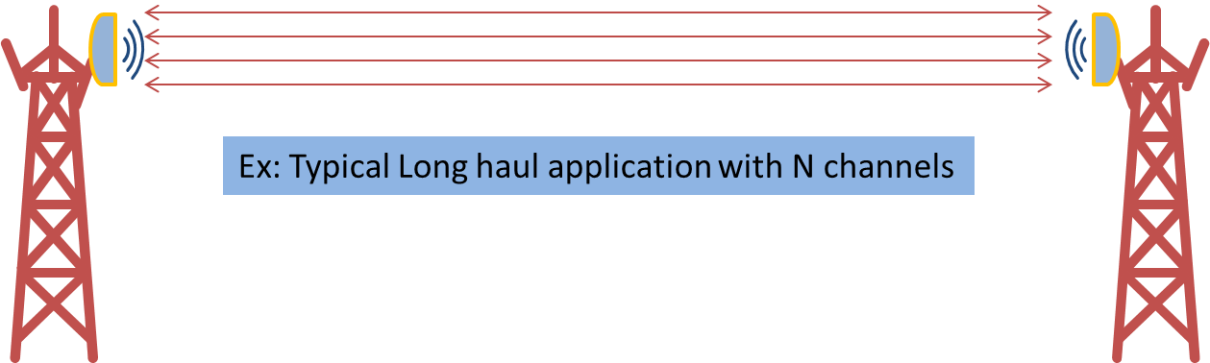

Fig.2 BCA Long Haul up to 13 GHz

In long haul transport, the aggregation of multiple RF channels to be transmitted by means of a single antenna over a link, is not a novelty. Those channels can be in the same frequency band or in different frequency bands, increasing the protection towards selective fading which is in fact the main impairment applicable to low frequencies. A typical use case when two bands are used, is aggregation of 7 and 11 GHz.

Having in parallel multiple channel in ACM, is allowed to reach multi-Gbps transmission. Moreover, spare capacity is no longer duplicated and transmitted over the spare channel. It can be demonstrated that, in average, with BCA approach can be transmitted the same capacity level than a traditional N+1 system, with the same or better availability, thus saving one radio channel (every 4) and its associated cost, in term of HW and fees.

- Channels aggregation in medium microwave frequency bands

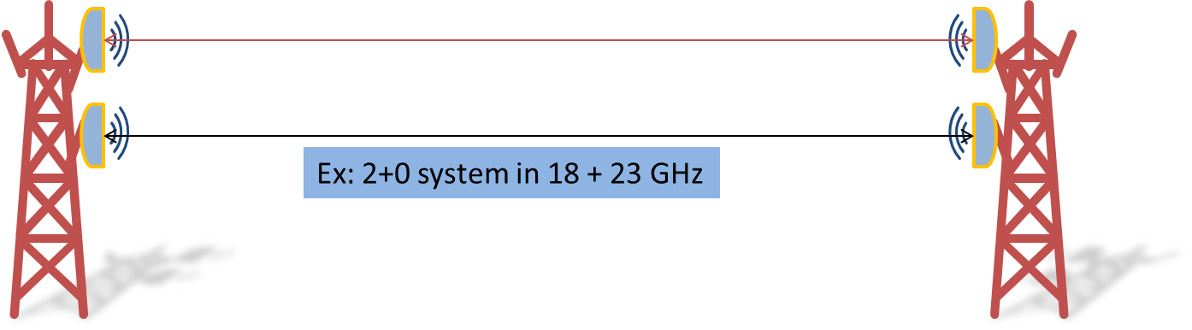

Fig.3 BCA Medium Haul: from 13 to 42GHz

Channels in traditional microwave frequencies can be aggregated over the same or different bands, here closer each other’s, in order to increase capacity overcoming spectrum limitations/congestion. In many cases in fact the required bandwidth cannot be found in a single band due to spectrum congestion: a given operator might not have the sufficient number of channels in a given band to reach the required capacity.
For this specific case, wide band antenna, able to cover two adjacent bands are under investigation.

- Microwave and mmW channels aggregation

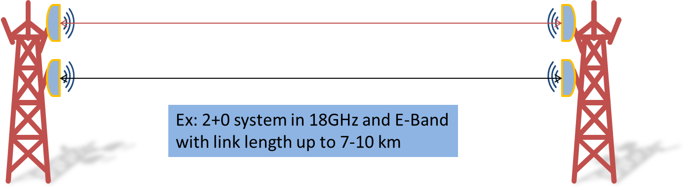

Fig.4 BCA Microwave plus millimiterwave
This case covers at least two different scenarios
- mmW as complement of high microwave bands to increase capacity, addressing spectrum congestion. This is the case, for instance of 38GHz + 80GHz, when hop length are not so demanding for E-Band connection and high/decent level of availability can be provided.

- mmW as complement of medium microwave bands to increase capacity and extend link distance. In such case microwave band would serve most critical services at highest availability, while mmW band would serve data-hungry applications for the majority of time.
The most interesting combination is between microwave in the range 15 – 23 GHz (main bands used to cover distances up to 7-10 km) with E-band. Even for this case, a bi-band antenna, able to cover, for instance 18 GHz and 80 GHz ere close to be delivered on the market.

In the following an example of this case.

- Example of BCA with 18GHz and 80GHz

It is here produced, as reference the design of a BCA system operating at 18 GHz and 80 GHz.
In this example, is considering two 56 MHz channels at 18GHz and 1 GHz channel at 80 GHz.
The performances of an actual Bi-band antenna, covering 18 and 80 GHz, is considered.
The following picture tries to capture the differences among channel size and diplexer spacing at 18 GHz

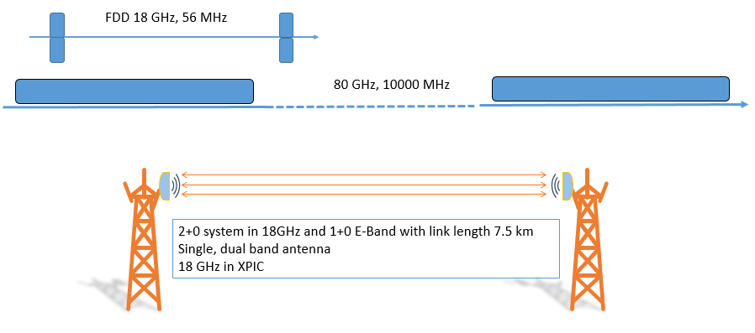

Fig.5 BCA example of a link design

System characteristics:

- Hop Length=7.5 Km
- Link designed for Unavailability =0.01% @ 256QAM/18GHz/56MHz
- Rain rate region = 42mm/h
- Polarization H&V - XPIC considered
- Bi-Band - Antenna gain:
  - 18 GHz=38dBi
  - 80 GHz=50dBi
- 18 GHz/ 56 MHz system using ACM up to 4096QAM
- 80 GHz/1000MHz system using ACM up to 128QAM

The following picture, provide a more complete view of the results obtained.

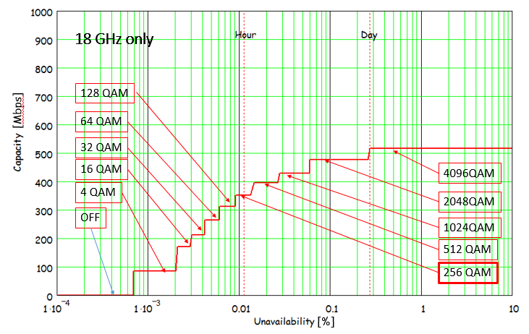

Fig. 5 Expected behaviour of 18GHz system with ACM

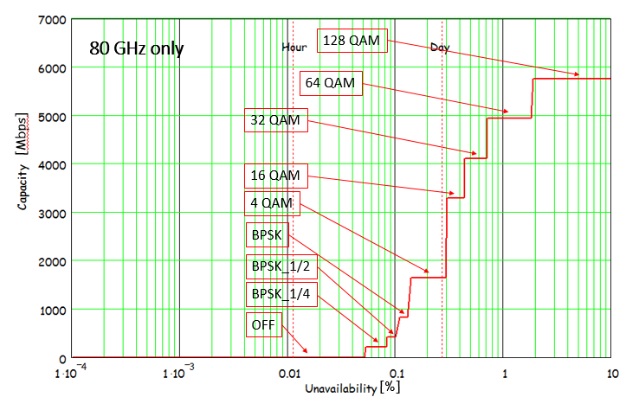

Fig. 7 Expected behaviour of 80 GHz system with ACM

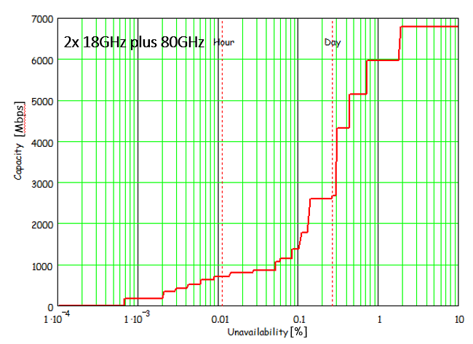

Fig. 8 Expected behaviour of BCA system
Therefore, looking at the last picture we can observe:

- BCA can provide an impressive level of capacity, close to 7 Gbps with an unavailability of less than few days over one year for 7.5 Km link.
- An E-Band link is working on 7.5Km.
  - BCA extend the range of applicability of mmW band, extending their feasibility range
- With a traditional approach, to deliver this capacity we would need 8 channel with XPIC @ 18GHz.
  - BCA decongested valuable band!
- The link will be, completely, unavailable for less that few minutes (<5min) over a period of observation of one year.

Main points should be considered:

- Bi-Band antenna is today feasible. Dimension (due to gain) limited by highest band considered
- Antenna RPEs are obviously different between the two bands. Due to their intrinsic technical complexity, it is expected that both bands might not reach the most stringent RPE ETSI classes 4.
- Antenna Pointing, usually very challenging when antenna gain is closed to 50 dBi and for long connection, is made feasible, in case of bi-band antenna.
  - The antenna will be aligned using lower frequency bands, with lower gain, therefore adjusted with the higher frequency bands signal. Of the result, will benefit the lower frequency signal as well, since the pointing will results practically perfect, without any losses.
- Considering the highest frequency, even the lowest modulation scheme could result in having an availability very low, in some cases even less than 99.0%. Therefore, it is expected that, regulation will consider that when BCA is concerned.

- Summary of BCA benefits

Major BCA benefits are here listed:

- Decongesting valuable frequency bands (in general the lowest one, which are, in general, enabling longer distances), increasing the efficient use of the spectrum
- Extend the use of higher frequency bands to a plenty of use cases, because the hop length limits can be extended. This is particular true for E-Band, W-Band or D-Band, that will be enabled to be used in sub-urban area as well, where distances are usually longer than what can be normally addressed.
- Enabling an increased channel granularity combining small channels into one logical bigger carrier, thus:
  - better matching the real capacity needs in terms of main KPIs. (capacity/coverage/availability/ latency)
  - enabling the possibility to send a single big pipe (e.g. 1 or more Gbps) on multiple channels
  - improving efficiency in the spectrum usage because aggregation of unused narrow slices of spectrum)
  - enabling the use of wider channels cannot be feasible with single carrier approach (wider channel could be obtained using multiple continuous channels or grooming channels around)
- No longer need to duplicate traffic flows on air to provide protection, thus saving also spectrum/bandwidth

