SE24 Meeting M84
Paris, 30 August – 2 September 2015

Date issued: 26 August 2015

Source: Ericsson, Qualcomm

Status: For consideration

Subject: Overview of Licensed Assisted Access of LTE (LAA-LTE)
 | Password protected: yes |  | No | x

Summary:

This paper aims at providing an overview of the Licensed Assisted Access of LTE (LAA-LTE) in response to the European Commission requirement to consider LAA-LTE in the sharing studies between RLANs and incumbent systems at 5GHz band. We describe LAA-LTE system in terms of two aspects: namely (1) RF parameter aspects, (2) deployment scenarios, and (3) activity level aspects. In all aspects, it has been shown that LAA-LTE has very similar characteristics compared to other RLANs in 5GHz spectrum.

Proposal:
To consider LAA-LTE as another RLAN system in 5GHz spectrum. As a consequence, LAA-LTE should be included when SE24 discusses sharing between RLANs and FSS at 5GHz band. Therefore we propose to modify the draft ECC Report so that it is clearly service and technology neutral. Thus, the achieved results should be generalised to cover LAA-LTE and other WAS/RLAN technologies

Background:
During the last WG FM meeting, PT 55 discussed the liaison statement sent by WG SE (doc. FM(15)149) which intended to limit the studies to WAS/RLAN technology based on Wi-Fi equipment. The EC Counsellor informed that the mandate is not limited to Wi-Fi technology and the Commission would be concerned if LTE-U were not taken into account in the studies.

Introduction

Total mobile data traffic growth is expected to overtake the available licensed band spectrum capacity. Therefore, opportunistic use of unlicensed spectrum has become an important complement for cellular operators to meet the growing traffic demands. The two main technology options for achieving this goal are: Wi-Fi (via LTE/Wi-Fi integration) and LTE (via Licensed-Assisted Access).

Licensed-Assisted Access of LTE (LAA-LTE) offers the possibility of offloading capacity by using the same LTE air interface technology and network for licensed and unlicensed spectrum. In this approach, LTE would operate in unlicensed spectrum as a Secondary cell to a Primary cell in licensed spectrum through standard LTE carrier aggregation, as shown in Figure 1-1. Thus, LAA-LTE networks are envisioned to be operator-deployed small cells, mainly in hotspots and enterprise networks, and most likely not in residential/private networks. LAA-LTE targets fair and friendly coexistence with other technologies (e.g. Wi-Fi) and other operators in unlicensed spectrum.

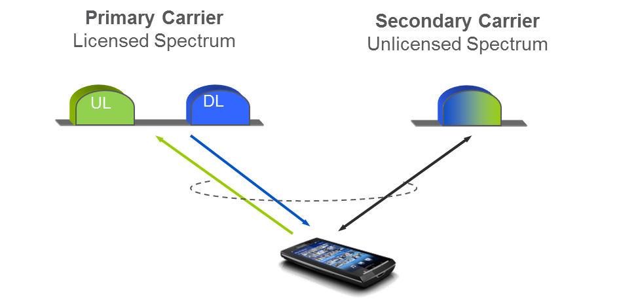
Figure 1-1: Unified LTE network for both licensed and unlicensed spectrum

Standardization activities

This section summarizes the standardization activities focusing on the horizontal coexistence between LAA-LTE and Wi-Fi in the 5GHz band.

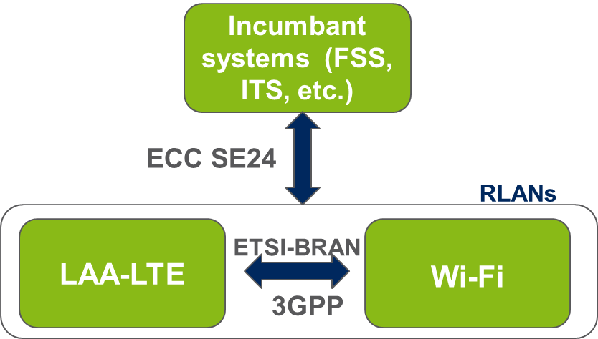
Figure 1.1-1 Vertical and Horizontal Coexistence in the 5GHz band

3GPP
The 3GPP study item on LAA-LTE to unlicensed spectrum was approved at 3GPP RAN#65 in September 2014 [1]. The study was started in 3GPP in October 2014 and version 1.0.0 of the LAA-LTE Technical Report 36.889 was endorsed in May 2015 [2]. The study evaluated LTE enhancements for a single global solution framework for LAA-LTE to unlicensed spectrum, primarily at 5 GHz band. Complementary access using the unlicensed band would be supported by licensed operation, the quality of which can never be matched by unlicensed operation. The objectives of the study included:
- the definition of an evaluation methodology to measure fair coexistence with Wi-Fi as well as LAA networks,
- the possible scenarios for LTE deployments focusing on LTE carrier aggregation,
- the documentation of the relevant requirements and design targets for unlicensed spectrum deployment,
- the identification and evaluation of the physical layer options and enhancements to LTE to meet the requirements and targets for unlicensed spectrum deployments,
- the identification and evaluation of any enhancements needed to LTE RAN protocols and an assessment of the feasibility of base station and terminal operation in the 5 GHz band in conjunction with relevant licensed frequency bands.

The results and findings of the study are documented in the Technical Report 36.889 v.1.0.0. In this report, LAA-LTE system has the following design targets: being a single global solution framework allowing compliance with any regional regulatory requirements, and have an effective and fair coexistence with Wi-Fi and LAA-LTE networks deployed by different operators. Moreover, the Technical Report 36.889 v.1.0.0 also provides an extensive summary of relevant regulatory requirements for 5GHz spectrum in different part of the world. It has further been identified that the use of LTE in unlicensed spectrum can serve as a useful additional tool by operators to maximize the value they can provide to users, while the core of the activity of the operators remains anchored to the licensed spectrum. The study item included twelve working group meetings across the RAN1, RAN2 and RAN4 working groups. More than 40 companies participated in extensive technical discussions as part of the 3GPP study. Over 1500 technical contributions were submitted to 3GPP meetings during the study.

The 3GPP work item was approved at 3GPP RAN#68 in June 2015 [5]. The work item is expected to be finalized in December 2015. The work item aims at designing LAA-LTE that can have a fair coexistence between Wi-Fi and LAA-LTE and fair coexistence between different LAA-LTE systems. Therefore, minimum set of mandatory features/parameters that enable fair coexistence will be identified. The work item will specify DL-only LAA-LTE operations. However, the principles of UL channel access should also be defined. Moreover, the DL design should be done in forward compatible manner so that UL can be added in future releases without modifications to the DL design.

ETSI BRAN
ETSI BRAN launched a work item on 5GHz high performance RLAN in December 2014. The work is scheduled to be finalized in December 2015. The main objective of the work item is to revise the existing EN 301 893 to become applicable under Directive 2014/53/EU. This revision considers the inclusion of receiver parameters, the review and/or improvement of the test methods, and the revision of Adaptivity for Frame Based Equipment and Load Based Equipment that provides equal (spectrum) access to different technologies.

ETSI BRAN#83 received many technical contributions from the WFA and 3GPP community, which were mainly focusing on revising the adaptivity rules in the existing EN 301 893. These contributions contain different views on the coexistence of dissimilar radio technologies, e.g. the coexistence of LAA-LTE and IEEE802.11. The contributions particularly discussed aspects of channel access schemes in LAA-LTE and IEEE802.11, and the LAA-LTE design functionalities that allow fair coexistence between RLANs in the unlicensed spectrum.

LAA-LTE RF characteristics

In the following section, we present a brief overview of the LAA-LTE RF characteristics such as transmission power, channel bandwidth, antenna characteristics, etc. Moreover, we also recall an analysis on the LAA-LTE adjacent channel leakage characteristics in terms of the Adjacent Channel Leakage Ratio (ACLR), which was originally presented as part of Technical Report 36.889 v.1.0.0. These discussions are essential for understanding the RF performance of both systems and it can be directly mapped to the interference that each system creates to other system, e.g. FSS. Thus, the goal of this section is to explain the similarities between an LAA-LTE system and a Wi-Fi system in terms of impact to incumbent systems.

LAA-LTE transmission power characteristics
The first aspects we want take into account are related to the maximum transmit power and in-band emission. Table 2.1-1 and Table 2.1-2 show the basic LAA-LTE transmitter and user equipment characteristics under discussion for standardization. As it can be observed, LAA-LTE will fulfil same requirements in terms of conducted and radiated power and power spectral density limits. Also, available channel bandwidths will be aligned with those assumed for RLAN. Therefore, when looking at the in-band (in-channel) RF performance, LAA-LTE can be considered as a generic RLAN seems same requirements will be applied.

Table 2.1-1: Basic LAA-LTE transmitter characteristics in the band 5725-5925 MHz

System Parameters | Indoor |  | Outdoor
 | RLAN | LAA-LTE | RLAN | LAA-LTE
Maximum Transmit Power (e.i.r.p. - dBm) | 23 |  | 30 | 23(29)
Bandwidth (MHz) | 20/40/80/160 |  | 20/40/80/160
Maximum Transmit Power Density (e.i.r.p. - dBm/MHz) | 10/7/4/1 |  | 17/14/11/8 |  | 10/7/4/1
Typical AP Antenna Type | Omni (azimuth) | 2D Omni-directional | Omni (azimuth) | 2D Omni-directional
AP Antenna gain + cable loses (dBi) | 0-6 | 5 | 6-7 | 5
AP Antenna Height (m) | 6-28.5 | 6 | 6-28.5 | 10

Table 2.1-2: Basic LAA-LTE UE characteristics in the band 5725-5925 MHz

System parameter | Value
 | RLAN | LAA-LTE
Bandwidth (MHz) | 20
kTB (dBm / bandwidth) | -101
Typical Noise figure (dB) | 4 | 4
Noise Power (dBm / bandwidth) | -97 | -97
I/N (dB) | -6
Maximum antenna gain (dBi) | 1.3 | 0
Antenna Height (m) | 1-1.5 | 1.5

LAA-LTE UE power distribution
Using baseline 3GPP Fractional Power Control (FPC) method to allocate the transmit power levels for UEs; we present our analysis for LAA-LTE UE power distribution in this section.
FPC has three components, base-line open loop operating point, dynamic offset part and bandwidth factor. The overall power control equation looks as follows:
(2.1-1)
Where is the resulting UE transmit power level, is the fractional path-loss compensation factor, is the estimation of actual path-loss between the BS and the UE. The dynamic offset part consists of MCS (Modulation and Coding Scheme) dependent factor, (TF stands for transmission format) and the explicit power control instruction part. The bandwidth factor is dependent on, which stands for granted bandwidth, in terms of number of granted PRBs.

Figure 2.2-1 Statistics of UL power levels used by the terminals in the indoor deployment scenario

Figure 2.1-1 shows the actual UL power levels used in the simulations. Since the LAA-LTE RBS is usually close to the UE in LAA-LTE operations, the terminals transmit in UL using very low power levels. In this case, the median UE transmit power is less than 0dBm, which is very low. The deployment scenario is as described in indoor in-building scenario in 3GPP TR 36.889.
Figure 2.2-2 shows instead the UE transmit power distribution in case of outdoor deployment (as specified in 3GPP TR 36.889). As expected, in this case power levels are higher compared to the indoor case due to higher coupling loss. UL power distribution depends on the specific power control settings, results presented in Figure 2.2-2 represents a reasonable trade-off in terms of noise raise due to intra system interference and achievable mean throughput. Note that in this scenario less than 3% of the users transmit at maximum power, which is a common target adopted in other CEPT studies.
Figure 2.2-2 Statistics of UL power levels used by the terminals in the outdoor deployment scenario

Table 2.1-3: LAA-LTE UE power distribution

Tx power e.i.r.p. | 1 W (omni) | 200mW (omni) | 200 - 80 mW (omni) | 80 -50 mW (omni) | 50 – 25 mW (omni) | 25 – 1 mW (omni) | <=1mW (omni) | all
indoor | 0% | 1,66% | 2,49% | 2,49% | 3,32% | 23,24% | 49,8% | 83%
outdoor | 0% | 0,51% | 0,51% | 1,53% | 0,85% | 8,5% | 5,1% | 17%

LAA-LTE BS power distribution
Currently, 3GPP is discussing power backoff for supporting higher order modulations. The scheme is proposed in 3GPP RAN4 contribution [7]. The main idea is to backoff transmit power of LAA-LTE BS when 64-QAM and 256-QAM can be used. The method will ensure that transmit power levels will be similar to existing WiFi procedures.
In the current specifications, LTE Rel-8 BS always transmits on full power. We update the above table on LAA-LTE UE power distribution so that the table also includes LAA-LTE BS power distribution by considering the following assumptions:
- There are at least 4 UEs per LAA-LTE node; thus, out of the LAA-LTE devices, there will be at least 20% LAA-LTE nodes and the rest 80% will be LAA-LTE terminals.
- One in every five LAA-LTE nodes is placed outdoor, as a baseline assumption. Thus, 20% LAA nodes are placed outdoors.

Considering the above two assumptions and including the LAA-LTE UE transmit powers, we obtain the following table for LAA-LTE power distribution:

Table 2.3-1: LAA-LTE power distribution considering both LAA node and UEs

Tx power e.i.r.p. | 1 W (omni) | 200mW (omni) | 200 - 80 mW (omni) | 80 -50 mW (omni) | 50 - 25mW (omni) | 25 - 1mW (omni) | <=1mW (omni) | all
indoor | 0 | 17,328 | 1,992 | 1,992 | 2,656 | 18,592 | 39,84 | 82,4
outdoor | 0,1 | 4,308 | 0,408 | 1,224 | 0,68 | 6,8 | 4,08 | 17,6

As it is seen from above table, the LAA-LTE power distribution is very similar to WiFi systems. Moreover, it is important to notice that great part of the devices transmit power lower than 25mW.

LAA-LTE channel bandwidth characteristics
Like Wi-Fi, LAA-LTE can support different channel bandwidths through a carrier aggregation mechanism. Because of the total transmitted power limit, power spectral density will scale based on the aggregated bandwidth. To determine what would be the channel bandwidth distribution is not an easy task since it depends on several factors. However, it can be observed that IEEE and 3GPP standards are converging in terms of overall spectral efficiency. This is particularly true we consider the evolution of the 802.11 family with 802.11ax standard. Assuming that LAA-LTE and Wi-Fi will be subject to the same traffic demand by the end users, it is reasonable to expect that very similar channel bandwidth distribution will be required by the two systems.

Based on the above observations, we assume that Wi-Fi and LAA-LTE will have same channel bandwidth distribution as described in Table 2.2 1.

Table 2.2-1: LAA-LTE channel bandwidth distribution and bandwidth correction values
Channel bandwidth | 20 MHz | 40 MHz | 80 MHz | 160 MHz
Device Percentage | 10 % | 25 % | 50 % | 15 %

LAA-LTE adjacent channel leakage characteristics

Another important aspect to be taken into account when looking at LAA-LTE impact on incumbent systems is the power leakage into adjacent channels/bands. A common figure of merit used to evaluate the adjacent channel performance is the Adjacent Channel Leakage Ratio (ACLR) which is a measure of the power leakage into adjacent channels. Indeed, from an RF point of view a system with high ACLR, i.e. higher rejection on adjacent channels will create lower adjacent channel interference. A detailed comparison of Wi-Fi and LAA-LTE ACLR was carried out in [2].

It is worth noticing that Adjacent Channel Leakage Ratio (ACLR) values are not defined in the IEEE specification [3]. However, a spectrum emission mask is defined for each transmission bandwidth. Figure 2.3-1 shows the spectrum mask defined for the 20 MHz case in harmonized 5GHz spectrum, whose values are relative to the in-band PSD. The ACLR that Wi-Fi should satisfy in 5GHz can be simply obtained by integrating the mask in the first frequency region characterising the first ACLR [3]. This integration process leads to a value of about 26.3dBc. On the other side, in 3GPP specification, an ACLR value is specified for both User Equipment (UE) and Base Station (BS). In particular, for legacy UE and BS specified ACLR values are 30dBc and 45dBc, respectively. Therefore, it is expected that even in terms of impact to adjacent channels LAA-LTE will create a lower amount of interference compared to Wi-Fi systems.

It is also worth mentioning that once ACLR values are defined in the 3GPP technical specification, conformance tests will be created. This means that devices implementing LAA-LTE features need to fulfil the minimum requirements defined in the specification, thus guarantying a controlled amount of created interference.

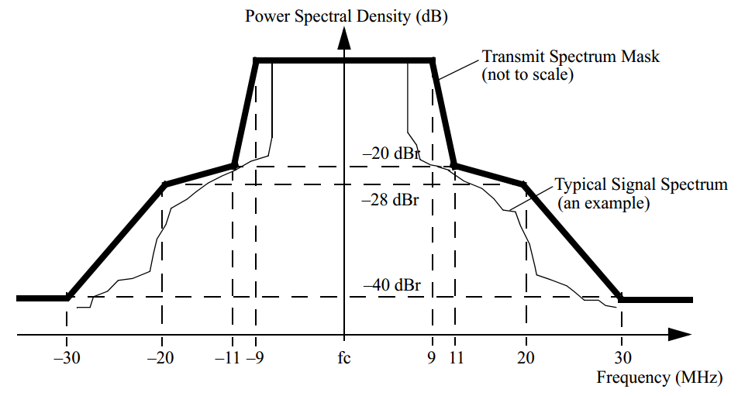
Figure 2.3-1 802.11 transmit spectrum mask for 20MHz

In essence, since all the RLANs in 5GHz must satisfy the regulatory requirements in terms of harmonized spectrum mask, there will not be any difference between RLAN systems operating in 5GHz in terms of worst case allowed leakage power.

Channel access characteristics
The channel access methods for LAA-LTE in 5GHz is still under discussions. In this section, we present the WLAN channelization for 5GHz as shown in a 3GPP contribution

WLAN specification [6] defines channel center frequencies as following:

Channel center frequency = Channel starting frequency + 5 ⋅ nch(MHz) where nch = 1,..., 200

Channel starting frequency is 5 GHz. Channel spacing is therefore 5 MHz but for high throughput, the IEEE specification defines only spectrum mask for 20 and 40 MHz channel BW’s. In [6], there is also 5 and 10 MHz channel bandwidth mentioned for 5 GHz but none of these are used in practice, nor certified. There is new effort to specify 80 and 160 MHz channel BW’s for 5 GHz.

For WLAN, wider bandwidths are allocated in similar fashion to LTE intra-band contiguous CA, by allocating primary channel and secondary channel. In some sources, it may be mentioned that e.g. channel 36 with centre frequency of 5180 can be used for 40 MHz BW. This means that the channel 36 can be aggregated with the channel 40, not that the used frequencies would between 5160 to 5200 MHz.

Used WLAN channels for lower 5GHz unlicensed band (5150 – 5350 MHz) are shown in Figure 2.5-1. The fundamental 20 MHz channels are shown in blue. The wider channel usage scenarios are shown in other colours. As explained above, e.g. 40 MHz channel BW is expressed by allocating two adjacent channels.

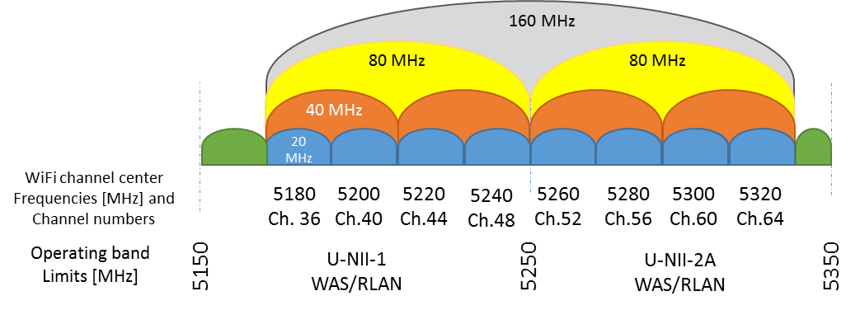
Figure 2.5-1 WiFi channels and frequency allocation boundaries in lower 5GHz

Green areas in Figure 2.5-1 are not used. This arrangement leaves 20MHz on each side of the band not being used by WiFi systems. This is due to the fact that, current WiFi systems are not able to satisfy the out-of.band emission requirements if the band edges are used. Thus, leaving the band edges as guard bands solves the issue. The regulatory emission limits outside the bands are defined as -30 dBm / MHz and WLAN specification only refers to the regulatory requirements. This may be the reason for guard band arrangement inside the allocated frequency band which is different than how licensed bands are allocated. Similar situation is also in the upper 5 GHz band 5470 to 5725 MHz as shown in Figure 2.5-2. In this range, 20 and 15 MHz guard bands between the occupied bandwidth edge and unlicensed allocation edge are left unused.
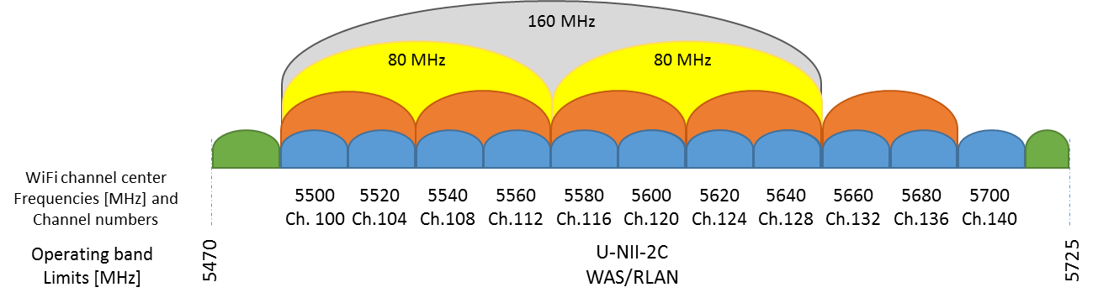

Figure 2.5-2 WiFi channels and allocation boundaries in upper 5 GHz

It seems that adopting WLAN channel arrangement to LAA-LTE would be straight forward solution. This would simplify the LBT definition and channel arrangement in the majority of the unlicensed 5 GHz band. It also would benefit WLAN operation as handling partial overlap is not designed in to WLAN systems and LAA-LTE needs to co-exist fairly with WLAN in the unlicensed band.
WLAN does not use < 20 MHz channel BW’s and the entire higher channel BW’s are divisible by 20MHz. Thus, 20 MHz should be the defined bandwidth at least for the majority of the operating band for LAA-LTE. Introducing smaller channel spacing and BW should be done very carefully and should comply with WLAN channel usage. The guard bands in the edges of the unlicensed allocation may need smaller bandwidth channels to fill the gaps.

Observation: Harmonising LAA-LTE channel bandwidth and channels spacing with WLAN would benefit both systems

Bandwidth access LAA-LTE vs WIFi
In LAA-LTE, only contiguous carrier aggregation is considered. As explained in 3GPP TS 36.101, for intra-band contiguous carrier aggregation Aggregated Channel Bandwidth, Aggregated Transmission Bandwidth Configuration and Guard Bands are defined as follows, see Figure 2.6-1.

F_{C,low}
Lower Edge
Higher Edge
Lowest Carrier Transmission Bandwidth Configuration, N_{RB,low} [RB]
F_{C,high}
F_{offset,low}

Highest Carrier Transmission Bandwidth Configuration N_{RB,high} [RB]
Resource block
Aggregated Channel Bandwidth, BW_{channel_CA} [MHz]
F_{edge,low}
F_{edge,high}
For each carrier, the center sub carrier (corresponds to DC in baseband) is not transmitted in downlink
F_{offset,high}

Guard Band
Guard Band
Aggregated Transmission Bandwidth Configuration, N_{RB_agg} [RB]
Figure 2.6-1 Definition of Aggregated channel bandwidth and aggregated channel bandwidth edges

The aggregated channel bandwidth, BW_{Channel_CA}, is defined as

BW_{Channel_CA} = F_{edge,high} - F_{edge,low} [MHz].
The lower bandwidth edge F_{edge,low} and the upper bandwidth edge F_{edge,high} of the aggregated channel bandwidth are used as frequency reference points for transmitter and receiver requirements and are defined by
F_{edge,low} = F_{C,low} - F_{offset,low}
F_{edge,high} = F_{C,high} + F_{offset,high}
The lower and upper frequency offsets depend on the transmission bandwidth configurations of the lowest and highest assigned edge component carrier and are defined as
F_{offset,low} = (0.18N_{RB,low} + Δf₁)/2 + BW_{GB} [MHz]
F_{offset,high} = (0.18N_{RB,high} + Δf₁)/2 + BW_{GB} [MHz]
where Δf₁ for the downlink with f the subcarrier spacing and Δf₁= 0 for the uplink, while N_{RB,low} and N_{RB,high} are the transmission bandwidth configurations according to Table 5.6-1 of TS 36.101 for the lowest and highest assigned component carrier, respectively. BW_{GB} denotes the Nominal Guard Band and is defined in Table 5.6A-1 of TS 36.101, and the factor 0.18 is the PRB bandwidth in MHz. Note that the values of BW_{Channel_CA} for UE and BS are the same if the lowest and the highest component carriers are identical.

Aggregated Transmission Bandwidth Configuration is the number of the aggregated RBs within the fully allocated Aggregated Channel bandwidth and is defined per CA Bandwidth Class (Table 5.6A-1 of TS 36.101).

When we compare the intra-band contiguous channel access in LAA-LTE as shown in Figure 3.5-1 and the WLAN access in 5GHz as shown in Figure 2.5-1 and Figure 2.5-2, we can clearly see that, there is actually no difference in channel access schemes for both WLAN and LAA-LTE in 5GHz spectrum.

Conclusions on LAA-LTE RF requirements
We analysed both in band and in adjacent band RF requirements for LAA-LTE. From the above discussions, it can be concluded that LAA-LTE should be considered same as any other RLAN systems in 5GHz spectrum.

Deployment of LAA-LTE
LAA-LTE is expected to be deployed by operators, mainly in hotspots and enterprise environments. Thus, user-deployed LAA-LTE is excluded from current discussions. Operator-deployed means that the actual deployment will be “somewhat planned”, this means that LAA-LTE will only be used in places where the operator coverage of LAA-LTE is available.

Deployment scenarios
This section describes possible deployment scenarios for LAA-LTE, which cover situations with and without macro coverage, both outdoor and indoor small cell deployments, and both co-location and non-co-location (with ideal backhaul) between licensed and unlicensed carriers. Figure 3-1 shows four LAA-LTE deployment scenarios:

- Scenario 1: Carrier aggregation between licensed macro cell (F1) and unlicensed small cell (F3)
- Scenario 2: Carrier aggregation between licensed small cell (F2) and unlicensed small cell (F3) without macro cell coverage
- Scenario 3: Licensed macro cell and small cell (F1), with carrier aggregation between licensed small cell (F1) and unlicensed small cell (F3)
- Scenario 4: Licensed macro cell (F1), licensed small cell (F2) and unlicensed small cell (F3) with carrier aggregation between licensed small cell (F2) and unlicensed small cell (F3).If there is ideal backhaul between macro cell and small cell, there can be carrier aggregation between macro cell (F1), licensed small cell (F2) and unlicensed small cell (F3).

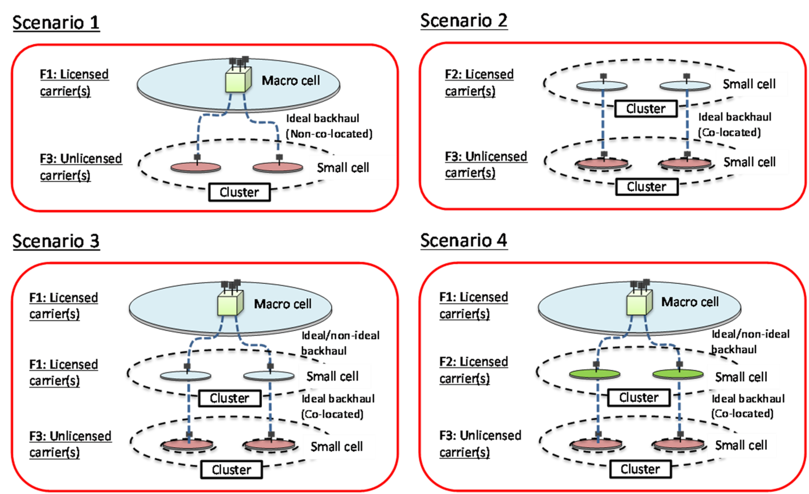
Figure 3.1-1 LAA-LTE deployment scenarios in terms of cell size

Notice that in these scenarios the number of licensed carriers and the number of unlicensed carriers can be one or more. Though the backhaul between small cells can be ideal or non-ideal, the unlicensed small cell only operates in the context of the carrier aggregation through ideal backhaul with a licensed cell. In scenarios where carrier aggregation is operated within the small cell with carriers in both the licensed and unlicensed bands, the backhaul between macro cell and small cell can be ideal or non-ideal. When non-ideal backhaul is applied between a Macro cell and a small cell cluster in Scenarios 3 and 4, a small cell on an unlicensed carrier has to be aggregated with a small cell on a licensed carrier in the small cell cluster through ideal backhaul.

The actual indoor and outdoor deployment scenario employed for 3GPP simulations are shown in Figure 3.1-2 and Figure 3.1-3. In this scenario depicted in Figure 3.1-2, two operators deploy 4 small cells each in the single-floor building. The small cells (LAA-LTE cells) of each operator are equally spaced and centered along the shorter dimension of the building. The distance between two closest nodes from two operators is random. The set of small cells for both operators is centered along the longer dimension of the building.
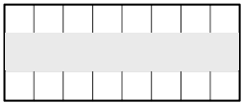
120 m
50 m

Figure 3.1-2 Layout for indoor scenario

Similar layout for outdoor deployment is shown in Figure 3.1-3. The LAA-LTE cells are in clusters uniformly distributed within the macro geographical area; 4 small cells per operator, uniformly random dropping within the cluster area.

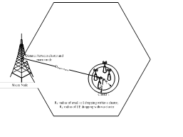
Figure 3.1-3 Layout for Outdoor deployment

Offloading operation

This sections describes how offloading works in LAA-LTE and establishes similarities with alternative offloading via Wi-Fi.

Offloading data from cellular networks typically implies traffic flows between a licensed macro or small cell and the unlicensed small cell, which can be Wi-Fi, LAA-LTE or another technology, through an ideal or no-ideal backhaul. LAA-LTE provides the possibility of offloading data traffic by employing the same technology in a single network framework, which enables reduced operation and management overheads, as shown in Figure 3.2-1. On the contrary, offloading data traffic via Wi-Fi typically implies hard switch between two technologies. Even though tight integration/aggregation between 3GPP and WLAN solution is performed at a lower layer that is closer to the RAN, and as such the scheduling and flow control of the data on the WLAN and 3GPP links can be controlled by considering dynamic radio network conditions; this solution still needs to have an interface to establish a controlled tunnel between the UE and a dedicated server in the cellular operator core network in order to obtain access to operator subscribed content to obtain access to operator subscribed content or public Internet.

In the downlink access, both technologies LAA-LTE and Wi-Fi access the medium based on the clear channel assessment (CCA) check to determine if the channel is free for use and exponential random backoff time (Category 4 LBT) if the channel is busy. In the uplink access, traffic is scheduled by the LAA-LTE eNBs which reduces the number of contending nodes at any given time. This implies that few LAA-LTE UEs, which are scheduled at a given time, attempt to access the medium. Notice that LAA-LTE UEs perform also LBT check before transmitting (according the latest description of UL LAA-LTE in [2]). On the other hand, when cellular traffic is offloaded via Wi-Fi, all UEs with non-empty uplink buffer contend for access to the medium, they do not need wait for a scheduling grant from a controlling base station. Therefore, the probability of collision is higher. Also, a larger number of sensed neighbours reduce the transmission opportunities due to higher deferral probability.

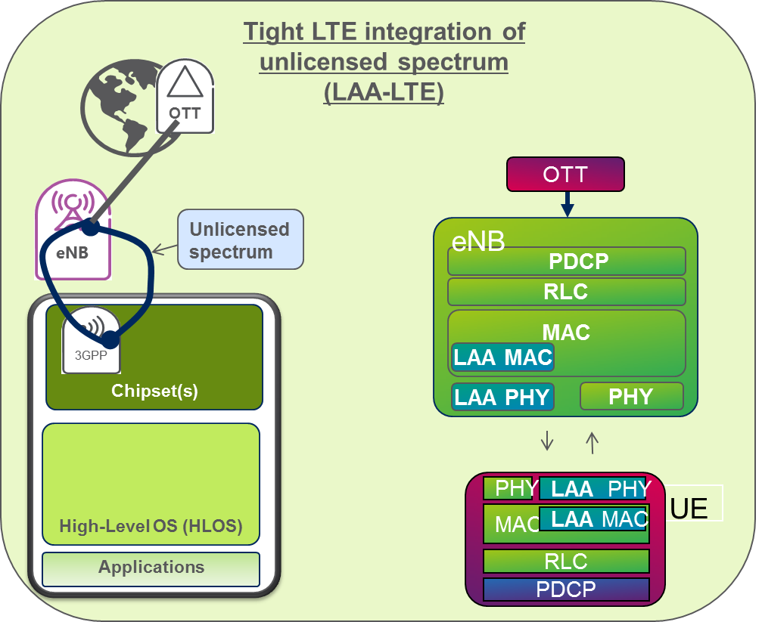
Figure 3.2-1Offloading via LAA-LTE

Interference Aggregation

For downlink transmission, LAA-LTE APs employ the maximum allowable transmission power, which is set according regulations. More details on the values of transmission power can be found in Section 2.1. For uplink transmissions, LAA-LTE UEs implement transmit power control (TPC) mechanisms which allows them to dynamically adjust their transmission power necessary to maintain the link and reduce interference. Moreover, TPC ensures an average reduction in the aggregated transmission power by at least 3 dB compared with the maximum permitted transmission power. Figure 2.1-1 shows the actual UL power levels used in the simulations, which are typically much lower than the maximum permissible transmit power for UEs (the median UE transmit power is less than 0dBm, which is very low).

Activity factors of LAA-LTE
In this section, we focus on how LAA-LTE nodes will use the 5GHz spectrum. In particular, we emphasize the similarities between LAA-LTE and other RLAN systems, by comparing LAA-LTE and Wi-Fi activity levels in 5GHz spectrum. We will take into account the following factors: deployment scenarios, activity factors, access mechanisms, DFS, TPC and carrier selection.
Similar to other RLAN systems in unlicensed band, there are number of design targets that are considered for LAA-LTE in 3GPP. These targets aim to achieve a single global solution framework, and effective and fair coexistence with Wi-Fi and other LAA-LTE networks deployed by different operators. This section provides an overview of the functionalities that are required for an LAA-LTE system to meet the design targets. These functionalities have a direct impact on the activity level of a LAA-LTE system at 5GHz spectrum.

Listen-before-talk (Clear channel assessment)
The listen-before-talk (LBT) procedure is defined as a mechanism by which the equipment applies a clear channel assessment (CCA) check to determine if the channel is free for use. Therefore, LBT procedure involves at least energy detection to determine the presence or absence of other signals on a channel in order to determine if a channel is occupied or clear, respectively. Regulatory requirements in some regions, e.g., in Europe, specify an energy detection threshold such that if a node receives energy greater than this threshold, the node assumes that the channel is occupied. It is recommended that LAA-LTE supports a mechanism to adaptively change the energy detection threshold, i.e., LAA-LTE should be able to adaptively lower the energy detection threshold from an upper bound. Such an adaptation mechanism does not preclude static or semi-static setting of the threshold.

Currently, Category 4 LBT mechanism is considered the baseline in 3GPP evaluations, at least for LAA-LTE downlink transmission bursts containing PDSCH. Category 4 LBT refers to LBT with random back-off with a contention window of variable size. The basic procedure consists of the transmitting entity varying the size of the contention window when drawing a random number N. The size of contention window is specified by the minimum and maximum value of N. The random number N is used in the LBT procedure to determine the duration of time that the channel is sensed to be idle before the transmitting entity transmits on the channel. Notice that Category 4 LBT is in conformance to ETSI EN 301.893 LBT framework.
Apart from regulatory requirements, carrier sensing via LBT is a vital feature for fair and friendly operation in the unlicensed spectrum in a single global solution framework.

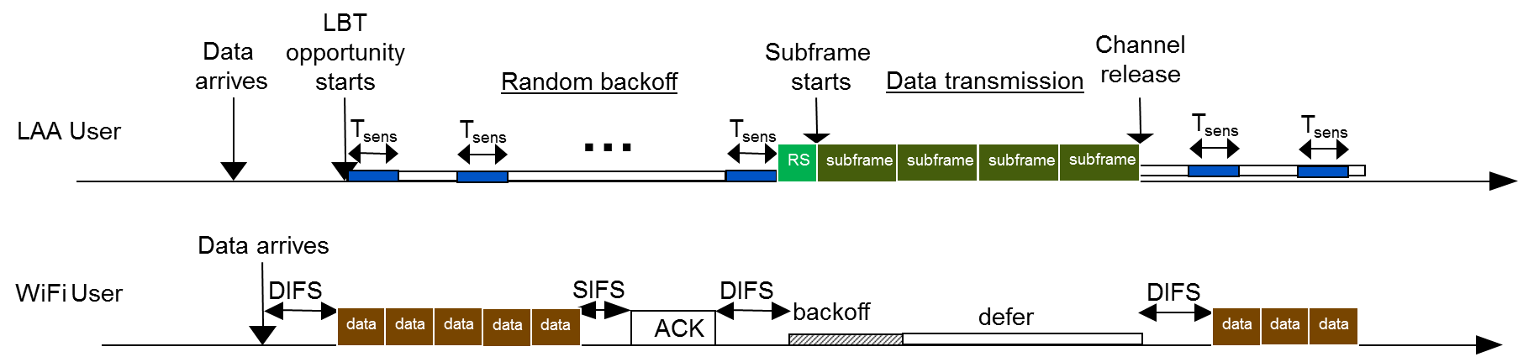
Figure 4.1-1Illustration of LBT mechanism

Discontinuous transmission on a carrier with limited maximum transmission duration
In unlicensed spectrum, channel availability cannot always be guaranteed. In addition, certain regions such as Europe and Japan prohibit continuous transmission and impose limits on the maximum duration of a transmission burst in the unlicensed spectrum. Hence, discontinuous transmission with limited maximum transmission duration is a required functionality for LAA-LTE.

Dynamic frequency selection for radar avoidance in certain bands/regions
Dynamic frequency selection (DFS) is a regulatory requirement for some frequency bands, e.g., to detect interference from radar systems and to avoid co-channel operation with these systems by selecting a different carrier on a relatively slow time scale. All LAA-LTE nodes should be equipped with supporting DFS mechanism in regions where DFS is a regulatory requirement.

Carrier selection
As there is a large available bandwidth of unlicensed spectrum, carrier selection is required for LAA-LTE nodes to select the carriers with low interference and with that achieve good co-existence with other unlicensed spectrum deployments.

Transmit Power Control
Transmit Power Control (TPC) is a regulatory requirement in some regions by which the transmitting device should be able to reduce the transmit power in a proportion of 3dB or 6dB compared to the maximum nominal transmit power.

The PHY layer options considered for LAA-LTE have at least the following characteristics:
- Support for at least 20MHz system BW option in the 5GHz band
- System bandwidths < 5 MHz are not considered for PHY layer options in LAA-LTE

Conclusions on Activity Factors of LAA-LTE

Based on the above description and the parameters used in [4], we present our analysis for LAA-LTE in the following table:

Table 4.6-1 Activity factors
Busy hour factor | This depends on deployment area. This factor is not influenced by the RLAN system. | Same as any other RLAN
5GHz spectrum factor | This factor depends on the possibility for the terminal to be under the coverage of 5GHz unlicensed cell. | Same as any other RLAN
RF activity factor | This factor provides the amount of time that the RF is ON for the RLAN | Same as any other RLAN

In essence, when LAA-LTE will be in operation, then part of RLAN devices will use LAA-LTE, thus, there is no reason for activity factors to increase in LAA-LTE compared to other RLANs in 5GHz spectrum.

Conclusions
In this paper, we have discussed the similarity of LAA-LTE with other RLANs in 5GHz spectrum in terms of several aspects, including RF requirements, device activity factors, channel access and coexistence mechanisms, etc.

Regarding technical parameters for LAA-LTE, they will comply with regulations on the Tx power/PSD, antenna gain and similar parameters, as defined by ECC for the extension bands. Considering adjacent channel coexistence, LAA-LTE should have at least equal performance (or better performance in most cases) compared to other RLAN systems, since LTE RF requirements are superior to other RLANs in this band. The current LTE requirements satisfy the regulatory limits with considerable margin. Moreover, the access scheme (i.e. LBT mechanism) is being designed so that it meets the regulatory requirements in the same way as any RLAN technology. The designed LBT mechanism will ensure that, LAA-LTE nodes will access the channel in a fair manner.

Considering the described aspects of LAA-LTE, there is no reason for LAA-LTE to have any different activity levels compared to other RLANs, e.g. Wi-Fi. Moreover, given that LAA-LTE would be an alternative to Wi-Fi in today’s data boost scenarios in hotspots and enterprise environments, the number of active devices currently considered in SE24 discussions should not significantly change. Indeed, the number LAA-LTE devices will be included in the estimations that are already made for the coexistence evaluations in 5GHz spectrum.

Based on the above observations we can conclude that LAA-LTE will not have any significantly different deployment and system parameters compared to other RLANs in 5GHz. As a consequence, we propose to consider LAA-LTE as any another RLANs in 5GHz spectrum and should be included when SE24 discusses sharing between RLANs and FSS at 5GHz band. In line with this understanding, we propose to modify the draft ECC Report so that it clearly reflects that, the 5GHz spectrum is service and technology neutral, thus, any RLAN service is allowed to operate in 5GHz spectrum.

References
[1] RP-141817, “Study on Licensed-Assisted Access to Unlicensed Spectrum”
[2] 3GPP TR 36.889 Study on Licensed-Assisted Access to Unlicensed Spectrum (Release 13), v.1.0.0, May 2015 (available at http://www.3gpp.org/ftp/tsg_ran/WG1_RL1/TSGR1_81/Docs/R1-153690.zip).
[3] Part 11: Wireless LAN Medium Access Control (MAC) and Physical Layer (PHY) Specifications, IEEE Std 802.11-2012.
[4] ECC Draft Report “Compatibility studies related to RLANs in the 5725-5925 MHz band”
[5] RP-151045 New Work Item on Licensed-Assisted Access to Unlicensed Spectrum
[6] IEEE Std 802.11™-2012, “Part 11: Wireless LAN Medium Access Control (MAC) and Physical Layer (PHY) Specifications”.
[7] R4-154895, Suitable RF requirements for LAA BS, Ericsson, RAN4#76, 24-28 August 2015, Beijing, China.

In LAA-LTE, basic transmission bandwidth per carrier is 20MHz. Transmsisions on bandwidths higher than 20MHz are done via carrier aggregation.
An omnidirectional antenna is a wireless transmitting or receiving antenna that radiates or intercepts radio-frequency (RF) electromagnetic fields equally well in all horizontal directions in a flat, two-dimensional (2D) geometric plane. Omnidirectional antennas are used in most consumer RF wireless devices, including cellular telephone sets and wireless routers. In theory, a vertically oriented, straight conductor such as a dipole antenna measuring no more than 1/2 wavelength from end-to-end always exhibits omnidirectional properties in a horizontal (azimuth) plane. Multiple collinear (in-line) vertical dipoles also exhibit omnidirectional behavior in the azimuth plane; they can offer improved performance over a single dipole in some applications. If the conductor axis is not oriented vertically, then the antenna radiates and receives equally well in all directions in the plane through which the conductor passes at a right angle. However, this ideal state of affairs exists only in the absence of obstructions or other nearby conducting objects. In practice, surrounding objects (such as the user of a cell phone set or a computer next to a wireless router) distort the radiation and reception pattern. Source: http://whatis.techtarget.com/definition/omnidirectional-antenna .
As per ITU-R Recommendation M.1739, the I/N ratio at the WAS/RLAN receiver should not exceed –6 dB, assuring that degradation to a WAS/RLAN receiver’s sensitivity will not exceed approximately 1.0 dB. Whilst it is designed to address interference from multiple sources, this criterion is also considered in this Report for single-entry analysis
3GPP RAN4 document: R4-150634, Channel spacing and channel bandwidth for LAA, Nokia Corporation.
3GPP TS 36.101: 3rd Generation Partnership Project; Technical Specification Group Radio Access Network; Evolved Universal Terrestrial Radio Access (E-UTRA); User Equipment (UE) radio transmission and reception (Release 12)
3GPP TS 36.101: 3rd Generation Partnership Project; Technical Specification Group Radio Access Network; Evolved Universal Terrestrial Radio Access (E-UTRA); User Equipment (UE) radio tran smission and reception (Release 12)

