93rd SE24 Meeting  11 - 13 December 2017  Dublin, Ireland |  | SE24(17)INFO13

Date issued: 04 December 2017

Source: Germany
Subject: Impact Measurements between DCF77 reception and WPT(EV) systems operating between 79 and 90 kHz

Password protected: Yes |  | No | x

Summary: This document describes measurements conducted in Germany to assess the impact on DCF77 receivers being interfered by the main emission of WPT (EV) systems operating in the frequency band 79 to 90 kHz.

Proposal: That SE24 notes the material.

Background: Since the main emission of WPT (EV) systems may be very close to the DCF77 standard time and frequency signal, questions were raised about possible
blocking effects of DCF77 clocks being in close proximity to vehicle charging stations.

Introduction
For the wireless charging of electric vehicles (EV), one of the designated frequency bands is the range from 79 to 90 kHz. Being very close to the standard time and frequency signal of 77.5 kHz (DCF77), transmitted from Mainflingen located close to Frankfurt/Main in the centre of Germany, the main emission of the wireless power transfer station (WPT) may cause
interference effects to the reception of radio controlled clocks in the vicinity. The current measurements aimed to determine the tolerable interfering field strengths from WPT stations and to estimate the minimum required distance to DCF77 receivers.
The current version of ETSI EN 300 330 specifies a maximum magnetic field strength of 68.5 dBµA/m in 10 m distance, but a future limit of 72 dBµA/m is under discussion and measurements of a WPT system in 2015 showed that the actual emission may reach field strengths of up to 74 dBµA/m.
A total of 11 DCF77 clocks and watches of different design have been tested in the
measurements presented here to establish criteria with WPT systems operating between 79 and 90 kHz.
The measurements were conducted in the large anechoic and shielded chamber of the
laboratory Kolberg of the Federal Network Agency (BNetzA), Germany, on the 23rd and 24th November 2017.

Tested DCF77 clocks
The following table contains the types of DCF77 clocks that were tested as “devices under test“ (DUT). To make the results anonymous, they are called “Rx1” through “Rx11” in this report.
Rx | Type | Remarks
1 | Reference receiver | 19” rack receiver to provide reference frequency
2 | Table clock
3 | Wall clock
4 | Weather station
5 | Wrist watch | Designed to use other time signals alternatively
6 | Alarm clock
7 | Alarm clock
8 | Mini clock module
9 | Table clock | needed at least 59 dBµV/m to synchronize
10 | Alarm clock
11 | Wrist watch
Table 2-1: DUTs
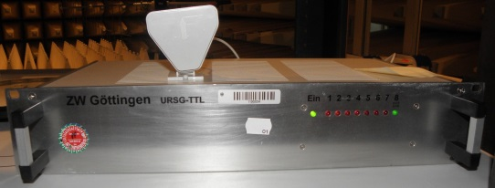
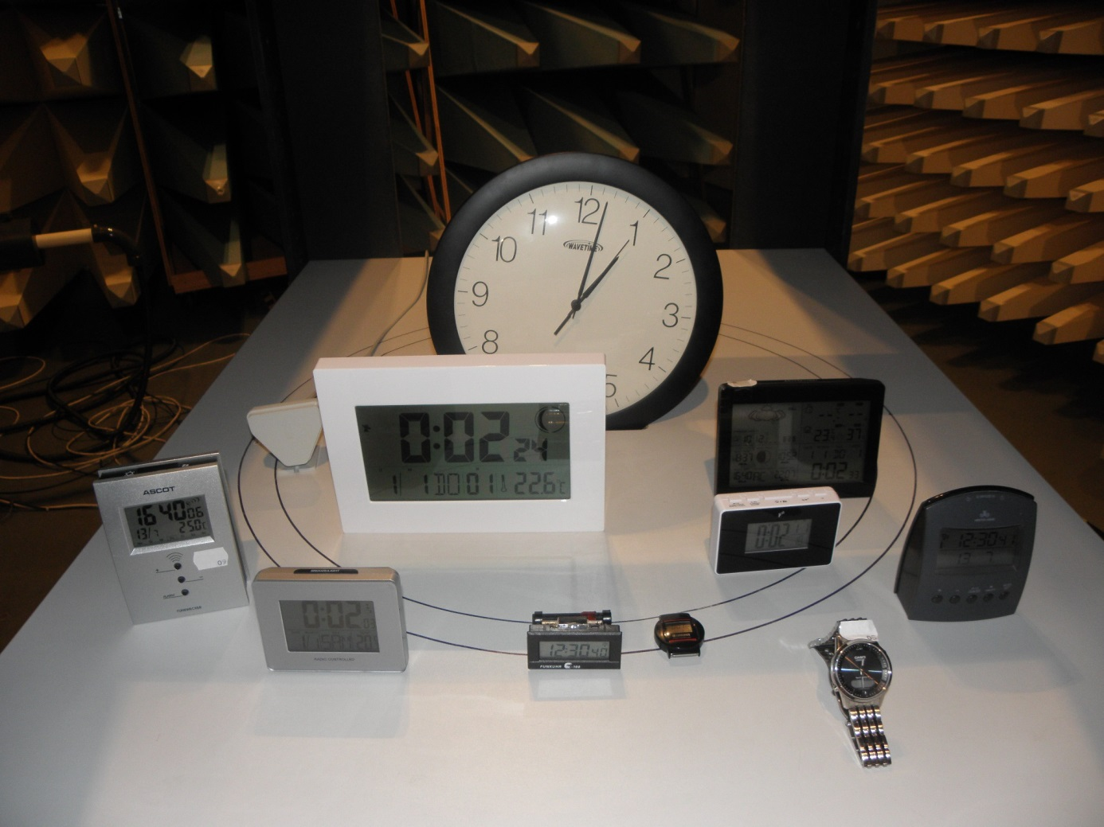
Figure 2-1: DUTs

DCF77 (wanted) signal
The DCF77 signal was produced by a signal generator (R&S SMU200). A programmed 10 minutes long sequence of pulses was repeatedly sent out through a magnetic loop antenna (EMCO 6511) positioned at a distance of 10 m to the DUTs.
For the majority of the measurements the field strength of the DCF77 signal at the location of the DUTs was adjusted to 50 dBµV/m. This corresponds to the minimum outdoor field strength of the real DCF77 transmitter in 1000 km distance.
To get indications on the nature of the interfering effect, additional measurements were made with a wanted field strength of 70 dBµV/m.
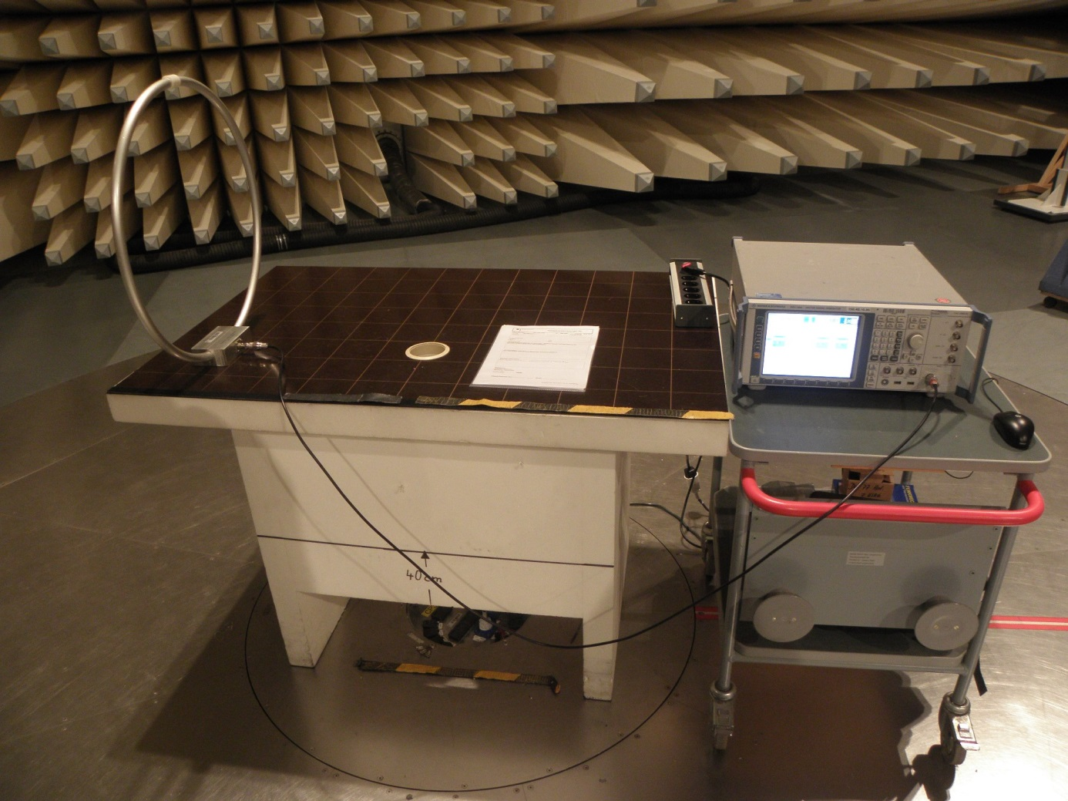
Figure 3-1: DCF77 Transmitter

WPT (unwanted) signal
The unwanted WPT signal was emulated by an unmodulated carrier from a signal generator (HP 8648C) and transmitted by a “Helmholtz coil”. This coil consists of two magnetic loops mounted in parallel to a wooden frame. Inside the frame, a homogeneous magnetic field is generated. The DUTs are placed in the centre of the frame (between the two coils).
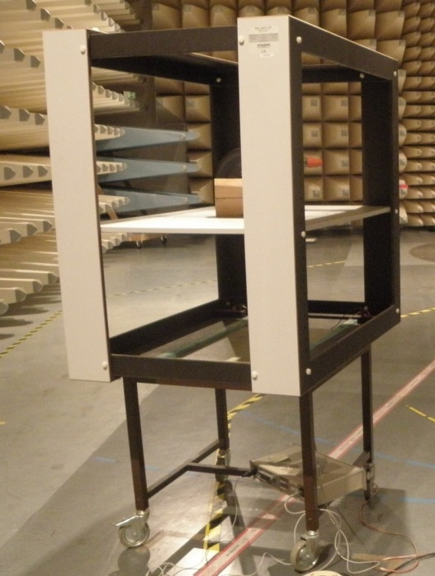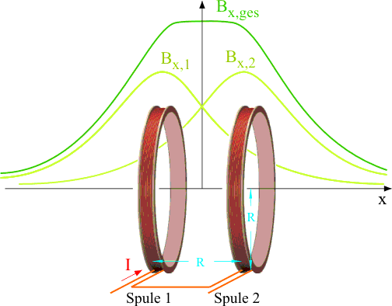
Coil 2
Coil 1
Figure 4-1: Helmholtz coil with principle
Four different frequencies were selected for the unwanted WPT signal:
- 79 kHz (the lowest possible frequency in the examined band)
- 82 kHz
- 85 kHz (a common frequency in the centre of the examined band)
- 90 kHz (the highest possible frequency in the examined band)
The sideband emissions of the WPT signal on the wanted channel at 77.5 kHz were at least 20 dB below the level of the wanted DCF77 signal, leaving more than enough C/I for
decoding.
According to Recommendation ITU-R P.372, the expected minimum ambient noise in this frequency range, dominated by atmospheric noise, corresponds to a field strength of 30 dBµV/m in 10 Hz bandwidth. Even at the highest measured interfering levels, the sideband noise of the unwanted signal was below the ambient noise level which can be expected in an outdoor environment.
Therefore, the only possible interfering effects in these measurements are blocking /
desensitization or overloading of the DCF77 receiver.

Failure criterion
All of the tested devices indicated when they were trying to synchronize. Some clocks even indicated each pulse of the DCF77 signal that they have received. The transmission of one complete date/time set lasts one minute. Since the start of the synchronisation process is normally somewhere in the middle of a full minute, it may take at least two minutes to receive the time and date. Some clocks wait for two consecutive minutes and compare the data
received to ensure validity. Without interferer, all clocks finished the synchronization process within 3 minutes after its start.
The failure criterion used for these measurements was any of the following effects:
- No indication of received pulses (for clocks with pulse indicator)
- Failure to synchronize to the transmitted date and time of the wanted signal
- Synchronization to the transmitted time of the wanted DCF77 signal lasted more than one minute longer as in a situation without interferer

Measurement setup
To ensure that the DUTs received nothing but the signals used for this measurement, the setup was placed in an anechoic, shielded chamber. Especially important was the fact that the “real” DCF77 signal from Mainflingen could not be received by the DUTs. This was
ensured by measurement with a magnetic loop antenna (R&S HFH2-Z2) in the centre of the Helmholtz coil and a spectrum analyser (R&S ESU).
The DUTs were placed in the centre of the wooden frame with the Helmholtz coil. The
wanted DCF77 signal was transmitted from a distance of 10 m. The direction of the DUTs was adjusted to receive a maximum of both wanted and unwanted signal.

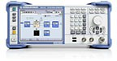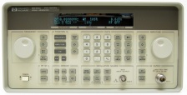
10 m
DUT with antenna direction
Helmholtz coil
(unwanted WPT signal)
wanted DCF77 signal
Generator 2
Signal
Generator 1
Figure 6-1: Measurement setup A (top view)
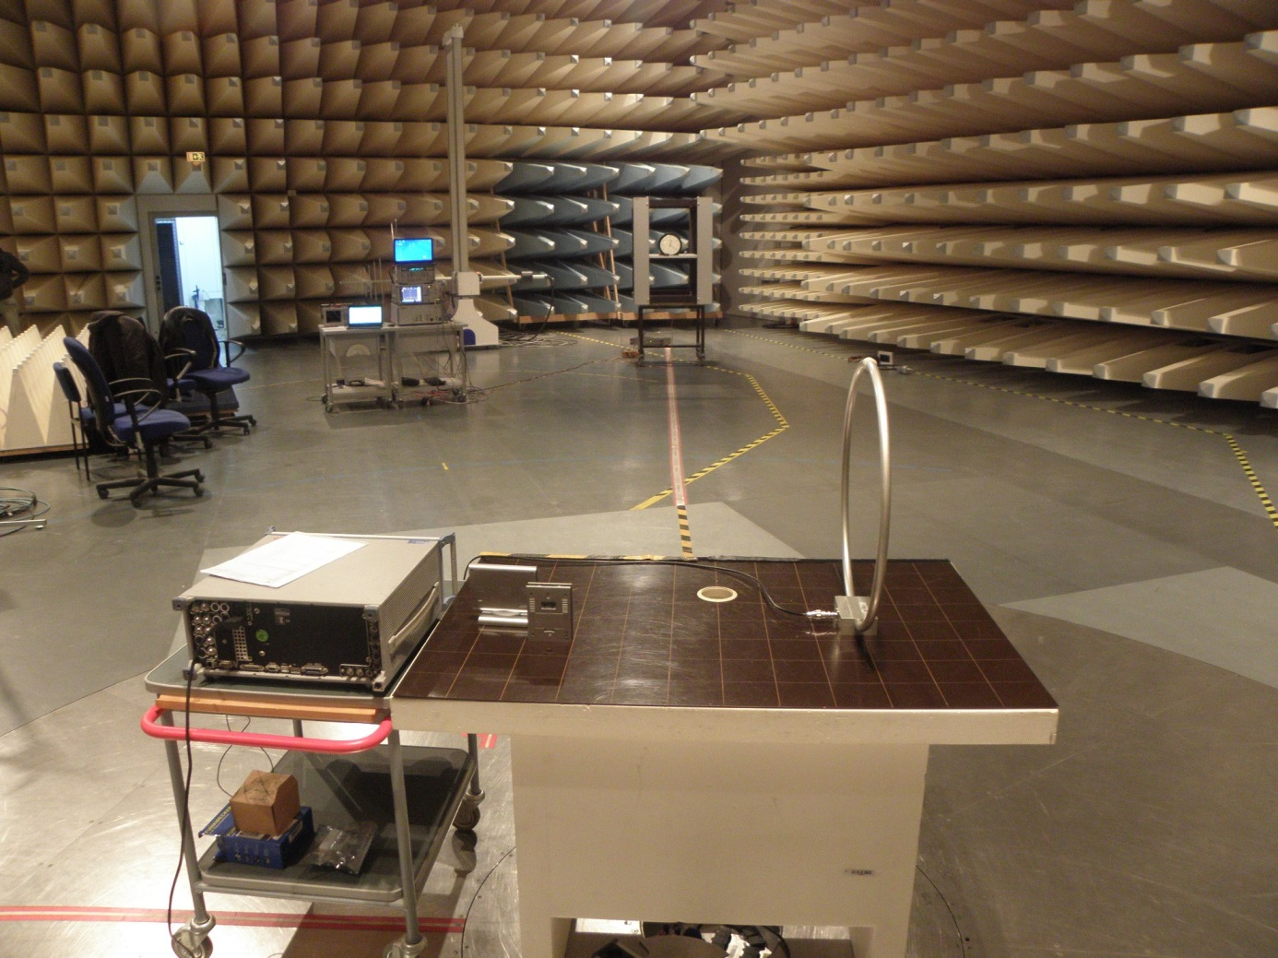
Figure 6-2: Measurement setup. Front: Wanted DCF77 signal generation, background: Helmholtz coil with DUT

Sensitivity measurement
To assess the undistorted minimum required DCF77 field strength necessary to synchronize the clocks, and to determine the optimum directivity of the clock antennas, the sensitivity of the DUTs was measured without interfering signals. The wanted signal was raised in steps of 5 dB until all clocks managed to synchronize.
Gen. out | Field strength |  | Rx1 | Rx2 | Rx3 | Rx4 | Rx5 | Rx6 | Rx7 | Rx8 | Rx9 | Rx10 | Rx11
4 dBm | 59 dBµV/m | 8 dBµA/m | ok | ok | ok | ok | ok | ok | ok | ok | ok | ok | ok
0 dBm | 55 dBµV/m | 4 dBµA/m | ok | ok | ok | ok | ok | ok | ok | ok | no | ok | ok
-5 dBm | 50 dBµV/m | -2 dBµA/m | ok | ok | ok | ok | ok | ok | ok | ok | no | ok | ok
-10 dBm | 45 dBµV/m | -7 dBµA/m | ok | ok | ok | ok | ok | ok | ok | ok | no | ok | ok
-15 dBm | 40 dBµV/m | -12 dBµA/m | ok | ok | ok | ok | ok | no | ok | ok | no | ok | ok
-20 dBm | 35 dBµV/m | -17 dBµA/m | ok | ok | ok | no | no | no | ok | ok | no | no | ok
-25 dBm | 30 dBµV/m | -22 dBµA/m | no | ok | ok | no | no | no | ok | no | no | no | no
-30 dBm | 25 dBµV/m | -27 dBµA/m | no | ok | no | no | no | no | no | no | no | no | no
-35 dBm | 20 dBµV/m | -32 dBµA/m | no | no | no | no | no | no | no | no | no | no | no
Table 7-1: Results of sensitivity measurements
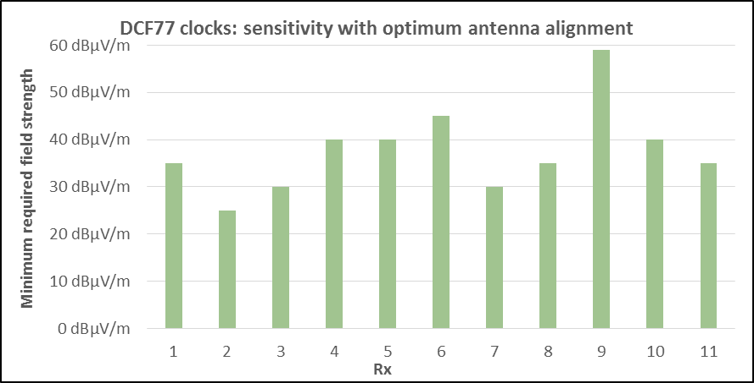
Figure 7-1: Results of sensitivity measurements

It can be seen that there were significant differences in sensitivity. The most sensitive clock needed only 25 dBµV/m to synchronize whereas the least sensitive clock needed 59 dBµV/m (34 dB more).
Except for Rx9, all clocks were able to synchronize at a wanted field strength of 50 dBµV/m which was selected for the following interference measurements.

Interference measurements at low wanted field strength
The wanted DCF77 level was adjusted to 50 dBµV/m at the location of the DUTs. The unwanted WPT level was raised in steps of 3 dB. For every measurement the synchronisation process was started at all DUTs and the ability to synchronize was determined for each DUT until failure. Rx9 was excluded from this measurement because it could not synchronize at the wanted field strength.
The setup was according to Figure 6-1, so that the magnetic field lines of both signals inside the Helmholtz coil have the same direction and arrive from the direction of maximum
sensitivity of the receiving antennas. This setup is independent of the direction of the DUTs, because if they were turned in another direction both wanted and unwanted signals would decrease by the same amount.
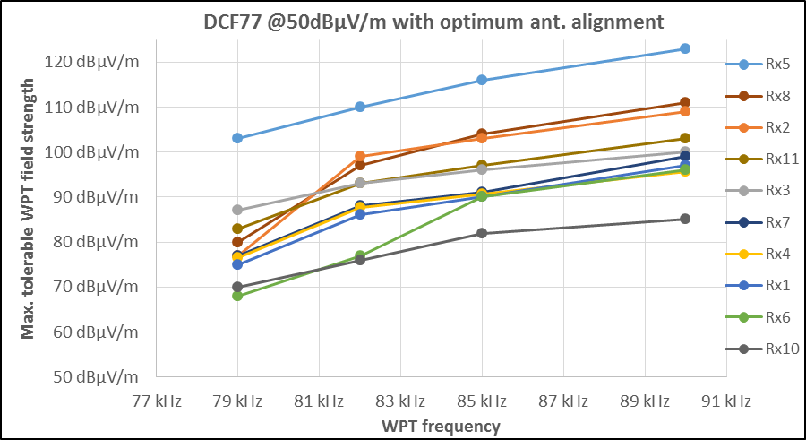
Figure 8-1: Measurement results for 50 dBµ/m wanted field strength and optimum antenna alignment
The results show a significant difference in the immunity against WPT signals between the different clocks. The most immune clock Rx5 still works with a WPT level that is about 35 dB higher as the least immune clock Rx10.
It is remarkable that there is no connection between sensitivity and immunity against
interference. Both extremes in the interference measurements Rx5 and Rx10 have the same sensitivity which is average among the test field.

Measurements with increased wanted field strength
To assess the actual interference effect (desensitization, selectivity, overloading), an
additional measurement was made with a wanted DCF77 field strength of 70 dBµV/m. The setup and procedure was identical to the one described in Section 8.
The following figure compares the measured carrier to interference ratio (C/I, difference
between wanted and unwanted field strength) of both measurements.
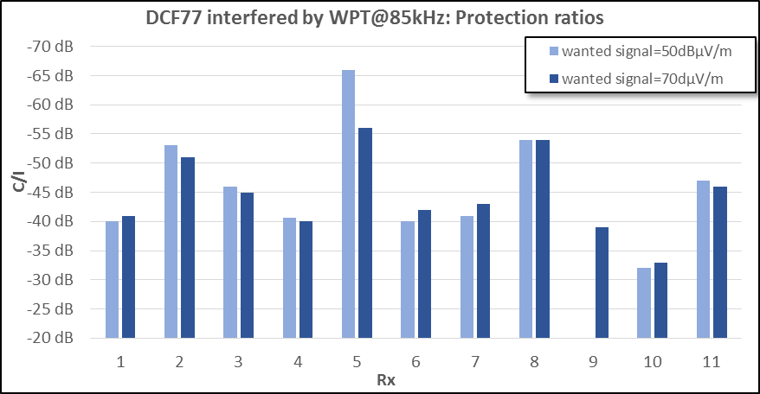Figure 9-1: Measured C/I for different wanted field strength
It can be seen that the C/I is nearly independent of the wanted level for all receivers except Rx5. So, generally, the interfering effect of high WPT field strengths can be compensated by raised DCF77 field strength. This indicates that the dominating effect is insufficient receiver selectivity or desensitization (blocking). Only Rx5 seems to be overloaded.

Measurements with different antenna orientation
In all previous measurements, the receiving antennas were aligned with both wanted and unwanted signals. However, in practice it may be argued that both signals not always arrive under optimum angle at the victim receiver. To assess the effect of non-optimal antenna alignments, additional measurements were made where the unwanted WPT signal still arrives in optimum receiving direction, but the wanted DCF77 signal arrives from a direction where the DUT antenna is least sensitive (90° offset). In so far, this setup could be regarded as a “worst case” scenario.
Figure 10-1: Setup for measurements with different antenna alignment
10 m
DUT with antenna direction
Helmholtz coil
(unwanted WPT signal)
wanted DCF77 signal
Generator 2
Signal
Generator 1

The measurements were done with a WPT frequency of 85 kHz and wanted field strengths of 50 and 70 dBµV/m.
With this setup, only Rx 1 and Rx2 were able to synchronize at 50 dBµV/m wanted field strength (without interferer), but all receivers could synchronize at 70 dBµV/m.
The following graph compares the two measurements: The one with optimum antenna alignment (from Sections 8 and 9) is labelled “best case”, the one with cross-alignment from this Section is called “worst case”.
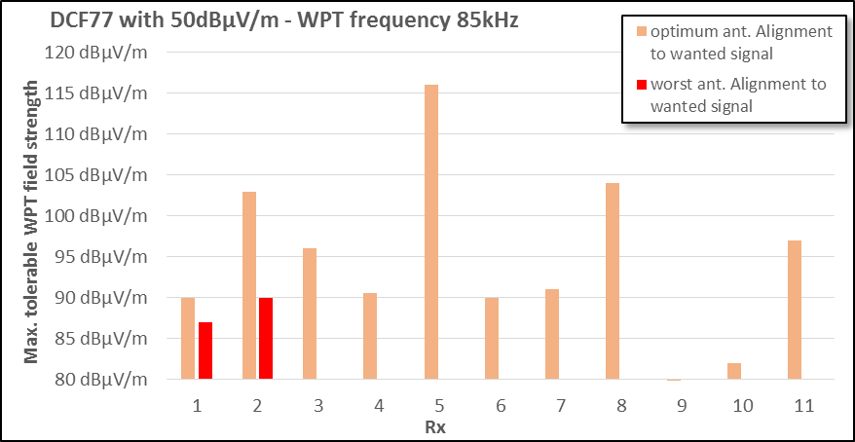
Figure 10-2: Comparison of results with different antenna alignment for low wanted field strength

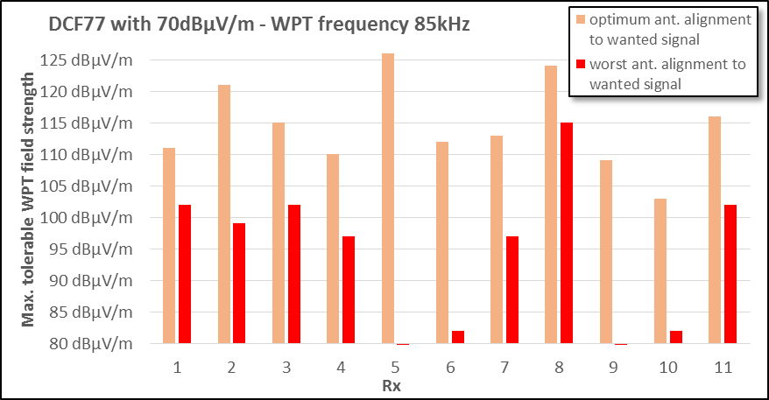
Figure 10-3: Comparison of results with different antenna alignment for high wanted field strength

From this measurement it can be seen that the directivity of the receiving antennas varies considerably: While for Rx1 the directivity is only 3 dB, it is 30 dB for Rx6. It should be
mentioned, however, that in an absolute homogeneous field the receiving minimum of the directional Rx antennas may be very sharp and needs exact positioning. This minimum
position may not have been realized for all DUTs.

Impact assessment
The results allow assessment of the required distance between WPT systems and DCF77 clocks to a certain extent to ensure that no impact of WPT on DCF77 occurs. The following tables and figures may serve to estimate these distances for the three measured frequency offsets. For the underlying calculations the following assumptions were made:
- All values are taken from the results under optimum antenna alignments (Sections 8 and 9)
- The maximum WPT field strength on the main frequency from ETSI EN 300 330 is 68.5 dBµA/m in 10 m distance which corresponds to an electrical field strength of 120 dBµV/m
- The WPT field strength in the near-field is assumed to follow a 60dB/decade drop with distance
- The 90% and 10% curves are derived from the second best and second worst value of the measurement results.
In the tables, the columns 90%, 50% and 10% contain the maximum values at which the
respective percentage of tested receivers are protected (i.e. are still functioning).

WPT frequency = 79 kHz
 | 90% |  | 50% |  | 10%
DCF77 F/S | E_{max} | Distance | E_{max} | Distance | E_{max} | Distance
50 dBµV/m | 70 dBµV/m | 68.1 m | 77 dBµV/m | 52.1 m | 87 dBµV/m | 35.5 m
55 dBµV/m | 75 dBµV/m | 56.2 m | 82 dBµV/m | 43.0 m | 92 dBµV/m | 29.3 m
60 dBµV/m | 80 dBµV/m | 46.4 m | 87 dBµV/m | 35.5 m | 97 dBµV/m | 24.2 m
65 dBµV/m | 85 dBµV/m | 38.3 m | 92 dBµV/m | 29.3 m | 102 dBµV/m | 20.0 m
70 dBµV/m | 90 dBµV/m | 31.6 m | 97 dBµV/m | 24.2 m | 107 dBµV/m | 16.5 m
75 dBµV/m | 95 dBµV/m | 26.1 m | 102 dBµV/m | 20.0 m | 112 dBµV/m | 13.6 m
80 dBµV/m | 100 dBµV/m | 21.5 m | 107 dBµV/m | 16.5 m | 117 dBµV/m | 11.2 m
85 dBµV/m | 105 dBµV/m | 17.8 m | 112 dBµV/m | 13.6 m | 122 dBµV/m | 9.3 m
90 dBµV/m | 110 dBµV/m | 14.7 m | 117 dBµV/m | 11.2 m | 127 dBµV/m | 7.6 m
Table 11-1: Protection distances at different wanted DCF77 field strength for a WPT frequency of 79 kHz
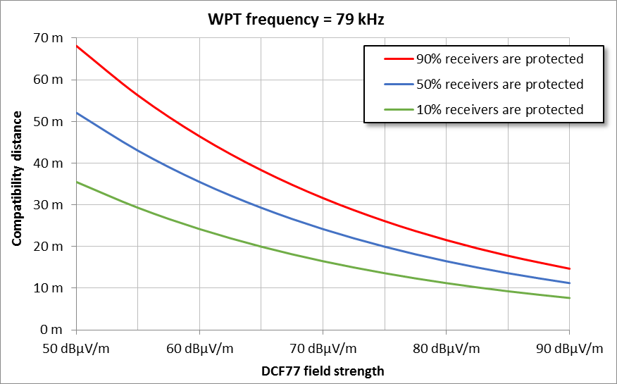
Figure 11-1: Protection distances at different wanted DCF77 field strength for a WPT frequency of 79 kHz

WPT frequency = 85 kHz
 | 90% |  | 50% |  | 10%
DCF77 f/s | E_{max} | Distance | E_{max} | Distance | E_{max} | Distance
50 dBµV/m | 90 dBµV/m | 31.6 m | 94 dBµV/m | 27.6 m | 104 dBµV/m | 18.5 m
55 dBµV/m | 95 dBµV/m | 26.1 m | 99 dBµV/m | 22.8 m | 109 dBµV/m | 15.3 m
60 dBµV/m | 100 dBµV/m | 21.5 m | 104 dBµV/m | 18.8 m | 114 dBµV/m | 12.6 m
65 dBµV/m | 105 dBµV/m | 17.8 m | 109 dBµV/m | 15.5 m | 119 dBµV/m | 10.4 m
70 dBµV/m | 110 dBµV/m | 14.7 m | 114 dBµV/m | 12.8 m | 124 dBµV/m | 8.6 m
75 dBµV/m | 115 dBµV/m | 12.1 m | 119 dBµV/m | 10.6 m | 129 dBµV/m | 7.1 m
80 dBµV/m | 120 dBµV/m | 10.0 m | 124 dBµV/m | 8.7 m | 134 dBµV/m | 5.8 m
85 dBµV/m | 125 dBµV/m | 8.3 m | 129 dBµV/m | 7.2 m | 139 dBµV/m | 4.8 m
90 dBµV/m | 130 dBµV/m | 6.8 m | 134 dBµV/m | 6.0 m | 144 dBµV/m | 4.0 m
Table 11-2: Protection distances at different wanted DCF77 field strength for a WPT frequency of 85 kHz
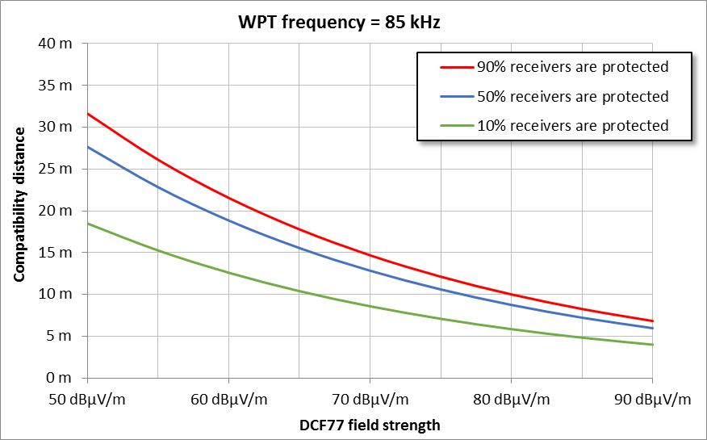
Figure 11-2: Protection distances at different wanted DCF77 field strength for a WPT frequency of 85 kHz

WPT frequency = 90 kHz
 | 90% |  | 50% |  | 10%
DCF77 f/s | E_{max} | Distance | E_{max} | Distance | E_{max} | Distance
50 dBµV/m | 96 dBµV/m | 25.1 m | 100 dBµV/m | 22.0 m | 111 dBµV/m | 14.1 m
55 dBµV/m | 101 dBµV/m | 20.7 m | 105 dBµV/m | 18.1 m | 116 dBµV/m | 11.7 m
60 dBµV/m | 106 dBµV/m | 17.1 m | 110 dBµV/m | 15.0 m | 121 dBµV/m | 9.6 m
65 dBµV/m | 111 dBµV/m | 14.1 m | 115 dBµV/m | 12.3 m | 126 dBµV/m | 7.9 m
70 dBµV/m | 116 dBµV/m | 11.7 m | 120 dBµV/m | 10.2 m | 131 dBµV/m | 6.6 m
75 dBµV/m | 121 dBµV/m | 9.6 m | 125 dBµV/m | 8.4 m | 136 dBµV/m | 5.4 m
80 dBµV/m | 126 dBµV/m | 7.9 m | 130 dBµV/m | 6.9 m | 141 dBµV/m | 4.5 m
85 dBµV/m | 131 dBµV/m | 6.6 m | 135 dBµV/m | 5.7 m | 146 dBµV/m | 3.7 m
90 dBµV/m | 136 dBµV/m | 5.4 m | 140 dBµV/m | 4.7 m | 151 dBµV/m | 3.0 m
Table 11-3: Protection distances at different wanted DCF77 field strength for a WPT frequency of 90 kHz
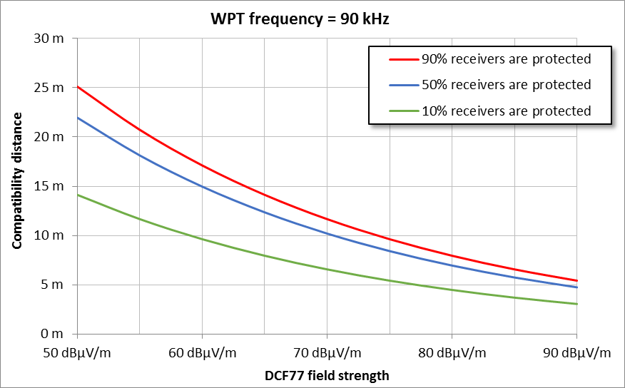
Figure 11-3: Protection distances at different wanted DCF77 field strength for a WPT frequency of 90 kHz

Conclusion
Even if the current limit in ETSI EN 300 330 of 68.5 dBµA/m for the main WPT emission is met, none of the tested devices work in 10 m distance when receiving only the minimum required wanted field strength of 50 dBµV/m. The actual protection distance depends on
wanted field strength and WPT frequency. For example, when the DCF77 level is 60 dBµV/m (which may be assumed throughout Germany), and the WPT frequency is in the middle of the band at 85 kHz, 50% of the clocks need to be at more than 18 m away from the WPT station to function properly.

