SE24 |  | Doc. WI63#7-01R2
SE24 WI63 web-meeting
Online, 12/03/2020
Date issued: | 11 March 2021
Source: | FBConsulting Sarl, Robert Bosch GmbH, UWB Alliance, Qorvo
Subject: | Peak Power consideration for UWB
Group membership required to read? (Y/N)
N
Summary:
Since SE24_WI63 meeting 4 several questions have been raised to the topic of peak power limits and peak power interference towards FS systems. In this contribution the peak power behaviour of a UWB signals will be presented and explained. The relation between the peak power and the mean power limits of UWB systems will be depicted.
Proposal:
invites Group to
Take into account the attached explanations
Add the contribution to the report as annex

Background:
Peak power discussions in SE24_WI63 and other UWB groups

IntroduCtion
In the UWB regulation world-wide typically two TX powers are regulated:
- Maximum mean power density in dBm/MHz e.i.r.p. (typically -41,3dBm/MHz) and
- Maximum peak power in dBm/50MHz e.i.r.p. (typically 0dBm/50MHz)

Both values have to be fulfilled in order to be compliant with the UWB regulatory framework.
The first rule dictates the maximum mean Power Spectral Density (PSD), i.e., the radiated power within a given bandwidth when averaged over 1 ms:
max. meanPSD = -41.3 dBm / MHz (74 nW per MHz) (eq.1)
The second rule imposes a limit on how strong a single pulse can be transmitted. It basically limits the power of the UWB signal to 0 dBm when passing it through a filter of a bandwidth of 50 MHz:
max. peakPSD = 0 dBm / 50 MHz (1mW in 50MHz) (eq.2)
Assuming 500 MHz of bandwidth (pulse duration t_{p} equal to 2 ns), we obtain a maximum average power of 37 μW by multiplying the 500 MHz of bandwidth with the maximum spectral density of 74 nW/MHz.
The mean power and the peak power are interrelated and mainly connected by the pulse repetition rate of the UWB signal. For frequency hopping signal the dwell time can be taken to describe this interrelation.

Peak power in the time domain

Derivation

The first rule (mean power limitation to -41,3dBm/MHz) states that the maximum mean PSD has to be averaged over at most 1 ms, which translates into 37 nJ of transmitted energy in 1ms. This means that during one millisecond, we could theoretically send just one very strong pulse with a maximum full band peak power depending on the pulse duration t_{p}. Taking this theoretical ideal numerical case above with t_{p} equal to 2 ns and P_{TX} equal to 37 μW (-14.3 dBm) yields a full band peak power of 18 W (+42.7 dBm) as shown in Figure 1. This pulse would then have a pulse duty cycle of 2ns/1ms = 0,0002% and a flat peak power spectrum in the complete 500MHz operation frequency range.

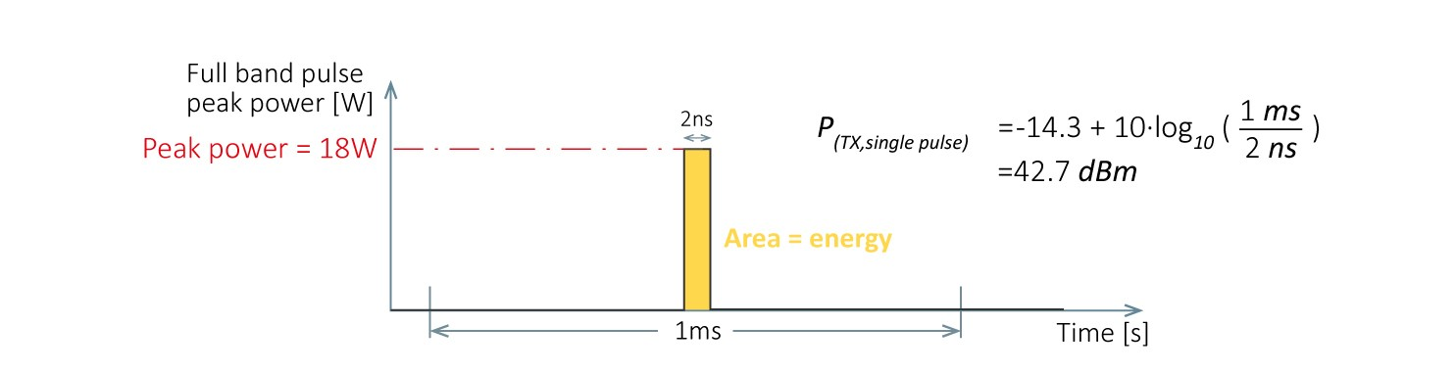
Figure 1: Example peak power without peak power limit definition[1]
The second rule (peak power limit of 0dBm/50MHz) however limits the instantaneous pulse peak power to a value that shall not exceed 0 dBm when passing the signal through a 50 MHz bandwidth filter (i.e., 10% of the energy of the original 500 MHz wide signal but 10 times higher duration). This translates into a full band signal peak power of +20 dBm [2], which is 22.7 dB lower than when only the first rule is applied. Therefore, to comply with both rules and maximize the transmitted energy per pulse, we can transmit around 186 (= 10^{(+22.7/10)}) pulses of +20 dBm (500 MHz bandwidth). Therefore, the mean pulse repetition rate of transmission becomes 1 ms /186 pulses = 5.3 µs = 186kHz [2].

Worldwide any UWB regulation strictly limit the amount of pulse energy (yellow area in figures) that can be sent during 1 ms in a given spectrum band. In Figure 2 a comparison of these considerations is given for a low rate (LRP) and a high rate (HRP) UWB system.
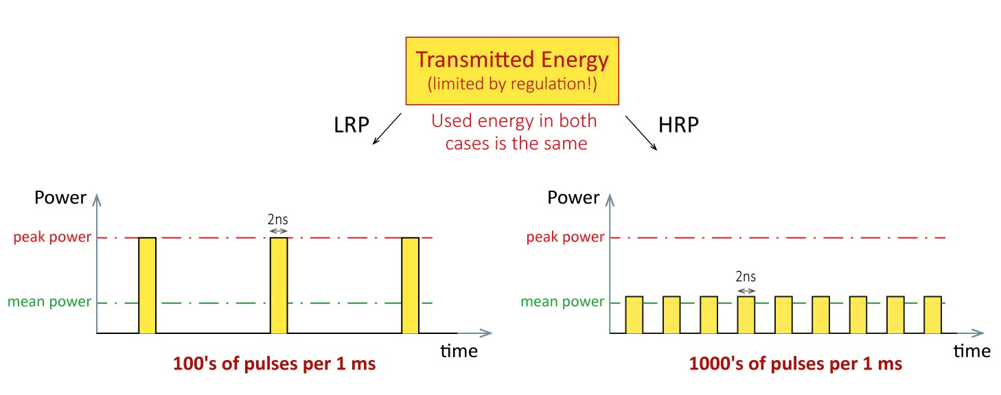
Figure 2: Comparison of low rate (LRP) and high rate (HRP) UWB [1]
Increasing the number of pulses sent in 1 ms leads to a reduction of the pulse peak power.

As mentioned above for a low rate UWB system with a repetition rate R ≤ 186kHz and an ideal flat bandwidth of 500MHz each pulse of 2ns duration can reach the peak power limit of 0dBm/50MHz.

In a typical FS system with 25MHz bandwidth this would lead to an interference power P_{i} of[2]:

P_{i} = 0dBm/50MHz * 20log(25Mhz/50MHz) = -6dBm/25MHz (eq.3)

The corresponding pulse duty cycle (PDC) in 500MHz is:

PDC_{500MHz} = 1.86* 10⁵*2ns/1s = 0,0372% (eq.4)

If one now filters this signal with a 25MHz bandpass filter the duration of the pulse will increase by the factor 500MHz/25MHz = 20. The pulse duty cycle in 25MHz PDC_{25MHz} and in 30MHz PDC_{30MHz} is given by:

PDC_{25MHz} = 1.86* 10⁵*2ns*20/1s = 0,744% (eq.5)

PDC_{30MHz} = 1.86* 10⁵*2ns*16,67/1s = 0,62% (eq.6)

In Figure 3 the behaviour of a pulse in the time domain using different resolution band widths (RBW) is depicted. It can be seen that the pulse width in time domain increases by a decrease of the RBW of the measurement equipment. This effect is equivalent to the behaviour of a RX filter with a specific bandwidth.
Figure 3: Impulse response in time domain using different filters/resolution band width (RBW)[4]
We can also calculate the maximum peak power density in 30MHz:

PSD_{peak_30MHz} = 0dBm/50MHz * 20log₁₀(30MHz /50MHz) = -4,4dBm/30MHz (eq.7)

For any given band of 30MHz bandwidth in the operational frequency range (OFR) of the UWB devices this is the maximum peak power level under the assumption that the peak power is constant over the complete OFR of the UWB and the pulse of 2ns duration is synchronously received at the FS filter input. For real signals both conditions will not be true, neither the peak power is constantly distributed over the OFR nor all pulses will be synchronized with the FS receiver. A typical peak power spectrum is given in Figure 3 taken from [4].

Figure 4: Measured peak power for a complete IEEE 802.15.4a signal [4]
It can be recognized that the peak power limit if 0dBm/50MHz is only reached at a specific frequency in the overall OFR.

Short-term interference level range calculation:

The noise floor of an FS system in 30MHz including 5dB noise figure is -94,2dBm.
Thus, the threshold of short-term interference would be -75,2dBm for an I/N of 19dB.

Based on that the required pathloss or minimum coupling loss (MCL) from UWB device with an omnidirectional antenna towards an FS receiver with 0dBi antenna gain in direction of the UWB device can be calculated as follows:

75,2dBm – 4,4dBm (UWB peak power in 30MHz) = 70,8dB (eq.8)

This MCL value of 70,8dB corresponds to LoS separation distance of 12,7m. If we now assume a down tilt fixed UWB antenna with 5dB as given in the use case section this value would decrease to 7,1m.

With this required pathloss (70,8dB) between the UWB device and the FS antenna, the FS TX with a TX power of 28dBm into the antenna will generate an interference level of around -42dBm in the UWB receiver. Taking into account this higher level of interference the UWB system will not correctly operate.

Long term peak criterion:

In order to take into account the peak power in the calculation of the long term criterion we have to take the limit given in ITU-R SM2057[3]

I_{p50}/N_{a50} = +5dB[3] (eq.9)
for not more than 20% of the time.

With a noise power of N_{a50} = -97dBmin 50MHz and a noise figure of 5dB the effective noise level in an FS receiver with 50MHz bandwidth is:

N_{a50_eff} = -92dBm (eq.10)

If one now takes the given threshold of I_{p50}/N_{a50} = +5dB the interference threshold I_{p50} at the FS receiver is -87dBm peak.

The required pathloss for a 0dBm peak power in 50MHz is 87dB. This translates into a LoS mitigation distance of 90m for an assumed 0dBi FS antenna gain towards the UWB device and including a 5dB down tilt antenna to around 50m.

Assuming a 25MHz bandwidth FS receiver the peak power limit is:

I_{p25}/N_{a25} = +2dB (eq.11)

Note 1: I_{p25} = I_{p50} – 20log₁₀(25/50) = I_{p50} – 6dB
N_{a25} = N_{a50} – 10log₁₀(25/50) = N_{a50} – 3dB

I_{p25}/N_{a25} = I_{p25}[dB] - N_{a25}[dB] = I_{p50}[dB] – 6dB - N_{a50}[dB] + 3dB = I_{p50}[dB] - N_{a50}[dB] - 3dB = 2dB

Based on the assumption that the noise decreases with 10log and the peak power effect with 20log the criterion (important: long-term 20% of time, see ITU-R SM.2057[3]) I_{p25}/N_{a25} = +2dB is valid.

Including a noise figure NF of 5dB as above the effective noise level at the FS receiver is:

N_{a25_eff} = -95dBm (eq.12)

Taking the Interference threshold of I_{p25}/N_{a25} = +2dB we get the peak interference limit of -93 dBm/25MHz peak. Now this leads to a MCL of 87dB between the FS receiver and the UWB transmitter. This is the same value as in 50MHz.

Summary and conclusion

Typical UWB system are limited to the TX energy of 37nJ in 1ms by set of regulations limiting the mean e.i.r.p. power in 1MHz during 1ms (-41,3dBm/MHz) and the peak e.i.r.p. power in 50MHz (0dBm/50MHz).

The consideration related to peak power interference of pulse based UWB systems into a FS system has to be split into two main parts:
- Long-term interference with a time probability of below 20% and
- Short-term interference with a time probability of below 4.5*10⁻⁵%
For both criterions mean Ia/N_{a} limits are defined for the mean power levels:
- long-term: I/N ≤ -20dB
- short-term: I/N ≤ +19dB
For the peak power limits for the long-term criterion ITU-R SM.2057 sets a limit of I_{p50}/N_{a50} = +5dB[3] for aggregated peak power interference. This level corresponds to a peak power limit of 0dBm/50MHz.

For the short-term interference criterion, a detailed signal structure of a UWB pulse system operating with the peak limit (peak limited systems) have to be considered, see [3] Annex 2, clause 1.1.1.2. These peak limited systems have a very low peak duty cycle of 0,0372% in 500MHz. This has to be taken into account in the aggregation simulations.
The peak power energy is not continuously distributed over the OFR of the UWB device, see Figure 3 and will have a different distribution for different UWB devices and operational modes. Not all devices in a given area will operate in the peak power limited mode.
The full interference effect will only be realized when the UWB pulses are fully synchronized with the FS receiver. In case of a desynchronization between the systems the received energy per symbol will be decreased.

References

- 3db-access: IMPULSE RADIO UWB PRINCIPLES AND REGULATION, https://www.3db-access.com/article/17
- R. J. Fontana and E. A. Richley, "Observations on Low Data Rate, Short Pulse UWB Systems," 2007 IEEE International Conference on Ultra-Wideband, Singapore, 2007, pp. 334-338.
- ITU-R SM. 2057: “Studies related to the impact of devices using ultra-wideband
technology on radiocommunication services”, Geneva, 2005.
- H- W. Pflug, J. Romme, K. Philipps, H. de Groot: “Method to Estimate Impulse-Radio Ultra-Wideband Peak Power”, IEEE TRANSACTIONS ON MICROWAVE THEORY AND TECHNIQUES, VOL. 59, NO. 4, APRIL 2011.

