Description of the software tool for processing of measurements data of IRIDIUM satellites at the Leeheim station
approved DD Month YYYY (Arial 9)
ECC Report <No>
[last updated: DD Month YYYY] (Arial 9)

Executive summary (style: ECC Heading 1)
Body text (style: ECC Paragraph)
(advice: the Executive Summary should provide a short and concise explanation on the purpose of the respective ECC Report and should clearly indicate the covered subjects to which it applies. In addition, it should clearly explain the application of the document.)

TABLE OF CONTENTS

0 Executive summary (style: ECC Heading 1) 2
1 Introduction 5
2 Definitions (optional section) 6
3 Scope of the Software 7
3.1 Copyright 7
3.2 System requirements 7
3.3 Software Installation 8
3.4 Setup for processing a new collection of measurements 8
3.5 Processing and Calibration of raw data 8
3.5.1 Structure of calibrated data save sets 10
3.5.2 Reducing the same dataset with different choices of parameters 10
3.5.3 EPFD Calculations 11
3.5.4 Running EPFD calculations 11
3.6 EPFD calculation for all 164 frequency channels 13
4 Conclusions 14
ANNEX 1: Structure of raw data MATLAB savesets 15
ANNEX 2: Calibration of Antenna and Spectrometer using Strong Cosmic Radio Sources 16
ANNEX 3: Sample Report generated for calibration 24
ANNEX 4: Sample report created by eval_data 27
ANNEX 5: Sample Report of an EPFD calculation 30
ANNEX 6: Example of an EPFD frequency survey 33
ANNEX 7: Creating Visibility data with STK 34
ANNEX 8: List of Reference 35

LIST OF ABBREVIATIONS

Abbreviation | Explanation (style: ECC Table Header red font)
CEPT | European Conference of Postal and Telecommunications Administrations
ECC | Electronic Communications Committee
<abbrev> | <explanation – edit the table as necessary>

Introduction
Body text (style: ECC Paragraph)
(advice: this document gives a template for preparing an ECC Report. All existing contents including the annexes are given for information/formatting purposes only, and shall be replaced by the relevant contents of the new ECC Report.)
- This is a note from an editor

Definitions (optional section)

Term | Definition
ECC Table text | ECC Table text
ECC Table text | ECC Table text
ECC Table text | ECC Table text

Scope of the Software
The software processes raw spectrogram data from the Leeheim Satellite monitoring station according to the principles described in ECC Report 171 (see example in Annex 1). It aims to create detailed and comprehensive documentation of the measured satellite emissions and their interference impact on the radio astronomy service in the band 1610.6 - 1613.8 MHz. Quantitative assessments of EPFD data loss are generated and error estimates of the data loss given.
Calibration information from on/off observations of celestial sources is derived and used to create data sets of absolutely calibrated spectral power flux density data from which the noise background of the receiver and sky have been subtracted. More information about calibration procedures can be found in ECC Report 171 with some additional practical information in Annex 2 of this document.
Automatic documentation of the processing and calibration steps is generated to enable checks and repeats of the analysis as well as the incorporation of results into summary reports.
The calibrated data is now used together with an external satellite visibility file (created using STK™ (System tool kit)) to calculate the EPFD Data loss according to ITU-R RA-1583 for a selected frequency. An estimate of the statistical error is also provided. An automatic report that contains figures and results is generated.
An option exists to produce a complete data loss survey report of all 164 frequency channels the band 1610.6 - 1613.8 MHz.

Copyright
ANFR reserves the copyright for the following routines contain in the core of the EPFD calculation package (EPFDcalculations.zip): analyse.m, cdf.m, gen_distribution.m, M_1583_IRIDIUM_par.m, lect_csv_access.m. Potential users of the EPFD package should sign the License Agreement provided in Annex 8 and send it to the ANFR at the specified address before the installation and/or use of the package.
Analytical Graphics, Inc. (AGI), 220 Valley Creek Blvd. Exton, PA 19341 USA holds the copyright for the Systems Tool Kit (STK) used to generate the satellite visibilities

System requirements
Leeheim raw data is expected to be supplied in the form of binary MATLAB savesets (*.mat). A short description of the data format is given in Appendix 1 of this document.
The data processing uses MATLAB™ and should therefore be largely platform and operating system independent as long as the requirements for running MATLAB are met and a licensed version of MATLAB is installed.
Processing the high resolution Leeheim spectrometer data requires sufficient disk space (>1.5 GB per typical day of measurements) and RAM where 2.5 - 3 GB will be needed for MATLAB alone. It is therefore recommended that at least 6 GB of RAM are installed.
EPFD calculations do not require that amount of RAM, but are CPU intensive. It is advisable to use a multi-core host system (>2 cores) and the parallel processing option of MATLAB (separate license needed). The modified EPFD routine will detect the parallel processing capability if available, allocate the resources and automatically distribute the computation tasks. There is a communication overhead between CPU's which results in a speed-up by about N/2 where N is the number of CPU's available. A single EPFD trial iteration takes about 20-30 seconds an eight core system.
It is advisable to use parallel processing for the full band data loss survey at least 164 x 5 = 820 iterations will be needed which will take about six to eight hours on a parallel CPU host.

Software Installation
The software is distributed in two zip containers:
- Datareduction.zip for the processing and calibration of Leeheim raw data including the automatic generation of processing reports for each satellite and the daily calibration as well the creation of MATLAB savesets for the calibration and the calibrated satellite data.
- EPFDcalculations.zip for evaluation of EPFD data loss and the creation of saved results and documentation.
Copy all files from both containers into one directory ('source directory'). Packages are compatible and work from one directory, which is simpler for the user, but separate source directories are also supported.
Obtain suitable visibility files for the envisaged EPFD calculations for the constellation using STK, a sample file RAS_IRIDIUM_REAL.CSV is included in in EPFDcalculations.zip

Setup for processing a new collection of measurements
Create three new directories for the following:
- raw data of new measurement session and move your new data to it.
- processing results, such as calibrated data, pfd distributions etc.
- documentation that is generated by data processing.
Steps 2+3 can also be taken on the first call to eval_data.

Delete the following files:
- dir_config.mat
- calibration_data.mat and
- epfd_parms.txt
should they still exist from a previous session.
Make sure that processing and documentation directories are empty, if you are re-using them.
Start your MATLAB session or clear your workspace using 'clear' and select the source directory as primary.

Processing and Calibration of raw data
Each measurement of a satellite transit must be individually processed to determine the background noise level and the range of valid data. Only one command is needed to process the data from one measurement. Simply enter
>>eval_data
and repeat the procedure outlined below for all measurements of a satellite transit of the session.
The system will now prompt you for the names of the three directories described in the previous chapter at the first call of eval_data:
- datadir for the raw data
- resultsdir for calibrated data and distributions and
- reportdir for the generated documentation.
the last two calls may also be used to create the directories if that is supported by your OS.
The names of these directories will be saved in dir_config.mat in your source directory and automatically loaded when detected on every new call.

You may also use command
>> assign_directories
separately if you want to re-assign your directories.

Now the system will check the existence of previously generated calibration information in the results directory. If that is not present (e.g. the first call was to eval_data), then the user is prompted for the name of a data set containing a calibration measurement in the data directory and taken through the calibration procedure (see Annex 2 for details).
A report containing calibration results is then placed in the reports directory under cal_report.doc and the calibration file calibration_data.mat is stored in the results directory. An example of cal_report.doc is provided in Annex 3.
Should you want to repeat the calibration with different input data or parameters, then the simplest way is deleting calibration_data.mat in the results directory and calling eval_data again.

eval_data command will then
- prompt for the name of a data file to be processed and then for
- the name of the object. Important: please use Irxx for Iridium satellites with xx being the satellite number (e.g. Ir10) for IRIDIUM 10 .It is also advisable to use CAS-A or Cyg-A for the calibration sources.
and the routine display_data will
- ask if you want to select a subset of the data. Enter '1' if that is the case and afterwards the approximate index number of the first and last spectrum in the spectrogram. (Hint: dividing the time given on the vertical axis of the spectrogram by 1.05 will yield the approximate index.)
Otherwise enter 0 and all the data will be used for later processing.
The following routine calibrate will prompt you regarding the background part of observation.

- please enter the start and end time of the background observation within the current data set. The areas can be identified in the raw data plots from display_data.m and should be at least 100 seconds in duration. They are typically at the beginning of the measurement. Please make sure that you do not have any interference in that part, as it will result in incorrect values for the measured fluxes later on.
Inspect again the system temperature plot to ensure that no interference occurred during background observation. If the system temperature is high or shows deviation from the smooth curve, then there has been either interference or a receiver problem. This may happen with some measurements which will have to be discarded. But in most cases one can find a good background measurement needed for the background subtraction.
The routine will display calibrated spectra and spectrograms in various units, on linear and log (dB) scales. The calibrated spectrograms are stored internally in array 'S' in Jy, channel frequencies (Hz) are in array 'fchan1' and the times of the spectra, counted in seconds from the beginning of the measurements are in the array 't2'.
The final routine 'flux_distributions.m' needs no user input and generates three additional graphs (Figures in Annex 4):
- the distribution of received fluxes as a function of frequency. The vertical axis shows the channel flux density (spfd) and the horizontal axis the channel frequency (f).
- The number of instances a particular flux was measured in a frequency channel is shown in a colour at each (f, spfd) position (Fig. 18). The colour is encoded on a logarithmic scale.
- the likelihood of flux measurements exceeding the threshold as a function of frequency. The 2% level is indicated. This graph may be useful for discriminating strongly interfered frequency ranges from those that are less affected (Fig. 19).
- a histogram of the number of channels in which the threshold has been exceeded by a certain fraction of the time. This may help to describe the distribution of strongly affected channels (Fig. 19).
The documentation will be stored in the results directory as [objectname '.doc]. An example is provided in Annex 4.

Structure of calibrated data save sets
The routine flux_distributions creates statistical information from the calibrated spectrogram and saves 'objectname','S0','fchan1','mean_SJy','t3','time_of_arrivel' in a data set with the file name constructed as [objectname '_calibrated.mat'] in the results directory.
  - The objectname must be of the form' Irxx' (see explanation above).
  - S0 contains the calibrated data in Jy (= 10-26 Wm-2Hz-1) with the selected background data finally removed for all frequency channels.
  - All data points that are below the rms have been set to 0 to ensure positive definite flux for subsequent EPFD processing.
  - The array mean_SJy contains the average fluxes per channel at the end of the measurements.
  - The centre frequency per channel (Hz) is given by fchan1 and t3 together with time_of_arrivel give the time (UT) when a particular spectrum of the set S0 was obtained.

Reducing the same dataset with different choices of parameters

- If you want to repeat the processing of the chosen data set, but use other parameters for the selection of valid data and background, then call
>>repeat_eval_data
and go through the same steps, however avoiding the selection of the dataset and the prompt for a new name. Calibrated data and report files will be overwritten.

EPFD Calculations
setup for EPFD calculations
- Data reduction must be completed for all measurements and the calibrated data been saved via the last step of 'flux_distributions' and conforming to the naming convention 'Irxx_calibrated.mat' in a results directory. Data of other origin can also be used as long as it conforms to structure and naming conventions outlined above.
- The software from EPFDcalculations.zip may either reside in its own directory or in a separate one.
- If you are using a separate directory then you have to assign the directory names for results and reports again at the first call of eval_epfd and a local dir_config.mat file will be created. Make sure that you delete any remaining dir_config.mat files which may point to previous EPFD calculations for other data than the ones you intend to investigate.
- If you have loaded all routines for data reduction and EPFD calculations into one directory, then the same directory setup will be used for results and reports.
- Create a text file epfd_config.txt in your source directory with list of satellite numbers of the satellite measurements that you want to include in the EPFD calculation. Enter only one number per line of text. The numbers xx must correspond to existing 'Irxx_calibrated.mat' files in the results directory.

Running EPFD calculations
Simply enter
>>epfd_report
at the MATLAB prompt and the calculation will be performed and documentation will be created in the results directory.
If you don’t need the documentation, then enter
>>eval_epfd
You'll be asked to enter a frequency within the range 1610.6-1613.8 MHz. Units are MHz. The software will determine the centre frequency of nearest frequency channel and calculate the EPFD for it.
The routine gen_distribution.m generates the cumulated pfd distributions of all satellites listed in the text file epfd_config.txt for the chosen frequency channel from the corresponding calibrated data. They are saved in a subdirectory of the results directory called './distributions/YYYY.ZZZZ' with 'YYYY.ZZZZ' being the channel frequency in MHz with 10 Hz resolution. Each satellite will have its own file named 'distribution_Ir_xx.mat' (Note the underscore between Ir and the satellite number xx). The saveset contains two arrays of fixed size, which is set in gen_distribution (e.g. 128 for an optimal resolution). The array pfd_dist will contain the pfd values for each interval, with the whole range of measured values for the satellite from 0 to the maximum in the channel being linearly divided into equal intervals. The units are the same as those of the calibrated data set. The array per_dist holds the normalised cumulated distribution values as percentages for each interval.
The distribution files remain after the calculation.
- Then you'll be asked for the number of trials (= full sky EPFD calculations with random choices of satellites and emission levels that conform to satellite visibilities from the position of Leeheim station and the measured distribution of received radiation for that frequency).
Note that the default number of trials has been set to 5 which ensures a fast calculation and keeps statistical errors of the EPFD below 1-2%. The statistical error of the EPFD simulation (more below) is mainly determined by the steep distribution of received pfd's and the antenna characteristics and decreases only very slowly with the number of trials. (Note: The canonical number of trials for ECC Rep. 171 has been chosen to 100, which returns the same mean EPFD result, but reduced statistical error perhaps by a factor of 2-3 at the expense of twenty times the execution time).
The routine M_1583_IRIDIUM_par.m which is entered to calculate the EPFD is a version of the original M_1583_IRIDIUM.m adapted to a modest degree of parallel processing and calculating the EPFD only for one frequency with the advantage of being incorporated into an external loop over frequencies (see later at epfd_survey). The EPFD calculation algorithm is otherwise unchanged.
The antenna diameter D is set to 100 m and integration time dur_init is set to 2000 seconds in eval_epfd.m
- On the first call M_1583_IRIDIUM_par.m will ask for the name of a satellite visibility file as generated by e.g. the STK package and generate an internal representation of the satellite sky coverage.
An example of such a file is provided in the software distribution; however, it is possible to use the STK package to generate a different file that may, for instance take into account the constellation at the time of the measurements. A short description of the basic steps needed to generate a visibility file for a given date and location is given in Annex 7. Special attention should be paid to this process given that differences in the visibility windows of one or several Iridium satellites may lead to differences on the calculation results.
The main part of the calculation will now start and the user will be informed and updated about the time needed per trial, the number of trials completed and an estimate of the time needed for finishing the calculations.
The results of the calculations are stored in another subdirectory of the results folder named
'2000 s/ YYYY.ZZZZ' with the same convention as has been used for the pfd distributions.
A modified version of the routine analyse.m is used to calculate the average percentage of EPFD sky cells that exceed a certain threshold. The routine has been modified in order to
be called with an additional argument for the number of the figure window for the EPFD sky plot, with zero indicating no plot and suppression of text output for a call in an external loop.
use the directory information from assign_directories via dir_config.mat
to calculate and return the statistical error of the result in addition to the average percentage of cells exceeding the threshold.
To that purpose, the percentages of each trial are not only averaged, but their standard deviation is also computed.
In accordance to the procedure of ECC Rep. 171 the routine analyse.m is first called with a threshold of -238 dBWm2Hz-1 (from ITU-R RA 769 Table 2) reduced by the computed maximum gain of the antenna 'Gmax' computed before in M_1583_IRIDIUM_par.m.
A sky plot (Annex 5, Figure 21) showing the percentages of EPFD data loss is created as a result of routine analyse.m.
In eval_dec.m the routine analyse.m is called for a sequence of additional attenuations of the signals with the variable 'dec' ranging from 0 to -50 (dB) and the attenuation required to meet the 2% criterion will be computed by finding the closest match of the returned average EPFD to 2%.
A graph showing the EPFD data loss and its statistical errors as a function of the additional attenuation is produced.

Last but not least the EPFD data loss for an increased threshold corresponding to only 30 seconds integration time is also computed via a call to analyse.m. For this, a threshold argument of - 238−Gmax−5*log10(30/2000) is used (Annex 5, Fig. 23).
All outputs will be saved in the report directory under 'EPFD_YYYY.ZZZZ.doc', using again the same convention for frequency designations.
Annex 5 provides an example of such a documentation file.

EPFD calculation for all 164 frequency channels
If sufficient processing power (or time) is available, then it could be worthwhile to calculate the EPFD values for all 164 channels 19.5 kHz bandwidth in a total of 164 x 5 = 820 trials (using five trials per frequency). Call:
>>epfd_survey
Finally a graph of the EPFD data loss as function of frequency for the default parameters (2000 seconds and 5 trials per frequency) will be created (Annex 6, Fig. 24, 25).
If you require a printable document in the report directory, then use
>>publish('survey_report.m','format',fmt,'outputDir',reportdir,'figureSnapMethod','print','showCode',false );
Annex 6 provides an example output of an EPFD frequency survey

Conclusions
Body text (style: ECC Paragraph)
(advice: a conclusion may review the main points of the ECC Report. A conclusion might elaborate on the results of the ECC Report and suggest extensions.)

- Structure of raw data MATLAB savesets

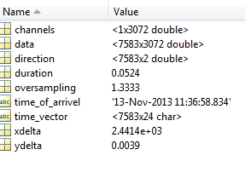
Figure 1: XXX
"channels" : Frequency of data channel.
"data" : raw spectrogram
"duration" : integration time per raw spectrum
"time_of_arrivel" : Start of measurement
"time_vector" : timestamp
= time_of_arrivel + sequence no of spectrum (first index of array data)* "duration"
"xdelta" : frequency difference between spectral channels
"direction" : vector containing AZ, EL corresponding to spectrum sequence in "data" (if available);

- Calibration of Antenna and Spectrometer using Strong Cosmic Radio Sources
- First make calibration measurements on Cygnus A and Cassiopea A.
The measurement should be a continuous recording of data, first at least 200 seconds on the source
Cas-A: RA 23h 23m 26s DEC 58° 48' 0" (J2000 coordinates)
or
Cyg-A: RA 19h 55m 00s DEC 40° 44' 0"
Then at least 200 seconds on the reference position of

RA 23h 10m 30s DEC 56° 30' 0" for Cas-A calibrations
and
RA 19h 24m 00s DEC 41° 0' 0" for Cyg-A calibrations
Make sure that both positions are recorded in the same data set! The longer one integrates on source and off-source, the more accurate the calibration dat will be.
It is preferable to use Cyg A as a primary source for calibrations as its radio flux density is constant on the timescales of thousands of years, whereas the flux density Cas A is slowly decaying with time at a rate of about 10 Jy/year at 1612 MHz.
A MATLAB routine radioflux4.m may be used for the calculation of the spectral flux density of the calibration sources that is needed as an input later on:
For CAS A enter:
>> radioflux4(1612, 2013+11/12,1) to obtain the spectral power flux density of the source Cas A (third argument 1) at 1612 MHz (first argument) for November 2013 (second argument) as
1.5359e+003 Jy
For Cyg A the call is similar, only with ‘2’ as the third argument:
>> radioflux4(1612, 2013+11/12,2)
Yielding
1.3693e+003 Jy

- Now load the data and run display_data.m, e.g.
>> load cygnus_und_leerer_Raum_241013.mat
>> display_data

This should give you a clear recording of on and off source positions:
Figure 2: Illustration of on/off source positions

- and a clean interference-free band pass:
Figure 3: Interference free band pass
Note that the ripple in this spectrum is caused by reflections from mismatching cable or amplifier terminations. The wavelength c/0.5 MHz indicates a reflection of on a cable of about 300m length, shorter for higher insulation dielectrics. This amount of ripple is just tolerable for calibration, but when higher levels occur the fault should be traced and removed as it will affect the precision of the calibration. The same is true for observations showing strong interference lines in the spectrum. The measurements should be repeated in such cases.
select good clean intervals for on and off source observations
from the spectrogram and total power plots given by display_data.m (see above)
start time ON source 1
stop time ON source 150
start time OFF source 200
stop time OFF source 300
enter the strength of the reference sources obtained from previous calls to radioflux4.m at 1610 MHz use e.g. 1535 Jy for Cas-A in 2013 and 1369 Jy for Cyg-A
Code will locate intervals in array:
i_on_0=find(t2>t_on_0,1,'first');
i_on_1=find(t2>t_on_1,1,'first')-1;
i_off_0=find(t2>t_off_0,1,'first');
i_off_1=find(t2>t_off_1,1,'first')-1;
%
make separate arrays for on and off
P_on=D(i_on_0:i_on_1,:);
P_off=D(i_off_0:i_off_1,:);
%
calculate time averages per channel
S_on=sum(P_on)/size(P_on,1);
S_off=sum(P_off)/size(P_off,1);
%
get source strength per channel in spectrometer units and divide it by catalogue value S_ref
S_src=S_on-S_off;
s_conv=S_src/S_ref;
fit a third order polynomial and calculate interpolated smoothed gain coefficients. This will create warnings because of the noise: ignore them!
s_coeff=polyfit(fchan1,s_conv,3);
s_conv_smooth=polyval(s_coeff,fchan1);
%
Warning: Polynomial is badly conditioned. Add points with distinct Xvalues, reduce the degree of the polynomial, or try centring and scaling as described in HELP POLYFIT.
Note: this warning is caused by the noise in the data and may be ignored.
- Display Results

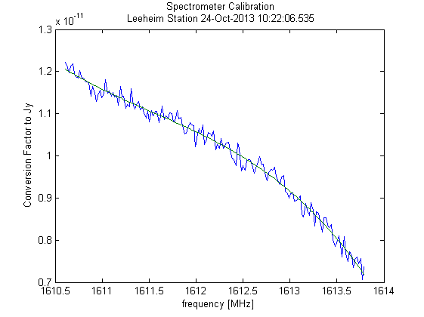
gain curve
Figure 4: Spectrometer calibration
- Display System noise level (Jy) (fig. 32)
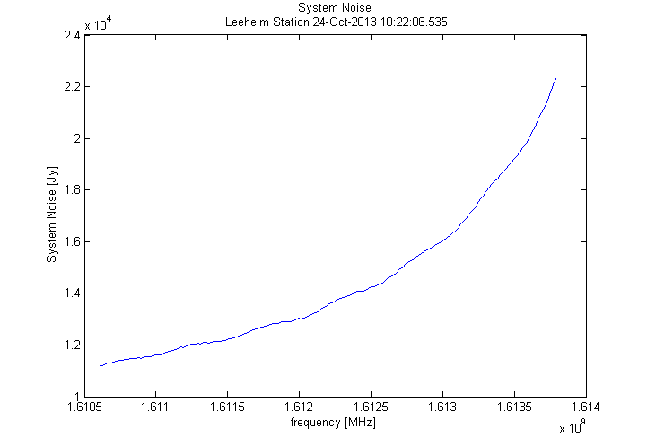
Figure 5: System noise level of Leeheim station

Display System Temperature assuming 0.026 K/Jy conversion (fig. 40)

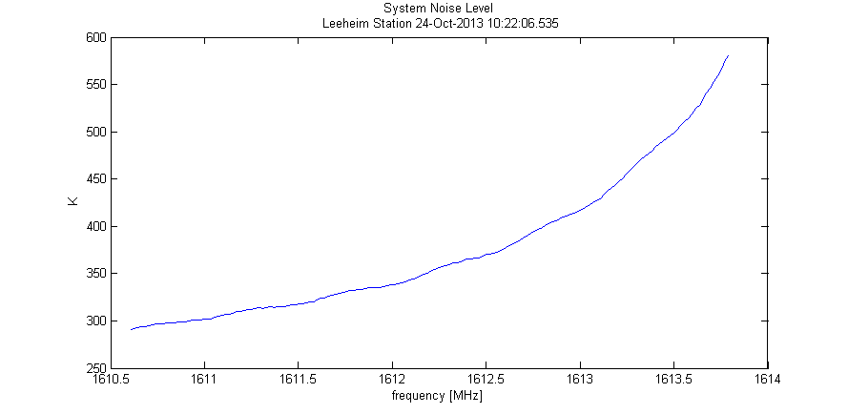
Figure 6: XXX
This graph should correspond closely to the one given in ECC Rep. 171 as Figure 5 on page 10 SE40(10)013 page 5:
Figure 7: The green trace shows the expected system temperature at ɸ=90° (zenit), the black trace at ɸ=5° and the red trace at ɸ=0° (horizontal). The filter loss is responsible for the majority of the system noise, only for elevations near the horizon (< 3°) can we expect a significant contribution of the ground radation.
- save calibration data for processing of subsequent observations
save 'calibration_data.mat' s_conv_smooth;
- Making a Cross Check using the other source

Observe the other strong source in the same manner and load and display the data:
>> clear
>> load cassiopeia_und_leerer_Raum_241013.mat
>> display_data
- measurement made on 24-Oct-2013 12:29:56.086
- time resolution 0.052429 seconds
- rebinning time by 20 new time resolution 1.0486 s
- rebinning frequency by 8 new channel bandwidth 19.5313 kHz
- last 0.68157 seconds discarded
- top 2.4414 kHz discarded
- please enter 1 if you want to select a smaller data set 0
- This will result in a similar total power plot:
Figure 8: XXX
and the data can be used to verify stability and consistency of the procedures but using the calibrate.m procedure on the cosmic source measurement.
>> calibrate
please enter start time of background observation, min= 0.4978 250
please enter end time of background observation, max= 375.888 350

- The result will be a graph of calibrated data for the source:
Figure 9
- Zooming into the graph shows that the measured flux is about 1470 Jy
Figure 10: XXX
which is about 4% less than the predicted value, but within the measurement errors of roughly 5%. A further verification of the system can be seen in the plot of system temperature (fig. 40):
Figure 11: XXX
Which should be very close to the one for the other source on the previous page

- Sample Report generated for calibration
- Calibration Report
for CAS_A created 22-Jul-2014
Data directory = data
data file = A33_cass_cold_13112013_1301.mat
measurement made on 13-Nov-2013 13:01:50.379
time resolution 0.052429 seconds
rebinning in time by 20 to new time resolution 1.0486 s
rebinning in frequency by 8 to new channel bandwidth 19.5313 kHz
Data selection from 1.0486 s to 476.0535 s
(index 1 to 454)
start time ON source 1 s
stop time ON source 190 s
start time OFF source 210 s
stop time OFF source 380 s
strength of reference source = 1851Jy

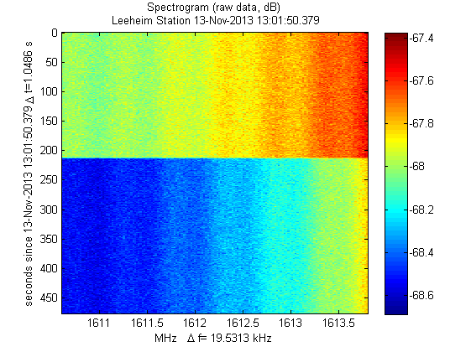
Figure 12:
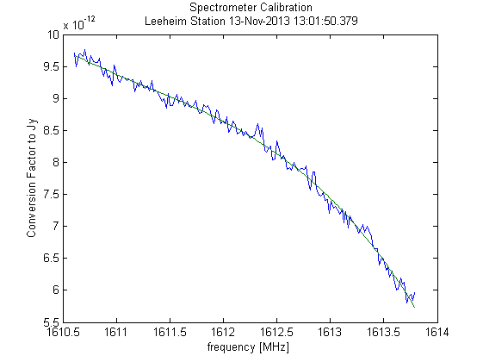
Figure 13:

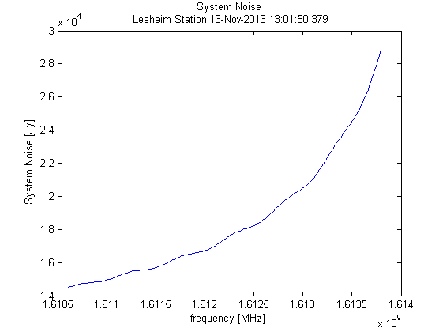
Figure 14:
- System Temperature assuming 0.026 K/Jy conversion

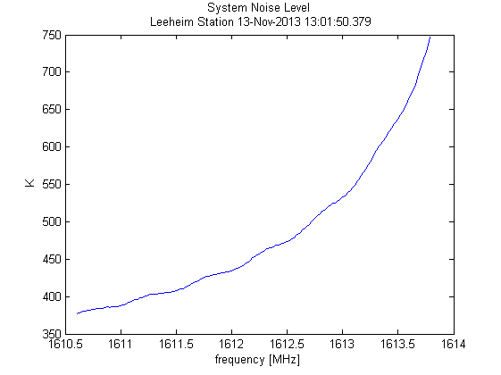
Figure 15: XXX

- Sample report created by eval_data
- Measurement Report

for IR12 created 12-Aug-2014
Data directory = C:\E\MATLAB\work\IRIDIUM\Leeheim\data
data file = A27_IR12_15112013_0802_RX1_20131115_075851.00001.mat
measurement made on 15-Nov-2013 07:58:51.758
time resolution 0.052429 seconds
rebinning in time by 20 to new time resolution 1.0486 s
rebinning in frequency by 8 to new channel bandwidth 19.5313 kHz
Data selection from 1.0486 s to 891.2896 s(index 1 to 850)

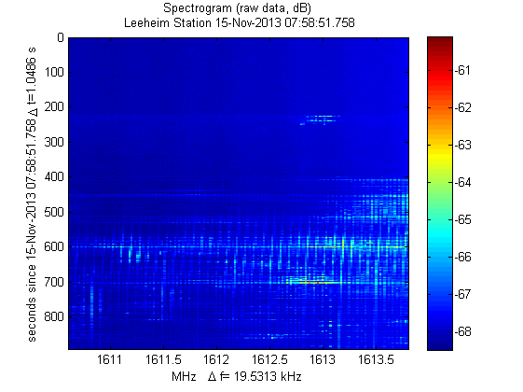
Figure 16:

- Calibrated Data
Background measurement from 3.1457 s to 200.278 s (index 3 to 191)
ITU-R RA 769 threshold single measurement = 7004.3045 Jy. Threshold exceeded in 5.6% of measurements.
ITU-R RA 769 threshold for average spectrum = 272.4359 Jy exceeded in 128 of 164 channels.

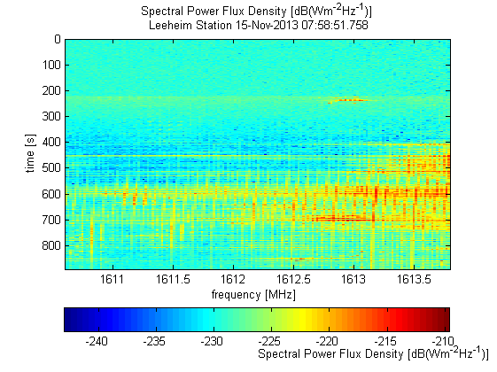
Figure 17:

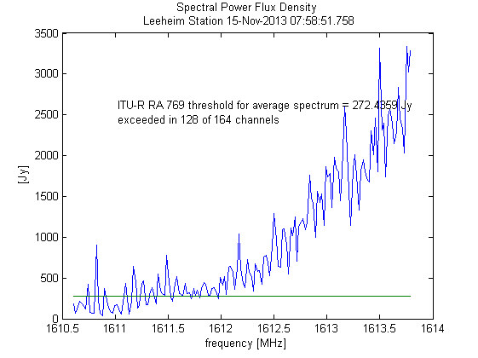
Figure 18: XXX

- Statistics
Maximum interference likelyhood of 18.6 % for frequency 1613.752 MHz in channel 162 threshold exceeded by more than 2% of the time in 79 of 164 frequency channels.
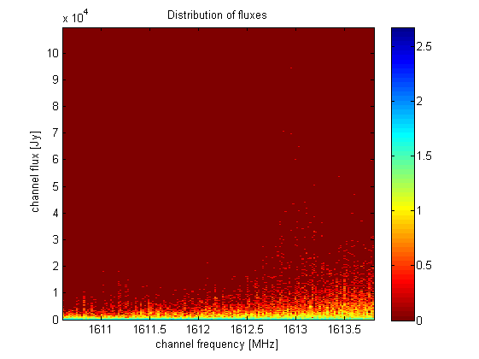
Figure 19:

The graph (Figure 18) shows how often a radio flux S was measured at a given frequency f during the measurement. The colour is encoded on a logarithmic scale given by log10( NS,f + 1) and indicates the number NS,f of 1 second measurements at a frequency f yielding a radio flux level S.
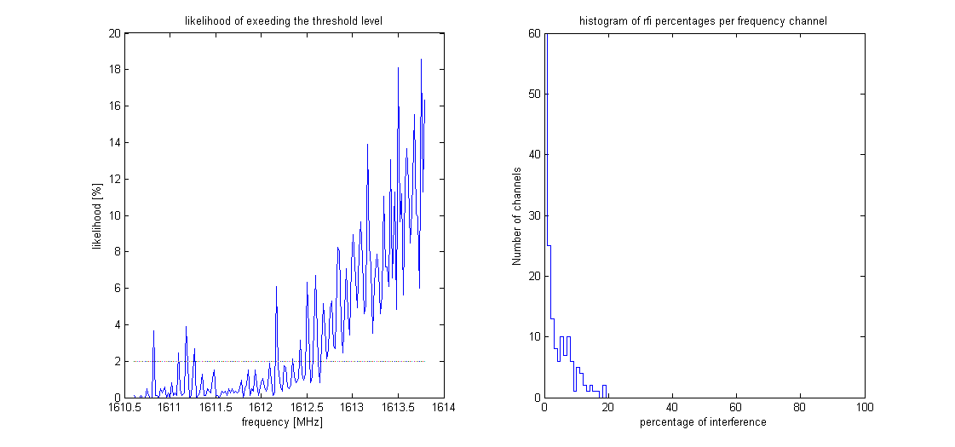
Figure 20:

- Sample Report of an EPFD calculation
Please enter frequency to be analysed in MHz [1610.6-1613.8] 1610.6267. Distribution generation for 1610.6267 MHz, number of intervalls 128 satellites:

Columns 1 through 6
12 13 29 32 59 65
Columns 7 through 11
70 75 76 77 86
selected frequency 1610.627 MHz, closest channel no. 2 centre frequency 1610.627 MHz mkdir C:\E\MATLAB\work\IRIDIUM\Leeheim\results/distributions : Directory already exists. number of epfd trials (default = 5 0 to keep default ) ? 5
nb_tirage =
5

EPFD calculation for 1610.6267 MHz using 5 trials measurement time 1 s, simulated integration time 2000 s, Antenna diameter 100 m visibility file = C:\E\MATLAB\work\IRIDIUM\Leeheim\RAS_IRIDIUM_REAL.csv distribution data directory C:\E\MATLAB\work\IRIDIUM\Leeheim\results/distributions/1610.6267 satellites in constellation 66 satellites measured 12 finished on 11-Aug-2014 15:11:41 after 2.2597 minutes EPFD Data loss for 1610.6267 MHz and 2000s integration time 97.3179% of time lost, statistical error 0.18076% required reduction of emissions 25.5102 dB
EPFD Data loss for 1610.6267 MHz and 30s integration time 24.3016% of time lost, statistical error 0.67839%

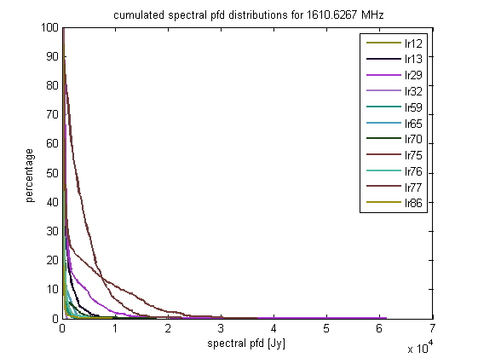
Figure 21:
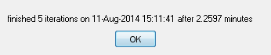
This window appears at the end of a successful EPFD simulation.

The figure below is a representation of the sky and provides the percentage of data loss calculated at every cell in which the sky is divided.
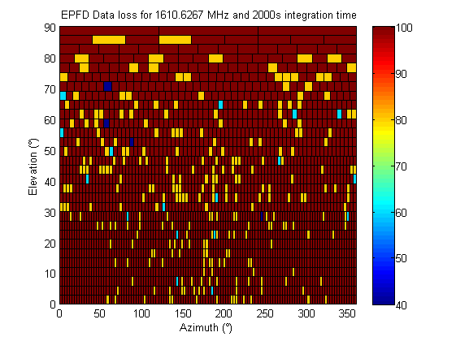
Figure 22: XXX

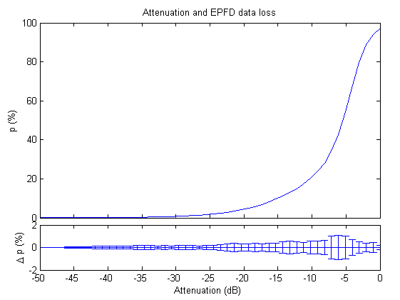
Figure 23: XXX

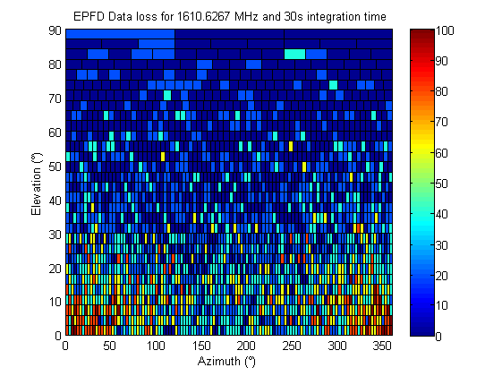
Figure 24: XXX

- Example of an EPFD frequency survey

EPFD Dataloss in the band 1610.60 - 1613.80 MHz

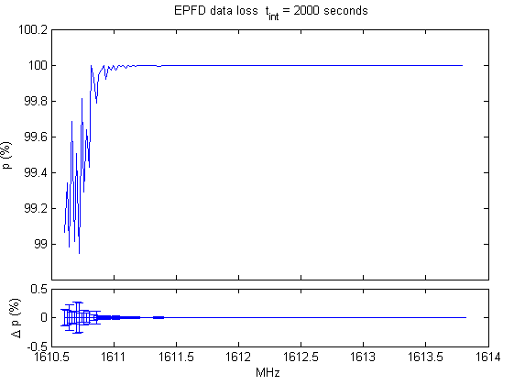
Figure 25: XXX

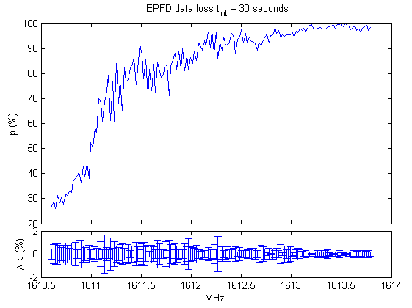
Figure 26: XXX

- Creating Visibility data with STK
- Create a scenario and load the RAS station as the first object.
- Then add all active Iridium satellites. Be careful to ensure that not only the satellite names are loaded, but their orbits too. Editor note: develop text explaining about process of selection of satellite taken into account in calculations
- Then open 'Analyse' -> 'Access'. That shows you all the objects that have been loaded and it is important to use the RAS Station as the object for which visibilities are computed.
- Now you have to (again!) select all satellites and click 'compute'. This will be quick and afterwards the AER report button is highlighted.
- After clicking the AER report button and waiting until all visibilities have been computed one sees the report displayed.
- Right-click on the report itself and select ‘complete export’ that appears in the drop down menu! IMPORTANT: Do not use the Excel export button, this creates incompatible files.

- List of Reference
- Reference one (style: reference)
- Reference two
- etc.

Note that the M_1583_IRIDIUM_par.m calculates EPFD values referred to the boresight gain of the antenna (formula 1 of ITU-R M 1583), whereas the threshold levels in ITU-R RA 769 are referred to 0 dBi antenna gain (formula 2 of ITU-R M. 1583).

