Practical information
9th CEPT ECC WGSE SE45 Meeting on 20 – 22 January 2020, Prague, Czech Republic
10th CEPT ECC WGFM FM57 Meeting on 22 – 24 January 2020, Prague, Czech Republic
Conference venue
Hotel Grand Majestic Plaza ****
Truhlářská 16, 110 00 Praha 1, Czech Republic
phone: +420 211 159 100
e-mail (reservation): reservation@hotel-grandmajestic.cz
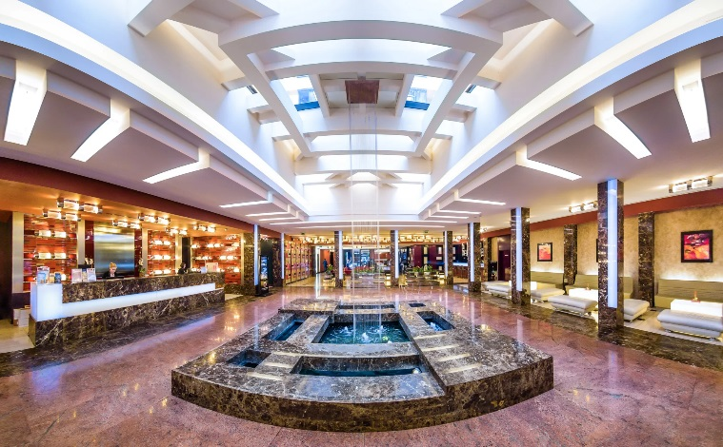
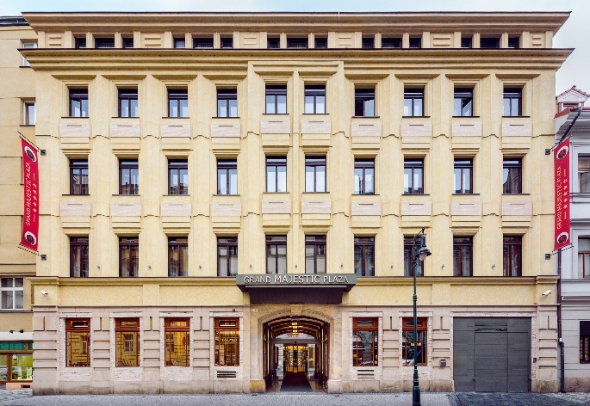
web site: https://www.hotel-grandmajestic.cz/en/

Accomodation
Special rates are available for registered participants in the conference venue – Hotel Grand Majestic Plaza (see above). If you would like to make a reservation at the Hotel Grand Majestic Plaza, please complete and send the attached registration form to reservation@hotel-grandmajestic.cz as soon as possible (number of rooms is limited). The deadline of the special rate is 23 December 2019. The rate is 70 €/room/night.
Hotel Cosmopolitan 5*, 250 m https://www.hotel-cosmopolitan.cz/en/
Hotel Art Deco Imperial 5*, 300 m https://www.hotel-imperial.cz/en/
Hotel UNIC Prague 4*, 250 m https://www.hotel-unic.cz/
Hotel Salvator 3*, 70 m http://www.salvator.cz/hotel/overview-services/
Hotel City Centre 3*, 300 m http://www.city-centre.cz/en/
Hotel Ibis Praha Old Town 3*, 400 m www.accorhotels.com/ ‎
Hotel Clement 4*, 400 m http://www.hotelclement.cz/en/home.html
Luxury family hotel Bílá Labuť 4*, 350 m http://www.hotelbilalabut.cz/?lang=en
How to Reach the Venue from the Airport
By taxi – cca 400 – 500 CZK (cca 15 – 20 Euro), distance 17 km, takes about 25 minutes depending on traffic, taxis available at the entrance to each terminal. Or you can contact the hotel reception at
e-mail: reception@hotel-grandmajestic.cz
https://www.aaataxi.cz/, http://www.nejlevnejsi-taxi.cz/ , http://www.kuryr-taxi.cz/

By car – GPS: N´ 50.090658 E´ 14.430125
Street address: Truhlářská 16, 110 00 Praha 1, Czech Republic

By public transport – price of the ticket 32 CZK (1.25 Euro), takes about 45 minutes, bus No. 100 stops in front of each terminal (see the map below), tickets available at the bus stop or in departure hall.
Take bus No. 100 from the airport to the terminal metro stop Zličín where you change to the metro Zličín, B line (yellow), then travel to Náměstí Republiky (12 stops) and také the exit direction Náměstí Republiky and Street Revoluční, continue straight on by department store Palladium and take the first right Street Truhlářská. The hotel is on your right side.
Information about the public transport: https://pid.cz/en/for-tourists/

Map (bus stops at the airport)

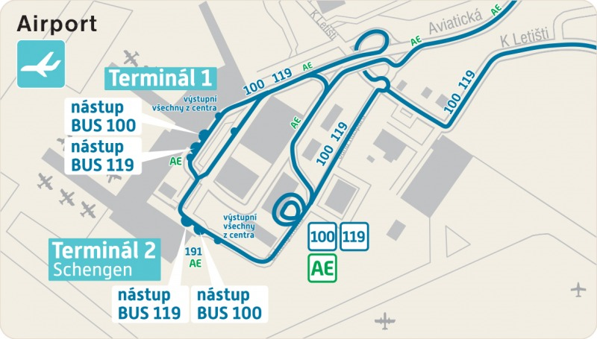

Nice to know
Tourist information about Prague: http://www.prague.eu/en
Time
Local time in the Czech Republic is GMT + 1.
Climate
Average weather for Prague in January is standard for central Europe. You may experience snow or clear skies, but no matter what – it's going to be cold! Temperatures range from a low -4°C (25°F) at night to a high 2°C (35°F) during the day, and there are just three hours of sunshine per day.
Electrical Appliances
Standard elektricity supply is 230V/50Hz. Plugs are 2-pin continental type.
Czech Dialling Code
+420
Emergency
EU emergency number 112 (ambulance, rescue services, fire department and police).
Currency
The currency is Czech crown (CZK, Koruna), 1 Euro = approx. 25.80 CZK.
Automatic cash dispensers are avalaible twenty-four hours a day. Banks are usually open Monday to Friday from 9.00 am to 5.00 pm. The majority of shops accept credit cards for payment.
Visa Requirements
For information about visa requirements, please consult the Ministry of Foreign Affairs web site http://www.mzv.cz/jnp/
If you need a personal invitation for visa support, please contact Ms. Katerina Chvalinova (e-mail: chvalinovak@ctu.cz )

