Doc. SE7(15)xxx

PT SE7 Meeting

26-27 May 2015

HANOVER, GERMANY

Date issued: May 25, 2015

Source: APWPT

Subject: Building Absorption and the RF Loss through Glass

N
Password protection required? (Y/N)

Summary

There has been much discussion and comment on the transparency of glass to radio waves we have carried out some research and believe the following information should be discussed within SE7 and figures agreed for Glass absorption within the SE7 work program.

Proposal

SE7 is kindly asked to consider the attached information for inclusion in work program.

Background

Indoor use of PMSE equipment

Annex
Building Absorption and the RF Loss through Glass

Building Absorption and the RF Loss through Glass

There has been much discussion and comment on the transparency of glass to radio waves we have carried out some research and believe the following information should be discussed within SE7 and figures agreed for Glass absorption within the SE7 work program.

This document consists of two parts, internet research and as an annex a recent presentation to Ofcom UK.

We found on the internet an interesting discussion:
( https://community.ubnt.com/t5/airMAX-General-Discussion/Is-it-normal-to-lose-15-dB-through-a-single-double-pane-window/td-p/250353 )
……………..

Q: Is it normal to lose 15 dBm across a single double-pane window?

My new 2.4 GHz Bullet M2 WISP setup was damaged in the recent storm; so a friend came by today to lend me his Ubiquiti AirGrid M2 Hi-Power (28dBm) 17x24-inch 20dBi setup until I'm back and running.
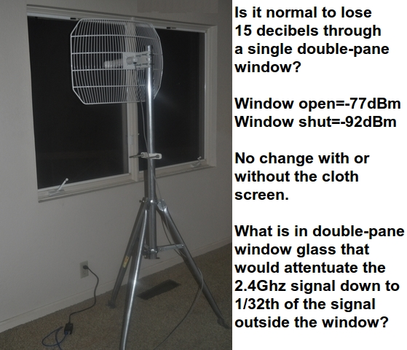
Oddly, we get -77 dBm with the window open (screen or no screen, which is cloth); but we get -92 dBm with the window shut. The difference is such that we can only connect to the access point with the window open to the cold and rain.
It's a typical double-pane window as far as I can tell.
Q: Is it normal to lose 15 dBm across a single double-pane window?
……………..

APWPT notes
This information made us curious. Therefore, we continued our research and found a scientific measurement that provided further information:
( http://www.cmi.aau.dk/Projects/Projects_detailed/ )
……………..
RF Insertion Loss in new and old building materials
New building materials such as walls and windows are improved with respect to thermal energy loss. Modern windows are coated with a thin metallic layer to improve indoor comfort in the summer and to prevent indoor thermal loss in the winter. This has a disadvantage with respect to insertion loss of incoming radio waves in the frequency area of 1 to 5 GHz.
To get some figures quantifying the problem a measurement program was initiated at CMI covering RF (radio frequency) measurements on new and old building materials. This research project was initiated by “Erhvervsstyrelsen”. The commissorium of CMI was to investigate the increasing problem of mobile telephone and internet communication in new buildings and to come up with some solutions to the problem.
The measurement setup is seen in fig. 1, using 2 horn antennas shown in fig. 3. Measuring S-parameters gives accurate results for insertion loss and reflection coefficients. See fig. 4
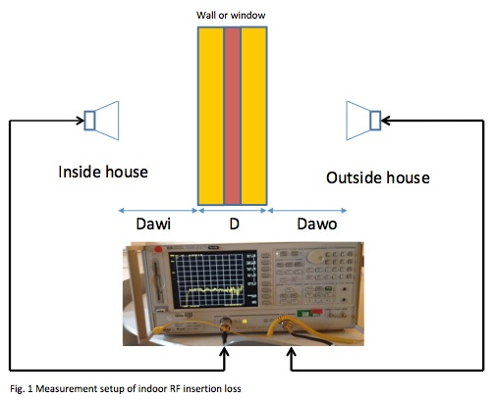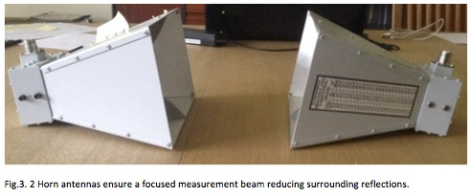
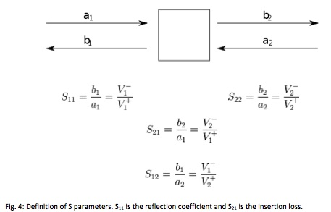

Measurements at Danish Building Information Centre
Measurements on new building materials were performed at “Middelfart Byggecenter” (fig 5 shows a double coated glass window). The measurements showed a significant increase in penetration loss compared to old building materials.
A reference measurements of insertion loss without any building material inserted between the 2 horn antennas, was carried out initially (see fig. 6). To calculate the loss, this reference measurement was subtracted from all the measurements to give the real insertion loss of the building material. See fig. 7 and fig 8.
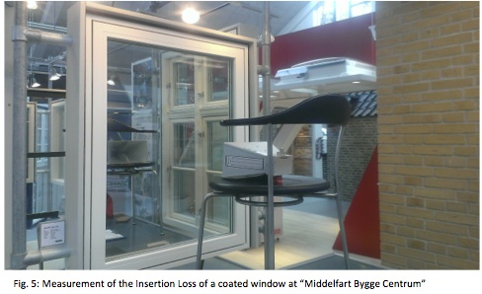
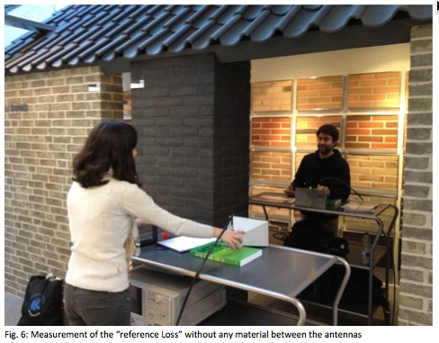
It can be seen on the fig. 8 (subtracting fig. 7) that a new double coated window has an insertion loss from 26 dB to - 35 dB in the frequency interval 1 GHz to 5 GHz. This should be compared to old uncoated windows which have an insertion loss of < 3dB to 10 dB. Below is shown the insertion losses new and old building materials:
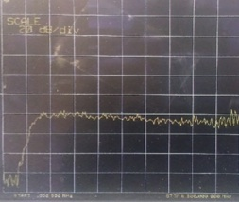 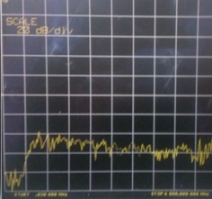
Fig. 7: reference loss (air - no glass) Fig. 8: Insertion Loss of a double coated window
Range: 0,03 MHz to 6 GHz. Each grid section Range: 0,03 MHz to 6 GHz. Each grid section
equals to: horizontally 600 MHz, vertically 20 dB equals to: horizontally 600 MHz, vertically 20 dB

Preliminary results
The values are different for different building materials and different frequencies. Below a table is presented showing the results of the measurements:
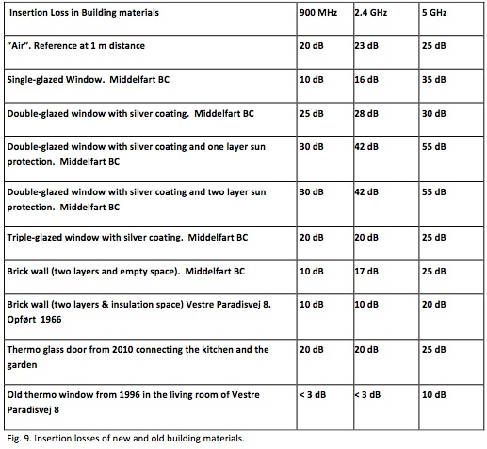

Conclusion
Looking at Figure 9, it can be seen that new building materials adds an extra RF Loss penalty of 7 - 28 dB compared to old building materials. A research paper (Gert Frølund: Limit values for Downlink Mobile Telephony in Denmark) indicates sensitivity limits for GSM and UMTS mobile phones at the range of -99.4 dBm to - 94.5 dBm depending on model and manufacturer.
Network coverage signal strength in DK goes from the unacceptable limit of -92 dBm to the very good level of -57 dBm. These network coverage signal strength values leaves a margin of 2.5 dB for the worst case (bad mobile phone and bad coverage) to 37.5 dB for the best case (excellent mobile phone and excellent coverage).
From figure 9 we can see that new building material RF loss at 2.4 GHz, is in the range of 17 dB to 28 dB ( 55 dB when all windows are covered with sun shutters) compared to old building materials which exhibits a loss from <3dB to 10 dB at 2.4 GHz.
The problems increases at 5 GHz where the highest RF loss was measured to 35 dB ( 55 dB when all windows are covered with sun shutters). The biggest problem is the coated windows due to the thin conductor material applied to the window to prevent heat radiation in and out of the building. But also the building brick materials exhibit an increasing loss penalty of an extra 7 dB comparing new materials from Middelfart Bygge Center to bricks from 1966.
We have not measured on concrete and armed concrete but the literature reports RF attenuation values of 15 dB for armed concrete with a thickness of 26mm and at a frequency of 2.3GHz, and up to 35 dB for a thickness of 305 mm (reference: Application note Digi XST-AN005a-indoor).
A final remark should be that buildings are not build of pure bricks or pure coated glass (even though new architects are very satisfied with glass), and therefore the RF attenuation in a building as a whole, would be something in between the range of 7 - 28 dB attenuation, depending on the number, material and thickness of internal walls and doors. Before building the building, care should be taken on how to reduce the RF attenuation by inserting the right number of slots, the right places and with the right dimensions.
Further information: Niels Koefoed
…………………

APWPT notes
It seems new building material and coated class will have a significant shielding effect.
There remains the question if this trend can be transferred to existing buildings equipped with old windows glasses? Or: could we find some were “old style glasses” with high RF absorption characteristics we would not expect?

This source gives a positive answer
( http://www.slt.co/products/RFShieldingWindowFilm/RFWindowFilm-SignalProtect-Clear.aspx )
If non-coated glasses would be retrofitted with coated foils their solar heat control blocking would be sustainable improved without significant loss in light. The side-effect is a high improved RF shielding.

SLT Name | Clear Glass | Signal Protect Clear - SLTWF1
Description | Clear | Clear
Thickness | 1/8 Inch Clear | 3 mil (8mil optional)
RF Power Attenuation
Blocking Power @ 1 GHz | 0 dB 0 % | -36 dB 99.97 %
Blocking Power @ 2 GHz | 0 dB 0 % | -48 dB 99.998 %
Blocking Power @ 10 GHz | 0 dB 0 % | -29 dB 99.88 %
% IR Light Blocked | NA | 95+
% UV Light Blocked | 27 | 99+
Total Solar Energy Rejected | 15 | 55
Visible Light
% Transmittance | 90 - High | 72 - High
% Reflectance Exterior | 9 - Low | 9 - Low
% Reflectance Interior | 9 - Low | 9 - Low

APWPT notes
Some similar (low price) products can be found on the market that offer shielding of above 20 dB at 1 GHz.
....................

APWPT refers to an additional information source
In 2013 the Ministry of Transport and Communications of Finland studied “mobile network reception problems in low energy buildings” and summarized the effect of an introduction of “selective film windows” with 25 dB absorption (http://www.lvm.fi/docs/en/2497123_DLFE-22133.pdf ).
In consequence of the improved shielding by new building materials the document suggests methods to ensure the indoor mobile service reception. If might be questionable if building’s owner will invest in this feature?
……………..

APWPT notes
In addition please see Annex A, Wideband Outdoor to Indoor Penetration Measurements
Thursday, 21 May 2015 from Tim Brown 5G Innovation Centre, University of Surrey, 22/5/15

Conclusion

This brief research has led to an interesting result: rather than glass being transparent to radio waves it shows the opposite and that the building loss is not a constant parameter. We must consider that modern buildings containing large glass arears are a barrier to radio transmissions which will increase as thermal building insulation increases in use.

SE7 is kindly requested to consider this evolution that can support the indoor operation of PMSE.

