Smart Grid Systems and Other Radio Systems suitable for Utility Operations, and their long-term spectrum requirements.

ETSI650 Route des Lucioles
F-06921 Sophia Antipolis Cedex - FRANCE

Tel.: +33 4 92 94 42 00 Fax: +33 4 93 65 47 16

Siret N° 348 623 562 00017 - NAF 742 C
Association à but non lucratif enregistrée à la
Sous-préfecture de Grasse (06) N° 7803/88

Important notice
The present document can be downloaded from:
http://www.etsi.org/standards-search
The present document may be made available in electronic versions and/or in print. The content of any electronic and/or print versions of the present document shall not be modified without the prior written authorization of ETSI. In case of any existing or perceived difference in contents between such versions and/or in print, the only prevailing document is the print of the Portable Document Format (PDF) version kept on a specific network drive within ETSI Secretariat.
Users of the present document should be aware that the document may be subject to revision or change of status. Information on the current status of this and other ETSI documents is available at http://portal.etsi.org/tb/status/status.asp
If you find errors in the present document, please send your comment to one of the following services:
https://portal.etsi.org/People/CommiteeSupportStaff.aspx
Copyright Notification
No part may be reproduced or utilized in any form or by any means, electronic or mechanical, including photocopying and microfilm except as authorized by written permission of ETSI.
The content of the PDF version shall not be modified without the written authorization of ETSI.
The copyright and the foregoing restriction extend to reproduction in all media.

© European Telecommunications Standards Institute yyyy.
All rights reserved.
DECTTM, PLUGTESTSTM, UMTSTM and the ETSI logo are Trade Marks of ETSI registered for the benefit of its Members.
3GPPTM and LTE™ are Trade Marks of ETSI registered for the benefit of its Members and
of the 3GPP Organizational Partners.
GSM® and the GSM logo are Trade Marks registered and owned by the GSM Association.
Reproduction is only permitted for the purpose of standardization work undertaken within ETSI.
The copyright and the foregoing restriction extend to reproduction in all media.

If an additional copyright is necessary, it shall appear on page 2 after the ETSI copyright notification
The additional EBU copyright applies for EBU and DVB documents.
© European Broadcasting Union yyyy.

The additional CENELEC copyright applies for ETSI/CENELEC documents.
© Comité Européen de Normalisation Electrotechnique yyyy.

The additional CEN copyright applies for CEN documents.
© Comité Européen de Normalisation yyyy.

The additional WIMAX copyright applies for WIMAX documents.
© WIMAX Forum yyyy.

Contents (style TT)
If you need to update the Table of Content you would need to first unlock it.
To unlock the Table of Contents: select the Table of Contents click simultaneously: Ctrl + Shift + F11.
To update the Table of Contents: F9.
To lock it: select the Table of Contents and then click simultaneously: Ctrl + F11.

Contents (style TT) 3
Intellectual Property Rights (style H1) 4
Foreword (style H1) 5
Modal verbs terminology 5
Executive summary (style H1) 5
Introduction (style H1) 6
2 References (style H1) 8
2.1 Normative references (style H2) 8
2.2 Informative references (style H2) 8
3 Definitions and abbreviations (style H1) 9
3.1 Definitions (style H2) 9
3.2 Abbreviations (style H2) 10
4 Utility Operations Requirements 11
4.1 Requirements 11
5 Existing and Potential Utility Operations technologies 13
5.1 Data systems 13
5.2 High-definition Real-time Video 15
5.3 Other Utility Operations Radio Systems 15
6 Long-term spectrum requirements for Utility Operations 16
7 Conclusion 17
Proforma copyright release text block 17
Annex <A>: Change History (style H9) 18
History (style H1) 18

Intellectual Property Rights
IPRs essential or potentially essential to the present document may have been declared to ETSI. The information pertaining to these essential IPRs, if any, is publicly available for ETSI members and non-members, and can be found in ETSI SR 000 314: "Intellectual Property Rights (IPRs); Essential, or potentially Essential, IPRs notified to ETSI in respect of ETSI standards", which is available from the ETSI Secretariat. Latest updates are available on the ETSI Web server (http://ipr.etsi.org).
Pursuant to the ETSI IPR Policy, no investigation, including IPR searches, has been carried out by ETSI. No guarantee can be given as to the existence of other IPRs not referenced in ETSI SR 000 314 (or the updates on the ETSI Web server) which are, or may be, or may become, essential to the present document.

Foreword
This Technical Report (TR) has been produced by {ETSI Technical Committee|ETSI Project|<other>} <long techbody> (<short techbody>). TGDMR

Modal verbs terminology
In the present document "shall", "shall not", "should", "should not", "may", "need not", “will”, “will not”, "can" and "cannot" are to be interpreted as described in clause 3.2 of the ETSI Drafting Rules (Verbal forms for the expression of provisions).
"must" and "must not" are NOT allowed in ETSI deliverables except when used in direct citation.

Executive summary
This [DRAFT] ETSI Technical Report highlights the future spectrum requirements for the mission critical real-time systems, e.g. Smart Grids, that are necessary to meet Europe's need for the 'reliable provision of electricity wherever and whenever it is required'. It also emphasises that almost all of Europe's businesses are dependent on electricity to enable them to supply the goods and / or services to Europe's citizens and consumers.
Article 194 of the Treaty on the Functioning of the European Union (TFEU / Treaty of Rome) sets out that the aim of EU Energy policy is to 'ensure security of energy supply in the Union', i.e. to ensure that energy (including electricity) is available to all when needed, and while doing so 'promote energy efficiency and energy saving and the development of new and renewable forms of energy'. Smart Electricity Grids will be used to distribute and control these energy efficient / saving networks.
This ETSI report builds on the Smart Grids Co-ordination Group Technical Report Reference Architecture for the Smart Grid (RASG) in that it highlights that real-time mission critical Smart Grid systems typically need to be resilient, sometimes requiring Best Practice resilience, whereas best-effort non-real-time Smart Meter systems typically do not need to be resilient. This should clarify which of the systems mentioned within the RASG may be suitable for Smart Grid systems and which may only be suitable for Smart Meter systems.
This report also highlights that there may be options for the existing ETSI standards for low bandwidth grid systems to be updated to enable higher data rates, e.g. 64 kbit/s, for use by Smart Grid systems.
This report supports the RASG recommendation that 'Deployment constraints mandate the need for both wire-line and wireless communications. Utility access to wireless network resources is necessary. Where spectrum is allocated for use by utility networks, this will help progress the Smart Grid deployments ensuring the standard work and products take into account the allocated spectrum for utilities.'
This report highlights that Utility Operations have ~50 years’ experience in designing, installing, operating, and maintaining resilient machine to machine (RM2M) systems using wire-line and wireless technologies.
Ultimately, this report seeks:
- the following spectrum requirements for Utility Operations, including Smart Grid, systems:
  - 1 MHz within the VHF bands;
  - 2 x 3 MHz within the 400 MHz UHF band;
  - 10 MHz within the 1400 MHz band;
- to identify Utility Operations Networks (UON) as a separate ITU defined category (as are PPDR, PMSE, GSM-R, etc).

Introduction
This DRAFT document has been developed to support the co-operation between ETSI and the Electronic Communications Committee (ECC) of the European Conference of Posts and Telecommunications Administrations (CEPT).
Almost every service or product offered to Europe's citizens and consumers relies directly or indirectly on the reliable provision of electricity by Europe's Utility Operations. The European Commission, within its Energy Strategy, fully recognises and supports the important requirement for 'secure energy supplies to ensure the reliable provision of energy whenever and wherever needed'.
The European Commission’s 2030 policy framework seeks to de-carbonise the energy system. The framework encourages the electrification of heat and transport, as well as the connection of more intermittent generation. As these policies take effect, the electricity system will become more complex to plan, control and balance. More flexibility will be needed to ensure that the energy system is able to cope with the future challenges. It will be key to delivering an affordable and climate-friendly energy system. Natural disasters, terrorist attacks, and criminal activity can all disrupt the critical energy infrastructure Europeans depend on. While national authorities are primarily responsible for the protection of energy facilities such as power plants and transmission lines, energy disruptions can be felt across national borders. The EC considers that, inter alia, energy infrastructures and facilities for the generation and transmission of electricity in respect of supply electricity between member states are European Critical Infrastructures (ECI). Likewise, Gas production, refining, treatment, storage and transmission by pipelines, and liquid natural gas (LNG) terminals, are considered to be ECI.
The EC's European Programme for Critical Infrastructure Protection (EPCIP) identifies that 'European Critical Infrastructures (ECI) constitute those designated critical infrastructures which are of the highest importance for the Community and which if disrupted or destroyed would affect two or more Member States, or a single Member State if the critical infrastructure is located in another Member State. The identification and designation of National Critical Infrastructures is defined by a Member State according to predefined national criteria. With due regard to existing Community competences, the responsibility for protecting National Critical Infrastructures falls on the NCI owners/operators and on the Member States'.
The EC Directive 2008/114/EC on European Critical Infrastructures fully recognises that the 'infrastructures and facilities for generation and transmission of electricity in respect of supply electricity' is part of each member state's critical infrastructure. This criticality is emphasised by the European Commissions' acknowledgement of the continued requirement for electricity grids to have Resilience to ensure critical infrastructure protection (CIP).
Indeed, the importance of Smart Grid electricity is such that the EC has created the M/490 EN Smart Grid Mandate. This is the 'Standardization Mandate to European Standardisation Organisations (ESOs) to support European Smart Grid deployment'. The objective of this mandate was / is to develop or update a set of consistent standards within a common European framework that integrates a variety of digital computing and communication technologies and electrical architectures, and associated processes and services that will achieve interoperability and will enable or facilitate the implementation in Europe of the different high level Smart Grid services. It should be noted that two of the high-level services the Smart Grids Task Force defined are 'Enhancing efficiency in day-to-day grid operation' and 'Ensuring network security, system control and quality of supply'. It should also be noted that there are options for the existing 12.5 / 25 kHz low bandwidth grid systems to use higher data rate systems, e.g. 64 kbit/s in 25 kHz. This will enable any higher data rate Smart Grid systems the option to continue to use low bandwidth channels.
The need for reliable, network secure, and resilient operation is an over-riding influence on the choice of technologies or service provision model in some instances. The increasing number of attacks on utility monitoring and control systems makes it increasingly important for Utility Operations systems to be protected against intrusion. Fortunately, Utility Operations have ~50 years’ experience in designing, installing, operating, and maintaining resilient machine to machine (RM2M) systems using wire-line and wireless technologies so they are the industry experts in their own field. A simple solution to potential Internet-based attacks is to ensure that there is an ‘air gap’ between critical utility control networks and the public internet to guarantee secure and reliable operation of the former.
This document highlights which types of self-managed Resilient Machine to Machine (RM2M) system technologies and self-managed Machine to Machine (M2M) system technologies are currently being used for Utility Operations, and their spectrum requirements. It will be seen that in some cases, in the absence of suitable licensed spectrum, utility operational systems may use alternative telecommunications solutions, but this does not necessarily indicate their suitability as long-term solutions.
In considering these requirements, it should be noted that current and future Utility Operations spectrum requirements are very limited compared with the spectrum requirements of, for example, broadband public mobile systems. Indeed, the European Utility Telecom Council (EUTC) spectrum proposal identifies a requirement for 6 MHz of licensed 400 MHz UHF and 10 MHz of 1.4 GHz spectrum for Smart Grid utility operations. This requirement is considered minimal in contrast to the 1,200 MHz of spectrum proposed for broadband data in the European Radio Spectrum Policy Programme (RSPP).

1 Scope
The document highlights:
1) systems suitable for Smart Grids, e.g. to include at least the following essential criteria:
- very high link availability;
- >30km link lengths;
- priority access;
- stringent end-to-end latency requirements;
- coverage to remote / unpopulated areas;
- licensed self-managed spectrum in a variety of bands (e.g. 400 MHz [including the FIXED / MOBILE sub-bands that have a European Common Allocation for Mobile systems and] 1400 / 1500 MHz);
- ability for Best Practice resilient operation.
2) the essential requirements for systems suitable for other Utility Operations radio systems.
3) the long-term spectrum requirements for Utilities

This document notes that the European Common Allocation Table shows 450 to 470 MHz is identified for use by narrow band mobile systems complying with, for example, ETSI Standards EN 300 086, EN 300 113, EN 301 166, and EN 302 561.
This document also notes ITU footnote 5.286AA: ‘The band 450-470 MHz is identified for use by administrations wishing to implement International Mobile Telecommunications (IMT). See Resolution 224 (Rev.WRC-07)*. This identification does not preclude the use of this band by any application of the services to which it is allocated and does not establish priority in the Radio Regulations. (WRC-07)’

2 References

2.1 Normative references
References are either specific (identified by date of publication and/or edition number or version number) or non-specific. For specific references, only the cited version applies. For non-specific references, the latest version of the referenced document (including any amendments) applies.
Referenced documents which are not found to be publicly available in the expected location might be found at http://docbox.etsi.org/Reference.
NOTE: While any hyperlinks included in this clause were valid at the time of publication, ETSI cannot guarantee their long term validity.
The following referenced documents are necessary for the application of the present document.
Not applicable.

2.2 Informative references
References are either specific (identified by date of publication and/or edition number or version number) or non-specific. For specific references, only the cited version applies. For non-specific references, the latest version of the referenced document (including any amendments) applies.
NOTE: While any hyperlinks included in this clause were valid at the time of publication, ETSI cannot guarantee their long term validity.
The following referenced documents are not necessary for the application of the present document but they assist the user with regard to a particular subject area.
[i.1] Centre for the Protection of National Infrastructure (CPNI) 1001002: Guide to Telecoms Resilience
[i.] EC M/441 EN Smart Meters Mandate
[i.] EC M/490 EN Smart Grid Mandate
[i.] EC Energy Strategy
[I.] IEC 61850
[I.] IEC 61968
[I.] IEC 62264-2003
[I.] IEC 62357-2011 [I.]
[I.] ETSI EN 60870
[i.] ETSI EN 300 186: …
[i.] ETSI EN 300 113: …
[I.] MPT1327: Trunked Private Mobile Radio Systems
[i.] Ofcom (UK) MPT1411: Performance Specifications and Frequency Assignment Criteria for Private Fixed Mobile Equipment for Telemetry and Telecontrol Purposes Operating in the Bands 457.5 to 458.5 MHz and 463.0 to 464.0 MHz (January 1995)
[i.] Ofcom (UK) OfW49: Fixed Point-to-Point and Point-to- Multipoint Scanning Telemetry Radio Services with Analogue Modulation Operating in the Frequency Ranges 457.5 to 458.5 MHz paired with 463.0 to 464.0 MHz [I.] Treaty on the Functioning of the European Union (TFEU / Treaty of Rome)

3 Definitions and abbreviations

3.1 Definitions
For the purposes of the present document, the following terms and definitions apply:
Best Practice Resilience: is defined as those measures that can be taken to guarantee resilience, irrespective of cost
Good Practice Resilience: is defined as those measures which can be taken to provide a degree of resilience commensurate with the Corporate risk strategy
Machine to Machine (M2M) systems: is defined as 'Any past, existing, or future wireless, wired, fibre, or combination of technologies that enable connected devices to exchange information and perform actions typically without the manual assistance of humans'

3.2 Abbreviations
For the purposes of the present document, the following abbreviations apply:
- Use the EW style and separate this from the definition with a tab. Use the EX style for the last term.
CENELEC European Committee for Electro-technical Standardisation
DMR Digital Mobile Radio
dPMR Digital Private Mobile Radio
eDMR e??? Digital Mobile Radio
ETSI European Telecommunications Standards Institute (a European Standards Body)
EUTC European Utilities Telecom Council
FM Frequency Modulation
GPRS General Packet Radio Service
IEE Institution of Electrical Engineers (UK)
IEEE Institute of Electrical and Electronics Engineers (American Standards body)
ITU International Telecommunications Union
M2M Machine to Machine
P25
PMR Private Mobile Radio
PSK Phase Shift Keying
QAM Quadrature Amplitude Modulation
QoS Quality of Service
QPSK Quadrature Phase Shift Keying
RM2M Resilient Machine to Machine
SCADA Supervisory Control and Data Acquisition
SRD Short Range Devices
ST Scanning Telemetry
TDMA Time Division Multiple Access
TFEU Treaty on the Functioning of the European Union (The Treaty of Rome)
TETRA TErrestrial Trunked RAdio
UHF Ultra High Frequency (300 to 3,000 MHz)
UON Utility Operations Networks
VHF Very High Frequency (30 to 300 MHz)
WiGRID

4 Utility Operations Requirements

4.1 Requirements
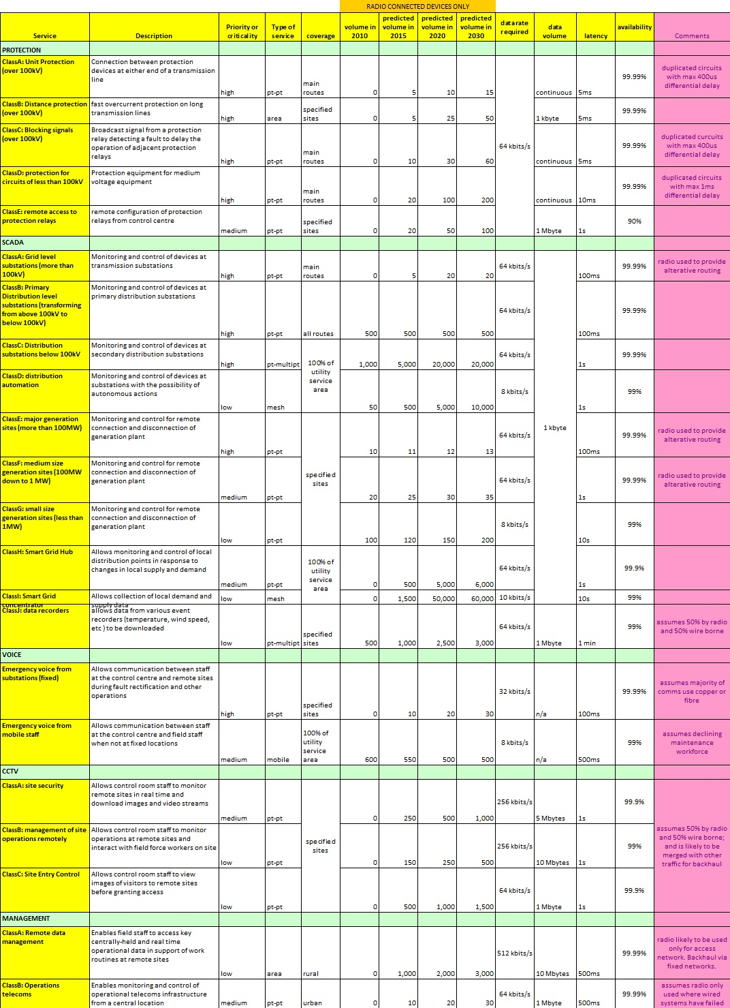Utilities have a wide and diverse range of requirements. In an effort to simplify and codify these requirements, the European Utilities Telecoms Council's (EUTC) Spectrum Group distilled the requirements of a number of different utilities to produce the table below to identify the Smart Grid and Smart Meter services which might require radio connections. These are shown in Table 1, below.

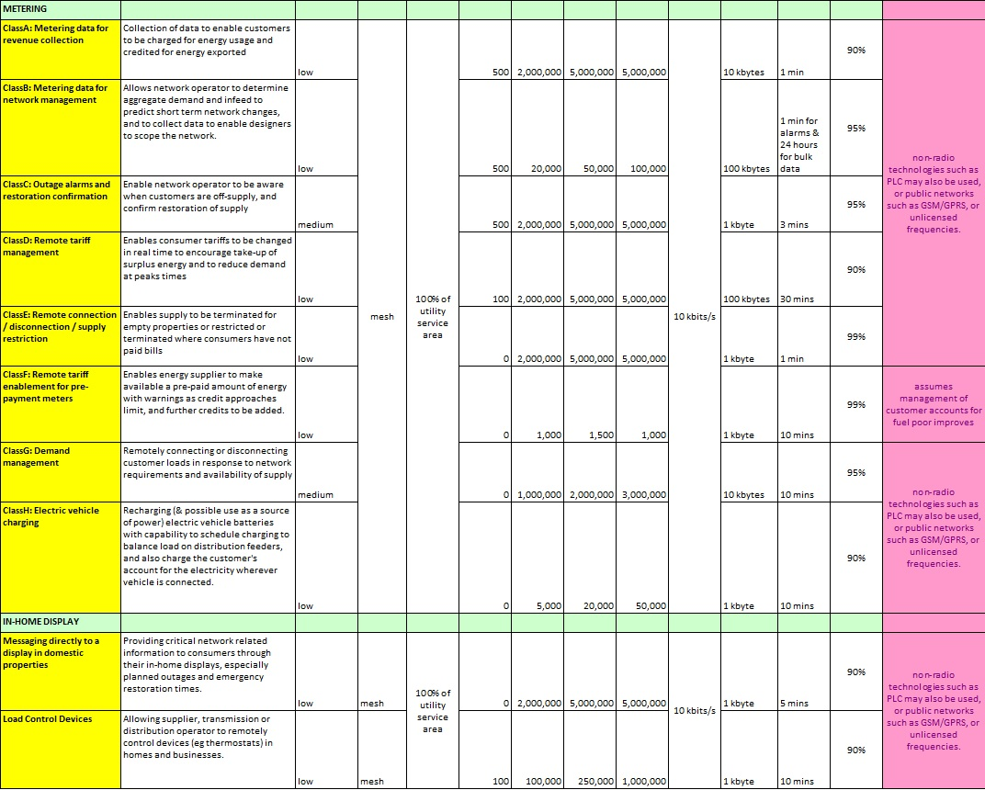

Table 1: EUTC Smart Grid telecommunications service requirements summary table for a typical European distribution network operator [NB: a clearer version of this table is required].
The table emphasises the array of requirements for Utility Operations systems, including:
- 100% coverage of the utility service area, including >30km remote and unpopulated areas;
- 90% (e.g. metering and in-home) to 99.99% (e.g. protection and SCADA) link availability;
- instant and guaranteed channel access, e.g. with 10mS end-to-end latency;
- ability for Best Practice resilience operation;
- licensed self-managed spectrum, in bands with different propagation characteristics:
  - 1 MHz within the VHF bands (e.g. wide-area voice and low data rates);
  - 400 MHz UHF Band (e.g. low data rates over medium to long distances);
  - 1.4 GHz Band (<= 2 Mbit/s, over medium to long distances);
  - 7.5 / 13 / 23 / 38 GHz (>= 2 Mbit/s, over medium to short distances);
- the above bands are used for redundant / diversity routing, e.g. using two or more wireless and / or wired / fibre links from different sources to a remote station;
- system and transmitted data have high levels of network security and integrity, including:
  - no connection to external and / or public communications systems, e.g. the Internet;
- hardened to ensure reliable operation in severe environmental conditions, including electromagnetic disturbances such a lightning strikes;
- up to 72 hours power backup;
- low jitter and synchronous requirements; and
- longevity of life and support, e.g. 10 to 20 years.

The systems with the higher percentages of availability are more likely to be resilient. Best Practice resilience may be used for Class A and Class B protection systems.

Caution should be observed when assessing which communication systems may be used for each of the above systems. Some technologies, or their typical network architecture, may only be suitable for best effort Smart Metering rather than mission critical real-time Smart Grids.
With Utility Operations having up to 50 years’ experience in designing, installing, operating, and maintaining resilient machine to machine (RM2M) systems, Utility Operations systems are often self-owned and self-managed. These systems typically offer very efficient operation. For example, it is usual for only the minimum spectrum to be occupied, with those channels perhaps having full 24-hour control and monitoring activity. For example, a 24-hour Scanning Telemetry (ST) system may use only a single narrow band 12.5 kHz channel and cover an area with a 35 km radius.

5 Existing and Potential Utility Operations technologies

5.1 Data systems
Table 1, above, shows that the current typical data rates of the fixed radio links vary from 1 kbits/s to 256 kbits/s.
In the UK, the typical channel bandwidths used to transmit these data rates vary from 12.5 kHz (e.g. within the VHF and 400 MHz UHF bands) to 512 kHz (e.g. within the 1.4 GHz and microwave bands).
The typical data rates are expected to rise, as are the number of links required to transport the data, e.g. Class I Smart Grid Concentrators are predicted to increase from 0 in 2010 to 50,000 in 2020. Also, Class H Smart Grid Hubs to increase from 0 in 2010 to 5,000 in 2020.
[More evidence is to be added here. Include references to the Access, Backhaul, and Core sections of Utility Operations networks.]
It is expected that improvements in technology will enable higher data rates to be transmitted within the existing narrow bandwidths, e.g. 32 kbit/s within a 12.5 kHz channel and 64 kbit/s within a 25 kHz channel.
Table 2 identifies some of the existing and potential systems that may be suitable for Smart Grids.

Technology | Channel (kHz) | Data rate (kbit/s) | Adjacent channel selectivity (dB) | Co-channel rejection (dB) | Receiver sensitivity (dBm) | Standard
Analogue | 12.5 | 1.2 / 2.4 | 55 | 12 | -94 (27dB SINAD) | MPT1411
Digital | 12.5 | 9.6 | 60 | 12 | -110 | EN 300 113
Digital | 12.5 | 16 | [Tbd] | 17 | -105 | EN 300 113
Digital | 12.5 | 38.4 | [Tbd] | 24 | -98 | EN 300 113
Digital | 12.5 | >38.4 | [Tbd] | 29 | -93 | EN 300 113
Digital | 25 | 9.6 | 70 | 8 | -110 | EN 300 113
Digital | 25 | 38.4 | [Tbd] | 12 | -105 | EN 300 113
Digital | 25 | 76.8 | [Tbd] | 19 | -98 | EN 300 113
Digital | 25 | >76.8 | [Tbd] | 24 | -93 | EN 300 113
Digital | 25 | 38.4 | 45 | 12 | -111 | EN 302 561
Digital | 25 | 76.8 | [Tbd] | 19 | -104 | EN 302 561
Digital | 25 | >76.8 | [Tbd] | 24 | -99 | EN 302 561
Digital | 50 | 76.8 | 39 | 12 | -108 | EN 302 561
Digital | 50 | 153.6 | [Tbd] | 19 | -101 | EN 302 561
Digital | 50 | >153.6 | [Tbd] | 24 | -95 | EN 302 561
Digital | 100 | 153.6 | 35 | 12 | -105 | EN 302 561
Digital | 100 | 307.2 | [Tbd] | 19 | -98 | EN 302 561
Digital | 100 | >307.2 | [Tbd] | 24 | -93 | EN 302 561
Digital | 150 | 230.4 | 33 | 12 | -103 | EN 302 561
Digital | 150 | 460.8 | [Tbd] | 19 | -97 | EN 302 561
Digital | 150 | >460.8 | [Tbd] | 24 | -91 | EN 302 561
Digital | 1250 | [Tbd] | [Tbd] | [Tbd] | [Tbd] | EN 302 426
Digital | 1400 | [Tbd] | [Tbd] | [Tbd] | [Tbd] | [eLTE]
Digital | 3000 | [Tbd] | [Tbd] | [Tbd] | [Tbd] | EN 302 426
Digital | 3000 | [Tbd] | [Tbd] | [Tbd] | [Tbd] | [WiGRID]

Table 2: existing and potential systems that may be suitable for Smart Grids
In the UK, Utility Operations are replacing their older 12.5 kHz analogue systems, e.g. conforming to MPT1411, with digital systems. These 12.5 kHz digital systems have become very popular because they meet the same frequency assignment criteria as the adjacent channel PMR systems.
Utility Operations access communications are often managed by using Supervisory Control and Data Acquisition (SCADA) systems. This includes point-to-multipoint networks referred to as Scanning Telemetry or Polling Radio. The Ofcom (UK) OfW49 document is used to plan Scanning Telemetry (ST) systems within the UK. Unfortunately, there is currently no harmonised European equivalent. Additionally, current ST frequency assignment criteria rules generally restrict modulation schemes such that 9.6 kbit/s is the highest usable data rate.
Table 2 shows that some higher data rates digital systems, including SCADA, may already be available using equipment that is compliant with ETSI EN 300 113 and EN 302 561. Unfortunately, suitable spectrum for licensing the 25 kHz, 50 kHz, 100 kHz, and 150 kHz channel widths aren't typically available in most Member States. Likewise, wideband systems may be suitable for significantly higher data rate systems, .e.g. for backhaul and core, the need for wideband 1.25, 1.4, and 3 MHz UHF channels has limited their deployment because these wider bandwidths are not available in many Member States. This could be resolved if an allocation of spectrum, e.g. 2 x 3 MHz in the 400 MHz band, for Utility Operations systems were to be made available.
It is recognised that there may already be significant use of the 400 MHz spectrum, e.g. within 450 to 470 MHz, by some Member States so it may be necessary to identify different 2 x 3 MHz blocks in some Member States.
Other technologies have been suggested as being suitable for utility operations networks but their system installation would need include at least the following essential criteria:
- 100% coverage of the utility service area, including >30km remote and unpopulated areas;
- 90% (e.g. metering and in-home) to 99.99% (e.g. protection and SCADA) link availability;
- instant and guaranteed channel access, e.g. with 10mS end-to-end latency;
- ability for Best Practice resilience operation;
- licensed self-managed spectrum;
- system and transmitted data have high levels of network security and integrity, including:
  - no connection to external and / or public communications systems, e.g. the Internet;
- hardened to ensure reliable operation in severe environmental conditions, including electromagnetic disturbances such a lightning strikes;
- up to 72 hours power backup;
- low jitter and synchronous requirements; and
- longevity of life and support, e.g. 10 to 20 years.

Satellite systems may be used for some utility operations systems where end-to-end latency is not an issue. Licence exempt equipment, e.g. within 870 to 876 MHz, may be used for best effort systems. Likewise, public mobile systems may be used for best effort systems, e.g. using General Packet Radio Service (GPRS).
Best practice resilience sites are likely to include 72-hour independent power backup. This backup is designed to ensure that, in a worst-case scenario, mains power will be returned as smoothly as possible despite a lengthy passage of time. This re-supply is likely to be controlled so that citizens, and businesses, are connected in phases. This would include the reconnection of mobile phone masts / base stations that may have been without power for most of the disruption. (NB: public mobile phone systems would therefore need to have appropriate resilience and power backup measures before they could be considered suitable for Utility Operations use.)

5.2 High-definition Real-time Video
There is much debate about the need for 2 Mbit/s high-definition real-time video. If it is required, there is also much discussion on whether this video is operationally critical such that it needs to be carried on a resilient network. Ultimately, the need of real-time video, and other high speed data services, will only become clear as the Smart Grid is rolled out or its use becomes mandated; perhaps, for physical network security reasons.

5.3 Other Utility Operations Radio Systems
This section identifies systems that may be suitable for Other Utility Operations Radio Systems, e.g. point-to-area.
These systems are typically used for day-to-day engineering work. They must also work during emergencies such as repairing storm damage. With the majority of Europe's citizens, consumers, and businesses relying on the 'reliable provision of electricity wherever and whenever it is required', and its speedy reconnection in the event of a power cut, these systems need to continue to work when all other communications have failed. They are therefore likely to be designed to include at least the following essential criteria:
- priority access;
- coverage to remote / unpopulated areas;
- licensed self-managed spectrum; and
- ability for Best Practice resilience operation.

In the UK, digital systems are now being rolled out by Utility Operations to replace older analogue frequency modulated (FM) systems and trunked MPT1327 Private Mobile Radio (PMR) Systems. Several technologies exist for the VHF and UHF bands, e.g. dPMR, DMR, Tetrapol, eDMR, TETRA, and P25, that may be used in Member States where suitable channels are available.

6 Long-term spectrum requirements for Utility Operations
Section 5.1 highlights that the number of links required to transport Utility Operations data will rise very significantly. Indeed, Smart Grids are predicted to need to monitor ten times the number of existing locations, e.g. sub-stations. The resulting spectrum requirements are likely to be compounded by access systems needing to increase their data rates, e.g. from 9.6 kbit/s to perhaps 64 kbit/s, or greater.
As detailed above, some higher data rates digital systems may already be available using equipment that is compliant with ETSI EN 300 113 and EN 302 561. Unfortunately, suitable spectrum for licensing the 25 kHz, 50 kHz, 100 kHz, and 150 kHz channel widths isn't typically available in most Member States. Also, whilst wideband systems may be suitable for significantly higher data rate systems, the need for wideband 1.25, 1.4, and 3 MHz UHF channels has limited their deployment because these wider bandwidths are not available in many Member States. These shortfalls may be resolved if an allocation of spectrum, e.g. 2 x 3 MHz in the 400 MHz band, for Utility Operations systems were to be made available. The 400 MHz UHF band, and VHF band, are identified for Utility Operations access systems because of their ability for wide-area coverage into remote / unpopulated areas. Additionally, it is usual for a replacement system to operate within the existing band. This is because the same infrastructure may be used. This makes it unlikely that additional transmitter sites, with their high masts, will be required as would be necessary if the frequency band of operation was to be increased.
Ideally, the 400 MHz UHF / VHF spectrum for the Utility Operations will be self-managed so as to ensure that the required resilience, quality of service (QoS), etc, are maintained. The required resilience will typically include having autonomous power supplies so that communications can continue during the loss of mains power supplies. Apart from failing their customers, electricity suppliers may incur significant fines for even short power outages. For example, having the confidence that the radio system will communicate with an engineer, especially with potential safety-of-life information, in even the remotest locations, so that they can bring their customers back on line quickly and safely is a priority. Compensation offered by a third-party system supplier for failure to meet the contracted QoS during an emergency is not suitable practice for utility communications systems.
Utility Operations will also need spectrum for its higher capacity backhaul systems. Whilst some backhaul systems may be able to operate within the 400 MHz band in some areas, the EUTC Spectrum Plan identifies a requirement for 10 MHz in the 1400 MHz band.
The EUTC Spectrum Plan predicts the following spectrum requirements:
- 1 MHz within the VHF bands, e.g. for access and day-to-day / emergency systems;
- 2 x 3 MHz within the 400 MHz UHF band, e.g. for access systems; and
- 10 MHz within the 1400 MHz band, e.g. for high data rate backhaul systems.
It is recognised that there may already be significant use of the 400 MHz spectrum, e.g. within 450 to 470 MHz, in some geographical areas. It may therefore be necessary to identify different 2 x 3 MHz blocks in some Member States.

7 Conclusion
This report seeks:
- the following spectrum requirements for Utility Operations systems, including Smart Grids:
  - 1 MHz within the VHF band;
  - 2 x 3 MHz within the 400 MHz UHF band; and
  - 10 MHz within the 1400 MHz band.

Proforma copyright release text block
This text box shall immediately follow after the heading of an element (i.e. clause or annex) containing a proforma or template which is intended to be copied by the user. Such an element shall always start on a new page.
Notwithstanding the provisions of the copyright clause related to the text of the present document, ETSI grants that users of the present document may freely reproduce the <proformatype> proforma in this {clause|annex} so that it can be used for its intended purposes and may further publish the completed <proformatype>.

Annex <A>:
Change History (style H9)
Date | Version | Information about changes
July 2015 | 0.0.1 | Early draft
Sept 2015 | 0.0.2.1 | Second draft
 | 1.3.1

<PAGE BREAK>

History (style H1)
This unnumbered clause shall start on a new page and be the last clause of an ETSI deliverable. It is a required informative element and shall not contain requirements.
The "History" identifies the major milestones in the life of an ETSI deliverable through the means of a table. The history box shall be provided by the ETSI Secretariat (all additional information will be removed at the publication stage).
Document history
<Version> | <Date> | <Milestone>
V0.0.1 | July 2015 | Early draft
V0.0.2 | Sept 2015 | Second draft

Latest changes made on 2015-09-28

http://eur-lex.europa.eu/legal-content/EN/TXT/PDF/?uri=CELEX:12012E/TXT&from=EN
http://ec.europa.eu/energy/sites/ener/files/documents/xpert_group1_reference_architecture.pdf
http://www.cpni.gov.uk/documents/publications/undated_pubs/1001002-guide_to_telecomms_resilience_v4.pdf
https://ec.europa.eu/energy/en/topics/energy-strategy
http://ec.europa.eu/energy/sites/ener/files/documents/EG3%20Final%20-%20January%202015.pdf
http://eur-lex.europa.eu/LexUriServ/LexUriServ.do?uri=OJ:L:2008:345:0075:0082:EN:PDF
http://eur-lex.europa.eu/LexUriServ/LexUriServ.do?uri=COM:2006:0786:FIN:EN:PDF Section 3.
http://eur-lex.europa.eu/LexUriServ/LexUriServ.do?uri=OJ:L:2008:345:0075:0082:EN:PDF Annex 1.
ftp://ftp.cencenelec.eu/CENELEC/Smartgrid/M490.pdf
http://www.cpni.gov.uk/documents/publications/undated_pubs/1001002-guide_to_telecomms_resilience_v4.pdf
http://www.cpni.gov.uk/documents/publications/undated_pubs/1001002-guide_to_telecomms_resilience_v4.pdf
http://stakeholders.ofcom.org.uk/binaries/spectrum/spectrum-policy-area/spectrum-management/research-guidelines-tech-info/tfac/tfac_ofw49.pdf
http://eutc.org/sites/default/files/public/UTC_Public_files/EUTC%20Spectrum%20Position%20Paper.pdf

