 |  | Doc. SE7(18)003
SE7 meeting
ECO, Copenhagen 30 January – 1 February 2018
Date issued: | 24 January 2018
Source: | APWPT and DFS
Subject: | Discussion of Receiver Parameters for 1030 and 1090 MHz
Group membership required to read? (Y/N)
N
Summary:
This document provides preliminary findings on currently known receiver parameters for SSR, IFF
and Mode S based systems and equipment. These parameters are required for the preparation of
the requested simulations for compatibility issues.

Proposal:
SE7 is invited to consider the enclosed material
Background:
WI on Audio PMSE in the band 960 MHz to 1164 MHz (1215 MHz)

Introduction
This document provides the information identified so far on receiver parameters for SSR, IFF and Mode S based systems and equipment. These parameters are required for the preparation of requested simulations for compatibility issues.
Note: Definitions for Signals and requirements can be found in the relevant reference documents and their attachment(s), e.g. ICAO SARPS and related documents, EUROCAE and RTCA MOPS; also the ARINC standard, which can differ with version, edition, amendment or revision or applicable user group.
Additional information and explanation are contained in the Compendium provided by DFS to SE-7.
Table 1: Example of ECC Table
 | RX Frequency | TX Frequency | Modes processed
SSR-Interrogator | 1090 MHz | 1030 MHz | Mode A, C
SSR-transponder | 1030 MHz | 1090 MHz | Mode A, C
Mode S Interrogator | 1090 MHz | 1030 MHz | Mode A, C, S
Mode S Transponder | 1030 MHz | 1090 MHz | Mode A, C, S
ADSB Receiver | 1090 MHz | 1090 MHz | Mode A, C, S
ACAS/TCAS II | 1030 MHz | 1090 MHz | Mode A, C, S
MLAT-airport | 1030 MHz | 1090 MHz | Mode A, C, S
MLAT-WAM | 1030 MHz | 1090 MHz | Mode A, C, S
CPME (Parrot) | 1030 MHz | 1090 MHz | Mode A, C
CPME (Parrot) Mode S | 1030 MHz | 1090 MHz | Mode A, C, S
IFF Mode 1-3A, C Interrogator | 1090 MHz | 1030 MHz | Mode 1 - 3A, C
IFF Mode 1-3A, C Transponder | 1030 MHz | 1090 MHz | Mode 1 - 3A, C
IFF Mode 4 Interrogator | 1090 MHz | 1030 MHz | Mode 1 - 3A, C, 4
IFF Mode 4 Transponder | 1030 MHz | 1090 MHz | Mode 1 - 3A, C, 4
IFF Mode 5 interrogator | 1030 MHz | 1090 MHz | Mode 1 - 5, A, C, S
IFF Mode 5 transponder Level 1 | 1030 MHz | 1090 MHz | Mode 1 - 5, A, C, S
IFF Mode 5 transponder Level 2 | 1030 MHz | 1090 MHz | Mode 1 - 5 Lev.2, A, C, S

Abbreviations: RX = Receiver and TX = Transmitter

Note 1: * All SSR, Mode S and IFF mode interrogation methods use Side Lobe Suppression (SLS).
* SSR Mode A, C, IFF Mode 1 to 3A, C replies consist of a max. of 15 Pulses including Special
Identification Pulse (SPI). For IFF there is optional transmission of Emergency Pulse Train
Note 2: The actual RF receiver selectivity of systems and equipment varies, among other factors, with the System and equipment type, e.g. GA, CA, state aircraft or SSR, Mode S, ADSB, ACAS or MLAT. Also by age, design and technology used – and the modes in use at the time.
Note 3: Reference documents for Certification have different requirements with regards to RF receiver parameters, including selectivity. Therefore, for operational equipment in use in the European Airspace the applicable version at the date of manufacturing/certification needs to be applied.
Note 4: RF receiver selectivity as defined in ICAO SARPS and related documents from ARINC, EUROCAE, RTCA MOPS and relevant standards do not necessarily specify the RF receiver selectivity, but are mostly defined by the necessary increase in a wanted signal, when the signal is moving away, both above and below. The defined transmit center frequencies are either 1030 MHz or 1090 MHz. Since all parameters are defined as “Rx-selectivity”, it is not always possible to conclude if general receiver selectivity, or RF receiver selectivity, for the suppression of any given signal type, is defined.
Note 5: Not all reference documents contain receiver selectivity data, e.g. in the last modification of ED-129B the definition for receiver selectivity has been deleted.
Note 6: Suppression of DME and TACAN signals is part of the systems design and relates to frequency offset.
Conclusion
1: CEPT needs to procure the necessary reference documents, at a minimum provide a scan/copy of those pages identified as relevant by the aviation community, to support SE7 to establish the necessary receiver parameters.
2: Furthermore, it is proposed to investigate this question in a laboratory measurement/environment.

Informative receiver parameters from CEPT working group FM51
OFCOM has provided this information and graphic in an input to FM51:
Table 2: Receiver characteristics of TCAS, ADS-B and SSR Mode S
Equip type | -25 MHz | -15 MHz | -10 MHz | -5.5 MHz | -3  MHz | 0  MHz | 3  MHz | 5.5 MHz | 10 MHz | 15 MHz | 25 MHz
TCAS¹ | -60 dB | -40 dB | -20 dB | -3 dB | - | 0 dB | - | - 3 dB | -20 dB | -40 dB | -60 dB
ADS-B² | -60 dB | -40 dB | -20 dB | -3 dB | - | 0 dB | - | - 3 dB | -20 dB | -40 dB | -60 dB
SSR Mode S³ | -60 dB | -40 dB | - | - | -3 dB | - | -3 dB | - | - | -60 dB | -40 dB

Note 1: RTCA DO-185B, Minimum Operational Performance Standards for Traffic Alert and Collision Avoidance System II (TCAS II)
Note 2: RTCA DO-260B, Minimum Operational Performance Standards For 1090 MHz Extended Squitter Automatic Dependent
Surveillance – Broadcast (ADS-B) and Traffic Information Services – Broadcast (TIS-B)
Note 3: RTCA DO-181C, Minimum Operational Performance Standards (MOPS) for Air Traffic Control Radar Beacon System/Mode
Select (ATCRBS/Mode S) Airborne Equipment

Figure 1: Comparison of receiver OOB rejection curves for TCAS, ADS-B and SSR Mode S
Note:
- OOB = Out of Band
- Center frequency not defined in the figure
This simplified information shows the current information provided to the working groups. Therefore, APWPT and DFS have carried out further searches, which are summarized below.

Preliminary information
For the scenarios currently under discussion, there are different definitions and receiver properties to consider, which vary among other factors, with the System and equipment type, e.g. GA, CA, state aircraft or SSR, Mode S, ADSB, ACAS or MLAT age, design and technology used, the modes in use at the time. Furthermore, the RF receiver selectivity differs with the reference documents applied for certification’s and Mode S based systems and equipment, version, revision or amendment of a reference document. For operational equipment in use in the European Airspace therefore applicable version at the date of manufacturing/certification needs to be applied. In case of equipment built using MLAT MOPS ED-129B as reference no receiver selectivity parameter are defined. While most likely not complete due to the limited time available to the current SE-7 meeting, the following basic receiver properties, provided in 3.1 have been identified.
Conclusion/Action Item 3: Since there multiple reference documents applicable to airborne and ground SSR and IFF equipment currently flying in the European airspace, SE-7 has to identify all in it’s report
Conclusion/Action Item 4: Since the name for the definitions and/or the definition of applicability can vary from reference document and source, it is necessary for SE-7 to provide a summary of the applied terminology and definition in it’s report

Basic receiver properties
- Receiver selectivity: is defined as the necessary increase in signal strength above the MDS level for the signal the receiver detector is built for, when the signal moved in frequency away from the nominal center frequency, above and below the center frequency, to achieve the defined detection
- Receiver selectivity: defines the suppression in dB for a frequency offset, above and below, the nominal center frequency
- Minimum Triggering Level (MTL) RF-power level necessary at the RF input to a transponder system to initiate generation of replies for defined reply or decode efficiency or Probability of Detection of 90% and 10 %, also known as receiver threshold
- Sensitivity and Probability of Detection (P_{d}) for 90% and 10% basis for intra system (same signal basis)
  - for SSR signals same mode
  - for SSR signals different mode
- Sensitivity to RFI for ARNS inter system signals (other signal formats)
  - for ARNS systems
DME/N, DME/P (IA- and FA), TACAN, A/A-TACAN
  - SSR, Mode S and IFF systems
  - CW-LO-radiation const. frequency unmodulated)
  - UAT
  - LDACS
  - CNPC
  - for non-ICAO Standard ARNS signals
    - RSBN
    - CNPC
- Selectivity in the receiver channel center
Note: to include the frequency tolerance (SSR, Mode S ±3 MHz @1090 MHz)
- Selectivity outside the receiver channel center (-3 dB, -20 dB, -40 dB and -60 dB), image frequency rejection
- Sensitivity to RFI of receiver discriminator to signals of non ARNS systems
- Blocking robustness
Note: to add required definitions, e.g. blocking outside 250% of center frequency bandwidth.
Question
How do we get access to these standards in order to carry out a joint analysis and evaluation?
APWPT and DFS suggest that CEPT should request access by LS(s).

Action points
The following actions points should be considered for the implementation of relevant receiver selectivity masks in the working document:
- Document the definitions in relation to the systems under consideration, and conditions under which they are applicable e.g. Power Density vs. probability.
- Procurement of all relevant standards for the members of SE7.
- Collect preliminary data for equipment operated at 1030 MHz and 1090 MHz.
- Provide a preliminary Input of these masks in SEAMCAT.
- Provision of two preparatory simulation files to the preparation group.

Receiver selectivity for the suppression of SSR and Mode S based signals
The receiver selectivity definitions for SSR and Mode S based receiver differ between receiver designed for 1030 MHz and 1090 MHz. For 1090 MHz the definition for some SSR and Mode-S based system and equipment are shown below. The requirements can differ with the reference documents version, edition or amendment, and do not allow for the frequency tolerance of up to ±3 MHz of the equipment.
The variation is shown in the table below:
Table 3: Receiver selectivity characteristics of TCAS, ADS-B and SSR Mode S
Equip type | Fc in MHz | f_{c} ±46 MHz | f_{c} ±29 MHz | f_{c} ±25 MHz | f_{c} ±19 MHz | f_{c} ±15 MHz | f_{c} ±12.5 MHz | f_{c} ±10 MHz | f_{c} ±5.5 MHz | f_{c} ±4.5  MHz | f_{c} ±3  MHz
SSR¹ | 1030 MHz |  |  | -60 dB |  | -40 dB
DABS² | 1030 MHz |  |  | -60 dB
TCAS^{3a} | 1090 MHz |  |  | -60 dB |  | -40 dB |  |  |  | -3 dB
TCAS^{3b} | 1090 MHz |  |  | -60 dB |  | -40 dB |  | -20 dB | -3 dB
ADS-B⁴ | 1030 MHz |  |  | -60 dB |  | -40 dB |  | -20 dB | -3 dB
SSR Mode S⁴ | 1030 MHz |  |  | -60 dB |  | -40 dB |  | - | - |  | -3 dB
MLAT^{6a1} | 1090 MHz |  | -60 dB |  |  | -40 dB |  | -20 dB | -3 dB
MLAT^{6a2} | 1090 MHz | -60 dB |  |  | -20 dB |  | -3 dB
MLAT6^{b} | 1090 MHz | Not defined

Note 1: ARINC Characteristics 532 D
Note 2: ARINC Characteristics 718-3
Note 3a: RTCA DO-185, Minimum Operational Performance Standards for Traffic Alert and Collision Avoidance System (TCAS), Vol. I
Note 3b: RTCA DO-185B, Minimum Operational Performance Standards for Traffic Alert and Collision Avoidance System II (TCAS II)
Note 4: RTCA DO-260B, Minimum Operational Performance Standards For 1090 MHz Extended Squitter Automatic Dependent
Surveillance – Broadcast (ADS-B) and Traffic Information Services – Broadcast (TIS-B)
Note 5: RTCA DO-181C, Minimum Operational Performance Standards (MOPS) for Air Traffic Control Radar Beacon System/Mode Select
(ATCRBS/Mode S) Airborne Equipment
Note 6a: 4a1 relates to table 1 and 4a2 to table 2
Note 6b: With publication of ED-129b the receiver selectivity requirements contained formerly in Table 1 and Table 2 were deleted from
ED-129

The figure below depicts some of the differences in receiver selectivity shown in the previous table. While most SSR and Mode S based systems that detect only the transmissions signal content follow the defined transmitter spectrums mask, MLAT systems require a much wider bandwidth for processing. Furthermore, the receiver frequency tolerance needs to be taken into account.
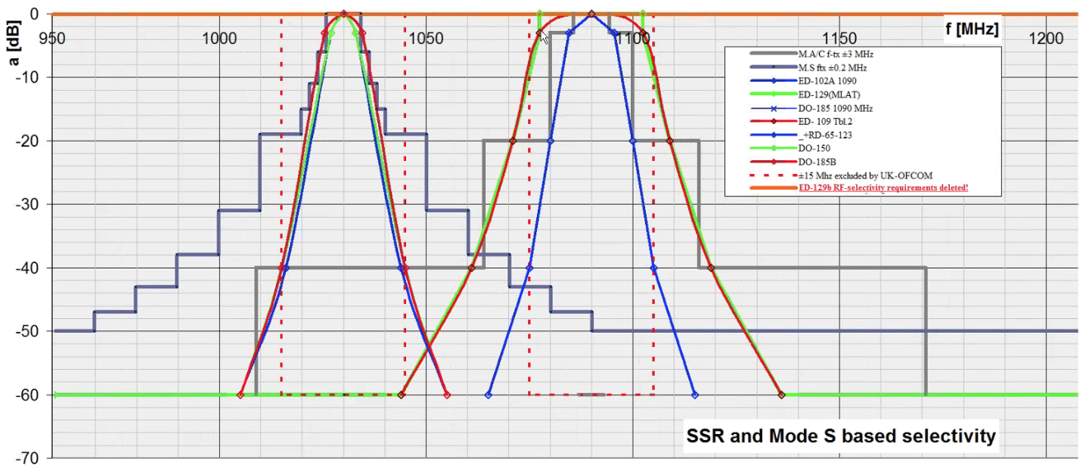
Figure 2: Overview of SSR and Mode S receiver selectivity in various reference documents vs. the 1030 MHz and 1090 MHz transmitter masks (grey)

Drafting of receiver masks for SSR and Mode S based systems and equipment
As In next step receiver masks for 1030 MHz and 1090 MHz will be drafted.

Draft Receiver mask for 1030 MHz
Based on the Figure 2, the following receiver mask was derived for 1030 MHz.
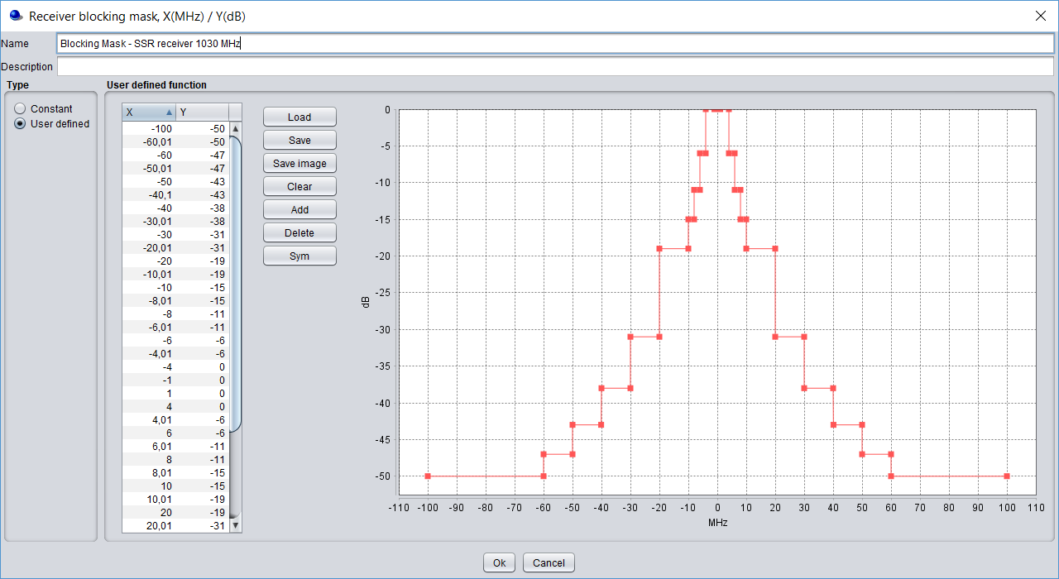
Figure 3: Initial proposal for the SSR and Mode S receiver selectivity in SEAMCAT at 1030 MHz
Note: the finally applied mask, shall include the receiver frequency tolerance.

Draft Receiver masks for 1090 MHz SSR and Mode S based system and Equipment
The following, as a starting point, for the evaluation of a mask for 1090 MHz was provided:
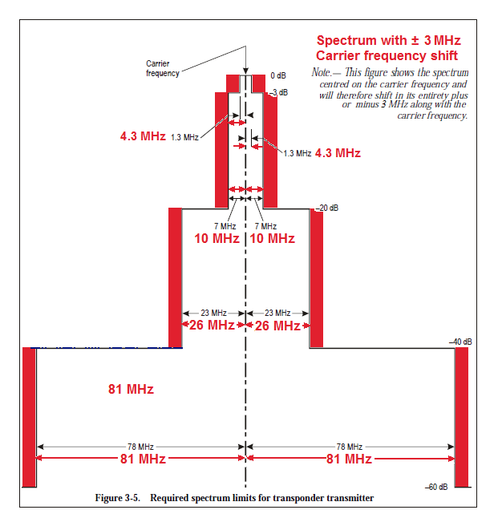
Figure 4: SSR and Mode S receiver selectivity at 1090 MHz
The current reference representation shows two different masks. Therefore, this graphic is suggested to be transferred into SEAMCAT by two mask designs. It is suggested to start with a preliminary mask for 1090 MHz that is considering the above’s envelop:
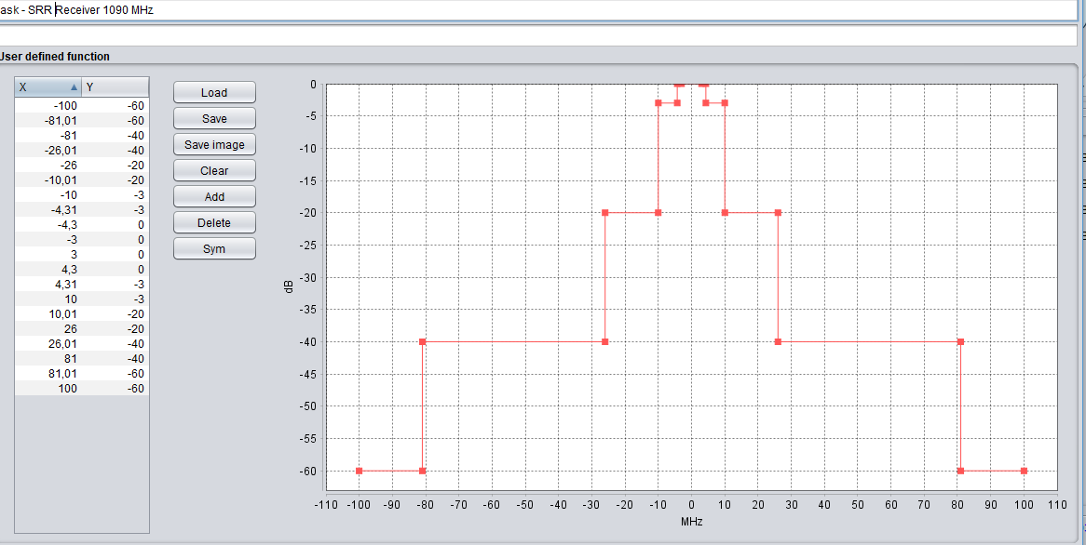
Figure 5: Initial proposal for the implementation of SSR receiver selectivity at 1090 MHz
Note: the finally applied mask, shall include the receiver frequency tolerance.

Draft Receiver masks for 1090 MHz SSR and Mode S based system and Equipment
Values from Table 2 of ED-129A should be used.

Draft Receiver masks for 1090 MHz SSR and Mode S based system and Equipment
Due to the deletion of the receiver selectivity requirements from EUROCAE 129B, the receiver selectivity mask would need to remain at 0 dB.

Discussion of the limitations identified so far
These masks only take into account the known selectivity at the receiver front end. However, in the last consultation of SE7 it was noted that another feature has to be considered – the improvement of DME receiver selectivity by a “discriminator function” in the receiver’s signal processing.
Note: for this task the support of experienced colleagues is required - who has more detailed data/information?

Practical comparison
APWPT observed the below depicted density of frequency usage within Radio Line Of Sight (distance about 13km) of the ground receiver location.
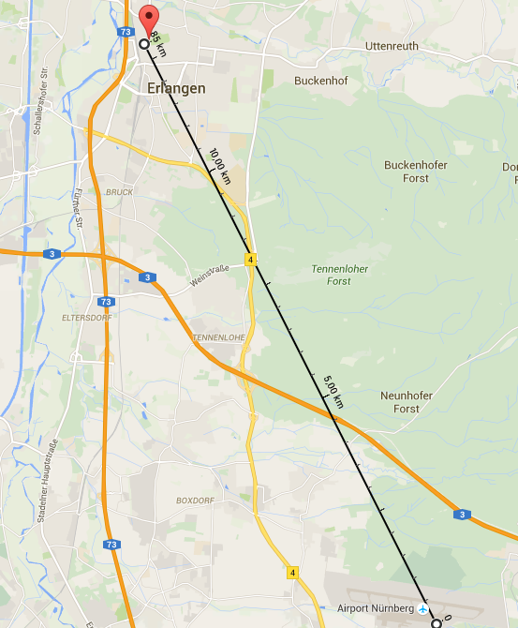
Figure 6: Location of spectrum observation – University Nuernberg-Erlangen
Note: Density of recorded signals will change relative to the receiver location due to the varying transmitter positions within RLOS. They will also vary by day and time, due to varying civil and military traffic density ATC. Airborne receivers will, due the increase of RLOS with increase of altitude, always be subjected to a much denser frequency usage.
APWPT has recorded these figures and would like to note some points:
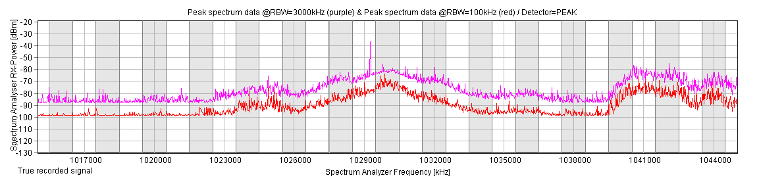
Figure 7: Aggregate spectrum allocation at 1030 MHz, RMS and PEAK Detector
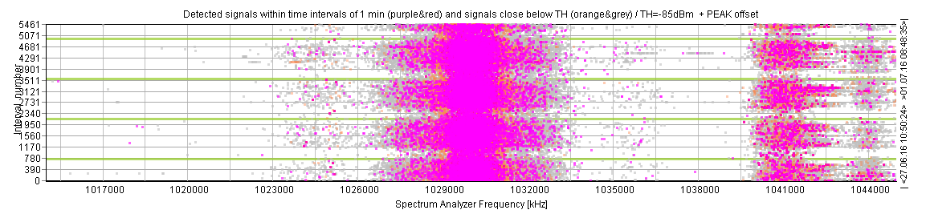
Figure 8: Signals within time intervals of 1 min at 1030 MHz, RMS and PEAK Detector
Note:
In the graphic’s center one sees the SSR signal. Next DME operation below 1030 MHz is at 1025 MHz.
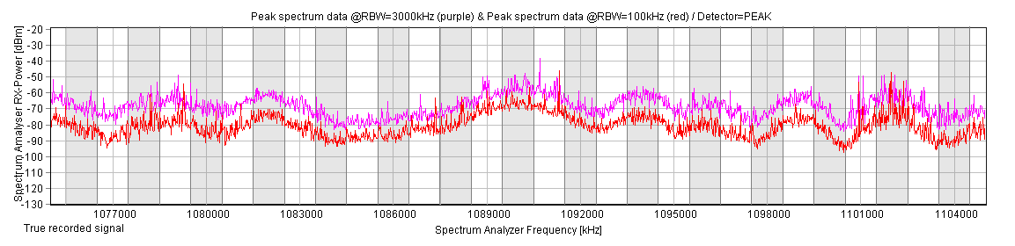
Figure 9: Aggregate spectrum allocation at 1090 MHz, RMS and PEAK Detector
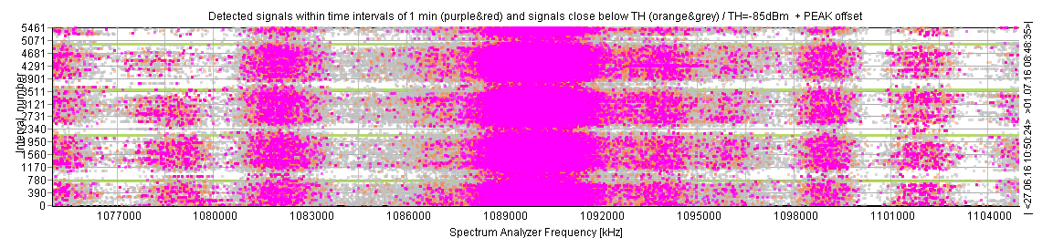
Figure 10: Signals within time intervals of 1 min at 1090 MHz, RMS and PEAK Detector
Note: In the graphic’s center one sees the SSR signal. Next DME operation above 1090 MHz is at 1094 MHz.
This local observation of a frequency offset of only 4 to 5 MHz between the SRR operation and DME usage leads APWPT to the question whether the currently known receiver mask supports a sufficient selectivity for the safe operation of SSR. Therefore, the frequency offset to the center frequency (1030 or 1090 MHz) is possibly used as an additional criterion in the practical receiver construction. If this assumption is correct, a modified receiver mask would have to be generated for the SEAMCAT simulations.
DFS would like to note: Protection of DME/TACAN and SSR and Mode S based systems is part of the system design and is possible because all are pulsed systems.

Conclusion
CEPT needs to procure the necessary reference documents to enable SE7 to establish the relevant receiver parameters, augmented by laboratory measurements.
The actual RF receiver selectivity of systems and equipment varies among other factors, with the System and equipment type, e.g. GA, CA, state aircraft or SSR, Mode S, ACAS or MLAT age, design and technology used and the modes in use at the time.
RF receiver selectivity as defined in ICAO SARPS and related documents from ARINC, EUROCAE, RTCA MOPS and relevant standards do not necessarily specify the RF receiver selectivity, but are mostly defined by the necessary increase in a wanted signal, when the signal is moving away, both above and below. The defined transmit center frequencies are either 1030 MHz or 1090 MHz.
Since all parameters are defined as “Rx-selectivity”, it is not always possible to conclude if general receiver selectivity, or RF receiver selectivity, for the suppression of any given signal type, is defined. In some modified version of MOPS, the definition for receiver selectivity has even been deleted, e.g. ED-129B.

recommendations
- Provision of two preparatory simulation files to the preparation group.
- Generation of a summary of definitions, including the conditions under which they are applicable.
- Clarification on the way the mask is derived in order to identify the blocking mode in SEAMCAT corresponding to those measurements.
- Procurement of the relevant excerpts containing all necessary information from standards and related documents, MOPS and characteristics/parameters for the members of SE7.
In addition, the previously stated conclusions and Action Items are listed:
- Conclusion/Action Item 1: CEPT needs to procure the necessary reference documents, as a minimum to provide a scan/copy of those pages identified as relevant by the aviation community, to support SE7 to establish the necessary receiver parameter.
- Conclusion/Action Item 2: Furthermore, it is proposed to investigate this question in a laboratory measurement/environment.
- Conclusion/Action Item 3: Since there multiple reference documents applicable to airborne and ground SSR and IFF equipment currently flying in the European airspace, SE-7 has to identify all in its report.
- Conclusion/Action Item 4: Since the name for the definitions and/or the definition of applicability can vary from reference document and source, it is necessary for SE-7 to provide a summary of the applied terminology and definition in its report.

Annex: Technical standards relevant to SSR/ADS-B/TCAS
Table 4: proposed Table for SSR, IFF and Mode S based systems and equipment reference documents
 | _abrv | _ | _f [MHz] |  | _ETSO | _TSO | _FAA | _RTCA | _EUROCAE | _ARINC | _ICAO | _ICAO-Docs | _mil-std | _STANAG
2018114 |  | Passive Global Navigation Satellite  System (GNSS) Antenna |  |  | ETSO-C144 | TSO-C144a |  | DO-228
2018114 | ACAS (TCAS II) | Collision Avoidance System (Traffic Collision Avoidance System II) | 1030 | 1090 | ETSO-C119c | TSO-C119c |  | DO-185 to B,  DO-300 | ED-143 to 3  ED-221 | ARINC-735 to A |  | Doc. 9863
2018114 | ADSB | (Extended Squitter) Automatic Dependent Surveillance - Broadcast (ADS-B) and Traffic Information | 1090 |  |  | TSO-166C |  | DO-260  to B | ED-102  ED-129 |  | A-10 to -IV,  Doc-9684  Doc-9688  Doc-9871  Doc-9924
2018114 | ADSB | Automatic Dependent Surveillance – Broadcast (ADS-B) Aircraft Surveillance Applications (ASA) |  |  |  | TSO-C195
2018114 | ADSB-Out |  |  |  |  |  | AC-20-165B
2018114 | ATCRBS | see SSR
2018114 | ATCRBS/M.S | see M.S |  |  |  |  |  |  |  | 718 to B
2018114 |  | Transponder Air Traffic Control Radar Beacon System (ATCRBS)/Mode S Transponder | 1030 | 1090 | ETSO-2C112b | TSO-C112c |  | DO-181 to D | ED-73 to B
2018114 |  | Mode A/C Transponder Equipment with Extended Squitter Automatic Dependent Surveillance – Broadcast (ADS-B) Transmission Capability |  |  |  |  |  | DO-260 to B
2018114 | CPME
2018114 | DABS | see M.S
2018114 | FIS-B | Flight Information Services -Broadcast(FIS-B) Data Link Systems and Equipment |  |  |  | TSO-C157 |  | DO-267 to A
2018116 | IFF |  |  |  |  |  |  |  |  |  |  |  | AIMS-Prg-office | STANAG-4193
2018114 | LAST | Light Aviation Secondary Surveillance Transponder |  |  | ETSO-2C509 |  |  |  | ED-115
2018114 | M.S | Mode S Aircraft Data Link Processor |  |  | ETSO-2C501 |  |  |  | ED-82A
2018114 | MLAT | Multi Lateration |  |  |  |  |  |  | ED-117  ED-129  to B
2018114 | SSR (ATCRBS) | (Transponder) Air Traffic Control Radar Beacon System Mode A/C | 1030 | 1090 | ETSO-C74d | TSO-C74d |  | DO-144 to A, DO-317 | ED-43  ED-73 | ARINC-532 to D  ARINC-718 to -b | A-10 to -IV,  Doc-9684  Doc-9924
2018116 | Mode S |  |  |  |  |  |  | DO-181E |  |  | A-10 to -IV,  Doc-9684  Doc-9688  Doc-9871  Doc-9924
2018114 | TACAN |  | 962 | 1213 |  |  | AC-00-31A, TSO-C66A |  |  |  | A.10-I | Doc-8071 | mil-std291 current -c | -5034
2018114 | TCAS I | Traffic Alert and Collision Avoidance I (TCAS-I) |  |  | ETSO-C118 | TSO-C118 |  | DO-197
2018114 | TCAS II see ACAS

Proposed List of standards
- ARINC Characteristics 532 Air Traffic Control Transponder
- ARINC Characteristics 572, Mark 2 Air Traffic Control Transponder
- ARINC Characteristics 718, Mark 3 Air Traffic Control Transponder (ATCRBS/DABS)
- ARINC Characteristic 735, Traffic Alert and Collision Avoidance System (TCAS II),
- DO-144, Minimum Operational Characteristics for Airborne ATC Transponder
- DO-184, Traffic Alert Collision Avoidance System (TCAS) I Functional Guidelines
- DO-181 Air Traffic Control Radar Beacon System/Mode Select (ATCRBS/Mode S)
- DO-185, Minimum Operational Performance Standards for Traffic Alert and Collision Avoidance
System (TCAS) Airborne Equipment
- DO-197, MOPS Standards for Active Traffic Alert and Collision Avoidance System (Active TCAS I)
- DO-212, Minimum Operational Performance Standards for Airborne ADS Equipment
- DO-229, Minimum Operational Performance Standards for Global Positioning System/Wide Area
Augmentation System Airborne Equipment
- DO-236, Minimum Aviation System Performance Standards: Required Navigation Performance for
Area Navigation
- DO-242, Minimum Aviation System Performance Standards for Automatic Dependent Surveillance
- DO-243, Guidance for Initial Implementation of Cockpit Display of Traffic Information
- DO-245, Minimum Aviation System Performance Standards for the Local Area Augmentation
System (LAAS)
- DO-246, GNSS-Based Precision Approach Local Area Augmentation System (LAAS) Signal-in-
Space Interface Control Document (ICD)
- DO-253, Minimum Operational Performance Standards for GPS Local Area Augmentation System
Airborne Equipment
- DO-259, Application Descriptions for Initial Cockpit Display of Traffic Information (CDTI) Applications
- DO-260, Minimum Operational Performance Standards for 1090 MHz Automatic Dependent
Surveillance - Broadcast (ADS-B)
- DO-300, MOPS for Traffic Alert and Collision Avoidance System (TCAS II) For TCAS II Hybrid
Surveillance,
- Doc 9688, Manual on Mode S Specific Services
- Doc-9863, Airborne Collision Avoidance System II (ACAS II) Manual
- Doc-9871, Technical provisions for Mode S Services and extended Squitter
- ED-102, MOPS FOR 1090 MHZ EXTENDED SQUITTER AUTOMATIC DEPENDENT
SURVEILLANCE – BROADCAST (ADS-B) AND TRAFFIC INFORMATION SERVICES –
BROADCAST (TIS-B
- ED-129, TECHNICAL SPECIFICATION FOR A 1090 MHZ EXTENDED SQUITTER ADS-B
GROUND SYSTEM
- ED-142, TECHNICAL SPECIFICATION FOR WIDE AREA MULTILATERATION (WAM) SYSTEMS
- ED-194, MOPS FOR AIRCRAFT SURVEILLANCE APPLICATIONS (ASA) SYSTEM
- ED-73, MOPS for Secondary Surveillance Radar Mode S Transponders
- ICAO Annex 10-IV
- TSO-C-118, Technical Standard Order C-118, Traffic Alert and Collision Avoidance System (TCAS I)
Airborne Equipment
- TSO-C-119, Traffic Alert and Collision Avoidance System (TCAS) Airborne Equipment
- TSO-C195, Avionics Supporting Automatic Dependent Surveillance–Broadcast (ADS–B) Aircraft
Surveillance Applications, FAA,
Notes:
- For the above listed reference documents there may exist several versions and amendments.
- There may be other technical standards and/or revisions, not currently listed above.
- Almost all reference documents listed above have to be purchased.
- Most Military reference documents may be classified for restricted user groups. How can calculations be performed and results be accepted, when the references are not available to all?
If possible, it would be helpful to add STANAGS, military standards, ARINC-Standards, RTCA- and EUROCAE-Mops.

FM51(18)276_Preliminary investigations on regulatory and legal issues for PMSE sharing in the 960 MHz band - guard band at 1030_1090 MHz

