WGFM QUESTIONNAIRE ON INVESTIGATING AND ASSESSING THE REQUIREMENTS FOR COGNITIVE RADIO ENABLED SHORT RANGE DEVICES (SRDs) AND ANY POTENTIAL IMPLICATIONS IN TERMS OF SRD HARMONISED TECHNICAL CONDITIONS
Doc. FM(15)166 Annex 1
Group: WG FM, SRD/MG
Submission dates: 18-02-2015 – 1 May 2015
Introduction:
Contact details of the company will not be published outside SRD/MG, only answers in gray boxes will be used for analysis. Contact details may be used in case of inaccuracy or in case of specific questions.
Guidance: The aim of this questionnaire is to receive feedback from stakeholders from the market. Respondents may either provide a paper response or use the electronic questionnaire tool. It is important to explain answer where indicated in the questionnaire.
Respondents are kindly invited to return the completed questionnaire
before 10 April 2015
to the European Communications Office (ECO)

ECO Contact: Thomas.weber@eco.cept.org

Thank you for your cooperation.
Questions:
CEPT/ECC has taken on-board a task to start investigations to assess requirements for future cognitive radio enabled SRDs. The investigations include this call for information from potential stakeholder and interested parties in the SRD community.

It is expected that the CEPT Report in response to the 6th update process of the European Regulations on SRDs may rather present the initial results of these investigations and not include a proposal for a final regulatory approach/implementation but it is intended to make a step forward and this may lead to an implementation proposal in a second step. This work is based on a permanent Mandate from the European Commission; the CEPT is tasked with regularly updating of the technical Annex of EC Decision 2006/771/EC and its further amendments. The guidance letter to the CEPT includes the request to study cognitive radio enabled SRDs to start investigations on assessing the requirements for cognitive radio enabled SRDs and any potential implications in terms of SRD harmonised technical conditions, taking into account the on-going work in ETSI under mandate M/512 (http://www.etsi.org/images/files/ECMandates/m512.pdf).

The ETSI Board adopted mandate M/512 on January 2013.
In ETSI, TC RRS was nominated as the lead ETSI Technical Body for the mandate M/512 on Reconfigurable Radio Systems (6 Feb 2013). Other groups (OCG_RTTE, ERM, BRAN, MSG) have contributed to the mandate:

• TC BRAN developed EN 301 598 on TV White Spaces;
• TC RRS developed EN 303 144 on Cognitive Radio Systems and geo-location databases;

Cognitive radio enabled SRDs may use opportunities for lower power applications to co-exist with other radio applications and services which use these frequencies already, and can be managed databases which identify where the white space opportunities are. This principle of 'geolocation', with better and more detailed databases, is at the heart of ideas to support access to locally unused space spectrum by cognitive devices i.e. cognitive as part of a wider system of management. The more autonomous element of 'cognitive' technique in radio transceivers is 'sensing', i.e. being able to detect what other signals are present and to respond accordingly to reduce the chance of interference. This principle is already used in techniques such as 'listen before talk' (LBT), and the Dynamic Frequency Selection (DFS) used in 5 GHz Radio Local Area Networks (RLANs) to ensure coexistence with radars.

Most current practical considerations on where the Cognitive Radio would operate focus on overlaying its use on an existing, more conventional system. Cognitive is therefore seen as a ’secondary’ usage, coexisting with itself and with the primary services. However, implementation of cognitive techniques could increase the effective capacity of bands designated for short-range devices.

Cognitive techniques need to be analysed not only from the perspective of the technical feasibility but also from the perspectives of the demand, fit to application and investment requirements, the level of technical complexity involved, and the long term predictability of the spectrum access.

Questions
Question 1: Date of response (13 responses)

Dutchview (NED) | 27 February 2015
Krohne (D) | 23 March 2015
Volkswagen (D) | 1 April 2015
Silver Spring Networks (G) | 7 April 2015
Sennheiser (D) | 7 April 2015
Deutsche Telekom (D) | 8 April 2015
Aidon (SE) | 8 April 2015
Siemens (D) | 10 April 2015
Pilz (D) | 10 April 2015
Sony Europe (G) | 10 April 2015
Bosch (D) | 28 April 2015
CEA-LETI (F) | 29 April 2015
Kamstrup (DNK) | 1 May 2015

Question 2: What is your activity in wireless domain?
Dutchview | User
Krohne | End product manufacturer
Volkswagen | End product manufacturer
Silver Spring Networks | Radio manufacturer  End product manufacturer
Sennheiser | Radio manufacturer
Deutsche Telekom | User  Other
Aidon | End product manufacturer
Siemens | Radio manufacturer  End product manufacturer  Chips or parts/modules seller  User
Pilz | Radio manufacturer  End product manufacturer
Sony Europe | End product manufacturer
Bosch (D) | End product manufacturer  Chips or parts/modules seller
CEA-LETI (F) | Other
Kamstrup (DNK) | End product manufacturer
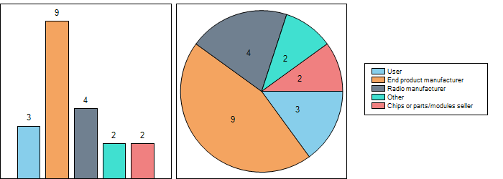
Question 2.1: What kind of user?
 | Please specify
Dutchview | broadcast industry
Deutsche Telekom | Network operator (e.g. 2G/3G/4G, WiFi hot spot operator)
Siemens | Manufacturing lines of the products
Question 2.2: Other activity
 | Please specify
Deutsche Telekom | Distributer
CEA-LETI | Research and development (RTO)
Question 3: What is your function in your company?
Dutchview | Other
Krohne | Marketing
Volkswagen | Other
Silver Spring Networks | Other
Sennheiser | Other
Deutsche Telekom | Other
Aidon | Other
Siemens | Designer
Pilz | Designer  Other
Sony Europe | Other
Bosch | Compliance and Quality
CEA-LETI | Other
Kamstrup | Other
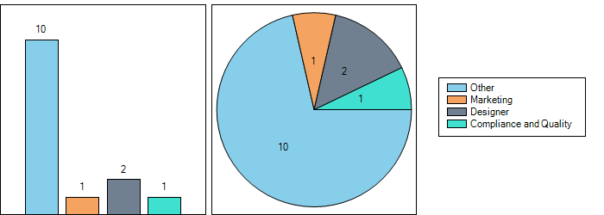
Question 3.1: Please specify
Dutchview | engineer
Volkswagen | Frequency Management (ACEA)
Silver Spring Networks | European Regulatory Director
Sennheiser | Spectrum Management
Deutsche Telekom | Spectrum Manager
Aidon | Sales
Pilz | Developer
Sony Europe | Regulatory/Technology Standards
CEA-LETI | Head of Communication and Security Dpt  Also answering as member of the FP7 ICT CRS-i project.
Kamstrup | Engineer

Question 4: Applications/Devices with wireless interfaces
 | Applications | Devices
Dutchview | PMSE use | wireless microphones  in ear monitoring  wireless intercom  wireless camera
Krohne | Process applications in various industries | Process instrumentation (flow, level, temperature, pressure, analytics sensors)
Volkswagen | Ca. 5 per vehicle
Silver Spring Networks | Smart Metering/Grid, street lights and IoT | >20M
Sennheiser | Audio PMSE
Deutsche Telekom | Hot Spots WiFi, DECT, NFC, Home Automation | WLAN (2.4 and 5 GHz), SRD e.g 868 MHz)
Aidon | Data acquisition networks for utilities, smart metering | Energy Meters
Siemens | Wireless Industrial Automation | IEEE802.11, .15, ISO18000-3/6 etc. based SRDs
Pilz | WIA | InduraNET p (EN300328 based SRDs)
Sony Europe |  | Consumer Electronics (https://www.sony-europe.com/)
Bosch | Building Material Analysis………… | Wallscanner…………..
CEA-LETI | Body Area Networks, Personal Networks, M2M, IoT, Indoor Localization, millimeter wave indoor/outdoor systems, TVWS. | Baseband technology, Coding technology, Modems, Antennas (steerable, flexible, miniature), SDR
Kamstrup | Radio mesh networking and Wireless M-Bus for data acquisition | Energy meters (Electricity, heating, cooling and water)

SRD/MG Assessment

Question 5: Approximate number of wireless devices sold/bought annually in Europe
Dutchview | <1000
Krohne | <1000
Volkswagen | >1M
Silver Spring Networks | <1M
Sennheiser | <1M
Deutsche Telekom | >1M
Aidon | >1M
Siemens | >1M
Pilz | <1M
Sony Europe | >1M
Bosch | <100 000
CEA-LETI | <100
Kamstrup | >1M
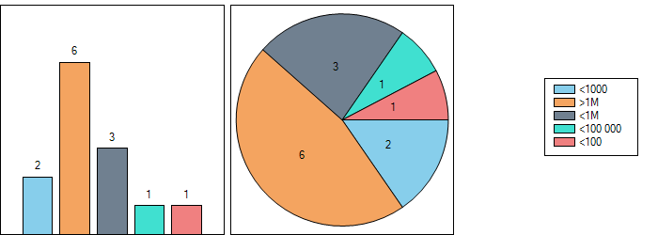

SRD/MG Assessment

Question 6: Is there a person responsible for the compliance of wireless products to the relevant framework in the company?
Dutchview | Yes
Krohne | Yes
Volkswagen | Yes
Silver Spring Networks | Yes
Sennheiser | Yes
Deutsche Telekom | Yes
Aidon | Yes
Siemens | Yes
Pilz | Yes
Sony Europe | Yes
Bosch | Yes
CEA-LETI | No
Kamstrup | Yes
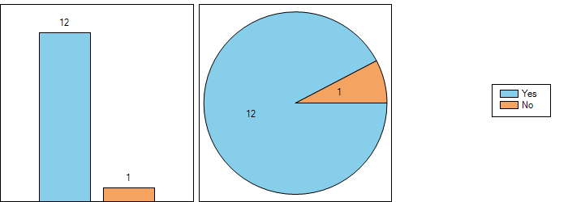

Question 7: After reading the introduction, do you understand the aim of the questionnaire?
Dutchview | Yes
Krohne | Yes
Volkswagen | Yes
Silver Spring Networks | Yes
Sennheiser | No
Deutsche Telekom | Yes
Aidon | Yes
Siemens | No
Pilz | Yes
Sony Europe | Yes
Bosch | Yes
CEA-LETI | Yes
Kamstrup | Yes
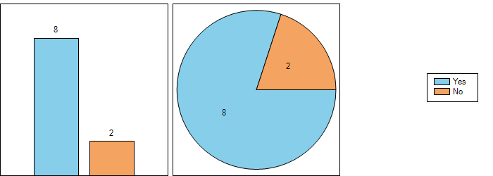
SRD/MG Assessment

Question 8: Have you already designed or integrated cognitive radio enabled SRD devices into modules or end products?
Dutchview | Yes
Krohne | No
Volkswagen | Yes
Silver Spring Networks | Yes
Sennheiser | No
Deutsche Telekom | No
Aidon | Yes
Siemens | Yes
Pilz | Yes
Sony Europe | No
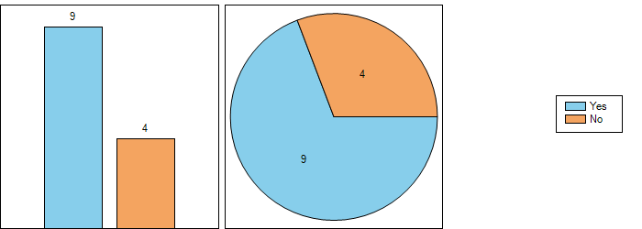

SRD/MG Assessment

Question 9: If no (Q8), are you planning to use cognitive radio enabled SRDs in the future?
Dutchview | Yes
Krohne | Yes
Volkswagen | Yes
Silver Spring Networks
Sennheiser | Yes
Deutsche Telekom
Aidon
Siemens | Yes
Pilz | Yes
Sony Europe | No
Bosch
CEA-LETI
Kamstrup
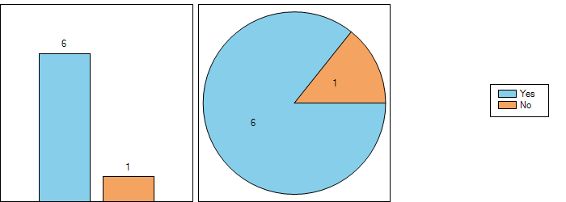
Question 9.1: Explanation
 | Why? | For which application? (If possible fill out question 9)
Dutchview | PMSE solutions for sharing purposes | PMSE solutions for sharing purposes
Krohne | Use of radio bandwidth in less crowded segments of the RF spectrum. Increase of transmit power for improving signal quality. | Process industry, e.g. WirelessHART, Bluetooth or similar SRD protocols
Volkswagen | maybe | Not defined till now
Sennheiser | According to C-PMSE study but only after fully implementation into relevant standards (e.g. ETSI). Because the PMSE interfaces to a number of different manufacturers products will have to be coordinated. | Secure production quality, will finally only work if all manufactures are using similar standards.
Siemens | a) For the use of battery powered devices in the 5,725 GHz … 5,875 GHz spectrum a centralized RRS concept is needed.  b) For increasing the spectrum efficiency; a RRS concept is the right way forward.  c) To add additional capabilities
Pilz | regulatory requirement
Question 9.2: Explanation
 | Why? | For which application? (If possible fill out question 9)
Sony Europe | However, we are carrying out R&D for the geo-location database approach to protect incumbent systems such as Earth Exploration Satellite Service for additional 5GHz spectrum for RLANs.
SRD/MG Assessment

Question 10: Which applications do you consider as particularly suited to use a cognitive approach?
 | Application(s) | Why?
Dutchview | wireless microphones  in ear monitoring  wireless intercom  wireless camera | for being a secondary user in the spectrum and to keep our core business
Krohne | Any industrial applications where transmit power could be increased either due to the absence of other SRDs or strict geographical borders, such as e.g. large petrochemical plants.
Volkswagen
Silver Spring Networks | All | Cognitive approaches are a responsible way in which to share a precious scare resource. There is a vast amount of evidence suggesting that channel sensing is a useful mechanism to avoid interference. Note, specifically, using repeated channel transmissions as a communications assurance mechanism is wasteful of spectral resources.
Sennheiser | Audio PMSE that are operated by frequency coordinator(s) | Cognitive application may maintain production quality at current level in a RF spectrum of higher user density but it will not save RF spectrum.
Deutsche Telekom
Aidon | Metropolitan area networks, including Smart Grid | Facilitates coexistence with other metropolitan area networks and other applications and increases the flexibility and capacity of the networks.
Siemens | Wireless Industrial Applications (WIA) | a) For the use of battery powered devices in the 5,725 GHz … 5,875 GHz spectrum a centralized RRS concept is needed.  b) For increasing the spectrum efficiency; a RRS concept is the right way forward.  c) To add additional capabilities
Pilz | WIA | Low requirements to roundtrip times/cycles
Sony Europe | Devices operating with incumbent systems under general authorisation. | There can be no extra hardware costs for accessing a geo-location database.
Bosch | Communication devices | Applications which have a pool of channels available to change if necessary
CEA-LETI | Broadband access, Super Wifi, Home networking, Public safety. | Broadband access: mosty expected in developping countries  Super Wifi: extend broadband access range of current campus WiFi  Home networking: exploitation of UHF indoor propagation properties (superior to WiFi for the same Tx power => lower EMF)  Public safety: first responders require reliable indoor to outdoor wireless connexion which can be provided by TVWS devices in the UHF band
Kamstrup | IoT and Smart Grid

SRD/MG Assessment

Question 11: Which of the before mentioned (or other) cognitive techniques do you consider as mature enough?
 | Mature enough? | Not mature enough? | Why?
Dutchview | industry is waiting for RSPG ECC decision and WRC2015.  For this moment no solutions | yes | no standards
Krohne | CSMA, LBT | geolocation | How will the geolocation database get into the device, especially for low complexity device such as e.g. temperature transmitters? Particularly relevant if the devices or applications are really ‘nomadic’.
Volkswagen
Silver Spring Networks | All mentioned |  | These is a substantial installed base of systems indicating mature access mechanisms. All of these techniques are known.
Sennheiser |  | To our knowledge there is no mature technology available on the market today | Test have proven that current cognitive devices cannot protect audio PMSE
Deutsche Telekom | only CR Geolocation systems relying on geolocation data bases are able to protect incumbent services | the Cognitive Radio (CR) approach based on autonomous sensing or beacons is inadequate to protect incumbent radio services
Aidon | Beacon, sensing with limitations | Geolocation database | Beacon based solution is in use, sensing requires suitable receiver sensitivity and signal levels and possible knowledge of the signal to be sensed.  Use of geolocation database may require regulation, collaboration between the various players and particular technical solutions.
Siemens |  | Cognitive approaches are mostly not suitable for WIA as they are not deterministic; it just increases the probability of less interference.  Central coordination point in the sense of a Reconfigurable radio system (RRS) is today a concept; it is not mature today.  Central coordination point in the sense of a Reconfigurable radio systems is today a concept, not mature.
Pilz |  | Cognitive approaches are mostly not suitable for WIA as they are not deterministic; it just increases the probability of less interference.
Sony Europe |  |  | General Comment; LBT is difficult to provide “fair spectrum access” between different radio access technologies and DFS is difficult to protect new military radar systems.
Bosch | LBT, DAA,CSMA
CEA-LETI | TVWS using GDB (and sensing)
Kamstrup | Autonomous sensing, beacon | Geolocation database | Geolocation database might introduce overhead and complexity which is not suited for battery powered devices.

Question 12: Do the cognitive spectrum access techniques, listed below, suit your application(s)? Use remarks field to explain why.
 | Geolocation database | Autonomous sensing | beacon
Dutchview | Yes | Yes
Krohne | No | Yes | Yes
Volkswagen
Silver Spring Networks | No | Yes | No
Sennheiser | Yes | No | Yes
Deutsche Telekom | Yes | No | No
Aidon | Yes | No | Yes
Siemens | No | Yes | No
Pilz | No | Yes | No
Sony Europe | Yes | No | No
Bosch | No | Yes | No
CEA-LETI | Yes | Yes | No
Kamstrup | No | Yes | Yes

SRD/MG Assessment

Question 13: Do you see other polite spectrum access techniques than mentioned before? Use remarks field to explain why.
Dutchview | No
Krohne | No
Volkswagen
Silver Spring Networks | Yes
Sennheiser | No
Deutsche Telekom | No
Aidon | No
Siemens | Yes
Pilz | No
Sony Europe | No
Bosch | No
CEA-LETI | No
Kamstrup | No
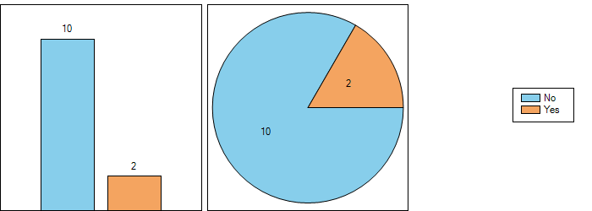

SRD/MG Assessment

Question 14: Intra-SRD spectrum sharing studies can be seen as a pre-requisite for the successful implementation of a regulatory approach based on cognitive techniques. Do you agree YES/NO?
Dutchview | Yes
Krohne | Yes
Volkswagen | Yes
Silver Spring Networks | Yes
Sennheiser | No
Deutsche Telekom
Aidon | Yes
Siemens | Yes
Pilz
Sony Europe | Yes
Bosch | Yes
CEA-LETI
Kamstrup | Yes
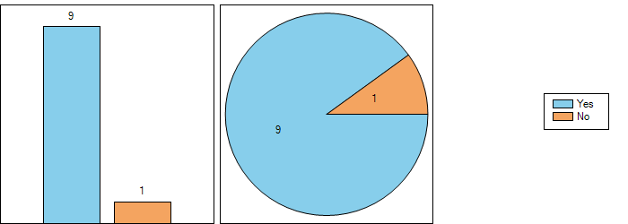

Question 14.1: Additional explanations
 | Description of the situation | Explain your answer | Suggestion for CEPT to study
Dutchview | see report 204 FM51 | see report 204 FM51 | see report 204 FM51  RSPG rapport 36
Krohne |  | predictable spectrum access needed
Volkswagen |  | possible interference situations | Coexistence studies before usage!
Silver Spring Networks | Spectrum being shared by devices using mixed mechanisms including simple SRDSs up to complex cognitive systems. | CEPT studies need to be extended to model systems in the time-domain (as well as the frequency domain) in order for the benefits of cognitive systems to be recognised. | CEPT needs to consider introducing tools that model the time-domain in addition to frequency analysis in SEAMCAT eg NS3 or Omnet
Aidon | It seems obvious that in the 870 MHz band there will be HDC SRD’s that are required to use specific mitigation techniques, other SRD’s not required to use mitigation techniques and incumbents. The sharing between those has been studied rather widely, but the impact of and opportunities opened through the use of cognitive capabilities has not been thoroughly addressed.  In many countries incumbent use, such as military use, continues in the 870 MHz band. The SRD’s could employ specific techniques facilitating coexistence with incumbents. Furthermore, in some countries the ER-GSM to be based on LTE is expected to operate in the upper portion of the 870 MHz band, in 873-875.6 MHz, whereas SRD’s would seem to be limited to the lower portion of the band. | In general, the impact of the utilization of cognitive capabilities by the SRD’s on sharing should be further investigated. For example coexistence with the military applications may be significantly enhanced by utilization of cognitive techniques by the SRD’s. Secondly, the same may apply in case the ER-GSM is deployed in the upper part of the band. | Study the feasibility of sharing and coexistence in the 870 MHz band in case cognitive radio enabled SRD’s are to be deployed. Address sharing and coexistence with military, ER-GSM, etc., duty cycles not limited to 0.1 %,
Siemens | Most of the used technologies are using COTS chip sets based on a IEEE 802 standard. These codings are well known and with that identifiable. | SRD spectrum sharing studies could be helpful to identify the intended neighbours so that outside of a controlled area for example the intended coding can be used to identify neighbours. | Such an approach is only worth to be considered if a completely different legal approach will be established. Today it will not be legal.
Sony Europe | We believe the use of Intra-SRD spectrum sharing studies are required to ensure the most efficient use of spectrum.
Bosch | General frequency allocation for all kinds of SRD (1% DC to 100% DC) in one band will lead to unbalanced performance |  | Types of SRD with similar techn. parameter should be grouped
Kamstrup | Soft harmonized bands such as 870-876MHz is a candidate for cognitive techniques where the band is not harmonized to ensure market similarity across country borders. | Coexistence issues needs to be investigated | Further studies must be imitated on impact from SRDs in e.g. military bands as well as other primary users.  Also if cognitive radio is enabled in SRD bands under existing regulations, the operation of existing SRDs must be ensured

Question 14.2: Additional explanations
 | Description of the situation | Explain your answer | Suggestion for CEPT to study
Sennheiser |  | All cognitive SRDs must have a compatible sharing method which is currently not the case.  An increasing number of SRDs in a given amount of RF spectrum will not be able to be controlled by a compatible cognitive technology as it can be foreseen that additional spectrum is required.  In our view, cognitive SRD does not save RF spectrum.  Cognitive audio PMSE is focused on reliability and audio quality. Any interference experienced at the front end of the production chain destroys not just the performance but also any downstream revenue generation. | How long can the secondary status of audio PMSE remain tenable? Programme distribution via whatever platform is protected but content production is not. This is a contradiction that has to be studied.

SRD/MG Assessment

Question 15: Concerning technical complexity: Do you think that cognitive radio enabled SRDs can compete in the market with less complex technical spectrum access solutions (e.g. duty cycle spectrum access could be understood as being less complex). Please explain your statement.
 | Can compete (explain why) | Cannot compete (explain why)
Dutchview | sharing like DECT and wifi systems. (Some microphone/intercom techniques) | Long distance use with High tower high power (helicopter links)
Krohne | If cost adder is sufficiently low even if complexity of CR technique is large | if cost adder is too large
Volkswagen |  | cannot compete - too complex
Silver Spring Networks | None of the techniques listed are expensive to manufacture, but they do require careful design.. These design practices lead to systems that are extremely spectrum efficient, but also act as good neighbours in mixed system environments. However, in the absence of a regulatory reward mechanism for polite behaviour, system designers will tend towards the lowest common denominator design.
Sennheiser |  | More complex technology leads to higher costs for end users. Therefore it will be more difficult for cognitive SRDs to compete in the market.
Deutsche Telekom |  | there is no “low cost approach tCR Geolocation systems are expensive and need proper attendance by software specialists and regulatorso CR” - due to the fact that SRDs are in general “low cost” CR and SRDs do not fit together.
Aidon | Use of cognitive capabilities facilitates optimization of the network, it becomes more predictable and easier to estimate the performance of the network when amount of devices or data increase.
Siemens | As the efficiency can be tremendously increased, it has to be excepted otherwise no or only limited digital communication can be used.
Pilz | If deterministic and fast.
Sony Europe
Bosch | Can compete, if there are significant advantages e.g. the possibility to transmit more often compared to low duty cycle. | Otherwise the costs are high, battery lifetime low (if used)
CEA-LETI | Depends on applications. E.g. professional markets allow for higher cost if superior performance is provided. Also depends on business models (e.g. subscription rate in rural broadband).
Kamstrup | Yes, as long as there is a reward in e.g. duty cycle for being polite

SRD/MG Assessment

Question 16: Cognitive techniques must also fit to the SRD application itself and the intentions in terms of quality and availability of the service. Do you agree? Please explain your statement. Where do you see the challenges?
Dutchview | Yes
Krohne | Yes
Volkswagen | Yes
Silver Spring Networks | Yes
Sennheiser | Yes
Deutsche Telekom
Aidon | Yes
Siemens | Yes
Pilz
Sony Europe
Bosch | Yes
CEA-LETI | Yes
Kamstrup | Yes
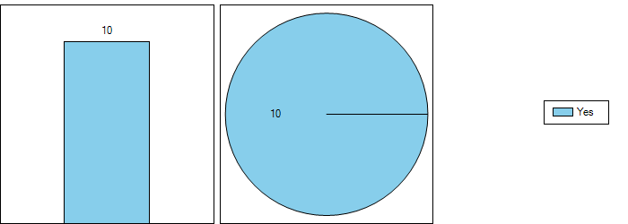

Question 16.1: Please explain
 | Explanations | Where are the challenges?
Dutchview | Availability: 100% duty cycle  Latency less than 3ms  Quality: very high professional use | standard and protocol
Krohne | see next question | Complexity must be in good relation with the sales price that can be achieved per unit. Availability of standardised access techniques will certainly help maintaining the cost.
Volkswagen |  | New standards need to be discussed with all users
Silver Spring Networks | Apart from the very simplest devices, cognitive techniques are beneficial to most SRD applications. Extremely low activity devices, eg alarms, can be considered a special case, but for most SRD applications, active sharing mechanisms will be beneficial both for the system itself and the wider mixed sharing environment. | The main challenge is the ability to reliably detect unlike systems in the same frequency, location and time.
Sennheiser | For audio PMSE reliability and audio quality are absolutely critical. Any implementation of new cognitive SRD techniques must ensure that no interference is experienced by audio PMSE. | Reliability, audio quality and latency and very low man-made noise.
Aidon | Utilization of cognitive techniques helps achieving and maintaining predictable capacity and QoS. | Challenges are e.g. in the availability of information about other networks and applications in the same geographical area operating in the same band.
Siemens | RRS combined with SRDs makes sense, see CCP concept in TR 103 329. | Computing power of SRD battery powered devices.
Bosch | If the application is not flexible concerning the usage of different frequencies, the frequency cannot be changed. | Some spectrum access depending intelligence has to be implemented
CEA-LETI | Reliability of service is an important factor of success. | Enable QoS in various channel occupation situations. Need for flexible radio able to address potentially fragmented spectrum.
Kamstrup |  | Battery powered devices might have a disadvantage vs. mains powered devices and politeness towards these devices should be ensured

SRD/MG Assessment

Question 17: Would you prefer an increase or a decrease in the number of spectrum access techniques (e.g. Duty Cycle, LBT, FHSS, DSSS, AFA, other cognitive techniques) in the regulations? Use remarks field to explain your suggestion.
Dutchview | Decrease
Krohne | Leave as it is
Volkswagen | Leave as it is
Silver Spring Networks | Decrease
Sennheiser | Decrease
Deutsche Telekom
Aidon | Leave as it is
Siemens | Increase options
Pilz | Decrease
Sony Europe | Increase options
Bosch | Increase options
CEA-LETI
Kamstrup | Decrease
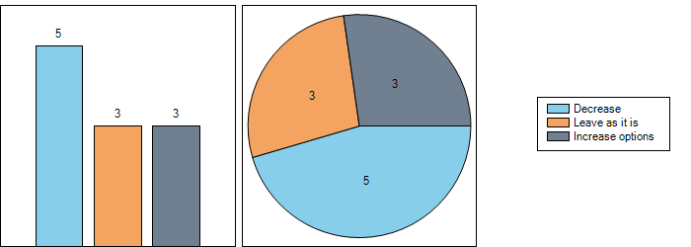

SRD/MG Assessment

Question 18: In SRD deployment it is not possible to give each application its own reserved frequency slot. What do you think is important to achieve a good balance and operational reliance for the cognitive enabled SRDs?
 | Comment
Dutchview | create sharing possibilities like geo-location databases
Krohne
Volkswagen | Some frequencies must be reserved for safety functions in the very near future!
Silver Spring Networks | In general, small spectrum bands reserved for special case systems (eg very low duty-cycle devices) cannot be avoided, however, in general the approach for SRD spectrum should be based on polite spectrum shared access.
Sennheiser | Audio PMSE requires a 100% duty cycle. This needs to be fully acknowledged.
Deutsche Telekom
Aidon | Utilization of advanced technical solutions, such as cognitive capabilities should be taken into account in the regulation in a manner that would incentivise their use, and thus increase in the efficiency of the overall spectrum use. Furthermore, sufficient bandwidths should be made available to avoid blocking.
Siemens | I disagree that only the frequency assignment is the only mitigation technique. The time is also a valid separator for different SRDs using the same channel, see “Time Synchronized Channel Hopping TSCH) in IEEE 802.15.4e and IEC 62591.
Pilz
Sony Europe
Bosch | General frequency allocation for all kinds of SRD (1% DC to 100% DC) in one band will lead to unbalanced performance  Types of SRD with similar techn. parameter should be grouped
CEA-LETI | SDR should be flexible enough to exploit opportunities wherever possible. This required frequency agility, possibility of exploiting fragmented spectrum, temporal agility.
Kamstrup | Comments It must be assured that the cognitive techniques are testable via standards to ensure fair distribution within band

SRD/MG Assessment

Question 19: What are the most important operational/technical parameters for cognitive radio enabled SRDs (may depend on the SRD application)? Please explain
 | Important operational parameters | Please explain
Dutchview | Availability: 100% duty cycle  Latency less than 3ms  Quality: very high professional use | for covering live events you need the above mentioned criteria
Krohne | Transmit power, interference control = QoS
Volkswagen
Silver Spring Networks | A polite device should minimise its interference range and maximise the success rate of transmission. To achieve this transmitted power should be adapted to that which is required, and supported by acknowledged transmissions and good receiver performance.
Sennheiser | Reliability, audio quality, very low latency and very low man-made noise in order to operate a high number of audio PMSE links in parallel. | These are the fundamental working principles for audio PMSE
Deutsche Telekom
Aidon | The most important operational/technical parameters depend on the applications, to be studied.
Siemens | All WIA important operational/technical parameters of an RRS are specified in IEC 62657-2, Ed 2.0 | The specified parameters in the various templates could be used to establish an automated coexistent management.
Pilz | Recognition time, reaction time, sync time | Fast recognition, reaction and sync, if possible with seamless data transfer are most important for wireless factory automation and wireless safety.
Sony Europe | Geo-location, output power and antenna parameters
Bosch | Always “on air” with a related power consumption (battery) | Receiver parameter, hidden node situations which cannot be avoided
CEA-LETI | Frequency range; frequency min/max bandwidth ; use of fragmented spectrum ; low radio time response ; good ACLR performance | To garantee service, SDR based cognitive radio must be flexible enough to face various spectrum occupation situations.
Kamstrup | APC should be used to limit interference to the level needed for the application. AFA could be used for detection and avoidance of other systems. SRDs with cognitive capabilities should be rewarded with e.g. bandwidth in foreign band or higher duty cycle.

SRD/MG Assessment

Question 20: Do you feel it is possible to enhance the existing SRD regulations to gain new frequency opportunities for cognitive radio enabled SRDs? Use remarks field to specify your suggestion
Dutchview | No
Krohne | Yes
Volkswagen | Yes
Silver Spring Networks | Yes
Sennheiser | No
Deutsche Telekom
Aidon | Yes
Siemens | Yes
Pilz | No
Sony Europe | Yes
Bosch | Yes
CEA-LETI
Kamstrup | Yes
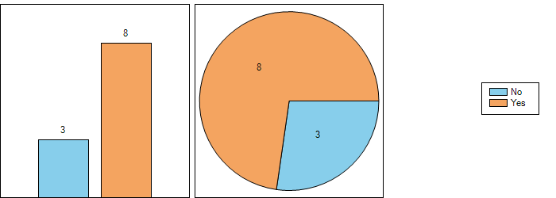

SRD/MG Assessment

Question 21: Are there emerging market needs where cognitive radio enabled SRDs are in your opinion a viable alternative to satisfy the demand/ emerging market needs?
Dutchview | Yes
Krohne
Volkswagen | Yes
Silver Spring Networks | Yes
Sennheiser | Yes
Deutsche Telekom | No
Aidon | Yes
Siemens | Yes
Pilz
Sony Europe
Bosch | No
CEA-LETI
Kamstrup | Yes
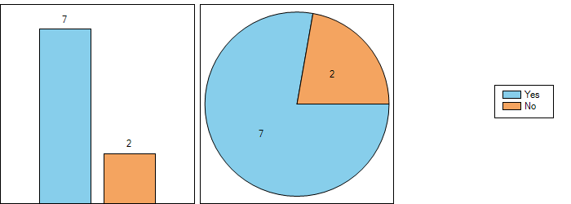

Question 21.1: Explanations
 | Please explain | Should these be treated as generic (non-specific) SRDs or as a specific type?
Dutchview | emerging market for audio video distribution is waiting for a standard protocol. Sharing of PMSE use depends on how much frequencies are still white space. | specific PMSE
Volkswagen | It seems necessary | specific types
Silver Spring Networks | The predicted enormous demand for IoT-connected devices will require much more sophisticated use of the limited spectrum resource. These are generic requirements. | The regulatory community should move away from the concept of application-specific regulation as much as possible to improve the efficiency with which Europe’s radio spectrum is utilized.
Sennheiser | Cognitive enabled SRDs could complement existing manually configurable audio PMSE devices but they should not be considered as a viable alternative. At present 100% of all audio PMSE devices are manually configurable and this situation will take many years to change if indeed it ever will. | Specific type of SRD with compatible RF spectrum access methodology.
Aidon | For particular SRD applications there is a need for higher bandwidths and network capacity, which can be fulfilled by access to new bands. Such access may be facilitated by employment of cognitive radio enable SRD’s. One such application is smart metering. | Specific type, as the applications have their specific characteristics and requirements.
Siemens | WIA | See requirements of Industrie 4.0, Smart Manufacturing initiatives, IoT, etc. - Generic, non-specific.
Kamstrup | Cognitive radio for SRDs could facilitate IoT and Smart Grid/Metering which will require spectrum in order to meet the demands | Specific categories of SRDs such as Smart Grids/Metering might show potential for global environment and economy and should awarded vs. non-specific SRDs

Question 21.2: Explanations
 | Please explain | Should these be treated as generic (non-specific) SRDs or as a specific type?
Deutsche Telekom | SRDs shall continue to be restricted to SRD bands and shall use already proven economic mitigation technologies such as LBT | -
Bosch | Cognitive radio enabled SRDs may relax the problem of congestion of frequency bands for a certain time. The overall increase of SRD will lead to a congestion anyway due to physical reasons: more than one device at the same place, same frequency, same time (independant of the spectrum access mechanism) | Specific in case of more relaxed working conditions allowed

SRD/MG Assessment

Question 22: Do you have proposals and descriptions of modifications to technical parameters keeping in mind that the use of spectrum has to be as much as possible technology neutral meanwhile ensuring that other SRDs applications (including existing ones) have to share the same spectrum on equal basis and work properly so as to achieve new spectrum utilisation opportunities for cognitive enabled SRDs?
 | Proposal
Dutchview | specific PMSE networks and frequencies
Volkswagen | Spectrum sharing has the big problem of possible interferences between the users. That can be very critical by safety applications!
Silver Spring Networks | All of the above are generally applicable, and technology and application neutral.
Sennheiser | To be considered in suggested studies. See question 9.
Aidon | The regulation should allow access to bands based on utilization of advanced technical approaches, if their utilization can facilitate sharing, coexistence and proper operation of the concerned applications. Furthermore, utilization of certain technical approaches may also have an impact on the regulatory requirements, for example utilization of geolocation database could allow deployment of HDC NRP’s based on general authorization.  In general, the use of advanced technical solutions could be required, but still the technology neutrality should be maintained. Some examples:  - use of an effective interference mitigation method would be required, but a specific method would not be required  - if the method is based on an ETSI standard, compliance with a specific HS is needed, but if another method is used, the performance would have to be shown by the manufacturer  It is also preferred that the regulatory approaches would be light. Some examples:  - coordination between the licensees may be left to be done between the licensees  - network deployment information would need to be presented to the regulator only on request
Siemens | The sharing should be based on the parameter:  - Frequency  - Time  - Coding  - Location  - Polarization  The use of those parameters to achieve coexistence could be organized by a coexistence manager or a RRS system like CCP concept.
Bosch | What means equal basis?  Technical parameter can be fine tuned if the RF-environment can be approximately predicted (families of devices with similar charecteristics)

SRD/MG Assessment

Question 23: Any other suggestion?
 | Proposal
Volkswagen | Safety applications (flight, road traffic) must have own safe frequencies bands!
Sennheiser | Stop implementing new SRDs (e.g. TVWSD) before suggested studies leading to a common standard with a compatible RF spectrum access methodology for all SRDs has been finalized. The existing RF landscape is already extremely congested, particularly in the UHF TV band, and great care needs to be exercised before allowing new devices to operate in parallel to audio PMSE.
Deutsche Telekom | a general discussion in CEPT is necessary to decide for which applications CR technologies are suitable.
Aidon | In general, the regulatory requirements should facilitate technology neutral approaches and deployments under general authorization.
Bosch | Incorperate a parameter qualifying the socio-economic benefit for the society ( device depending).  If and how this could be done needs sensitive studies.  The fact that this will become difficult should not avoid profound discussions.

SRD/MG Assessment

