Road and Urban Rail (CBTC) ITS Systems spectrum sharing solutions
Report approved on XX Month 2019
ECC Report <No>

Executive summary
The focus of this Report is on the inclusion of Urban Rail Systems in the range 5875-5925 MHz (i.e. no new requirements to be imposed on ITS applications as provided under the current regulation in 5875-5905 MHz) and within the framework of the existing compatibility studies related to ITS (i.e. no additional spectrum compatibility studies needed).
The aim is to define a common framework to share the 5875-5925 MHz band between ITS and Urban Rail System, with Urban Rail being under the umbrella of the ITS regulatory framework.
The Executive Summary should provide a short and concise explanation on the purpose of the respective ECC Report and should clearly indicate the covered subjects to which it applies. In addition, it should clearly explain the application of the document.
This report also recognises existing urban rail system implementations.

TABLE OF CONTENTS

0 Executive summary 2
1 Introduction 7
2 Definitions 8
3 Spectrum and Operational requirements for Urban Rail systems 10
3.1 Spectrum requirements 10
3.2 Operational Requirements 12
3.2.1 Communications requirements 13
3.2.1.1 CBTC Message types 13
3.2.1.2 Lower layer requirements 13
3.2.1.3 Upper layers requirements 14
3.2.1.4 Synthesis 14
3.2.1.5 Specifying the raw data rate and the latency for CBTC communications of a single line 15
3.2.1.6 Train transmitter scheduling 16
3.2.1.7 Wayside transmitter scheduling 16
3.3 Market size, value and timing 17
3.4 Differences between ITS and Urban Rail Systems 17
4 Sharing aspects with other applications in the spectrum 20
5 Existing standards, specifications and Reports 22
5.1 EN 302 571 and related ETSI standards and technical specifications 22
5.2 Existing ITS implementations 23
5.3 ITS implementations using MNO networks 24
5.4 Tentative LTE implementation of CBTC 27
6 Mitigation methods 28
6.1 Description of the scenario 28
6.2 Detection of mitigation area 29
6.2.1 Energy detection 29
6.2.2 Using same protocol for both ITS and CBTC 29
6.2.3 Increasing EIRP 30
6.3 Beacon solution method 31
6.3.1 Considerations about the size of the impact zone 32
6.4 Sharing of Urban Rail and ITS over time in detail within the so-called Urban Rail corridors or impact zones 33
6.5 Deployment of the ETSI ITS access mechanisms in the CBTC system with 10 MHz channelisation 34
6.6 Fully integration of CBTC as part of the 10 MHz based ETSI ITS systems with prioritisation mechanisms in all protocol layers based on the existing Decentralized Congestion Control mechanism of the ETSI ITS system 34
7 Recognition of existing Urban Rail system implementations in the band 5915-5975 MHz 35
8 Principles 37
9 Concept for future regulation 38
9.1 Needs for the future Regulation in EC and ECC Decision 38
9.1.1 Need for revision of ECC Decision (08)01 and ECC Recommendation (08)01 38
9.1.2 Need for revision of the EC Decision 2008/671/EC 38
9.1.3 Transition Period 38
9.2 Need for inclusions in standards 38
10 Conclusions 39
ANNEX 1: Current Implementation status in CEPT 40
ANNEX 2: Throughput requirements for generic CBTC systems 41
ANNEX 3: CBTC legacy system 48
ANNEX 4: List of Reference 49

LIST OF ABBREVIATIONS

Abbreviation | Explanation
CEPT | European Conference of Postal and Telecommunications Administrations
ECC | Electronic Communications Committee
ETSI  ITS | European Telecommunications Standards Institute  Intelligent Transport Systems
URS | Urban Rail Systems
MHz | Megahertz
ATC | Automatic Train Control
ATO | Automatic Train Operation
ATP | Automatic Train Protection
IEEE | Institute of Electrical and Electronics Engineers
DCS | Data Communication Systems
UGTMS | Urban Guided Transport Management System
IEC | International Electrotechnical Commission
OBU | OnBoard Unit
TSU | Track-Side Unit
CENELEC | European Committee for Electrotechnical Standardization (Comité Européen de Normalisation Electrotechnique)
GHz | Gigahertz
SIL | Safety Integrity Level
RF | Radio Frequency
AP | Access Point
LOS | Line Of Sight
NLOS | Near Line Of Sight
EM | Electromagnetic
MIMO | Multiple Input Multiple Output
CSMA/CA | Carrier-sense multiple access with collision avoidance
MAC | media access control
BBDR | Broad-Band Disaster Relief
e.i.r.p. | Equivalent Isotropically Radiated Power
RLAN | Radio Local Area Network
V2V | Vehicle-to-Vehicle
V2I | Vehicle-to-Infrastructure
LTE | Long Term Evolution
DCC | decentralised congestion control
BFWA | Broadband Fixed Wireless Access
PC | Personal Computer
MFCN | mobile/fixed communications networks
TPC | Transmit power control
V2X | Vehicle-to-Everything
MNO | mobile network operator
D2D | direct-device-to-device
GNSS | Global Navigation Satellite System
LAA | License Assisted Access

Introduction
Urban Rail Systems (URS), e.g. mass transit metro-type lines using CBTC – Communication Based Train Control - are efficient urban public transport systems in major cities. Their safety-of-operation and their operational performances (mainly low headway between trains and high number of passengers carried and exchanged along the line) depend on minimum radio communications performances, therefore they need access to spectrum with conditions ensuring these performances and the required level of urban rail related safety of operations. The European urban rail sector targets the 5.855-5.925 GHz band, as explained in ETSI system reference document TR 103 111 [1].
This band is already used in several European countries for more than 15 years with agreement of national or metropolitan regulators.
The ECC Decision (08)01 [2] identifies the frequency band 5905-5925 MHz for use of Intelligent Transport Systems (ITS), and the Commission Decision 2008/671/EC [5] is currently limited to the frequency range 5875-5905 MHz. The automotive industry is making substantial progress in view of EU-wide deployment of ITS in 2019 in the 5.9 GHz ranger and connected and automated vehicles will heavily rely on this service notably for safety-related features.
To make sure that CBTC messages can be transmitted sustainably and independently from the underlying communications technology which could be subject to change, most of CBTC systems operators are currently “technology” neutral.
A stable legal environment - identifying the 5905-5925 MHz band as one offering the highest priority for CBTC operation for medium to long range continuous communications with a trackside infrastructure would help ensuring continued safe operation of existing CBTC systems and future deployment of CBTC.

Definitions
The definitions used by the regulatory framework (ITS, Urban Rail systems, CBTC) have to be clear.
Term | Definition
Communication-Based Train Control (CBTC) | CBTC is using an applicative protocol for railway signalling, ATP and ATO for railway lines excluded from the scope of the railway interoperability [21] and segregated from road and pedestrian traffic.  CBTC is a wireless Automatic Train Control (ATC) system, more flexible and cost efficient than traditional ATC.  CBTC has been standardised:  1. by the IEEE in IEEE 1474 [8], which gives the following definition:  A CBTC system is a continuous, automatic train control system utilising  - high-resolution train location determination, independent of track circuits;  - continuous, high-capacity, bidirectional train-to-wayside data communications;  - and trainborne and wayside processors capable of implementing automatic train protection (ATP) functions, as well as optional automatic train operation (ATO) and automatic train supervision (ATS) functions.  2. by the IEC in IEC 62290-1 [18] and IEC 62290-2 [19]  CBTC is used in IEEE, whereas UGTMS is used in IEC. UGTMS stands for Urban Guided Transit Management and Control/Command Systems.
Data Communication System (DCS) | A global communication architecture into which radiocommunication links are integrated
OnBoard Unit (OBU) | Antenna, radio frequency accessories, radio transmitter and receiver, usually installed in an urban rail train
Track-Side Unit (TSU) | Antenna, radio frequency accessories, radio transmitter and receiver, usually fixed as part of the urban rail railway infrastructure.
Urban Rail System | A definition is provided in the CEN-CENELEC Guide 26 [20].  A public transport systems permanently guided at least by one rail, intended for the operation of local, urban and suburban passenger services with self-propelled vehicles and operated either segregated or not from general road and pedestrian traffic. Urban Rail Systems are excluded from the scope of the Interoperability Directive 2016/797/EU [21]. Urban Rail Systems include Metros and suburban lines, which are intended only for the operation of local, urban or suburban passenger services, as well as railway undertakings operating solely on these networks.  The focus in this Report is on Metro and suburban lines using CBTC applications and operating in the 5.9 GHz range. CBTC systems are deployed on urban and suburban train on dedicated tracks. Tramways, tram trains and buses are not covered by this system.  Note that systems not using CBTC and operating in the 5.9 GHz range can still use the spectrum as a normal ITS station. Tramways, tram trains and buses can also be seen as ITS stations, even when using CBTC, i.e. they are not considered to use an Urban Rail radio solution but using ITS.
Urban Rail Systems - safety | Freedom from unacceptable levels of risks resulting from unintentional acts or circumstances
Urban Rail System - security | Freedom from unacceptable levels of risks resulting from intentional acts or circumstances

Spectrum and Operational requirements for Urban Rail systems
Mass transit metro lines which are operated at a high level of performance and short intervals between successive trains are now installing Communications-Based Train Control systems, in short CBTC. CBTC systems have been deployed for more than 15 years in several European countries under national exclusive agreements in the upper 5 GHz band.
CBTC areas are quite limited compared to ITS. Security, safety, and radio link availability aspects should be clear for the Urban Rail application.
Background information on spectrum and operational requirements for Urban Rail systems is as follows:
- ETSI adopted an ETSI system reference document in 10/2014: ETSI TR 103 111: Spectrum requirements for Urban Rail Systems in the 5.9 GHz range [1];
- ETSI TR 103 111 was provided to the ECC and after a first analysis performed in ECC/WG FM [6], a request from ECC/WG FM to ETSI to consider Urban Rail Systems as part of 5.9 GHz ITS was launched in 02/2015;
- This led to the development of ETSI TR 103442 v1.1.1 (2016-05) [4] on the shared use of spectrum between Communication Based Train Control (CBTC) and ITS applications
Spectrum requirements for Urban Rail systems can be differentiated for the following communications of urban rail systems:
- primarily trackside/infrastructure-to-train communications; and
- optionally train-to-train communications.
A CBTC system is a continuous, automatic train control system utilising:
- high-resolution train location determination, independent of track circuits;
- continuous, high-capacity, bidirectional train-to-wayside data communications;
- trainborne and wayside processors capable of implementing automatic train protection (ATP) functions, as well as optional automatic train operation (ATO) and automatic train supervision (ATS) functions.
The technical harmonisation of the spectrum aspects of Urban Rail System rail would be beneficial from the pan-European market harmonisation perspective and of avoiding coordination/protection zone issues at borders. The approach is to include Urban Rail Systems 'under the umbrella' of the 5.9 GHz ITS regulation which is already harmonised in Europe. This approach is considered to have the benefit of being available at an acceptable time-to-market throughout Europe.
It is necessary to distinguish between spectrum co-existence which is needed amongst all technologies (V2X, G5, Urban Rail) and interoperability (only V2X and G5 for implementation considerations in the automotive market). The spectrum harmonisation for Urban Rail is motivated to achieve a bigger market in Europe while regional/metropolitan deployment does not necessarily need the harmonisation of frequencies for operational reasons or even interoperability aspects.
Both the ITS critical safety applications and Urban Rail systems critical safety applications are not seeking the status of safety service (RR 1.59).

Spectrum requirements
The main spectrum requirements for Urban Rail systems cover the needs for:
- 1) fundamental time-critical CBTC and safety relevant applications with very low latency; and
- 2) non-safety relevant applications, applying mobile networking based on internet protocol as well as other protocols, extending the applicability of the communications equipment towards railway traffic management tasks and other applications. Non-safety related urban rail applications include internet access, passenger information systems, Urban Rail maintenance applications, video, audio and telecommand/telemetry applications.
Both of these types of applications might indirectly enhance the urban rail traffic safety and system operation. All these functionalities are described in the ETSI system reference documents and are normally implemented in one single system.
CBTC is providing automatic train control with and without driver. To drive automatically a train, a Data Communication System (DCS) is needed. When trains are moving the wireless system allows communication with a central system. The wireless system is used to transmit traction order or breaking order in a safe mode. If trains cannot transmit messages, they will not be authorised to move.
Each train typically sends its location 5 times a second and the central system sends an authorisation to move for each train in the line. All the messages use the wireless DCS. This system allows reducing the time between trains in automatic mode (85 s instead of 105 s with human drivers). The ETSI system reference document recommended to have contiguous and/or nearby frequency bands in the upper 5 GHz frequency range:
- to designate 20 MHz of spectrum for CBTC and urban-rail safety relevant critical applications, preferably within the frequency range from 5905 MHz to 5925 MHz;
- to designate 20 MHz of spectrum, i.e. 5855 MHz to 5875 MHz, for non-safety related urban rail applications (secure control, railway traffic management and video-surveillance).

Continuity in terms of space is ensured by the radio planning, defining where trackside radio needs to be installed. Radio systems for CBTC make use as much as possible of diversity, sending the data from both train ends (spatial diversity), each train end using a distinct frequency (frequency diversity), several successive times (time diversity) and sometimes successive access points together (macro-diversity).
It is for these reasons that CBTC radio communications systems require two channels for its transmission per line (and more in case of a network) and why the amount of data to transmit is increased between the initial raw need for communication and the real amount of communication over the air.
The complete redundancy is achieved through the permanent, parallel transmission of all data through two separate frequency channels.
To maximise the availability of connections between train and wayside applications, path diversity is required. Each train has a minimum of two radio paths with the wayside radio infrastructure. Each radio path operates on two channels with different carrier sets.
Two independent radio paths are required and characterised by:
- Frequency diversity: two different sets of frequencies;
- Space diversity: connection with two different base stations.

To maximise the independence between Radio paths and avoid interference between channels non adjacent channels should be used on a given line. Such a pattern is required to avoid interference between redundant base stations, and also between train radios.
Hence, in a frequency band of 20 MHz (5905 to 5925 MHz), with four channels shall have a channel bandwidth of 5 MHz.
In each train front and rear cabs are equipped with On board Radio modem connected to directive antennas.
Base stations connected to directive antennas are installed along the Tracks
Directive antennas open the way to extend the distance range significantly and to reduce the potential interference zone from the tracks.

Figure 1: Use of directive antennas and possibility for channelisation

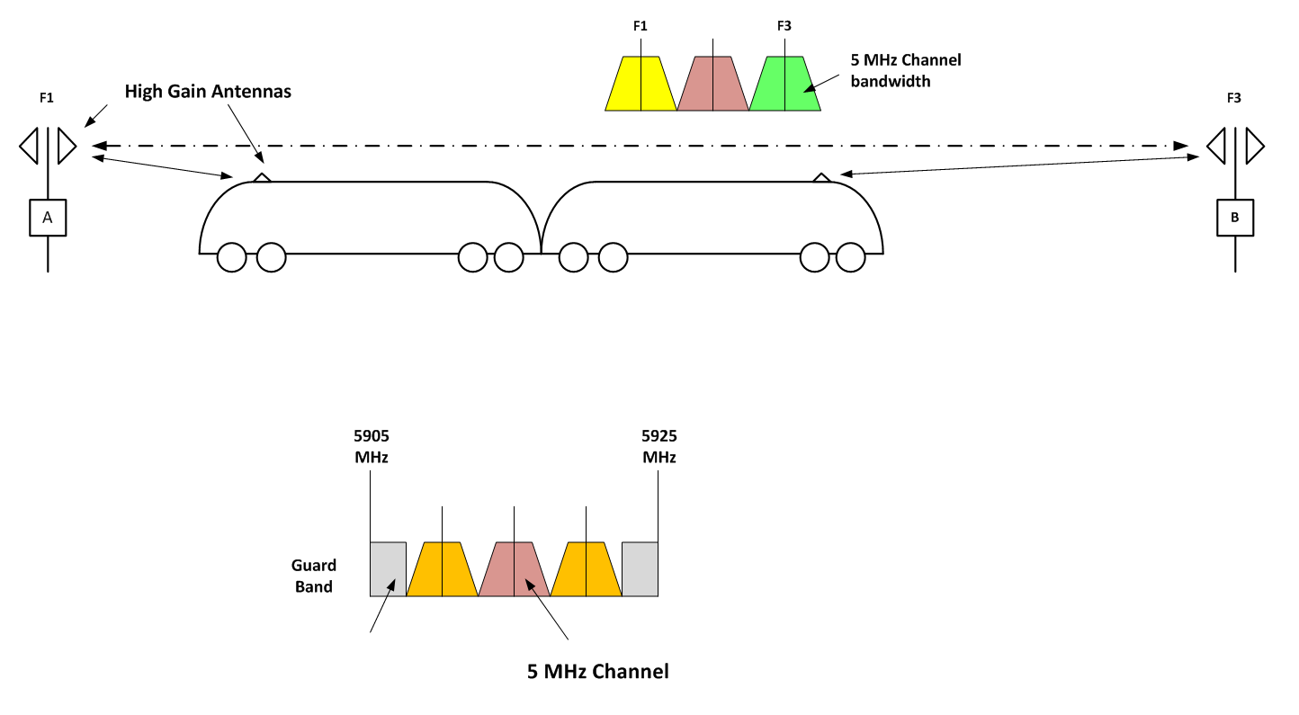
In most cities which have a metro network, some lines cross each other, or can have some tracks in parallel in some areas (common stations, for example).
Lines are working with completely independent systems, which can come from different manufacturers and can have different communication systems with possible different technology. Therefore, to guarantee the independence between lines, the independence of paths in each line and performances in term of latency and throughput in that situation, 2 pairs of channels are required.
In addition, in stabling area and depot due to higher train densities, two pairs of channel are required to cover these large areas while maintaining performances in term of latency and throughput.

Operational Requirements
For CBTC, mass transit operators have critical requirements which are classified at the highest Safety Integrity Level (SIL4). This level is equivalent to the highest one in aeronautics and nuclear plants, and exceeds the current classification of the automotive industry (ASIL-A to D). This level implies enforcing formal methods for specifications, development, and validation of hardware and software parts, then of the whole systems.
According to EN 50159 [7], the requirement transferred to the CBTC communication system is to ensure a sufficient level of access control (cyber security): authentication of all participants in the communication system, integrity and confidentiality of the transmitted data have to be ensured.
In addition, the content of the messages and the protocol of data transmission itself have to ensure the safety: the way to timestamp the transmitted information and the evaluation of the possible default of synchronization between CBTC components is a big part of that. The reception of too many stale (or time-expired) messages is considered by the safety applications as an abnormal and potentially dangerous situation, and can lead to a fail-safe reaction (stopping the train). The evaluation of the position of the train also takes into account a lot of criteria, in order to avoid any unsafe decision. Data rate, sampling rate, buffering processes, latency and packet integrity are also parameters that are taken into account in the safety demonstration and cannot be changed.
In addition, the communication system should not create any additional risk of intrusion into the CBTC system which could create a possibility of a secondary level of attack such as software or configuration modification after illicitly obtaining a password.
Finally, from a more general point of view, proper functioning of CBTC and therefore efficiency of the transport system and the safety of passengers are based on highly reliable communication links between wayside and on-board CBTC. External interference on the frequency band used by CBTC can cause repeated disturbances reducing the public transport capacity.
CBTC systems typically allow running trains only 90 seconds (or less) apart with total safety for the passengers and the staff. The headway depends upon time spent by the train at every station for passengers to leave and board trains, the distance between stations and the profile of the line as well as the possible acceleration, maximum speed and deceleration of the train).
Emergency braking causes huge discomfort and may even lead to injury to metro passengers. There is no seat belt in metro systems.
From a system point of view, CBTC is a complete safety system, interfaced with safety train network on board, and at least interlocking signalisation, platform screen doors on wayside.
CBTC system ensures safety operation for a complete metro line based on, EN 50126 [22], EN 50128 [23] and EN 50129 [25] demonstration. These demonstrations have to show that cases appearing as dangerous, such as a train stopped at an interstation position for a long time, leading to possible people on track, cannot happen with a probability higher than 10-9.
CBTC application must stay fully independent from the communication system. Therefore no constraints should come from the application layer regarding repartition of data indifferent messages, recurrences of these messages, etc.

Communications requirements
The amount of data transmission for CBTC communication cannot be reduced by external conditions (example: amount of non CBTC transmitter in the area) without reducing its performances and therefore the public transport capacity. On the other side, when there are too many cars in the same area, it is admitted that traffic jam reduces efficiency of road transport. Moreover local impact in CBTC system will have repercussions on all the metro line throughout the city, which is not the case for road traffic.

CBTC Message types
Note: the whole document uses a lot the term 'message' , so it would be good to explain the various CBTC message categories/types/differences

Lower layer requirements
CBTC needs a continuous redundant communication link with a wayside infrastructure, while ITS application uses only sporadic communication with wayside devices in specific areas, in addition with communication between vehicles only when they are close enough. Therefore, relatively long distance coverage (order of magnitude of more than 1 km on straight lines, 500 m in tunnels) are favoured compared with higher throughput, using the lowest possible modulation rate. A low density in b/s per Hz is required in order to allow long distance ranges and to cope with interference. For instance Binary Phase Shift Keying (BPSK) or Quadrature Phase Shift Keying (QPSK) are preferred to Quadrature Amplitude Modulation (QAM).
The safe operation of CBTC systems requires a redundancy of the communication (see section 8.2.1 of ETSI TR 103 111 [1]). This redundancy must be continuous in space and permanent in time. To ensure redundancy a single train contains 2 radio transmitters, both transmitting in parallel the same data towards two different trackside radio equipment on 2 different channels. On the other side, each trackside transmitter has most of the time multiple trains to communicate with, from a nominal value of 4 trains in operational lines up to typically a dozen trains in dense areas such as multiple-platform stations, multiple tracks in parallel, branches and train yards/depots.
In addition, in order to follow critical orders from the CBTC application, the radio devices are required to run short real time (end-to-end latency of less than 100 ms), which needs to be maintained even under a significant load of the radio.

Upper layers requirements
The amount of payload to be transmitted to ensure CBTC performances is of the order of some hundreds of kilobits per second and per train (depending on the CBTC system).
This amount can be considered small in comparison to the throughput used nowadays to stream video flows or big files, but there are very strong requirements in terms of guarantee of transmission and real time transmission for safety reasons. Looking more in details at the impact if messages are delayed or lost, shows shows that for any CBTC implemented application:
- Trains report several times per second their position to the trackside train control infrastructure, and regularly receive an authorisation to run until a certain position (MAL -Movement Authority Limit) also several times per second. The MAL is calculated by the trackside, based on the position received from all trains in the area, and is valid for a certain time.
- In case a train has not received any MAL message for more than a freshness time which is typically between one and five seconds, it will stop immediately by applying the emergency brake. Applying emergency braking causes huge discomfort and may even lead to injury to metro passengers.
- In case the trackside has not received any position report from a train for more than the same freshness time, it will stop the trains in the complete area.
- The MAL message received by the train requires a level of integrity ensuring it is valid and up to date.
- Similarly, in the other direction, the train position/location received must also be "up to date" and be able to give a real picture of the complete situation at a given time. For this reason train positions/locations are sent and received regularly.
- For a driverless train, any stopping outside of the station due to a loss of transmission may put at risk the safety of the passenger: there is a need to guarantee that no passenger has left the train and is walking on the tracks.
- To allow freshness verification, all messages are provided with a time stamp, and to be able to interpret correctly the time stamp of the sender, the receiver needs to have assurance that its own time reference is the same as the time reference of the sender. This is achieved through a complex synchronization mechanism, based on the measurement of "round trip time" messages, which requires that the time needed for the transmission is stable (stability is checked but if not stable enough, the process will not be able to converge).
- In addition to this data required to ensure safe movement of the trains, the radio is also used to transmit other data required to ensure correct operation such as speed limits in some areas, mission of the train (if it has to stop at all stations or not), monitoring of the correct behaviour of the on-board devices, and to be able to detect and fix any failure before it has an operational impact. CBTC architectures are massively redundant and are still able to work safely with some failures.

Synthesis
The CBTC needs for a continuous communication:
- not only in time – no losses of transmission are allowed as it will stop trains, but
- also in space – there must be no place where a train would be unable to transmit and receive because trains would not be able to leave that place, and
- with a guaranteed and stable time to transmit data,
- otherwise very large margins are required in the calculation, leading to very poor performances in terms of headway between successive trains, and therefore in terms of capacity of transportation of the metro line.
Table X: The TR 103 442 summary of typical general requirements:
Criteria | Value
Payload throughput | Between 30kb/s and 150 kb/s per train on a channel (but these data have to be sent redundantly in parallel on 2 different channels by the two train ends)  See Annex 2: throughput requirements for generic CBTC systems
Typical train density | 12 trains for 1.2 km length of double track  36 trains in depot
Minimum number of channel needed | 4
A message received after too much delay is considered lost. On application level, it is the Message Error Rate, with the hypothesis of one IP packet for each message.  Maximum delay (end to end transmission between CBTC application devices) | 100 ms
Availability of the communication | 99.999% time and space availability (due to two-channel use in parallel, redundancy in the networks as well as redundant messaging). There is no location on the track where a train is not able to communicate.
Data security to ensure train safety | Compliant CENELEC EN 50159 [7]
For additional information about uplink and downlink payload throughput, see sections 3.2.1.1 and 3.2.1.2.
Link Data rates in the Urban Rail system are modest, except for video transmissions (train video) which may need up to 2 Mbit/s per link (latter one described as not relevant for urban rail safety, but for urban rail security considerations). Some extra coding is needed for reliability for urban rail safety applications. In addition, there are several links per line which are used for several trains. The duty cycle per channel can increase in certain situations such as a lot of train traffic at one station (it could be around 50% at multiple-platform stations). At this moment, there is not a single way to determine how exactly the channels are in use by different urban rail system implementations.
Safe train protection involves a number of operational functions; noticeably the emergency braking that must be anticipated to guarantee the safety of standing passengers: indeed emergency braking from 80 km/h to a full stop will occur if latency time is greater than 1 second. Emergency braking causes huge discomfort and may even lead to injury to metro passengers. For this reason, the CBTC's radio must provide a low latency or delay, even under a significant load of the radio. It is of course very important for the train to be sure that the message received is valid, that is to say up to date.

Specifying the raw data rate and the latency for CBTC communications of a single line
A 200 Bytes - 1 000 Bytes CBTC packet content is assumed for each train (100 Bytes - 500 Bytes each direction) per second. The worst case scenario is usually not along the main line, but in a train yard/depot. In this scenario, dozens of trains and maintenance vehicles can be stationary, yet still in full CBTC communication with the wayside controller.
The supported protocol - not specified in common for all CBTC systems - is expected to provide efficiency (incl. max. channel loading, duty cycle, gaps, and access mechanism) under 20 %, ensuring the latency requirement of being faster than 1 second re-transmit.
This translate to a rough rate of 2 000 kbit/s at minimum. It is reasonable to assume that a phase-modulated radio will be used, and that some protection will be expected from the coding and modulation process. Assuming a modulation with the minimal spectral efficiency of QPSK leads to an RF Baud rate of 4 Mbaud (2 bits per symbol from 4 × 2 Mbps). So the nominal bandwidth, with a QPSK signal changing at 4 Mbaud, is about 4 MHz. Allowing a guard band between channels, 5 MHz is the minimum channel spacing.
Other re-transmission cycles are also possible for CBTC applications, e.g. some messages are transmitted at a period of 200 ms while others are transmitted every 360 ms and some others at a period of a few seconds.
In order to allow short headways performances, an absolute minimum low latency of the transmission (less than 100ms) and a very low frame error rate is required. Typically a value of maximum 1 % of frame error rate is taken into account to calculate the performances of the complete CBTC system.
At transmitting level, a high grade of diversity is required, in order to cope with the weakness of EM propagation in various physical environments: LOS, NLOS, with multi-path, multi-mode and spatial filtering. It is common to combine 3 to 4 types of diversity. One type is generally kept for redundancy, e.g. a whole communication channel. The other types are devoted to improving availability: frequency diversity, polarization diversity, MIMO, spatial diversity (head & end of train) and macro diversity using simultaneous connections to several successive AP's. The last one is very efficient in tunnels, when trains are masking each other at a moderate distance from the current AP. All types of diversities being combined, a train can maintain more than 4 simultaneous links with wayside, and the wireless coverage should be continuous.
The TR 103 442 summarises these general requirement (see Table X above).

Train transmitter scheduling
Transmission is a combination of several periodic messages - transmitted regularly each Ton_bord_cycle (around 200ms) - and of some "on event" messages. Sometimes also there is request to transmit a large amount of data.
The periodic messages are spread within the Ton_bord_cycle period and their destinations are different logical addresses. The "on event" messages are fully independent of the cycle and it's not possible to predict when they will be needed.
All these messages must be transmitted to the wayside destination address in less than 100ms, with an error rate less than 1% (taking into account the fact that a too old message is considered as lost).
The amount of application data to be transmitted on a single channel by a single train transmitter can be up to 150 kbit/s per second for the uplink and 150 kbit/s for the downlink during several seconds.

Wayside transmitter scheduling
The transmission scheme at a wayside transmitted level is similar to the one of a train transmitter, but complicated by the fact that a wayside access point has to transmit the data coming from different wayside equipment, the Zone Controllers. Each of these Zone controllers has its own cycle of production of data to transmit to each train in its zone and a trackside transmitter has to communicate with up to dozens of trains at least in specific areas.
All these messages must be transmitted from the wayside to the destination address in less than 100ms, with an error rate less than 1% (taking into account the fact that a too old message is considered as lost).
The amount of application data to be transmitted on a single channel by a single trackside transmitter can be up to 1.8 Mbit/s per seconds during several seconds. Furthermore, proprietary secure messaging system and IP suite can be used, with some geographical routing facilities (IP v4 or sometimes IP v6). So there is a continuous overload due to the protocol stack.

Market size, value and timing
There are currently more than 150 metro lines in operation in Europe (See: http://www.urbanrail.net/eu/euromet.htm).
About 70 projects have been already recorded on operators' side for operational CBTC service:
- 18 until 2015
- 12 between 2016 and 2020
- additionally around 40 beyond 2020
Based on these 70 projects and an assumption of 30 km and 50 trains per project, each of them would involve 250 radios in full traffic conditions. This leads to a total of 17 500 transmitters either fixed and/or mobile at the end of the current planned deployment.
The market for unattended urban rail operations as of 2013 was 32 cities, 674 km track length, 48 lines and with 700 stations and is expected to grow to nearly 2000 km of track lines in 2025. 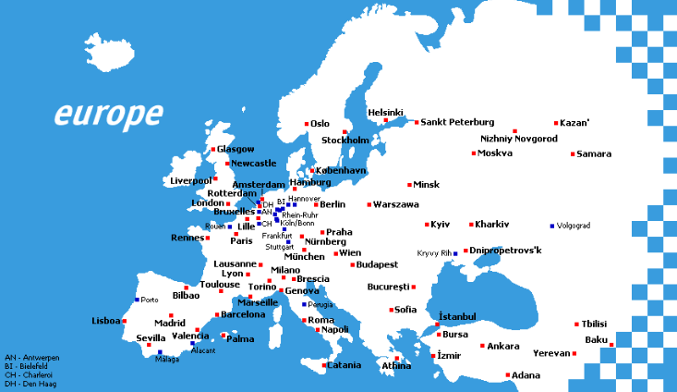
Figure 2: Urban rail in Europe (source: http://www.urbanrail.net/eu/euromet.htm)

Differences between ITS and Urban Rail Systems
From a physical point of view, CBTC is based on an infrastructure train to wayside architecture instead of a mobile to mobile ad hoc for ITS architecture.

 | Urban Rail | ITS (ETSI EN 302 571) [10]
Transmit Power | The required power level (EIRP) range is from 3 dBm to 33 dBm to achieve communication distances of up to 1 000 m.  The related maximum power spectral density (EIRP) is 23 dBm/MHz.  It should be noted that a number of trackside-to-train applications will require a much shorter communications distance than 1 000 m, and therefore lower power levels than 33 dBm are involved on average. If it is considered an average range of 700 m in rural areas, one needs an EIRP not exceeding 20 dBm. TPC reduces the transmission power to the level needed with up to 30 dB dynamic range. | The maximum spectral power density for ITS stations is imited to 23 dBm/MHz e.i.r.p. but the total power shall not exceed 33 dBm e.i.r.p. with a Transmit Power Control (TPC) range of 30 dB. The real TPC range implemented by ITS equipment is even wider.
Antenna | For the communication between vehicles and TSUs the required transmitted power can be asymmetric concerning uplink and downlink communications, because TSU can be deployed with more directive antennas. This means that the average interference contribution from TSUs will be significantly lower than the EIRP value on its own would indicate. The EIRP max is 29.54 dBm for TSU and vehicles. In vehicles, standard horn antenna are used (average gain: 17-18 dBi and an aperture of 18°).  TSU uses antenna patch. Two antennas are installed for one TSU. They are installed "back to back" to have a linear coverage. TSU can also use one antenna patch because of the tunnel constraints. Alternatively, coverage may also be achieved by a wayside leaky waveguide.  OBU antennas are also directive, with typical gains between 9 dBi and 12 dBi. They are installed either in the train behind the windscreen, or on the roof of the train. | No requirements set out in the regulations  The ITS station concept and the ITS reference communications architecture is set out in EN 302 665 [17], and there is no difference in the functions between a vehicle-based station, a fixed installed station or a portable ITS stations, i.e. all ITS stations can support all relevant features and facilities
Channel bandwidth | Up to 10 MHz, minimum needed is 4 MHz, typically 5 MHz including guard bands | 10 MHz channel bandwidth - implemented normally by OFDM signal solutions
Receiver parameters | Legacy systems:  Minimum Sensitivity: -94 dBm in 4 MHz  Selectivity rejection 56 dBc for adjacent 4 MHz channel  Blocking -10dBm  Minimum Signal Level used by URS above ground: …  Generic system:  Corresponding to 802.11 receivers configured for 5MHz channels | -68 dBm to -85 dBm in 10 MHz depending on modulation and code rate  Limits for receiver adjacent channel rejection and alternate adjacent channel rejection are included in EN 302 571 but are much less than for Urban Rail systems  The blocking level shall not be less than -30 dBm.
Duty cycle/ channel access | Legacy systems (see Annex 3):  All wayside transmitters of a given area are transmitting at the same time with a duty cycle of 50%. Each train in the area has a allocated slot to transmit  Generic systems (see Annexe 2).  Only one DCS transmitting device in a defined geographic area uses a frequency channel at the same time and uses  listen-before-talk and transmitter power reduction in congestion situations.  The average conveyed DCS duty cycle can be assumed to be in the range of 10 % to 15 % for one train transmitter | Only one ITS transmitting device uses an ITS frequency channel at any one time using listen before talk, transmitter power reduction and duty cycle restriction. The average conveyed ITS message duration is assumed to be below 1 millisecond. The frequency re-use distance depends on the ITS transmitter power and typically varies between 15 metres to 1 000 metres.  ITS-G5 uses the CSMA/CA MAC protocol as specified in IEEE 802.11 [12]. A decentralised congestion control (DCC) ensures low packet loss rates for high priority packets. The DCC reduces automatically the ITS-G5 transmission rate when the channel gets highly loaded.  The DCC is mandatory in EN 302 571 and specifies a maximum Ton time of 4 ms and a minimum Toff time of 25 ms.
The Urban Rail System has to be sufficiently robust in order to limit the size of impact zones for ITS use in 5905-5925 MHz. This may include re-consideration of some system parameters such as a more robust minimum receiver sensitivity, introduction of some coding gain by using spread spectrum modulation or redundancy in the messaging. A more robust mimimum signal level can be choosen for the Urban Rail system use above the ground. For example, the maximum operating range can in this case be limited to e.g. to not exceed 200 to 400 metres, while in tunnels, the operating range can be greater.

Sharing aspects with other applications in the spectrum
The CEPT/ECC compatibility studies addressed in ECC Report 101 [13] conclude that between 5875 MHz and 5905 MHz ITS will not suffer from excessive interference resulting from other systems/services.
ECC Report 228 [15] includes a review of the compatibility studies between ITS in the frequency band 5855-5925 MHz and other systems in adjacent bands and concluded that regarding unwanted emissions at the antenna, a level of -65dBm/MHz e.i.r.p. will be required in the band 5795-5815 MHz for truck installation and -60 dBm/MHz e.i.r.p for car installation respectively. ECC Report 228 also lists a number of mitigation techniques and if so employed, an unwanted emission limit of -30dBm/MHz e.i.r.p. is sufficient for the protection of the FS above 5925 MHz.
Thus the compatibility studies have taken into account both sharing within the band 5875-5925 MHz required for ITS applications in Europe and services below 5875 MHz including the Radiolocation service below 5850 MHz as well as services above 5925 MHz including the Fixed Service.
The ECC Report 109 [14] “on the aggregate impact from the proposed new systems (ITS, BBDR and BFWA) in the 5725-5925 MHz band on the other services/systems currently operating in this band” and ECC Report 110 “on compatibility studies between broad-band disaster relief (BBDR) and other systems” also relate to ITS.
The ECC Report 244 [16] already considers Urban Rail systems could be considered as part of ITS. In order to further investigate the impact of possible future RLANs on the operation of public transport automation systems, the following scenarios were identified (but no compatibility studies were conducted):
- Scenario A (inside and outside subway tunnels) a passenger, on board a train, is using his mobile phone as a wireless access to bridge his PC to the MFCN. In this configuration the mobile phone transmits over WiFi at 5,8 GHz, to the PC of the passenger. This scenario has already been identified as a real interference scenario, in other bands, for communications on board of trains. The situation is particularly prone to interference, considering that attenuation from inside the train to outside it, where the antenna of the automation systems is located, is estimated to be around 20 dB only.
- Scenario B (outside subway tunnels): a RLAN access point (i.e. at a fixed location) is installed in proximity of the fixed infrastructure antenna of the public transport automation system.
- Scenario C (outside subway tunnels): a train moves, on a rail in an open area. The rail is surrounded by buildings, where RLANs are operated.

In all these cases, the antennas of the Urban Rail system can take profit from their directivity.

The ECC Report 244 and CEPT Report 64 identified the need for mitigation techniques to be used by WAS/RLAN for the protection of ITS - and therefore, also public transportation systems. CEPT requested ETSI to develop mitigation techniques for RLANs, inter-alia in 5855 to 5925 MHz, to protect ITS applications.
MCL calculations for both directions of interference have been performed and showed the need for significant separation distances if compatibility is dependent upon protection to an I/N level of -6 dB. No studies have been conducted to analyse the actual effects of this I/N level being reached due to intermittent interference. Currently there is no commonly agreed protection criteria for both safety and non-safety ITS.
One possible approach for further studies has been suggested in ECC Report 244 and confirmed by CEPT Report 64:
- Generic Energy Detection without any consideration of the interferer and victim signal frames: Under the assumptions considered, preliminary studies show that in the case of an energy detection threshold of -90 dBm/10 MHz for an RLAN system operating with 23 dBm/20 MHz, an ITS device with 23 dBm/20 MHz is not reliably detected. Further consideration is required, including on the feasibility of such a detection threshold and its impact on the RLAN operation.
In addition, the ECC Report 244 also proposed the following option:
- Combination of energy detection and carrier sensing, such as one of the Clear Channel Assessment (CCA) modes defined in the IEEE Std. 802.112016. Further study is required to assess the applicability to ITS of the interference avoidance techniques currently employed in 5 GHz RLAN systems.
As a result, work on mitigation techniques was initiated at ETSI BRAN to help improve the compatibility between individual RLAN devices and ITS. ETSI created in TR 103 319: Mitigation techniques to enable sharing between RLANs and Road Tolling and Intelligent Transport systems in the 5 725 MHz to 5 925 MHz band 5 GHz WAS/RLAN sharing with transport [ref] under the assumption that WAS/RLAN would use the spectrum used by traffic safety related ITS applications (if WAS/RLAN is restricted to non-traffic safety related channels below 5875 MHz, this condition does not apply).

Some of the parameters within TR 103 319 are included in square brackets based upon proposals and discussions within ETSI TC BRAN, these are suggested as starting points upon which to continue future work and develop technical requirements.
The document discusses the compatibility between RLAN and ITS in the bands 5 855 MHz to 5 875 MHz (non-safety ITS), 5 875 MHz to 5 905 MHz (safety-related ITS) and 5 905 MHz to 5925 MHz (ITS extension band) ; Compatibility considered in the technical report includes RLAN and ITS technology as defined in ETSI EN 302 663. LTE-V2X and LAA technologies as defined in ETSI TS 136 211, ETSI TS 136 101 and ETSI TS 136 104 are not part of the report but should be considered in future compatibility studies. No conclusions on compatibility between ITS and RLAN can be drawn unless compatibility studies consider all ITS and RLAN technologies.

I.e this TR is only an interim report and the mitigations to be used by WAS/RLAN to protect traffic safety related ITS are not fully defined yet.

The conclusion is that the current development of such mitigation techniques is not sufficient yet to safeguard ITS (incl. Urban Rail) traffic safety related applications in 5875-5925 MHz. In addition, it is questionable whether improvement of this situation (i.e. full complete and sufficient mitigation technique specifications will be reached in the near future) will be achieved.
It is note in this context that WAS/RLAN can also use the current SRD regulation in 5725-5875 MHz up to 25 mW and that a new work item for allowing WAS/RLAN operation above 5925 MHz where the fixed Service is the main victim has been started. It was noted with regard to the new work above 5925 MHz that WGFM requested WGSE to conduct studies and referred to the latest version of ERC Report 25 (ECA Table) and to EFIS, and it should also be taken into account that public transport automation systems (like subway) are in operation on a national basis in some CEPT countries in the band 5915-

Existing standards, specifications and Reports

EN 302 571 and related ETSI standards and technical specifications
The technical solution for the frequency sharing of ITS / Urban Rail Systems should be described in ETSI standards but not in the ECC Decision. A future revision of the EN 302 571 will therefore be needed to also cover Urban Rail Systems.
The objective is to ensure equal access for all technologies in the view of EN 302 571 to the spectrum and in case of congestion a graceful degradation of service for all depending on the related safety level. The DCC mechanism can also be used (or is part of the solution) to provide prioritisation mechanisms between ITS and Urban Rail System applications. The feasibility of this has to be investigated. Furthermore, it also includes a review of the test related methods, receiver parameter and measurement uncertainties. From this it can be seen that the harmonised standard is very important for the description of the technical solution.
The current harmonised European standard for ITS is EN 302 571 V2.1.1 [10], published in February 2017 by ETSI. EN 302 571 specifies technical characteristics and methods of measurement for radio transmitters and receivers operating in the 5855 MHz to 5925 MHz frequency band. ETSI EN 302 571 V2.1.1 was published in the Official Journal of the European Union on 8 June 2017. The Commission Decision 2008/671/EC which mandates a harmonised use of the frequency band 5 875-5 905 MHz dedicated to safety-related applications of ITS throughout the Member States of the European Union is technology neutral. This means that any technology can be used for ITS in the 5.9GHz band as long as it is presumed to meet the essential requirements of the Radio Equipment Directive (RED) 2014/53/EU and complies with the technical requirements specified in EN 302 571.
The harmonised standard does not make a dedicated protocol mandatory but includes amongst others the following requirements:
- The equipment is required to operate on the applicable specific carrier centre frequencies that correspond to the nominal carrier frequencies at 5860 MHz, 5870 MHz, 5880 MHz, 5890 MHz, 5900 MHz, 5910 MHz, and 5920 MHz with a maximum channel bandwidth of 10 MHz.
- DCC (Decentralised Congestion Control) is an unconditional requirement for ITS equipment using the access layer technology based on IEEE 802.11-2012 in the current EN 302 571, noting that existing deployments use IEEE 802.11/ETSI G5 equipment. Other systems also need congestion control functionality:
  - Decentralised congestion control (DCC) is a mandatory mechanism to be used by the equipment using the access layer technology based on IEEE 802.11-2012 [12] to ensure that the radio channel is not congested by too many transmissions within a certain geographical range. The mechanism is such that the equipment adapts its transmission behaviour dynamically based on how occupied the channel is at the moment.
  - The DCC limits and mechanisms provided are based on IEEE 802.11-2012 but other technologies need also congestion control functionality.
- Transmit power control (TPC) to be used amongst other means as one mechanism for decentralised congestion control (DCC) to reduce the congestion on the communication channel. The TPC range shall be at least 3 dBm up to the maximum specified RF output power e.i.r.p of the equipment (33 dBm e.i.r.p).
No access layer standard such as EN 302 663 (access layer specification for Intelligent Transport Systems operating in the 5 GHz frequency band, ETSI EN but not a harmonised European standard) is referenced in EN 302 571.
The work on EN 302 571 will also be supported by another new work item approved in April 2017 in ETSI on draft ETSI TS 103 518 [ref] on requirements for the shared use of spectrum for Urban Rail and ITS applications in the 5855-5925 MHz frequency band. The deliverable intends to define a technical solution and the related minimum requirements for use of the 5855-5925 MHz frequency band by ITS and Urban Rail applications, also by taking into account the needs of existing use cases of CBTC systems and considering the outcome of the ETSI TR 103 442 proposed sharing mechanisms. The objective is to ensure access for all applications to the spectrum and in case of congestion/co-located situations a graceful degradation of service for all depending on the application related safety level. The deliverable should provide technical requirements enabling the use of different technical solutions. ITS equipment can also use more than one specific operating carrier centre frequencies at the same time. In this regard, it should be noted that the regulatory approach does not establish a minimum benchmark performance for the spectrum efficiency of the technical solution using the spectrum. This means that no stakeholder can ultimately argue that other technical implementations fail to achieve a certain defined minimum technical efficiency target.
Editor's note: There is no agreement yet in ETSI with regard to the work on TS 103 518. The CBTC community made a proposal based on the beacon solution including the use of ITS G5 CAM messages and sharing over time (TDMA, while CPTC is assumed to have a duty cycle of up to 50%, same channels could also be used for new applications such as platooning). I compromise is also difficult to achieve because of the uncertainty introduced by the V2X vs G5 discussions. It was clarified that the draft ECC Report will include information about all technical possibilities and leave it to standardization to find solutions (or: independently of for which one, standardisation may find a solution).
Different sharing mechanisms are proposed in ETSI TR 103 442:
- Implementation of mitigation techniques on the ITS side like detect and avoid or geolocation based solution using 5 MHz CBTC systems. For this option, it is important that no new restrictions should be imposed on ITS equipment operating in the frequencies at 5875-5905 MHz.
- Deployment of the ETSI ITS access mechanisms in the CBTC system with 10 MHz channelisation.
- Full integration of CBTC as part of the 10 MHz based ETSI ITS systems with prioritisation mechanisms in all protocol layers based on the existing Decentralized Congestion Control mechanism of the ETSI ITS system.
There may be further alternatives such as the limitation of a maximum ITS signal level close to CBTC tracks, beacon solutions (there may be several options for this;
Further specifications in ETSI….
Which solutions are within the framework of the existing compatibility studies related to ITS (i.e. no additional spectrum compatibility studies needed), as this is one important condition for the solution to be found in ETSI?
A table is proposed to be added here to check the options on hand of some criteria (criteria tbd out of this document).

Existing ITS implementations
ITS implementations in the 5855-5925 MHz range are despite of many R&D activities, tests and field trials still at the very beginning of the implementation in the mass automotive market. First implementations are based on one-receiver solutions operating only on the ITS control channel G5-CCH as defined ion EN 302 663 [ref] (which is IEEE 802.11 channel number 180) in the 5895-5905 MHz range. There are no negative impacts on existing ITS implementations to be expected as long as the technical sharing solution for ITS and Urban Rail applications does not impose new requirements on ITS below 5905 MHz.
Future ITS implementations will also be possible to use the frequencies at 5905-5925 MHz, also inside the (limited) zones where the frequencies are shared with Urban Rail applications, i.e. no application will be excluded from using any frequencies. For this reason it is necessary to investigate the zone of impact in its dimensions (link budget considerations in both directions) for the sharing between Urban Rail and ITS applications. In order to better define the zone of impact, it should be noted that systems not using CBTC and operating in the 5.9 GHz range can still use the spectrum as a normal ITS station. Tramways, tram trains and buses are also seen as ITS stations, even when using CBTC, i.e. they are not considered to use an Urban Rail radio solution but using ITS.

ITS implementations using MNO networks
An important feature of the IEEE 802.11/11p/ETSI G5 [ref] is that this would be self-organising networks，not related to MNO networks.
As an alternative, as part of the expansion of the LTE platform to new services, and to keep track with the increasing needs of the automotive industry, 3GPP is developing functionality to provide enhancements specifically for vehicular communications - both in terms of direct communication (between vehicles, vehicle to pedestrian and vehicle to infrastructure) and for cellular communications with networks.
LTE based V2X as one enabling technology of advanced ITS is intended to support both telematics and road safety related applications. 3GPP is working on development of V2X (LTE based V2X) technical specifications, and CCSA (China Communications Standards Association) is also working on standardisation studies of V2X (LTE based V2X) technology with enhancements according to Chinese traffic circumstances.
The initial Cellular Vehicle-to-Everything (V2X) standard is planned for inclusion in the Release 14. It focuses on Vehicle-to-Vehicle (V2V) communications, with further enhancements to support additional V2X operational scenarios to follow, in Release 14, targeting completion in 2017.
V2V communications are based on direct-device-to-device communications (D2D) defined as part of ProSe (Proximity Services – i.e. ‘direct mode’) services in Release 12 and Release 13 of the specification. As part of ProSe services, a new D2D interface (designated as ‘PC5’, also known as sidelink at the physical layer) was introduced and now as part of the V2V work item it has been enhanced for vehicular use cases, specifically addressing high speed (up to 250Kph) and high density (thousands of nodes).
To that end, a few fundamental modifications to PC5 have been introduced.
Firstly, additional symbols have been added to handle the high Doppler associated with relative speeds of up to 500kph and at high frequency (stating that the 5.9GHz ITS band being the main target).
Secondly, a new arrangement of scheduling assignment and data resources has been agreed. The arrangement is designed to enhance the system level performance under high density while meeting the latency requirements of V2V.
Finally, for distributed scheduling a sensing with semi-persistent transmission based mechanism was introduced. V2V traffic from a device is mostly periodic in nature. This was utilised to sense congestion on a resource and estimate future congestion on that resource. Based on estimation resources were booked. This technique optimises the use of the channel by enhancing resource separation between transmitters that are using overlapping resources.
The design is scalable for different bandwidths including 10 MHz bandwidth.
The general architecture of LTE based V2X consists of the Uu interface via cellular network, and the PC5 interface via direct links for communication between vehicle to vehicles (V2V), vehicle to pedestrian (V2P), vehicle to infrastructures (V2I), and vehicle to network (V2N). LTE based V2X could be operated under the coverage of cellular network, which is called an “in coverage” scenario (IC), as the services are controlled by the network. Meanwhile, the “out of coverage” scenario (OoC) is also supported by LTE based V2X, considering the V2X road safety related applications, which should be supported regardless of network deployment.
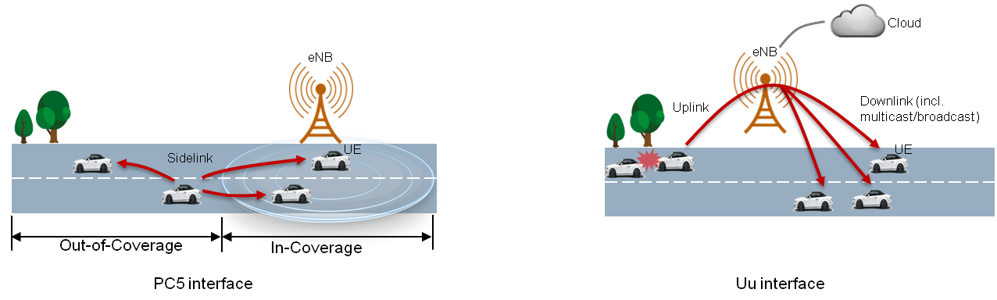
Typical telematics applications can be supported via the Uu interface. For road safety related applications, both PC5 and Uu interfaces are able to support the LTE-V2X in order to meet the associated service requirements.
The PC5 interface is designed based on the existing LTE Device-to-Device (D2D) communication technology with more enhancements in resource allocation, physical layer structure, and synchronisation, in order to meet the V2X transmission requirements. SC-FDMA and multiple (re)transmissions are inherited from LTE D2D. Multiple (re)transmissions can ensure the reception performance and reliability. Furthermore, both of the centralised and distributed resource allocation mechanisms are supported for V2X communication. The centralised resource assignment is valid within network coverage; eNB (evolved Node-B) could provide dynamic scheduling or semi-persistent scheduling based on traffic circumstances. For the distributed resource mechanisms, it could be supported regardless of the network control, and a detailed sensing with semi-persistent transmission mechanism is specified in order to decrease the potential transmission collision and maintain high reliability. From the synchronisation perspective, LTE-V2X relies on a precise external synchronisation signal. Three kinds of synchronisation references are supported using an external GNSS module, eNB or another vehicle. For the out-of-coverage scenario, GNSS case has a higher synchronisation priority in order to obtain a good system performance.
For the Uu interface, the road safety related V2X messages can be transmitted to the cellular network via the Uu uplink and be forwarded to the vehicles, which individually operate components via the Uu downlink. To accommodate the broadcast nature of V2X messages, the SC PTM (Single Cell Point To Multipoint) and MBSFN (Multicast-Broadcast Single-Frequency Network) technologies are both investigated and supported in LTE-V2X with necessary enhancements.
Both configurations use a dedicated carrier for V2V communications, meaning the target band is only used for PC5 based V2V communications. Also in both cases GNSS is used for time synchronisation.

Two V2X - new band combinations have been proposed to be added for V2X as below:
Please note that 3GPP band 5 is in 824–849/869–894 MHz and relevant for the USA, Australia, India, Korea and some other countries, band 34 is in 2010–2025 MHz, band 47 is in 5855-5925 MHz.

V2X inter-band concurrent combination | V2X Band | Channel bandwidths [MHz] | Interface
V2X_34_47 | 34 | 5, 10, 15 | Uu
V2X_34_47 | 47 | 10, 20 | PC5
V2X_5_47 | 5 | 5,10 | Uu
V2X_5_47 | 47 | 10,20 | PC5
Table X: Concurrent operation of additional LTE Uu frequency bands and PC5 operation on Band 47
Highest priority is given in 3GPP to the following combination:
V2X MCC Band | V2X Band | Channel bandwidths [MHz] | Interface
V2X_20_47 | 20 | 5, 10, 15, 20 | Uu
V2X_20_47 | 47 | 10, [20] | PC5
Table XX: xxx
Other LTE Uu frequency bands are not precluded.

V2X inter-band concurrent combination | V2X Band | Channel bandwidths [MHz] | Interface
V2X_34_47 | 34 | 5, 10, 15 | Uu
V2X_34_47 | 47 | 10, 20 | PC5
V2X_5_47 | 5 | 5,10 | Uu
V2X_5_47 | 47 | 10,20 | PC5
Table Y: Concurrent operation of LTE Uu Carrier Aggregation and PC5 operation on Band 47.
The total number of carriers of LTE Uu CA and PC5 operation is restricted up to 3CCs: e.g. CA_XA-YA (Uu) + 47A (PC5) or XA (Uu) + 47B (PC5)
Once the work in 3GPP on a band combination is completed, it will be included in the 3GPP specifications immediately, and Release independence of that combination shall be supported from release 14 (the same approach as for LTE frequency bands and CA combinations today).
As can be seen from the above, only vehicle-to-vehicle communication is currently foreseen in 5855-5925 MHz in this standardisation approach. No Uu interface in band 47 is indicated.

From the above considerations in this report, it can be concluded at all applications in the 5855-5925 MHz range are considered to share the spectrum under defined rules and even when the future version of EN 302 571 is technically neutral, the target band in the 5855-5925 MHz cannot only be used for PC5 based V2V communications.
Interoperability between ITS-G5 and LTE-V2X is currently not possible, meaning that a ITS-G5-only vehicle and an LTE-V2X-only vehicle cannot communicate with each other. However, the progressive introduction of connected vehicles – initially equipped only with ITS-G5 but later on also with LTE-V2X (and 5G) – raises the need to ensure interoperability of all connected vehicles on the road.
The LTE community indicated in in ETSI that the revision work or EN 302 571 comes early because some receiver parameters for V2X-based ITS are not fixed yet. Because of the sharing aspect and technical neutrality, V2X cannot expect to work in 10 MHz channels alone on an exclusive use basis in 5875-5925 MHz. This would not work with IEEE802.11/ETSI G5, WAS/RLAN or Urban Rail applications. All applications in the band have to prepare for common spectrum access in 5855-5925 MHz.

Spectrum requirements for ITS based on 3GPP specifications:
ITS Parameter | Value
Packet size | 300 B
Packet generation frequency | 20 Hz
Max. Communication range | 150 m
Latency | 100 ms
Reliability | 95%
References:
3GPP TR 22.885, Study on LTE support for Vehicle to Everything (V2X) services, V14.0.0
3GPP TR 36.885, Study on LTE-based V2X Services; (Release 14), V14.0.0

Tentative LTE implementation of CBTC
A number of CBTC manufacturers are converging into the use of TD-LTE in 4 channels, 5 MHz wide, inside the 5.9 GHz band. Such a TD-LTE should be privately owned or managed through a MVNO (Mobile Virtual Network Operator). The equipment of recurrent micro Base-Stations (micro BS) is optimised to the low granularity required by Urban Rail. To cover long sections, compact and cost effective RRH (Remote Radio Heads) can be mounted away in intermediate positions, Micro Base-Stations and RRH are backhauled by single mode fiber optics. The deployment is considered as purely V2I, with a double coverage in 2 different channels for a full redundancy along a given urban line.
There is no need for V2V or D2D mode, and the synchronisation of UE is performed directly by the wayside.
Preferably, Down Link, Up Link and their time frontier are scheduled in parallel between the 2 redundant channels to facilitate spectrum dispatching and rejecting.
Moreover, there is no real geographic "cell", so time-slot allocation dynamics can be minimized: for a given train, the same time-slot is kept as long as possible from a micro BS to the following ones, and roughly half the capacity of the system can be granted by micro BS at a local scale. To solve contention problems, a solution is a pool of time slots which are reserved and granted temporarily to trains passing each other.

Mitigation methods
The technical solution for the frequency sharing of ITS / Urban Rail Systems should be described in ETSI standards but not in the ECC Decision. The following sections describe the options for the mitigation in 5905-5925 MHz with their advantages and disadvantages as seen from the perspective of the Urban Rail application.
Future ITS implementations will also be possible to use the frequencies at 5905-5925 MHz, also inside the (limited) zones where the frequencies are shared with Urban Rail applications, i.e. no application will be excluded from using any frequencies. For this reason it is necessary to investigate the zone of impact in its dimensions (link budget considerations in both directions) for the sharing between Urban Rail and ITS applications.
It is important to clarify the impact of Urban Rail applications and in particular CBTC on ITS solutions for road vehicles (LTE-V2X and on IEEE 802.11p "ETSI ITS-G5") in the 5.9 GHz ITS band. Mitigation techniques developed through ETSI standardisation will be accompanied by technical conditions for spectrum access and relevant harmonised standards, in a technology neutrality approach.

Description of the scenario
A schematic overview of one possible scenario is depicted below:
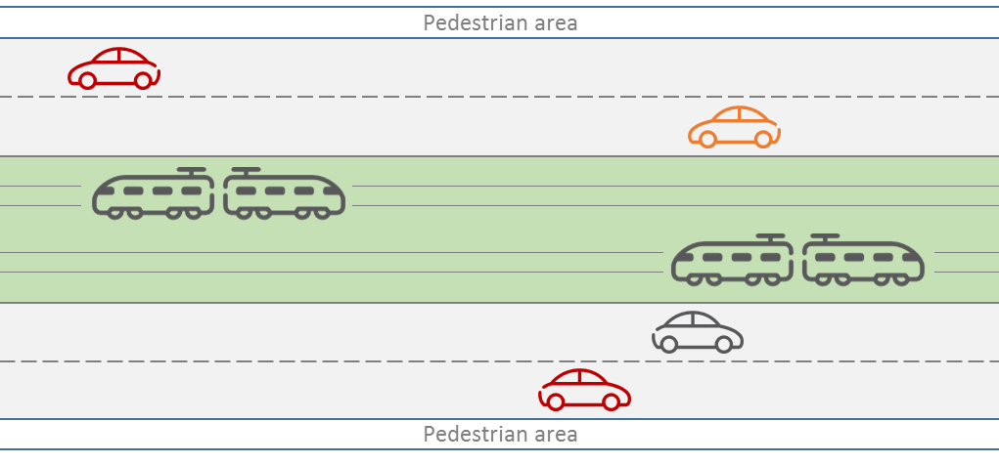
A pair of urban railways is surrounded by roads on each side. Pedestrian areas are located on both sides. Parameters defining the scenario in detail are collected in the table below:
Scenario Parameter | Value
Number of railways | 2
Number of traffic lanes | 4
Average distance between cars in lanes | 15 m
Density of pedestrians on each side | 4 per m
This scenario could possibly be simplified to consider:
-parallel urban railways and street at a given distance, e.g. 50 metres. Due to the directive antennas used by the urban railways,

Detection of mitigation area
Expecting the detection by ITS devices of nominal CBTC messages is not a solution as shown by the issues described below.

Energy detection
It leads to an increase of surrounding noise and has an impact on coverage: If one wants to stay technologically neutral, then only energy detection is possible. But even when the energy detector is no longer able to detect a signal, the receiver/demodulator can demodulate packets correctly. Typically e.g. 802.11 devices have an energy detection threshold of -62dBm, whereas the minimum sensitivity of the receiver is -85dBm. Using energy detection to detect the mitigation area will introduce the need to have everywhere in the CBTC area at least the threshold of energy detection (e.g. -62dBm including worse case fading, so possibly if fading is not maximum, a level of -50dBm), where only the level of sensitivity (e.g. -85dBm including worst case fading, so even when fading is not maximum -73dBm) would be enough. So the resulting penalty of 23 dB will reduce the CBTC distance range and the average noise level would be increased.

Using same protocol for both ITS and CBTC
Even if both ITS and CBTC would use the same protocol allowing ITS to detect CBTC preamble and training symbols using the CCA threshold, one would consider the same receiver sensitivity for both ITS and CBTC. But due to the fact that CBTC is using directive antennas with gain, and due to the fading impact, there are several scenarios where CBTC could be disturbed by ITS stations which are not able to detect any CBTC messages, such as the following:
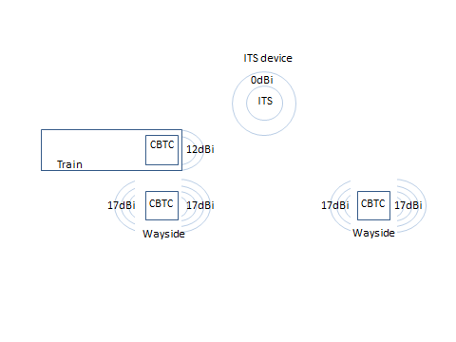
The typical maximum distance between CBTC equipment, taking into account an EIRP of 20dBm, a worst case 12dB fading effect, and a minimum 50m of overlap to ensure a seamless handover. Hypothesis of CBTC using ITS physical equipment:
sensitivity = -85dBm for both CBTC and ITS receivers in 10 MHz channel.
The maximum distance between the 2 wayside CBTC equipment is the distance d ensuring that the train will receive a minimum level of -85dBm from the far CBTC AP even when 50m before the closer CBTC AP. If the wayside antenna is sufficiently high, it is given by the following equation where (d given in km):
-85 = 20 -12 +12 -107,41 -20log(d-50)
d = 0,707km
But the ITS station, if also affected by the maximum fading and without reception antenna gain, would receive a level Pr in dBm given by the following equation :
Maximum level: Pr = 20 -12 -107,41 -20Log(0,350) = -90dBm for a RSU (Road Side Unit) with high antenna;
Minimum level: significantly less for an OBU (Onboard Unit), due to the destructive reflection by the nearby ground plane, that could give typically -96 dBm.
Both values are under the CCA threshold of -85 dBm in an ITS channel bandwidth of 10 MHz.
Therefore in that scenario, an ITS OBU would not detect any CBTC messages, and it is the same for an RSU unless gain antenna should be provided by a specific beam pointed at the railway track. And sending with the same EIRP of 20dBm, it will disturb the reception of the wayside CBTC.

Increasing EIRP
A solution could be to create a difference between the allowed EIRP for CBTC compared to EIRP for ITS, compensating both difference of antenna gain and risk of fading.
Allowing more EIRP than today for CBTC is not practicable, as it would increase the level of RF power to which both passengers and metro drivers are exposed in the near field (level currently used has been limited for this reason and not for technical reasons). Reducing EIRP for ITS would apply everywhere and not only in the very reduced area where CBTC is present, therefore it doesn't appear as a good solution. Installing the CBTC wayside equipment closer to each others would also increase the average level of RF noise.
Use of specific messages termed “CBTC to ITS alert beacons” (preferred option)
The use of specific messages decoded and understood by all ITS station without the need for any specific receiver, call hereafter "CBTC to ITS alert beacons" is the preferred solution.
These "CBTC to ITS alert beacons" could be sent by devices different or not from the CBTC equipment themselves, and could use antennas better fitted for their specific feature where applicable (wide sector antennas, radiating everywhere excepting toward the tracks).
This solution has therefore the following advantages:
- allows easy detection by ITS in their 10 MHz standard channels;
- allows also detection by RLAN, as RLAN are already supposed to detect ITS messages in the same channels;
- allows CBTC communication to stay technologically neutral, therefore protecting:
The legacy systems already deployed;
The CBTC system build on a full or modified "802.11" base, including if they are using 5MHz channels instead of 10MHz;
Any future systems, such as some LTE based one.

To Be Discussed with ITS:
Periodicity of " CBTC to ITS alert beacons " needs a balance between probability of detection and efficient reaction of ITS on one hand, and CBTC disturbance on the other hand (a magnitude of order of very short beacon each 200ms with a few % duty cycle could be taken as a basis for further simulations: CBTC systems could decide or not to synchronize every beacon and their own transmission with the beacons);
Channel(s?) for beaconing. Variants with beaconing into lower ITS channels could be considered (below 5,895 GHz, in order to spare CCH)…;
Content of the beacon => do we give information about the area to be protected in it, or do we just signal the CBTC presence – without any meaningful content?
Where do we put them (for protection toward ITS, wayside beacons could be enough. To be detected by RLAN that could be handled by passenger inside the metro cars, perhaps we would also need to have some in the trains...).
Note: All the CBTC area is "beaconed" and not only the entry points. Moreover, as "CBTC to ITS alert beacons" should be also used to advertise RLAN of the presence of CBTC, the area must be fully protected.

Beacon solution method
Within the course of work in the ECC, the beacon principle method has been offered by the urban rail community. An advantage of this method as seen from the ITS perspective is certainly that the method ensures that no restrictions are to be imposed on 5855-5905 MHz on ITS. Further detailed link budget considerations in both directions are necessary to see the area and the expected impact, and finally to reach acceptance by the ITS community. There is some flexibility in this because of the Urban Rail antennas for CBTC can have a certain directivity/diagram (and also a somewhat different Transmit Power control (TPC) approach) which may help. Other technical solutions may be possible under the umbrella of the technically neutral regulatory framework, but these would also need acceptance by stakeholders in the Urban Rail community and precise consideration and precise description in the standards and specifications.
As part of the preferred option “CBTC to ITS alert beacons”, two principles of mitigation methods are envisaged, similar to the one described in the on-going study of cohabitation between ITS and RLAN.
- "Detect and Mitigate" – not preferred - refers to methods in which, when the interferer (here it would be an ITS station) has detected presence of protected user (here it would be CBTC), it changes his behavior to let priority to each protected user message (either relative priority or absolute priority). This method implies that each message from the protected user is detected by the interferer.
- "Detect and Avoid" – preferred - refers to methods in which when the interferer (here it would be an ITS station) has detected presence of protected user (here it would be CBTC), it stops using the protected channel for a given time. Each time the protected user is detected again, it resets the timer for avoidance. If the timer finished without new detection the interferer is able to use again the protected channels.
The "Detect and Avoid" mitigation method may allow CBTC transmitters to stay technology neutral provided that ETSI G5 and LTE-V will have found a common sharing solution. Such a common sharing solution is not agreed yet.
An important limitation with the beacon method is how much streets and roads for ITS are restricted to transmit on depending of the need of protection around the Urban Rail location. For underground rail, one does not expect any problems and in cities with only some few percent of the rails not in tunnels this problem is probably limited. But for other cities such as Vienna or Stockholm where most of the rail is not in tunnels this could be very restrictive for the use of ITS. A detailed study of the challenges of the detection range and also how large areas ITS will be restricted to transmit at the time of use by Urban rail is needed.

Considerations about the size of the impact zone
In the calculations it can be assumed that each Urban Rail radio, both on train and stationary, are combined with an ITS beacon. Because the signal path for the detection of the ITS beacon and the signal path for maximum interference are the same, the attenuation for both are the same. Thus the use of propagation model doesn't matter.
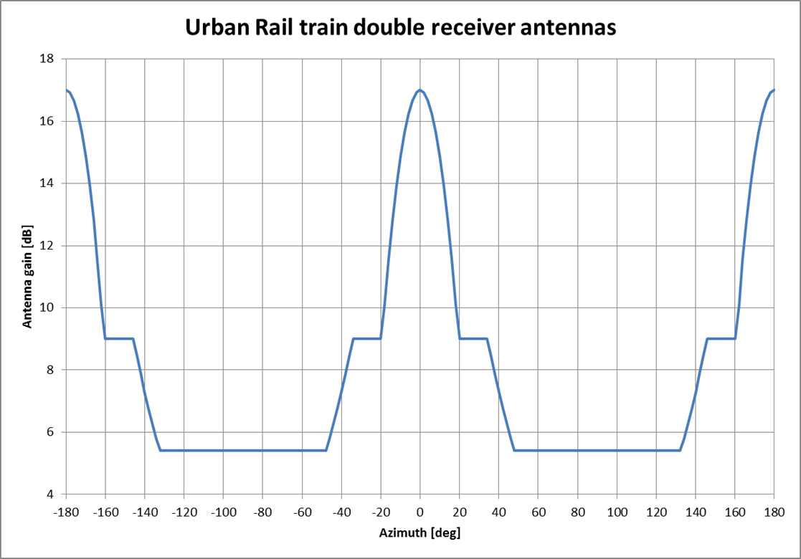
ITU-R F.699 with maximum gain 17 dB
UR receiver sensitivity -?? [dBm] (must be much more robust than -95/-94 dBm)
QPSK modulation SNR 11 [dB]
I/N protection criteria 6 [dB]
Maximum allowed received interference in 4 MHz bandwidth: ??
Other gains: e.g. due to spread spectrum or redundant messaging?
ITS beacon output +33 [dBm] eirp
ITS vehicle sensitivity -82 [dBm] including 0 dB antenna gain
Maximum possible path loss 33 + 82 = 115 dB
Conclusion (size of the impact zone): if the pathloss is larger than 115dB, the vehicle ITS will not detect the beacon. As scenario, the one with a road parallel to the tracks could be selected, taking into account the urban rail antenna gain.
Contributions needed.

Sharing of Urban Rail and ITS over time in detail within the so-called Urban Rail corridors or impact zones
Real sharing in 5905-5925 MHz requires also sharing in the time domain. ITS stations use low duty cycles can make use of this opportunity:

EN 302 571 defines as part of the Decentralised Congestion Control as an unconditional technical requirement the following duty cycle limitation:
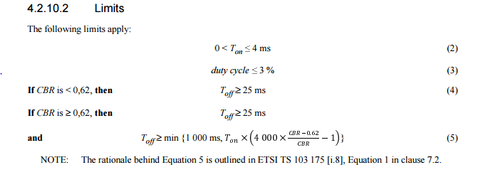
I.e. a single Tx on-time shall not exceed 4ms and is followed by a TX off-time according to the specificastions shown above. Only one ITS transmitting device uses an ITS frequency channel at any one time using listen before talk, transmitter power reduction and duty cycle restriction. The average conveyed ITS message duration is assumed to be below 1 millisecond. The frequency re-use distance depends on the ITS transmitter power and typically varies between 15 metres to 1 000 metres.
ECC Decision (08)01 already considers that duty cycle restrictions and specified frequency re-use conditions (e.g. for periodic ITS messages and ITS channel congestion control considerations) are not only beneficial for the compatibility with other systems in the same or adjacent frequency bands but also for the efficient use of the spectrum by cooperative ITS.
This means that all ITS applications including Urban Rail applications should use duty cycle restrictions in the shared spectrum access scenario to permit an effective sharing of the spectrum over time.
Each train sends its location typically 5 times a second and the central system sends an authorisation to move for each train in the line. All the messages use the wireless DCS. This system allows reducing time between trains in automatic mode (typically 90 seconds). Concerning the spectrum demand for CBTC, section 8.2 of the SRDoc includes the following description:
If a 200 Bytes - 1 000 Bytes CBTC packet content is assumed for each train (100 Bytes - 500 Bytes each direction) per second, then the next step is to assume the quantity of trains that need to be controlled. The worst case scenario is usually not along the main line, but in a train yard/depot.
500 Bytes/packet × 2 directions/radio link × 8 bits/Byte × X (e.g. 50) packets/second = 400 kbps.
The supported protocol - not specified in the SRDoc - is expected to provide efficiency under 20 %, including duty cycle, gaps, and access mechanism. This means a need for a rough rate of 2 000 kbps at least.
All applications will need to comply to the DCC requirements which are mainly duty-cycle related today but can also be more sophisticated in future. A defined Channel Congestion Control (DCC) is already a requirement in EN 302 571 and DCC applies up to 5925 MHz.
In summary, the technical solution to be described in ETSI should also include a duty cycle limitation for Urban Rail System applications.

Deployment of the ETSI ITS access mechanisms in the CBTC system with 10 MHz channelisation

Fully integration of CBTC as part of the 10 MHz based ETSI ITS systems with prioritisation mechanisms in all protocol layers based on the existing Decentralized Congestion Control mechanism of the ETSI ITS system

Recognition of existing Urban Rail system implementations in the band 5915-5975 MHz
The sub-band 5 915 MHz to 5 975 MHz is currently granted to CBTC systems operators in several European countries:
- Denmark and Finland (5925-5975 MHz);
- France (pioneer systems since more than 10 years with maximum EIRP of 30 dBm outside and inside tunnels), Spain and Sweden (5915-5935 MHz);
- Belgium: provisional regulatory agreement (5905-5925 MHz).
In more detail, in France:
- existing lines are currently using 5915-5935 MHz;
- Lille / Lyon / 4 lines in Paris;
- Lines which are waiting for regulator authorisation:
- Grand Paris (200 km of new metro driverless lines);
- 4 new lines in Paris (modernisation including 2 driverless lines);
- Rennes;
- Lille;
- Lyon.

Not all existing solutions in European cities are CBTC-based. In France, in the Paris area, there are tramway solutions where the railway signalling is provided via a specific applicative protocol carried over GSM-R. In Amsterdam, the railway signalling is provided via a specific applicative protocol (not CBTC) carried over a radio link at 5.9 GHz.
An example of the part of a metro system which operates outside of tunnels is given below for Brussels:

Total Track length | 77,44 km | % Track length | % Road length
Track and road at the same level | 4,019 km | 5,2 % | 0,19 %
Track and road at a different level (open trench) | 4,692 km | 6,1 % | 0,23 %
11.3 % of the metro track length is outside a tunnel.
The impact of 6.1 % of metro running in a trench is to be evaluated. An attenuation of 20 to 30 dB at the road level could be estimated
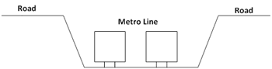

A real test should be done to determine the impact of the radio communication system on the surrounding area.
A more detailed analysis of path loss and link budget have to be done before releasing any document showing the sharing areas.

New work item: WAS/RLAN > 5925 MHz ?!

Transition?? Forced by ITS implementation

Principles
- The following principles should apply:- Uncompromised safety services for all users in case of multiple technologies implementation;
- - Technology neutrality of spectrum use (such as in the 5.9 GHz band for safety-related applications, pursuant to Commission Decision 2008/671/EC and the ECC Decision (08)01);
- - Efficient spectrum use (an overarching principle of Union's Radio Spectrum Policy, also encompassed in the provisions of the Radio Equipment Directive 2014/53/EU);
- No segmentation and segregation of the band 5875-5925 MHz. The principle of equal access to shared spectrum should be applied inn the spectrum regulation.
Fragmentation of the spectrum use in 5855-5925 MHz for ITS / Urban Rail should be avoided and no use be excluded from parts of the spectrum, i.e. shared use to be achieved.
The ECC Decision should be as technology-neutral as possible and should not impose the use of one technology. This does however not preclude the definitions describing the minimum requirements for common spectrum access. It should be emphasised that the principle of technology neutrality in the European spectrum regulations implies that any radio technology which can demonstrate conformance with the technical requirements for spectrum access can operate in 5855-5925 MHz.
The technical solution shall be consistent for sharing the band with an extension of RLAN if necessary, both CBTC and ITS being protected.
Urban Rail Systems should not be excluded from the future EC Decision.
Priorities for ITS or Urban Rail Systems should not be identified in the EC Decision and the ECC Decision. The technical solution is to be found in standardisation.
No update of ECC sharing reports should be required.
Backward spectrum compatibility implies that all technologies are at least capable to co-exist in the same frequency band. A long-term spectrum-efficient approach requires co-channel co-existence. Operation of the V2X and G5 technologies in the 5.9 GHz band and in the same geographic area without an agreed coexistence solution would result in mutually harmful co-channel interference.
Interoperability between ITS-G5 and LTE-V2X is currently not possible, meaning that a ITS-G5-only vehicle and an LTE-V2X-only vehicle cannot communicate with each other. However, the progressive introduction of connected vehicles – initially equipped only with ITS-G5 but later on also with LTE-V2X (and 5G) – raises the need to ensure interoperability of all connected vehicles on the road.
It is necessary to distinguish between spectrum co-existence which is needed amongst all technologies (V2X, G5, Urban Rail) and interoperability (only V2X and G5 for implementation considerations in the automotive market). The spectrum harmonisation for Urban Rail is motivated to achieve a bigger market in Europe while regional/metropolitan deployment does not necessarily need the harmonisation of frequencies for operational reasons or even interoperability aspects.

Concept for future regulation

Needs for the future Regulation in EC and ECC Decision

Need for revision of ECC Decision (08)01 and ECC Recommendation (08)01
Designation of ITS extension band (5905MHz to 5925MHz) is required.

Need for revision of the EC Decision 2008/671/EC
Designation of ITS extension band (5905MHz to 5925MHz) is required.
Urban Rail Systems should not be excluded from the EC Decision.
Considering that the 5.9 GHz ITS band is likely to be used by different technologies for safety-related systems (for road and rail such as ETSI ITS-G5, LTE-V2X and CBTC) each having their own merit, and observing the principle of technology neutrality, it is needed to expand the 5 875-5 905 MHz band by 20 MHz upwards and amend article 2(1) of Decision 2008/671/EC in order to expand the definition of ITS beyond road transportation.

Transition Period
May also include discussion about a possible transition period. A transition period could be needed before new technical solutions facilitating sharing would be available.
Impact on existing CBTC implementations.
Use of 5905-5925 already possible for CBTC (see existing implementations) on a national basis.

Need for inclusions in standards
Existing situation and need for additions, revisions, etc.
ETSI TR 103 442 v1.2.1 is considered as an interim report, and It is acknowledged that complementary studies are needed to find effective technical solutions for sharing spectrum. Therefore, ECC requested ETSI to continue the work which was developed by ETSI in order to:
- provide a detailed and agreed technical standard allowing practical implementation of both Urban Rail and ITS applications in the 5875-5925 MHz band;
- specify (a) technical solution(s) for the minimum requirements for common spectrum access;
- remain as far as possible technology neutral, but define a minimum set of common rules to ensure coexistence, also with respect of the safety level of the applications;
- take into account the need for CBTC which needs to be made compatible with ITS channels (10 MHz wide).

Discuss the options for technical solutions in standards (pros/cons) and related consequences

Prioritisation

Conclusions
Conclusions may review the main points of the ECC Report. A conclusion might elaborate on the results of the ECC Report and suggest extensions.

- Current Implementation status in CEPT
The current national implementation information for ECC Decision (08)01 is included in ERC Recommendation 70-03 annex 13 and in the EFIS database under: Link
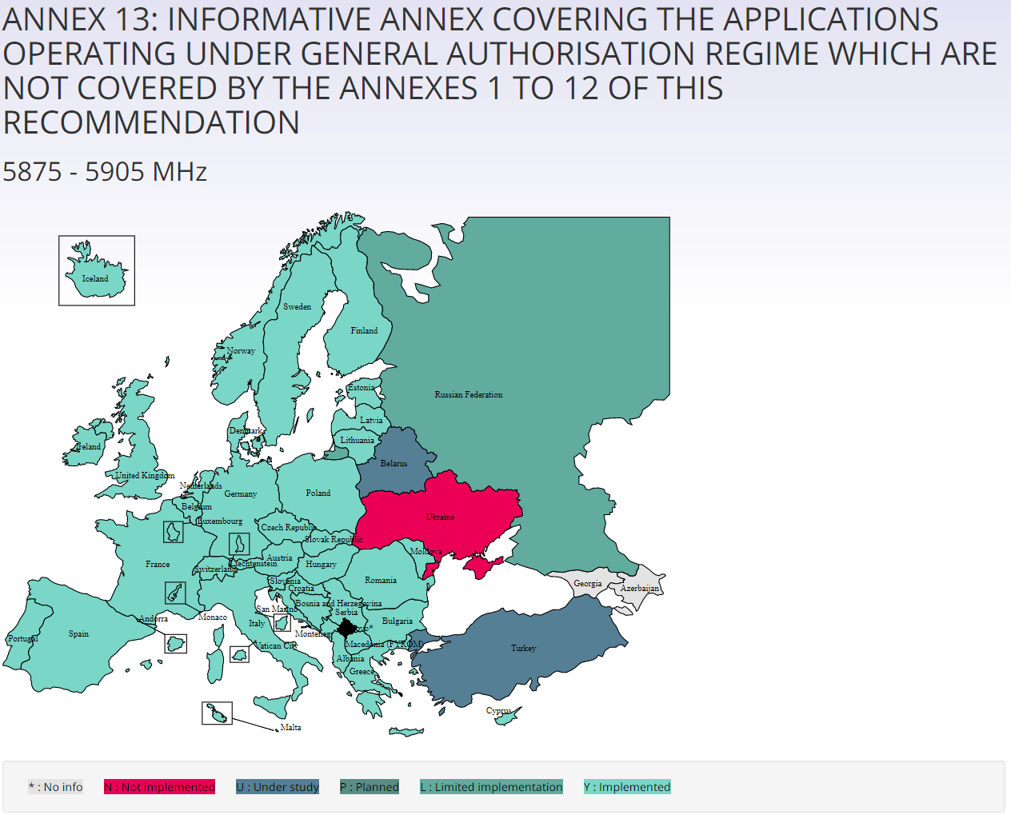
Figure X: Implementation of ECC Decision (08)01

- Throughput requirements for generic CBTC systems
  - Typical scenarios in CBT systems
There are three types of throughput requirement for generic CBTC systems:
- Throughput requirement for communication with one ZC (Zone Controller)
- Throughput requirement for communication with three ZC
- Throughput requirement for communication with three ZC and with Platform Screen Door (PSD) (worst case)
  - Typical scenArios
    - One Zone Controller
    - Two Zone Controllers

Train in the inter ZC area have to ensure a dialog with both ZC. This area depends highly on the kind of external signalization, but is typically as long as a complete interstation (a station - the distance to the next station - that next station)

    - Three Zone Controllers

  - Platform Screen Doors
Trains needs to establish a continuous dialog with the PSD Control unit at least 20s before entering the station, during in stay in station, and 10s after leaving the stations

  - THROUGHPUT REQUIREMENT FOR COMMUNICATION WITH ONE ZC
CBTC Application services Uplink Throughput requirements for one ZC

CBTC Application services | Period in ms | Average packet length in Bytes | Maximum packet length in Bytes | Packets/s | Throughput in Bits/s average | Throughput in Bits/s max
Location Report to one ZC | 200 | 200 | 800 | 5 | 8000 | 32000
Periodic Train Functional Status message | 300 | 500 | 1000 | 3.3333 | 13333 | 26667
On demand specific status message | 300 | 500 | 1000 | 3.3333 | 13333 | 26667
Total |  |  |  |  | 34666 | 85334

CBTC Application services Downlink Throughput requirements one ZC
CBTC Application services | Period in ms | Average packet length | Maximum packet length | Packet/s | Throughput in Bits/s average | Throughput in Bits/s max
Movement of authority from ZC | 600 | 200 | 1000 | 1.6666 | 2667 | 13333
Information about Line from ZC | 400 | 500 | 1400 | 2.50 | 10000 | 28000
Burst Traffic for Track data base update (File transfer) | 100 | 50 | 150 | 10 | 4000 | 12000
Request for Health train status | 500 | 50 | 100 | 2 | 800 | 1600
Total |  |  |  |  | 17467 | 54933
Note:
- These requirements are for one train cab meaning one channel.
- Each train transmits continuously on two independent channels the same information
- All the data flows have the same priority and need the same QoS
  - Throughput requirements for communication with three ZC
CBTC Application services Uplink Throughput requirements Three ZC
CBTC Application services | Period in ms | Average packet length in Bytes | Maximum packet length in Bytes | Packets/s | Throughput in Bits/s average | Throughput in Bits/s max
Location Report to one ZC | 200 | 200 | 800 | 5 | 8000 | 32000
Location Report to a second ZC | 200 | 200 | 800 | 5 | 8000 | 32000
location Report to a third ZC | 200 | 200 | 800 | 5 | 8000 | 32000
Periodic Train Functional Status message | 300 | 500 | 1000 | 3.3333 | 13333 | 26667
On demand specific status message | 300 | 500 | 1000 | 3.3333 | 13333 | 26667
Total |  |  |  |  | 50666 | 149334
Note:
- These requirements are for one train cab meaning one channel.
- Each train transmits continuously on two independent channels the same information
- All the data flows have the same priority and need the same QoS

CBTC Application services Downlink Throughput requirements for three ZC

CBTC Application services | Period in ms | Average packet length | Maximum packet length | Packets/s | Throughput in Bits/s average | Throughput in Bits/s max
Movement of authority from ZC | 600 | 200 | 1000 | 1.6666 | 2667 | 13333
Information about Line from ZC 1 | 400 | 500 | 1400 | 2.50 | 10000 | 28000
Information about Line from ZC 2 | 400 | 500 | 1400 | 2.50 | 10000 | 28000
Information about Line from ZC 3 | 400 | 500 | 1400 | 2.50 | 10000 | 28000
Burst Traffic for Track data base update (File transfer) | 100 | 50 | 150 | 10 | 4000 | 12000
Request for Health train status | 500 | 50 | 100 | 2 | 800 | 1600
Total |  |  |  |  | 37467 | 110933
Note:
- These requirements are for one train cab meaning one channel.
- Each train transmits continuously on two independent channels the same information
- All the data flows have the same priority and need the same QoS

  - Throughput requirements for communication with three ZC and PSD
CBTC Application services Uplink Throughput requirements Three ZC and PSD
CBTC Application services | Period in ms | Average packet length in Bytes | Maximum packet length in Bytes | Packets/s | Throughput in Bits/s average | Throughput in Bits/s max
Location Report to one ZC | 200 | 200 | 800 | 5 | 8000 | 32000
Location Report to a second ZC | 200 | 200 | 800 | 5 | 8000 | 32000
location Report to a third ZC | 200 | 200 | 800 | 5 | 8000 | 32000
Periodic Train Functional Status message | 300 | 500 | 1000 | 3.3333 | 13333 | 26667
On demand specific status message | 300 | 500 | 1000 | 3.3333 | 13333 | 26667
Platform Screen Door monitoring and control approaching, in station and leaving station | 100 | 50 | 150 | 10 | 4000 | 12000
Total |  |  |  |  | 54666 | 161334

Note:
- These requirements are for one train cab meaning one channel.
- Each train transmits continuously on two independent channels the same information
- All the data flows have the same priority and need the same QoS

CBTC Application services Downlink Throughput requirements three ZC and PSD
 | Period in ms | Average packet length | Maximum packet length | Packets/s | Throughput in Bits/s average | Throughput in Bits/s max
Movement of authority from ZC | 600 | 200 | 1000 | 1.6666 | 2667 | 13333
Information about Line from ZC 1 | 400 | 500 | 1400 | 2.50 | 10000 | 28000
Information about Line from ZC 2 | 400 | 500 | 1400 | 2.50 | 10000 | 28000
Information about Line from ZC 3 | 400 | 500 | 1400 | 2.50 | 10000 | 28000
Platform Screen Door | 100 | 50 | 200 | 10 | 4000 | 16000
Burst Traffic for Track data base update (File transfer) | 100 | 50 | 150 | 10 | 4000 | 12000
Request for Heath train status | 500 | 50 | 100 | 2 | 800 | 1600
Total |  |  |  |  | 41467 | 126933
Note:
- These requirements are for one train cab meaning one channel.
- Each train transmits continuously on two independent channels the same information
- All the data flows have the same priority

- CBTC legacy system
The system uses DSSS modulation (processing gain and hence, is more robust), the same is the case for Barcelona and Budapest. The operational frequencies are 5915-5935 MHz.
CBTC legacy systems may work differently from what is proposed for harmonisation and the full impact of these needs to be clarified and described.
Impact…
- List of Reference
- ETSI TR 103 111 V1.1.1: Electromagnetic compatibility and Radio spectrum Matters (ERM); System Reference document (SRdoc); Spectrum requirements for Urban Rail Systems in the 5.9 GHz range
- ECC Decision (08)01 of 3 July 2015 on the harmonised use of the 5875-5925 MHz frequency band for Intelligent Transport Systems (ITS)
- ECC Recommendation (08)01: Use of the band 5855-5875 MHz for Intelligent Transport Systems (ITS)
- ETSI TR 103 442 v1.2.1: Railways Telecommunications (RT); Shared use of spectrum between Communication Based Train Control (CBTC) and ITS applications
- Commission Decision 2008/671/EC of 5 August 2008 on the harmonised use of radio spectrum in the 5875-5905 MHz frequency band for safety-related applications of Intelligent Transport Systems (ITS)
- FM(15)094 Annex 41: Analysis of Urban Rail Systems in WGFM / SRD/MG
- CENELEC EN 50159 (2010): Railway applications - Communication, signalling and processing systems - Safety-related communication in transmission systems
- IEEE 1474.1TM-2004: IEEE Standard for Communications-Based Train Control (CBTC) Performance and Functional Requirements
- ETSI TR 102 638: Intelligent Transport Systems (ITS); Vehicular Communications; Basic Set of Applications; Definitions.
- ETSI EN 302 571 V2.1.1 (02-2017): Intelligent Transport Systems (ITS); Radiocommunications equipment operating in the 5855 MHz to 5925 MHz frequency band; Harmonised Standard covering the essential requirements of article 3.2 of Directive 2014/53/EU.
- ETSI EN 302 663: "Intelligent Transport Systems (ITS); Access layer specification for Intelligent Transport Systems operating in the 5 GHz frequency band.
- IEEE 802.11: IEEE Standard for Information technology--Telecommunications and information exchange between systems Local and metropolitan area networks--Specific requirements Part 11: Wireless LAN Medium Access Control (MAC) and Physical Layer (PHY) Specifications
- ECC Report 101: Compatibility studies in the band 5855–5925 MHz between Intelligent Transport Systems (ITS) and other systems
- ECC Report 109: The aggregate impact from the proposed new systems (ITS, BBDR and BFWA) in the 5725-5925 MHz band on the other services/systems currently operating in this band
- ECC Report 228: Compatibility studies between Intelligent Transport Systems (ITS) in the band 5855-5925 MHz and other systems in adjacent bands
- ECC Report 244: Compatibility studies related to RLANs in 5725-5925 MHz
- ETSI EN 302 665 V1.1.1: Intelligent Transport Systems (ITS); Communications Architecture.
- IEC 62290-1 Ed.2 (2014): Systems principles and fundamental concepts
- IEC 62290-2 Ed.2 (2014):Fundamental Requirements Specifications
- CEN-CENELEC Guide 26 Railway applications: Preparation of standards for urban rail systems design, construction, manufacture, operations and maintenance
- Directive (EU) 2016/797 of the European Parliament and of the Council of 11 May 2016 on the interoperability of the rail system within the European Union
- CENELEC EN 50126-1 (1999): The specification and demonstration of Reliability, Availability, Maintainability and Safety (RAMS) - Part 1: Basic requirements and generic process
- CEI EN 50128 (2011): Railway applications - Communication, Signalling and processing systems software for railway control and protection systems
- IEC 61508 Series (2010) (7 parts): Functional safety of electrical/electronic/programmable electronic safety-related systems
- EN 50129 (2003): Railway applications - Communication, signalling and processing systems - Safety-related electronic systems for signalling
- ETSI TS 103 518 on requirements for the shared use of spectrum for Urban Rail and ITS applications in the 5855-5925 MHz frequency band

See IEC 61508 Series (2010) (7 parts): Functional safety of electrical/electronic/programmable electronic safety-related systems [24].
Equivalent mitigation techniques, as defined in the relevant harmonised European standard ETSI EN 302 571, may also be used.
Directive 2013/35/EU of the European Parliament and of the Council of 26 June 2013 on the minimum health and safety requirements regarding the exposure of workers to the risks arising from physical agents (electromagnetic fields) (20th individual Directive within the meaning of Article 16(1) of Directive 89/391/EEC) and repealing Directive 2004/40/EC.

