Doc. SE(23)INFO002
ECC(23)005
94th WG SE meeting
Basel, Switzerland (Hybrid meeting), 5 – 9 June 2023
Date issued: |  | 11 May 2023
Source: |  | ECO
Subject: |  | ECO Bulletin on on-going/new issues in other regions or organisations – March 2023 edition
Group membership required to read? (Y/N)
N
 | Summary:
This ECO Bulletin provides a summary update on aspects of progress in spectrum management and numbering outside the CEPT. The items in this bulletin include:
1 Asia Pacific Region (APT)
1.1 China private 5G in 6 GHz and 26 GHz bands
1.2 Indonesia spectrum auction
1.3 South Korea 28 GHz licence withdrawal
1.4 Saudi Arabia NTN auction
2 Americas (CITEL)
2.1 USA
2.1.1 Radio altimeters 4.2-4.4 GHz
2.1.2 SpaceX Starlink second generation constellation FCC filings
2.2 Brazil authorisations for SpaceX constellations
3 Global developments
3.1 Direct satellite to cellular connectivity developments

It should be noted that the information is up-to-date at the time of writing (1 March 2023) based on available sources, and further developments may have occurred in the meantime.
 | Proposal:
WGSE is invited to note this Bulletin which was submitted to ECC#61 as ECC(23)005.

Most of the articles in this edition are noted for particular attention of WGSE, as highlighted below.
 | Background:
The ECO brings to each ECC meeting a bulletin on activities in radio communications and numbering in other regions outside CEPT, where a regulatory dimension is raised (e.g. by innovative services or technology).
The primary objective is to identify whether the ECC needs to investigate further or consider possible new actions. A secondary but more frequently addressed objective is to enable comparison to be made with the regulatory approach in other regions for subjects already treated by the ECC (including, where relevant, to the work of the CPG).

Asia Pacific Region (APT)

China private 5G in 6 GHz and 26 GHz bands
In late November the Chinese Ministry of Industry and Information Technology (MIIT) designated spectrum in the 6 GHz and 26 GHz bands for use by private 5G networks.
This covers 200 MHz from 5925—6125 MHz and 400 MHz from 24.75-25.15 GHz.
The first licence has been awarded to the passenger aircraft manufacturer Commercial Aircraft Corp of China (COMAC).
(For information in PT1, SE45)

Indonesia spectrum auction
The Indonesian Ministry of Communication and Informatics is reportedly planning to auction spectrum in the 700 MHz, 3.5 GHz and 26 GHz bands during Q1 2023. This would include 2x45 MHz at 700 MHz, 200 MHz at 3.5 GHz and 2.7 GHz at 26 GHz. The licences would be technology neutral, so that 4G or 5G could be used (particularly relevant at 700 MHz).
The 700 MHz band has become available following the recent completion of analogue switch-off in most parts of the country.
The Ministry also recently completed refarming of existing licences in the 2.1 GHz band to provide contiguous assignments between the 3 operators.
(For information in SE, PT1)

South Korea 28 GHz licence withdrawal
In late December the South Korean Ministry of Science and ICT cancelled the licences of 2 operators in the 28 GHz band – KT and Uplus – due to their failure to meet rollout obligations. The operators have reportedly only built 10% of the required number of base stations, and mobile devices supporting the band are not available in the South Korean market.
An exception was granted to allow the operators to continue to use the band to provide backhaul to a Wi-Fi service on the Seoul underground rail network.
A third operator, SK Telecom, had its licence duration shortened by 6 months, and it will lose its licence altogether if it doesn’t meet the rollout condition of 15,000 base stations by the end of May.
All 3 operators met the rollout conditions for the 3.5 GHz band (part of the same original award).
(For information in SE, PT1)

Saudi Arabia NTN auction
The Saudi Arabian auction of spectrum for NTN (non-terrestrial networks) in 1980-2010 MHz (downlink) and 2170-2200 MHz (uplink) concluded in early December 2023 with the main operator Saudi Telecommunication Company (STC) winning both licences.
STC is now required to provide nationwide mobile satellite services as well as to build an air-to-ground network covering the main national air routes.
(For information in PT1, FM44, SE40)

Americas (CITEL)

USA

Radio altimeters 4.2-4.4 GHz
In January the FAA issued a new Notice of Proposed Rulemaking setting out new minimum performance standards for radio altimeters which would be effective from 1 February 2024. The proposed requirements are specified as tolerance to interference EIRP PSD levels as a function of the aircraft’s height (see below), as well as an aggregate conducted base station spurious emission level of -48 MHz/MHz within the 4.2-4.4 GHz band. Aircraft operators with the most susceptible altimeters would need to either add filters or retrofit the equipment in order to meet these new requirements.
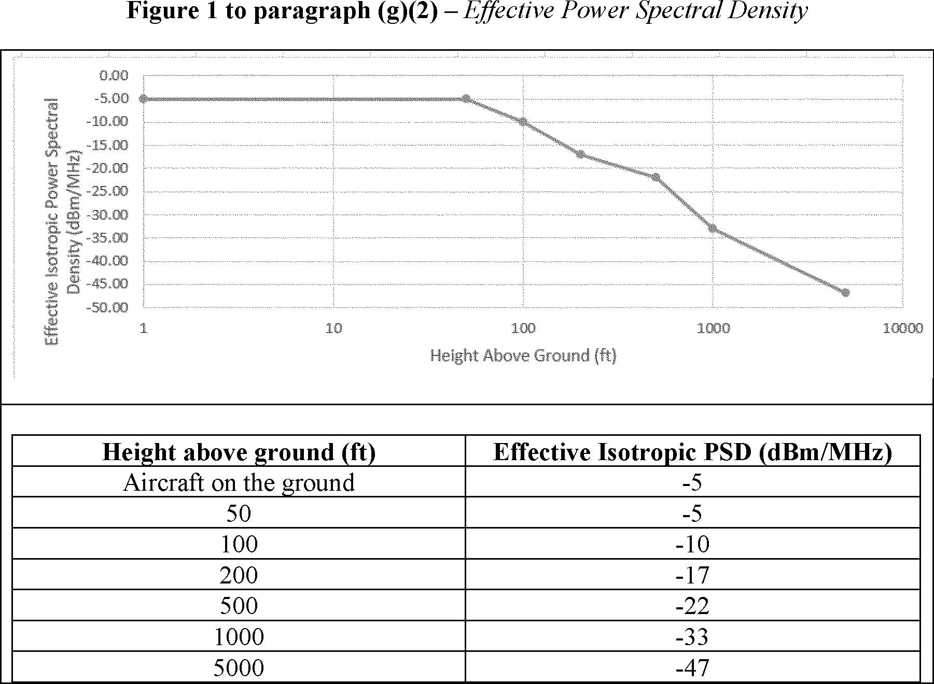
Comments were invited on the proposed rules until 10 February.
The new limits would supersede the existing restrictions requiring limitations on 5G deployments around airports, as reported in previous Bulletins.
(For information in PT1)

SpaceX Starlink second generation constellation FCC filings
In December 2022 the FCC approved part of SpaceX’s application for approval of its second generation of the Starlink constellation “Gen2”. The partial approval allows the operator to deploy a new constellation of up to 7500 satellites, whereas SpaceX had requested 29988 satellites. The approval covers frequencies for user links in the Ku Band (10.7-12.75 GHz space-Earth, 12.75-13.25 GHz and 14.0-14.5 GHz Earth-space) and both user and gateway links in Ka Band (18.8-19.3 GHz and 19.7-20.2 GHz space-Earth, 7.5-29.1 GHz and 29.5-30.0 GHz Earth-space), at altitudes of 525, 530 and 535 km and orbit inclinations of 53, 43 and 33 degrees respectively. Several conditions are attached to this approval, in particular related to EPFD limit compliance and orbital debris mitigation.
It is noted that SpaceX had previously received authorisation in 2018 for 7518 separate satellites to operate in the V-Band (37.5-52.4 GHz). However SpaceX now intends to incorporate these V-Band operations into the Gen2 constellation, and therefore the total number of authorised satellites will not increase.
The FCC deferred consideration of SpaceX’s request for access to E-Band frequencies (71-76 GHz space-Earth and 81-86 GHz Earth-space) for backhaul links and the use of tracking beacons in the VHF range at 137-138 MHz (Earth-to-space) and 148-150-05 MHz (space-Earth).
SpaceX has since requested and received special temporary authority for these VHF and E-Band operations to allow early launches of satellites with these capabilities while the full application is still being considered. The VHF operations are permitted for a period of 30 days with 15 satellites, and are planned for use in the orbit raising and early operation phase. The E Band operations are permitted for 60 days for the full approved constellation.
Launches of the first Gen2 satellites commenced in December using the existing v1.5 hardware, while the first launch of 21 upgraded “v2.0 Mini” satellites including the VHF and E-Band capability took place on 27 February.
(For information in FM44, SE40, CPG PTB)

Brazil authorisations for SpaceX constellations
In February the National Telecommunications Agency (Anatel) granted satellite usage rights to SpaceX for both the Starlink and Swarm constellations.
Starlink is granted rights to provide services from its 4408 first generation satellite NGSO constellation to provide broadband internet access in Brazil until March 28, 2027, without right to protection and without causing harmful interference to the Kepler NGSO system in Ku band or the O3b NGSO system in Ka band.
Swarm is granted rights to explore and use radio frequencies for its 150 satellite IoT NGSO constellation until September 7, 2035.
According to Anatel's determination, any change in the number of satellites of non-geostationary systems will require a new authorisation by the Agency.
(For information in FM44, SE40, PTB)

Global developments

Direct satellite to cellular connectivity developments
Several new players have announced intentions to enter the direct satellite to cellular connectivity market, further to those reported in the previous Bulletins.
In January Qualcomm and Iridium announced a partnership to enable emergency messaging from handsets using the new Snapdragon Satellite chipset connecting via the Iridium L-Band network. Emergency messaging is planned to be made available from the second half of 2023. Garmin also plans to join this collaboration in order to extend its existing emergency messaging capabilities. It is noted that the Iridium frequencies of 1610-1626.5 MHz are outside the initial 3GPP NTN (not-terrestrial networks) range for L-Band, so this is a proprietary solution, however Qualcomm has indicated it plans to support the NTN ecosystem in future.
In late February Samsung also announced that it will integrate 3GPP compliant NTN modem technology into its Exnyos chipset range, which will support two-way text messaging as well as high-definition image and video sharing. The company also indicated it plans to support NB-IoT NTN in a future design.
Also in late February Omnispace and Ligado announced a collaboration to combine their MSS networks in order to provide NTN direct-to-device connectivity. This would include portions of Ligado’s L-Band spectrum in 1525-1559 MHz and 1626.5-1660.5 MHz in the US and Canada, as well as Omnispace’s S-Band spectrum (1980-2010 MHz and 2170-2200 MHz). These bands are standardised for NTN in 3GPP Release 17 (bands n255 and n256).
Echostar has also announced it intends to build 28 LEO satellites in the 2 GHz range with both LoRa and NTN support to provide satellite based IoT connectivity. The satellites will be manufactured by Astro Digital and are planned for launch in 2024.
(For information in WGFM, SE, SE40, FM44, PT1)

