ECC Recommendation (16)03

Cross-border coordination for Broadband Public Protection and Disaster Relief (BB-PPDR) systems in the frequency band 698 to 791 MHz
approved 17 October 2016

introduction
ECC/DEC/(16)02 establishes the harmonised technical conditions and frequency bands for implementing Broadband Public Protection and Disaster Relief (BB-PPDR) systems. For BB-PPDR FDD systems, the following frequency bands may be used: 698–703 MHz/753–758 MHz, parts of 703–733 MHz/758–788 MHz, and 733–736 MHz/788–791 MHz.
This Recommendation contains provisions for cross-border coordination between Broadband Public Protection and Disaster Relief (BB-PPDR) for the frequency bands above in order to avoid harmful interference.
It also covers Wideband (WB) vs. Wideband systems cross-border coordination scenarios but does not address cross-border coordination of BB-PPDR vs. other systems in these bands.
Wideband systems include Long Term Evolution (LTE) and New Radio (NR).

ECC RECOMMENDATION (16)03 OF 17 OCTOBER 2016 ON CROSS-BORDER COORDINATION FOR BROADBAND PUBLIC PROTECTION AND DISASTER RELIEF (BB-PPDR) SYSTEMS IN THE FREQUENCY BAND 698 to 791 MHz, AMENDED DD MM YYYY

“The European Conference of Postal and Telecommunications Administrations,
considering
- that ECC/DEC/(16)02 [1] provides the harmonised technical conditions and frequency bands for the implementation of Broadband Public Protection and Disaster Relief (BB-PPDR) systems;
- that there is a need for threshold levels which will trigger co-ordination between neighbouring countries;
- that each new frequency assignment above the defined coordination threshold level must be coordinated with frequencies already assigned in the same geographical area for use by the stations of neighbouring administration(s);
- that to ensure the service coverage in border areas, coordination or bilateral agreements / arrangements are likely to be required, also to facilitate cross-border operations;
- that ECC/DEC/(15)01 [2] provides the harmonised technical conditions for mobile/fixed communications networks (MFCN) in the band 694-790 MHz including a paired frequency arrangement (Frequency Division Duplex 2x30 MHz) and an optional unpaired frequency arrangement (Supplemental Downlink);
- that the ECC/REC/(15)01 [3] provides guidance to CEPT administrations on cross-border coordination for mobile / fixed communications networks (MFCN) in, amongst others, the frequency band 694-791 MHz;
- that in some CEPT countries the frequency band 694-790 MHz may be used for terrestrial broadcasting services. The implementation of the 700 MHz frequency arrangement by administrations will require coordination with any other administration whose broadcasting service and/or other primary terrestrial services are considered to be affected. For coexistence with broadcasting, the coordination procedure will take into account the framework of the GE-06 agreement;
- that guidance on cross-border coordination for BB-PPDR systems in the 450-470 MHz frequency band is provided in Recommendation T/R 25-08 [4];
- that frequency planning of land mobile systems in border areas will be based on coordination between administrations in cooperation with their operators;
- that different administrations may wish to adopt different approaches to cross-border coordination;
- that PPDR is a sovereign national matter and that each CEPT administration shall decide on a national basis how much spectrum and which specific frequency ranges should be designated for BB-PPDR radio systems within harmonised tuning ranges;
- that administrations may diverge from the technical parameters, propagation models and procedures described in this Recommendation subject to bilateral / multilateral agreements;
- that coordination is necessary between countries operating different technologies and different channel bandwidths in the same frequency band;
- that in the case of operator arrangements approved by administrations it is possible to deviate from this Recommendation;
- that Physical-layer Cell Identifier (PCI) coordination is necessary for LTE/NR systems to avoid unnecessary signalling load and handover failures;
- that only non-AAS base stations are covered by this Recommendation.
recommends
- that cross-border coordination between BB-PPDR systems and BB-PPDR systems with other land mobile systems, i.e. MFCN, PMSE, M2M operating in the 700 MHz range, should be based on bilateral / multilateral agreements between administrations;
- that cross-border coordination between BB-PPDR systems and other systems in neighbouring countries should be based on bilateral / multilateral agreements between administrations;
- that bilateral / multilateral agreements should define coordination methods which encompass all land mobile system radio interfaces present on each side of the border;
- that cross-border operation between BB-PPDR systems as well as BB-PPDR and other land mobile systems should be based on the principles and the field strength limits provided in Annex 1;
- that interference field strength predictions should be made using the appropriate propagation models defined in Annex 2;
- that if the levels in Annex 1 are exceeded the coordination is required and the procedure detailed in Annex 3 should be used;
- that cross-border coordination between neighbouring BB-PPDR and other land mobile systems using LTE/NR technology should use the PCIs provided in Annex 4 when synchronisation signal centre frequencies are aligned;

- that administrations should encourage and facilitate the establishment of arrangements between operators in different countries with the aim to enhance the efficient use of the spectrum and to optimise the coverage/throughput in their respective border areas;
- that coordination in coastal areas is based on prediction of field strength levels at the coastline of the neighbouring country while other principles for coordination in coastal areas may be agreed between the administrations concerned.”

Note:
Please check the ECO Documentation Database http://www.docdb.cept.org for the up to date position on the implementation of this and other ECC Recommendations.
- Field strength levels for the cross-border operation without coordination between BB-PPDR and other land mobile systems
  - Field strength levels for the cross-border operations for the 698-791 MHz frequency band
Non-AAS base stations of BB-PPDR FDD systems on both sides of the borderline in respective frequency bands with synchronisation signal centre frequencies not aligned for all PCIs or with synchronisation signal centre frequencies aligned and for preferential PCIs may be used without coordination with a neighbouring country if the mean field strength of each cell produced by the BB-PPDR base station does not exceed the value of:
- 59 dBµV/m/5 MHz at a height of 3 m above ground level at the borderline between concerned countries and
- 41 dBµV/m/5 MHz at a height of 3 m above ground level at a distance of 6 km inside the neighbouring country.
Non-AAS base stations of BB-PPDR FDD systems on both sides of the borderline in respective frequency bands with synchronisation signal centre frequencies aligned and for non-preferential PCIs may be used without coordination with a neighbouring country if the field strength of each cell produced by base station does not exceed the value of:
- 41 dBµV/m/(5 MHz) at a height of 3 m above ground at the borderline between neighbouring countries.
Table 1 gives an overview of the field strength values.
Table 1: Field strength values at a height of 3 m above ground between wideband systems
Wideband system vs. Wideband system
Synchronisation signal centre frequencies  aligned |  | Synchronisation signal centre frequencies  not aligned
Preferential PCIs | Non-preferential PCIs | All PCIs
59 dBμV/m/(5 MHz) @ 0 km  and  41 dBμV/m/(5 MHz) @ 6 km | 41 dBμV/m/(5 MHz) @ 0 km | 59 dBμV/m/(5 MHz) @ 0 km  and  41 dBμV/m/(5 MHz) @ 6 km
@ stands for “at a distance from the borderline into the neighbouring country”
For NR base station the values in this table correspond to the following SSB values:
- 59 dB(μV/m)/5 MHz corresponds to 37 dB(µV/m)/30 kHz,
- 41 dB(μV/m)/5 MHz corresponds to 19 dB(µV/m)/30 kHz
For field strength predictions the calculations should be made according to Annex 2. In cases of other frequency block sizes 10 x Log10 (frequency block size/5 MHz) should be added to the field strength values.
- PROPAGATION MODELS
The following methods are proposed for assessment of anticipated interference inside neighbouring country based on established trigger values. Due to complexity of radiowave propagation nature different methods are proposed to be considered by administrations and are included here for guidance purposes only.
It should be noted that following methods provide theoretical predictions based on available terrain knowledge. It is practically impossible to recreate these methods with measurement procedures in the field. Therefore only some approximation of measurements could be used to check compliance with those methods based on practical measurement procedures. The details of such approximation are not included in this recommendation and should be negotiated between countries based on their radio monitoring practices.
Path specific model
Where appropriate detailed terrain data is available, the propagation model for interference field strength prediction is the latest version of Recommendation ITU-R P.452 [5]. For the relevant transmitting terminal, predictions of path loss would be made at x km steps along radials of y km at z degree intervals. The values for those receiver locations within the neighbouring country would be used to construct a histogram of path loss – and if 10% of predicted values exceed the threshold the station shall be required to be coordinated.
Values for x, y and z are to be agreed between the administrations concerned.
Site General model
If it is not desirable to utilise detailed terrain height data for the propagation modelling in the border area, the basic model to be used to trigger coordination between administrations and to decide, if coordination is necessary, is Recommendation ITU-R P.1546 [6]. This model is to be employed for 50% locations, 10% time and using a receiver height of 3 m.
For specific reception areas where terrain roughness adjustments for improved accuracy of field strength prediction are needed, administrations may use correction factors according to terrain irregularity and/or an averaged value of the terrain clearance angle (TCA) parameter in order to describe the roughness of the area on and around the coordination line.
Administrations and/or operators concerned may agree to deviate from the aforementioned model by mutual consent.
Area calculations
In the case where greater accuracy is required, administrations and operators may use the area calculation below.
For calculations, all the pixels of a given geographical area to be agreed between the Administrations concerned in a neighbouring country are taken into consideration.
For the relevant base station, predictions of path loss should be made for all the pixels of a given geographical area from a base station and at a receiver antenna height of 3 m above ground.
For evaluation,
- only 10 percent of the number of geographical area between the borderline (including also the borderline) and the 6 km line itself inside the neighbouring country may be interfered by higher field strength than the trigger field strength value given for the borderline in Annex 1 at a height of 3 m above ground;
- only 10 percent of the number of geographical area between the 6 km (including also 6 km line) and 12 km line inside the neighbouring country may be interfered by higher field strength than the trigger field strength value given for the 6 km line in Annex 1 at a height of 3 m above ground.
It is recommended that during area calculations not only detailed terrain data but also clutter data be taken into account. Use of correction factors for clutter is crucial in particular where the border area is ‘open’ or ‘quasi-open’ from the point of view of clutter or where the interfering base station is just a few kilometres from a borderline.
If the distance between a base station and a terrain point of a borderline is closer than or equal to 1 km, free space propagation model needs to be applied. Furthermore, if there is no terrain obstacle within the 1st Fresnel zone,” also the free space propagation model should be applied.
If clutter data is not available, it is proposed to extend the usage of free space propagation model to a few kilometres, depending on the clutter situation in border areas.
For area type interference calculations, propagation models with path specific terrain correction factors are recommended (e.g. Recommendation ITU–R P.1546 [6] with the terrain clearance angle correction factor TCA, HCM method with the terrain clearance angle correction factor or Recommendation ITU–R P.1812 [8]).
As to correction factors for clutters ‘open area’ and ‘quasi-open area’, 20 dB and 15 dB should be used respectively. Recommendation ITU–R P.1406 [9] should be used if a finer selection of clutter is required. It must be noted that terrain irregularity factor Δh is not recommended to be used in area calculations. Administrations and/or operators concerned may agree to deviate from the aforementioned models by mutual consent.

- Coordination Procedure
When requesting coordination the relevant characteristics of the base station should be forwarded to the Administration affected. All of the following characteristics should be included:
- channel centre frequency (MHz);
- synchronisation signal centre frequency (MHz), if differs from centre frequency
- channel bandwidth (MHz)
- subcarrier spacing (kHz) (only for NR)
- name of transmitter station;
- country of location of transmitter station;
- geographical coordinates (W/E, N; WGS84);
- effective antenna height (m);
- antenna polarisation;
- antenna azimuth (deg);
- directivity in antenna systems or antenna gain (dBi);
- effective radiated power (dBW);
- expected coverage zone or cell range (km);
- date of entry into service (month, year);
- PCI numbers used (only for LTE and NR);
- antenna tilt (electrical and mechanical (deg));
- antenna pattern or envelope.
The Administration affected shall evaluate the request for coordination and shall within 30 days notify the result of the evaluation to the Administration requesting coordination.
If in the course of the coordination procedure an Administration may request additional information.
If no reply is received by the Administration requesting coordination within 30 days it may send a reminder to the Administration affected. An Administration not having responded within 30 days following communication of the reminder shall be deemed to have given its consent and the station may be put into use with the characteristics given in the request for coordination.
The periods mentioned above may be extended by common consent.

- PHYSICAL-LAYER CELL IDENTITIES (PCI) FOR LTE and NR

ETSI TS 136 211 [11] defines 168 “unique physical-layer cell-identity groups” in §6.11, numbered 0..167, hereafter called “PCI groups” for LTE. Within each PCI group there are three separate PCIs giving 504 PCIs in total.
ETSI TS 138 211 [12] defines NR Physical channels and modulation, in NR 2-step identification using PSS/SSS detection of the Physical Cell ID (same as LTE), the number of different cell IDs has been increased from 504 in LTE to 1008 for NR.
Administrations should apply sharing of PCIs in border areas, on an equitable distribution of these PCIs when synchronisation signal centre frequencies are aligned as provided in Table 2.
Sharing of PCIs between operators of neighbouring countries should only be applied where synchronisation signal centre frequencies used in the neighbouring countries are aligned independent of the channel bandwidth or where it is not known whether or not the synchronisation signal centre frequencies used in the neighbouring countries are aligned, or where there is no network in operation in the neighbouring country unless otherwise stated in Annex 1 or administration/operator agreements/arrangements.

As shown in Table 2, the PCIs for LTE and NR are divided into 6 sub-sets containing each one sixth of the available PCIs. Each country is allocated three sets (half of the PCIs) in a bilateral case and two sets (one third of the PCIs) in a trilateral case, therefore dividing the PCI groups or PCIs is equivalent.
The preferential PCIs of a two country PCI sharing should be applied for a base station if the level of field strength relating to non-preferential PCIs could be exceeded at the borderline of only one neighbouring country. The preferential PCIs of a three country PCI sharing should be applied for a base station if the level of field strength related to non-preferential PCIs could be exceeded at the borderline of only two neighbouring countries.
Four types of countries are defined in a way such that no country will use the same code set as any one of its neighbours. The following lists describe the distribution of European countries:
Type country 1: AZE, BEL, CVA, CYP, CZE, DNK, E, FIN, GRC, IRL, ISL, LTU, MCO, SMR, SRB, SUI, SVN and UKR;
Type country 2: AND, BIH, BUL, D, EST, G, GEO, HNG, I and MDA;
Type country 3: ALB, AUT, F, HOL, HRV, MLT, POL, POR, ROU and S;
Type country 4: LIE, LUX, LVA, MKD, MNE, NOR, SVK and TUR.
(Note: Country type map can be found in the figure below).
For each type of country, the Table 2 and Figure 1 describe the sharing of the PCIs with its neighbouring countries, with the following conventions of writing:
Preferential PCI
non-preferential PCI

Table 2: PCI sub-sets for LTE and NR for use in border areas when synchronisation signal centre frequencies are aligned
PCI | Set A | Set B | Set C | Set D | Set E | Set F |  | PCI | Set A | Set B | Set C | Set D | Set E | Set F
Country 1 LTE | 0..83 | 84..167 | 168..251 | 252..335 | 336..419 | 420..503 |  | Country 2 LTE | 0..83 | 84..167 | 168..251 | 252..335 | 336..419 | 420..503
Country 1 NR | 0..83  504-587 | 84..167  588..671 | 168..251  672..755 | 252..335  756..839 | 336..419  840..923 | 420..503  924..1007 |  | Country 2 NR | 0..83  504-587 | 84..167  588..671 | 168..251  672..755 | 252..335  756..839 | 336..419  840..923 | 420..503  924..1007
Border 1-2 |  |  |  |  |  |  |  | Border 2-1
Zone 1-2-3 |  |  |  |  |  |  |  | Zone 2-3-1
Border 1-3 |  |  |  |  |  |  |  | Border 2-3
Zone 1-2-4 |  |  |  |  |  |  |  | Zone 2-1-4
Border 1-4 |  |  |  |  |  |  |  | Border 2-4
Zone 1-3-4 |  |  |  |  |  |  |  | Zone 2-3-4
PCI | Set A | Set B | Set C | Set D | Set E | Set F |  | PCI | Set A | Set B | Set C | Set D | Set E | Set F
Country 3 LTE | 0..83 | 84..167 | 168..251 | 252..335 | 336..419 | 420..503 |  | Country 4 LTE | 0..83 | 84..167 | 168..251 | 252..335 | 336..419 | 420..503
Country 3 NR | 0..83  504-587 | 84..167  588..671 | 168..251  672..755 | 252..335  756..839 | 336..419  840..923 | 420..503  924..1007 |  | Country 4 NR | 0..83  504-587 | 84..167  588..671 | 168..251  672..755 | 252..335  756..839 | 336..419  840..923 | 420..503  924..1007
Border 3-2 |  |  |  |  |  |  |  | Border 4-1
Zone 3-1-2 |  |  |  |  |  |  |  | Zone 4-1-2
Border 3-1 |  |  |  |  |  |  |  | Border 4-2
Zone 3-1-4 |  |  |  |  |  |  |  | Zone 4-2-3
Border 3-4 |  |  |  |  |  |  |  | Border 4-3
Zone 3-2-4 |  |  |  |  |  |  |  | Zone 4-3-1

Notes
1) All PCIs are available in areas away from the border.
2) In certain specific cases (e.g. AUT/HRV) where the distance between concerned countries of the same type number is very small (< few 10s km), it may be necessary to address the situation in bilateral /multilateral coordination agreements as necessary, and may include further subdivision of the allocated codes in certain areas.

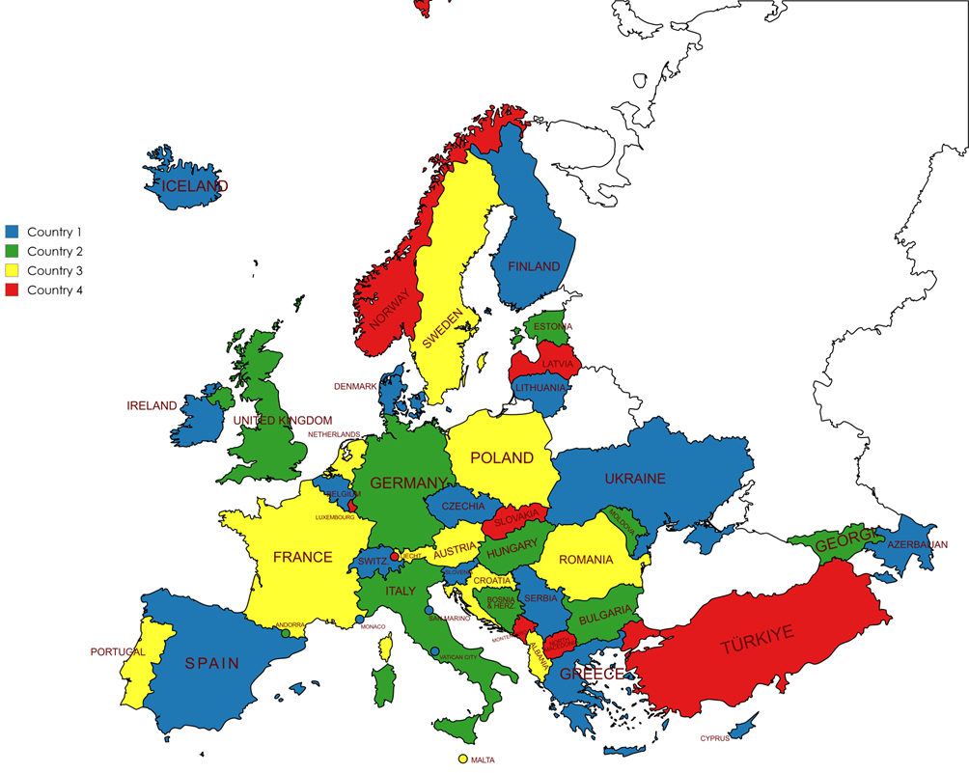
- Country type map

- List of references

- ECC Decision (16)02: “The harmonised technical conditions and spectrum bands for the implementation of European Broadband Public Protection and Disaster Relief (BB-PPDR) systems”, approved June 2016, amended March 2019
- ECC Decision (15)01: “The harmonised technical conditions for mobile/fixed communications networks (MFCN) in the band 694-790 MHz including a paired frequency arrangement (Frequency Division Duplex 2x30 MHz) and an optional unpaired frequency arrangement (Supplemental Downlink)”, approved March 2015
- ECC Recommendation (15)01: “Cross-border coordination for Mobile/Fixed Communications Networks (MFCN) in the frequency bands: 694-790 MHz, 1427-1518 MHz and 3400-3800 MHz”, approved February 2015, latest amended June 2022
- Recommendation T/R 25-08: “Planning criteria and coordination of frequencies for land mobile systems in the range 29.7-470 MHz”, approved January 1990, latest amended June 2025
- Recommendation ITU-R P.452: “Prediction procedure for the evaluation of interference between stations on the surface of the Earth at frequencies above about 0.1 GHz”
- Recommendation ITU-R P.1546: “Method for point-to-area predictions for terrestrial services in the frequency range 30 MHz to 4 000 MHz”
- HCM Agreement: https://hcm.bundesnetzagentur.de/http/englisch/verwaltung/index_europakarte.htm
- Recommendation ITU-R P.1812: “A path-specific propagation prediction method for point-to-area terrestrial services in the VHF and UHF bands”
- Recommendation ITU-R P.1406: “Propagation effects relating to terrestrial land mobile and broadcasting services in the VHF and UHF bands”
- Resolution 906 (WRC-12): “Electronic submission of notice forms for terrestrial services to the Radiocommunication Bureau and exchange of data between administrations”
- ETSI TS 136 211: “LTE; Evolved Universal Terrestrial Radio Access (E-UTRA); Physical channels and modulation”
- ETSI TS 138 211: “5G; NR; Physical channels and modulation”

Synchronisation signal means Synchronisation Signal Block (SSB) for 5G NR and Primary/Secondary Synchronisation Signal (PSS/SSS) for LTE.
e.g. as used by members of the HCM-Agreement [6]

