Feasibility of spectrum sharing between High-Definition Ground Based Synthetic Aperture Radar (HD-GBSAR) application using 1 GHz bandwidth within 74-81 GHz and existing services and applications
approved DD Month YYYY
ECC Report 315

Executive summary
This Report evaluates the compatibility between High Definition - Ground Based Synthetic Aperture Radar (HD-GBSAR) applications [1], requiring 1 GHz of operating bandwidth within the frequency range 74-81 GHz, and existing services and applications operating in the candidate bandwidth identified as possible victims of interference from HD-GBSAR. The technical information, deployment scenario and market size of HD-GBSAR used in the compatibility study are based on ETSI SRdoc TR 103 594 [1].
The HD-GBSAR is a highly-specialised professional application to be used for safety-critical deformation monitoring of natural as well as man-made objects and structures. The HD-GBSAR would allow achieving up to 5 times improvement of resolution performance while providing 4 times reduction of device size, compared with the first generation GBSAR used in 17.1-17.3 GHz [2].
HD-GBSAR market forecast [1] shows that this will be a niche application with the total HD-GBSAR demand in the foreseeable future not expected to exceed 500 units for the entire CEPT area. Significant proportion of those units would be used in terrain shielded (quarries) and underground (mines and tunnels) scenarios, leading to attenuation of EM emissions from the HD-GBSAR. The report does not provide coexistence analysis for such scenarios, given the extremely low likelihood of harmful interference with existing services and applications. However, a fraction of HD-GBSAR units may be used in open environments, such as for structural health monitoring of compromised buildings, where they could potentially interact with other radio spectrum users. Three possible frequency bands of 1 GHz have been examined for the HD-GBSAR operation in this Report (section 3):
- 74-75 GHz;
- 76-77 GHz;
- 77-78 GHz.
This Report addresses the spectrum sharing between HD-GBSAR and existing users for each of the three identified candidate bands, to determine the most suitable option minimising the risk of harmful interference towards existing services and applications.
Because of the very low HD-GBSAR expected average deployment density (Table 4: Estimated European HD-GBSAR market size for 5 years period [1]), the case of multiple HD-GBSAR operating in the same area may be considered unrealistic, therefore all the coexistence studies have been conducted by using the Minimum Coupling Loss method, to evaluate the range beyond which an HD-GBSAR would not impact the performance of the victim receiver. The outcomes of the analysis are summarised in the following table, which shows for each candidate frequency band the considered victim band user and the sharing evaluation conclusion.
Table 1: Summary outcome of sharing analysis
Candidate Band | Interfered Service or Application | Section | Conclusion
74-75 GHz | FS | 4.5.1 | The study was performed on three possible worst-case interference scenarios (A, B and C), all related to the urban environment. The MCL analysis indicates the risk of harmful interference from HD-GBSAR for all the three interference scenarios and the case C, where the FS is installed in LOS to the GBSAR but not on the SHM-surveyed building, appears to be the most critical with a worst-case minimum separation distance of about 90 km. The distance is problematic as the number of FS in this frequency range is constantly growing and information about the locations of the FS is not available, i.e. establishing exclusion zone is not possible.  The above high MCL value could be drastically reduced if the boresight of the FS antenna is not pointing in the direction of the GBSAR, as analysed in ANNEX 7.  As there is a large amount and a FS links in this frequency range and the location and pointing direction is seldomly known a statistical evaluation would be needed for estimation of the probability of interference.  This Report does not provide such statistical evaluation; therefore, it shall be considered the worst-case analysis conclusion.
 | Space Research Service | 4.5.2 | The MCL analysis, performed assuming direct LOS between HD-GBSAR and victim receiver, provides a minimum separation distance of around 1600 m.  The presence of an HD-GBSAR at such distance from an SRS victim receiver can be considered extremely unlikely. Therefore, it may be assumed no relevant concern of coexistence between HD-GBSAR and SRS.
 | RAS operating in the adjacent bands | 4.5.3 | The MCL analysis provides a residual risk of interference, in case HD-GBSAR is located at a distance closer than 6.3 km from the radio astronomy station. The probability of such condition is extremely low, however the adoption of a circular exclusion zone for HD-GBSAR around the radio astronomy station listed in ANNEX 3 with a radius of 6.3 km would avoid any risk of interference.
76-77 GHz | Automotive Radar SRD | 4.6.1 | The coexistence studies considered the possible interference between HD-GBSAR and automotive radar used for front and corner applications in urban environment.  The MCL analysis indicates the risk of harmful interference, especially for automotive radar used for front applications (CAS and ACC). The implementation on HD-GBSAR of a Detect and Avoid (DAA) system (ANNEX 6), capable to detect automotive radar signals and to timely stop HD-GBSAR transmission, in case of automotive radar detection, would allow the coexistence between the two applications.
 | LPR | 4.6.2 | No risk of harmful interference.
 | Rotorcraft Radar | 4.6.3 | The coexistence study indicates a residual risk of interference, in case of an HD-GBSAR monitoring a building with a rooftop heliport. Because of the very low probability of occurrence of such scenario, it may be concluded a not significant risk of interference.
 | TTT Fixed Radar | 4.6.4 | The MCL analysis result provides a minimum separation distance of 50 m. The extremely low likelihood to have an HD-GBSAR and a victim receiver at such distance, it indicates the absence of relevant risk of harmful interference.
 | ODR at railway level crossing | 4.6.5 | The available information about Obstruction Detection Radar (ODR) operating at railway level crossing does not allow an accurate compatibility study analysis.  Nevertheless, because of the low number of possible interference situations combined with the low expected number of deployed HD-GBSAR, it can be inferred an extremely low likelihood of interference.
 | AS and ASS | 4.6.6 | No risk of harmful interference.
 | RAS | 4.6.7 | The sharing analysis indicates the risk of harmful interference, in case of an HD-GBSAR operating at a distance shorter than 157 km from the victim RAS receiver and assuming free line of sight.  A reasonable protection criteria is represented by the definition of a circular exclusion zone for HD-GBSAR around the radio astronomy station with a radius of 157 km. ANNEX 3 reports the list of radio astronomy station in CEPT countries operating in the 76-81 GHz frequency range, for which the exclusion zone shall be respected.
 | FS operating in the adjacent bands | 4.6.9 | No risk of harmful interference assuming and HD-GBSAR out of band e.i.r.p. limit of 0 dBm.
 | RAS operating in the adjacent bands | 4.6.8 | The MCL analysis provides a residual risk of interference, in case HD-GBSAR is located at a distance closer than 6.3 km from the radio astronomy station. The probability of such condition is extremely low, however the adoption of a circular exclusion zone for HD-GBSAR around the radio astronomy station listed in ANNEX 3 with a radius of 6.3 km would avoid any risk of interference.
77-78 GHz | Automotive SRR | 4.7.1 | The sharing analysis (based on the same interference scenario based for the 76-77 GHz candidate band) shows the risk of harmful interference, especially for automotive radar used for front applications (CAS and ACC). The implementation of a Detect and Avoid (DAA) system (Annex 6) on HD-GBSAR capable to detect the relevant automotive radar signals and to timely stops HD-GBSAR transmission in case of automotive radar detection would allow for coexistence between the two applications.
 | LPR | 4.7.2 | No risk of harmful interference.
 | AS and ASS | 4.7.3 | No risk of harmful interference.
 | RAS | 4.7.4 | As for the band 76-77 GHz, HD-GBSAR harmful interference is prevented by defining a circular exclusion zone with a radius of 157 km around the radio astronomy stations listed in ANNEX 3.
 | RAS operating in the adjacent bands | 4.7.5 | The MCL analysis provides a residual risk of interference, in case HD-GBSAR is located at a distance closer than 6.3 km from the radio astronomy station. The probability of such condition is extremely low, however the adoption of a circular exclusion zone for HD-GBSAR around the radio astronomy station listed in ANNEX 3 with a radius of 6.3 km would avoid any risk of interference.
 | FS operating in the adjacent bands | 4.7.6 | No risk of harmful interference assuming and HD-GBSAR out of band e.i.r.p. limit of 0 dBm.
As an overall conclusion, the analysis provided in this Report gives the following operational conditions and technical requirements that would allow HD-GBSAR deployment either in the 76-77 GHz or the 77-78 GHz frequency bands so as to protect existing services and applications:
- maximum radiated power: 48 dBm (e.i.r.p);
- maximum power at the transmitter antenna input of 24 dBm;
- operating channel bandwidth: 1000 MHz;
- antenna pattern requirement as defined in section 2.1 (equation 1 and 2);
- a circular exclusion zone with a radius of 157 km around the radio astronomy stations listed in ANNEX 3 , in case of potential free line of sight between HD-GBSAR and radio astronomy station;
- implementation of a DAA spectrum access system capable to detect automotive radar signals in any part of the frequency band used by the HD-GBSAR to timely stop the HD-GBSAR transmissions in the presence of static or moving automotive radars potentially interfered (ANNEX 6). ANNEX 6 provides a description of the DAA system. The required DAA detection threshold and automotive radar signal characteristics to be considered are presented in section 4.6.1.3 and section 4.7.1.
The last two requirements related to RAS exclusion zone and DAA are applicable only in case of outdoor use of HD-GBSAR, excluding underground mine and tunnel in construction environment.

TABLE OF CONTENTS

0 Executive summary 2
1 Introduction 10
2 Description of HD-GBSAR application 11
2.1 Technical description 11
2.2 Deployment scenarios 15
3 Overall sharing considerations across the range 74-81 GHz 17
3.1 Overview of band use 17
4 Considered victim services and applications 18
4.1 74-75 GHz band victim services 18
4.1.1 Fixed Service 18
4.1.2 Space Research Service 19
4.2 76-77 GHz band victim applications and services 20
4.2.1 Short Range Device applications 20
4.2.1.1 Obstruction/Vehicle detection radars at railway level crossings 20
4.2.1.2 Ground based veichular radar 21
4.2.1.3 Fixed transport infrastructure radar equipment 22
4.2.1.4 Rotorcraft 23
4.2.1.5 Level Probing Radar 23
4.2.2 Amateur and Amateur Satellite Service 24
4.2.3 Radio Astronomy Service 25
4.3 77-81 GHz band victim applications and services 26
4.3.1 Automotive (Mobile) Short Range Radars (SRR) 26
4.3.2 Short Range Device applications 26
4.3.3 Amateur and Amateur-Satellite Service 26
4.3.4 Radio Astronomy Service 26
4.4 Interference analysis method 26
4.5 Interference analysis in the 74-75 GHz band 28
4.5.1 Sharing with Fixed Service 28
4.5.1.1 Interference Scenario A 30
4.5.1.2 Interference Scenario B 32
4.5.1.3 Interference Scenario C 34
4.5.1.4 Conclusion on coexistence with the Fixed Service 36
4.5.2 Sharing with Space Research Service 37
4.5.3 Sharing with RAS operating in the adjacent bands 38
4.6 Interference analysis in the 76-77 GHz band 38
4.6.1 Sharing with Automotive Radar SRD 38
4.6.1.1 Front antenna boresight direction 40
4.6.1.2 Corner antenna boresight direction 42
4.6.1.3 Conclusion on sharing with automotive radars 44
4.6.2 Sharing with LPR 46
4.6.3 Sharing with rotorcraft 47
4.6.4 Sharing with TTT 50
4.6.5 Sharing with railway 53
4.6.6 Sharing with Amateur & Amateur-Satellite Services 54
4.6.7 Sharing with Radio Astronomy Service 57
4.6.8 Sharing with RAS operating in the adjacent bands 62
4.6.9 Sharing with FS operating in the adjacent bands 64
4.7 Interference analysis in the 77-78 GHz band 65
4.7.1 Sharing with Short Range Radar (SRR) 65
4.7.2 Sharing with LPR 67
4.7.3 Sharing with Amateur & Amateur Satellite Services 67
4.7.4 Sharing with Radio Astronomy Service 67
4.7.5 Sharing with RAS operating in the adjacent bands 67
4.7.6 Sharing with FS operating in the adjacent bands 67
5 Conclusions 68
ANNEX 1: Frequency allocation within the 74–81 GHZ band 69
ANNEX 2: SRD operating in the 74-81 GHz frequency range 71
ANNEX 3: European Radio astronomy sites operating in the 74-81 GHz band 72
ANNEX 4: Mitigation factor in case of FMCW victim receiver 73
ANNEX 5: consideration on the typical usage of HD-GBSAR 75
ANNEX 6: Detect And Avoid 81
ANNEX 7: FS interference analysis in case of antenna horizontal misalignment 85
ANNEX 8: List of References 89

LIST OF ABBREVIATIONS

Abbreviation | Explanation
ADC | Antenna duty cycle
AS | Amateur Service
ASS | Amateur-satellite Service
ACC | Adaptive Cruise Control
CA | Collision Avoidance
CAS | Collision Avoidance System
CEPT | European Conference of Postal and Telecommunications Administrations
CIS | Commonwealth of Independent States (post-Soviet states)
C/I | Carrier-to-interference ratio
DAA | Detect And Avoid
ECC | Electronic Communications Committee
ECO | European Communication Office
EFIS | ECO Frequency Information System
e.i.r.p | Equivalent Isotropically Radiated Power
ERC | Electronic Radiocommunications Committee
ETSI | European Telecommunications Standards Institute
FMCW | Frequency Modulated Continuous Wave
FoV | Field of view
FS | Fixed Service
GBSAR | Ground Base Synthetic Aperture Radar
HD-GBSAR | High Definition - Ground Base Synthetic Aperture Radar
HPBW | Half Power Beamwidth
IARU | International Amateur Radio Union
IF | Intermediate Frequency
ITU | International Telecommunication Union
I/N | Interference-to-noise ratio
LOS | Line of sight
LFMCW | Linear Frequency Continuous Wave
MCL | Minimum coupling loss
MG | Modulation gain
PP | Point to point
ODR | Obstruction Detection Radar
RA | Radio Astronomy
RAS | Radio Astronomy Service
RF | Radio Frequency
RMS | Root Mean Square
RPE | Radiation Pattern Envelope
SAR | Synthetic Aperture Radar
SHM | Structural Health Monitoring
SRS | Space Research Service
SRR | Short Range Radar
SRD | Short Range Devices
SRdoc | System Reference Document
TLPR | Tank level probing radar
TTT | Transport and Traffic Telematics
VLBI | Very long baseline interferometry

Introduction
This Report evaluates the compatibility between High Definition - Ground Based Synthetic Aperture Radar (HD-GBSAR) applications and existing services and applications operating in the candidate bandwidth identified as possible victims of interference from HD-GBSAR. The HD-GBSAR applications requires 1 GHz of operating bandwidth within the frequency range 74-81 GHz. The technical information, deployment scenario and market size of HD-GBSAR used in the compatibility study are based on ETSI SRdoc TR 103 594 [1].
The first-generation of GBSAR operating in the band 17.1-17.3 GHz [2] was introduced in the market more than 10 years ago. GBSAR utilises a radio channel bandwidth of up to 200 MHz, which allowed it achieving spatial resolution of 0.75 m with displacement measurement accuracy of 1 mm.
Since then, GBSAR had become an important professional tool. It is today widely used for various safety-critical monitoring applications that are based on observing the deformation of terrain features or man-made objects, such as landslide monitoring or dam monitoring. In general, the GBSAR technology is well suited for any application requiring real-time deformation monitoring. However, large dimensions and limited range resolution performance of first-generation of GBSAR technology has restricted its practical applicability. Many more potential applications would be open to GBSAR if it was more compact and would provide a finer resolution.
The latest technological advances thus made possible the development of HD-GBSAR. HD-GBSAR would provide up to 5 times improvement of resolution performance compared with GBSAR, while allowing to achieve 4 times reduction of physical size of measurement equipment. Moreover, the next generation HD-GBSAR technology enables a higher interferometric accuracy on displacement measurements. It is in fact possible to reach 0.1 mm accuracy on natural targets allowing the early detection of displacement trends such as those occurring before a rockfall event.
The higher resolution and measurement accuracy, however, requires a much larger operational bandwidth compared with the first-generation GBSAR. This leads to reconsideration of frequency designation needed for second generation HD-GBSAR application and it was proposed to consider the range of 74-81 GHz as potential tuning range that could accommodate the required 1 GHz channel bandwidth.
This Report will therefore consider feasibility of HD-GBSAR deployment by utilising 1 GHz channel bandwidth within the range 74-81 GHz. It will start by reviewing the different placement option within the addressed frequency range and will perform the quantitative and qualitative assessment of sharing prospects vis-à-vis other users of the identified frequency band.

Description of HD-GBSAR application

Technical description
The HD-GBSAR system (Figure 1) is a remote sensing radar system able to perform real-time monitoring of deformations/displacements of an illuminated surface over wide area with sub-millimetre accuracy. From a technical point of view, the measurement is performed by a high frequency interferometry radar working as a rotating Synthetic Aperture Radar (SAR).
The system can perform an acquisition in less than a minute and provide as output a displacement heat-map of the monitored scenario. The obtained displacement information is typically used to provide early warning in case of deformation having magnitude and rate indicative of hazardous instabilities of the monitored scenario.
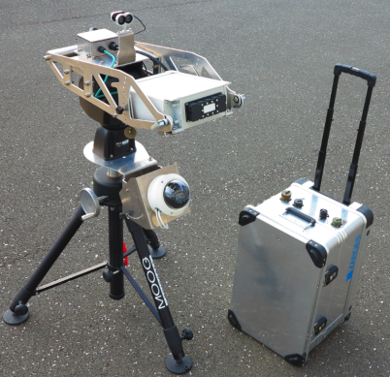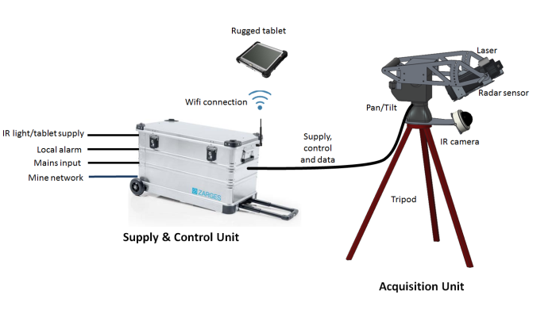
Figure 1: HD-GBSAR system components in deployed state
The HD-GBSAR system consists of two main parts (Figure 1)
- Acquisition Unit:
  - The Acquisition Unit consists of a Pan/Tilt module which rotates the radar sensor in order to perform the SAR acquisition, while a night vision camera continuously provides visual feedback of the monitored area, even under complete darkness. A laser unit is used to survey the 3D model of the monitored area, on which the heat map produced by the radar is overlaid.
- Supply and Control Unit:
  - The Supply and Control Unit provides power to the Acquisition Unit, processes the radar data and provides the network interfaces to remotely control the system.
The following Table 2 contains the summary of main technical parameters of HD-GBSAR system.

Table 2: HD-GBSAR Technical Specifications [1]
Parameter | Value
Modulation | Linear Frequency Modulated Continuous Wave (LFMCW)
Central frequency | Tuneable between 74.5 GHz ÷ 80.5 GHz
Emissions Bandwidth | 1 GHz
Sweep Duration | 1 ms
Maximum Equivalent Isotropically Radiated Power (e.i.r.p) | 48 dBm
Maximum Spectral Power Density | 18 dBm/MHz
Antenna Type | Horn
Antenna Gain | 17 dBi÷24 dBi
Antenna Horizontal Half Power Beamwidth | 15°÷30°
Antenna Vertical Half Power Beamwidth | 15°÷30°
Antenna Polarisation | Linear Vertical or Horizontal
Antenna Rotation Speed | 10 deg/s
Target’s Surface Point Illumination Time | 1.5-3 s
Weight | 24 kg
Size (Height x Depth x Width) | 1000 mm x 300 mm x 600 mm
HD-GBSAR could utilise any 1 GHz wide portion within the range 74-81 GHz. This 1 GHz wide band would be used as a single channel for transmitting a LFMCW signal (Figure 2) through a horn transmitting antenna and receives the signal backscattered from the observed object/landscape with an identical receiving horn antenna.
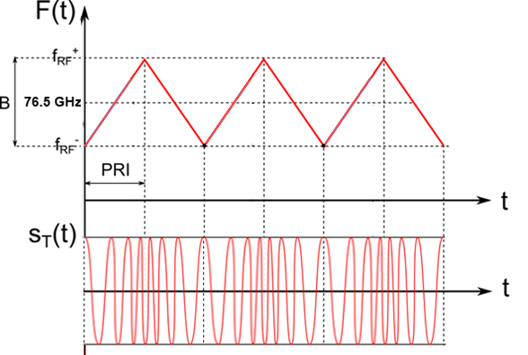
Figure 2: HD-GBSAR signal in the frequency and time domain
The HD-GBSAR’s RF signal is transmitted continuously and received while the entire transceiver with transmit and receive antennas is mechanically rotated by the Pan/Tilt mounting module (see Figure 3), with a typical angular rotation speed of 10 deg/s.
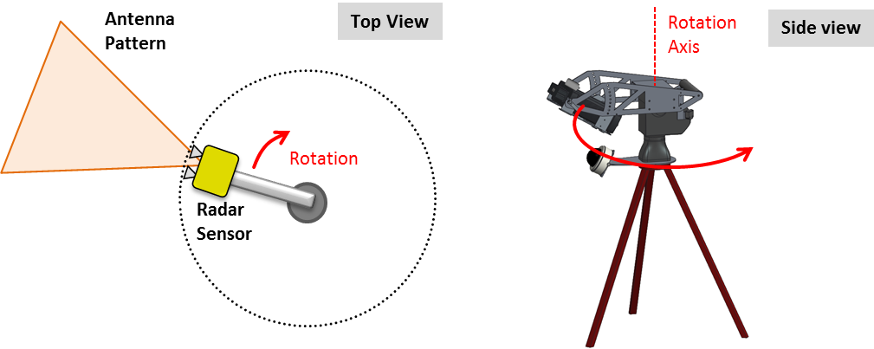
Figure 3: Arc SAR acquisition
HD-GBSAR provides a bi-dimensional image of the monitored scenario; the two dimensions are determined by the range resolution and the angular resolution capability (Figure 4).
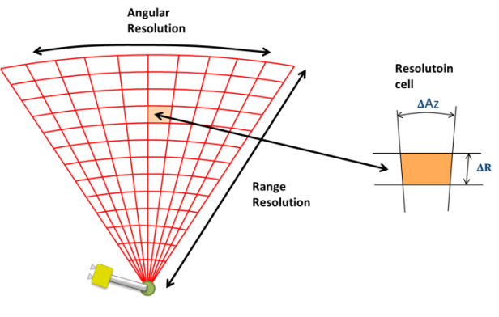
Figure 4: HD-GBSAR spatial resolution
The range resolution $ΔR$ is determined by the bandwidth of the emitted signal ($ΔR=c/2B$); with a 1 GHz bandwidth, it is equal to 0.15 m, whereas the angular resolution $ΔAz$ is around 8 mrad assuming a rotation radius of 0.5 m.
The combination of range and angular resolution allows the creation of a bi-dimensional image (Figure 4), where each resolution cell is a measurement point providing a real-time displacement information with sub-millimetre accuracy thanks to the interferometric technique.
HD-GBSAR antenna radiation pattern influences the vertical coverage of the monitored scenario. The characteristics of two examples of HD-GBSAR radiation patterns are summarised in Table 3.
Table 3: Example of HD-GBSAR antenna radiation patterns [1]
Antenna | Gain | Vertical HPBW | Horizontal HPBW | Polarisation
Type 1 | 17 dBi | 30° | 30° | Vertical
Type 2 | 24 dBi | 15° | 15° | Vertical
The antenna with the larger half-power beamwidth (type 1) represents the worst-case scenario for the interference analysis with victim services. The sharing study will consider the antenna radiation pattern for the vertical $P_{V}\left(θ\right)$ and horizontal $P_{H}\left(φ\right)$ plane obtained with the equations (1) and (2), representing a simplified version of the antenna type 1 indicated in [1]. The antenna normalised radiation pattern expressed in dB is shown in Figure 5.
$P_{H}\left(φ\right)dB=\left\{\begin{aligned}20⋅{Log}_{10}{(}{\cos\left(φ\right)}^{10}) \\ P_{0} \\ P_{0}-\frac{\left|φ\right|-30}{60}⋅\left(P_{0}+20\right) \\ <-20\end{aligned}\begin{aligned}\left|φ\right|<30° \\ \left|φ\right|=30° \\ 30°<\left|φ\right|<90° \\ 90°<\left|φ\right|<180°\end{aligned}\right.$ (1)
$P_{V}\left(θ\right)dB=\left\{\begin{aligned}20⋅{Log}_{10}{(}{\cos\left(θ\right)}^{10}) \\ P_{0} \\ P_{0}-\frac{\left|θ\right|-30}{60}⋅\left(P_{0}+20\right) \\ <-20\end{aligned}\begin{aligned}\left|θ\right|<30° \\ \left|θ\right|=30° \\ 30°<\left|θ\right|<90° \\ 90°<\left|θ\right|<180°\end{aligned}\right.$ (2)
Where $P_{0}={20⋅{Log}_{10}(cos{(}30))}^{10}$.
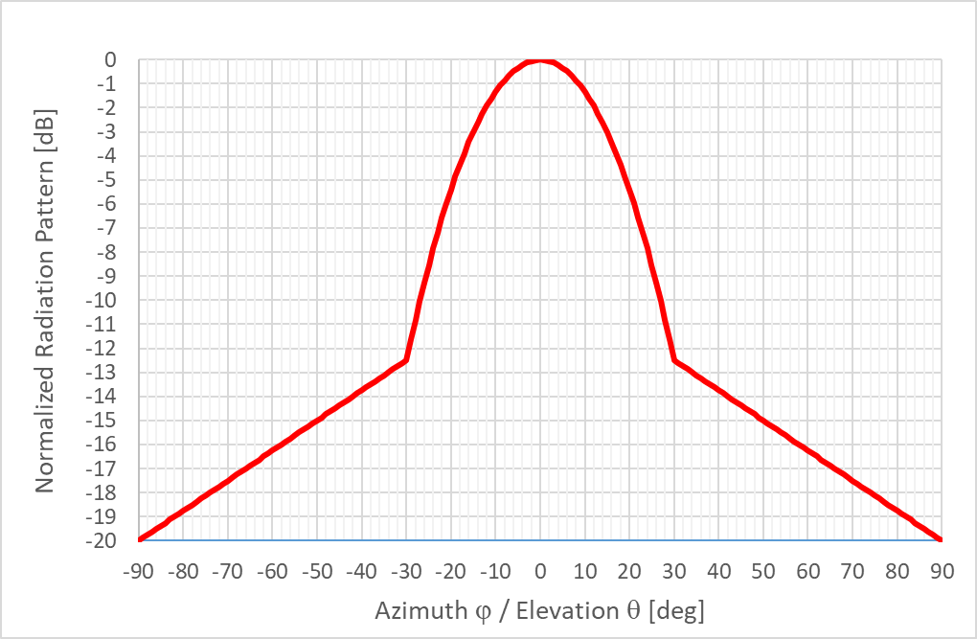
Figure 5: Representative Radiation pattern of HD-GBSAR
Necessary bandwidth of HD-GBSAR is 1 GHz to achieve a range resolution of 0.15 m, while typical maximum occupied bandwidth is 980 MHz.
The necessary bandwidth of 1 GHz is allocated within 74-81 GHz frequency range.
The maximum e.i.r.p. in the out of band domain maximum is 0 dBm.
Maximum emissions in the spurious domain are given as follows:
- -54 dBm, for f within the bands 47-74 MHz, 87.5-118 MHz, 174-230 MHz, 470-862 MHz;
- -36 dBm, for 9 kHz ≤ f ≤ 1 GHz (except the above frequency bands);
- -30 dBm, for 1 GHz < f ≤ F_{upper.}
Where f is the frequency of the spurious domain emission while F_{upper} is defined as the second harmonic of the fundamental frequency, as prescribed in ERC Recommendation 74-01 [3].
During the active object scan periods, the HD-GBSAR transceiver is constantly ON. However, from the perspective of other devices sharing the same band the HD-GBSAR signal will appear periodical, with equivalent Duty Cycle less than 100%. This is a result of HD-GBSAR scanning the object with mechanical rotation of antenna beam at 10°/s within the angular limits defined by the user depending on the type of application and size of monitored object. This operation results in maximum target illumination time depending on the antenna half-power beamwidth.

Deployment scenarios
The following main use cases and deployment scenarios are envisaged for the HD-GBSAR, enabled by the highly compact portable size and increased measurement precision of second-generation equipment:
- Structural Health Monitoring (SHM): HD-GBSAR can be used to monitor the deformation of civil structures such as various buildings or other man-made structures to either assess stability of the structure, or to monitor for any instabilities induced over time by external causes, such as earthquake or underground construction taking place close to or directly under the monitored object;
- Underground Mine and Tunnel Construction Monitoring: HD-GBSAR can be used for monitoring of underground mines and tunnels under construction as a geotechnical tool for deformation measurement to provide early warning in case of surface deformation as precursor of an impending collapse;
- Quarry, Cut-slope and Natural Landslide Monitoring: This is already a very well-established use scenario for GBSAR equipment, where it is used to monitor the ground superficial deformation of active quarry or natural landslide. For this use case the HD-GBSAR is able to offer a maximum measurement distance of 800 m providing a real-time displacement measure of the monitored scenario every minute or less.
Further details of HD-GBSAR use cases and respective market size estimates are provided in Annex A of ETSI TR 103 594 [1]. Considering the above listed main uses cases, it may be assumed that HD-GBSAR will be operated only by professional user, therefore:
  - Setup and maintenance of the HD-GBSAR devices will be performed only by professionally trained individuals;
  - Installers should guarantee the optimal setup of HD-GBSAR to optimise the transmission of the radar signal towards the area or the object to be monitored only;
  - The use of HD-GBSAR is coordinated with the public authority or private entity responsible of the area to be monitored.
ANNEX 5 reports further information about typical HD-GBSAR setup geometry to be used to define possible use case and interference scenario, which are influenced by the specific characteristics of HD-GBSAR technology. Characteristics that a professional and trained user needs to be aware of to effectively operate HD-GBSAR for its intended purpose.
In the context of shared spectrum use considerations, it is obvious that the use case of Underground Mine and Tunnel Construction Monitoring can be disregarded from further analysis because the systems would be deployed within the artificial structures or underground with no risk of mm-wave RF signal escaping to the environment outside of the observed object. The forecasted deployment numbers for the other two use cases may be seen in Table 4. Table 4 also reports the average density deployment of HD-GBSAR for the outdoor applications, based on the European area of 5.1x10^6 square km (such a value does not include CIS countries area).
Table 4: Estimated European HD-GBSAR market size for 5 years period [1]
# | Market segment | Units Deployment Forecast | Units per km^2
A | Structural Health Monitoring | 40 | 0.000007843
B | Underground Mine and Tunnel Construction Monitoring | 154 | NA
C | Quarry, Cut-slope and Landslide Monitoring | 280 | 0.000054902
 | Total number relevant for spectrum sharing considerations (A+C): | 320 | 0.000062745
It may be seen from the numbers given above, that the expected average deployment density of HD-GBSAR devices posing the risk of possible interference towards existing services and application will be extremely low. Consequently, the case of multiple HD-GBSAR operating in the same area may be considered unrealistic.
HD-GBSAR systems will have very different deployment circumstances and activity patterns, depending on the use case (Table 5):
- For SHM application the use of HD-GBSAR typically consists of short one-two days survey, installing the system nearby the structure to monitor: building, bridge, dam, etc. During the monitoring survey period the activity factor of the system is around 60%;
- For underground mine monitoring the HD-GBSAR can be used either for continuous monitoring of unstable wall areas for a period from one day to several weeks, or for performing several surveys of various areas in different time-periods, where each survey lasts a few hours. In both cases the system is installed for the survey period close to the monitored area (<200 m) and the maximum activity factor is 60%;
- For tunnelling monitoring application, the HD-GBSAR is installed 20-50 m from the excavation front face and is then constantly re-located along with the tunnel progress. Typically, the system would be moved every 2-3 days and during the monitoring the activity factor is around 50%;
- For quarry, cut-slope and landslide monitoring application, the HD-GBSAR can be exploited for continuous or for time-discreet monitoring surveys: in the first case the system is permanently installed in front of the landslide/unstable slope, while in the second case it will be used as a nomadic system, used for performing several different surveys in different time-period. In the case of a time-discreet nomadic use, one survey would usually last for about 1-2 weeks with a time repetition interval of some months. During the monitoring phase the activity factor is around 30%.
The activity factor is evaluated considering the worst-case acquisition time of 36 seconds needed to achieve the maximum FoV of 360° (360° at 10 deg/sec). Typically, the HD-GBSAR is configured to monitor with FoV smaller than 360°, for instance to monitor a landslide or a building the required field view is lower than 180°, thus in this case the typical acquisition time is lower than 18 seconds.
Table 5: HD-GBSAR activity factor and deployment scenario
Market segment | Typical Monitoring session duration | Activity Factor
Structural Health Monitoring | 1-2 days | 60%  (one acquisition every minute)
Tunnel Construction Monitoring | Continuous | 60%  (one acquisition every minute)
Underground Mine | 1 days or Continuous | 60%  (one acquisition every minute)
Quarry, Cut-slope and Landslide Monitoring | 1-2 weeks or Continuous | 30%  (one acquisition every 2 minutes)

Overall sharing considerations across the range 74-81 GHz

Overview of band use
The up-to-date information about the European use and frequency allocation provided in the ECO Frequency Information System (EFIS) [4] gives the following key radiocommunications services and applications used today across the range 74-81 GHz. This is depicted in Figure 6. The table of the frequency allocation within 74-81 GHz is also reported in ANNEX 1.
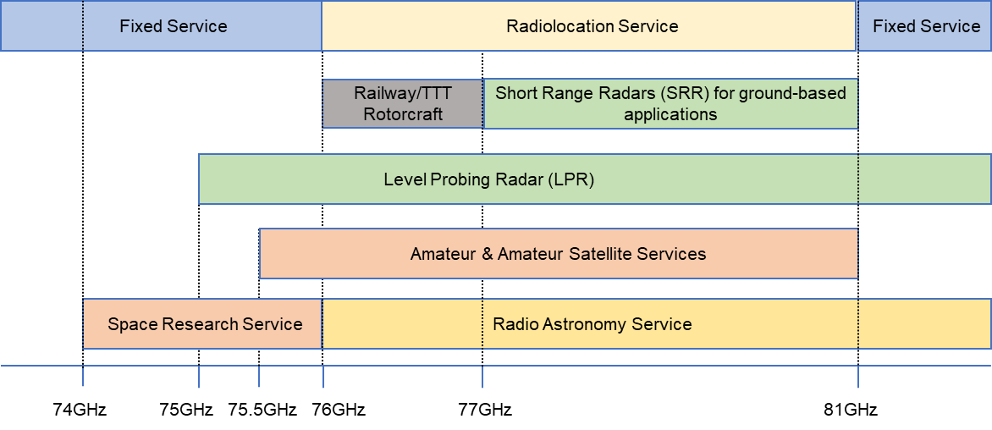
Figure 6: Services and applications in the 74-81 GHz range
The qualitative analysis of the frequency use information leads to the following deductions:
- The band 74-75 GHz is designated for Point-to-Point (PP) Fixed Service (FS) links [5] and Space Research Service (SRS);
- The band 75-76 GHz in addition to FS and SRS is allocated to the Amateur and Amateur-Satellite Services (AS) and is also designated for Level Probing Radar (LPR);
- The band 76-77 GHz is designated for short range device for Transport and Traffic Telematics (TTT) used for fixed Infrastructure and ground based vehicular radar (automotive SRD), Railway applications, proximity alert radars used by rotor crafts and Level Probing Radar (ref. Annexes 4 5 and 6 of ERC Recommendation 70-03 [6]). In addition, Radio Astronomy Service (RAS), and Radiolocation service have primary allocation in this frequency band, whereas Amateur and Amateur-Satellite service have secondary allocations;
- The band 77-81 GHz is globally allocated to the Radiolocation service on a primary basis and is harmonised in Europe for automotive Short Range Radars according to ECC Decision (04)03 [8] and corresponding EU legislation. These stipulate provisions for deploying Short Range Radar applications on road vehicles as means of collision warning technologies with transmit power of up to 55 dBm/4 GHz and –3 dBm/MHz e.i.r.p. In addition, according to RR 5.559B the use of the frequency band 77.5-78 GHz by the radiolocation service shall be limited to short-range radar for ground-based application, including automotive radar.
Considering the above, three target candidate bands in the frequency range 77-81 GHz are analysed for HD-GBSAR in this Report: 74-75 GHz, 76-77 GHz and 1 GHz.
The band 75-76 GHz is excluded from the analysis, because the interference scenario is similar to that in the 74-75 GHz case with the addition of LPR application and Amateur service.
In the 77-81 GHz frequency range, the interference analysis is identical wherever the 1 GHz frequency band for HD-GBSAR is considered. For sake of simplicity, the compatibility analysis will be performed assuming only the 77-78 GHz frequency range for HD-GBSAR, knowing that any other 1 GHz slot in the 77-81 GHz would lead to the same conclusion.
As additional information, the 76-77 GHz frequency band was allowed in 2017 by FCC for HD-GBSAR application in mines and tunnel in construction [7].

Considered victim services and applications

74-75 GHz band victim services

Fixed Service
The band 71-76 GHz is used by high bitrate/high bandwidth Point-to-Point (PP) FS links [37], normally as one of go-return parts of duplex arrangements with the corresponding band 81-86 GHz. The designation of this band for FS is given in ECC Recommendation (05)07 [5] and it is widely referred to in FS community as "E-band".
The E-band is the strongest growing fixed service band. A recent outlook report from Ericsson expects that in 5-6 years from now 20%, of all new deployments of wireless transport links will be in the E-Band (Figure 7).
As reported in ECC Report 173 [37], the CEPT administrations indicated 8440 active PP links and expectation to increase of band use in next future was indicated by Bulgaria, France, Greece, Netherlands, Croatia, Italy, Portugal, Sweden, Switzerland, Slovenia Latvia and Romania.
The reason for the rapid growth of the E-band is the available wide frequency channel making it possible to reach 10 Gbps links already today and 100 Gbps link in the foreseeable future. These high capacities are needed to handle the build out of 5G transport networks the coming years.
E-band PP link has a shorter possible hop length compared with the conventional fixed service bands (6-42 GHz), instead of 10-100 km the maximum hop length is in the range of 1-3 km. This makes E-band suitable for the last hop within an urban area, i.e. not long hop length between masts but rather between rooftop to rooftop or rooftop to street furniture. This place the radio equipment just above or down in the clutter of buildings. As the links are shorter the difference in antenna height can be substantial, which means that fully horizontal antenna alignment cannot be assumed.
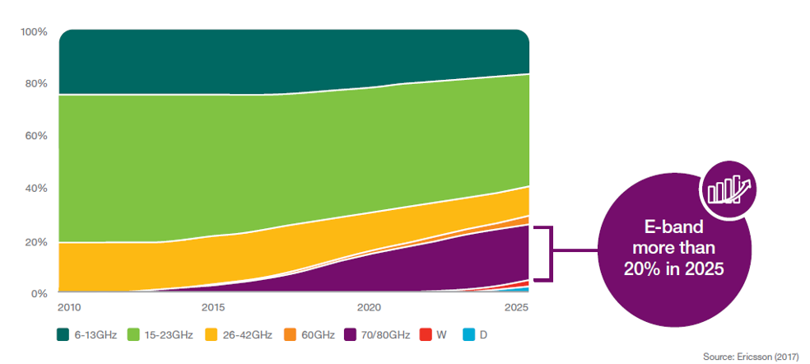
Figure 7: Expectations of the E-band growth compared to the other frequency bands
(Source: Ericsson microwave outlook report, 2017 [29])
System parameters and protection criteria to be used for sharing compatibility analysis for PP FS operating in E-Band are reported in table 10 of Recommendation ITU-R F.758-6 [24]. Table 6 shows the information related to the system parameters and protection criteria for this band and are extracted from the Recommendation ITU-R F.758-6 Table 4.
Table 6: System parameters and protection criteria for PP FS systems operating in E-Band [24]
Parameter | Value
Channel spacing and receiver noise bandwidth (MHz) | 250, 500, 750, 1000, 1250, 1500, 1750, 2000, 2250
Antenna gain range (dBi) | 54
e.i.r.p. density range (dBW/MHz) | 0
Receiver noise figure typical (dB) | 10
Receiver noise power density typical (=NRX) (dBW/MHz) | -134
Normalised Rx input level for 1 × 10–6 BER (dBW/MHz) | -120.5
Nominal long-term interference power density (dBW/MHz) | -134+I/N
I/N for long term interference analysis (dB) (Note1) | -20
Note 1 From Table 4 of Recommendation ITU-R F.758-6
As regards FS antenna reference Radiation Pattern Envelope, the Antenna Class 3 pattern given in ETSI EN 302 217-4 [10] (cf. Figure 40) is assumed, which is reproduced below in Figure 8 and represents the most commonly used in the market. The antenna Class 3 has a typical maximum gain of 43 dBi.
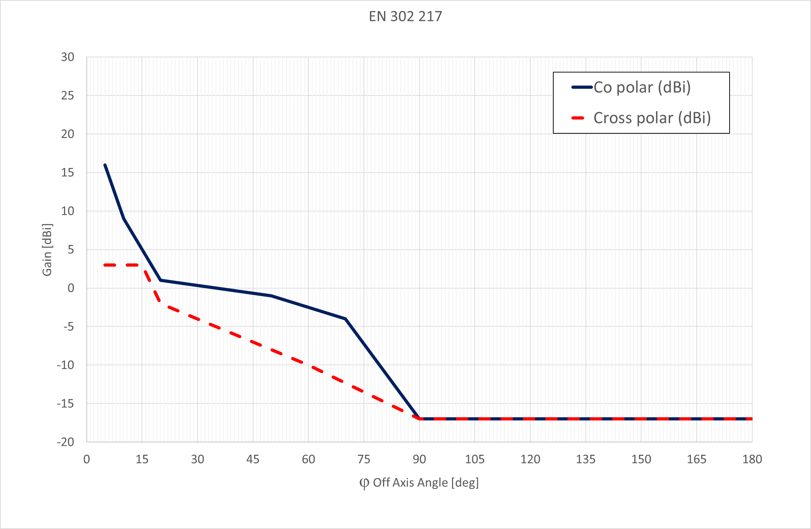
Figure 8: Representative Radiation Pattern Envelope (RPE) of FS antenna in 71-76 GHz [10]

Space Research Service
Although there is an indication in the EFIS [4] of possible use of the band 74-75.5 GHz by Space Research Services (SRS), the subsequent desk research of relevant regulatory and informational sources did not allow to identify any current or potential usage of this band by SRS in terms of any passive or active observation or sensing applications.
More specifically, the band 74-75.5 GHz is not listed among frequencies of interest to space research communities in key reference sources on the subject:
- Recommendation ITU-R RA.314-10 [38]: "Preferred frequency bands for radio astronomical measurements";
- Recommendation ITU-R RS.515-5 [39]: "Frequency bands and bandwidths used for satellite passive remote sensing";
- Recommendation ITU-R RS.577-7 [40]: "Frequency bands and required bandwidths used for spaceborne active sensors operating in the Earth exploration-satellite (active) and space research (active) services";
- Recommendation ITU-R RS.2064-0 [41]: "Typical technical and operating characteristics and frequency bands used by space research service (passive) planetary observation systems".
It is also noted that in the Report ITU-R M.2322-0 [12], no SRS (space-to-Earth) systems have been identified to date in the frequency range 76-81 GHz.
The only information on any usage of frequencies in 74-75.5 GHz for science applications is a listing of 74-84 GHz tuning range being possibly used as a secondary service identification in support role for 10 GHz wideband transmission of VLBI-generated telemetry data and time/phase reference signals in the space-to-Earth direction with a typical RF bandwidth of 4000 MHz in accordance with provisions of Recommendation ITU-R SA.1344-1 [13].
Report ITU-R SA.2065 [28] provides the following information about protection criteria for VLBI telemetry link:
- I/N threshold at telemetry receiver input of -12.5 dB to guarantee a tolerable degradation of receiver performance;
- Typical receiver thermal noise power density of -206.84 dBW/Hz, which, considering the typical RF bandwidth of 4000 MHz, it is equivalent to a receiver noise power of -86.8 dBm.
The list of European radio astronomy stations with operational ranges covering the band 74-75 GHz is reported in ANNEX 3.

76-77 GHz band victim applications and services

Short Range Device applications
ERC Recommendation [6] reports several SRD usages of the 76-77 GHz band (ANNEX 2:Table 30):
- Obstruction/Vehicle detection radars at railway level crossings. (Annex 4 Railway Applications)
- Ground based vehicular radar ([6] Annex 5 TTT)
- Fixed infrastructure vehicular radar ([6] Annex 5 TTT)
- Obstacle detection radars for rotorcraft use ([6] Annex 5 TTT)
- Level Probing Radar ([6] Annex 6 Radiodetermination application)

Obstruction/Vehicle detection radars at railway level crossings
In this application the radar system (Figure 9) is used to confirm that a crossing is not occupied by a person or by any object that may cause damage to a moving train. ERC Recommendation 70 03 [6] designates the frequency band 76-77 GHz for such usage and EN 301 091-3 [15] provides the technical requirements.
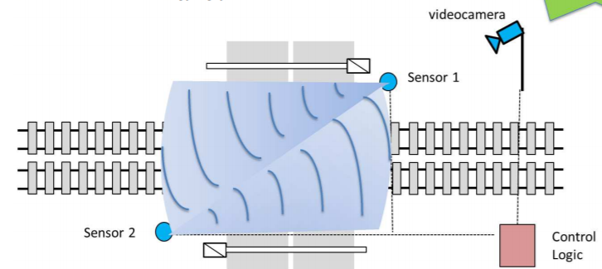
Figure 9: Typical radar system installation at railway level crossing
According to the European project Safer-LC (www.safer-lc.eu), the number of railway level crossing in European Union were around 11500 in 2014. There is no available information about the number obstruction detection radars currently deployed in Europe, however it may be assumed that only a small percentage of the total number of level crossings is monitored with radar.

Ground based veichular radar
Recommendation ITU-R M.2057 [16] specifies the system characteristics of automotive radars operating under the radiolocation service in the frequency band 76-81 GHz. These technical and operational characteristics are used in compatibility studies between automotive radars and systems operating in other services. According to [16], the band 76-77 GHz is used for adaptive cruise control (ACC) and collision avoidance (CA) radar, for measurement ranges up to 250 metres with the technical parameters listed in Table 7 ([16] Radar A of Table 1). The antenna patterns is specified by using the -3 dB beamwidth parameters of Table 7 and the formula indicated in [16] Chapter 3.
The 76-77 GHz band is the only frequency band that can be currently used on a worldwide basis for driving assistance and automotive collision avoidance technologies based on medium range and long-range radars. It is a harmonised band that is continuously growing all over Europe.
Table 7: Automotive radar characteristics in the 76-77 GHz frequency band [16]
Parameter | Value | Units
Frequency range | 76-77 | GHz
Typical operating range | Up to 250 | m
Range resolution | 75 | cm
Typical emission type | FMCW, Fast-FMCW
Max necessary bandwidth | 1 | GHz
Chirp bandwidth | 1 | GHz
Typical sweep time | 10000-40000 for FMCW  10-40 for fast-FMCW | μs
Maximum e.i.r.p. | 55 | dBm
Maximum transmit power to antenna | 10 | dBm
Max power density of unwanted emissions | 0 (73.5-76 GHz and 77-79.5 GHz)  –30 otherwise | dBm/MHz
Receiver IF bandwidth (–3 dB) | 0.5-1 | MHz
Receiver IF bandwidth (–20 dB) | 0.5-20 | MHz
Receiver sensitivity (Note 1) | –115 | dBm
Receiver noise figure | 15 | dB
Equivalent noise bandwidth (kHz) | 25 | kHz
Antenna main beam gain | Typical 30, Maximum 45 | dBi
Antenna height | 0.3-1 above road | m
Antenna azimuth 10 dB beamwidth | TX/RX: ±10 | degrees
Antenna azimuth 3 dB beamwidth | TX/RX: ±5 | degrees
Antenna elevation -3 dB beamwidth | TX/RX: ±3 | Degrees
Note 1: the receiver sensitivity is determined using the equivalent noise bandwidth.

Fixed transport infrastructure radar equipment
Fixed infrastructure radar systems operating in the 76-77 GHz range are used for automatic incident detection on motorways and other strategic roads, bridges and tunnels.
ECC Report 262 [17] provides the fixed transport infrastructure radar technical parameters reported in Table 8including typical antenna patterns (Figure 10) and deployment scenario.
Table 8: Fixed infrastructure radar technical parameters [17]
Parameter | Value
Frequency range | 76.2-76.8 GHz
Range of sensor | 500 m
Field of view coverage | 360° full coverage (for scanning systems)
Peak power | 37-40 dBm
Average e.i.r.p. in a given direction while rotating | 38 dBm+10log(1.8°/360°) = 15 dBm
Occupied RF bandwidth | 650 MHz
Rotation speed | Nominal 4 Hz rotation rate through 360° taking 400 measurements per rotation.
Period of chirp | 625 µs
Beamwidth in azimuth | 1.8 degrees
Main lobe duty cycle (Note) | 0.5 %
Mounting height | Typical 3-5 m above ground level
Deployment of infrastructure radar | Typical separation is 350-700 m
Note: Here the duty cycle is defined as the ratio between the total angle scanned and the azimuth beamwidth of the antenna
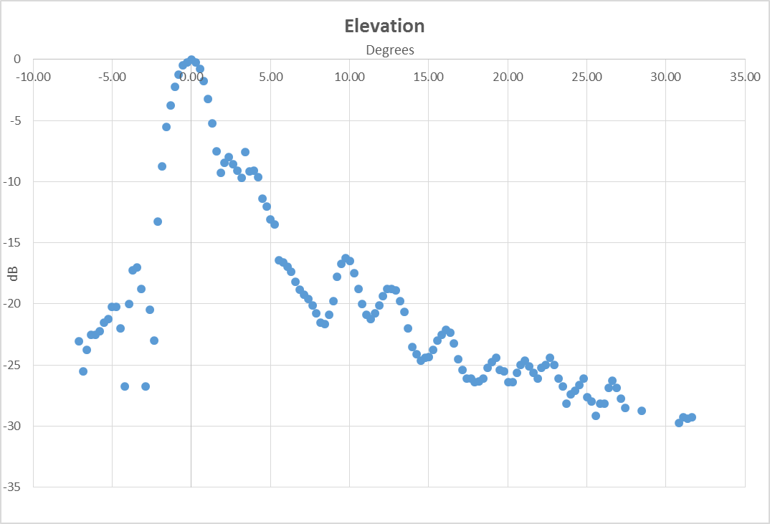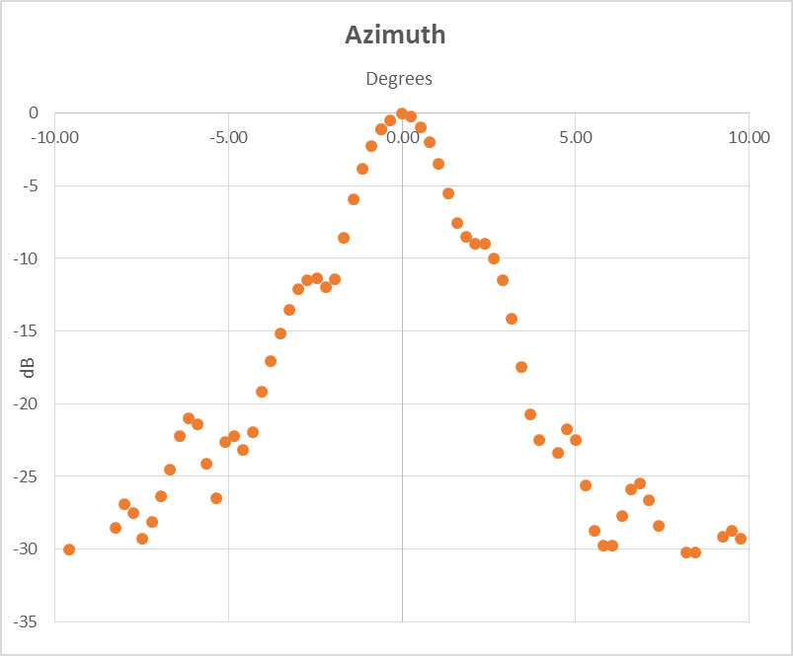
Figure 10: Fixed transport infrastructure radar elevation and azimuth antenna pattern

Rotorcraft
ECC Decision (16)01 [18] designates the band 76-77 GHz for obstacle detection radars for rotorcraft use with the technical requirements of Table 9.
Obstacle Detection radar for rotorcraft use is intended to detect and inform the flight crew of obstacles in a protective volume around the helicopter, during the initial or final phases of flight, as well as during hovering phases, in which the helicopter moves in ground vicinity at low airspeeds. ECC Report 222 [19] specifies two operational use cases and radar working mode:
- Near Field Obstacle Detection. The radar system is used for detection of obstacles in the direct vicinity of the helicopter. This mode is supporting hover and slow-moving operations for approach, landing and take-off. The detection range does not need to be more than 40 m;
- Medium Range Obstacle Detection. The radar system is used for detecting obstacles during approach, landing and take-off. In these flight phases the detection range needs to be higher to ensure an appropriate warning time when flying at higher speeds. The detection range does not need to be more than 250 m.
Table 9: Technical requirements for the obstacle detection radar devices for rotorcraft [19]
Frequency Band | Power /  Magnetic Field | Spectrum access and mitigation requirements | Notes
76-77 GHz | 30 dBm peak e.i.r.p. | ≤ 56 %/s duty cycle | 3 dBm/MHz average power spectral density. For obstacle detection radars for rotorcraft use

Level Probing Radar
The use of the band 76-77 GHz by the applications within Radiodetermination service entails only the deployment of industrial Level Probing Radars according to provisions established by the ECC Decision (11)02 [20]. In accordance with this ECC Decision, the band 75-85 GHz is designated as a tuning range for industrial Level Probing Radar applications. Such a band is also allocated for Tank Level Probing Radar, however for the nature of the application enclosed in tank, there is no risk of interference between HD-GBSAR and TLPR.
ECC Report 139 [21] reports typical LPR technical parameters and deployment scenario.

Amateur and Amateur Satellite Service
Amateur and amateur-satellite are allocated as secondary services in the 76-77.5 GHz frequency range (Table 29), and the IARU Region 1 VHF/UHF/Microwaves BANDPLANS (Figure 11) indicates such a bandwidth as not preferred segment, that should be used only in case the preferred segment (75.5-76 GHz and 77.5-78 GHz) cannot be used. Based on the IARU Region-1 VHF Managers Handbook [22] they can be categorised in this frequency range as:
- Weak-signal reception of Narrowband Terrestrial operation in harmonised sub-bands centred at 76032, and 77501 MHz (and at 75976 MHz, where EU35 is implemented);
- These narrowband amateur stations are generally portable low-power directional systems focussed on long-range communications from hilltop portable stations (where they can achieve line-of-sight contacts up to 100-200 km).
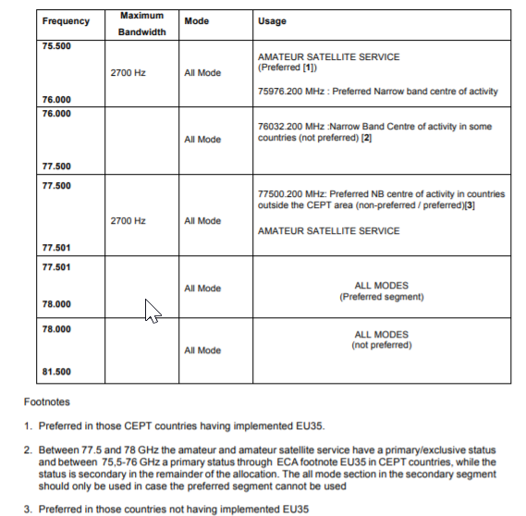
Figure 11: Extract from IARU Region 1 VHF/UHF/Microwaves BANDPLANS clause 4.14:
75.5–81.5 GHz
Recommendation ITU-R M.1732-1 [26] provides characteristics of stations operating in the amateur service for use in sharing studies, however they are not very specific for the 76-81 GHz frequency range. The present report will consider the same Amateur Service characteristic used in ECC Report 222 [19] and summarised in the Table 10.
Terrestrial amateur service and amateur-satellite services have identical technical characteristics, except for the (variable) positive elevation angle of the receiver antenna.
Table 10: Examples of Amateur Service characteristics in the band 76-79 GHz
Parameter | CW-Morse | SSB Voice | NBFM Voice
Transmitter Power (dBm) | 0–20  (typically: 13) | 0–20  (typically: 13) | 3–20  (typically: 13)
Typical Feeder Loss (dB) | 1 | 1 | 1
Antenna gain (dBi) | 36–42  (typically: 40) | 36–42  (typically: 40) | 36–42  (typically: 40)
Typical e.i.r.p. (dBW) | 22 | 22 | 22
Antenna polarisation | Horizontal, Vertical, | Horizontal, Vertical | Horizontal, Vertical
Receiver IF bandwidth (kHz) | 0.5 | 2.7 | 15
Receiver Noise Figure (dB) | 3–7  (typically 4) | 3–7  (typically 4) | 3–7  (typically 4)

Radio Astronomy Service
RAS is allocated as primary service in the 76 -77.5 GHz frequency range (see Table 29 in ANNEX 1), because of the scientific interest of this frequency range. In fact, since the beginning of this century important detections of molecules in the interstellar medium have been performed with first-class radio telescopes like the 30 m radio telescope (IRAM Pico Veleta, Spain), the NOEMA interferometer (IRAM Plateau de Bure, France), the Effelsberg 100 m radio telescope (Max-Planck Institute for Radio astronomy, Germany), the Onsala 20 m radio telescope (OSO, Sweden) and the 40 m telescope (IGN - Yebes Observatory, Spain) in the 74-81 GHz range. In addition, it must be mentioned that the future ALMA band 2 receiver will include this frequency range.
Remarkably, many large prebiotic molecules are detectable, like CH3OH, CH3C5N, and the long carbon chains (HC3N, HC9N, C3N, C5H, etc). Other molecules of interest are SiC, HCS, SiO, and NaCN.
Particularly important are some deuterated molecules, like DNC, DC3N and mainly N2D+. Because of the favourable chemistry of N2H+/N2D+, including freezing of many other molecules and efficient deuteration at low temperatures, the N2D+ J=1-0 line at 77.11 GHz is the best tracer of prestellar condensations, particularly in the crucial phase in which stars are ready to be formed but the interstellar gas is still cold.
The 74-81 GHz band is also very important in the study of emission of galaxies, observed from their strongly shifted (low-J) CO lines. Rotational transitions of CO J=1-0, 2-1 and 3-2 at 115.27, 230.54 and 345.8 GHz, respectively, are shifted to the 74-81 GHz band due to the Universe expansion. The analysis of these lines is required to understand star formation inside galaxies.
In addition, continuum observations in the frequency range 86-92 GHz, which could be affected by out-of-band signals, are crucial to identify the nature of natural radio emissions, to study very cool and big dust grains (which are tracers of the first phases of planetary formation and are particularly intense at these frequencies) and to identify high-density ionised gas from the change of the spectral index of free-free emission.
Another important scientific case is the emission of radio-recombination lines, like H 43,44α, H 43,44β, and He 43,44α, which are very useful to study ionised regions, providing information of the gas dynamics.
Finally, VLBI observations at 86 GHz provide high resolution maps to understand the spatial distribution and time evolution of natural radio sources. This band could be affected by out-of-band emissions, too.
Recommendation ITU-R RA.769-2 [27] provides the following protection criteria for observations located in proximity of the analysed frequency range:
- Continuum observations centred at 89 GHz with a bandwidth of 8 GHz with a received power threshold level of -189 dBW in 8 GHz, equivalent to a spectral pfd of -228 dBw/(m2·Hz), assuming 2000 seconds of integration time;
- Spectral Line Observations (SLO) centred at 88.6 GHz with a bandwidth of 1 MHz with a received power threshold level of -209 dBW in 1 MHz, equivalent to a spectral pfd of -208 dBw/(m2·Hz), assuming 2000 seconds of integration time;
- VLBI observations at 86 GHz will suffer detrimental interference if the received spectral density of power flux is higher than -172 dBW/(m2·Hz);
- RAS antenna side-lobe gain of 0 dBi for evaluating interference arriving along terrestrial paths.
The list of European radio astronomy stations which operational ranges cover the band 74-81 GHz is reported in Table 31 in ANNEX 3.
As a result, a compatibility study between HD-GBSAR and RAS, considering both in-band and out-of-band emissions, is required.

77-81 GHz band victim applications and services

Automotive (Mobile) Short Range Radars (SRR)
As already mentioned in 4.2.1.2, Recommendation ITU-R M.2057 [16] specifies the system characteristics of automotive radars operating under the radiolocation service in the frequency band 76-81 GHz to be used in compatibility studies. According to Recommendation ITU-R M.2057, the band 77-81 GHz is used for high resolution applications such as blind spot detection, lane-change assist and rear-traffic-crossing-alert, detection of pedestrians and bicycles in close proximity to a vehicle, for measurement ranges up to 100 metres.
The Recommendation ITU-R M.2057 provides four different radar characteristics operating in this frequency range (Table 1 of the Recommendation), indicated as:
- Radar B used for front applications;
- Radar C used for corner applications;
- Radar D;
- Radar E used for very short range applications (e.g. parking-aid, CA at very low speed).

Short Range Device applications
The LPR is the only SRD operating in the 77-81 GHz frequency range. LPR characteristics and deployment scenarios are already specified in 4.2.1.5.

Amateur and Amateur-Satellite Service
It applies the same information reported in 4.2.2.

Radio Astronomy Service
It applies the same information reported in 4.2.3.

Interference analysis method
Given the very low HD-GBSAR expected average deployment density (Table 4), the case of multiple HD-GBSAR operating in the same area may be considered unrealistic. Based on this consideration and the stationary usage of HD-GBSAR, all the interference analysis between HD-GBSAR and existing services and application is conducted by using the Minimum Coupling Loss (MCL) method, to evaluate the range beyond which an HD-GBSAR should not impact the performance of the victim receiver.
Unless differently specified in the coexistence studies, the MCL methodology applied in the present Report consists in the following steps:
Step 1- Evaluation of the interference threshold
The first step of MCL analysis is to evaluate the interference thresholds at the receiver antenna input $I$ below which the victim performance is not affected by the presence of the interferer. The receiver interference threshold can be evaluated either using I/N or C/I protection criteria:
- In case of I/N protection criteria the interference threshold at receiver input $I_{R}$ is evaluated as:
$I_{R}\left[dBm\right]=N_{R}\left[dBm\right]+I/N[dB]$ (3)
where $N_{R}$ is the receiver noise floor and $I/N$ is the acceptable interference level with respect to receiver noise specified for the victim receiver. The receiver noise floor of the victim receiver is derived from fundamental equation of thermal noise:
when victim receiver’s noise is defined through noise figure $NF$:
$N_{R}\left[dBm\right]=-113.83+10⋅\log\left(B_{R}\left[MHz\right]\right)+NF \left[dB\right]$ (4)
when victim receiver’s noise is defined through system noise temperature $T_{s}$:
$N_{R}\left[dBm\right]=-138.6+10⋅\log\left(B_{R}\left[MHz\right]\right)+10⋅log⁡(T_{s}\left[K\right])$ (5)
Where $B_{R}$ is the receiver reference bandwidth. In case of a FMCW receiver with direct down conversion to IF (no frequency image suppression), the above formula shall use ${2⋅B}_{IF}$ instead of $B_{R}$, where $B_{IF}$ is the receiver IF filter bandwidth (ANNEX 4).
- In case of C/I protection criteria the interference threshold at receiver input $I_{R}$ is evaluated as:
$I_{R}\left[dBm\right]=RSL\left[dBm\right]-C/I[dB]$ (6)
where $RSL$ is the receiver Reference Signal Level assuring the desired receiver performance and $C/I$ is the acceptable interference level below $RSL$ specified for the victim receiver.
The interference threshold at receiver antenna input is then evaluated by knowing the gain of the victim receiver antenna in the direction of the interferer $G_{R}$ (antenna loss included):
$I\left[dBm\right]=I_{R}[dBm]-G_{R}[dBi]$ (7)
Step 2- Evaluation of the separation distance
The MCL is evaluated as path loss isolation that is necessary to reduce interfering signal to below interference threshold identified in step 1. This condition may be expressed as follow:
$MCL\left[dB\right]=\left(e.i.r.p.\left[dBm\right]+BWCF\left[dB\right]\right)-I\left[dBm\right]$ (8)
Where ${e.i.r.p.}_{I}$ is the mean equivalent isotropic radiated power of the interfering HD-GBSAR in the direction of the victim and $BWCF$ is the bandwidth correction factor corresponding to the ratio between victim receiver bandwidth $B_{R}$ and the HD-GBSAR interfering bandwidth.
In case of FMCW victim receiver, in place of the bandwidth correction factor it is more appropriate to use the Modulation Gain (MG), which expresses the victim receiver interference suppression due to the presence of the IF filter after the down-conversion stage of the victim receiver (ANNEX 4).
If the position and orientation of the victim receiver antenna is fixed (static scenario), the long-term interference evaluation shall be performed taking into account of the HD-GBSAR horizontal scanning (Figure 3) and of the antenna pattern attenuation in the horizontal plane. Given the declared HD-GBSAR typical rotation speed of 10 deg/sec (Table 2) and the antenna beamwidth of 30° in the horizontal plane (Figure 5), the interferer illumination time is 3 seconds every acquisition. The acquisition time $T_{A}$, depends on the considered use case and varies from 60 to 120 seconds (Table 5). The e.i.r.p. mitigation effect of the rotation in the horizontal plane of HD-GBSAR is evaluated by defining the Antenna Duty Cycle (ADC):
$ADC\left[dB\right]=10⋅log10\left(\frac{3 }{T_{A}}\right)$ (9)
Therefore, in case of long-term interference evaluation towards fixed victim receiver, the mean e.i.r.p of the interfering HD-GBSAR is given by:
${e.i.r.p.}_{I}\left[dBm\right]={e.i.r.p.}_{Imax}\left[dBm\right]+P_{V}\left[dB\right]+ADC\left[dB\right]$ (10)
Where, ${e.i.r.p.}_{Imax}\left[dBm\right]$ is 48 dBm and $P_{V}$ is the HD-GBSAR normalised radiation pattern in the direction of the interferer. The ADC factor shall not be considered, in case of moving victim receiver (i.e. automotive radar), since in this scenario the interference can't be considered long-term, and in case of PP Fixed Service.
Eventually the evaluation of the required separation distance $d$ is done by solving the inverted Free Space path loss model for previously obtained MCL value:
$d\left[km\right]={10}^{\frac{MCL-32,44-20\log\left(F\left[MHz\right]\right)}{20}}$ (11)

Interference analysis in the 74-75 GHz band

Sharing with Fixed Service
Fixed service operating in E-band (71-76 GHz) is used for point to point link often in the range of 1-3 km from rooftop to rooftop in urban area (4.1.1). It may be deduced that the most likely situation of interference of PP FS is represented by the following three cases:
- Case A: when an FS terminal is installed on rooftop of a building that is monitored for structural health by a HD-GBSAR, as illustrated in Figure 12.
- Case B: the FS victim receiver is installed on rooftop of a building in proximity of the structure monitored by an HD-GBSAR, as illustrated in Figure 13. The interference towards the FS receiver is expected to come from the surveyed building specular reflection of the HD-GBSAR signal.
- Case C: FS terminal on top of a building outside the field of view of HD-GBSAR that the HD-GBSAR anyway illuminates.
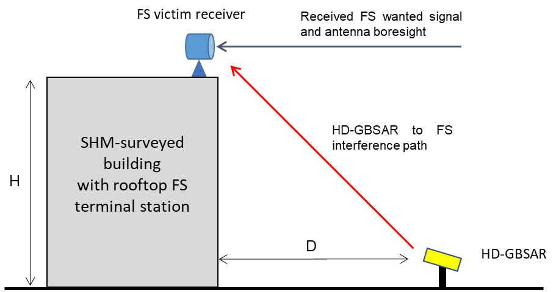
Figure 12: HD-GBSAR to FS interference case A (V-plane only)
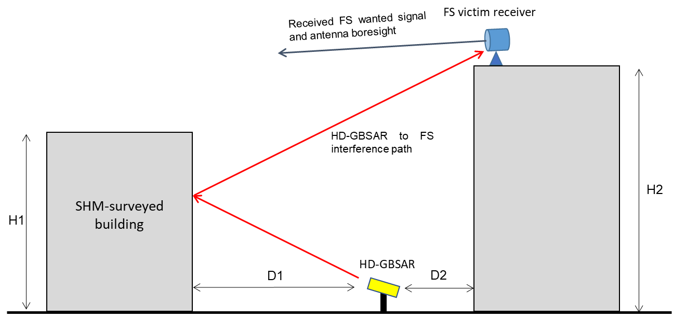
Figure 13: HD-GBSAR to FS interference case B (V-plane only)

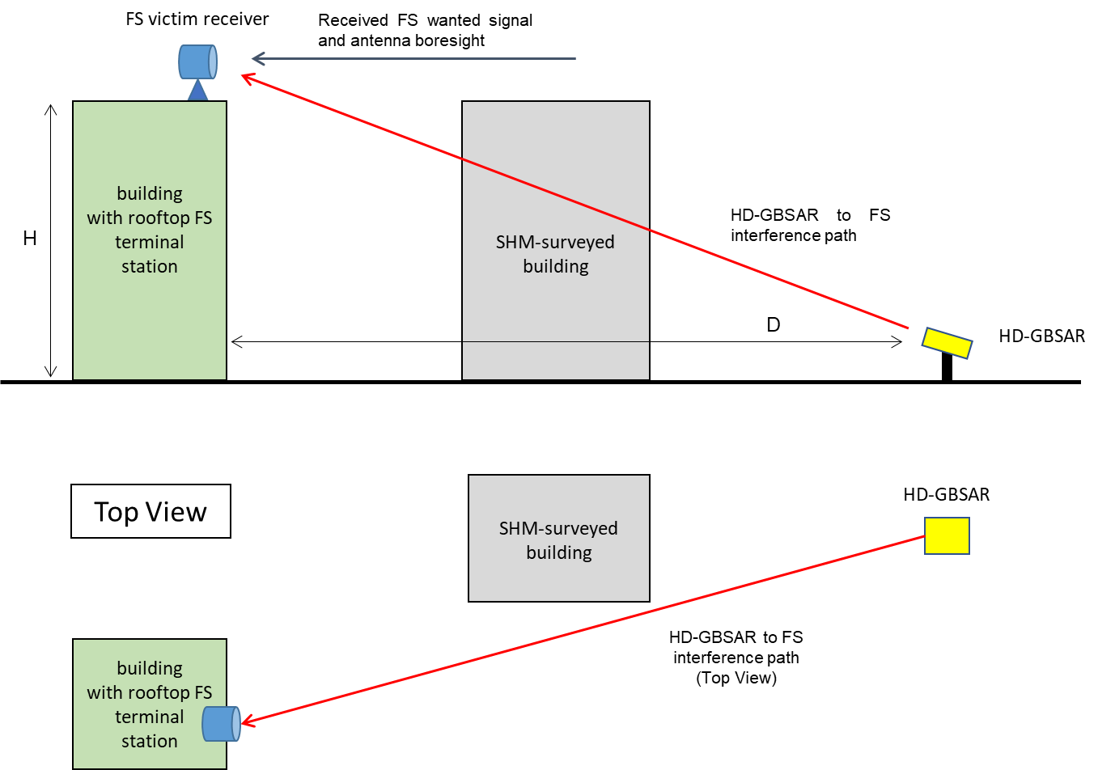
Figure 14: HD-GBSAR to FS interference case C (V-plane and Top View)
When considering the depicted scenarios, it becomes clear that the risk of interference shall depend on composite of probability of mutual alignment of FS vs HD-GBSAR antennas as well as separation distance between the two transceivers. For the horizontal plane scenario geometry for the three cases (Figure 15, Figure 16 and Figure 17), it is assumed a perfect alignment between FS terminal antenna boresight and HD-GBSAR, which represents a worst-case scenario, since HD-GBSAR user will not have information of the placement of the FS radio equipment orientation (direction of the FS main beam).
For sake of completeness, ANNEX 7 reports additional analysis for the three identified worst-case interference scenario assuming the same geometry and the effect of horizontal antenna misalignment between HD-GBSAR and FS antenna boresight.
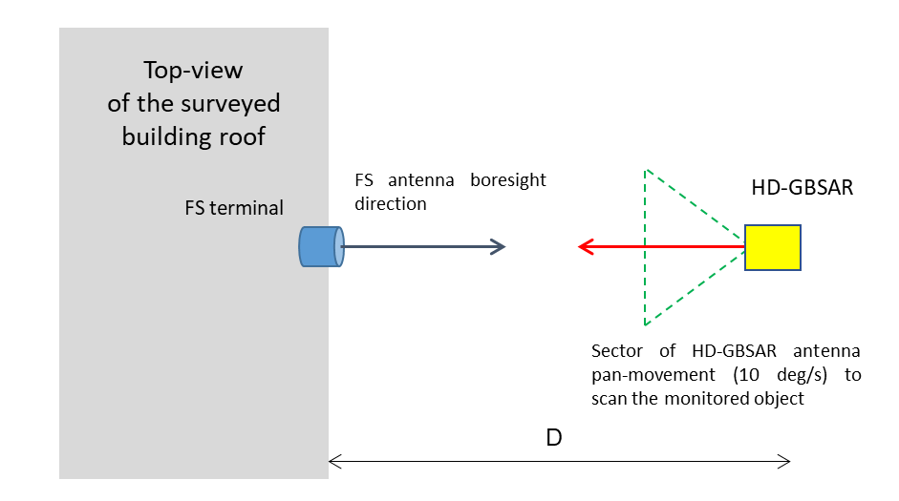
Figure 15: HD-GBSAR to FS interference worst-case scenario A (H-plane)
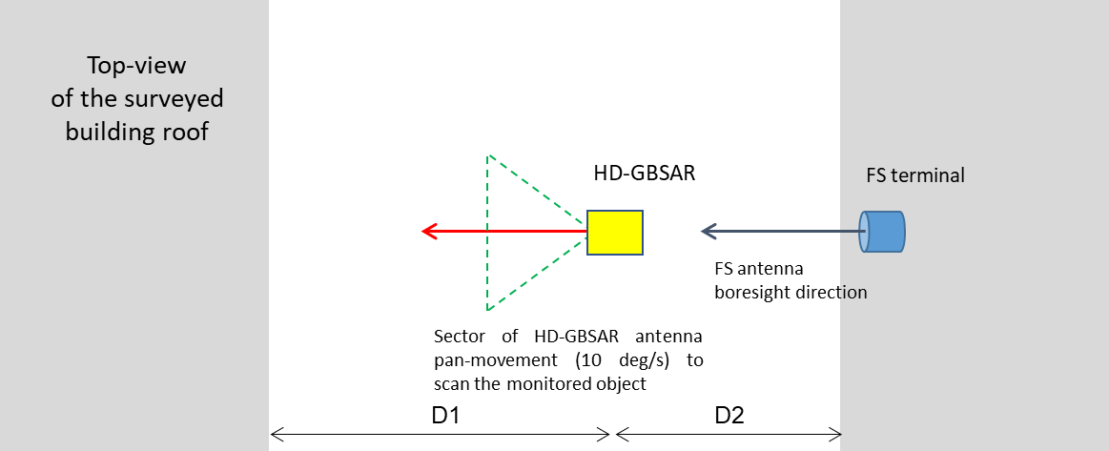
Figure 16: HD-GBSAR to FS interference worst-case scenario B (H-plane)
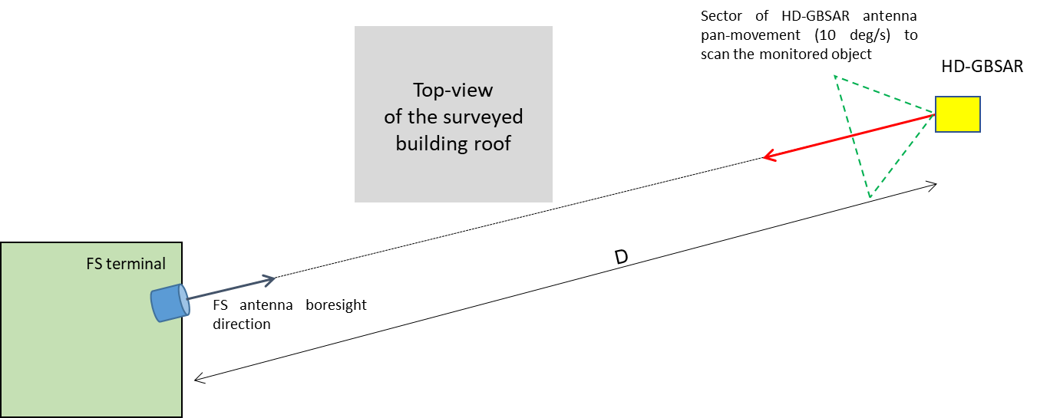
Figure 17: HD-GBSAR to FS interference worst-case scenario C (H-plane)
The three identified interference scenarios are treated separately in 4.5.1.1, 4.5.1.2 and 4.5.1.3. All the analysed cases are based on assumptions on what could be considered a reasonable geometric configuration of such possible real-life placement, based on the typical FS and HD-GBSAR use cases.
For all scenarios, the location and orientation of HD-GBSAR with the respect of the surveyed building are in accordance with the considerations reported in ANNEX 5.

Interference Scenario A
The interference scenario, depicted in Figure 18, is defined based on the following proposed assumptions:
- Building height H (correspondingly FS height above ground) of at least 20 m;
- FS terminal antenna tilt is considered 0 degrees, corresponding to geometry of short distance link between terminals mounted at approximately similar height;
- HD-GBSAR positioned at 20 m from the building allowing good frontal coverage of the entire building, accordingly the HD-GBSAR antenna is pointed at the geometric centre of the surveyed building.
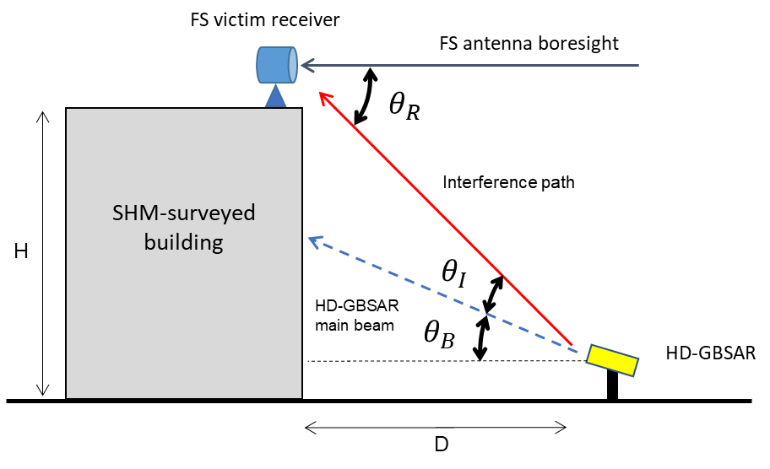
Figure 18: HD-GBSAR to FS interference scenario A (V-plane)
Provided the above assumptions, the corresponding antenna pointing angles in vertical plane would be:
- HD-GBSAR antenna boresight direction $θ_{B}=\tan^{-1}\left(\frac{H/2}{D} \right){=tan}^{-1}\left(\frac{10 m}{20 m}\right)≅26,5°$
- HD-GBSAR antenna off-set angle towards FS terminal $θ_{I}=45°-θ_{B}≅17,5°$
- FS terminal antenna off-set angle towards HD-GBSAR interference source $θ_{R}=\tan^{-1}\left(\frac{H}{D}\right)=45°$
Matching the FS antenna off-set angle with radiation pattern envelope depicted in Figure 8, it is possible to deduce that the antenna gain towards interferer at 45° is approximately -0.7 dBi.
Considering the HD-GBSAR antenna reference radiation pattern specified in Figure 5, the off-set angle on HD-GBSAR antenna of would mean an antenna discrimination factor of -4.3 dB.
Table 11 provides MCL verification of minimum required separation distance for complete avoidance of interference from HD-GBSAR to FS based on the considered scenario and the victim receiver parameters and long-term I/N protection criteria from Recommendation ITU-R F.659 (see 4.1.1).
Table 11: Calculation of separation distance between HD-GBSAR and PP-FS (Scenario A)
PP FS | Unit | Parameter | #
Victim
74 | GHz | Operating Frequency | $$F$$
1250 | MHz | Receiver reference bandwidth | $$BW_{R}$$
10 | dB | Noise Figure | $$NF$$
-20 | dB | Protection criterion | $$I/N$$
45 | deg | Direction of interferer in the vertical plane (boresight off-set angle) | $$θ_{R}$$
-0.7 | dBi | Antenna Gain in the direction of the interferer | $$G_{R}$$
-72.9 | dBm | Receiver thermal noise | $$N_{R}$$
-92.9 | dBm | Interference threshold at receiver input | $$I_{R}$$
-92.2 | dBm | Interference threshold before antenna | $$I$$
HD-GBSAR Interferer
48 | dBm | Maximum e.i.r.p. | $${e.i.r.p.}_{max}$$
1000 | MHz | Reference Bandwidth | $$B_{I}$$
18.4 | deg | Direction of victim in the vertical plane (boresight off-set angle) | $$θ_{I}$$
-4.6 | dB | Normalised Vertical Antenna Pattern in the direction of the victim | $$P_{V}$$
43.4 | dBm | Total interfering power towards Victim | $${EIRP}_{I}$$
0 | dB | Bandwidth correction factor | $$BWCF$$
Impact Range calculation
135.6 | dB | Minimum Coupling Loss | MCL
1943 | m | Minimum separation distance | d
The estimated required minimum separation distance of approximately 1943 m is larger than the typical separation distance that may be assumed due to likely separation of two systems in vertical plane (i.e. locations at the bottom vs the top of a surveyed building), which indicates the risk of harmful interference of HD-GBSAR towards FS in such scenario.

Interference Scenario B
The interference scenario B, depicted in Figure 19, analyses the possible interference of the FS victim receiver originated from the surveyed building specular reflection of the HD-GBSAR signal. The scenario is based on the following assumptions:
- HD-GBSAR position and orientation $θ_{B}≅26.5°$ respect to the surveyed building (H1=20 m and D1=20 m) as for the interference scenario A;
- FS victim receiver located on the rooftop of a building height H1 located in front of the surveyed building. The height of such building must respect the following geometrical condition to make the interference condition occur:
$H_{2}=\left(2⋅D1+D2\right)⋅\tan\left(θ_{i}\right)$ (12)
Where, $θ_{i}$ is the considered HD-GBSAR interferer direction, D2 is the distance between HD-GBSAR and the building where it is located the FS victim receiver and H2 is the height of the FS building;
- The FS receiver antenna tilt ($θ_{F})$ is considered 0° assuming that the FS transmitter is located on the top of a building located behind the one monitored by HD-GBSAR. The height of the FS building H2 is assumed to be higher than surveyed one H1 to maximise the possible interference. Values of H2 lower than H1 would lead to an upward pointing of the victim receiver antenna ($θ_{F}>0$), that would increase the victim antenna vertical mitigation;
- The HD-GBSAR signal building specular reflection loss $Γ$ is assumed to be -3 dB (see [31]).
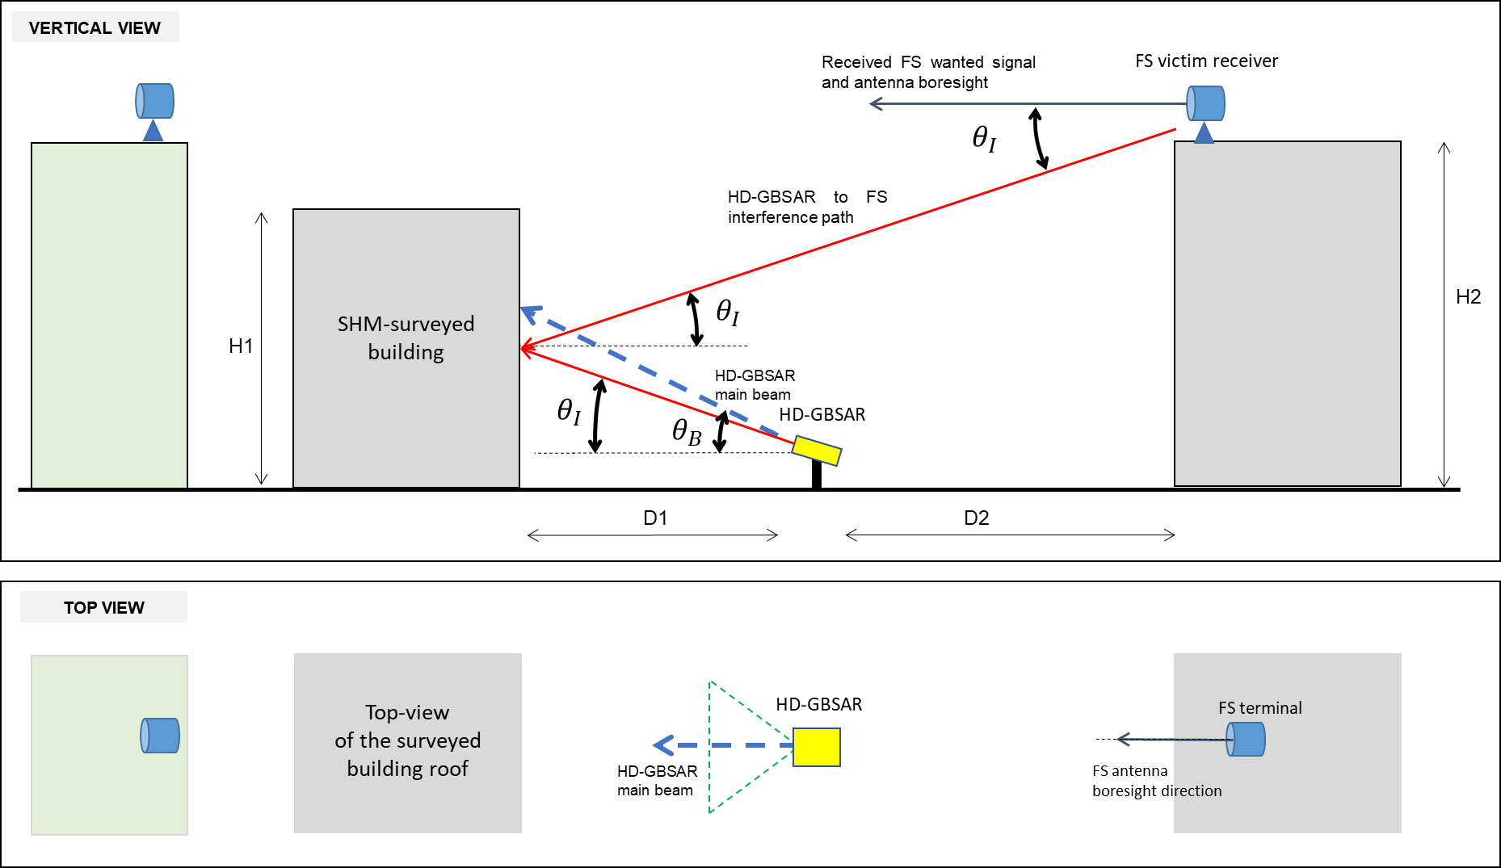
Figure 19: HD-GBSAR to FS interference scenario B
The worst-case interference condition is obtained considering very low value of the interferent elevation angle $θ_{i}$, to minimise the FS victim receiver antenna pattern mitigation in the vertical plane, as $θ_{i}$ exactly the vertical offset angle respect the victim receiver antenna boresight.
Table 12 shows the value of D2 (obtained with the equation 12) for different building height, assuming the lowest possible victim interferent vertical direction $θ_{I}=1°$. The table also reports the interference path length $L$ evaluated with the following formula:
$L=\frac{2D_{1}+D_{2}}{\cos{θ_{I}}}$ (13)
Table 12: Scenario B geometry parameters evaluated for different FS building heights ($θ_{I}=1°$)
H2 | D2 | L
30 m | 1679 m | 1719 m
40 m | 2252 m | 2291 m
50 m | 2824 m | 2864 m
60 m | 3397 m | 3437 m
From the MCL analysis point of view, the level of interference received by the FS victim receiver depends only on the value of the interferent vertical direction $θ_{I}$, which is the same for all the FS building heights listed in Table 12. Therefore, the results of the MCL analysis (see Table 13) is the same whatever the considered building height.
Table 13: Calculation of separation distance between HD-GBSAR and PP-FS (Scenario B)
PP FS case B | Unit | Parameter | #
Victim
74 | GHz | Operating Frequency | $$F$$
1250 | MHz | Receiver reference bandwidth | $$BW_{R}$$
10 | dB | Noise Figure | $$NF$$
-20 | dB | Protection criterion | $$I/N$$
1 | deg | Direction of interferer in the vertical plane (boresight off-set angle) | $$θ_{R}$$
37.6 | dBi | Antenna Gain in the direction of the interferer | $$G_{R}$$
-72.9 | dBm | Receiver thermal noise | $$N_{R}$$
-92.9 | dBm | Interference threshold at receiver input | $$I_{R}$$
-130.5 | dBm | Interference threshold before antenna | $$I$$
HD-GBSAR Interferer
48 | dBm | Maximum e.i.r.p. | $${e.i.r.p.}_{max}$$
1000 | MHz | Reference Bandwidth | $$B_{I}$$
-25.6 | deg | Direction of victim in the vertical plane (boresight off-set angle) | $$θ_{I}-θ_{B}$$
-8.9 | dB | Normalised Vertical Antenna Pattern in the direction of the victim | $$P_{V}$$
-3 | dB | Specular reflection loss | $$Γ$$
36.1 | dBm | Total interfering power towards Victim | $${e.i.r.p.}_{I}$$
0 | dB | Bandwidth correction factor | $$BWCF$$
Impact Range calculation
166.5 | dB | Minimum Coupling Loss
68287 | m | Minimum separation distance
The estimated required minimum separation distance is approximately 68 km and it is larger than the actual interference path lengths L between HD-GBSAR and victim receiver, prospecting the concrete risk of interference in such situations. The possible presence of clutter in the interference path has not been considered in the MCL analysis.

Interference Scenario C
The interference scenario C, depicted in Figure 20, evaluates the possible interference caused by HD-GBSAR towards a FS receiver installed either on the roof of a building or a pole located behind the building surveyed by HD-GBSAR. The examined scenario is based on the following assumptions:
- HD-GBSAR position and orientation respect to the surveyed building (H1=20 m and D1=20 m) as for the interference scenario A ($θ_{B}=26.5 deg)$;
- FS victim receiver located on the rooftop of a building having a height H;
- Coherently with the above consideration, the FS terminal antenna tilt is considered 0 degrees, corresponding to geometry of short distance link between terminals mounted at approximately similar height not shadowed by the HD-GBSAR monitored building;
- A variable distance D between the HD-GBSAR and the building where the FS receiver is installed.
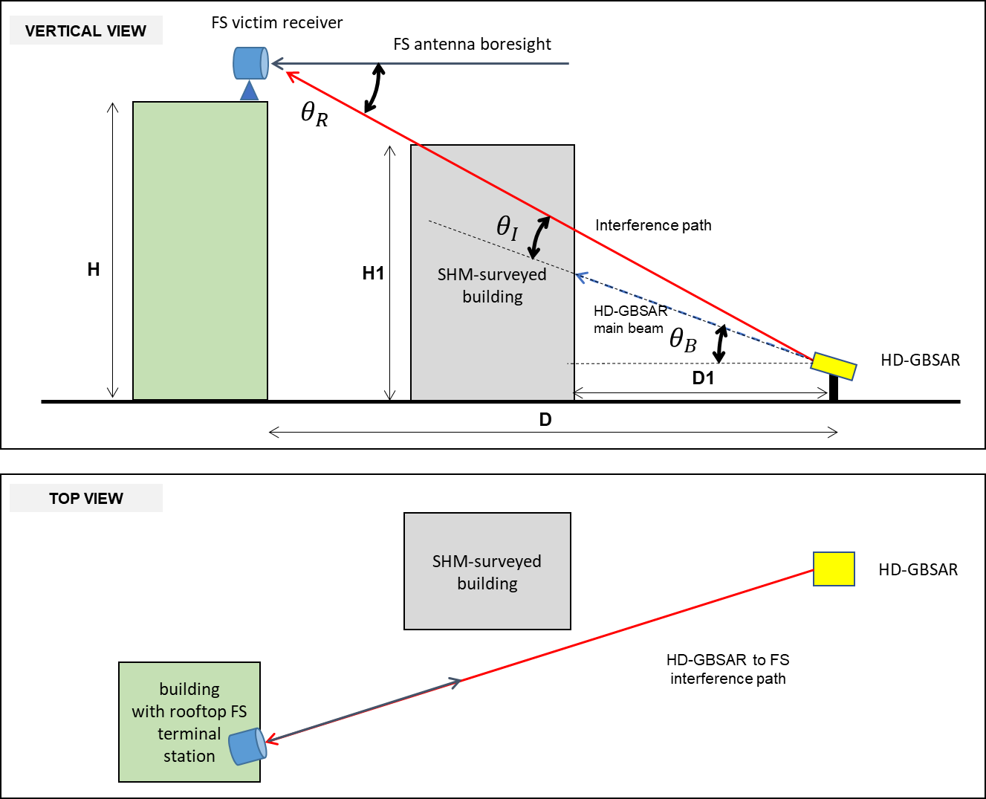
Figure 20: HD-GBSAR to FS interference scenario C
A first MCL analysis has been conducted assuming FS terminal building height $H$ equal to $H1$ and $2⋅H1$, where $H1=20 m$ is the height of the HD-GBSAR monitored building. The chart showed in Figure 21 represent the obtained minimum separation distance between HD-GBSAR and FS receiver required to assure no interference for value of distance D ranging between 50 m and 1 km. It appears clear that the required separation distance is always of the order of several km (up to 90 km), indicating the presence of significant interference of HD-GBSAR towards FS receiver, whatever is the distance D and the height of the building where the victim receiver is installed.
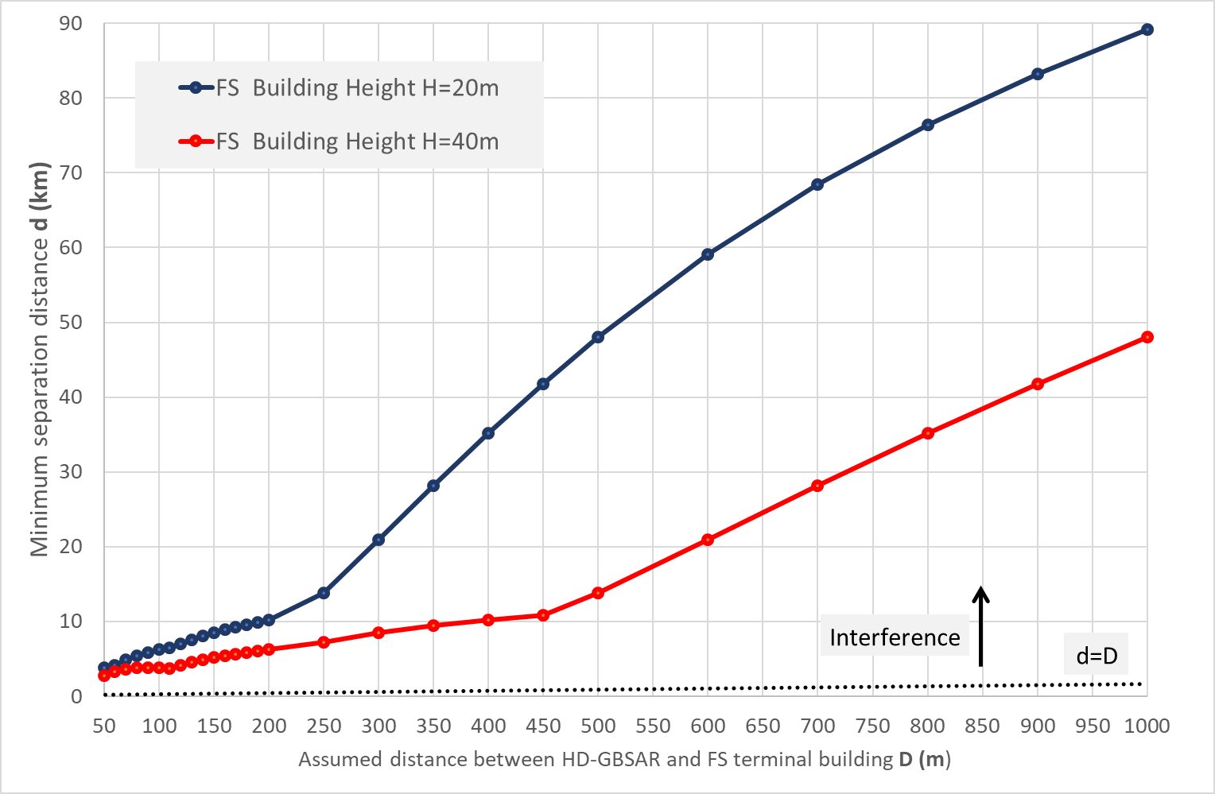
Figure 21: Minimum separation distance in case of perfect horizontal alignment (case C)

Conclusion on coexistence with the Fixed Service
In summary, based on the coexistence analysis performed on the three identified worst-case interference scenarios, it may be concluded that for all the three scenarios HD-GBSAR could cause harmful interference towards FS terminal operating in the 71-76 GHz. In particular, for the three interference scenarios it has been evaluated the following maximum required separation distance, indicating the case C as the most critical:
- Case A: 2 km;
- Case B: 68.3 km;
- Case C: 90 km.
For sake of completeness, a further analysis has been conducted (see ANNEX 7) assuming the same worst-case interference scenario geometry and a misalignment in the horizontal plane between HD-GBSAR an FS receiver antenna boresight. The additional analysis indicates that a misalignment of a few degrees provides a drastic reduction of the required minimum separation distance for all the three cases. In details:
- Case A: for value of $ϕ_{R}>3°$ the minimum separation distance is reduced to 300m
- Case B: for value of $ϕ_{R}>9°$, HD-GBSAR wouldn't cause harmful interference at any distance from the FS victim receiver;
- Case C: for value of $ϕ_{R}>18°$, HD-GBSAR would cause interference only if located at a distance closer than 250 m from a FS victim receiver installed on top of a building of 20m. Such distance becomes 300 m if the FS receiver building height is 40 m.
A more accurate analysis and estimation of the probability of interference between HD-GBSAR and FS receiver would require the combination of the above conditions with the likelihood of occurrence of the three analysed interference scenarios, derived by the expected density deployment of HD-GBSAR and FS receiver in urban area. This Report does not provide such statistical evaluation; therefore, it has to be considered as valid the worst-case analysis conclusion.

Sharing with Space Research Service
As elaborated in section 4.1.2, the only available information on any usage of frequencies in 74-75.5 GHz band for science applications is a listing of 74-84 GHz band being possibly used in support of VLBI radio astronomy stations for space to earth transmission of telemetry time/phase signals. ANNEX 3 reports the list of European RA stations with operation frequencies including the band 74-75 GHz potentially receiving such time-phase reference signals.
Table 14 reports the MCL analysis between HD-GBSAR and telemetry received based on the following assumptions:
- A worst-case use case scenario assuming direct LOS between HD-GBSAR and victim receiver;
- Victim receiver antenna gain towards HD-GBSAR of 0 dBi, considering the typical high directivity radiation pattern of the antenna used in SRS station and the upward boresight direction to receive the telemetry signal from space-born satellite. Such a value has been derived from the Recommendation ITU-R SA.509-3, which provides SRS station reference antenna radiation pattern for use in interference calculations up to 30 GHz, assuming similar performance for antenna operating at 74 GHz;
- Protection criteria for telemetry receiver as specified in section 4.1.2.
Table 14: Calculation of separation distance between HD-GBSAR and SRS
SRS | Unit | Parameter | #
Victim
74 | GHz | Operating frequency | $$F$$
4000 | MHz | Receiver reference bandwidth | $$B_{R}$$
-12.5 | dB | Interference objective | $$I/N$$
0 | dBi | Antenna Gain in the direction of the interferer | $$G_{R}$$
-86.8 | dBm | Receiver thermal noise | $$N_{R}$$
-99.3 | dBm | Interference threshold at receiver input | $$I_{R}$$
-99.3 | dBm | Interference threshold before antenna | $$I$$
HD-GBSAR Interferer
48 | dBm | Maximum e.i.r.p. | $${e.i.r.p.}_{max}$$
1000 | MHz | Reference Bandwidth | $$B_{I}$$
0 | deg | Direction of victim in the vertical plane (off-set from boresight) | $$θ_{I}$$
0 | dB | Normalised Vertical Antenna Pattern in the direction of the victim | $$P_{V}$$
60 | sec | Acquisition time | $$T_{A}$$
-13 | dB | Antenna Duty Cycle | $$ADC$$
35 | dBm | Total interfering power towards Victim | $${e.i.r.p.}_{I}$$
0 | dB | Bandwidth correction factor | $$BWCF$$
Impact Range calculation
134.3 | dB | Minimum Coupling Loss | $$MCL$$
1672 | m | Minimum separation distance | $$d$$
The simplified considered use case and MCL analysis indicates a minimum separation distance of around 1600 m (Table 14), nevertheless it must be taken into account that:
- RA observatories are located in non-industrial areas and often in mountainous areas at elevation of more than 2500 m above sea level (see ANNEX 3). In general, it can be assumed a distance of several kilometres between space observatory and area where HD-GBSAR could be potentially used;
- Analysing the list of European observatories operating in the analysed frequency range, only in the case of the Onsala observatory there could be a remote possibility of HD-GBSAR interference due to the presence of a small urban area at around 5 km from the observatory, such a distance is in any case greater than the evaluated separation distance;
- The possibility to have direct LOS between HD-GBSAR and the victim receiver appears to be unrealistic, for the above-mentioned reasons and because HD-GBSAR setup is done to optimise the illumination of the area to be monitored, so further mitigation factor should be considered to have a more realistic MCL evaluation.
In view of the MCL evaluated minimum separation distance and of the additional considerations, it may be assumed with high confidence that any possible mutual signal coupling along the surface of the Earth between HD-GBSAR transmitter and space observatory's Earth Station receiver is extremely unlikely and there is no concern of coexistence between HD-GBSAR and SRS.

Sharing with RAS operating in the adjacent bands
It applies the same conclusion of paragraph 4.6.8, because the HD-GBSAR out of band emission and RAS protection criterion are the same.

Interference analysis in the 76-77 GHz band

Sharing with Automotive Radar SRD
This paragraph analyses the coexistence between HD-GBSAR and automotive radar operating in the 76-77 GHz frequency range. Among the possible HD-GBSAR applications, the case of HD-GBSAR employed for Structural Health Monitoring of a building nearby a public road where a car is moving within HD-GBSAR horizontal field of view, it is assumed the most likely and critical interference scenario towards automotive radar. Figure 22 and Figure 23 show respectively the plain and vertical geometry of the scenario considered for the interference analysis of HD-GBSAR towards automotive SRD radar. A further possible interference scenario could be represented by the case of an HD-GBSAR monitoring an unstable slope nearby a road, although the urban scenario it is assumed to be the worst-case in terms of interference, due to the minimal possible distance between HD-GBSAR and cars.
The interference analysis considers the case of an HD-GBSAR monitoring a building with a public road in between, to maximise the possible risk of interference with automotive radar (Figure 22). Based on the geometry of Figure 22 and Figure 23, the following further assumptions have been considered in the MCL analysis:
- The building height ($H$) of 8 m, which corresponds to the typical height of 2 floors buildings. This represents a worst-case condition, since typically instability issue is more likely to happen on taller building;
- The road lane width ($W$) of 3 m and pavement width of 2 m ($O=2 m$);
- The HD-GBSAR is mounted on a tripod at a height $h_{i}=1 m$ from the ground and placed at 1 m from the road in the middle of the pavement ($o=1 m$);
- The distance (D) between the HD-GBSAR system and the building is 9 m, in accordance with the typical usage considerations reported in ANNEX 5;
- The HD-GBSAR is tilted up by an angle of 19° ($θ_{B}$), in order to have the vertical antenna boresight approximately pointing the central height of the building ($H/2$) to maximise the building face coverage. The boresight position over the building face can be calculated as: $h_{b}=h_{i}+D\tan\left(θ_{B}\right)≅4.2 m$;
- Typically, HD-GBSAR is configured to optimise the horizontal coverage of the building and avoid building horizontal incidence angle greater of 60°, which provides low level of back-reflection of the radar signal towards HD-GBSAR, since most of the reflection goes towards the specular direction;
- The normalised three-dimensional radiation pattern of HD-GBSAR antenna $P(ϕ,θ)$ is approximated as the sum of the normalised horizontal $P_{H}(ϕ)$ and vertical $P_{V}(θ)$ cut of the radiation pattern expressed in dBi [32].
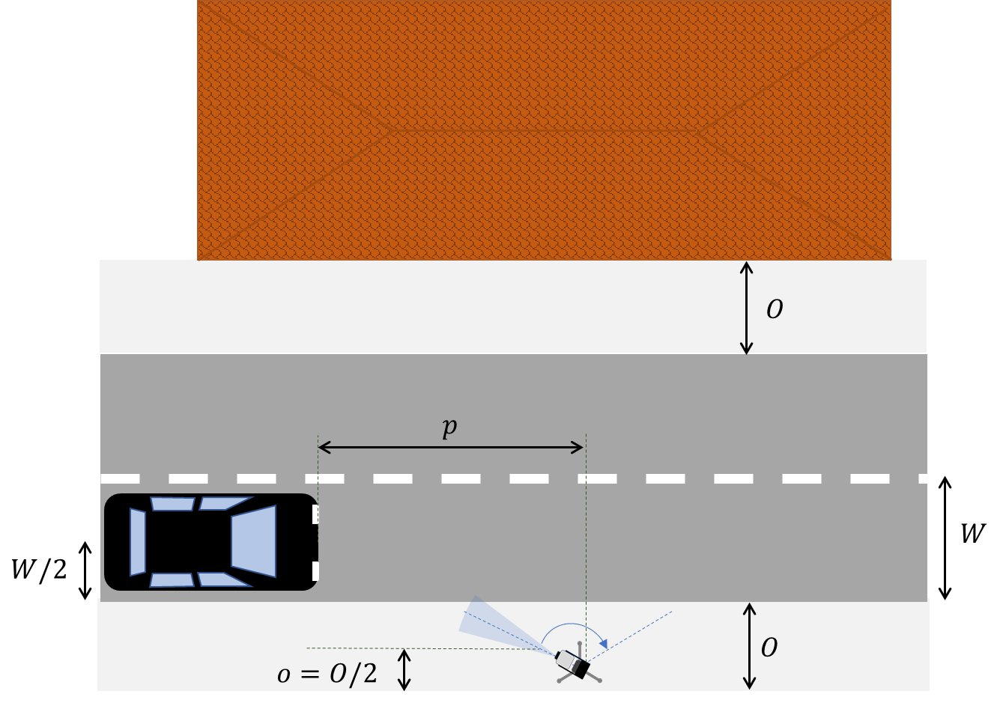
Figure 22:HD-GBSAR Structural Health Monitoring geometry (top view)
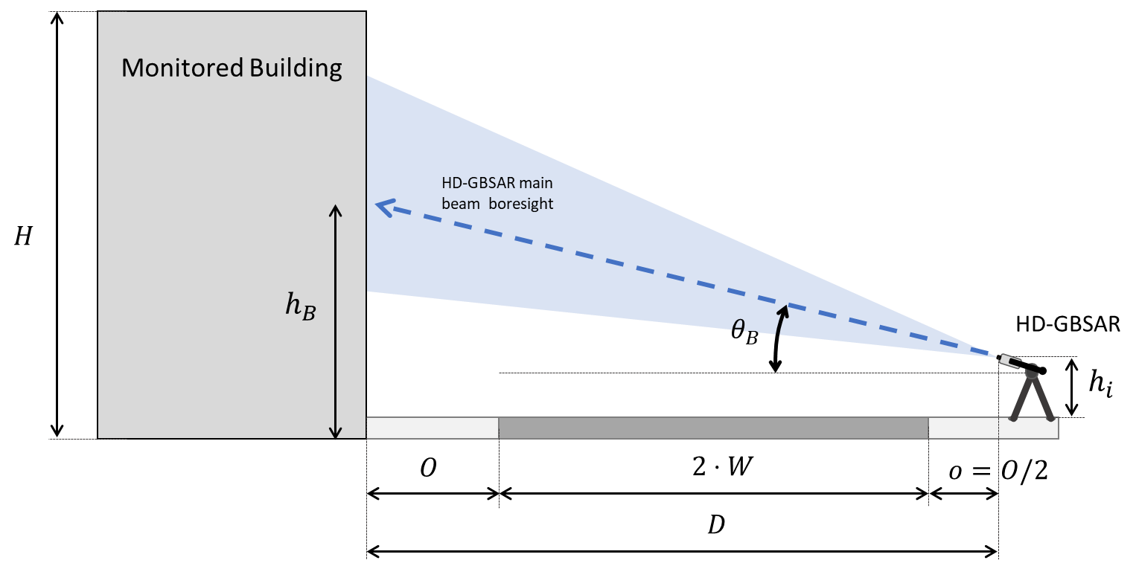
Figure 23: HD-GBSAR Structural Health Monitoring geometry (vertical view)
For the victim automotive radar both the front and corner position and boresight direction are considered as illustrated in Figure 24. The MCL analysis for the two different radar positions are reported respectively in paragraph 4.6.1.1 and 4.6.1.2.
The interference evaluation is repeated assuming several fixed positions $p$ (Figure 21) of the car along the road from 1000 m to 0 m (exactly in front of HD-GBSAR) and for each car position $p$ HD-GBSAR horizontal antenna boresight pointed towards the car to maximise the interference.
In addition, for both the front and corner cases, the following common assumptions have been considered:
- I/N protection criteria of -6 dB based on Recommendation ITU-R M.1461-2 [25];
- Being the victim receiver an FMCW radar for the interference analysis, it is considered the modulation gain $MG$ as specified in ANNEX 4;
- The link budget includes a bumper loss $BL$ of 2 dB in accordance with ETSI TR 103 593 V0.1.3 [35]. The bumper loss is applied as a loss factor along the propagation path from HD-GBSAR to the automotive radar antenna.
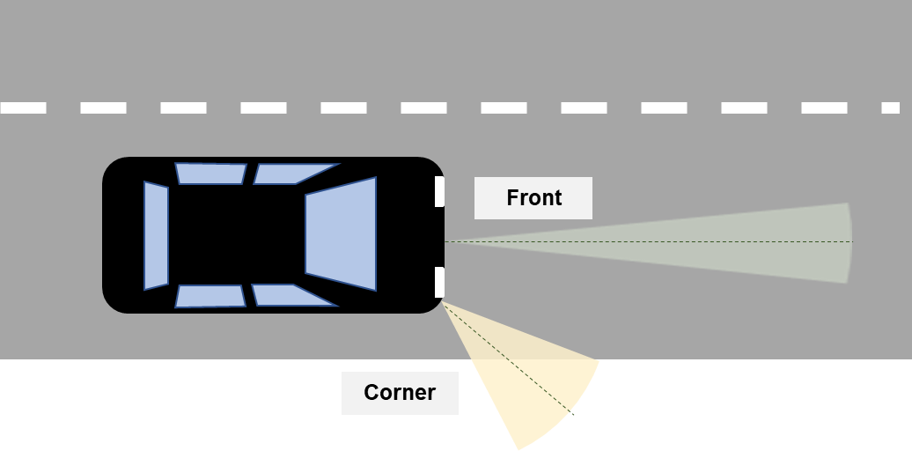
Figure 24: Automotive Front and Corner positions

Front antenna boresight direction
The characteristics of automotive radar used for front applications, such as Adaptive Cruise Control (ACC) and Collision Avoidance (CA), are defined in ITU-R M.2057 [16] (Radar Type A) and summarised in Table 7 of the present document. In particular the victim antenna pattern used in the coexistence analysis has been evaluated using the formula defined in ITU-R M.2057 assuming an horizontal half power beamwidth $φ_{3}$ of 10° and a vertical half power beamwidth $θ_{3}$ of 6°.
Figure 25 shows the detailed geometry and interference angles in the horizontal and vertical plane used in the MCL analysis to evaluate the antenna pattern discrimination factor.
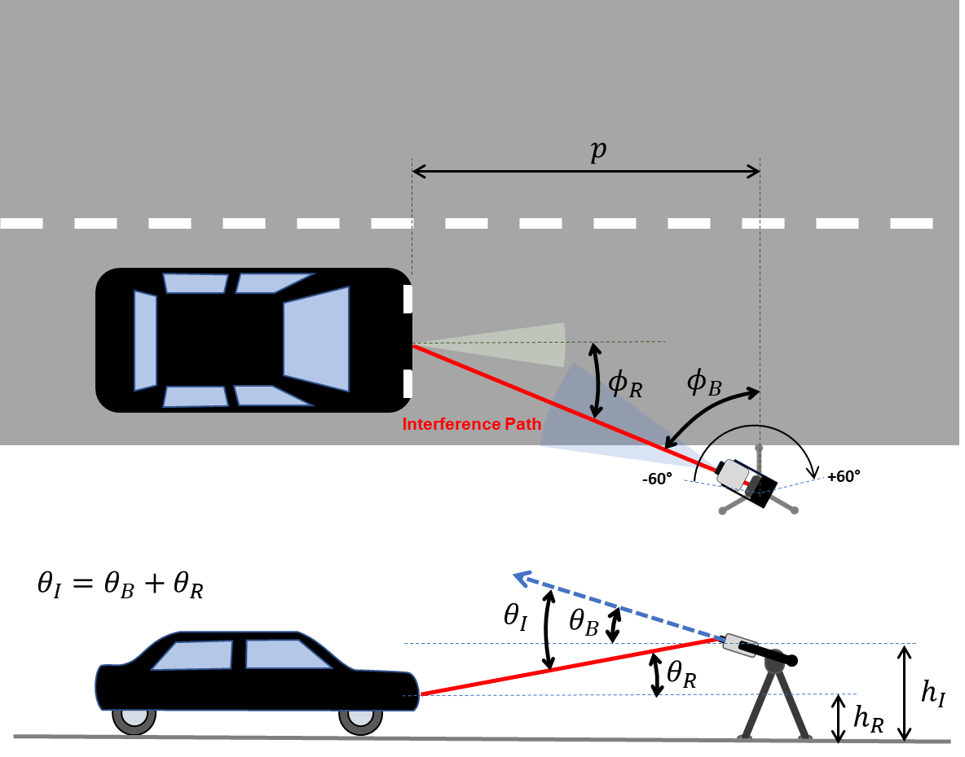
Figure 25: HD-GBSAR vs automotive worst-case interference geometry (front case)
Table 17 reports the victim automotive radar receiver performance, the adopted protection criteria and the derived acceptable interference power at receiver input.
The MCL analysis results, reported in Table 16 (evaluated considering the interference threshold at receiver input of Table 15) and represented in Figure 26, indicates the minimum separation distance calculated for each of the assumed victim receiver position along the road respect to the interferent HD-GBSAR. The required MCL separation distance is always greater than the actual HD-GBSAR to car distance, indicating the risk of harmful interference of HD-GBSAR towards automotive radar for all the simulated car positions.
Table 15: Automotive radar interference threshold at receiver input (front case)
Value | Unit | Parameter | #
Victim
76 | GHz | Operating frequency | $$F$$
1 | MHz | Receiver IF Bandwidth | $$B_{IF}$$
15 | dB | Receiver noise figure | $$NF$$
-6 | dB | Protection criterion | $$I/N$$
-98.8 | dBm | Receiver thermal noise | $$N_{R}$$
-104.8 | dBm | Interference threshold at receiver input | $$I_{R}$$
Table 16: MCL results for different car positions (front case)
Minimum separation distance | Minimum Coupling Loss | Total Interfering power towards victim | HD-GBSAR Antenna Attenuation | Interference threshold before antenna | Victim antenna gain | Victim position
$d$ (m) | $MCL$ (dB) | ${e.i.r.p}_{.I}$ (dBm) | $P$ (dB) | $I$ (dBm) | $G_{R}$ (dBi) | $p$ (m)
2121 | 136.6. | 30.8. | -17.2. | -136.8. | 30.0 | 1000
2146 | 136.7. | 30.9. | -17.1. | -136.8. | 30.0 | 500
2192 | 136.9. | 31.1. | -16.9. | -136.8. | 30.0 | 250
2296 | 137.3. | 31.7. | -16.3. | -136.6. | 29.7 | 100
2342 | 137.4. | 32.7. | -15.3. | -135.7. | 28.9 | 50
1974 | 136.0. | 34.5. | -13.5. | -132.5. | 25.7 | 25
660 | 126.4. | 38.2. | -6.4. | -119.3. | 12.5 | 10
502 | 124.1. | 39.9. | -7.9. | -115.1. | 8.3 | 5
227 | 117.2. | 37.3. | -10.7. | -110.9. | 4.1 | 2
158 | 114.0. | 35.9. | -12.1. | -109.1. | 2.2 | 1
124 | 111.9. | 35.5. | -12.5. | -107.5. | 0.6 | 0.1

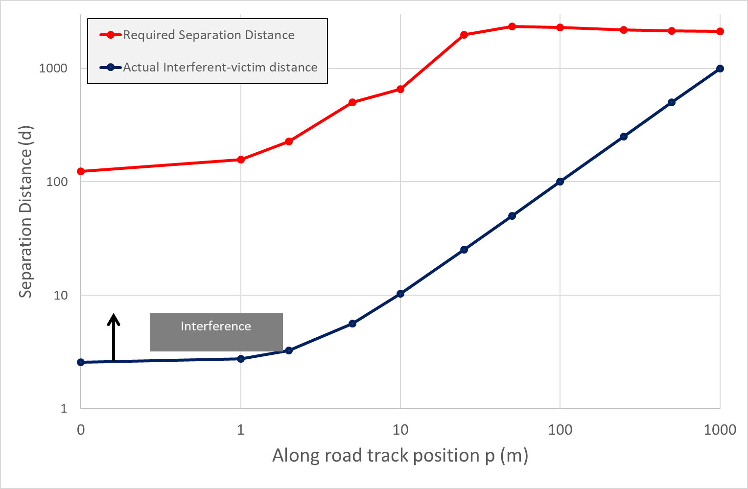
Figure 26: Comparison between actual HD-GBSAR to victim automotive distance and required separation distance in logarithmic scale (front case)

Corner antenna boresight direction
The technical parameters of automotive radar used for corner applications and adopted in the analysis are taken from Recommendation ITU-R M.2057 [16], the one specified for Radar type C of table 1. It shall be noted that the ITU-R Recommendation do not indicate the use of the 76-77 GHz for corner applications, for such reason it is considered all the receiver and antenna characteristics of the Radar type C except the indicated frequency range, which is assumed to be 76-77 GHz. The victim antenna pattern has been evaluated using the formula defined in ITU-R M.2057 with a horizontal half power beamwidth $φ_{3}$ of 32° and a vertical half power beamwidth $θ_{3}$ of 11° in accordance with Radar Type C characteristics.
Figure 27 shows the detailed geometry and interference angles for the analysed scenario. The only difference with respect to Figure 25 is related to the automotive radar position and antenna boresight orientation in the horizontal plane.
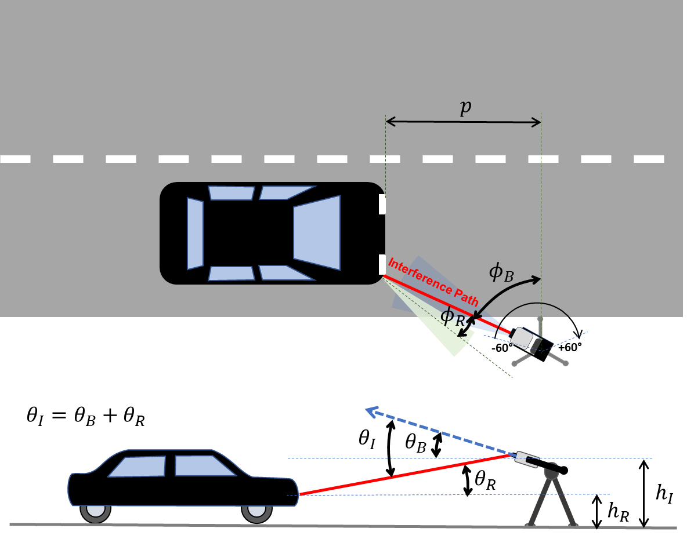
Figure 27: HD-GBSAR vs automotive worst-case interference geometry (corner case)
Table 17 reports the receiver performance of Radar type C, the adopted protection criterion and the derived acceptable interference power at the receiver input.
The results of the MCL analysis (summarised in Table 18 and represented in Figure 28) shows that HD-GBSAR may cause harmful interference to automotive radar for separation distance lower than 65 m.
Table 17: Automotive radar interference threshold at receiver input (corner case)
Value | Unit | Parameter | #
Victim
76 | GHz | Operating frequency | $$F$$
10 | MHz | Receiver IF Bandwidth | $$B_{IF}$$
12 | dB | Receiver noise figure | $$NF$$
-6 | dB | Protection criterion | $$I/N$$
-91.8 | dBm | Receiver thermal noise | $$N_{R}$$
-97.8 | dBm | Interference threshold at receiver input | $$I_{R}$$

Table 18: MCL results for different car positions (Corner case)
Minimum separation distance | Minimum Coupling Loss | Total Interfering power towards victim | HD-GBSAR Antenna Attenuation | Interference threshold before antenna | Victim antenna gain | Victim position
$d$ (m) | $MCL$ (dB) | ${e.i.r.p.}_{I}$ (dBm) | $P$ (dB) | $I$ (dBm) | $G_{R}$ (dBi) | $p$ (m)
58 | 105.3. | 30.7. | -17.3 | -87.6 | -4.2 | 1000
59 | 105.4. | 30.8. | -17.2 | -87.6 | -4.2 | 500
60 | 105.5. | 30.9. | -17.1 | -87.7 | -4.2 | 250
62 | 106.0. | 31.2. | -16.8 | -87.7 | -4.1 | 100
68 | 106.7. | 31.8. | -16.2 | -87.9 | -4.0 | 50
78 | 107.9. | 32.8. | -15.2 | -88.1 | -3.7 | 25
113 | 111.1. | 35.3. | -12.7 | -88.8 | -3.0 | 10
216 | 116.8. | 37.5. | -10.5 | -92.3 | 0.5 | 5
154 | 113.8. | 35.5. | -12.5 | -91.3 | -0.5 | 2
92 | 109.3. | 34.9. | -13.1 | -87.4 | -4.5 | 1
65 | 106.3. | 34.6. | -13.4 | -84.7 | -7.1 | 0.1
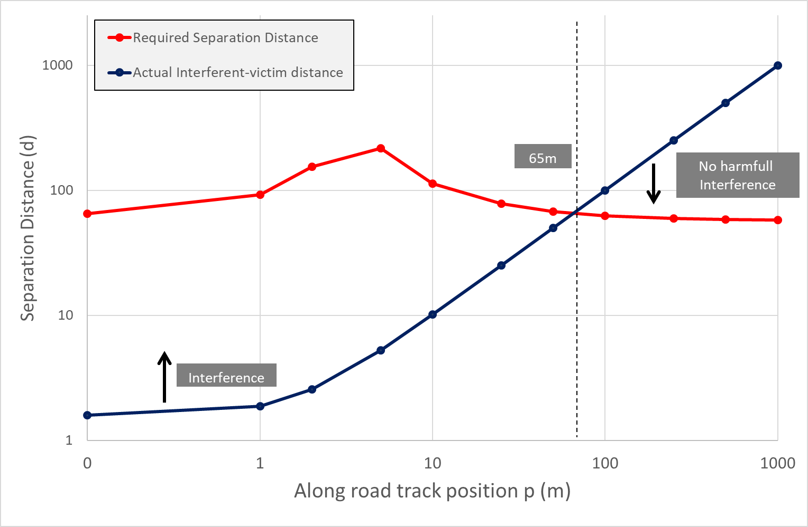
Figure 28: Comparison between actual HD-GBSAR to victim automotive distance and required separation distance in logarithmic scale (corner case)

Conclusion on sharing with automotive radars
The results of the sharing studies between HD-GBSAR and the automotive radar operating in the 76-77 GHz frequency range for front and corner applications in urban environment (worst-case scenario) indicate the potential risk of harmful interference, especially in the case of automotive radar used for front applications (ACC and CA).
It is worth noting that SHM scenarios are often represented by construction sites or other working areas forbidden to vehicular traffic; hence the analysed scenario should not be considered as the most common monitoring configuration. Moreover, the HD-GBSAR is usually mounted high enough to avoid disturbance arising from vehicular traffic which may affect the monitoring performance. I In other words, common HD-GBSAR user intentionally avoids interference from automotive radar to maximise the coverage of the structure to be monitored.
However, since interference events cannot be excluded, a DAA (Detect And Avoid) technique shall be implemented to exclude any residual risk. This technique is used by GBSAR systems to avoid interference towards other radar applications in the Radiolocation service operating in the frequency band 17.1-17.3 GHz ECC Report 111 [2].
ANNEX 6 provides information about DAA technique; the principle is to stop HD-GBSAR transmission as soon as the presence of a potential victim service is detected by the same antenna used to monitor the structure. The detection of the automotive signal is based on power threshold to be measured at HD-GBSAR receiver input to detect the presence of a victim automotive radar:
$DAA threshold=P_{R}-P_{I}-MG+(N_{R}-I/N)$ (14)
where:
- ($N_{R}+I/N)$ is the victim receiver maximum acceptable interferent signal power corresponding to -104.8 dBm for front automotive radar and -97.8 dBm for corner one (Table 15 and Table 17);
- $P_{R}$ is the conducted power at the transmitter antenna input for automotive radar, which is assumed to be 10 dBm for automotive radar, based on the parameter reported in Table 7 and for Radar type C of Recommendation ITU-R M.2057 [16];
- $P_{I}$ is the HD-GBSAR conducted power at the transmitter antenna input corresponding to 24 dBm (ETSI TR 103 594 [1]);
- $MG$ is the modulation gain of -27 dB for front automotive radar and -17 dB for corner automotive radar.
The resulting DAA threshold limit is -91.8 dBm for front automotive radar and -94.8 dBm for corner automotive radar, therefore if an HD-GBSAR during the listening state or the transmission state (see ANNEX 6) detects the presence of an automotive radar signal with a power level above the DAA threshold shall immediately stop the HD-GBSAR transmission to avoid interference.
According to equation (14), the DAA threshold depends on the HD-GBSAR conducted power at the transmitter antenna $P_{I}$. The DAA threshold values above indicated are obtained considering a value of $P_{I}$ equals to 24 dBm, based on HD-GBSAR provided technical requirements. However, lower values of $P_{I}$ would determine higher DAA threshold values, to take this into account the DAA threshold could be defined as function of $P_{I}$. In addition, since automotive radar signal typically have a duty cycle ranging between 20% and 50% with a measurement cycle of 50 ms, the DAA threshold should be defined as average value to consider it. Equation (15) expresses the average DAA threshold as function of $P_{I}$ (considering the worst-case threshold of -94.8 dBm, when $P_{I}$ is 24dBm) and a Duty Cycle Factor ($DCF$), which depends on the specific automotive radar signal duty cycle and it is defined as $10⋅\log_{10}{(Duty Cycle)}$.
$Avg DAA threshold=-70.8-P_{I}+DCF$ (15)
The DAA shall be able to detect the presence of automotive radar signal with the characteristics defined in Table 3 of ECC Report 262 [17]. The presence of the automotive radar is detected when the average power of the automotive radar signal at the input of the HD-GBSAR receiver exceed the threshold defined by equation (15). Table 9 summarises the relevant signal characteristics taken from ECC Report 262 to be considered for DAA.
As reported in ECC Report 262 section 7.2, automotive radar usually works with tracking algorithm which updates a raw target list every radar cycle consisting on a burst of processed short chirps. The tracking algorithm can be different from manufacturer to manufacturer, however in general a potential target is validated and used for AC and ACC functions when it is detected in multiple radar cycles to reduce the probability of false alarm. The radar cycle time typically ranges from 50 ms to 100 ms. HD-GBSAR DAA shall detect the presence a victim automotive radar within the time of a single radar cycle to limit the interference to a single detection cycle and avoid false target validation by the tracking algorithm.
Table 19: Relevant automotive radar signal parameters taken from ECC Report 262
Parameter | Values | Reference in ECC Report 262 [17]
Modulation Type | FMCW
Occupied RF bandwidth (typical) | 100-1000 MHz | Table 3
Tx frequency sweep time (typical) | Slow FMCW: 1-20 ms;  Fast FMCW: 20-80 µs | Table 3
Tx antenna feed power (typical) | 10 dBm | Table 3
Tx duty cycle  (Ratio of transmit on/off ratio) | 20–50% | Table 3
Radar measurement cycle | 50 ms | Table 28
In conclusion, considering DAA as a mandatory requirement, it may be assumed that there is no relevant risk of harmful interference between HD-GBSAR and automotive radar working the 76-77 GHz frequency range used for anti-collision avoidance (AC) and assisted cruise control (ACC) and corner application.

Sharing with LPR
Based on the information provided by ECC Report 139 [21], a worst-case interference scenario between LPR and HD-GBSAR may occur when LPR are used to measure the water level of a river, whereas HD-GBSAR monitors the deformation of a slope in close proximity (Figure 29). Typically for this application LPR is installed 2-10 m over normal water level, under a bridge or a similar structure.
The MCL evaluation reported in Table 20 is based on the following assumptions:
- Given the use case geometry (Figure 29), it may be assumed that LPR receives HD-GBSAR interferent signal with an offset angle close to -90° with respect to the main lobe boresight direction. The MCL analysis considers an LPR antenna gain in the direction of the interferer of -10 dBi, in accordance with ECC Decision (11)02 requiring a maximum antenna gain of -10 dBi above 60 degrees for LPR;
- ECC Report 139 doesn't provide any information about typical receiver noise performance. The evaluation assumes a NF of 15 dB and a receiver IF bandwidth of 10 MHz, which are typical values for receiver operating in the examined frequency range;
- In absence of LPR protection criteria, it is assumed an I/N objective of -6 dB based on Recommendation ITU-R M.1461-2 [25];
- It is assumed a vertical tilt of HD-GBSAR antenna radiation pattern of 15° to optimise the coverage of the slope to be monitored, therefore the HD-GBSAR antenna off-set angle towards LPR is around 15°;
- HD-GBSAR activity factor for landslide monitoring application is 30% (one acquisition every 120 seconds), therefore the victim LPR is interfered by HD-GBSAR for 3 seconds every 120 seconds.
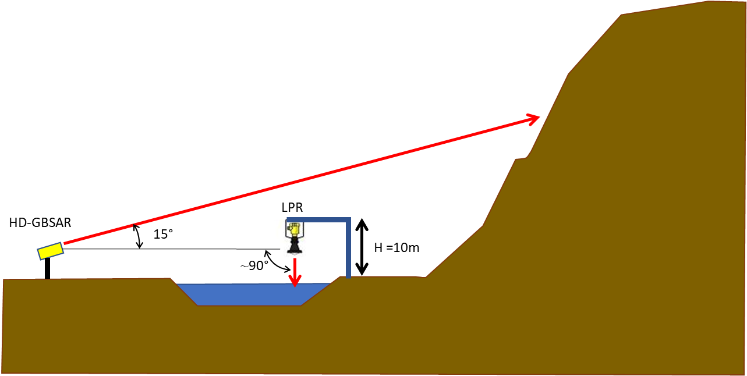
Figure 29: HD-GBSAR to LPR interference scenario in V-plane

Table 20: Calculation of separation distance between HD-GBSAR and LPR
LPR | Unit | Parameter | #
Victim
74 | GHz | Operating Frequency | $$F$$
10 | MHz | Receiver IF bandwidth | $$B_{IF}$$
15 | dB | Noise Figure | $$NF$$
-6 | dB | Protection criterion | $$I/N$$
>60° | deg | Direction of interferer in the vertical plane | $$θ_{R}$$
-10 | dBi | Antenna Gain in the direction of the interferer | $$G_{R}$$
-85.8 | dBm | Receiver thermal noise | $$N_{R}$$
-91.8 | dBm | Interference threshold at receiver input | $$I_{R}$$
-81.8 | dBm | Interference threshold before antenna | $$I$$
HD-GBSAR Interferer
48 | dBm | Maximum e.i.r.p | $${e.i.r.p.}_{max}$$
1000 | MHz | Reference Bandwidth | $$B_{I}$$
-15 | deg | Direction of victim in the vertical plane | $$θ_{I}$$
-3 | dB | Normalised Vertical Antenna Pattern in the direction of the victim | $$P_{V}$$
120 | sec | Acquisition time | $$T_{A}$$
-16 | dB | Antenna Duty Cycle | $$ADC$$
29 | dBm | Total interfering power towards Victim | $${e.i.r.p.}_{I}$$
-17 | dB | Modulation Gain | $$MG$$
Impact Range calculation
93.8 | dB | Minimum Coupling Loss
15 | m | Minimum separation distance
The MCL analysis indicates a minimum separation distance between HD-GBSAR and LPR of 15 m, which is far less than the realistic distance assumed in the worst-case scenario. According also the following additional considerations:
- HD-GBSAR is installed to have the better possible line of sight of the area to be monitored, thus is not placed nearby any kind of structures covering the LOS of the area to be monitored;
- Both HD-GBSAR and LPR expected deployment density expressed as number of devices per square km is extremely low, as consequence the probability to have one HD-GBSAR and one LPR operating in the same area it may be assumed extremely unlikely.
It may be concluded that there is no concern of coexistence between HD-GBSAR and LPR.

Sharing with rotorcraft
Obstacle detection radar for rotorcraft use is intended to detect and inform the flight crew of obstacles during the phase of take-off and landing. The most likely interference scenario between HD-GBSAR and rotorcraft radar is assumed to be when HD-GBSAR monitors the stability of a building with rooftop heliport, as illustrated in Figure 30, while the rotorcraft equipped with the obstacle detection radar is taking off or landing.
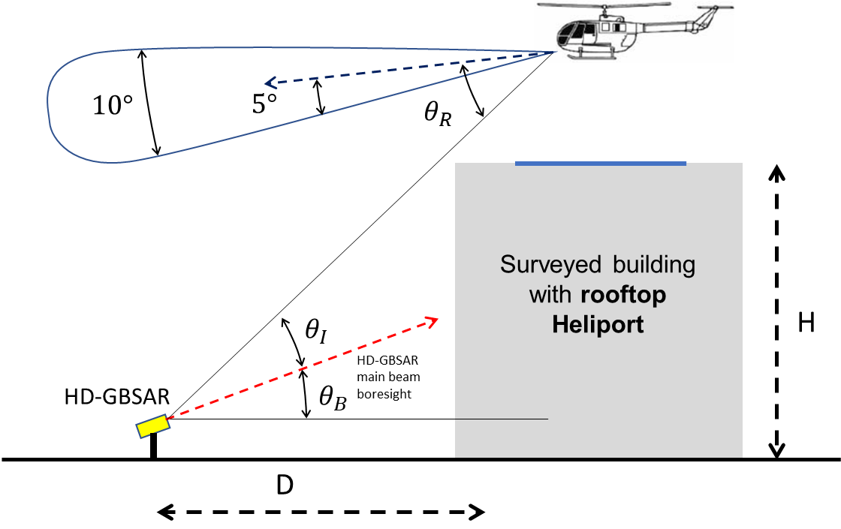
Figure 30: HD-GBSAR to Rotorcraft Obstacle detection Radar interference scenario in V-plane
The MCL analysis is performed based on the following assumptions regarding the geometrical configuration of the above depicted interference scenario:
- Building height H of at least 20 m, as lower building would not be suitable for rooftop heliport, which requires the absence of higher buildings in the proximity to avoid dangerous flight interference during take-off and landing. The building height of 20 m shall be assumed as a very extreme situation, since very often rooftop heliports are built on top of very height building, such as skyscrapers;
- HD-GBSAR positioned at 20 m from the building (D=20 m) allowing good frontal coverage of the entire building, accordingly the HD-GBSAR antenna is pointed at the geometric centre of the surveyed building. A longer distance between HD-GBSAR and building are unlikely possible in dense urban area and it would also represent a better condition in terms of interference, since HD-GBSAR would see the victim receiver with greater offset angle with respect to the boresight direction and therefore with a better antenna discrimination factor. Vice versa shorter distance would limit the HD-GBSAR coverage of the building front face and would reduce the probability of direct LOS of the victim receiver;
- HD-GBSAR vertical orientation is assumed to be at the centre of the building (H/2) to optimise the coverage of the front face;
- The position of the rotorcraft is assumed at the same height of the building as worst interference condition during the phase of take-off and landing.
According to the aforementioned geometrical assumptions:
- HD-GBSAR antenna boresight direction $θ_{B}=\tan^{-1}\left(\frac{H/2}{D} \right){=tan}^{-1}\left(\frac{10 m}{20 m}\right)≅26.5°$
- HD-GBSAR antenna off-set angle towards rotorcraft radar receiver $θ_{I}=45°-θ_{B}≅17.5°$
Table 21 provides MCL evaluation of minimum required separation distance for complete avoidance of interference from HD-GBSAR to rotorcraft radar based on the considered scenario and the following additional assumptions on the victim receiver characteristics derived from ECC Report 222 [19]
- Receiver antenna characteristics (A.3.1 of ECC Report 222):
Gain 13 dBi;
Horizontal half-power beamwidth 70°;
Vertical half-power beamwidth 10° (pointing 5° downwards);
Vertical Side Lobe Level below 15 dB for offset angle greater than 10°.
- FMCW receiver with direct down-conversion with an IF filter of 10 MHz;
- Receiver Noise Figure of 10 dB.
Since the interference is evaluated only during phase of take-off and landing for the victim receiver it is considered only the characteristics of the Near Field Obstacle Detection System.
Table 21: Calculation of separation distance between HD-GBSAR and rotorcraft obstacle detection radar
AS | Unit | Parameter | #
Victim
76 | GHz | Operating Frequency | $$F$$
10 | MHz | Receiver IF bandwidth | $$B_{IF}$$
15 | dB | Noise Figure | $$NF$$
-6 | dB | Protection criterion | $$I/N$$
40 | deg | Direction of interferer in the vertical plane (boresight offset) | $$θ_{R}$$
-2 dBi | dBi | Antenna Gain in the direction of the interferer | $$G_{R}$$
-85.8 | dBm | Receiver thermal noise | $$N_{R}$$
-91.8 | dBm | Interference threshold at receiver input | $$I_{R}$$
-89.8 | dBm | Interference threshold before antenna | $$I$$
HD-GBSAR Interferer
48 | dBm | Maximum e.i.r.p. | $${e.i.r.p.}_{max}$$
1000 | MHz | Reference Bandwidth | $$B_{I}$$
18.4 | deg | Direction of victim in the vertical plane | $$θ_{I}$$
-4.6 | dB | Normalised Vertical Antenna Pattern in the direction of the victim | $$P_{V}$$
43.4 | dBm | Total interfering power towards Victim | $${e.i.r.p.}_{I}$$
-17 | dB | Modulation Gain | $$MG$$
Impact Range calculation
116.2 | dB | Minimum Coupling Loss
204 | m | Minimum separation distance
The MCL analysis (Table 21) provides a minimum separation distance requirement between HD-GBSAR and the victim receiver of 204 m greater than the assumed distance of around 28 m, indicating the risk of possible interference between HD-GBSAR and rotorcraft radar. Nevertheless, it shall be considered that:
- The extremely low expected deployment density of HD-GBSAR in urban area combined with the low number of existing rooftop heliport implies an extremely low probability of occurrence of the considered interference scenario;
- Rooftop heliports are typically built on very high building (higher than 20 m) such as skyscrapers to reduce the risk of accident due to the presence of surrounding buildings. In particular, it is sufficient to assume a building height of 50 m to reduce the minimum separation distance to 35 m and eliminate any risk of interference;
- HD-GBSAR is typically used to monitor the deformation of building and structure known as potentially unstable, thus and eventual rooftop heliport would be very likely closed to avoid unnecessary risk. This reduces furtherly the probability HD-GBSAR interference towards rotorcraft in case of building monitoring application.
Based on the above considerations, it may be concluded that there is not significant risk of interference between HD-GBSAR and rotorcraft radar.
Eventually, to eliminate any residual risk of interference towards Rotorcraft obstacle detection radar, the usage of HD-GBSAR to monitor building or structure with rooftop heliport could be explicitly forbidden, without any relevant impact on the HD-GBSAR market prospect.

Sharing with TTT
Fixed transport infrastructure radars (referred in the following as Fixed TTT) are used for automatic incident detection on motorways and other strategic roads, bridges and tunnels ECC Report 262 [17]. Among such possible applications, it may be assumed as worst-case interference scenario the situation where HD-GBSAR surveys the stability of a cut-slope endangering a motorways road monitored at the same time by fixed infrastructure radar, as illustrated in Figure 31.
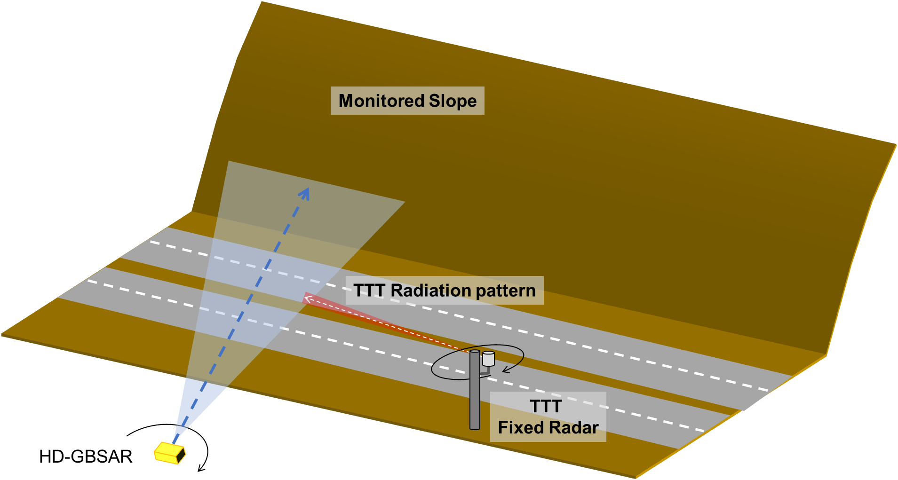
Figure 31: HD-GBSAR to fixed infrastructure radar worst-case interference scenario
Figure 32 provides the vertical and top view of the identified interference scenario introducing additional geometrical parameters impacting the MCL analysis, which are described below:
- HD-GBSAR placed at a height $h_{i}=1 m$, a distance $d_{y}$ from the road of at least 10 m not to be shadowed by the motorway protection barriers and with an horizontal offset $d_{x}$ from the Fixed TTT victim receiver of 20 m, since the pole used as support for the Fixed TTT would represent an obstacle to the visibility of the slope to be monitored;
- Fixed TTT placed on the side of the road at a height $h_{r}=4 m$ based on the typical installation information indicated in the ECC Report 262;
- A cut-slope inclination $α$ of 45° (lower angle would reduce the probability of instability of the slope) and height $H$ of around 50 m;
- A road width $w$ of 20 m (6 lanes of about 3.5 m).
From the above geometrical assumptions, it can be derived that:
- HD-GBSAR antenna is tilted up at half slope height of an angle $θ_{B}$ to maximise the coverage. The value of $θ_{B}$ is given by the following equation:
$$θ_{B}=\operatorname{atan}\left(\frac{H}{2⋅D}\right)=\operatorname{atan}\left(\frac{H}{2⋅(d_{y}+w+H/{tan⁡(α)}}\right)=atan\left(\frac{50}{2⋅80}\right)=17.3 deg$$
- Fixed TTT fixed victim receiver is pointed with no vertical tilt [17], therefore the HD-GBSAR interferent signal vertical direction with respect the receiver antenna boresight corresponds to:
$$θ_{R}=\operatorname{atan}\left(\frac{h_{r}-h_{i}}{D}\right)=\operatorname{atan}\left(\frac{3}{25}\right)=6.8 deg$$
- At that angle the victim receiver antenna vertical mitigation factor is at least -17 dB (Figure 10).
- HD-GBSAR sees the victim receiver with a vertical angle offset with respect to the boresight direction of $\left(θ_{I}-θ_{B}\right)=\left(θ_{I}-θ_{R}\right)=10.5 deg$, producing a vertical discrimination factor of -1.2 dB (Figure 5).
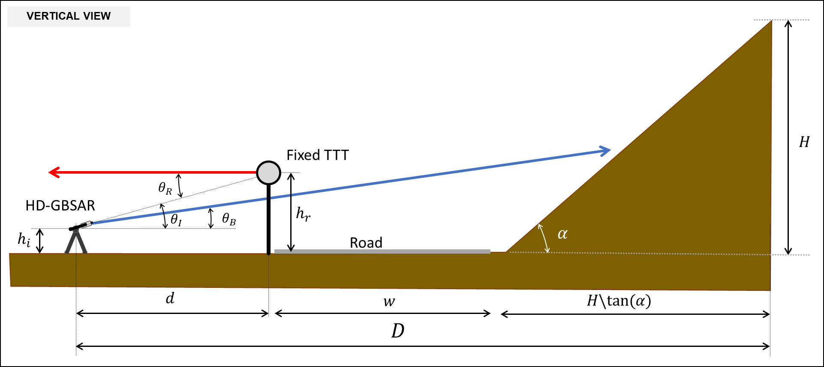
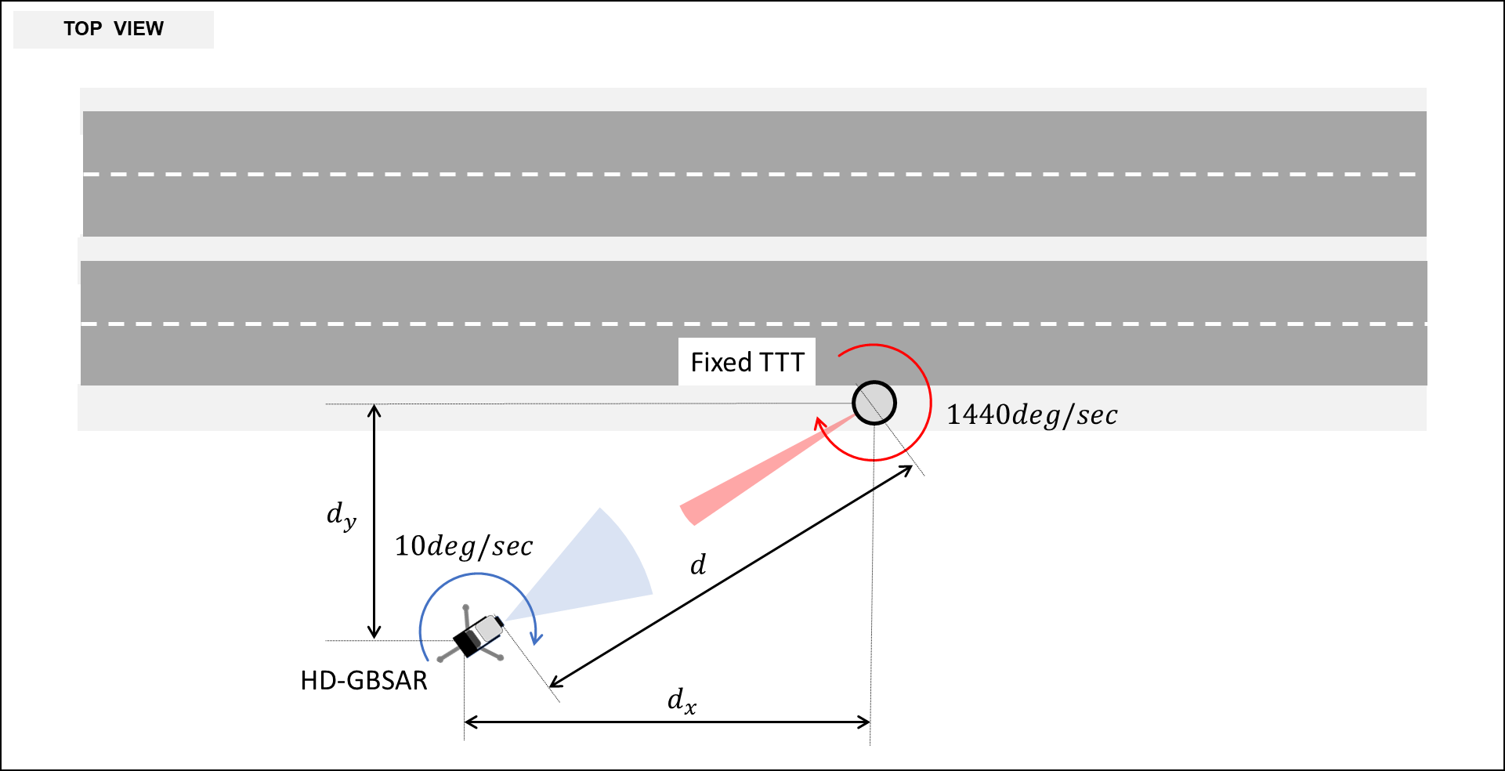
Figure 32: HD-GBSAR to fixed infrastructure radar worst-case interference scenario geometry
The fact that both HD-GBSAR and Fixed TTT are rotating in the horizontal plane while operating adds the following further considerations to be taken into account in the analysis:
- HD-GBSAR rotates with a speed $v_{I}=10 deg/sec$, therefore the horizontal antenna main-lobe (half power beamwidth $θ_{HPBW}=30 deg$) is illuminating the Fixed TTT for a time $T$ of 3 seconds every acquisition. Considering the declared activity factor for slope monitoring application (Table 5), the Fixed TTT is illuminated by HD-GBSAR 3 seconds every 120 seconds;
- Fixed TTT rotates continuously with a speed of $v_{R}=1140 deg/sec$ (4 rounds per second), therefore the main-lobe to main-lobe interference in the horizontal plane is only a fraction of the time $T$. More precisely, every round the Fixed TTT is interfered for a time $T_{I_{round}}={(θ}_{HPBW}/v_{R})$ and during the time $T$ the Fixed TTT performs $\frac{T}{{(360}/{v_{R)}}}=12$ rounds, thus the actual interference time $T_{I}$ is:
$$T_{I}=12⋅ T_{I_{round}}=12⋅\left(\frac{30}{1440}\right)=0.25 sec$$
In conclusion, the interference occurs a time $T_{I}$ every 120 seconds. The mitigation factor produced by the mutual antenna rotation is considered in the MCL analysis by means the Antenna Duty Cycle (ADC) parameter equals to:
$$ADC=10⋅\log_{10}\left(\frac{T_{I}}{120}\right)=-26.8 dB$$
Being the victim receiver a FMCW radar, an additional mitigation is provided by the modulation gain (MG) evaluated as specified in ANNEX 4.
Table 11 reports the MCL analysis based on the aforementioned assumptions, the Fixed TTT technical parameter reported in Table 8 and an I/N protection criterion of -6 dB.
Table 22: Calculation of separation distance between HD-GBSAR and Fixed TTT
Fixed TTT | Unit | Parameter | #
Victim
76 | GHz | Operating Frequency | $$F$$
650 | MHz | Receiver reference bandwidth | $$BW_{R}$$
10 | MHz | Receiver IF bandwidth | $$B_{IF}$$
15 | dB | Noise Figure | $$NF$$
-6 | dB | Interference objective | $$I/N$$
6.8 | deg | Direction of interferer in the vertical plane (boresight off-set angle) | $$θ_{R}$$
11 | dBi | Antenna Gain in the direction of the interferer | $$G_{R}$$
-85.8 | dBm | Receiver thermal noise | $$N_{R}$$
-91.8 | dBm | Interference threshold at receiver input | $$I_{R}$$
-102.8 | dBm | Interference threshold before antenna | $$I$$
HD-GBSAR Interferer
48 | dBm | Maximum e.i.r.p. | $$e.i.r.p.{}_{max}$$
1000 | MHz | Reference Bandwidth | $$B_{I}$$
10.5 | deg | Direction of victim in the vertical plane (boresight off-set angle) | $$θ_{I}-θ_{B}$$
-1.2 | dB | Normalised Vertical Antenna Pattern in the direction of the victim | $$P_{V}$$
-26.8 | dB | Antenna Duty Cycle | $$ADC$$
20.0 | dBm | Total interfering power towards Victim | $${e.i.r.p}_{I}$$
-1.87 | dB | Bandwidth correction factor | $$BWCF$$
-17 | dB | Modulation Gain | $$MG$$
Impact Range calculation
104.0, | dB | Minimum Coupling Loss | MCL
50 | m | Minimum separation distance | d
The MCL analysis indicates a minimum separation distance between HD-GBSAR and Fixed TTT of 50 m, which is a value similar to the distance assumed in the analysis. However, considering the expected low deployment density of both HD-GBSAR and Fixed TTT, the probability to have one HD-GBSAR and one Fixed TTT operating in the same area at a distance closer than 50 m can be considered extremely unlikely.
It may be concluded that there is no relevant concern of coexistence between HD-GBSAR and Fixed TTT.

Sharing with railway
As reported in 4.2.1.1 radar systems operating at 76-77 GHz are used for obstruction detection at railway level crossing, where one or more radar devices are mounted on a pole pointed downwards to cover the level crossing area (Figure 33).
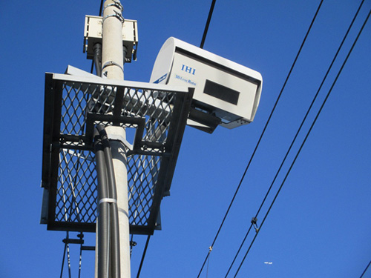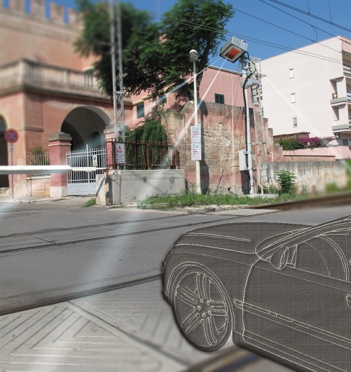
Figure 33: Examples of Obstruction/Vehicle detection radars at railway level crossings setup
Considering HD-GBSAR possible use cases, two possible interference scenarios can be identified (Figure 34):
- SHM of a building nearby to a railway level crossing;
- Monitoring of an unstable slope putting at risk a railway track, with a level crossing in the proximity.

Looking at the geometry of the aforementioned scenarios, it may be assumed that the victim receiver could be interfered by HD-GBSAR on its antenna pattern side-lobe.
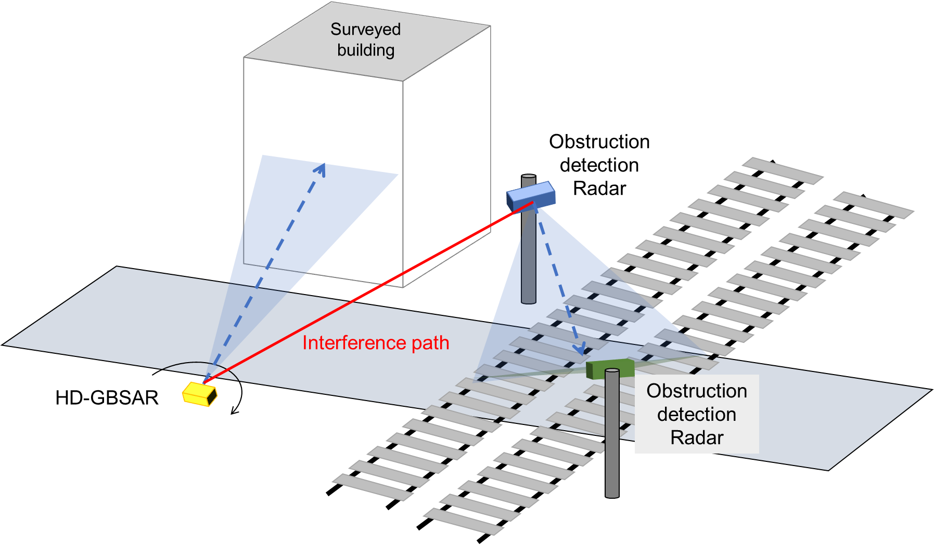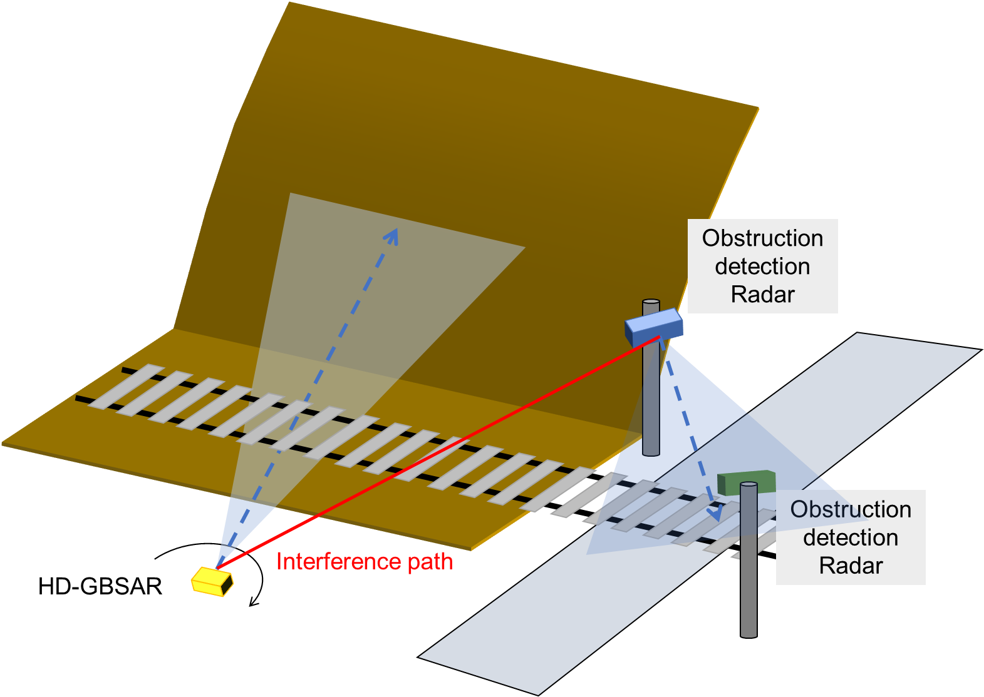
Figure 34: Interference scenarios between HD-GBSAR and SRD for obstruction detection at railway level crossing
The available information about Obstruction Detection Radar (ODR) [15] do not allow an accurate compatibility study analysis for the absence of data concerning typical antenna characteristics, receiver performance and protection criteria.
In addition to the above consideration, it shall be noted that the number of railway level crossing equipped with ODR can be estimated on a few thousands distributed in all the EU countries (4.2.1.1) and only a few hundreds could configure one of the two defined interference scenario. Particularly the second scenario (unstable slope monitoring) it appears to be very unlikely.
Combining the low number of possible interference situations with the low expected number of deployed HD-GBSAR (Table 4), it can be inferred that the likelihood of interference between HD-GBSAR and ODR is extremely low and do not represent a relevant concern.

Sharing with Amateur & Amateur-Satellite Services
The HD-GBSAR use case posing possible risk of interference towards Amateur Service is represented by the landslide monitoring application. The possible scenario, depicted in Figure 35, consists in the presence of an amateur station located on hilltop used for long-range point to point communication (100-200 km) and the contemporary presence of an HD-GBSAR monitoring the deformation of the hill slope.
The assumed interference scenario is based on the following worst-case assumptions:
- HD-GBSAR working at the maximum range of 800 m with a vertical orientation of $θ_{e}$ to maximise the slope coverage. Such geometry minimises the antenna off-set angle towards AS victim receiver and therefore minimises the HD-GBSAR antenna pattern mitigation factor;
- AS receiver located on the hilltop having a generic height of H. The interference evaluation is repeated for H equals to 100 m, 200 m and 300 m,
- Perfect alignment in the horizontal plane between the AS receiver main lobe and HD-GBSAR;
- Clear LOS between HD-GBSAR and victim receiver.
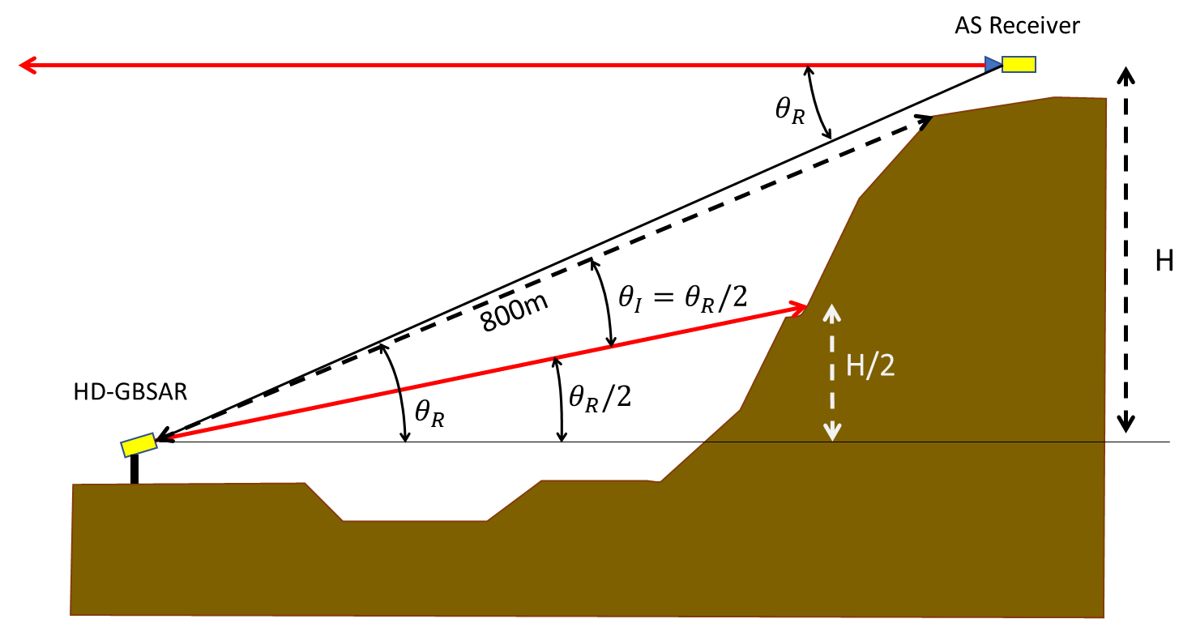
Figure 35: HD-GBSAR to AS interference scenario in V-plane
In order to realise long-range point to point communications, amateur stations use high directivity antenna with a typical gain of 40 dBi (Table 10). In Figure 36 the radiation pattern of a commercial parabolic antenna is reported as an example for an amateur station operating at 76 GHz with an aperture diameter of 22 cm, a gain of 42 dBi and an half power beamwidth of 1.2°.
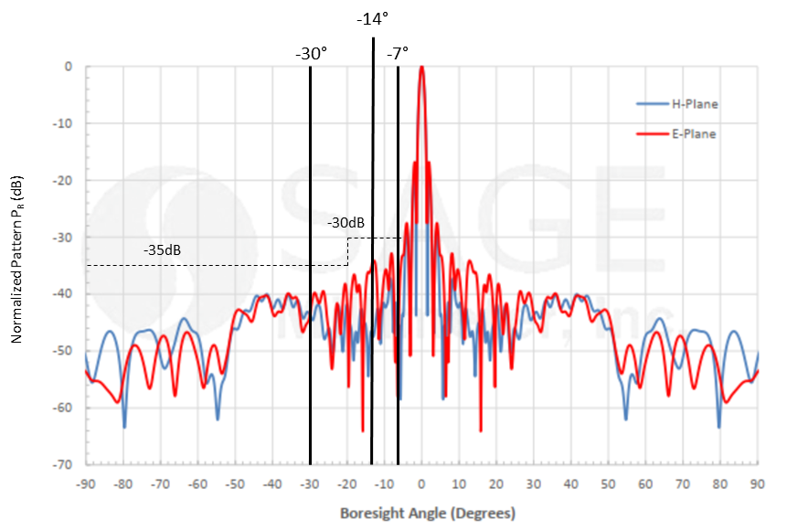
Figure 36: Example of AS station antenna radiation pattern
Looking at the interference scenario the victim amateur station sees the HD-GBSAR interferer with an offset angle $θ_{R}$ with respect the boresight direction given by the following equation:
$$θ_{R}=\operatorname{atan}\left(\frac{H}{800}\right)$$
assuming an antenna pattern with characteristics similar to those reported as an example, the antenna discrimination factor in the direction of the interferer, for the analysed values of H, is reported in Table 23 where the maximum victim receiver antenna gain is assumed to be 40 dBi.
Table 23: Victim receiver antenna gain towards the interferer
$G_{R}$ (dBi) | $P_{R}$ (dB) | $θ_{R}$ (deg) | H (m)
10 | -30 | 7.1 | 100
10 | -30 | 14.3 | 200
5 | -35 | 20.5 | 300
The MCL analysis (Table 24) is also based on the following assumptions:
- AS receiver characteristics indicated in Table 10;
- I/N interference protection criteria of -6 dB;
- HD-GBSAR antenna off-set angle towards AS terminal $θ_{I}≅θ_{R}/2$, corresponding to an antenna discrimination factor respectively of 0 dB, -0.5 dB and -1 dB for H equals to 100 m, 200 m and 300 m;
- HD-GBSAR activity factor for landslide monitoring application of 30% (one acquisition every 120 seconds), therefore the victim receiver is interfered by HD-GBSAR for 3 seconds every 120 seconds.
Table 24: Calculation of separation distance between HD-GBSAR and AS
H=300 m | H=200 m | H=100 m | Unit | Parameter | #
Victim
76 | 76 | 76 | GHz | Operating Frequency | $$F$$
2.7 | 2.7 | 2.7 | kHz | Receiver reference bandwidth | $$BW_{R}$$
4 | 4 | 4 | dB | Noise Figure | $$NF$$
-6 | -6 | -6 | dB | Protection criterion | $$I/N$$
20.5 | 14.3 | 7.1 | deg | Direction of interferer in the vertical plane | $$θ_{R}$$
5 | 10 | 10 | dBi | Antenna Gain in the direction of the interferer | $$G_{R}$$
-135.5 | -135.5 | -135.5 | dBm | Receiver thermal noise | $$N_{R}$$
-141.5 | -141.5 | -141.5 | dBm | Interference threshold at receiver input | $$I_{R}$$
-146.5 | -151.5 | -151.5 | dBm | Interference threshold before antenna | $$I$$
HD-GBSAR Interferer
48 | 48 | 48 | dBm | Maximum e.i.r.p | $${e.i.r.p.}_{max}$$
1000 | 1000 | 1000 | MHz | Reference Bandwidth | $$B_{I}$$
15 | 15 | 15 | deg | Direction of victim in the vertical plane | $$θ_{I}$$
-1 | -0.5 | 0 | dB | Normalised Vertical Antenna Pattern in the direction of the victim | $$P_{V}$$
120 | 120 | 120 | Sec | Acquisition time | $$T_{A}$$
-16 | -16 | -16 | dB | Antenna Duty Cycle | $$ADC$$
31 | 31.5 | 32 | dBm | Total interfering power towards Victim | $${e.i.r.p.}_{I}$$
-55.7 | -55.7 | -55.7 | dB | Bandwidth correction factor | $$BWCF$$
Impact Range calculation
121.8 | 127.3 | 127.8 | dB | Minimum Coupling Loss
387 | 729 | 772 | m | Minimum separation distance
The MCL analysis reported in Table 24 provides a minimum separation distance for all the analysed cases lower than the distance between HD-GBSAR and victim receiver assumed in the interference scenario Therefore, it may be concluded that there is no risk of interference between HD-GBSAR and AS.
It is also worth noting that the MCL analysis does not take into account the following additional mitigation factors:
- The probability that the AS station antenna is pointed directly towards HD-GBSAR would be around 1.5/360, assuming an antenna half-power beamwidth of 1.5°, typical for a gain of 40 dBi;
- There may be no clear LOS between HD-GBSAR and AS antenna;
- The probability to have an HD-GBSAR and AS station operating in the same area may be assumed extremely low, because of the low expected deployment density of HD-GBSAR and the low probability to have an amateur station located over the top of an unstable slope.
The compatibility analysis is limited only to terrestrial amateur service, which may be considered as a worst-case scenario, since in case of amateur-satellite ground stations the victim receiver antenna elevation is typically pointed with higher elevation angle increasing the antenna discrimination factor towards the interferer.

Sharing with Radio Astronomy Service
According to footnote 5.149 of the Radio Regulations, administrations are urged to take all practicable steps to protect the RAS from harmful interference in the 76-86 GHz frequency band.
The protection criterion used is derived from Recommendation ITU-R RA.769-2 [27]. Since no value is provided for this particular frequency band, it is proposed to consider the threshold values given for 86.6 GHz, for spectral line, continuum and VLBI observation, corresponding to a maximum interference level at input of the victim receiver RAS with a spectral pfd of -208 dB(W(m2*Hz)), -228 dB(W(m2*Hz)) and -172 dB(W(m2*Hz)) respectively (see ITU-R RA.769-2 Table1 and Table 2 column 9 respectively and Table 3).
Although very unlikely, a possible worst-case interference scenario is represented by the case of an HD-GBSAR monitoring the stability of building located in the surrounding of observatory and having clear line of sight of the radio astronomy radio telescope (Figure 37). In such situation the interference could be caused by:
- The HD-GBSAR back-lobe signal radiation;
- The signal reflected by the surveyed structure towards the RAS station.
Additionally, a scenario is considered where interference can occur due to radiated signals of the HD-GBSAR main beam for which the propagation path is not completely obstructed by the surveyed structure.
In the following the first of the two possible interference scenarios is analysed. The HD-GBSAR radar signal is mostly reflected towards the specular direction, which is not interfering with the RAS station, whereas the signal backscattered in the horizontal direction is assumed to be lower than the one transmitted from the HD-GBSAR back radiation lobe.
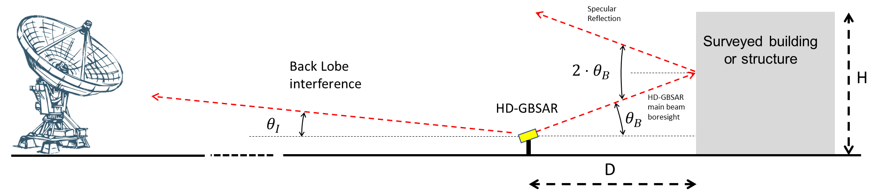
Figure 37: HD-GBSAR to RAS worst case interference scenario
The MCL analysis reported in Table 25 is based on the following assumptions:
- HD-GBSAR monitoring a building height H=20 at a distance D=20 m and therefore a main lobe vertical tilt angle $θ_{B}=\operatorname{atan}\left(\frac{H}{2B}\right)=26.6°$;
- Clear LOS between the HD-GBSAR back-lobe and the victim RAS;
- The surveyed building is assumed to be at several kilometres from the RAS, therefore the direction of the back-lobe interferent signal can be considered almost parallel to the ground ($θ_{I}=0°$);
- HD-GBSAR activity factor for SHM monitoring application of about 50% (one acquisition every 60 seconds)
- A RAS antenna gain of 0 dBi in the direction of the interferent signal. Such a value is taken in accordance with Recommendation ITU-R RA.769 [27], indicating that in case of terrestrial interference (interferent placed at ground level) the radio telescope antenna gain shall be assumed 0 dBi, corresponding to the maximum side-lobe level.
The emitted spectral power flux density of a single HD-GBSAR device, in the unit (dBW/m2/Hz), is calculated assuming isotropic radiation as shown below:
$S_{H HD-GBSAR}=P_{HD-GBSAR}-30\frac{dBW}{dBm}-90\frac{dBHz}{dBGHz}+10log\left(\frac{4{πv}_{0}^{2}}{c^{2}}\right)$ (16)
where:
- $S_{H HD-GBSAR}$: emitted spectral power flux density (dBW/m2/Hz) of a HD GBSAR transmitter;
- $P_{HD-GBSAR}$: Transmit power density of a HD-GBSAR device (dBm/GHz e.i.r.p.);
- $V_{0}$ frequency (Hz);
- c: speed of light (m/s).The minimum required coupling loss is evaluated according the following formula:
$A_{Min}=S_{H HD-GBSAR}-S_{H Radio astronomy}+10log\left(\frac{T_{Interference HD-GBSAR}}{T_{Integral}}\right)$ (17)
where:
- AMin: Minimum coupling loss (dB);
- $S_{H HD-GBSAR}$: emitted spectral power flux density (dBW/m2/Hz) of a HD-GBSAR device;
- $S_{H Radio astronomy}$: allowed spectral power flux density threshold (dBW/m2/Hz) of a RA receiver;
- TInerference HD-GBAR : Total on-time of a single HD-GBSAR device;
- Tintegral: Integration time of the Radio Astronomy detector (s).
The spectral pfd values of Table 2 in Recommendation ITU-R RA.769-2 [27] are based on an integration period of 2000 seconds.
The minimum separation distance can be calculated based on Recommendation ITU-R P.620-7 [42]. This recommendation considers two modes, mode (1) "propagation condition in clear air" and mode (2) "hydrometer scatter". Only mode (1) is taken into account because according to this ITU-R Recommendation at frequencies above 40.5 GHz the attenuation in the hydrometeor scatter volume is very high. The applied model is based upon free-space loss and a conservative estimate of gaseous absorption, plus an allowance for signal enhancements at small time percentages. Free space loss can be assumed reasonably accurate for situations with line of sight propagation conditions and a clearance of more than 4 m in the middle of the propagation path at propagation distances below about 50 km. At 4 mm wavelength, the propagation by diffraction over terrain irregularities can be neglected for practically all real situations. Clutter losses are not taken into account.
Table 25: MCL analysis between HD-GBSAR and RAS for scenarios considering HD-GBSAR back lobe radiation
RAS | Unit | Parameter | #
Victim
76 | GHz | Operating Frequency | $$F$$
0 | dBi | Antenna Gain in the direction of the interferer | $$G_{R}$$
-208 | dBW(m2*Hz) | Spectral pfd interference threshold (Spectral line observation) | $$S_{H Radio astronomy}$$
-228 | dBW(m2*Hz) | Spectral pfd interference threshold (Continuum observation) | $$S_{H Radio astronomy}$$
-172 | dBW(m2*Hz) | Spectral pfd interference threshold (VLBI observation) | $$S_{H Radio astronomy}$$
HD-GBSAR Interferer
48 | dBm | Maximum e.i.r.p. | $${e.i.r.p.}_{max}$$
1000 | MHz | Reference Bandwidth | $$B_{I}$$
-12.93 | dBW(m2*Hz) | Radiated spectral pfd main beam | $S_{H HD-GBSAR}$:
-20 | dB | Back-lobe antenna pattern discrimination | $$P_{V}$$
-32.93 | dBW(m2*Hz) | Radiated spectral pfd back pattern | $S_{H HD-GBSAR_bp}$:
60 | s | Acquisition time | $$T_{A}$$
0.1 |  | HD-GBSAR on time to RAS integration time ratio (Assuming 60° HD-GBSAR rotation) | $$\frac{T_{Interference HD-GBSAR}}{T_{Integral}}$$
Minimum Coupling Loss
165.1 | dB | Minimum permissible transmission loss (Spectral line observation) | $$L_{B}$$
185.1 | dB | Minimum permissible transmission loss (Continuum observation) | $$L_{B}$$
129,1 | dB | Minimum permissible transmission loss (VLBI observation) | $$L_{B}$$
With the model according to Recommendation ITU-R P.620-7 propagation losses are calculated for specific values of time probability. The required distance for 165.1 dB, 185.1 and 129.1 propagation loss values shown in Table 25 is presented in the Figure 38.
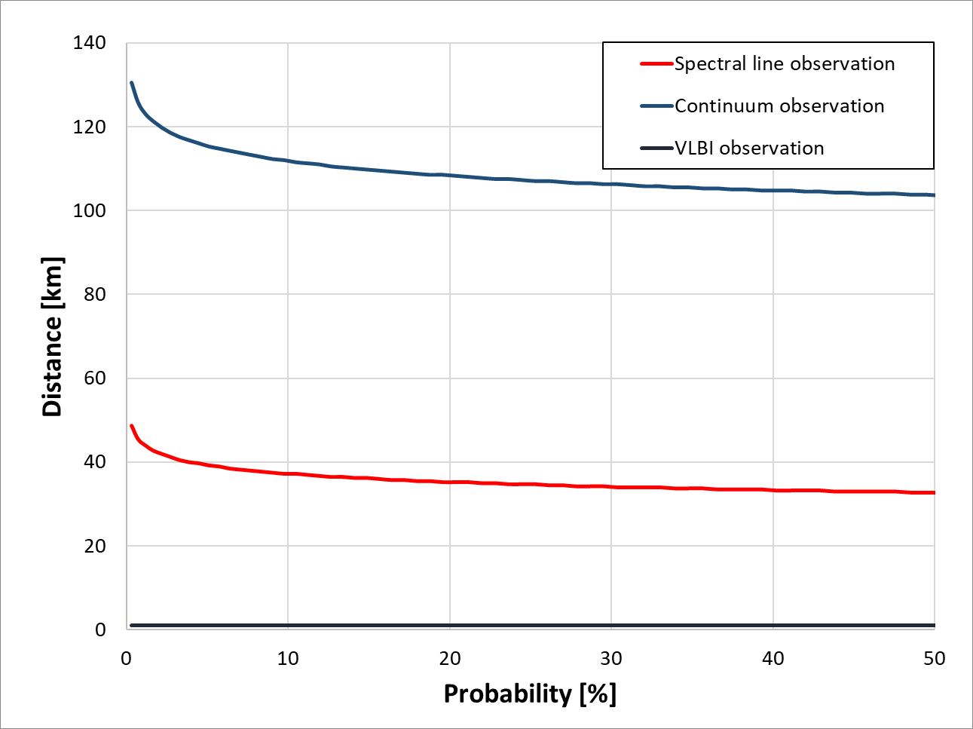
Figure 38 Required distance for a propagation loss of 165.1 dB, 185.1 dB and 129.1 dB at a given probability
In the following, the minimum separation distance is evaluated for the scenario where the radio signal path of the HD-GBSAR is not completely obstructed by the surveyed structure, as shown in figure A.6 of document ETSI TR 103 594 [1]. A copy of that figure is shown in Figure 39
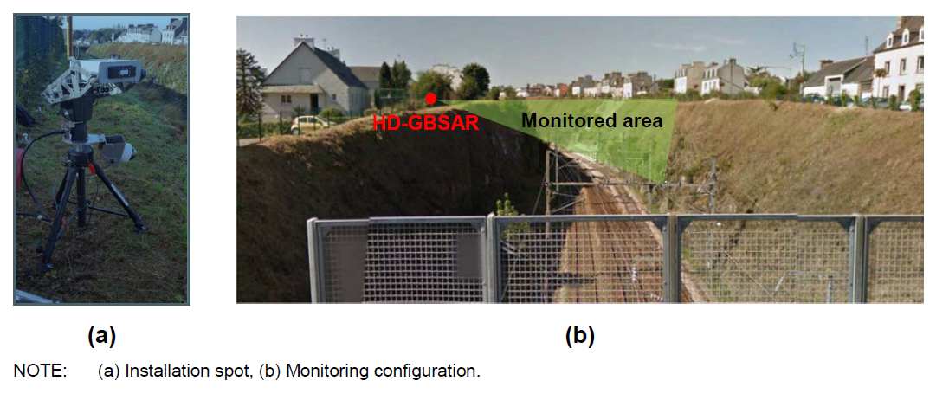
Figure 39 HD-GBSAR used for cut-slope monitoring
The vertical positioning of HD-GBSAR is such that the upper edge of the monitored area is illuminated by -3 dB of the maximum power (due to antenna orientation considering the HPBW directing to the upper edge of the monitored area). The upper limit of the HPBW can be assumed at an elevation angle of 0°. Accordingly, there are interfering signals radiated at elevation angles > 0° at power levels of less than the HD-GBSAR e.i.r.p. -3 dB. Assuming an elevation angle of 5° for the worst-case interfering scenario, an antenna mitigation factor of -5 dB can by evaluated by means of the antenna pattern graphical representation in Figure 5.
Due to the antenna rotation and antenna pattern shape, the radiated power towards the RA receiver within the duration of a single HD-GBSAR scan is not constant. This effect is considered in calculating an average antenna gain, based on the integration of the antenna gain over a complete single HD GBSAR scan angle. Considering the formula 1 of section 2.1, the antenna gain integration is done as shown below:
$$G_{average}=20 log\left(\frac{1}{\frac{2π}{3}}\int_{-\frac{π}{6}}^{\frac{π}{6}}{\cos^{10}\left(φ\right)}dφ+\frac{2}{\frac{2π}{3}}\int_{-\frac{π}{3}}^{-\frac{π}{6}}{{10}^{\frac{\left(P_{0}-\frac{\left|φ\right|-30}{60}\left(P_{0}+20\right)\right)}{20}}}dφ\right)+G=42.05 dBi$$
The average antenna gain is 5.95 dB lower than the maximum gain under the assumption of an elevation angle of 0°. Taking into account the above assumption of 5° interference path elevation, an additional gain reduction of -5 dB needs to be taken into account. Accordingly, the averaged antenna gain is 11.0 dB lower than the maximum antenna gain and needs to be considered as -11.0 dB gain pattern discrimination. The calculation of the required separation distance is done based on the figures presented in Table 26.
Table 26 MCL analysis between HD-GBSAR and RAS for scenarios considering HD-GBSAR main-lobe radiation
RAS | Unit | Parameter | #
Victim
76 | GHz | Operating Frequency | $$F$$
0 | dBi | Antenna Gain in the direction of the interferer | $$G_{R}$$
-208 | dBW(m2*Hz) | spectral pfd interference threshold (Spectral line observation) | $$S_{H Radio astronomy}$$
-228 | dBW(m2*Hz) | spectral pfd interference threshold (Continuum observation) | $$S_{H Radio astronomy}$$
-172 | dBW(m2*Hz) | spectral pfd interference threshold (VLBI observation) | $$S_{H Radio astronomy}$$
HD-GBSAR Interferer
48 | dBm | Maximum e.i.r.p. | $${e.i.r.p.}_{max}$$
1000 | MHz | Reference Bandwidth | $$B_{I}$$
-12.93 | dBW(m2*Hz) | Radiated spectral pfd main beam | $S_{H HD-GBSAR}$:
-11 | dB | Gain pattern discrimination | $$G_{D}$$
-23.93 | dBW(m2*Hz) | Radiated spectral pfd main beam @ 5° elevation | $S_{H HD-GBSAR_bp}$:
120 | s | Acquisition time | $$T_{A}$$
0.1 | - | HD GBSAR On time to RAS integration time ratio (Assuming 120° GB SAR rotation) | $$\frac{T_{Interference HD-GBSAR}}{T_{Integral}}$$
Impact Range calculation
174.1 | dB | Minimum permissible transmission loss (Spectral line observation) | $$L_{B}$$
194.1 | dB | Minimum permissible transmission loss (Continuum observation) | $$L_{B}$$
138,1 | dB | Minimum permissible transmission loss (VLBI observation) | $$L_{B}$$
The required distance for 174.1 dB, 194.1 dB and 138,1 propagation loss values is shown in the Figure 45
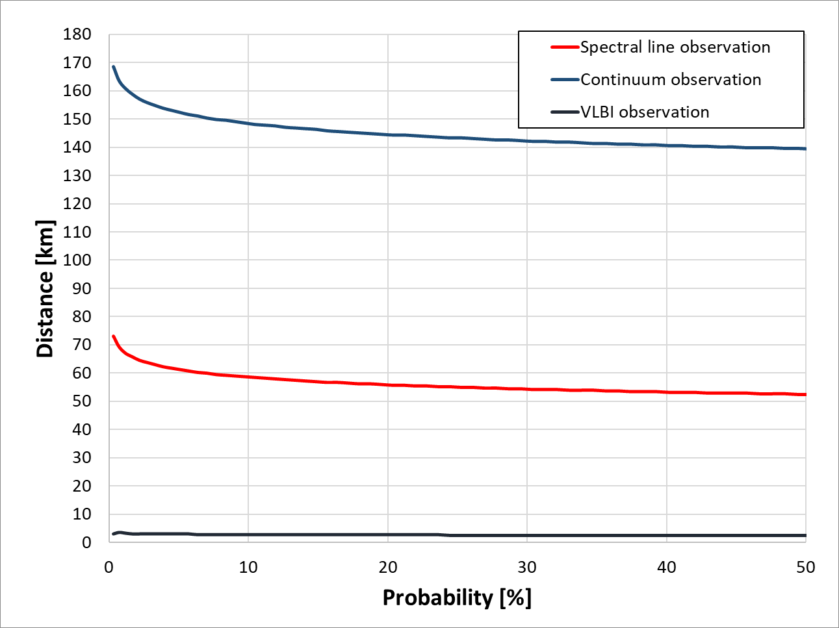
Figure 40: Required distance for a propagation loss of 174.1 dB, 194.1 and 138.1 at a given probability
Based on the above considerations, it may be concluded that, for a reasonable protection of a radio astronomy station operating in the band 76-77 GHz from HD-GBSAR interference, a circular exclusion zone around the radio astronomy station with a radius of 157 km need to be respected.
According previously made remarks on the propagation model, all evaluated separation distances are only valid for free space loss conditions. Free space loss can be assumed reasonably accurate under situations with LOS propagation conditions and a clearance of more than about 7 m in the middle of the propagation path at propagation distances below 150 km. In cases of radio wave propagation path obstruction by terrain irregularities, the propagation losses increase by tens of dB. As an example, an obstacle is assumed which protrudes in a semicircle with a radius of 10 m beyond the line of sight by 25 m. In other words, it is assumed that the LOS is obstructed by 10 m by a semi-circular obstacle. According to Recommendation ITU-R P.526-14, an additional loss of minimum 15 dB is introduced in calculations when such an object is placed in the middle of a 150 km propagation path. In any other position of that object or for shorter distances, the additional loss would significantly increase. Under those conditions no interference will occur for any of the above considered scenarios.
Therefore, the following can be concluded: If the HD-GBSAR is operating in LOS conditions with respect to a radio astronomy station, a separation distance of 157 km, 72 km and 3 km respectively is required, depending on whether the station operates for continuum, spectral line or VLBI observation. If the LOS is obstructed by terrain irregularities with a height of more than 25 m, no interference is expected to occur at any separation distance.
In ANNEX 3, the list of radio astronomy stations in CEPT countries operating in the 76-81 GHz frequency range is reported. For these stations the separation distance shall be ensured.

Sharing with RAS operating in the adjacent bands
The present paragraph evaluates the possible harmful interference of HD-GBSAR operating in the 76-77 GHz frequency range towards RAS operating above 77 GHz.
The sharing analysis considered the worst-case interference scenario identified in section 4.6.7, which is represented in Figure 39 and for HD-GBSAR a peak e.i.r.p. in the out of band emission domain of 0 dBm.

Table 27 MCL analysis between HD-GBSAR transmitting in the 76-77 GHz band and RAS operating in the adjacent band above 77 GHz
RAS | Unit | Parameter | #
Victim
76 | GHz | Operating Frequency | $$F$$
0 | dBi | Antenna Gain in the direction of the interferer | $$G_{R}$$
-208 | dBW(m2*Hz) | spectral pfd interference threshold (Spectral line observation) | $$S_{H Radio astronomy}$$
-228 | dBW(m2*Hz) | spectral pfd interference threshold (Continuum observation) | $$S_{H Radio astronomy}$$
-172 | dBW(m2*Hz) | VLBI | $$S_{H Radio astronomy}$$
HD-GBSAR Interferer
0 | dBm | Maximum e.i.r.p. | $${e.i.r.p.}_{max}$$
1000 | MHz | Reference Bandwidth | $$B_{I}$$
-59.9 | dBW(m2*Hz) | Radiated spectral pfd main beam | $S_{H HD-GBSAR}$:
-11 | dB | Gain pattern discrimination | $$G_{D}$$
-70.9 | dBW(m2*Hz) | Radiated spectral pfd main beam @ 5° elevation | $S_{H HD-GBSAR_bp}$:
120 | s | Acquisition time | $$T_{A}$$
0.1 | - | HD GBSAR On time to RAS integration time ratio (Assuming 120° GB SAR rotation) | $$\frac{T_{Interference HD-GBSAR}}{T_{Integral}}$$
Impact Range calculation
127.1 | dB | Minimum permissible transmission loss (Spectral line observation) | $$L_{B}$$
147.1 | dB | Minimum permissible transmission loss (Continuum observation) | $$L_{B}$$
91.1 | dB | Minimum permissible transmission loss (VLBI observation) | $$L_{B}$$
The sharing analysis (Table 27) indicates a required propagation loss of 127.1, 147.1 and 91.1 respectively for spectrum line, continuum and VLBI observations. By considering, for sake of simplicity, the free space path loss model the resulting minimum required separation distances are:
- 632 m for spectral line observation;
- 6317 m for continuum observation;
- 10 m for VLBI observation.
In case of spectral line and VLBI observation there is no risk of harmful interference, since the condition of and HD-GBSAR working inside the radio astronomy station area and pointing towards the radio-telescope shall be considered not realistic. The risk of interference shall be considered extremely low also in case of continuum observation, considering the significantly low probability to have an HD-GBSAR operating at a distance lower than 6317m form a radio astronomy stations, which are located in relatively remote area.

Sharing with FS operating in the adjacent bands
The present paragraph evaluates the possible harmful interference of HD-GBSAR operating in the 76-77 GHz frequency range towards FS operating in the 71-76 GHz and 81-86 GHz bands.
The compatibility analysis is conducted assuming:
- An unwanted e.i.r.p. emitted in the FS operating frequency range by the HD-GBSAR of 0 dBm;
- The interference scenario C considered for the compatibility studies between FS and HD-GBSAR operating in the 74-75 GHz (see section 4.5.1.3), which represents the worst-case interference condition.
The MCL analysis has been conducted assuming a FS terminal building height $H$ equal to 20 m and 40 m (Figure 20). The chart reported in Figure 41 indicates the required minimum separation distance between HD-GBSAR and FS receiver to assure no harmful interference for value of distance D ranging between 50 m and 1 km. The required separation distance is always significantly below the actual distance between HD-GBSAR and FS victim receiver assumed for the analysis, whatever is the distance D and the height of the FS building, clearly indicating the absence of risk of harmful interference.
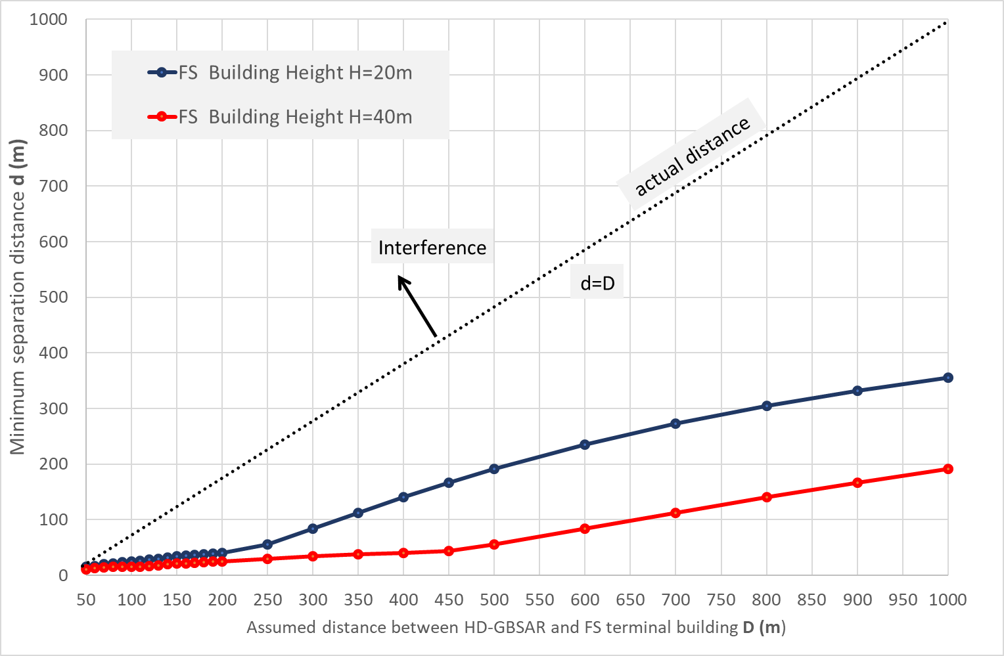
Figure 41: Minimum separation distance between HD-GBSAR operating in the 76-77 GHz frequency range and FS operating in the adjacent band

Interference analysis in the 77-78 GHz band

Sharing with Short Range Radar (SRR)
The coexistence studies between HD-GBSAR and automotive radar operating in the 77-81 GHz frequency range is performed assuming the same worst-case interference scenario and geometry defined for the automotive radar operating in the 76-77 GHz frequency range (see section 4.6.1).
The characteristics of automotive radar operating in the 77-81 GHz frequency range used for the sharing analysis are taken from Recommendation ITU-R M.2057 [16] and summarised in Table 28.
Table 28: Automotive radar characteristics in the 77-81 GHz frequency band [16]
Parameter | Radar B | Radar C | Radar D | Radar E | Units
Chirp bandwidth | 4 | 4 | 4 | 4 | GHz
Applications | Front | Corner | Front/Corner | Front/Corner | n.a.
Maximum e.i.r.p. | 33 | 33 | 45 | 33 | dBm
Maximum transmit power to antenna | 10 | 10 | 10 | 10 | dBm
Receiver IF bandwidth (–3 dB) | 10 | 10 | 10 | 10 | MHz
Receiver noise figure | 12 | 12 | 12 | 12 | dB
Receiver antenna gain | 16 | 13 | 35 | 13 | dBi
Receiver Antenna azimuth  -3 dB beamwidth | ±13.5 | ±16 | ±16 | ±27 | deg
Receiver Antenna elevation  -3 dB beamwidth | ±5.5 | ±5.5 | ±5.5 | ±5.5 | deg
The MCL analysis has been performed separately for front and corner automotive radar, assuming different positions of the victim car along the road with respect to the interferer as represented in Figure 25 and Figure 27 respectively. For each evaluated victim receiver position, the maximum interference condition has been simulated whereby the HD-GBSAR antenna main-lobe is pointed towards the victim receiver in the horizontal plane. The analysis also considered a bumper loss of 6 dB.
Figure 42 and Figure 43 show the results of the coexistence analysis between HD-GBSAR and automotive radars used for front and corner applications. In summary:
- Automotive radars used for front applications are interfered in case of separation distances lower than 425 m for Radar B and 650 m for Radar D and E;
- Automotive radar used for corner applications are interfered in case of separation distances lower than 65 m for Radar C and D and 170 m for Radar E;
In both cases HD-GBSAR may cause harmful interference, however the case of automotive radar used for front applications is more critical.
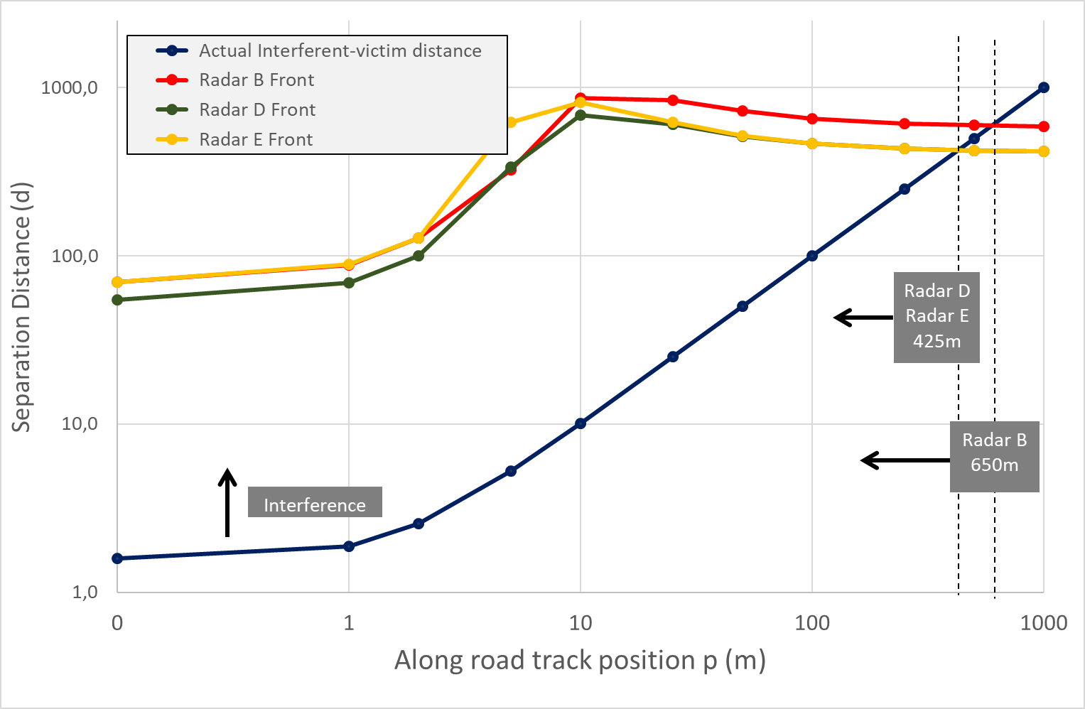
Figure 42: Minimum separation distance between HD-GBSAR operating in the 77-78 GHz and automotive radar used for front applications
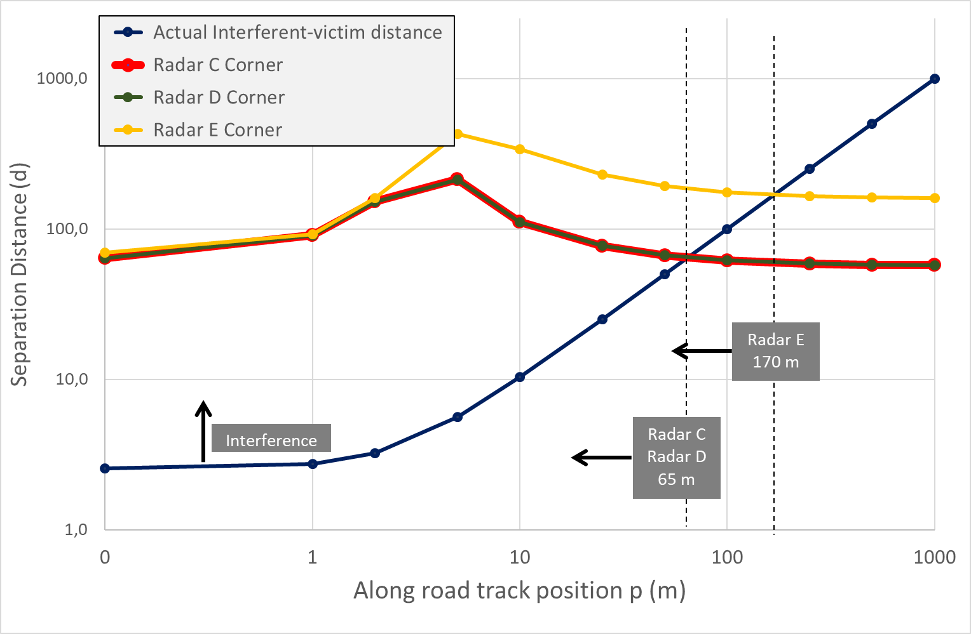
Figure 43: Minimum separation distance between HD-GBSAR operating in the 77-78 GHz and automotive radar used for corner applications
As already mentioned in the sharing studies with automotive radar operating in the 76-77 GHz frequency range, usually HD-GBSAR is used to monitor building located in construction sites or unsafe area forbidden to vehicular traffic. Besides, HD-GBSAR is intentionally installed by the user high enough to maximise the free line of sight of the structure to be monitored, trying to minimise the visibility of any kind of moving objects such as cars or trucks, which could potentially negatively affect the radar measurement. Nevertheless, to avoid any possible risk of harmful interference, HD-GBSAR should implement the DAA technique as described in ANNEX 6, with a threshold limit of -94.8 dBm for all the four radar types. The DAA threshold has been evaluated using the formula (14) of section 4.6.1.3 and can be also expressed by means of equation (15) as function of the HD-GBSAR conducted power at transmitter antenna.
In conclusion, the risk of harmful interference of automotive radar working the 77-78 GHz frequency range used for front and corner application is avoided considering DAA as a mandatory requirement for HD-GBSAR.

Sharing with LPR
It applies the same conclusion of section 4.6.2.

Sharing with Amateur & Amateur Satellite Services
It applies the same conclusion of section 4.6.6.

Sharing with Radio Astronomy Service
It applies the same conclusion of section 4.6.7.

Sharing with RAS operating in the adjacent bands
It applies the same conclusion of section 4.6.8, because the HD-GBSAR out of band emission and RAS protection criterion are the same.

Sharing with FS operating in the adjacent bands
Assuming for HD-GBSAR an unwanted e.i.r.p. emitted in the FS operating frequency range of 0 dBm, it applies the same conclusion of section 4.6.9.

Conclusions
Three possible frequency bands of 1 GHz have been examined for the HD-GBSAR operation in this Report (section 3):
- 74-75 GHz;
- 76-77 GHz;
- 77-78 GHz-
The results of the spectrum sharing analysis between HD-GBSAR and existing services and applications for each candidate band lead to the following main conclusions:
- HD-GBSAR operating in the 74-75 GHz could potentially interfere with FS operating in the 71-76 GHz frequency band;
- a DAA spectrum access system as specified in ANNEX 6 is needed to avoid interference towards automotive radar operating in the 76-77 GHz and 77-81 GHz frequency bands;
- Radio astronomy stations could be interfered by HD-GBSAR, in case of free line of sight and a separation distance shorter than 157 km. Therefore, a circular exclusion zone of 157 km around the radio astronomy stations defined in ANNEX 3 can ensure protection of RAS;
- No relevant risk of harmful interference has been identified for all the other services and applications operating in the 74-81 GHz frequency range.
In summary, the analysis provided in this Report shows that the following operational conditions and technical requirements would allow HD-GBSAR deployment either in the 76-77 GHz or the 77-78 GHz frequency bands and ensure protection of existing services and applications:
- maximum radiated power: 48 dBm (e.i.r.p.);
- maximum power at the transmitter antenna input of 24 dBm;
- operating channel bandwidth: 1000 MHz;
- antenna pattern requirement as defined in section 2.1 (equation 1 and 2);
- implementation of a DAA spectrum access system capable to detect automotive radar signals in the HD-GBSAR operating band and to timely stop HD-GBSAR transmissions in the presence of static or moving automotive radar potentially interfered. ANNEX 6 provides a description of the DAA system. The required DAA detection threshold are presented in section 4.6.1.3 and section 4.7.1;
- a circular exclusion zone with a radius of 157 km around the radio astronomy stations listed in ANNEX 3, in case of potential free line of sight condition between HD-GBSAR and radio astronomy station.
The last two requirements related to and DAA and RAS exclusion zone are applicable only in case of outdoor use of HD-GBSAR, excluding underground mine and tunnel in construction environment.

- Frequency allocation within the 74–81 GHZ band
The following table lists the existing spectrum allocations and applications that are in major use in Europe according to the up-to-date relevant provisions of Article 5 of ITU Radio Regulations and those of the European Common Frequency Allocations Table defined in ERC Report 25 [23].
Table 29: Spectrum allocations and applications in frequency range 74-81 GHz [23]
Frequency band | Allocations | Applications
74–75.5 GHz  RR 5.561 | BROADCASTING-SATELLITE  FIXED  FIXED-SATELLITE (SPACE-TO-EARTH)  MOBILE  BROADCASTING  Space Research (space-to-Earth) | Space research  Radiodetermination applications  Fixed
75.5–76 GHz  RR 5.561  ECA35 | BROADCASTING  BROADCASTING-SATELLITE  FIXED  FIXED-SATELLITE (SPACE-TO-EARTH)  Amateur  Amateur-Satellite | Fixed  Radiodetermination applications  Amateur  Amateur-satellite  Space research
76–77.5 GHz  RR 5.149 | Amateur-Satellite  Amateur  RADIO ASTRONOMY  RADIOLOCATION  Space Research (space-to-Earth) | Amateur-satellite  Radio astronomy  Amateur  Radiolocation (civil)  Railway applications  Transport and Traffic Telematics (76-77 GHz)  Radiodetermination applications  Short Range Radars (77-81 GHz)
77.5–78 GHz  RR 5.149 | RADIOLOCATION (5.559B)  AMATEUR-SATELLITE  Space Research (space-to-Earth)  AMATEUR | Short Range Radars (77-81 GHz)  Radiodetermination applications  Radio astronomy  Amateur  Amateur-satellite
78–79 GHz  RR 5.149  RR 5.560 | Amateur  Amateur-Satellite  Radio Astronomy  Space Research (space-to-Earth)  RADIOLOCATION | Radio astronomy  Amateur-satellite  Amateur  Radiolocation (civil)  Short Range Radars (77-81 GHz)  Radiodetermination applications
79–81 GHz  RR 5.149 | RADIO ASTRONOMY  RADIOLOCATION  Amateur-Satellite  Amateur | Radiodetermination applications  Short Range Radars (77-81 GHz)  Radiolocation (civil)  Radio astronomy  Amateur  Amateur-satellite
Pertinent RR/ECA footnotes quoted verbatim from ERC Report 25 [23]:
- ECA 35: In Europe, the band 75.5-76 GHz is also allocated to the Amateur and Amateur-Satellite services;
- RR 5.149: In making assignments to stations of other services to which the bands: [omissis] 76-86 GHz, [omissis] are allocated, administrations are urged to take all practicable steps to protect the radio astronomy service from harmful interference. Emissions from spaceborne or airborne stations can be particularly serious sources of interference to the radio astronomy service (see Nos. 4.5 and 4.6 and Article 29). (WRC-07);
- RR 5.559B: The use of the frequency band 77.5-78 GHz by the radiolocation service shall be limited to short-range radar for ground-based applications, including automotive radars. The technical characteristics of these radars are provided in the most recent version of Recommendation ITU-R.M.2057. The provisions of No. 4.10 do not apply. (WRC-15);
- RR 5.560: In the band 78-79 GHz radars located on space stations may be operated on a primary basis in the earth exploration-satellite service and in the space research service;
- RR 5.561: In the band 74-76 GHz, stations in the fixed, mobile and broadcasting services shall not cause harmful interference to stations of the fixed-satellite service or stations of the broadcasting-satellite service operating in accordance with the decisions of the appropriate frequency assignment planning conference for the broadcasting-satellite service. (WRC-2000).
- SRD operating in the 74-81 GHz frequency range
Table 30: SRD Spectrum allocations in frequency range 74 -81 GHz [6]
Annex | Frequency band | Power | ETSI Harmonised Standard | Note
ANNEX 4  RAILWAY APPLICATIONS | 76-77 GHz | 55 dBm  peak e.i.r.p. | EN 301 091 | Obstruction/Vehicle detection via radar Sensor at railway level crossings. 50 dBm average power or 23.5 dBm average power for pulse radar.
ANNEX 5:  TRANSPORT AND TRAFFIC TELEMATICS (TTT) | f1 76-77 GHz | 55 dBm  peak e.i.r.p. | EN 301 091 | 50 dBm average power or 23.5 dBm average power for pulse radar only. For ground based vehicle and infrastructure systems only.
 | f2 76-77 GHz |  | EN 303 360 | For obstacle detection radars for rotorcraft use.  Use is not possible in specific areas of some European countries due to exclusion zones implementation around RAS observatories.
ANNEX 6:  RADIODETERMINATION APPLICATIONS | f5 75-85 GHz | -41.3 dBm/MHz e.i.r.p. outside the enclosed test tank structure | EN 302 372 | For Tank Level Probing Radar (TLPR).
 | g4 75-85 GHz |  | EN 302 729 | For Industrial Level Probing Radar (LPR).

- European Radio astronomy sites operating in the 74-81 GHz band
Table 31 reports the list of radio astronomy stations in CEPT countries operating in the 74-81 GHz frequency range according Report ITU-R RA.2457 [34].
Table 31: European radio astronomy stations potentially operating in the 74-81 GHz band [14]
Observatory Name | Administration | Longitude (E), Latitude (N) | Elevation (m AMSL) | Geographical characteristics
Plateau de Bure | France | 05°54'26"  44°38'01" | 2553 | Isolated high mountain top in the Alps
Pico Veleta | Spain | -03°23'34"  57°23'45" | 2850 | Sierra Nevada Mountain
Yebes | Spain | -03° 05′ 13″  40° 31′ 28.8″ | 980 | Broad flat plain
Onsala | Sweden | 11°55'35"  57°23'45" | 18 | Waterside, forested. Located at 5 km from the closest urban area (Onsala)
Effelsberg | Germany | 6°52′58″  50°31′29″ | 369 | Located in a valley in a mountainous area
Sardinia | Italy | 9°14′42.71″  39°29′34.96″ | 600 | High exposed plain
Noto | Italy | 14°59′20.51″  36°52′33.78″ | 90 | Flat exposed plain
Metsähovi | Finland | 24°23′38  60°13′05 | 80

- Mitigation factor in case of FMCW victim receiver
The MCL analysis method described in section 4.4 evaluates the interreference of HD-GBSAR towards any kind of victim receiver regardless the demodulation scheme implemented by the victim receiver. Nevertheless, the actual performance degradation of the victim receiver due to HD-GBSAR interferent signal does not depend only on the mean power at victim receiver input, particularly in the case of FMCW radars (i.e. LPR, automotive radars, rotorcraft obstacle detection radars). A further mitigation factor related to the time-frequency characteristics of the interferent signal and the victim radar should be considered.
Figure 44 illustrates a simplified block diagram of a FMCW transceiver, where both the received wanted and interferent signals are down-converted to IF by mixing the transmitted modulated signal with the received signals. The down converted signal is then filtered by the receiver IF filter, digitised and processed.
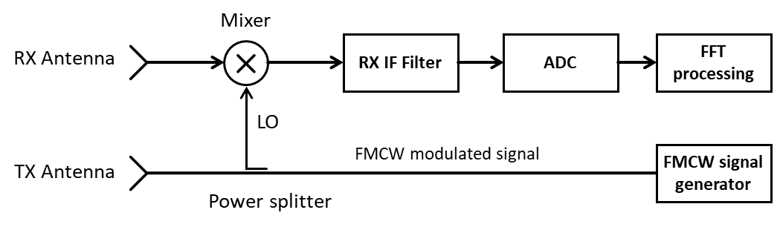
Figure 44: Simplified FMCW transceiver block diagram
The interfering signal that reaches the receiver processing block and therefore can degrade the receiver performance only when the offset between the interfering signal and the victim local oscillator falls within the pass bandwidth of the RX IF filter. Figure 45 graphically shows when such condition is verified. It appears clear that the interference degrades the victim receiver performance only for a limited time and the total amount of the interference depends on the characteristics of victim and interferent FMCW signals.
ECC Report 262 (section 7.1) [17] quantifies the interference power suppressed by the victim receiver IF filter by means of the following formula:
$MG=10⋅\log\left(\frac{2⋅B_{IF}}{B_{I}}\right)$ (18)
$MG$ is defined as Modulation Gain, $B_{IF}$ is the victim receiver IF bandwidth and $B_{I}$ is the interferent signal modulation bandwidth. ECC Report 262 supports the applicability of the modulation gain mitigation factor with simulations and real measurements of interference degradation of victim SRR caused by fixed TTT radar. Since HD-GBSAR and fixed TTT radar have similar emitted signal characteristics the evaluations reported in ECC Report 262 are valid also for HD-GBSAR.
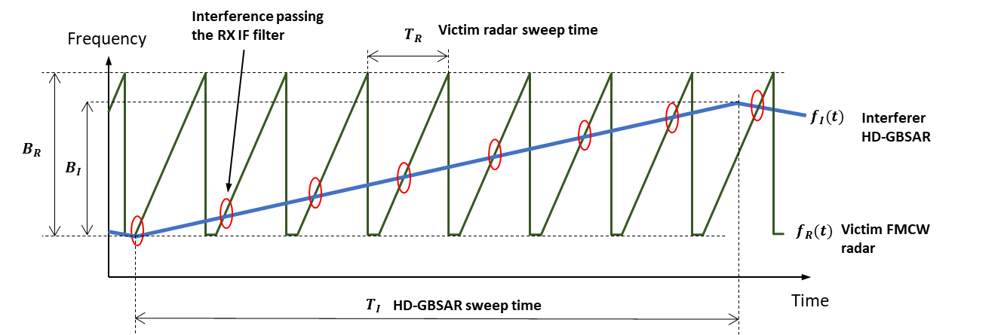
Figure 45: Interference of HD-GBSAR towards a victim FMCW radar
It shall be noticed that the interferent HD-GBSAR signal could degrade the victim radar performance even when the interferent demodulated signal is outside the IF filter band. In particular, if the interference power is larger than the victim receiver RF or IF 1 dB compression point, the non-linear distortion in the RF or IF stages of the victim receiver would degrade its Noise Figure. Typical 1 dB RF compression point for FMCW receiver operating in the 74-81 GHz frequency range is of the order of -10 dB m, so the degradation due to possible non-linear effect shall be neglected in case of interference power at victim receiver input below -10 dBm.

- consideration on the typical usage of HD-GBSAR
As stated in section 2.2, HD-GBSAR is not a large-scale consumer technology. HD-GBSAR shall be used only by trained professionals, knowing the intrinsic technological limitations of the instruments and capable to configure the system to obtain the best possible monitoring performance of the area or structure to be monitored. In details, the aspects influencing HD-GBSAR setup are represented by:
- Range Resolution performance in relation to the structure or surface to be monitored;
- Measurement of the Line of Sight displacement;
- Definition of the Monitoring Area.
These aspects are treated in this Annex and shall be considered in the definition of HD-GBSAR interference scenario use-cases, to define the typical position and tilting of HD-GBSAR with respect the area or structure to be monitored.
Range Resolution
HD-GBSAR provides a bidimensional (2D) image of the monitored area (see Figure 4 in section 2.1) thanks to the combination of the ArcSAR and FMCW technique, which respectively gives angular and range resolution.
The 2D resolution capability of HD-GBSAR (Figure 4) needs to be mapped on the 3D geometry of the monitored surface or structure, to understand what HD-GBSAR is actually monitoring and where the measurement points (resolution cell) are located. Particular attention shall be posed on how the range resolution is mapped on the monitored surface/structure depending on the position and orientation of HD-GBSAR.
Figure 46 shows the typical acquisition geometry in the vertical plane of a HD-GBSAR monitoring the deformation a building, where $D$ indicates the planar distance between HD-GBSAR and the building and $H$ indicates the height of the building. HD-GBSAR resolves the building in the vertical direction thanks to its range resolution capability $ΔR$ and each resolution cell corresponds to a deformation measurement point. The range resolution is combined with the HD-GBSAR angular resolution $ΔAz$ of 10 mrad to obtain the actual resolution cell extension mapped on the building (Figure 47).

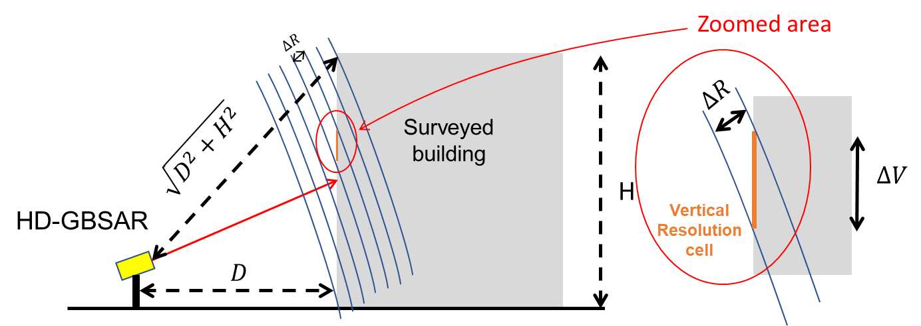
Figure 46: HD-GBSAR Range Resolution mapped on a building (vertical plane view)
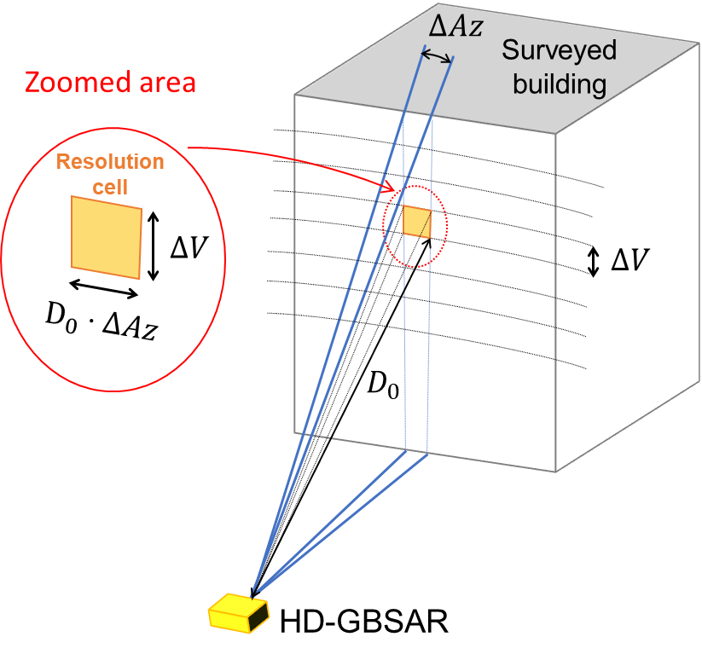
Figure 47: HD-GBSAR 2D Resolution mapped on a building
Based on simple geometrical evaluation, the number $N$ of HD-GBSAR resolution cells (measurement points) can be determined along the building, for a given angular direction, by means of the following formula:
$N=\frac{\sqrt{D^{2}+H^{2}}-D}{ΔR}$ (19)
In order to have a good understanding of the building differential deformation behaviour between the bottom and the top of the building, it is essential to have as many as possible resolution cells along the structure height. By expressing $D=k⋅H$, where $k$ is a linear factor, and the vertical resolution $ΔV=H/N$, it can be found that:
$k=\frac{{1-\left(\frac{ΔR}{ΔV}\right)}^{2}}{2⋅\left(\frac{ΔR}{ΔV}\right)}$ (20)
An optimal geometrical setup of HD-GBSAR should provide and average vertical resolution cell $ΔV$ of 0.5 m Therefore, by considering the HD-GBSAR range resolution of $ΔR=0.15 m$, the linear factor $k$ should be:
$k=\frac{1-{0.3}^{2}}{0.6}≅1.5$ (21)
Table 32 shows suggested value for $D$ considering different building height, obtained adopting the formula above.
Table 32: HD-GBSAR suggested distance $D$ from the building to be monitored
Building Height H  (m) | $$D$$  (m)
10 | 15
20 | 30
30 | 45
40 | 60

Similar considerations are valid also for landslide surface monitoring, with the difference that ground surface geometry in most of the cases is not vertical, thus the range resolution degradation is less critical and the proportional factor $k$ between the height of the slope and the distance from the slope can be significantly greater than 1.4. As an example, by considering Figure 48, the ground resolution, indicating the dimension of the range resolution mapped on the ground, corresponds to:
$ΔS=ΔR/cos⁡(α-β)$ (22)
Where $α$ is the slope gradient and $β$ is the elevation angle of the considered resolution cell. Independently of the value of H and D, in the worst case of the perfectly horizontal LOS ($β=0$) the ground resolution is:
$ΔS=ΔR/cos⁡(α)$ (23)
Even for a very steep slope gradient $α$ of 60°, the value of $ΔS=\frac{0.15}{\cos\left(60°\right)}=0.58 m$ allows a good resolution of the monitored slope. In case of almost vertical slope ($α>80°$), the same evaluation done for the building monitoring scenario applies.
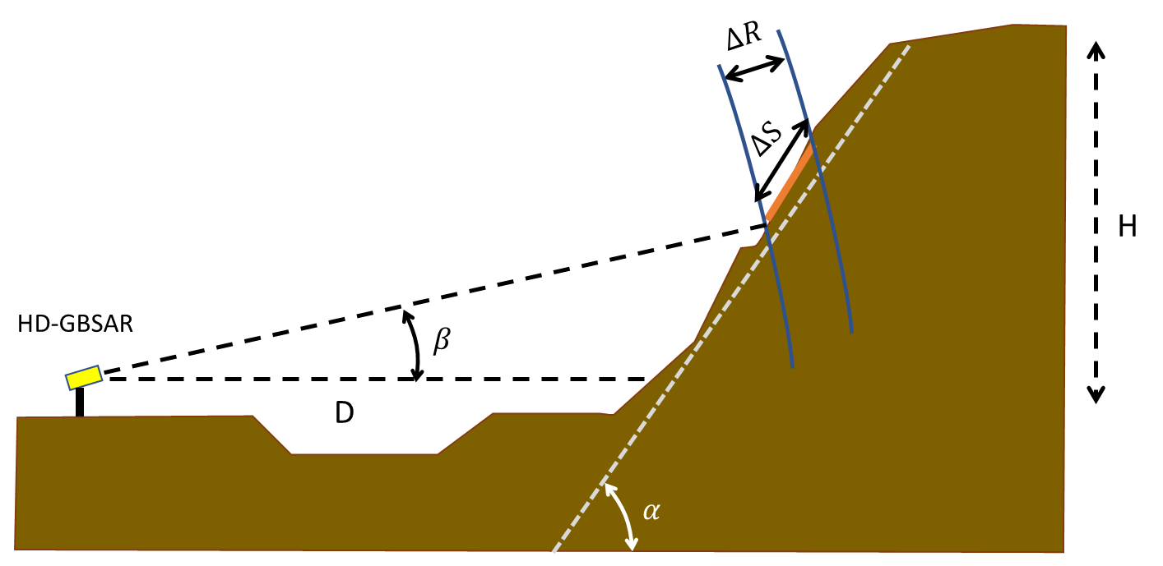
Figure 48: Slope ground range resolution

Line of Sight Displacement
For each resolution cell HD-GBSAR provides the measure of the component of the real displacement projected along the Line of Sight. In case the movement is perfectly vertical the measured line of sight displacement is:
$d_{LoS}=d_{v}⋅sin⁡(β)$ (24)
Where $β$ is the LOS elevation angle. The sensitivity to movement in the vertical direction is given by the ratio between the measured displacement $d_{LoS}$ and the real vertical displacement $d$ corresponding to $S_{V}=sin⁡(β)$. Similarly, if the real movement is perfectly horizontal
$d_{LoS}=d_{h}⋅cos⁡(β)$ (25)
and the sensitivity to the horizontal deformation is $S_{H}=cos⁡(β)$.

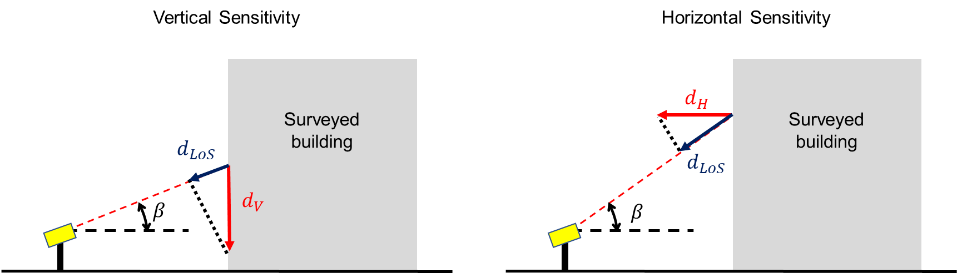
Figure 49: HD-GBSAR LOS displacement sensitivity to the vertical and horizontal movement
An unstable building can have movements both in the horizontal and the vertical direction, therefore is important to place HD-GBSAR to have a good sensitivity to both movement directions along the building monitored face. It is important to have a good sensitivity for both the horizontal and vertical movement component on the top half of the building, which is the part expected to move most. By expressing $D=k⋅H$, the elevation value of the top (point A) and the middle (point B) of the building face is:
$β_{A}=\operatorname{atan}\left(\frac{H}{D}\right)=\operatorname{atan}\left(\frac{1}{k}\right)$ $β_{B}=\operatorname{atan}\left(\frac{H/2}{D}\right)=\operatorname{atan}\left(\frac{1}{2⋅k}\right)$
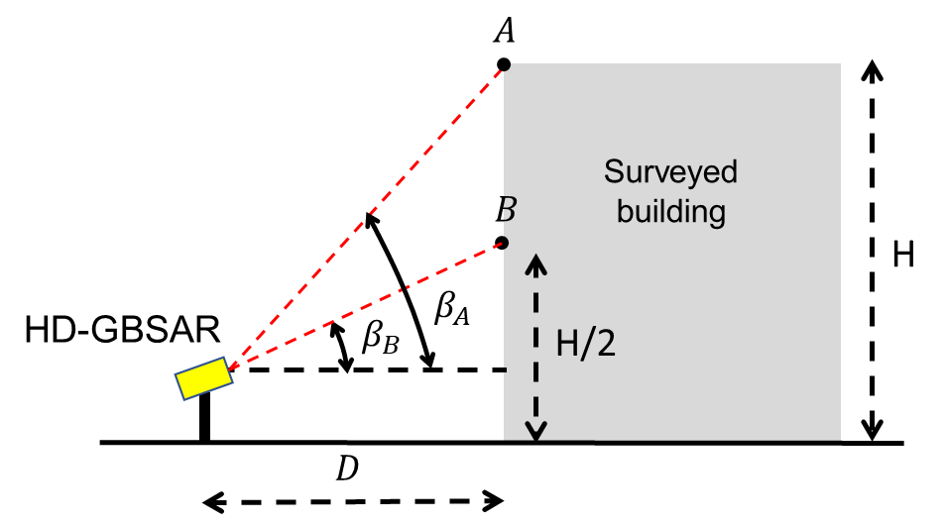
Figure 50: HD-GBSAR top and middle building face point
Table 33 shows the value of horizontal and vertical sensitivity for different values of the proportional factor $k$ for the top and middle point of the building face. If $σ_{LoS}$ is the LOS displacement measurement accuracy, the accuracy in the horizontal and vertical displacement accuracy is:
$σ_{H}=\frac{σ_{LoS}}{S_{H}}$ $σ_{V}=\frac{σ_{LoS}}{S_{V}}$ (26)
The acquisition geometry shall assure an accuracy in the measurement of vertical and horizontal deformation of at least 0.5 mm (significantly lower than 1 mm). Since $σ_{LoS}$ is 0.1 mm the horizontal and vertical sensitivity value shall be greater than 0.25. Such a condition is guarantee in case of value of $k$ up to 1.5, as highlighted in Table 33.
Table 33: HD-GBSAR sensitivity to vertical and horizontal movement
$$k$$ | Point A |  |  | Point B
 | $$β$$ | $$S_{H}$$ | $$S_{V}$$ | $$β$$ | $$S_{H}$$ | $$S_{V}$$
0.5 | 63.4 | 0.45 | 0.89 | 45.0 | 0.71 | 0.71
1 | 45.0 | 0.71 | 0.71 | 26.6 | 0.89 | 0.45
1.5 | 33.7 | 0.83 | 0.55 | 18.4 | 0.95 | 0.32
2 | 26.6 | 0.89 | 0.45 | 14.0 | 0.97 | 0.24
2.5 | 21.8 | 0.93 | 0.37 | 11.3 | 0.98 | 0.20
3 | 18.4 | 0.95 | 0.32 | 9.5 | 0.99 | 0.16
3.5 | 15.9 | 0.96 | 0.27 | 8.1 | 0.99 | 0.14
4 | 14.0 | 0.97 | 0.24 | 7.1 | 0.99 | 0.12

In case of slope surface monitoring, the expected direction of the movement is along the steepest direction (Figure 51), therefore the relation between the measured LOS deformation and the actual deformation is:
$d_{LoS}=d⋅cos⁡(α-β)$ (27)
Where $α$ is the slope gradient and $β$ is the elevation of the considered resolution cell. The sensitivity respect to the real movement assumed along the slope steepest direction can be defined as $S=cos⁡(α-β)$.
The sensitivity analysis can be simplified considering three points along the slope surface, located on the top the middle and the bottom of the slope, indicated in Figure 51 respectively as A, B and C. The elevation of these three points with respect to HD-GBSAR is:
$β_{A}=\operatorname{atan}\left(\frac{H}{D+H/tan⁡(α)}\right)=\operatorname{atan}\left(\frac{\tan\left(α\right)}{k⋅\tan\left(α\right)+1}\right)$
$β_{B}=\operatorname{atan}\left(\frac{H/2}{D+\frac{H}{2tan⁡(α)}⋅}\right)=\operatorname{atan}\left(\frac{\tan\left(α\right)}{2⋅k⋅\tan\left(α\right)+1}\right)$
$β_{C}=0$
where $D=k⋅H$.
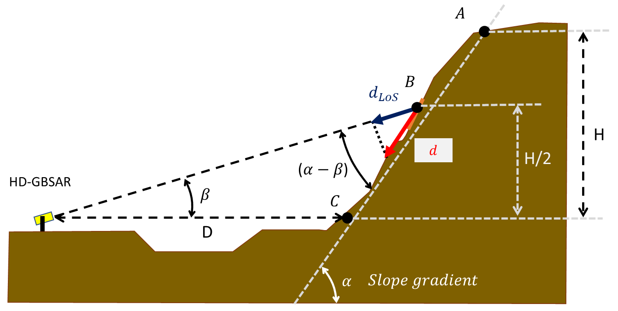
Figure 51: HD-GBSAR LOS displacement sensitivity in case of unstable slope
Table 34 shows the HD-GBSAR sensitivity with respect to the movement along the slope steepest direction for points A, B and C, considering three different slope gradients (45°, 60° and 80°). The sensitivity $S$assumes value below 0.25 only in case of very steep slope and $k$ greater than 5.

Table 34: HD-GBSAR sensitivity to the steepest slope direction movement
$$k$$ | $$α=45°$$ |  |  | $$α=60°$$ |  |  | $$α=80°$$
 | $$S_{A}$$ | $$S_{B}$$ | $$S_{C}$$ | $$S_{A}$$ | $$S_{B}$$ | $$S_{C}$$ | $$S_{A}$$ | $$S_{B}$$ | $$S_{C}$$
1 | 0.95 | 0.89 | 0.71 | 0.89 | 0.78 | 0.50 | 0.77 | 0.57 | 0.17
2 | 0.89 | 0.83 | 0.71 | 0.78 | 0.67 | 0.50 | 0.57 | 0.40 | 0.17
3 | 0.86 | 0.80 | 0.71 | 0.71 | 0.62 | 0.50 | 0.46 | 0.33 | 0.17
4 | 0.83 | 0.78 | 0.71 | 0.67 | 0.60 | 0.50 | 0.40 | 0.29 | 0.17
5 | 0.81 | 0.77 | 0.71 | 0.64 | 0.58 | 0.50 | 0.36 | 0.27 | 0.17
6 | 0.80 | 0.76 | 0.71 | 0.62 | 0.57 | 0.50 | 0.33 | 0.25 | 0.17
7 | 0.79 | 0.75 | 0.71 | 0.61 | 0.56 | 0.50 | 0.31 | 0.24 | 0.17
8 | 0.78 | 0.75 | 0.71 | 0.60 | 0.55 | 0.50 | 0.29 | 0.23 | 0.17
Monitoring Area
In order to maximise the coverage and the efficiency of the monitoring, HD-GBSAR shall be setup pointing the antenna vertical boresight towards the middle of the structure or the surface to be monitored (Figure 52).
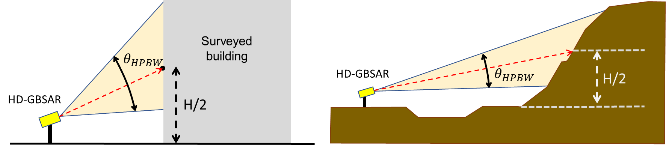
Figure 52: HD-GBSAR vertical pointing
The operator has also to specify the horizontal extension of the area to be monitored, in order to configure HD-GBSAR to emit and receive the electromagnetic signal only when the area to be monitored is illuminated, whereas no power is emitted while the sensor is rotating and scanning other directions (Figure 53). The monitoring area is identified by the user by means of the visual feedback of a camera showing the same field of view as the radar’s. In particular, the user defines the area to be monitored interacting with the visual feedback. The range of azimuth angles during which HD-GBSAR is transmitting and acquiring is defined accordingly.
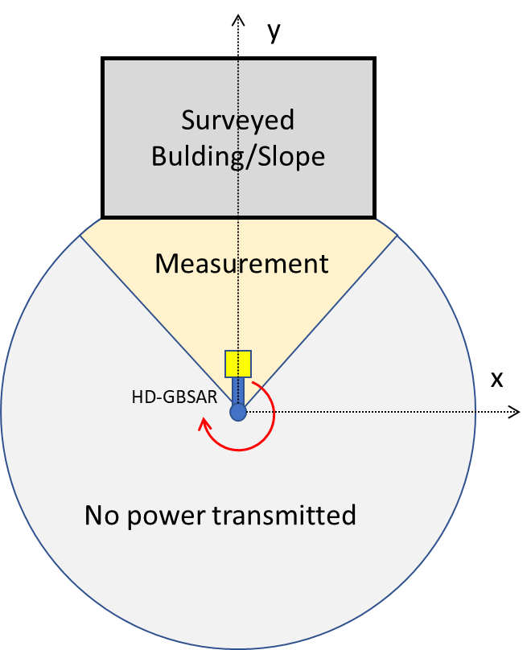
Figure 53: HD-GBSAR monitoring area top view
- Detect And Avoid
This section considers the implementation of a DAA function in HD-GBSAR to avoid harmful interference to other applications and services using the same frequency or adjacent band. This mechanism is aimed to detect if a transmission from a victim service/application is present in the area vicinity of the area illuminated by HD-GBSAR, to switch off HD-GBSAR transmissions in case of detection. Such interference mitigation technique is already applied for GBSAR [2],[33]. In the following, it is first defined how to evaluate the detection threshold required to avoid interference, then an implementation workflow and finally an example of DAA subsystem design able to detect the presence of automotive radar signals while the HD-GBSAR is transmitting.
DAA threshold limit
The DAA threshold for a specific victim service is determined considering the link budget calculated considering the diagram represented in Figure 54.
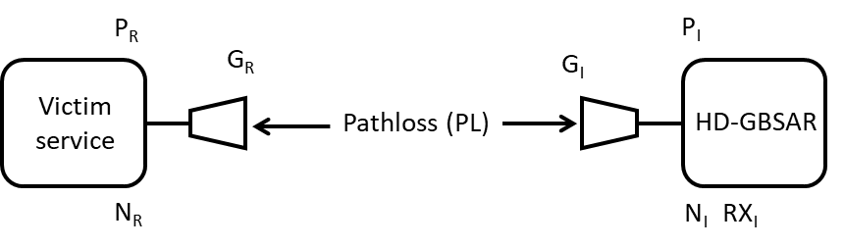
Figure 54: Link budget diagram
where:
- $N_{R}$ = receiver noise floor for the victim service;
- $N_{I}$ = receiver noise floor for the HD-GBSAR equipment;
- $P_{R}$ = Conducted power for the victim service;
- $P_{I}$ = Conducted power for the victim service;
- $G_{I}$ = HD-GBSAR antenna gain;
- $G_{R}$ = RL antenna gain;
- ${RX}_{I}$ = HD-GBSAR receiver input power;
- $PL$ = Path loss between HD-GBSAR and victim service (in both directions due to reciprocity).
The calculation assumes that HD-GBSAR uses the same antenna to receive both the wanted signal and the victim receiver signal and that the victim receiver transmits and receives in the same frequency band.
The maximum acceptable interference level at victim service receiver input can be expressed as:
$I=N_{R}+I/N$ (28)
Where I/N is the interference to noise ratio required to assure no harmful interference towards the victim service. Such value can change depending on the protection criteria of the considered victim service, for instance the Recommendation ITU-R M.1461-2 [25] indicates a value of -6 dB for $I/N$ to be used for interference analysis towards radiodetermination service. Considering the link budget, in order to have an HD-GBSAR interference power equal to the maximum acceptable interference level the following equation applies:
$I=N_{R}+I/N=P_{I}+G_{I}-PL+MF+G_{R}$ (29)
Where $MF$ indicates additional mitigation factor which reduce the effective interferent power at receiver antenna input, such as $BWCF$ or $MG$ as defined in section 4.4. Solving the equation for $PL$ yields:
$PL=P_{I}+G_{I}+G_{R}+MF-(N_{R}+I/N)$ (30)
At the same time the HD-GBSAR received signal from the victim transmitter is given by:
$RX_{I}=P_{R}+G_{R}-PL+G_{I}$ (31)
Substituting $PL$ with the equation (30):
$RX_{i}=P_{R}+G_{R}-\left(P_{I}+G_{I}+G_{R}+MF-\left(N_{R}+I/N\right)\right)+G_{I}$ (32)
A further re-arrangement then yields:
$RX_{i}=P_{R}-P_{I}-MF+(N_{R}+I/N)$ (33)
Equation (33) provides the signal level of the victim transmitter at the HD-GBSAR receiver input, obtained using the same pathloss of the interferent HD-GBSAR signal towards the victim receiver. The received signal level calculated with equation (33) measured at HD-GBSAR receiver input corresponds to the DAA threshold. If HD-GBSAR measures a power level below the DAA threshold, the path loss is high enough to assure no harmful interference towards the victim receiver.
For automotive radar the value of the required DAA threshold is defined in Section 4.6.1.3.
DAA workflow
DAA workflow can be described by 4 different states of the HD-GBSAR system (Figure 55):
- Stand-by: HD-GBSAR is waiting for start command from the user;
- Listen: after a start command has been received, the HD-GBSAR verifies whether another system is already transmitting within the operating bandwidth and monitored area and whether the signal is over the DAA threshold limit;
If yes, the HD-GBSAR goes to the Detection state; if no, the HD-GBSAR moves to the Transmission state. For the case of sharing with automotive radars, the Listen time should be at minimum a complete automotive radar cycle;
- Transmission: HD-GBSAR start transmitting and acquiring data, at the same time, and during the transmission keeps verifying whether another system appears within the operating bandwidth over the DAA threshold limit. If this happens, the HD-GBSAR stops its transmissions and switches to Detection state. For the case of sharing with automotive radars, the DAA should be able to detect and stops its transmission within an automotive radar cycle for compatibility with such application; this is 50 msec (Table 19);
- Detection: HD-GBSAR transmission and data acquisition are immediately stopped. The user is notified about the detection state and the HD-GBSAR system start to listen again over the operating bandwidth. If no emission over DAA threshold limit is received for a certain time interval T, at least equal or higher than the listen state duration, the HD-GBSAR goes back to the listen state.
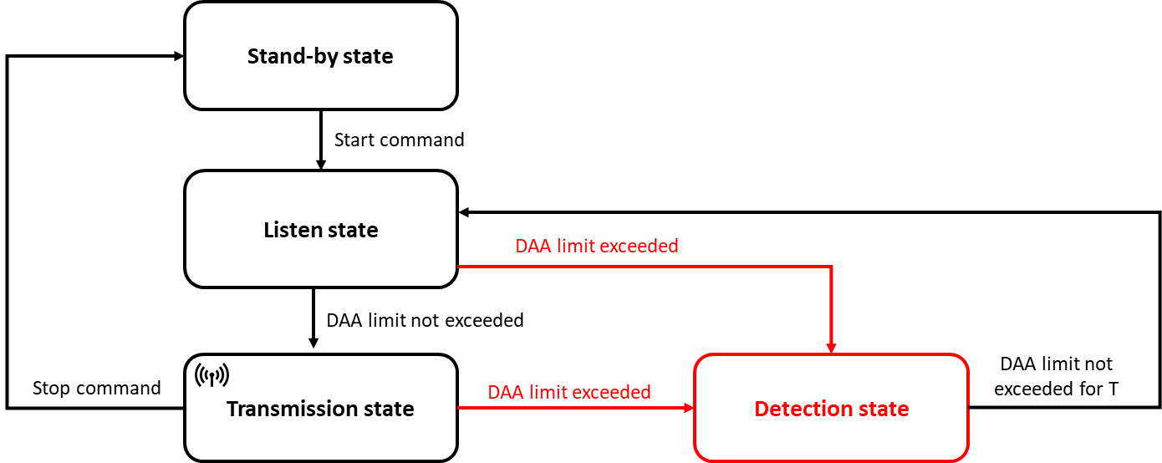
Figure 55: DAA workflow example

DAA block diagram
This section illustrates a possible design of a sub-system of HD-GBSAR implementing the DAA procedure to detect the presence of automotive radar signals. The sub-system design described is just as an example and variations are possible. The only requirement for any implementation is to have the capability to detect any automotive radar signal not permanently overlapping in time and in frequency with the HD-GBSAR signal. In the described implementation this is obtained by processing an IF signal with a bandwidth of 1 GHz. Figure 56 shows the possible architecture of an HD-GBSAR Digital and Radio Frequency front-end including the DAA sub-system:
- The digital front-end generates the IF chirp, which is up converted at RF amplified and transmitted by means of the TX antenna;
- A part of the transmitted signal is extracted before the RF power amplifier (PA) by means of a directional coupler and used to down-convert the received RF signal to IF;
- The signal received is amplified by a Low Noise amplifier and then it is down-converted to IF;
- The down-converted signal is filtered through a low pass filter with a bandwidth of 1-2 MHz (HD-GBSAR Filter), digitized by means of Analog to Digital Converter and processed by the digital front-end to obtain the displacement measure of the monitored scenario (HD-GBSAR application);
- The DAA sub-system takes a part of the down-converted signal and filters it with a band pass filter. The low cut-off frequency of the band pass filter should be higher than the cut-off frequency of the low-pass filter and an high cut-off frequency of 1GHz, to exclude the HD-GBSAR signal back-reflected by the monitored scenario and at the same time keep only the automotive down-converted signals (Figure 57);
- The output of the DAA IF filter contains only the potential presence of automotive radar signals down-converted at IF, for this reason such signal can be used to detect the potential presence of automotive radars;
- The DAA detection block applies the DAA thresholds (analogically or digitally) on the signal filtered by the DAA band-pass filter and if it identifies the presence of an automotive radar signal (if the DAA threshold is exceeded) then the digital front-end immediately turns-off the transmitter PA amplifier to interrupt HD-GBSAR transmission.

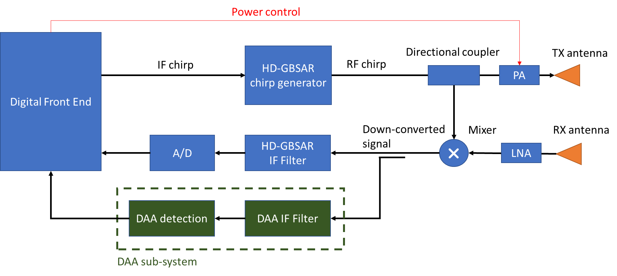
Figure 56: DAA sub-system diagram
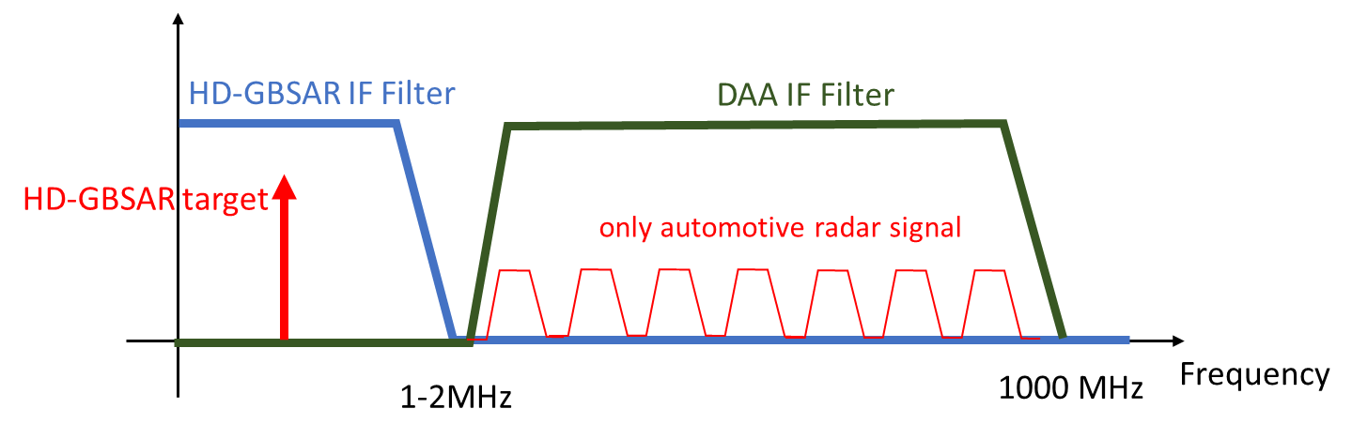
Figure 57: HD-GBSAR IF filter and DAA IF filter
The upper graph of Figure 58 shows an example of transmitted HD-GBSAR chirp signal (blue line) along with a possible automotive chirp signal (green line), while the red line represent the HD-GBSAR signal backscattered by a target located in the monitored scenario and received by HD-GBSAR RX antenna.
The lower graph of Figure 58 shows the down-converted signal, where the HD-GBSAR target signal is located in the HD-GBSAR IF filter frequency domain (yellow background), while the automotive down-converted signal is mainly in the DAA IF filter frequency domain (green background).
This implementation would allow to distinguish HD-GBSAR backscattered signals from automotive radar signals, even while HD-GBSAR is operating.

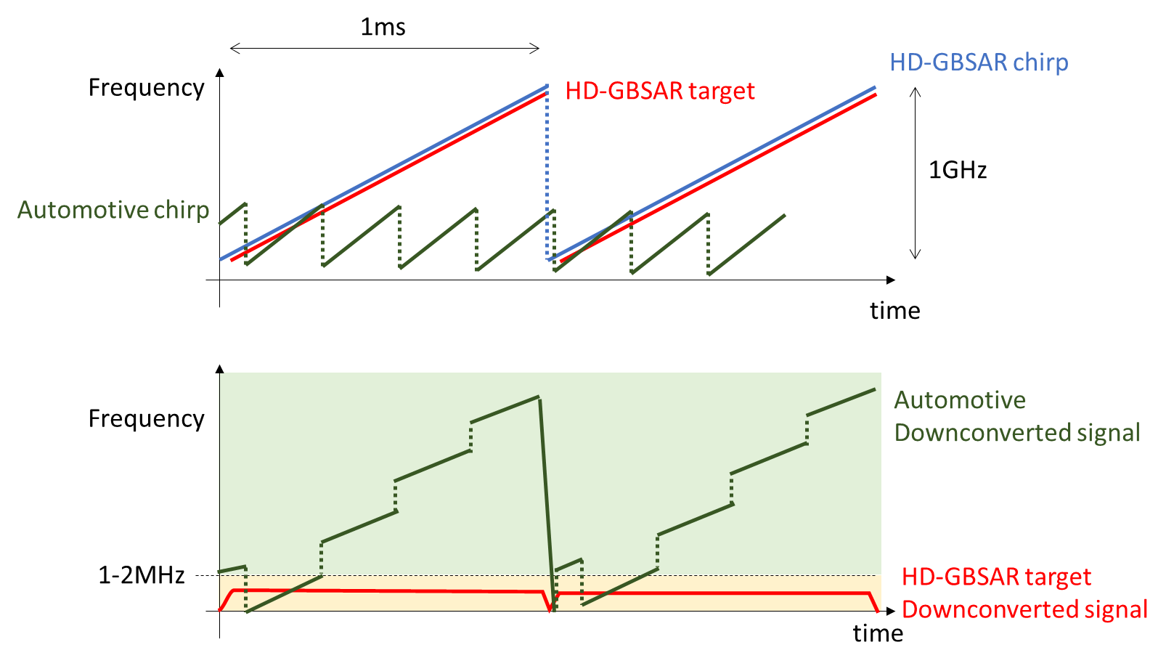
Figure 58: HD-GBSAR and automotive received signal

- FS interference analysis in case of antenna horizontal misalignment
This Annex reports additional MCL analysis concerning the effect of the antenna boresight horizontal misalignment between HD-GBSAR and FS victim receiver for the three identified worst-case scenarios defined in section 4.5.1. The analysis is conducted assuming exactly the same geometry configuration and assumption, except the perfect alignment condition.
In case of not perfect horizontal alignment between HD-GBSAR and FS (main beam to main beam), the MCL analysis shall also include the mitigation factor introduced by the FS antenna pattern in the horizontal plane, in addition to the vertical antenna mitigation factor. In general, the three-dimensional main lobe radiation pattern of an high directivity antenna $G\left(ϕ,θ\right)$ can be approximated as the sum of the antenna maximum gain $G_{Max}$ plus the normalised horizontal $P_{H}\left(ϕ\right)$ and vertical $P_{V}\left(θ\right)$ cut of the radiation pattern expressed in dBi [32]:
$G\left(ϕ,θ\right)=G_{Max}+ P_{H}\left(ϕ\right)+P_{V}\left(θ\right)$ (34)
Assuming antenna class 3 radiation pattern for FS, as specified in section 4.1.1, it can be assumed a maximum gain $G_{Max}$ of 43 dBi and a vertical and horizontal cut equivalent to the RPE pattern represented in Figure 8 normalised subtracting $G_{Max}$ (Figure 59). The gain of an ETSI class 3 antenna cannot be lower than -17 dBi (Figure 8), therefore the equation (34) shall be re-formulated as follow to take this into account:
$G\left(ϕ,θ\right)=\max\left( G_{Max}+ P_{H}\left(ϕ\right)+P_{V}\left(θ\right) , -17dBi \right)$ (35)

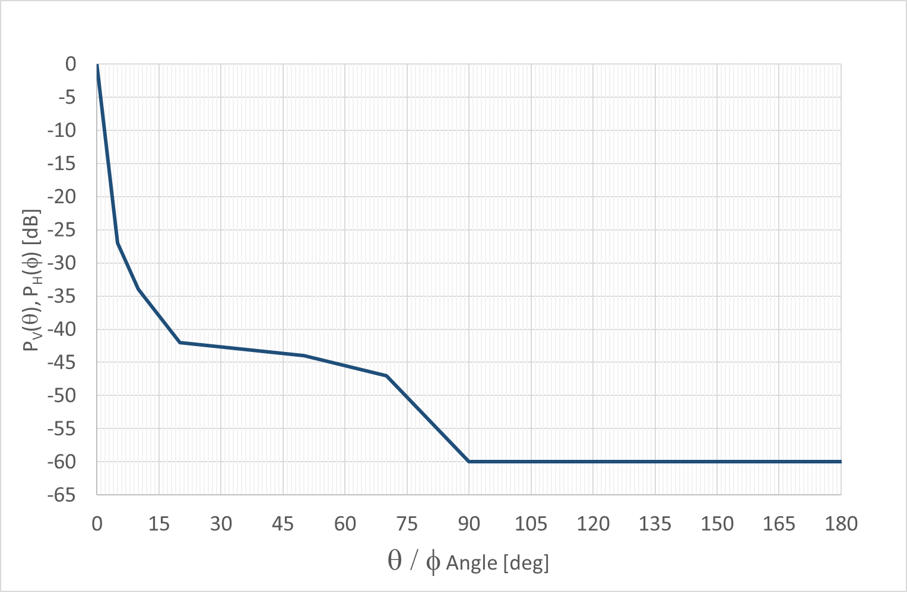
Figure 59: Normalised vertical and horizontal FS radiation pattern
Case A
Figure 60 represents the condition of boresight antenna misalignment ($ϕ_{R}$) between HD-GBSAR and FS in the horizontal plane for interference scenario A.
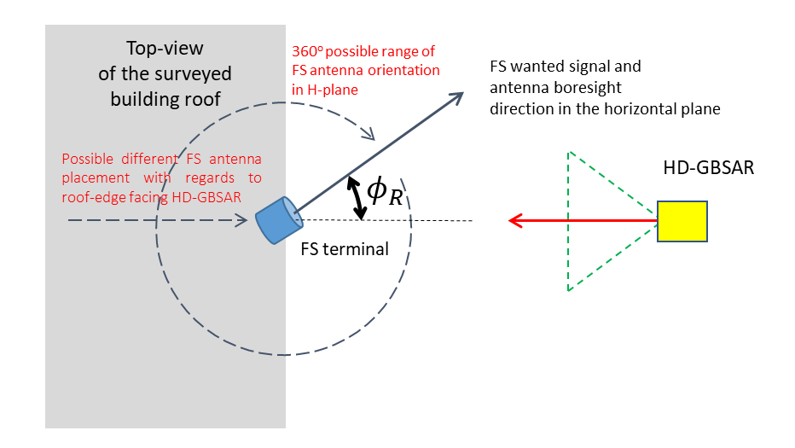
Figure 60: HD-GBSAR to FS interference scenario A in case of misalignment (H-plane)
The chart reported in Figure 61 shows the minimum separation distance derived from the MCL analysis repeated considering the three-dimensional FS antenna pattern calculated as expressed in (35) for antenna boresight misalignment value $ϕ_{R}$ up to 30 deg. The analysis indicates that for horizontal misalignment angles greater than 3 deg, the evaluated minimum separation distance decreases from 1943 m to 300 m, which is however greater then the actual distance assumed between HD-GBSAR and FS terminal. Therefore, a horizontal misalignment between HD-GBSAR and FS main lobe of 3 degrees or more reduces drastically the required minimum separation distance, but it doesn't completely eliminate the risk of interference.
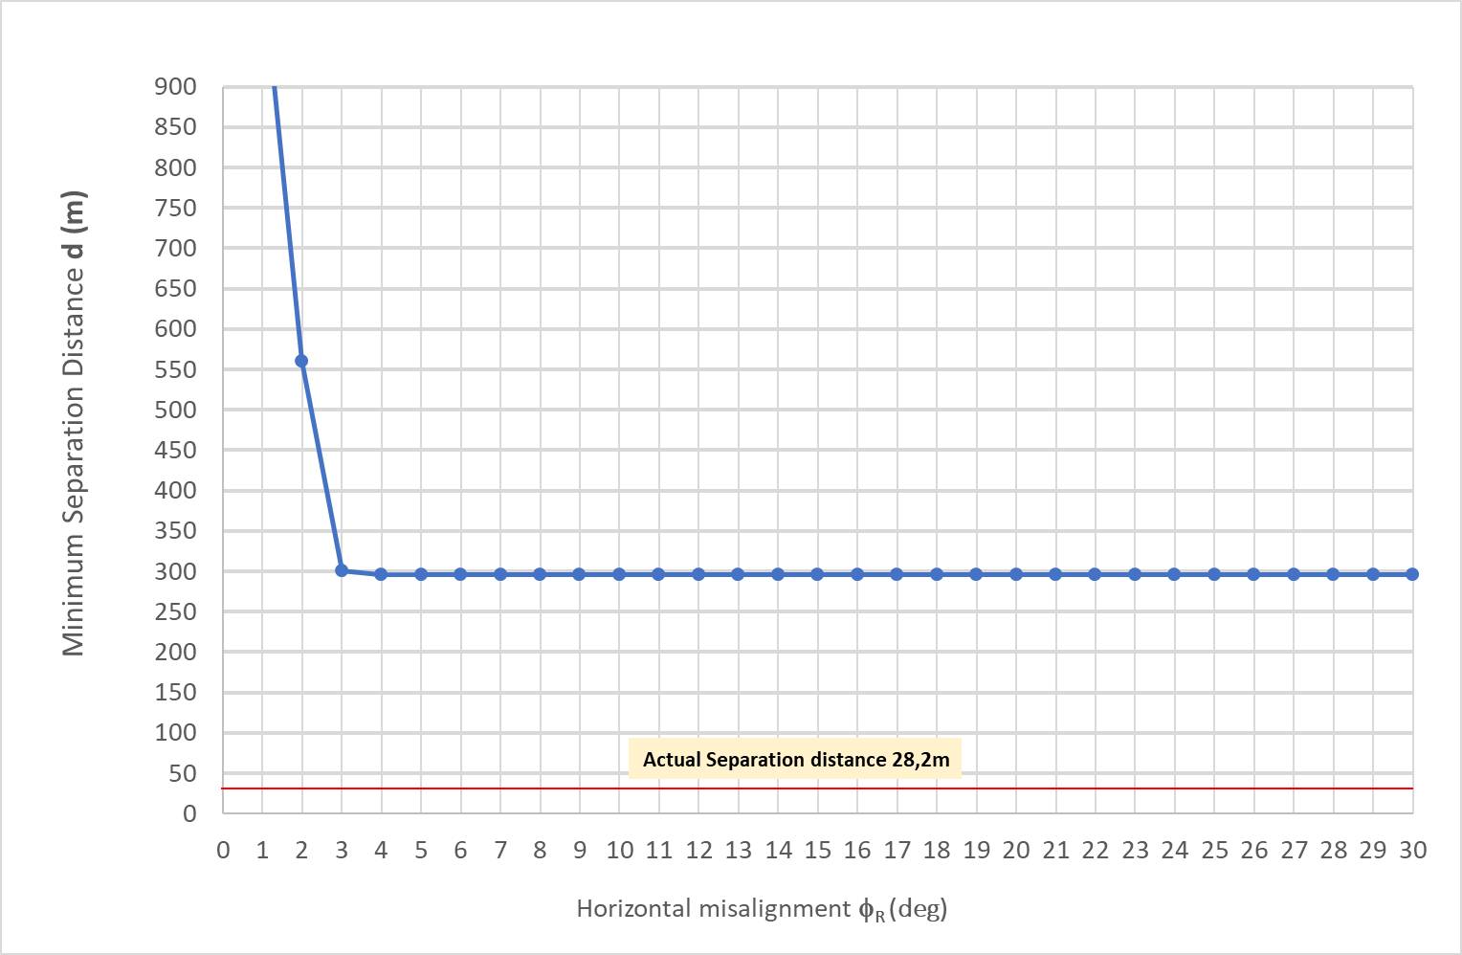
Figure 61: Minimum separation distance in case of horizontal misalignment (case A)
Case B
As for the interference scenario A, the MCL analysis reported in section 4.5.1.2 has been repeated assuming a variable antenna horizontal misalignment $ϕ_{R}$ between HD-GBSAR and FS victim receiver (Figure 62) located on top of a building having an height H2 of 30 m. In case of a misalignment greater than 9 degrees (Figure 63), the required minimum separation distance becomes lower than the assumed distance between HD-GBSAR and FS victim receiver, indicating the absence of interference under such circumstances. FS receiver antenna boresight could be pointed in any direction in the horizontal plane with uniform probability distribution, thus the probability to have harmful interference between HD-GBSAR and FS receiver can be estimated equal to 18/360 = 5%.
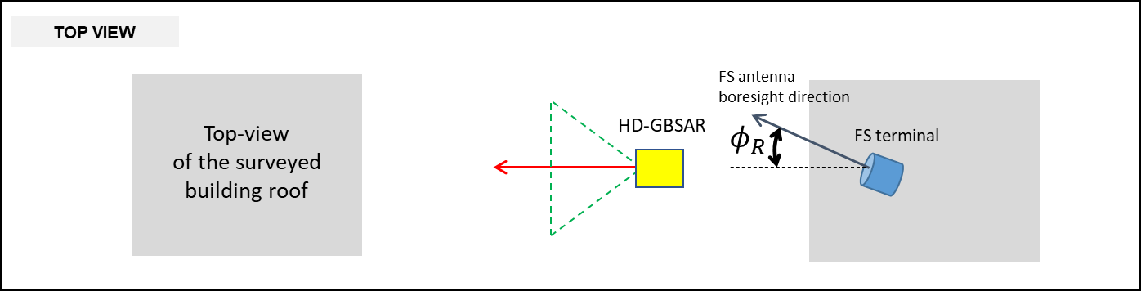
Figure 62: HD-GBSAR to FS interference scenario B in case of misalignment (H-plane)
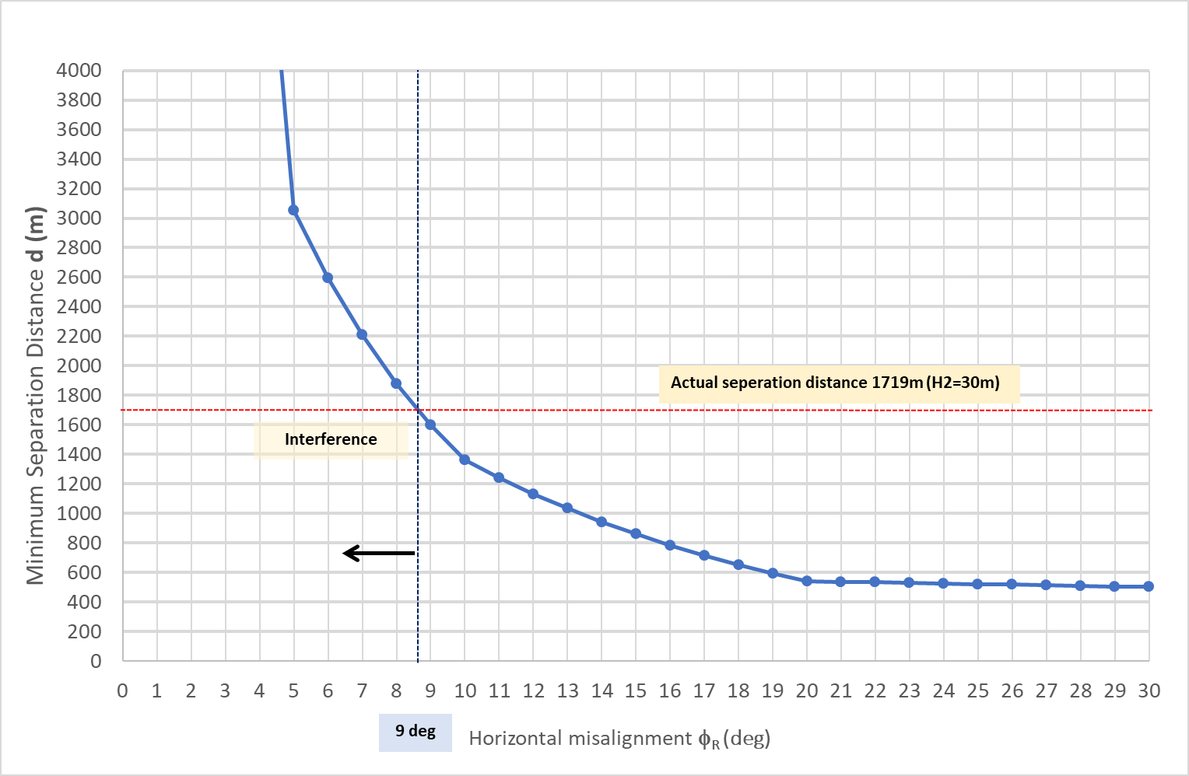
Figure 63: Minimum separation distance in case of horizontal misalignment (case B)
Case C
The MCL analysis reported in section 4.5.1.3 has been repeated considering an horizontal misalignment of $ϕ_{R}=18$ (Figure 64), which represents the value of $ϕ_{R}$ minimizing the interference condition only to the situation where FS receiver is located at a distance closer than 250m and 300m respectively assuming a FS building height of 20 m and 40 m (Figure 65).
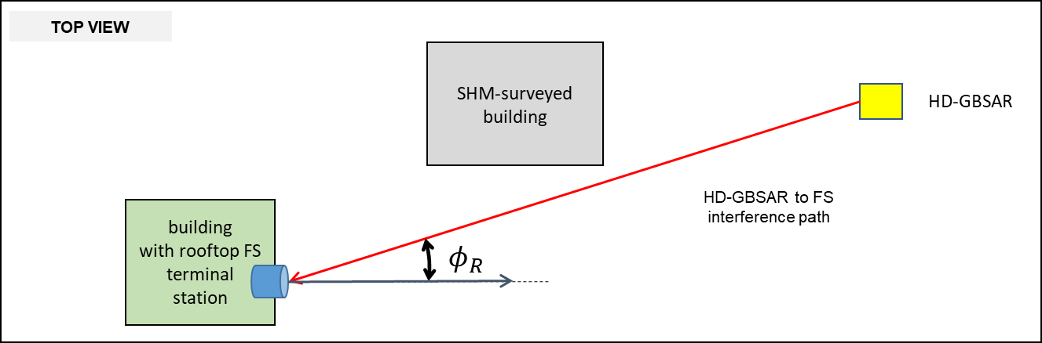
Figure 64: HD-GBSAR to FS interference scenario C in case of misalignment (H-plane)

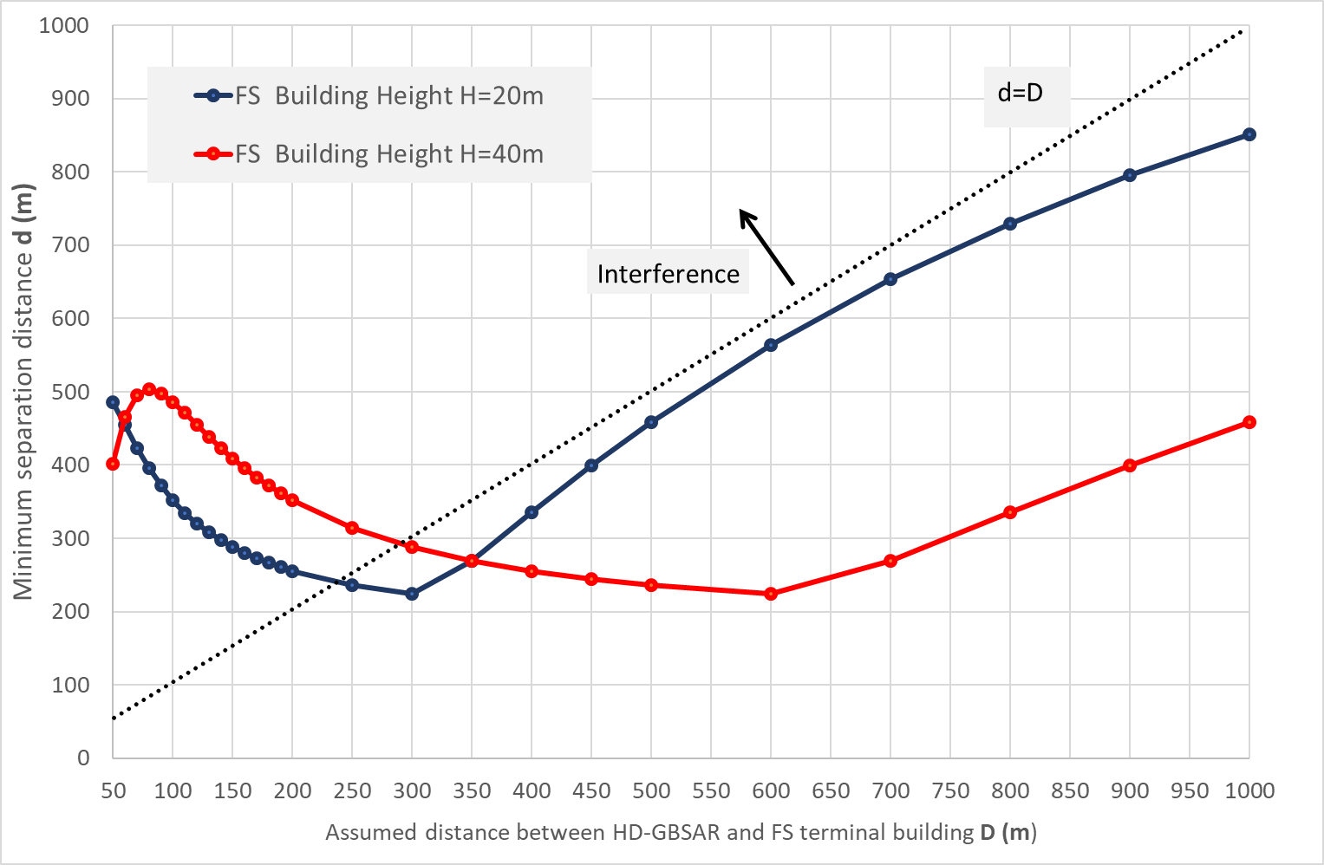
Figure 65: Minimum separation distance in case of horizontal misalignment of $ϕ_{R}$18°(case C)

- List of References

- ETSI TR 103 594: "Short Range Devices (SRD) using Ultra Wide Band (UWB); Technical characteristics and spectrum requirements for High-Definition Ground Based Synthetic Aperture Radars (HD-GBSAR) operating in 1 GHz band within 74 - 81 GHz tuning range" (2018)
- ECC Report 111: "Compatibility studies between Ground Based Synthetic Aperture Radar (GBSAR) and existing services in the range 17.1 GHz to 17.3 GHz" (2007)
- ERC Recommendation 74-01: "Unwanted Emissions in the Spurious Domain" (2011)
- ECO Frequency Information System, available online at: https://www.efis.dk/
- ECC Recommendation (05)07: "Radio frequency channel arrangements for Fixed Service Systems operating in the bands 71-76 GHz and 81-86 GHz" (2013)
- ERC Recommendation 70-03: "Relating to the use of Short Range Devices (SRD)" (2018)
- FCC DA 18-839: "Request for Waiver to Allow Licensing and Use of Its 76-77 GHz Band Radar in Mines and Tunnels" (2018)
- ECC Decision (04)03: "ECC Decision of 19 March 2004 on the frequency band 77-81 GHz to be designated for the use of Automotive Short Range Radars" (2004)
- ETSI EN 302 217-2 V3.1.1: "Fixed Radio Systems; Characteristics and requirements for point-to-point equipment and antennas; Part 2: Digital systems operating in frequency bands from 1 GHz to 86 GHz" (2017)
- ETSI EN 302 217-4 V2.1.1: "Fixed Radio Systems; Characteristics and requirements for point-to-point equipment and antennas; Part 4: Antennas" (2017)
- Recommendation ITU-R F.699-8 (2018): "Reference radiation patterns for fixed wireless system antennas for use in coordination studies and interference assessment in the frequency range from 100 MHz to 86 GHz"
- Report ITU-R M.2322-0: "Systems characteristics and compatibility of automotive radars operating in the frequency band 77.5 78 GHz for sharing studies" (2014)
- Recommendation ITU-R SA.1344-1 (02/2009) "Preferred frequency bands and bandwidths for the transmission of space VLBI data within existing space research service (SRS) allocations"
- Radio Observatories in Europe, by Committee on Radio Astronomy Frequencies (CRAF), available online at: https://www.craf.eu/radio-observatories-in-europe/
- ETSI EN 301 091-3 v1.1.1 "Short Range Devices; Transport and Traffic Telematics (TTT); Radar equipment operating in the 76 GHz to 77 GHz range; Harmonised Standard covering the essential requirements of article 3.2 of Directive 2014/53/EU; Part 3: Railway/Road Crossings obstacle detection system applications" (2017)
- Recommendation ITU-R M.2057-1: "Systems characteristics of automotive radars operating in the frequency band 76-81 GHz for intelligent transport systems applications" (2018)
- ECC Report 262: "Studies related to surveillance radar equipment operating in the 76 to 77 GHz range for fixed transport infrastructure" (2017)
- ECC Decision (16)01: "ECC Decision of 4 March 2016 on the harmonised frequency band 76-77 GHz, technical characteristics, exemption from individual licensing and free carriage and use of obstacle detection radars for rotorcraft use" (2016)
- ECC Report 222: "The impact of Surveillance Radar equipment operating in the 76 to 79 GHz range for helicopter application on radiosystems" (2014)
- ECC Decision (11)02: "ECC Decision of 11 March 2011 on industrial Level Probing Radars (LPR) operating in frequency bands 6-8.5 GHz, 24.05-26.5 GHz, 57-64 GHz and 75-85 GHz, updated on 17 November 2017" (2017)
- ECC Report 139: "Impact of Level Probing Radars using Ultra-WideBand technology on radiocommunications services" (2010)
- CRAF Handbook for radioastronomy (2005)
- ERC Report 25: "The European Table of Frequency Allocations and Applications in the frequency range 8.3 kHz to 3000 GHz".
- Recommendation ITU-R F.758-6: "System parameters and considerations in the development of criteria for sharing or compatibility between digital fixed wireless systems in the fixed service and systems in other services and other sources of interference " (09/2015)
- Recommendation ITU-R M.1461-2: "Procedures for determining the potential for interference between radars operating in the radiodetermination service and systems in other services " (01/2018)
- Recommendation ITU-R M.1732-1: "Characteristics of systems operating in the amateur and amateur-satellite services for use in sharing studies " (01/2017)
- Recommendation ITU-R RA.769-2: "Protection criteria used for radio astronomical measurements " (05/03)
- Report ITU-R SA.2065-0: "Protection of the space VLBI telemetry link " (2006)
- U. K. Elektronicznej https://bip.uke.gov.pl/pozwolenia-radiowe/wykaz-pozwolen-radiowych-tresci/linie-radiowe,7.html (2019)
- "Ericsson microwave outlook report" (2017)
- IEEE PIMRC: "Reflection and transmission behaviour of building materials at 60 GHz" (1994)
- IEEE ANTENNAS AND WIRELESS PROPAGATION LETTERS "A Three-Dimensional Directive Antenna Pattern Interpolation Method", VOL. 15 (2016)
- ETSI EN 300 440 "Short Range Devices (SRD); Radio equipment to be used in the 1 GHz to 40 GHz frequency range; Harmonised Standard for access to radio spectrum "
- Report ITU-R RA.2457: "Coexistence between the radio astronomy service and radiolocation service applications in the frequency band 76-81 GHz"
- ETSI TR 103 593 V0.1.3: "System Reference document (SRdoc); Transmission characteristics; Technical characteristics for radiodetermination equipment for vehicular applications within the frequency range 77 GHz to 81 GHz"
- Decision 2004/545/EC "Commission Decision of 8 July 2004 on the harmonisation of radio spectrum in the 79 GHz range for the use of automotive short-range radar equipment in the Community"
- ECC Report 173: " Fixed Service in Europe Current use and future trends post 2016"
- Recommendation ITU-R RA.314-10: "Preferred frequency bands for radio astronomical measurements"
- Recommendation ITU-R RS.515-5: "Frequency bands and bandwidths used for satellite passive remote sensing"
- Recommendation ITU-R RS.577-7: "Frequency bands and required bandwidths used for spaceborne active sensors operating in the Earth exploration-satellite (active) and space research (active) services"
- Recommendation ITU-R RS.2064-0: "Typical technical and operating characteristics and frequency bands used by space research service (passive) planetary observation systems"
- Recommendation ITU-R P.620-7: "Propagation data required for the evaluation of coordination distances
in the frequency range 100 MHz to 105 GHz"

