To enable WAS/RLAN use on a national basis in the band 5725-5850 MHz but also ensure the protection of RTTT/Smart Tachograph and radars (including Fast Frequency Hopping) taking into account free circulation of WAS/RLAN
approved DD Month YYYY
ECC Report 330

Executive summary
This Report contains an analysis of the regulatory and implementation issues to enable WAS/RLAN use on a national basis in the band 5725-5850 MHz to enable the protection of, RTTT/Smart Tachograph and radars (including Fast Frequency Hopping). This Report also looks at issues around enforcement and the free circulation of WAS/RLAN equipment in countries that do not allow the use of the 5725-5850 MHz band by WAS/RLAN.
The Report describes the possibilities for national implementation of conditions for WAS/RLAN usage within the 5725-5850 MHz band (above the generic SRD limit of 25 mW), with the assumption that WAS/RLAN use would be predominately based on the exemption from individual licensing. It summarises examples, practical experiences and other innovative solutions to enable spectrum sharing conditions for WAS/RLANs on a national level.
If there were steps taken to introduce a harmonisation measure for WAS/RLAN use in this band by EU, CEPT and/or ETSI then taking into account the free circulation of WAS/RLAN devices at an EU level, and equipment put on to a wider European market, it is recommended that a requirement for the implementation of an automated Country Determination Capability (CDC) functionality at device level in WAS/RLAN Access Points capable of transmitting over 25 mW e.i.r.p. should be applied to ensure that the 5.8 GHz band cannot be used exclusively in countries which do not allow WAS/RLAN operation in 5725-5850 MHz. It is also recommended that fixed outdoor use or fixed use in vehicles would not be allowed for devices operating above 25 mW.
Consideration is also given to enhanced techniques, including geolocation database solution that could be implemented on a national basis. Some of the detail on these techniques might need CEPT administrations and/or incumbents to provide their requirements to be published. Additional work would need to be conducted to establish a process to collect and publish the appropriate information. Additionally, it may be used as a knowledge base for further standardisation efforts for WAS/RLAN.
Some studies, at both CEPT and national level, on compatibility between WAS/RLAN and incumbent services and applications (i.e. TTT applications) show the need for separation distances of hundreds of metres when WAS/RLAN uses higher output levels than 25 mW e.i.r.p of the SRD regulation. Additionally, the existing DFS techniques at 5 GHz have not been designed to protect all of the operating modes of frequency hopping radars in the 5725-5850 MHz band. Hence countries implementing WAS/RLAN in these bands will have to take steps to address cross border issues. Individual CEPT countries have made regulations to allow WAS/RLAN use under their specific national conditions, which are outlined in this report. In some CEPT countries, low power indoor and outdoor operation of WAS/RLANs up to 200 mW e.i.r.p. is allowed under national licence-exempt radio use, with one country publishing a table of mandatory exclusion zones to protect military radar and TTT installations. Some countries also allow high-power operation up to 1 W e.i.r.p., based on specific national conditions, including the light-licensing approach and use of geolocation databases, however this use is predominately BFWA type operation as detailed in ECC Recommendation (06)04 [31].

TABLE OF CONTENTS

0 Executive summary 2
1 Introduction 7
2 Overview of fast frequency hopping radar and transport and traffic telematics in 5725-5850 MHZ 8
2.1 Overview of radiolocation use in the 5725-5850 MHz 8
2.1.1 Technical characteristics of radar systems 8
2.2 Overview of TTT use in 5795-5815 MHz 9
2.2.1 General Description of TTT applications 9
2.2.2 Examples of Road Tolling Installations 11
2.2.3 Impact of RLAN interference into TTT 12
3 Overview of Regulations in the Band 5725-5875 MHz 13
3.1 WAS/RLAN - Wireless Access Systems and Radio local area networks 13
3.2 Radiolocation systems 14
3.3 Road tolling (TTT) and smart tachograph 14
3.4 industrial, scientific and medical (ISM) applications (of radio frequency energy) use of the 5725-5850 MHz 15
4 Summary of earlier studies in ECC 16
4.1 Studies looking at sharing with Radiodlocation services 16
4.1.1 ECC REPORT 68 16
4.1.2 ECC Report 192 17
4.1.3 ECC Report 244 17
4.1.4 CEPT Report 57 17
4.1.5 CEPT Report 64 17
4.1.6 Radiodeterminations issues taken from final CEPT Brief for WRC-19 18
4.2 Studies looking at sharing with Road Tolling (TTT) 19
4.2.1 ECC Report 101 19
4.2.2 ECC Report 192 19
4.2.3 ECC Report 228 19
4.2.4 ECC Report 244 19
4.2.5 Compatibility between RLAN and road tolling in the band 5795-5815 MHz 20
4.2.6 ECC Report 250 20
4.2.7 ECC Report 277 20
4.2.8 ECC Report 290 21
4.2.9 ECC Report 291 21
4.2.10 CEPT Report 57 21
4.2.11 CEPT Report 64 22
4.2.12 ETSI TR 103 319 22
4.2.13 ETSI TR 102 792 23
4.2.14 Analysis of road tolling (TTT) issues as reflected inthe final CEPT Brief for WRC-19 23
5 Analysis of relevant conclusions in earlier studies 24
5.1 Road Tolling (TTT) 24
5.2 Radiolocation 24
6 Issues related to equipment circulation 25
6.1 Country Determination Capability (CDC) 25
6.2 Detection and Mitigation of TTT by RLAN 25
6.3 Geolocation capability and DatabaseS 26
6.3.1 GEOLOCATION capability 26
6.3.2 Databases 26
6.4 INDOOR and outdoor determination methods 26
6.4.1 ELEMENTS for indoor/outdoor Detection 27
6.5 Enforcement CONSIDERATIONs 28
6.5.1 TTT 29
6.5.2 RADAR 29
6.5.3 Enforcement 29
6.5.4 MITIGATION OF NON-COMPLIANT EQUIPMENT USE 29
6.5.5 Cross border issues 30
6.6 Circulation of Equipment in the Single Market 30
7 National implementations of WAS/RLAN in the band 31
7.1 Current status in some administrations at the publication of this report 31
7.2 National regulatory regimes 31
7.2.1 Czech Republic - WAS/RLAN usage in the 5.8 GHz band 31
7.2.2 United Kingdom - WAS/RLAN usage in the 5.8 GHz band 31
7.3 National TTT protection 32
7.3.1 Czech Republic 32
7.3.2 United Kingdom 32
7.4 National WAS/RLAN spectrum sharing with defence radars 32
7.4.1 Czech Republic 32
7.4.2 United Kingdom 32
8 Conclusions 33
ANNEX 1: Geolocation databases, light-licensing coordination and data protection issues considered in the Czech Republic 34
ANNEX 2: INDOOR/OUTDOOR DETERMINATION 41
ANNEX 3: Example of Country Determination Capability (CDC) implementation 44
ANNEX 4: Explanation of the UK regulations that RLAN technology use in the 5725–5850 MHz band 46
ANNEX 5: Detection and Mitigation Methods of ETSI TR 103 319 47
ANNEX 6: List of References 50

LIST OF ABBREVIATIONS

Abbreviation | Explanation
AI | Artificial Intelligence
AP | Access Point
ASECAP | European Association of Operators of toll road infrastructures
BFWA | Broadband Fixed Wireless Access
BRAN | Broadband Radio Access Networks
BTS | Base Transceiver Station
CAM | Cooperative Awareness Messages
CEN | Comité Européen de Normalisation
CEPT | European Conference of Postal and Telecommunications Administrations
DA2GC | Direct Air-to-Ground Communications
DFS | Dynamic frequency selection
DSRC | Dedicated Short-Range Communications
EC | European Commission
ECA | European common allocations
ECC | Electronic Communications Committee
ED | Energy Detection
EETS | European Electronic Toll Service
EFC | Electronic fee collection
e.i.r.p. | Equivalent isotropically radiated power
ETSI | European Telecommunications Standards Institute
EU | European Union
FSS | Fixed-satellite service
GMSS | Global Navigation Satellite System
GPS | Global Positioning System
GSM | Global System for Mobile Communications
HDR | High data rate
I/N | Interference to noise ratio
ISM | Industrial, scientific and medical
ITS | Intelligent transport system
LBT | Listen before talk
MAC | Medium access control
MBR | Maritime broadband radio
MCL | Minimum coupling loss
MGWS | Multi gigabit wireless systems
OBU | On-Board Unit
OS | Operative system
POD | Probability Of Detection
PP | Point-to-point
RECR | Remote Early Detection Communication Reader
RLAN | Radio local area network
RSSI | Received Signal Strength Indicator
RSU | Road side unit
RTTT | Road Transport and Traffic Telematics
SRD | Short Range Devices
TC | Technical Committee
TLPR | Tank level probing radar
TPC | transmitter power control
TR | Technical Report
TS | Technical Specifications
TTT | Transport and Traffic Telematics
UE | User equipment
WAS | Wireless access systems
WIA | Wireless industrial applications
WiFi | Wireless Fidelity

Introduction
Agenda Item 1.16 from WRC-19 looked at possible new mobile allocation (limited to WAS/including RLAN) in the band. The incumbent primary services that operate in the band are Fixed Satellite Service (FSS) Earth to Space (E-S) and Radiolocation were all studied during the WRC-19 study period. In addition, other incumbent users of the different applications that are authorised for use throughout CEPT at various power levels such as Short Range Devices (SRD), Road Tolling, WIA (Wireless Industrial Applications) and BFWA (Broadband Fixed Wireless Access) were also studied under this WRC-19 agenda item.
The studies concluded that sharing with FSS and most of the applications that were being operated in CEPT countries under general authorisation regimes were feasible with appropriate mitigation techniques or measures, however there was no consensus reached on the conclusions for the possibility of sharing between RLANs and both the radiodetermination service (particularly Fast frequency hopping radar) and road tolling. Views on these sharing issues are shown in Sections 4.1.6 and 4.2.13.
As a result of the above views CEPT did not support a primary mobile allocation in the band at WRC-19 but approved further work to develop ECC Deliverables to provide guidance on suitable limitations for appropriate technical conditions, mitigation techniques and regulatory measures for CEPT countries who would wish to enable RLAN use on a national basis in this band and allowing the protection of radars (including Fast Frequency Hopping) and RTTT for CEPT countries who are not interested in open the band for WAS/RLAN.
Prior to WRC-19, studies were conducted for WRC-15 under Agenda Item 1.1 and related to other ECC activities.
Some administrations have already made regulations nationally allowing WAS/RLAN see Section 7 for more information.
However, some CEPT countries consider that no effective mitigation techniques have been proposed to protect certain modes of fast frequency hopping radars and RTTT that operate in their countries in this band. As result some CEPT countries have not made national regulations for WAS/RLAN in the band.
The approved further work was not intended to revise or review the existing technical studies, but to draw on national experiences and innovative solutions to therefore provide information for administrations who might wish to make national regulatory implementation for WAS/RLAN in the band.
This document contains an analysis of the possible regulatory issues to enable WAS/RLAN use on a national basis in the band 5725-5850 MHz but also ensure the protection of RTTT/Smart Tachograph and radars (including Fast Frequency Hopping) taking into account free circulation of WAS/RLAN.
This Report does not cover usage that is currently harmonised under ERC Recommendation 70-03 and ECC Recommendation (06) 04 [31].

Overview of fast frequency hopping radar and transport and traffic telematics in 5725-5850 MHZ

Overview of radiolocation use in the 5725-5850 MHz

Technical characteristics of radar systems
Recommendation ITU-R M.1638-1 [62] provides characteristics of radars operating under the Radiolocation services in the frequency range 5250-5850 MHz. Within this range, the band between 5725 and 5850 MHz is used by many different types of radars on fixed land-based, ship borne and transportable platforms. It should be noted that most of these radars are designed to operate not only in the 5725-5850 MHz band but in a larger portion of the band 5250-5850 MHz.
The below table contains technical characteristics of radars 22 and 23 contained in Recommendation ITU-R M.1638-1 [62]. Both radars use frequency hopping modulation and work within the frequency band 5725-5850 MHz.
Table 1: : Characteristics of radars 22 and 23 (fast frequency hopping radars)
Characteristics |  | Unit | Radar 22 | Radar 23
Function |  |  | Multi-function | Multi-function
Platform type (airborne, shipborne, ground) |  |  | Surface and air search, ground-based on vehicle | Search, ground-based on vehicle
Tuning range |  | MHz | 5400-5850 | 5250-5850
Modulation |  |  | Coded pulse/barker code and Frequency hopping | Coded pulse/barker code and Frequency hopping
Tx power into antenna |  | kW | 12 peak | 70
Pulse width |  | us | 4.0-20.0 | 3.5/6.0/1.0
Pulse rise/fall time |  | us | 0.2 | 0.3
Pulse repetition rate |  | pps | 1 000-7 800 | 2 500-3 750
Chirp bandwidth |  | MHz | NA | NA
RF emission bandwidth | –3 dB  –20 dB | MHz | 5  Not available | 5  Not available
Antenna pattern type (pencil, fan, cosecant-squared, etc.) |  |  | Pencil | Pencil
Antenna type (reflector, phased array, slotted array, etc.) |  |  | Phased array | Phased array
Antenna polarization |  |  | Vertical | Horizontal
Antenna main beam gain |  | dBi | 35 | 31.5
Antenna elevation beamwidth |  | degrees | 30 | 30
Antenna azimuthal beamwidth |  | degrees | 2 | 2
Antenna horizontal scan rate |  | degrees/s | Variable | Variable
Antenna horizontal scan type (continuous, random, 360°, sector, etc.) |  | degrees | 360 | 360  sector
Antenna vertical scan rate |  | degrees | NA | NA
Antenna vertical scan type (continuous, random, 360°, sector, etc.) |  | degrees | Sector | Sector
Antenna side-lobe (SL) levels (1st SLs and remote SLs) |  | dB | –40 | –30
Antenna height |  | m | 10 | 6-13
Receiver IF 3 dB bandwidth |  | MHz | 4 | 5
Receiver noise figure |  | dB | 5 | 13
Minimum discernable signal |  | dBm | –103 | –108
The usage of the 5725 and 5850 MHz band, by fast frequency hopping Defence radars, is assumed to be a combination of static locations with possibility of usage by the same FFH radars where vehicular mounted
Defence radars operated in the 5725-5850 MHz employ advanced and fast frequency hopping techniques. Frequency hopping is one of the most common electronic counter-counter-measures (ECCM). Radar systems that are designed to operate in hostile electronic attack environments use frequency hopping as one of its ECCM techniques. This type of radar typically divides its allocated frequency band into channels. The radar then randomly selects a channel from all available channels for transmission. This random occupation of a channel can occur on a per beam position basis where many pulses on the same channel are transmitted, or on a per pulse basis.
Thanks to FFH technology, the technologies are capable to find dynamically proper list of noise-free channels. In case of co-channel usage of frequencies with high-power RLANs, the range of channels for radar operation may be affected by noise floor produced by WAS/RLAN operation. However, several radar technologies are capable of using e.g. the gap between 5350 MHz and 5470 MHz. Actually, there is no mature technology (incl. DFS) for implementation into WAS/RLAN devices for reliable protection of FFH radar operation.

Overview of TTT use in 5795-5815 MHz

General Description of TTT applications
The Commission Decision 2006/771/EC on short range devices names road tolling applications and smart tachograph, weight and dimension applications under the category of Transport and Traffic Telematics (TTT) in 5795-5815 MHz. These applications are also subject to EU transport legislation.
Electronic road toll systems are typically used for the automatic collection of fees for road usage. In Europe, there are mainly two types of systems for tolling: Satellite/GNSS-based systems and DSRC. Both types are subject to tolling interoperability regulation in Directive (EU) 2019/520 [15]. Dedicated Short-Range Communications (DSRC) is a short range microwave technology that is operated in the Transport and Traffic Telematics (TTT) band 5795-5815 MHz and based on CEN DSRC standards in Europe [18][19][20][21] - with the exception of Italy, where a variant high data rate (HDR) DSRC is used.
DSRC is used for the tolling and tolling enforcement, which requires the ability to automatically check whether a tolling on-board unit (OBU) is correctly installed and working in a vehicle. DSRC is also used for enforcement in Satellite/GNSS-based systems, where fees depend on the recorded GNSS trajectory, but the vehicle’s OBU status is checked via DSRC communication (cf. Annex 2 of ECC Report 250 [5] on the German Tolling System).
DSRC at 5.8 GHz is used in over 20 countries in Europe (see Figure 1). According to the statistics from members of ASECAP, the European Association of Operators of toll road infrastructures, 29 million TTT OBUs are in use. The revenue for all kinds of tolling is 29 billion Euro and the TTT based tolling is a substantial part of this. Revenues from TTT road toll systems are an important income to build and maintain road infrastructure in Europe [21].
In DSRC based tolling systems, vehicles are equipped with on-board units (also called “tags”) that communicate with road side units (RSUs) installed on toll roads. Road side units (also called “beacons” or “reader”) initiate the communication. RSUs can be found in the following configurations:
- Toll plaza with barrier: the RSU is mounted next to / over a lane, the barrier is opened upon successful completion of the tolling transaction;
- Toll plaza with electronic fee collection (EFC) lane: the RSU is mounted over a lane, where the vehicle passes at low speed;
- Free flow tolling: RSUs are mounted on overhead gantries, one RSU per lane;
- Fixed and mobile enforcement: RSUs are mounted on overhead gantries, road-side poles or on enforcement vehicles.
On-board units operate in passive backscatter mode, a design without active transmitter that allows low unit cost, low power consumption and long battery lifetime. A specific characteristic of the system is that the roadside equipment has a high sensitivity in order to be able to decode the reflected signal of the OBU. The high sensitivity of the RSU makes it more vulnerable for in-band interference. An OBU is waked up by the signal of the RSU followed by an exchange of several frames, which together form a tolling transaction. Single frames within the tolling transaction can be repeated. However, in free flow tolling, there is limited time to complete the transactions, because a vehicle spends limited time within the communication zone. In single-lane systems with barrier, repeated interference could block the barrier from opening.
The smart tachograph introduction and the enforcement of weight and dimension both impact traffic safety and fair competition on the road transport market. Additionally, the digital tachograph is used to guarantee correct working conditions for truck drivers as prerequisite for safe driving. The EU regulated the radio technology to be used for the remote enforcement (i.e. wireless interrogation) of the tachograph in Appendix 14 of the Commission Implementing Regulation 2016/799 [17] and for the weight and dimension enforcement in Article 10d of the Directive 2015/719 [23]. This radio technology is similar to road tolling equipment and uses the same harmonised standards.
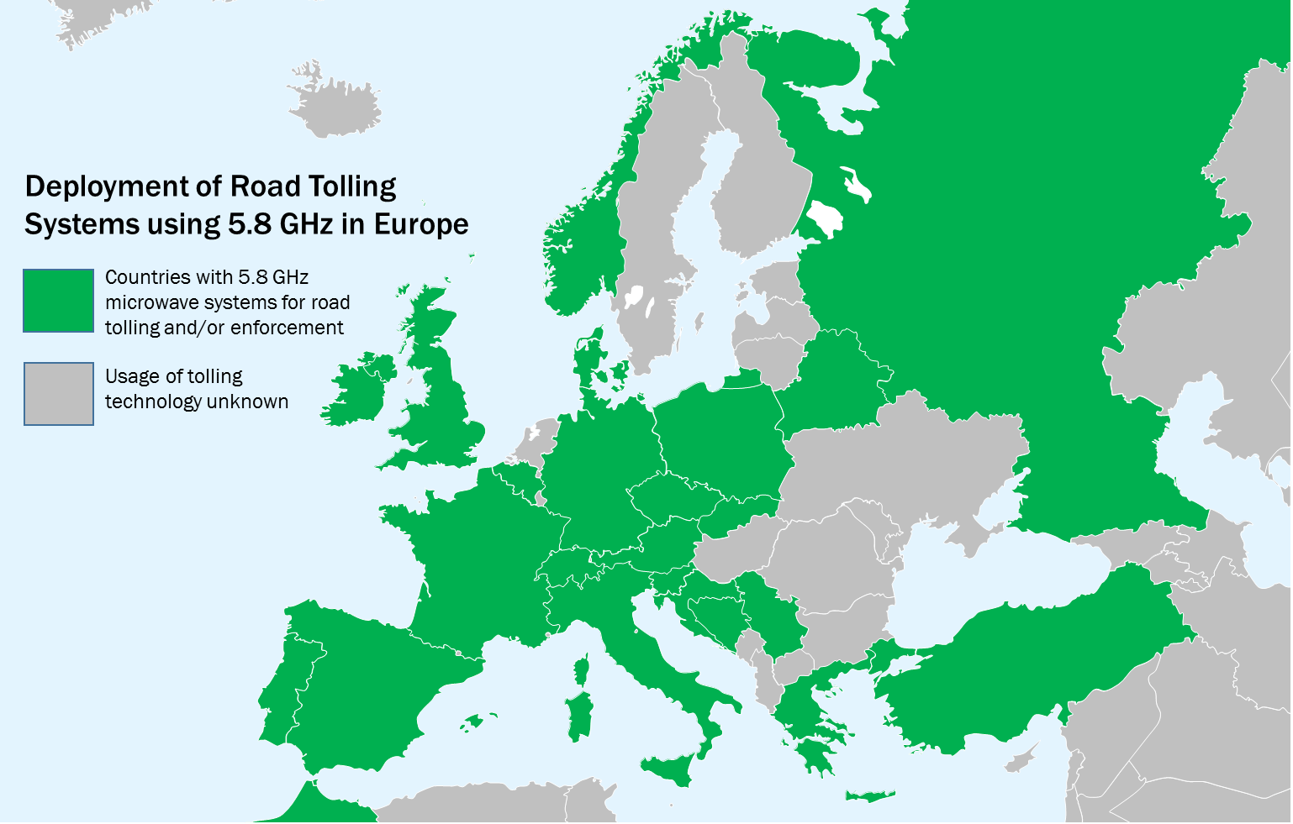
Figure 1: Deployment of Road Tolling Systems using 5.8 GHz in Europe for 2020
Note 1: The density of Road Tolling infrastructure, in each country, varies across CEPT

Examples of Road Tolling Installations
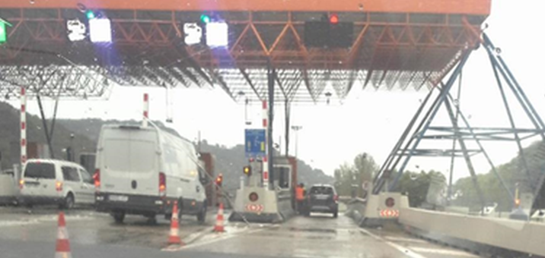
Figure 2: Toll plaza on the Spanish motorway C-32
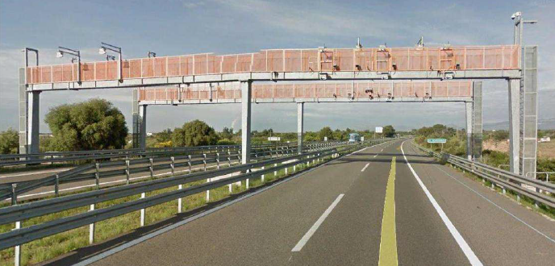
Figure 3: Free flow toll gantry on the Spanish motorway AP-7
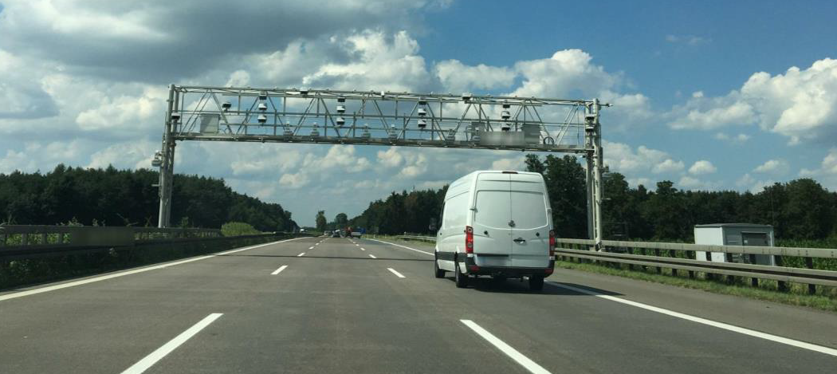
Figure 4: Tolling enforcement gantry on the German motorway

Impact of RLAN interference into TTT
The DSRC protocol specifies an exchange of several frames between roadside unit and on-board unit. This group of frames is called transaction. Single frames within the tolling transaction can be repeated. However, in free flow tolling, there is limited time to complete the transactions, because a vehicle is within the communication zone only for a limited time. A transaction fails if repetitions cannot recover an error within this time. In single-lane systems with barrier, repeated interference could block the barrier from opening.
Interference cannot be easily detected by the toll charger or operator of roadside tolling equipment. Lost tolling transactions become only visible in statistics if the loss is already significant. Lost transactions relate to a loss in toll revenue. Interference on the on-board unit might wake up the on-board unit and increase battery consumption, but there is no monitoring by the user (i.e. the drivers or vehicle owners).

Overview of Regulations in the Band 5725-5875 MHz
Table 2: Overview of applications in the band 5725-5875 MHz
Application | Frequency Range | ECC/ERC  harmonisation  measure | Standard | Notes
Amateur | 5650-5850 MHz |  | ETSI EN 301 783 [42]
Amateur Satellite | 5830-5850 MHz
BFWA | 5725-5875 MHz | ECC/REC/(06)04 [31] | ETSI EN 302 502 [45]
Direct Air-to-Ground Communications (DA2GC) | 5855-5875 MHz | ECC/DEC/(15)03 [30] | ETSI EN 303 316 [65]  ETSI EN 303 339 [66]
FSS Earth Stations | 5850-5925 MHz |  | ETSI EN 301 443 [41] | Priority for civil networks
ITS | 5855-5875 MHz,  5875-5935 MHz | ECC/DEC/(08)01 [29]  ECC/REC/(08)01 [32]  ERC/REC 70-03 [34] | ETSI EN 302 571 [46] | Only the part non- safety  5855-5875 MHz is considered here.
Maritime Broadband Radio (MBR) | 5852-5872 MHz,  5880-5900 MHz | ECC/REC/(17)03 [33] | ETSI EN 303 276 [48]
Non-specific SRD | 5725-5875 MHz | ERC/REC 70-03 | ETSI EN 300 440 [37]
Radiodetermination applications | 4500-7000 MHz | ERC/REC 70-03  (Annex 6) | ETSI EN 302 372 [44] | Within the band 4500-7000 MHz for TLPR application
Radiolocation (military) | 5250-5850 MHz
TTT | 5795-5815 MHz | ERC/REC 70-03  (Annex 5) | ETSI EN 300 674 [38][39][40] | Within the band 5795-5805 MHz. TTT in the band 5805-5815 MHz on a national basis
Weather Radar | 5250-5850 MHz |  |  | Ground based and airborne
WIA | 5725-5875 MHz | ERC/REC 70-03  (Annex 2) | ETSI EN 303 258 [67] | Not considered to be used outside factories
Note: see the ECA table [36] for a complete list.
Note: Industrial, scientific and medical (ISM) in 5725-5875 MHz is covered by EN 55011

WAS/RLAN - Wireless Access Systems and Radio local area networks
ECC/DEC/(04)08 [28] designates 5150-5350 MHz and 5470-5725 MHz for WAS/RLANs in the 5 GHz frequency band and sets technical and operational conditions. A comparable designation is given in EC Decision 2005/513/EC [24] complemented by EC Decision 2007/90/EC [25]. Both ECC and EC regulation are under revision in response to the EC Mandate on RLAN at 5 GHz [27].
The regulation in CEPT/EU distinguishes between indoor and outdoor use and requires mitigation techniques such as dynamic frequency selection (DFS) and transmitter power control (TPC) in order to protect radar applications/systems. The technical and operational conditions within CEPT/EU are as follows:
- 5150-5350 MHz: only indoor use, mean e.i.r.p. limited to 200 mW; DFS and TPC required above 5250 MHz;
- 5470-5725 MHz: indoor as well as outdoor use, mean e.i.r.p. limited to 1 W; DFS and TPC required.
A comparable designation is given in EC Decision 2005/513/EC [24] complemented by EC Decision 2007/90/EC [25]. Both ECC and EC regulation are under revision in response to the EC Mandate on RLAN at 5 GHz [27].
ECC has studied the use of RLAN technology in cars under SRD regulation in ECC Report 277 [6].
ECC has studied the possibility of coexistence between RLAN and other applications including road tolling in the band 5725-5925 at an output power higher than 25 mW e.i.r.p (CEPT Report 57 [9], CEPT Report 64 [11], ECC Report 244 [4], ECC Report 291 [8]). In ECC Report 244, MCL calculations for both directions of interference (including indoor RLAN, see Table 32) have been performed and showed the need for significant separation distances if compatibility is dependent upon protection to an I/N level of -6 dB.
In summary mitigation is necessary when using RLAN in the frequency range 5725-5850 MHz to avoid interference on other applications. As a result, work on mitigation techniques has been initiated in ETSI TS 103 319 which is summarised in 4.2.11.
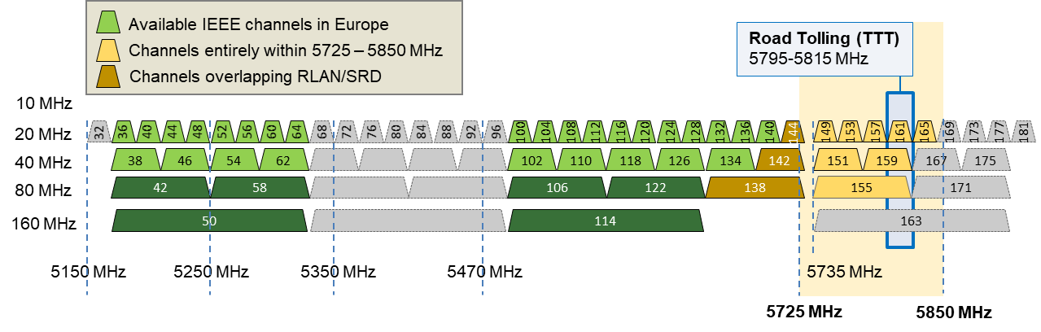
Figure 5: IEEE channels in the 5 GHz band

Radiolocation systems
Radiolocation systems operate on a primary basis in the 5250 MHz to 5850 MHz band. Dynamic Frequency Selection is the only recognised mitigation technique, for WAS/RLAN devices in bands harmonised for WAS/RLAN use, that provides protection to radiolocation operations. In the band 5725-5850 MHz DFS is also used to provide protection to Radiolocation Services by some, but not all, of the applications harmonised to operate in CEPT. Studies have currently established that the current DFS standard has not been proven to be able to detect fast frequency hopping radars.

Road tolling (TTT) and smart tachograph
ERC Recommendation 70-03 [34] recommends the 5795-5815 MHz frequency band for Transport and Traffic Telematics (TTT), which includes road tolling. Annex 5b identifies the band 5795-5815 MHz for TTT. Commission implementing decision EU 2019/1345 [14] on radio spectrum for short range devices includes 5795-5815 MHz for road tolling applications and smart tachograph, weight and dimension applications. Technical parameters are given in the Harmonised Standard EN 300 674 [38][39][40]. The vast majority of the existing road tolling installations using DSRC technology in Europe operate throughout the whole 20 MHz.
The Directive 2004/52/EC [22] proposes the introduction of European Electronic Toll Service (EETS) that makes mandatory for fee collection systems the use of one or more of the following technologies: satellite positioning, mobile cellular communications and 5.8 GHz microwave technologies (DSRC). DSRC at 5.8 GHz is the main technology for vehicle identification and toll transactions in many European tolling systems, but is also used as complementing technology for enforcement in satellite-based tolling systems such as in Germany, Czech Republic or Slovakia.
Communication standards for DSRC at 5.8 GHz were developed in CEN TC 278 and published as CEN EN 12253 [18], CEN EN 12795 [19], CEN EN 12834 [20] and CEN EN 13372 [21]. It should be noted that the term DSRC is used in the United States for ITS standards defining vehicle-to-X communications based on IEEE 802.11 and the IEEE 1609 [52] family of standards.
Within the EU, the new applications of weights and dimension and smart tachograph, which have similarities to toll enforcement, are required to use DSRC at 5795-5805 MHz according to the Commission Implementing Regulation (EU) 2016/799 [17], and Directive (EU) 2015/719 [23], respectively.
The density of Road Tolling infrastructure, in each country, varies across CEPT

industrial, scientific and medical (ISM) applications (of radio frequency energy) use of the 5725-5850 MHz
Under footnote 5.150 of the RR, the 5725-5850 MHz band is designated as and ISM band. The definition given in the RR for ISM states "industrial, scientific and medical (ISM) applications (of radio frequency energy): Operation of equipment or appliances designed to generate and use locally radio frequency energy for industrial, scientific, medical, domestic or similar purposes, excluding applications in the field of telecommunications." In footnote 5.150 of the RR it also states that "Radiocommunication services operating within these bands must accept harmful interference which may be caused by these applications. ISM equipment operating in these bands is subject to the provisions of No. 15.13". In 15.13 of the RR it states also that "Administrations shall take all practicable and necessary steps to ensure that radiation from equipment used for industrial, scientific and medical applications is minimal [68]"

Summary of earlier studies in ECC
Several studies on road tolling and RLAN were already performed by ECC and ETSI. Below a list of Reports is provided with relation to RLAN and road tolling as well as smart tachograph and weight and dimension applications.

Studies looking at sharing with Radiodlocation services
Several studies on the coexistence of radiolocation service and WAS/RLAN, including BFWA systems, were already performed by ECC. Below is a list of Reports and studies, and their conclusions relevant to RLAN and defence radars.

ECC REPORT 68
ECC Report 68 [69] deals with “compatibility studies in the band 5725-5875 MHz between fixed wireless access (FWA) systems and other systems”.
The ECC Report 68 depicts different architectures of BFWA and provides the relevant information on these different kinds of networks including technical parameters to ensure compatibility with other systems. BFWA parameters considered within this study are 20 MHz bandwidth and e.i.r.p. 4 W. Characteristics of radars operating under the Radiolocation services in the frequency range 5250-5850 MHz are taken form Recommendation ITU-R M.1638. Studies used in this report are based on MCL methodology using FSPL model. As MCL approach shows theoretical separation distances of 1840 km and 490 km in the case or radar X/Y and Z respectively (co-channel operation), the study further investigates the radio horizon, taking into account the prevalence of LOS propagation characteristics in the 5.8 GHz band and the Earth curvature. With the assumed radar antenna height of 10 m to 40 m, the visible radio horizon of radar receiver is in the order of 20–55 km.
Practical tests were being conducted at the time of writing this report in France and Germany on the efficiency of DFS, which has been implemented in RLAN networks operating in the frequency band 5470-5725 MHz. Since it was anticipated that the implementation of DFS in 5.8 GHz FWA may be based on the same principles as DFS used for 5 GHz RLANs and that some of the radars considered in the tests operate both below and above 5470 MHz, it seemed useful to consider the results of these tests in the discussions related to the implementation of DFS in FWA in 5725-5875 MHz.
The pieces of equipment under tests were compliant to ETSI EN 301 893 v1.2.3.
For fixed frequency radars, the results obtained were dependent upon the characteristics of the radar signals. It is expected that a revision of the ETSI EN 301 893 with extension of the test signals, such as the version ETSI EN 301 893 v1.3.1, will clarify the requirements for DFS. As a result, the DFS will be more efficient for detecting fixed frequency radars.
The results currently available of both bench and field tests indicate that the detection of some frequency hopping radars by the current implementation of DFS is not successful, although it is recognised that the DFS function, as described in the ETSI EN 301 893 v1.2.3, was not tested for its ability to detect frequency hopping radars. In addition, it has been shown that when the frequency hopping radar is not detected the impact of a 1 W RLAN is noticeable. It is expected that the work currently in progress in ETSI towards revision of the ETSI EN 301 893 (i.e. ETSI EN 301 893 v1.3.1), will not improve the detection of these frequency hopping radars.
This has two impacts on the protection of radars:
The operation of some frequency hopping radars is likely to be affected in the band 5470-5725 MHz. Since some of the frequency hopping radars can operate in both the 5470-5725 MHz and the 5725-5850 MHz bands or parts of them, this should be taken into account when assessing the protection of radars from FWA in the latter bands;
An implementation of DFS for FWA at 5.8 GHz, which is similar to that for 5 GHz RLANs, will lead to similar results, which is that the operation of some frequency hopping radars is likely to be affected in the band 5725-5850 MHz. This should be considered in conjunction with the specific characteristics of the FWA at 5.8 GHz, e.g. the increase of e.i.r.p. in the case of FWA systems, the wider use of directional antennas for FWA, the aggregate effect from a real FWA deployment.
Practical testing has been carried out on the DFS mechanisms that have been developed for RLAN systems operating below 5725 MHz. These tests have shown that a revision of the original ETSI EN 301 893 v1.2.3, such as the one contained in the version EN 301 893 v1.3.1, is required in order to ensure protection of fixed frequency radars. In addition, the tests have shown that some current DFS implementations do not ensure proper detection of some frequency hopping radars, which may result in harmful interference to these radars. It is expected that the work currently in progress in ETSI towards a revision of the ETSI EN 301 893 (i.e. ETSI EN 301 893 v1.3.1), will not improve the detection of these frequency hopping radars.
In conclusion, sharing between FWA systems and Radiolocation systems is considered to be feasible provided the appropriate DFS mechanism is applied to FWA devices. The DFS specifications of FWA systems need further consideration, including considerations related to protection of frequency hopping radars. It is noted that these radars might not be deployed in all CEPT countries and some administrations have already allowed the deployment of FWA systems in 5.8 GHz.

ECC Report 192
ECC Report 192 [2] deals with "The Current Status of DFS (Dynamic Frequency Selection) in the 5 GHz frequency range". In this study coexistence between RLAN and Metrological radar was investigated.

ECC Report 244
ECC Report 244 [4] deals with “Compatibility studies related to RLANs in the 5725-5925 MHz band”.

CEPT Report 57
CEPT Report 57 [9] contains the “Report A from CEPT to the European Commission in response to the Mandate to study and identify harmonised compatibility and sharing conditions for Wireless Access Systems including Radio Local Area Networks in the bands 5350-5470 MHz and 5725-5925 MHz ('WAS/RLAN extension bands') for the provision of wireless broadband services".
This CEPT Report has been developed within the European Conference of Postal and Telecommunications Administrations (CEPT) in the framework of the EC Mandate on the 5 GHz WAS/RLAN extension bands (see Annex 1 of CEPT Report 57).
Based on existing studies and observations, the report expressed the necessity to demonstrate coexistence between RLANs and radars, in particular bi-static radars and radars that employ advanced and fast frequency hopping techniques. A number of additional mitigation techniques have been proposed for further study (i.e. DFS, e.i.r.p. mask, new spreading and channelling arrangements, spectrum access system using geo-location database and further restrictions on maximum RLAN power). However, it should also be noted that the 5725-5850 MHz band is an ISM band and CEPT countries already allow generic SRD use (including RLAN) up to 25 mW in the band 5725-5875 MHz without DFS under ERC Recommendation 70-03 (annex 1) [34]. In addition, a number of CEPT countries allow the use of the band 5725-5875 MHz by BFWA up to 4W with the inclusion of DFS (up to 5850 MHz) to provide suitable mitigation under ECC Recommendation (06)04 [31] . Therefore, when discussing appropriate mitigation techniques for RLANs, the impact of interference from ISM devices and these existing radio communication applications into radiolocation systems would need to be considered for comparison purposes.

CEPT Report 64
CEPT Report 64 [11] contains “Report B from CEPT to the European Commission in response to the Mandate to study and identify harmonised compatibility and sharing conditions for Wireless Access Systems including Radio Local Area Networks in the bands 5350-5470 MHz and 5725-5925 MHz ('WAS/RLAN extension bands') for the provision of wireless broadband services”.
This CEPT Report has been developed within the European Conference of Postal and Telecommunications Administrations (CEPT) in the framework of the EC Mandate on the 5 GHz WAS/RLAN extension bands (see Annex 1 of CEPT Report 64).
This report confirms the previous results described in CEPT Report 57 and concludes with note, that the 5725-5850 MHz band is an ISM band and various services and applications already operate in CEPT countries with and without DFS at various power levels under different ECC deliverables. Therefore, when discussing appropriate mitigation techniques for RLANs, the impact of interference from ISM devices and these existing radio communication applications into radiolocation systems would need to be considered for comparison purposes.
Therefore, at the time of finalising the ECC Report 64, after consideration of the results of the studies so far and without knowing the conclusions of any further studies, it is not possible to specify any appropriate mitigation techniques and/or operational compatibility and sharing conditions that would allow WAS/RLANs to be operated in the bands while ensuring relevant protection of the radiolocation services in these bands.

Radiodeterminations issues taken from final CEPT Brief for WRC-19
Within the WRC-19 study period, CEPT considered issues and studies related to wireless access systems, including radio local area networks (WAS/RLAN), in the frequency bands between 5150 MHz and 5925 MHz, with the view of possible harmonisation of the band for WAS/RLANs. With respect to radiodetermination service in the 5725-5850 MHz:
- It should be noted that they are allocated in the whole 5250-5850 MHz frequency range and some defence radars (such as advanced and frequency hopping) are able to operate throughout the whole frequency range;
- One compatibility study looking at an MCL analysis showed that in the frequency band 5725-5850 MHz additional measures for reducing interference need to be developed to ensure compatibility of RLAN with the radiodetermination radars operating in the indicated frequency bands. The effect of DFS as a mitigation technique has not been considered in this study;
- In the case of advanced frequency hopping radars, frequency agility and adaptive hopping technologies have been specifically developed as a mitigation technique against intentional jamming and to avoid detection. However, their effectiveness relies on suitable amount of available frequencies for the radar to use across their operating range;
- The existing DFS techniques at 5 GHz have not been designed to protect all of the operating modes of frequency hopping radars in the 5725-5850 MHz band. At this stage, current DFS requirements contained in both EN 301 893 and EN 302 502 as well as the parameters contained in ITU-R Recommendation M.1652 for DFS are not sufficient to protect all frequency hopping radar operating modes, although other operating modes used by these frequency hopping radars are covered by implementations of DFS in current ETSI standards;
- It should also be noted that no new elements have been presented in ITU-R WP 5A, CPG PTD or standardisation organisations (e.g. ETSI) on any additional mitigation techniques that could be envisaged to provide co-existence with all the frequency hopping radars operating modes used across the 5250-5850 MHz;
- Some CEPT countries are of the view that the anticipated BFWA density of deployment compared to that expected for RLANs and this means that interference to radars from BFWA, including those operating in all FH radar operating modes, can be managed, which is different from RLAN deployment scenario in their view;
- Additionally, in the view of some CEPT countries operating these radars, there is already a difficult electromagnetic environment in 5725-5850 MHz band, due its designation as an ISM band and the existing applications they already have to share with e.g. BFWA, SRD 25 mW, Road tolling and WIA (Wireless Industrial Applications);
- In some CEPT countries, the operating range of frequency hopping radar is 5400-5850 MHz. Thus, these radars currently need to use a combination of frequencies in the 5400-5470 MHz and the 5725-5-850 MHz band. In some other CEPT countries their radar can use all the spectrum available in the 5350-5470 MHz band. The combination of being able to use the whole 5350–5470 MHz band, as well as some frequency hopping modes being recognised by DFS, enables them to develop feasible deployment strategies for these types of radars; when the 5725-5850 MHz band has other users in the vicinity of their radar operations.
- In addition, in the view of some CEPT countries, the whole sharing and compatibility environment between RLANs and other services and applications currently using the band within CEPT should be considered in the results of the sharing studies and that there should be no more restrictions placed on RLAN use than those currently placed on other similar services and/or applications using the band;
- Some countries are of the view that conclusions on sharing should also take into account the fact that the 5725-5850 MHz frequency band is designated for Industrial, Scientific, and Medical (ISM) applications under RR No. 5.150 and Radiocommunication services operating within these bands must accept harmful interference which may be caused by these applications;
- Sharing studies have shown that when looking at the single interference case, applications already operating in CEPT countries today under current or proposed ECC/EC Deliverables (e.g. TTT, BFWA, WIA etc.) could cause up to 17 dB more interference to Frequency Hopping type radars operating in the band than RLANs with a max e.i.r.p. of 200 mW, the effect of aggregate interference was not studied;
- Some other countries are of the view that a list of registered outdoor access points of WAS/RLANs based on e.g. light touch licensing could be an additional information tool for management of military radars deployment.

Studies looking at sharing with Road Tolling (TTT)

ECC Report 101
ECC Report 101 [1] deals with "Compatibility studies in the band 5855–5925 MHz between Intelligent Transport Systems (ITS) and other systems".
In this study coexistence with ITS and road toll were investigated. RLAN was not considered in this report.

ECC Report 192
ECC Report 192 [2] deals with "The Current Status of DFS (Dynamic Frequency Selection) in the 5 GHz frequency range".
In this study coexistence between RLAN and radar was investigated. Road tolling was not considered in this Report.

ECC Report 228
ECC Report 228 [3] deals with "Compatibility Studies between the Intelligent Transport Systems (ITS) in the Band 5855 MHz to 5925 MHz and other systems in adjacent bands".
In this study coexistence with ITS and road tolling were investigated. RLAN was not considered in this report.

ECC Report 244
ECC Report 244 [4] deals with “Compatibility studies related to RLANs in the 5725-5925 MHz band”.
A copy of parts of the executive summary with relevance to road tolling and RLAN is provided below.

Compatibility between RLAN and road tolling in the band 5795-5815 MHz
MCL calculations for both directions of interference have been performed and showed the need for significant separation distances if compatibility is dependent upon protection to an I/N level of -6 dB. No studies have been conducted to analyse the actual effects of this I/N level being reached due to intermittent interference.
As a result, work on mitigation techniques has been initiated and the following approaches have been suggested to enable the coexistence between RLAN and road-tolling:
- Implementation in RLAN of a detection mechanism to detect road tolling applications based on energy detection. Under the assumptions considered, preliminary analysis indicated that for a RLAN system operating with 23 dBm/20 MHz a detection threshold of the order of -100 dBm/500 kHz and for a RLAN system with 23 dBm/160 MHz a detection threshold of the order of -90 dBm/500 kHz would be required for a reliable detection of road tolling. Further consideration is required, including on the feasibility of such a detection threshold and its impact on the RLAN operation.
- Transmission from the road tolling applications of predefined signals (beacons) which indicate that the used channels are busy, similar to one of the mitigation techniques used to facilitate ITS and Road Tolling adjacent channel co-existence.
- Ensure coexistence with the road tolling systems through the detection of ITS. This is based on the assumption that there will always be ITS systems in the close vicinity of road tolling road side units. Under this approach, once ITS have been detected by RLAN under the conditions described in section 2 of ECC Report 244, the road tolling frequency band 5795-5805 MHz / 5805-5815 MHz will also be considered as occupied and thus, not available for RLAN use.
- Use of a geolocation database approach. The geolocation database should hold actual information from static and, due to construction sites, temporary tolling installations. The implementation of such a platform, its access and, its maintenance should be addressed. In addition, the role and responsibilities or the stakeholders have to be clearly defined.
It has to be noted that time domain effects in regard to sensing procedures (e.g. listening time, dead time) or the effect of RLAN network deployments on POD (Probability Of Detection) and the associated aggregate interference environment have not yet been considered.
Further work is required to assess these approaches.
The summary of MCL calculations (including indoor RLAN) from ECC Report 244 are shown in Table 32.

ECC Report 250
ECC Report 250 [5] deals with “Compatibility studies between TTT/DSRC in the band 5805-5815 MHz and other systems”.
In this study coexistence with road tolling and other systems were investigated. RLAN was not considered in this Report. However, the SRD regulation 5725-5875 MHz with maximum 25 mW e.i.r.p has been considered, under which also RLAN can operate.
Extract from the SRD part of the executive summary
Worst-case calculations show that SRD with 25 mW power have the potential to harmfully impact road tolling systems. Separation distances in the road tolling main beam are 0.7-1.2 km in urban environment and 2.8-5.5 km rural (in the road tolling sidelobe urban 0.3-0.6 km, rural 1.1-2.2 km). Only the potential impact to the road tolling reader was considered. With fixed road toll installations using down tilted antennas only sidelobe calculations are to be considered except for SRDs used in a car.

ECC Report 277
ECC Report 277 [6] deals with the “Use of SRD applications in cars in the band 5725-5875 MHz”.
Extract from the executive summary with relevance to road tolling and RLAN
This ECC Report investigates the use of SRD applications in the band 5725-5875 MHz in cars equipped with 5.8 GHz road toll equipment, WAS/RLAN use in cars based on the 5.8 GHz SRD regulation (maximum 25 mW) as well as co-channel ITS communications (5855-5875 MHz) which are all operating under the existing SRD regulations. The aim of this Report is to investigate, under the existing regulations, potential problems when having all these applications implemented in the same car within close proximity to each other.
The following sharing scenarios have been studied:
- WAS/RLAN use with max 25 mW in the band 5725-5875 MHz under the SRD regulation (ERC Recommendation 70-03 Annex 1: Non-specific short range devices , band 5725-5875 MHz) and road toll equipment (ERC Recommendation 70-03 Annex 5: Transport and traffic telematics (TTT)), band 5795-5815 MHz) as victim;
- Co-channel non-safety ITS use (5855-5875 MHz, as per ECC Recommendation/(08)01) and WAS/RLAN use with maximum 25 mW e.i.r.p. in the band 5725-5875 MHz under the SRD regulation.
Studies of road tolling (TTT) and WAS/RLAN in cars are based on MCL calculations, lab and field measurements as well as existing work in ECC Report 244 and in ETSI TR 103 319:
- MCL calculations using worst-case I/N values for both directions of interference showed the need for significant separation distances;
- Experiments show that RLAN detects the TTT signal and will reduce or stop its transmissions at some point when approaching the toll stations and this may enable the TTT toll transactions to be completed. However, it appears that the range of detection is smaller than the worst-case separation distance taken from the MCL calculations. Thus, the effect of RLAN transmissions in cars outside the RLAN receiver detection range may cause interference to a TTT RSU during its communication with other cars;
- Within the detection range of a TTT signal the RLAN reduces or stops transmitting with the consequential throughput loss as long as the vehicle is in the vicinity of the detectable TTT transmissions;
- Lab and field measurements in Spain and Germany show a slight increase in the duration of TTT transaction times when RLAN is active on adjacent channels;
- In studies looking at higher power RLAN use, mitigation methods have been suggested and assessed in ETSI TR 103 319.
The effect of aggregate RLAN deployments in a number of cars and the associated interference environment has not been considered. Experiments have been conducted with only a single vehicle.

ECC Report 290
ECC Report 290 [7] deals with “Studies to examine the applicability of ECC Reports 101 and 228 for various ITS technologies under EC Mandate (RSCOM 17-26Rev.3)”.
In this study coexistence with ITS and road tolling was investigated. RLAN was not considered in this Report.

ECC Report 291
ECC Report 291 [8] deals “Compatibility studies between smart tachograph, weight & dimension applications and systems operating in the band 5795-5815 MHz and in the adjacent bands”.

CEPT Report 57
CEPT Report 57 [9] contains the “Report A from CEPT to the European Commission in response to the Mandate to study and identify harmonised compatibility and sharing conditions for Wireless Access Systems including Radio Local Area Networks in the bands 5350-5470 MHz and 5725-5925 MHz ('WAS/RLAN extension bands') for the provision of wireless broadband services".
Extract from the executive summary with relevance to road tolling and RLAN
This CEPT Report has been developed within the European Conference of Postal and Telecommunications Administrations (CEPT) in the framework of the EC Mandate on the 5 GHz WAS/RLAN extension bands (see Annex 1 of CEPT Report 57).
The Mandate requests CEPT to study and identify harmonised compatibility and sharing conditions for a sustainable and efficient use on a shared basis of the frequency bands 5350-5470 MHz and 5725-5925 MHz ('WAS/RLAN extension bands') for wireless access systems including radio local area networks (WAS/RLANs).
Other applications/services that have been studied in this band include Road Tolling, BFWA and WIA. MCL calculations for both directions of interference have been performed and showed the need for significant separation distances. No studies have been conducted to analyse the actual effects due to intermittent interference. For WIA, it is expected that compatibility can be achieved through a coordination procedure within factory premises where WIA are expected to be deployed. For Road Tolling and BFWA, work on possible mitigation techniques has been initiated.

CEPT Report 64
CEPT Report 64 [11] contains “Report B from CEPT to the European Commission in response to the Mandate to study and identify harmonised compatibility and sharing conditions for Wireless Access Systems including Radio Local Area Networks in the bands 5350-5470 MHz and 5725-5925 MHz ('WAS/RLAN extension bands') for the provision of wireless broadband services”.
Extract from the executive summary with relevance to road tolling and RLAN
This CEPT Report has been developed within the European Conference of Postal and Telecommunications Administrations (CEPT) in the framework of the EC Mandate on the 5 GHz WAS/RLAN extension bands (see Annex 1 of CEPT Report 64).
The Mandate requested CEPT to study and identify harmonised compatibility and sharing conditions for a sustainable and efficient use on a shared basis of the frequency bands 5350-5470 MHz and 5725-5925 MHz ('WAS/RLAN extension bands') for wireless access systems including radio local area networks (WAS/RLANs).
Although CEPT have published ECC Report 244 [4] and ETSI have initiated work to look at implementation and feasibility of new alternative mitigation techniques, only limited further sharing studies and compatibility analysis has been carried out between TTT, BFWA and RLANs since the publication of CEPT Report 57 [9], therefore the conclusions from CEPT Report 57 are still valid.

ETSI TR 103 319
ETSI TR 103 319 V1.1.1 [12] deals with “Broadband Radio Access Networks (BRAN); 5 GHz high performance RLAN; Mitigation techniques to enable sharing between RLANs and Road Tolling and Intelligent Transport Systems in the 5725 MHz to 5925 MHz band”.
ETSI investigated possible sharing techniques between RLAN and other applications including road tolling.
Extract from the executive summary with relevance to road tolling and RLAN
The present document contains mitigation technique studies related to RLANs in the 5795 MHz to 5815 MHz and 5855 MHz to 5925 MHz frequency ranges. These have been triggered by the EC Mandate on 5 GHz [27] and by the activities on WRC-15 Agenda Item 1.1 [54] and subsequent work at CEPT. In particular CEPT have requested clarification on what mitigation techniques RLAN systems intend to employ to protect other systems that presently operate in the 5725 MHz to 5925 MHz band and in adjacent bands.
Some of the parameters within the present document are included in square brackets based upon proposals and discussions within TC BRAN, these are intended as starting points upon which to continue future work and develop technical requirements.
At the time of drafting the present document the status of the various sharing and compatibility studies related to Road Tolling and ITS is as detailed in ECC Report 244 [4] and summarised in section 4.2.4.

ETSI TR 102 792
ETSI TS 102 792 V1.2.1 [13] deals with "Intelligent Transport Systems (ITS); Mitigation techniques to avoid interference between European CEN Dedicated Short Range Communication (CEN DSRC) equipment and Intelligent Transport Systems (ITS) operating in the 5 GHz frequency range".
This is a coexistence standard specifically designed for ITS and road tolling. Even if RLAN is not covered in this standard some parts can be useful to assess coexistence between road tolling and RLAN. The specified techniques include detection based on a geolocation database or a tolling signal detector, as well as mitigation based on transmit power reduction and duty cycle limitations. The mitigations techniques are based on previous investigations in ETSI, documented in ETSI TR 102 654 [50] and ETSI TR 102 960 [51], as well as ECC Report 228 [3].

Analysis of road tolling (TTT) issues as reflected inthe final CEPT Brief for WRC-19
Regarding sharing with road tolling:
- MCL analysis showed that mitigation techniques would be needed to ensure compatibility between RLANs and RTTT;
- Studies have shown that the interference range of a single 200 mW RLAN operating indoor would be half of the interference range of a single non-specific SRD already operating in this band.
- One proposed mitigation technique is outlined in ETSI TR 103 319; this indicates that a similar mitigation technique recommended for ITS vs Road Tolling sharing may also be sufficient to provide additional protection for Road Tolling services from WAS/RLAN use in CEPT countries with heavy road tolling usage. The mitigation uses a combination of device geo-location with pre-set exclusion zones to protect fixed road tolling stations. Further work would be necessary to assess the efficiency and parameters needed to implement this mitigation technique;
- LBT mitigation technique would be required at detection levels of -105 dBm, when considering the theoretical minimum sensitivity level. If road tolling is working with a certain margin above its sensitivity, then the detection threshold could be increased accordingly (see ECC Report 244).
- Other CEPT studies have also shown that the current LBT mechanism used in RLANs can cause an exclusion zone around road tolling equipment where RLANs may not be able to operate. The size of this exclusion zone will be dependent upon several factors with respect to the Road tolling and RLAN set-up. Further work is required to evaluate the both effectiveness of the CSMA/CA protocol and the different deployment scenarios of Road Tolling equipment to analyse sharing between RLANs with mobile road tolling and possible future E-tachograph/weights and dimensions use.

Analysis of relevant conclusions in earlier studies
Analysis of conclusions from relevant ECC studies (ref. Chapter 4) regarding interference potential of WAS/RLAN into Road Tolling (TTT) and Radiolocation.

Road Tolling (TTT)
Several coexistence scenarios between WAS/RLANs (incl. 25 mW generic SRD in accordance with ERC Recommendation 70-03) and road tolling have been performed within CEPT, ETSI.
Worst-case calculations show that in-band SRD with 25 mW power have the potential to harmfully impact road tolling systems. Separation distances in the road tolling main beam are 0.7-1.2 km in urban environment and 2.8-5.5 km rural (in the road tolling sidelobe urban 0.3-0.6 km, rural 1.1-2.2 km). With fixed road toll installations using down tilted antennas only sidelobe calculations are to be considered except for SRDs used in a car.
Studies investigating the efficiency of the LBT WAS/RLAN mechanism, are non-conclusive when it comes to LBT as a mitigation mechanism to protect TTT. Studies and practical tests imply that LBT improve the coexistence, but the degradation of TTT performance varies in the reports.
Studies investigating necessary detection thresholds for DAA of the TTT operation on the receiver side of the WAS/RLAN implies that the necessary threshold is below the feasibility of today's WAS/RLAN technology and its energy detection capabilities.
Further work is required to assess practical experience, geolocation approaches and other techniques enabling the RLAN co-existence with TTT applications.

Radiolocation
The existing DFS techniques at 5 GHz have not been designed to protect all of the operating modes of frequency hopping radars in the 5725-5850 MHz band. At this stage, current DFS requirements contained in both ETSI EN 301 893 and ETSI EN 302 502 as well as the parameters contained in ITU-R Recommendation M.1652 for DFS are not sufficient to protect all frequency hopping radar operating modes, although other operating modes used by these frequency hopping radars are covered by implementations of DFS in current ETSI standards.
Up until now no new elements have been presented in ECC, ETSI or ITU-R on any additional mitigation techniques that could be envisaged to provide co-existence with all the frequency hopping radars operating modes used across the 5250-5850 MHz.

Issues related to equipment circulation
This section provides examples of measures that might be implemented, in equipment, to inhibit operation in particular administrations or locations within an administration.
It is considered that some of the options, where intended to inhibit use in an administration as a whole, would not be practical to implement in the context of national implementation of WAS/RLAN. A national measure to inhibit use at regulatory level would be the proportionate measure. This report is addressing national measures to facilitate use, outside ECC Harmonisation measures.
Measures to inhibit WAS/RLAN use in an administration as a whole, would be appropriate where an ECC Harmonisation measure was considered. In that situation standardised WAS/RLAN devices would have to have that functionality to inhibit operation in administrations where that administration does not permit use for national reasons. This Report's scope, as originally agreed, was not intended to be used in support of work towards an ECC Harmonisation measure for WAS/RLAN.
RLAN equipment that is allowed to operate in a European Member State can be sold and circulated in the European Single Market. An unintended use in other Member States where RLAN operation in 5725-5850 MHz is not allowed, and measures to avoided this are explained in this section.

Country Determination Capability (CDC)
Country determination capability is a (software) functionality implemented on the device which aim is to decide if the device is allowed or not to use the spectrum depending on the current country location of the device and its regulatory framework. In order to make this decision the device shall check its current geolocation, have access to a table that contains the relation between the country and the corresponding national rules for the use the band (regulatory table provided by an authority designated).
The aim of this functionality is to provide a mechanism to set up automatically the device to have access to the spectrum without the intervention of final users. This capability of the device could be seen as a mitigation technique for sharing spectrum in environments where regulatory harmonisation over CEPT countries is not possible. This capability could be required on a national basis when required in devices and implemented through standardisation processes at a national level or when other standardisation processes may be involved. This would predominately offer protection for incumbents in countries where use is not permitted. An administration who is opening the band for WAS/RLAN may wish to require this functionality as a mechanism to alleviate concerns of illegal use of these devices in countries other than their own.
Therefore, Country Determination Capability (CDC) is proposed as an innovative solution that could allow the use of 5.8 GHz band in some countries and exclude its use in other countries where use is not allowed For more detailed information for examples of CDC implementations ANNEX 3.

Detection and Mitigation of TTT by RLAN
Detection and mitigation methods have been generally categorised in ETSI TR 103 319 and separately evaluated (for details see ANNEX 8). The combination of a geolocation database was considered feasible to protect fixed road toll installations, together with exclusion zones where the frequency band is not used.
At the time of writing ETSI TR 103 319, the economic availability of providing a database has been questioned. However, in the meantime, ASECAP has set up a database of the European tolling locations. ETSI is currently assessing a review of detection and mitigation methods for WAS/RLAN interference into TTT.

Geolocation capability and DatabaseS

GEOLOCATION capability
Geolocation Capability, i.e. the ability of a device to determine its geographical location, helps in properly using a geolocation database. Where the own location can be determined, the device can automatically detect whether being inside an exclusion zone or not. Many types of devices such as tablets, smartphones, smart watches, location trackers etc. have GNSS receivers built in for localisation. They can use this built-in function for automatic detection of exclusion zones.

Databases
ASECAP has set up a Protected Zone Database with the initial purpose of providing protected zone information for mitigation by ITS equipment, as defined in ETSI TR 102 792 and required by the ITS harmonised standard ETSI EN 302 571. The database contains around 4500 road tolling locations (status August 2020) in several European countries. Tolling locations are contributed voluntarily to ASECAP by the responsible organisations, thus there is no guarantee for completeness - no entry in the ASECAP database does not mean that there is no tolling equipment. Protected zone locations are typically the centre location of a tolling gantry, or a toll plaza where several TTT road side units are mounted. ITS equipment vendors can request and download a copy of the contained protected zone data in order to implement the mitigation techniques in their equipment.
The ASECAP database has also been considered for inclusion in the harmonised standard for wireless industrial applications (WIA), in order to support coexistence between WIA and TTT.
The use of the geolocation database, requires that potentially interfering equipment can localise itself (i.e. determine its own geographical location). This is the case for ITS equipment, where each ITS on-board unit is connected to a GNSS receiver in order to be able to use its geolocation in the ITS messages. RLAN equipment is not always capable of automatically determining a GNSS location, but the advances of GNSS technology and economy of scale has led to widespread use of GNSS in smartphones, tablets, watches etc. Location information could also be indirectly retrieved via the connected network, or by manual configuration. Manual configuration has been scrutinised in the past, and the RLAN harmonised standard EN 301 893 [43] requires restrictions on the end user access to settings impacting the regulatory requirements. The determination whether an RLAN equipment is within a protected zone might also be checked in a registration process (“light licensing”).
Exclusion zones in a geolocation database do not require that RLAN is completely turned off in such zones. WAS/RLAN is allowed to use several channels in the whole 5 GHz band (see Figure 6), while road tolling is by ECC and EC regulation, subject to its 20 MHz frequency band plan.

INDOOR and outdoor determination methods
This section elaborates on automatic indoor/outdoor determination methods via technology built into devices where a change of parameters is required when moving between indoors and outdoors. This would potentially automate this functionary thereby not only relying on user intervention.
According to ECC/DEC/(04)08, indoor use is intended to mean inside a closed space which will typically provide the necessary attenuation to facilitate sharing with other services. One main example of this could be where it is a national requirement to lower e.i.r.p. from a value higher than 25 mW when indoors, to 25 mW or lower when moved outdoors.
The aim is to consider possible detection methods to be implemented within devices without the need of specific user intervention to configuration changes..

ELEMENTS for indoor/outdoor Detection
Some administrations may wish to implement mitigation measures that would require the WAS/RLAN device to automatically determine whether it is located indoor or outdoor. This describes one such possible implementation.
Based on the indoor/outdoor detection result (see Figure 6), WAS/RLAN equipment will not operate where it determines that it is located outside or may reduce e.i.r.p.) in order to protect incumbents within radiocommunication services (microwave links, radiolocation etc.). See Annex 1 for more detail on possible implementations.
The aim is to consider possible detection methods to be implemented within common WAS/RLAN without the need of specific hardware modification by the user, since hardware modifications shall be limited to the manufacturer; an example of such detection algorithm is DFS described within IEEE Std 802.11 (MAC specifications) [53] , and further in the ETSI EN 301 893 [43].

Indoor indication: | Outdoor indication:
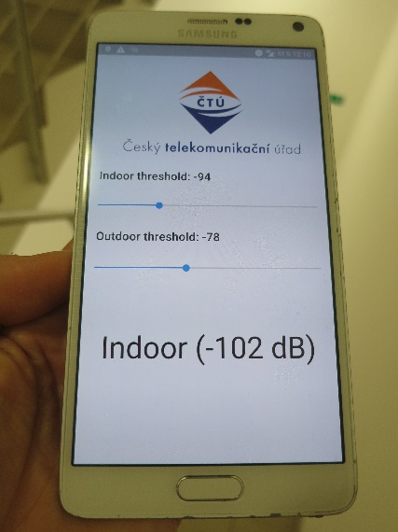 | 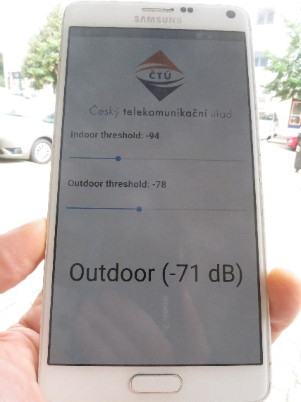
Figure 6: Indoor/outdoor detection
Where GNSS reception is not possible, a device is not able to determine its own geolocation. This is often an indoor location, where indoor use could be considered. Indoor use is defined in ECC/DEC/(04)08 as being inside a closed space which will typically provide the necessary attenuation to facilitate sharing with other services”. In order to meet the requirement of having the necessary attenuation, indoor detection, or to be more precise, the detection of an attenuating environment [60] is a valuable capability. There are several options for indoor detection, two of which are described in ANNEX 2.
"Indoor" detection actually aims at detecting an attenuating environment, where the emissions of a device are attenuated towards the outside world. This can be done via GNSS, as depicted in Figure 7 and further described in ANNEX 2.

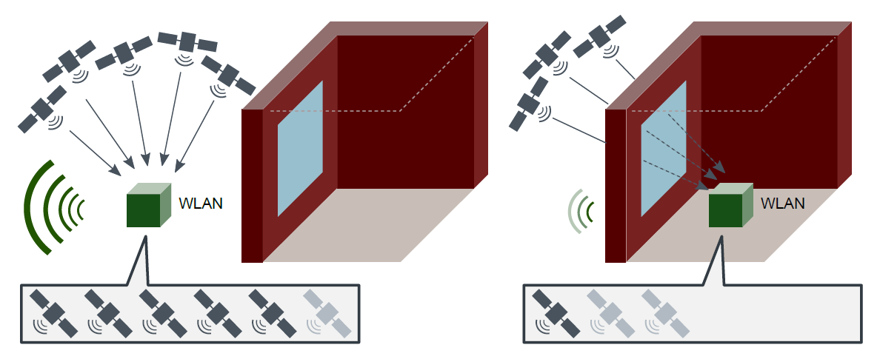
Figure 7: In an attenuating environment [60] the received GNSS signals and the emitted signals are attenuated
Geolocation capability allows an outdoor mode of operation when being outside exclusion zones (for the protection of TTT and military operations), while indoor detection allows an indoor operation of WAS/RLANs.
Geolocations capability and indoor detection can be combined (e.g. by using GNSS for both purposes). Therefore, the use of a geolocation database and indoor operation do not exclude each other.
Table 3 shows the combinations of geolocation, indoor detection capabilities and the operation modes.
Table 3: Device capabilities and RLAN operation at types of locations
Device Capability | Real RLAN device location
 | Inside Exclusion Zone |  |  | Outside Exclusion Zone
 | indoor | outdoor | indoor |  | outdoor
No geolocation capability, no indoor detection | avoid TTT | avoid TTT | avoid TTT  (Note 1) |  | avoid TTT  (Note 1)
GNSS geolocation only | avoid TTT (Note 3) | avoid TTT | With position fix: Indoor mode  Without position fix: avoid TTT (Note 2) |  | Outdoor mode
GNSS geolocation + indoor detection | avoid TTT (Note 3) | avoid TTT | Indoor mode |  | Outdoor mode
Indoor detection only | avoid TTT (Note 3) | avoid TTT | avoid TTT (Note 1) |  | avoid TTT  (Note 1)
Note 1: without localisation, the device cannot know if it is inside/outside an exclusion zone
Note 2: without position fix, the device cannot determine whether it is inside an exclusion zone
Note 3: because of separation distances between 252m and 690m according to ECC Report 244.

Enforcement CONSIDERATIONs
WAS/RLAN equipment operating in 5725-5850 MHz, once declared compliant for being sold and used within one EU country, could be sold across all EU/EFTA countries. This applies to equipment that is considered as consumer devices where users can install it easily without having the knowledge about possible national restrictions on the use of the band. This situation does not allow an effective enforcement by market surveillance authorities. The deployment and operation of 5.8 GHz RLAN equipment in countries that do not allow the use of this band can lead to interferences into the radiolocation service (including FFH radars) and TTT applications.

TTT
Interference into tolling systems is not always easy to detect by the tolling system operator or toll charger, particularly where free flowing tolling systems are used. Unlike weather radars, there is no immediate visual feedback of an interference to the operator. Possible interference is indicated via tolling transaction statistics. Then the reason for the deviation in transaction statistics has to be investigated. The source of sporadic interference is therefore hard to determine, since the source could already be offline when the statistics show a deviation from normal operation. An interference threat is already given by a single source of interference in vicinity of a tolling location. Single interferers are considered more relevant than an aggregated interference over a large area. This could result in lost revenue where no automatic back-up system to the TTT are in operation, or where TTT is already the enforcement technology.
Indoor operation in the vicinity of tolling installations could be an interference risk. There are indoor locations that are clearly under a roof, but do not provide an attenuation to the surrounding environment. This risk cannot be mitigated (without a detection approach) since indoor operation cannot be enforced.

RADAR
The existing DFS techniques at 5 GHz have not been designed to protect all of the operating modes of frequency hopping radars in the 5725-5850 MHz band. Current DFS requirements contained in both ETSI EN 301 893 and ETSI EN 302 502 as well as the parameters contained in ITU-R Recommendation M.1652 for DFS are not sufficient to protect all FH radar operating modes, Therefore, there is no mitigation technique available to allow the coexistence between FFH radars and WAS/RLAN in the band 5725-5850 MHz. Taking into account free circulation of WAS/RLAN equipment for 5.8 GHz band across EU countries, the unintended use of WAS/RLAN equipment, above 25 mW, in a country where the use of WAS/RLAN in 5.8 GHz band is not allowed may cause harmful interference to FFH radars.

Enforcement
Therefore, the implementation of Country Determination Capability in WAS/RLAN equipment through the standardisation process is a recommended mechanism protection, to prevent the use of the band 5725-5850 MHz exclusively in countries where it is not allowed.
Section 6.3.2 gives an example of a proposed voluntary industry supported process to prevent non-compliant equipment from interoperating with compliant WAS/RLAN.

MITIGATION OF NON-COMPLIANT EQUIPMENT USE
Non-compliant equipment has been found in market surveillance studies on 5 GHz RLAN. The use of non-compliant equipment can be mitigated, if compliant equipment does not establish a connection to non-compliant equipment. This could be achieved by a public key infrastructure. Public key infrastructures and trust lists are established mechanisms to establish a trust environment with respect to cybersecurity. These mechanisms can be used to establish a “trusted” environment with respect to compliance [64]. This involves the following steps:
- Manufacturers provide RLAN equipment with digital certificates during manufacturing. These certificates are signed by a certification authority (CA) using a higher-level certificate, which is e.g. issued for all devices of a certain type or model;
- All CA certificates across all vendors are collected in a trust list and provided to RLAN devices, e.g. as part of regular software updates;
- Upon connection establishment between two RLAN devices, one device is able to verify the certificate of the other device. Connections are rejected, if no valid certificate of the counterpart exists;
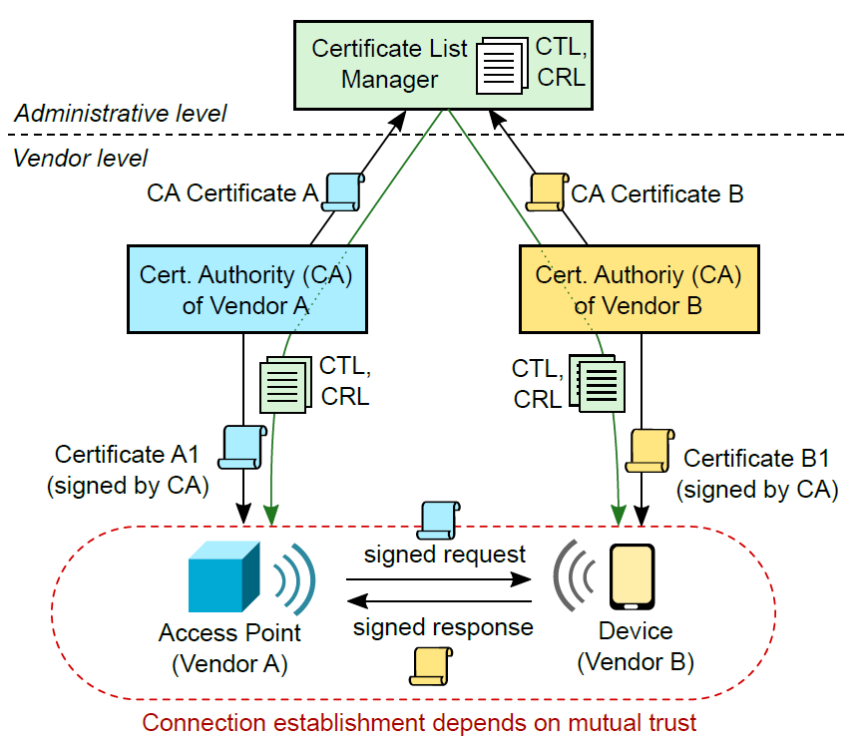
- If a certain model of RLAN equipment is found to be non-compliant, then its certificate is revoked. As a consequence, other equipment will not establish a connection any longer, and the non-compliant model is limited in operation.
Figure 8: Concept of PKI-based mitigation of non-compliance

Cross border issues
Cross border issues can be addressed via a bi-lateral agreement or via technical measures required in national regulations. One example of other measures that can be used is that by the Czech Republic where no use is permitted with 1.8 km of the border of the Czech Republic (with other countries), of any device above 25 mW.

Circulation of Equipment in the Single Market
RLAN equipment that is allowed to operate in a European Member State can be sold and circulate in the European Single Market and the wider European market. An unintended use in other Member States where RLAN operation in 5725-5850 MHz is not allowed, could be avoided by a country determination capability.
WAS/RLAN equipment that is allowed to operate in a European Member State can be sold and circulate in the European Single Market and the wider European market. An unintended use in other Member States where RLAN operation in 5725-5850 MHz is not allowed, could be avoided by the recommended implementation of minimum requirements on RLAN equipment through the standardisation process. Those minimum requirements for WAS/RLAN equipment operating in 5725-5850 MHz are covered by the Country Determination Capability in Section 6.1 of this ECC Report.

National implementations of WAS/RLAN in the band

Current status in some administrations at the publication of this report
Of the date of publication of this Report, two CEPT administrations (Czech Republic, United Kingdom) have opened this band, for WAS/RLAN, under a model that is considered outside the regulations in ERC Recommendation 70-03 and ECC Recommendation (06)04. This use is, therefore, predominately indoor WAS/RLAN, under a general authorisation (i.e. not light licensing) and with power levels above 25 mW but below 1 Watt.

National regulatory regimes

Czech Republic - WAS/RLAN usage in the 5.8 GHz band
This section depicts national conditions on the 5725-5850 MHz band usage by RLANs in the Czech Republic. The band was made available for Wi-Fi and other WAS/RLAN technologies from April 15 2021. The Czech Republic's proposed and implemented national regulation are shown at https://www.ctu.cz/sites/default/files/obsah/vo-r12-032021-3.pdf.
To manage the coexistence of WAS/RLAN with other devices and radiocommunication services, the national CZE concept is based on:
- exclusion zones for indoor and outdoor WAS/RLANs around Road Toll Installations and military areas; the zones are published (table and map). Note: For FWA stations above 200 mW, registration applies,
- exclusion zones can be monitored by supplemental automatic measuring probes, designed for remote watching of spectrum usage,
- DFS requirements are not explicitly specified in Czech Republic national regulations,
- No use within 1.8 km of the border of the Czech Republic, with other countries, of any device above 25 mW is permitted.
The concept facilitates the feasibility of the coexistence with road tolling, radiolocation service and the management of cross-border issues including the application of Nos. 4.2 and 4.4 of Radio Regulations. It was presented within the CEPT CPG preparatory work to WRC-19.

United Kingdom - WAS/RLAN usage in the 5.8 GHz band
The UK have made new licence exemption regulations to allow the use of RLAN technologies in the 5725 – 5850 MHz band up to 200 mW e.i.r.p. with no fixed outdoor use in accordance with the technical and usage conditions set out in UK IR2030 Table IR2030/8 for WAS.
The decision to allow RLAN use in the band under these conditions was made as a result of further studies carried out in the UK looking at the rollout of existing users of the band in the UK FSS, Radar, RTTT, BFWA and generic SRD and a comparison of the likely impact of the proposals being explored for licence exempt RLAN use.
When looking at the rationale for making these regulations several important factors were taken into account in the decision-making process for the UK:
- From UK and CEPT studies for WRC-19 it was apparent that limiting the majority of RLAN use to 200 mW and indoor only would provide more than adequate protection for FSS operations in the band;
- TTT is considered to be an SRD in UK exemption regulations so operates under the same regulatory status as other SRDs;
- Evidence showed that there is extremely limited use of TTT systems in the UK and these sites also use optical technologies as either the main or backup enforcement system;
- Evidence showed that there was existing use and potentially substantial use of narrowband SRDs operating at 25 mW in the band in the UK under licence exemption;
- Military radar use was normally in limited geographical areas and could access the whole range available for radar in the 5 GHz band;
- The protection criteria used to come up with the regulations was different from that used in the previous ECC Reports for TTT and Radar although similar to that inputted to the European WRC-19 process by the UK (i.e. protection was based on the impact of current SRD use and regulations into radar and TTT receivers);
- Interference from RLAN devices operating under these regulations would be the equivalent or less than that of SRD devices operating under ERC Recommendation 70-03 at the UK border.

National TTT protection

Czech Republic
The protection of RTTT is based on circle protection zones (1.8 km radius) around the the fixed installations of road toll gates. The list of protection zones is published in the national regulation. Indoor and outdoor RLANs (25 mW < e.i.r.p. < 200 mW) are subject to general authorisation.

United Kingdom
When looking at sharing with Road Tolling Telematics (RTTT) it was decided to compare the impact of RLANs operating at max PSD/MHz of 10mW/10dBm compared to SRDs which were able to use the full 25mW/14dBm across any bandwidth. UK studies [70] looked at conservative comparison and assumed if the RTTT receiver is 500kHz then the additional impact of possible individual SRD use can be 4dB greater on RTTT receivers than an individual RLAN device operating at the same distance if you assume free space path loss.

National WAS/RLAN spectrum sharing with defence radars

Czech Republic
To manage the coexistence between RLANs and defence radars, the following issues and estimations have been taken into account in CZE (national approach).
Since 2014, the band 5725-5875 MHz is harmonised for non-specific SRD with e.i.r.p. 25 mW. Moreover, ISM usage is allowed in the 5725-5875 MHz band (RR FN 5.150) and, in some countries, SRD of road toll gates operates up to 33 dBm. Therefore, radiocommunication services operating within these bands must accept harmful interference which may be caused by these applications. Taking into account the reality, comparison of SRD transmission and its contribution to the noise level at the radar receiver side with the equivalent noise effect of an RLAN transmitter located at a longer distance can be a reasonable approach
Further coexistence issues will be based on practical experience and measurements undertaken in the Czech Republic.

United Kingdom
In addition, UK regulations made in 2016, DFS was assumed to be implemented as specified in ETSI EN 301 893 [43] and ETSI EN 302 502 [45]. In 2020, the UK carried out further analysis of; the use of radar in the UK, the impact that DFS was having on equipment availability and cost for the UK market, as well the likely impact of WAS/RLAN device use without DFS under the current regulations compared to comparable SRD use. As a result of these studies UK removed the national requirement for DFS implementation in WAS/RLAN devices in the UK regulations [71] These further studies looking at a comparison of SRD device use vs RLAN device use into proxy Fast Frequency Hopping radar receivers, radar 22 (4 MHz bandwidth) and Radar 23 (5 MHz bandwidth) were also submitted to the CEPT WRC-19 Conference Preparatory Process and are reflected in the final CEPT Brief for WRC-19 on agenda item 1.16.

Conclusions
This document contains an analysis of the regulatory and implementation issues to enable WAS/RLAN use on a national basis in the band 5725-5850 MHz to enable the protection of, RTTT/Smart Tachograph and radars (including Fast Frequency Hopping). This Report also looks at issues around enforcement and the free circulation of WAS/RLAN equipment in countries that do not allow the use of the 5725-5850 MHz band by WAS/RLAN.
The Report describes the possibilities for national implementation of conditions for WAS/RLAN usage within the 5725-5850 MHz band (above the generic SRD limit of 25 mW), with the assumption that WAS/RLAN use would be predominately based on the exemption from individual licensing. It summarises examples, practical experiences and other innovative solutions to enable spectrum sharing conditions for WAS/RLANs on a national level.
If there were steps taken to introduce a harmonisation measure for WAS/RLAN use in this band by EU, CEPT and/or ETSI then taking into account the possible free circulation of WAS/RLAN devices at an EU level, and equipment put on to a wider European market, it is recommended that a requirement for the implementation of an automated Country Determination Capability (CDC) at device level in WAS/RLAN Access Points capable of transmitting over 25 mW should be applied to ensure that the 5.8 GHz band cannot be used in a country exclusively where WAS/RLAN operation in 5725-5850 MHz is not allowed. It is also recommended that no fixed outdoor use or fixed use in vehicles by devices operating above 25 mW should not be allowed under any harmonisation measure.
Consideration is also given to enhanced techniques, including geolocation database solution that could be implemented on a national basis. Some of the detail on these techniques might need CEPT administrations and/or incumbents to provide their requirements to be published. Additional work would need to be conducted to establish a process to collect and publish the appropriate information. Additionally, it may be used as a knowledge base for further standardisation efforts for WAS/RLAN.
Some studies, at both CEPT and national level, on compatibility between WAS/RLAN and incumbent services and applications (i.e. TTT applications) show the need for separation distances of hundreds of metres when WAS/RLAN uses higher output levels than 25 mW e.i.r.p of the SRD regulation. Additionally, the existing DFS techniques at 5 GHz have not been designed to protect all of the operating modes of frequency hopping radars in the 5725-5850 MHz band. Hence countries implementing WAS/RLAN in these bands will have to take steps to address cross border issues. Individual CEPT countries have made regulations to allow WAS/RLAN use under their specific national conditions, which are outlined in this report. In some CEPT countries, low power indoor and outdoor operation of WAS/RLANs up to 200 mW e.i.r.p. is allowed under national licence-exempt radio use, with one country publishing a table of mandatory exclusion zones to protect military radar and TTT installations. Some countries also allow high-power operation up to 1 W e.i.r.p., based on specific national conditions, including the light-licensing approach and use of geolocation databases, however this use is predominately BFWA type operation as detailed in ECC Recommendation (06)04 [31].
- Geolocation databases, light-licensing coordination and data protection issues considered in the Czech Republic
Following information presents the national decision of CZE on WAS/RLAN introduction within the 5725-5850 MHz and 57-66 GHz bands, based on light-licencing. In addition, the band 5150-5250 MHz has been released for national WAS/RLAN outdoor operation, respecting the ITU-R Resolution 229 (WRC-19). In the 5.2 and 5.8 GHz bands, RLAN users are obliged to register GPS and MAC addresses. To maintain the entries up to date, all data is re-confirmed by users annually. Several software tools decrease the users' digital burden, e.g. batch data import functions, API interfaces and users' data management. In the 5.8 GHz band, the WAS/RLAN operation is allowed up to 1 W e.i.r.p. Details are published in the national regulatory framework [63].
  - WAS/RLAN 5.8 GHZ band IN CZE
The concept of light licensing in the 5.8 GHz band is based on the platform of the registration website for the 60 GHz band (see A2.3)see Fig. 8:
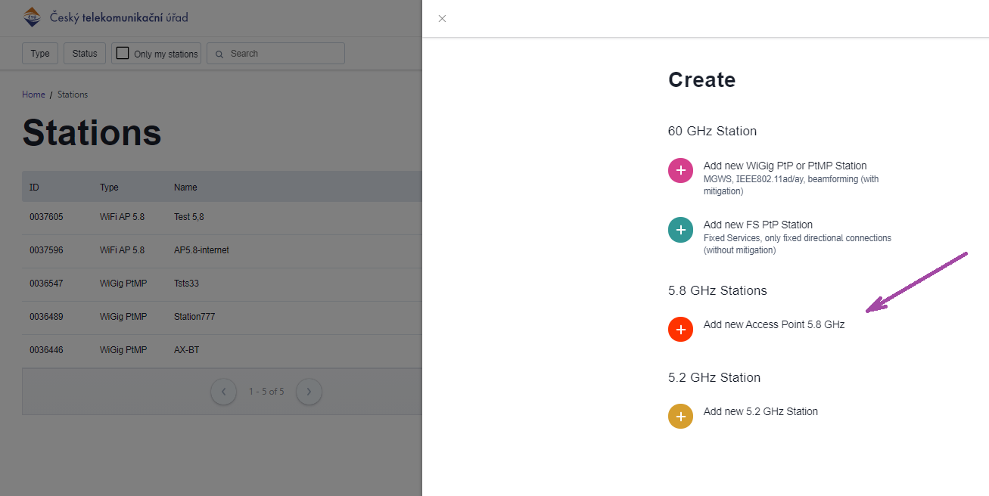
Figure 9: User window of the 5.8 GHz registration website. It comprises 3 bands:
60 GHz, 5.8 GHz, and 5.2 GHz
    - CZECH REPUBLIC CONSIDERATION OFRLAN coexistence with road tolling (fixed installations)
The coexistence scenario is based on previous work within CEPT. Following section presents statistical simulation of WAS/RLAN-Tx/RSU-Rx coexistence in rural area.
The layout of DSRC RSU and OBU explains link budget:
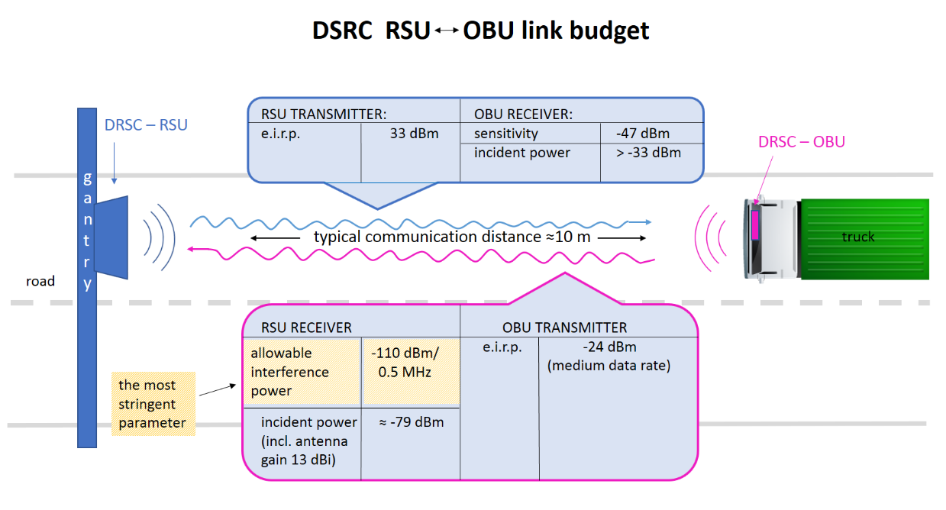
Figure 10: Energy budget of the DSRC communication. The most interference-sensitive part is the RSU reception signal level
The most vulnerable element of the budget is the DSRC-RSU (gantry) receiver signal value. According to standards (ETSI TR 102 960), the maximum allowable interference power is -110 dBm/0.5 MHz. This value is used in some studies to determine appropriate geographical distance.
Table 4: Parameters for modelling
Issue | Parameter
Victim link receiver (DSRC-RSU) | Antenna height 7 m  Antenna pattern (H, V): Grsu_max = 13 dBi, Grsu_min = -3.5 dBi  Elevation: -45 deg.  Sensitivity threshold: -104 dBm  C/I: 6 dB  interference threshold -110 dBm/0.5 MHz (allowable interfering power level 'I' at the RSU receiver antenna input)  Channel BW: 500 kHz
Interfering link (RLAN-Tx) | Geographical separation >1.8 km, random positions, fixed installations  Coverage (WAS/RLAN) radius 1 km  Common RLAN (AP) directional antenna, max. gain GRLAN = 12 dBi, front-to-back ratio 20 dB, symmetrical horizontal and vertical patterns  Mean e.i.r.p. 30 dBm, BW: 20 MHz, i.e. 50 mW/MHz (2005/513/EU), therefore 14 dBm/0.5 MHz  Antenna height 15 m, random deviation 3 m
RLAN-Rx | No spatial restriction – random positions allowed (to simulate all possible RLAN-Tx directions). This means that the directional transmit antennas point into random directions and not always towards the victim receiver.  Antenna height 7 m
Further details | Seamcat 4.1.0., ITU-R P.452

The simulation showed that, applying the protection distance of 1.8 km (all RLANs are concentrated beyond the border), the interference threshold exceeded in a few events (probability 3 %) % of all RLAN locations) with the excess of ≈ 3 dB, which is partly caused by RLANs clustered in direction of the main antenna RSU lobe. The median value of unwanted emissions at RSU receiver is -127 dBm (so, below the interference threshold).
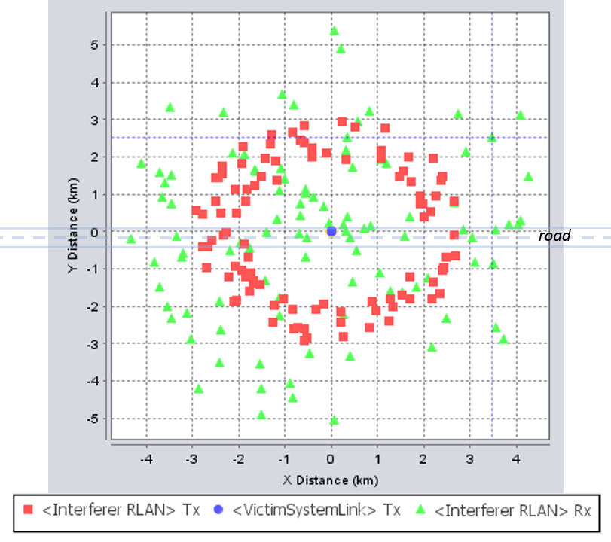
Figure 11: Scenario outline: RTTT/RSU is pointed towards East; separation distance is 1.8 km; RLAN-Rx positions are without location restrictions
In CZE, the list of RTTT protection zones is published in the national regulation [63]. As outdoor high-power RLANs fall under registration obligation, the website avoids users to enter the protection circles:
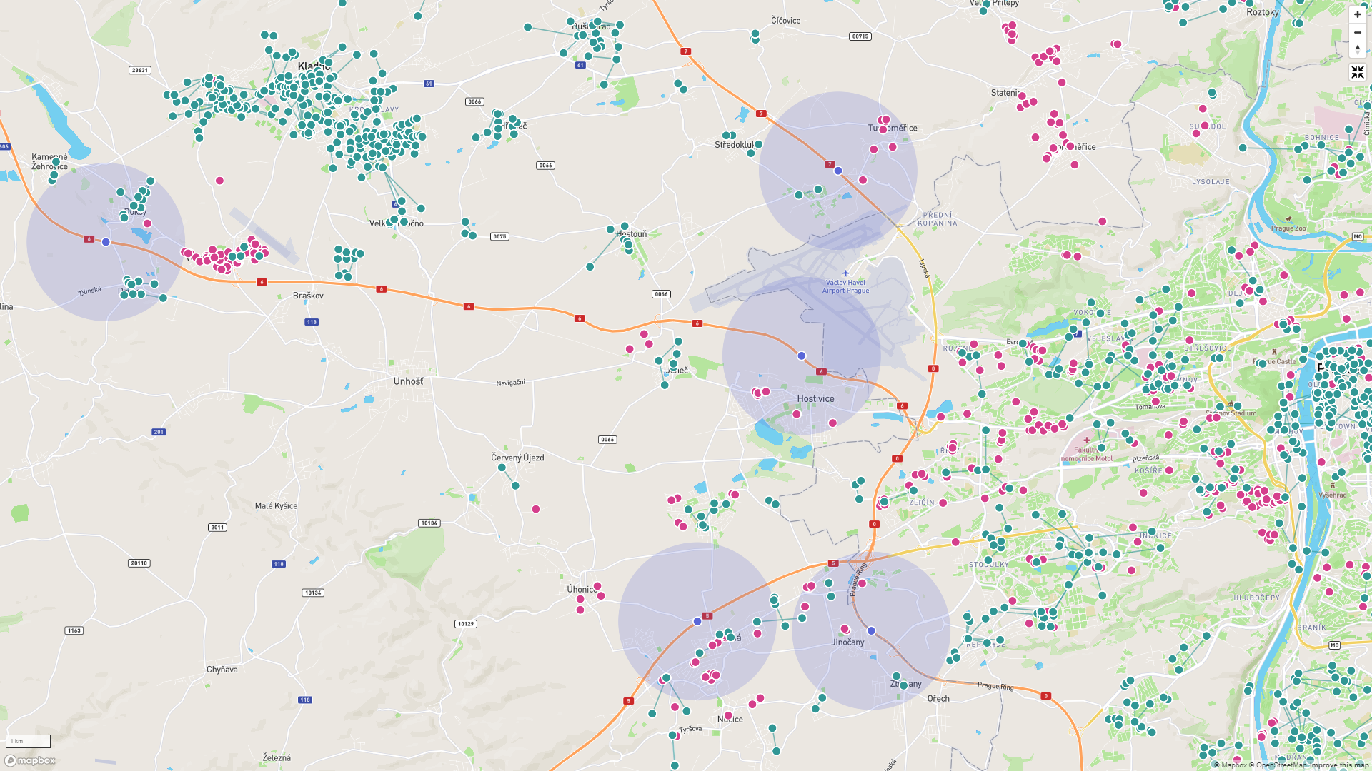
Figure 12: Toll-gate protection zones of 1.8 km (light lilac circles) in CZE are maintained via registration web-site. (Note: Example in the district of Prague West. Green and magenta dots are 60 GHz band stations.)
    - CZECH REPUBLIC CONSIDERATION OF RLAN spectrum sharing with defence radars
To manage the coexistence between RLANs and defence radars, the following issues and estimations have been taken into account in CZE (national approach).
Since 2014, the band 5725-5875 MHz is harmonised for non-specific SRD with e.i.r.p. 25 mW. Moreover, ISM usage is allowed in the 5725-5875 MHz band (RR FN 5.150) and, in some countries, SRD of road toll gates operates up to 33 dBm. Therefore, radiocommunication services operating within these bands must accept harmful interference which may be caused by these applications. Taking into account the reality, comparison of SRD transmission and its contribution to the noise level at the radar receiver side with the equivalent noise effect of an RLAN transmitter located at a longer distance can be a reasonable approach.
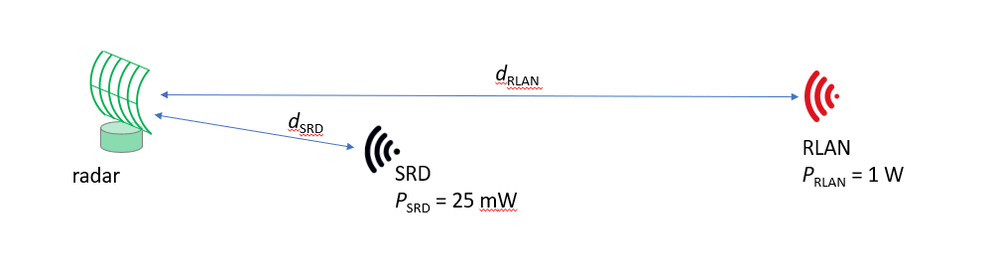
Figure 13: Equivalent effect of RLAN station compared with SRD
Using the Friis transmission formula, we can estimate the interference noise PRx_SRD and PRx_RLAN on the radar receiver side from both the SRD respectively RLAN. Considering the equivalent noise power effect (PRx_SRD = PRx_RLAN) and the same bandwidth of SRD and RLAN, we conclude that
$$d_{RLAN}= d_{SRD}\sqrt{\frac{P_{RLAN}}{P_{SRD}}} \left[km;km, W, W\right] (1)$$
Although SRD can be found in any vicinity around the radar, we take dSRDd_srd = 2 km as the reference distance of a single SRD from the radar. Then, the equivalent distance of a single RLAN is dRLANd_rlan ≈ 13 km.
To consider the aggregate effect of RLANs, national situation (e.g. terrain) is taken into account. As typical minimum distance of a city from the military district is 10 to 20 km, the aggregate effect N*PRLANPrlan can be maintained in addition to formula (1). Instead, to simplify assumptions, FSPL model (derived e.g. from ECC Report 250) with exponent coefficients (reflecting rural propagation) can be applied (see Fig. 12).
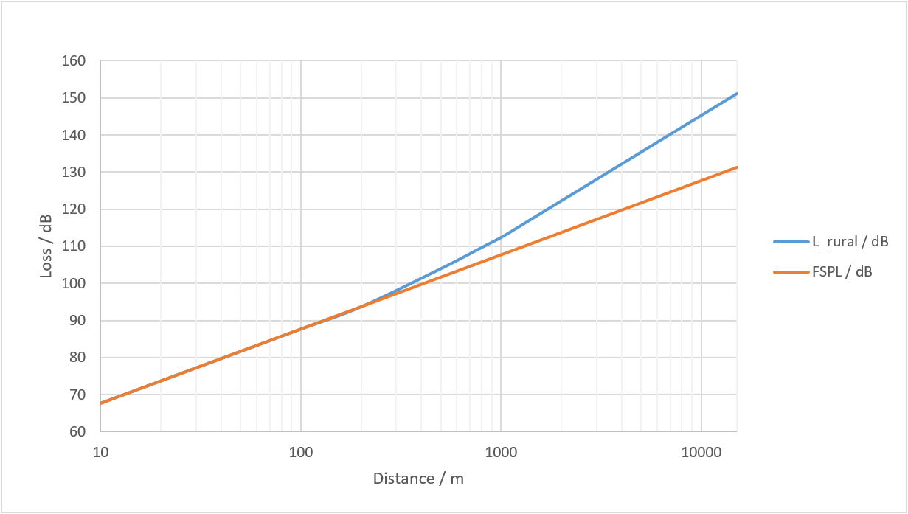 Figure 14: Three-slope path loss model in the 5.8 GHz band compared with the FSPL model. Breakpoint distance d0 = 256 m, pathloss factor beyond the first break point n0 = 2.8, breakpoint distance d1 = 1024 m, pathloss factor beyond the second breakpoint n1 = 3.3
E.g., at a distance of 13 km, compared to FSPL, an additional loss of 19 dB applies. It corresponds to the additional noise effect of N = 80 RLAN stations.
Furthermore, based on e.g. ECC Report 206, the following formula can be used to find the radio horizon limit He in case of large separation distances. The formula considers the curvature of the Earth. It uses the hight of fixed installation of RLAN (H_{RLAN}) and radar (H_{rad}):
$$H_{e}=4.12(\sqrt{H_{RLAN}}+\sqrt{H_{rad})} [km;m, m] (2)$$
For H_{RLAN}H_{RLAN} = 9 m and H_{rad} = 20 m, the radio horizon is ≈ 31 km. However, specific layout of RLAN and radar location applies, including terrain profile.
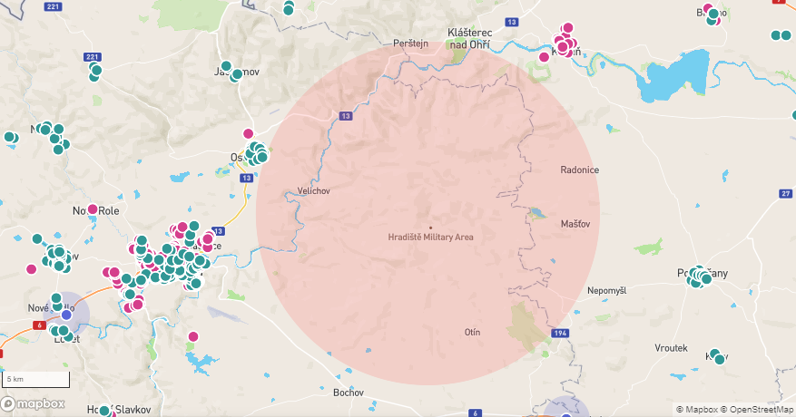
Figure 15: Example of a protection zone of 13 km (radius) around a military area
In case of temporary operation of the Czech Armed forces, or NATO joint operations, in places beyond ex-ante defined zones, further temporary protection zones places can be established, based on the public consultation process.
In CZE, circle protection zones of a radius 13 km with restriction of RLANs operation (> 200 mW) around the centre of the territory with possible defence radars operation will beare established. To handle the radar and RLAN coexistence, outdoor AP RLANs (e.i.r.p. > 200 mW) fall under light licensing regime (i.e. registration via new web portal). [61]). It allows the administration i.a. to manage possible ad-hoc needs from the military side to protect further temporary radar operations, or to solve cross-border issues including maintenance of the aggregate effects towards satellite service. An additional regulatory tool is the readiness of high-power outdoor RLANs (access points) to temporarily fall back to e.i.r.p. 25 mW in specified location and time period, upon prior request by the administration (e.g., in case of troop exercises).) based on public announcement and consultation.
The national decision resigns from the radar receiver protection criteria (I/N =-6 dB). Instead, it facilitates radio spectrum sharing principles and efficient use of spectrum during peace time. To gain feedback and experience from real conditions, measurements of the effect of RLAN operation on defence radars will be done.
Further coexistence issues will be based on practical experience and measurements.
  - 60 GHZ WAS/RLAN BAND IN CZE: REGISTRATION WEBSITE FOR WiGig AND MICROWAVE Point-to- point LINKS
Based on preparations of ECC Report 288 [3] ("Conditions for the coexistence between Fixed Service and other envisaged outdoor uses/applications in the 57-66 GHz range"), CZE launched national survey on possible usage conditions in September 2018. The results showed significant interest to operate both WAS/RLAN (WiGig, MGWS; ETSI EN 302 567 [55]) systems and microwave Fixed Service point-to-point links (ETSI EN 302 217 [56]; ECC Recommendation (09)01 [57]). As the two technologies are not compatible, considerations on possible coexistence within national conditions were initiated. Internal analyses came to the conclusion that spectrum sharing is feasible, based on:
(i) both WAS/RLAN/MGWS and microwave stations´ registration (light licensing), and
(ii) introduction of an algorithm called Coordination Calculator that facilitates coordination among WiGig stations and Fixed Service stations.
The software calculation tool is implemented in [61] and is based on free space path loss model and Recommendation ITU-R F.699 [58]. The calculator assesses whether there is a risk of harmful interference or not. The calculation covers these cases: Fixed Service Point-to-Point (PP) vs WiGig and vice-versa.
The registration website contains maps and several simple tools to establish self-regulation. Proposed identification of spectrum users is based on e-mail only; further personal data are voluntary. No personal identification is published.
During initial 15 month of the 60 GHz band light-licencing operation in CZE, and the number of 50.000 stations registered, no interference issues occurred. Light-licencing approach lead to the creation of new business opportunities and, finally, to the benefit of end-users' QoS experience.
  - Data protection application in the Czech Republic
Registration websites and the light-licensing approach presupposes processing of personal data (at least e-mail, and/or name or address, if required). In the absence of explicit enabling legislation to process personal data (i.e. a legal obligation to process personal data, as is the case of CZE for 5.2 GHz, 5.8 GHz and 60 GHz band registration website), and in order to justify processing of personal data for the performance of a task carried out in the public interest, an impact assessment of processing on the personal data protection is required per the General Data Protection Regulation. It justifies the needs for setting up registration websites and the effectiveness and suitability of the data processing solution. It is also important to justify why certain personal data should be published on the website, i.e. to be available to third parties. The assessment considers processing of personal data, technical data as well as metadata. Importantly, MAC addresses are considered personal data and are processed by the Czech regulator for the purposes of ensuring enforcement and control measures. The impact assessments for 60 GHz band and for the 5.8 and 5.2 GHz bands have been published here [61]. The structure of the assessments is as follows:
- General description of the solution, including public interest description;
- Justification for the data processing;
- Test of effectiveness and suitability;
- Test of necessity;
- Impact assessment on individuals.
  - Legal issues on multicounty SW usage and/or SW licensing
This Annex describes possible legal solutions for international (CEPT) operation or SW licensing (incl. multicountry SW operation) of registration websites and corresponding SW systems facilitating the efficient use of radio spectrum. As the SW was created with public funds as a proprietary solution on the part of the Czech Republic, a question of due care and diligence concerning state property arose. An obligation to generate profit on the part of the state administration was considered, but was eventually not identified in the applicable public law in the Czech Republic. Furthermore, it was difficult to value the SW given the specificities of the market within which it could be potentially commercialised. An open-source and free license was therefore seen as a viable alternative to proprietary licenses to foreign CEPT administrations. A synergy effect between national regulators was considered to represent a model that could significantly contribute to future improvements of the SW. A standard Mozilla Public License, v. 2.0, a weak copyleft license, was chosen as the most appropriate model, given its permissiveness, the possibility to combine it with other licenses and to modify the SW. This open-source and free license could be accompanied by know-how exchanges provided the Czech regulator. This is in line with the spirit of good cooperation between national administrations in the EU, also given its prominence in the EU spectrum regulation arena. Moreover, publishing the SW as open-source and free software may be considered as a state-of-the-art technology transfer between EU Member States.
- INDOOR/OUTDOOR DETERMINATION
  - PRELIMINARY REQUIEMENTS FOR INDOOR AND OUTDOOR DETERMINATION
- The aim: based on the indoor/outdoor detection result, user equipment (UE)will not operate outside (or reduce e.i.r.p.) in order to protect incumbents within radiocommunication services (microwave links, radiolocation etc.). Therefore, the detection result will be used by media access control.
- UE modifications for existing RLANs: (i) simple SW modification on vendors side; (ii) UE operation system independent and (iii) based on SW only (i.e. no hardware modifications by the user).
- Description of basic functional elements (i.e. without machine learning) should be easy to describe within global and/or European standards (IEEE, ETSI) and fit to Radio Equipment Directive [59] requirements. Feasibility of vendors product specification for Europe countries.
- The algorithm should use standard UE features (comms) if possible.
- The algorithm should not increase significantly battery consumption. If additional interfaces are used (e.g. GNSS or GSM), their power consumption should be taken into account, e.g. by defining a detection method in such a way that these interfaces do not need to be permanently active.
- To increase future accuracy of results, the algorithm could cooperate via Internet with remote systems (geolocation databases, or remote machine learning systems including AI, etc.).
- The algorithm shall be operational in different places (urban, rural areas).
  - Indoor detection via GSM signals
First approach: was based on identification of presence of a specific outdoor RLAN signal in the 5 GHz band (Access Points, AP). Once the smartphone detected presence of the 5 GHz signal, any UE WiFi transmission was deactivated. The sensitivity was quite precise due to the nature of 5 GHz radio waves; however, the results were sometimes conservative. Moreover, in rural areas, the algorithm did not operate due to absence of outdoor RLAN 5 GHz AP transmitters. Therefore, condition No. 7 in A2.1 was not met, and the team moved to the second approach.
Second approach: was based on identification of BTS GSM signals (RSSI, Received Signal Strength Indicator). At least three elements are necessary for reliable results:
  - Measurement of GSM signal strength (RSSI).
  - Detection of number of visible GSM BTS. (Outdoors, the number of visible BTS is typically around 6; however indoors, only 1 or 2).
  - Machine learning (including possible cooperation with geolocation database or remote computer centre) in order to adapt UE threshold levels to conditions on specific location.
So far, element a) has been complete, and some observations on element b) have been made. Experience shows that locations should be recognised with better granularity, e.g. “outdoor, semi-outdoor, indoor and deep indoor”. The algorithm is simplified into three ranges: indoor, not sure, outdoor. Decision levels are set manually. Figure 6 clarifies the results.

Indoor indication: | Outdoor indication:
Figure 16: Indoor – outdoor recognition (trial algorithm)
Some disadvantages of the GSM detection are as follows:
- For newer Android OS versions, only one GSM BTS is recognised. Further research is needed;
- The RSSI threshold levels vary for different UE types and for different places;
- In case of indoor GSM microcell (e.g. hotels, conference rooms), results are mismatched;
- Probably not all UE for 5.8 GHz band and 6.4 GHz band will be equipped with GSM.
  - Indoor Detection via GNSS
Global Navigation Satellite Systems (GNSS) are available in most parts of the world. The emitted signals can be received practically everywhere under an open sky. This makes GNSS especially interesting for indoor detection or, more specifically, the detection of an attenuating environment.
It has been investigated in [60] that GNSS raw data such as carrier-to-noise density read from GNSS receiver can help to detect attenuating environments in a short time. As an example, the following measurements show the carrier-over-noise-density for each detected satellite over time, while the device is moved from an outdoor to an indoor location. The initial phase is relatively short (around 100 ms) and also the transition between outdoor (Location 1) and indoor (Location 2) is clearly visible by a drop of maximum within short time.
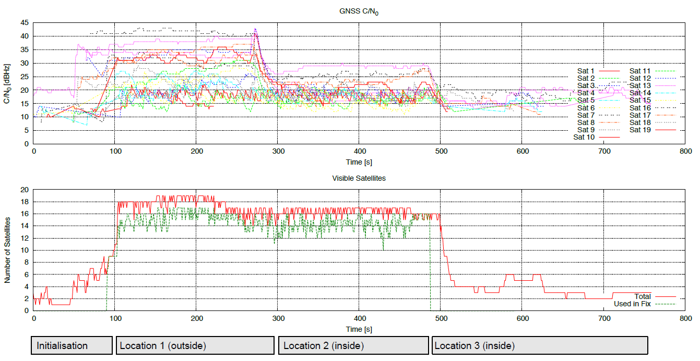
Figure 17: GNSS carrier-over-noise-density when moving a device from outdoor to indoor [60]
Measurements were performed at various locations inside and outside attenuating environments. A distinction between attenuating and non-attenuating environments could be achieve by a applying a simple threshold on the carrier-to-noise-density. By this method, a location in a glass waiting booth (non-coated glass), which is actually indoor, could be characterised as non-attenuating environment. This could prevent an access point operating in indoor mode while a proper attenuating environment is not given.
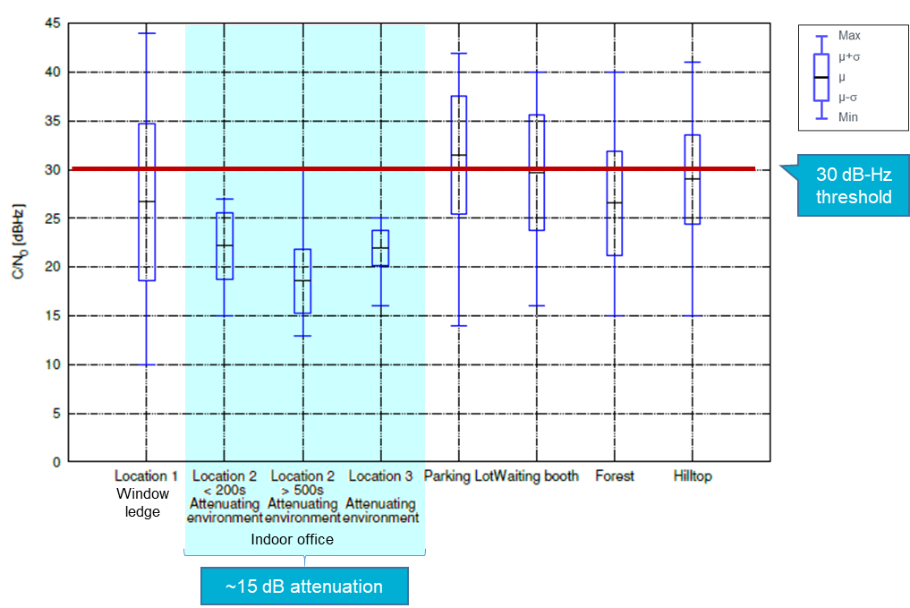
Figure 18: Distribution of carrier-over-noise-density from different locations [60]
- Example of Country Determination Capability (CDC) implementation
  - Algorithm of Decision
The below picture shows the decision algorithm of the country determination capability. The national location data should be obtained during the initial power up of the equipment, reinstallation and at each power up of the device. Examples of possible methods to obtain the device location data are evoked in Annex 2.
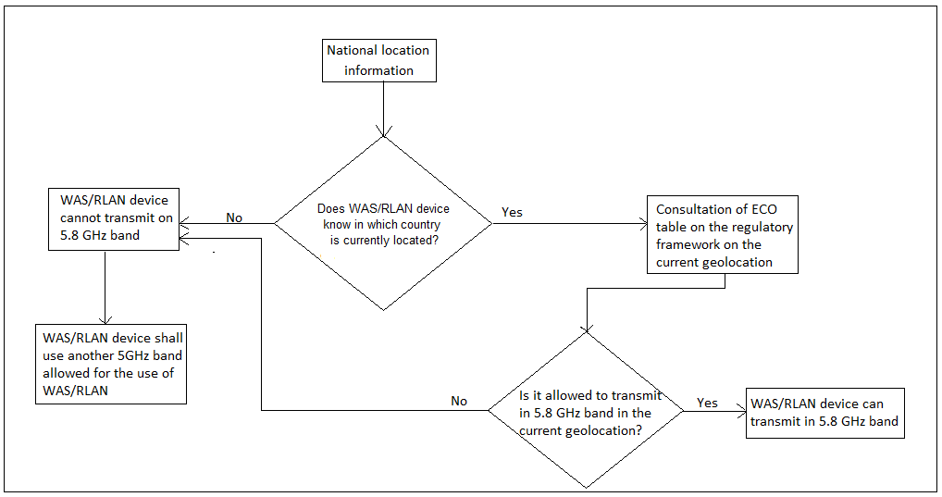
Figure 19: Decision algorithm of the country determination capability
The WAS/RLAN device shall only transmit in the 5.8 GHz band once it successfully knows in which member states is located, get the information on the regulatory framework and run the algorithm determining if it is allowed or not to use the 5.8 GHz band.
The Table with the relevant regulatory information for each CEPT country can be created, managed and maintained by the ECO (see also the paragraph below). This would provide an easy and effective way to compile and centralise the information on the regulatory framework at national level.
The WAS/RLAN device shall stop transmitting on a channel within 5.8 GHz band immediately if:

- it fails to determine its national location
New run of the algorithm of decision is required prior to any new transmission of the WAS/RLAN device on the 5.8 GHz band.
    - Minimum requirements to implement CDC
This section introduces the minimum requirements to implement the country determination capability. It includes the definition and the needs to apply into standardization.
      - ECO table on the regulatory framework on the RLAN 5.8 GHz band
ECO table should provide the information about the regulatory framework applied in each CEPT country for the use of 5.8 GHz band for WAS/RLAN. The status of the band should be declared by each CEPT country to ECC. The declaration should inform ECC about the permitted use of the band for WAS/RLAN in the territory of the country.
      - Characteristics of ECO table
ECO table should be created with the following characteristics:
- Pre-defined and standardised format providing the information about the country and the status of 5.8 GHz band use for WAS/RLAN in CEPT countries
- Easy way to update the table when the regulatory framework of the band changes in some country (e.g. the ECO table update could be made during software updates into the WAS/RLAN device or even a frequency of ECO table update could be defined).
- It should be open to access to all users (e.g. industry)
      - Regulatory status stored within the device or its associated controller.
An alternative to relying upon communication between the transmitting device and the ECO server containing the aforementioned ”ECO table” would be to store the required information either on the transmitting device (e.g. access point) itself, or its associated controller.
Modication access to this table and associated functionally shall not be available to the end user, other than to initate a system software update from a trusted source.
      - Minimum requirements for WAS/RLAN devices
- National location
- Master-slave configuration
- User access restrictions
      - National location
It allows the WAS/RLAN device to know in which member states is located.
National Location should be taken into account by the algorithm of decision to provide information on available spectrum on the 5.8 GHz band.
If the WAS/RLAN device fails in determining its current national location the WAS/RLAN device could not use the 5.8 GHz band and shall choose to use another 5 GHz band.
      - Master-slave configuration
In the master-slave configuration, it is envisaged that the master would be responsible for the decision on the use of the band and that associated slaves would be controlled by the master and would receive information directly from the master without making a decision on the use of the band themselves. DFS implementation in ETSI EN 301 893 is an interesting and useful reference on master-slave configuration in WAS/RLAN devices.
A master shall be able to fulfil the above requirements, and in addition also be capable of:
Communicating with associated slaves;
Control the operation of the slave in terms of the use of the 5.8 GHz band.
A slave shall be capable of:
Communicating with an associated master (e.g. Receipt, Acknowledge,…);
Only transmit on the band 5.8 GHz when it has been authorised to by the master device.
      - User Access Restrictions
The country determination capability (CDC) functionality shall not be accessible to the final user. The restriction shall include the capabilities associated to the operation of this functionality. The aim of this restriction is to avoid the deactivation of the CDC functionality by the final user.
- Explanation of the UK regulations that RLAN technology use in the 5725–5850 MHz band
In the UK there are 3 different regulations where equipment based on RLAN technologies could currently use the 5725 – 5850 MHz band.
  - Use under Non-Specific Short-Range Devices (SRD) regulations up to 25 mW
The earliest use of RLAN technology in the band 5725 – 5850 MHz band in the UK enabled equipment to transmit up to 25 mW e.i.r.p under licence exemption in accordance with ERC Recommendation 70-03 and the latest version of UK Interface Requirement (IR) 2030 - Table IR2030/1 for Non-Specific Short-Range Devices. It should be noted that there are no PSD limits in these regulations so devices using narrower bandwidths than RLANs (e.g. 1MHz or less) devices could use the full 25 mW e.i.r.p in these narrower bandwidths.
  - Use of RLAN technology under the BFWA regulations
From 2004, the UK have also allowed outdoor Broadband Fixed Wireless Access in the 5725–5850 MHz band up to 4W e.i.r.p. technical conditions in accordance with UK IR2007 and under a light licencing regime that requires online registration of terminals, this use in also in line with ECC Recommendation (06)04 [31]. Initially the UK excluded the use of 5795-5815 MHz to protect Road Tolling Telematics (RTTT) use in the band. In 2017 after carrying out new analysis of taking account of the rollout of both services (BFWA and RTTT) across the UK, further technical analysis looking at parameters of installed systems and the likely hood of interference occurring to the users of RTTT in the UK it was decided that it was disproportionate to continue to have this exclusion of BWFA use in this part of the band. See https://www.ofcom.org.uk/__data/assets/pdf_file/0019/108235/5.8GHz-statement.pdf for further information.
    - Use of RLAN technology under Wireless Access Systems (WAS) regulations
In 2016, the UK also made new regulations to allow the use of RLAN technologies in the 5725–5850 MHz band up to 200 mW e.i.r.p. in accordance with the technical and usage conditions set out in UK IR2030 Table IR2030/8 for WAS. The decision made was as a result of further studies carried out in the UK looking at the rollout of existing users of the band in the UK FSS, Radar, RTTT, BFWA and generic SRD and a comparison of the likely impact of the proposals being explored for licence exempt RLAN use. When looking at sharing with Road Tolling Telematics (RTTT) it was decided to compare the impact of RLANs operating at max PSD/MHz of 10mW/10dBm compared to SRDs which were able to use the full 25 mW/14dBm across any bandwidth. In our studies we looked at conservative comparison and assumed if the RTTT receiver is 500kHz then the additional impact of possible individual SRD use can be up to 4dB greater on RTTT receivers than an individual RLAN device operating at the same distance if you assume free space path loss. For more information see https://www.ofcom.org.uk/consultations-and-statements/category-1/5-GHz-Wi-Fi. In addition, in the UK regulations made in 2016, Dynamic Frequency Selection was assumed to be implemented in the RLAN equipment. Last year the UK carried out further analysis of the use of radar in the UK, the impact that DFS was having on equipment availability and cost for the UK market, as well the likely impact of RLAN device use without DFS under the current regulations compared to comparable SRD use. As a result of these studies we have also recently consulted on a proposal to remove the assumption that DFS would be implemented by RLAN use in the UK regulations. For further information see https://www.ofcom.org.uk/__data/assets/pdf_file/0036/198927/6ghz-statement.pdf. These further studies looking at a comparison of SRD device use vs RLAN device use into proxy Fast Frequency Hopping radar receivers, radar 22 (4 MHz bandwidth) and Radar 23 (5 MHz bandwidth) were also submitted to the CEPT WRC-19 Conference Preparatory Process and are reflected in the final CEPT brief for WRC-19 on agenda item 1.15.
- Detection and Mitigation Methods of ETSI TR 103 319
Detection methods in general can be divided into the following categories, according to ETSI TR 103 319 [12]:
- Detectors monitor a frequency band and report whether it is used or not. Usually, the interfering technology monitors the frequency band of the victim technology (for energy above a certain threshold or presence of a carrier signal), but it is also possible to monitor other frequencies where the frequency use is correlated with the victim technology;
- Beacons are transmitted specifically for the purpose of protecting the victim technology. This requires the interfering technology to be able to receive and react on beacons;
- Geo-location methods aim at detecting a spatial closeness between victim and interferer by the exchange of geographic information. This is usually realised by localisation and look-up of stored locations from a database of fixed victim positions.
Based on the general methods above, the following Table 5 contains approaches described in ETSI TR 103 319.
Table 5: Detection of TTT by RLAN
Technique | Advantage | Disadvantage | Reference
Road toll detector:  A road toll detector tries to directly detect the road tolling signal via energy detection or carrier sensing on the road tolling frequencies. | - | For a RLAN system operating with 23 dBm/20 MHz, a detection threshold of the order of -100 dBm/500kHz and for a RLAN system with 23 dBm/160 MHz a detection threshold of the order of -90 dBm/500kHz would be required for a reliable detection of road tolling. (see ECC Report 244 [4]).  False detections occur when a level of -80 dBm is approached, based upon a 20 MHz bandwidth (see ETSI TR 103 319 [12]).  Thus energy detection alone is not possible. | ECC Report 244,  ETSI TR 103 319, 6/7.3.1
Detection of road toll stations via ITS-G5:  This detection method is based on the assumption that in the vicinity of tolling stations there are always ITS-G5 equipped vehicles, which actively use the ITS-G5 channels. If an RLAN system detects the use of ITS-G5 channels, it should activate mitigation techniques. This way, road tolling is indirectly detected via the presence of ITS-G5 equipment. | - | Depends on the correlation between road tolling locations and the presence of ITS-G5 equipped vehicles.  This correlation is only rarely given. | ETSI TR 103 319, 6/7.3.2
RLAN beacons:  One beaconing possibility to signal the presence of road tolling is to generate IEEE 802.11 beacons on channel 161 (5 795 MHz to 5 815 MHz), which covers the same band as road tolling. RLAN devices should activate mitigation techniques upon reception of a beacon frame. | - | RLAN beacons in the road tolling frequency band cause in-band interference.  Beacon messages are not standardised, not implemented in existing RLAN equipment. | ETSI TR 103 319, 6/7.3.3
ITS-G5 beacons (coexistence CAMs)  ITS-G5 beacons are special messages ("Coexistence CAMs") containing protected zone information and part of the coexistence techniques between ITS-G5 and road tolling. These messages are Cooperative Awareness Messages (CAM) containing protected zone information. | - | ITS-G5 beacons are not suitable for broadcasting at toll plazas.  This method is technology dependent and requires an IEEE 802.11™ based receiver listening to a 10 MHz ITS-G5 channel and a CAM decoder on the interferer's side. | ETSI TR 103 319, 6/7.3.4
Geolocation database  A geolocation database defines exclusion zones where the victim technology (road toll stations) should be protected. Every RLAN device uses this database and checks whether it is located within an exclusion zone or not. As long as an RLAN device is within an exclusion zone, mitigation techniques should be active. | Effective method to protect long term road toll installations. Such database is already implemented. | The geo-location database cannot cover mobile enforcement vehicles, unless the whole road network (subject to tolling) is included in protected zones. | ETSI TR 103 319, 6/7.3.5
Mitigation methods in general can be divided into the following categories, based on ETSI TR 103 319 [12]:
- Vacating a channel/frequency non-use;
- Change of transmit parameters;
- Output power limitation;
- Duty cycle limitation;
- Coordinated use of the same frequency band, i.e. interoperation on MAC layer or higher layers.
Based on the general methods above, the following Table 6 contains more approaches described in ETSI TR 103 319 [12].
Table 6: Mitigation of RLAN interference into TTT
Short description | Advantage | Disadvantage | Reference
Vacate a channel /frequency non-use  Vacating a channel upon detection is a method to protect a victim technology by not using the frequency band in which interference is harmful. This method can be combined with a signal detector or beacon detector or with a geolocation database. | Vacating a channel/frequency non-use is the most effective method for protecting the victim technology.  In the case of road tolling, only a small portion of the land area is affected by protected zones, where the road tolling frequency band should not be used by RLAN.  There is no technology lock in, i.e. the method does not depend on the interfering technology. | - | ETSI TR 103 319
Transmit power control  Transmit power control (TPC) describes a method of using lower transmit powers upon detection in order to reduce interference to a level that is tolerable by the victim technology. | - | The tolerable transmit power limit calculated in clause 6.4.2 of ETSI TR 103 319 is so low that the road tolling frequencies are actually not useable for RLAN within the vicinity of the road toll stations. | ETSI TR 103 319
Duty cycle limitation  Duty cycle limitation describes a method of using a channel with only a limited duration per unit of time in order to leave the victim technology unaffected during the rest of the time. | - | The tolerable duty cycle calculated in clause 6.4.3 of ETSI TR 103 319 is so low that the road tolling frequencies are actually not useable for RLAN within the vicinity of the road toll stations. This is further supported by the analytical investigation in Annex A of ETSI TR 103 319 and related discussion in 7.4.3 of ETSI TR 103 319. | ETSI TR 103 319
Packet by packet interoperation  Packet by Packet Interoperation describes a method to divide the channel use by two technologies in the time domain, where each allocation is made on a per packet (per frame) basis. The application of this method suggests a compatible medium access control (MAC) protocol. | - | Since road tolling and RLAN have fundamentally different and incompatible MAC layers, this method is not applicable. | ETSI TR 103 319
- List of References

- To be reviewed by ECO during public consultation

- ECC Report 101: "Compatibility studies in the band 5855–5925 MHz between Intelligent Transport Systems (ITS) and other systems", 2007
- ECC Report 192: "The Current Status of DFS (Dynamic Frequency Selection) In the 5 GHz frequency range ", 2014
- ECC Report 228: "Compatibility Studies between the Intelligent Transport Systems (ITS) in the Band 5 855 MHz to 5 925 MHz and other systems in adjacent bands", 2015
- ECC Report 244: “Compatibility studies related to RLANs in the 5725-5925 MHz band”, January 2016
- ECC Report 250: “Compatibility studies between TTT/DSRC in the band 5805-5815 MHz and other systems”, 2016
- ECC Report 277: “Use of SRD applications in cars in the band 5725-5875 MHz”, 2018
- ECC Report 290: “Studies to examine the applicability of ECC Reports 101 and 228 for various ITS technologies under EC Mandate (RSCOM 17-26Rev.3)”, 2019
- ECC Report 291, “Compatibility studies between smart tachograph, weight & dimension applications and systems operating in the band 5795-5815 MHz and in the adjacent bands”, 2019
- CEPT Report 57: “Report A from CEPT to the European Commission in response to the Mandate. To study and identify harmonised compatibility and sharing conditions for Wireless Access Systems including Radio Local Area Networks in the bands 5350-5470 MHz and 5725-5925 MHz ('WAS/RLAN extension bands') for the provision of wireless broadband services", 2015
- CEPT Report 59 In response to the EC Permanent Mandate on the "Annual update of the technical annex of the Commission Decision on the technical harmonisation of radio spectrum for use by short range devices", 2016
- CEPT Report 64: “Report B from CEPT to the European Commission in response to the Mandate. To study and identify harmonised compatibility and sharing conditions for Wireless Access Systems including Radio Local Area Networks in the bands 5350-5470 MHz and 5725-5925 MHz ('WAS/RLAN extension bands') for the provision of wireless broadband services”, 2016
- ETSI TR 103 319 V1.1.1: “Broadband Radio Access Networks (BRAN); 5 GHz high performance RLAN; Mitigation techniques to enable sharing between RLANs and Road Tolling and Intelligent Transport Systems in the 5 725 MHz to 5 925 MHz band”, August 2017
- ETSI TS 102 792 V1.2.1: "Intelligent Transport Systems (ITS); Mitigation techniques to avoid interference between European CEN Dedicated Short Range Communication (CEN DSRC) equipment and Intelligent Transport Systems (ITS) operating in the 5 GHz frequency range", June 2015
- Commission Implementing Decision (EU) 2019/1345 of 2 August 2019 amending Decision 2006/771/EC updating harmonised technical conditions in the area of radio spectrum use for short-range devices
- DIRECTIVE (EU) 2019/520 OF THE EUROPEAN PARLIAMENT AND OF THE COUNCIL of 19 March 2019 on the interoperability of electronic road toll systems and facilitating cross-border exchange of information on the failure to pay road fees in the Union.
- Explanatory paper related to RLAN equipment using the 5 GHz bands in vehicles, including the usage under the non-specific SRD regulation. http://www.efis.dk/documents/44659, February 2017
- Commission Implementing Regulation 2016/799 of 18 March 2016 implementing Regulation (EU) No 165/2014 of the European Parliament and of the Council laying down the requirements for the construction, testing, installation, operation and repair of tachographs and their components
- CEN EN 12253: “Road transport and traffic telematics - Dedicated short-range communication - Physical layer using microwave at 5,8 GHz”, 2004
- CEN EN 12795: "Road transport and traffic telematics - Dedicated Short Range Communication (DSRC) - DSRC data link layer: medium access and logical link control”, 2003
- CEN EN 12834: “Road transport and traffic telematics - Dedicated short-range communication - (DSRC) DSRC Application Layer”, 2003
- CEN EN 13372: “Road transport and traffic telematics (RTTT) - Dedicated short-range communication - Profiles for RTTT Applications”, 2004
- Directive 2004/52/EC of the European Parliament and of the Council of 29 April 2004 on the interoperability of electronic road toll systems in the Community, 29 April 2004.
- Directive 2015/719/EU of the European Parliament and of the Council of 29 April 2015 amending Council Directive 96/53/EC laying down for certain road vehicles circulating within the Community the maximum authorised dimensions in national and international traffic and the maximum authorised weights in international traffic
- EC Decision 2005/513/EC: COMMISSION DECISION of 11 July 2005 on the harmonised use of radio spectrum in the 5 GHz frequency band for the implementation of wireless access systems including radio local area networks (WAS/RLANs)
- EC Decision 2007/90/EC: COMMISSION DECISION of 12 February 2007 amending Decision 2005/513/EC on the harmonised use of radio spectrum in the 5 GHz frequency band for the implementation of Wireless Access Systems including Radio Local Area Networks (WAS/RLANs).
- EC Decision 2008/671/EC: "Commission Decision of 5 August 2008 on the harmonised use of radio spectrum in the 5875-5905 MHz frequency band for safety related applications of Intelligent Transport Systems (ITS)"
- EC Mandate to CEPT on 5 GHz: "Mandate to CEPT to study and identify harmonised compatibility and sharing conditions for Wireless Access Systems including Radio Local Area Networks in the bands 5350-5470 MHz and 5725-5925 MHz ('WAS/RLAN extension bands') for the provision of wireless broadband services".
- ECC Decision (04)08: "Harmonised use of 5 GHz for the implementation of WAS/RLANs", 2009, updated in June 2021
- ECC Decision (08)01: "ECC Decision of 14 March 2008 on the harmonised use of Safety-Related Intelligent Transport Systems (ITS) in the 5875-5935 MHz frequency band", 2020
- ECC Decision (15)03: "The harmonised use of broadband DA2GC systems in the frequency band 5855-5875 MHz", 2015
- ECC Recommendation (06)04: "Use of the band 5725-5875 MHz for Broadband Fixed Wireless Access (BFWA)", 2006
- ECC Recommendation (08)01: "Use of the band 5855-5875 MHz for Intelligent Transport Systems (ITS)", 2020
- ECC Recommendation (17)03: "Guidance for the harmonised use and coordination of Maritime Broadband Radio (MBR) systems on board ships and off-shore platforms operating within the frequency bands 5852-5872 MHz and 5880-5900 MHz", 2017
- ERC Recommendation 70-03: “Relating to the use of Short Range Devices (SRD)” version from May 2017
- ERC Recommendation 74-01: “Unwanted emissions in the spurious domain”, January 2011
- ERC Report 25: “The European Table of Frequency Allocations and Applications in the Frequency Range 8.3 KHz To 3000 GHz (ECA Table)”
- ETSI EN 300 440-2 V1.4.1: “Electromagnetic compatibility and Radio spectrum Matters (ERM); Short range devices; Radio equipment to be used in the 1 GHz to 40 GHz frequency range; Part 2: Harmonized EN covering the essential requirements of article 3.2 of the R&TTE Directive”, August 2010
- ETSI EN 300 674-1 V1.2.1: “Electromagnetic compatibility and Radio spectrum Matters (ERM); Road Transport and Traffic Telematics (RTTT); Dedicated Short Range Communication (DSRC) transmission equipment (500 kbit/s / 250 kbit/s) operating in the 5,8 GHz Industrial, Scientific and Medical (ISM) band; Part 1: General characteristics and test methods for Road Side Units (RSU) and On-Board Units (OBU)”, August 2004
- ETSI EN 300 674-2-1 V2.1.1: "Transport and Traffic Telematics (TTT); Dedicated Short Range Communication (DSRC) transmission equipment (500 kbit/s / 250 kbit/s) operating in the 5 795 MHz to 5 815 MHz frequency band; Part 2: Harmonised Standard covering the essential requirements of article 3.2 of the Directive 2014/53/EU; Sub-part 1: Road Side Units (RSU)", September 2016
- ETSI EN 300 674-2-2 V2.1.1: "Transport and Traffic Telematics (TTT); Dedicated Short Range Communication (DSRC) transmission equipment (500 kbit/s / 250 kbit/s) operating in the 5 795 MHz to 5 815 MHz frequency band; Part 2: Harmonised Standard covering the essential requirements of article 3.2 of Directive 2014/53/EU; Sub-part 2: On-Board Units (OBU)", November 2016
- ETSI EN 301 443 V2.1.1: “Satellite Earth Stations and Systems (SES); Harmonised Standard for Very Small Aperture Terminal (VSAT); Transmit-only, transmit-and-receive, receive-only satellite earth stations operating in the 4 GHz and 6 GHz frequency bands covering the essential requirements of article 3.2 of the Directive 2014/53/EU”, May 2016
- ETSI EN 301 783 V2.1.1:” Commercially available amateur radio equipment; Harmonised Standard covering the essential requirements of article 3.2 of the Directive 2014/53/EU”, January 2016
- ETSI EN 301 893 V2.1.1 : "5 GHz RLAN; Harmonised Standard covering the essential requirements of article 3.2 of Directive 2014/53/EU", May 2017
- ETSI EN 302 372 V2.1.1: “Short Range Devices (SRD); Tank Level Probing Radar (TLPR) equipment operating in the frequency ranges 4,5 GHz to 7 GHz, 8,5 GHz to 10,6 GHz, 24,05 GHz to 27 GHz, 57 GHz to 64 GHz, 75 GHz to 85 GHz; Harmonised Standard covering the essential requirements of article 3.2 of the Directive 2014/53/EU”, December 2016
- ETSI EN 302 502 V2.1.1: “Wireless Access Systems (WAS); 5,8 GHz fixed broadband data transmitting systems; Harmonised Standard covering the essential requirements of article 3.2 of Directive 2014/53/EU”, March 2017
- ETSI EN 302 571 V2.1.1: “Intelligent Transport Systems (ITS); Radiocommunications equipment operating in the 5 855 MHz to 5 925 MHz frequency band; Harmonised Standard covering the essential requirements of article 3.2 of Directive 2014/53/EU”, February 2017
- ETSI EN 302 663 V1.2.1: “Intelligent Transport Systems (ITS); Access layer specification for Intelligent Transport Systems operating in the 5 GHz frequency band”, July 2013
- ETSI EN 303 276 V1.1.1 2 Maritime Broadband Radiolink operating within the bands 5 852 MHz to 5 872 MHz and/or 5 880 MHz to 5 900 MHz for ships and off-shore installations engaged in coordinated activities; Harmonised Standard covering the essential requirements of article 3.2 of Directive 2014/53/EU”, November 2017
- ETSI TS 136 141 V14.5.0 : “LTE; Evolved Universal Terrestrial Radio Access (E-UTRA); Base Station (BS) conformance testing (3GPP TS 36.141 version 14.5.0 Release 14)”, October 2017
- ETSI TR 102 654 V1.1.1: "Electromagnetic compatibility and Radio spectrum Matters (ERM); Road Transport and Traffic Telematics (RTTT); Co-location and Co-existence Considerations regarding Dedicated Short Range Communication (DSRC) transmission equipment and Intelligent Transport Systems (ITS) operating in the 5 GHz frequency range and other potential sources of interference", January 2009
- ETSI TR 102 960 V1.1.1: "Intelligent Transport Systems (ITS); Mitigation techniques to avoid interference between European CEN Dedicated Short Range Communication (RTTT DSRC) equipment and Intelligent Transport Systems (ITS) operating in the 5 GHz frequency range; Evaluation of mitigation methods and techniques", November 2012
- IEEE 1609:“Family of Standards for Wireless Access in Vehicular Environments (WAVE). ITS Standards Fact sheet” https://www.standards.its.dot.gov/Factsheets/Factsheet/80
- IEEE Std. 802.11™-2016: “IEEE Standard for Information Technology - Telecommunications and information exchange between systems - Local and metropolitan area networks - Specific requirements. Part 11: Wireless LAN Medium Access Control (MAC) and Physical Layer (PHY) Specifications”
- World Radiocommunication Conference 2015 (WRC-15) Agenda. https://www.itu.int/dms_pub/itu-r/oth/12/01/R12010000014A01PDFE.pdf
- ETSI Harmonised Standard EN 302 567 V2.1.1 (2017-07): “Multiple-Gigabit/s radio equipment operating in the 60 GHz band; Harmonised Standard covering the essential requirements of article 3.2 of Directive 2014/53/EU”
- ETSI Harmonised Standard EN 302 217: "Fixed Radio Systems; Characteristics and requirements for point-to-point equipment and antennas; Harmonized EN covering the essential requirements of article 3.2 of the R&TTE Directive", July 2009
- ECC Recommendation (09)01: “Use of the 57-64 GHz Frequency Band for Point-To-Point Fixed Wireless Systems”, January 2009
- Recommendation ITU-R F.699: “Reference radiation patterns for fixed wireless system antennas for use in coordination studies and interference assessment in the frequency range from 100 MHz to about 86GHz"
- Directive 2014/53/EU of the European Parliament and of the Council of 16 April 2014 on the harmonisation of the laws of the Member States relating to the making available on the market of radio equipment and repealing Directive 1999/5/EC, 16 April 2014
- S. Ruehrup: On the use of GNSS for Automatic Detection of Attenuating Environments, 2020, https://arxiv.org/abs/2007.14329https://arxiv.org/abs/2007.14329
- Registration portal for RLANs, MGWS, WiGig and other general authorisation stations in the Czech Republic (60 GHz, 5,8 GHz, 5,2 GHz): https://rlan.ctu.cz/en
- Recommendation ITU-R М.1638-1 Characteristics of and protection criteria for sharing studies for radiolocation (except ground based meteorological radars) and aeronautical radionavigation radars operating in the frequency bands between 5 250 and 5 850 MHz
- National decision in the Czech Republic: General Authorisation VO-R/12/03.2021-3 for the use of radio frequencies and for the operation of equipment for broadband data transmission in the 2,4 GHz - 71 GHz band (valid from 15 April 2021), https://www.ctu.eu/general-authorisation
- S. Ruehrup: A public key infrastructure for compliant spectrum use by wireless devices, 2021. http://arxiv.org/abs/2104.07470
- ETSI EN 303 316 V1.2.1 (2018-04) Broadband Direct Air-to-Ground Communications; Equipment operating in the 1 900 MHz to 1 920 MHz and 5 855 MHz to 5 875 MHz frequency bands; Beamforming antennas; Harmonised Standard covering the essential requirements of article 3.2 of Directive 2014/53/EU
- ETSI EN 303 339 V1.1.1 (2016-06) Broadband Direct Air-to-Ground Communications; Equipment operating in the 1 900 MHz to 1 920 MHz and 5 855 MHz to 5 875 MHz frequency bands; Fixed pattern antennas; Harmonised Standard covering the essential requirements of article 3.2 of Directive 2014/53/EU
- ETSI EN 303 258 V1.1.1 (2020-04) Wireless Industrial Applications (WIA); Equipment operating in the 5 725 MHz to 5 875 MHz frequency range with power levels ranging up to 400 mW; Harmonised Standard for access to radio spectrum
- Radio Regulations Volume 1 Articles 1-59, Edition of 2020
- ECC Report 68 ECC Report of June 2005 on “Compatibility Studies in the Bands 5725 – 5875 MHz Between Fixed Wireless Access (FWA) Systems and Other Systems”
- https://www.ofcom.org.uk/consultations-and-statements/category-1/5-GHz-Wi-Fi
- https://www.ofcom.org.uk/__data/assets/pdf_file/0036/198927/6ghz-statement.pdf

"Current" refers to the time of publication of ECC Report 192, which was approved in 2014 and updated in 2017.
"Current" refers to the time of publication of ECC Report 192, which was approved in 2014 and updated in 2017.
ECC Report 277 refers to the 2015 version of ECC/REC/(08)01
ECC Report 277, 4.2.6.3: While small delays in DSRC transactions are tolerable in a fixed setting where the vehicle waits in front of a barrier, large delays would break a tolling transaction in a free flow situation where the vehicle passes through the communication zone in short time.

