**Cover Letter to Draft ECC Report 322: “Compatibility analysis (inter-service and intra service) for S-PCS below 1 GHz”**

*WG SE #88 meeting, 19-23 April 2021, has agreed to send into Public Consultation the draft ECC Report 322 “Compatibility analysis (inter-service and intra service) for S-PCS below 1 GHz”  (see section 10.3.3  of WG SE #88 meeting minutes as contained in* [*SE(21)079*](https://cept.org/Documents/wg-se/64177/se-21-079_minutes-of-88th-wg-se-meeting) *for further details). Moreover, it was decided to prepare a draft ECC Report 322  as a dedicated document  with the agreed new structure (*[*SE(21)079A10*](https://www.cept.org/Documents/wg-se/64170/se-21-079a10_proposed-structure-and-corrrespondence-table-of-draft-ecc-report-322)*) and containing only the relevant sections to be considered during PC* Therefore, the following document is based on [*SE(21)079A09_Draft ECC Report 322*](https://www.cept.org/Documents/wg-se/64173/se-21-079a09_draft-ecc-report-322-wi-se40_40-compatibility-studies-to-be-conducted-according-to-erc-dec-99-06) which includes sections of text which were previously addressed during previous PC (WG SE #85 meeting), text now under PC, as well as the text which is still under development and not finalised.

*CEPT administrations and other stakeholders are invited to provide comments only to the relevant sections of the draft ECC Report 322 as contained here until 9 July 2021.*

Compatibility analysis (inter-service and intra service) for S-PCS below 1 GHz

approved DD Month YYYY

ECC Report <322>

# Executive summary

[]

TABLE OF CONTENTS

0 Executive summary 3

1 Introduction 8

2 Services to consider for inter-service compatibility with MSS systems 9

3 Operational constraints 10

3.1 Operational constraints for HIBER) 10

3.2 Operational constraints for SWARM 10

3.3 Swarm 10

3.4 Operational constraints for MYRIOTA 10

3.4.1 Operational constraints for MYRIOTA for UHF band 10

3.4.2 Operational constraints for MYRIOTA for VHF band 11

3.5 Operational constraints for FLEET 11

4 Conclusions 12

ANNEX 1: Description of MSS Systems and inter-service studies 13

A1.1 Description of LEOTELCOM-1 13

A1.1.1 General description 13

A1.1.2 LEOTELCOM 1 RF compatibility techniques 13

A1.1.3 DCAAS 13

A1.1.4 LEOTELCOM 1 data session 13

A1.2 Inter-service studies 13

A1.2.1 Description of HIBER 13

A1.2.2 General description 13

ANNEX 2: Description of HIBER 14

A2.1 General description 14

A2.2 Technical characteristics 14

A2.3 Inter-service studies 14

A2.4 Description of ARGOS/KINEIS 14

A2.5 General description 14

A2.6 Technical characteristics 14

A2.7 Inter-service studies 14

ANNEX 3: Description of SWARM 15

A3.1 General description 15

A3.2 Technical characteristics 15

A3.3 Inter service studies 15

ANNEX 4: Description of MYRIOTA 16

A4.1 General description 16

A4.2 Technical characteristics 17

A4.2.1 UHF parameters 19

A4.2.1.1 Uplink parameters (UHF band) 19

A4.2.1.2 Downlink parameters (UHF band) 22

A4.2.1.3 Downlink out-of-band emissions 23

A4.2.2 VHF parameters 25

A4.2.2.1 Uplink parameters (VHF band) 25

A4.2.2.2 Downlink parameters (VHF band) 27

A4.3 inter service studies (UHF band) 28

A4.3.1 Uplink (399.9-400.05 MHz (Earth-to-space )) 28

A4.3.1.1 Protection of Mobile Services 28

A4.3.1.2 Protection of Radio Astronomy 28

A4.3.1.3 Protection of the Cospas-Sarsat system 29

A4.3.2 Downlink (400.15-401 MHz (space to Earth)) 30

A4.3.2.1 Coordination with terrestrial systems 30

A4.3.2.2 Protection of Radio Astronomy 30

A4.3.2.3 Standard frequency and time signal satellite (400.1 MHz) 31

A4.3.2.4 Other existing services in the 400.15-401 MHz band 33

A4.4 Inter-service studies (VHF band) 33

A4.4.1 Uplink (148-149.9 MHz (Earth-to-space)) 33

A4.4.1.1 Protection of Radio Astronomy 33

A4.4.1.2 Protection of Mobile Services 34

A4.4.2 Downlink (137-138 MHz (space-to-Earth)) 36

A4.4.2.1 Coordination with terrestrial systems 36

A4.4.2.2 Compatibility with AMS(OR) in the CEPT countries listed in RR N.5.206 36

A4.4.2.3 Protection of Radio Astronomy 38

A4.4.2.4 Protection of Meteorological Satellite Services 39

ANNEX 5: Description of FLEET 48

A5.1 General description 48

A5.1.1 MES 48

A5.1.2 SPACE SEGMENT 49

A5.2 Inter-service Compatibility studies 52

A5.2.1 Compatibility with terrestrial services in the 312-315 MHz (EARTH-TO-SPACE) band 52

A5.2.2 Compatibility with terrestrial services in the 387-390 MHz (SPACE-TO-EARTH) band 55

A5.2.3 Compatibility with terrestrial services in the 399.9-400.02 MHz (EARTH-TO-SPACE) band 57

A5.2.4 Compatibility with terrestrial services in the 400.15-401 MHz (SPACE-TO-EARTH) band 57

A5.2.5 Compatibility between FLEET SPACE system and Standard Frequency Time Signal Satellite radio Service in the ADJACENT frequency band 400.05-400.15 MHz 58

A5.2.6 Compatibility with Radio Astronomy in the band 406.1-410 MHz 60

ANNEX 6: Intra-services study on ARGOS/KINEIS - HIBER 62

A6.1.1 Studies for the band 399.9-400.05 MHz band 62

A6.1.2 Studies for the 400.15-401 MHz band 62

A6.1.3 Conclusions 62

ANNEX 7: Intra-services study on SWARM - LEOTELCOM-1 63

A7.1 Interference level study 63

A7.2 Time domain study 63

ANNEX 8: Intra-services study on MYRIOTA - LEOTELCOM-1 64

A8.1 DOWNLINK (Myriota to/from LEOTELCOM-1) 64

A8.2 UPLINK (Myriota to/from LEOTELCOM-1) 64

ANNEX 9: Intra-services study on MYRIOTA - HIBER 65

A9.1 UPLINK (Myriota to/from Hiber) 65

A9.2 DOWNLINK (Myriota to/from HIBER) 69

A9.3 UPLINK (Myriota to HIBER) 69

A9.4 DOWNLINK (Myriota to/from Hiber) 69

ANNEX 10: Intra-services study on MYRIOTA - ARGOS/KINEIS 70

A10.1 CEPT compatibility study 70

A10.2 Methodology 70

A10.2.1 System properties 73

A10.3 Summary of INTRA-SERVICE SHARING MYRIOTA - ARGOS/KINEIS 74

ANNEX 11: Intra-services study on MYRIOTA - SWARM 76

A11.1 UPLINK (Hiber to/from Fleet) 76

A11.2 DOWN LINK (Hiber to/from Fleet) 76

A11.3 Conclusions 76

ANNEX 12: Intra-services study on FLEET - ARGOS/KINEIS 77

A12.1 UPLINK (ARGOS-Kinéis to/from Fleet) 77

A12.2 DOWN LINK (ARGOS-Kinéis to/from Fleet) 77

A12.3 Conclusions 77

ANNEX 13: Intra-services study on FLEET - MYRIOTA 78

A13.1 UPLINK (Myriota to/from Fleet) 78

A13.2 DOWN LINK (Myriota to/from Fleet) 82

A13.3 UPLINK (Myriota to/from Fleet) 82

A13.4 DOWN LINK (Myriota to/from Fleet) – STUDY 2 82

A13.5 Conclusions – STUDY 2 82

ANNEX 14: Compatibility with the Radio Astronomy Service 83

ANNEX 15: List of Reference 84

LIST OF ABBREVIATIONS

|  |  |
| --- | --- |
| Abbreviation | Explanation (style: ECC Table Header red font) |
| CEPT | European Conference of Postal and Telecommunications Administrations |
| ECC | Electronic Communications Committee |
| DCAAS | Dynamic Channel Activity Assignment System |
| GCC | Gateway Control Center |
| FDMA | Frequency Division Multiple Access |
| GESs | Gateway Earth stations |
| MESs | Mobile Earth stations |
| LEO | low-Earth orbit |
| NCC | Network Control Center |
| MS |  |
| MSS |  |
| PMR |  |
| TT&C |  |
| RHPC |  |
| MK |  |
| PFSD |  |
| EPFSD |  |
| MEO |  |
| PFP |  |
| P/L |  |
| IoT |  |
| M2M |  |
| VHF |  |
| LBT |  |
| CMES |  |
|  |  |
|  |  |

# Introduction

[]

# Services to consider for inter-service compatibility with MSS systems

# Operational constraints

## Operational constraints for HIBER)

## Operational constraints for SWARM

## Swarm

## Operational constraints for MYRIOTA

### Operational constraints for MYRIOTA for UHF band

Table 1:

|  |  |
| --- | --- |
| **System NAME: Myriota** | |
| **OPERATIONAL CONSTRAINTS (399.9 – 400.05 MHz & 400.15 – 401 MHz)** | |
| Up-link designated bands | 399.9 – 400.05 MHz |
| Down-link designated bands | 400.15 – 401 MHz |
| Multiple access method | Uplink: Narrow band frequency hopping  Downlink: narrow band FDMA |
| Modulation method | Uplink: FSK  Downlink: FSK |
| Downlink e.i.r.p | 400.15 – 401 MHz band:   * 4 kHz carrier: 10 dBW * 20 kHz carrier: 8.5 dBW |
| Downlink duty cycle | 400.15 – 401 MHz band:   * 4 kHz carrier: 10% in 5 s * 20 kHz carrier: 20% in 5s |
| Technique to avoid causing interferences from the downlink emissions | 400.15 – 401 MHz band:  Myriota downlink transmitters shall be designed to filter out of band emissions to at least level of -110 dBc, corresponding to a maximum peak e.i.r.p. of --100dBW, in any 4 KHz bandwidth within the band 406.1-410 MHz to comply with the 2% data loss criteria in accordance with Recommendations ITU-R RA.769-2 and ITU-R RA.1513 for the protection of the Radioastronomy Service.  To protect the SFTSS in the frequency band 400.05-400.15 MHz, the lower 10 kHz (400.15 – 400.16 MHz) of this frequency band shall not be used.  SFTSS: Standard frequency and time signal service |
| Maximum MESs e.i.r.p. spectral density | IoT modules: 5 dBW/4kHz, maximum 4 kHz  Micro-gateways: -2.96 dBW/4kHz, maximum 50 kHz |
| Technique to avoid causing interference from MESs | The MES transmits only when the satellite is visible. |
| Maximum burst duration for MESs transmission | 262 ms |
| Minimum time between bursts | 2 s |
| Maximum duty cycle per MESs | IoT modules: 0.5 % in 24 hours (typically 0.02%)  Micro-gateways: 5.0% in 24 hours (typically 0.5%)  Note: duty cycle is defined over all frequency hops. |

### Operational constraints for MYRIOTA for VHF band

## Operational constraints for FLEET

# Conclusions

1. Description of MSS Systems and inter-service studies
   1. Description of LEOTELCOM-1
      1. General description
      2. LEOTELCOM 1 RF compatibility techniques
      3. DCAAS
      4. LEOTELCOM 1 data session
   2. Inter-service studies
      1. Description of HIBER
      2. General description
2. Description of HIBER
   1. General description
   2. Technical characteristics
   3. Inter-service studies
   4. Description of ARGOS/KINEIS
   5. General description
   6. Technical characteristics
   7. Inter-service studies
3. Description of SWARM
   1. General description
   2. Technical characteristics
   3. Inter service studies
4. Description of MYRIOTA
   1. General description

Myriota is an established global provider of satellite-based IoT services. Through its global headquarters in Australia, Myriota Pty Ltd has authorisation from the Australian Government to operate a constellation of up to 208 two-way communications satellites in Low Earth Orbit (LEO) to utilise the VHF and UHF frequency bands of the Mobile Satellite Service (MSS).

Myriota has designed a novel communications protocol that uses a Software Defined Radio (SDR) and advanced signal processing to allow very large numbers of low power signals from user terminals to be received on the same frequency channel. Myriota enables secure low-cost communications for Internet of Things (IoT) devices anywhere on the planet using patented techniques for massive scale direct-to-orbit communications. Myriota’s system brings a cost-effective data communication technology to a new class of users with operations that require direct-to-orbit access to small amounts of data from numerous low-power devices.

Myriota’s direct-to-orbit IoT connectivity platform allows modules to communicate directly with low earth orbit (LEO) satellites and provides affordable access to location data and other data collected by sensors using devices with a battery life of several years.

Myriota’s system enables millions of terrestrial IoT modules – associated with sensors or other devices – to transmit small data messages direct-to-orbit, without requiring a gateway between the device and satellite.

Examples of applications that Myriota’s system can provide include:

* Environment: Weather monitoring; water flow sensing; oceanography; soil monitoring; natural resource management;
* Agriculture: Water security; livestock tracking; sensor telemetry; soil moisture probes; weather stations; feral animal trapping;
* Resource sector: Asset tracking and monitoring; predictive maintenance; process optimisation;
* Utilities: Smart grid; meter reading; infrastructure management; remote alerts and control;
* Transport and Logistics: Asset tracking and monitoring; end-to-end freight; route planning and optimisation; intelligent transport.

The satellite service operates within the VHF and UHF MSS frequency bands, including 137-138 MHz (space-to-Earth), 148-150.05 MHz (Earth-to-space), 399.9-400.05 MHz (Earth-to-space), and 400.15-401 MHz (space-to-Earth).

There are three categories of terrestrial station anticipated to be used for Myriota’s system, as shown in the figures that follow:

* IoT Modules - provide Myriota’s advanced nanosatellite transceiver for secure data transfer and a system for sophisticated power management. They allow Original Equipment Manufacturers to add global IoT connectivity, and reliable, long battery life to their devices for a wide range of mobile applications;
* International ground stations - backhaul data to and from the satellite constellation to provide connectivity to the Internet, and also perform telemetry, tracking, and control (“TT&C”) functions;
* Low-cost micro-gateways - also backhaul data to and from the satellite constellation, augmenting the international ground station network and providing low latency connectivity to the Internet. Each micro-gateway includes a Myriota radio for nanosatellite connectivity.

Myriota’s IoT modules communicate with the NGSO constellation at given times as the satellites pass overhead. The IoT modules wait to transmit only when a satellite is visible, which leads to extended battery lifetime. Their emissions are low power (< 1 Watt), low bandwidth (< 4 kHz), and low duty cycle (< 0.02%). This means the IoT modules are small and inexpensive, with long battery life, supporting a myriad of different applications in the context of the Internet of Things.

The VHF and UHF downlink is used to broadcast updates to IoT modules. It also enables ability to command individual IoT modules, e.g. to cease transmissions, if required.

Operation of Telemetry, Tracking and Control (TT&C) shall be performed from ground stations at various global locations using S Band spectrum: 2025-2110 MHz (Earth-to-space) and 2200-2290 MHz (space-to-Earth). In the future, Myriota may also consider using other frequency bands for this purpose, including those allocated in VHF and UHF.

The user data uplinked from the IoT modules is downlinked using S Band frequencies (2200-2290 MHz) or X Band (8025-8400 MHz) to ground stations in various global locations. Data arriving at ground stations is delivered via the Internet to Myriota’s cloud hub, where a customer portal provides users with access to their data.

Data may also be transferred between IoT modules and Myriota’s cloud system via micro-gateways in CEPT countries, using 148-150.05 MHz and 399.9-400.05 MHz for uplink; 137-138 MHz and 400.15-401 MHz for downlink.

Note that Myriota will not provide voice services in Europe.

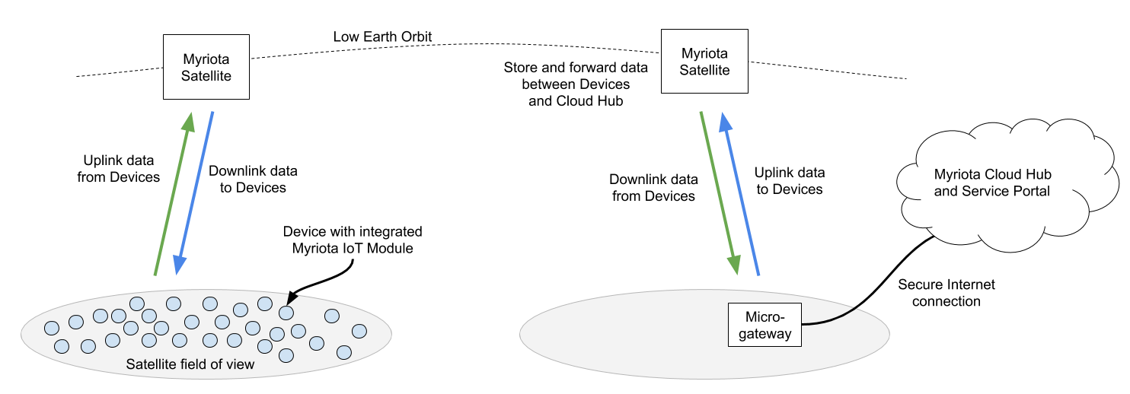

Figure 1: Myriota System Architecture (IoT device and micro-gateway data flow)

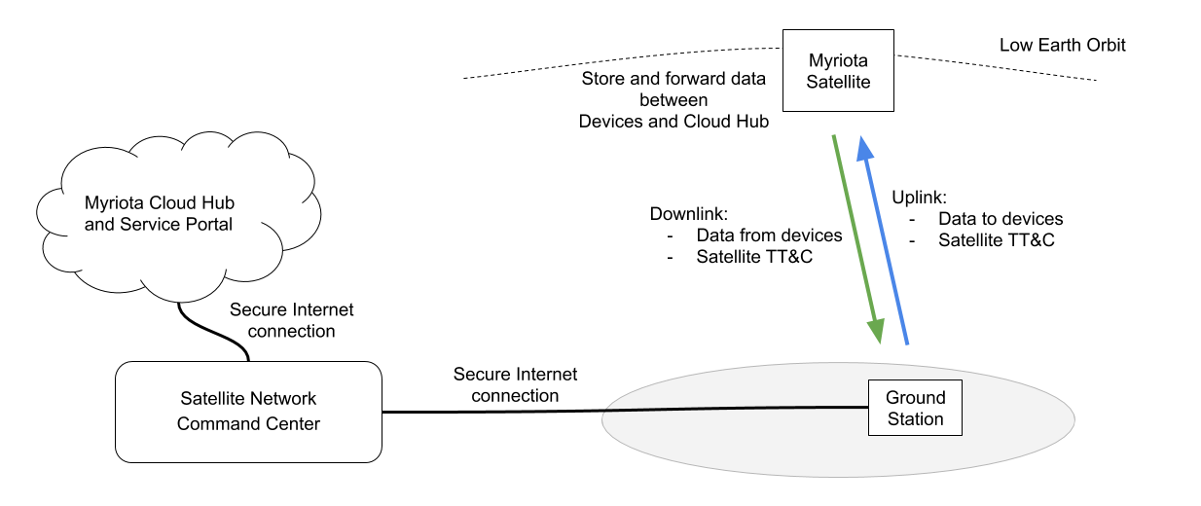

Figure 2: Myriota System Architecture (Operations and ground station data flow)

* 1. Technical characteristics

The following table outlines the frequency bands to be used by Myriota satellites

Table 2: Myriota satellite frequency bands

|  |  |  |
| --- | --- | --- |
| Frequency range | Direction | Typical operating bandwidth per transponder |
| 137-138 MHz | space-to-Earth | 20 kHz transmit |
| 148-149.9 MHz | Earth-to-space | 50 kHz receive |
| 149.9-150.05 MHz | Earth-to-space | 50 kHz receive |
| 399.9-400.05 MHz | Earth-to-space | 50 kHz receive |
| 400.15-401 MHz | space-to-Earth | 20 kHz transmit |

Myriota’s satellite system for service will consist of a total of 52 satellites, within 16 orbital planes:

* 12 satellites in sun synchronous orbits, in 6 planes
* 40 satellites at 54° inclined orbit, in 10 planes

Orbital altitudes of all satellites will be launched between 450 to 600 km.

Myriota has filed via the Australian Administration and a coordination request has been published under the ITU name MNSAT in Special Section CR/C 4735 in BR IFIC 2878 on 4th September 2018. The complete satellite constellation will consist of at least 26 satellites that will be replenished. But the system may employ up to 52 satellites to provide Myriota’s service. The satellites will be launched at various altitudes between 450-600 km, and inclination angles ranging from 0° to 98°. The orbital parameters provided to CEPT are a subset of the envelope Myriota's satellite constellation outlined in its ITU filings. For example, the MNSAT filing enables 208 satellites at orbital altitudes ranging from 400-850 km, and inclination angles ranging from 0-98.9°.

Myriota also intends to employ other existing ITU filings to provide its service in CEPT countries. At present, Myriota has purchased satellite communications assets from exact Earth Ltd, including hardware and access to the ITU filing ADS. Myriota's satellite system will provide service to CEPT countries using both ITU filings MNSAT (for UHF and VHF bands) and ADS (for UHF band). Note that 6 of the 52 satellites in Myriota's constellation will be from the ADS filing. All 52 satellites will operate at altitudes below 600 km. Myriota has no intention of operating satellites outside this altitude range.

The studies presented in this report consider orbital height of 600 km. Conclusions reached for the altitude of 600 km are valid for heights below 600 km as a satellite closer to Earth will have a smaller field of view, therefore less impact on Earth.

Table 3

|  |  |  |  |  |  |  |
| --- | --- | --- | --- | --- | --- | --- |
| Orbital plane ID | Number of satellites per plane | Inclination of the orbital plane | Orbital period (minutes) | Apogee (km) | Perigee (km) | Right ascension of the ascending node |
| 1 | 2 | 97.69 | 97 | 600 | 600 | 0 |
| 2 | 2 | 97.69 | 97 | 600 | 600 | 30 |
| 3 | 2 | 97.69 | 97 | 600 | 600 | 60 |
| 4 | 2 | 97.69 | 97 | 600 | 600 | 90 |
| 5 | 2 | 97.69 | 97 | 600 | 600 | 120 |
| 6 | 2 | 97.69 | 97 | 600 | 600 | 150 |
| 7 | 4 | 54 | 97 | 600 | 600 | 0 |
| 8 | 4 | 54 | 97 | 600 | 600 | 36 |
| 9 | 4 | 54 | 97 | 600 | 600 | 72 |
| 10 | 4 | 54 | 97 | 600 | 600 | 108 |
| 11 | 4 | 54 | 97 | 600 | 600 | 144 |
| 12 | 4 | 54 | 97 | 600 | 600 | 180 |
| 13 | 4 | 54 | 97 | 600 | 600 | 216 |
| 14 | 4 | 54 | 97 | 600 | 600 | 252 |
| 15 | 4 | 54 | 97 | 600 | 600 | 288 |
| 16 | 4 | 54 | 97 | 600 | 600 | 324 |

There are two types of terrestrial stations anticipated to be used for Myriota’s system: the IoT module, and micro-gateway.

* + 1. UHF parameters
       1. Uplink parameters (UHF band)

The uplink operational parameters are outlined in the table below:

Table 4: Uplink parameters (UHF band)

|  |  |  |  |
| --- | --- | --- | --- |
| TYPE OF STATION | OPERATING PARAMETER | TYPICAL | MAXIMUM |
| IoT Modules  UHF 399.9-400.05 MHz | Maximum e.i.r.p. | < -3 dBW | 5 dBW |
| Transmit power | -3 dBW | 0 dBW |
| Occupied bandwidth  (99% of emission power) | 4 kHz | 4 kHz |
| Duty cycle | < 0.02% | 0.50% |
| Modulation | MSK  (FSK modulation index ½) | MSK  (FSK modulation index ½) |
| Micro-gateways  UHF 399.9-400.05 MHz | Maximum e.i.r.p. | < 5 dBW | 5 dBW |
| Transmit power | -3 dBW | 0 dBW |
| Occupied bandwidth  (99% of emission power) | 25 kHz | 50 kHz |
| Duty cycle | < 0.50% | 5.00% |
| Modulation | FSK | FSK |

Table 5: IoT module uplink (UHF band)

|  |  |  |  |
| --- | --- | --- | --- |
| IoT module uplink (UHF) | | | |
| Parameter | Value | Notes |
| Typical duty cycle | 0.02% |  |
| Maximum duty cycle | 0.50% |  |
| Maximum individual transmission time | 262 ms |  |
| Minimum off time in between emissions | 2 s | There may be more than one emission per satellite pass. IoT modules only transmit when within footprint of Myriota satellite. |
| Time period of duty cycle | 1 day (24 hours) |  |
| Parameter | Value | Notes |
| Frequency hopping dwell time | 262 ms |  |
| Occupied bandwidth of emission (99% of power) | 4 kHz |  |
| Hopping bandwidth | UHF: Up to 150 kHz | The hopping bandwidth depends on the frequency range permitted to operate.  UHF: If assigned 150 kHz of the 399.9-400.05 MHz allocation, Myriota IoT modules will hop over the entire 150 kHz range  Myriota's IoT modules are reconfigurable in the field, and can perform frequency hopping over several non-contiguous frequency allotments. |
| Duty cycle relation to frequency hopping | Duty cycle is defined over all hops | Duty cycle is the transmit duty cycle of the device (regardless of frequency).  Due to the narrow emission bandwidth (4 kHz) of Myriota's IoT module, a larger permitted frequency hopping bandwidth will result in lower probability of occupying the same frequency. |

Table 6:

|  |  |  |
| --- | --- | --- |
| IoT module uplink (UHF) | | |
| Parameter | Value | Notes |
| Typical duty cycle | 0.02% |  |
| Maximum duty cycle | 0.50% |  |
| Maximum individual transmission time | 262 ms |  |
| Minimum off time in between emissions | 2 s | There may be more than one emission per satellite pass. IoT modules only transmit when within footprint of Myriota satellite. |
| Time period of duty cycle | 1 day (24 hours) |  |
| Frequency hopping dwell time | 262 ms |  |
| Occupied bandwidth of emission (99% of power) | 4 kHz |  |
| Hopping bandwidth | UHF: Up to 150 kHz | The hopping bandwidth depends on the frequency range permitted to operate.   UHF: If assigned 150 kHz of the 399.9-400.05 MHz allocation, Myriota IoT modules will hop over the entire 150 kHz range  Myriota's IoT modules are reconfigurable in the field, and can perform frequency hopping over several non-contiguous frequency allotments. |
| Duty cycle relation to frequency hopping | Duty cycle is defined over all hops | Duty cycle is the transmit duty cycle of the device (regardless of frequency).  Due to the narrow emission bandwidth (4 kHz) of Myriota's IoT module, a larger permitted frequency hopping bandwidth will result in lower probability of occupying the same frequency. |

Typical operation is for the majority of satellite IoT applications, for the majority of time. Many applications using Myriota's IoT modules are expected to be battery powered, with battery life related to the transmit power and number of transmissions; therefore, there is motivation to operate with the minimum necessary transmit power and duty cycle. There will be some applications and situations that may require the maximum transmit power and duty cycle.

In terms of channel spacing and bandwidth, Myriota’s IoT modules employ frequency hopping with 4 kHz narrow band emissions that can operate within any given range or multiple ranges within the 399.9-400.05 MHz frequency bands. The IoT modules do not use predefined channels. Due to the flexibility of Myriota’s system, the IoT modules can be updated via the MSS downlink to modify the ranges of frequencies allowed to operate.

Myriota IoT modules will typically operate with e.i.r.p. below -3 dBW, for the UHF MSS frequency band. This will be typical operation for most applications, and due to varying antenna gain, the e.i.r.p. in a given direction will be far less than this most of the time. Some applications may require IoT modules to transmit at higher power or may be connected to an antenna with higher gain. However, the e.i.r.p. of IoT modules will never exceed 5 dBW, for UHF band.

The micro-gateways will remain within the 5 dBW e.i.r.p. limit for the UHF MSS frequency band. Due to the flexibility of Myriota’s system, the micro-gateways can be updated with regulatory permissions, including e.i.r.p. limits depending on their location and the location of surrounding terrestrial services. Emissions of Myriota ground stations will comply with the spectrum mask limits set forth in US 47 CFR 25.202(f).

In the band 399.9-400.05 MHz, Myriota can configure the length, interval, data rate, bandwidth, and frequency of transmissions from earth stations in its system. Myriota’s system will be able to share these bands with other systems without causing harmful interference. Both IoT modules and micro-gateways transmit only when a Myriota satellite is overhead, significantly reducing the times during which there is a risk of interference. All of Myriota’s terrestrial stations in the 399.9-400.05 MHz band will operate with less than 5 dBW e.i.r.p. Myriota’s IoT modules will operate with typical transmit duty cycle less than 0.02%, and occasionally with duty cycle of up to 0.5%. They employ frequency hopping across the intended band, with a narrow emission bandwidth of less than 4 kHz. Myriota’s micro-gateways will typically operate with transmit duty cycle less than 0.5% and occasionally up to 5%, with emission bandwidth ranging from 25-250 kHz. Since the micro-gateways are far less numerous than other devices communicating with Myriota satellites in this band, their slightly higher duty cycle will have a negligible effect on the spectrum environment. These operating characteristics give Myriota the ability to share the entire uplink frequency range with other satellite systems also operating in the same bands, as well as the ability to operate in various portions of the frequency bands designated for use. The time period for the station's duty cycle is 24 hours.

Myriota's MESs employ frequency hopping with a maximum dwell time of 262 ms and a minimum off time between emissions of 2 seconds. The hopping bandwidth is configurable so that the entire available bandwidth can be used. In addition, the transmit duty cycle is defined per device, regardless of the frequency of operation or frequency hopping arrangements. Myriota’s system will employ feeder link earth stations using S-band uplink (2025-2110 MHz), as well as S-band downlink (2200-2290 MHz) and X-band downlink (8025-8400 MHz).

* + - 1. Downlink parameters (UHF band)

Examples of Myriota’s downlink operational parameters are outlined in the table below:

Table 7: Downlink parameters (UHF band)

|  |  |  |
| --- | --- | --- |
|  | UHF band | |
| Bandwidth | 4 kHz | 20 kHz |
| Satellite altitude [km] | 600 | 600 |
| Transmit bandwidth [kHz] | 4 | 20 |
| Transmit power [dBW] | 10 | 8.5 |
| Typical Antenna Gain [dBi]  (Omnidirectional antenna) | 0 | 0 |
| e.i.r.p. over given bandwidth [dBW] | 10 | 8.5 |
| Maximum e.i.r.p. density [dBW / 4 kHz] | 10 | 1.5 |
| Duty cycle | 10% | 20% |

Table 8: Satellite downlink (UHF band)

|  |  |  |
| --- | --- | --- |
| Satellite downlink (UHF band) | | |
|  | **Value** | **Notes** |
| Duty cycle per individual satellite | 10%  20% | 0.5 second every 5 seconds  1 second every 5 seconds |
| Length of individual transmissions | 0.5 second  1 second |  |
| Off time in between transmissions | 4.5 seconds  4 seconds |  |
| Frequency hopping | No plan to implement frequency hopping | Depending on noise sources and developing congestion in Europe, Myriota may implement frequency hopping. |

These example downlink parameters apply to UHF band. Myriota’s satellites have the flexibility to control the transmit power according to satellite altitude. Ideally, Myriota will deploy all satellites at 600 km altitude, however some satellites may be subject to orbital parameters determined by launch providers. Operating parameters of the satellites will be adjusted so that the received signal power on the surface of the Earth is the same, regardless of orbital height. For that reason, in the studies presented here, the orbital height of 600 km was considered but the conclusions reached are valid for heights of 450 km as well.

Omni directional satellite antennas are used for the studies, with max gain shown in table above. Myriota's satellites will be steered for solar pointing purposes (charging battery). Therefore, the antenna gain in the direction of the Earth’s surface can vary. The satellites will have dual polar linear antennas for UHF, and the spacecraft will be operated such that the gain in nadir direction is close to maximum for the majority of time.

In the band 400.15-401 MHz, Myriota’s system has the flexibility and spectral efficiency to be able to operate harmoniously with other users of the bands. Myriota’s satellites can vary channel bandwidth through on-board processing, and dynamically control their emissions across the entire frequency ranges to accommodate sharing arrangements with other users of these bands. Myriota downlink emissions can range in bandwidth between 4-20 kHz and operate within the entire MSS allocation or any portion thereof designated for use. Myriota downlink emissions can employ frequency hopping to move through the assigned band, or operate with a defined channel plan, using either multiple contiguous channels or a fragmented channel arrangement. Myriota can also configure the length, interval, data rate, bandwidth, and frequency of transmissions of satellites in its system. The flexibility of the software defined radio on board Myriota’s satellites will enable Myriota to share spectrum by coordinating usage and/or time of operations. It is important to note that the time reference for Myriota's downlink duty cycle is 5 seconds.

* + - 1. Downlink out-of-band emissions

This section describes measurements of Myriota's downlink out-of-band emissions. The output power from Myriota's satellite at 400.55 MHz was set to 36.63 dBm, or ‑0.37 dB(W/4 kHz). An attenuator was used to reduce this power across the entire 400-410 MHz band, and a notch filter was inserted at the carrier frequency to prevent overloading the spectrum analyser. The frequency response of the notch/LNA is shown in in the figure below. Between 406.1-410 MHz, the notch/LNA produced gain, which amplifies the unwanted emissions and makes the results appear worse. This gain ranges between 2.2 dB to 6.38 dB, and is compensated for in the results. However, this gain is assumed to be only 2.2 dB as a conservative approach.

Measurement of noise was only performed during transmission 'on time', thus without any benefit from duty cycle. The resulting measurements assume always on transmission and are shown in Figure 4. The measured noise power over 3.9 MHz is compensated by 2.2 dB to account for notch/LNA gain, and then converted to 4 kHz reference bandwidth, which results in -111.29 dBm (per 4 kHz). Compared to the input power of -0.37 dBm (per 4 kHz), this means attenuation of at least -110.92 dBc is achieved across the 406.1-410 MHz band.

The results here presented are for the UHF band, but a similar out-of-band attenuation value can be assumed for the VHF band due to the similarity between the Myriota payloads in both bands. In addition, the frequency separation between the Myriota downlink and the RAS band in the VHF spectrum is more than twice the separation in the UHF band. If a spectral roll off of -110 dBc/4 kHz was measured in the UHF band with a 5.1 MHz separation between the transmit and the interference bands, more roll off can be expected in the VHF band, with a 12.05 MHz frequency separation.

Table 9: Parameters and results

|  |  |
| --- | --- |
| **Parameters** | **Results** |
| Output power of satellite (no attenuator, no notch) | 36.63 dBm |
| Input power to measurement notch/LNA (over 4 kHz bandwidth) | -0.37 dBm |
| Attenuation from notch/LNA at carrier frequency 400.57 MHz | -22.97 dB |
| Carrier power after notch/LNA | -23.34 dBm (calculated)  -23.53 dBm (measured) |
| Notch/LNA gain | 2.2 dB (at 406.1 MHz)  6.38 dB (at 410 MHz)  (lower gain value used as worst case) |
| Transmission on time | 1100 ms |
| Measured noise power (over 3.9 MHz bandwidth) | -79.2 dBm |
| Calculated noise power after compensating for 2.2 dB notch/LNA gain | -81.4 dBm (over 3.9 MHz)  -111.29 dBm (over 4 kHz) |
| Ratio of noise power to carrier power | -110.92 dBc (4 kHz reference) |

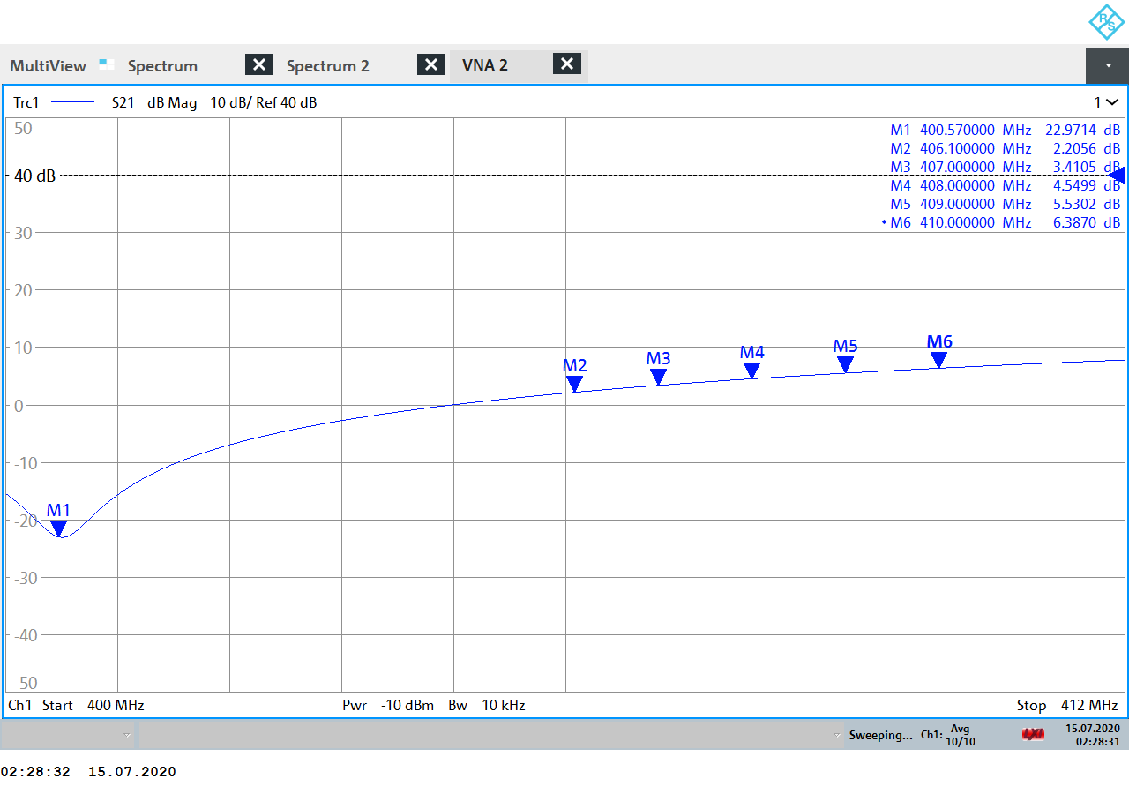

Figure 3: Notch filter with -23 dB attenuation at the carrier; and between 2.2 dB to 6.38 dB gain over RAS frequency range

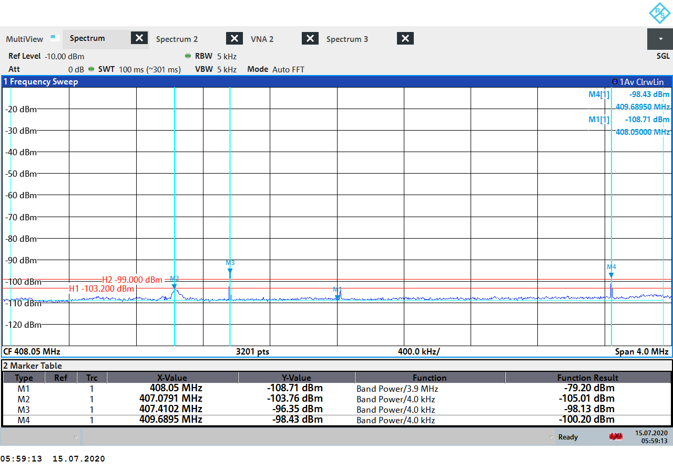

Figure 4: Test measurement over RAS frequency range. Marker M1 measured total power across the 3.9 MHz range as -79.2 dBm, from which an amplification of 2.2 dB was discounted

* + 1. VHF parameters
       1. Uplink parameters (VHF band)

The uplink operational parameters are outlined in the table below:

Table 10: Uplink parameters (VHF band)

|  |  |  |  |
| --- | --- | --- | --- |
| TYPE OF STATION | OPERATING PARAMETER | TYPICAL | MAXIMUM |
| IoT Modules  VHF 148-150.05 MHz | Maximum e.i.r.p. | < -3 dBW | 5 dBW |
| Transmit power | -3 dBW | 0 dBW |
| Occupied bandwidth  (99% of emission power) | 4 kHz | 4 kHz |
| Duty cycle | < 0.02% | 0.50% |
| Modulation | MSK  (FSK modulation index ½) | MSK  (FSK modulation index ½) |
| Micro-gateways  VHF 148-150.05 MHz | Maximum e.i.r.p. | < 5 dBW | 10 dBW |
| Transmit power | -3 dBW | 10 dBW |
| Occupied bandwidth  (99% of emission power) | 25 kHz | 250 kHz |
| Duty cycle | < 0.50% | 5.00% |
| Modulation | FSK | FSK |

Table 11: IoT module uplink (VHF band)

|  |  |  |  |
| --- | --- | --- | --- |
| TYPE OF STATION | OPERATING PARAMETER | TYPICAL | MAXIMUM |
| IoT Modules  VHF 148-150.05 MHz | Maximum e.i.r.p. | < -3 dBW | 5 dBW |
| Transmit power | -3 dBW | 0 dBW |
| Occupied bandwidth  (99% of emission power) | 4 kHz | 4 kHz |
| Duty cycle | < 0.02% | 0.50% |
| Modulation | MSK  (FSK modulation index ½) | MSK  (FSK modulation index ½) |
| Micro-gateways  VHF 148-150.05 MHz | Maximum e.i.r.p. | < 5 dBW | 10 dBW |
| Transmit power | -3 dBW | 10 dBW |
| Occupied bandwidth  (99% of emission power) | 25 kHz | 250 kHz |
| Duty cycle | < 0.50% | 5.00% |
| Modulation | FSK | FSK |

Typical operation is for the majority of satellite IoT applications, for the majority of time. Many applications using Myriota's IoT modules are expected to be battery powered, with battery life related to the transmit power and number of transmissions; therefore, there is motivation to operate with the minimum necessary transmit power and duty cycle. There will be some applications and situations that may require the maximum transmit power and duty cycle.

In terms of channel spacing and bandwidth, Myriota’s IoT modules employ frequency hopping with 4 kHz narrow band emissions that can operate within any given range or multiple ranges within the 148-150.05 MHz frequency band. The IoT modules do not use predefined channels. Due to the flexibility of Myriota’s system, the IoT modules can be updated via the MSS downlink to modify the ranges of frequencies allowed to operate.

Myriota IoT modules will typically operate with e.i.r.p. below -3 dBW, for VHF MSS frequency band. This will be typical operation for most applications, and due to varying antenna gain, the e.i.r.p. in a given direction will be far less than this most of the time. Some applications may require IoT modules to transmit at higher power or may be connected to an antenna with higher gain. However, the e.i.r.p. of IoT modules will never exceed 5 dBW, for VHF band.

For the VHF MSS band, micro-gateways may occasionally operate with e.i.r.p. up to 10 dBW. Due to the flexibility of Myriota’s system, the micro-gateways can be updated with regulatory permissions, including e.i.r.p. limits depending on their location and the location of surrounding terrestrial services. This ensures Myriota’s responsible use of the VHF MSS band and does not impose any risk of harmful interference to terrestrial services. Emissions of Myriota ground stations will comply with the spectrum mask limits set forth in US 47 CFR 25.202(f).

In the band 148-150.05 MHz, Myriota can configure the length, interval, data rate, bandwidth, and frequency of transmissions from earth stations in its system. Myriota’s system will be able to share these bands with other systems without causing harmful interference. Both IoT modules and micro-gateways transmit only when a Myriota satellite is overhead, significantly reducing the times during which there is a risk of interference. Earth stations in the 148-150.05 MHz frequency band will typically operate with less than 5 dBW e.i.r.p. but may operate higher. Myriota’s IoT modules will operate with typical transmit duty cycle less than 0.02%, and occasionally with duty cycle of up to 0.5%. They employ frequency hopping across the intended band, with a narrow emission bandwidth of less than 4 kHz. Myriota’s micro-gateways will typically operate with transmit duty cycle less than 0.5% and occasionally up to 5%, with emission bandwidth ranging from 25-250 kHz. Since the micro-gateways are far less numerous than other devices communicating with Myriota satellites in this band, their slightly higher duty cycle will have a negligible effect on the spectrum environment. These operating characteristics give Myriota the ability to share the entire uplink frequency range with other satellite systems also operating in the same bands, as well as the ability to operate in various portions of the frequency bands designated for use. The time period for the station's duty cycle is 24 hours.

Myriota's MESs employ frequency hopping with a maximum dwell time of 262 ms and a minimum off time between emissions of 2 seconds. The hopping bandwidth is configurable so that the entire available bandwidth can be used. In addition, the transmit duty cycle is defined per device, regardless of the frequency of operation or frequency hopping arrangements. Myriota’s system will employ feeder link earth stations using S-band uplink (2025-2110 MHz), as well as S-band downlink (2200-2290 MHz) and X-band downlink (8025-8400 MHz).

* + - 1. Downlink parameters (VHF band)

Examples of Myriota’s downlink operational parameters are outlined in the table below:

Table 12: Downlink parameters (VHF band)

|  |  |  |  |  |
| --- | --- | --- | --- | --- |
|  | UHF | | VHF | |
| Bandwidth | 4 kHz | 20 kHz | 4 kHz | 20 kHz |
| Satellite altitude [km] | 600 | 600 | 600 | 600 |
| Transmit bandwidth [kHz] | 4 | 20 | 4 | 20 |
| Transmit power [dBW] | 10 | 8.5 | 1.5 | 8.5 |
| Typical Antenna Gain [dBi]  (Omnidirectional antenna) | 0 | 0 | 0 | 0 |
| e.i.r.p. over given bandwidth [dBW] | 10 | 8.5 | 1.5 | 8.5 |
| Maximum e.i.r.p. density [dBW / 4 kHz] | 10 | 1.5 | 1.5 | 1.5 |
| Duty cycle | 10% | 20% | 10% | 20% |

Table 13: Satellite downlink (VHF band)

|  |  |  |
| --- | --- | --- |
| Satellite downlink (VHF band) | | |
|  | **Value** | **Notes** |
| Duty cycle per individual satellite | 10%  20% | 0.5 second every 5 seconds  1 second every 5 seconds |
| Length of individual transmissions | 0.5 second  1 second |  |
| Off time in between transmissions | 4.5 seconds  4 seconds |  |
| Frequency hopping | No plan to implement frequency hopping | Depending on noise sources and developing congestion in Europe, Myriota may implement frequency hopping. |

These example downlink parameters apply to VHF band. Myriota’s satellites have the flexibility to control the transmit power according to satellite altitude. Ideally, Myriota will deploy all satellites at 600 km altitude, however some satellites may be subject to orbital parameters determined by launch providers. Operating parameters of the satellites will be adjusted so that the received signal power on the surface of the Earth is the same, regardless of orbital height. For that reason, in the studies presented here, the orbital height of 600 km was considered but the conclusions reached are valid for heights of 450 km as well.

Omni directional satellite antennas are used for the studies, with max gain shown in table above. Myriota's satellites will be steered for solar pointing purposes (charging battery). Therefore, the antenna gain in the direction of the Earth’s surface can vary. The satellites will have dual polar linear antennas for VHF, and the spacecraft will be operated such that the gain in nadir direction is close to maximum for the majority of time.

In the band 137-138 MHz, Myriota’s system has the flexibility and spectral efficiency to be able to operate harmoniously with other users of the bands. Myriota’s satellites can vary channel bandwidth through on-board processing, and dynamically control their emissions across the entire frequency ranges to accommodate sharing arrangements with other users of these bands. Myriota downlink emissions can range in bandwidth between 4-20 kHz and operate within the entire MSS allocation or any portion thereof designated for use. Myriota downlink emissions can employ frequency hopping to move through the assigned band, or operate with a defined channel plan, using either multiple contiguous channels or a fragmented channel arrangement. Myriota can also configure the length, interval, data rate, bandwidth, and frequency of transmissions of satellites in its system. The flexibility of the software defined radio on board Myriota’s satellites will enable Myriota to share spectrum by coordinating usage and/or time of operations. It is important to note that the time reference for Myriota's downlink duty cycle is 5 seconds.

* 1. inter service studies (UHF band)
     1. Uplink (399.9-400.05 MHz (Earth-to-space ))

The band 399.9-400.05 MHz is only allocated to the MSS (Earth-to-space) in the ITU Radio Regulations. Therefore, there is no need for compatibility studies in this band with other services.

* + - 1. Protection of Mobile Services

The ECA table identifies ECC/DEC/(08)05 “The harmonisation of frequency bands for the implementation of digital Public Protection and Disaster Relief (PPDR) narrow band and wide band radio applications in bands within the 380-470 MHz range” as pertinent for the band 399.9-400.05 MHz. However, none of the frequency arrangements for mobile systems, including PPDR, include the band 399.9-400.05 MHz.

* + - 1. Protection of Radio Astronomy

Myriota’s UHF uplink transmissions between 399.9–400.05 MHz are separated by 5.05 MHz from the 406.1–410 MHz RAS allocation. Note that Myriota will carefully manage the deployment location of micro-gateways such that they avoid interference potential to RAS facilities.

For Myriota’s IoT modules, there are several reasons why they are unlikely to cause harmful interference:

* There is a low probability of an IoT module operating in proximity to RAS facilities for a prolonged period of time;
* Over the intended operating frequency ranges, typical e.i.r.p. of an IoT module will be less than -3 dBW in the direction of RAS site;
* Emissions outside the intended operating frequency ranges will be significantly reduced over any 4 kHz measured bandwidth through front-end filtering compared to the emission at frequency of operation.

Using the operating parameters of Myriota’s terrestrial stations, it is possible to calculate the necessary separation distance from a RAS site in order to comply with the protection criteria of Table 14. First step is to calculate the minimum path loss between the two systems, based on the transmission parameters of the Myriota Earth stations and the maximum allowable interference to the RAS site. Then, using the propagation model described in ITU-R P.452, the minimum distance that corresponds to a path loss equal to or higher to the minimum path loss calculated is computed. This minimum distance is the required separation distance between a Myriota Earth station and a RAS site.

Table 14: RAS parameters

|  |  |  |
| --- | --- | --- |
| UHF Parameter | Value | Unit |
| RAS centre frequency | 408.05 | MHz |
| RAS bandwidth | 3.9 | MHz |
| PFD threshold | -255 | dB(W/m2/Hz) |
| Interference limit | -203 | dBW |

The table below outlines the required separation distances for typical and maximum operation of Myriota terrestrial stations in the UHF band, using attenuation of 65 dBc over the RAS operating frequency range. The antenna gain of the radio astronomy station was assumed to be 0 dBi, as indicated in Recommendation ITU-R RA.769-2.

Table 15: Minimum separation distances between RAS site and UHF Myriota IoT modules/ Micro-Gateways

|  |  |
| --- | --- |
| Minimum separation distances | |
| Myriota IoT modules | |
| Worst case | 9.03 km |
| Typical | 3.4 km |
| Myriota Micro-Gateways | |
| Worst case | 8.56 km |
| Typical | 4.8 km |

Despite these precautionary features, if a specific RAS site is nonetheless susceptible to interference, Myriota can utilise its geofencing technology to prevent IoT modules from transmitting within certain distances of a given location. Myriota can even send messages instructing specific terrestrial stations to cease transmission should interference concerns arise. Accordingly, using such measures, Myriota will protect RAS facilities operating in the UHF band from harmful interference from unwanted emissions.

* + - 1. Protection of the Cospas-Sarsat system

The 406-406.1 MHz frequency band is exclusively allocated to the mobile-satellite service, which is currently used by the Cospas-Sarsat system. Report ITU-R M.2359-0 outlines the uplink operational parameters of data collection platforms in the 401-403 MHz frequency range. Myriota’s IoT modules and micro-gateways operating in the 399.9-400.05 MHz range will use transmit power lower than the values presented in Table 5 -1 of the Report. Furthermore, the 399.9-400.05 MHz range has at least 5.95 MHz frequency separation with the 406-406.1 MHz range, which is significantly more than that of data collection platforms operating between 401-403 MHz. The Report concludes that the Cospas-Sarsat system is protected from interference from data collection platforms in the 401-403 MHz, and the same conclusion is valid for Myriota’s IoT modules and micro-gateways operating within 399.9-400.05 MHz, even when operating at maximum transmit power.

* + 1. Downlink (400.15-401 MHz (space to Earth))
       1. Coordination with terrestrial systems

For the UHF frequency band, Myriota’s 20 kHz downlink transmissions comply with the -125 dB(W//m2) pfd threshold for coordination with terrestrial systems. When accounting for duty cycle, Myriota's 4 kHz downlink transmissions will meet an average PFD on the Earth's surface of less than -125 dB(W//m2). Without taking into account the duty cycle Myriota 4 kHz downlink emissions do not comply with the threshold for the protection of terrestrial services. Due to its flexibility, Myriota’s system can adjust its transmission parameters to comply with this threshold and protect terrestrial systems, if necessary. Any exceedance of pfd limit shall be subject to upon agreement with the concerned administration in CEPT.

Table 16: Myriota's ground pfd

|  |  |  |  |
| --- | --- | --- | --- |
| Parameter | Maximum operation | Alternate operation  example | Unit |
| Orbital height | 600 | 600 | km |
| Bandwidth | 4 | 20 | kHz |
| Transmit power | 10 | 8.5 | dBW |
| Duty cycle | 10 | 20 | % |
| Antenna gain towards ground | 0 | 0 | dBi |
| e.i.r.p. towards ground | 10 | 8.5 | dBW |
| e.i.r.p. density (1 kHz) | 3.98 | -4.51 | dB(W/1kHz) |
| e.i.r.p. density (4 kHz) | 10.00 | 1.51 | dB(W/4 kHz) |
| PFD density | -116.56 | -125.04 | dB(W/4 kHz/m2) |
| PFD density with duty cycle | -126.56 | -132.03 | dB(W/4 kHz/m2) |
| PFD threshold | -125 | -125 | dB(W/4 kHz/m2) |
| Margin with duty cycle | -1.56 | -7.03 | dB |
| Margin without duty cycle | 8.44 | - 0.04 | dB |

* + - 1. Protection of Radio Astronomy

For the protection of RAS systems in the band 406.1-410 MHz, the data loss in an integration time of 2000s must not exceed the value of 2%. According to Recommendation ITU-R RA.769-2, the interference pfd threshold above which there is data loss at a RAS site is -189 dB(W/m2) in the UHF band. To compute the data loss, the method described in Recommendation ITU-R M.1583-1 is used. According to this recommendation, the sky is divided into grid of cells and the RAS station receiver is pointing to a random location inside each cell. The interfering MSS constellation is simulated for 2000s for a number of iterations and the interference statistics are collected for all cells and iterations. The antenna pattern described in Recommendation ITU-R RA.1631 is used for the RAS station. The results of the studies are provided in Figure 5 and Figure 6.

In all simulated cases, a spectral roll off of ‑110 dBc was applied to Myriota's in-band transmissions to calculate the out-of-band power in the RAS band. It is concluded that Myriota adequately protects the Radio astronomy in the band 406.1-410 MHz.

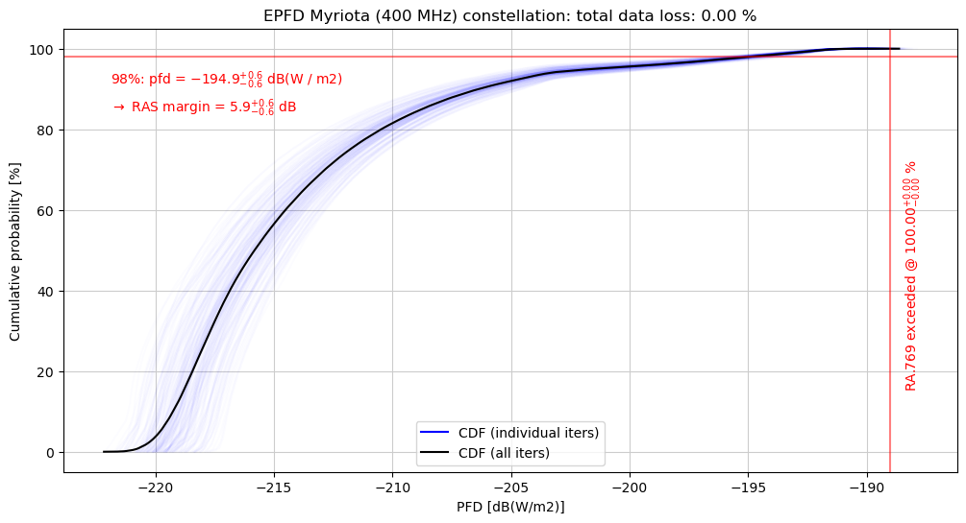

Figure 5: Data loss distribution for 4 kHz carrier

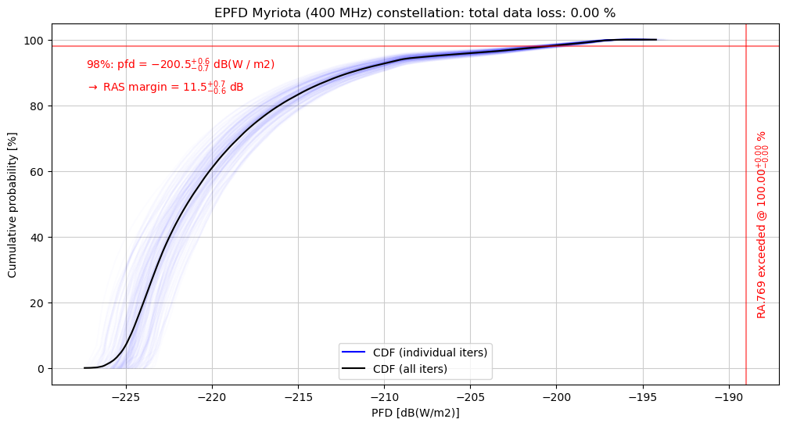

Figure 6: Data loss distribution for 20 kHz carrier

* + - 1. Standard frequency and time signal satellite (400.1 MHz)

The SFTSS (Standard Frequency and Time Signal – Satellite) Service is allocated in Article 5 of the Radio Regulations on a primary basis in the band 400.05-400.15 MHz. In accordance with footnote 5.261, emissions shall be confined in a band of +/- 25 kHz about the standard frequency 400.1 MHz.

There is no identified ITU-R Recommendation or Report providing characteristics or protection criteria for SFTSS. However, some satellite networks contain assignments in this service (class of station EE or EY) in the band 400.05-400.15 MHz. Their characteristics can be used to assess adjacent band compatibility with Myriota downlink operations within the adjacent 400.15-401 MHz MSS allocation.

The following formula permits to calculate the pfd value (dBW/m²/4 kHz) to meet a given I/N criterion into an Earth station with an antenna gain Grx and noise temperature N:

$${pfd}_{(\frac{dBW}{m^{2}}/4kHz)}=\left(\frac{I}{N}\right)-38.55+20*Log\left(f_{MHz}\right)-G_{rx}-228.6+10*Log(T*4000)$$

The identified SFTSS network’s characteristics are summarised as follows, and the right column provides the pfd value to meet an I/N of -10 dB in the worst-case conditions.

Table 17: SFTSS network’s characteristics

|  |  |  |  |  |  |  |  |  |
| --- | --- | --- | --- | --- | --- | --- | --- | --- |
| Network name | Adm | Freq min | Freq max | Station class | Emission designator | E/S Rx Gain | E/S Noise temp | Worst case PFD (dBW/m²/4 kHz) |
| TSYKADA | RUS | 400.075 | 400.125 | EE | 50K0G2D-- | 0 | 200 | -166.1 |
| LEOTELCOM-1 | USA | 400.075 | 400.125 | EE | 50K0G7D-- | 2 | 400 | -165.1 |
| 400.075 | 400.125 | EE | 50K0G7D-- | 6.1 | 400 | -169.2 |
| ICARUS | D | 400.05 | 400.15 | EY | 5K00G1D-- | -10 | 3000 | -144.3 |
| 400.05 | 400.15 | EY | 50K0G1D-- | -10 | 3000 |
| F-SAT-NG-8 | F | 400.05 | 400.15 | EY | 50K0G7W-- | 0 | 500 | -162.1 |
| 400.05 | 400.15 | EY | 12K3G7W-- | 0 | 500 |
| 400.05 | 400.15 | EY | 1K00G7W-- | 0 | 500 |

Myriota will employ the necessary guard bands so that there is sufficient frequency separation to protect SFTSS from Myriota satellite emissions. For example, Myriota's 20 kHz emissions require attenuation of at least 44.2 dBc to ensure the pfd produced on the Earth's surface in the 400.05-400.15 MHz range is below -169.6 dBW/m²/4 kHz, which is sufficient to protect SFTSS. To reach this attenuation, Myriota will apply a guard band from the 400.15 MHz boundary. Myriota's 4 kHz emissions require attenuation of at least 52.64 dBc to protect SFTSS, which is achievable with frequency separation from the 400.15 MHz boundary.

Given the orbital parameters of Myriota's system, there will be several satellites in view of any point on the Earth's surface in Europe. However, the duty cycle of each of Myriota's satellites is no more than 20%. Myriota can control its satellite emissions to ensure that their aggregate effect does not exceed the required pfd limit to protect SFTSS.

In addition, the figure below shows measurements for Myriota's UHF downlink out of band emissions. The image shows the narrow 4 kHz emission transmitting at centre 400.2 MHz achieves at least -53 dBc attenuation by the 400.15 MHz boundary to protect SFTSS. However, Myriota can get much closer to the 400.15 MHz boundary as the tests show that when transmitting at 400.16 MHz the attenuation is close to ‑53 dBc. For the 4 kHz emission, transmitting at centre 400.162 MHz would ensure at least -53 dBc attenuation by the 400.15 MHz boundary. Similar results can be expected to the 20 kHz emissions, given the fact that the transmit bandwidth is larger but the necessary attenuation is lower than for the 4 kHz emissions.

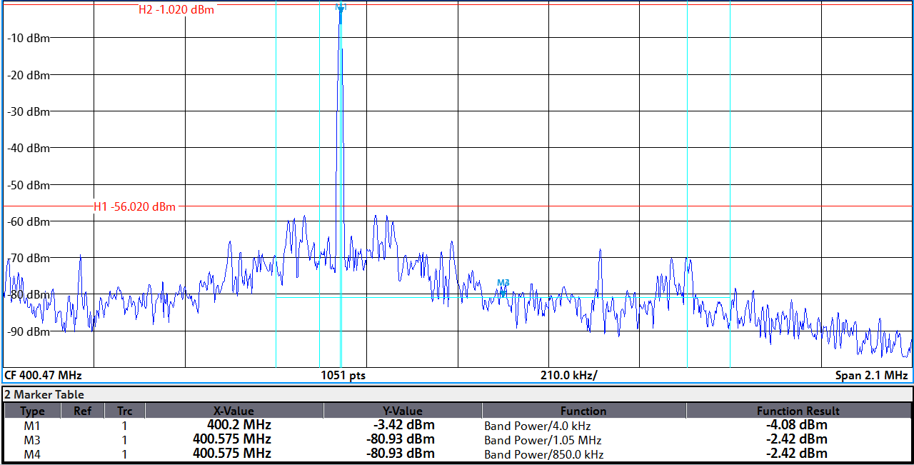

Figure 7: Myriota's UHF downlink out of band emissions

* + - 1. Other existing services in the 400.15-401 MHz band

The 400.15-401 MHz band is allocated to the Meteorological Aids Service, Meteorological-Satellite Service (space-to-Earth), Space Research Service (space-to-Earth) on a co-primary basis, and the Space Operation Service (space-to-Earth) on a secondary basis. There is no ITU-R Recommendation or other documentation providing technical characteristics, protection or sharing criteria for such systems with MSS operations in this specific frequency band.

With regards to the Meteorological Aids Service, the Australian administration will coordinate the MNSAT downlink emissions with the French administration under RR 9.14 for the protection of the meteorological aids service in the band 400.15-401 MHz. The coordination is for the frequency assignments registered by France into the MIFR and subject to PFD threshold of -125 dB(W/m²/4kHz) or the use of the Recommendation ITU-R RS.1262 when the threshold is exceeded.

* 1. Inter-service studies (VHF band)
     1. Uplink (148-149.9 MHz (Earth-to-space))

In the band 148-150.05 MHz, Myriota can configure the length, interval, data rate, bandwidth, and frequency of transmissions from earth stations in its system. Myriota’s system will be able to share these bands with other systems without causing harmful interference. Both IoT modules and micro-gateways transmit only when a Myriota satellite is overhead, significantly reducing the times during which there is a risk of interference. All of Myriota’s earth stations in the 148-150.05 MHz frequency band will typically operate with less than 5 dBW e.i.r.p., but may operate higher.

* + - 1. Protection of Radio Astronomy

Myriota’s VHF uplink transmissions between 148–150.05 MHz are adjacent to the 150.05–153 MHz allocation of RAS. Note that Myriota will carefully manage the deployment location of micro-gateways such that they avoid interference potential to RAS facilities.

For Myriota’s IoT modules, there are several reasons why they are unlikely to cause harmful interference:

* There is a low probability of an IoT module operating in proximity to RAS facilities for a prolonged period of time
* Over the intended operating frequency ranges, typical e.i.r.p. of an IoT module will be less than -3 dBW in the direction of RAS site
* Emissions outside the intended operating frequency ranges will be significantly reduced over any 4 kHz measured bandwidth through front-end filtering compared to the emission at frequency of operation.

Using the operating parameters of Myriota’s terrestrial stations, it is possible to calculate the necessary separation distance from a RAS site in order to comply with the protection criteria of Table 18. First step is to calculate the minimum path loss between the two systems, based on the transmission parameters of the Myriota earth stations and the maximum allowable interference to the RAS site. Then, using the propagation model described in ITU-R P.452, the minimum distance that corresponds to a path loss equal to or higher to the minimum path loss calculated is computed. This minimum distance is the required separation distance between a Myriota earth station and a RAS site.

Table 18: RAS parameters

|  |  |  |
| --- | --- | --- |
| VHF Parameter | Value | Unit |
| RAS centre frequency | 151.525 | MHz |
| RAS bandwidth | 2.95 | MHz |
| PFD threshold | -259 | dB(W/m2/Hz) |
| Interference limit | -199 | dBW |

The following table outlines the required separation distances for typical and maximum operation of Myriota terrestrial stations in the VHF band, using attenuation of 65 dBc over the RAS operating frequency range. The antenna gain of the radio astronomy station was assumed to be 0 dBi, as indicated in Recommendation ITU-R RA.769-2.

Table 19: Minimum separation distances between RAS site and VHF Myriota IoT modules/ Micro-Gateways

|  |  |
| --- | --- |
| Minimum separation distances | |
| Myriota IoT modules | |
| Worst case | 19.1 km |
| Typical | 3.4 km |
| Myriota Micro-Gateways | |
| Worst case | 23.4 km |
| Typical | 5.8 km |

Despite these precautionary features, if a specific RAS site is nonetheless susceptible to interference, Myriota can utilise its geofencing technology to prevent IoT modules from transmitting within certain distances of a given location. Myriota can also send messages instructing specific terrestrial stations to cease transmission should interference concerns arise. Accordingly, using such measures, Myriota will protect RAS facilities operating in the VHF band from harmful interference from unwanted emissions.

* + - 1. Protection of Mobile Services

As provided by RR 5.221, stations of the mobile-satellite service in the frequency band 148-149.9 MHz shall not cause harmful interference to, or claim protection from, stations of the fixed or mobile services. In addition, according to RR 5.219, the use of the band 148-149.9 MHz by the mobile-satellite service is subject to coordination under 9.11A.

In the VHF band, Myriota’s uplink transmissions share spectrum with PMR and PAMR land mobile systems. The parameters and protection criteria used for these systems in this study were taken from Recommendation ITU-R M.1808-1 and shown in the below table.

Table 20: Land mobile systems (base stations) parameters

|  |  |  |
| --- | --- | --- |
| Parameter | Value | Unit |
| Protection criterion (I/N) | -6 | dB |
| Centre frequency | 149.025 | MHz |
| Bandwidth | 12.5 | kHz |
| Antenna gain (dBd) | 0 | dBd |
| Antenna gain (dBi) | 2.15 | dBi |
| Antenna height | 30 | m |
| Radiation pattern | Omnidirectional |  |
| Noise figure | 12 | dB |
| Noise temperature | 300 | K |

The recommended separation distance between Myriota’s stations and Land Mobile stations is shown in Table 21. To calculate these values, the minimum coupling loss between the two systems was calculated and the associated separation distance determined, using the propagation model described in ITU-R P.1546. This was calculated for the co-channel scenario where a Myriota station overlaps in frequency with a Land Mobile station; and, for the scenario where there is 10 kHz frequency separation between the two systems. If the two systems operate in channels more than 10 kHz apart, Myriota’s emissions into the land mobile service channel will be attenuated by at least 55 dB, and the recommended physical separation distances are significantly reduced.

For this analysis, the transmit antenna gain was assumed to be 0 dBi for Myriota’s stations in the direction of the horizon (direction towards Land Mobile station). In practice, the gain towards the horizon is expected to be far below 0 dBi for the majority of Myriota’ stations, which would further reduce the distance values shown in the below table.

Neither duty cycle nor clutter losses were considered in the calculation leading to the values in the below table.

Table 21: Minimum recommended separation distance to protect Land Mobile base stations

|  |  |  |
| --- | --- | --- |
| VHF IoT Modules | Recommended Distance  (Co-channel scenario) | Recommended Distance  (10 kHz frequency separation) |
| Typical operation | 2.19 km | 0.35 km |
| Maximum operation | 5.48 km | 0.44 km |
| VHF Micro-gateways | Recommended Distance  (Co-channel scenario) | Recommended Distance  (10 kHz frequency separation) |
| Typical operation | 4.59 km | 0.47 km |
| Maximum operation | 11.20 km | 0.83 km |

* + 1. Downlink (137-138 MHz (space-to-Earth))

In the band 137-138 MHz, Myriota’s system has the flexibility and spectral efficiency to be able to operate harmoniously with other users of the bands. Myriota’s satellites can vary channel bandwidth through on-board processing, and dynamically control their emissions across the entire frequency ranges to accommodate sharing arrangements with other users of these bands. Myriota downlink emissions can range in bandwidth between 4-20 kHz and operate within the entire MSS allocation or any portion thereof designated for use. Myriota downlink emissions can employ frequency hopping to move through the assigned band, or operate with a defined channel plan, using either multiple contiguous channels or a fragmented channel arrangement. Myriota can also configure the length, interval, data rate, bandwidth, and frequency of transmissions of satellites in its system. The flexibility of the software defined radio on board Myriota’s satellites will enable Myriota to share spectrum by coordinating usage and/or time of operations.

* + - 1. Coordination with terrestrial systems

For the VHF frequency band, Myriota’s downlink transmissions comply with the -125 dB(W/4 kHz/m2) pfd threshold for coordination with terrestrial systems. Due to its flexibility, Myriota’s system can adjust its transmission parameters to comply with this threshold and protect terrestrial systems, if necessary. Both the transmission power and the bandwidth can be adjusted to reduce the pfd generated by Myriota’s downlink transmissions.

Table 22: Myriota's ground pfd

|  |  |  |  |  |
| --- | --- | --- | --- | --- |
| Parameter | | 4 kHz carrier | 20 kHz carrier | Unit |
| Orbital height | 600 | | 600 | km |
| Bandwidth | 4 | | 20 | kHz |
| Transmit power | 1.5 | | 8.5 | dBW |
| Duty cycle | 10 | | 20 | % |
| Antenna gain towards ground | 0 | | 0 | dBi |
| e.i.r.p. towards ground | 1.5 | | 8.5 | dBW |
| e.i.r.p. density (1 kHz) | -4.52 | | -4.51 | dB(W/1kHz) |
| e.i.r.p. density (4 kHz) | 1.5 | | 1.51 | dB(W/4 kHz) |
| PFD density | -125.06 | | -125.04 |  |
| PFD density with duty cycle | -135.06 | | -132.03 | dB(W/4 kHz/m2) |
| PFD threshold | -125 | | -125 | dB(W/4 kHz/m2) |
| Margin with duty cycle | -10.06 | | -7.03 | dB |
| Margin without duty cycle | -0.06 | | - 0.04 | dB |

* + - 1. Compatibility with AMS(OR) in the CEPT countries listed in RR N.5.206

As provided by RR 5.206, the 137-138 MHz band is allocated to the aeronautical mobile service on a primary basis. Annex 1 to RR Appendix 5 of the ITU Radio Regulations shall be used as a coordination trigger. That PFD threshold is -140 dBW/m2/4 kHz at the Earth’s surface.

In some CEPT administrations listed in RR. 5.206, the 137-138 MHz band is allocated to the aeronautical mobile service on a primary basis with a coordination PFD threshold of -140 dBW/m2/4 kHz at the Earth’s surface. As shown in , the PFD level produced by Myriota emissions is ordinarily above -140 dBW/m2/4 kHz for elevation angles above 30.55 degrees. Radio Regulations defines coordination procedures for the operation of MSS to ensure compatibility, including with the Aeronautical Mobile Service in the same band. To comply with the PFD provisions, interference mitigation techniques are proposed which are only applicable in countries where necessary. The studies are not coordination and equally are not regulation. ECC studies and Decisions are intended to assist harmonisation, but they do not override national licensing and authorisation, or rights under Radio Regulations.

As part of the mitigation technique, Myriota satellites will reduce their transmission power by up to 10 dB when covering the territory of the Russian Federation at elevations above 30.55 degrees. The table below summarizes Myriota's downlink transmit power and PFD as function of the elevation angle. For elevations above 30.55 degrees, reductions in duty cycle will guarantee the protection of AMS systems, as is discussed further ahead.

Table 23: Myriota's transmit power as a function of elevation

|  |  |  |  |  |  |  |
| --- | --- | --- | --- | --- | --- | --- |
| Worst case PFD vs elevation | | | | | | |
| **Geometry** | | **20 kHz carrier** | | **4 kHz carrier** | | |
| **Elevation (deg)** | **Distance (km)** | **Myriota Tx Power (dBW)** | **PFD (dB(W/4 kHz/m2))** | **Myriota Tx Power (dBW)** | **PFD (dB(W/4 kHz/m2))** | |
| 10 | 1931.6 | 3.70 | -140.00 | -3.29 | -140.00 | |
| 20 | 1392.2 | 0.86 | -140.00 | -6.13 | -140.00 | |
| 30 | 1075.1 | -1.39 | -140.00 | -8.38 | -140.00 | |
| 30.55 | 1061.9 | -1.50 | -140.00 | -8.49 | -140.00 | |
| 40 | 882.3 | -1.50 | -138.39 | -8.50 | | -138.40 |
| 50 | 760.8 | -1.50 | -137.11 | -8.50 | | -137.12 |
| 60 | 683.2 | -1.50 | -136.17 | -8.50 | | -136.18 |
| 70 | 634.9 | -1.50 | -135.54 | -8.50 | | -135.55 |
| 80 | 608.4 | -1.50 | -135.17 | -8.50 | | -135.18 |
| 90 | 600.0 | -1.50 | -135.04 | -8.50 | | -135.06 |

With the transmit power reductions proposed above, Myriota satellites will always comply with the ‑140 dB(W/m2/4 kHz) pfd threshold for coordination with AMS systems at elevations below 30.55 degrees. For higher elevations, Myriota satellites will reduce their duty cycle in order to maintain the percentage of time at which the threshold is exceeded below or close to the value of 0.2%. To estimate the necessary duty cycle reduction, dynamic simulations of Myriota's system interference to an AMS ground station were performed. In the simulation, an AMS ground station was positioned at 55N36E with an omnidirectional 0 dBi antenna while the entire Myriota constellation was simulated, using the parameters and orbital characteristics presented in the previous section.

The results, shown in the below figure below were obtained for a Myriota downlink duty cycle of 0.25% and 0.5% for the 4 kHz and 20 kHz carriers, respectively. The 20 kHz transmissions exceed the ‑140 dB(W/m2/4 kHz) for only 0.2% of the time, approximately.

Table 24 shows Myriota’s duty cycle at elevations above 30.55 degrees to protect the AMS, while Table 25 shows the percentage of time the pfd threshold is exceeded for all the analysed cases.



Figure 5: PFD statistical distribution for AMS duty cycle of 100%

Table 24: Myriota’s duty cycle at elevations above 30.55 degrees to protect the AMS

|  |  |
| --- | --- |
| Carrier Bandwidth | Myriota Duty Cycle |
| 4 kHz | 0.25% |
| 20 kHz | 0.5% |

Table 25: PFD threshold exceedance

|  |  |
| --- | --- |
| Carrier Bandwidth | PFD Threshold Exceedance |
| 4 kHz | 0.079% |
| 20 kHz | 0.21% |

With regards to Aeronautical Mobile (OR) Service, the Australian administration will coordinate the MNSAT downlink emissions with the French administration under RR 9.14 for the protection of the aeronautical mobile (OR) service in the band 137-138 MHz. The coordination is for the frequency assignments registered by France into the MIFR and subject to Annex 1 of the Appendix 5 of RR.

* + - 1. Protection of Radio Astronomy

For the protection of RAS systems in the band 137-138 MHz, the data loss in an integration time of 2000s must not exceed the value of 2%. According to Recommendation ITU-R RA.769-2, the interference pfd threshold above which there is data loss at a RAS site is -194 dB(W/m2) in the VHF band. To compute the data loss, the method described in Recommendation ITU-R M.1583-1 is used. According to this recommendation, the sky is divided into grid of cells and the RAS station receiver is pointing to a random location inside each cell. The interfering MSS constellation is simulated for 2000s for a number of iterations and the interference statistics are collected for all cells and iterations. The antenna pattern described in Recommendation ITU-R RA.1631 is used for the RAS station. The results of the studies are provided in the following two figures.

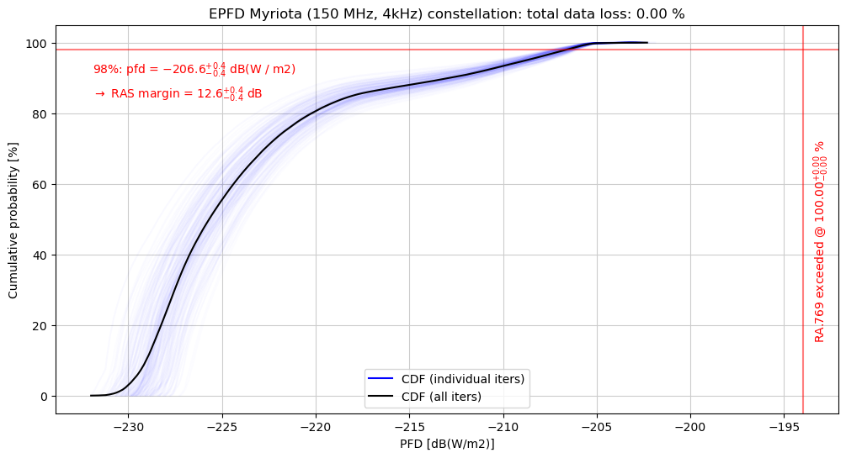

Figure 6: PFD distribution in the RAS band for Myriota's 4 kHz emissions

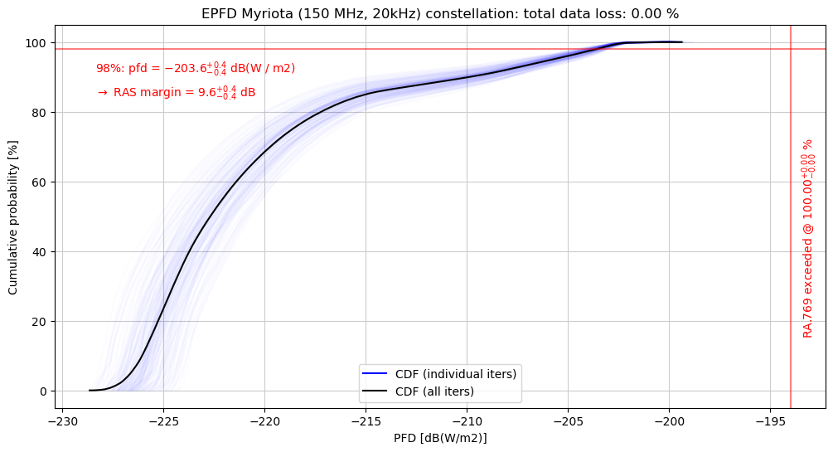

Figure 7: PFD distribution in the RAS band for Myriota's 20 kHz emissions

In all simulated cases, a spectral roll off of 110 dBc was applied (see section A4.4.2.3) to Myriota's in-band transmissions to calculate the out-of-band power in the RAS band. It is concluded that Myriota adequately protects the Radio astronomy in the band 150.05–153 MHz.

* + - 1. Protection of Meteorological Satellite Services

The Meteorological Satellite service is allocated on the 137 - 138 MHz band on a primary basis. Compatibility studies were conducted, in order to determine the level of interference generated by Myriota's satellite stations into Meteorological Satellite receiving Earth stations in Russia. The Recommendation used for the parameters is ITU-R SA.1026 and ITU-R SA. 1027. The parameters used for the victim station are shown in the table below:

Table 26: MetSat Earth Station parameters

|  |  |  |
| --- | --- | --- |
| Parameter | Value - VHF | Unit |
| Long-term protection criterion (I) | -142.00 | dBW |
| Long-term time allowance | 20.00 | % |
| Short-term protection criterion (I) | -136.00 | dBW |
| Short-term time allowance | 0.0125 | % |
| Centre frequency | 137.50 | MHz |
| System | B |  |
| Bandwidth | 150.00 | kHz |
| Antenna gain | 0.00 | dBi |
| Antenna pattern | Omnidirectional |  |

Dynamic aggregate interference simulations were performed. For this study, Myriota's constellation of 52 satellites was simulated and the interference generated at the meteorological satellite earth station was estimated, considering the orbital characteristics and the duty cycle of the interferer stations. The simulated MetSat earth stations are positioned in Russia. The propagation model considered between the two systems is described in ITU-R P.525 with the addition of fading loss from Recommendation ITU-R P.618 and atmospheric attenuations taken from Recommendation ITU-R P.676. A power reduction of 10 dB was applied to the Myriota satellites to account for the interference mitigation technique to protect the METEOR-3M earth stations in Russia. Note that the interference mitigation techniques proposed are only applicable invisibility of the three MetSat earth stations (listed below), considered in this study, which are located in Russia.

Table 27

|  |  |  |
| --- | --- | --- |
| Earth station location (number) | Longitude | Latitude |
| Moscow (1) | 37.3 E | 55.8 N |
| Novosibirsk (2) | 83.0 E | 55.0 N |
| Khabarovsk (3) | 135.2 E | 48.5 N |

The transmission cycle of the simulated satellites is independent, meaning that at a random time step each satellite has a chance of causing interference to the MetSat station equal to the satellite’s duty cycle regardless of whether other satellites are active or not. For that reason, there is a chance that more than one, or even none, satellites will be causing interference to the MetSat simultaneously. In addition, each satellite transmit only one carrier at a time, so that the total transmissions of a Myriota satellite fit into a single 4 or 20 kHz bandwidth.

A total of 20 days was simulated in time steps of 30 seconds, in a configuration shown in Figure 8. The complimentary cumulative distribution function of the interference measured at the victim station is shown in Figure 9. In this scenario, the protection criteria (for both short-term and long-term) is met for the 4 kHz transmissions but not for the 20 kHz transmissions.

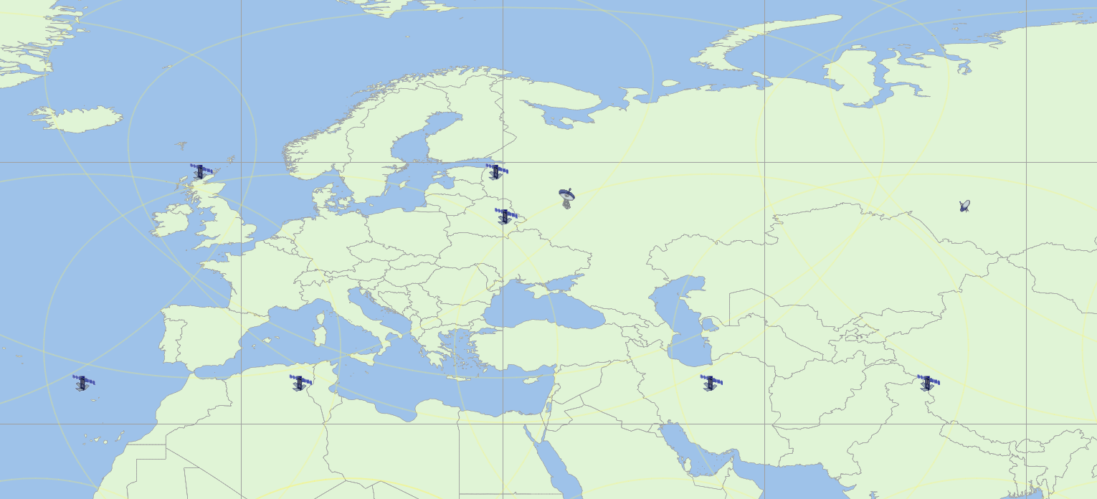

Figure 8: Simulation scenario for interference analysis between Myriota and

Meteorological Satellite earth station in Moscow



Figure 9: Interference at the Moscow Meteorological Satellite Earth station considering protection criteria from ITU-R SA.1026

On a second analysis, the METEOR-3M constellation was also simulated, in order to evaluate the impact of Myriota's interference when the Meteorological Satellite stations are overhead the receiving earth station. In this scenario, the meteorological satellite earth station is only a victim of interference when it is in line of sight of a meteorological satellite. When a satellite is not passing over, the meteorological satellite earth station is inactive and therefore not a victim of interference. The complimentary cumulative distribution function of the interference measured at the victim station is shown in Figure 10. Considering the entire constellation, the victim station is only receiving data and, consequently interference, when there is a meteorological satellite overhead. Thus, the long-term criterion is met for the 20 kHz carrier, but the short-term criterion is not met. The short-term exceedance margin for the 20 kHz carrier is in the order of 5 dB.



Figure 10: Interference at Moscow Meteorological Satellite Earth station when transmitting constellation is simulated considering protection criteria from ITU-R SA.1026

The 4 kHz carrier complies with both the short and long-term protection criteria, while 20 kHz carrier only complies with the long-term criterion if the Moscow MetSat station is considered to be active only when a METEOR‑3M satellite is visible. Thus, a duty cycle reduction of the 20 kHz carrier is necessary. In Figure 11, the duty cycle of the 20 kHz carrier was reduced to 0.08% for the case where the MetSat earth station is always active and to 0.45% for the case MetSat earth station is only active when a METEOR‑3M satellite is visible. Hence, Myriota can reduce the transmit power by 10 dB, for both carriers, and reduce the duty cycle to 0.45%, for the 20 kHz carrier, when in sight of a MetSat earth station in Russia in order to avoid interference.



Figure 11: Interference distribution when Moscow MetSat station is always active (left) and when it is only active when a METEOR-3M satellite is visible (right) with duty cycle reduction considering protection criteria from ITU-R SA.1026

The effectiveness of the proposed mitigation techniques was also analysed for MetSat earth stations located in Novosibirsk and Khabarovsk, with results shown below. For Novosibirsk, a duty cycle reduction to 0.04%, when the MetSat station is considered to be always on, and 0.13%, when it is only active when a METEOR-3M satellite is overhead, is necessary. For Khabarovsk, those values are 0.035% and 0.13% respectively.

 

Figure 12: Interference distribution when Novosibirsk MetSat station is always active (left) and when it is only active when a METEOR-3M satellite is visible (right) with duty cycle reduction considering protection criteria from ITU-R SA.1026

 

Figure 13: Interference distribution when Khabarovsk MetSat station is always active (left) and when it is only active when a METEOR-3M satellite is visible (right) with duty cycle reduction considering protection criteria from ITU-R SA.1026

Results considering the protection criteria described in Recommendation ITU-R SA.1027 were also generated. The Recommendation defines a long-term protection criterion of -147 dBW at a time percentage of 20% and -137 dBW at 0.0031% of the time. The results below analyse the necessary duty cycle reduction to protect the MetSat system from Myriota’s downlink interference. No duty cycle reduction is necessary for the 4 kHz carrier, but the 20 kHz carrier needs its duty cycle reduced to 0.008% in the case in which the Moscow MetSat station is always active and 0.05% when it is only active when a meteorological satellite is overhead. For the Novosibirsk MetSat station, those numbers are 0.006% and 0.055% respectively. For Khabarovsk they are 0.0065% and 0.05% respectively.

 

Figure 14: Interference distribution when Moscow MetSat station is always active (left) and when it is only active when a METEOR-3M satellite is visible (right) with duty cycle reduction considering protection criteria from ITU-R SA.1027

 

Figure 15: Interference distribution when Novosibirsk MetSat station is always active (left) and when it is only active when a METEOR-3M satellite is visible (right) with duty cycle reduction considering protection criteria from ITU-R SA.1027

 

Figure 16: Interference distribution when Khabarovsk MetSat station is always active (left) and when it is only active when a METEOR-3M satellite is visible (right) with duty cycle reduction considering protection criteria from ITU-R SA.1027

The table below summarises the necessary duty cycle of 20 kHz emissions for the short-term protection of MetSat earth stations. Combined with a 10 dB power reduction, the duty cycles shown in the Table will guarantee that the interference measured at the victim MetSat stations are not subject to harmful interference. For the 4 kHz carrier, the 10 dB power reduction is sufficient to protect the MetSat. It is important to note that Recommendation ITU-R SA.1026 states that “interference criteria are specified with respect to the percentage of time of reception by the earth station”. The results consider both scenarios: when the MetSat earth station is always active; and when the MetSat station is active only when a meteorological satellite is visible. Both results are kept for information purposes. The most stringent duty cycle values based on Recommendation ITU-R SA.1027 (the value of 0.006% for when the MetSat Novosibirsk earth station is always active) will be used to derive the mitigation techniques imposed on the Myriota system to protect METSAT earth stations in Russia.

Table 28: Necessary duty cycle of 20 kHz emissions for the short-term protection of MetSat earth stations

|  |  |  |  |  |
| --- | --- | --- | --- | --- |
|  | SA.1026 | | SA.1027 | |
| **MetSat station:** | **Always active** | **Active when satellite is visible** | **Always active** | **Active when satellite is visible** |
| Moscow | 0.08% | 0.45% | 0.008% | 0.05% |
| Novosibirsk | 0.04% | 0.13% | 0.006% | 0.055% |
| Khabarovsk | 0.035% | 0.13% | 0.0065% | 0.05% |

In order to verify that a duty cycle of 0.006% can protect all three considered earth stations, further study was carried out for 5.3 days with time steps of 0.01 seconds resulting in 45809992 ticks simulated. With minimum margin is positive 0.3 dB, 0.006% duty cycle ensures compatibility with considered MetSat earth stations and should be used when in their visibility. The Figures below depict these results.

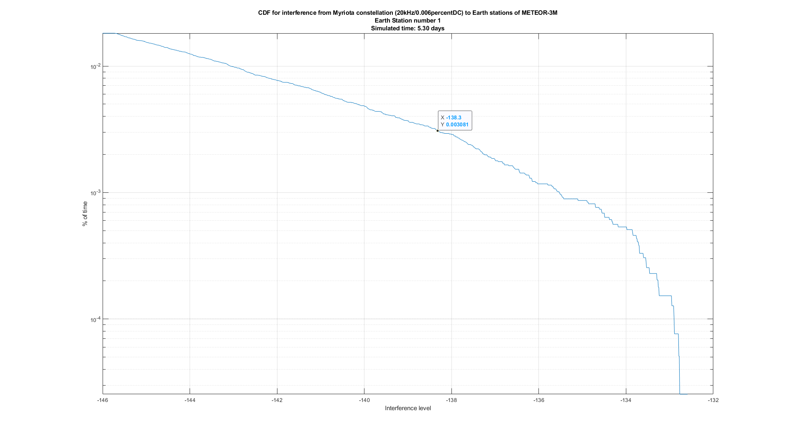

Figure 17: Interference distribution at Moscow station for Myriota downlink duty cycle of 0.006%

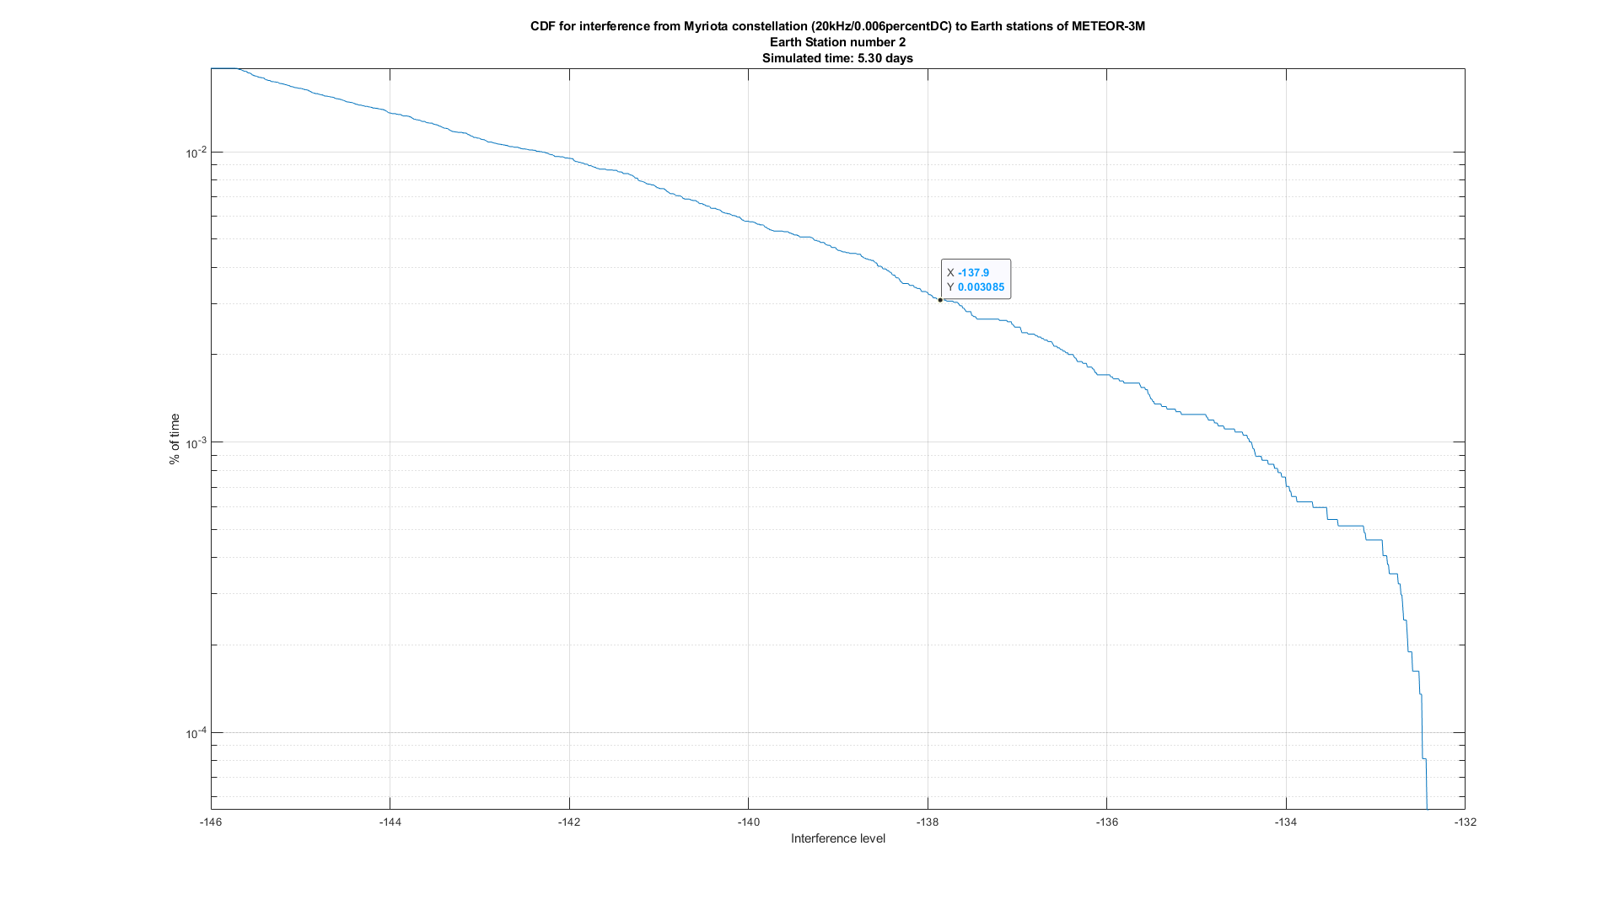

Figure 18: Interference distribution at Novosibirsk station for Myriota downlink duty cycle of 0.006%

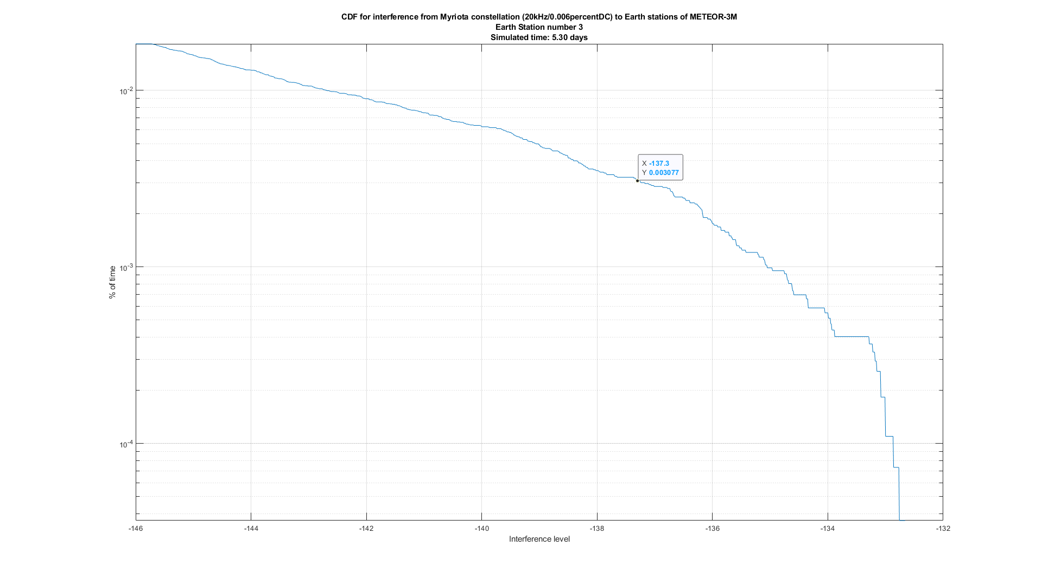

Figure 19: Interference distribution at Khabarovsk station for Myriota downlink duty cycle of 0.006%

The 137-138 MHz band is allocated to the Space Research Service (space-to-Earth) and Space Operation Service (space-to-Earth) on a secondary basis, they are not studied.

1. Description of FLEET
   1. General description

FLEET SPACE is an international satellite system operator which is providing IoT and M2M services through its NGSO satellite constellation, the deployment of which started in 2018 and will continue during 2020 and beyond.

FLEET SPACE is developing a combined satellite and ground segment network focused on industrial IoT, which aims to address the enterprise end of the market, where companies deploy thousands of sensors over a wide area. FLEET’s technology enables these companies to address and manage these large numbers of sensors.

The FLEET SPACE network will consist of:

* Up to 145 nanosatellites;
* Gateway ground stations around the globe. FLEET SPACE has constructed one gateway satellite ground station in South Australia, has rights of use for gateway ground stations in Italy and Spain. FLEET SPACE will expand the number of its own gateway ground stations over time;
* FLEET SPACE has developed a terrestrial network component called a Portal. The Portal provides:

Uplink and downlink communications to FLEET SPACE nanosatellites.

A LoraWAN network, connecting up to 1000 sensors within its wide area network catchment. This could be within a radius of up to 15 kilometres, depending on the topography of the area;

An edge platform for applications, plus a data analytics capability for processing the sensor data received.

The FLEET SPACE key components and system architecture is shown in the figure below:

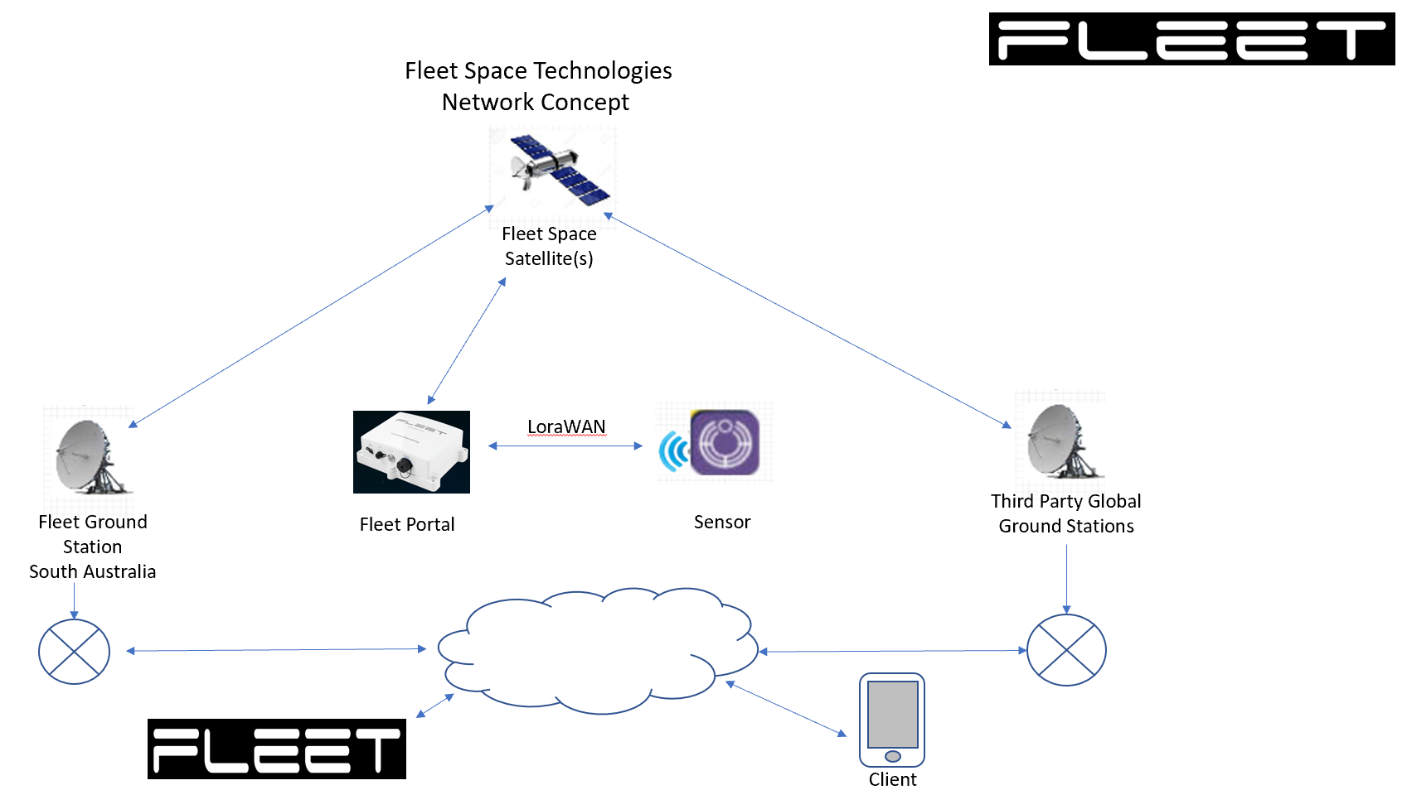

Figure 63: FLEET SPACE key components and system architecture Technical characteristics

* + 1. MES

IoT sensors in the FLEET SPACE network do not communicate directly with the FLEET SPACE satellites. FLEET SPACE IoT sensor devices communicate through a LoraWAN network to FLEET SPACE Portal terminals. The Portal terminals utilise an edge platform to process and compress the sensor data. FLEET SPACE’s proprietary algorithm thus ensures that there is between a 90% and 95% data-saving, in terms of the sensor data collected, that is actually transmitted to the FLEET SPACE satellites.

In terms of the MES interference environment:

* The MES density is considerably lower, since each IoT sensor is not an independent MES. Each Portal MES will service up to 1000 IoT sensors within its catchment area. The maximum MES density is expected to be in the range 5-10 MES terminals per 100 km2 and more typically would be in the range of 2 MES terminals per 100 km2;
* Because of the consolidation of the sensor traffic within the Portal terminals, the data uplinked to the satellites will be only around 5% to 10% of the data actually generated by the IoT sensors;
* Within the 399.9-400.05 MHz band, FLEET SPACE will operate its Portal terminals only in the 399.9 - 400.02 MHz range, and will operate a limited number of telecommand uplinks in the 400.02-400.05 MHz band in accordance with RR No. 5.260B (WRC-19). It should be noted that FLEET SPACE is not seeking to introduce its telecommand uplink stations into the ERC Decision (99)06 process. The operation of those telecommand uplink stations will be subject to ITU frequency coordination and national licencing of specific earth stations in the usual manner;
* Each FLEET SPACE Portal terminal will transmit with a low duty cycle of 0.05%. The maximum signal burst duration from each terminal will not exceed 3 seconds when the full constellation is deployed, with a burst repeat-period of 6000 seconds (so a ‘quiescent period’ of 5997 seconds between bursts). The typical burst duration will be close to this maximum. Each Portal terminal will transmit only when a FLEET SPACE satellite is passing overhead.

The maximum e.i.r.p. level in the 312-315 MHz and 399.9-400.02 MHz bands will be in the range -5 dBW to +3.5 dBW.

The RF Characteristics of a FLEET SPACE MES in the 312-315 MHz and 399.9-400.02 MHz bands are as shown in the following table.

Table 29: RF Characteristics of FLEET SPACE MES in the 312-315 MHz and 399.9-400.02 MHz frequency band

|  |  |
| --- | --- |
|  | FLEET SPACE MES |
| Maximum output power (W) | 1 |
| Maximum e.i.r.p (dBW) | 3.5 |
| Modulation | Chirp Spread spectrum |
| Data rate (bps) | 5600 |
| Bandwidth (kHz) | 120 |
| Symbol rate (sps) | 1 000 |

* + 1. SPACE SEGMENT

The FLEET SPACE system will be based on constellation of 145 nanosatellites with orbital parameters as shown in the following table:

Table 30: FLEET SPACE NGSO Satellites Orbital Parameters

|  |  |  |  |  |  |  |  |
| --- | --- | --- | --- | --- | --- | --- | --- |
| Orbital Plane No. | No. of satellites in this plane | Orbital altitude (km) | Incli-nation (degree) | Mean anomaly (degree) | Arg. of perigee (degree) | Right ascension of the ascending node (degree) | Eccentricity (degree) |
| 1 | 5 | 587 x 577 | 45 | Uniform distribution | 0 | 0 | 0 |
| 2 | 5 | 587 x 577 | 45 | Uniform distribution | 7.2 | 18 | 0 |
| 3 | 5 | 587 x 577 | 45 | Uniform distribution | 14.4 | 36 | 0 |
| 4 | 5 | 587 x 577 | 45 | Uniform distribution | 21.6 | 54 | 0 |
| 5 | 5 | 587 x 577 | 45 | Uniform distribution | 28.8 | 72 | 0 |
| 6 | 5 | 587 x 577 | 45 | Uniform distribution | 36 | 90 | 0 |
| 7 | 5 | 587 x 577 | 45 | Uniform distribution | 43.2 | 108 | 0 |
| 8 | 5 | 587 x 577 | 45 | Uniform distribution | 50.4 | 126 | 0 |
| 9 | 5 | 587 x 577 | 45 | Uniform distribution | 57.6 | 144 | 0 |
| 10 | 5 | 587 x 577 | 45 | Uniform distribution | 64.8 | 162 | 0 |
| 11 | 5 | 587 x 577 | 45 | Uniform distribution | 72 | 180 | 0 |
| 12 | 5 | 587 x 577 | 45 | Uniform distribution | 79.2 | 198 | 0 |
| 13 | 5 | 587 x 577 | 45 | Uniform distribution | 86.4 | 216 | 0 |
| 14 | 5 | 587 x 577 | 45 | Uniform distribution | 93.6 | 234 | 0 |
| 15 | 5 | 587 x 577 | 45 | Uniform distribution | 100.8 | 252 | 0 |
| 16 | 5 | 587 x 577 | 45 | Uniform distribution | 108 | 270 | 0 |
| 17 | 5 | 587 x 577 | 45 | Uniform distribution | 115.2 | 288 | 0 |
| 18 | 5 | 587 x 577 | 45 | Uniform distribution | 122.4 | 306 | 0 |
| 19 | 5 | 587 x 577 | 45 | Uniform distribution | 129.6 | 324 | 0 |
| 20 | 5 | 587 x 577 | 45 | Uniform distribution | 136.8 | 342 | 0 |
| 22 | 1 | 505 | 97.3 | - | 0 | 310 (SSO) | 0 |
| 23 | 1 | 525 | 97.6 | - | 0 | 317.6 (SSO) | 0 |
| 25 | 4 | 582 | 53 | Uniform distribution | 0 | 0 | 0 |
| 26 | 4 | 582 | 53 | Uniform distribution | 0 | 36 | 0 |
| 27 | 4 | 582 | 53 | Uniform distribution | 0 | 72 | 0 |
| 28 | 4 | 582 | 53 | Uniform distribution | 0 | 108 | 0 |
| 29 | 4 | 582 | 53 | Uniform distribution | 0 | 144 | 0 |
| 30 | 4 | 582 | 53 | Uniform distribution | 0 | 180 | 0 |
| 31 | 4 | 582 | 53 | Uniform distribution | 0 | 216 | 0 |
| 32 | 4 | 582 | 53 | Uniform distribution | 0 | 252 | 0 |
| 33 | 4 | 582 | 53 | Uniform distribution | 0 | 288 | 0 |
| 34 | 4 | 582 | 53 | Uniform distribution | 0 | 324 | 0 |
| 35 | 1 | 450 | 97.2 | - | 0 | 0 (SSO | 0 |
| 36 | 1 | 520 | 97.5 | - | 0 | 0 (SSO) | 0 |
| 37 | 1 | 540 | 97.6 | - | 0 | 0 (SSO) | 0 |

The main operating configuration is based on the 100-satellite configuration at 45° inclination in orbit planes 1–20 and the 40-satellite configuration at 53° inclination in orbit planes 25 - 34. Orbit planes 22, 23, 35, 36 and 37 are being used for initial implementation and technology validation, and will continue to be operated after deployment of the full constellation, in order to provide better service availability to very high and very low latitudes. FLEET SPACE does not currently plan to use planes 21 and 24 as included in the published ITU filing and does not propose to include them in the compatibility studies. Therefore, these orbit planes are not included in the above table.

The satellite transmitting and receiving antennas in the <1 GHz frequencies have a 1.5 dBi gain pattern, symmetrical around the nadir axis.

Table 31: Satellite antenna gain pattern for the 312-315 MHz, 387-390 MHz, 399.9-400.02 MHz and 400.15-401 MHz bands

|  |  |  |  |  |  |  |  |  |  |
| --- | --- | --- | --- | --- | --- | --- | --- | --- | --- |
| Off-axis angle (°) | 0 | 10 | 20 | 30 | 40 | 50 | 60 | 70 | 80 |
| Elevation (°) | 90 | 79.4 | 68.7 | 57.9 | 46.9 | 35.4 | 22.9 | 1.3 | - |
| Gain (dBi) | 1.5 | 1.5 | 1.2 | 1 | 0.5 | 0.1 | -1 | -1.2 | -1.3 |

Note that the above table is provided for the lowest altitude orbit, i.e. 407 km, since this case represents the configuration that results in the highest PFD on the Earth’s surface.

Satellite emission characteristics:

* Maximum power at antenna flange: 6 dBW
* Maximum e.i.r.p.: 7.5 dBW
* Emission bandwidth: less than 125 kHz

The FLEET SPACE satellite downlinks in the bands 387-390 MHz and 400.15-401 MHz will be used primarily for network control, firmware updates and confirmations of data packets received. The downlink channel may also be used to issue commands to user equipment linked to the Portal terminal (e.g. valve actuation), however, such use will represent only a very small use of the downlink channel (less than 1% of the downlinked data).

The duty cycle of the FLEET SPACE downlinks will not exceed 8% per satellite. The maximum signal burst duration from each satellite will not exceed 400 seconds, with a burst repeat-period of 5000 seconds (so a ‘quiescent period’ of 4600 seconds between bursts). The typical burst duration will be closer to 200 seconds, but for such a case the duty cycle would be less than 8%.

* 1. Inter-service Compatibility studies
     1. Compatibility with terrestrial services in the 312-315 MHz (EARTH-TO-SPACE) band

The band 312-325 MHz is allocated to the FIXED and MOBILE services.

The band 312-315 MHz may be used by the mobile-satellite service, on condition that stations in this service do not cause harmful interference to, nor claim protection from, those primary services operating or planned to be operated in accordance with the Table of Frequency Allocations.

Hence, the band 312-315 MHz will only be used on the condition that FLEET SPACE MES stations will not cause harmful interference to, nor claim protection from, the FIXED and MOBILE services.

The parameters and protection criteria used for the land mobile systems in this study were taken from Recommendation ITU-R M.1808-1 and shown in the below table.

Table 32: The parameters and protection criteria for the land mobile systems in the band

312-315 MHz

|  |  |  |
| --- | --- | --- |
| Frequency band (MHz) | 223 to 328.6 | 223 to 328.6 |
| Channel bandwidth (kHz) | 25 to 1250 | 25 to 1250 |
| Modulation type | CPM, 4CPM, 8CPM, BPSK, QPSK, 8‑PSK, 16-QAM, 64‑QAM | CPM, 4CPM, 8CPM, BPSK, QPSK, 8-PSK, 16-QAM, 64-QAM |
| Type of operation | Simplex/duplex | Simplex/ duplex |
| Typical SINAD (dB) or BER (%) | 5% | 5% |
| Transmitter |  |  |
| Output power (W) | 0.4 to 50 | H: 0.2 to 10  V: 0.4 to 50 |
| e.r.p. (dBW) | –1.8 to 19 | H: −12 to 5  V: −7 to 14 |
| Necessary bandwidth (kHz) | 25 to 1 250 | 25 to 1 250 |
| Coverage radius (km) | 1 to 200 | - |
| Antenna gain (dBd) | 0 to 11 | H: −7.15  V: −2.15 |
| Antenna height (m)  (relative to ground level) | 5 to 10 | H: 1.5  V: 2.5 to 5 |
| Radiation pattern | Omnidirectional | Omnidirectional |
| Antenna polarization | Vertical | Vertical |
| Total loss (dB) | 3 | 0 to 3  (H: 0, V: 3) |
| Receiver |  |  |
| Noise figure (dB)* | 5 to 12(7) | 5 to 12(7) |
| IF filter bandwidth (kHz) | 25 to 1250 | 25 to 1 250 |
| Sensitivity (dBm) | −95 to −121 | −95 to −121 |
| Antenna gain (dBd) | 0 to 11 | H: −7.15  V: −2.15 |
| Antenna height (m)  (relative to ground level) | 5 to 10 | H: 1.5  V: 2.5 to 5 |
| Radiation pattern | Omnidirectional | Omnidirectional |
| Antenna polarization | Vertical | Vertical |
| Total loss (dB) | 3 | 0 to 3  (H: 0, V: 3) |
| Protection criterion (I/N) (dB) | -6 | -6 |
| *When considering the radio-frequency noise contribution from the operating environment to determine the noise level, N, for land mobile systems, Recommendation ITU-R P.372 should be used. | | |

In accordance with Recommendation ITU-R M.1808-1 for carrier-to-interference analysis, Recommendations ITU-R P.452 and/or ITU-R P.1546 and/or ITU-R P.2001 should be used to estimate carrier and interference levels in the operating environment for land mobile systems. In this study Recommendation ITU-R P.1546 was used.

The required separation distances between MES and Land Mobile stations are shown in Table 33. To calculate these values, the minimum coupling loss between the two systems was calculated and the associated separation distance determined, using the propagation model described in ITU-R P.1546. Calculations were made for two types of LMS BSs (type 1 – antenna gain 13 dBi and antenna height 10 m; type 2 - antenna gain 0 dBi and antenna height 5 m) and LMS MS (see Figure 1). For this analysis, the transmit MES e.i.r.p. in the direction of the horizon towards LMS was considered the same as for the direction towards the satellite (in the range -5 dBW to +3.5 dBW as provided in section A13.1). In practice, the gain towards the horizon is expected to be lower and would further reduce the distance values shown in the below table.

Table 33: Separation distances between MES and LMS

|  |  |  |  |
| --- | --- | --- | --- |
| MES operation mode | LMS BS type 1 | LMS BS type 2 | LMS MS |
| Maximum operation | 23.82 km | 12.75 km | 11.94 km |
| Minimum operation | 15.15 km | 8.35 km | 7.9 km |

|  |  |
| --- | --- |
|  |  |
|  |  |
|  |  |

Figure 64: Separation distances determined, using the propagation model described in ITU-R P.1546

Because of the consolidation of the sensor traffic within the Portal terminals (IoT sensors in the FLEET SPACE network do not communicate directly with the FLEET SPACE satellites), the MES density is considerably lower, since each IoT sensor is not an independent MES. The maximum MES density is expected to be in the range 5-10 MES terminals per 100 km2 and more typically would be in the range of 2 MES terminals per 100 km2. Due to such system architecture it is much easier for the operator to control Portal terminals location and manage mitigation with LMS (Geographical Location of a MES mitigation technique).

Based on current allocation and performed study results the following approach could be considered to share the spectrum in the band 312-315 MHz.

MES shares the 312–315 MHz frequency spectrum, or portions thereof, on a Non-Interference Basis (NIB). At any time, if stations of services, operating in accordance with the table of frequency allocations, suffer interference from FLEET SPACE, FLEET SPACE shall take any necessary action to stop the interference, in accordance with ITU procedures. In addition, FLEET SPACE may not claim protection from stations of services operating in accordance with the table of frequency allocations.

In order to further mitigate interference towards mobile service systems a restricted duty cycle mode could also be introduced applying if the number of MES emissions in CEPT countries exceeds a particular value per day. In the restricted duty cycle mode, all uplink terminal activity in CEPT countries (each IoT sensor in the FLEET SPACE network is not an independent MES) will have to comply with the following constraints simultaneously (see below figure):

* Duration of activity and muting period;
* Duration of activity window;
* Maximum ratio between activity window and the activity window plus the muting window;
* Transmission windows in CEPT countries are synchronised.



Figure 65: Example of possible restricted duty cycle mode

Other operational constraints of FLEET SPACE in the considered frequency band, such as maximum MES e.i.r.p., techniques to avoid causing interference from MESs (MES transmits only when satellite is visible), maximum burst duration for MESs, geographical location of a MES could also be introduced.

* + 1. Compatibility with terrestrial services in the 387-390 MHz (SPACE-TO-EARTH) band

The band 387-390 MHz is allocated to the FIXED and MOBILE services.

The band 387-390 MHz may be used by the mobile-satellite service, on condition that stations in this service do not cause harmful interference to, nor claim protection from, those primary services operating or planned to be operated in accordance with the Table of Frequency Allocations.

Hence, the band 387-390 MHz will only be used on the condition that FLEET SPACE nanosatellites will not cause harmful interference to, nor claim protection from, the FIXED and MOBILE services.

All practical steps must be taken to protect the Radio Astronomy Service in the bands 150.05-153 MHz, 322-328.6 MHz, 406.1-410 MHz and 608-614 MHz from harmful interference from unwanted emissions from operations in the 387-390 MHz band, as per RR No. 5.208A (see section A5.2.6).

In accordance with ECA table the band 387-390 MHz is identified for the use of digital land mobile PMR (Professional (Private) Mobile Radio)/PAMR (Public Access Mobile Radio). Mobile station transmit (base station receive) paired with 397.0-399.9 MHz. The ECA table also identifies PPDR on a tuning range basis in 380-470 MHz range according to ECC/DEC/(08)05 “The harmonisation of frequency bands for the implementation of digital Public Protection and Disaster Relief (PPDR) narrow band and wide band radio applications in bands within the 380-470 MHz range”.

The Recommendation T/R 25-08 contains band plans for land mobile systems between 29.7 MHz and 470 MHz. CEPT administrations should endeavour to comply with the provisions in Recommendation T/R 25-08, when assigning frequencies to stations in the land mobile service. In accordance with Recommendation T/R 25-08 the band 387-390 is identified for mobile station transmit, so the receiving station is an LMS BS.

The compatibility of the FLEET SPACE downlink transmissions with the terrestrial services in the band 387-390 MHz will be ensured by achieving a low level of pfd at the Earth surface. The transmission power and the carrier bandwidth of on-board transmitter may vary to achieve optimal values. In total, with a low duty cycle not exceed 8%, this provides significant flexibility while ensuring compatibility with terrestrial services. FLEET SPACE can vary the length, interval, data rate, bandwidth, frequency of its satellite downlink transmissions.

FLEET SPACE ground pfd in the band 387-390 MHz was simulated to demonstrate that compatibility with terrestrial services could be ensured.

Satellite antenna gain pattern for the 387-390 MHz band is presented in section A5.1.2.

Satellite emission characteristics:

* Maximum power: 6 dBW;
* Typical power: 0 dBW;
* Maximum e.i.r.p.: 7.5 dBW;
* Typical e.i.r.p.: 1.5 dBW;
* Emission bandwidth: 125 kHz;
* Duty cycle: 8%.

The CDFs of FLEET SPACE pfd at the Earth surface in a particular point (43.733N; 7.416E) for the maximum and typical satellite downlink e.i.r.p. in the band 387-390 MHz are shown in the below figures.



Figure 66: FLEET SPACE ground pfd, maximum e.i.r.p.



Figure 67: FLEET SPACE ground pfd, typical e.i.r.p.

It can be seen that for the typical satellite downlink e.i.r.p. FLEET SPACE pfd in the band 387-390 MHz will amount to -142 dB(W/(m2·4 kHz)) for the 8% of time and pfd value of -135 dB(W/(m2·4 kHz)) will not be exceeded more than 0.002315% of time. The resulting values will be significantly less than the threshold value of -125 dB(W/(m2·4 kHz)) identified for the protection of terrestrial services in the VHF and other similar UHF bands.

* + 1. Compatibility with terrestrial services in the 399.9-400.02 MHz (EARTH-TO-SPACE) band

The band 399.9-400.02 MHz is allocated solely to the MSS (Earth-to-space), limited to non-geostationary systems. Hence there are no compatibility studies to be carried out with respect to terrestrial services.

The ECA table identifies ECC/DEC/(08)05 ”The harmonisation of frequency bands for the implementation of digital Public Protection and Disaster Relief (PPDR) narrow band and wide band radio applications in bands within the 380-470 MHz range” as pertinent for the band 399.9-400.02 MHz. However, none of the frequency arrangements for mobile systems, including PPDR, include the band 399.9-400.02 MHz.

Based on the above, no specific measures are necessary to ensure compatibility with terrestrial services.

* + 1. Compatibility with terrestrial services in the 400.15-401 MHz (SPACE-TO-EARTH) band

The band 400.15-401 MHz is allocated to the METEOROLOGICAL AIDS service, and to the FIXED and MOBILE services in certain countries under RR No. 5.262.

All practical steps must be taken to protect the radio astronomy service in the bands 150.05-153 MHz, 322-328.6 MHz, 406.1-410 MHz and 608-614 MHz from harmful interference from unwanted emissions from operations in the 387-390 MHz band, as per RR No. 5.208A (see section A5.2.6).

As provided by RR No. 5.264, the PFD threshold indicated in Annex 1 of Appendix 5 of the ITU Radio Regulations shall be used as a coordination trigger in the 400.15-401 MHz band with respect to terrestrial services. That PFD threshold is -125 dBW/m2/4 kHz at the Earth’s surface.

In order to demonstrate compliance with this value, the table below provides the PFD for a satellite in the FLEET SPACE system for the whole range of satellite transmit off-axis angles with Earth visibility (elevations ranging from 0 to 90°). In all cases, the PFD on Earth is below the prescribed power flux density threshold.

This table is based on the lowest ITU filed altitude of a FLEET SPACE satellite, i.e. 407 km (noting that this altitude is not currently planned to be used operationally). The flux density from any other altitude will be lower, owing to increased range and thus increased spreading loss.

Table 34:

|  |  |  |  |  |  |  |  |  |  |
| --- | --- | --- | --- | --- | --- | --- | --- | --- | --- |
| Off-axis angle (°) | 0 | 10 | 20 | 30 | 40 | 50 | 60 | 70 | 80 |
| Elevation (°) | 90 | 79.4 | 68.7 | 57.9 | 46.9 | 35.4 | 22.9 | 1.3 | - |
| Gain (dBi) | 1.5 | 1.5 | 1.2 | 1 | 0.5 | 0.1 | -1 | -1.2 | -1.3 |
| Power (dBW/4 kHz) | -8.8 | -8.8 | -8.8 | -8.8 | -8.8 | -8.8 | -8.8 | -8.8 | -8.8 |
| e.i.r.p. (dBW/4 kHz) | -7.3 | -7.3 | -7.6 | -7.8 | -8.3 | -8.7 | -9.8 | -10.0 | -10.1 |
| Range (km) | 407.0 | 413.7 | 435.0 | 475.1 | 543.8 | 664.9 | 912.4 | 2168.3 | - |
| Spreading loss (dB) | 123.2 | 123.3 | 123.8 | 124.5 | 125.7 | 127.4 | 130.2 | 137.7 | - |
| Power Flux Density  (dBW/m²/4 kHz) | -130.4 | -130.6 | -131.3 | -132.3 | -134.0 | -136.1 | -139.9 | -147.7 | - |

As a consequence of the above, the FLEET SPACE system is compatible with terrestrial services in the 400.15-401 MHz band.

* + 1. Compatibility between FLEET SPACE system and Standard Frequency Time Signal Satellite radio Service in the ADJACENT frequency band 400.05-400.15 MHz

The SFTSS (Standard Frequency and Time Signal Satellite Service) is allocated in Article 5 of the Radio Regulations on primary basis in the band 400.05-400.15 MHz. In accordance with footnote 5.261, emissions shall be confined in a band of +/- 25 kHz about the standard frequency 400.1 MHz.

Depending on the required necessary bandwidth of MSS (s-E) emission in the band 400.15-401 MHz, there may be two interference scenarios with SFTSS in the band 400.05-400.15 MHz (see the below figure):

* The SFTSS signal frequency falls in the spurious emissions domain of the MSS (s-E) emissions (narrow-band cases and all cases in the upper parts of MSS band);
* The SFTSS signal frequency falls in the out-of-band domain of the MSS (s-E) emissions (wide-band cases in the lower part of MSS band).



Figure 68: Interference scenarios with SFTSS

In accordance with RR the boundary between the out-of-band and spurious domains occurs at frequencies that are separated from the centre frequency of the emission by the values of 250% of the necessary bandwidth, or at 2.5 BN (see below figure). The reference bandwidth of all space service spurious domain emissions should be 4 kHz.



Figure 69: Example of the boundary between the out-of-band and spurious domains

Values for frequency separation between the centre frequency and the boundary of the spurious domain for different MSS (s-E) cases of BN are shown below

Table 35:

|  |  |  |
| --- | --- | --- |
| Frequency band | for BN | Separation |
| 400.15-401 MHz | 4 kHz | 10 kHz |
| 125 kHz | 312.5 kHz |

The following formula can be used to calculate the pfd value to protect SFTSS systems:



where:

* I : interference corresponding to the SFTSS system protection criterion (dBW);
* G : SFTSS system antenna gain (dBi);
* λ : wavelength (m).

For a given I/N criterion, interference can be represented as  and N=kTB, then the formula for pfd in the reference band B=4 kHz takes the form:

The identified SFTSS network’s characteristics are summarized as follows, and the right column provides the pfd value to meet an I/N of -10 dB protection criteria in the worst-case conditions.

Table 36:

|  |  |  |  |  |  |  |  |  |
| --- | --- | --- | --- | --- | --- | --- | --- | --- |
| Network name | Adm | Freq min | Freq max | Station class | Emission designator | E/S Rx Gain | E/S Noise temp | Worst case PFD  (dBW/m²/4 kHz) |
| TSYKADA | RUS | 400.075 | 400.125 | EE | 50K0G2D-- | 0 | 200 | -166.1 |
| LEOTELCOM-1 | USA | 400.075 | 400.125 | EE | 50K0G7D-- | 2 | 400 | -165.1 |
| 400.075 | 400.125 | EE | 50K0G7D-- | 6.1 | 400 | -169.2 |
| ICARUS | D | 400.05 | 400.15 | EY | 5K00G1D-- | -10 | 3000 | -144.3 |
| 400.05 | 400.15 | EY | 50K0G1D-- | -10 | 3000 |
| F-SAT-NG-8 | F | 400.05 | 400.15 | EY | 50K0G7W-- | 0 | 500 | -162.1 |
| 400.05 | 400.15 | EY | 12K3G7W-- | 0 | 500 |
| 400.05 | 400.15 | EY | 1K00G7W-- | 0 | 500 |

Simulation of Fleet constellation (out-of-band pfd in 4 kHz reference bandwidth) for the worst-case scenario when the SFTSS signal frequency falls in the out-of-band domain of the MSS (s-E) emissions was performed. With a space station transmitter total mean power of 6 dBW attenuation relative to total mean power of 60 dBc was used. Satellite antenna gain pattern for the 400.15-401 MHz bands is presented in section A5.1.2. The duty cycle of the Fleet downlinks was 8% per satellite during this simulation. The receiving SFTSS ES was placed at a location with geographical coordinates 55N; 37E.

For the given assumptions the impact into the SFTSS station was simulated (simulation time 15 days, simulation step 1 sec) (see below figure).



Figure 70: pfd distribution at the SFTSS ES site

The simulated Fleet system pfd values within the adjacent band 400.05-400.15 MHz are below pfd values calculated to protect the identified SFTSS systems with a margin of at least 20 dB.

* + 1. Compatibility with Radio Astronomy in the band 406.1-410 MHz

The band 406.1-410 MHz is allocated to Radio astronomy service and is used for continuum observations integrated throughout the band.

The FLEET SPACE downlink transmissions in the band 400.15-401 MHz will comply with Appendix 3 of the Radio Regulations with respect to emissions in the spurious domain, and with Recommendation ITU-R SM.1541-1 with respect to emissions in the out-of-band domain. The actual emissions of the FLEET SPACE payload are expected to be lower than these levels. In order to mitigate MSS downlink interference to the Radio Astronomy Service, FLEET SPACE will ensure sufficient filtering in its satellite downlinks to ensure that unwanted emissions in the 406.1-410 MHz Radio astronomy band will not exceed -87.6 dBc.

The FLEET SPACE uplink transmissions operate in the 399.9-400.02 MHz band are also able to protect Radio astronomy sites. The radio telescopes use highly directive antennas, with low gain towards transmitters located on Earth. In addition, terrain often provides significant path attenuation. In order to mitigate MSS uplink interference to the Radio astronomy Service, FLEET SPACE will ensure sufficient filtering in its MES uplinks to ensure that unwanted emissions in the 406.1-410 MHz Radio astronomy band will not exceed -85 dBc.

The FLEET SPACE Portal terminals transmit at low power levels, typically in the range -5 dBW to +1.5 dBW and never more than 5 dBW. The low duty cycle further reduces the interference impact as Radio astronomy observations are made over large integration times. Moreover, FLEET SPACE Portal terminals will have a relatively low density expected to be in the range 5-10 MES terminals per 100 km2, and more typically in the range of 2 MES terminals per 100 km2, which will further reduce

1. Intra-services study on ARGOS/KINEIS - HIBER
   * 1. Studies for the band 399.9-400.05 MHz band
     2. Studies for the 400.15-401 MHz band
     3. Conclusions
2. Intra-services study on SWARM - LEOTELCOM-1
   1. Interference level study
   2. Time domain study
3. Intra-services study on MYRIOTA - LEOTELCOM-1
   1. DOWNLINK (Myriota to/from LEOTELCOM-1)
   2. UPLINK (Myriota to/from LEOTELCOM-1)
4. Intra-services study on MYRIOTA - HIBER
   1. UPLINK (Myriota to/from Hiber)

Myriota modules and micro-gateways share radio frequencies with other satellite communication systems. This document analyses the extent that Myriota IoT modules and micro-gateways cause interference to the HIBER, and the extent to which the HIBER system causes interference to the reception of signals from Myriota IoT modules and micro-gateways. The communications systems of interest here are packetised, so the analysis takes the form of a maximum rate at which a given system can transmit packets before causing intolerable interference to another system.

The CEPT compatibility study applies to the operation of Myriota's and HIBER's satellite systems in Europe, showing the coexistence between these systems. Further compatibility studies are intended to be mutually ongoing between operators to determine precisely how coexistence is achieved for maximum capacity, with intent to optimise parameters between systems.

This study considers two satellite communication systems that share a segment of radio frequencies of bandwidth W. With the aim of understanding the constraints under which these two systems can operate in a largely uncoordinated fashion, for example, without need for dividing the radio frequencies into two segments of bandwidth W/2. To this end the interference caused by one satellite communications system upon another is analysed. The proposed methods will arrive at acceptable rates at which one system can transmit so as not to cause intolerable interference on another. These methods are used to compare the interoperability between Myriota’s system (with IoT modules and micro-gateways) and the MSS systems of HIBER.

The analysis performed makes use of the following parameters that describe each system:

* Transmit power P, measured in Watts (W);
* Burst length B, measured in seconds (s);
* Noise tolerance Ƭ, (unitless constant).

The power P is the effective isotropic radiated power (e.i.r.p.). This incorporates the effect of amplifiers and antennas in the transmission of signals. In the case that a system may transmit at multiple distinct power levels, then P is taken to be the average power.

All systems featured in this comparison are packetised, so data is transmitted in bursts of finite length B. For example, the duration of bursts transmitted by the Myriota module are all 260 ms. In the case that a system makes use of multiple distinct burst lengths, then B is taken to be the average burst length.

The noise tolerance measures the ability of the system to tolerate interference or noise signals and is defined as follows. Given a burst x with unit power (1 W) and a white noise signal n of constant power spectral density 1 W kHz−1, then the tolerance T is a positive constant such that useful information can be gained from observation of the sum

$$x+ αn$$

when α2 ≤ T. For α2 > T, information may not be able to be extracted from observation of the sum. In practice this typically means that the information contained in x (the bits) is not correctly demodulated or decoded.

The noise tolerance T is typically measured by simulation or experiment as a part of the communication system design. For example, in Myriota’s case, the occupied bandwidth of a burst is 4 kHz, so a burst x is well represented by samples xk = x( k / R ), k ∈ ℤ taken at rate R > 8 kHz. The amplitude of the burst is scaled so that the total energy

or equivalently, so that the average power of the burst is 1 W. Similarly, samples nk , k ∈ ℤ of the noise process n taken at rate R are independent and have variance R/1000 corresponding with n having power spectral density 1 W kHz−1. One then applies the demodulator and decoder to the samples

for various values of α to determine the tolerance Ƭ. Such experiments are commonplace in the communications system design process.

Table 37 outlines the power P, burst length B, and noise tolerance Ƭ for the Myriota module, Myriota micro-gateway, and the MSS systems of HIBER. The remainder of this document describes how these parameters can be used to analyse the interference caused by one system upon another to evaluate the ability of two satellite communication systems to share a segment of radio frequencies of bandwidth W. To this end this study supposes one system to be the victim and another to be the interferer, and analyses the extent to which transmissions from the interferer impact the victim. In particular, a number of packets per second Si that the interferer may transmit without causing intolerable interference to the victim is determined. The packets per second Si can be computed for any combination of interfering and victim systems, and provides a metric of compatibility with two possible outcomes:

A system can profitably transmit Si packets per second and not cause intolerable interference to others, and the interferer is compatible with the victim.

Alternatively, Si is too small for the interferer to be profitable, and the interferer is not compatible with the victim.

The method for determining the packets per second Si for an interfering system in terms of the power, burst length, and noise tolerance is now derived. Let Pi and Bi be the power and burst length of the interfering system and let Pv and Ƭv be the power and noise tolerance of the victim. The interfering system is supposed to utilise the entire bandwidth W such that the interference generated can be approximately modelled as white noise with power spectral density $I_{PSD}$ described by:

$$I_{PSD}= \frac{S_{i}P_{i}B_{i}}{W}$$

per kHz. Intolerable interference will be caused to the victim if this noise power exceeds the tolerance Tv once normalised by the power of the victim Pv, that is, if

The maximum number of packets per seconds Si that the interferer can transmit is then:

This expression is simple and useful but ignores the variation of received signal strength that occurs as satellites orbit the earth. To account for this, denote the path loss of the victim by Lv and of the interferer by Li . While the radiated power of the victim is Pv the received power is Pv/ Lv. Similarly, the received power of the interfering signals is Pi/ Li . The maximum number of packets per second accounting for path loss is then:

Observe that this is simply the first equation for scaled by the ratio of path losses Li / Lv . It remains to define the path losses Lv and Li in relation to the receiving satellite of the victim.

A satellite orbiting at altitude A has range given by:

$$R\left(θ\right)= R_{E}\left(\sqrt{{\left(\frac{A+ R_{E}}{R_{E}}\right)}^{2}-\cos^{2}(θ)}-sin(θ)\right)$$

when viewed at elevation angle θ, where RE = 6378 km is the radius of the earth. The path loss at elevation θ is given by:

$$L\left(θ\right)= \frac{16π^{2}R^{2}(θ)f_{c}^{2}}{c^{2}}$$

Where:

* c = 299.792 km/s is the speed of light
* fc is the frequency (Hz) at which the signal is transmitted.

Satellite antennas often display elevation dependent gain that is denoted by G(θ). The gain G (dBi) is specified at a number of elevations for each system and varies from system to system. If packets from the interfering system occur at elevation θi, and packets from the victim occur at elevation θv, then the ratio of path losses takes the form:

The final expression of the maximum number of packets per second that may be transmitted by an interference system is:

Where:

* R(θ) is the range (km)
* G(θ) is the antenna gain (dBi) of the victim's satellite when viewed at elevation angle θ.

In what follows, we consider the value of Si in three scenarios:

* Best-case scenario, where θi = 15° and θv = 90°
* Realistic scenario, where θi = θv and Lv/Li = 1
* Worst-case scenario, where θv = 15° and θi = 90°

The best-case scenario supposes that devices from the interfering system observe the victim satellite at 15° elevation, while the devices of the victim observe the victim satellite at 90°. In this case, the distance from satellite to interferer is larger than from satellite to victim. The interference is correspondingly smaller, and the number of packets Si that can be transmitted by the interfering system is larger. The best-case scenario might be realisable in a partially coordinated setting where systems actively choose to limit transmissions when satellites of a different MSS operator are visible.

The realistic scenario considers the path loss to be equal between systems. This is a likely outcome in a fully uncoordinated setting.

The worst-case scenario observes what happens when transmissions from an interfering system are concentrated when in close proximity to a satellite of a different MSS operator. While interesting for analytical purposes, the worst-case scenario is unlikely to occur in a sustained manner in practice.

The below table outlines the relevant properties of expected radiated power P, average burst length B, and noise tolerated T. The altitude and antenna gain of the MSS systems are also tabulated. The power and burst length have been specified by the operators of these systems. The noise tolerance for the Myriota IoT module is T = 1/4. The Myriota micro-gateway can operate with various noise tolerances. For this study, a typical operating value T = 1/4 is assumed.

The noise tolerance for the HIBER services is specified by the carrier to noise ratio and occupied bandwidth of these systems. Given carrier to noise ratio C0, and occupied bandwidth W0, the corresponding noise tolerance is:

$$T= \frac{1}{C_{0}W_{0}}$$

HIBER has not specified either a noise tolerance or carrier to noise ratio. For these systems we assume a noise tolerance of 5/12, which is equivalent to the ARGOS-Kinéis wideband service. The equivalent assumption was made, for example, by ARGOS-Kinéis who assumed the HIBER 120 kHz CDMA service to have a carrier to noise ratio of −17 dB in their compatibility analysis.

Table 37: Typical system properties

|  |  |  |  |  |  |  |
| --- | --- | --- | --- | --- | --- | --- |
| **MSS System** | **P**  **Earth station e.i.r.p. (dBW)** | **B**  **burst length (s)** | **Ƭ**  **noise tolerance (unitless)** | **A**  **satellite altitude (km)** | **G (15°)**  **satellite antenna gain at 15° (dBi)** | **G (90°)**  **satellite antenna gain at 90° (dBi)** |
| Myriota (IoT Module) | -3 | 0.26 | 0.25 | 600 | 0 | 0 |
| Myriota (micro-gateway) | 0 | 0.5 | 0.25 | 600 | 0 | 0 |
| HIBER | 0 | 0.4 | 0.417 | 600 | 3 | -2.6 |

This intra-service analysis shows that uplink operations of Myriota’s system poses minimal interference risk HIBER’s system, and that sharing of the spectrum may be possible. The two tables below summarises the results of the analysis, and outline the number of packets per second a single MSS system can transmit when operating with 150 kHz bandwidth. This analysis motivates further detailed coordination studies between Myriota and HIBER to identify the best sharing methods, whilst also considering the effects of interference to Myriota’s system.

Table 38: Maximum packets per second that may be transmitted by Myriota before causing interference to HIBER, with W = 150 kHz, for realistic scenario θi = θv

|  |  |  |
| --- | --- | --- |
| **VICTIM** | **INTERFERER** | |
| **Myriota (IoT module)** | **Myriota (micro-gateway)** |
| HIBER | 480.01 | 125.10 |

Table 39: Maximum packets per second that may be transmitted separately by HIBER before causing interference to Myriota, with W = 150 kHz, for realistic scenario θi = θv

|  |  |  |
| --- | --- | --- |
| **INTERFERER** | **VICTIM** | |
| **Myriota (IoT module)** | **Myriota (micro-gateway)** |
| HIBER | 46.99 | 93.75 |

System compatibility calculations in the UHF band are provided for the following:

* The number of packets per second that HIBER can transmit without causing intolerable interference to the Myriota system, for Myriota's IoT modules and micro-gateways.
* The number of packets per second that Myriota's IoT modules and micro-gateways can transmit without causing intolerable interference to themselves and to HIBER’s system.
* The best-case, realistic, and worst-case scenarios are considered for each compatibility assessment. The results are between two systems; not the combined aggregate of all systems.

Table 40: Maximum packets per second for HIBER interfering with the Myriota module as the victim, with W = 150 kHz shared bandwidth between 399.9-400.05 MHz

|  |  |  |  |  |
| --- | --- | --- | --- | --- |
| System | Scenario | Best-case | Realistic | Worst-case |
| HIBER | Interferer | 345.01 | 46.99 | 6.40 |

Table 41: Maximum packets per second that may be transmitted by Myriota modules before causing interference to HIBER, with W = 150 kHz shared bandwidth between 399.9-400.05 MHz

|  |  |  |  |  |
| --- | --- | --- | --- | --- |
| System | Scenario | Best-case | Realistic | Worst-case |
| HIBER | Victim | 970.76 | 480.01 | 237.35 |

Table 42: Maximum packets per second for HIBER interfering with the Myriota micro-gateway as the victim, with W = 150 kHz shared bandwidth between 399.9-400.05 MHz

|  |  |  |  |  |
| --- | --- | --- | --- | --- |
| System | Scenario | Best-case | Realistic | Worst-case |
| HIBER | Interferer | 688.38 | 93.75 | 12.77 |

Table 43: Maximum packets per second that may be transmitted by Myriota micro-gateways before causing interference to HIBER systems, with W = 150 kHz shared bandwidth between 399.9-400.05 MHz

|  |  |  |  |  |
| --- | --- | --- | --- | --- |
| System | Scenario | Best-case | Realistic | Worst-case |
| HIBER | Victim | 253.00 | 125.10 | 61.86 |

* 1. DOWNLINK (Myriota to/from HIBER)

The information provided for the HIBER system indicates that the power flux density produced on ground would amount to -129.14 dB(W/m²/4 kHz) in a 60 kHz band. Myriota’s downlink is expected to produce an average power flux density below -125 dB(W/m²/4 kHz) in a 4 kHz band and 20 kHz band. Considering the relatively large 850 kHz bandwidth of the concerned MSS allocation compared to the bandwidth requirements of both systems, it will be possible to ensure that co-frequency, co-coverage operation is avoided.

* 1. UPLINK (Myriota to HIBER)
  2. DOWNLINK (Myriota to/from Hiber)

1. Intra-services study on MYRIOTA - ARGOS/KINEIS
   1. CEPT compatibility study

Myriota IoT modules and micro-gateways share radio frequencies with other satellite communication systems. This document analyses the extent that Myriota IoT modules and micro-gateways cause interference to ARGOS-Kinéis systems, and the extent to which those MSS systems cause interference to the reception of signals from Myriota IoT modules and micro-gateways. The communications systems of interest here are packetised, so the analysis takes the form of a maximum rate at which a given system can transmit packets before causing intolerable interference to another system.

* 1. Methodology

Two satellite communication systems are considered to share a segment of radio frequencies of bandwidth W. Of interest is understanding the constraints under which these two systems can operate in a largely uncoordinated fashion, for example, without need for dividing the radio frequencies into two segments of bandwidth W/2. From this, the interference caused by one satellite communications system upon another is analysed. The methods will arrive at acceptable rates at which one system can transmit so as not to cause intolerable interference on another. These methods are used to compare the interoperability between Myriota’s system (with IoT modules and micro-gateways) and the Argos-Kinéis system.

The results presented here are pairwise between systems, that is, they analyse the extent to which two systems are compatible in the absence of any others. As such, the results provided here should be considered indicators of compatibility between two systems and no more. In particular, they are not finalised rules or requirements to be imposed on any operator. The rationale for the approach taken in this study is to:

1. Provide analysis methods that are simple to use;
2. Treat operators equitably with respect to the total energy radiated by their systems.

The first point corroborates the objective to indicate the level of compatibility between systems rather than provide finalised rules. Simple equations may be useful in this context since they can be applied in a spreadsheet, rather than more complicated studies that require more sophisticated software simulations.

The second point considers the alternate approach to take into account the variation in burst length and transmit power between these systems, i.e., the energy per burst. A system with low energy bursts produces less interference per burst and correspondingly could transmit relatively more bursts per unit time.

The analysis performed makes use of the following parameters that describe each system:

* Transmit power P, measured in Watts (W);
* Burst length B, measured in seconds (s);
* Normalised signal-to-noise ration Ƭ, measured in kilohertz (KHz).

The power P is the effective isotropic radiated power (e.i.r.p.). This incorporates the effect of amplifiers and antennas in the transmission of signals. In the case that a system may transmit at multiple distinct power levels, then P is taken to be the average power.

All systems featured in this comparison are packetised, so data is transmitted in bursts of finite length B. For example, the duration of bursts transmitted by the Myriota IoT module are all 260 ms.

The normalised signal-to-noise ratio (SNR) Ƭ measures the ability of the system to tolerate noise or interference . The normalised SNR is given by

$$Ƭ=C_{0}W_{0}$$

where C0 is the minimum carrier-to-noise ratio that allows for successful reception of the signal (unitless), and W0 is the burst occupied bandwidth (kHz). Both C0 and W0 are parameters commonly provided by operators for the purpose of compatibility analysis. The normalised SNR given by the product Ƭ = C0W0 is considered to be more useful than carrier-to-noise ratio alone due to the need to compare systems operating at various bandwidths. The normalised SNR Ƭ has the following physical interpretation. Let x(t) be a burst transmitted, in time domain with power P in Watts (W), and let n(t) be white noise of power spectral density, in time domain, N Watts per kilohertz (W kHz−1). Suppose the signal plus noise

$$x(t)+n(t)$$

is observed at a receiver. The normalised SNR Ƭ is such that information contained in the burst x can be extracted if

$$Ƭ< \frac{P}{N}$$

That is, decoding of the burst succeeds if the ratio of the signal power to noise power spectral density exceeds the normalised SNR Ƭ.

The power P, burst length B, and normalised SNR Ƭ for the Myriota IoT module, Myriota micro-gateway, and the Argos-Kinéis system are listed in Table 75. Before doing so it is described how these parameters can be used to analyse the interference caused by one system upon another. Of interest in analysing the ability of two satellite communication systems to share a segment of radio frequencies of bandwidth W. To this end this study supposes one system to be the victim and another to be the interferer and analyses the extent to which transmissions from the interferer impact the victim. In particular, a number of bursts per second Si is determined that the interferer may transmit without causing intolerable interference to the victim. The bursts per second Si can be computed for any combination of interfering and victim systems, and provides a metric determining compatibility.

If a system can profitably transmit Si bursts per second and not cause intolerable interference to others, then these systems can be considered compatible.

On the other hand, Si is too small for the interferer to be profitable then the systems are not compatible.

The bursts per second Si is determined for an interfering system in terms of the power, burst length, and normalised SNR. Let Pi and Bi be the power and burst length of the interfering system and let Pv and Ƭv be the power and normalised SNR of the victim. The interfering system is supposed to utilise the entire bandwidth W such that the interference generated can be approximately modelled as white noise with power spectral density equal to the average power spectral density of the transmission of all bursts:

$${PSD}_{i}=\frac{S_{i}P_{i}B_{i}}{W}$$

per kHz. Intolerable interference will be impacted on the victim if the ratio of the signal power Pv to this noise power is less than normalised SNR Tv that is, if

$$T_{v}> \frac{P_{v}}{{PSD}_{i}}= \frac{P_{v}W}{S_{i}P_{i}B_{i}}$$

The maximum number of bursts per seconds Si that the interferer can transmit is then:

$S_{i}= \frac{P_{v}W}{T_{v}P_{i}B_{i}}$ (1)

The above expression (1) sets the interferer burst rate Si value so that the victim link noise allowance is entirely allocated to the external interference created by the average contribution of the interfering system. No allowance is considered for multiple transmissions in the victim system and victim system receiver thermal noise.

Also, the implicit assumption in the calculation of Si is that the interfering system bursts impact is averaged in time and frequencies. The interfering burst arrival at the victim system being a stochastic process, burst arrival events at a rate above Si will trigger victim burst loss. This may be captured in a more complex statistical study, to be used, e.g., during the ITU coordination process. Si can be considered as the maximum burst arrival rate in the interfering system to be tolerated by a single link in the victim system, corresponding to optimal bursts arrivals in time and frequencies.

Considering the above, the value of Si is expected to be over-estimated compared to an operational situation.

The expression (1) is simple and useful but ignores the variation of received signal strength that occurs as satellites orbit the earth. To account for this, denote the path loss between the victim system transmitter and receiver by Lv and of the path loss between the interferer transmitter and victim receiver by. While the radiated power of the victim is Pv the received power is Pv/Lv. Similarly, the received power of the interfering signals is Pi/Li. The maximum number of bursts per second accounting for path loss is then:

$$S_{i}=\frac{L_{i}P_{v}W}{T_{v}L_{v}P_{i}B_{i}}$$

Observe that this is simply (1) scaled by the ratio of path losses Li/Lv. It remains to define the path losses Lv and Li in relation to the receiving satellite of the victim.

A satellite orbiting at altitude A has range given by:

when viewed at elevation angle θ, where RE = 6378 km is the radius of the earth. The path loss at elevation θ is given by:

$$L\left(θ\right)= \frac{16π^{2}R^{2}(θ)f_{c}^{2}}{c^{2}}$$

where c = 299.792 is the speed of light (km/s) and fc is the frequency (Hz) at which the signal is transmitted.

Satellite antennas often display elevation dependent gain that is denoted by G(θ). The gain G (dBi) is specified at a number of elevations for each system and varies from system to system. If bursts from the interfering system occur at elevation θi, and bursts from the victim occur at elevation θv , then the ratio of path losses takes the form:

$$\frac{L_{i}}{L_{v}}= \frac{R^{2}\left(θ_{i}\right)G(θ_{v})}{R^{2}\left(θ_{v}\right)G(θ_{i})}$$

The final expression of the maximum number of packets per second that may be transmitted by an interference system is:

$$S_{i}=\frac{P_{v}WR^{r}\left(θ_{i}\right)G(θ_{v})}{T_{v}P_{i}B_{i}R^{2}\left(θ_{v}\right)G(θ_{i})}$$

Where:

* R(θ) is the range (km) and
* G(θ) is the antenna gain (linear scale) of the victim's satellite when viewed at elevation angle θ.
* (None of the values in the equation are in dB).

In what follows, the values of Si are considered in three scenarios:

* Best-case scenario, where θi = 15° and θv = 90°;
* Median scenario, where θi = θv and Lv/ Li = 1;
* Worst-case scenario, where θv = 15° and θi = 90°.

The best-case scenario supposes that devices from the interfering system observe the satellite at 15° elevation, while the devices of the victim observe the satellite at 90°. In other words, the victim satellite is directly above the victim earth station transmitters, while the interfering earth stations are off axis to the satellite at an elevation of 15°. In this case, the distance from satellite to interferer is larger than from satellite to victim. The interference is correspondingly smaller, and the number of bursts Si that can be transmitted by the interfering system is larger. The best-case scenario might be realisable in a partially coordinated setting where systems actively choose to limit transmissions when satellites of a different MSS operator are visible.

The median scenario considers the path loss to be equal between systems. This is a likely outcome in a fully uncoordinated setting.

The worst-case scenario observes what happens when transmissions from an interfering system are concentrated when in close proximity to a satellite of a different MSS operator.

The geometrical configurations in the three above scenarios are likely to happen during system operations. The median scenario provides an average indication of interference impact.

* + 1. System properties

Table 44 outlines the relevant properties of expected radiated power P, average burst length B, and normalised SNR Ƭ for the Myriota and Argos-Kinéis system. The altitude and antenna gain of the MSS systems are also tabulated. Some parameters used in Table 44 may not be exactly that intended to be used by the MSS operator. They can be assumed to be a good approximation for calculation purposes and to prove compatibility among systems. They should not be used to constrain any MSS operator, and any operator agreeing to these studies is not necessarily agreeing to the accuracy of the parameter assumptions.

The power and burst length have been specified by the operators of these systems. In the case that a system specifies multiple distinct powers or a range of powers then P is taken to be the average of these powers. It may be that these systems use either the upper or lower end of the stated power range more frequently. The average power P could be adjusted to accommodate such information when it becomes available. Similarly, when a system specifies multiple distinct burst lengths or a range of burst length then B is taken to be the average burst length. Again, it may be that these systems use either shorter or longer bursts within the stated range more frequently. The average burst length B could be adjusted to accommodate such information when it becomes available.

The normalised SNR for the Myriota IoT module is *Ƭ =4*, and the normalised SNF for the Myriota micro-gateway system is anticipated to be similar.

The normalised SNR for the Argos-Kinéis wideband and narrowband services are specified by the minimum carrier-to-noise ratio C0, and occupied bandwidth W0 of these systems.

In the case of the Argos-Kinéis wideband code-division-multiple-access (CDMA) service this is:

$$Ƭ=C_{0}W_{0}=-17dB×120 kHz≈\frac{12}{5}$$

In the case of the Argos-Kinéis narrowband service this is:

$$Ƭ=C_{0}W_{0}=-1dB×2.4 kHz≈3$$

Table 44: Typical system properties

|  |  |  |  |  |  |  |  |
| --- | --- | --- | --- | --- | --- | --- | --- |
| **MSS System** | **P**  **Earth station**  **e.i.r.p. (dBW)** | **B**  **burst length (s)** | **Ƭ**  **Norma-lised SNR**  **(kHz)** | **W**  **shared bandwidth (kHz)** | **A**  **satellite altitude (km)** | **G(15°)**  **satellite antenna gain at 15° (dBi)** | **G(90°)**  **satellite antenna gain at 90° (dBi)** |
| Myriota (IoT Module) | -3 | 0.26 | 4 | 150 | 600 | 0 | 0 |
| Myriota (micro-gateway) | 0 | 0.5 | 4 | 150 | 600 | 0 | 0 |
| Argos-Kinéis (SSP) (-9 dBW) | -9 | 1 | 2.4 | 150 | 650 | 3.6 | -3.8 |
| Argos-Kinéis (SSP) (-3 dBW) | -3 | 1 | 2.4 | 150 | 650 | 3.6 | -3.8 |
| Argos-Kinéis (LBR) | 0 | 1 | 3 | 150 | 650 | 3.6 | -3.8 |

* 1. Summary of INTRA-SERVICE SHARING MYRIOTA - ARGOS/KINEIS

This section provides system compatibility calculations in the UHF bands for the following:

* The number of bursts per second that each individual MSS system can transmit without causing intolerable interference to the Myriota system, for Myriota's IoT modules and micro-gateways. The number of bursts per second that Myriota's IoT modules and micro-gateways can transmit without causing intolerable interference to themselves and to other MSS systems;
* The best-case, median, and worst-case scenarios are considered for each compatibility assessment. The results are between two systems; not the combined aggregate of all systems.

The studies consider Myriota's IoT modules and micro-gateways, which are separated in the results. The results are simplified to assume only one type of Earth station in Myriota's system at a time.

Table 45 shows the number of bursts per second that each UHF MSS system may transmit before interfering with the Myriota IoT module single link.

Table 46 shows the number of bursts per second that the Myriota IoT module may transmit before interfering with Argos-Kinéis single link.

Table 47 shows the number of bursts per seconds that each UHF MSS system may transmit before interfering with the Myriota micro-gateway single link.

Table 48 shows the number of bursts that the micro-gateway may transmit per second before interfering with Argos-Kinéis single link.

Table 45: Maximum bursts per second for each system interfering with the Myriota module as the victim, with W = 150 kHz shared bandwidth between 399.9-400.05 MHz

|  |  |  |  |  |
| --- | --- | --- | --- | --- |
| **System** | **Scenario** | **Best-case** | **Median** | **Worst-case** |
| Argos-Kinéis (SSP) (-9 dBW) | Interferer | 1096.71 | 149.29 | 20.32 |
| Argos-Kinéis (SSP) (-3 dBW) | Interferer | 275.38 | 37.50 | 5.10 |
| Argos-Kinéis (LBR) | Interferer | 138.07 | 18.79 | 2.56 |

This table shows that the Myriota IoT transmissions received at low elevation are highly affected by a small number of Argos-Kinéis transmissions received at or close to Myriota satellite nadir (worst-case scenario). By contrast, Myriota satellite reception is relatively resilient to Argos-Kinéis transmissions when the Myriota IoT module is seen at higher elevation (best-case scenario).

Table 46: Maximum bursts per second that may be transmitted by Myriota modules before causing interference to Argos-Kinéis systems, with W = 150 kHz shared bandwidth between 399.9-400.05 MHz

|  |  |  |  |  |
| --- | --- | --- | --- | --- |
| **System** | **Scenario** | **Best-case** | **Median** | **Worst-case** |
| Argos-Kinéis (SSP) (-9 dBW) | Victim | 78.02 | 60.38 | 39.87 |
| Argos-Kinéis (SSP) (-3 dBW) | Victim | 310.61 | 240.38 | 186.33 |
| Argos-Kinéis (LBR) | Victim | 494.61 | 383.70 | 296.89 |

This table shows the Argos-Kinéis system is relatively resilient to the Myriota modules transmission, irrespective of the elevation at which the Myriota module is seen.

Table 47: Maximum bursts per second for each system interfering with the Myriota micro-gateway as the victim, with W = 150 kHz shared bandwidth between 399.9-400.05 MHz

|  |  |  |  |  |
| --- | --- | --- | --- | --- |
| **System** | **Scenario** | **Best-case** | **Median** | **Worst-case** |
| Argos-Kinéis (SSP) (-9 dBW) | Interferer | 2188.22 | 297.87 | 40.55 |
| Argos-Kinéis (SSP) (-3 dBW) | Interferer | 549.66 | 74.82 | 10.19 |
| Argos-Kinéis (LBR) | Interferer | 275.48 | 37.50 | 5.10 |

This table shows that the Myriota micro-gateways transmissions received at low elevation are highly affected by a small number of Argos-Kinéis transmissions received at or close to Myriota satellite nadir (worst-case scenario). By contrast, Myriota micro-gateways reception is resilient to Argos-Kinéis transmissions when the micro-gateway is seen at higher elevation (best-case scenario).

Table 48: Maximum bursts per second that may be transmitted by Myriota micro-gateways before causing interference to Argos-Kinéis systems, with W = 150 kHz shared bandwidth between 399.9-400.05 MHz

|  |  |  |  |  |
| --- | --- | --- | --- | --- |
| **System** | **Scenario** | **Best-case** | **Median** | **Worst-case** |
| Argos-Kinéis (SSP) (-9 dBW) | Victim | 20.33 | 15.74 | 12.20 |
| Argos-Kinéis (SSP) (-3 dBW) | Victim | 80.95 | 62.65 | 48.56 |
| Argos-Kinéis (LBR) | Victim | 128.98 | 100.00 | 77.38 |

This table shows that a small number of micro-gateway transmissions can significantly affect the low power Argos-Kinéis SSP transmissions, irrespective of the elevation at which the interfering micro-gateways are seen. As the SSP transmissions are in spread-spectrum, frequency avoidance does not provide a mitigation. If the micro-gateways employ a relatively high duty cycle then a small number of these units in the Argos-Kinéis satellite footprint (e.g., Europe) will affect Argos-Kinéis SSP low power signal reception.

1. Intra-services study on MYRIOTA - SWARM
   1. UPLINK (Hiber to/from Fleet)
   2. DOWN LINK (Hiber to/from Fleet)
   3. Conclusions
2. Intra-services study on FLEET - ARGOS/KINEIS
   1. UPLINK (ARGOS-Kinéis to/from Fleet)
   2. DOWN LINK (ARGOS-Kinéis to/from Fleet)
   3. Conclusions
3. Intra-services study on FLEET - MYRIOTA
   1. UPLINK (Myriota to/from Fleet)

Myriota modules and micro-gateways share radio frequencies with other satellite communication systems. This section analyses the extent that Myriota IoT modules and micro-gateways cause interference to Fleet systems, and the extent to which those MSS systems cause interference to the reception of signals from Myriota IoT modules and micro-gateways. The communications systems of interest here are packetised, so the analysis takes the form of a maximum rate at which a given system can transmit packets before causing intolerable interference to another system.

This study considers two satellite communication systems that share a segment of radio frequencies of bandwidth W. With the aim of understanding the constraints under which these two systems can operate in a largely uncoordinated fashion, for example, without need for dividing the radio frequencies into two segments of bandwidth W/2. To this end the interference caused by one satellite communications system upon another is analysed. The proposed methods will arrive at acceptable rates at which one system can transmit so as not to cause intolerable interference on another. These methods are used to compare the interoperability between Myriota’s system (with IoT modules and micro-gateways) and the Fleet system.

The analysis performed makes use of the following parameters that describe each system:

* Transmit power P, measured in Watts (W);
* Burst length B, measured in seconds (s);
* Noise tolerance Ƭ, (unitless constant).

The power P is the effective isotropic radiated power (e.i.r.p.). This incorporates the effect of amplifiers and antennas in the transmission of signals. In the case that a system may transmit at multiple distinct power levels, then P is taken to be the average power.

All systems featured in this comparison are packetised, so data is transmitted in bursts of finite length B. For example, the duration of bursts transmitted by the Myriota module are all 260 ms. In the case that a system makes use of multiple distinct burst lengths, then B is taken to be the average burst length.

The noise tolerance measures the ability of the system to tolerate interference or noise signals and is defined as follows. Given a burst x with unit power (1 W) and a white noise signal n of constant power spectral density 1 W kHz−1, then the tolerance T is a positive constant such that useful information can be gained from observation of the sum

x+ αn

when α2 ≤ T. For α2 > T, information may not be able to be extracted from observation of the sum. In practice this typically means that the information contained in x (the bits) is not correctly demodulated or decoded.

The noise tolerance T is typically measured by simulation or experiment as a part of the communication system design. For example, in Myriota’s case, the occupied bandwidth of a burst is 4 kHz, so a burst x is well represented by samples xk = x( k / R ), k ∈ ℤ taken at rate R > 8 kHz. The amplitude of the burst is scaled so that the total energy

or equivalently, so that the average power of the burst is 1 W. Similarly, samples nk , k ∈ ℤ of the noise process n taken at rate R are independent and have variance R/1000 corresponding with n having power spectral density 1 W kHz−1. One then applies the demodulator and decoder to the samples:

for various values of α to determine the tolerance Ƭ. Such experiments are commonplace in the communications system design process.

Table 49 outlines the power P, burst length B, and noise tolerance Ƭ for the Myriota module, Myriota micro-gateway, and the Fleet system. The remainder of this document describes how these parameters can be used to analyse the interference caused by one system upon another to evaluate the ability of two satellite communication systems to share a segment of radio frequencies of bandwidth W. To this end this study supposes one system to be the victim and another to be the interferer and analyses the extent to which transmissions from the interferer impact the victim. In particular, a number of packets per second Si that the interferer may transmit without causing intolerable interference to the victim is determined. The packets per second Si can be computed for any combination of interfering and victim systems, and provides a metric of compatibility with two possible outcomes:

A system can profitably transmit Si packets per second and not cause intolerable interference to others, and the interferer is compatible with the victim.

Alternatively, Si is too small for the interferer to be profitable and the interferer is not compatible with the victim.

The method for determining the packets per second Si for an interfering system in terms of the power, burst length, and noise tolerance is now derived. Let Pi and Bi be the power and burst length of the interfering system and let Pv and Ƭv be the power and noise tolerance of the victim. The interfering system is supposed to utilise the entire bandwidth W such that the interference generated can be approximately modelled as white noise with power spectral density IPSD described by:

$$I_{PSD}= \frac{S_{i}P_{i}B_{i}}{W}$$

per kHz. Intolerable interference will be caused to the victim if this noise power exceeds the tolerance Tv once normalised by the power of the victim Pv, that is, if

The maximum number of packets per seconds Si that the interferer can transmit is then:

This expression is simple and useful but ignores the variation of received signal strength that occurs as satellites orbit the earth. To account for this, denote the path loss of the victim by Lv and of the interferer by Li . While the radiated power of the victim is Pv the received power is Pv/Lv. Similarly, the received power of the interfering signals is Pi/Li. The maximum number of packets per second accounting for path loss is then:

Observe that this is simply the first equation for scaled by the ratio of path losses Li/Lv. It remains to define the path losses Lv and Li in relation to the receiving satellite of the victim.

A satellite orbiting at altitude A has range given by:

when viewed at elevation angle θ, where RE = 6378 km is the radius of the earth. The path loss at elevation θ is given by:

$$L\left(θ\right)= \frac{16π^{2}R^{2}(θ)f_{c}^{2}}{c^{2}}$$

where

* c = 299.792 km/s is the speed of light;
* fc is the frequency (Hz) at which the signal is transmitted.

Satellite antennas often display elevation dependent gain that is denoted by G(θ). The gain G (dBi) is specified at a number of elevations for each system and varies from system to system. If packets from the interfering system occur at elevation θi, and packets from the victim occur at elevation θv, then the ratio of path losses takes the form:

The final expression of the maximum number of packets per second that may be transmitted by an interference system is:

Where:

* R(θ) is the range (km);
* G(θ) is the antenna gain (dBi) of the victim's satellite when viewed at elevation angle θ.

In what follows, we consider the value of Si in three scenarios:

* Best-case scenario, where θi = 15° and θv = 90°;
* Realistic scenario, where θi = θv and Lv / Li = 1;
* Worst-case scenario, where θv = 15° and θi = 90°.

The best-case scenario supposes that devices from the interfering system observe the victim satellite at 15° elevation, while the devices of the victim observe the victim satellite at 90°. In this case, the distance from satellite to interferer is larger than from satellite to victim. The interference is correspondingly smaller, and the number of packets Si that can be transmitted by the interfering system is larger. The best-case scenario might be realisable in a partially coordinated setting where systems actively choose to limit transmissions when satellites of a different MSS operator are visible.

The realistic scenario considers the path loss to be equal between systems. This is a likely outcome in a fully uncoordinated setting.

The worst-case scenario observes what happens when transmissions from an interfering system are concentrated when in close proximity to a satellite of a different MSS operator. While interesting for analytical purposes, the worst-case scenario is unlikely to occur in a sustained manner in practice.

The below table outlines the relevant properties of expected radiated power P, average burst length B, and noise tolerated T. The power and burst length have been specified by the operators of these systems. The noise tolerance for the Myriota IoT module is T = 1/4. The Myriota micro-gateway can operate with various noise tolerances. For this study a typical operating value T = 1/4 is assumed.

Fleet systems have not specified either a noise tolerance or carrier to noise ratio. For these systems we assume a noise tolerance of 5/12, which is equivalent to the ARGOS-Kinéis wideband service. The equivalent assumption was made, for example, by ARGOS-Kinéis who assumed the Hiber 120 kHz CDMA service to have a carrier to noise ratio of −17 dB in their compatibility analysis .

Table 49: Typical system properties

|  |  |  |  |  |  |  |
| --- | --- | --- | --- | --- | --- | --- |
| **MSS System** | **P**  **Earth station e.i.r.p. (dBW)** | **B**  **burst length (s)** | **Ƭ**  **noise tolerance (unitless)** | **A**  **satellite altitude**  **(km)** | **G (15°)**  **satellite antenna gain at 15° (dBi)** | **G (90°)**  **satellite antenna gain at 90° (dBi)** |
| Myriota (IoT Module) | -3 | 0.26 | 0.25 | 600 | 0 | 0 |
| Myriota (micro-gateway) | 0 | 0.5 | 0.25 | 600 | 0 | 0 |
| Fleet (-5 dBW) | -5 | 3 | 0.417 | 577 | 1.5 | -1.3 |
| Fleet (3.5 dBW) | 3.5 | 3 | 0.417 | 577 | 1.5 | -1.3 |

This intra-service analysis shows that uplink operations of Myriota’s system poses minimal interference risk to Fleet, and that sharing of the spectrum may be possible. The two below tables summarises the results of the analysis and outline the number of packets per second a single MSS system can transmit when operating with 150 kHz bandwidth in the UHF MSS band. This analysis motivates further detailed coordination studies between Myriota and the Fleet operator to identify the best sharing methods, whilst also considering the effects of interference to Myriota’s system.

Table 50: Maximum packets per second that may be transmitted by Myriota before causing interference to Fleet systems, with W = 150 kHz, for realistic scenario θi = θv

|  |  |  |
| --- | --- | --- |
| **VICTIM** | **INTERFERER** | |
| **Myriota (IoT module)** | **Myriota (micro-gateway)** |
| Fleet -5 dBW | 151.79 | 39.56 |
| Fleet 3.5 dBW | 1,074.62 | 280.06 |

Table 51: Maximum packets per second that may be transmitted separately by Fleet system before causing interference to Myriota, with W = 150 kHz, for realistic scenario θi = θv

|  |  |  |
| --- | --- | --- |
| **INTERFERER** | **VICTIM** | |
| **Myriota (IoT module)** | **Myriota (micro-gateway)** |
| Fleet -5 dBW | 19.81 | 39.53 |
| Fleet 3.5 dBW | 2.80 | 5.58 |

System compatibility calculations in the UHF band is shown below for the following:

The number of packets per second that the Fleet system can transmit without causing intolerable interference to the Myriota system, for Myriota's IoT modules and micro-gateways.

The number of packets per second that Myriota's IoT modules and micro-gateways can transmit without causing intolerable interference to the Fleet systems.

The best-case, realistic, and worst-case scenarios are considered for each compatibility assessment. The results are between two systems; not the combined aggregate of all systems.

Table 52: Maximum packets per second for Fleet system interfering with the Myriota module as the victim, with W = 150 kHz shared bandwidth between 399.9-400.05 MHz

|  |  |  |  |  |
| --- | --- | --- | --- | --- |
| **System** | **Scenario** | **Best-case** | **Realistic** | **Worst-case** |
| Fleet (-5 dBW) | Interferer | 136.79 | 19.81 | 2.50 |
| Fleet (3.5 dBW) | Interferer | 19.32 | 2.80 | 0.35 |

Table 53: Maximum packets per second that may be transmitted by Myriota modules before causing interference to Fleet systems, with W = 150 kHz shared bandwidth between 399.9-400.05 MHz

|  |  |  |  |  |
| --- | --- | --- | --- | --- |
| **System** | **Scenario** | **Best-case** | **Realistic** | **Worst-case** |
| Fleet (-5 dBW) | Victim | 632.50 | 151.79 | 41.89 |
| Fleet (3.5 dBW) | Victim | 4,477.76 | 1,074.62 | 296.56 |

Table 54: Maximum packets per second for Fleet system interfering with the Myriota micro-gateway as the victim, with W = 150 kHz shared bandwidth between 399.9-400.05 MHz

|  |  |  |  |  |
| --- | --- | --- | --- | --- |
| **System** | **Scenario** | **Best-case** | **Realistic** | **Worst-case** |
| Fleet (-5 dBW) | Interferer | 272.93 | 39.53 | 4.98 |
| Fleet (3.5 dBW) | Interferer | 38.55 | 5.58 | 0.70 |

Table 55: Maximum packets per second that may be transmitted by Myriota micro-gateways before causing interference to Fleet systems, with W = 150 kHz shared bandwidth between 399.9-400.05 MHz

|  |  |  |  |  |
| --- | --- | --- | --- | --- |
| **System** | **Scenario** | **Best-case** | **Realistic** | **Worst-case** |
| Fleet (-5 dBW) | Victim | 164.84 | 39.56 | 10.92 |
| Fleet (3.5 dBW) | Victim | 1,166.98 | 280.06 | 77.29 |

* 1. DOWN LINK (Myriota to/from Fleet)

The information provided for the Fleet system indicates that the power flux density produced on ground would amount to less than -132 dB(W/m²/4 kHz) in a 125 kHz band. Myriota’s downlink is expected to produce an average power flux density below -125 dB(W/m²/4 kHz) in a 4 kHz band and 20 kHz band. Considering the relatively large 850 kHz bandwidth of the concerned MSS allocation compared to the bandwidth requirements of both systems, it will be possible to ensure that co-frequency, co-coverage operation is avoided. HIBER – FLEET.

The MSS operations of the FLEET SPACE and HIBER satellite systems share spectrum in the 399.9–400.02 MHz uplink band and in the 400.15–401 MHz downlink band.

This section presents compatibility studies that show that the FLEET SPACE and HIBER systems may be considered as technically compatible.

* 1. UPLINK (Myriota to/from Fleet)
  2. DOWN LINK (Myriota to/from Fleet) – STUDY 2
  3. Conclusions – STUDY 2

1. Compatibility with the Radio Astronomy Service
2. List of Reference
3. Reference one (style: reference)
4. Reference two
5. etc.