ERC Recommendation (12)06

Preferred channel arrangements for Fixed Service systems operating in the frequency band 10.7-11.7 GHz

**Approved 1996**

**[last updated: February 2010]**

# ERC recommendation 12-06 of 1996 on PREFERRED CHANNEL ARRANGEMENTS FOR FIXED SERVICE SYSTEMS OPERATING IN THE FREQUENCY BAND 10.7-11.7 GHz, AMENDED 05 FEBRUARY 2010 AND AMENDED DD MM 2019

“The European Conference of Postal and Telecommunications Administrations,

*considering*

1. that CEPT has a long-term objective to harmonise the use of frequencies throughout Europe in order to make the most effective use of the spectrum available;
2. that the band 10.7-11.7 GHz is co-primarily allocated to the fixed service and to the fixed-satellite service (space-to-Earth); however, ERC Decision (00)08 specify that uncoordinated Earth stations in the FSS should operate on a non-protected basis;
3. that ERC Decision (00)08 also limits the use of the band 10.7-11.7 GHz to high capacity (i.e. 140 Mbit/s or higher) point-to-point links;
4. that Recommendation ITU-R F.387 also gives channel arrangements for the fixed service in this band;
5. that, when very high capacity links are required, it may be achieved by using wider channel bandwidth;
6. that ITU Radio Regulation Footnote **5.340** states that all emissions in the band 10.68-10.7 GHz are prohibited except for those provided for by Radio Regulation Footnote **5.483**,

*recommends*

1. that in the 10.7-11.7 GHz band, CEPT administrations may consider the preferred radio frequency channel arrangement for digital point-to-point fixed wireless systems with a duplex frequency of 530 MHz as presented in ANNEX 1;
2. that in the 10.7-11.7 GHz band, CEPT administrations may consider the preferred radio frequency channel arrangement for digital point-to-point fixed wireless systems with a duplex frequency of 490 MHz as presented in ANNEX 2;
3. that CEPT administrations may consider merging any two adjacent 40 MHz channels recommended in Table 1, Annex 1 item 1or Table 1, Annex 1 item 2 to create one 80 MHz channel, on the centre frequency between the merged channels. The same spectral efficiency should be maintained. To assist cross-border co-ordination, administrations may refer to the channel identifiers described in ANNEX 3;
4. that CEPT administrations may consider merging any two adjacent 28 MHz channels recommended in in Table 2, Annex 2 item 1 or Table 2, Annex 2 item 2 to create one 56 MHz channel, on the centre frequency between the merged channels. The same spectral efficiency should be maintained. To assist cross-border co-ordination, administrations may refer to the channel identifiers described in ANNEX 3;
5. that CEPT administrations may consider merging any two adjacent 56 MHz channels recommended in ANNEX 3 to create one 112 MHz channel, on the centre frequency between the merged channels. The same spectral efficiency should be maintained. To assist cross-border co-ordination, administrations may refer to the channel identifiers described in ANNEX 4”

*Note:*

*Please check the Office documentation database https://www.ecodocdb.dk for the up to date position on the implementation of this and other ECC Recommendations.*

1. RECOMMENDATION FOR CHANNEL ARRANGEMENT WITH DUPLEX FREQUENCY 530 MHz

Let

F0 be the frequency of the centre of the band of frequencies occupied (MHz);

FN be the centre frequency of a radio frequency channel in the lower half of the band (MHz); F’N be the centre frequency of a radio frequency channel in the upper half of the band (MHz);

and F0 = 11200 MHz

1. The radio frequency channel arrangement for digital point-to-point fixed wireless systems based on 40 MHz channel separation will contain 11 go/return channels and the individual channels should be derived as follows:

Lower half of the band FN = (F0 - 505 + 40*n*) MHz

Upper half of the band F’N = (F0 + 25 + 40*n*) MHz where *n* = 1, 2, 3, … 9, 10, or 11

The channel arrangement is shown in Figure 1(all frequencies in MHz).

Guard band Centre Gap Guard Band

|  |  |  |  |  |
| --- | --- | --- | --- | --- |
|  | 11 x 40 MHz channels |  | 11 x 40 MHz channels |  |
|  |  |  |  |  |

10700 10715 11155 11245 11685 11700 MHz

Figure 1: Channel arrangement for 40 MHz channel separation with duplex frequency 530 MHz

1. The radio frequency channel arrangement for digital point-to-point fixed wireless systems based on 28 MHz channel separation will contain 16 go/return channels and the individual channels should be derived as follows:

Lower half of the band FN = (F0 - 505 + 28*n*) MHz

Upper half of the band F’N = (F0 + 25 + 28*n*) MHz where *n* = 1, 2, 3, ……. 15, or 16

The channel arrangement is shown in Figure 2 (all frequencies in MHz).

Guard band Centre Gap Guard Band

|  |  |  |  |  |
| --- | --- | --- | --- | --- |
|  | 16 x 28 MHz channels |  | 16 x 28 MHz channels |  |
|  |  |  |  |  |

10700 10709 11157 11239 11687 11700 MHz

Figure 2: Channel arrangement for 28 MHz channel separation with duplex frequency 530 MHz

1. Calculated parameters according to Recommendation ITU-R F.746

|  |  |  |
| --- | --- | --- |
| Parameter | ANNEX 1: item 1 | ANNEX 1:item 2 |
| XS / MHz | 40 | 28 |
| N | 11 | 16 |
| f1 / MHz | 10735 | 10723 |
| f11 / MHz | 11135 | 11003 |
| f12 / MHz | − | 11031 |
| f16 / MHz | − | 11143 |
| f’1 / MHz | 11265 | 11253 |
| f’11 / MHz | 11665 | 11533 |
| f’12 / MHz | − | 11561 |
| f’16 / MHz | − | 11673 |
| Z1S / MHz | 35 | 23 |
| Z2S / MHz | 35 | 27 |
| YS / MHz | 130 | 110 |
| DS / MHz | 530 | 530 |

XS Separation between centre frequencies of adjacent channels

YS Separation between centre frequencies of the closest go/return channels

Z1S Separation between the lower band edge and the centre frequency of the first channel

Z2S Separation between centre frequencies of the final channel and the upper band edge

DS Duplex spacing (FN’ - FN)

Note: On a national level, CEPT administrations not implementing ERC/DEC/(00)08, may wish to use 14 MHz, 7 MHz channel arrangement by subdividing the 28 MHz channel arrangement.

1. RECOMMENDATION FOR CHANNEL ARRANGEMENT WITH DUPLEX FREQUENCY 490 MHz

Let

F0 be the frequency of the centre of the band of frequencies occupied (MHz);

FN be the centre frequency of a radio frequency channel in the lower half of the band (MHz);

F’N be the centre frequency of a radio frequency channel in the upper half of the band (MHz).

and f0 = 11200 MHz

1. The radio frequency channel arrangement for digital point-to-point fixed wireless systems based on 40 MHz channel separation will contain 12 go/return channels and the individual channels should be derived as follows:

Lower half of the band FN = (f0 - 505 + 40*n*) MHz

Upper half of the band F’N = (f0 - 15 + 40*n*) MHz where *n* = 1, 2, 3, … 10, 11 or 12

The channel arrangement is shown in Figure 3 (all frequencies in MHz).

Guard band Centre Gap Guard Band

|  |  |  |  |  |
| --- | --- | --- | --- | --- |
|  | 12 x 40 MHz channels |  | 12 x 40 MHz channels |  |
|  |  |  |  |  |

10700 10715 11195 11205 11685 11700 MHz

Figure 3: Channel arrangement for 40 MHz channel separation with duplex frequency 490 MHz

1. The radio frequency channel arrangement for digital point-to-point fixed wireless systems based on 28 MHz channel separation will contain 17 go/return channels and the individual channels should be derived as follows:

Lower half of the band FN = (F0 - 505 + 28*n*) MHz

Upper half of the band F’N = (F0 - 15 + 28*n*) MHz where *n* = 1, 2, 3, ……. 16, or 17

The channel arrangement is shown in Figure 4 (all frequencies in MHz).

Guard band Centre Gap Guard Band

|  |  |  |  |  |
| --- | --- | --- | --- | --- |
|  | 17 x 28 MHz channels |  | 17 x 28 MHz channels |  |
|  |  |  |  |  |

10700 10709 11185 11199 11675 11700 MHz

Figure 4: Channel arrangement for 28 MHz channel separation with duplex frequency 490 MHz

1. Calculated parameters according to Recommendation ITU-R F.746

|  |  |  |
| --- | --- | --- |
| Parameter | ANNEX 2: item 1 | ANNEX 2: item 2 |
| XS / MHz | 40 | 28 |
| n | 12 | 17 |
| f1 / MHz | 10735 | 10723 |
| f11 / MHz | 11135 | 11003 |
| f12 / MHz | 11175 | 11031 |
| f16 / MHz | − | 11143 |
| f17 / MHz | − | 11171 |
| f’1 / MHz | 11225 | 11213 |
| f’11 / MHz | 11625 | 11493 |
| f’12 / MHz | 11665 | 11521 |
| f’16 / MHz | − | 11633 |
| f’17 / MHz | − | 11661 |
| Z1S / MHz | 35 | 23 |
| Z2S / MHz | 35 | 39 |
| YS / MHz | 50 | 42 |
| DS / MHz | 490 | 490 |

XS Separation between centre frequencies of adjacent channels

YS Separation between centre frequencies of the closest go/return channels

Z1S Separation between the lower band edge and the centre frequency of the first channel

Z2S Separation between centre frequencies of the final channel and the upper band edge

DS Duplex spacing (FN’-FN)

Note: On a national level, CEPT administrations not implementing ERC/DEC/(00)08, may wish to use 14 MHz, 7 MHz channel arrangement by subdividing the 28 MHz channel arrangement.

1. CHANNEL Arrangement and IDENTIFIERS FOR 80 MHz AND 56 MHz CHANNELS

The 80 MHz channels (ref. *recommends in Table 1, Annex 1, item 1* and *Table 2, Annex 2, item 1*) can be identified by using the following numbering and illustrated in Figure 5 (a) and (b), respectively:

|  |  |  |
| --- | --- | --- |
| *recommends in Table 1, Annex 1, item 1* |  |  |
| lower half of the band: | FN = F0 - 485 + 40n MHz |  |
| upper half of the band: | FN’ = F0 + 45 + 40n MHz | where n = 1, 2, 3, ….9, 10 |
| *recommends in Table 2, Annex 1, item 1* |  |  |
| lower half of the band: | FN = F0 - 485 + 40n MHz |  |
| upper half of the band: | FN’ = F0 + 5 + 40n MHz | where n = 1, 2, 3, ….10, 11 |

The 56 MHz channels (ref. *recommends in Table 1, Annex 1, item 2* and *Table 2, Annex 2, item 2*) can be identified by using the following numbering and illustrated in Figure 6 (a) and (b), respectively:

|  |  |  |
| --- | --- | --- |
| *recommends in Table 1, Annex 1, item 2* |  |  |
| lower half of the band: | FN = F0-491 + 28n MHz |  |
| upper half of the band: | FN’ = F0 + 39 + 28n MHz | where n = 1, 2, 3, ….14, 15 |
| *recommends in Table 2, Annex 2, item 2* |  |  |
| lower half of the band: | FN = F0-491 + 28n MHz |  |
| upper half of the band: | FN’ = F0 -1 + 28n MHz | where n = 1, 2, 3, ….15, 16 |

In all cases F0 = 11200 MHz

Note: The numbering is just for identification of the channelling. It should be noted, that adjacent channel numbers cannot be used on the same physical link due to channel overlap. See figures below for channel arrangement examples with identifiers.



**(a) duplex frequency 530 MHz**



**(b) duplex frequency 490 MHz**

Figure 5: Illustration of the channel arrangement and identifiers for 80 MHz channels   
from the channel arrangements recommended in Table 1, Annex 1, item 1 (a) and Table 2, Annex 2, item 2 (b)



**(a) duplex frequency 530 MHz**



**(b) duplex frequency 490 MHz**

Figure 6: Illustration of the channel arrangement and identifiers for 56 MHz channels   
from the channel arrangements recommended in Table 1, Annex 1, item 2 (a) and Table 2, Annex 2, item 2 (b)

1. Arrangement and identifiers for 112 MHz channels

The 112 MHz channels (ref. *recommends 5*) can be identified by using the following numbering:

Let

F0 be the reference frequency of 11200 MHz;

FN be the centre frequency (MHz) of a radio frequency channel in the lower half of the band;

FN’ be the centre frequency (MHz) of a radio frequency channel in the upper half of the band;

then the frequencies of individual channels are expressed by the following relationships:

|  |  |  |
| --- | --- | --- |
| *recommends in ANNEX 1: item 2* |  |  |
| lower half of the band: | FN = F0 - 463 + 28n MHz |  |
| upper half of the band: | FN’ = F0 + 67 + 28n MHz | where n = 1, 3, ….13 |
| *recommends in ANNEX 2: item 2* |  |  |
| lower half of the band: | FN = F0 - 463 + 28n MHz |  |
| upper half of the band: | FN’ = F0 +27 + 28n MHz | where n = 1, 2, 3, ….14 |

The numbering is just for identification of the channeling. It should be noted that four adjacent channel numbers cannot be used on the same physical link due to channel overlap.

It is also to be noted that some of the 112 MHz channels may not be supported by the equipment due to duplex implementation.

See figures below for channel arrangement examples with identifiers.

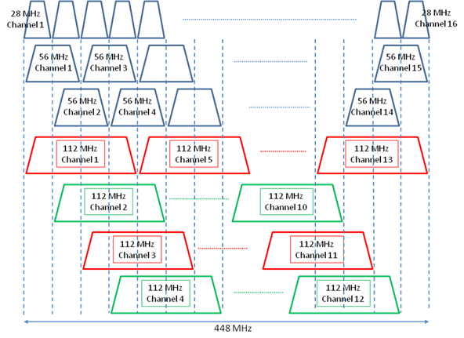

Figure 7: Channel arrangement and identifiers with channel width of 112 MHz as of Table 1, Annex 1, item 2

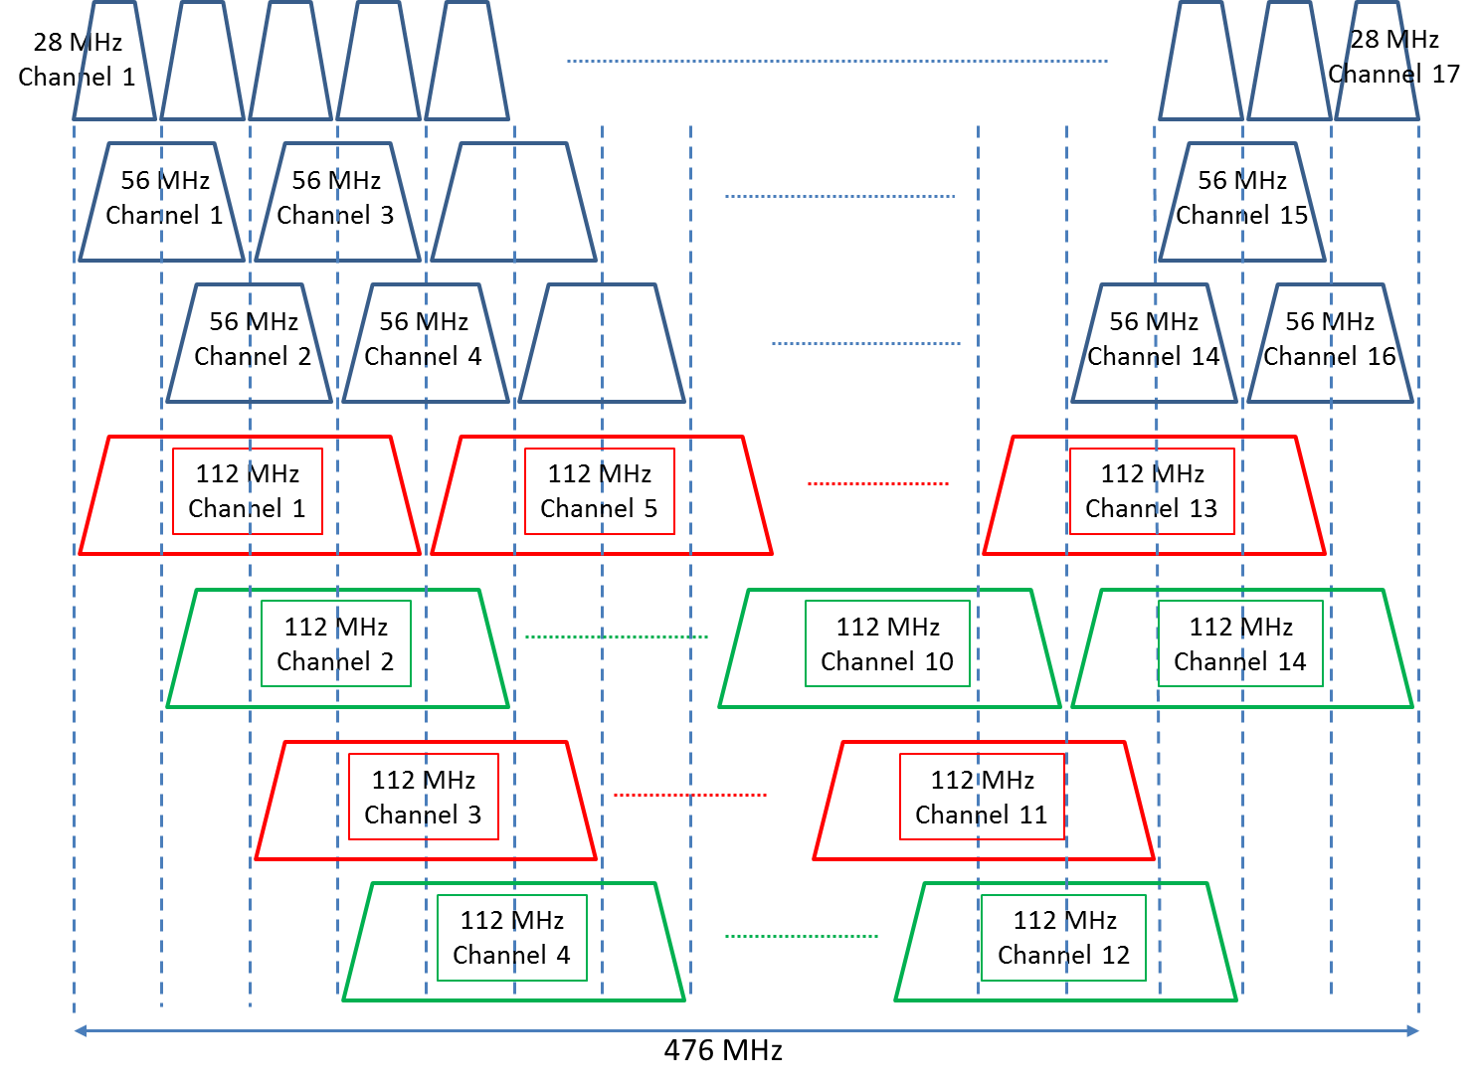

Figure 8: Channel arrangement and identifiers with channel width of 112 MHz as of Table 2, Annex 2, item 2