ECC Recommendation (05)01

Harmonisation of automatic measuring methods and data transfer for frequency band registrations

**Approved 02 February 2005**

**Amended: DD Month 2018**

# introduction

In order to support the WGFM and its Project Teams as well as the preparatory work for WRCs by CPG and its Project Teams, monitoring campaigns are conducted by the radio monitoring services of the various CEPT Administrations.

With regard to such campaigns and other exchanges of monitoring information between Administrations, the measuring method and format in which data is stored should be harmonised. It is also helpful to harmonise the presentation of the processed data.

In recent years there has been an increase in monitoring information gathered from mobile devices therefore the original recommendation is updated to incorporate these developments.

# ECC recommendation of 05(05)01 on HARMONISATION OF AUTOMATIC MEASURING METHODS AND DATA TRANSFER FOR FREQUENCY BAND REGISTRATIONS

“The European Conference of Postal and Telecommunications Administrations,

*considering*

1. that different measuring methods applied to the same frequency bands at the same time can produce different results;
2. that various Administrations may use different measuring equipment and controlling software;
3. that there are various data formats in which captured data can be stored;
4. that there are several possibilities to process the data and produce presentations of the measurement data;
5. that there are also similar needs within the framework of RR Article 16, International Monitoring.

*recommends*

1. that data gathered and exchanged during common monitoring campaigns from fixed locations should be in accordance with the method described in Annex 1.
2. that results from such co-ordinated measurements from fixed locations should be processed and presented as described in Annex 2.
3. that data gathered and exchanged during common monitoring campaigns along routes should be in accordance with the method described in Annex 3.”
4. that results from such co-ordinated measurements along routes should be processed and presented as described in Annex 4.
5. that administrations should discuss the conditions under which a monitoring or measurement campaign is conducted and data is exchanged before starting the campaign.”

*Note:*

*Please check the Office documentation database* [*http://www.ecodocdb.dk*](http://www.ecodocdb.dk) *for the up to date position on the implementation of this and other ECC Recommendations.*

1. HARMONISATION OF AUTOMATIC MEASURING METHODS AND DATA TRANSFER FOR FREQUENCY BAND REGISTRATIONS FROM FIXED LOCATIONS
   1. Introduction

Automatic frequency band registrations collect a large amount of data from a certain Start frequency to a certain Stop frequency.

From the monitoring point of view, there is always a wish to measure as large a frequency band as possible in as short a time as possible with very good resolution whilst keeping the amount of data collected down to an acceptable size.

In practice, this is very difficult to achieve and the final solution will be a compromise between all the above-mentioned parameters.

* 1. Relationship between the different parameters

There is a strong relationship between:

* Size of the band
* Resolution of measurements
* Scan time
* Step size
* Filter bandwidth
* Duration of monitoring
* Occupied bandwidth of the expected spectra in the band to be measured
* Transmission length of the expected emissions.

If one of these variables changes, many other parameters will change or this will have an influence on the accuracy of the results.

* 1. Harmonised measurements

A measurement co-ordinator should be nominated for each monitoring campaign who will liaise with the requesting body to ensure that there is a common understanding on the required data, processing method and manner of final presentation.

The initial discussions with the requesting body should cover at least the following items:

Table A1.1: Parameters to be discusses with the requesting body

|  | **Parameter** | **Considerations** | **Example** |
| --- | --- | --- | --- |
| 1. | Dates/times of measurements | Availability of monitoring stations. |  |
| 2. | Wanted geographic location | Availability of monitoring stations | Europe |
| 3. | Frequency range  (FreqStart, FreqStop) | As desired, noting the relationship between the frequency span and the resolution of measurements | 6200-6400 kHz |
| 4. | Duration of monitoring | This will vary depending on the task | 24 hours |
| 5. | Re-visit time | Should be short enough to detect brief duration transmissions | 10 seconds |
| 6. | Antenna  (AntennaType) | Directivity, gain, etc depending on task | Omnidirectional |
| 7. | Detector  (Detector) | Intermittent signals may be best presented using maximum hold | Average |
| 8. | Common exchange format version | For a common understanding of the fields that should be considered | Annex 1 |
|  | Others | As appropriate |  |

The co-ordinator should also recognise that there are some parameters which are controlled by the measuring equipment. These include:

Table A1.2: Measuring equipment parameters

|  | **Parameter** | **Settings** | **Comments** |
| --- | --- | --- | --- |
| 1. | Number of measuring points / step size  (DataPoints) | = > 400 points | To guarantee sufficient resolution |
| 2. | Filter Bandwidth  (FilterBandwidth) | Around 120% of step size | To ensure that all frequencies are monitored with minimal overlap |
| 3. | Scan Time  (ScanTime) | < re-visit time | The actual time taken for the equipment to scan from FreqStart to FreqStop |
| 4. | Attenuation  (Attenuation) | As required | As low as possible, depending on local conditions |
| 5. | RF level | As required | To ensure that sufficient dynamic range is available to cope with the strongest signals expected to be received |
|  | Others |  | As appropriate |

The co-ordinator should advise all participating Administrations of the required parameters prior to the start of the task. They should establish if their equipment is capable of measuring with these parameters and advise the co-ordinator if they are unable to fulfil the requirements.

All participating Administrations must ensure that their measuring equipment is operating in a calibrated manner. This is necessary as it is often possible to manually uncouple some spectrum analyser parameters which can result in un-calibrated measurement results.

* 1. Exchange of data

Once the agreed measurements have been made, it is necessary to send the results obtained from all the participating Administrations to the co-ordinator in order to process the data on a common basis.

Although the type of information stored by the various Administrations is broadly common, the internal format in which the monitoring data is stored varies greatly between the different types of equipment used. The often incompatible data format makes this transfer (data processing) very difficult.

* 1. Standard data format

To allow easy processing of the data, it should be submitted to the co-ordinator as an ASCII text file conforming to the following format.

The data file should comprise two sections:

* A ‘Header’ section containing the static information relating to the monitoring task such as the location used for monitoring, date and key monitoring parameters (see later).
* A ‘Data’ section containing all the measured results during the period of observation.
  + 1. Header section

The following fields and fieldnames should be used. All appropriate data fields should be included in the header area before the measured results are added.

The header section can contain three types of information – Essential, Optional or Additional Optional (marked E, O or AO in the following table.)

Optional means that space is reserved in the header but the field containing the data is left blank. Additional Optional fields are fields that may be added to the header in order to provide further information, however, these will not be automatically processed or recognised by the transfer software. The header and data sections should be separated by ONE blank line.

Table A1.3: Header Fields

| **Type** | **Fieldname** | **Data format** | **Array (1)** | **Description** | **Example** |
| --- | --- | --- | --- | --- | --- |
| E | FileType | Text | N | Type and/or version of the data file | Common exchange format V2.0 |
| E | LocationName | Text | N | Name of the location where the measurements are made | NERA |
| E | Latitude | Text | N | DD.MM.SSx where ‘x’ is ‘N’ or ‘S’ | 52.10.04N |
| E | Longitude | Text | N | DDD.MM.SSx where ‘x’ is ‘E’ or ‘W’ | 005.10.09W |
| E | FreqStart | Numeric (real) | Y | Frequency in kHz | 1000.000 |
| E | FreqStop | Numeric (real) | Y | Frequency in kHz | 2000.000 |
| E | AntennaType | Text | Y | Info, gain (dBi), Kfactor (dB/m) The gain and k factor fields can be omitted if not used | LPD, 7, 10 |
| E | FilterBandwidth | Numeric (real) | Y | In kHz | 0.2 |
| E | LevelUnits | Text | N | dBuV, dBuV/m or dBm (note that ’u’ is used instead of ’μ’) | dBuV |
| E | Date | Text | N | Date of measurements in the format YYYY-MM-DD (start date if measurements span midnight). Note that time is also stored in each line in the datasection | 2017-04-04 |
| E | DataPoints | Numeric (integer) | Y | Number of data elements in the data row (analyser data points or receiver steps) | 80000 |
| E | ScanTime | Numeric (real) | N | The actual time taken (in seconds) for the equipment to scan from FreqStart to FreqStop. For a digital system using Fast Fourier Transform (FFT) this time is the time needed to sample the data block | 24.1 |
| E | Detector | Text | N |  | RMS |
| O | Note | Text | N | General comments |  |
| O | AntennaAzimuth | Text | Y | DDD.DD (0 = North) | 181.12 |
| O | AntennaElevation | Text | Y | DD.DD (0 = no elevation) | 45.32 |
| O | Attenuation | Numeric (integer) | Y | Equipment attenuator setting in dB | 3 |
| O | FilterType | Text | Y | Filtertype bandwidth and shapefactor. For a digital system using FFT the window type used can be specified here | Gaussian 3 dB shapefactor 3.2 |
| O | DisplayedNote | Text | N | A small remark of less than 40 characters containing essential information which could be displayed next to the data on any final report |  |
| O | Multiscan | Text | N | Y or N  If this optional field is not present the value is automatically N |  |
| AO | Measurement Accuracy | Numeric (real) | N | Total accuracy of the system |  |
| AO | VideoFilterType | Text | Y | Video Filtertype bandwidth and shapefactor |  |

1. An explanation can be found in chapter A1.6
   * 1. Data section

The data area should consist of a separate line of data for each scan.

Each line should contain the start time of the measurement in HH:MM:SS format converted to UTC (or local time if requested by the co-ordinator) followed by a reading for each analyser data point or receiver step, all separated by commas.

Each signal level value should be rounded to the nearest integer value. If necessary, the co-ordinator will ask for an accuracy of one decimal place however this will increase the size of the resultant data file.

* + 1. Example file

FileType Bandscan

LocationName Baldock

Latitude 52.00.00N

Longitude 000.08.00W

FreqStart 7000

FreqStop 7200

AntennaType Inverted V

FilterBandwidth 0.5

LevelUnits dBuV/m

Date 2004-04-18

DataPoints 501

ScanTime 7.5

Detector Average

Note This is a sample file of the data format.

00:00:00,65,56,64,54,23,29,32,43,54,25,29,25,36…etc…,43,59

00:00:10,64,53,65,59,42,37,35,34,64,25,26,36,63…etc…,54,61

00:00:20,62,57,64,59,41,36,26,42,53,62,16,52,24…etc…,52,66

.

etc

.

23:59:30,53,33,61,44,25,44,36,26,46,24,26,24,63…etc…,29,56

23:59:40,54,32,62,48,24,42,35,26,24,64,24,34,35…etc…,29,56

23:59:50,64,52,63,57,33,23,32,53,25,26,63,35,26…etc…,32,59

* 1. MULTISCAN

For specific applications it can be necessary to scan multiple small frequency segments with large gaps in between. This optional field determines if the data file contains more than one of these segments. When this value is set to Y the fields indicated with Y in the column “array” change from one value to an array of values. The individual values in the array are separated by a semicolon.

For example for part of the header of a multiscan file:

FileType Common Exchange Format 2.0 this field will not change

FreqStart 3100;7000;5000.2 this field will change to an array of, in this case, 3 values

FreqStop 3200;7200;5100.1 this field will change to an array of, in this case, 3 values

The same is the case with the datasection. One line with 3 scans will look like this:

23:59:50,64,52,63,57,33,23,26,…etc…,38,55;,64,52,63,57,33,23,26,…etc…,32,46;,64,52,63,57,33,23,26,…etc…,55,23

Note that only one timestamp is used for the complete array of scans and the scantime in the header is the total time to complete the array of scans. Another application of multiscan is channel scan. Start and stop frequency are defined equal so only one frequency is scanned. The line in the data section now contains the scanned frequencies separated by semicolons.

* 1. Transfer software

As various Administrations use different data formats, they should therefore develop their own specific transfer software in order to translate their internal data layout to and from the common interchange format. Depending on the complexity of the internal design, this transfer software may be a simple macro file and could be shared between Administrations using the same type of data gathering equipment.

Administration 1

Specific format A

Common

exchange

format

Administration 2

Specific format B

Figure A1.1: Schematic presentation of data transfer to and from the common exchange format

1. Examples of frequency band registration presentations FROM FIXED LOCATIONS
   1. Introduction

The measured field strength values, stored in the format described in chapter A1.5 of Annex 1, enables different processing methods which can produce several presentations. A number of them are described below.

When comparing harmonized results from different locations, it is beneficial to use common scaling values for displaying time and signal level.

* 1. Spectrogram

A spectrogram is a two-dimensional plot representing the received transmissions in the measured frequency band with the frequency on the horizontal axis and time on the vertical axis.

The colour indicates the field strength of the captured data in accordance with the colour bar on the right side of the plot



Figure A2.1: Spectrogram



* 1. Minimum/median/maximum values

A minimum (blue), median (green) and a maximum value (red) can be calculated for all the measured data points during the monitoring period.

In the case of a monitoring duration of 24 hours and a re-visit time of 10 seconds there are 8,600 field strength values available for each data point to determine the minimum, median and maximum value.

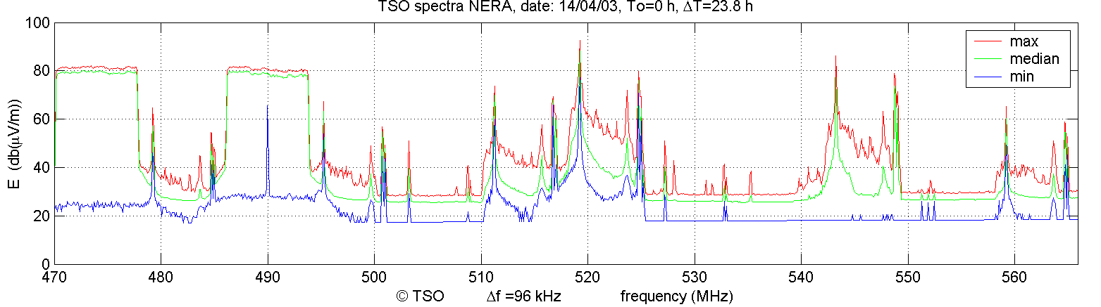

Figure A2.2: Minimum, median and maximum values



* 1. Occupancy

The occupancy plot shows the occupancy above a certain threshold level for all measured data points during the monitoring period.

In the case of a re-visit time of 10 seconds and a measurement period of 24 hours, 4,300 of the measured 8,600 values of a certain data point exceed the adjusted threshold level, the occupancy for that data point is 50%. The occupancy is calculated and presented for each data point.

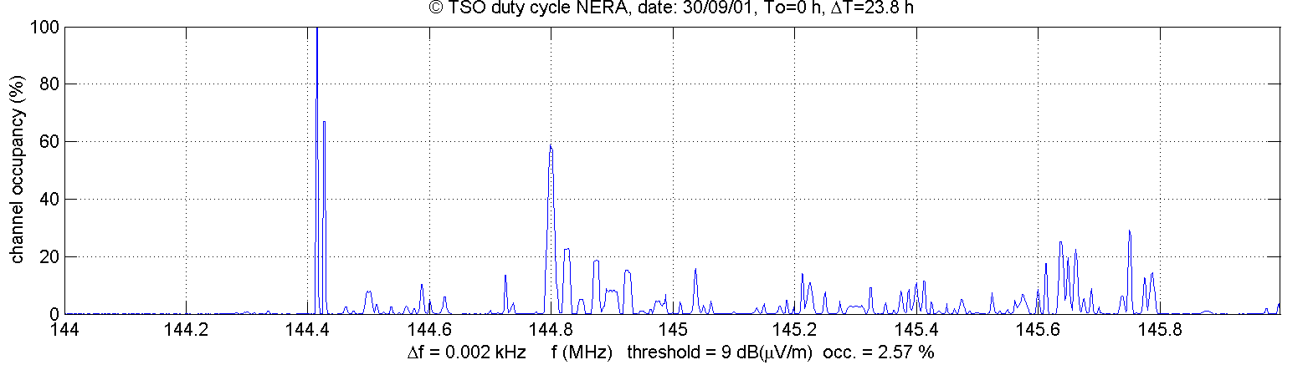

Figure A2.3: Occupancy



* 1. Waterfall

This is a three-dimensional plot presenting the frequency, time and field strength in a number of scans.

The number of scans must be adjusted, but optically a number of about 60 scans is often sufficient to give a reliable picture of the measured frequency band.

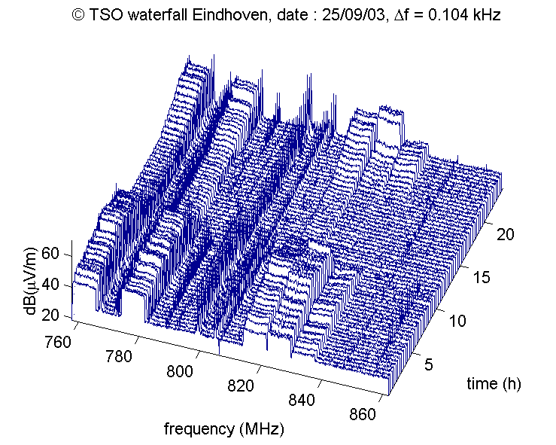

Figure A2.4: Waterfall



* 1. Field strength over time per channel (e.g. in case of broadcasting)

A plot presenting the field strength over time can be compiled for each of the measured data points, normally > 400.

This is often useful in case the measured bands are broadcasting bands. The time of on and off switching transmitters can be determined.

In the case of a frequency span of 200 kHz, 40 of these channels can be displayed (channel separation is 5 kHz).



Figure A2.5: Field strength Over Time



1. HARMONISATION OF AUTOMATIC MEASURING METHODS AND DATA TRANSFER FOR FREQUENCY BAND REGISTRATIONS along Routes
   1. Introduction

The mobile frequency band registrations are normally used for coverage measurements of any service. The harmonization of data transfer will be useful for measurements along the countries border or for services with coverages larger than one country.

For this data transfer, due to the normal big amount of data collected during mobile measurements, the data exchange could be done in binary format witch allow much smaller data files that the ones exclusively saved in ASCII format.

* 1. Relationship between the different parameters

There is a strong relationship between:

* Size of the band
* Resolution of measurements
* Scan time
* Step size
* Filter bandwidth
* Occupied bandwidth of the expected spectra in the band to be measured
* Transmission length of the expected emissions
* Velocity of the vehicle
* Measurement distance

If one of these variables changes, many other parameters will change or this will have an influence on the accuracy of the results.

* 1. Harmonised measurements

A measurement co-ordinator should be nominated for each monitoring campaign who will liaise with the requesting body to ensure that there is a common understanding on the required data, processing method and manner of final presentation.

The initial discussions with the requesting body should cover at least the following items:

Table A3.2: Parameters to be discussed with the requesting body

|  | **Parameter** | **Considerations** | **Example** |
| --- | --- | --- | --- |
| 1. | Dates/times of measurements | Availability of monitoring vehicles |  |
| 2. | Wanted geographic location | Type of area to monitor | City / Border |
| 3. | Frequency range  (FreqStart, FreqStop) | As desired, noting the relationship between the frequency span and the resolution of measurements | 87.5-108 MHz |
| 4. | Duration of monitoring | This will vary depending on the task | working hours |
| 5. | Distance/Area of monitoring | Minimum distance or area to monitor | 10 km2 |
| 6. | Scan Speed | Should be high enough to clearly associate the measured frequency with the geographical point | 1 scan/second |
| 7. | Antenna  (AntennaType) | Directivity, gain, etc depending on task | Omnidirectional |
| 8. | Detector  (Detector) | Intermittent signals may be best presented using maximum hold | Average |
| 9. | Common exchange format version | Common understanding of the fields that should be considered including the data format (ASCII/Binary) |  |
| 10. | Others | As appropriate |  |

The co-ordinator should also recognise that there are some parameters which are controlled by the measuring equipment. These include:

Table A3.2: Measuring equipment parameters

|  | **Parameter** | **Settings** | **Comments** |
| --- | --- | --- | --- |
| 1. | Number of measuring points / step size  (DataPoints) | = > 1000 points | To guarantee sufficient resolution |
| 2. | Filter Bandwidth  (FilterBandwidth) | Around 120% of step size | To ensure that all frequencies are monitored with minimal overlap |
| 3. | Scan Time  (ScanTime) | The necessary to guarantee an adequate coverage regarding the frequency band and maximum speed of the vehicle | The actual time taken for the equipment to scan from FreqStart to FreqStop |
| 4. | Attenuation  (Attenuation) | As required | As low as possible, depending on local conditions |
| 5. | RF level | As required | To ensure that sufficient dynamic range is available to cope with the strongest signals expected to be received |
|  | Others |  | As appropriate |

The co-ordinator should advise all participating Administrations of the required parameters prior to the start of the task. They should establish if their equipment is capable of measuring with these parameters and advise the co-ordinator if they are unable to fulfil the requirements.

All participating Administrations must ensure that their measuring equipment is operating in a calibrated manner. This is necessary as it is often possible to manually uncouple some spectrum analyser parameters which can result in un-calibrated measurement results. And that the maximum vehicle speed limit is not exceeded.

* 1. Exchange of data

Once the agreed measurements have been made, it is necessary to send the results obtained from all the participating Administrations to the co-ordinator in order to process the data on a common basis.

Although the type of information stored by the various Administrations is broadly common, the internal format in which the monitoring data is stored varies greatly between the different types of equipment used. The often incompatible data format makes this transfer (data processing) very difficult.

* 1. Standard data format

The data file should comprise two sections:

* A ‘Header’ section containing the static information relating to the monitoring task such as the location used for monitoring, date and key monitoring parameters (see later) in ASCII format.
* A ‘Data’ section containing all the measured results during the period of observation. The data can be in ASCII format or in binary format
  + 1. Header section

The following fields and fieldnames should be used. All appropriate data fields should be included in the header area before the measured results are added.

The header section can contain three types of information – Essential, Optional or Additional Optional (marked E, O or AO in the following table.)

Optional means that space is reserved in the header but the field containing the data is left blank. Additional Optional fields are fields that may be added to the header in order to provide further information, however, these will not be automatically processed or recognised by the transfer software. The header and data sections should be separated by ONE blank line.

Table A3.3: Header Fields

| **Type** | **Fieldname** | **Data format** | **Array (2)** | **Description** | **Example** |
| --- | --- | --- | --- | --- | --- |
| E | FileType | Text | N | Type and/or version of the datafile | Common exchange format V3.0 |
| E | LocationName | Text | N | Name of the location where the measurements are made | Lisbon |
| E | Latitude | Text | N | Starting Latitude  DD.MM.SSx where ‘x’ is ‘N’ or ‘S’ | 38.41.30N |
| E | Longitude | Text | N | Starting Longitude  DDD.MM.SSx where ‘x’ is ‘E’ or ‘W’ | 009.12.57W |
| E | FreqStart | Numeric (real) | Y | Frequency in kHz | 1000.000 |
| E | FreqStop | Numeric (real) | Y | Frequency in kHz | 2000.000 |
| E | AntennaType | Text | Y | Info, gain (dBi), Kfactor (dB/m) The gain and k factor fields can be omitted if not used | Omni Vertical, 7, 10 |
| E | FilterBandwidth | Numeric (real) | Y | In kHz | 0.2 |
| E | LevelUnits | Text | N | dBuV, dBuV/m or dBm (note that ’u’ is used instead of ’μ’) | dBuV |
| E | Date | Text | N | Date of measurements in the format YYYY-MM-DD (start date if measurements span midnight). Note that time is also stored in each line in the datasection | 2017-04-04 |
| E | DataPoints | Numeric (integer) | Y | Number of data elements in the data row (analyser data points or receiver steps) | 1001 |
| E | ScanTime | Numeric (real) | N | The actual time taken (in seconds) for the equipment to scan from FreqStart to FreqStop. For a digital system using Fast Fourier Transform (FFT) this time is the time needed to sample the data block | 5.0 |
| E | Detector | Text | N |  | RMS |
| E | DataType | Text | N | ASCII or BINARY | ASCII |
| E | NumberBytes | Numeric (integer) | N | Total number of bytes in the data section. This information is ignored if DataType is ASCII. |  |
| O | Note | Text | N | General comments |  |
| O | Attenuation | Numeric (integer) | Y | Equipment attenuator setting in dB | 3 |
| O | FilterType | Text | Y | Filtertype bandwidth and shapefactor. For a digital system using FFT the window type used can be specified here | Gaussian 3 dB shapefactor 3.2 |
| O | DisplayedNote | Text | N | A small remark of less than 40 characters containing essential information which could be displayed next to the data on any final report |  |
| O | Multiscan | Text | N | Y or N  If this optional field is not present the value is automatically N |  |
| AO | Measurement Accuracy | Numeric (real) | N | Total accuracy of the system |  |
| AO | VideoFilterType | Text | Y | Video Filtertype bandwidth and shapefactor |  |

1. An explanation can be found in section A3.6
   * 1. Data section
        1. ASCII format

The data area should consist of a separate line of data for each scan.

Each line should contain the start time of the measurement in HH:MM:SS format converted to UTC (or local time if requested by the co-ordinator) and the geographical coordinates latitude (±DD.DDDDDD) and longitude (±DDD.DDDDDD) in WGS 84 standard on the decimal format followed by a reading for each analyser data point or receiver step, all separated by commas.

Each signal level value should be rounded to the nearest integer value. If necessary, the co-ordinator will ask for an accuracy of one decimal place however this will increase the size of the resultant data file.

* + - 1. Example file

FileType Common exchange format V3.0

LocationName London

Latitude 51.30.03N

Longitude 000.07.28W

FreqStart 430000

FreqStop 440000

AntennaType Omnidireccional

FilterBandwidth 0.5

LevelUnits dBuV/m

Date 2016-04-20

DataPoints 1001

ScanTime 1

Detector Average

DataType ASCII

Note This is a sample file of the data format.

09:00:00,+51.500868,-000.124517,65,56,64,54,23,29,32,43,54,25,29,25,36…etc…,43,59

09:00:01,+51.500897,-000.124340,64,53,65,59,42,37,35,34,64,25,26,36,63…etc…,54,61

09:00:02,+51.500849,-000.124086,62,57,64,59,41,36,26,42,53,62,16,52,24…etc…,52,66

etc

11:59:57,+51.506459,-000.074732,53,33,61,44,25,44,36,26,46,24,26,24,63…etc…,29,56

11:59:58,+51.506355,-000.074787,54,32,62,48,24,42,35,26,24,64,24,34,35…etc…,29,56

11:59:59,+51.506219,-000.074871,64,52,63,57,33,23,32,53,25,26,63,35,26…etc…,32,59

* + - 1. BINARY format

The data section should be initiated by the following identifier: **CEFBFSDS**, which size do not count for the NumberBytes size information

In the BINARY format all values have a fixed length. For that reason the data area is in this case a continuous line of information even though the sequence of information is the same as in the ASCII format, where each set of information should contain the start date and time of the measurement converted to UTC (or local time if requested by the co-ordinator) and the geographical coordinates latitude and longitude in WGS 84 standard followed by a reading for each analyser data point or receiver step.

This data format should only be used when is expected a large number of values and they **should** be rounded to the nearest integer.

The values will be saved in one of the following binary representation:

INT8: signed integer from -128 to 127 (from –(27) to 27-1)

Example: 85 **0**1010101  
 -85 **1**0101011

INT16: signed integer from -32 768 to 32 767 (from –(215) to 215-1)

Example: 21845 **0**1010101 01010101  
 -21845 **1**0101010 10101011

INT32: signed integer -2 147 483 648 to 2 147 483 647 (from –(231) to 231-1)

Example: 1 431 655 765 **0**1010101 01010101 01010101 01010101  
 -1 431 655 765 **1**0101010 10101010 10101010 10101011

UINT64: unsigned integer from 0 to 18 446 744 073 709 551 615 ( 264-1)

Example: 6 148 914 691 236 517 205 **0**1010101 01010101 01010101 01010101  
01010101 01010101 01010101 01010101

All values are saved in the big-endian order like is written a decimal number and in the signed values the sign bit is the most significant bit (leftmost 0 = plus, 1 = minus).

Date and Time:

The date and time are represented by the number of milliseconds since Jan 1st, 1970, without leap seconds and are saved in the UINT64 binary format.

03 Apr 2017 09:00:00 (UTC) –> 1 491 296 400 000

UINT64 -> **0**0000000 00000000 00000001 01011011 00111000 00110001 00110010 10000000

Note: the space between bytes is only for better reading purposes

Geographical Coordinates:

The geographical coordinates are represented by the 1/100000 of degree in decimal format and is saved in the INT32 binary format.

+51.500868 –> +51500868

INT32 -> **0**0000011 00010001 11010111 01000100

-000.074787 -> -74787

INT32 -> **1**1111111 11111110 11011011 11011101

Note: the space between bytes is only for better reading purposes

Data Value:

The data values **should** be rounded to the nearest integer of the unit in decimal format and are saved in the INT8 binary format.

Examples: -35

INT8 -> **1**1011101

66

INT8 -> **0**1000010

* + - 1. Example file

FileType Common exchange format V3.0

LocationName London

Latitude 51.30.03N

Longitude 000.07.28W

FreqStart 430000

FreqStop 440000

AntennaType Omnidireccional

FilterBandwidth 0.5

LevelUnits dBuV/m

Date 2016-04-20

DataPoints 1001

ScanTime 1

Detector Average

DataType BINARY

NumberBytes 25200

Note This is a sample file of the data format.

**CEFBFSDS** 00000000 00000000 00000001 01011011 00111000 00110001 00110010 10000000 **0**0000011 00010001 11010111 01000100 **1**0000000 00000001 00100100 00100011 **0**0000010 10001010 00000010 00110000 00000010 10000000 ……...…. 00000010 01001110 00000000 00000000 00000001 01011011 00111000 00110001 00110110 01101000 ………

Note: the space between bytes is only for better reading purposes

* 1. MULTISCAN

For specific applications it can be necessary to scan multiple small frequency segments with large gaps in between. This optional field determines if the data file contains more than one of these segments. When this value is set to Y the fields indicated with Y in the column “array” change from one value to an array of values.

Note that only one timestamp is used for the complete array of scans and the scantime in the header is the total time to complete the array of scans. Another application of multiscan is channel scan. Start and stop frequency are defined equal so only one frequency is scanned.

* + - 1. ASCII format

In the ASCII format the individual values in the array are separated by a semicolon.

For example for part of the header of a multiscan file:

FileType Common Exchange Format 3.0 this field will not change

FreqStart 3100;7000;5000.2 this field will change to an array of, in this case, 3 values

FreqStop 3200;7200;5100.1 this field will change to an array of, in this case, 3 values

The same is the case with the datasection. One line with 3 scans will look like this:

09:00:00,+51.500868,-000.124517, 65,56,64,54,…etc…,38,55;,64,52,63, 26,…etc…,32,46;,64,52,63, 26,…etc…,55,23

In the case of channel scan the line in the data section now contains the scanned frequencies separated by semicolons.

* + - 1. BINARY format

In the BINARY format the individual values in the array create a continuous line of data.

The header of a multiscan file in BINARY format is equal to the one in ASCII format plus the Field NumberBytes:

The datasection will look like this:

**CEFBFSDS** 00000000 00000000 00000001 01011011 00111000 00110001 00110010 10000000 **0**0000011 00010001 11010111 01000100 **1**0000000 00000001 00100100 00100011 00000010 10001010 00000010 00110000 00000010 10000000 ……...…. 00000010 01001110 ……...…. 00000010 01001110 ……...…. 00000010 01001110 00000000 00000000 00000001 01011011 00111000 00110001 00110110 01101000 00000011 00010001 ………

Note: the space between bytes is only for better reading purposes

* 1. Transfer software

As various Administrations use different data formats, they should therefore develop their own specific transfer software in order to translate their internal data layout to and from the common interchange format. Depending on the complexity of the internal design, this transfer software may be a simple macro file and could be shared between Administrations using the same type of data gathering equipment.

Administration 1

Specific format A

Common exchange

format

ASCII/BINARY

Administration 2

Specific format B

Figure A3.1: Schematic presentation of data transfer to and from the common exchange format

1. Examples of frequency band registrations along routes
   1. Introduction

The measured field strength values, stored in the format described in chapter A3.5 of Annex 3, enables different processing methods which can produce several presentations.

In complement with the presentations of Annex 2, also possible to create with the data collected in mobile measurements, the main objective is to identify the field strength, or other values, in different positions of a route.

* 1. Field strength ALONG A ROUTE

A map representing if some criteria is full field or no based in a threshold value specified in the analysis of the results.

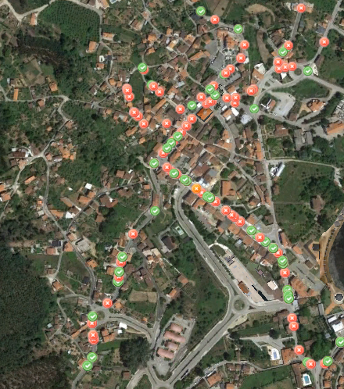

Figure A4.1: Go NoGo Map

Maps indicating field strength of the captured data in accordance with a colour bar.

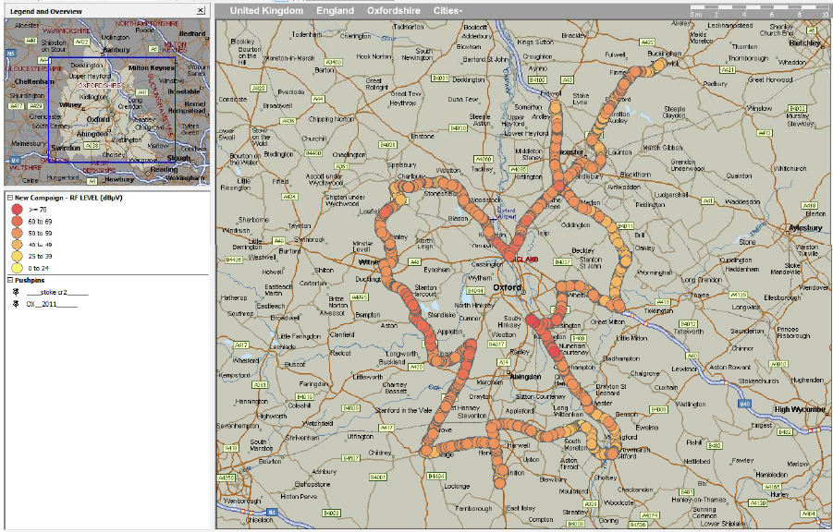

Figure A4.2: Long Route Coverage Map

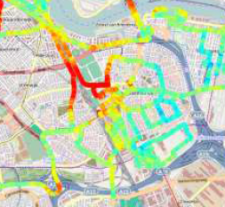

Figure A4.3: City Coverage Map